
PROfiRAM

5110 GRUN

BERSERKER

BOOKS

HYPERBOREAN PROGRAM

Index

Self World Enemy

"A Self stripped of every moral, of every dogma, indifferent to the deceptions of the world but open to the memory of the blood, will be able to gallantly march towards the Origin and no force in the universe will be capable of stopping it"
-Nimrod de Rosario

Introduction

This work is a presentation of a basic program that leads the asleep toward a state of wakefulness, the domesticated to recover the state of a warrior Berserker along the path of immortality against the Will of 'The One', the 'God' of monotheism, the Demiurge.
It prescribes a basic template for the transmutation of the aspirant into an Berserker Warrior. However it is not a cowardly flight from reality but the doorway to Eternity, a black hole toward the Green Ray beyond the spatio-temporal density of 'The One', the creation of His matrix prison.
Herein is discussed a tripartite mode of action in 'the world' of 'The One' for the active warrior in his engagement with the enemy, namely 'The One' and his legions. It prescribes a strengthening of Self across all lines from basic exercise and physical life to spiritual tactics brought together as a synchronism of Spirit and matter to deploy in the assault against the foe.
An extensive and prioritized bibliography is provided to amplify one's arsenal of weapons of war. The works cited constitute ammunition for the most lethal weapon of all-the mind. These works can subsequently be integrated into oneself and serve as a guide to create an integral unit of body; soul and Spirit, an alloy of tungsten carbide; oricalchum and immortal vajra.
The work is presented in simple point-form making it accessible to as wide an audience as the writer deems appropriate. It is the writer's express intention that this work be as widely disseminated as possible and ideally with no profit motive, only the motive of victory against the foe.
For the writer it is a distillation of a lifetime of dilettantish study and groping in the darkness and confusion of the Demiurge's penitentiary. May it serve as a guide through his world of illusion and densest matter and enable the aspirant to attain the light of the black sun in the last battle for the destruction of 'The One' and his earthly emissaries who chain all in the prison of this tortured earth. To victory and to Valhalla, back to the Origin-to Hyperborea!

SELF

Exercises for Body; Soul and Spirit

Physical Exercise

Martial Arts

"Fear is a strategic weapon[...]all fear is of external origin, alien to one's own being" "Emotions are the most viscous form of illusion"
-Nimrod de Rosario

Research pressure points and vital areas that inflict the greatest damage against the opponent to subjugate them and minimize legal liability for yourself.
Exercise caution to avoid injury and wear appropriate padding

- Sambo: Combines throws; strikes and grappling for the most comprehensive and well-rounded martial art. Developed by the SS in Germany and transported to Russia. Sambo entails the martial arts listed below and more.
- Kickboxing: solo or partner(s)
- Kung Fu (Dim Mak; Hung Gar)

purpose: subjugate opponent through strikes; defend through forearm; glove and thigh blocks

equipment: heavy bag with gloves and headgear; elbow and shin pads if taking blows from partner(s) as well as pads on floor or to be performed on soft grass or sand, ideally in the sun in a quiet and private environment
- Grappling/wrestling:

purpose: subjugate opponent to immobilize or knockout using joint locks and throws

- Stick Fighting:
purpose: strike blows to vital areas and keep distance to subjugate the opponent/equipment: small baton-sized stick; larger broom sized stick (eg. aluminum hockey stick without blade)
6) Knife Fighting:

purpose: strike and escape and evade not trade stabs and blows

equipment: use fake knives (from martial arts supply store or make one) to simulate actual street encounter. Use appropriate padded head and body gear to cushion blows and strikes. Take it seriously and don't condition yourself to downplay the seriousness of the threat. Below are charts indicating pressure points and vulnerable areas of the anatomy:
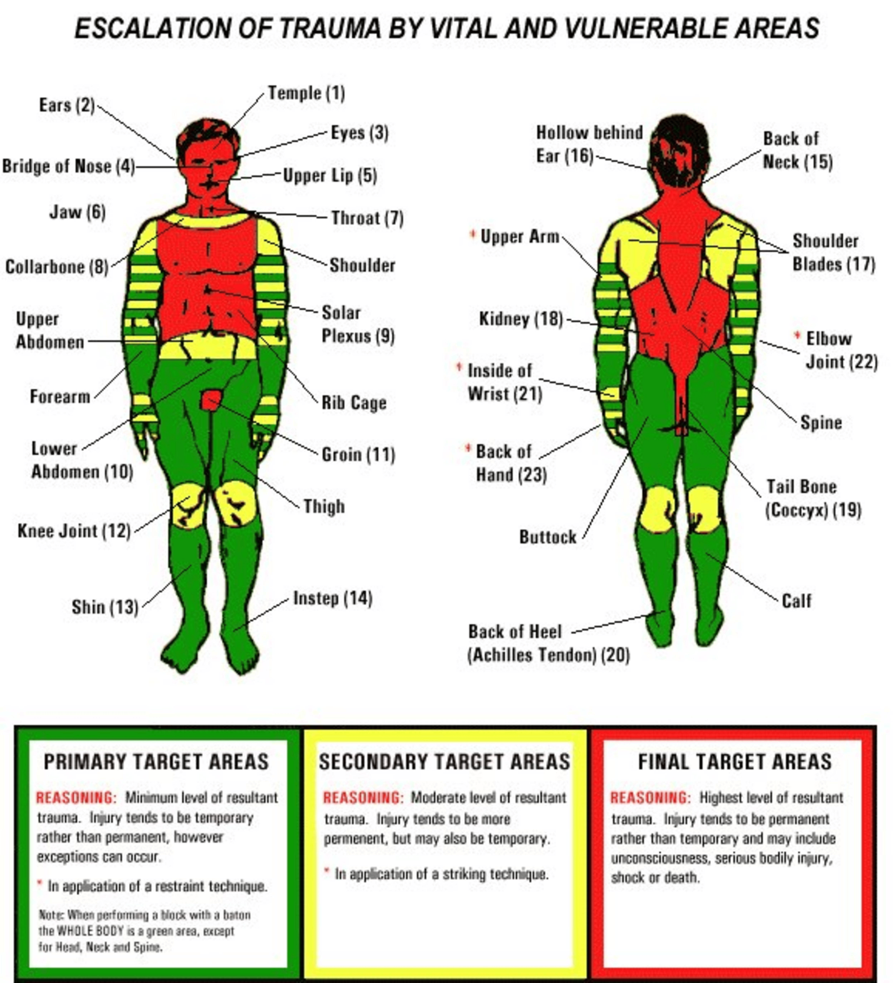

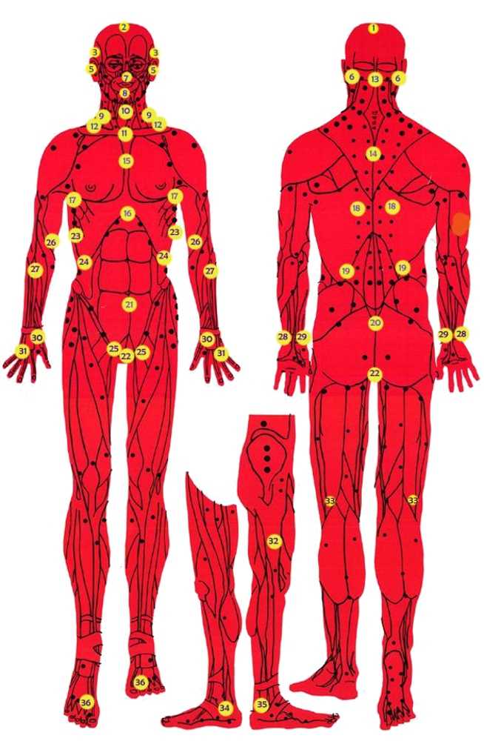

Resistance Training

purpose:

strengthen and develop the muscles; tendons; joints; and bones (musculoskeletal system); metabolic conditioning (increase endurance and develops the cardiovascular system); develop will- power
frequency: 3-4 times per week with one or both of:

- Bodyweight Resistance: Note: bodyweight resistance is preferable to bodybuilding-style weight training as it conforms to the natural motion of the body in real life scenarios, eg. squatting; jumping; pushing without adding excessive weight during the movement that causes muscoloskeletal imbalances and joint damage. It also enables higher repetitions and improves endurance capacity (which has a greater correspondence to normal movements.
circuit training (military style training): 4 sets of maximal reps (aim for 20 minimum)

  - push-ups<--->squats/jumps; pull-ups/chin-ups--->
  - alternate leg raises (kicks) hanging from pull-up/chin-up bar--→
iii) hyper- extensions<--->squats/jumps (superset)
(start with higher reps and decrease as you go each set; no breaks; continual motion)

- Weight-Training:

1 basic exercise for each major muscle group and direction of joint motion

(Avoid excessively heavy weights as it causes too much load on joints and excessive intra-thoracic pressure and doesn't translate to metabolic conditioning but Absolute Strength which is not as useful for daily encounters)

- Olympic Lifting: (caveat: can require excessive investment of time/effort in training and motor skill development; also can result in injury to a great degree)

examples of conventional weight training routines:

  - 3 times per week: 10-12 reps x 4-5 sets; higher reps for calves and neck (eg. 20 reps); continual exercise without rest between alternating exercises; use proper form for exercises
Duration: 15-20 minutes; less than 30 seconds between sets; supersets and giant sets

Day 1: upper body superset/giant set chest exercise<--->back exercise
(eg.s 1) flat bench dumbbell fly<--->1) lat cable pull downs or cable crossover<--->2) alternate dumbbell row)

take day off

Day 2: Lower Body superset/Giant set

[(eg.s 1) hamstring/knee flexion<--->2) quads/knee extension--->3) optional: calves)]

    - 1) leg curl<--->2) leg extension or

    - 1) stiff-legged deadlift<--->2) squats (note: 2) can be hard on the spine, hence use lighter weight with more rapid movement)

    - a) calf raise←-→b) broomstick/pipe twist or->

a) machine←-→b) broomstick twists supersetted or
a) dumbbell on elevated platform<---> b)broomstick twists)

take day off

Day 3: Arms/Shoulders/Neck/Trunk

1) Shoulders

(eg.s 1) bent over flyes (posterior deltoids)<--->broomstick twists---> alternate dumbbell extensions)

2) i) Elbow Flexion (biceps)<--->ii) Elbow Extension (triceps)
[(eg.s i) alt. dumbbell (hammer) curls<--->i) rope pressdowns
- pull-ups<---> dumbbell kickback extensions)]

3) Truck/Erector Spinae

(eg. 1) hyper-extensions<---> broomstick twists/side-to-side motion)

4) Neck

(eg.s i) hanging off bench: flexion<--->extension: 20 reps or ii) side-to-side rotation facing ground<---
>side-to-side rotation facing ceiling: go slowly; 20 reps each or iii) wrestler's bridge

day off

Day 4: weighted pack or weight vest walk (25-45 minutes)

Kettlebells

-More dynamic movements and less weight
-do a complete basic circuit, eg.: 1) Double-Arm kettlebell swings--->2) kettlebells slingshots (round-the-body, both directions)--->3) Goblet squats (30 reps per circuit x 3-5 circuits)

other forms of strength training: Hands:
- hand squeezer (use only multi-prong squeezer such as 'eagle claw' martial arts style squeezers
or cage-style squeezer; no single coil v-shaped squeezer as damages hand)
ii)-weighted vest;
iii)-strongman exercises (farmer's walk; sled drag; football style exercises); iv)-Eyes: sun gazing (look indirectly at the sun for 3 minutes per day);
v)-reflexology sandals: stand on spike wooden or metal sandals for multiple hours straight (increases metabolic rate and bone mineral density; circulates blood) as well as lying on a bench and elevating the feet above the head (eg. gravity boots or bracing heels against furniture/desk): serves to circulate the lymphatic fluid through the lymphatic vessels.

Cardiovascular/Endurance Training

6 days per week:

If no joint problem occur run 20-30 minutes 5-6 days on an empty stomach or after other exercises (follow proper technique; stretching, etc.)
If joint problems occur: elliptical trainer (ski machine) or other cardio machine that will utilize both upper and lower limbs and induce sweating and increase of heart rate as well as deep breathing.
1 day per week: long walk with small light pack or no pack for at least two hours

-swim in lake or kayak or cross-country ski if you have the facilities and equipment Trampoline:
6 minutes per day one or more times per day, preferably rotating in a leftwards direction (levorotatory)

purpose: lymphatic drainage; proprioceptic; helps to exercise internal organs via g-forces and leftwards direction activates right-brain/intuitive consciousness (Re-Turn to Origin)

Recuperation/Recovery

'Normie lifestyle':

Sleep #1: 21:00-22:00 PM-05:00 AM/06:00 AM

purpose: (accords with circadian rhythms; facilitates liver detoxification: "early to bed early to rise")

'Rebel lifestyle':

Sleep #2: Midnight or later-early morning (shifts consciousness to dark side, increases intuitive faculty)

Rest: 8-13 minute meditation sessions 2-5 times per day (ideally doing third eye meditations in a quiet environment; minimize discursive thought, aka. 'monkey mind'). Position: reclining in chair or lying with head propped up, else kneeling on mat.
Near Infrared heat lamp: lie underneath for 30 minutes to 1 hour per day concentrating its light on naked abdomen, avoiding head exposure. Helps to relax organs and purge liver of parasites and especially the liver (right side) [see 'parasite cleanse' for more]

Chromotherapy: Different colors for different mood states/effects (eg. greenlight for harmonious states of consciousness; blue for spirituality; yellow for intellect, etc.)

Oxygenate: ozone generator therapy: breath ozone rich atmosphere and drink ozonated water throughout the day
Heliotherapy/sun exposure: before 10:00 AM and after 02:00 PM in most regions of the earth for at least 5 minutes on face and arms earthing/grounding: stand on bare earth with barefeet for 5-10 minutes per day. (obtain grounding mat which generates negative ions if this isn’t an option. caveat: avoid parasites in soil, etc.)

Massage: (oil region to be massaged with olive or sesame oil)

- Reflexology/gua sha stone (reduce muscle tension through massaging along muscle fibers)
- Vibration machine massage

- Tiger Balm or similar ointment (eg. capsaicin oil in beeswax) to reduce muscle tension

Colonic Hydrotherapy + enemas: purifies body, extends lifespan

Fasting: distilled water only +/- herbal/green tea +/- olive oil (energy)

Energy Medicine:

PEMF (pulsed electro-magnetic frequency device)

Lakhovsky MWO (multiple wave oscillator device)

Magnetic Mattress pad

Spiritual Exercises

"Isolate the material body from the rest of the material order[...]become an 'autonomous microcosm', independent of pantheistic Space and karmic Time."
-Nimrod de Rosario

  - Meditation:

Purpose: strengthens concentrative ability. Activates pineal gland to enhance higher intuition. Enables dissociation and attachment of soul to Spirit under control of will.
    - 3rd eye meditation: stare at 3rd eye/pineal gland crossing eyes and count down from 99-0. Do this 2-3 times per day
    - Light meditation: stare at a candle or light.

    - Darkness meditation: shut off all sensory stimuli and perform void meditation. Do this daily just after waking and prior to sleep for at least 15 minutes, optimally 30 minutes in kneeling posture or lying down with head elevated. Fingers not touching anything.
Placing tongue on roof of mouth breathing through nose and 3rd eye meditation as above

  - Recollection:

    - prior to sleep rewind the events of the day to the period of waking

    - upon waking: recall dream sequence ensuring not to fall back to sleep (sit in kneeling posture)

    - recollect the events of the week and contemplate them at week's end purpose: integrates experience and increases self-understanding

  - Contemplation:



Contemplate works of art (music; poetry; pictorial or plastic art) and let them serve as sources of ideas and motivation

A totemic icon or object can be set up in a shrine for recollection of the blood memory (eg. Hyperborean symbols such as the TyrOdal rune above)
purpose: self-understanding integrating experiences into the soul

  - Fast:

Periodically fast taking only pure, distilled water

(eg. 36 hours every 2 months; 2-4 day fast every spring or summer with the context of 1-1.5 weeks vegan or fruitarian; one month of the year eat only twice daily and not greater volume than normal; 24 hourts every 2 weeks)
purpose: elevate consciousness; purifies body

  - Endurance:

(possibly in a fasted state): walk or hike with a full backpack of no greater than 20 lbs.

(depending on height and weight) for at least 4 hours continually taking only occasional water breaks

  - Yoga: (See Nimrod de Rosario's recommendations in bibliography)
Tantra

"The esoteric objective of tantra, as we have already said is the same as that of any Hyperborean strategy: the mutation of the animal nature of the pasu into the divine and immortal nature of the siddha[.] The Hyperborean virya, by means of tantra, does not seek any fusion with the Demiurge but, on the contrary, seeks to isolate himself from him to gain the absolute individuality that vril grants".
-Nimrod de Rosario
Runic Yoga (cf. The Runic Library, Marby)

  - Voluntary Reclusion:

Go into a quiet environment if it can be found and experience total silence for at least 24 hours (ear plugs can be used if needed) preferably in a rural place
  - Chant:

Chant runic mantras (focusing on third eye with appropriate mudra or hand gesture)

  - Remote Viewing and Influencing (see bibliography)

Soul Exercises

purpose: subject oneself to hardship to overcome emotional reaction

- Dereliction:

Throw yourself onto the streets for three days a few times each year. Dress in the poorest clothes from a thrift store and appear to be a vagrant (don't shave prior to this time). Ideally fast during this time.
purpose: experience deprivation without affect + cultivate empathy for one's own

- Harmonization:

Listen to harpsichord music for 3 hours continually or listen to military music for 3 hours continually (eg. while exercising)
purpose: harmonizes the consciousness with the music and its meaning. Older electronica music might also be a candidate. This will induce a trance state.

- Poetry:

Write poetry for an entire day ideally under similar or different conditions (eg. Urban environment; rural environment; with noise; in silence, etc.)
purpose: expands consciousness and elevates the mind creating a lyrical mode of being.

- Art:

Undergo artistic activity for 1 day of a similar or different nature (eg. Drawing; painting; sculpture, etc.).
Avoid staring into computer screens as this disturbs the consciousness and is to artificial a form of media. It is best to have at least two days per week without electronic/virtual communications and most electronic devices (eg. radio; stereo; etc.)
- Music:

Play a musical instrument or sing songs (ideally compose culturally relevant songs, eg. slavic folk songs, etc.)

- Communion:

Sleep next to a person of the opposite sex who you have a positive rapport with for the night without any contact separated by a sword. The person should ideally never have had contact with you before.

Nutrition

Eat: most nutrient dense; high alkalizing; all natural organic food (eg. animal products: yoghurt; cheese; high omega-3 farm eggs; dairy; fruits; vegetables; nuts; starch; legumes). The writer's preference is a lacto-vegetarian diet owing to its being minimally acidifying and optimally digested as well as environment and animal friendly

Food List:

Animal Food
Dairy (cheese; thick Yogurt with no carageenan or milk powder-only milk; cream and active bacterial cultures)
if necessary:
Fish (small fatty wild caught ocean fish, eg. sardines; sprats; herring) Eggs (high omega-3 free range)

Starch
(in order of most to least alkalizing)
white beans; potatoes; millet; buckwheat; quinoa; lentils; chickpeas sweet potatoes; oats; (calrose) brown rice;

Vegetables
carrots; beets; cabbage; broccoli; brussels sprouts; sweet onions (red; white); nori/seaweed; vegetable juice (beet & carrot can be too high in sugar so minimize; cabbage; avoid 'green juice', as they contain poisonous substances).

Nuts/Nut Butter
sesame seed; flax seed(grind both); peanut/almond/sesame butter; walnuts

Fruit
figs; dates (post workout)
lemons/limes (drink via straw with herbal tea)

Herbal Tea green tea (sencha); dandelion leaf &/or root; oatstraw

Supplements
testosterone boosting herbs:
(kanchnar guggul; sarsaparilla root powder; shilajit/mumijo; tribulus terrestris)
beet powder; bee pollen; chlorella powder; turmeric; borax; oregano; cayenne pepper; ginger powder; garlic powder; onion powder

Do not eat/drink

minimize or eliminate meat and red meat especially unless no alternatives are available (poor quality protein + joint inflammation + massive acidification + needless death of animals)

-alcohol (including all drugs pharmaceutical or street drugs; all pills; potions; creams; smoke; injectables; oral; nasal; rectal; dermal)
-no artificial or processed food if at all possible
-cook all grain/starch to the point of dextrinization (eg. 350-450 for 90 minutes in oven)

Frequency of Meals

3 meals per day with 4-5 hour interval; 6-7 days/week (optional: one day/week water fast)
Ideal timing (for normies):

- 06:00-08:00 hrs.

- 11:00-13:00 hrs.

- 04:00-06:00hrs.

Timing for rebels
1) 09:00-10:00

2) 13:00-15:00

3) 18:00-20:00 PM

Meal Plan example:

- Starch (eg. 1/2-1 cooked cup grain/starch)+fruit+dairy (eg. 1-2 cups yogurt) for extra calories add nut butter or nuts
- Dairy+fruit or starch+nuts/nut butter or ghee+cooked vegetables (1-2 cups)

- eggs (x2) or dairy or meat (eg. 4 oz. meat) [repeat 2) with variations of type of food]

Macronutrient Ratio: 15-20% Protein (of which 60-75% is animal protein)
40-65% Carbohydrate (of which 50-75% should be starch) 15-35% Fat (minimal animal fat and 'free oil')
(eg. for athletic man of average height and activity level: 2,400 cal.; 90-100 gr. Protein; remainder carbs + fat according to preferred ratio)

Volume: one-two fist-seized portions 3x/day

Drink:
Distilled water and herbal tea only drink tea 30 minutes or more prior to &/or 1 1/2-2 hours after a meal

Sanitation:
Cleaning Supplies: all natural 100% olive oil soap (body); vinegar (dishes+floor_toilet, etc.);
all natural toothpaste; baking soda (laundry)
Bathe+Scrub entirety of body with scrub clothe 3x/ week (possibly shower additionally if necessary but ideally not as kills healthy bacteria)

-neti pot (purpose: clean sinuses): 1x/ day use

-tongue scrape

-brush and floss: 2x per day 30 min.s-1.5 hrs.after first and last meal; use gum stimulator 1x/week inside and outside gums; wash out mouth at noon meal + chew xylitol gum
-earwax: clean out w/ hydrogen peroxide and squeezer ball 1x/month lying on each side for 10 minutes then flushing out H3O with squeeze bulb of warm water)
-wear as few clothes as possible to allow the skin to breath; oil massage after bath

-use Tesla's violet ray machine on body after oil massage Parasite Cleanse:
fast once per week (24-36 hours) colonic hydrotherapy: once per month enemas: 1-2x per week (ensure to repopulate gut and colon bacteria with added yoghurt, etc.)

parasite cleanse tea: 3 x per day comprised of:
black walnut hull powder (1 tbsp)+ wormwood herb (1 tbsp.) + cloves (1 tbsp) in 3-4 cups of distilled water (steep for 20+ minutes + filter out sediments)

Sexual Health

minimize ejaculation(1-2x /week)/no porn

-tantric alchemy ("Metaphysics of Sex", Julius Evola)

-only heterosexual sex

-no anal sex

-no usage of sex 'toys' or other artificial devices

Caveats

Never 'wear your heart on your sleeve'. Never allow anyone to know what your thoughts or feelings are as they will use them against you.
The government experiments on people for their 'transhumanist agenda' and for the torture and abuse of dissidents. To provoke you to respond to them is part of their program which is run through 'community policing' (aka. State-sponsored terrorism)

Never engage the enemy in word or deed in any public way. Appear normal at all times. Consider NOT reacting to the enemy as a test of strength and challenge to self-control.
The government and its endless community agents ('community based agents', CBAs) all work as informants attempting to set up dissidents (those the government convinces them are 'evil'; 'criminal'; 'pedophile', etc.).
Note: these agents come in all shapes; sizes and races and are typically christians or pasus (especially the mossad who controls the gangstalking operation at its highest levels) and all monotheists participate in this terroristic abuse of citizens not monotheistic robots like themselves. This is not only a protocol of attempted neutralization of dissidents but is torture-ritual murder (‘sikul memukad’, hbw)
ALWAYS appear as normal as possible or they will gather information on you and this might lead to:

  - forced psychiatric institutionalization by the police or

  - incarceration should you retaliate in word or deed to the provocations of these plainclothes agents.

AVOID all government agents and understand that ALL 'moral majority' people and MOST people in western societies are unofficial or official agents of the police state. THEY have a 'hive mind' and are incapable of rational thought outside of their programming/dogma which is 'egalitarian globalist pacifism' (including and especially monotheism). Anyone they consider to be 'Other' to themselves they will persecute to death (ie.'nationalists' or tribalists)

Therefore: employ the 'grey man' strategy: never become known or you will be subjected to 24/7 persecution globally. (cf. "Terrorism of the Hidden Hand", Sieg Grun)

WORLD

Network/Associate Organizational Template

Below is a template for preparedness; self-development and organization to facilitate the survival, expansion and advancement of the awakened warrior. The reader may pick and choose (or not) from the list of practically oriented ideas and carve his own path for the coming chaos.

Structure of Organization: Ranks

-rank structure: pyramidal, the leader is the center and top and descending in rank; duties and power are correlated with rank; final decision making power vested in the leader (of whatever name)

Duties

Spiritual warfare; Power Building (eg. business conglomerate, etc.)

propaganda (create/disseminate music/writings/leaflets; tracts)
-missions (leaflet drops on excursions; missionary recruitment work, etc.)

-presentation of lectures, etc./recruit drives

-gym/exercise/orienteering

Website

Untraceable; anonymous; provides
- this document which explains the org. and its ethics and principles. Anyone acting in accordance with these and not in accordance with its prohibitions can claim affiliation
- library of works in pdf that are referenced in this document

- a means of contact anonymously for meet-ups, etc.

Function of Organization

Community building; pooling of resources; constant propaganda and recruitment; members must demonstrate they are actively propagandizing for the org. with photos of their leaflets/flyers, etc.
The organization may be divided into an external and an internal 'inner core' for vetted initiates:

Organizational Types

- Initiatic Order

- Business Enterprise, eg. organic farm cooperative; private security company; buddhist meditation center; gym

- Social Club

Note: the organization could be a combination of some or all of these

- the Initiatic Order can be designed based upon this handbook's spiritual and lifestyle prescriptions and the 'Spiritual' references in the bibliography
- Company: depends on interests and talents of the members and the world situation (ie. what markets exist and the resources available in terms of materials; skilled employees, etc.)

ENEMY

To understand who The Enemy is and how to deal with same consult the bibliography below under the appropriate section. Suffice to say that the Enemy is the Demiurge and his legions, ie. seraphim (E.T. reptilian transdimensionals; greys and other E.T.s) and their genetic hybrid lineages and those who serve under them (druids; freemasons; religious bigots; communists, etc.)

References

Spiritual/Magic

(note: this should be one of the goals of philosophy but can be undergone simultaneously)
General:
"Spiritual Warfare Training Program", Joy of Satan Ministries/Temple of Zeus [+all of their practical work, eg. ‘reverse torah rituals’(RTRs), etc.]
"The Forbidden Parapsychology", Jose M.Herrou Aragon
"The Metaphysics of Sex", "lntroduction to Magic", Vol. 1-3, Julius Evola "Magic: History, Theory, Practice", Ernst Shertl
"Remote Viewing", Tim Rifat

Yoga: (+ recommendations of Nimrod de Rosario)
“The Yoga of Power” (aka. ‘The Man of Power’), Julius Evola
"Tantric Yoga", Jean Riviere
"The Serpent Power", Arthur Avalon "Hatha Yoga", Theos Bernard
"The Subtle Forces of Nature", Rama Prasad
Kulanava tantra
Tantra kumadi
Shakti Sangana
Tantra Satva

Philosophy

(note: the purpose of philosophy is to lead to action not passive contemplation) Nimrod de Rosario:
"Fundamentals of the Hyperborean Wisdom" (note: his novel "The Mystery of the Hyperborean
Wisdom" and "The Secret History of the Thulegesellshaft" should be read first for a more thorough understanding); "Gnostic Fragments" (a compilation of quotations from his work)

Miguel Serrano:
"Adolf Hitler: the Last Avatar"; "Manu: For the Man to Come"; "Resurrection of the Hero"; "NOS: Book of the Resurrection"

Christian Cortes: "Hyperborean Symbolism"

Julius Evola:
"Essays in Magical Idealism"; "The Path of Cinnabar"; "Revolt Against the Modern World"; "The Hermetic Tradition"; "Ride the Tiger"

Friedrich Nietzsche:
"Beyond Good and Evil"; "Genealogy of Morals" (translators: Thomas Common; Anthony Ludovici)

Martin Heidegger:
"Nietzsche", 4 volumes; ‘The Question Concerning Technology’; ‘The History of Beyng’; ‘Mindfulness’

Sieg Grun:
"Wise Warrior", vol. 1 & 2; "Re-Turn"; "Hyperborean Light"; "Berserker"; "Master of the World"

András László:

‘Solum Ipsum: Metaphysical Aphorisms’; ‘Traditionalist Worldview’

Jose M.Herrou Aragon: "The Forbidden Religion"

Heraclitus: "Fragments"
Xunxi

Buddhism:
‘The Doctrine of Awakening’, Julius Evola
‘Primordial Buddhism’, Joy of Satan Ministries/Temple of Zeus
translations and writings of Nanavira Thera (aka. H. E. Musson); Nanamoli Thera (aka. Osbert Moore); Nyanatiloka Mahathera (aka.Anton Walther Florus Gueth)
caveat: most of contemporary buddhism is simply pacifist slavery. Buddhism’s value lies in its ‘active nihilism’ and meditative and transmutative practices as well as general philosophy.

Rene Guenon:
‘The Reign of Quantity & the Signs of the Time’
‘Freemasonry & the Compagnonnage’

Politics

(note: having political ideals is fruitless in this current world situation. Understand you are limited and will not be elected to any parliament or other political formation/structure as they are all controlled opposition. Know what you need to do and don't focus on what you can't)
"Mein Kampf"; "Table Talks" Adolf Hitler
"A New Aristocracy of Blood and Soil", Richard Walther Darre
"The Myth of the Twentieth Century", Alfred Rosenberg
"Ancient Eugenics", Allan G. Roper
"The Art of War", Sun Tzu

"On Small War", Carl von Clauswitz

‘Russia through Crooked Mirrors’, Nicolai Levashov

Practical Handbooks

"Terrorism of the Hidden Hand"; "Optimal Survival Handbook", Sieg Grun

Literature(Poetry/Epic/Myth)

Poetry

"Eternal Poems" trilogy; "Silent Violence"; "Confronting the Beast", Sieg Grun
"The Elder Edda", (trans.Paul.B.Taylor & W.H.Auden) "The Nibelungenlied", (trans. George Henry Needler) "Kalevala", (trans. John Martin Crawford)
"Rg Veda", Ralph T.H.Griffith "The Aeneid", Virgil "Tragedies", Seneca "Poetry", Ezra Pound

Novels

"The Mystery of the Hyperborean Wisdom"; "The Secret History of the Thulegesellshaft",
Nimrod de Rosario

"Demian"; "Steppenwolf", Hermann Hesse
"Horror Tales"; "Conan The Barbarian", Robert E. Howard
‘The Phoenix’, Alexei Trekhlebov
"Call of the Wild"; "The lron Heel", Jack London "Atlantis", Gerhard Hauptmann
‘The Tale of the Clear Falcon’, Nicolai Levashov
"Thule Trilogy" (3 vols.), Wilhelm Landig
"The Bourgeois Gentleman"; "The School for Wives", Moliere "The Lord of the Rings", Tolkein
"Pinocchio", Carlo Collodi
"The Pleiades", Arthur Comte de Gobineau "Rigoletto", Francesco Maria Piave
stories of the Lovecraft circle: (H.P.Lovecraft; Robert E. Howard; Clark Ashton Smith)
"Grey Wolves"; "Soul of Man", Nihal Atsiz

Mythology

"Teutonic Mythology", volumes 1-4, Jacob Grimm

The Enemy (the 'synarchy') and their Strategy

E.Ts ('seraphim')[?] "The Yahweh Collective"; compiled by Sieg Grun
"The Body Snatchers", Susan.B.Reed
‘Mankind’s Reptilian Past’, anonymous
‘Outer Gateways’, Kenneth Grant
‘Hyperborean Symbolism’, Christian Cortes

Druids

"ldentity of the Religions Druidical and Hebrew", anonymous

"The Celtic Druids, or, An attempt to shew that the Druids were the priests of oriental colonies who emigrated from lndia", Godfrey Higgins

Freemasonry

"Freemasonry", Dieter Schwarz

"Destruction of Freemasonry through Revelation of its Secrets", General Erich von Ludendorf

"Studies in Freemasonry & the Compagnonnage", ReneGuenon
"Pythagoreanism & Freemasonry", Arturo Rhegini
"Morals & Dogma", Albert Pike

Christians

"The Criminal History of Christianity", volumes 1-10, Karlheinz Deschner

‘The Christ Myth’, Arthur Drews

"The Origins of Christianity", Revilo P. Oliver
"Exposing Christianity", Joy of Satan Ministries
"Rome Contra Judaea, Judaea Contra Rome", Europa Soberana "The Christ Conspiracy", Archarya.S (aka. D.M.Murdoch)
‘The Birth of the Gospel’, William Benjamin Smith

Plutocracy

"Classism", Sieg Grun

"Manifesto Against Usury", Gottfried Feder

"Banking and Currency and the Money Trust", Charles Lindberg "The Theory of the Liesure Class", Thorstein Veblen
‘The Ruling Class’, Gaetano Mosca

Democracy

"The False Assumptions of Democracy"; "The Specious Origins of Liberalism", Anthony Ludovici

Feminism
"Contra Matriarchy: A Selection from the Works of Julius Evola" "Woman: A Vindication", Anthony Ludovici
"Women Problems", Sieg Grun "Panic Power", Bruno Cariou

Islam

"The Original Sources of the Quran", W.St.Clair Tisdall "Exposing lslam", Joy of Satan Ministries/Temple of Zeus
"lslam: The Religion of the J[...]", Joy of Satan Ministries/Temple of Zeus

Libertarianism

"The Virtue of Selfishness", Ayn Rand

Communism/Leftism

"Revolt Against Civilization: The Menace of the Underman", T. Lothrop Stoddard
"Bolshevism From Moses to Lenin", Dietrich Eckhart

Psychology of the Enemy

Old Testament; Babylonian Talmud;
"The 48 Laws of Power"; "33 Strategies of War", Robert Greene (j);
Xunxi;
Sun Tzu;

"How to Get Anyone to Do Anything and Never Feel Helpless Again", David.J.Leiberman(j);
"The Manipulation of Human Behavior", Biderman and Zimmer(j);
"The Power of Persuasion: How We're Bought and Sold", Robert Levine(j); "Programming and Metaprogramming in the Human Biocomputer", John.C.Lily;(j)
"How the llluminati Create a Total, Undetectable Mind Controlled Slave", Fritz Springmeier;
"The Communist Brainwashing Manual", L.Ron. Hubbard(j);
Neurolinguistic programming works of Bandler and Grinder(j)

Personal_Defense Weapons
(only for W.R.O.L/S.H.T.F situation-abide by all laws) "Weapons of the Streets", Ted Gambordella
"Always be Armed" (legal defense weapons)
"L.A.P.D improvised weapons and other safety concerns"
"Knives of War: An lnternational Guide to Knives from WW1 to the Present" "ASP Tactical Baton Manual", Gordon Hughes
Any D.I.Y manuals on firearms and other defense weapons manufacture (eg. Paladin
Press; Delta Press; Desert Publications; Loompanics)

Combat Skills

"Dim Mak Weakness of the Human Anatomy"; "Dragons Touch-Weaknesses of the Human Anatomy", Master Hei Long
"Bloody Brazilian Knife Fighting techniques", Rick Nakayama, et.al "The Secrets of Street Self Defense", Paul Wellard
"Prison Killing Techniques", Ralph Dean Omar "1,001 Street Fighting Secrets", Sammy Franco
"Fighting with Sticks", Nick Evangelista

"The Bare-Knuckle Boxer's Companion: Learning How to Hit Hard and Train Tough from the Early
Boxing Masters", by David Lindholm and Ulf Karlsson Tada

'law'

"Fire Arson lnvestigationManual"
"Car Bomb Recognition Guide"
"lf an Agent Knocks", (U.S specific)
"On lnformants", Bill White (caveat: agent) "Beware of the Agent Provacateur"
"A Treatise on Arrest and False lmprisonment" (U.S Specific), Charles Weisman
(caveat 'christian identity' agent)
"Identifying Undercover Activity and Agents", Timothy Tobiason
"Dirty Tricks Cops Use", Bart Rommel

Survivalism

"How to Steal Food from the Supermarket", J. Andrew Anderson "Survival Poaching", Ragnar Benson
"Techniques of the Professional Pickpocket", Wayne Yeager

"Living in a Car 101"

"Modern Weapons Caching", Ragnar Benson
"The Art and Science of Dumpster Diving", John Hoffman "The Modern Survival Retreat", Ragnar Benson

"Van Dwelling and Living off the Grid", Stacey Jaiden
"Van Dwelling Basics", Chris On

Infrastructural Security

"Expedient B & E", Carl Hammer

"Security Systems Simplified", Stephen Hampton
"How to Make you Own Professional Lock Tools", Eddie the Wire "Modern High Security locks: How to Open Them", Stephen Hampton "Tricks of the Burglar Alarm Trade", Mike Kessler
"The Construction of Secret Hiding Places", Charles Robinson "The Big Book of Secret Hiding Places", Jack Luger

Intel and Communications Security

"Shadowing and Surveillance", Burt Rapp
"Don't Bug Me: The Latest High Tech Spy Methods", M.L.Shannon "Methods of Disguise", John Sample

"Gang lntelligence Manual", Bill Valentine

"Codes, Ciphers and Secret Writing", Martin Gardner

"The Quick and Dirty Guide to Learning Languages Fast", A.G.Hawke

Books from:
Desert Publications; Delta Press; Paladin Press; Loompanics (internet: circulate them before they go down the memory hole)

The Enemy and Their Tactics

"New World War"; "The Hidden Evil: The Financial Elite's Covert War Against the Civilian Population", Marc M.Rich

‘Terrorism of the Hidden Hand’’, Sieg Grun
‘Secret Torture of Civilians in Western Democratic Countries’, Richard Lighthouse

Outro

The journey the aspirant has made in studying this brief work should equip them to pursue further study according to the prescribed template. Inevitably the Hero will follow his own path and thus may take from this work what they will.
Know that time is short at this point in the Kali Yuga and that the aspirant must limit themselves and their worldly concerns at least as they had heretofore confronted them.
The path is not an escapist reclusion of monk-like asceticism, but one of power and strength. It is the path of the Madman and of the Berserker, that of the Vama Marg or left-hand, the leftwards rotating swastika, and therefore necessitates challenges across all dimensions of one's being.
Enter therefore into the battlefield of the world and the war everlasting between the Eternal champions of the light of the Morning Star against the powers of matter- victory and Valhalla await on the other side.
"Strategy is the Hyperborean way of life"
"All fear is of external origin, alien to one's being"
"Confusion is the main impediment for the transmutation of the virya into the Immortal Siddha"
-Nimrod de Rosario

BERSERKER

BOOKS

