Jews Behind Race Mixing

by Der Stürmer

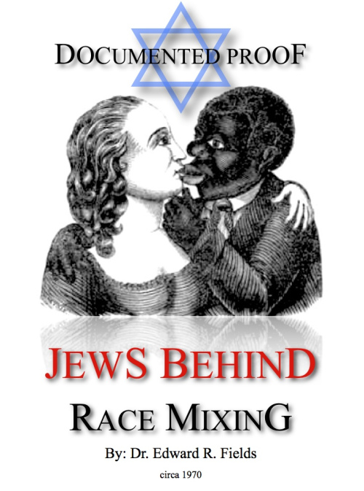

DOCUMENTED PROOF
By: Dr. Edward R. Fields
circa 1970
Source: https://katana17.wordpress.com/2015/05/21/jews-behind-race-mixing/

Contents
Jew Civil Rights Bill Author — Jacob Javits
Jews Behind Race-Mixing in America
The Answers Are Complex
Here Are the Facts
From Their Own Mouths — The Jews Reveal Their Plans
Jews Raise Money for Blacks
Lawyers for Militants Are Jews
Jews Urge White Christians to Marry Blacks but Urge Own Kind to Marry Jews Only
Different Story for Jews
Don’t Date Non-Jews
Why the Jews Seek the Mongrelization of the White Christian People
Self-Hate Instilled Within Whites
Charge Whites Guilty of Negroes’ Crimes
New Jersey’s Little Riot Commission
Communist Party Fought for Race Mixing
Millionaire Jews Back the Black Revolution
NAACP — A Jewish Organization
Jew Civil Rights Bill Author — Emanuel Celler

JEW CIVIL RIGHTS BILL AUTHOR
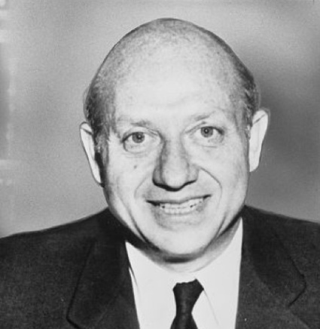Sen. Jacob Javits (above) at a dinner given by the Joint Defense Appeal, a Jewish Fund raising organization, at the Hotel Plaza, in N.Y. on Oct. 24, 1957, called on President Eisenhower to name immediately the members of the CIVIL RIGHTS COMMISSION called for under the new Civil Rights Law.
At the time Javits was running for the U.S. Senate, there was much ado about his Red-front associations.
Cong. Emanuel Celler and Sen. Jacob Javits, both Zionists, were the authors of the infamous;
Civil Rights Bill.
JEWS BEHIND RACE-MIXING IN AMERICA
The purpose of this article is to prove, through documented evidence that Jews in America are the prime movers and guiding force behind the massive attempt to mongrelize the White Christian people with the Black Race.
Of course everyone realizes that there are many gullible and brainwashed Gentiles working toward this same end.
But the movement to mix the races in America is most definitely sparked and financed by organized Jewry in every city of any size in America containing a formal Jewish community.
The first question which arises is why are the Jews so fanatical in their zeal to integrate the races and why do they intensely resist mixing of their own blood with either us White Christians, or the Blacks?

THE ANSWERS ARE COMPLEX
In order to understand Jewish thinking on this matter, one must first recognize that the Jews are a very unique people.
The Jews are bound to one another by three different means— which no other people in the world have in common.
- The Jews have one religion—Judaism!
- The Jews are of one nation—Israel!
- The Jews are of one Race!
Race is defined as a group of people who have inbred with their own kind for centuries and exhibit like features and characteristics. Thus the Jews of today are a tight-knit race, and highly conscious of the great gulf which separates them from White Christians.
Gentiles do not have even the basic rudiments of unity existing in Jewry. We are of many different churches, different nationalities and from divided language groups of Europe. Feuds, wars, jealousy and hatreds have always divided our White Folk.
This division has made it easy, for a skillful and highly organized Jewish minority to dominate us.
If anyone is in doubt about Jewish control over our daily lives, let them check on who owns all the stores on Main Street. Find out who controls the three T. V. Networks. (Sarnoff heads NBC, Paley (Palensky) heads CBS and David Goldenson heads ABC.)
Check who controls Hollywood, or which racial group controls many of the giant combines buying controlling interest in thousands of formerly Christian owned companies in America!

HERE ARE THE FACTS
Within each Jewish Community in every city of any size in America the Jews operate numerous organizations. They are designed to guide and control the lives of every Jew. They are also constructed to give the Jews a tremendously powerful single voice in American politics. Almost every Christian politician lives in dread of offending his local Jewish community. He knows that if he does not tread softly, listen to their every demand, endorse aid to Israel and sale of Israeli Bonds, support United Jewish Appeal—the Jews will vote for the man against him, spend a fortune to elect his next opponent, and direct the local daily press in a hate campaign against him.
All the small Jewish clubs and social groups are united under the American Jewish Committee. All Jew businessmen belong to a secret society called “B’nai B’rith” and they have their own secret spy agency called the “Anti-Defamation League.” These are the groups that harass Right-Wing Patriots and seek to control elected politicians and the daily press. But, their most important mission of all, is to integrate the White Christian people to produce an indolent, Mulatto race for the future.

FROM THEIR OWN MOUTHS — THE JEWS REVEAL THEIR PLANS
The following are especially selected quotes from the most important Jewish leaders in America concerning the integration of the races.
Aaron Goldman addressing the National Council of Jewish Women said:
“We Jews have played a significant part in securing laws for Negroes that guarantee equality. We have raised the expectations of American Negroes and must not allow them to become frustrated, angry, and desperate if their dreams fail to materialize. The Negro must enter the mainstream of American life.”
Mrs. Joseph Willen, president of the National Council of Jewish Women reported on April 9, 1968 that:
“Jewish parents must intensify their fight in behalf of the American Negro’s struggle for racial justice and economic opportunity.
Our children ask us to look forward, not backward. We cannot bind our young people to us by reciting past persecutions.
We must set an example far Jewish youth by intensifying efforts in behalf of increased employment for Negroes and to aid anti-poverty programs. This is the best way to combat White backlash.”
Sen. Jacob Javits addressing the National Commission of the Jewish Anti-Defamation League in 1967 said:
“The Negroes’ struggle for equal rights is of vital importance to American Jews, and is the most important struggle in the United States.
Jewish support of the Negroes’ aspirations for equality should be regarded as a badge of honor.”
Sen. Javits called for massive aid to Negroes and asked for the taxpayers to provide $35 billion over the next 10 years to raise the Black man up to the level of Whites. He also called for the adoption of a guaranteed annual wage at double the amount called for by President Nixon.
Philip M. Klutznick, Vice-President of the Anti-Defamation League at the same convention said:
“Jewish communities have set the pattern in the area of ‘social action’ in America. The outpouring of Federal funds for poverty programs during the next 25 years will give the Jewish community an opportunity to redistribute their resources and redirect their energies in the most meaningful religious, cultural and special educational activities for Jews that history has ever known. Major Jewish organizations must unite to set up long range survey communities to establish the goals and priorities of American Jewish communities over the next three decades.”
(IMPORTANT NOTE: Readers should re-read this last paragraph. Jews run the poverty aid and urban renewal programs in many cities. It is not an admission that this tax money is being used by Jews to build political power for Jews).
Saul M. Linowitz, former ambassador to the Organization of American States, told the Zionist woman’s order, Hadassah at its 53rd meeting at Miami Beach:
“The bedrock for civil rights is nothing less than economic rights, school integration and the right to vote.”
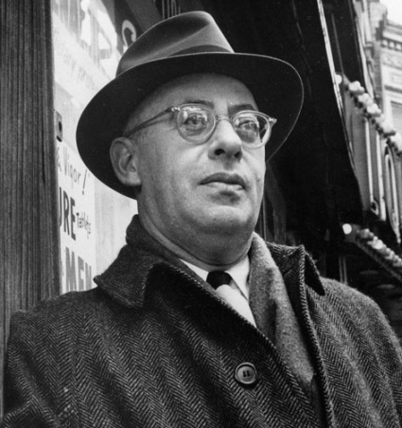SAUL ALINSKY Trains Black revolutionists.
Rabbi Arthur J. Lelyveld, addressing last year’s American Jewish Congress meeting in Miami Beach said:
“All of us must be prepared to make any sacrifice necessary to achieve an effective program aimed at achieving economic justice for the negro. We must make the economic sacrifice of paying higher taxes to win the more important war on poverty at home.”
Former Justice Abe Fortas, (removed from the Supreme Court for taking bribes from the corrupt Jew financier, Louis Wolfson) told a dinner of the American Jewish Committee in July of 1968 in New York City:
“The battles of the non-Whites for equality in America are essentially the same as those of the Jew, and the Jews must help in his struggle.”
Albert Vorspan, addressing the National Federation of Temple Sisterhoods in Miami Beach on Oct. 28, 1969, said:
“We Jews should know something about the outer limits of frustration and rage of the Black Communities. We who have suffered better understand the anguish of the Black man today.”
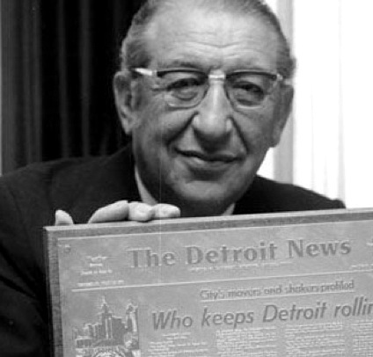MAX FISHER Millionaire Jew Republican finances Black Militants.
Theodore Bikel, Jewish folk singer and star in the play, “Fiddler On The Roof” in a speech of July, 1969, in a Jewish temple in Honolulu said:
“A strong commitment to civil rights is implicit in Judaism.
We must speak out against discrimination.”
Rabbi Maurice N. Eisendrath, president of the Union of American Hebrew Congregations, on Oct. 26, speaking in Miami Beach called for a five year moratorium on the space program and an immediate ceasefire in Vietnam. The rabbi said this would free billions of tax dollars which could be immediately funneled into the Black ghetto:
“Call it reparations or simple justice, but some form of restitution is owed to the Negro.
America must rush massive aid to the Negro the way aid has been rushed to the Jews of Israel.”

JEWS RAISE MONEY FOR BLACKS
Jewish publications are filled with countless articles about Jews raising money for militant negro causes. The Emma Lazarus Federation in New York City raised thousands of dollars for Martin Luther King’s now infamous Selma, Alabama march. Each year Mrs. Edward M. Warburg, wife of the multi-millionaire international Jewish banker, raises millions for the United Negro College Fund.
The most sensational and publicized fund raising dinner was held by wealthy Leonard Bernstein in his plush Park Avenue apartment for the 21 Black Panthers on trial for bombings in New York City. It was a sight to behold, in Bernstein’s elegant duplex apartment, the Jewesses in evening gowns, welcoming Black Panthers wearing wild beards, bushy Afro-hair styles and blue jeans.
The wife of the famous director of the New York Philharmonic, Mrs. Bernstein said later to the press:
“This was not a frivolous party, but a chance for all of us to hear what’s happening to them. They’ve really been treated very inhumanely. The trial of the 21 New York Black Panthers has had me very upset.”
Here we have the rich affluent left-wing, whose children all go to exclusive private schools, consorting with the Black militant radicals who are out to destroy this nation. Mr. and Mrs. Leonard Bernstein personally made out a check for $12,000 to help the Black Panthers at the dinner.
Two other fund raising parties have been held in New York by millionaire Jews to raise money for the murderous Black Panthers. John Simon, a Jew editor at T.V. panelist Bennet Cerf’s Random House Publishers, gave a similar party, as did Jew film director Sidney Lumet.

LAWYERS FOR MILITANTS ARE JEWS
In almost every case of radical militants who are caught burning, killing and bombing, we find Jewish lawyers ready to defend them. Eldridge Cleaver, who fled the U. S. to escape prison was represented by the Jew Charles Garry.
The New York 21 are defended by the Jews Gerald B. Lefcourt and Sanford Katz. Of course everyone knows that the “Chicago Seven” (4 were Jews) revolutionaries were defended by the Jew legal team of Leonard Weinglass and William Kunstler.
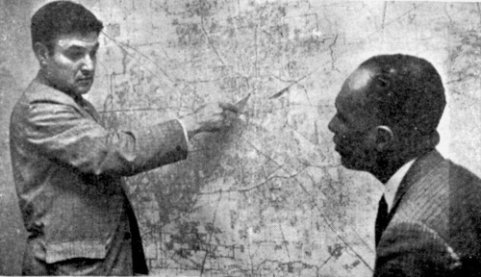JACK GREENBERG, lawyer who heads NAACP legal fund explains how busing should take place in Houston, Texas.
Jew lawyers are also pushing for integration of White suburbs. A Harvard trained lawyer named Roger N. Beilenson heads “Westchester Residential Opportunities, Inc.”
They purchase homes in fine White neighborhoods for $16,000 up to $50,000 and then re-sell them to Blacks. Beilenson was a former housing director for the Urban League.
Both the Rockefeller Foundation and (Jew) Aaron Norman Foundation have given tax free grants to further his work.
“The New York Times” of Sept. 19, 1966, really let the cat out of the bag when it admitted:
“The Jewish community has long been the financial backbone of the civil rights movement. … No special commission on race is needed to arouse Jewish support for civil rights activity in the South. … Jewish support for civil rights is still high.”
And, of course, we all know that Jack Greenberg is the head of the NAACP Legal Fund and is responsible for filing all of the suits which have resulted in so much suffering by innocent White children forced into mixed schools by this Jewish conspiracy.

JEWS URGE WHITE CHRISTIANS TO MARRY BLACKS BUT URGE OWN KIND TO MARRY JEWS ONLY
Rabbi Abraham Feinberg of Canada has won the nickname, “The Red Rabbi” for his visits to North Vietnam and efforts on behalf of communist causes. In the Maclean’s Review magazine of Sept. 5, 1967 he states:
“Until we learn to fight our ingrown fears of sexual relations between the races, the end of the race problem will not be in sight. Only when we no longer raise our eyebrows at the sight of a Negro holding hands with a White girl will the West have begun to tear the racial poison from its vitals.
Such a change will involve an inside-out remodelling of the White psyche, for our fear of mixed marriages is deeply rooted. But the change must begin sometime. Why not now!
If anything, the law should encourage, not forbid, the intermingling of ‘bloods’. Marches and civil-rights demonstrations can dramatize the immediate imperative of justice. Religious teaching can now enunciate the challenge of brotherhood.
Fair-employment laws and other civil rights legislation can protect minorities from overt discrimination.”
Plan for the Future
“The great ideal of Judaism. … is that the whole world shall be imbued with Jewish teachings, and that in a Universal Brotherhood of Nations—a greater Judaism, in fact—all the separate races and religions shall disappear.”
— from the Jewish World, 9th Feb. 1883
“ONE WORLD, ONE RACE … the deliberate encouragement of interracial marriages is the only way to hasten this process. And it may be that time is growing short. The dominance of our world has begun to shift, like cargo in a listing vessel, from the White races to the colored.”
Thus Rabbi Feinberg urges our White Christian people to surrender the blood of our forefathers and commit racial suicide by helping mongrelize the White race through interracial marriage!

DIFFERENT STORY FOR JEWS
Here we find the great contradiction in Jewish teachings.
While preaching the most extreme forms of race-mixing at inter-religious meetings and on college campuses in the press, on T.V. and Hollywood, the Jews tell their own youth a completely different story in the confines of the Synagogue.
Dr. Immanuel Jakobovits, Chief Rabbi of England, said in the “New York Times”:
“Intensive Jewish education must cover youths between 13 and 18”.
He said that unless they are warned of the dangers of inter-marriages:
“The whole fabric of the Jewish structure will suffer irreparable harm and damage.”
Rabbi Pesach Z. Levovitz, president of the Rabbinical Council of America said in the “New York Times,” Jewish;
“religious leaders must exercise all of their influence to stop mixed marriages between Jews and non-Jews. Those who marry out of the faith disappear within the preponderant Christian religions and cultural community.”

DON’T DATE NON-JEWS
England’s Chief Rabbi, Immanuel Jakobovits recently made a visit to New York, and in point blank terms declared:
“Jewish teenagers shouldn’t date non-Jews. … Interfaith marriage is something we view with horror, almost as apostasy. For Jews the problem of intermarriage is the problem of sheer survival. Countless Jewish martyrs did not die for their faith so that we might fritter away our heritage.”
We would like to ask the rabbi; What about White Christians whose countless ancestors fought and died so that our race might be preserved? Is not the blood line of our people worth saving in the light of the importance the Jews place on this question? The Jews are not called “bigots” and “race prejudiced” when they fight against inter-marriage for their own kind. Yet, these same leftist Jews attack and vilify every White Christian who dares stand up for racial purity for our folk.
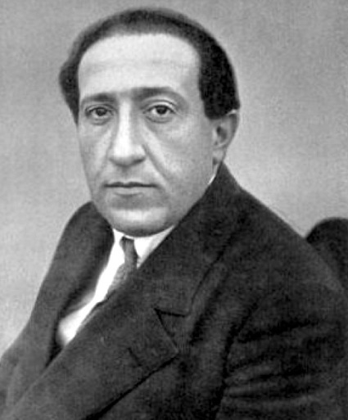JOSEPH POGÁNY alias SCHWARTZ.
A FAMOUS JEW who came to America from Moscow in 1928 to write the first Civil Rights platform for the U. S. Communist Party.
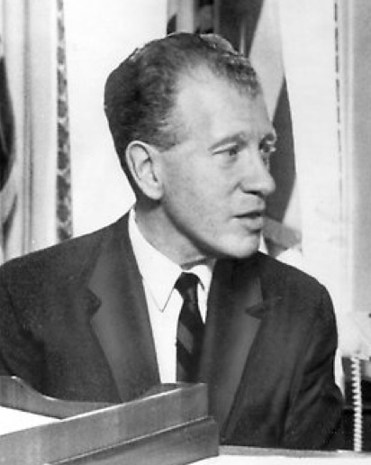DAVID GINSBURG. Wrote Riot Commission Report charging Whites were responsible for Negro riots.

WHY THE JEWS SEEK THE MONGRELIZATION OF THE WHITE CHRISTIAN PEOPLE
The most cleverly contrived scheme in the history of race relations is now being employed by the Jews to break down the resistance of the White race. It is an elaborate plan to make White people ashamed of the color of our skin. It is deliberately designed to give us an inferiority complex whereby we will feel compelled to bring about our own racial destruction to rectify the superior position we naturally hold over the Black race.
It is even more clearly spelled out in a book written back in 1912 by a Communist theoretician named Israel Cohen of London, England. It is titled, “A Racial Program For The Twentieth Century” and has been published in the Congressional Record of June 7, 1957, and even entered as a paid ad some years ago in the Atlanta newspapers by Gov. Lester Maddox (then a prominent restaurant owner). Israel Cohen wrote:
“We must realize that our Party’s most powerful weapon is racial tension. By pounding into the consciousness of the dark races that for centuries they have been oppressed by the Whites, we can mold them to the program of the Communist Party. The terms colonialism and imperialism must be featured in our propaganda.
In America, we will aim for a subtle victory. While inflaming the negro minority against the Whites, we will endeavor to instill in the whites a guilt complex for their exploitation of the Negroes.
We will aid the negroes to rise to prominence in every walk of life, in the professions and in the world of sports and entertainment. With this prestige, the negroes will be able to intermarry with the Whites and begin a process which will deliver America to our cause.”

SELF-HATE INSTILLED WITHIN WHITES
This is the most diabolical plan ever conceived, to instill “self-hate” within White people so that we will embrace the Black race in order to “up-lift” them to our level (an impossibility). The plan goes much further and is a master hoax fostered by Jews upon our people.

CHARGE WHITES GUILTY OF NEGROES’ CRIMES
In March of 1968 Lyndon Johnson’s “Commission on Civil Disorder” issued their report on the bloody and destructive negro riots which swept many of our major cities that previous summer. The full time staff director of the Commission was the Jew David Ginsburg. With a $1 million dollar budget, and 200 employees Ginsburg spent 7 months ‘investigating’ the riots. The final report, which he personally drafted found:
“Of the filth, crime and slums in which the Negro lives, White institutions created it, White institutions maintain it, and White society condones it — White racism is essentially responsible for the explosive mixture which has been accumulating in our cities since the end of World War II.”
The crux of the million dollar report was that — WE WHITE PEOPLE ARE TO BLAME FOR THE NEGRO RIOTS!
Many Americans openly expressed their outrage at Ginsburg’s findings. But most people missed the real point in question, that this was a brazen attempt to instill an inferiority complex in masses of White Christian Americans in one grand sweep.
We are supposed to feel guilty for the oppression Blacks have experienced in the past. Now we should want to throw ourselves at the feet of the negroes and beg for their forgiveness. The Jews would like for our vast masses to adopt the attitude of the young White girl from San Francisco, whose story was reported in The Thunderbolt. She said she was looking for a negro man to marry, so that in her own individual way she could try to make up some of the oppression Negroes had suffered.
Of course the truth of the story is that the American negro has a far higher standard of living than negroes have in ANY of their own countries in Africa. We do not owe the Black man anything. In fact the negro has shown us the height of ingratitude to the fact that we lifted them out of jungle savagery, gave them sanitary homes for the first time, jobs, welfare, free medical care, poverty aid and free food.
But, David Ginsburg says that we have not done enough.
His Riot Commission Report advocates raising the negro to a real life of luxury by the following methods:
- The spending of $10 billion a year on poverty aid and welfare.
- Create 2 million federal jobs for Blacks. Guarantee every negro a job.
- Provide a Guaranteed annual wage to all negroes who do not want to work.
- Build 6 million new dwellings for negroes in White suburbs with either subsidized or free rent.
This is Ginsburg’s plan to chain the White worker to a lifetime of tax slavery to make the negro an elite class of citizens to whom we third class Whites owe a free living.

NEW JERSEY’S LITTLE RIOT COMMISSION
Also in 1968, former New Jersey Gov. Richard J. Hughes appointed a “blue ribbon” committee to investigate the bloody Newark riots. Once again a Jew named Sanford Jaffe, wound up as executive director of this commission. You guessed it, he also found that White people were guilty of the crimes of the blacks! Sounds unbelievable, even insane, yet when you control the news media, you can make the right seem wrong and change lies into truth.
The Jaffe Commission found the following:
- National Guardsmen used excessive force in shooting rioters and looters.
- Police antagonize negroes, thus encouraging them to disorder.
- More Black police are needed as well as civilian review boards.
- Elimination of bail is needed so negroes can be released from jail with less difficulty.
- (following point is quoted word for word because it is so hard to believe anyone would claim this:)
“Widespread violence in the nation’s urban slums would have happened sooner had not the Negro been patient and forbearing.”
- Jaffe’s final point absolved the negro of any blame for the riots and said there was no organized conspiracy behind the rioting.

COMMUNIST PARTY FOUGHT FOR RACE MIXING
The 1928 Civil Rights Program of the U. S. Communist Party was written by Joseph Pogany. This was the first [party] in America to adopt a civil rights program and the major parties copied them after World War Two.
Pogany was a Jew, born in Moscow and sent to America in 1928 to help build the U. S. Communist Party. Using the alias Joseph Schwartz, he wrote the following program which the Reds adopted and distributed all over America.
OFFICIAL 1928 COMMUNIST PARTY PROGRAM
- Abolition of the whole system of race discrimination and insure full racial equality.
- Insure Negroes the right to vote.
- Abolish all Jim Crow laws and forbid discrimination against Negroes in selling or renting houses.
- Abolish all laws forbidding intermarriage of persons of different races.
- Assure full integration of public schools and universities.
- Equal admittance of Negroes to railway stations, waiting rooms, hotels, restaurants and theatres.
- Full integration of the Army and Navy.
- Allow negroes to join all labor unions.
- Equal employment opportunity for Negroes.
Every single one of the Jew Pogany’s original Platform points have today been adopted and put in force by both of the Jew influenced Democratic and Republican Parties.

MILLIONAIRE JEWS BACK THE BLACK REVOLUTION
Some people find it difficult to understand how a millionaire Jew can be a staunch supporter of the Black Militant Communist Revolution. It is because of their Jewish nature according to one of the richest Jews in America, Max Fisher of Detroit. Max Fisher owns the Marathon Oil Co. and the Fisher Theater chain. He sits on the board of directors of Michigan Consolidated Gas Co. and Michigan Bell Telephone Co., is chairman of Fruehauf Trucking Co., a director in Allen Industries and Safran Printing Co. and a partner in the huge $150 million Somerset Park apartment project in Troy, Michigan.
Being a militant revolutionary has not stopped him from declaring himself a Republican, and he is George Romney’s chief campaign fund raiser. He recently represented President Nixon at a meeting of Jewish leaders in New York City.
He told them Nixon had assured him Israel would receive all the aid she needs. On the negro question, no one can claim to be more radical than Max Fisher, who the “Detroit News” of Feb. 23, 1969 quotes:
“My fellow Jews must enter the great American Equal Rights Revolution. The growth of the Black Power concept is healthy because there was no leadership before. Militancy and turmoil are good, because it shows that the Negro is himself concerned and involved. We are in a revolution and the Negro has to be allowed to develop. I think that through my Jewishness I have a feeling of what the Negro wants. It comes from an empathy that springs from my Jewishness.”
Or take the Jew Saul Alinsky whose activities are financed by the Jew owned Midas Muffler Co. Alinsky heads a radical group called F.I.G.H.T. They led riotous picketings and demonstrations by Blacks demanding jobs at the Kodak Film Co. in Rochester, N. Y. They succeeded in blackjacking the company into giving them hundreds of jobs.
Alinsky now operates a school for Black revolutionaries— still financed by the Jewish owned Midas Muffler Corp. Recently he said:
“Just think of all the hell we kicked up in the past with only four or five organizers. Now we will be turning them out by the hundreds.”

NAACP — A JEWISH ORGANIZATION
Last but not least is the NAACP. The largest and best financed of all the groups fighting for the mongrelization of the White race. This organization has never had a negro as its head.
For the first 35 years of the NAACP’s formal existence it was run by two millionaire Jewish brothers. Joel Spingarn was president of the NAACP from 1920 until his death in 1939. Thereupon his brother Arthur Spingarn ran it until 1966. Due to old age, he turned the presidency over to Kivie Kaplan, a millionaire Jew shoe manufacturer from Boston, Mass. He heads it to this day. Roy Wilkins is merely his secretary and front dressing for the outer office.
The real mastermind behind the NAACP’s massive legal offensive which is almost solely responsible for the destruction of all the South’s laws and traditions keeping the races separate, including all the major school mixing decisions, were suits brought by Jack Greenberg, Jewish head of the NAACP Legal and Defense Fund.
The Jews visualize themselves in a never ending cold war with the White Christian people. They know that we are an independent and freedom loving people. The Jew knows that our individualism springs from the restless creative spirit of our race. They know that eventually our White race will revolt against Jewish economic, cultural and racial domination of our people.
They have but one hope, to put the White race to sleep through assimilation with the lazy, mindless, leaderless, shiftless and slave-like Negro race. As Mulattoes our future descendants would make obedient workers under Jewish masters.
The Jews are organized to prevent assimilation of their racial blood with either us White Christians or the Blacks.
They stand to be the only race in the future which will be mentally alert if mongrelization conquers our unborn descendants to come.
We are now, TODAY in a life and death STRUGGLE for racial survival. We are faced by a tight knit, political machine which is hell bent upon using its money power to destroy our White Folk. The time has come for every White man, woman and child in America to take his stand. The National States Rights Party provides our fellow White brothers with the best fighting attack program in existence to defeat this evil conspiracy.
Remember that your life upon this earth is but a very short one. We are placed here to create a decent and wholesome society in which our children can be raised and propagate. It is our duty to keep the race separate so as to provide for the everlasting continuation of future generations.
This is our God given mission upon this earth. Are you doing your part while there is yet still time to preserve the White race? It is a task more important than your personal life itself. Sacrifice and struggle lie ahead and we must be prepared to give our all for the SALVATION of God’s real ‘Chosen People’, —The White Race. Our White Race is responsible for the concepts of Liberty and Civilization which we have given to the entire world.
Always remember the following quotation from the late Sen. Theodore G. Bilbo who fought all his life to maintain the separation of the races:
“If our buildings, our highways, our railroads should be wrecked, we could rebuild them. If our cities should be destroyed, out of the very ruins we could erect newer and greater ones. Even if our armed might should be crushed, we could rear sons who would redeem our power.
But if the blood of our White race should become corrupted and mingled with the blood of Africa, then the present greatness of the United States of America would be destroyed and all hope for civilization would be as impossible for a negroid America as would be redemption and restoration of the White man’s blood which had been mixed with that of the negro.”

JEW CIVIL RIGHTS BILL AUTHOR
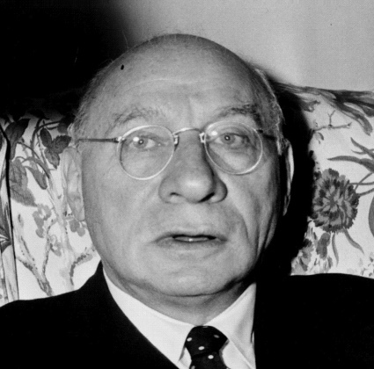Congressman “Manny” Emanuel Celler (above), Zionist Chairman of the House Judiciary Committee is one of the boastful authors and defenders of the infamous Celler “CIVIL RIGHTS BILL,” which was prepared as part of the plan. to disorganize and condition the U.S. for the Communist take-over.
He gave a “BOYCOTT AMERICANS” speech in the House of Representatives on Aug. 28, 1957, which appears in the Congressional Record of Sept. 11, 1957, on page A-7475. It seems he is more concerned with the welfare of ISRAEL than that of the U.S

