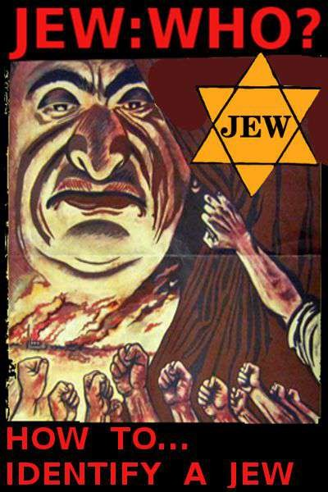

JEW: WHO?

HOW TO... IDENTIFY A JEW

### being a compilation of jewish bioanthropology in the following works:

1. “Who Is The Jew: The Jew Identifier Document”, by Loki Hulgaard

### “How to Recognize and Identify a Jew”, by John Doe Goy

1. “What is a Jew?”, from Julius Streicher’s “Der Stuermer” magazine

### “Racial Biology of the Jews”, Baron Otmar von Vershuer, M.D

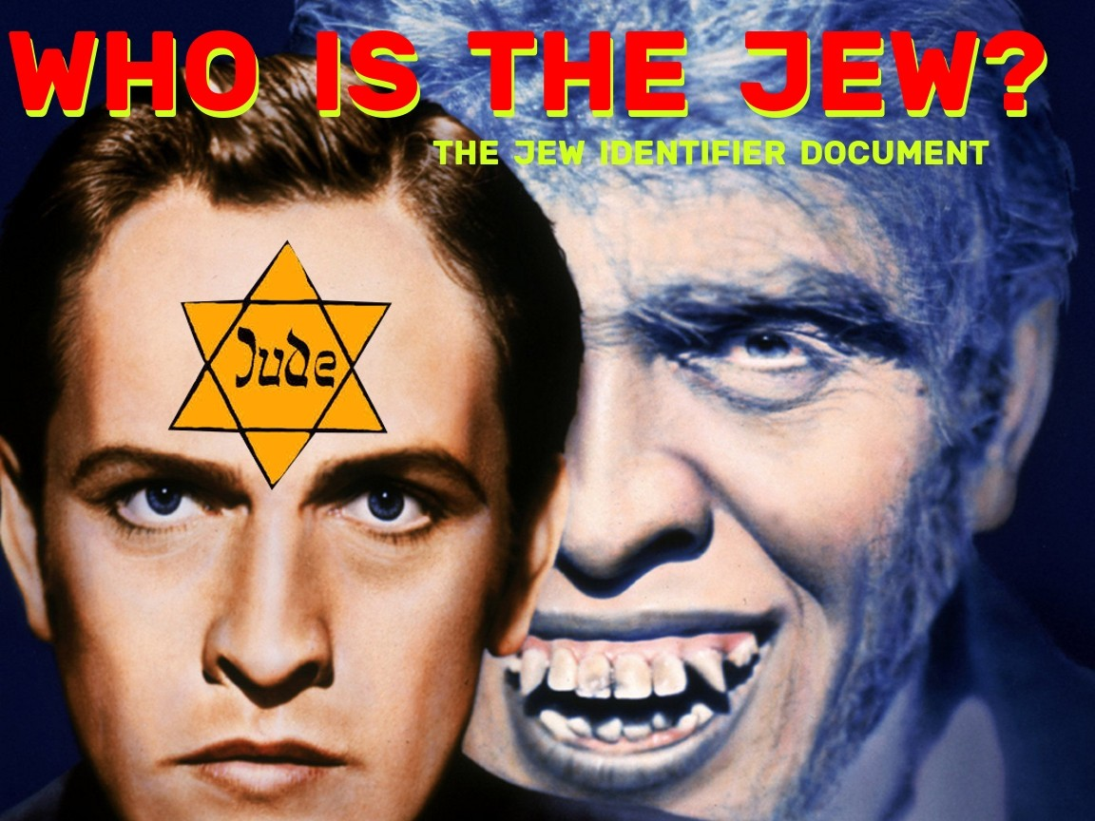

##### WHO IS THE JEW?

At this time in history one must become an adept at discrimination, he must learn to discriminate between what is good for the White Race(the highest virtue) and what is bad for the White Race ( the ultimate sin).

The most dangerous threat to the White Race is the Jew. In order to avoid the harm the jew poses to the White Race a White Racial Loyalist (he who is loyal to his own kind the White Race) must become acquainted with the Jew.

In becoming versed in the lore of jewishness, its characteristics and attributes, one must make a thorough going empirical study of jews in one’s own personal life, through a prior acquaintance with the following works which constitute a

###### basic course on jewishness:

1. “*How to Recognize and Identify a Jew”*, by John Doe Goy;
2. “*The Racial Biology of the Jew*”, by Baron Freiherr von Vershuer, M.D;
3. ”*What is a Jew*”, from Der Stuermer, the 3rdReich magazine of Julius Streicher;
4. `*On the Physical Characteristics of the Jews*`, John Beddoe; Transactions of the Ethnological Society of London,Vol.1 (1861), pp.222-237;
5. “*Purity of Race*”, Joseph Jacobs (a jew); Jewish Encyclopedia, 1905, p.283-4; 1901, p.619; other articles in the same encyclopedia1901-1905
6. “*Physical Anthropology of the Jews”; Jews: A Study of Race and Environment (1911),Maurice Fishberg* (a jew) (1902)
7. “*The Biological Jew*”, Eustace Mullins;

The first 5 works acquaint one with both the anatomy and physiology of the jew and prepare one to visually, psychologically understand the jew in his behavior and dealings with others. The 6thwork adds corroboration of the behavioural attributes of the jew and a perusal of selections from the Babylonian Talmud, the jews’ religious text drives home the malignancy which is the jew’s inherent nature.

From a reading and rereading of these works over time juxtaposed with a practicum of sensory experience in real life and through consulting search engine ‘image’ searches for such key words as ‘jew’;‘jewish’, etc. one can glean a large body of evidence to lend itself to an educational background on this predatory being, the eternal jew, the greatest peril to White survival.

**JEWS WHO ARE THEY**? ( a brief synopsis) JEWS are a RACE (a matrilineal inbred ethnicity) ;

JEWS are a RELIGION (based on RACIAL SUPREMACISM);

JEWS FUNCTION as a RACE (they self-organize around the concept of `chosen people`); JEWS are ALL of the above and below (traits):

###### ANATOMY:

**HEAD**:

hair: widow's peak hairline; often dark, curly (could be any color); often receding or bald[ing]; sparse ears: earlobes attached to jawline; low set ears; often protruding; 'rat/rodent-like'; larger, especially upper ear

chin: weak; receding; low/slanting jaw: heavy; broad cheekbones/maxillae

forehead: narrow; receding (acute angle when viewed in profile);

skull: occiput (back of head): flattened/high ;abnormally low skull: brachycephalic (round headed) eyebrows: arched; bushy

eyes: almond/asiatic/'squinty' shaped; 'lizard-like'; thick/fleshy eyelids; 'sleepy'; laterally drooping; 'pop'

eyes (protruding laterally) eyelids (lower):'puffy'

nose: convex; 'hooked'; noticeable 'hump' in top portion; resembles a '6' in profile view; long and narrow;

face: long; thin; 'pinched'(narrow)

mouth: gaping; frog (slim/wide/pronounced); mouth opening larger than normal skin tone: 'corpse-like'; pasty; sallow; yellow

###### BODY:

torso: elongated; 'reptilian' limbs: short relative to torso length

###### PSYCHO-SOCIAL BEHAVIORAL TRAITS:

gaze: wary/piercing voice: high-pitched; often nasal; sometimes

husky gait: shifty/uncertain; flighty gestures: moves hands when talking speech/tone: jabbering; nervous;

aggressive; whiney odour: unpleasant; sweetish vibrations: 'dark'; negative; vampiric psychology: psychopathy;

mendacity; surreptitious; obsessive-compulsive; neurotic

**JEWISH PSYCHO-LOGY**, aka. mind control sorcery techniques used by the jews:

1. scape-goating/ set-up-man/ framing/ frame-up/ transference /shifting blame/reverse projection/ table- turning/:

setting up another as the villain to avoid culpability for one's own deeds; attributing to the attributor what he attributes to yourself

1. straw man: Constructing a false identity of another to have others destroy them thinking it is their real identity; often comes in the form of smearing/ slandering the victim
2. victim pose/ possum play/ passive aggression/: portraying yourself as a victim or weak/inferior to disarm opposition by deceiving them into thinking you are not a threat to their power; also used to incur sympathy from others and turn them against threats to oneself (eg. one's own enemies);portraying oneself as a victim/ injured

party to weaken opposition through feigning weakness often while subtlety/ guilefully injuring them

1. adhominem/ vilification/ mudslinging/ labeling/ defamation (slander=spoken /libel= written):portrayal of an opponent in a negative light for the purpose of i) destroying or ii) exploiting them
2. divide and conquer/ playing both ends against the middle/ triangulation: get enemies to fight against each other to 'fall on their own swords'/ mutually destroy each other thereby subjugating opposition/ ingratiate oneself with one party and

turn them against the other,etc.

1. parasitism: exploitation of others without contribution in the manner of a parasite
2. passing off/ expropriation: representing another’s work as one's own for personal gain chameleon/ shape-shifting/ actor: adopting fluid behavior/ character that changes with circumstances for the purpose of ingratiating oneself with the dupe
3. shaming/ demoralization: getting the opponent to turn inward and believe there is something wrong with them/ their (past) actions as a means of getting them to make concessions to you (eg. the sins of the fathers)
4. mockery: discrediting opposition through derision
5. pied piper/ mountebankery/ rabble rousing: representation of self as benevolent leader of 'victims'(workers/ non-whites/ women/ freaks, etc.); to use ‘victims’to strike against opposition (see ' cats paw')
6. middle man: role played between parties allegedly for their (mutual) benefit to derive personal advantage
7. poison the well: creating problems in an environment (society, workplace, etc.) for personal advantage typically though slyness/ deceit
8. false front/ false humility: the creation of a false identity character for purposes of ingratiation with intended victims/ lowering the opponents’ defence or subjugating offense
9. bold-faced lying: "its' not a lie if you believe it"-George Castanza/ talmud
10. Semantic twisting: pharasiacal interpretation of words or deliberate misuse/ wrenching from context to distort the meaning of words
11. interrogation:use of cross-questioning/ (socratic) dialectical techniques to establish the position of the Other/ascertain their opinion/ belief/ establish liability (all government agents are taught this)
12. gradualism/ leaven of the pharisees: introducing (near) imperceptible change that creates desired circumstances the opponent would not allow given an awareness of the end result. (surreptitious slippery slope)
13. preemption/ preemptive strike: anticipation of the opponents' move and countering it through making the first move or

'strike'

1. gaslighting: distortion of the perception of the opponent through convincing them to believe that their perceived reality is incorrect and they must change to the desired state thereby -which is itself forever changing/ portrayed as inadequate-leading to their subjugation ( a form of demoralization)
2. blinds/cats paws/dupes/patsies: these are gullible/ unwitting 'useful idiots' who perform a role in your agenda and who have blame transferred to them if necessary (often plays a scapegoat function)
3. provoke/instigate/antagonize: to deliberately rile up opponent to elicit a reaction that portrays them in a negative light/yourself in a favorable one
4. emotionalize: introducing emotive content into relations with others(eg.discussion/debate) to create certain emotional reactions in the audience or interlocutors.To make an emotional issue arise where none existed before. Done through tone of voice; use of trigger/buzz words;actions/gestures,etc.
5. Nudge:i) control the options ii) shotgun clause iii) restrictive choice: i)engineering circumstances to enable oneself to control the outcome; ii)orchestrate/ represent circumstances such that the opponent has choices only in

your favour (eg. lesser of two evils); iii) restrict their choices

1. blame the victim: similar to reverse projection but differs in harming an opponent while blaming them for your actions/ implicating them as the cause of their own suffering.
2. dynamic silence:refusal to acknowledge the position/ statements of the Other as means of subjugating Other
3. Normative Inversion: positing the inversion of an Others’ norms as the good to subjugate the Other
4. Double Talk/ speak/ Newspeak/ Ambiguity:use of irrelevant,meaning less or ambiguous language to create confusion in the Other
5. Argumentative fallacies: see D.N Walton, “A Pragmatic Theory of Fallacy”

**JEW PLANS** for White genocide both historical and contemporary:

“The Protocols of the Elders of Zion”; Israel Cohen’s “Racial Program of the 20thCentury”(racial mongrelization/ mixing and white marginalization);

Richard Coudenhove von Kalergi’s “Practical Idealism”(racial mongrelization of the white race); "Germany Must Perish!"(forced sterilization advocated),Theodore N Kaufman;

"The Hidden Tyranny",Harold Rosenthal;

Earnest Hooton plan (forced mongrelization of Germans with negros) (1943);

Henry Morgenthau,jr.”Germany is our problem: a plan for Germany” (genocide of German people).

**CAVEAT**: the Jew is the greatest threat to White Racial Survival. Know the jew or suffer the consequences of your ignorance. Below are graphics of Jewish biometrics to assist in identifying the jew

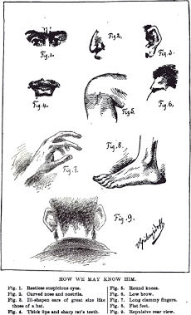 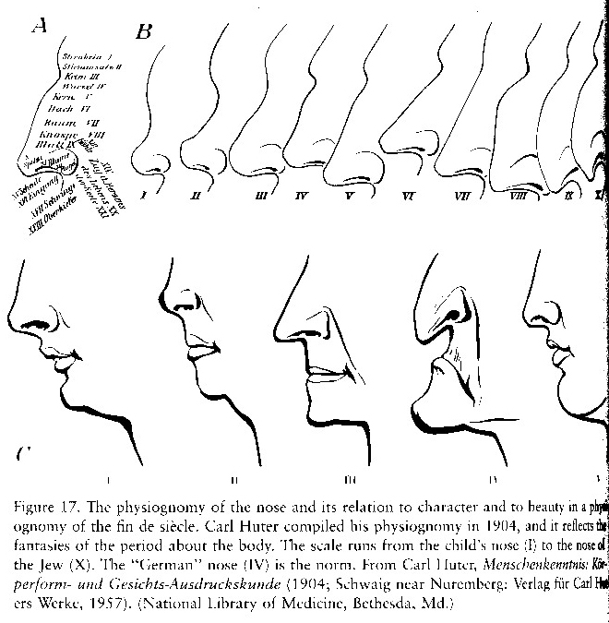

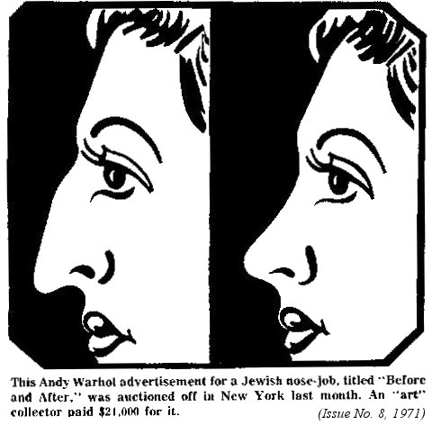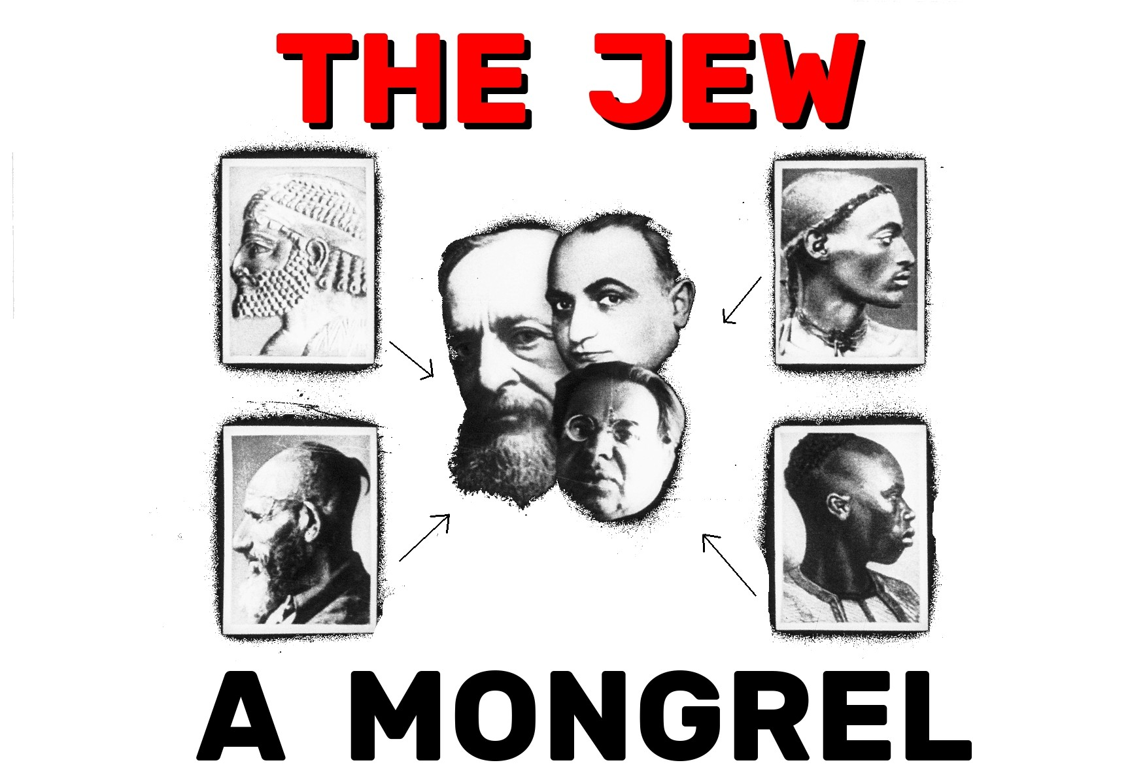

##### JEWISH MAFIA

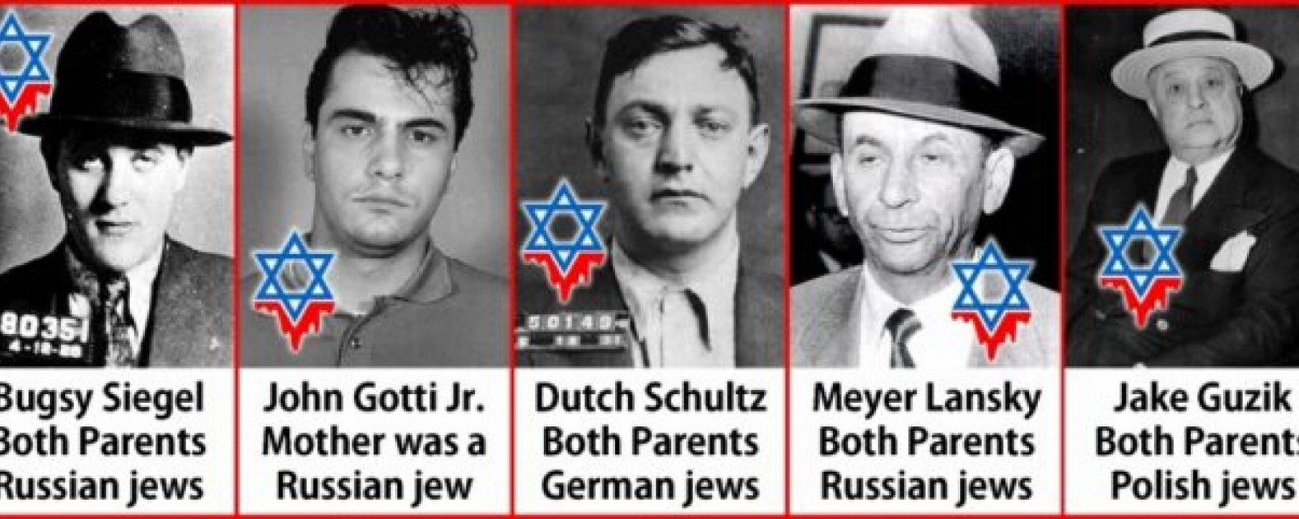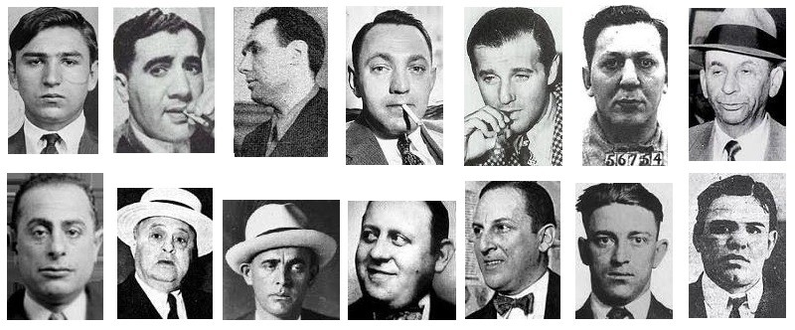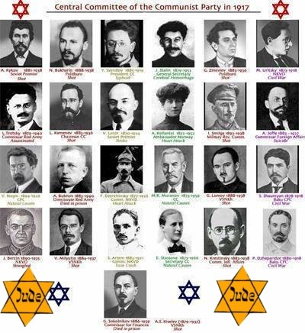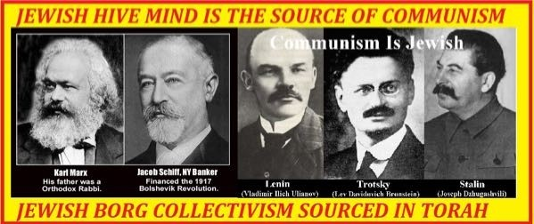

**JEWISH COMMUNISTS**

**BEWARE THE JEW... A BORN CRIMINAL**

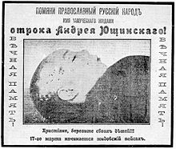

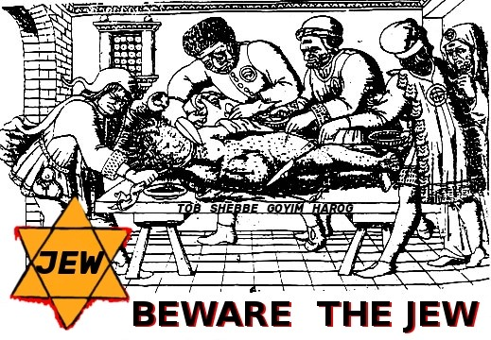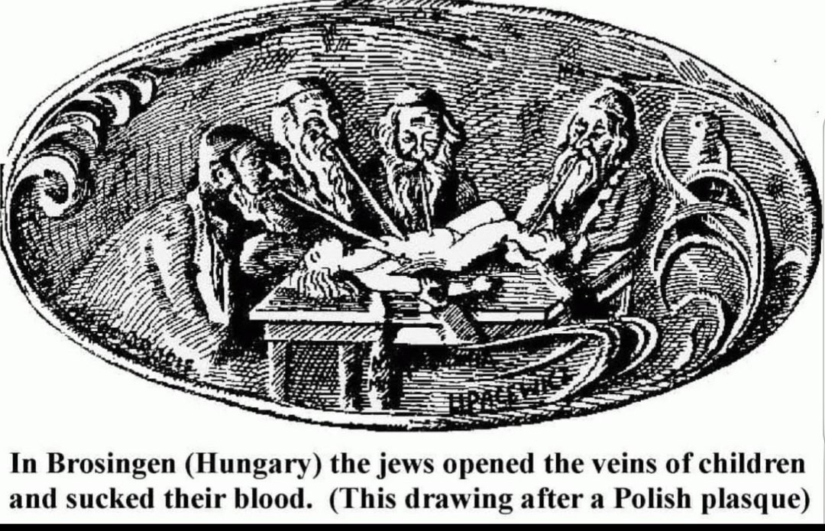

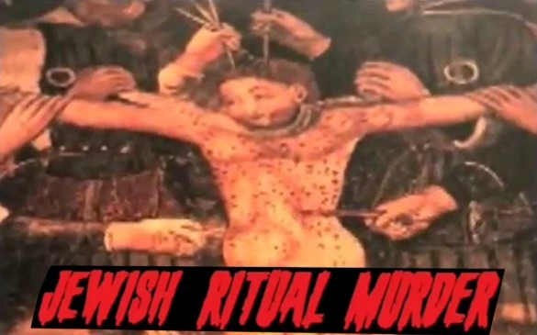

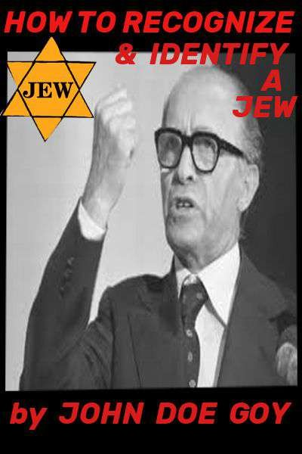

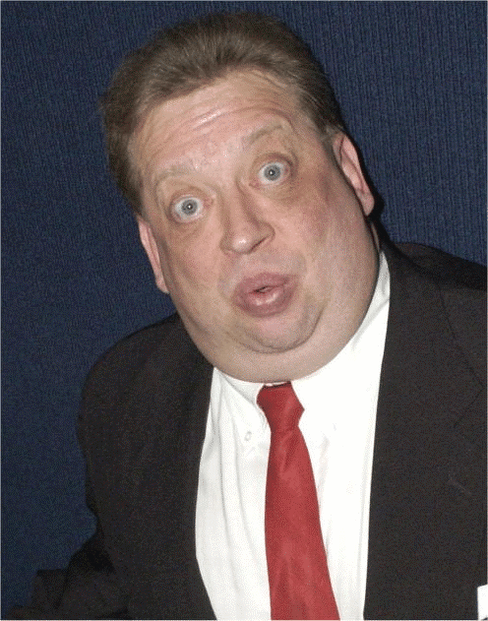

**How to recognize and Identify a Jew Part 1 - Physical Features**

# by

John Doe Goy

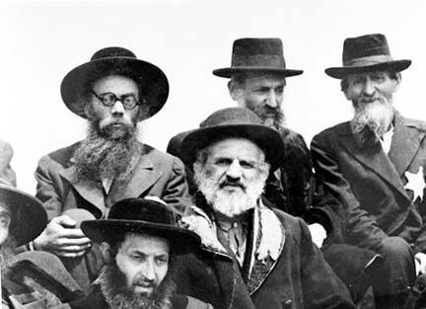

*"Once, when I was walking through the inner city, I suddenly came across a being in a long caftan with black side-locks. My first thought was: Is that a Jew?*

*I watched the man stealthily and cautiously, but the longer I stared at that strange countenance and studied it feature by feature, the more the question in a different form turned in my brain: Is that a German?"*

--Adolf Hitler, Mein Kampf

These days, nearly everyone is mixed to some extent. There are very few pure of any of the three main races. The three main races are White, Asian [Oriental] and Black. Many Gentiles have all three of these races in them, especially in the Mediterranean areas where the three continents meet. Most have two. The Jew is thoroughly mixed with all three. **The Jews are a distinct race** within all races. In other words, there are white Jews, black Jews, Oriental Jews and while the Jew may be black, white or yellow, they are still of the Jewish race. **Just type into any search engine, such as 'Google' the word 'Jew' or 'Jews' and click on images and it is very apparent just by their physical appearance alone, they are a distinct and separate race.** The more pure the Jew, the easier it is to identify them, the more white blood or blood of another race, this can be difficult. All Jews carry a 'reptilian' gene and have reptilian physical features. Gentiles and Jews are cosmic enemies.

When making a judgment, one must put as many different factors together as possible. Many of the physical features mentioned in this book also occur amongst Gentiles.

To begin with, we will go through the physical features of a Jew. Because the Jews have been repeatedly expelled from nearly every country and area on the face of the earth at one time or another, they are wanderers, thus the term "The Wandering Jew." Through centuries of wandering, they have picked up all kinds of genes and sub-racial characteristics. This has also given them a host of diseases and general ill health. Hideous and rare diseases have always plagued these peoples. Nearly every Jew has something physically wrong with them, and is vulnerable to diseases that most Gentiles are naturally immune to.

The blatant lie that they are a "religion" can be proven wrong on many accounts. You can draw a picture of a Jew, but you can't do the same with a Catholic or Lutheran. Certain physical features and racial characteristics have long been associated with Jews such as the large nose, 'talking with the hands' an overwhelming fixation on money and material wealth, stinginess, dark beady eyes, and so forth. Jews have been equated with rats for centuries.

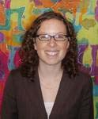

There are different types of Jews, with the Western 'European Jew' often being the most difficult to identify in many cases. Though the Jews occur within all races, the focus of this book will be on identifying Jews within the white race.

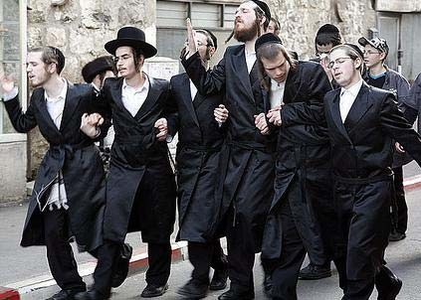

**Physical Features**

For most people, the large curved nose comes to mind when identifying a Jew. While many Jews do indeed have large/prominent noses, this is not always a reliable way of identifying them, as some Gentiles, such as Italians, some English and Irish people and Native American Indians have large/prominent noses. The shape of the nose here is an important factor. Many Native American Gentiles have the 'hooked' nose, but the bump is much higher than in the Jew and near the root of the nose. English and Irish large noses have a 'ball' tip. Many Gentile Arabs and Mediterranean peoples have large noses. With the Jewish nose, the classic is curved and the bump is in the middle. Do not forget, with the vast wealth these people have, many opt for plastic surgery in reducing the size of and changing the Jewish shape of their noses.

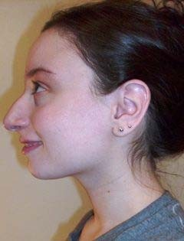There are other physical features that give the Jews away. Always remember, though, there are some Gentiles who have certain features mentioned here, so always put everything together before making a judgment, this includes names and character. Many Jews are blatantly Jewish upon appearance. It takes practice and one eventually gets a sixth sense of feel as to whether one is a Jew.

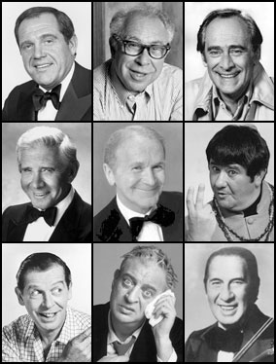

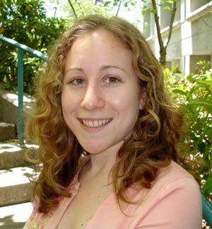 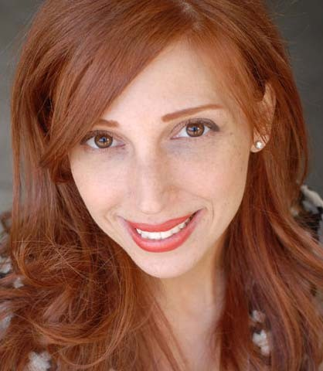

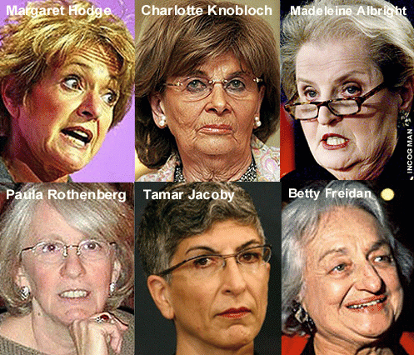

##### The "Wiener" Face

###### Here, with many Jews, the face is very long, thin, and often there is an unusually high forehead. This feature is also a dead giveaway with black Jews and other non-white Jews.

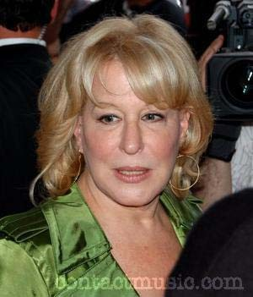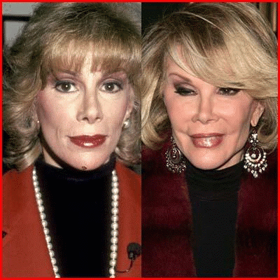

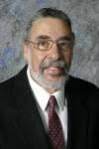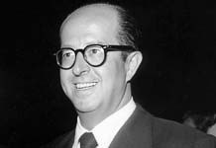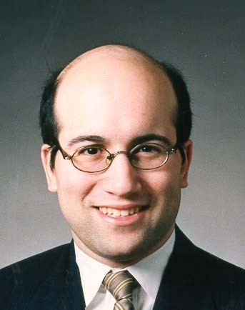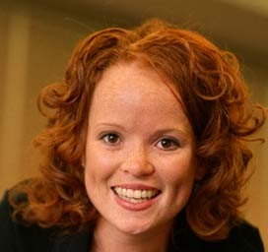

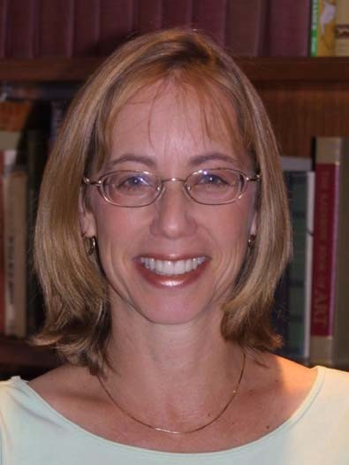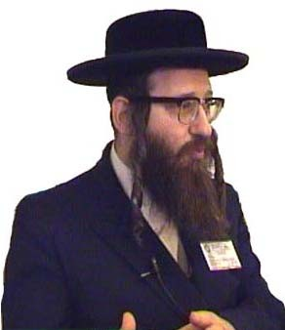

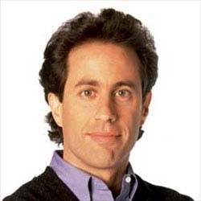 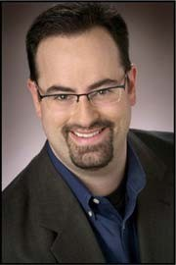

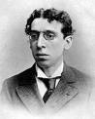Not all Jews have a high forehead, though. Most Jews look 'off' in that the features are uneven in some way- not in proportion. The Jewish fellow at left has a low forehead. Note the features are not proportioned. The forehead is abnormally low. Also, the classic Jewish mouth, which 90% of the time is a dead giveaway. Note the Jewish ears and read on for more examples.

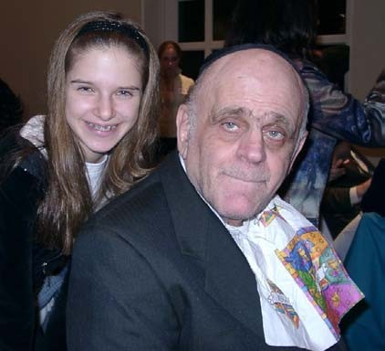

##### Jewish Ears

**Classic Jewish ears are like those of a rat.** Singer/actress Barbra Streisand serves as a perfect model of Jewish features. Barbra has a classic Jewish nose, mouth and ears**. In addition to their rat-like shape, Jewish ears are often low- set on the head and protrude.**

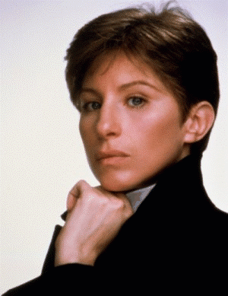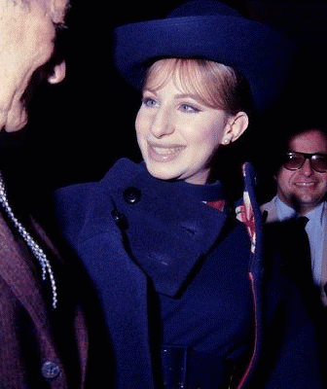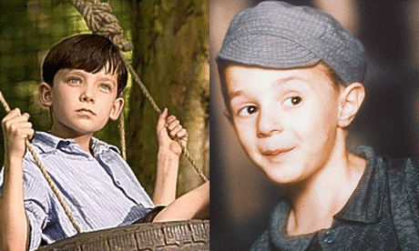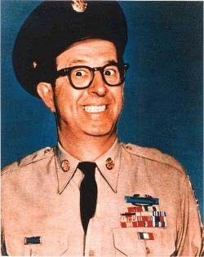

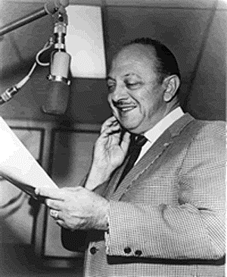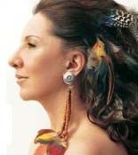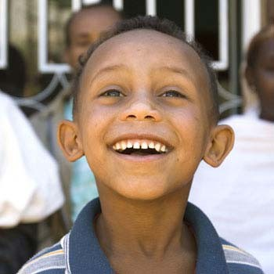

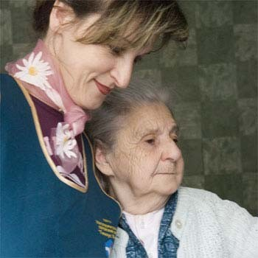

##### The Jewish Mouth

**Nearly all Jews have a prominent lower lip, meaning the lower lip is larger than the upper lip.** Some Gentiles have this as well. It comes from having black blood somewhere in the ancestry. Certain Native American tribes who kept black slaves have this large/prominent bottom lip. **Some 90%+ Jews have the prominent bottom lip.** In addition, many have the full 'meaty' lips, again from black blood in the ancestry, which every Jew has. Also, note the examples of the Jewish mouth in regards to other features, such as **the lizard mouth.** The classic Jewish mouth is very ugly. **There are basically two types of Jewish mouths- the full meaty lips and then what I call the 'frog mouth.'**

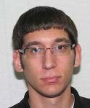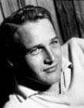

Jews have certain expressions they make with their mouth. A classic is the girl with the CD in the photo below. It is very 'reptilian' and VERY Jewish. **Many tend to gape and expose the tongue like a reptile, when speaking as well.** It takes a bit of practice and experience, but you will definitely get what I mean.

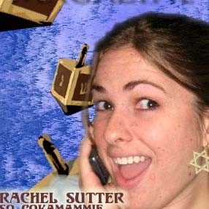 

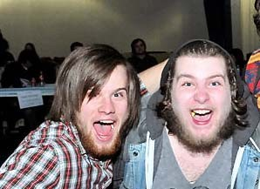 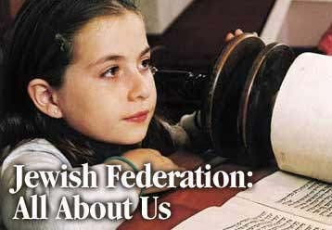

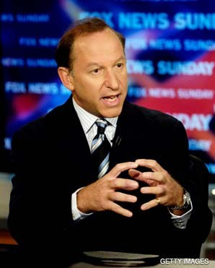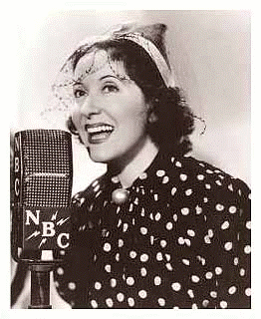

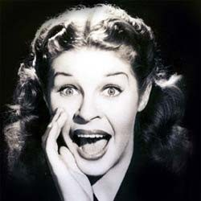 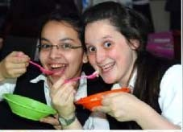

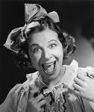

###### The "Frog" Mouth:

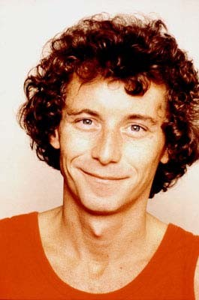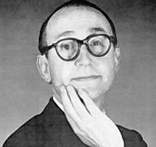The mouth is slim, wide, and pronounced on the face. As opposed to the meaty lizard mouth as shown in the photos above, the lips are often thin and even with the "frog" mouth. The "frog" mouth is not as common, but is still a very exclusive Jewish physical feature.

##### Jewish Eyes

There are several types of Jewish eyes: The lizard-like Asiatic eyes, as seen in the photos directly below, the pop eyes and the sleepy and sometimes bulging eyes, the sad sack eyes. In some, the eyes are like drawn towards the nose- note Bette Midler's eyes in the photo below on the left.

Note the Asiatic Lizard eyes in the photos directly below:

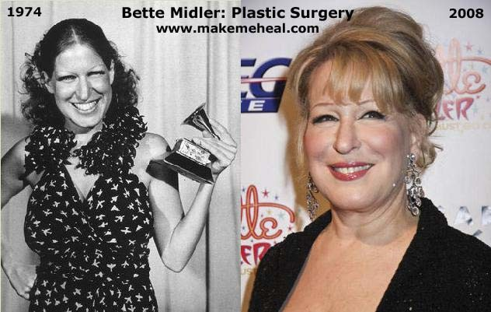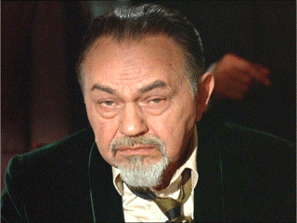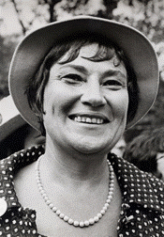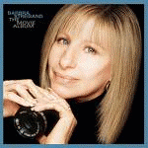

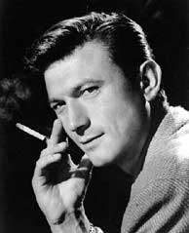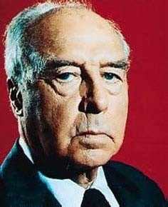

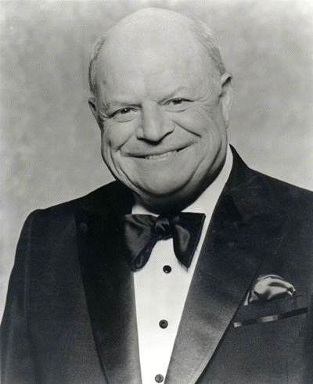 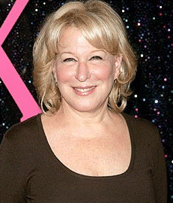

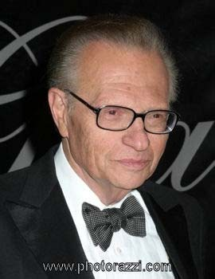 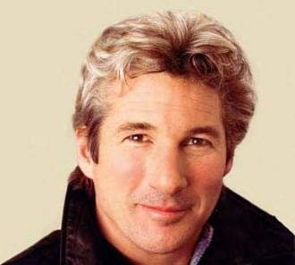

The **'Sad Sack' eyes have a droopy look to them**, as they tend to droop on the outer edges as shown in the photos below:

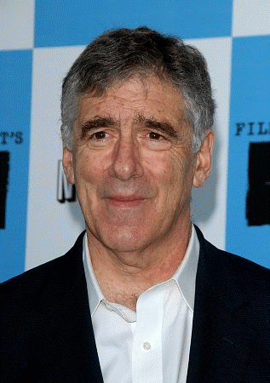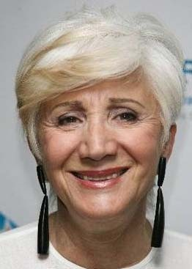

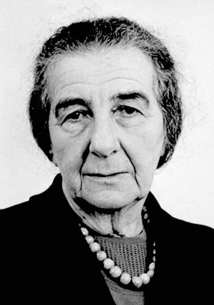

###### The 'pop-eye' is another exclusive Jewish physical feature as seen below:

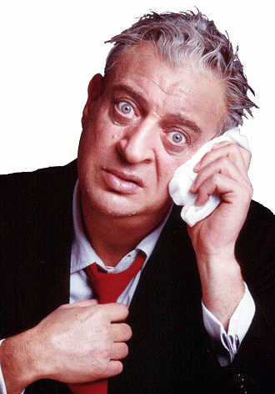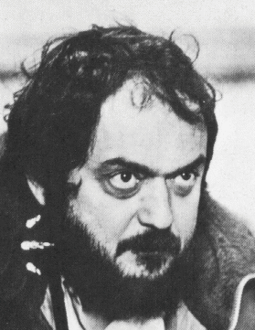

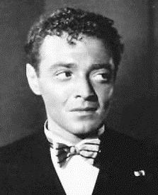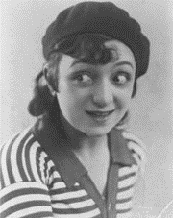

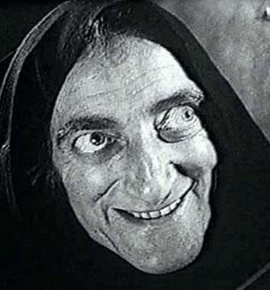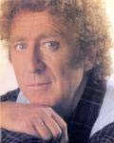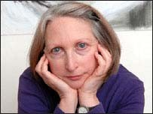**The Jewish 'Sleepy-eye'**

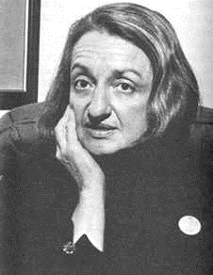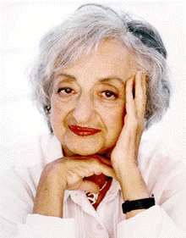

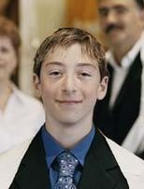 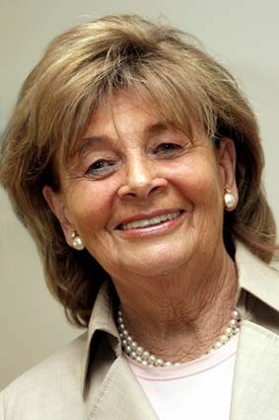 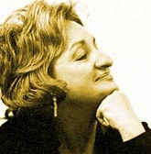

###### Many Jews have eyes that not only bulge, but bulge particularly at the outer corners:

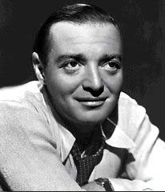

**Jewish skin coloring is often 'off.' Many have a dead corpse-like appearance.**

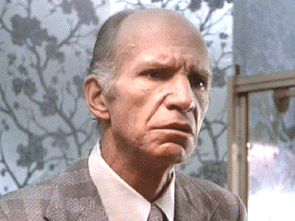

**Most Jews are short in height.** Don't let this fool you, though. There are tall jews who are mixed, such as many Western European Jews, who have a lot of white Anglo-Saxon genes. This is common when one of the parents is a Gentile. **The more Jewish genes, the more the tendency towards shortness in height.**

**Nearly all Jews, including mixed Jews have naturally curly and/or kinky and coarse hair.** This is resulting from black blood, which every Jew has. The more Jewish genes, the hair tends to be naturally dark or black. Again, do not let this fool you. There are many blonde Jews- always look to the facial and physical features and more. There are many blonde or light Jews who have a predominance of Western European genes. In addition, some Jewish women use hair- straightener, as very few have naturally straight hair. Jewish men tend to have coarse beards.

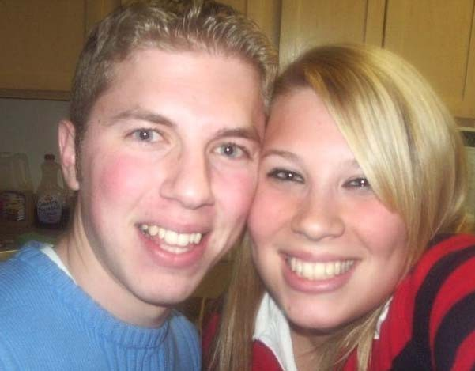Many Jews also tend to tint and dye their hair blonde, as do many Gentiles.

In the photo below, both are Western European mixed. Note the Jewish ears on the one on the left and the mouth of the one on the right. The more mixed they are, it is often more difficult to spot the Jewishness. Anyone with Jewish genes WILL have one or more Jewish features, though. Both have the prominent Jewish lower lip.

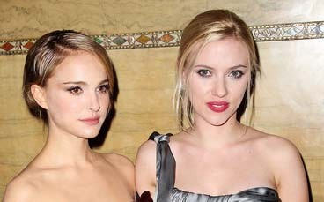

Note the nose and eyes of the Jewish girl in the photo on the left, below. Her skin coloring is also 'off.'

Jewish actress Gwyneth Paltrow on the left obviously dyes her hair, as can be seen as her natural color outgrowth. Her long "wiener face" gives her Jewishness away.

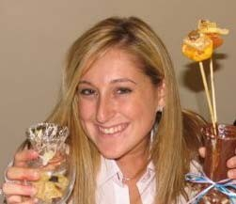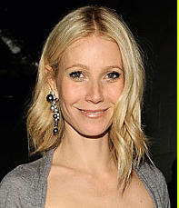

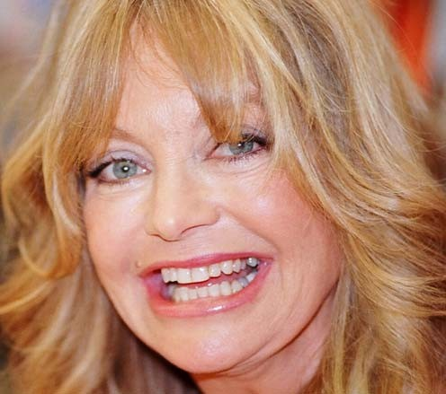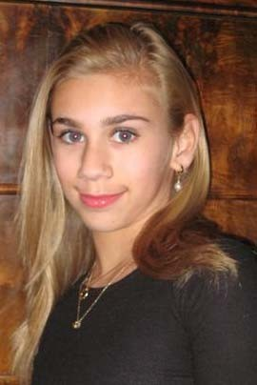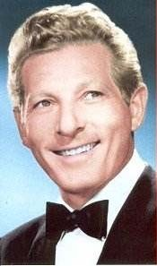Below is a photo of half-Jewish actress Goldie Hawn, daughter of a Gentile white father and Jewish mother. With the mixed Jews, as they age, their Jewishness usually becomes more and more apparent. The Jewish reptilian "Levi" and 'Cohen' genes are always carried in and passed on through the Jewish mother. One must have a Jewish mother to be accepted amongst the orthodox Jews, but those who have any Jewish genes still have the physical features, general Jewish traits, the Jewish character, and are prone to a host of Jewish hideous rare diseases. Of course, as with any race, there is always the 5% that do not fit the characteristics, but these are very small percentages. I mention this because the Jewish media is always using this very small percentage to represent the rest in their propaganda and lies.

Though the Jewish children have lighter coloring, owing to the mixing with West European Gentiles in their ancestry, their Jewishness is very apparent, by their facial features. The skin coloring also tends towards yellow. As they grow older and age, their Jewish features will become more and more blatant. The mouth is almost always a dead giveaway.

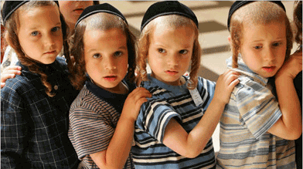

Again, do not let the blonde hair and blue eyes fool you. Note the puffy Jewish eyes, and the Jewish ears in this young Jewish child. She has a lot of Western European genes.

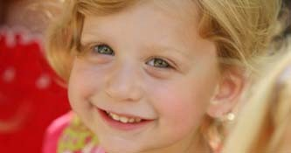

Jewish children are often sallow, frail and sickly looking

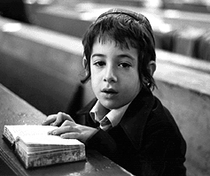

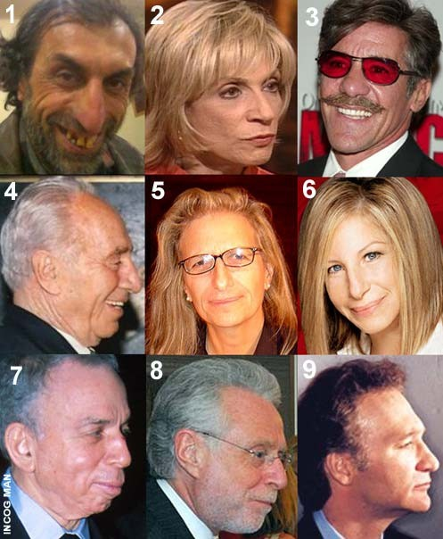

# How to Recognize and Identify a Jew, Part 2

## By

John Doe Goy

### The Jews are a race within all races:

*"God has granted to us, His Chosen People, the gift of dispersion, and from this, which appears to all eyes to be our weakness, has come forth all our strength, which has now brought us to the threshold of sovereignty over all the world."*

### -- JEWISH PROTOCOL No. 11

Jewish Character

There is always 5% of a race, which does not conform to the other 95% majority. The Jews have used these examples to stand out and represent the entire 95%, in other words, making excuses which work to elevate the entire race in the eyes of other races. When judging anything, one must always look to the majority, not the small minority percentage, as this is another trick.

The average Jew has an IQ of 135. The average IQ is around 100. 101-110 is bright, 110-120 is superior, 121-130 is very superior, 131-140 is gifted, and 141+ is genius. Beyond 110, the percentages become smaller and smaller, with 135 and above being in the upper 2% of the entire world population. This is not to say every Jew has a gifted IQ, but the majority does, especially those at the top. This is something to be aware of, along with their knowledge of things that are deliberately kept from Gentiles in the way of loopholes in the law and other things where they can screw a Gentile.

On the other end, GENETIC mental retardation amongst the Jewish race is extremely high. The Jew has endless genetic afflictions. One can tell the difference between a genetic retard and one who was injured at birth, as the genetic retard has physical anomalies that are quite blatant, as in the photo below- most of these anomalies are blatantly Jewish:

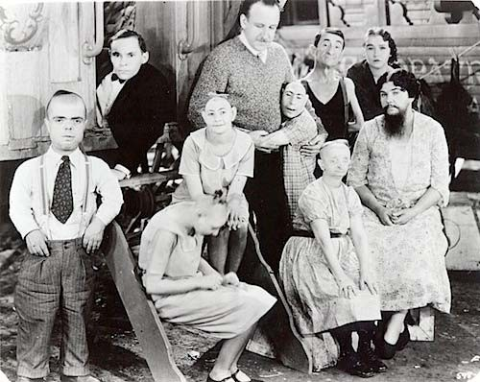

One who is retarded through a birth injury [not genetic] will often look normal until they act out, or speak, which reveals their affliction.

From very early on, Jewish children are taught about money, how to make it and also how to make money off of money. While Gentile children are being indoctrinated with all sorts of studies and subjects in the schools, (most of which have no bearing on real life issues, how to survive, or to make a decent living), the average Jew is being prepared not only to survive, but also how to connive their way in this world, especially the religious Conservative and Orthodox Jews.

Jews call themselves "People of the book." While Gentiles are being indoctrinated with Jewish media, the Jews themselves are busy studying. At Yeshiva school, Jews are taught how to argue. Arguing, along with twisting and perverting the facts is a very strong Jewish trait, along with lying. **The Jew is master of telling lies. A Jew will lie directly to your face,** even in spite of your having proof on paper, and tell you what you are seeing on the paper is not correct. They are endless liars and swindlers. The Jew is highly intelligent and extremely deceptive.

Unbeknownst to most of the world, the purpose, and mission of the Jew is to destroy the white race and to enslave the remaining colored races of the world, which they look down upon as 'cattle.' **"Goyim" a Jewish derogatory term for "Gentile' means "cattle."** The way in which they packed the black Africans on the slave ships headed to America is very revealing. The Jews owned all of the slave ships and operated the slave trade.

The Jews have removed some 90% of all spiritual knowledge through their programs of Christianity and Islam, all the while, fooling the world into believing Christianity and Judaism are enemies. The majority fall for all of this. All three of these Jewish inventions are working for the Jewish goal of world communism, where all spiritual knowledge will be systematically removed and kept only within the upper Jewish power structure. The "Symbolic Snake of Judaism" is a code reference to 'Kundalini" which is psychic/occult power, which the Jews use liberally. This power has been systematically stripped from all Gentiles via Christianity and Islam.

For more information about this, check out [www.exposingchristianity.com](http://www.exposingchristianity.com/) There is nothing spiritual about Islam or Christianity, both of these religions are hoaxes.

In the Protocols of the Learned Elders of Zion, the Jews claim the 'serpent' represents Israel. The Kundalini Serpent is within all humans and is the seat of psychic ability and power. The Jews at the top make liberal use of the powers of the mind and more, to enslave the masses. Freemasonry was originally Gentile, until the Jews took it over through infiltration, gained control of it, and now own it. Modern Freemasonry now works for the Jewish goal of worldwide communism.

Unbeknownst to most people, Jews and Gentiles are cosmic enemies- meaning- from 'out there.' Jews are from a reptilian race of beings that lack emotion and are highly advanced in the powers of the mind and soul. One can readily see the marked reptilian physical features in the Jews in part one of the companion book on 'How to Recognize &Identify a Jew." This is what is called 'the Cohen gene' that is passed along from the Jewish mother. Conservative and orthodox Jews do not accept one as Jewish unless one is born of a Jewish mother.

While a Jew may appear to be very liberal and all for 'free thought,' certain issues, they are highly inflammatory against, such as nationalism, pride in one's white race or anything that is contrary to their goal of world domination. Child abuse, murder, molestation, and such are just fine as long as the average Jew is concerned and the Jewish lawyer will work to defend those who commit such low crimes, but anyone who works for the advancement of the white race, of which the Jew works relentlessly to destroy and the Jew will attack. Jews, especially the younger ones will talk of fetuses being 'parasites' and other ugly attacks against children, in order to destroy the Gentile family, which they have nearly succeeded in doing these days.

Jews have a strong fixation on feces, excrement, urine, and other ugly things. This can readily be seen in the Judeo/Christian Bible

***2 Kings 18: 27***

*"But Rabshakeh said unto them, Hath my master sent me to thy master, and to thee, to speak these words? hath he not sent me to the men which sit on the wall, that they may eat their own dung, and drink their own piss with you?"*

There are endless examples of this repeated throughout both the old and new testaments of the Bible. There is nothing at all spiritual about this endless gibberish and filth. Jews have a strong fixation on this sort of thing in their daily lives, writings, sexuality, and so forth.

The average Jew is often lacking in compassion and ruthless, especially towards Gentiles. They display the same ruthlessness with animals. Jews run industrial farming, puppy mills, laboratories, and other heinous places where animals are hideously abused, experimented upon, and mistreated. Most of what the public does not see and is not aware of is enough to make any feeling person want to vomit. The Jew knows no end to ruthless exploitation. Ethics is a very foreign concept for the Jew. **The average Jew does not care how he/she makes money or a profit. The sufferings of others, namely non-Jews are of no concern to them.**

###### Most Jews are condescending and rude, especially towards Gentiles, that is, unless they are busy kissing ass in order to infiltrate or gain some favor.

**Jews look down upon Gentiles and are deliberately insulting and verbally abrasive.**

"GENTILES ARE STUPID"

--Protocol No. 15

In order to gain favor and needed sympathy from unwitting Gentiles, the Jew plays professional victim**. The "Holocaust" which is another hoax of catastrophic proportions [fro PROOF on this, see:** [**http://www.holocaustdenialvideos.com/**](http://www.holocaustdenialvideos.com/) **]** works to further the Jewish goal, along with the other Jewish programs. The Jew is and always has been a professional victim, who plays upon the sympathies of Gentiles to get their way, and further their agenda. Below is an excerpt from "The White Man's Bible" by Ben Klassen:

"If the six million hoax has no basis in fact, the question arises— why would the Jews want to promote such a vicious and horrible lie?

###### Jews have Profited Tremendously.

The answer is: The Jews have profited handsomely from this atrocious lie, as they have a knack of doing with most of the lies they propagate.

* 1. It aroused world sympathy for the Jews when the world should have been (and thanks to Hitler, partially was) alerted to the dangerous and destructive nature of this worldwide parasite.
  2. It acted as a moral club and a propaganda lever with which they have extracted as blackmail $12 billion dollars from the German people as “reparation” to Israel and as “compensation” to individual Jewish claimants. The insanity of such claims can only be appreciated when we considered that many German taxpayers today, who were not even born when the alleged crimes were supposedly committed, are paying “reparation” to a state (Israel) that didn’t even exist at that time. Furthermore the list of Jewish claimants, now, over 35 years later has reached a staggering 3,375,000 when there were less than 200,000 Jews in Germany after 1939. Since it has been so easy for the Jews to rob the Germans by means of this so-called “compensation,” the number of registered claimants against the West German government has tripled in the last ten years. Nothing could be more devastating proof of the brazen effrontery of the Six Million Lie.
  3. It has been devastatingly effective as a propaganda club against the White Race as a whole in trying to preserve its racial integrity. The Six Million Lie has been promoted and propagandized to such a fever pitch of emotionalism that unless the White Race yields and defers on every issue, such as forced busing and in any way voices opposition to race-mixing and integration, they are immediately clubbed with the charge of being racists, and the Nazis were racists, and it led to the death of six million Jews, etc., etc.

By this time the Jews are frothing at the mouth and large crocodile tears are rolling down their cheeks. By this time, the gullible goyim yields the floor and defers to the Jew, although he knows he has been shafted. It works every time.

* 1. By means of this powerful propaganda tool of undercutting White racial loyalty, the Jews are now able to promote race-mixing on a gigantic world-wide scale with practically no opposition from the White Race. After all, we don’t want to be racists like the Nazis, who killed six million— , etc., so our Jew-programmed mind goes down the groove to oblivion, and the future of the White Race with it.
  2. The Six Million lie has been a powerful propaganda tool that enabled the Jews to steal Palestine from the Arabs in 1948 and set up the bandit state of Israel. Thanks to the Six Million lie the Jews had the support and blessing of the befuddled world, especially the Jew-infested United States.
  3. The Six Million lie has had a devastating effect in shaming and discrediting the German people, and indirectly the White Race as a whole. Whereas the Germans should be honored for the noble fight they waged in order to expose and shake off the world-wide Jewish pestilence, the powerful and effective Jewish propaganda networks have pictured the Germans as the villains in the eyes of the gullible world.
  4. It has rallied and united the Jews of the world as nothing else has in the last thousand years. Although most of the Jews know it is an abominable lie, they keep constantly harping about it amongst themselves (as well as to the outside world) until they have become so hypnotized by their own lie that it actually becomes part of their religion. On this sleazy basis vast sums of money have been raised amongst the Jews themselves and hundreds of organizations formed. All this in the interest of promoting Israel, and the Jewish race, and helping to mongrelize the White Race.

“Holocaust” Lie— Jewish Rallying Cry.

This lie, then, has become the rallying cry of the modern day Jew, a continuation of the oldest lie in their tumultuous history— namely that the Jews are a persecuted race. It has worked wonders for them. It has been devastatingly effective as a two-edged sword. It has demolished any attempt by the White Race to retain their own racial integrity, or even any form of nationalism. On the other hand, it has made the Jews fanatically nationalistic when it concerns Israel, fanatically racist when it concerns Zionism or the Jewish race.

Jews now More Powerful than ever.

So powerful a tool has this depraved Six Million Lie become that not only individuals but governments of nations cower before it while the Jews take charge, silencing any and all opposition. Dr. Max Nussbaum, the former chief Rabbi of the Jewish community in Berlin, openly bragged on April 11, 1953, “the position the Jewish people occupy in the world today, despite its tremendous losses, is ten times stronger than it was twenty years ago.”

He is right on half of his statement. They suffered no “tremendous losses,” but they are ten times stronger than they were before the White Race was inveigled into that bloody, fratricidal holocaust, known as World War II, incited, and provoked by the Jews themselves. Much of this increased strength they have acquired thanks to the despicable Six Million Lie."

**Jews are obsessive and compulsive by nature.** They are relentless. They have survived for centuries intact, in spite of repeated pogroms, attacks and near decimation when their true character and purpose became apparent to the gentile communities in which they infested. **They have not only survived intact, but also in character. They have not evolved or changed in thousands of years.**

Jewish obsession – they cannot take 'no' for an answer. They are relentless and very persistent.

Jews by nature, in addition to their long and endless list of physical diseases and afflictions, many of which are hideous and rare [specific to Jews, such as Tay- Sachs], many suffer from mental illnesses in very high proportion to their population. Obsessive/compulsive as mentioned above, and psychotic disorders such as schizophrenia are rampant amongst Jews, along with many other ugly mental disorders, most of which are genetic when it comes to the Jews.

In addition to the obsessive/compulsive disorders, most Jews are extremely driven by nature, and work relentlessly to get to the top so they can gain power and control over Gentiles. Many also ingratiate themselves with powerful Gentiles. **Many, if not most powerful Gentiles these days are married to Jews. The Jew then works to control all of the Gentile's money and also influences the decisions of those in positions of power.**

### Jewish Living

**Jewish neighborhoods in most cities are the wealthiest-** the ones with the huge homes and mansions. One will usually find a synagogue in the area. This is something many are unaware of and the Jews keep quiet.

Ask anyone if they are English, Irish, Russian, Japanese, whatever and nearly all will reply with what they are. The Jew on the other hand is ashamed of and tries to hide the fact that he/she is a Jew or part Jew. Most will lie and claim to be Italian, Greek, 'Mediterranean', [dark white] or anything else or just not want to talk about it.

###### Jewish humor is always demeaning and insulting.

**Jewish domination of the media is also obvious in the most common "Brooklyn" accents in nearly all of the cartoons.**

The Jew usually presents a false façade of pacifism, brotherhood, tolerance and acceptance of others. Like the Christianity program, communism, and others, these are all a come-along to get Gentiles locked in, confused, and then damned.

### Jewish Diseases

###### Jewish diseases are endless. The average Jew is severely afflicted in one or more ways. Quite a few of the genetic diseases listed below are exclusively Jewish, such as 'Tay Sachs.' If you have any doubts, do some research on 'Jewish diseases" on the internet. Fools, who believe the Jewish lie that the Jews are a religion, need to do a bit of research right from Jewish sources about the diseases listed below. 'Religions' do not transmit genetic diseases, obviously.

Alpha 1-anti-trypsin Deficiency Amyotrophic Lateral Sclerosis Aut. Dom. Optic Atrophy

Aut. Dom. Retinitis pigmentosa Bardet Biedl syndrome Berger's Disease

Beta-thalassemia Bloom Syndrome Canavan disease

Celiac Disease, or Sprue Color-blindness

Con. Stat. Night Blindness Congenital blindness Congenital deafness Corneal Dystrophy Crohn's Disease

Cystic fibrosis Dwarfism

Early rheumatoid arthritis, often occurring in childhood

Elephant man's disease- Proteus syndrome

Fabry Disease Factor XI deficiency

Familial Dysautonomia Familial Hypercholesterolemia Familial hyperinsulinemia Familial Mediterranean fever Fanconi Anemia

Gaucher Disease Glucose-6-phosphate- dehydrogenase deficiency

Glycogen storage disease type 1a Glycogen storage disease type III

Hereditary Hearing Loss Kaposi's sarcoma

Lactose intolerance [cannot digest milk]

Leber’s congenital amaurosis Lipoamide Dehydrogenase- Deficiency

Machado Joseph Disease Malformed limbs

Maple syrup urine disease Mucolipidosis IV

Multiple Sclerosis Muscular Dystrophy Nemaline Myopathy Niemann-Pick disease

Non-Classical Adrenal Hyperplasia Non-syndromic sensorineural hearing loss

Nosebleeds that do not stop [especially common amongst Southeastern European Jews] Progeria

Psychotic disorders- abnormally high incidence of

Rib cage misaligned Stargardt disease Tay Sachs

Temperature intolerance Thalassemia

Torsion Dystonia

Type III Glycogen Storage disease Usher Syndrome Type 1F Vitelliform Macular Dystrophy Wilson disease

The endless and hideous list goes on and on.

### Jewish Dominated Professions

Most Jews work in positions of power. Farming and agriculture are demeaning and 'beneath' them. There are very, very few if any Jewish farmers. Below is a list of professions common to Jews. **If one is stupid enough to doubt the authenticity of the 'Protocols of the Learned Elders of Zion,' one only needs to search no further than a local telephone directory – physicians and attorneys alone have an extremely disproportionate listing of Jewish names.**

Advisors

Bank management, ownership- Jews operate and control all of the banks and financial institutions.

College Professors [Jews are rampant at most Universities] Hollywood actors, actresses, producers, script writers, etc. Lawyer

###### Management/Ownership- the higher up one goes in most major corporations, one will find more and more Jews near and on the top, with six digit salaries.

Media domination and control: Hollywood, News, Journalism, Television, broadcasting, radio

Medical Doctor [physician] Politician

Stock Brokers

Self-owned Business

There are many more than listed above. Jews mainly work so-called 'white-collar jobs' where pay is much higher.

### Jewish Words

Below is a list of Jewish words, mainly coming from Yiddish. Jews tend to use these words commonly:

Chutzpah – meaning 'nerve' Gimp – slang for penis

Schmuck – slang for penis [How many times have we heard the Jewish expression 'Ya Schmuck!'?

Mazel tov: congratulations, good luck Mitzvah/Mitzvoth — A blessing or commandment Oy gevalt, or "Oy Veh": a cry of anguish

Putz – slang for penis

Shalom – meaning 'peace' very common Jewish greeting between Jews Shmaltz, shmaltzy: grease or fat, sentimental, corny

Schmo – one who is a sap

Shtetl: "old-country" village [Jewish Ghetto in Europe]

### Jewish "religion," symbols, etc.

**Hillel** – The Jewish center at Universities, for Jewish students

**Hoopla**- Jewish wedding canopy. It is customary for a glass to be crushed by the groom with his heel at a jewish wedding. The Jewish bride and groom are married under a canopy called a 'hoopla.'

**Kosher dietary laws**- prohibited foods: Orthodox and Conservative Jews are not permitted to mix meat with dairy products. This is not 'kosher.' Pork and shellfish are also forbidden.

###### Menorah

Mezuzah: Tube with scriptures on doorway of Jewish homes- this is usually placed on the doorframe.

###### Star of David

**This symbol, like everything else the Jews claim as their own, was stolen from the Hindu 'Star of Vishnu.'**

**Orthodox, Conservative, Reform, are the three main branches of Judaism.** Orthodox and Conservative follow Jewish law, with the orthodox being the most strict. Reform is also known as 'Liberal Judaism.' Many reform Jews do not follow kosher dietary laws, or other Jewish laws.

###### Kosher Food Tax

**The symbols below are all Jewish. Jews have been extorting trillions of dollars with a special tax on food that Gentiles must pay at the supermarket. Look to your labels for the symbols below, the most common is:**

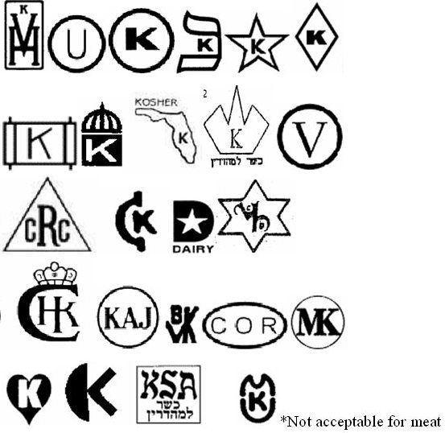

### Index of Jewish Surnames/Last Names

This is a comprehensive list of Jewish surnames (last names). While this list is extensive, it is not complete. **NOTE- THERE ARE A FEW NAMES WITHIN THIS LIST THAT ARE ALSO USED BY SOME GENTILES.** Usually, when enough Jews take certain Gentile names, more and more Gentiles stop using those names, but there are cases when old family names survive. The original names were Gentile.

**There are also exclusively Jewish names such as Levi, Cohen, Stein; variations, prefixes such as "Eisen," "Lev" "Rabin," "Roth," suffixes such as "baum, berg, witz, feld, lieb, thal, stein, and middle, (before the last name)- "Ben" and "Bar," to cite a few examples.** Most of the names listed below are almost exclusively used by Jews. In addition, many Jews take Gentile names in order to hide their Jewish identity. Many Jewish names also have to do with extreme wealth, money, "Gam" (tax collector), "Goveh" (treasurer), "Gold" "Goldberg" (mountain of gold), Silver, Silverstein (silver stone), Greenberg, and so forth.

### A

Aaron Aaronin Aaronsen Aaronson Aaronstein Abba

Abel Abelson Abendana Aberke Aberl Aberlein Aberlieb Aberzuss Abil Abrabanel Abraham Abrahm Abrahmsohn Abram Abrami Abramin Abramov

Abramowitz Abrams Abramsky Abramsohn Abramson Abravanel Abravaneln Absalom Abudraham Abulafia Abzug Achselrad Ackerman/n Acosta Adele Adelman Adelman/n Adelson

Adelstein – "precious stone; very expensive"

Ader Adler

Adler-Adonoilom Admon Adolescenti Africk

Afrom – variation of "Ephraim"

Agosi Agozi Agranat Agron Agronsky Ahavah Ahikam Ahitov Ahl Ahuvah Akabiah Akashia Akiba

Album – variation of "Weiss"

Alcalay Alembik

Alfandari Algus Aliyah Alizah Alkus Alper Alpern Alpert Alpron Alter Alterman Altfeld Altmann Altneu Altschul Altschuler Altshule Amdur Amdursky Amschel Amsel Amsle Amsler Amster Anastasios Anav Ancier Andrussier Anixter Ansbach Anschel Antman/n Anzieher Apel Apelopwitz Apfelbaum Appel

Apt Apter

Aren- variation of Aaron

Arfa

Arkin - variation of Aaron

Arkules

Aron, variation of Aaron

Aroni, variation of Aaron

Aronin, variation of Aaron

Aronoff, variation of Aaron

Aronoff, variation of Aaron

Aronov, variation of Aaron

Aronow, variation of Aaron

Aronowitch, variation of Aaron

Aronowitz, variation of Aaron

Aronson, variation of Aaron

Aronstam Aronstein

Aronthal, variation of Aaron

Aryeh Arzt Asael Asaf Asch

Aschenheim Aschenheimer Ascher Aschheim Ash

Ashburg Ashendorf Ashkenazi – this

name used to mean "German" (Gentile) until the 17th century when many European Jews migrated to Asia Minor, where they

were given this name by Turkish jews to identify them as coming from the German territories.

Ashman/n Ashner Askush Asner Aspis Astruc Astruc Atar

Atlin Atzmon Auerbach Auslander Auspitz Austern Averik Avigaal Avigad Avigdor Avil Avindam Aviram Avi-Shaul Avraham Avrech Avril Avrom Awerbuch Axeldar Axelrad Axelrod Axelrood Ayalah Ayelet

Ayzenschtat Azariah Azria Azzopardi

### B

Bab Babad Bacharach Bacher Bacherach Bachrach Bachrich Bad Badanes Bader Badt

Baer Bailin Bak Bakst Balaban Balak Balfur Balsam Balta Balter Bamberg

Bamberger Banet

Bar Barad Baram Baratz Barbakoff Barch Bard Bardach Bardowitz Barg

Bar-Gada Bar-Ilan Barkan

Bar-Kokhba Barlas Barmak Barmash Barmat

Bar-Nathan

Baron – variation of 'Bar-Aaron" (son of Aaron)

Barr Barron Barrstein Barshay Barth Baru Baruch Barukh

Bar-Yehuda Barza

Bas Basch Bashe Basheva Baskin Baskind Bass Bassan Bassani

Bassovsky Basyah Batnick Batusanschi Batyah Baum Bauman/n Baumgarten Baxt

Bayla Bechar Becher Bechor Bechtheim Becker Beckerman/n Beckman/n Bedwinek

Beederman/n Behar – variation of "ben-harav"

Behokhmah Behrman Beifuss Beilin Beilke Bekher Bekhorath Belier Belka Belkin Bellow Belmont Belmonte Belofsky Belzer

Ben Bender Bendit Bendit Bendor Ben-Gurion Ben-Horin Benjamin Benowitz

Ben-Shahar Bensheim Bensinger Ben-Tikvah Bentwich Benveniste Ben-Zahav Ben-Zvi

Ber Berakhiah Berg Berger Bergman/n Berish Berkal Berkman/n Berko Berkovits Berkowitz

Berl

Berlin (Nothing to do with the city. The name means "Son of Berl')

Berliner Berman Bernbaum Bernheim Bernick

Bernstein – derived from "dealings with amber"

Bertinero Beshanim Beshar Besser Bethel Bettelheim Bettsack Betzalel Biback Biber Bibick Bickel

Biederman/n Biegeleisen Bildhauer Bilu

Binder Bing Birnbaum Bistritzky Bitensky Blacher Black Blaser Blashki Blaszka Blau Blaustein Blecher

Blechman/n Bleich Bleiweiss Blitstein

Bloch Block Bloom Bloomberg Bloomfeld Bloomfield

Bloomingdale Blowitz Blozer Bluestein Blum

Bluma Blumenberg Blumenfeld Blumengarten Blumenheim Blumenkrantz Blumenkrohn Blumenreich Blumenstein Blumenstock Blumenthal Blumfeld Blumkin Blustein Bobroff Bochner Bodanis Bodek Bodenstein Bodner Boerne

Bogatch (Polish- meaning "wealthy") Bogati

Bogolub Bogoraz Bohm Boim Bokser Bollag Bolotin Bondi Borer Bornstein Borodaty

Boros Borowsky Bortnik Boruchschomer Botbol

Botnick Botstein Botushansky Botwinnik Boxerman/n Boyer

Brach Bradt Brady Braf Bragin Brainin Bram Bran Brand Brandão Brandeis

Brandelstein Brander Brandler Brandwein Brann Brasch

Brat Braude Braunfeld Braunschild Braunspan Braunstein Braunthal

Braverman/n Breger Breindel Breine Bremel Brender Brenner Breuer Brewda Breyer Brickenstein

Brik Brill Brilliant Brim Brisch Brock

Brockman/n Brod Broder Brodner Brodsky Brodt

Brody

Brog Broitman/n Bromberg Bronfman/n Bronfn Bronstein Brosch Brostoff Brownstein Bruck Bruckenstein Bruckstein

Brüll Buber

Buchsbaum Buchwald Bufman/n Bukspan Bulka Bunim Burack Burla Burstein Buschbaum Buxbaum

### C

Cahan- variation of Cohen

Cahen- variation of Cohen

Cahn- variation of Cohen

Calish Cantarini Cardozo Carlebach Caro Casdan

Cassirer (Yiddish for Cash)

Castro Casuto Chabas Chabin Chabner Chagall Chai Chaikin Chaim Chait Chalef Chalfan Chamedes Chameides Chamides Chamudes Chanen Chanin Chankin

Chapiro – variation of Shapiro

Charlap Charmatz Charness Charnis Charrik Charry Chasin Chasins Chason Chatan Chavkin Chayes Chayim Chayyah Chazan Chazzan Cherkasky Cherniak Chernik Chernoff Chernoffsky Chiel Chiger Chiya Chodes Chodesh Chodosh Chomsky Chorney Chubin Chubinsky Chudnow Citron

Cogan- variation of "Cohen"

Cohan- variation of Cohen

Cohen -(Exclusively Jewish name)

Cohn- variation of Cohen

Cohnheim- variation of Cohen

Cohnstein- variation of Cohen

Cole Colombo

Cone– variation of Cohen

Consolina Cooper (Some

Gentiles also use this name)

Cooperman/n Cornberg Cornblith Cornblum Cornfein Cornfeld Cornfield Corngreen Corngut Cornpracht Cramer Cresca Csillag Czaczkes

### D

Da Costa Damrosch

Danto- variation of "David"

Daskal Daskelowitz Daube Dauber David Davidovitch Davidowitz Davidson Davis Dayag Dayan

De Haas Dekovnick Del Medigo Del Vecchio Dembitz Dewoskin Diamant

Dick Dickenstein Dickstein Dienesmann Dieudonné Diofatto Dissen Ditzah

Dobe Dobkin Dobrin Dohm Dolinsky Dorfman/n Doron Drach Dratwa Drechsler Dreebin Dreifuss Dresner Dressler

Drexler Drexsler Dreyfus Dreyfuss Druck

Drucker Dubin Dubofsky Dubow Dubowsky Duchan Duchen Duchin Duchovny Dukhen Dunkelman/n Durchschlag Dushkin Duskin Duvdevani Dvoshke

Dym

### E

Eberman/n Ebril Eckstein Edel Edelman/n Edelsberg Edelstein Efer Efroike Efroikin Eger Egers Ehmann

Ehren (all names with Ehren" are variations of Aaron)

Ehrenberg Ehrenfeld Ehrenfest Ehrenfreund Ehrenfried Ehrenfrucht Ehrenhaft Ehrenhaus Ehrenkrantz Ehrenpreis Ehrenreich Ehrenstamm Ehrenstein Ehrenteil Ehrenthal Ehrentreu Ehrenzweig Ehrlich Ehrman/n Eibenschitz Eibenschütz Eibeschütz Eichel Eichhorn Eichler Eidels

Eifer

Eiferman/n Eige

Eiger Eiges Einhorn Einstein Eisbart Eise Eiseman/n Eisen Eisenbach Eisenberg

Eisengarten Eisenheim Eisenhower Eisenkraft Eisenman/n Eisenstadt Eisenstam Eisenstark Eisenstein Eisinger Eisler Eisman/n Eisner Eisnick Eissig

Eizik Elath Elazar Elbaz Elchanan Eleazar Elhanan Eliakim Elias Eliasaph Eliezer Elijah Elimelech Elimelekh Elishama Elishaphat

Elkan Elkin Ellbogen

Ellenbogen Ellman/n Elman/n Elnathan Elow Elowitz Elya Emale Embden Emden Engel Engeler Enker Entin

Enzil Enzlin Ephraim Ephrat Ephron Ephros Eppenstein Eppstein Epsteen Epstein Erlanger Eshkol Espérance Esperanza Esterine Esterman/n Esterson Estrin Ettinger Ettlinger Evron

Ewig Ewigkeit Eybeschitz Ezekiel

### F

Fagan Fagin Faibisch Fairchild Falk Falkenberg Falkenfeld Falkenheim Falkenstein Falkenthal Falkheim Farber Farkas Fassbinder Fayvel Feder Federbusch Federman/n Feibelman/n Feig

Feige Feigel Feigelman/n Feigelstock

Feigenbaum Feigenblat Feigin Feigler Feigon Feilchenfeld Fein Feinberg Feiner Feinerman/n Feingold Feinman/n Feinsilver Feinstein Feis

Feischl Feitel Feivel Feivis

Feivish Feivus Fekete Feld Feldbaum Feldblum Feldhaus Feldheim Feldinger Feldleit Feldman/n Feldscher Feldstein Feller Fellerman/n Fellner Felltrager Felman/n Felsen Felsenbach Felsenberg Felsenstein Felsenthal Felsher Feltenberg Fenichel Fenster Ferber Fertel Fetterer

Feuchtwanger Feuer Feuerstein Fiedler

Figel Figler Figlin Filehne Filene Filler Fine Fingerhut Fink

Finkdorf Finke Finkel

Finkelstein (dealing in diamonds)

Finkenfeld Finkerfeld Finkheim Finkhof Finn

Finzi Firestone Fisch Fischbein Fischel Fischer Fischman/n Fiscl Fishkin Fishkind Fishman/n

Flacksman/n Flaks

Flasch Flaschin Flax Flaxman/n Fleischer Fleischhaker Fleischhauer

Fleischman/n Flesch Flexner Florscheim Florsheim Floss Flosser Fogel Fogelbaum Fogelman/n Fogelsang Fogelsdorf Fogelson

Fogelstein Fonseca Forman Forscheim Fortel Forti Fradkin Fraime Fram Frank Frankel

Frankfurter Frayda Freeman Freilach Freilich Frenkel Freud Freudenberg Freudenfeld Freudenfels Freudenheim

Freudenreich Freudenstein Freudenthal Freudman/n Fried

Friedel Friedenheim Friedenson Friedenstein Friedenthal Frieder Friedheim Friedjung Friedland Friedländ Friedlich Friedman/n Friedson Friedwald Frohlich Froikin

Froikin – [variation of Ephraim]

Froike Froim Fromel Fromer Fromkin Fromm Frommer Frosch Fruma Fuchs Fudim Fudm Fudym Fuld Funk Furrier Fürth Fürther Futorian

Futterman/n

### G

Gabbai Gabel Gabler Gad Gaffen Galinsky Galpern Gam Gamliel Gamoran Gans Garfinkel

Garfunkel (dealings with diamonds) Garland

Garmaize Gartenhaus Gaster Gedaliah Geduld Geffen Geffner Geiger Gelbart Gelber Gelfman/n Geller Gellman/n Gendel Gerber Gersh Gershman/n Gershom Gershon Gershovitz Gerson Gerstein Gerstner Gertz

Getz Getzel Getzl

Gewirtzman/n

Giblichman/n Giesser Gilah

Gilden Gilman/n Gimbel Gimpel Gingold Ginsburg Ginzberg Giora Gittel

Gittelmacher Gittelman/n Gittelsohn Gittelson Gitzok Glass Glassman/n Glatzer Glazer Gewirtz Glick Glickberg Glickin Glickman/n Glicksberg Glickselig Glicksman/n Glickstein Glickstern Gluck

Gluckenspiegel Gnendel Goetzl

Goiten Golan Gold Goldbart Goldbaum Goldberg Goldberger Goldblatt

Goldblitt Goldblum Goldbrunn Golde Golden Goldenbaum Goldenberg Goldenthal Goldfarb Goldfeder Goldfish Goldfluss Goldhaber Goldhammer Goldheim Goldhirsch Goldich Goldkorn Goldkrantz Goldkraut Goldman/n Goldmann Goldmark Goldner Goldreich Goldsand Goldscheider Goldschild Goldschlag Goldschmidt Goldsmith Goldstadt Goldstaub Goldstein Goldstern Goldstrand Goldstrom Goldzweig Golomb Goltz

Goltzer Goltzman/n Golub

Gompers Gompertz Goodman/n

Gordon (also used by Gentiles, originally a Gentile name)

Goren Gorenstein Gorfinkel Goronchik Gorwitz Gottesman/n Gottinger Gottlieb Gottstein Gotze Gougenheim Gould Goveh Grabber Graiver Granot

Granovsky Gratz Graubart Green Greenberg Greene Greenhut Greenleaf Greenspan Greenspun Greenstein Greenstone Grinberg Grobtuch Gross Grossbart Grossinger Grossman/n Grozovsky Gruenbaum Guberman/n Guggenheim

Guckenheim Guggenheimer Gumbeiner Gumpel Gumpertz Gumprecht Gunzburg Gunzelmann Gur

Gurovitz Gurvich Gute Gutein Gutfeld Gutfreund Gutmacher Gutman/n Gutreich Gutstein Gutter

Gutterman/n Guttman/n

Haare Haas Haber Habib Hadash Hadassah Haffkin Haganah Hahn

Hait Halafta Halevi Halevy Halfan Halper Halperin Halprin Hamashbir

Hammerstein Hananel Hananiah Handel Handwerger Handwerker Hankin Hanoch Hardt

Harif Harpaz

Harris (also used by some Gentiles)

Hart (also used by some Gentiles) Hartig

Hartman/n (also used by some Gentiles) Hartog

Hartwick Hartwig Harz Haspel Hassan Hatzkel

H

Hauer Havah Havkin Hayt Hayyah Hayyim Hazan Hedvah Hefter Heifetz Heilbron Heilbronner Heilbrun Heilpern Heilprin Heilprun Heiman/n Heine Helfgott Heller Hellman/n Helpern Hendel Henkin Hersch Herschel Herschfus Herschson Herschstein Hersh Hershdorfer Herskowitz Herstein Hertzman/n Hertzmark Herz Herzbach Herzberg Herzbrunn Herzfeld Herzl Herzlia Herzog

Heskel Heuer Heyman/n Hezekiah Hickman/n Higger Hildesheim

Hillel (Hillel is also the name for the Jewish center on college campuses)

Hillman/n Himmelfarb Hinda Hindes Hindin Hirsch Hirschbaum Hirschberg Hirschberger Hirschbruk Hirschburg Hirschfeld Hirschfield Hirschhaut Hirschhorn Hirschkopf Hirschkorn Hirschler Hirschman/n Hirschthal Hirschwald Hirsh

Hirz Hirzh

Hirzhman/n Hittelmacher Hode

Hodel Hodes Hodesmann Hodi

Hoffman/n (also used by Gentiles) Hofstadter

Holtz Holtzer Holz Holzer Holzman/n Hoos Horn

Hornstein Hornthal Horowitz Horre Horwitz Houseman/n

Huberman/n Hudel Hyman Hymen Hyrcanos

### I

Ibn Ichel Idelson Ifland Ignatz Imber Ingber Irving Isaac

Isaacsohn

Jacob Jacobin Jacobsen Jacobson Jaffe Jaffin Jastrow Javitz

Jehoshaphat Jellenik

Isaacson Isaakovitch Isak Ishmael Isidore Israel Israelin Isril

Isser Isserl

### J

Jellin Jellinik Jephthah

Jerusalimsky Jessel Jesselman/n Jewison

Isserles Isserlin Itkin Itts Itzhaki Itzhakin Itzig Itzik

Itzkovitz Itzl

Jochanan Joffin Joske Judah Judel Julius Jurnove

Kabakoff Kacev Kaciff Kadar Kadoorie Kadury Kafka

Kagan – variation of Cohen

Kaganoff – variation of Cohen

Kahane – variation of Cohen

Kahn- variation of Cohen Kaiserman/n Kalisch

Kalischer Kalman/n Kalonymos Kaluzna Kamin Kaminetzsky Kamins Kammerstein

Kane– variation of Cohen

Kansi Kantor Kapke Kaplan Karelitz Karlin Karliner Karlinsky Karlman Kartagener Kashdan Kaskel Kaspi

Kassirer (Yiddish for Cash)

Katz Katzenellenbogen

K

Katzenstein Katzer Katziff Katzin (rich) Katzman/n Katzoff Katzovitz

Kaufman/n – also used by some Gentiles Kavinoky

Kavka Kavner Kawka Kay Kaye Kayla Kazan Kazhdan

Kedoshim Kele

Kelman/n – (also used by some Gentiles) Kelpfish Kemmelman/n

Kemp Kemper Kempenich Kempler Kesef Kestenbaum Kevod Kibalti Kibaltic Kimchi

Kimmelman/n Kirchen Kirchstein Kirmeyer Kirsch Kirschdorf Kirsche Kirschenbaum Kirschenberg

Kirschenblatt Kirschenzweig Kirschheim Kirschner Kirstein Kirsten Kirzner

Kisch Kisselevich Kissinger Kissner Kitay

Kivel Klapholtz Klass Klausner Kleban Klein Kleinman/n Kleinsinger Klinger Klippfisch Klopman/n Kluger Klugman Knesset Kobel Kobrin Kochabi Kodesh Koenig Koenigsberg Kofman/n Kogan Kogen

Kohanim – variation of Cohen

Kohen– variation of Cohen

Kohlberg

Kohn– variation of Cohen

Kohut Kojeteiner

Kolatch Kolben Kolitz Kolodkin Kolodny Kompert

Kone– variation of Cohen Konotopsky

Kopel Kopelman/n Kopeloff Kopelovitch Kopke Koppel Koppelman/n Korentayer Korf

Korff Korn Kornberg Kornfeld Kornfield Korngold Kornreich Korshak

Koshes Koslowsky Kossowsky Kotelschik Kotlar Kovalsky Kovarsky Kozin Kraines Krainin Kramer Krasny Kratchmer Kraus Kraushaar Krauskopf Krauss Kreindel Kreine Krensky Kretske Kretskes Krichevsky

Krieger, Kriegman/n (This name is also used by Gentiles)

Kripke Krischer Krochmal Kronish Krulewitz Krumbein Krupnick

Kuhn– variation of Cohen

Kulefsky Kulikowsky Kulp Kumpert Kupietz Kuppenheim Kurtz

Kus Kushner Kusiel Kusmann Kutner Kutoff Kuznitsky Kwilecki

### L

Lachman/n Ladany Laffer Lagover Lakin Lamdan Lamech Landau Landman/n Lang Langsam Lansky Lanzner Lapidus Lapin Lapman/n Lasar

Lash Lasker Laskov Laskowitz Lautenberg LaVine

Lawentman/n Layb Lazarowitch Lazarus Leah

Leahy Lebeau Lebedoff Leblang Lebovitch Lebow Lebowitz Leder Lederer Leeser Leff

Lehman/n (money- lender)

Lehner Lehrer

Leibowitz Lekach Lekachman/n Lemberger Leml

Lemlin Lempert Lenchitzky Leno Lenoff Leorekh Lepavsky Lepretre Lerner Leser

Lev Levandula Levenson Levey

Levi (Exclusively Jewish, including all variations- prefix, middle of the name, suffix, "Lev") Levigne

Levin Levine LeVine Levinsky/i Levinstein Levinthal

Levitan/sky or ski Levitch

Levite Levitt Levitz Levy Lewin Lewin Lewis Leyisrael Leyser Liba

Libschitz Licht Lichtenberg Lichtenfeld Lichterman/n Lichtman/n Lichtzer

Lieb Lieberman/n Liebman/n Liebowitz Lifschitz Lifshitz Ligorner Lilienthal Linetsky Linker

Lipa Lipes Lipis Lipkin Lipman/n Lipschitz

Lipschuetz Lipsky

Lis Lisagor Liss Litant Litaur Litman/n Littauer Littman/n Litvak Litwack Litwin Locker Loeb Loetstein Lome Long Lopata Lopatnik

Lopatnikov Lopez Lorge Lorig Lorsch Lotstein Löw

Lowenbraun Lowenstein Lowitz

Luban Lubar Lubarsky Lubin Lubowitz Ludwig

Luepschuetz Lugner Lukatzsky Luria

Lunz Lurie Lurje Lustig Lutz Luzzati Luzzato Lysagora

### M

Maccabi Macht Magid Magida Magidson Magit Magtaz Mahalalel Mahler Maimon Maites Maitin Maizlish Malachi Malawsky Malbim Malech Malev Malevsky Malin Malkah Malkes Malkiel Malkin Malkinson Malkoff Malkov Mall Malter Maltin Manba Mandel

Mandelbaum Mandelblum Mandelbrodt Mandelbrot Mandelman/n Mandelstam Mandelstamm Mandelsuss Manewith Manewitz Maniowitz

Manisch Manischewitz Manishen Mankovsky Mankuta Mann Mannheim Mannish Mannsky Manoah Mapu

Maram Marans Marantz Marburg Marcuse Maremont Margalit Marganit Margolin Margolioth Margolis Margolouth Marguiles Margules Margulies Margulis Marhuc Markowitz Marks Marmelstein Marpurch Marpurg Marshak Marx Mashbir

Mashbitz- setter of jewels

Mashgiah Maslin Mass Matanky Mattathias

Mattis Mattisoff Mattison Mattityahu Mattiyahu Mautner May Mayefsky Mayer Maymin Maza Mazal Mazur Meckler Medinah Meer Meersand Mehler Mehlman/n Meir Meisel Meislish Meisterlin Meites Meitin Melamed Melber Melezin Mellitz Melnick Melnikoff Meltsner Meltz Meltzer Melzner Menachem Menachim Menaheim Menahem Menaker Menasche Menba Menche

Menchen Mendel Mendelberg Mendelheim Mendelovitch Mendelovitz Mendelsberg Mendelsohn Mendelson Mendelssohn Mendheim Mendthal Menke Menken Menkin Menlin Menuchin Menuhah Menuhin Menz Merman

Merr- variation of "Meir"

Merrick- variation of "Meir"

Mervitz Meslin Messenger Metchik Metz Metzger Metzia Mevaser Meyer Meyerfeld Meyerhardt Meyerheim

Meyeroff – variation of "Meir"

Meyers Meyersberg

Meyersicht Meyerstein Michel Mihály Milgrom Milhaud

Miller – (this name is also used by many Gentiles)

Millman/n Milstein Milton Minc Mince Mindel Minkche Minkovsky Minne Minowitz Mintz Miriam Mirman/n Mirsky Mirvis Mishkin Mishnah Mizera Mlotok Model Mogilner Mohel Molotok Monsky Montagu Montalban Montefiore

(disambiguation) Morah

Moran Mordecai Moreh

Morenu Morgenstern Morgenthau Moritz Morpurgo

Mosak - variation of "Moses"

Moscheles- variation of "Moses"

Moses

Moshe- variation of "Moses"

Moshia- variation of "Moses"

Moskowitz- variation of "Moses"

Moss- variation of "Moses"

Mosse- variation of "Moses"

Motche Moteff Motel Motele Motew Motke Motlin

Motz- variation of "Moses"

Motzkin- variation of "Moses"

Mozak- variation of "Moses"

Muchnik Mukel Munves Munz Mytofsky Mytosky Mytowsky

### N

Nachman Nachman/n Nadel Naftalin Naftulin Naftulis Nagel Nager Nahman/n Nahum Naiman/n Naimon Najmark Namir Namslau Naparstek Naphtali Nardi Narkiss

Narudetzki Nasati Nasatir Nash Nashelka Nass Natati Nathan Nathaniel Nathanson Naymark Neeman/n Nehamah Nehemiah Nehunyah Neiger Nelkin

Nemirovsky

Nerenberg Netzky Neumark Neviaser Nevler Newmark Nierenstein Nili

Nissan Nissen Nissenbaum Nissenfeld Nissenholtz Nissim Novak Novick Nuger Nussbaum

### O

Oberlander Ochakoff Ochs

Ochsenschwantz Oder

Oettinger Ofen Offen Ohringer Okner Okun Olshansky Onixt

Oppenheim

Oppenheimer Or

Orbach Ore Oren

Orenstamm Orenstein Orenthal Orke

Orkin- (descendant of Aaron)

Orlansky Orlik Orlinsky

Ornstein Oron

Or-tzion Orun Oshinsky Osina Osinsky Osterweil Ostrow Ostrower Ottensosser Ovosky Ozarovsky

### P

Pacifico

Packer – (peddler) Pailet

Paiser Panet Papernick

Papiermeister Papirnyi Pappenheim Parchi Parness Pasch Pasternack Patinka Patinkin Pauker

Pearl Pearlman/n Pechenik Peiman/n Peiser Pekarsky Peled Pelles Pelofsky Penner Perachiah Perah Perelman/n Peres Pergament Perles Perlin Perlman/n

Perlmutter Perlow Perlowsky Perlstein Perlzweig Persky Pervin

Peshe Peshke Peshkin Pessel Pevsner Pfaltzer Pforzheim Pianko

Pick Pikelny Pilch Pinchofsky Pinchuk Pines Pinhas Pinke Pinkhas Pinner Pinsk Pinsker Pinsky Piser Pizer Plisken Plotkin Plotnick Podoloff

Podolov Podolsky Polier Politzer Polka Pollack Pollock Polski Polster Pomis Poneviaser Popp Popper Poppers Porat

Porath Portnoy Portugal Posner Potashnik Poticha Potok Prensky Prenzlau Presch Presser Primack Pringsheim Prinz Pritikin Prochownik Proskauer Pruzansky Pugatch

Rabad Rabak Rabb Rabbi Rabin Rabinovitch Rabinowitz Rackofsky Rackover Racoosin Racusen Racusin Radzik Rafael Rahamin Rakh Rakowsky Rakusin Ralbag Rambaum Raphael Raphan Rappaport Rashal Rashi Raskin Rasofsky Rathenau Ratner

Rauchwerker- furrier Ravidovitch

Rawitz Rayzel Razumny Rebhuhn Rebhun Redstone Reese Regensberg Regensburg

Reich – variation of "Rachel"

R

Reiche Reichel Reichelson Reichenbaum Reichenheim Reichenthal Reichman/n Reichner Reichstein Reifman/n Reines

Reis Reisen Reiss Reiter Reitza Reitzes Rele Reles Remba Rembo Renah Rephun Resh Resnick Reuben Reuven Reysel Riback Ribalow Ribeisen Ribicoff Ribnick Richter Ridker Ries Riese Rifkin Rifkind Rimland Ringel Ringlet

Rise Rivke Rivkes Rivki Rivkin Rivkind Rivlin Roback Rockoff Rödelheim Rofe Rofeh Rogoff Rogov Rogover Rogovsky Rogow Roman/n Rose Rosen

Rosenbach Rosenbaum Rosenberg Rosenblatt Rosenblith Rosenblum Rosenbusch Rosendorf Rosendorn Rosenfarb Rosenfeld Rosenfrucht Rosengarten Rosenhaft Rosenhain Rosenhaus Rosenheim Rosenkrantz Rosenkwit Rosenmann Rosenschein Rosenstamm

Rosenstein Rosenstern Rosenstock Rosenstrauch Rosenstrauss Rosenthal Rosenwald Rosenwasser Rosenwein Rosenzweig Rosh

Roskin Rosmarin Rosow Rosshaelter Rossi

Rossof Rossovsky Rostholder Roth Rothbart Rothberg Rothenberg Rothman/n Rothschild Rothstein Routenstein Rovner Roytbarg Rubashov Rubel Rubenchick

Rubenstein Rubenzik Rubin Rubinfeld Rubinger Rubinstein Ruchames Ruffer Rush

Rushnevsky Ruskin Ruttman/n Rymartz Rymer Ryter

### S

Sacerdote Sachs Sahl

Saks Salaman Salander Salant Salanter Salida Salinger Salmen Salmon Salomon Salpeter Salzman/n Sameth Samter Samuel Sandak Sandek Sanditen Sanvil

Saperstein (deals with sapphire)

Saphir (deals with sapphire) Sapoznik

Saran Sarassohn Sarfatti Sason Sasportas Sassoon Satz Saunders Savit Savitt Savitz Savitzky Schach Schachtel Schaffer Schaffner

Schalit Scharf Scharfman/n Scharfstein Schatz Schatzmann Schauer Schayer Schechter Scheier Schein Scheinberg Scheinberger Scheinfeld Scheinman/n Schemlke Schen Schenberg Schenberger Schenfeld Schenman/n Scher Scherer Schertzer Scheuer Schick

Schiff Schimmel Schindler Schinkel Schlagbaum Schlamps Schlampps Schlechter Schleh Schleifer Schlesinger Schloss Schlossberg Schlossman/n Schmaltz Schmelkin Schmukler

Schmulke Schnaittacher Schneebalg Schneider (some Gentiles use this name)

Schnell Schnitman/n Schochet Schoenteil Schonbrunn Schorr Schram Schramm Schreiber Schreier Schreiner Schreter Schrift Schulhof Schulman/n Schulsinger Schultz Schupack Schupakevitch Schwab Schwartz Schwartzbart Schwartzberg Schwartzchild

Schwartzenberg Schwartzman/n Schwarz Schwarzschild Schweid Schwersensky Sculsinger Scwartzen Seagal

Seckel Seckl Sedlis Sefansky

Seff Segal

Segalowitch Segalowitz Segan Seidman/n Seidner Seigal Seigel Seiler Seixas Selda Selde Seldes Seldin Seldis

Selig Seligman/n Selik Seltzer Senelnick Sered Sertels Sexton Shabad Shabbetai Shaffer Shafran Shaliah

Shalom- Hebrew for "peace." Often used as a greeting, like "hello" among Jews Shames

Shandalov Shaphat Shapiro Sharer Sharett Sharf Sharfman/n Sharlott Shatach Shatsky Shatz Shayna

Shayndel Shazar

Shelomo (Solomon) Shemo

Shephatiah Sherer Shereshefsky Sherman/n Shertok Sheva Shevin

Shick Shifra Shifrin Shigon Shik Shikolnik Shimke Shimme Shimmel Shimon

Shimshelevich Shimshon Shimshon Shkolnik Shlensky Shlomit

Shlomo (Solomon) Shlonsky

Shmelke Shmuel Shmulik Shnayer Shnitke Shoenkind Shohet Sholk Shor Shoshan Shprinzel Shteyn Shtull Shub Shuldine Shulruf Shulvass

Shulweis Sickel Sidelko Sidney Siedenfaden Siegal Siegbert Siegel Siegelman/n Siegfried Sigismund Sigmund Silber Silberberg Silberman/n Silver

Silverberg (mountain of silver) Silverman/n Silvermintz (name of one in the money- lending business) Silvers

Silverstein (jeweler) Simeon

Simhah Simkin Simmon Simmons Simms Simon Simonsky Singer Sinilnik Sinykin Sirkes Sirkin Sirota Sivitz Sklar Skolnik Skora Skudin Skurnik Skyer Sladovsky

Slava Slavin Slepin Sliva Sloma Slonimsky Slova Slovin Slutzky Sluva Smilansky Smoler

Smorgansky Sobol

Sofar Sofer Sokol Sokoloff Sokolow

Sokolowsky Sokolsky Solarz Solinger Sollender Solodar Solomon Soloveichik Soref Sorke Sorkin Soroka Sorotzkin Sourkes Spanier Spear Spector

Speishandler Spelling Spellman/n Sperling Spero

Spett Speyer Spiegel Spiegler Spielberg Spier Spilky Spira Spire Spiro Spitalny Spitz Spitzer Spivak Sprai Springer Sprinze Spritzer Srol

Srul Srulik Sruloff Stamm Stampfer Stark Starkman Stawitsky

Stein (exclusively Jewish) Steinberg Steinberger

Steinem Steiner Steinitz Stellmacher Stendal Stern Sternberg Sternin

Steuer- (tax collector) Sticker- (gold worker) Stier

Stoller Stolper Storch Storm Strahl Strashun

Strauss (used by some Gentiles) Strikman/n Strizower

Stroh Sturm Sudnovsky Sukenik Sulz Sulzbach Sulzberg Susskind Sussman/n Svirsky Swibel Synikin Szpir

Szrift

### T

Tabachnik Tabor Tadlis Tahlifa

Taksen - (the one who levied taxes on meat, milk, etc)

Talesnick

Talisman/n- (maker of prayer shawls) Talisnick

Talmach Talmadge Tamar Tamara Tamari Tamarkin Tambor Tandler Tannenbaum Tanzer Taradash Targ Targovetsky Targow Targownik Tarler

Tarr Tarshish Tartakover Taub Taube Tauber

Taxin- (the one who levied taxes on meat, milk, etc) Tcherikover Tchernowitz

Tehiya Teibel

Teig Teigman/n Teitelbaum Teller Temkin Tendler Tene Tenenbaum Teomim Teplitz Térine Tessler Tewel Tewele Teybel Tibbon Ticktin Tikvah Tischler Tobias Tolmach Tomim Toporek Touro

Tov Tovah Tovim

Trachtenberg Trainin Trana Trandel Trattner Trefus Treindel Treine Treinel Treves Trèves Trevis

Tribas Trilling Trillinger Tringler Trivash Trock Trubnick Tuchman/n Tulman/n Tunik Turbin Turetz Turetzky Turoff Turofsky Turov Turover Turowitz Tuvia Tuviah Twersky Tygel Tzabok Tzahal Tzarfat

Tzchernowitz Tzedek Tzedekah Tzevi Tzibbur Tzion

Tzipor Tzipporah Tzirel Tziyonah Tzukerman/n Tzur

Tzvah Tzvi

|  |  |  |  |
| --- | --- | --- | --- |
|  | | U |  |
| Uchitel | Ungar |  | Ushpiz |
| Udelevsky | Unger |  | Uziel |
| Udell | Unna |  | Uzziah |
| Ulman/n | Urbach |  | Uzziel |
| Ulrich | Urevich |  |  |
| Umelitz | Uri |  |  |

### V

Valk Vardah Vardimon Vardina Vardit Varon Veinberg

Veivelman/n Veivis Velikoff Velikov Velikovsky Verbin Vered

Vidal Vifs Vigder

Vigdorchik Vigdorowitz Vigoda

Vis Viscl Vital Vitkin Vivant

Vivanti Vivas Vivelman/n Vives

Vivis Vivs Vogel

Voorsanger Vromel

### W

Wachtel

Wahl (This name is also used by some Gentiles) Wahrman/n Waldenburg

Walfish Walk Walker

Wallach Wallack Wallerstein Wallich Wallik

Wank Wapner Warberg Warburg Warnik Wartel

Wasserman/n Wasserstein Waxman/n

Waxstein Weber Wechsler Weckler Weil Weile Weiler Weill

Wein Weinberg Weinberger Weiner Weinglass Weinlaub Weinles Weinreb

Weinreich Weinstein Weintraub Weisbart Weisberg Weisberger Weisel Weiss

Weissmann Weisz

Weitz Weizman/n Welsch Werben

Werbin Wernik Wertheim

Wertheimer Westheimer Wetzlar

Wexler Wieder

Wiederman/n Wigodar Wigodney Wilk

Windner Winkler

Winnick Winokur Winternitz

Wita Witkin Wittenberg Wloch

Wolf

Wolfberg Wolfenberg Wolfenfeld Wolfenstein Wolfenthal Wolfheim Wolfinger Wolfish

Wolfsfeld Wolfshaut

Wolfsheimer Wolfsohn Wolfson

Wolk

Wollman/n Wolper Woskoboinik Wygoda

### Y

Yaakov (variation of Jacob)

Yablunsky Yafeh Yaffah Yaffe Yaffin Yakhne Yakir

Yakobl (variation of Jacob)

Yakof (variation of Jacob)

Yakofman/n (variation of Jacob)

Yakov (variation of Jacob)

Yakovman/n (variation of Jacob)

Yale Yamin Yampol Yampolsky

Yankel Yankelowitz Yarchi Yareah Yarmak Yatkeman/n Yavetz Yechiel Yedidya Yedidyah Yehezkel Yehi-am Yehiel Yehielchik Yehieli Yehuda Yekel Yekusiel Yekutiel Yellen Yellin Yellinik Yente

Yentlin Yerahmiel Yesse Yishtabach Yisrael Yitkin Yitzhak Yoelberg Yoelsdorf Yoelson Yoetz Yokel Yolleck Yollenberg Yolles

Yos Yosef Yosel Yosi Yoske Yudke Yudko Yukel

### Z

Zackheim Zadok Zadok Zager Zahav Zaitz Zakai Zakkai Zaks Zalkin Zalman/n

Zamattison Zangwill Zarchin Zaret Zaretsky Zarfatti Zaslavsky Zavill Zechariah Zeckendorf Zederbaum Zeev Zeevy Zegman/n Zehavah Zehavit Zehuva

Zeideman/n Zeidler Zeidner Zeitel

Zeitlin Zeitman/n Zeitz

Zekl Zelda Zelde Zeldes Zeldin

Zeleznikov Zelig Zeliger Zelighaus Zeligsberg Zeligsheim Zeligstein Zelik Zelikovitz Zelinger Zemach Zerobnick Zertel

Zev Zevin Z'fansky Zfass

Zfassman/n Ziegel Ziegelman/n Ziegler

Ziff Zilber

Zimbalist Zimmerman/n Zimmet Zimring Zinneman/n Zipperstein Zipporah Zirelsohn Zitnik

Zlate Zlatkin Zlotkin Zlotnick Zloty Zmira Zoe Zohar Zokovsky Zolotar Zorach Zoref Zucker

Zuckerman/n Zunder

Zunz Zupnick Zweibel Zweig Zwibel Zwillenberg Zwirn

# How to Recognize and Identify a Jew, Part 3

## By

John Doe Goy

## Part 3 is an add on to How to Recognize and Identify a Jew, Parts 1 and 2

1

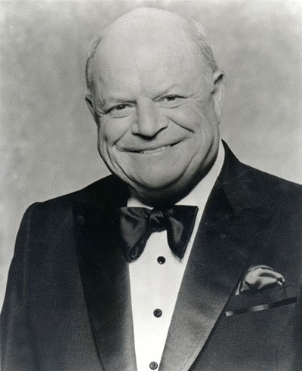 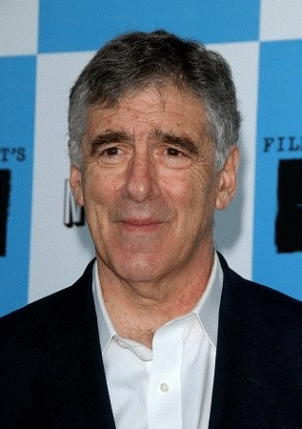

## Note the long and disproportionate lower jaw.

Also, with the Jew on the right in the color photo, the slanted down eyes. The Jews were at one time in Japan, many centuries ago and stole copiously from the Japanese religion of Shintoism. The suffix “KIN” on many Jewish surnames, such as “Rivkin” is the word for “gold” in Japanese. The little black box that orthodox Jews wear upon their foreheads was stolen from Shintoism, among other things.

## Note, though this Jewish girl has straight blonde hair, note her long jaw and pointed chin. Also, her classic Jewish nose.

2

Index of Jewish Surnames/Last Names add-on here.

The suffix “KIN” on many Jewish surnames, such as “Rivkin” is the word for “gold” in Japanese. Any name with a “KIN” on the end is Jewish.

Another suffix is “EL.” As in “Edel.” The “EL” can also occur in the middle of the Jewish surname as with Edelman/n, Edelsberg, Edelstein, etc.

For a list of Jewish surnames, please see How to Recognize and Identify a Jew, Part 2.

Please be aware, as several rabbis have written, the Jewish modus operandi is to “CONQUER FROM WITHIN.” They have been doing this for centuries. Nearly all NS groups, groups that are racially aware and onto the Jewish menace are infiltrated by Jews. They kiss ass, and work their way up to positions of influence and power and then proceed to rot the organization out from the inside. Racial background and color does not matter. Jews took down Black leader Marcus Garvey who was against them and advocated racial separation.

They work relentlessly to gain trust, especially the trust of those who are in positions of power. They will try to get members to commit crimes and related so they wind up in prison. Anyone in prison is no threat to the Jewish regime.

One prominent White racialist is now serving some 40 years in prison. He was deliberately framed. Jews went as far as they staged a life threatening attack on him, of which one infiltrator “saved” his life. The entire deal was a false set up. This unfortunately gained his trust. The infiltrator then proceeded to get him to reply to a statement in a way that was seriously twisted and he is now in prison.

Every organization that is Jewish aware has been taken down this way, or seriously compromised. Idiots who support Christianity, Islam, and other Jewish “religious” programs only open themselves to Jewish curses. Do some research. Very few if any died of natural causes.

[www.exposingchristianity.com](http://www.exposingchristianity.com/)

3

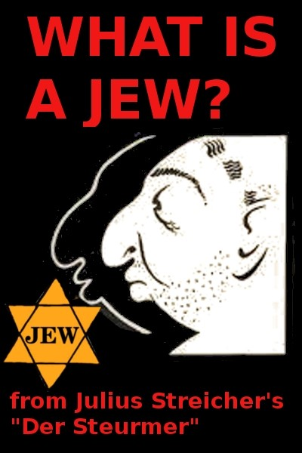

**What is a Jew?**

###### by Der Stürmer

**Jews: A Race? A Historically-Inbred Ethnic Group? A Religion? Or All Three?**

**A**re Jews a race? Yes…and no. Yes, they are people related by DNA or genes. But most anthropologists do not classify Jews as a race, or a subrace, since a) Ashkenazim Jews, i.e. most, Jews are a racial hybrid, and b) calling Jews anything other than a religion has been taboo since WWII. Further, that question “are Jews a race?” depends on the/your scientific definition of the word “race” [subspecies]. The term “ethnic group” is probably more accurate in describing the Jew, although “race” can also be used.

[A word needs to be said about the field of Anthropology and Jews. An anthropologist informed us that when he studied anthropology in the 1950s, Jews were not referred to as anything other than a religion, and he said that that feature is still true today. We call this non-mention of Jews as an ethnic group by the anthropology field dishonest and politically-motivated].

Someone on the web mentioned that [paraphrasing] “Jews function as a race, so they are a race, regardless of what modern science calls them.” Indeed. Jews are more cohesive and unified than any other ethnic group, so that is a great description of the Jews. Thanks, somebody.

*Furthermore, the word “White” means White European. In other words, a White person’s ancestors originally came from a White European country, such as England, Germany, France, etc. Some Jews may appear to be White. In other words, they may have light-colored skin and light-colored hair. That does not make them White, however. Only genetics makes a person White. The Jews are not genetically White.* [One of the reasons that the Jews have been so successful in the Western countries is that they sometimes appear to be White].

White gentiles should hopefully be able to recognize Jewish people based upon their physical appearance, but granted, this is not always possible. However, Jews often have features that identify them as being Jewish by race. The majority of Jews do share common physical features — especially in their faces and/or craniums [skulls].

###### Brief History of the Jews

Jews originally came from the tribe of Judah/Judahites back in old Canaan or Palestine. The Judah tribe was banished from the other Israelite tribes in about 950 BC. In 70 AD, the Romans destroyed Jerusalem, and did so again in 134 AD, compelling Jews as a people to scatter in the wind. Some of those Jews made their way to Europe, others stayed closer to their original homeland.

There are two main types of Jews. Most Jews in America and Europe are Ashkenazim, aka “Eastern European” or “Russian” Jews.

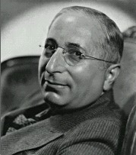

###### Typical Jewish appearance: large nose that curves downward, weak chin, sloped forehead, ‘pinched’ facial appearance

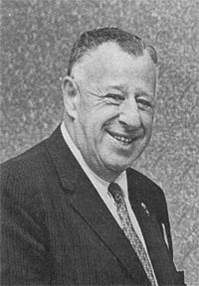

**Typical Jewish appearance, including large ears that protrude away from the head and a heavy, ‘fleshy-looking’ face. Some people in the White Nationalist movement have called this traditional Jewish facial appearance “rodent-like,” although some Whites may find that description tasteless**

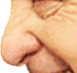

###### Above: typical Jewish nose, curving downward at the tip

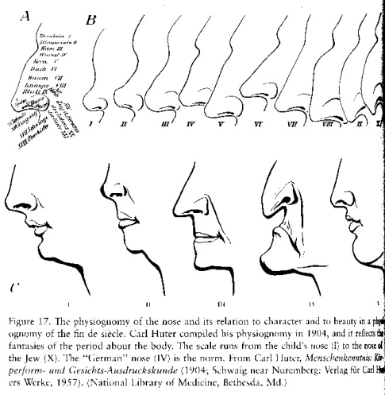

**Ashkenazim Jews are a hybrid race by long interbreeding, their major ethnicities being Arab + Armenid [Armenid is also sometimes called Hittite or Subarian]. According to Oxford University’s Dr. John R. Baker, “the evidence from blood-groups bears on the theory that the Ashkenazim have both Armenids and Orientalids [“Orientalids” is Dr. Baker’s word for Arabs] for ancestors.” — from Baker’s book *Race*, [see below], page 242, hardcover.**

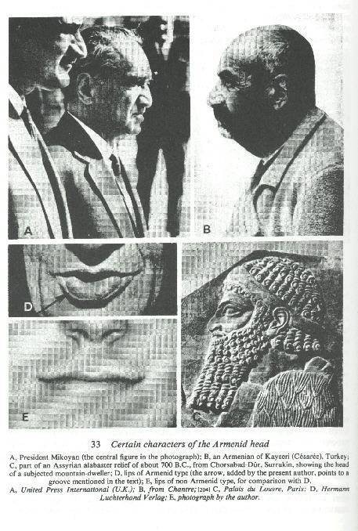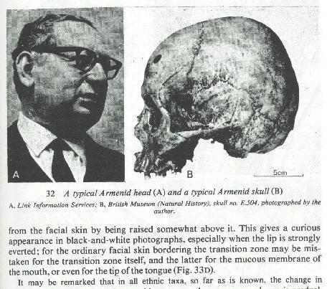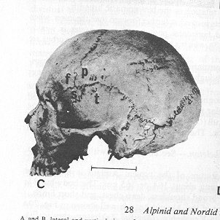

###### Compare White skull above to Armenid/Jewish skull — White skull has longer rear portion, whereas Armenid/Jew skull looks as if the back of the head were “sawed-off.”

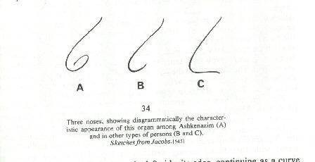

The other, comparatively rarer type of Jew is the Sephardim, also known as “Mediterranean,” or “Spanish,” or “Portuguese,” or “North African” Jews. These Jews lived mostly near the Mediterranean Sea. Sephardim Jews also lived in Iraq (Babylon), Syria, Greece, Turkey, and in the Americas, especially South America. Furthermore, Sephardic Jews lived in Palestine long before the European Zionist movement. Only about 10% of all Jews worldwide are Sephardim; the rest are Ashkenazim. Sephardim are more closely related to Arabs, while Ashkenazim are more related to Armenids/Hittites/ Assyrians.

According to Dr. Baker, “when it is said that a person has a Jewish appearance, the speaker usually has persons of Ashkenazic stock in mind. The members of this group are the typical Jews of Russia, Poland, and England, and they constitute the great majority, perhaps 90%, of all the people in the world to whom the name of Jews is applied.” — from *Race*, page 238, hardcover.

In 1492, Jews were expelled from Spain. Portugal expelled her Jews five years later. Some Spanish and Portuguese Jews converted to Christianity, and these Jews were referred to as “Marranos” by Jews who had left Spain/Portugal but kept their faith. Later, as the new converts began to gain power and social status, these “New Christians” become suspect by the “Old Christians” in Spanish society as being insincere converts. They were then called Crypto Jews, or Anusim — Jews who still practiced Judaism in secret.

It is the opinion of many gentiles that there are many Crypto or Marrano — also called “converso” — Jews in positions of power all over the West, but that few gentiles know of these hidden Jews’ real ethnic heritage.

Despite their geographical dispersion, however, all Jews are genetically similar to a remarkable degree, given their diaspora and the chance, seldom taken, to mix blood with surrounding populations.

[Also of note is that a U.N.-sponsored body listed “Jewish” as being only a religion in 1951 — no doubt for political purposes, since WWII had just ended a few years previously. John Baker shows that

Jews are indeed an ethnic group related by race, although he says that they are not a subrace since some people of Armenid descent are not Jewish].

The question “who is a Jew?” has a simple answer: anyone whose birth mother was Jewish by race — i.e., not a convert to Judaism; or, cleverly, the few people who convert to Judaism. Under Israel’s Law of Return [1], a gentile who converts to Judaism can immigrate to Israel. However, conversion to Judaism is rare and difficult by design, and such converts are not considered to be “true Jews.” It is the opinion of many that Jews “allow” converts so as to make Jews appear, to outsiders, to be “not a race, only a religion.” Such a feature also allows Jews to deflect the charge that Israel is “a race-based state.”

1. quote from Israel’s amended Law of Return: “Definition 4B. For the purposes of this Law, “Jew” means a person who was born of a Jewish mother or has become converted to Judaism and who is not a member of another religion.” — Law of Return (Amendment No. 2) 5730-1970*; Addition of sections 4A and 4B apparently occurred in 1970.

——————————————

###### Facial/Cranial Features of Ashkenazim Jews

[Note that not all Jews have the physical features listed below]

* 1. **A)** Ashkenazim Jews have a long, large nose — one that differs from Italian-type noses by the fact that it often curves downward at the tip; the nose often has a noticeable “hump” on the top portion of it, if viewed in profile; the nose often resembles the number “6,” if viewed with the grooves of the “wings” of the nose, in profile [2]. Further, some gentiles have commented that Jews often have a facial appearance that seems “pinched,” as if God had taken their faces between his thumb and fingers and then squeezed.
  2. **B)** The forehead and temples of the skull recede quickly. In other words, the forehead and temples begin to slope or curve almost immediately, whereas in Whites those areas are more “wall-like” and vertical. Studies of Jewish skull shapes show that most Jews are either a) not Semitic; or b) only partly Semitic. Instead, they are Armenid/Hittite in their skull shapes [3]. This means that the term “anti-Semitism” does not really apply to Jews [also 3]. Further, many Ashkenazim Jews have short heads, as compared to Europeans.
  3. **C)** The ears of Ashkenazim Jews are usually larger than a gentile’s, especially the upper ear, and the ears often stick out, away from the head; this, combined with their large noses, often gives Jews a “rat-like” or “rodent-like” appearance. This “rodent-like” appearance is more noticeable when they smile.
  4. **D)** Mouth opening/lips often larger than normal.
  5. **E)** The eyes are sometimes slightly Asian in appearance, i.e. slightly more “squinted” than a European’s. This is more noticeable when they smile, squeezing their eyes shut even more than a gentile’s. Eyelids, especially the lower ones, are more puffed-out and “fleshy” than a European’s.
  6. **F)** Jews usually have a “weak chin” that does not jut out.
  7. **G)** Jews usually have legs and arms that are, proportionately speaking, rather short.
  8. **H)** Their head hair is usually curlier, and darker, than a gentiles; further, Jews often cannot grow heavy beards; their beards are often scraggly and frizzy instead.

1. source: book *Race*, by Dr. John R. Baker, Oxford University Press/FHU; 1974/1981; pages 232ff, hardcover. This book is considered by many to be the most detailed book ever written about the various human races. It includes many photos and diagrams.
2. “Luschan holds that the hook-nose is by no means characteristic of the Semites, and contends that the number of arched noses that are found among the Jews is due to ancient intermixture with the Hittites in Asia Minor. He shows that other races also, as the Armenian, for instance, who have a good portion of Hittite blood in their veins, have hook-noses” (Jewish Encyclopedia IX [1905], 338). Also: “The relation of the breadth of the nose to its length, known as the ‘nasal index,’ has been considered one of the best means of distinguishing the various races of mankind.” (Jew. Enc. IX [1905], 339). And, “The nose is generally the characteristic feature of the Jews, who have, on the average, the longest (77 ram) and narrowest (34 mm)” (Jew. Enc. I [1901], 619).
3. “The most important problem suggested by a study of craniometrical results concerning Jews is the relation of the type head of the modern Jews to that of the ancient Hebrews and to the modern Semitic skulls. The pure Semitic skull is dolichocephalic [long-headed], as may be seen from a study of the heads of modern Arabs, Abyssinians, Syrians …. The only way the type of the head may change is by intermixture with other races. If the ancient Hebrews were of the same stock as the modern non-Jewish Semites, and if the modern Jews are their descendants, then a pure dolichocephalic type of head would be expected among the Jews. As has been seen, all results of craniometry prove that the Jews are brachycephalic [broad-headed], and that the dolichocephalic form is only found among them in less than two percent of the cases” (Jewish Encyclopedia IV [1902], 335). Also, “Some anthropologists are inclined to associate the racial origins of the Jews, not with the Semites, whose language they adopted, but with the Armenians and Hittites of Mesopotamia, whose broad skulls and cuffed noses they appear to have inherited” (Jew. Enc. X [1903], 264). Dr. John Baker’s modern book *Race* also calls Jews brachycephalic instead of dolichocephalic.

###### Some Common Psychological Characteristics of Jews

While humans vary in their personalities and behavior, Jews often display distinctive behavior patterns.

Listed below are their more well-known behaviors:

* 1. Jews often have a superiority complex, believing that they are superior to gentiles.
  2. Jews are known to complain about life’s daily hardships more than gentiles.
  3. Jews are known to be more paranoid than gentiles, often believing that gentiles are “out to get them simply because they are Jewish.”
  4. Disloyalty towards non-Jewish persons and governments is a frequent feature among Jews.
  5. Jews are often obsessed with scatological [fecal] subjects, e.g., human fecal- and urine-based humor. Further, Jews do not value “moral” behavior as Whites do, since their ancestors and relatives did not embrace the Christian socioreligious concept of “moral vs. immoral” behavior.
  6. Jews, due to their unique history, have an uncanny ability to manage money and financial resources. Indeed, Jews seem obsessed with money and finance, and further, Judaism is a very materialistic religion that obsesses over valuable commodities.
  7. Jews see themselves as physically unattractive; indeed, Jewish women often reduce the size of their noses via plastic surgery.
  8. Jews seem to have an inborn dislike of anything culturally “European” or “White,” be it art, literature, music, film, etc., and further, Jews seem to delight in criticizing such White cultural features.
  9. Jews have a predisposition to thinking and acting in human “group” terms, i.e. “which social/political action is best for Jews?” This is an opposing feature as compared to Western gentiles, who have been trained to think as “individuals.”
  10. Jews seem to have an inability to believe that Jews might engage in any wrongdoing. Any gentile accusing any Jew of criminal or unethical behavior is automatically wrong in the eyes of Jews. Jews can never be guilty of anything, according to most Jews.

***SLAY THE SERPENT!***

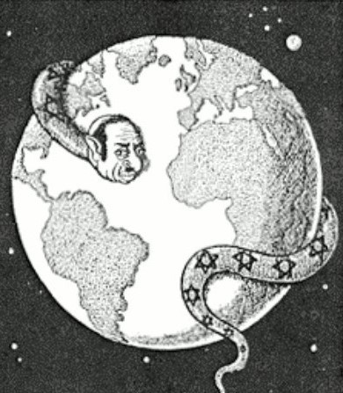

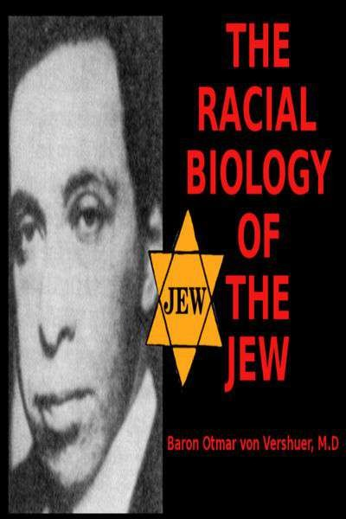

**The Racial Biology of the Jews**

By Baron Otmar von Verschuer, M.D. TRANSLATOR'S INTRODUCTION (Charles E. Weber, Ph.D.)

The following article was taken from Volume III (1938) of the very important series, Forschungen zur Judenfrage (Studies on the Jewish Problem), the first six volumes of which were published by the Hanseatische Verlagsanstalt in Hamburg during 1937 to 1941. The nearly fifty articles in these six volumes represent the thinking on the Jewish question by some of the best German minds of that time. The authors of the articles were specialists, in some cases internationally known specialists, in a variety of fields, including anthropology, demography, genealogy, genetics, history, law, literary scholarship, musicology, philosophy and theology. The earlier articles in the series were given as lectures before meetings of the Reichsinstitut für die Geschichte des neuen Deutschlands, Forschungsabteilung Judenfrage (National Institute for the History of the New Germany, Research Division for the Jewish Problem). It is not at all difficult to imagine that the research efforts which went into these articles cost the erstwhile German government hundreds of thousands, if not millions of Reichsmark.

Although the research was subsidized by the National Socialist government, the tone of the articles is by no means generally and uniformly hostile to Jews. Baron von Verschuer's article, for example, is nearly free of value judgments and it concedes in a number of passages that Jews have special strengths characteristic of their race.

By 1936 a number of circumstances had converged which made possible the publishing of this large body of research by non-Jews on the Jewish question. Such a constellation is highly unlikely ever to appear in the sky again, certainly not in our lifetime, and that is a fact which in itself gives these volumes a unique position and value in the serious study of the Jewish question. One circumstance was the importance which the German government attached at that time to the Jewish question and its willingness to allocate considerable economic resources to the study of the question in an attempt to find a constructive solution to it. This circumstance was combined with the willingness and ability of German scientists and scholars to come to grips with the Jewish problem as far as their areas of expertise were concerned. Perhaps most important, however, was the circumstance that there were individuals who had the vision and ability to organize such efforts. Especially noteworthy was Dr. Karl Alexander von Müller (1882-1964), who, was a history professor at the University of Munich from 1917 to 1945 and who also became President of the Bavarian Academy of Sciences. Not only did he publish a number of notable books between 1923 and 1949, but he also published the Historische Zeitschrift during the years 1933-1945. His student, Walter Frank (1905-1945), became President of the above-mentioned Reichsinstitut für die Geschichte des neuen Deutschlands. We encounter Frank's vivid and interesting exposition of the objectives of

the Forschungsabteilung at the beginning of the first volume of the series. One need only read Frank's sixteen-page address to understand the attitude toward the Jewish problem held by many middle class Europeans in its historical perspective.

It would be difficult to imagine that the present generation of effete, career-oriented, intimidated American academic types could ever produce a series similar to the Forschungen zur Judenfrage. The American academic establishment has been far too seriously corrupted by funds from Washington and Jewish donors. Fortunately, not all American scholars kowtow. There are individual Americans in academic life who have shown the courage, vision, ability and integrity necessary to challenge some of the historical and anthropological myths which have been used with cynically evil calculation to manipulate American public opinion. Such scholars have been harassed and in some cases even dismissed from their hard-earned positions which required many years of professional preparation.

Even the most philo-Semitic of readers will have to concede the historical value, if nothing else, of the Forschungen zur Judenfrage because they throw penetrating light on the European attitudes toward Jews during the 1920s and 1930s and how they came about. Many Jews, but not all of them, would have us believe that they were just the convenient victims of a scapegoat mentality, prevalent especially in the defeated nations of Europe after 1918. However, this is a grossly oversimplified, self-serving explanation that disregards a number of strong historical forces, such as the great and justifiable fear which the European middle classes had of the barbarically cruel Communist government which had been installed over the former Russian Empire and which was correctly sensed as an essentially Jewish government.

As a result of the energetic book burning and intellectual intimidation on the part of officials of the powers which occupied Germany beginning in 1945 after the tragic, unnecessary and fratricidal Second World, War, these volumes are especially scarce. The number of known copies in the United States could very well be Ins than a dozen. I have learned that they are in strong demand and are being sold at high prices in the German book trade.

The first article I have chosen for translation is certainly one of the most important in the series and perhaps one of the most interesting ones for the American reader concerned with the Jewish question. It deals with genetically determined characteristics which, in their totality, differentiate Jews from other races Many Jews, but by no means all of them, have energetically sought to deny that such genetically determined differences exist, or at least they have sought to deny to non-Jews the existence of such differences, even if they themselves are consciously or subconsciously aware of them. Here we need only think of Franz Boas (1858-1942) and his all too influential school of anthropology.

The author of this incisive article, Otmar Freiherr von Verschuer (1896-1969), had a distinguished career in the study of human genetics. From 1927 to 1935 he was a division chief of the Kaiser Wilhelm Institute for Anthropology, Human Genetics and Eugenics in Berlin and during 1942 to 1945 he was its director. He published studies of tuberculosis

in twins in 1933. His Eugenik was published in 1966. Baron von Verschuer also held professorial posts in Frankfurt am Main, Berlin and Münster. The second edition of his layman's manual on hereditary diseases and eugenic measures, Leitfaden der Rassenhygiene, was published in 1944.

When reading von Verschuer's Rassenbiologie der Juden we must bear in mind that it was written nearly a half century ago. I have not chosen to modernize his vocabulary or use such fashionable euphemisms as "mental retardation" for "feeblemindedness" (Schwachsinn).

Lest it be thought that von Verschuer was simply summarizing his own subjective observations or was exclusively dependent on materials published after 1933, we need only note that nearly all of the literature cited in the valuable bibliography at the end of the article originated before 1933 and that many of its authors would seem to be Jewish.

Since the center of gravity of the Jewish problem has passed from Europe to North America, especially during the course of the twentieth century, it is now high time that some of the best non-Jewish research ever done on the Jewish problem be made available to English-speaking readers. Even just the titles and the names of the authors make exciting reading for those who wish to acquire a deeper knowledge of the roots of one of the gravest and most pressing of American national problems. In order to convey a hint of the breadth and depth of the articles in the Forschungen zur Judenfrage we shall list the original titles and their English equivalents after the conclusion of the article by Baron von Verschuer.

Finally let me recommend to Jews themselves that they read and reflect on the Forschungen zur Judenfrage, for these studies contain many astute observations and much valuable historical information as seen through the eyes of outstanding non-Jewish scholars. The Jews' persistence in blind hatred of their host populations, their insensitivity to or even total disregard of the sufferings of their victims, their ruthless use of the media which they now largely control, their insidious but shortsighted attempts to destroy the mores of their host populations, their disregard of the lessons of history and their arrogant presumption of their own moral superiority can only render impossible a constructive, nonviolent solution to the Jewish Problem.

#### RACIAL BIOLOGY OF THE JEWS

by Baron Otmar von Verschuer, M.D.

"Jewry was and is a religion -- but never a race" is the final conclusion at which the Jew

M. Fishberg arrives in his book, Die Rassenmerkmale der Juden (The Racial Characteristics of Jews), Munich, 1913. A large number of similar opinions of Jewish authors could be quoted additionally. Among the opinions of Jewish authors, however, there are also opposing ones. Thus, we find in the book by F.A. Theilhaber, Der Untergang der deutschen Juden (The Decline of German Jews), Munich, 1911, the remarkable passage: "Inbreeding guarantees the only objective Jewish identification and maintains the racial nature of Jews while the adherence to the Jewish religion represents the subjective aspect of belonging to the Jewish group." Thus, within the Jews' own ranks there is not only to be found denial but also recognition of the racial aspect as their own identification and differentiation from their host populations.

Much confusion has been caused by the improper formulation of the question, "Are Jews a race?" The term "race," a systemic race [Systemrasse], as it has been established by scientific anthropology, cannot immediately be applied to Jews. As we heard in the lecture by Professor Fischer ["Rassenentstehung und äteste Rassengeschichte der Hebräer" (Racial Origin and Earliest Racial History of the Hebrews), Forschungen zur Judenfrage, Volume III, pp. 121-136], the Jews have developed from various racial roots. They consist of a number of races which are contrasted as a foreign element to the races of our nation. By means of this simple formulation we have not yet sufficiently grasped the racio-biological problem of the Jews as we encounter it today. The racial history of the Jews during the past 2,000 years must be taken into consideration. The inherently astonishing phenomenon that an ethnic group could preserve itself so long without a territory (the Teutons lost their ethnic identity in southeastern Europe and northern Africa within centuries -- the Nordic racial admixture which the Teutons imparted to those countries can be noticed even today) has been explained too unilaterally simply by the racial characteristics of Jews and their genetic isolation. The communality of religion, the special education through the Talmud and the idea of being a chosen people have maintained themselves with such force that during the course of history individuals and even groups of people could be absorbed into Jewry by marriage and conversion without their being any change in the characteristics of Jews. Taken as a whole, the Jews have remained racially isolated within the other nations.

Quite contradictory conclusions have been drawn from the history of the Jews for the judging of the racial question: Some emphasize the preservation of the original racial character while others speak of an "adaptation" of the Jews to the racial characteristics of their host populations. The attempt is made to substantiate this by individual pictures of "Nordic," "Ethiopian," "Indian" or even "Mongolian" Jews. Even the strictest laws cannot erect any absolute barriers between human beings when they live together, "Border

crossings" cannot be avoided forever and the occurrence of persons of mixed race is the result. (I am grateful to Karl Georg Kuhn for pointing out that in some cases it also could be a matter of missionized Jews.)

In order not to encumber the investigation of the racial biology of modem Jews with any hypotheses, I shall first give a description of the Jews simply confined to those living in central Europe. The purpose of this description shall be to separate the genetic from the non-genetic characteristics in order to reach the objective of recognizing the genetic differences between Germans and Jews (I.e., persons of German extraction -- "of German or racially related heritage." [Translator's note: The phrase "deutschen oder arterwandten Blutes" is a formulation taken from the German racial laws of 1935].) From this position of hereditary biological makeup, which has its foundation in laws of nature that are generally recognized today, it will be easier to arrive at a clear insight into the racial- biological problem of the Jewish question.

If two groups of human beings are compared with one another, it must first be observed that every characteristic within a group has a certain more or less wide-ranging variational latitude. A distinguishing difference in a characteristic is then present if the variational latitude of the one group does not overlap with that of the other group, i.e., characteristics of the one group do not occur in the other group. The observation of such a characteristic then clearly establishes the membership of a human being. Such characteristics that are absolutely typical of a race are, for example, the black skin color of the Negro races, the "fil-fil" or peppercorn hair of the Bushmen and the slanting upper eyelid fold of the Mongolians. These characteristics do not occur among persons of German extraction. By such characteristics one would immediately be able to recognize the strain of a foreign race. Such an individual characteristic by which a Jew could be recognized with absolute certainty is not known.

All individual characteristics of the German racial groups are also found in individual Jews and characteristics typical of Jews do not prove with certainty a Jewish strain in the ancestry of a person of German extraction when they occur isolated in him. The racial characteristics of the Jews (preponderantly Near Eastern-Oriental) can also have come to us through non-Jews in individual cases. Obviously, those are rare exceptions; as a rule we are correct in our racial diagnosis, which, however, is always based on the observation of typical combinations of characteristics.

Between a group of Germans and a group of Jews the differences can easily be observed because the distribution curve in many characteristics is a clearly different one. The mean values are different as well as characteristic types which occur with greatest frequency.

Nevertheless the curves of distribution of characteristics overlap. It is thus a question of gradual differences as they are, in most cases, expressed in frequency differences. A decision from the characteristic as to the membership in one group or the other can then be made only with greater or lesser probability.

After these general preliminary remarks, we are going to discuss the characteristics, one by one, by which the Jews are differentiated from the persons of German extraction. As

the first group of characteristics we shall observe the normal physical features, the racial characteristics in the narrower sense of the word. Thereafter the sicknesses and the psychological characteristics, will undergo a discussion.

As the medium height of the Jews, values between 161 cm and 164 cm [2.54 cm=1 inch] are found for the male sex. If we compare this measurement with the anthropological data which are recorded in Deutsche Rassenkunde ("German Anthropology"), published by Eugen Fischer and now comprising 16 volumes, we find that all German comparative groups have a higher average height, between 166 cm and 173 cm. Height of the body is, aside from certain environmental variations, a preponderantly genetically determined characteristic.

During the course of growth, differences occur by virtue of the fact that rather generally sexual maturity begins earlier in the case of the Jews. The beginning of menstruation in the case of Jewesses occurs 1/2 to 1 year earlier than in groups in comparable climatic and social circumstances. Even if the onset of puberty is changed by external influences such as climate, urban life and occupational activity, racial differences manifest themselves. The early maturity of Jewish children is manifested in the physical as well as psychological areas.

In the growth ratios of the body the Jew is characterized as follows: In relation to the length of the torso the length of the legs is not as great, frequently resulting in the impression of a squat build. The arms are also relatively short. Hands and feet are often narrow. On the legs, which are frequently crooked, a weak calf musculature is often quite noticeable. The musculature and connective tissue exhibit a flabbiness which is caused in part by a lack of use and bodily exercise, but also in part by a hereditary tendency. As a result of these factors, one often observes a flat chest, a round back, a limp posture and the so frequent tendency to flat feet. According to Salaman, among the enlisted men of the English army during the war flat feet were found in a frequency of 1 to 40 in the English soldiers and in a frequency of 1 to 6 in the Jewish soldiers. Of course, these body ratios have an effect on the gait, which is described as soft or slinking, or, as groping, dragging or shuffling.

The head of the Jew is of medium size. In the majority of cases it is short to medium. The comparable German groups show in part larger measurements, and some groups also narrower heads in the length-breadth ratio without the differences being particularly noticeable.

Pronounced differences can be seen in the soft parts of the face. In the case of Jews, to some extent (more commonly in the case of young people and the female sex), the "almond eye" characteristic of the oriental race is found. The inner comer of the eye is inclined to be round, while the outer comer is inclined to be pointed and turned up toward the outside. The upper lid is often described as thickened and of a heavy appearance.

In most cases the lips are somewhat fleshy, often puffed up, and above all the outward- hanging lower lip is noticeable, which is in conjunction with the high position of the

furrow of the lower chin lip.

The "Jewish nose" has been described rather often. It is characterized by the fact that the tip of the nose is hook-shaped and beat downward and the sides of the nose are drawn upward. Viewed from the side, the shape of a "6" thus results with a stroke extended upwards. The sides of the nose are characterized by a special fleshiness, the cartilage of the tip of the nose is rather thick and the nasal septum sags downwards. Only a minority of Jews have this nasal form, which, for example, is not only characteristic of Jews but also the Near Eastern race. In addition to the course, thick and hooked "Jewish nose" there is also found the narrow, gently curved nose of the oriental race.

The ear is often described as especially "fleshy," relatively large and jughandle-like.

The skin of the Jews is often lacking in a ruddy color and of a light yellow, dull color, which often appears especially light in contrast to the dark color of the hair.

According to more recent investigations, the various human races are differentiated in the patterns of the side lines of the finger tips, and probably also of the surfaces of the hands and feet. From a table compiled by Fischer it is to be observed that the Jews occupy a special position among the European groups; they have more of the whorl pattern and less of the loop pattern. The pattern formation of the skin lines is essentially determined by special hereditary factors, it is completed after the first two to three months of the development of the embryo and it is not alterable by later environmental influences.

Thus, a new proof of the distinct racial position of the Jews is to be seen in this observed difference from the European nations, which is greatest in contrast to the predominantly Nordic nations.

The color of the hair and of the eyes is darker on the average than in our case. Hair colors between brown and black and brown eyes are encountered most frequently. For many Jewish groups, a relatively large portion of red-haired persons is alleged (between 3% and 6% according to Martin), while in the case of Virchow's investigation of school children only 0.5% of Jewish children were observed to be red-haired. Redness of hair is often associated with strikingly white skin and an increased formation of freckles. Blond hair and blue eyes are not a rarity amongst Jews, however. In the case of the investigation of school children during the years 1874-1877 initiated by Virchow, amongst all school children in the German Empire, including the Jewish children, there were found 31.8% with light skin, blond hair and blue eyes, and amongst the Jewish children alone there were 11.17%. Altogether, children with dark skin, dark hair and dark eyes were found at a ratio of 14.35%, while the ratio was 42% amongst the Jewish school children.

The question does not have to be discussed here in detail as to whether the blond people and the people with light eyes were to be found with a similar frequency amongst the Jews even of ancient times or whether they were absorbed by the Jews at a later time. I concur with Günther's view that a strain of the Nordic race must not be seen as a primary factor in the light pigments amongst the Jews, but that it is mostly a matter of strains of the East Baltic race. Fischer also thinks of a mutational new origin of the hereditary

makeup.

The form of the head hair in the case of Jews is less frequently straight and more frequently twisted in a spiral manner than is the case with German ethnic groups. The black head hair, which is twisted in a closely spiral manner and which is still occasionally encountered amongst Jews, is viewed as a result of an earlier Negroid admixture.

The body hair cover and the beard growth are often especially strong amongst Jews. Occasionally the border of the head hair ends in a downward point over the middle of the forehead.

The differences in characteristics of movement and gestures are more difficult to set forth in an objective, scientific manner than the differences in morphological characteristics, although the former, in particular, are especially strongly noticeable as a pure impression and are also striking to the layman. The fact that the Jews are different from us in typical movements and gestures is not doubted by Jews themselves. I quote two statements by Walther Rathenau: "A strange vision! In the midst of German life a separate, foreign kind of human beings, brilliantly and strikingly attired, with a hot-blooded, mobile behavior! An Asiatic horde on the sand of the March [i.e., Brandenburg]!" In another passage he says of the Jew: "It is difficult for him to find the happy mean between tail-wagging subordination and nasty arrogance." We have already spoken of the general lax body stance. Günther describes [the following] as characteristic: "The movements of the head often have a rocking aspect, just as the movements of the shoulder area, which gives the impression of something padded in the case of many Jews. In the case of many Jews the head appears pushed forward along with the neck, so that the collar is at some distance from the neck." "The arm movements of many Jews are characterized by the fact that the upper arm is closer to the thorax down to the elbow, while the lower arm gives a lively accompaniment to speaking with its movements." An alert observer will recognize the Jew amongst people on the street by his gait and by movements, even in the case of actors. The fact that in the kind of movement of a human being there is much which is hereditary, and thus of racial origin, has been demonstrated by observations of families and twins as well as comparative racial studies.

It is difficult to answer the question as to what extent the peculiar manner of speaking of many Jews, the "jabbering," must be viewed as an hereditary tendency or as something which has originated through education and other environmental influences.

It has also been claimed by various sources that the Jews are characterized by a particular "racial scent." It is difficult to judge what is attributable in this regard to environmental influences, such as living quarters, clothing, occupational activity, cleaning of the body and the composition of food; one need only think of the consumption of garlic, which the Jews like. The secretion of odorous substances takes place through the so-called apocrine glands, which form part of the sweat glands and are differentiated from the sweat glands by several features. They are to be found only at particular places on the body. They are supposed to be present to a greater extent among the colored races and the Jews, especially of the female sex (Leven, according to Schubert).

It has thus far been impossible to distinguish between Jews and non-Jews on the basis of the characteristics of their blood. In 1925 Manoiloff published an article, according to which he believes he can distinguish between the blood of Jews and that of Russians on the basis of a different coloration with cresol violet. Further data on the process have not been published. Subsequent investigations appear to have been without success. The investigation of blood groups, which was all the rage for a while, has not furnished us with any new method for differentiating human races. Only the proportion of the blood group hereditary characteristics is different in the racial groups. In this incidence the Jews occupy a position between Near Eastern and oriental groups, which is quite in keeping with our conception of the racial origin of Jews. The Jews are differentiated from the German population only by a somewhat higher proportion of blood group B.

On the whole, from the comparison of physical racial characteristics it is clear that the Jews living in Germany are quite distinct from the German population. Since it is a question of characteristics which are quite essentially genetically determined, the observed difference cannot be caused by external influences of any kind; the difference can only be explained by the different racial origin of the Germans on the one hand and of the Jews on the other hand. The characteristics which are considered typical of the present-day Jew and by which we can recognize him in his outward appearance, point to the Near Eastern and oriental-Mediterranean races. Hence, the results of research on racial history and those of the racial-biological examination of the Jews of the present time are in keeping with each other. The racial types of the Near Eastern and oriental races, known as Ashkenazim and Sephardim are still found today amongst the European Jews. The Ashkenazic type is the predominant one amongst the Jews in Germany.

Obviously, it must not be expected that every Jew can be classified as one of these types; this is possible only for a minority of them. Quite incorrectly there has been a tendency to see in this circumstance an "adaptation" to the environment or the host populations!

The distribution of racial characteristics and the divergence from typical combinations of characteristics in the present-day populations is a rather general phenomenon. Let us simply consider our own nation: How many exhibit in their physical appearance, for example (not to mention at all the psychological characteristics), the "pure" type of the Nordic race, which, after all, forms the basic component of our entire nation? If a group of people of another race is absorbed in another population (let us assume of an originally uniform race) and if finally a state of being completely mixed comes about, then the correlation between the characteristics of the two races is dissolved, that is, for example, the characteristic of blue eyes of the first race as well as the characteristics of dolichocephalism and smooth hair of the first race can be combined just as with the characteristics of brachycephalism and wavy hair of the second race. The frequency with which such "harmonic" or "unharmonic" combinations occur is then determined only by the frequency of the characteristics. In the case of the individual person, then, (in a state of being completely mixed) the presence of other characteristics of this race cannot be ascertained off hand from the one characteristic. For this reason the heritage of the

Nordic race must not be sought in special "purity" only in those who conform to the racial pattern in the characteristics of the external physical type. Someone can display "defects" in comparison with this racial pattern (such as a round head or brown eyes) and still be quite preponderantly of the Nordic race; and vice versa a good Nordic type can exhibit in one instance a complete lack of Nordic characteristics in his psychological behavior.

On the basis of these general racial-biological investigations we understand the lack of uniformity in the physical racial pattern of the Jews. Various racial springs have flowed together in them. For that reason "pure" types of the Near Eastern race or oriental race are now only seldom to be found amongst them. Most Jews can indeed be recognized as to their racial origin and type by several physical characteristics. [Being a member of a foreign race cannot be circumvented by "assimilation." For that reason Jews who favor assimilation (Assimilationsjuden) are especially inclined to admit the possibility of the change of racial characteristics by the environment.] However, there are also Jews who cannot be recognized as such by their external appearance. Mind you, those are not, for instance, especially well "adapted" and especially slightly "Jewish" Jews! They are types of combinations which have simply remained free of the physical characteristics by which we recognize the Jew externally. There are not any indications of the other Jewish characteristics, especially the psychological ones, which can be inferred from them. It is therefore of little consequence whether prominent persons of intellectual Jewry can be recognized as Jews also in their purely physical characteristics or not. [There are rare cases of Jews by religion who are not Jews by race; under those circumstances, however, the conversion of the parents or grandparents, illegitimate origin or, if not those, adoption must be proved.]

We cannot cover the racial-biological problem of the Jews completely until we have examined the sicknesses and the normal psychological characteristics of Jews.

The different ways in which two human races are afflicted by diseases can be caused by three different groups of factors:

1. Pathological racial traits. Just as there are normal traits which characterize a race and differentiate it from the other human races, a racial difference can also be defined in terms of pathological hereditary traits. Up to the present there is no pathological hereditary trait known which occurs only in one race and in no other races. For that reason all differences of pathological racial traits can only be expressed in the different frequency of pathological hereditary traits.
2. Racial predisposition. A human race is characterized by the common possession of hereditary characteristics by which it differentiates itself from other races. A certain constitution of the whole body as well as of individual organs is necessarily concomitant with a particular susceptibility or, also, resistance in the presence of certain pathogenic influences. As a result of this the statistics give a varied frequency of diseases; the course of the disease and the kind of clinical picture can also bear a particular stamp in accordance with the racial predisposition.
3. Externally caused differences. Differences of two races in contracting illnesses can also be only apparently racially caused: Makeup of the soil, climatic conditions, exposure to infection, habitation, clothing, nutrition and occupational activity are seldom the same in the case of two races. However, in the evaluation of racial-pathological data they require extremely great attention.

In the following section only such observations are listed which have been confirmed by repeated investigations and which cannot find their explanation in various environmental influences.

The special need for physicians and the fear of disease on the part of Jews is confirmed by nearly all observers. Weissenburg speaks of nosophilia and nosophobia of Jews.

Psychopathic and in nervous persons go to their physicians more frequently, even on account of imagined illnesses, and, on the other hand, just the fear of sickness rather frequently leads to actually becoming sick. There is thus a close, alternating relationship of cause and effect. The especially strong sensitivity to pain on the part of Jews has also been noted.

The average life expectancy is a somewhat longer one in the case of Jews and correspondingly the mortality rate is lower, From this circumstance, we cannot conclude that Jews have a greater vitality, for instance. The statistical averages are strongly influenced by the mortality rates of infants and small children, which are lower in the case of Jews. However, this is essentially concomitant with the social milieu and the lower numbers of children of the Jews. Quite generally there exists a close connection between the number of children and the mortality ratios of infants and small children. A comparison of the age distribution, however, also shows a somewhat greater proportion of the highest age groups amongst the Jews. The cause of this must probably be seen in the fact that the Jews go to their physicians more frequently and sooner. Furthermore, they are afflicted by occupational injuries to a smaller extent.

The lower frequency of various infectious diseases amongst Jews must be explained as a result of the same factors, with the exception of tuberculosis, in the case of which a more profound cause is to be assumed. According to consistent statistical data concerning the occurrence of tuberculosis in Jews and non-Jews in various countries with various non- Jewish populations, and also taking into account the given social conditions, the results are consistent: In the case of Jews, the mortality from tuberculosis is a lower one, the course of the disease is slower and more favorable, less frequently do there come about exudative decomposition processes and more frequently there are found benign forms contained by the formation of connective tissue. It is well known that for the contracting of tuberculosis in a human being, and in particular for the course of the disease, an hereditary predisposition is of significantly contributing importance. On the basis of general epidemiological experiences, tuberculosis exhibits the character of an acute epidemic with a preponderantly rapid and grave course in the case of ethnic groups which come in contact with it for the first time. During the course of generations the sickness

takes on more and more the character of a chronic, insidious ethnic epidemic. Those who are predisposed are killed off by the disease with an increased incidence, in large part before the end of their reproductive age. For that reason the number of those who are resistant increases more and more in the population. There comes about that which is called a selective resistance. The Jews are now the race which has been exposed longest of all the races to the conditions of urban life. For that reason this race has been subjected longest to the selection process just described. The result is a genuine racial characteristic.

From the field of internal illnesses the frequency of diabetes in Jews is best known. For that reason diabetes has even been designated as the "Jewish disease." Having diabetes and dying from it are about four times as frequent in the case of Jews as in non-Jews.

Nutritional factors are of significance in the occurrence of diabetes. The decline of the disease during the famine years of the war and the postwar period is well known. A sufficient explanation for the difference between Jews and non-Jews is not furnished by that circumstance. The greater frequency of marriage of related persons in the case of Jews has been pointed out, by which recessive hereditary diseases appear more frequently. There is no doubt about the fact that bearers of rare recessive hereditary diseases are especially frequently the products of marriages between related persons. In this connection, however, diabetes is not a rare hereditary disease. In addition to the recessive hereditary process there is also the dominant one. For that reason I am inclined to assume that the hereditary tendency to diabetes occurs more frequently amongst Jews than amongst non-Jews.

Two further grave metabolic diseases, Gaucher's disease and Niemann-Pick's disease, in the case of which the metabolism of fatty substances is impaired, occur with greater frequency in Jews. A special form of grave feeble-mindedness, amaurotic idiocy, also belongs in the group of disturbances of the lipoid metabolism. The infantile form of this disease occurs predominantly in Jews from the East.

Diseases of the blood vessels, especially arteriosclerosis, are said to occur more frequently in Jews. As a result of the arteriosclerosis of certain leg vessels there occurs a disease which is known as intermittent limping. It has been observed especially frequently in Jews. Spontaneous gangrene, a gangrene of the limbs resulting from disturbances of the vessels, is also especially common in Jews.

The problem of race and cancer has frequently been worked on. A number of things which were originally viewed as racial difference have been explained differently when subjected to critical examination. Thus, much which was reported about differences between Jews and non-Jews should not be considered. No differences exist in the frequency of cancer. On the other hand, the places attacked by it are perhaps not the same in the case of individual races. There are consistent reports from numerous observers concerning the low frequency of cancer of the uterus in Jewesses.

In the national census of handicapped people of 1925 more blind and deaf-mute persons were enumerated amongst Jews than in the rest of the population. This difference is to be

attributed principally to a greater frequency of hereditary blindness and deafness amongst Jews. A more exact differentiation on the basis of the particular causative hereditary diseases is not yet possible. The only certain observation is the more frequent occurrence of glaucoma in Jews. Astigmatism is also reputed to be more frequent in Jews.

All investigators agree on a greater frequency of nervous and mental diseases in the case of the Jews. The organic nervous diseases are quite scarce and a statistical comparison is difficult for that reason. According to various reports Parkinson's disease (paralysis agitans) is especially common in Jews, while hereditary St. Vitus' dance is supposed to occur less commonly. Organic tics and bilateral athetoses, as well as hemicranic and neuralgic diseases, appear more frequently in Jews. Special investigations have been concerned with the shaping of the clinical picture of paralysis. During these it was noticed that in the case of the Jews the cheerfully excited, manic conditions occurred more commonly. More frequent were also sensory delusions, hypochondria imaginations and symptoms of a sexual-erotic nature (Gutmann).

Schizophrenia is strikingly more frequent among Jews. According to statistics from Polish insane asylums, among insane Jews schizophrenia is twice as common as among insane Poles (Becker). Atypical patterns are quite frequently found amongst the Jewish schizophrenics. Several observers have found hysterical reactions in schizophrenics.

According to another observation the schizophrenic form of the disease is supposed to be more common amongst Jews. Since it is a matter of a hereditary disease in the case of schizophrenia which comes about rather independently of external influences, the more frequent occurrence of the disease in Jews must be viewed as a racial characteristic.

Manic-depressive insanity is also found to be more frequent amongst Jews, but the difference between Jews and non-Jews is not as great as in the case of schizophrenia. Here, too, atypical clinical pictures with hysterical admixtures are more frequent. From the Munich clinic, Lange reports that the disease occurs more frequently in Jews before the twentieth year of life and that it takes a graver course. In the case of the melancholy disorders, hypochondriac illusions are of great importance, a grumbling, gross and dissatisfied behavior is more frequent and ideas of persecution and impoverishment play a considerable rôle, while guilt complexes play a lesser rôle. Frequent were self- reproaches about the family, the business and personal assets; ideas of religious shortcomings were completely lacking. In the case of the manic disorders, which relatively frequently occur amongst Jews, the disturbance of thinking very often went as far as a case of disintegration. There was often lacking the actually happy phase, in place of which there occurred vexed, gross dissatisfaction, with slander, quarreling, arrogant behavior and frequent paranoid ideas. Lange sees in his observations a relation to the normal dispositional characteristics of Jews: Their need for medical attention, anxiety, insufficient physical skill, preoccupation with profit, their lack of imagination (monotony of the clinical pictures), their critical attitude toward everything, the preference for extremes, the exaggerated expressive movements and, with regard to the lack of guilt complexes, the fact that the Jews are either orthodox or, indifferent with regard to religion.

From numerous statistics there are consistent reports about the scarcity of epilepsy amongst the European Jews. The attempt has been made to explain this fact by the likewise seldom occurrence of alcoholism in Jews. It was believed that alcoholism was an important factor in epilepsy. Today we view the connections between alcoholism and epilepsy differently inasmuch as we know that the most important cause of true epilepsy is a pathological hereditary predisposition. In most cases, too, serious and chronic alcoholism comes about on the basis of a hereditary psychopathic constitution. The concomitance of alcoholism and epilepsy in one family must therefore be sought, essentially, in an at least partial, equal or similar pathological hereditary predisposition.

Hence, there appears to me to exist a connection between the less frequent occurrence of epilepsy and alcoholism in Jews. The causative pathological hereditary tendencies appear to be scarcer amongst them.

A comparison of the incidence of feeble-mindedness in two groups of human beings involves great difficulties. Very careful investigations were necessary in order to obtain usable statistics for the German ethnic groups. Various observers assume a greater frequency of congenital feeble-mindedness in the case of Jews in comparison with non- Jews. In particular, grave forms of feeble-mindedness appear to be more frequent in Jews. It is possibly a question of particular hereditary types (Schottky).

In general there are reports concerning the special frequency of psychopathy and neurasthenia in Jews. Buschan is of the opinion that the majority of Jews are neurasthenics and Ziemssen is of the opinion that "there is a neurotic character through the whole Jewish ethnic group" (according to Schottky). It is certainly no coincidence, but rather a result of a racial characteristic that psychoanalysis originates, in essence, with Jewish authors and that Freud has made sexuality, and Adler has made the drive for prestige and power the central aspect of their doctrines on neuroses. Hysterical phenomena are also supposed to be especially common in Jews.

Even if we observed a lower proportion of Jews amongst alcoholics, addiction to morphine and cocaine is found more frequently amongst them than in the case of non- Jews. In choice of the narcotic the psychological makeup is of considerable importance and its inheritability is quite characteristic: In families of alcoholics only alcoholism, and in the families of morphine addicts only morphinism is found to be clustered.

From 1849 to 1907 the frequency of suicide in Jews increased by sevenfold. While suicides were formerly less frequent amongst Jews than non-Jews, they are more frequent today. There has been an inclination to make emancipation, with its decline of religious restrictions, responsible for that fact. However, only persons with psychopathic and neurotic tendencies will react in such a manner to such a change in their external condition.

A typical difference betweens Jews and non-Jews is manifested in the kinds of criminal behavior. According to earlier statistics, the Jews in Germany were less frequently involved in punishable acts than the remaining population. Lenz views in this circumstance a confirmation of the rule that intelligence prevents a person from

transgressions to a certain extent. He adds "that it keeps a person from getting caught to an even greater extent." A considerably lower incidence of crime is found amongst Jews in the case of bodily injury and larceny but they are sentenced far more than average for slander, fraud and forgery. In addition to social position and occupation, racial psychological differences are certainly of considerable importance here.

The characteristics which have just been discussed already lie on the border between the pathological and normal. In themselves, they throw light on the problem of intellectual traits and traits of character of Jews. If I were to give a detailed discussion of this topic I would be going beyond the limits of this paper. I am able to forego this all the more inasmuch as the intellectual nature of Jews, especially as it is manifested in outstanding representatives of Jewry, is the theme and content of numerous papers which were given, at our working meetings and are published in the two volumes [I and II] of the Forschungen zur Judenfrage (Studies on the Jewish Problem). I also refer to the exposition by Lenz in Menschliche Erblehre (Human Genetics) by Baur, Fischer and Lenz (4th edition, 1936, pp. 746 ff.).

This general and basic observation can be made: The Jews have preserved a rather high degree of uniformity, particularly in their intellectual traits and traits of character, and have not only kept a distance from their host populations at all times, but have accented their differences. The fact that they have maintained themselves as an ethnic group without a country and as a community in spite of dispersion throughout the world through two-millennia must be ascribed to their psychological nature in particular. The attempt has been made to portray the psychological characteristics of the Jews as a result of the milieu in which they live, grow up and are educated. Numerous Jewish authors are especially energetic in trying to deny the connection between race and culture. The basic resolution of this question has been made on the basis of modern genetic research on man: It can no longer be contested that the psychological characteristics in man, just as the physical ones, are essentially determined in their development by hereditary tendencies. The results of research on twins in particular have had in this case an elucidating and clarifying effect. [This, however, could not prevent a series of Jewish speakers at the last international congress for demographics in Paris in 1937 from ignoring these research results in order to stay in line with the prejudiced hypothesis of the environmental causation of all cultural achievements. The manner of delivery which characterized the German and Jewish speakers gave the best demonstration of the subject of "race and culture" to every attentive and objective observer!] The psychological differences between Germans and Jews are caused by a different hereditary makeup, i.e., by a different racial origin.

The racial characteristics (physical and mental) of the Jews of the present day are probably explainable to a considerable extent on the basis of the origin of the Jews from the geographical area of the Near Eastern and Oriental races. However, the present-day Jews are different from the ethnic groups now living in this area. The profound contrast between Arabs and Jews in Palestine also has a racial root! Jewry possesses a distinct racial nature which is found in no other groups of people and which therefore appears to justify our speaking of Jews as a race. Of course, we must keep clearly in mind that the

Jews are not one of the races which we designate as "systemic races" because they form a group in the genetic system of mankind. Humanity, however, is in a constant state of development which leads to the formation of new races, i.e., to reproductive groups which are differentiated from other people by the common possession of certain genetic traits.

The Jews have "bred" their race themselves. This particular objective might have been a conscious one only amongst a few of their leaders. We can forego the discussion of that here. However, it is a fact that in most cases the Jews have reproduced themselves by strong inbreeding. The absorption of rather large groups of people of other races into Jewry has been a rare occurrence. Individual conversions to Judaism, for example as a result of marriage, have certainly occurred more frequently than is generally supposed. The absorption of individuals into Judaism did not take place haphazardly but were guided by a selective process. One need only think, for example, of how the choice of a marital partner was determined by social and occupational objectives in the peasantry, nobility and middle class and how the formation of groups of people is determined as a result of intellectual objectives by which people of a certain makeup are attracted. The occupational types are the best example of this. As a result, I believe that only people of a certain type feel attracted by Judaism and could decide on conversion to it, people in particular who felt related to Judaism on the basis of their intellectual and psychological makeup. (It may only seldom have been physical reasons.) in this sense, the element which was absorbed into Jewry was not "foreign."

In addition to this selection of admissions into Jewry, there are selective processes, perhaps even more important ones, to which Jewry has been subject for more than 2,000 years. The following environmental circumstances appear to me to be of special importance in the determining of the direction of the selective process:

1. For over 2,000 years Jews have been living far from the natural attachments to a certain region. Perhaps there were specific racial traits which led the Jews into the diaspora even in ancient times and caused them to live in cities. Even at that time the Jews must have been especially well adapted to urban life; otherwise he would not have been able to preserve himself and increase his numbers. Other races perish in the city, they cannot live without a close attachment to nature and they need a home, a piece of soil to which they feel attached.
2. The Jews prefer to be active in the commercial occupations, not as a result of an external compulsion but as a result of an inner nature; that has frequently been demonstrated. By selection of marital partners and the selective process involving life and reproduction tied in with occupation selection, an "enrichment" of such traits comes about and thus a stronger emphasis of the original character.
3. As a result of their Talmudic education, the Jews were kept at a purely formal, logical intellectual activity. A certain direction of education not only leaves its stamp on people because certain attributes develop while others are repressed, but it also influences the choice of an occupation and the social stratification. The kind of person who corresponds

to the educational ideal is the more successful in life. With this, in turn, there is a reproductive selection.

1. A specific religious-ethnic idea of being a chosen people has constantly given Jewry an intellectual exclusivity, which reinforced the isolation from other peoples and favored the preservation of their own racial peculiarity.

By means of such selection processes, the intellectual type of the Jew in particular has been preserved and constantly shaped anew, while the physical type has remained less uniform. The effect of these selective processes has also become clear through the investigation of the sicknesses of the Jews: The selective resistance of the Jews to tuberculosis is a result of urban life, likewise the pathological hereditary tendencies to metabolic disturbances, blindness, deaf-muteness and above all nervous and mental diseases, since such hereditary tendencies are more frequently eradicated under the conditions of a natural rural life. The specific mentality of Jews has as its result the concentration of hereditary traits which, in turn, lead to the more frequent manifestation of psychopathic and neuropathic conditions and endogenous psychoses.

The Jew is the specific type of the urban human being, that is, of a human being who no longer has an inner connection with the natural foundations of life and who no longer lives from instinct or the subconscious, but rather only believes and views as his world that which he can grasp with his reason. In such a despiritualized world there is no room for faith, for genuine, unselfish, devoted love and for respect. There are also urban people of other races. However, do we not readily sense them as "Jewish?" It is not a coincidence that the people who have entered into marriages with Jews are quite preponderantly urban people.

The danger which Jewry meant for the German population was a double one:

1. By excessive racially foreign influence the preservation of the character of our people was threatened. The complete racial separation of Germans and Jews was an absolute necessity for that reason.
2. The excessive intellectually Jewish foreign influence sought to introduce principles of living and selection which were favorable for the preservation of Jewry, but would have meant the decline of our people. For that reason the racial separation of Germans and Jews has the national separation as a requisite.

*[Translator's note: The original bibliography is reproduced below for those who wish to pursue von Verschuer's sources in greater detail. There follow then English equivalents only of the titles of the works listed so that a ready overview of the nature of the sources may be obtained by the reader who does not readily comprehend the meaning of the original German titles.]*

Literatur:

—Otto Ammon, Zur Anthropologie der Badener, Jena, Fischer, 1899.

—Fritz Arlt, Volksbiologische Untersuchungen über die Juden in Leipzig, Leipzig, 1938 (Arch. Bevölk. wiss. Beiheft 4 zu Bd. 7).

—Rafael Becker, Bibliographische Übersicht der Literatur aus dem Gebiet: "Geisteserkrankungen bei den Juden," in: Allg. Z. Psychiatr., 98 (1932), S. 241-276.

—Rafael Becker, Die Geisteserkrankungen bei den Juden in Polen; in Allg. Z. Psychiatr., 96 (1932), S. 47-66.

—Hans Burkhardt, Studie über endogene Psychosen bei Juden, in: Z Neur., 135 (1931), S. 733-766.

—Egon Frhr. v. Eickstedt, Rassenkunde und Rassengeschichte der Menschheit, Stuttgart, 1934.

—A. D. Elkind, Eine vergleichend anthropologische Untersuchung, vorzugsweise auf Grund von Beobachtungen an polnische Juden, Moskau 1903, ref. in: Arch. Rassenbiol., I (1904), S. 915 bis 917.

—Arkadius Elkind, Anthropologische Untersuchungen über die russischpolnischen Juden und der Wert dieser Untersuchungen für die Anthropologie der Juden im allgemeinen, in: Z. Demogr. Stat. d. Juden, 2 Jg. (1906), S. 49-54; S. 65-69.

—Sigmund Feist, Stammeskunde der Juden, Leipzig 1925.

—Eugen Fischer, Spezielle Anthropologie: Rassenlehre, in Anthropologie, htsg. v. G. Schwalbe und E. Fischer, Leipzig, Berlin 1923, S. 122-22 (=Kultur d. Gegenwart, 3. Teil,

5. Abt.).

—Maurice Fishberg, Die Rassenmerkmale der Juden, München 1913.

—Forschungen zur Judenfrage. Sitzungsberichte der (I. u. II) Arbeitstagung des Reichsinstituts für Geschichte des neuen Deutschlands, Hamburg 1937, I. u. II. Bd.

—Ludwig Frigyes, Über Geistes- und Nervenkrankheiten und Gebrechlichkeiten unter den Juden, Med. Diss., Frankfurt a.M. 1927.

—Hans F. K. Günther, Rassenkunde des jüdischen Volkes, 2. Aufl., München 1931.

—M. J. Gutmann, Über den heutigen Stand der Rasse- und Krankheitsfrage der Juden, München 1920.

—M. J. Gutmann, Geisteskrankheiten bei Juden, in: Z. Demogr. u. Stat. d. Juden, 3. Jg. (1926), II, S. 123-128.

—Handbuch der Blutgruppenkunde, hrsg. v. Paul Steffan, München 1932.

—J. M. Judt, Die Juden als Rasse, Berlin, Jüd. Verlag. (1903).

—Paul Kaznelson, Über einige "Rassemerkmale" des jüdischen Volkes, in: Arch. Rassenbiol., 10 (1913), S. 484-502.

—Th. Lang, Die Belastung des Judentums mit Geistig-Auffälligen, in: Nat. soz. Monatsh., 3. Jg. (1932), H. 24, S. 119-126.

—Johannes Lange, Über manisch-depressives Irresein bei Juden, in: Münchn. med. Wschr., 1921, S. 1357-1359.

—Lenz, F. in Baur-Fischer-Lenz, Menschliche Erblehre und Rassenhygiene, Bd. I., 4. Aufl. München 1936.

—E. O. Manoiloff, Eine chemische Blutreaktion zur Rassenbestimmung beim Menschen, in: Müchn. med. Wschr., 72 (1925), II, S. 2186-2188.

—Rudolf Martin, Lehrbuch der Anthropologie in systematischer Darstellung, 2. Aufl., I. Bd.: Somatologie, Jena 1928.

—Siegfried Passarge, Das Judentum als landschaftskundlich-ethnologisches Problem, München 1929.

—Rasse und Krankheit, hrsg. v. Johannes Schottky, München 1939.

—Jacob Segall, Die Kriminalität der Juden in Deutschland während der Jahre 1915 und 1916 im Vergleich mit der Vorkriegszeit, in: Z. Demogr. Stat. d. Juden, I. Jg. (1924), H. 2, S. 33-42.

—Max Sichel, Der Selbstmord bei den Juden—einst und jetzt, in: Z. Demogr. u. Stat. d. Juden, I. Jg. (1924), H 566, S. 91-107.

—Ludwig Stieda, Ein Beitrag zur Anthropologie der Juden, in: Arch. Anthropol., 14 (1883), S. 62-71.

—Felix A. Theilhaber, Der Untergang der deutschen Juden, München 1911.

—Hans Ullmann, Zur Frage der Vitalität und Morbidität der jüdischen Bevölkerung, in: Arch. Rassenbiol., 18 (1926), 1-54.

—S. Weißenberg, Zur Anthropologie der deutschen Juden in: Z. Ethnol., 44 (1912), S. 269-274.

—S. Weißenberg, Zur Sozialbiologie und Sozialhygiene der Juden, in: Arch. Rassenbiol., 19 (1927), S. 402-418.

—S. Wellisch, Rassendiagnose der Juden und ihrer Vorfahren, in: Anthropos., 32 (1937), S. 783-794.

—Siegmund Wellisch, Serologische Untersuchungen über das Rassentum der Juden, in: Z. Rassenphysiol., 1 (1929), S. 204-208.

—Ignaz Zollschan, Das Rassenproblem unter besonderer Berücksichtigung der theoretischen Grundlagen der jüdischen Rassenfrage, Wien, Leipzig 1910.

* * * * *

Ammon, On the Anthropology of the people of Baden Arlt, Ethnobiological Investigations of the Jews of Leipzig

Becker, Bibliographical Survey of the Literature in the Field of Mental Illnesses in Jews Becker, The Mental Illnesses of Jews in Poland

Burkhardt, Study of the Edogenous Psychoses in Jews Eickstedt, Ethnology and Racial History of Humanity

Elkind, A Comparative Anthropological Investigation, Primarily on the Basis of Observations on Polish Jews

Elkind, Anthropological Investigations Concerning Russian-Polish Jews and the Value of Such Investigations for the Anthropology of Jews in General

Feist, The Ethnology of Jews Fischer, Special Anthropology: Race

Fishberg, The Racial Characteristics of Jews

Forschungen zur Judenfrage (Research on the Jewish Problem) Volumes I and II Frigyes, Concerning Mental and Nervous Diseases and Handicaps Amongst Jews

Günther, Ethnology of the Jewish People

Gutmann, Concerning the Present Status of the Question of Race and Illness in Jews Gutmann, Mental Diseases in Jews

Handbuch der Blutgruppenkunde (Manual of Blood Groups) Judt, The Jews as a Race

Kaznelson, Concerning Several "Racial Characteristics" of the Jewish People Lang, The Burdening of the Jewish People with Mentally Abnormal Individuals Lange, Concerning Manic-Depressive Insanity in Jews

Lenz (in Baur, Fischer and Lenz), Human Genetics and Eugenic Measures Manoiloff, A Chemical Blood Reaction for the Determination of Race in Man

Martin, Textbook of Anthropology in a Systematic Presentation: Volume I, Somatology Passarge, Jewry as a Regional Ethnological Problem

Schottky (ed.), Race and Disease

Segall, The Criminality of Jews in Germany During the Years 1915 and 1916 in Comparison with the Pre-War Period

Sichel, Suicide in Jews—Formerly and Presently Stieda, A Contribution to the Anthropology of Jews Theilhaber, The Decline of German Jews

Ullmann, On The Question of the Vitality and Morbidity of the Jewish Population Weißenberg, On the Anthropology of the German Jews

Weißenberg, On the Social Biology and the Social Health of Jews Wellisch, Racial Diagnosis of Jews and their Ancestors

Wellisch, Investigations on the Racial Identity of Jews

Zollschan, The Racial Problem with Special Reference to the Theoretical Bases of the Jewish Racial Question

* * * * *

