I figured I should oughtta start a build thread for my Dodge Grand Caravan. I don't make up cute nicknames for things so I just call it "My 2008 Dodge Grand Caravan" or "My Mini-RV."
Because we are limited to how many pictures we can have per post, I will put the basic bed design in this first post, and then show my cabinet build in the next one. Let's see how well this works.
The first picture is of just the tubs set on the floor. You can see that I had to put boards under some of them to level things out. The floor is higher in the rear than it is in the middle.
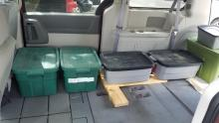
The second picture is of the board that I cut to fit over the tubs and into the space along the wall. You can see that it is wider towards the front than around the wheel well. I figured out that I only need 24" of width for my upper body and only 18" of width for my legs. So, I cut the board to fit. Note that it fits the contours of the inside of the van pretty well. For those who complain about it being OSB. It was what I could afford at the time, it is plenty stiff because it has lots of tubs under it, and it hasn't absorbed moisture and started falling apart in over two years of use. I have since painted it with several coats of acrylic paint, so I think it will last me many more years.
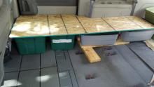
The third picture is with the foam on the board. The bottom layer is some of that green, cushion foam from JoAnn Fabrics. That part cost $80, with a coupon. Lord, foam is expensive these days. The top layer is my old "thermal foam" matress topper that I got from CostCo for $100 but used for years before I cut it up for this, so I considered it free for this purpose. The combination of the two is very comfortable. Truly the most comfortable mattress I have ever slept on.
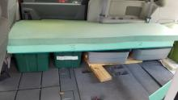
Just this spring, I finally decided to do a real build. I took out the Stow-N-Go seats and cut boards to fit over the holes. I should note that I used high-quality, 7-layer, 1/2" plywood for this cabinet and the panels over the holes in the floor. This has proven to be very stiff and straight. It really made building the cabinet much easier. The plywood was $33 per sheet, which I thought was astronomical. I used about 2 1/2 sheets, so far. So, the total cost for the cabinets, including hardware was about $130. Piano hinges are not cheap.
The first picture is of when I was about finished fitting all the pieces in. There were days of painstaking marking, cutting and fitting of cardboard, then cutting and fitting of the plywood just to get to this point. When cutting the plywood, I cut it about 1/2" bigger than my cardboard cutouts told me to, because you can always take away some more wood, but you can't put more back on. You will notice that I used Gorilla tape to hold everything in place as I was fitting it together. That worked great. I could drive around with the stuff half put together back there and never had anything fall apart.
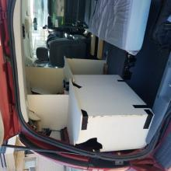
These next two pictures are of the finished cabinets. One with the desktop up:
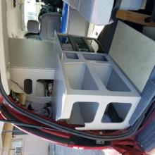
Sorry about these thumbnails being rotated. They are rotated just fine when viewed on my computer (and I'm a computer person, so I usually know what I'm doing), and they are rotated just fine when you click on them to view them at full size. So, I'm not going to mess with trying to fix them in the post. My only guess is that the forum software auto-rotates based on the dimensions and it guessed wrong with these images.
You will notice the odd cutout at the rear of the cabinet. That is so it will fit as closely as possible to the rear hatch when it is closed, but without rubbing. You can see the plastic shelf unit that I built the whole cabinet around. I don't believe in building heavy wood drawers when light, plastic ones will do just fine. I set the height of the rear "counter top" to be as high as possible without interfering with my ability to see out my back window. I set the height of the little ledge over the drawers to be so that the desktop, when it is folded down, will be at a comfortable height when sitting on the bed. So, the bed becomes my office chair without having to put anything away. I had to cut about an inch off the top of the top drawer. Now, as to the sizing of the little shelves. They are almost entirely random. I did not have time to measure all my gear (especially gear I haven't bought yet) and make spaces to fit everything perfectly. Oh well. I was going to use the parts that I cut out as doors on the cabinets. But once I cut them out, I liked how much lighter the cabinets were, and how much more roomy it made the van feel with those open spaces. I figure the 1" lips around all the openings will help keep things in place.
The next is with the desktop down:
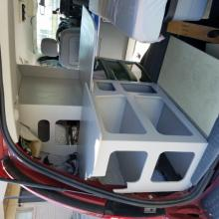
You will notice that, with the desktop down, there is a 4" vertical space behind the desktop. This is where my laptops will be mounted. I have two laptops and both are the kind where the keyboard folds all the way around back. So, I am going to mount them in brackets in that space and use a separate keyboard that I can pull closer to me. Naturally, I will be able to easily remove the laptops for use outside of the van. And the brackets are going to be cushioned so they won't be slamming around in there.
You will also probably notice the spaces behind the "laptop space." Those go all the way through from one side of the cabinet to the other. i figure I can put folding chairs or other long things in these spaces. Or I could just put rarely used things in the middle back there, with more often used things on the ends where I can get to them.
I have more pictures, which I can post if people are interested. Pictures of the panels as I was cutting them all out, and pictures of how the boards fit to cover the holes. I just haven't gotten around to "processing" them to fit the required sizes. Posting pictures is pretty much my lowest priority thing I have to do these days.
I went ahead and got the other pictures off the camera and "processed" them. I don't have time to post them all at once, but I can put up some every once in a while.
Here are pictures of the spaces left over after I removed the Stow-N-Go seats:
Here is the space where the middle-row seats used to be:
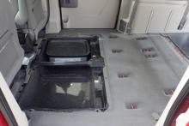
I decided to also remove the folding panels that went over the holes in the floor. Those panels were a real pain in the rear and they weighed a ton. The boards I replaced them with (to be shown in later posts) are much lighter and sit flatter.
Here is the space where the rear seats used to be:
One from almost straight behind the van:
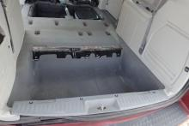
And one from a bit to the side:
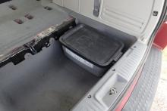
I put the tub in the spaces so people can see how deep they are. Those tubs are 9" tall, and almost 16" x 24" (including the handles).
There really is a lot of room down in these spaces. Heck, most of the floor is actually under-the-floor storage. That's one of the reasons I like this van.
I plan to put my batteries and all the electrical equipment down in the space behind the front passenger seat. Yes, that will be directly under my head. Because my bed literally just sits in place, it will be relatively easy to move a couple of tubs to open that space for maintenance later. Plus, all my electrical will be only within 3-4 feet of anything else, so that will really reduce my wiring requirements.
Side note: After removing the seats and the folding panels that went over the holes, there were a lot of little studs (welded in bolts) that I had to cut off with my angle grinder. That was the first thing I did that I couldn't take back. So I definitely took a deep breath before firing up the angle grinder.

I'm back to post some more build pictures. These are from November, when I went to the Enigmatic Nomadic Build Party. I had volunteered to help other people install their solar, but my teak kinda fell apart. I kept trying to get assigned to another team but Jamie was always too busy to point me in a good direction. I just gave up and decided to work on my own build instead.
OK, I had previously decided that I wanted to put as much solar on my roof as I could. So, when I stopped by Northern Arizona Wind and Sun (NAWS), on my way to the build party, I picked up two 305 watt, Canadian Solar panels. Yes, for a total of 610 watts on top of a minivan. I also bought my charge controller, inverter, and a BattleBorn 100 Amp-hour, Lithium Iron Phosphate (LiFePo) battery. Even though it was outside of the previously stated discount time, James went ahead and gave me the 7% discount just because I said I recognized him from Bob's video. The whole package cost me $1,800. Which is $800 more than I had planned on spending. I was going to just get two AGM batteries, for a total of 100 Amp-hours (50, usable), but that was gonna cost $600. So, I just went ahead and spent the extra $200 for the BattleBorn. And I'm glad I did. I'll talk about that more in the solar section.
So, the dudes at NAWS insisted that they load the panels into the inside of my minivan. That left things a little crowded, but they fit because I had designed my build to fit large items if necessary. I arrived at the Van Build Party that same night and just slept with the panels next to me. The next morning I figured out how to strap the panels onto the top of my minivan, just to carry them around, because I didn't want them just sitting on the ground in that insanely crowded area. I spend the next few days trying to find people to help while stewing on how I was going to mount the panels on my roof.
I finally settled on two 2x10s, mounted on edge on the tops of my existing roof-rack-rails. The reason I didn't just use 2x4s is because I wanted to be able to store things on top of the roof, and under the panels.
Before I mounted the panels, I decided to lay down strips of white Gorilla Tape on the part of my roof that would have tubs sitting on it. This is so grit wouldn't get under said tubs and grind through the paint, thus causing the top of my van to rust through. So, I had to spend almost a whole day at the car wash scrubbing all the decades worth of tree sap off the top of my car. Then I put down the tape.
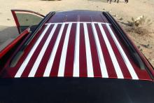
I am not going to store anything under the front solar panel. Once the tape was down, I popped of the plastic covers on the ends of the roof-rack-rails and made sure all the nuts holding it down were good and tight. Unsurprisingly, some of them had worked loose over the years.
Next, I traced the curve of the roof-rack rails onto the lightest of my 2x10s (I knew I was going to be putting it up and down dozens of times while I made everything fit just right. To hold it in place, while I was tracing the line, I just clamped my one, giant C-clamp onto the bottom edge and put tubs up on the roof. I have learned, over the years, to never trust another person to hold something while you mark it. For some reason, they never pay as much attention to what they are doing when helping someone else as they do for their own projects.
And, it did take dozens of fittings to get the board to sit perfectly on top of that roof-rack-rail. Fortunately, I have a Stanley SurForm tool, which is kinda like a cross between a rasp and a plane. So, even though it was an inside curve, it was shallow enough for my SurForm tool to take off the "high" spots. Then I made sure that the wood did not touch either of the two end caps or the roof itself. This way, all the weight is on the rails, where it belongs, and no grit can get trapped under it and scuff up my roof.
Because I wanted it to be at least a little aerodynamic, I sloped the front panel down in the front, as you can see here.
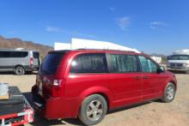
Notice how there is a "barb" of sorts on the front, with another slope down to the edge of the roof. This is for the air dam, which you will see in the next post.
Cutting the second side was much easier because I had a template. But it still took a bit of fitting to get it right.
Then I cut a cross-bar to go between the two uprights and keep them from falling to one side or the other. Much to my surprise, the roof-rack-rails were not completely horizontal on the top, so my uprights were not perfectly vertical. So I had to taper in the sides of the cross-bar a little.
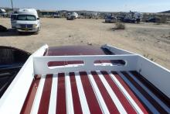
Notice that the cross-bar is cut so that it does not touch the roof of the car. And, I took out some of the wood to lighten it up a little. I had thought about taking out some of the wood for the side pieces (the uprights) but someone reminded me that then people would be able to reach in and try to steal things. I may route out some of the wood on the inside of those, later. That will be a pain because I do not plan on taking this monstrosity off of the car ever again.
And here is a kind of front angle view of the uprights and cross-bar mounted on the roof-rack-rails.
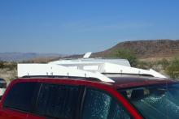
If you look close, you can see that the uprights are held onto the rails with square "U"-bolts. I bought extra cross-straps for the u-bolts so they would take more tension. I also put both the nut that came with the u-bolts AND a nylon-insert, "lock" or "stop" nut. I use "stop" nuts on everything.
I'l talk about how I mounted the panels in the next post.

I have designed a new camping conversion for the Dodge Caravan/Chrysler Town & Country (2016 and prior.)
We wanted a comfortable vehicle for traveling, and an economical place to camp at the end of the day.
The Dodge Caravan was chosen because of the unique Stow-N-Go seats. With the camping conversion in the rear of the van, the second row of seats is still usable, allowing you to have 1,2,3 or 4 people seated in the van.
The bed platform retracts to just behind the second row of seats. It extends to the back of the driver's seat to create a full-size bed just over 6-feet long.
The rear kitchen galley (shown in the photo) occupies the back of the van, under the rear hatch.
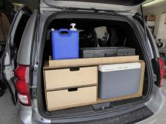
This design was copied from the popular teardrop campers - but we didn't want to tow a trailer. And we didn't want to pay over $10,000 for a plywood camper that would self-destruct over time.
The "GoneCamper" has proven to be economical to drive and comfortable for camping. Please see the GoneCamper YouTube channel for several informative videos. Or visit GoneCamper for additional information and more photos.
PS. The GoneCamper conversion package INCLUDES:
full-size retractable bed frame and folding foam mattress
rear kitchen galley with 5-gallon water container and dual fuel 2-burner stove (kitchen utensils not included.)
Reflectix insulating, black-out window covers for the six side windows (three on each side) and rear hatch window

