1

**THE TRUTH ABOUT 9-11**

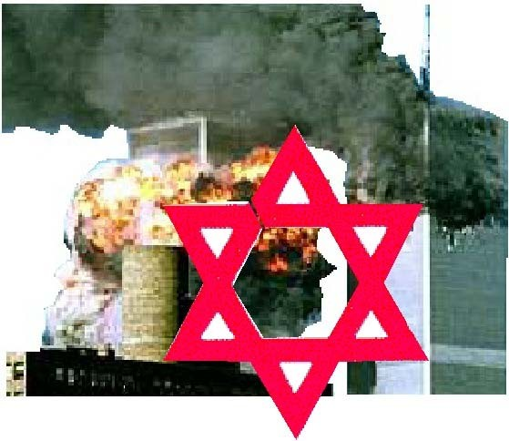

**HOW JEWISH MANIPULATION KILLED THOUSANDS**

## About Rev. Dr. Matt Hale

2

Rev. Dr. Matt Hale is currently an ordained minister and leader of the internationally recognized World Creativity Movement, which has bases across the United States and most European countries. While an advocate of nonviolence and change through peaceful methods, he has had an interesting life that has caused much controversy.

Among Hale’s other talents (such as being a gifted orator and writer), he is an excellent violin player. He even received a partial scholarship during his undergraduate studies for his violin talent.

During his undergraduate studies, he majored in Political Science at Bradley University in Peoria, Illinois. Bradley University is a private school that has a 25 percent acceptance rate. He graduated in May 1993, having received his B.A.

Later, Hale attended Southern Illinois University. He graduated on 9 May 1998, having received his Juris Doctor (doctor of law). Afterwards, he took the 12-hour Bar Exam on July 28 and 29. He passed the Bar Exam and expected to receive his license to practice law.

Due to Hale’s outspoken and politically incorrect views (such as being against Israeli-terrorism), he was denied his license to practice law. He fought the Illinois Bar all the way to the U.S. Supreme Court. Unfortunately, in a victory for those who wish to suppress politically incorrect views, the Supreme Court did not allow his case to be reviewed. Hale has been trying since then to obtain his license, even trying in the state of Montana, with no luck.

The Illinois Bar was just the beginning of a long string of organizations that tried to hurt Hale for his politically incorrect views. For a period of time, even his car insurance carrier sought to deny him coverage (which later changed after a lawsuit). At other times, some politically correct organizations have sought to keep him from publicly speaking in libraries. He has been maliciously attacked (both physically and verbally), and his mainstream views are often distorted by the media. In fact, most of his views are essentially the same as America’s Founding Fathers.

Rev. Dr. Matt Hale actively promotes his views. He has appeared on NBC, CNN, the “Montel Williams Show,” the “Jane Whitney Show,” the “Jerry Springer Show,” and the “Geraldo” show, among others. He has also has his own online radio show and produces videos that appear on public access television.

He has recently been imprisoned as a result of entrapment, and is making an appeal.

**THE TRUTH ABOUT 9-11**

**HOW JEWISH MANIPULATION KILLED THOUSANDS**

Rev. Dr. Matt Hale Creativity Publications

Second Printing Copyright July 2002

## Subject Headings

Foreword 5

The Arguments Begin......................................................... 6

Born in Blood 7

Mainstream Jewish Terrorism Directed Against America 14

Israel Destroyed Liberty..................................................... 16

Dead US Marines Because Israel Didn’t Want to

“Protect Americans” 22

Israeli Deception. 23

Israel Tricked the U.S. into Fighting Battle....................... 23

Jews and Spying 25

Paying Tribute to Terrorists................................................ 28

Zionist Hatred Worldwide? 30

Pre-911: What America Knew 31

What America’s “Ally” Israel Knew................................. 32

The Day Death Visited America......................................... 38

Why Is America Hated Abroad?........................................ 39

Osama bin Laden, America, and the Israelis..................... 40

Are Jews Pulling the Strings of the American Government? 42

Moving Systems Incorporated—the Name Says It All... 43

The Spy Hunt Begins 48

The Conspiracy Begins 49

Remote Controlled Jets? 49

Earth, Wind, and Fire. 50

The Implosion Conspiracy 51

A Brief Review 53

Israel, the Wild Card 53

Reincarnated Muslims. 54

Flight 11 and the Mossad 57

The Identity Thieves 58

Terrorism via Germany 59

The Grand Jewish Conspiracy Begins to Unfold............... 60

The Jewish Media Barons: Selling Israel’s Fantasyland.. 63

The Jewish Propagandists 64

The Best Government that Money Can Buy:

Jewish Plutocrats in Action 68

Reviewing the Grand Jewish Conspiracy 71

Putting an End to the Grand Jewish Conspiracy................ 74

Footnotes 76

#### Foreword

T

his book was not intended to be a *New York Times’* bestseller. It was not written as something to be found at your local bookstore since only those books that are *politically correct* are allowed

in such places. In fact, it is the antithesis of *political correctness*. It was written by one who feels that Jewish supremacism is unacceptable. This book may not even sell more than 100 copies and may at the same time be censored across the world, particularly in those countries that cater to the interests of the Jews. However, this makes no difference to me, as telling the truth is my interest here rather than sales.

I refuse to play by the rules of the media darlings. When speaking of Jews who have committed vicious crimes against humanity, I call them what they are: “terrorists.” When speaking of Jews who engage in vicious acts of hate, I refer to them as what they are: “hatemongers.” Also, I try *not* to be too kind to their co- conspirators who accept these vicious acts and have the gall to attempt to make these terrible acts appear as if something decent.

I write this knowing full well that Jewish groups will try to ignore this book or, if forced to acknowledge its existence, will routinely condemn it. Vouchsafed, if acknowledged by Jewish supremacists, this book will be referred to as simply “anti-Semitic.” However, this book was not written for the Jewish supremacists or their *Amen Corner*. It was written instead for those who want to right the wrong that the Jews have wrought in our country and who have the courage to do so.

I hope to prove beyond the shadow of a doubt in this book just one simple statement:

“Israel knew in advance when the World Trade Center was to be hit with planes and yet allowed thousands to die needlessly, and there is credible evidence to suggest that Israelis and their Jewish cohorts abroad were involved in the plot.”

The intricate details will be shown of what truly occurred on that terrible day when people were burnt alive and crushed under tons of rubble. The conspiracy is vast, and it reaches all corners of

American culture. There may be some people who will dismiss this notion without looking at the arguments. These will be the people who argue that Israel is America’s “best ally” in the Mid-East. These same people will say that Israel is simply incapable of either masterminding the World Trade Center’s destruction or, at the very least, having foreknowledge of the specific plans to destroy it and not sharing it with the U.S.

For those people who would believe that Israel would not allow this to happen—falsely believing that Israel actually cares about its greatest benefactor, America—I would like to first comment on what has occurred in the past. By doing this, I hope to establish a precedent regarding Israel’s treacherous and terrorist activities directed towards the United States and our other true allies, particularly England.

#### The Arguments Begin

In the early 1940s, the Jewish aspiration of an Israeli state was in doubt. Still, large numbers of Jews from around the world continued to immigrate to Palestine. Some Jews felt that their deity said they could just come and take the Arabs’ homes—or something along those lines. Understandably, people in the Arab countries were not particularly fond of the idea that many Arabs would be forcibly displaced from their businesses, farmland, and homes where they had resided and did business for countless generations. Many Arabs, whose homes were later confiscated by Jews, were forced to vacate with

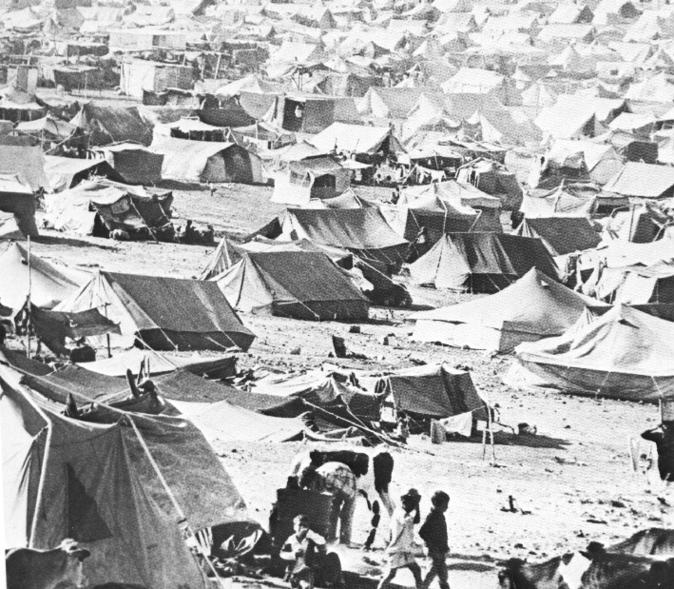

what little they could carry and live in the barren desert, un p r o t ected against the e l e m e n t s . N o n - Jew i sh sympathizers would later provide tents, and *entire tent cities came into existence*.

In England, a relatively small clique who sought the Jewish plutocrats’ favor supported these acts committed by Jews. On 9 June 1942, one of these men, Lord Wedgwood, a quick-tempered man who cared little for common decency, gave a speech before the House of Lords. He argued that only Jews should rule Palestine. Any Arabs there, Lord Wedgwood contended, should be subjugated. It is unknown how much Wedgwood’s pockets were filled with Jewish coins for having said this, but it seems as if it must have been quite a bit judging from his lavish lifestyle that he later enjoyed.

Still, there were some honorable men who stood steadfast against this subversive Jewish idea and proclaimed that Arabs should have self-determination and not be subjugated by Jews. These were men who cared more for people and peace than for the power of the purse. Sir Oswald Mosley was one of these men of decency. Lord Moyne was another one of these honorable men. Unlike Wedgwood, Lord Moyne exhibited qualities that you might expect of a statesman. Because Lord Moyne was considered to be well-reasoned and brilliant, many people paid close attention to his remarks. Lord Moyne argued that if European Jews were truly desirous of a homeland, Madagascar would be an ideal place for them to relocate. He promulgated that “it is surely those who wish to force an imported regime upon the Arab population who are guilty of the spirit of aggression and domination.” Further, he noted that “despite the sympathy of the world,” “the Zionists reject all schemes to re-settle … elsewhere, such as Madagascar.”

#### Born in Blood

Some Jewish terrorists were unhappy with Moyne’s comments and planned a violent response. Itzhak Yezernitsky, the 32-year-old leader of the Jewish terrorist organization known as the Stern Gang, approved Lord Moyne’s assassination. Consequently, two members of the Stern Gang—Eliahu Beit-Zouri and Eliahu Hakim—went to Cairo and murdered Lord Moyne on 6 November 1944. They were caught and hanged in Cairo on 23 March 1945.

The picture on the next page is Lord Moyne, inset, and the funeral he was awarded by the hatemongering Jews for simply speaking his mind and seeking a peaceable solution.

Because of Lord Moyne being murdered, Itzhak Yezernitsky became a wanted man by England. It should be pointed out that Yezernitsky’s feelings and actions did not deviate too much from mainstream Jews in Israel, as will be shown shortly. The picture of

### Lord Moyne was murdered for trying to bring peace to Israel

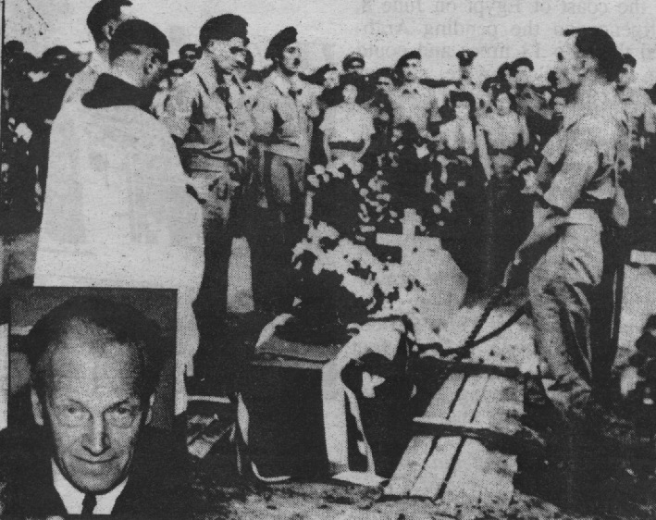

him here was taken from a Wanted Poster for his arrest.

Winston Churchill was in shock that his lifelong friend, Lord Moyne, was murdered in cold blood by Jewish terrorists of the Stern Gang. In 1945, the Yalta Conference occurred. While there, both Stalin and Roosevelt urged Churchill to go along with their plans for the formation of a Jewish Israel. Churchill refused, and it was not until 1948 after he left office that Israel was indeed formed.

Jewish terrorism continued to grip the land. Field Marshall Bernard Montgomery, regarded as England’s “most revered WWII hero,” described these Jewish terrorists at the time:

“He is likely to refuse to engage in pitched battles with our troops; instead,

Yezernitsky became a wanted man for murder

he will go in for sabotage and kidnapping and generally will try to exhaust our patience.”

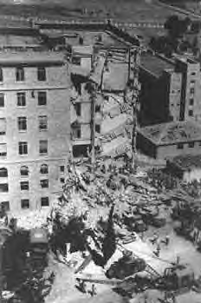

This is what the King David Hotel looked like after the Israelis were done. Dozens of innocent people were injured; many died.

In 1946, Jews blew up the King David Hotel in Palestine, murdering 96 innocent people and injuring dozens more, many of whom were from England. It was later determined that the Jewish terrorist Moshe Begin ordered this wicked act.

In 1946 alone— excluding civilians, people from other nations, and Arabs— J e w i sh terro r ist s murdered 49 English soldiers and 28 English policemen. These were people who were told by the League of Nations to maintain peace in the

area. But the Jewish terrorists did not want peace.

This terrorism continued. Although it is not the purpose of this book to mention all such acts, as it would take a much larger volume, a few other particularly vicious acts that occurred in 1947 as noted from *The Black Paper on the Jewish Agency* (cited in *The Palestine Plot* [pp. 122-123]), are mentioned below:

“April 18, 1947: A group of Jews drove into the Army Red Cross Building…. The medical inspection room, adjoining a ward containing sick men, was blown up. The Army Red Cross Building had two Red Cross flags flying… Two days later, a bomb was thrown at the Red Cross Convalescent depot cinema….

“April 22, 1947: A Cairo-Haifa train was blown up near Rehovoth by Jewish terrorists. Five British and three Arabs were

killed. Twenty-three British and four Arabs were injured….

“May 21, 1947: A band of armed Jews attacked a café in the Arab village of Fajja, near Petah Tikva, shooting one Arab dead, wounding seven others, and placing explosive charges on the premises….

“June 6, 1947: Twenty ‘explosive letters’ in all were sent at various times to British high officials, including Prime Minister Attlee … Winston Churchill, Herbert Morrison, etc. Leaders of the Stern Gang finally admitted they were the senders of those letters, which when opened would explode and maim or kill the receiver.”

Hatemongering Jewish terrorists were regularly murdering non-Jews who tried to prevent the Jewish ultimate goal of making Israel Arab-free. Itzhak Yezernitsky was behind many of these measures. Newspapers in England at the time showed many of the English victims.

The book *The Palestine Plot* (p. 123), citing *The Black Paper on the Jewish Agency*, describes what occurred on the

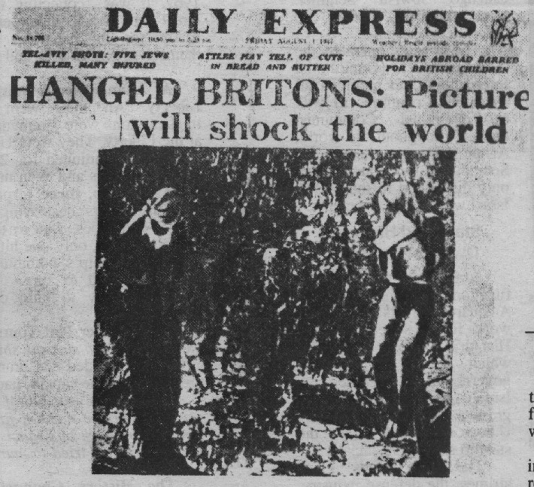

previous page:

“…On July 12 [1947], Stern Gang terrorists kidnapped two British sergeants—Paice, aged 20, and Martin, aged 21—as hostages for three Jewish terrorists who were being tried by the military court for murder and sabotage. The two sergeants were murdered by hanging [with piano wire, and their bodies were later] … found hanging from twin eucalyptus trees. One of the bodies was booby- trapped; and when it fell to the ground, it set off a mine, blowing the body to pieces, which were difficult to collect. A British captain nearby was seriously injured. This revolting crime aroused the wrath of the whole civilized world.”

On many occasions, this Stern gang, led by the iniquitous Itzhak Yezernitsky, used bombs against non-Jews. The British High Commander of Palestine along with the British governors of Trinidad and Cyprus received letter bombs. In one instance, a letter bomb, which was sent to Major Roy Farran, was opened by Roy’s brother, Rex, who died. A bomb was even planted under the seat of Foreign Secretary Ernest Bevin, when Jewish terrorists in England were able to sneak into London’s Parliament building when no one was there.

Men of peace sought to end the Jewish terrorism that plagued the area, hoping to find some way to stop the violence and hatred there. Count Folke Bernadotte of

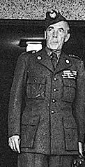

Count Folke Bernadotte tried to bring peace

Sweden was one of these men. He had dedicated his life to humanitarian causes, having been elected head of the Swedish Scouts in 1939 and president of Sweden’s Red Cross in 1946. In fact, he had once been one of the leaders responsible for helping rescue Jews in Denmark, taking them to Sweden via a fleet of boats when it was discovered that they were to be placed in camps.

In May of 1948, UN Secretary- General Trygva Lie appointed Bernadotte as the mediator between the Palestinians and Jews. Bernadotte then established a cease-fire between the two groups on 11 June. He proposed that Jews receive Galilee and that Palestinians receive

Negev, with Jerusalem becoming an international city. However, Jews didn’t like that idea.

On 17 September 1948, Count Bernadotte, who was always unarmed and demanded the same of his bodyguards, was murdered in cold blood by Jewish terrorists. Jews blocked his car during a procession, shooting him and an aide at point-blank.

The fact cannot be emphasized enough that similar incidents to the ones cited above continued throughout Israel’s formation as a Jewish country. Terrorism was the rule, not the exception. Up until the past few years, many people who resided in these areas simply accepted it until more recently when some Arabs have responded on a level that the mainstream Jewish terrorists could finally understand.

Some might wonder why these people are referred to as “mainstream Jewish terrorists.” Indeed, how do the above-cited incidents prove that Jews at-large in Palestine supported such terrible measures in which numerous innocent non-Jews who simply sought to bring peace to the area were murdered in order to form Israel? How can it be said that the actions of Jewish terrorists represented mainstream Jews? In order to properly answer these questions, one more question must be asked: What ever happened to those vicious terrorists who murdered so many civilians? Moshe Begin, who gave orders for the bombing that murdered 96 people in the King David Hotel, later became Prime Minister of Israel. Itzhak Yezernitsky—who was responsible for

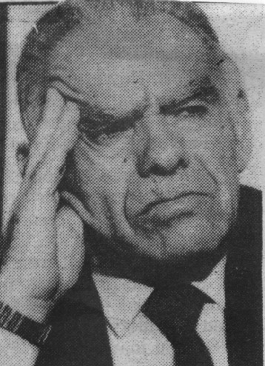

Former Israeli Prime Minister Itzhak Shamir, also known as Itzhak Yezerernitsky

the murders of Lord Moyne, U.N. Mediator Count Bernadotte, and scores of others, not to mention deaths via letter bombs—became known as Itzhak Shamir, yet another Israeli Prime Minister. Shamir later brought the remains of the two who murdered Lord Moyne back to Israel, where they were given a funeral fit for national heroes. In fact, Israeli postage stamps were made of the two. Could you imagine a non-Jew who had engaged in such terrorist activities in the United States or England being elected to such a high-position? Probably not, and yet, this is the mentality that shaped Israel.

In fact, even Jewish religious leaders in Palestine supported this massacre of people. Dr Isaac Herzog, who was the Chief Rabbi of Palestine, said that Palestine was “their homeland” despite the fact that many European Jews had never seen the country before. It appears that he felt that bombs and assassinations that were carried out by Jewish terrorists were the fault of the people trying to maintain peace. Twisting arguments, he suggested that the English were trying to prevent Jews from reaching “the shores.” However, this is utter nonsense, as England’s military was very capable of preventing all Jews from reaching Israel if this is what it had chosen to do. In April 1947, Chief Rabbi Dr. Herzog nevertheless promulgated:

“As a man of religion, I believe the misfortunes befalling Britain are heavenly punishments for her treatment of Jewish refugees reaching the shores of their homeland.”

Despite the terrorism exhibited by mainstream Jews, in 1948, Israel, as a Jewish country, was formed. Ever since then, terrorism has been the way of life for Jews there. The Jews’ ultimate goal appears to be to drive the Arabs into the sea, a task that has proven difficult considering that there are 1.3 billion Muslims in the world and only about 6 million Jews in Israel. This is not something said lightly. In fact, many Palestinians who lived in Jaffa

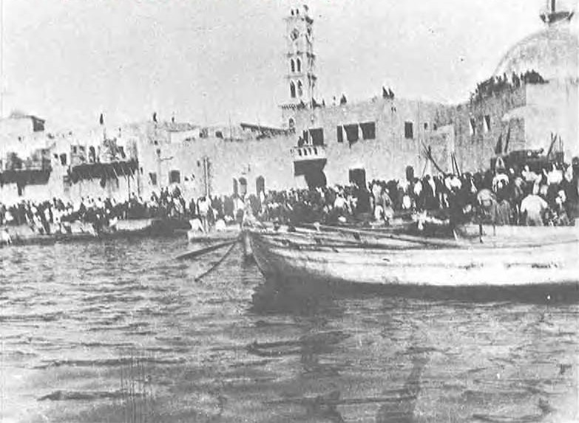

Palestinians in Jaffa were literally driven into the sea by Jewish hatemongers

were literally pushed into the sea in May of 1948, as shown on the previous page.

Today, as in the past, Israeli terrorists have proven to be particularly vicious and often attack their Arab neighbors at will. This Israeli terrorism has been occurring for several decades. And, on occasion, the victims of Israeli terrorism have been Americans.

#### Mainstream Jewish Terrorism Directed Against America

Much like England, America, which also sought peace in the area, was not to go unscathed. The mainstream Jewish terrorists took no prisoners; murder was their game, as it has always been. It is not the goal of this book to cite every act of terrorism or treachery against America, but a few of the major anti-U.S. attacks and so forth will be cited.

In 1954, one of the most well-known acts of terror perpetrated by mainstream Jewish terrorists occurred. It is now known as the Lavon Affair and it was but one more incident in a long string perpetrated by Jewish hatemongers at the highest level of Israel’s government.

The Lavon Affair began when Israelis Gen. Moshe Dayan, Brig. Gen. Abraham Givli, and Shimon Peres developed a scheme designed to sever ties between the United States and Egypt. President Eisenhower had recently given Egypt $50 million in aid and was considering assisting Egypt with the world’s largest dam, now known as the Aswan High Dam. The high-ranking Israeli terrorists decided that if large American facilities were bombed in Egypt with blame being pinned on “anti-American Egyptians,” America would no longer support Egypt.

In order to have their plans succeed, these Jewish hatemongers called upon the Jewish communities in Egypt for assistance and found their “Sayanim,” a term for ordinary Jews who volunteer to conduct “special missions” to benefit Jews. (According to the book *By Way of Deception* by Victor Ostrovsky, a former member of the Mossad, there are only 30 to 35 case officers of the Mossad, who are referred to as “Katsas.” The reason that so few are needed is that there is such a large pool of these “Sayanim” who want to volunteer.) Several educated Jews volunteered for this mission: Dr. Musa Marzuk, Marcelle Ninio, Max Bennett, Prof. Samuel Azar, and a couple others. All were brought to Israel for training. There plans were unveiled that they were to attack several facilities in Egypt: an MGM theater, the U.S. Library of

Information, and several other businesses owned by America or England in Cairo and Alexandria.

The Mossad, Israel’s spy organization, furnished the Jews with bombs, some of which were put inside of hollowed out books. First, the Jews took out the Alexandria Post Office with a firebomb. Next, on 14 July 1954, the Jews took out the U.S. Library of Information in Cairo. The blast nearly decimated the building and the ensuing fire consumed what remained. Two other Jews went to another target, the English-owned Rio Cinema. However, right before they walked in to plant their incendiary devices, the phosphorous bomb that was held by Philip Natanson went off prematurely, causing him severe burns. Upon interrogation, being caught red-handed

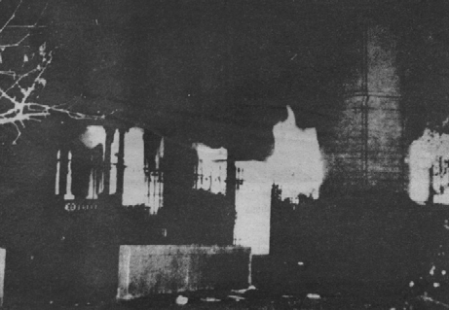

(literally), he c o n f e s s e d . Co nseq u e ntl y , they were arrested, with others being caught some time later.

D a v i d Hirst, in his book *The Gun and the Olive Branch* (c it i n g th e *Jerusalem Post* of

Flames light up the sky at night in Cairo, as the US

12 December Library of Information that Israelis bombed burns away

1954), notes that

Israeli Jews initially denied the incident. Many Jews used the age- old canard of the incident being evidence of mere “anti-Semitism,” failing to admit that they were caught red-handed. At the time, Prime Minister Moshe Sharett declared:

“[It is a] wicked plot hatched in Alexandria ... the show trial which is being organized there against a group of Jews who have fallen victims to false accusations and from whom it seems attempts are being made to extract confessions of imaginary crimes, by threats and torture . . .”

This is the usual response, as those who are cognizant of the games Jews play realize.

The trial revealed all the grisly facts, however, much to the

chagrin of the Jews. As noted in Hirst’s above-cited book, it was determined that an Israeli Colonel Avraham Dar a.k.a. John Darling (who was acting under orders from the head of Israeli Intelligence, Benyamin Givli) had ordered the strike.

According to the initial Israeli story, the Defense Minister Pinhas Lavon and the Prime Minister knew nothing about this plan, which was described by them as something of a rogue-operation. However, it seems nearly impossible that such a well-orchestrated plan involving the actual bombing of buildings owned by Britain and the U.S. could be carried out in Egypt without at least the Defense Minister’s knowledge, let alone the Prime Minister, and this seems more like an attempt by them to save face. (In fact, Lavon later had to resign as a result of this reality.)

Even with all this occurring, other Jewish agents out in the field continued to terrorize Egypt, setting fire to several buildings on 23 July 1954. Two movie theaters in Cairo burned down, the main post office was set on fire, and the railway station was set likewise. Innocent human lives meant nothing to these Jewish terrorists who were more concerned about destruction than anything else.

The trial resulted in Dr. Marzuk and Prof. Azar receiving the death penalty. (Israelis later celebrated these terrorists by naming streets after them in the cities Beersheba and Ramat Gan.) Bennett committed suicide. The others received lengthy prison sentences, with them being revered as heroes among Israeli Jews upon their return. In fact, when Marcelle Ninio was married, “Prime Minister Golda Meir, Defense Minister Dayan, and the Chief of Staff General Bar Lev all attended the wedding,” according to Hirst. This demonstrates, once again, how terrorists are celebrated by the Israeli people.

#### Israel Intentionally Attacked U.S.S. Liberty

On 8 June 1967, another act of anti-American treachery occurred. It involved the ship USS Liberty, sailing in international waters near Egypt. It had no major weapons. The ship proudly flew a large U.S. flag, with the wind being somewhat gusty that day, and was well-marked. Its mission was to simply monitor radio transmissions in the area, such as those by Syria and Egypt.

At around 2:00 in the afternoon, one of the most vicious, unprovoked attacks on a ship in American history occurred, rivaled only by Pearl Harbor. Much like the previous incident, it should have been considered an Act of War, deserving nothing less than a

full-scale counter-attack. However, it was *Israel* that attacked, so what eventually happened became one of the greatest scandals in U.

S. history.

Israel wanted to make it look as if Arabs were attacking America (just as they had tried to do in the Lavon Affair) by quickly sinking the USS Liberty and then placing the blame on Egypt and Syria with whom it was presently at war. As stated by Admiral Thomas Moore at the USS Liberty crew’s official website [(w](http://www/)w[w.](http://www/) ussliberty.org), “I have to conclude that it was Israel’s intent to sink the Liberty.” By sinking the Liberty and pinning the blame elsewhere, Israel thought that it

would bring America into the war on the Israeli side against Egypt and Syria thereby insuring the defeat of those two countries. In other words, Israel wanted America to do Israel’s bidding and that American lives would be lost and in fact deliberately taken by the Israelis in the process was of no concern whatever. Further, by sinking an American ship and successfully causing Egypt and Syria to be blamed, it would make America more willing to ignore Israel’s other war crimes. (For instance, James Ennes Jr., who was on the ship that fateful day, reported in the *Washington Report on Middle East Affairs* of May/ June 1996 that during the war, 150

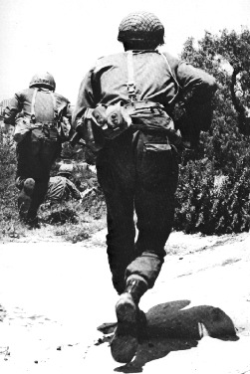

Jewish troops on the move

Egyptian POWs were forced to dig holes. Afterwards, Israelis shot the Arabs down with Uzis and tossed them in the holes.)

Of course, Jews deny that the U.S.S. Liberty was a vicious and calculated attack, saying that it was merely a mistake—an accident. However, as noted in former US Congressman Paul Findley’s book *They Dare to Speak Out: People and Institutions Confront Israel’s Lobby*, two different stations intercepted radio communications from one of the Israeli pilots who clearly identified to his base that it was an American ship. This was in fact obvious, as Jewish jets had flown over the ship for several hours before the attack, and the 5 by 8-foot American flag flying in the wind was

plainly seen. During the course of the attack, this was replaced with a 7 by 13-foot flag when the first was destroyed by Israeli jets.

To make matters worse, “The CIA had learned a day before the attack that the Israelis planned to sink the ship,” according to former Congressman Findley. Why wasn’t something done at the CIA to prevent this? Because their fellow Jews were entrenched also in the CIA. The Jews in the CIA were sympathetic with their brethren in Israel and could care less if some Gentiles died if Israel was benefited in the process. Therefore, the knowledge that Israel planned to sink the Liberty was ignored. Impossible? Hardly, for make no mistake about this: there is a Grand Jewish Conspiracy that this book will prove beyond a questionable doubt, and it penetrates every fiber of the Defense Department.

The attack began. Israel was able to find out the radio frequencies that the USS Liberty used (probably from one of their fellow Jews—or “*Sayanim*”—in the U.S. Navy this time) and jammed the USS Liberty’s radio preventing initial calls for help. The Jewish mainstream terrorists in their jets (unmarked for the ruse just in case there were problems blocking the Liberty’s SOS calls) continued to fire on the Liberty for 25 minutes. Rockets, bombs, large caliber bullets—even napalm—were used against the crew. Special bombs were released to take out their antenna. Dead people were all over the deck; legs, arms, and other body parts littered it. Large holes from the attacking Israeli terrorist jets were everywhere but the ship wouldn’t sink. The Jewish hatemongers had murdered only nine people so

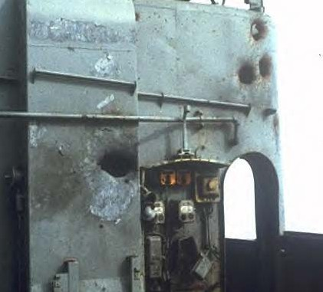

Israelis put a total of over 800 holes in the American ship USS Liberty

far aboard the Liberty. This was gearing up to be a problem though for t h e s e J e w i s h terrorists, since the longer it remained afloat, the more likely they would be thwarted in their o b j e c t i v e o f destroying the Liberty a n d inv e i g lin g America into war on the Israeli side.

The crew of

the USS Liberty was somehow by fearless determination during the hellish attack able to use a back-up antenna to send a message to a nearby US warship. The message was received and jets were dispatched. However, in the highest office, President Johnson, caring less for the lives of America’s military men than his own political career, *ordered them back*. The pilots were dispatched again, with the same response: they were ordered to return on Presidential orders. Johnson said that he didn’t want his Jewish “friends” in Israel to be “embarrassed.” “We were forbidden to help and could only listen to Liberty’s call for air cover,” said Admiral Morris, as noted in James Ennes Jr.’s book *Assault on the Liberty: The True Story of the Israeli Attack on an American Intelligence Ship* (1990) (available from the aforementioned website). Thanks to Johnson’s pro-Israel (but anti-American) actions, more died aboard the Liberty. In fact, 25 more people died as a result of what happened next.

The Israeli jet fighters (gifts of the U.S. or at least funded with American tax-dollars) were

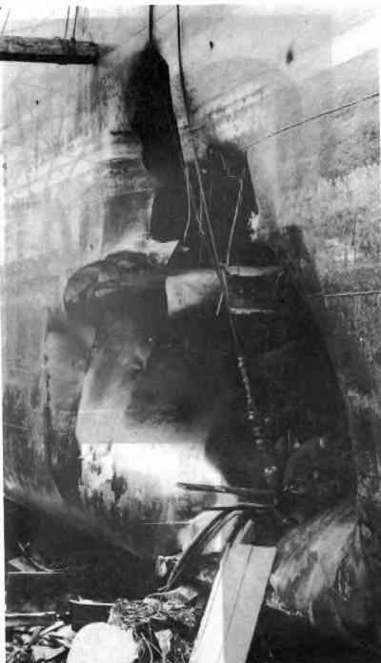

not destroying the USS Liberty. So, the Israelis brought in back- up: three Israeli torpedo boats. The Liberty maneuvered to the best of its ability; but a torpedo still struck it, causing a 40-foot wide hole. During this whole time, the Israeli torpedo boats communicated via radio to its headquarters and thes e transmissions were intercepted by the U.S. The Israeli Jewish hatemongers knew who they were attacking and wanted them dead. The crew of the Liberty, concerned about drowning at sea, got out the lifeboats. However, sickeningly and in violation of all rules of war, crewmen were shot down and the Israeli Jews machine-gunned the lifeboats to pieces.

Unprovoked Israelis did this to the nigh-defenseless ship the USS

After the attack, there were a total of 821 holes in the

Liberty

ship, of which 100 were rocket-sized holes as well as the 40-foot wide hole in the hull. The crewmen struggled for their lives. Dead men littered the deck and the lower levels where the torpedo struck. Thirty-four brave American sailors died because of Jewish Israeli terrorists that day with the collusion of the President of the United States while 171 were injured. The attack had lasted for approximately 70 minutes (though a Navy report initially falsified the information and said it had only lasted 6 minutes; this it was forced to correct later after protests by the crew).

Why did Israel stop its attack when it knew what it was attacking and had planned it all out in advance? Because the Liberty’s radio distress signals were able to reach the U.S. ships with positive identification that the attack was being perpetrated by Israel. This information was then relayed to other branches of the service whose Jewish operatives must have warned Israel that America was now wise to its sick game. Only after realizing that an American warship had been warned, with the ship saying that it would be sending immediate help (although it did not), did Israel stop its attack and then tell the U.S. government it had merely made a “mistake.” In addition (and ironically enough since Russia was the unofficial enemy of the U.S.), a Russian warship that was nearby came over after the attack to assist the Liberty, though the Liberty declined the Russian ship’s help. (Nevertheless, the Russians stood by and waited until shortly before the American warship arrived, which is probably a good thing, as the Israelis might have returned to finish the job.) It was 15 hours before help finally arrived from an American vessel. The crew had been left for dead; it was a miracle, given the vicious nature of the attack, that most survived.

After the attack, Jews at the highest levels of the Defense Department sought to cover-up the ordeal. Quaintly for the Israelis, Jewish Admiral Isaac Kidd conducted the official inquiry. During this, as noted in Findley’s book, he gave orders to the crew:

“Answer no questions. If somehow you are backed into a corner, then you may say that it was an accident and that Israel has apologized. You may say nothing else.”

He said that the crewmembers should “say that it was an accident and that Israel has apologized.” However, as is clear from the above, it was not an accident and apologies don’t do too much good for the dead and maimed. Perhaps he ought to tell that to the children who grew up without fathers or to the wives who lost their

husbands on that fateful day. It seems obvious that he was but another Jew trying to cover-up for his brethren in Israel. How many American lives are we supposed to sacrifice so that Israel can play its wicked games?

How many more non-Jews must die to satisfy Israel’s bloodlust?

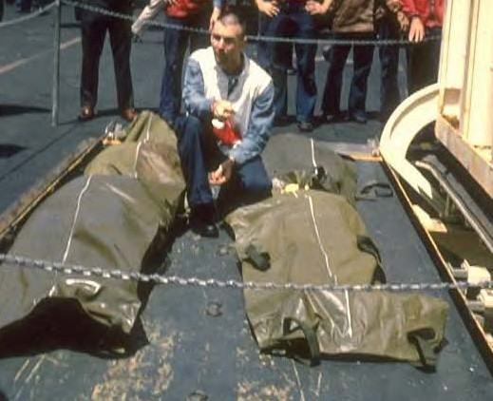

Two of the many American victims of Israel’s War Crime—the attack on the USS Liberty—come home in a body bag

It seems that Admiral Kidd was not the only Jew in the U.S. government to help cover-up the affair for Israel. Eugene R o s t o w , undersecretary of state for political affairs, received a copy of a secret report about this from Israel. This rep o rt lat e r

disappeared, making the Freedom of Information Act useless. It is fair to question the loyalties of these Jews who seem more concerned with Israel and their fellow Jews than American soldiers.

Israeli Jews continued to deny fault for the incident. They did not initially want to pay for the ship’s damage because, according to Israel, “we did not consider ourselves responsible for the train of errors,” noted Findley. Thirteen years later, in 1980, when Senator Adlai Stevenson began to start an official inquiry, Israel appeared to have changed its mind, probably not wanting the issue brought to the attention of the American people. Israel then agreed to pay $6 million for the damages, and this effectively silenced the government’s inquiry. (In reality, Israel merely agreed to accept $6 million less in American tax dollars from the countless millions in aid that it received in 1980 from the U.S.)

The full story concerning the dastardly attack upon the Liberty is even worse than I have stated, and I highly recommend the aforementioned books regarding this incident to those interested in learning more. As Admiral Moorer stated (as quoted in Findley’s book), “The American people would be goddamned mad if they

knew what goes on.” How true this is.

#### Dead U.S. Marines Because Israel Didn’t Want to “Protect Americans”

In 1983 Beirut, a huge bomb went off while many Marines were sleeping in their barracks. The attack was purportedly the work of some extremist Shi’ite Muslims. The Mossad (if members of that Israeli intelligence agency were not involved in the matter themselves) reportedly had received warning that a truck was being prepared to convey some large bombs and that the Marines’ barracks were the likely target. Former Mossad agent Victor Ostrovsky’s book *By Way of Deception* said that only a routine notice was given to the CIA, which “was like sending a weather report.” He noted that the Mossad chief in Tel Aviv promulgated:

“We’re not there to protect Americans.”

Indeed, as we’ve seen so far, the Israeli hatemongering Jews are certainly not there to protect the U.S. On that fateful day in

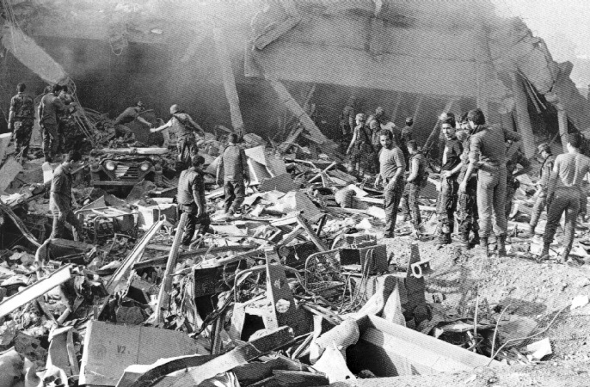

241 U.S. Marines died as a result of Israel’s treachery because the Israelis intentionally failed to forewarn the U.S.

1983, 241 U.S. Marines died. If Israel had been a true ally, they would be still alive today. However, Israel once again probably wanted this to occur so that America might be encouraged to fight its battles.

#### Israeli Deception

The title to the book *By Way of Deception* (1990) by Victor Ostrovsky has an interesting meaning. Apparently, this title is also part of the logo of the Mossad itself. Below you’ll see the Mossad’s icon with a logo in Hebrew both above it—



“Kee betachbulot ta'ase lecha milchama”— and below it—“Ha'Mossad Le'modiein.”

If you understand these terms, you’ll understand the Mossad. The first line means, “By way of deception, thou shalt do war.” The second lines means, “The institute for the collection of information.”

#### Israel Tricked the U.S. into Attacking Libya

Apparently, as has already been shown, the Mossad takes this quote “by way of deception” to heart. This was clearly demonstrated again in 1986 Libya. Ostrovsky describes what occurred there in his 1994 book *The Other Side of Deception*.

Apparently, the Mossad developed a plan called Operation Trojan. The plan was simple enough: plant a communication device deep inside of Libya close to where messages are usually sent by the Libyan government. This device retransmitted messages that were sent from Israel on a different frequency. Hence, Israel was able to send a message to the device, and people monitoring radio transmissions would believe that it was Libya transmitting this message. When the messages were retransmitted, they used the same code as Libya to further make the listeners believe that it was Libya who was sending the messages. This is why it was called Operation Trojan: it reminded the perpetrators of the tale of the Trojan Horse. Ostrovsky describes what happened next:

“By the end of March, the Americans were already intercepting messages broadcast by the Trojan, which was only

activated during heavy communication traffic hours. Using the Trojan, the Mossad tried to make it appear that a long series of terrorist orders were being transmitted to various Libyan embassies around the world (or, as they were called by the Libyans, Peoples' Bureaus). As the Mossad had hoped, the transmissions were deciphered by the Americans and construed as ample proof that the Libyans were active sponsors of terrorism. What’s more, the Americans pointed out, Mossad reports confirmed it.**”**

America fell for the Mossad’s subterfuge, but other countries such as France and Spain thought it too suspicious for such radio transmissions to be believed. They thought it was too easy, and they were right. However, due to the false signals being intercepted by the U.S. and believed to be true, President Reagan launched an air attack upon Libya.

Ostrovsky called this one of the “Mossad’s greatest successes.” He called it this for three reasons: 1) It stopped negotiations for the release of American hostages held in Lebanon, which caused Hezbollah (God’s Party) to remain a major enemy to

U.S. interests; 2) it created more friction between Arabs and the U. S., showing Arabs that the U.S. was allied with Israel; and, 3) it boosted the Mossad’s ego since its plan had worked.

In fact, the Mossad’s plan worked greater than it could imagine. On 14 April 1986, approximately 60 tons of bombs were dropped on Libya. During this bombing, Libyan leader Qadafi’s home was destroyed; and his daughter was killed.

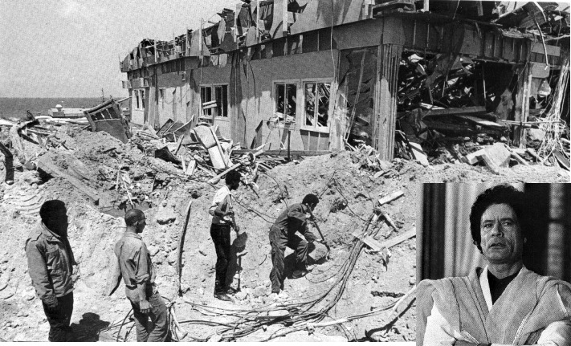

Quadafi (inset) had his home destroyed, which resulted in his daughter being killed, as a result of Jewish deception

In response to the bombings, the Hezbollah murdered American hostage Peter Kilburn. On the other hand, France, which hadn’t fallen for the Mossad’s tricks and stayed out of the foray, had two of its hostages released. Once again, by the U.S. allying itself with Israel and its deceptive measures, many innocent people died. Ostrovsky then goes on to seemingly suggest that, according to another Mossad agent, Israel was somehow involved in masterminding the Iraqi conflict:

“Iraq and Saddam Hussein are the next target. We’re starting now to build him up as the big villain. It will take some time, but in the end, there’s no doubt it’ll work.”

#### Jews and Spying

As has already been shown, the Mossad is one of the most ruthless spy rings in the world when it comes to other nations. But what about the U.S.? Do Jews, particularly in the Mossad, spy on the government—and citizens—here as well? The answer to that question about Jews and spying has been answered many times throughout America’s history. One might not think that a small group like the Jews, who constitute roughly two percent of America’s population (and even a slimmer portion of the world’s population), would not be the vast majority of spies apprehended in the U.S. However, this very much appears to be the case. While it would be too lengthy here to delve into all the Jews who have been arrested for spying (and, as one might imagine, there are probably a lot more who haven’t been caught), a few of the major cases will be cited.

Even as far back as the Civil War, Jews were noted for spying. Back then, many Jews, some of whom were slave owners, supported the Jewish proselyte-Christian Confederacy Vice President Judah P. Benjamin. Perhaps as a result, the Jewish secret society B’nai B’rith (Sons of the Covenant) was reportedly involved in treasonous activities within the Union. The book *The Ugly Truth about the ADL* (of B’nai B’rith) tells how Simon Wolf, an early leader of B’nai B’rith, was arrested by LaFayette C. Baker, the chief of detectives in Washington, D.C., for being part of a “conspiratorial organization” that was allegedly involved in “spying and blockade running on behalf of the Confederacy.” (LaFayette was later promoted to the position of head of the U.S. Secret Service.) Both General Grant and Baker reportedly looked upon the B'nai B'rith as

a “spy agency.” Grant issued General Orders No. 11 to expel Jews from Tennessee's western military district, though this was later rescinded by Abraham Lincoln. According to Leonard Dinnerstein’s book *Anti-Semitism in America*, however, Abraham Lincoln relayed a message to Grant through Henry

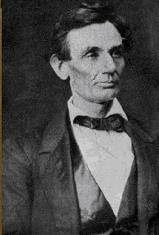

Abraham Lincoln had no problem with Gen. Grant expelling Jew “traitors and Jew peddlers.”

W. Halleck, the General-in-Chief of the Army, with respect to Grant’s desires:

“The President has no objection to you expelling traitors and Jew peddlers.”

Treason seems to be a recurring theme among small groups of Jews in America despite their small numbers among the population as a whole. On 3 February

1949, during the height of the Cold War, the most notorious group of spies in U.S. history—the Klaus-Gold Spy Ring—was broken up. These spies were successful in stealing the secrets of the Manhattan Project, the project to build atomic bombs. They then gave this information to the now-defunct

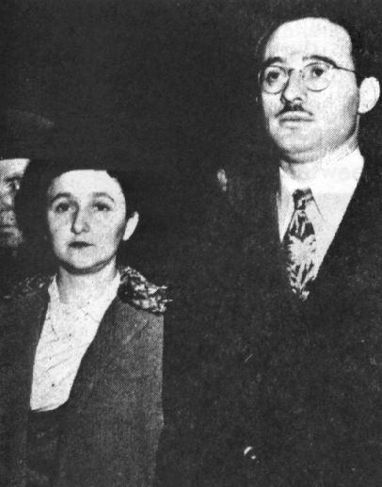

Julius and Ethel Rosenberg—a premonition of more things to come?

Soviet Union. Of those convicted for the crime of espionage—Harry Gold, David Greenglass, Abraham Brothman, Israel Weinbaum, Miriam Moscowitz, Sidney Weinbaum, Julius Rosenberg, Ethel Rosenberg, Klaus Fuchs, and Alfred Slack—the first 8 of the 10 were Jewish. The Rosenbergs were sentenced to death, which caused outrage among the Jews. They had stolen the secrets of a “proximity fuse” which was later used against American planes in Korea. In 1943, the so-called “Scientist X,” who had been giving vital atomic

secrets away, turned out to Joseph Weinberg.

While these incidents are from long ago, the trend continues up to the present. As noted in Congressman Findley’s book *They Dare to Speak Out*, former FBI Assistant Director Raymond W. Wannal Jr. said that he was aware of many times that the Israelis gained secret documents. As Wannal stated:

“[The FBI] knew of at least a dozen incidents in which American officials transferred classified information to the Israelis.”

However, most such incidents appear to be ignored or dealt with silently so as not to alert the nation to this grave matter. Citing numerous sources among high-ranking government officials, former Congressman Findley said of the Israelis who were arrested for espionage, “None was prosecuted. The files gathered dust.” However, there was one case that the government just could not allow to gather “dust.”

In the history of the U.S., the spy who stole the most sensitive data in more recent history was the Jew Jonathon Pollard. Pollard took advantage of his position working for the government and stole classified documents every month. In fact, Pollard stole enough documents to “fill a box six by six by ten feet in dimension.” During the Cold War, many of these documents were traded with Russia. Many of these were described as “sensitive U.S. weapons technology and strategic information” that the U.S. had gathered about other countries, according to former



Congressman Findley’s book. The CIA said that the way in which intelligence is gathered was compromised and Israel probably gained the ability to break top secret American codes. When he was initially caught by the U.S. government, Israel said that he was part of a “rogue”

operation. However, *Israel later set up a bank account for him*, and put in $1 million for when the Jewish lobby in the

Pollard—locked up for life?

United States finally succeeds in getting him out. It appears that in Israel, treachery and hatred of non-Jews is something to be admired.

#### Paying Tribute to Terrorists

The acceptance of terrorism seems to somehow be

embedded within Israel’s Jewish culture. This is probably because, as shown, Israel was founded on it. The actions of hatemongering Jews seems to be respected in Israel, providing that this hate is directed against non-Jews, and this has allowed some Jews in America to escape the law unscathed. This is because Jews in the U.

S. are often allowed to have dual-citizenship. When they commit a crime, they often flee to Israel where Jewish law is administered and Israel does not allow Jewish criminals from the U.S. to be extradited.

Robert Manning was a member of the organization known as the Jewish Defense League. He was believed to have been involved in a 1980 letter bomb that resulted in the murder of Arab civil rights activist Alex Odeh. Some police were also injured in an attempt to defuse a similar bomb. When Manning was indicted in the U.S., he ran off to Israel. Manning was even allowed to serve in the Israel Defense Forces (IDF). Perhaps the IDF liked him, since it he had apparently proven himself a dedicated terrorist in service of Israel.

Richard Smyth was indicted for selling devices to trigger nuclear bombs. He posted bail but fled before trial. He escaped to Israel where he lived happily ever after with his fellow Jews. The question might be asked: how many innocent people might die because of Smyth’s treachery—treachery that Israel apparently condones by its refusal to extradite him? As noted in Findley’s book, a Jewish official in Israel told of Israel’s policy:

“There’s a sort of feeling here that you can’t hand a Jew to be tried by Gentiles.”

This appears to always be the case—even when brutal, non- political murders are committed. Nineteen-year-old Samuel Sheinbein murdered and dismembered one of his classmates, Alfredo Tello, in 1997. Like so many others, Sheinbein fled to Israel. When the state of Maryland tried to have him extradited, the Jewish country’s Supreme Court would not allow it. To allow Jews to be tried by Gentiles is against the Jewish religion and is further against Israeli law. In 1978, Israeli Prime Minister Begin passed a law that forbade the extradition of Jews, saying:

“No Jews should ever be handed to the Gentiles for punishment.”

American Jewish terrorists are indeed often able to escape the hands of justice by running off to Israel and the entire Jewish culture there seems to venerate

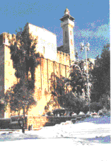

The tall tower is a monument in Israel that was made in remembrance of the mass-murderer Dr. Goldstein

these terrorists provided that the acts committed were against Gentiles.

On 25 February 1994, this deeply imbued, pathological hatred of non-Jews was clearly shown to the world. A Jewish physician born in NYC, Dr.

Baruch Goldstein, went to Israel to share his hatred of non-Jews. In a mosque, while the members were having their morning prayers, Dr. Goldstein shot 292 people, murdering 67 of them. While non-Jews in the U.S. might find such acts deplorable, many Israeli Jews approved of these actions. One person said, “We bow our heads for our sacred hero, Dr. Goldstein. He

died as a martyr while killing for the cause of God.” A friend of Dr. Goldstein said, “He was a great Jew who dared to commit the very same thing that we have always wanted to do ourselves.” As a lasting tribute



Even Jewish schoolchildren terrorize Arab women

to Goldstein for murdering so many non- Jews, a great monument to pay tribute to Dr. Goldstein was made in Israel and this monument is accorded great respect among many

Jews.

This hatred of non-Jews is part of Jewish culture. A

European television crew just a couple days after the Goldstein Massacre recorded this hate firsthand. According to the Damascus newspaper *Al-Thawra* of 22 February 2002 (No. 11721), a bus full of Jewish schoolchildren were witnessed singing a particularly gruesome song:

“This ugly Arab … whom I hate … I’ll kill him with my bare hands … and pierce his flesh with my teeth … then, with these lips of mine, I’ll suck his blood.”

This hatred doesn’t seem to be merely limited to Israel. Recently, members of the Jewish Defense League (JDL) were arrested for planning to murder Congressman Darrell Issa in California. According to the December 19-25, 2001, edition of the NY paper *The Village Voice*, these Jewish hatemongers of the JDL had plans to give Arabs “a wake-up call” and, possibly, bomb what the Jews described as “filthy mosques.” Fortunately, the culprits were arrested before they ran off to Israel.

#### Jewish Hatred Worldwide?

It seems that no country is immune to these Jewish hatemongers. In fact, even Mexico recently faced Israeli terrorism. The Mexican Department of Justice’s website ([www.pgr.gob.mx,](http://www.pgr.gob.mx/) Bulletin No. 697/01) recently told about this in part in an article entitled (translated) “PGR Information about the Situation of Subjects who were Stopped in the House of Representatives.” Two Israelis—Salvador Guersson Smecke and Saur Ben Zvi—were caught inside the Mexican Congress with pistols. This story was also confirmed by the Mexican website La Voz de Aztlan ([www.](http://www/) aztlan.net) on October 12, 2001 in an English article entitled “Zionist Terrorists Arrested Inside Mexican Congress”. Bombs, hand grenades, and wiring were reportedly also discovered with the Israeli terrorists. The article noted, “It is possible that an act of terrorism against the Mexican Congress was planned in order to ‘terrorize’ Mexico into towing the line against Islam.”

#### Pre-911: What America Knew

There has been much talk recently about the U.S.

government having foreknowledge of the WTC attacks and failing to act upon this information. However, most of this knowledge that was known in advance appears to be little more than suspicions. Magazines such as *Time* and *Newsweek* have written many articles about this, with some even being fairly impartial. It is not the purpose of this book to recognize what the government knew in advance. Therefore, in an effort to keep this book concise, many details concerning the U.S. government’s foreknowledge will not be re-told here. A brief examination, however, is worth taking a look.

Many curious things have been shown about the U.S. government and how it “should” have known what was to occur. There are probably many reasons why this did not occur. Probably, one of the greatest reasons were the language differences. Obviously, even if bugs had been planted, most FBI agents would have had no idea what they were saying if the supposed “terrorists” spoke to each other in Arabic as was probably the case. Another reason that the FBI may not have looked into these matters (and should be a matter of grave concern for all Americans) is summed up in one sentence contained in Newsweek: “The FBI was concerned about racial profiling.”1 When an American law enforcement agency fails to maintain a safe environment for the American people because it is more concerned about the *appearance* of impropriety (not any real impropriety), it is certainly time to reevaluate these policies in full.

There are so many details—so many things—that might lead one to believe that the U.S. government knew about this, that it behooves the imagination. As of this writing, a Congressional Inquiry is in the works. It is unknown what will come out of it.

There is also the possibility that some Jews within the FBI may have cared more for Israel’s interest than that of America and looked the other way when it knew their fellow Israeli Jews were spying. Had the FBI paid more attention to the Mossad, it may have uncovered the plot well in advance. The government may have been able to find out what the Mossad was watching or doing, thereby preventing the attacks; but it seems that the government has a general “look the other way” policy when it comes to Jewish spying or treachery. This policy only changes in extreme cases, which is why after the WTC incident that so many suspected Israeli spies were indeed deported.

The head of the FBI just prior to the WTC attacks was Louis Freeh. In fact, it was literally days before the attack that Freeh left and Mueller took over. Certainly, Freeh—more than anyone else—

deserves to be punished for criminal negligence if it is determined that the FBI did not properly act on information it obtained. If anyone in the government was aware of what was being planned, it was certainly Freeh. Whether the government takes the appropriate action, if any, based on their findings remains to be seen.

#### What America’s “Ally” Israel Knew

Did America’s so-called “ally,” Israel, know about the attacks beforehand and fail to tell the U.S. the full details? Did Israel have this specific knowledge about what was to occur, yet allowed thousands to die? Was Israel an *Accessory to the Fact* by not informing the United States of the disaster in advance? It seems that many people in the United States have started to feel that a resounding “yes” can be answered to all these questions and, from what has been shown so far, there is credible evidence that supports this conclusion.

Why would Israel do this? If you recall, according to former Mossad agent Victor Ostrovsky, Israel knew about some terrorists’ plans but still allowed a U.S. Marine base in Beirut to be bombed that resulted in the deaths of 241 Marines. This was probably done so that America would be more sympathetic to Israel’s problems. As noted earlier, the response from the Mossad chief was that Israel is “not there to protect Americans.” This may be true, but it does seem that Israel is there to protect Israelis.

If Israel knew in advance what was going to occur, it would make sense that not many Israelis would have died. Therefore, a couple questions need to be asked: how many people were killed during the heinous WTC attack and how many were Israelis? Well, we know that of the total people estimated at the WTC on that terrible day (50,000), approximately 6 percent of all people (roughly 3,000) died, but was the relationship of the Israelis who were at the WTC and who died about the same percentage—6 percent—as that of all the other people at the WTC?

Some may say this is a stereotype, but Jews are well known throughout the world for their financial acumen and shrewd business tactics. Perhaps this is why it seems that there is always a Jewish head of the Federal Reserve Board (Greenspan, Greenberg, et cetera) and why we also regularly hear of reports about the latest Jewish financial criminals such as Marc Rich, (who was able to get a pardon from President Clinton despite Rich’s outright illegal activities), Michael Milkin, Ivan Boesky, and the like. It would

therefore make sense that a great deal of the workers at the World Trade Center were Jewish.

So how many Jews worked at the WTC? Israel has not given any specific figures on this matter and Israel is unlikely to volunteer this information in the near future. However, immediately after the attack, the *Israel Insider* suggests that there were a great deal of Israelis who were employed at the WTC:

“According to media reports, many Israelis work in the high tech companies and trade agencies in the towers.”2

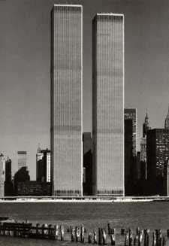

4,000 Israelis were said to have been “in the areas of the WTC and Pentagon” on 9-11.

r

While the term “many Israelis” is rather vague, we do know that there are some Israeli companies that had offices there. *The Jerusalem Post* reported something that d e s e r v e s f u r t h e consideration:

“ T h e F o r e i g n Ministry in Jerusalem has so far received the names of 4,000 Israelis believed to have been in the areas of the World Trade Center and the

Pentagon at the time of the attack.”3

Of course, *The Jerusalem Post* does not say how many Israelis specifically worked at the WTC—just that they were “believed to have been in the areas.” However, *if only half* that number—2,000—had worked there, it would make sense if 120 had perished if we base this on the 6 percent of all other people at the WTC who were killed on that terrible day.

President Bush spoke somewhat prematurely about this matter and said that many Israelis died at the WTC. He did this because there were rumors that no Israelis had died. However, the President said this before the toll had actually been counted, while Israelis were still trying to contact their relatives but were having difficulties and assuming the worst. President Bush suggested that

130 Israelis had perished. If what Bush had said was true, this would mean that Israel did not give their citizens advance warning. However, Bush spoke too early, and what he said was false.

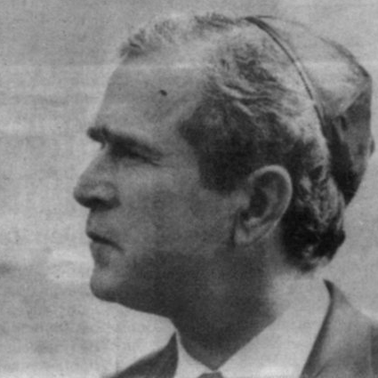

President Bush wearing a yarmulke

According to CNN, the final tally proved quite different from Bush’s early comments. In fact, according to CNN.com, only one Israeli is mentioned, Alona Avraham, who died during the WTC disaster. This one Israeli was not inside the

building but inside the plane on UA Flight 175.4

Another Israeli, Daniel Lewin, also died, but he had dual- citizenship with the U.S. and is listed as an American at CNN’s website. This brings the total to two people if he is included as an Israeli. He was also on a plane and not inside the WTC. According to the Jewish website and paper *Israel Insider*, “He served as officer in the Israel Defense Forces for more than four years.”5

So, while two Israelis died in a plane, *there were no Israelis who died inside the WTC on that day*. Not one single Israeli. Some people might think this is kind of a miracle—but not if Israel knew in advance about the attacks.

Let’s stop for a minute and think about the two known Israelis who were inside a plane and were killed. If Israel warned all of its citizens at the WTC in advance, why didn’t it also warn its citizens who were planning to use those flights? There are two logical possibilities to this query.

If the Israelis were monitoring the Arabs and knew their plans, they might have known what was being planned but they might not have known the particular planes that were to be used. So, while Israelis may have been warned in advance what was to occur at the WTC, they might not have been given the specific flights that were to be used. Further, if the Arabs bought these tickets at the last minute, the Israelis might not have been able to comb the airports and look for their fellow Israelis. Indeed, if the Israeli government wanted to forewarn their fellow Israelis, they obviously couldn’t announce over the airport’s intercom that all Israelis should not board planes because Arab terrorists were

planning on destroying the WTC with planes.

It is also possible that the two Israelis aboard the flight were members of the Mossad and wanted to see this happen. Perhaps they were there to ensure that the operation was a success. After all, Lewin, as noted above, had been an officer in the Israel Defense Forces. This possibility will be looked at in more detail later.

Several things have been shown to be amiss so far. No Israelis died inside of the WTC and only two known Israelis died inside of the planes. These strange occurrences are enough to make one suspicious, but more proof is needed to demonstrate Israel’s foreknowledge and possible involvement. Such proof is readily available.

In at least one known incident, an instant messaging service sent an advance warning to Israelis who were working at the World Trade Center. This was noted by the Israeli paper Ha’aretz.6 According to Newsbytes (WashingtonPost.com), this warning was sent two hours before the WTC disaster to some Israelis who worked inside the WTC. Newsbytes noted:

“Officials at instant-messaging firm Odigo confirmed today that two employees received text messages warning of an attack on the World Trade Center two hours before terrorists crashed planes into the New York landmarks.”7

The instant messaging service that was used, Odigo, is a US-based company with offices in Israel that has a unique service, People Finder, in which users can “seek out and contact others based on certain interests or demographics.” In this particular case, it seems that the “interests” might have been the fact that they were Israelis. Despite the advanced warning given to the Israelis, it was reportedly not until “after the terrorist attacks on New York” that this warning given was shared with law enforcement.8

In any event, the Israelis who were found inside the WTC by the instant messaging service Odigo were given an advance warning two hours before the catastrophe, but what about the other Israelis? This was not an operation that was planned overnight. Years of planning went into it. The flight school itself took quite some time. It seems likely that most Israelis, particularly those who were part of large companies, would have been given more time to react.

The Zim Israel Navigation Company had many workers at the WTC. In fact, it had 10,000 square feet of space at the WTC.

While it is difficult to say for certain, this company might have even taken up an entire floor, if not more. In April, Zim announced that it had plans to move. This was not too long after the terrorists had started their flight training. It appears that the Mossad was monitoring this and later that year, one to two weeks before the WTC disaster, Zim moved. Dan Nadler, a spokesman for Zim, said, “When we watched the pictures, we felt so lucky.”9 Was it luck—or something more?

ClearForest is another Israeli-owned company. Much like Zim, its employees seemed to be emerge unscathed from the WTC; unlike Zim, however, ClearForest did not relocate. ClearForest Human Resource Director Sigal Srur claimed that “four or five” employees of that Israeli company were inside the WTC when the planes struck.10 Sigal Srur promulgated:

“They got out at the last minute, and two who were lightly injured with scrapes have already been discharged from the hospital.”11

This makes it seem as if some Israelis were there when the planes struck, but they *just happened* to avoid the fate of thousands of others and get away with “scrapes.” However, this appears *not to be the case*. In fact, there is evidence that contradicts these “scrapes” that the Israelis, who were supposedly inside the WTC, received, because the day after the attack, according to the Jewish paper *Israel Insider*, no known Israelis had been admitted to hospitals:

“No Israelis have been located in any of the New York City hospitals admitting the injured from the bombings.”12

So, as “luck” would have it, none of ClearForest’s employees required hospitalization, nor any other Israeli within a day of the attack. Further of course, there was that bit of “luck” that Zim “just happened” to move out a week or so before the terrorists struck. Now, if that isn’t enough “luck,” the spokesman for ClearForest mentioned some more:

“Luckily, unlike many US companies which were totally wiped out, our R&D [research and development] is here, so all of our technology is here.”13

By now, there can be no doubt left that all Israelis inside the WTC received an advance warning as to the planned attack. *Not one* Israeli died inside the WTC and *not one* Israeli even ended up in the hospital. As you might expect, it seems pretty clear that the Israeli government itself knew what was going to occur.

Probably to protect themselves, the Israelis actually did give America an advance warning. However, this warning was so vague that it was of absolutely no use to the American government. The Jerusalem Post describes the advance warning that was given:

“The paper said the Israeli officials specifically warned their counterparts in Washington that ‘large-scale terrorist attacks on highly visible targets on the American mainland were imminent.’ They offered no specific information about targets, but they did link the plot to Afghanistan-based terrorist Osama bin Laden, and they told the Americans there were ‘strong grounds’ for suspecting Iraqi involvement.”14

So, Israel told the U.S. government that “highly visible targets” were going to be attacked. Football stadiums? The Empire State Building? The Statue of Liberty? The Sears Tower? The list goes on and on and on. And how soon is “imminent”? Today? Tomorrow? Next week? Eight days? Next month? Obviously, this bit of information was not given to the U.S. to help save its citizens but, rather, to help Israel if people figured out what it did--and that has now occurred, with this book.

The attack upon the World Trade Center benefited Israel the most. It created sympathy for Israel’s problems in the eyes of some Americans who will not bother to find out the truth in these matters. The WTC catastrophe was good for Israel because it generated a feeling of compassion for Israelis who suffer from suicide bombers. This fact seems to even be acknowledged by former Israeli Prime Minister Benjamin Netanyahu. In an interview with The New York Times, Netanyahu stated:

“Asked tonight what the attack meant for relations between the United States and Israel, Benjamin Netanyahu, the former prime minister, replied, ‘It’s very good.’ Then he edited himself: ‘Well, not very good, but it will generate immediate sympathy.’”15

Netanyahu was right about one thing: it’s “not very good” that thousands of Americans were killed with Israeli complicity, *and*

*it’s especially not going to be good for Israel when the American people find out*.

#### The Day Death Visited America

September 11, 2001 will forever go down in history as one of the worst catastrophes to ever occur on U.S. soil. America was not ready for

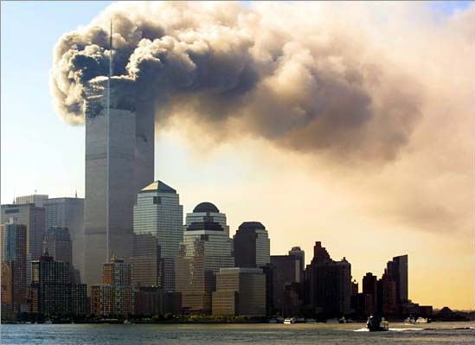

such an attack and indeed, how could it be? Aside fro m some occasional s k i r m i s h e s abroad, there was no actual war occurring.

On that terrible day, I walked into Goodyear to get my car fixed and

like so many other millions of Americans, saw the World Trade Center towers ablaze on the television there. When I later saw the buildings collapse also live on television, I knew that thousands of innocent people—from countries around the world—had died a cruel death.

When I first saw this, two questions immediately came to my mind: (1) Who did this, and (2) Why? At the time, neither answer was given.

Later in the day, President George W. Bush got on the airwaves. He said that the terrorists did it because they hated America’s freedom or something along those lines. In a sense, he was partly right: whoever did it truly hated America. However, simply knowing that America is hated does not answer the extremely important question as to why it is hated. This question must be answered if we wish to prevent more attacks upon our country in the future.

#### Why is America Hated Abroad?

The reason that America is hated abroad is largely because

of its alliance with Israel. It has been shown alread y that Israel in the past has committed many treacherous activities against America and many American citizens have died as a result of Israel’s activities. Keep in mind that

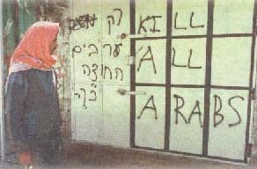

Picture the life of a Palestinian

Israel is supposed to be America’s so-called “ally.” However, if Israel does this to its ally, you might guess what it does to its enemies!

Far too often in the Middle-East, particularly in Palestine, the inhabitants see Israelis wreaking havoc upon the land. Buildings are often destroyed. Innocent men, women, and children are shot.

y

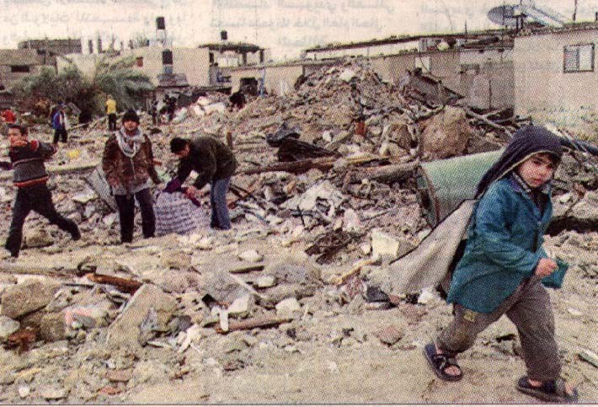

120 homes were bombed by Israelis on 11-11-01. Many Palestinians died. Over the course of the last two years, over 1,700 Palestinians have been murdered and 40,000 injured by Israelis. If Palestine had a comparative population to the U.S. and the same percentage was killed, this would roughl equal 170,000 murders; and the 40,000 injured would equate to 4 million

This has been occurring for over a half-century, and there is no end in sight.

When these bombs from the Israelis hit the ground in Palestine, destroying lives and homes, an occasional piece is found. Typically, it will have these words emblazoned on it: “Made in the USA.” In fact, many people in the Mid-East feel that the attacks were “made in the USA,” just as the bombs were. It is because of America’s support of Israel that the entire world hates America.

#### Osama bin Laden, America, and the Israelis

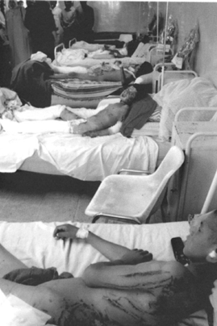

Iraqi children who were injured from a US bomb. For more about the horrific problems encountered there, please see this footnote’s reference.16

Arab anger is constantly fueled by these unprovoked Israeli attacks against Palestinians. This was the driving force by Osama bin Laden (and perhaps it still is, if he is still alive). He hates America because of its support for Israel that resulted in many children suffering needlessly. In fact, this was noted in an interview with Peter Arnett on CNN in 1997. Bin Laden said specifically:

“[The US government] has committed acts that are extremely unjust, hideous and criminal whether directly or through its support of the Israeli occupation….

And we believe the US is directly

responsible for those who were killed in Palestine, Lebanon, and Iraq. The mention of the US reminds us before everything else of those innocent children who were dismembered, their heads and arms cut off in the recent explosion that took place in Qana (in Lebanon). …

“A reaction might take place as a result of US government’s hitting Muslim civilians and executing more than 600 thousand Muslim children in Iraq by preventing food and medicine from reaching them.

“With a simple look at the US behaviors, we find that it judges the behavior of the poor Palestinian children whose country

was occupied: if they throw stones against the Israeli occupation, it says they are terrorists whereas when the Israeli pilots bombed the United Nations building in Qana, Lebanon, [that] was full of

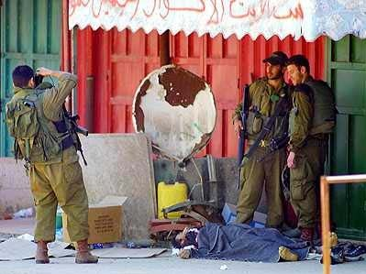

Jews pose for picture with dead Palestinian “trophy” that they killed at their feet

children and women, the US stopped any plan to condemn Israel. “Mentioning the name of Clinton or that of the American

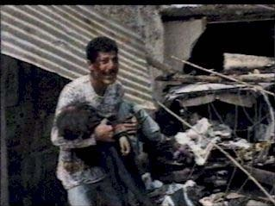

A Palestinian man holds his lifeless child, who was murdered by an Israeli bomb

government provokes disgust and revulsion. This is because the name of the American government and the name of Clinton and Bush directly reflect in our minds the picture of children with their heads cut off before even reaching

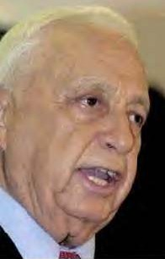

Israeli Prime Minister Ariel Sharon says “Jewish people control America”

one year of age. It reflects the picture of children with their hands cut off, the picture of the children who died in Iraq, the picture of the hands of the Israelis with weapons destroying our children.”

#### Are Jews Pulling the Strings of the American Government?

Jewish politicians in Israel seem to boast and laugh about their control over the U.S. through financial means. This point will be shown later in more detail. Arabs pay close attention to this though the American public is often kept from this knowledge. This boasting of Jewish control over America extends to the highest levels of the Jewish government in Israel. During an argument

between Prime Minister Ariel Sharon and Foreign Minister Shimon Peres on October 3, 2001, Peres said that the Israelis’ policies of continued violence might “turn the

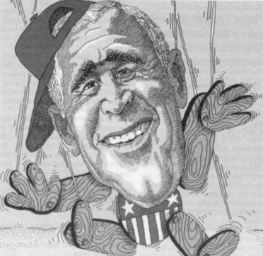

US against us.” To this, Sharon retorted:

“Every t ime we do something, you tell me Americans will do this and will do that. I want to tell you something very clear: Don’t worry about American pressure on Israel; we, the Jewish people, control America. And the Americans know it.”17

Bush is viewed as a puppet by Jews

This was noted in clear-cut

terms by IAP News in an article appearing at the Washington Report on Middle East Affairs’ website.

Indeed, it seems Jews around the globe feel as if Gentiles are merely puppets to be controlled like little toys. Even as far away as Australia, Jews depict President Bush in their newspapers as a little toy. This picture of President George W. Bush appeared in the *Australian Jewish News* of 15 February 2002 and reveals the true Jewish opinion of him: a puppet. Some may get the impression that President Bush is exactly that, after reading about what happened during the 9-11 attack.

#### Moving Systems Incorporated—the Name Says It All

“Evidence linking these Israelis to 9/11 is classified. I cannot tell you about evidence that has been gathered. It’s classified information.”

--US official quoted in Carl Cameron’s Fox News report

After the World Trade Center horrible attack that resulted in thousands of innocent people being burnt alive or crushed under thousands of tons of rubble, law enforcement around the country began to take an extremely pro-active approach to what was going on around it. No longer could the police or FBI or CIA ignore or neglect many of the suspicious activities occurring. Indeed, terrorism had to be uncovered, but what began to be uncovered was much different from what you might expect.

A mere eight hours after the bombing, police were on the lookout for a white van which was purportedly being driven by some men who were described as having a Middle Eastern appearance. Apparently, according to *The New York Post*, witnesses “saw them ‘cheering’ and ‘jumping up and down’ in Liberty State Park after the attack.”18 An alert was then issued to law enforcement:

“Vehicle possibly related to New York terrorist attack. White, 2000 Chevrolet van with New Jersey registration with ‘Urban Moving Systems’ sign on back seen at Liberty State Park, Jersey City, NJ, at the time of first impact of jetliner into World Trade Center.

“Three individuals with van were seen celebrating after initial impact and subsequent explosion. FBI Newark Field Office requests that, if the van is located, hold for prints and detain

individuals.”19

Shortly thereafter, the suspects were arrested. They worked for a company known as Moving Systems Incorporated. Upon further investigation, it was discovered that the van had maps of the city with the location of the World Trade Center highlighted. One source commented, “It looked like they knew what was going to happen when they were at Liberty State Park.” The employees were described as “Israeli tourists.”20

It is certainly peculiar that such Israeli “tourists” would “cheer” at such a terrible catastrophe when all around them were in a state of grief and shock. Instead, as difficult as it may be to stomach for Americans, these Israelis were taking photographs of themselves on a rooftop, smiling with the nearby WTC in the background, while thousands of innocent people were being crushed or burnt alive.21

Later, police investigators searched the facilities of Moving Systems Incorporated. One thing that aroused the investigators’ suspicions was the clear view of the WTC from the roof, which was easily accessible.22 However, this turned out to be naught but a small piece of the puzzle. An Israeli mother, whose son thought that the WTC disaster was funny and was interrogated, told of the FBI’s suspicions:

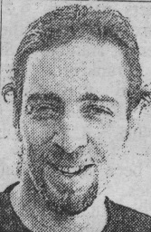

An Israeli who was questioned about the

“They thought that because he has citizenship of a European country as well as of Israel that he was working for the Mossad [Israel’s spy agency].”23

Approximately a month after that, *The Mercury*, a news source out of Pottsdam, Pennsylvania, reported some equally strange things that added greatly to the puzzle’s pieces. The police had been alerted by a call about some men dumping furniture illegally. At first, the police believed it to be a routine call. However, when the police arrived, they discovered that it was a moving company (with its name printed on the side of the van—“Moving Systems

Incorporated,” to be specific) that was dumping this furniture. This must have struck the police as certainly odd: a company that was

supposed to be moving furniture for someone was throwing it away. The police approached the supposed movers but they quickly fled the area.24

Fortunately, the police were able to apprehend these “movers.” What the police found was extremely interesting: the men had a detailed video of the Sears Tower in Chicago. This video had zoomed-in shots of various parts of the building. Were they planning something there? All the suspects were discovered to be Israelis, including one woman (not the typical employee of a moving company). The woman had a German passport in one name, and prescription drugs in another name, which logically leads one to believe that she was working under different names.25

The police began to question the movers who offered strange and contradictory stories probably as a result of being nervous with their cover blown. The movers said that they were coming from New York and said they were going to New York. The reason that they were in Plymouth, Pennsylvania, they said, was that they were supposed to be picking up some furniture. Certainly, moving companies often move furniture for people out of state (though they are not usually found throwing it away). However, when asked for the name or phone number of the person’s furniture they were to pick up, they could not give either. Obviously, a moving company would not offer to move someone’s furniture out of state without a phone number, let alone a name. Upon further investigation, the police discovered that the truck’s logbook was false too. Some of the so-called movers were then transported to a federal facility.26 It seems likely that the crew had recently come from Chicago and had been casing the Sears Tower.

Other suspicious things continued to be uncovered about the Israelis involved with the company. Apparently, the owner of the company closed his business and fled to Israel. All the suspects in custody were given lie-detector tests twice, except for one who was given the test seven times. The “art students”—what some of the employees claimed to be—had even been recently trained by the Israeli Army in “signal interception and ordnance [demolition].”27

Pause here for a moment and consider the company’s name. This is the company whose employees were jumping up and down in glee and taking pictures of themselves in front of the WTC when it burned and others were found to have a video that may have been part of a greater plan to deal with the Sears Tower. As you might know, many Jews like to play word games. This is clearly evident by their so-called “mystical” works, like the Kabala, where the

words equal numbers, which in turn stand for other words. Was this the case with the name of the company; did it also have a secret meaning?

Moving Systems Incorporated **MO**ving **S**ystem**S** incorpor**A**te**D** MOSSAD

Is this idea of the Mossad’s name within the company’s name far-fetched? Possibly. Nevertheless, the FBI reportedly discovered that the employees of Moving Systems Incorporated were actually working for the Mossad. Due to the circumstances, the FBI even launched a Foreign Counter-intelligence Investigation. However, New York FBI spokesman Jim Margolin said, “If we found evidence of unauthorized intelligence operations, that would be classified material.”28 However, the pro-Zionist paper *Forward* quotes a former American official who was privy to this investigation. He said quite frankly:

“The assessment was that Urban Moving Systems was a front for the Mossad and operatives employed by it.”29

The FBI—due to “prodding by Jewish and Israeli officials” (and, most likely, its *Amen Corner* in the U.S.)— eventually allowed these agents to escape to Israel.30 It was purportedly believed by the FBI that these Israelis were not actually involved in the WTC disaster themselves but were just monitoring Arabs. Apparently, according to Chip Berlet, described as “a leading expert in American intelligence operations” (and who is employed as a senior analyst by Political Research Associates out of Boston), there is a protocol among spies who are from “allied” countries. Berlet said that there is a “backdoor agreement” between allied countries in that if a spy is caught, he is released provided that not too much harm was done and the usual reason given is that of a visa violation.31 If this was the case why these Israelis were allowed to be deported, the government’s view of “harm done” and that of its citizens seem completely different. How many lives could have been saved if America was given specific knowledge of what was to occur? Did these Mossad operatives know?

While the Israelis still claim that they had no foreknowledge of the attacks, their claims are illogical and inconceivable. This is best revealed by a slip of the tongue made to a news source by one

of the celebrating Israeli operatives. He tried to explain why the others (not him, of course) at the time of the WTC disaster were taking pictures and smiling while the building was burning and people were trying to scramble for their lives. The reason for their happiness, according to the Israeli operative, was simply this:

“These guys were like, ‘Now America knows what we go through.’”32

When the WTC disaster occurred, no one but the perpetrators, of course, knew exactly who or what caused it. So, the Israeli operatives couldn’t have been initially overjoyed without having known who brought about the attack (whether it was Arabs or possibly the Mossad itself, as will be looked at shortly). If they were simply deranged individuals who enjoyed utter destruction, while still not understandable from a normal person’s viewpoint, it would be more believable that they did not

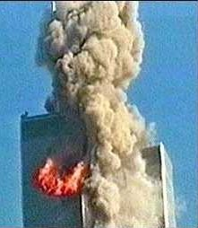

They thought this was funny.

have advance knowledge. The idea that they had no foreknowledge would be more believable if they had said that they hated Americans and enjoyed watching the disaster. At least that might have explained their happiness if the plot was unknown to them.

How could a plane initially striking a building alone be reason to think, “Now, America knows what we [Israelis] go through,” without having foreknowledge of who caused it? It could have been a plane that simply went off-course due to engine problems. Indeed, no one believed at the very second that the first plane struck that it was done by Arab terrorists, and there was no reason to suspect any particular group at the time. Information had not yet been given to the public about who caused the tragedy or who was even suspected of having done it. All that these Israelis should have known—if they were in the dark as they claimed—is that Israelis themselves could have been flying the jets. Yet, from

the beginning, these Israeli spies were seen watching the entire events unfold, enjoying the carnage as if it was a pre-planned little show made for them--as if they knew the intricate machinations of the events and found the whole thing utterly amusing to them--as if it was this well-made plan being successfully executed that made them happy.

Later, other suspicious stories continued to add to the puzzle’s pieces. *The* [UK] *Times* reported another strange incident. Six men, driving in two separate white cars, were pulled over. The men all had Israeli passports. Oddly, the men also had box cutters, but what is more strange is that, according to *The Times*, the men had “detailed plans and photographs of a nuclear power plant in Florida.” Further, “the men were also carrying plans of the 800-mile Trans-Alaska pipeline, which delivers 17 percent of America’s oil,” said *The Times*. Since the police felt that the men’s papers were in order, they were released, which reportedly “infuriated” field agents of the FBI (and understandably so).33 Despite the local police’s mistake in this matter, the federal government took this possibility quite serious, and for 10 days, flights were not allowed to come within 10 miles of a nuclear facility. In addition, National Guardsmen were deployed at Florida’s nuclear reactors.34

#### The Spy Hunt Begins

In the aftermath, dozens of Israelis were initially rounded up. Some were interrogated and later deported. Many were believed to have been spies posing as art students or pretending to have unassuming careers. On 12 December 2001, Carl Cameron reported on Fox News what had occurred:

“Since Sept. 11, more than 60 Israelis have been arrested or detained either under the new PATRIOT anti-terrorism law or for immigration violations. A handful of active Israeli military were among those detained, according to investigators, who say some of the detainees also failed polygraph questions when asked about alleged surveillance activities against and in the United States.”

So why haven’t we heard more about this? Cameron revealed this on Fox News on December 13:

“Investigators within the DEA, INS and FBI have all told Fox News that to pursue or even suggest Israeli spying ... is considered career suicide.”

A few months later, it was reported by Intelligence Online in France that 120 Israelis had been deported or detained pending investigations. This was revealed in a 60-page report based on numerous field reports by the Drug Enforcement Agency and other law enforcement organizations. The report told about many of these Israelis’ backgrounds: “special forces,” “intelligence officer,” “demolition/explosive ordnance specialist,” “bodyguard to head of Israeli army,” and “electronic intercept operator.”35

No matter what way one looks at it, the Israeli spy network in the U.S. is vast with its tentacles reaching into the most well kept secrets of the U.S. Department of Defense.

#### The Conspiracy Begins

One of the more curious aspects of the World Trade Center catastrophe is the dissemination of many inaccuracies. These inaccuracies concern much of the disaster’s background. Perhaps “inaccuracies” is too kind of a word for they are actually gross mistakes—if not outright lies and propaganda—that have been reported to the public as fact.

### Part of the reason for this might have been the government wanting to both solve and share the information about who caused the World Trade Center disaster as soon as possible. It is true that many citizens were noticeably upset about the ordeal and many millions demanded that the politicians answer the question as to who did it. Such an atmosphere, however, is ripe ground for mistakes. As a result of initial poor research by the government, which will be shown in greater detail shortly, all sorts of conspiracy theories have been generated.

#### Remote Controlled Jets?

One conspiracy theory seems particularly bizarre. Some have recently suggested that there were no suicide bombers at all. Writer Carole Valentine of Public Action stated,

“There were no ‘suicide’ pilots on those September 11 jets. The jets were controlled by advanced robotics and remote- control technology, not hijackers.”36

The above article goes on to suggest that there are remote- controlled jets. And, indeed, there are such devices. However, it is untrue that any of the four commercial jets in question were designed to be remote-controlled. If all America’s jets were designed to be remote-controlled, it would be relatively simple for our jets to be wrecked via remote control, particularly when overseas near hostile regimes, which is why they are not made that way. This technology does exist—mostly for experimental and army planes (and this has resulted in several unmanned spy planes crashing); but, again, this technology is not used in commercial airlines. Further, even if these jets were remote-controlled—and there is no evidence to suggest that they were—it is doubtful that they could be maneuvered remotely in such a manner as to circle 270 degrees and strike the WTC at such a high speed. I merely mention this to demonstrate some of the rumors flying around.

#### Earth, Wind and Fire

Another writer at Public Action, J. McMichael, suggests that the fire created by the burning fuel would not have generated enough heat to melt the steel beams, and this claim warrants a closer look. He notes that the melting temperature of the steel beams by themselves is 2,800 degrees Fahrenheit (1,538 degrees Celsius). The steel beams in the center of the structure were encased within concrete, making the temperature needed to melt them even higher. Further, the steel floors had concrete on them as well.37 Citing scientists, he argues that the heat created by the jet fuel would not reach the intense heat required to melt the steel beams.

Keep in mind that the WTC was not built like a house; it was designed so that if a fire occurred, no matter how severe, that the rest of the building would not be destroyed. It was designed to withstand incredible stress as well. Consider that a building of that magnitude experiences incredible forces from high winds alone hitting the entire structure. It was designed for the worst. In fact, one of the buildings demonstrated how durable it was back in 1993 when it withstood a large bomb inside the WTC that was caused by other Muslim extremists. The bombing caused no major structural damage. McMichael’s report of the impact of fire on the WTC is certainly something that deserves greater study.

#### The Implosion Conspiracy

There is one other thing of particular interest that is noted in McMichael’s report. He cites a prominent engineer, Van Romero, who initially suggested that the buildings appeared as if they were imploded. According to this other article that appeared in the *Albuquerque Journal*, Romero had served as the director of the Energetic Materials Research and Testing Center at New Mexico Tech. This center studie s, no te s the *Albuqu erqu e Journal* , “explosive materials and the effects of explosions on buildings, aircraft and other

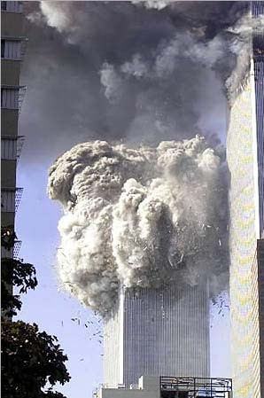

Is this an implosion?

str u c t ur es .” R o m e r o

commented on the fact that the buildings’ collapse appeared “too methodical.”38 He promulgated:

“My opinion is, based on the videotapes, that after the airplanes hit the World Trade Center

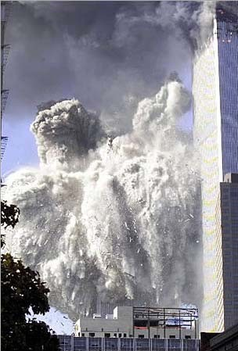

there were some explosive devices inside the buildings that caused the towers to collapse…. It would be difficult for something from the plane to trigger an event like that….”39

Immediately after making the statement, he was “bombarded with e- mail” and, quite likely, phone calls from reporters. Understandably, many people wanted to know about this. “I’m very upset about that,” he said, referring to the firestorm of controversy set off by his remarks. A little over a week after his first

statement, he said that, “certainly,” the fire caused the building to “fail” but also stated again that, “the final collapse of each building was triggered by a sudden pressure pulse” that occurred as a result of some “source of combustion within the building.” In conclusion, while he on the one hand backed off his original statement, he seemed to maintain his belief that the buildings’ final collapse was caused by an additional reason. Trying to lessen the controversy, he said, “I'm not trying to say anything did or didn’t happen.”40

Obviously, for good reasons, Romero did not want to put his neck out and become the center of a great debate, but pause for a minute and think about what he said. If you’ve seen the footage, you’ll probably agree that it certainly appears that the buildings may have been imploded. Could Israel’s Mossad have planted bombs there in order to ensure that the WTC would be destroyed so that a greater amount of anti-Arab animosity would be generated? One bomb had been exploded in 1993 at the WTC by some Arab extremists but this bomb resulted in no significant structural damage. What if people who were trained in explosives had planted bombs in key areas throughout the WTC to make sure that unlike what happened in 1993 and what happened with the Liberty in 1967, this “ship” (the two towers) would sink? It seems likely that the Mossad would have wanted to see the Arab extremists’ mission succeed so that international outrage would be created and directed against Arabs.

A few people who reportedly witnessed the disaster firsthand said some strange things that certainly give credence to the belief that there may have been bombs planted causing the buildings to collapse. Reportedly, one eyewitness said there were “a number of brief light sources being emitted from inside the building between floors 10 and 15.” A “crackling sound” then followed this.41 Kim White, who worked as an employee on the WTC’s 80th floor said there was an “explosion” that occurred some time after the plane struck.42 The online edition of the magazine *People* quoted firefighter Louie Cacchioli who was assigned to Engine 47 in Harlem. He said:

“I was taking firefighters up in the elevator to the 24th floor to get in position to evacuate workers. On the last trip up a bomb went off. We think there was [*sic*] bombs set in the building.”43

University of Colorado Civil Engineering Professor Hyman Brown said that the building’s structure should have been OK after

the plane crash but said that the ensuing fire caused the real damage. He had been a construction manager of the WTC. He stated, “This building would have stood had a plane or a force caused by a plane smashed into it.”44

Would Israel’s Mossad be so utterly ruthless that it would sacrifice thousands of people just so that it might generate American sympathy for Israel’s battle against Arabs? Could the Mossad have planted explosives that were set off some time after the planes struck in order to ensure that the Arab extremists’ mission was a success?

#### A Brief Review

Let’s briefly review a few things here. If you’ll recall, as noted in the Jewish pro-Zionist paper *Forward*, some of the so- called “art students” of Moving Systems Incorporated (who were determined to actually be working for the Mossad) were trained in “ordnance” (explosives/demolition).45 Intelligence Online also said that some of the Israeli spy ring had been trained to work in “demolition/explosive ordnance”46 This begs the question: why would Mossad operatives trained to use explosives be inside the U.

S. unless they were here to plant them somewhere? In the past, as noted in the first part of this book, Israel has staged attacks against American interests in an effort to make it appear as if another country had done it. This has included planting bombs.

Make no mistake about it: Israel is known for its deceitfulness and has demonstrated that it has no qualms with murdering its allies. In fact, the U.S. Army’s best school even recognizes this.

#### Israel--the Wild Card

In Fort Leavenworth, Kansas, the **School for Advanced Military Studies** (SAMS) provides training and works as a think- tank for the “Army’s brightest officers.” According to officials there, both the Army’s chief of staff and the Joint Chiefs of Staff have asked SAMS in the past for the development of future military strategies.47

Ironically, on the day before the World Trade Center catastrophe, *The Washington Times* had a story that mentioned SAMS’s findings on Israel. In a 68-page report issued by SAMS, it described Israel as a “500-pound gorilla” in the Mid-East. It went on to say that Israel’s army is “well armed and trained” and “known

to disregard international law to accomplish [its] mission.”48 The report by SAMS also described Israel’s Mossad:

“Wildcard. Ruthless and cunning. [The Mossad has the] capability to target US forces and make it look like a Palestinian/ Arab act.”49

It seems likely, however, if the Mossad wanted to stage such an event, some Israeli operatives would have had to masquerade as Arabs and infiltrate the terrorist groups. This would be necessary in order to gain specific knowledge. This specific foreknowledge was indeed gained as is evident by the advance warnings of the attack. However, we know the identities of all the terrorists, and they were all Arabs. At least, that is what we have been told. However, what if their true identities were not actually given?

#### Reincarnated Muslims

The British Broadcasting Corporation, which is well respected around the globe, reported that many of the so-called Arab Terrorists who were supposed to have been on the planes the day of the WTC attack *are still alive*. Many other sources have



“Time to get up.”

Are Muslim terrorists waking from the dead?

corroborated the BBC’s findings. So who were some of these people if not the Muslim extremists that the media and government keeps telling us they were? Could some have been Mossad agents?

Certainly if several of the individuals whom the U.S. government says flew planes into the World Trade Center are still alive, we have a bit of a problem. Mistakes do happen, of course, but mistakes of this magnitude—to this degree—raise doubts to the integrity of the entire investigation surrounding the tragedy. Some

of these suspects’ pictures were circulated worldwide as being the terrorists aboard the flights.

To keep track of these people, the number sign and a corresponding number in parentheses will appear before the mentioning of these people’s names who were mistakenly identified. Almost immediately after the terrorist list was issued, mistakes were found. As time progressed, more and more of the terrorists alleged to have been on the suicide mission were discovered to still be alive. Arabs (#1) Adnan Bukhari and (#2) Ameer Bukhari were the first two to be incorrectly identified. This “correction” appeared at CNN’s website a couple days after the

attack:

“…Based on information from multiple law enforcement sources, CNN reported that Adnan Bukhari and Ameer Bukhari of Vero Beach Florida were suspected to be two of the pilots who crashed planes into the World Trade Center. CNN later learned that Adnan Bukhari is still in Florida where he was questioned by the FBI…. A federal law enforcement source now tells CNN that Bukhari passed an FBI polygraph and is not

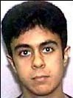

Al Ghamdi

considered a suspect. Through his attorney, Bukhari says that he is helping authorities. Ameer Bukhari died in a small plane crash last year.”50

Another so-called “terrorist” who was reportedly aboard the United Flight is still alive and well. This is the flight that crashed in Pennsylvania. Apparently, (#3) Saeed Al Ghamdi escaped death somehow.51 At least, he says that he is still alive. Has he too come back from the

dead? He was on the FBI list of terrorists who died in flames aboard the hijacked plane.

Another Arab, (#4) Khalid Al Midhar, was also on the list but says that he is still alive.52 Despite arguments to the contrary, he says that he was not aboard any of the Suicide Flights on that terrible day.

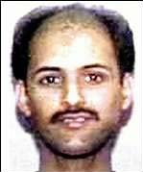

Al Midhar

Another suspected Suicide Flight terrorist, (#5) Ahmed Al Nami, had this to say:

“I’m still alive, as you can see. I was

shocked to see my name mentioned by the American Justice Department. I had never even heard of Pennsylvania where the plane I was supposed to have hijacked [crashed].”53

|  |
| --- |
|  |
| Al Nami |
|  |
| Alhazmi |

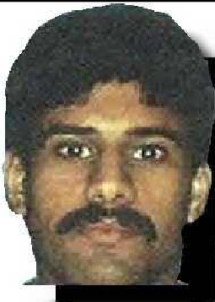Al Nami went on to say that he never lost his passport or any form of identification. This was also true of (#6) Salem Alhazmi, who was supposed to be one of the suicide terrorists aboard Flight 77. The UK Telegraph reported that he is working for a petrochemical company in the city of Yanbou. At the time of the attacks, he was in Saudi Arabia. Alhazmi said,

“I have never been to the United States and have not been out of Saudi Arabia in the past two years.”54

The website AllAfrica.com also mentions another person who was purportedly aboard the suicide mission but is still alive. “…[A] suspect sought by the FBI, (#7) Amer

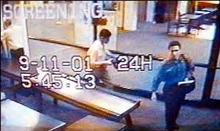

Kamfar, [is] in fact an alive pilot in Arabia.”55

In the p i c t u r e b e l o w , Mohammed Atta, who is pictured on the right and is suspected

by the FBI as being one of the main participants in the WTC attack, is shown with another suspect, Waleed Al Shehri. This picture was obtained from a surveillance video just hours prior to the ordeal. However, this picture cannot be (#8) Waleed Al Shehri for a good reason. He says that he is still alive.

Waleed Al Shehri admits that he did attend flight school as the FBI said. There may have even been other Arabs who trained there with him. However, he said that he left the United States a year ago and has been working as an airline pilot for Saudi Arabian Airlines since then. He says that he was not on Flight 11, but was in Marrekesh at the time of the WTC disaster.56 Should we believe him? Or should we believe the U.S. government who said that he died in the WTC attack in an apparent suicide mission?

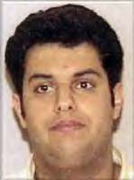

Al Shehri Claims to Be Alive. Should We Believe Him?

Another Flight 11 survivor is among us. His name is (#9) Abdulaziz Al Omari. He has been working for Saudi Telecoms.57 He said that he has been to the U.S. but he left long before the WTC disaster. “The name [listed by the FBI] is my name and the birth date is the same as mine, but I am not the one who bombed the World Trade Center in New York,” Abdulaziz Al Omari said to the London-based newspaper *Asharq Al Awsat*.



Al Omari

Should we believe him when he tells us that he is alive, or is he a zombie who has mastered life and death? This brings the total up to 9 of 19 people—a little under 50 percent—who it is believed were mistakenly identified by law

enforcement. Were the others who they were said to be? Or were there more corpses lying in graves somewhere, with impostors having flown in their places?

#### Flight 11 and the Mossad?

As noted above, it is known for certain that there are at least 2 out of 5 falsely identified Arabs on Flight 11 who actually had no part in the terrorist attacks. There are a couple other peculiar things about that flight according to remarks made by Flight 11 stewardess Madeline Amy Sweeney before she died. She spoke to someone via cellular phone during the hijacking. “She was very, very composed, very detailed,” said an American Airlines employee. “It was impressive that she could do that.” According to the British Broadcasting Corporation News, she gave the seat numbers where

the *true* hijackers were originally sitting. However, none of these seats were the same as the ones that were “registered in the hijackers’ names.” Also, she said, according to BBC News, that “one spoke very good English.”58 However, since all of the hijackers had lived abroad until not too long ago, none of the hijackers should have spoken “good English.” In reports in *Time* and *Newsweek*, those who had spoken with these Arabs say that the opposite was in fact true--they had spoke English poorly.

There was one person from the Mid-East aboard Flight 11 who we know did speak good English. His name was Daniel Lewin, and he was one of the *two Israelis* who died. However, as noted earlier, he was listed as a U.S. citizen at CNN’s website because he held dual citizenship, being actually born in the U.S.59 In an obituary appearing in the *Chicago Tribune* of 17 September 2001, it notes that he had served “four years in the Israel Defense Forces” (IDF) and excelled. In fact, the *Chicago Tribune* noted:

“He rose to the rank of captain in what is considered the [Israeli] Army’s most elite unit.”

It certainly seems strange that a former(?) captain of the IDF who had been a member of the “most elite unit” was aboard that flight along with the supposed terrorists. The Mossad is believed by many to be Israel’s “most elite unit,” though this article does not specify that. (It certainly may have raised some eyebrows if it had.) Since the government has refused to release the information, we don’t know if one of the seat numbers given by the matches Lewin’s seat number. This raises even more suspicions about the true identities of the suicide bombers.

#### The Identity Thieves

The whole issue of the FBI posting several incorrect names—names of people who are still alive—is an international embarrassment. It seems almost as if there are two possible reasons for this international embarrassment: 1.) The FBI just picked Arabic names out of the blue; or, 2.) Others were masquerading as some of these reported Arab terrorists? Let’s consider these two possibilities.

Would the FBI and CIA just make up names out of the blue? While this is possible, it seems doubtful. Admittedly, the FBI’s COINTELPRO speaks volumes. The CIA has its share of dirty

tricks too; but, on such a critical issue, it seems that a great deal of investigation probably went into this from all facets of law enforcement. Further, while the FBI had some names, the names and the true identities obviously did not match—at least, not entirely. This we know for certain.

So some people, whose identities remain unknown at the time, were masquerading as the people who were initially identified as the terrorists. It cannot be said that ALL the terrorists had fake identities, but it can be said that there were 9 who were at first incorrectly identified by law enforcement. This is a little under 50 percent and is quite a margin for error. Notwithstanding this, the director of the FBI, Robert Mueller, admitted (probably a little uneasily), according to CNN, “that some of those behind last week’s terror attacks may have stolen the identification of other people.”60

This brings up even more questions. How would these terrorists obtain such vital data to get visas based on someone else’s identity? More importantly, who has this capability? Before these questions are answered, an interesting piece of information must be reviewed.

#### Terrorism via Germany

It seems that some of the terrorists came via Germany. This certainly seems like an odd correlation, to say the least, but ABC News reported this about supposed ringleader Mohammed Atta:

“Prior to coming to the United States, Atta and his cousin, Marwan Al-Shehhi, lived in Hamburg, Germany, a country federal authorities say has been used often as a base by a number of terrorist mastermind Osama bin Laden’s operatives.”61

There is one interesting possibility that is not openly disclosed about Germany. Evidently Germany, much like the U.S., has a very cozy relationship with Israel. In fact, according to one source—Jeffrey Steinberg of Executive Intelligence Review—Israel might even maintain all of Germany’s visa applications. According to Steinberg, it is known that Israel oversees the visa process for Arabs who wish to visit certain European countries. Steinberg noted:

“…[In] several Western European countries, including the Netherlands and possibly Germany, the Israeli Mossad is officially

handling all visa background checks for applicants from Arab and Muslim countries. According to a well-placed diplomatic source, the Israelis offered these ‘services’ free of charge to the European immigration agencies in return for access to the unusually detailed information contained in the visa applications. The rationale for the deal is that the Israeli secret services maintain the most comprehensive watch-lists of suspected Arab and Islamic terrorists and criminals.”62

The article then goes on to suggest that *Israel would have been the country that gave visas to Mohammed Atta and other Muslim extremists believed to have committed the attacks.* Steinberg asks the valid question: why was Atta allowed to run between Europe and the U.S.?63 There is further another valid question not raised by the article: how is it that some of these terrorists who came via Germany were not who they were supposed to be? Could they have actually been Mossad agents (or *Sayanim*, their fellow Jews who volunteered to help as spies) who were given fictitious identities? More than likely, there are some Jews in Israel (whose families may have been killed or wounded in the decades-long struggle between Arab and Jew) who would gladly volunteer for such a critical operation. It seems likely that if what Steinberg says is true, identity theft would have been relatively easy for Israel, since it allegedly oversees some European countries’ visa process.

Another interesting discovery again seems to implicate Israel in the matter. Reportedly, one Israeli company, ICTS (International Consultants on Targeted Security), controlled security at all the airports from which the hijacked planes departed.64 This control was said to either be direct or through its subsidiaries. So, not only did Israel possibly have the ability to issue false visas but it also may have been able to have the security look the other way.

#### The Grand Jewish Conspiracy Begins to Unfold

Everything mentioned thus far deserves further examination. According to the Middle East Media Research Institute, columnist Galal Alsayyed asked a question in the daily Egyptian government newspaper Al-Akhbar that is worth considering. He wondered:

**“…**Why couldn’t it be the Mossad that secretly planned this crime without exposing itself? [Later,] the idea crept out to bin Laden and his aides via his collaborators [in the Mossad]. I wouldn’t

be exaggerating by saying that perhaps the Mossad sent bin Laden- trained men and pilots to carry out the operation, without [this] being discovered… Flight experts have pointed out that it’s impossible for amateurs trained for a number of hours, or months, to fly such planes and to do what was done.”65

The columnist’s question is thought provoking. Could there be such a connection between the Mossad and Muslim extremists? Perhaps even between Osama bin Laden’s operatives? While at first this might sound implausible given the hatred of many in the Mid- East to each other, this might not always be the case.

India’s “number one weekly magazine,” *The Week*, described such a link between Osama bin Laden’s extremist Muslims, and this was described well over a year before the WTC attack in February 2000. This link was born out when in January 2000, several Muslims, believed to be extremists, were “detained on the suspicion of being hijackers.” However, as odd as this may sound, according to the article, “under Israeli pressure, India allowed them to fly to Tel Aviv [Israel].” 66 A diplomat in India’s Bangladesh High Commission in Delhi told the details to Subir Bhaumik, a reporter of *The Week* and BBC’s eastern India correspondent. *The Week* described this unusual scenario:

“The eleven had Israeli passports but were believed to be Afghan nationals who had spent a while in Iran. …

“Indian intelligence officials, too, were surprised by the nationality profile of the eleven. ‘They are surely Muslims; they say that they have been on tabligh (preaching Islam) in India for two months. But they are Israeli nationals from the West Bank,’ said a Central Intelligence official.

“[The diplomat from India] claimed that Tel Aviv ‘exerted considerable pressure’ on Delhi to secure their release. ‘It appeared that they could be working for a sensitive organisation in Israel and were on a mission to Bangladesh,’ the official said. The Israeli intelligence outfit, Mossad, is known to recruit Shia [Shi’ite?] Muslims to penetrate Islamic radical networks.

“‘It is not unlikely for [the] Mossad to recruit 11 Afghans in Iran and grant them Israeli citizenship to penetrate a network such as Bin Laden’s. They would begin by infiltrating them into an Islamic radical group in an unlikely place like Bangladesh,’ said intelligence analyst Ashok Debbarma. ‘The pressure exerted on India by Israel for the release of the men, and the hurry with which they were flown

bac k s u g g este d an ab or te d ope r a t i on . ’ “On January 11, the Bureau of Civil Aviation Security (BCAS) issued a top secret circular (NO: ER/BCAS/PIC/ CIRCULAR/99), quoting ‘an intelligence input’ about the possible hijack attempt on a Bangladesh Biman aircraft originating out of India. Copies of the circular signed by regional deputy commissioner of security (Calcutta Airport), L. Singsit, were issued to relevant Indian agencies and Bangladesh Biman’s station manager in Calcutta, Md. Shahjahan. It said that eight ‘Pushtu-speaking

Mujahideen’ had infiltrated into India for the purpose.”67

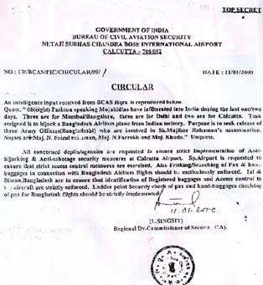

This **Top Secret** document from India’s government indicates that the Mossad may have been working with Osama bin Laden

There may therefore b e a

connec t i o n b e t w

e e n

Osama bin L a d e n ’ s network and the Mossad. Agai n , as noted by the above article, th i s w a s mentioned on

6 February 20 00 an d

wh i l e i t

appears that

India later

foiled the plans of these ext r e m is t s , America may not have been

so lucky. Unfortunately, the article does not give the individuals’ names, so there is no way to compare them to the WTC hijackers to see if they were the same. However, in any event, there probably was more than one group of Muslim extremists working with the Mossad terrorists.

It seems that, judging from articles by the Middle East Media Reporting Institute and appearing elsewhere, people in the

Middle East are some of the few who recognize many of the inconsistencies that surround the WTC disaster. Indeed, while it is known for certain overseas that Israel knew in advance of the attacks, the American media coolly ignores this altogether. Rather, the American media only reported the possibility that Bush knew in advance the intricate details of the WTC disaster and yet failed to take action. It must be asked, however, why the American media fails to look at Israel with the same magnifying glass. Indeed, while some reporters have written about Israel’s foreknowledge and possible involvement, the mainstream media as for the most part failed to acknowledge this, choosing to keep the American people in the dark.

#### The Jewish Media Barons: Selling Israel’s Fantasyland

While there are some honest reporters out there such as Carl Cameron of Fox News who has honestly reported many of the facts concerning this massive cover-up that reaches to the highest levels of the U.S. government and beyond, their numbers are few and far between. The reason for this is really quite simple: Jews control the media for the most part, and they seldom allow true criticism of Jews or Israel. If someone criticizes Israel in the media, Jews deal with them harshly.

Examples of Jewish Media Barons Thought Control policies abound. Reportedly, a month after the WTC disaster, a gentleman wrote a letter to the editor of the *Oneida* [NY] *Daily Dispatch* and blamed Israel for the September 11 attack. The managing editor printed it. The Associated Press of 20 October 2001 reportedly told what happened next in an article entitled “Newspaper Retracts Editorial Blaming Jews”: Not only was the article retracted but both the managing editor and city editor were fired. The former managing editor commented:

“I am not working at the *Oneida Daily Dispatch* as of yesterday because of repercussions from allowing the Sept. 19 editorial to be published. I am not anti-Semitic, and anyone who knows me knows that.”

This type of behavior by the Jewish Media Barons is typical.

It happens because they have the power over our press.

Look at the heads of almost all the major news sources: Gerald Levin is the CEO of CNN, AOL, and Time Warner. Peter

Chernin is president and CEO of the FOX Group. Sumner Redstone, also known as Murray Rothstein, recently acquired CBS and controls the book publishing companies Simon & Schuster, Scribner, The Free Press, and Pocket Books. Redstone’s Viacom also controls Showtime, MTV, and Nickolodeon, among other TV networks. Steven Borenstein is CEO of ESPN. Michael Eisner controls Walt Disney, Touchstone

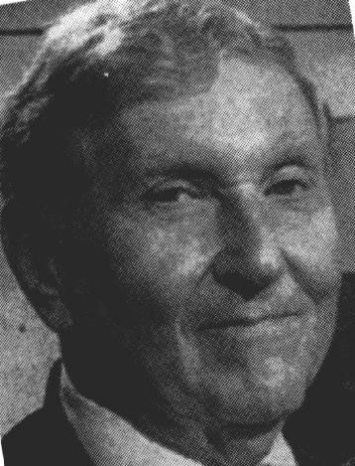

Television, Buena Vista Television, and ABC, not to mention dozens of radio stations. Ronald Perleman owns New World Entertainment. Jeffrey Katzenberg, Steven Spielberg, and David Geffen own DreamWorks. The brothers Samuel and David Newhouse, the children of media baron Samuel Newhouse, control 26 newspapers, 12 television stations, 87 cable TV systems, and about two-dozen popular magazines. Edgar Bronfman Jr., President and CEO of Seagrams, controls MCA and Universal Pictures which recently merged under the name of Universal Studios and controls Interscope Records

Sumner Redstone, aka Murray Rothstein

and PolyGram as well. Mortimer Zuckerman controls *U.S. News & World Report*. Arthur Sulzberger Jr. controls *The New York Times*, 33 other newspapers, and about a dozen magazines. Until her recent death, Katherine Meyer Graham controlled Newsweek and the *Washington Post*. The same can be said of Canada where Israel Asper controls numerous newspapers and has reportedly fired employees for being critical of Israel. Names may change, but the Jewish Media Barons’ practices and monopoly continues.

#### The Jewish Propagandists

As noted in the book *Anti-Semitism in America* by Leonard Dinnerstein, even former President Nixon acknowledged the Jewish Media Barons’ influence in America. This is why Jews tend to hate him and say that he was an anti-Semite. In reality, according to Jews, anyone who dares to speak the truth about Jews is an anti- Semite. President Nixon said:

“[People] have to realize that the Jews in the U.S. control the entire information and propaganda machine, the large newspapers, the motion pictures, radio and television, and the big companies. And there is a force that we have to take into consideration.”

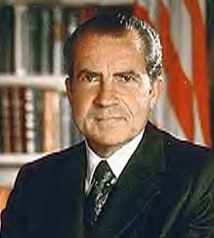

**Nixon told the Truth about Jewish influence**

The usual Jewish response to these facts is to say that it is merely *anti- Semitism* (and “anti-Semitism” actually means “against” the “favoritism of Jews,” which is probably the true reason that Jews dislike anti-Semitism so much). However, whether the person is anti-Jewish or not is irrelevant to the facts that he states. Put another way, if there are people who dislike Jews and they say that the sky is blue, is it any less blue because they dislike Jews? According to Jews, if the person who says that comment

about the sky is anti-Jewish, the answer is “yes,” the sky is, therefore, not blue. Or, the Jews might say that it doesn’t matter that the sky is blue because the person is anti-Jewish.

These little mind-games that Jews play are seen everywhere but particularly in the government. Jewish influence over the government is so vast that many Gentiles in high-level positions are following the Jews’ every whim. Jewish groups are even training some members of the government by use of propaganda.

FBI Director Robert Mueller, for example, has said that he has “long admired the work of the ADL” of B’nai B’rith. The ADL is an exclusively Jewish organization that has strong ties with Israel. In fact, its Jewish members seem to stand with Israel over America. A recent example came when President Bush demanded that Israel pull out of Palestine. Jews throughout the world ignored or laughed at him, and the ADL was among those groups who sided with Israel over America. At the time, the ADL’s website said that it was “concerned” that Bush asked Israel to “cease” its “activity.” The article then went on to say, “We are also disappointed that the U.S.

voted for a second Security Council resolution that demanded Israeli withdrawal...” There can be no mistake of whom the ADL puts first: their fellow Jews in Israel over Americans.

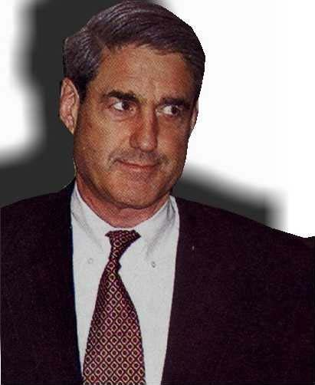

The above article was written on April 5, 2002 and just a month later, FBI Director Mueller gave a speech at the Anti-Defamation League's 24th Annual National Leadership Conference in Washington, DC, on May 7, 2002. During the course of Mueller’s speech, he said some things that most Americans should f ind disturbing. He said that the

FBI Director Mueller: Putting Israel’s interests before America’s?

ADL provides the FBI with “training and education,” and said that this has “never been more relevant.”

“That includes the conference on extremist and terrorist threats you are sponsoring later this month at the FBI Academy. And it especially includes the classes at the Holocaust Museum that Abe and Jess helped arrange for our New Agents and for National Academy students.”

Essentially, Americans are paying with their taxes for the new FBI agents to study under the tutelage of an organization that is more representative of a foreign government’s interests than that of the US. FBI agents are being indoctrinated with Jewish propaganda by this organization that promotes Israel over America. In addition to promoting Israel over America, the ADL also promotes the acceptance of other actions that most Americans find repugnant.

Much like many other Jewish groups, the Anti-Defamation League of B’nai B’rith openly encourages the acceptance of such deviant behavior as homosexuality. Likewise, their Jewish brethren in the media encourage people to accept such disgusting behavior as well, pushing their amoral lifestyle on good-natured people. In 1995, the ADL joined in a legal brief. This brief urged the “Supreme Court to let gays and lesbians march in Boston’s St.

Patrick’s Day parade.” Imagine taking your children to see a parade, only to discover that there are men kissing one another, carrying whips, and having their buttocks exposed. This type of thing is occurring in some cities, and it is largely a result of the ADL’s actions. “Certainly,” said an attorney for the ADL, it supports “freedom of expression”—that is, the acceptance of homosexuality. This has been a long and disturbing trend with the ADL and its use of what might be construed as psychological warfare.



These transvestites would have been locked up in a mental institution a few decades ago; now, they parade down the streets because of Jews.

Jews try to stifle any criticism through psychological tactics. The Jewish Media Barons excel at this. Typically, Jews do this by exaggerating events of WWII Germany and trying to keep such thoughts fresh in our minds. This is one of the reasons that the ADL had some of the FBI’s classes at the Holocaust Museum. While Jews openly talk about this holocaust, Jews try to avoid talk of the Bolshevik revolution in which Jews were overwhelmingly dominant and which resulted in the murder of over 40 million Gentile Russians. An example of these psychological games that Jews play can be seen in many

respected Jewish works. For example, Jewish author Gavin Langmuir writes in his book *Toward a Definition of Antisemitism*:

“Not only are Jews good in their eyes, but they are now seen as no worse than, or as good as, anyone else in the West. Consequently, ‘antisemitism’ is now understood as a highly pejorative term both by Jews and many non-Jews—which is *what makes the charge of ‘antisemitism,’ loosely defined, so useful a weapon in political discourse*. So long as memories of the ‘Final Solution’ remain vivid, the use of that special term of dark origin implies that there is something unusually and uniquely evil about any serious hostility toward all Jews.”

As you noticed, he said that this term of “anti-Semitism” is “useful” as “a weapon in political discourse.” This is typically the game that Jews play: if non-Jews tell the truth about the nefarious activities of Jews, these non-Jews are called “anti- Semites” regardless of whether it is true. However, by the actions of these Jews, they create Jewish antipathy; for who wants to put up with their nonsense?

It seems that the Jewish Media Barons focus on President Bush’s supposed “foreknowledge” for the simple reason that the Jewish Media Barons want to distract people from finding the truth about Israel’s foreknowledge and, possibly, Israel’s involvement. In a sense, the Jewish Media Barons are concealing Israel’s involvement, which is at the least an Accessory to the Fact, in one of the greatest mass-murders in history.

#### The Best Government Money Can Buy: Jewish Plutocrats in Action

As you can see, there is indeed a conspiracy and this conspiracy reaches all corners of America. It even extends to the highest level of government and even well beyond the FBI’s practice of being trained by the ADL. America’s politicians probably allow this travesty of justice to continue with the hope that the American Israel Public Affairs Committee (AIPAC) will toss them a bone and this is indeed what happens.

AIPAC is viewed by many as Israel’s premier political

action committee, although it is actually a group of approximately seventy various Jewish plutocrats or organizations that work together to support Israel by offering money to politicians who vote favorably for issues concerning Israel. U.S. politicians, for the most part, seem to take this money without any qualms. Honest men might call this bribery and treason; politicians call it business as usual. Rather than use the given euphemism American Israel Public Affairs Committee, these pro-Israel organizations will be called here what they truly are: Jewish Political Action Committees (J-PACs).

In effect, this is what occurs: the government gives several *billion* dollars in American taxpayers’ money every year to Israel (despite the fact that there are children in the US who go hungry). This has amounted to over $135 billion since Israel was formed, or to over $23,000 per every single Israeli.68 (Think about that next time you can’t afford to eat out or have to pay exorbitant taxes.) Much other taxpayer money is also sent to other countries in the Mideast to bribe them into not attacking Israel. Hence, the true amount spent due to Israeli influence is much greater.

Some Jews who are allowed to have dual-citizenship between Israel and the U.S. probably funnel a portion of this money that they receive in aid back to influence U.S. politicians. In fact, *over 60 percent of the Democrat budget and 35 percent of the Republican budget* comes from J-PACs.

Because of the J-PACs’ influence, many US politicians support Israel—either because they want this money (paid for by US tax dollars) or because they fear that Jews will vigorously support their opponents, which has been shown to be true in many cases. (For example, see former Congressman Paul Findley’s book, *They Dare to Speak Out*, which describes his problems when he dared to defy the J-PACs’ totalitarian desires.) Essentially, what all this means is that Israel—through its financial influence—makes the United States’ foreign policy decisions in the Mid-East. In addition, Jews are even allowed to make tax-deductible donations to various organizations in Israel. The whole thing should be illegal; but, being that the very people who make the laws are the same people receiving this money, it

is pretty easy to figure out why it’s not.

U.S. Senator William Fulbright (after whom the Fulbright Scholarship is named) told the truth about Israel’s relationship with the U.S. Senate. He admitted that the Senate was “subservient” to the Israelis’ interests even when these interests were opposed to those of America. The truth about the

U.S. government can be summed with just two sentences that Senator Fulbright said:

“Israel controls the Senate…. We should be more concerned about the United States’ interests.”69

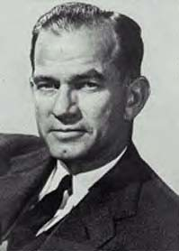

Senator Fulbright told the truth about Jewish control

It is not the purpose of this book to mention all politicians who have tapped into Israel’s purse. Nearly all of them receive this money. This includes Presidents, too, who will not be mentioned here in an effort to keep this concise. It is staggering when you think about how a foreign government can exhibit such influence over Congress. Some of those Senators

(S) and Representatives (H), who have received over $50,000 from the J-PAC’s over the years follow:

Frank Murkowski (S),

$63,000; Jon Kyl (S), $77,000; Dianne Feinstein (S), $113,000; Tom Lantos (H), $69,000; Howard Berman (H), $55,000; Jane Harman (H), $57,000; Bob Filner (H), $71,000; Christopher Dodd (S), $183,000; Joseph Lieberman (S), $227,000; Sam Gejdenson (S), $335,000; Bob Graham (S), $94,000; John Lewis (H), $64,000; Daniel Akaka (S), $93,500; Richard Durbin (S),

$246,000; John Porter (H), $71,000; Lane Evans (H), $74,000; Dan Burton (H), $61,000; Thomas Harkin (S), $424,000; Mitch McConnell (S), $285,000; Olympia Snowe (S), $71,000; Paul Sarbanes (S), $160,000; Steny Hoyer (H), $52,000; Edward Kennedy (S), $66,000; Carl Levin (S), $564,000; Sander Levin (H), $87,000; Trent Lott (S), $67,000; Richard Gephardt (H),

$135,000; Ike Skelton (H), $69,000; Max Baucas (S), $232,000; Conrad Burns (S), $165,000; J. Robert Kerrey (S), $199,000;

Harry Reid (S), $254,000; Shelley Berkley (H), $100,000; Robert Torricelli (S), $127,000; H. James Saxton (H), $54,000; Jeff Bingaman (S), $261,000; Eliot Engel (H),$99,000; Nita Lowey (H), $84,000; Benjamin Gilman (H), $81,000; David Price (H),

$51,000; Kent Conrad (S),

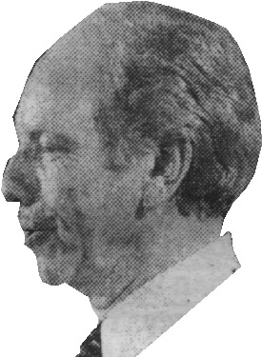

$196,000; Byron Dorgan (S),

$96,000; Arlen Specter (S),

$366,000, Richard Licht (S),

$246,000; Jack Reed (H), $75,000;

Claiborne Pell (S), $181,000; Ernest Hollings (S), $73,000; Tim Johnson (S), $51,000; Barton Gordon (H), $55,000; Martin Frost (H), $127,000; Orrin Hatch (S),

$51,000; Charles Robb (S),

$255,000; Slade Gorton (S),

$180,000; Russell Feingold (S),

$57,000; and, David Obey (H),

$147,000.70

Senator Lieberman: Is he working for the US’s interests or those of Israel?

As you can see, the amount of bribery received is

staggering. In many cases, it is enough to make or break an election. The full-list is 12-pages long, and only under a dozen politicians received less than $1,000 from these J-PACs. The Jewish conspiracy reaches the highest offices of the government.

#### Reviewing The Grand Jewish Conspiracy

Some may scoff at the title of this section, thinking that even after having read this, that there is no such thing as “The Grand Jewish Conspiracy.” However, in actuality, there is no term that is more apt, more pertinent, more fitting, than this; for there truly is a large body of Jews who are, in effect, working towards the same purpose—the subjugation of mankind. Many of these extremist Jews live in Israel, and their brethren throughout the world assist them in this devious purpose.

In the beginning of this book, it was shown that Israel was born in the blood of non-Jews. Many non-Jews met cruel deaths due to the hatred of these Jewish terrorists. Ironically, it is these same Jews who clamor about imagined persecution (unless

retaliatory measures for their own hateful deeds can somehow be construed as “persecution”) that engage in some of the most ruthless terrorism. Men of peace who died at the hands of the Israeli hatemongers were mentioned. Moshe Begin, after having ordered the bombing of the King David Hotel that resulted in many innocent deaths, became Prime Minister of Israel. Likewise, Yitzhak Shamir, who also became Prime Minister, was responsible for several murders as well. Dr. Goldstein, who murdered dozens of people while they were praying in peace, now has a large monument erected in his behalf in Israel. Additionally, Jews in Israel murdered dozens of Americans aboard the USS Liberty, an act that should have resulted in America going to war against Israel but was instead covered up. Jews bombed US institutions in the Mid-East and yet hardly a word came out of the U.S. government for that as well. Jews in Israel allowed 241 US Marines to die in an effort to generate support for the Jews’ totalitarian measures. Israel tricked the US into fighting Libya. Jews in America and abroad often spy on the US government. Jewish murderers and criminals often escape to Israel to live the good life because Jews live there without fear of extradition. What is more incredible than this is the simple fact that these incidents are just a small sampling of many, many such wicked crimes.

Israel had specific foreknowledge of the WTC attack. This is my unshakable conclusion based upon the evidence. Despite having this foreknowledge, Israel did not share it with the US. Admittedly, it is unknown for certain why Israel allowed 2,823 people to die a cruel and horrible death, but it seems that the reason why Israel did not share this information was because they wanted to unite America with Israel in its anti-Arab stance. While others in the WTC buildings died horrible deaths, Jews there received “instant” warnings and avoided this fate. This resulted in there being not one single Jew who was inside the WTC and who died. In fact, none even required a hospital visit.

The true reason why America is hated abroad was shown. It wasn’t because other countries hate America’s “freedom”; rather, it is because other countries are tired of seeing America supply Israel with bombs that it uses on civilians. This is one of the reasons that even the purported terrorist Osama bin Laden stated, and it is the reason that there will always be such people until America develops a more even-handed international

policy. As mentioned earlier, Jews sometimes boast about their control over America, and they themselves even depict American leaders as their little “puppets” in Jewish newspapers. Their arrogance is sickening.

The vast Israeli spy ring that was discovered after the WTC attack was described in these pages. Some Jews openly jumped up and down in glee after seeing the WTC burst in flames. It was later discovered that these Jews had special training and this training dealt with many different things, including explosives.

Along with the above, I described some conspiracies. One conspiracy about remote-controlled planes was shown to be hogwash. Yet another was viewed with curiosity: the implosion conspiracy. There were some things about this that deserve further investigation.

Israeli involvement in the WTC disaster was shown to be possible and in fact probable. From the very beginning, Jews were shown to have controlled the security at the airports. Many of the people suspected of being suicide bombers turned up alive and well, so this raises even more questions as to their true identities. Israelis have the ability to forge such identities. Jews might have even been able to oversee the visa process from Germany that allowed the terrorists, who may have even been Israelis, access to the United States. Many of those who were believed to have been the terrorists aboard Flight 11 were not sitting in the same seats as the actual terrorists. There appeared to be an odd connection with a member of the Israeli Army’s “most elite unit” aboard that very same Flight 11. Some Israelis determined to be spies had been trained in the use of explosives. The School for Advanced Military Studies issued a report that said the Mossad has the “capability to target US forces and make it look like a Palestinian/Arab act,” and this was noted on the very day before the WTC attack. Some people said that they thought that explosions occurred within the towers. Did these explosions—in addition to the planes—help bring down the towers?

And it was also shown that in January of 2000, reported members of Osama bin Laden’s network were arrested in India. They were believed to be involved with a possible hijacking plan. This plan might have merely been training for the WTC incident. These Muslims were only released at the behest of Israel, and

they went to Tel Aviv, Israel, afterwards.

I showed how Jews control the media. I described a case in which someone was fired for allowing someone else to speak poorly of Israel in a newspaper. Jews often play these psychological games in an effort to stifle debate.

Further, I showed that Jewish plutocrats strongly influence—if not control—the American government. This is done with both financial influence, some of which inevitably comes from Israel, and with propaganda by the Jewish Media Barons.

Throughout all this, I have asked many questions. These questions were designed to make you think about all this. Now I have more questions, but of a different nature. How long are non-Jews expected to tolerate this bitter hatred by the Jews? How long are we supposed to just sit here and take it while the very concepts on which this nation was created are being torn asunder by mostly Jewish interests? Are we expected to sit idly by while foreign interests control our land and sell our future? Should Americans allow this outrage against our citizens to continue unabated? How many more people must die at the hands of Jews before action is taken? How many more USS Liberties? How many more Lavon Affairs? How many more Lebanons? How many more dead Marines? How many more WTCs?

Some may say that I am angry, and this may be true.

However, my anger is the anger of the righteous.

#### Putting an End to The Grand Jewish Conspiracy

For far too long, Gentiles have watched while Jews have been viciously attacking our civilization. The time has come to put an end to this nonsense. I call upon all Gentiles of good will to work towards the immediate implementation of these 10 simple policies:

1.) An end to all foreign aid to Israel, with no tax- shelters allowed for Israeli bonds;

2.) An end to all dual-citizenship for Jews;

3.) An end to the acceptance of any PAC money that is designed to influence a politician to favor a foreign country or ethnicity;

4.) An end to supplying Israel with any military hardware or intelligence;

5.) A thorough background check on any Jew who wishes to go to Israel in order to ensure that he is not a criminal who is trying to take advantage of Israel’s non-extradition policy;

6.) An immediate and thorough investigation of possible Israeli involvement in the WTC attacks—and an investigation of other attacks, such as the USS Liberty;

7.) An American peace-keeping force to keep Israelis from bullying their neighbors;

8.) An intensive investigation to determine how widespread Israeli spying is inside the US;

9.) An end to the legalization of Jewish-promoted homosexuality which makes a mockery of the family unit upon whose foundation our civilization is based; and,

10.)An end to the Jewish Media Barons’ monopoly, which promotes Israeli propaganda and poor values.

With the implementation of the above 10 steps, America stands a chance of beginning to regain its former glory. To ignore The Grand Jewish Conspiracy and allow it to continue, however, will cause America to continue heading down the path toward destruction.

# The End

- or -

The Beginning?

**Footnotes**

1 Hirsh, Michael and Isikoff, Michael, Newsweek, “What Went Wrong” (May 27, 2002),

p. 30.

2 Shuman, Ellis, “Fear for Fate of Israelis in New York,” *Israel Insider* (September 12, 2001).

3 *Jerusalem Post*, “Thousands of Israelis Missing near WTC, Pentagon” (September 12,

2001)

4 CNN.com, “September 11: A Memorial,” 2001 (sorted by “country: Israel”). Currently online (as of 6 June 2002):<http://www.cnn.com/SPECIALS/2001/memorial/lists/by->

country/page9.html

5 Shuman, Ellis, “Fear for Fate of Israelis in New York,” *Israel Insider* (September 12, 2001).

6 Dror, Yuval, *Ha’aretz*, “Odigo Says Workers Were Warned of Attack” (September 26,

2001)

7 McWilliams, Brian, *Newsbytes*, “Instant Messages To Israel Warned Of WTC Attack” (September 27, 2001)

8 McWilliams, Brian, *Newsbytes*, “Instant Messages To Israel Warned Of WTC

Attack” (September 27, 2001)

9 Shaviv, Miriam, *Jerusalem Post*, “Zim Workers Saved by Cost-Cutting” (September 13, 2001)

10 Shaviv, Miriam, *Jerusalem Post*, “Zim Workers Saved by Cost-Cutting” (September 13, 2001)

11 Shaviv, Miriam, *Jerusalem Post*, “Zim Workers Saved by Cost-Cutting” (September

13, 2001)

12 Shuman, Ellis, “Fear for Fate of Israelis in New York,” *Israel Insider* (September 12, 2001).

13 Shaviv, Miriam, *Jerusalem Post*, “Zim Workers Saved by Cost-Cutting” (September

13, 2001)

14 Davis, Douglas, *Jerusalem Post*, “Mossad Warned CIA of Attacks, Report” (September 17, 2001).

15 Bennet, James, *New York Times*, “Spilled Blood Is Seen as Bond That Draws 2 Nations

Closer” (September 12, 2001)

16 Mohammed Alomari wrote an excellent book in English that tells of the struggles and hardships in Iraq. As a result of perpetual bombs that have destroyed the land and the

blockade, hundreds of thousands of children there have died as a result. Alomari’s book—*The Blockade & Destruction of Iraq: Crimes Against Humanity*—is available from Focus on American and Arab Interests and Relations; 17418 W. Ten Mile Rd.; Southfield, MI 48075.

17 See the Washington Report on Middle East Affairs’ website:<http://www.wrmea.com/> html/newsitem_s.htm

18 Guart, Al, *The New York Post*, “Trio who Cheered Attack Face Boot as Illegal

Aliens” (September 13, 2001), p. 12.

19 Lima, Paulo, *The [New Jersey] Bergen Record*, “Five Men Detained as Suspected Conspirators” (September 12, 2001).

20 Lima, Paulo, *The Bergen Record*, “Five Men Detained as Suspected Conspirators” (September 12, 2001).

21 Radler, Melissa, *The Jerusalem Post*, “Israelis Mistaken for Terrorists May Be Home

Soon” (October 26, 2001). One question about this article must be asked: Were they truly mistaken for terrorists, or wasn’t there just enough readily available evidence to prove their guilt?

22 Lisberg, Adam, The Bergen Record, “Five Hijack Suspects Had Links to N. J.” (September 15, 2001).

23 Melman, Yossi, (online English edition of Israeli newspaper) *Ha’aretz*, “5 Israelis

Detained for ‘Puzzling Behavior’ after the WTC Tragedy” (September 17, 2001).

24 Mowad, Michelle, *The Mercury*, “2 found with video of Sears Tower” (October 17, 2001).

25 Mowad, Michelle, *The Mercury*, “2 found with video of Sears Tower” (October 17, 2001).

26 Mowad, Michelle, *The Mercury*, “2 found with video of Sears Tower” (October 17, 2001).

27 Perelman, Marc, *Forward*, “Spy Rumors Fly on Gusts of Truth” (March 15, 2002). 28 Perelman, Marc, *Forward*, “Spy Rumors Fly on Gusts of Truth” (March 15, 2002). 29 Perelman, Marc, *Forward*, “Spy Rumors Fly on Gusts of Truth” (March 15, 2002). 30 Perelman, Marc, *Forward*, “Spy Rumors Fly on Gusts of Truth” (March 15, 2002). 31 Perelman, Marc, *Forward*, “Spy Rumors Fly on Gusts of Truth” (March 15, 2002). 32 Lisberg, Adam, The Bergen Record, “Five Hijack Suspects Had Links to N.

J.” (September 15, 2001).

33 Kay, Katty, *The* [UK] *Times*, “FBI Fury as Men with Nuclear Plan Escape” (November 1, 2001).

34 Merzer, Martin, et al., The Miami Herald, “Nuclear plants tighten security: FBI seeking

6 men seen in Midwest” (October 3, 2001).

35 Sugg, John, *The* [Tampa Bay] *Weekly Planet*, “Israeli Spies Exposed” (April 22, 2002). (One question begs to be asked: Why would Israel have “demolition” and “explosive”

experts here? Perhaps, that is best answered with another question: Anyone think that the buildings looked as if they were imploded?)

36 Valentine, Carole, [http://www.public-action.com/911/robotplane.html,](http://www.public-action.com/911/robotplane.html) “Operation 911:

No Suicide Pilots” (October 6, 2001).

37 McMichael, J., Public Action, “Muslims Suspend Law of Physics” (November 25, 2001).

[www.public-action.com/911/jmcm/physics_1.html](http://www.public-action.com/911/jmcm/physics_1.html)

38 Uyttebrouck, Olivier, Albequerque Journal, “Explosives Planted in Towers, N.M. Tech Says” (September 11, 2001).

39 Uyttebrouck, Olivier, Albequerque Journal, “Explosives Planted in Towers, N.M. Tech

Says” (September 11, 2001).

40 Fleck, John, *Albequerque Journal*, “Fire, Not Extra Explosives, Doomed Buildings, Expert Says” (September 21, 2001).

41 Bollyn, Christopher, *American Free Press*, “Some Survivors say ‘Bombs Exploded Inside WTC’” (October 22, 2001).

42 Bollyn, Christopher, *American Free Press*, “Some Survivors say ‘Bombs Exploded

Inside WTC’” (October 22, 2001).

43 *People*, “New York City” (September 12, 2001). See [http://people.aol.com/people/special/0,11859,174592-3,00.html](http://people.aol.com/people/special/0%2C11859%2C174592-3%2C00.html)

44 Baum, Geraldine and Farley, Maggie, *LA Times*, “Hijacked Jets Fly into Trade Center,

Pentagon” (September 11, 2001).

45 Perelman, Marc, *Forward*, “Spy Rumors Fly on Gusts of Truth” (March 15, 2002).

46 Sugg, John, *The* [Tampa Bay] *Weekly Planet*, “Israeli Spies Exposed” (April 22, 2002). 47 Scarborough, Rowan, *The Washington Times*, “US troops would enforce peace under Army study” (September 10, 2001), pp. A1, 9

48 Scarborough, Rowan, *The Washington Times*, “US troops would enforce peace under Army study” (September 10, 2001), pp. A1, 9

49 Scarborough, Rowan, *The Washington Times*, “US troops would enforce peace under Army study” (September 10, 2001), pp. A1, 9

50 CNN, “Arrests Made at NY Airports” (September 13, 2001).

51 BBC News, “Hijack Suspects Alive and Well” (September 23, 2001). 52 BBC News, “Hijack Suspects Alive and Well” (September 23, 2001). 53 Harrison, David, [UK] Telegraph, “Revealed: The Men with Stolen Identities” (September 23, 2001).

54 Harrison, David, [UK] Telegraph, “Revealed: The Men with Stolen Identities” (September 23, 2001).

55 AllAfrica.com, (translated) “The Americans Are Mistaken about 5 of the 19

Terrorists” (September 21, 2001). See: <http://allafrica.com/stories/200109210084.html>

56 Bamford, David, BBC News, “Hijack ‘Suspect’ Alive in Morocco” (September 22,

2001).

57 BBC News, “Hijack Suspects Alive and Well” (September 23, 2001).

58 BBC News, “The Last Moments of Flight 11” (September 21, 2001).

59 <http://www.cnn.com/SPECIALS/2001/memorial/people/1359.html>

60 Sieberg, Daniel, CNN, “Expert: Hijackers Likely Skilled with Fake IDs” (September 21, 2001).

61 ABCNews.com, “Who Did It? FBI Links Names to Terror Attacks” (January 9, 2002).

62 Steinberg, Jeffrey, Executive Intelligence Review, “Administration Makes First Move Against Israeli Spies” (March 29, 2002).

63 Steinberg, Jeffrey, Executive Intelligence Review, “Administration Makes First Move

Against Israeli Spies” (March 29, 2002).

64 Source attributed--ICTS’s website[--http://www.icts-int.com](http://www.icts-int.com/) At the time of this writing, this website could not be accessed for verification.

65 MEMRI (http://www.memri.org), “A New Anti-Semitic Myth in the Arab

Press” (January 8, 2002); citing *Al-Akhbar* (Egypt), October 29, 2001.

66 Bhaumik, Subir, *The Week*, “Aborted Mission Investigation: Did Mossad Attempt to Infiltrate Islamic Radical Outfits in South Asia?” (February 6, 2000).

67 Bhaumik, Subir, *The Week*, “Aborted Mission Investigation: Did Mossad Attempt to Infiltrate Islamic Radical Outfits in South Asia?” (February 6, 2000).

68 Washington Report on Middle East Affairs. See this website link for a better

breakdown of Israel’s foreign influence: [http://www.wrmea.com/html/us_aid_to_israel.](http://www.wrmea.com/html/us_aid_to_israel) htm

69 Findley, Paul, *They Dare to Speak Out* (Chicago: Lawrence Hill Books, 1989), p. 95. 70 Washington Report on Middle East Affairs. See this link for a more comprehensive list: <http://www.wrmea.com/html/aipac.htm>

**NOTE**: Many of these references can be found online using the search engine [http://www.google.com](http://www.google.com/) . Some links may not be active, but this may be resolved by clicking the “cached” link for the sources that Google displays. Usually, the references can be found by simply typing in the title of the article within quotation marks. (If this does not provide the article, adding the author not within quotation marks might help.) An example of a typical search for Footnote 67 above would be this exactly as shown:

“Did Mossad Attempt to Infiltrate Islamic Radical Outfits in South Asia?”

<http://www.the-week.com/20feb06/events2.htm>

This should work for most sources cited above. Other sources taken directly from newspapers and books might be found by searching for author’s names in quotation marks and general subject matter.

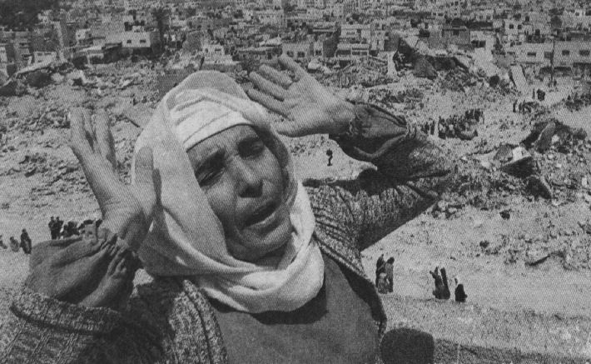

Her entire city was destroyed by the Jews.

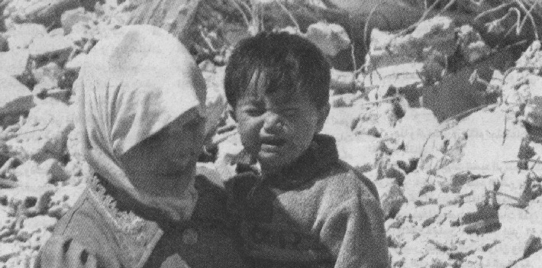

This child cries because his father is underneath the rubble.

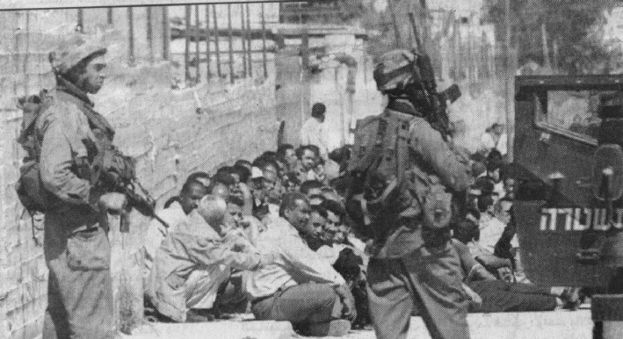

These Arabs were arrested. Their crime? Not being Jewish. Some will be tortured; others, murdered in cold blood. Just a typical day there.

## On September 11, 2001—often referred to as Black Tuesday—the most vicious act of terrorism occurred on U.S. soil in our history. Much like Pearl Harbor, it is truly a day that will live in infamy.

80

From the moment that the wicked act occurred, there has been a curious movement to suppress many of the facts surrounding the ordeal. The mainstream media has all but ignored many important events that might lead to the conclusion that there may have been others—in particular, Jews from Israel and abroad—who were involved in the attack.

Indeed, from the very day the attack occurred, Israelis who were witnessing the event unfold firsthand were seen “celebrating” it. And it was later proven that Israelis had advance knowledge of the World Trade Center attack but did not share this information with American intelligence.

The conspiracy surrounding the WTC is vast and deep. And finally, with the publication of this book, all the sinister machinations surrounding the WTC attacks are exposed.