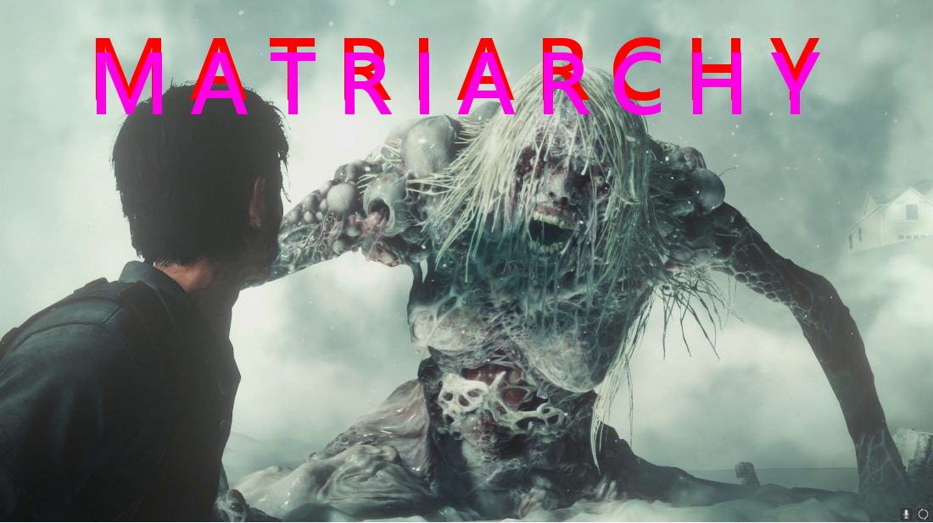

MATRIARCHY

Matriarchy is the politicization of female psychobiology, the extrapolation of the female ego into macropolitical or state form. In order to understand matriarchy you must understand the female nature which orients around the lower egoic tendencies of consciousness: a desire for the accumulation of material comfort and needs, the desire for recognition or status within the collective group and the desire to sate the insatiable desire that burns within woman and is a result perhaps of her inability to attain sexual exhaustion in any definite climactic process such as in the case of ejaculation of the male.

The figure of Lady Macbeth serves best as a reference point towards which ones attention must be focused in order to understand the psychology of the female and thus serves as an archetype of insatiable female desire. As in Shakespeare’s play Macbeth, Lady Macbeth is forever pressing Macbeth to ascend in the hierarchy of nobility so that she might, as the moon in relation to the sun, be able to reflect his brilliance and be looked upon by all as a significant figure in the social firmament. Like the moon, the female is mutable, forever changing her trajectory and incapable of any constancy given that, though she is impelled from without by the opinions and phenomena of existence her innate motor principle always follows her own broad and winding path orbiting the mundane realm of daily trends and cares exerting her magnetic influence upon the earth to absorb into herself vampirically all of the energy and attention that she can accrue to herself. Her path represents her psychological tendency of mutability: the consistency of inconsistency as Hitler referred to in Mein Kampf is the psychology of the female which is borne of her emotional mind and undeveloped rational faculties which trend in the direction most advantageous to her immediate needs having no regard for principles of truth or justice as that would entail self-sacrifice placing others before the self and the principle of woman is that of egotism, her virtue that of selfishness as Ayn Rand encapsulated in her book “the virtue of selfishness”.

Her altruism extends to the limit of her ability to maximize pleasure and minimize pain which is the only other principle she could be said to possess, namely the minimax or maximin principle also referred to in her libidinal economy as the pleasure principle. From this general principle of feminine psychology emanates her mendacity which in her mind is typically though not always a result of deliberate self-blindness, a cognitively dissonant, wilfully ignorant mentality which turns away or shuns all of that which is a source of greater pain than pleasure unless there is a greater overall pleasure to be derived over time if this is considered sufficiently worthy of sacrificing for and investing in which it typically isn’t given the lack of long term planning ability and concomitant myopic vision of the female which in most cases reveals her in her true light grabbing for immediate gain and self-gratification if need be at the expense of others. As such she is typically heedless and recklessly negligent in upholding the duties she has acquired as a functionary of the state.

Her egoic desire for personal power and recognition ha her work together with her fellow females in shunning and politically castrating male opposition who exist as a threat to her power. Thus the matriarchy is formed on the principle of sympathy, that like kind begets like kind and a hen house bureaucratic control freakish police state is formed on the basis of this feminine oligarchy given that the ego of the female must be sated at all times and the mechanism by which to do that is to impose an infinitely complex spider’s web of bureaucratic red tape which can ultimately be enforced only through the barrel of a gun.

The maternal instinct of woman also tends towards this totalitarian state form given that her inherent overprotectiveness seeks an outlet in the form of various kinds of legislation, eg. State intervention into the home under the guise of safety and security in the form of child or women protective services, favoritism in divorce proceedings and bias in hiring and academic admission as well as censorship and the enforcement of political correctness which is simply a veiled form of censorship. Ms.Manners the bureaucratic apparatchnick of the nanny state shaking her finger in the face of any self-assertive male as a means of psychically castrating him and enforcing the matriarchal operation of the nanny state. This finger wagging which not only embodies itself in the form of red tape generation but enforces itself through the spread of culture in the jewish controlled media in the behavioural forms of shunning and a spy society of rats whose allegiance to the nanny state which veils its tyranny under the guise of being a ‘community’ thereby blurring the lines of private and public both in the minds of the citizens as well as the bureaucrats who embody whatever public role they have acquired and base their identity upon. Thus ‘the state is everything and everything in the state” as Mussolini said only the form is not the phallus but vaginal, is not explicit and open and honest but covert and cunning in its operations.

Given that there are no standards of truth in the nanny state as all public discourse is a perpetual flux or babel of opinions and relativistic standards perpetually shading into one another as a shifting prism reflects the rays of the sun from pure and clear to an endlessly changing variety of wave lengths. Thus given that there are no fixed or determinate standards upon which to rely, a climate of uncertainty, fear and terror exists where anyone can be accused of anything at anytime and everyone is a suspect simply on the basis of the display of the slightest abnormality or deviation from the paradoxically standardized ‘rainbow reality’, ie. Anything not heterosexual, whit and male; anything which does not assert any universal truths in opposition to the empty dogma of universalism, ie. Egalitarian secular humanism. This general cultural chaos gathered together under the umbrella of ‘love, peace, tolerance, equality, etc.’ manifests itself in the equally vacillatory standards of the jewdicial system which are indecipherable to the average person as based upon completely general abstractions and could be and are interpreted by the powers that be who are all anti-white and especially anti-heterosexual white male. This ambiguity not only amounts to psychic terror but the terrorism of the police state which exerts capricious sways over the broad masses themselves cowed into silence. This lack of standards enables the dimunition of the educational standards which enables the dumbing down of the populace which enforces the tyranny through subjugation of opposition through disabling them from thinking and finding out what is being done to them by the matriarchal nanny state. For indeed those at higher levels do have nefarious plans and these are outlined in the Protocols of the Elders of Zion and in the Babylonian Talmud as well as in the Communist Manifesto.

Though a matriarchy the state is of course controlled from above by the elders of zion who merely use the psychopolitics of feminine duplicity to enforce their hidden tyranny. The white males are placed into harness and used for the self-serving ends of the matriarchy who assist the luciferian cabal of jews unwittingly given that they have partaken of the forbidden fruit of feminism and communism(their natural inclinations having been exploited to this end) in demoting the white males into the levels of a helot class perhaps sensing intuitively weakness through their over accomodative nature and wish to either challenge the white man and or subjugate him; challenging him to demonstrate that he the object of their natural desires is ‘man enough’ to conquer them and that he as competitor requires castration in order for them to usurp his place while in reality they are merely serving the interests as their overlords the jews.

Binding themselves to the collective out of their instinctive communistic and pacifistic inclination they enforce a rigorous unwritten and unspoken moral code of conformism to the aleatory and ambiguous principles that the nanny state upholds: equality,love,unity,etc. Which are merely emotionally charged buzzwords which neither have nor could have any concrete basis in reality as the Protocol of the Elders of Zion themselves say. As a consequence of matriarchy there exists the greater power still held in check by the remnant of heterosexual white males , namely that of jewish supremacism, which has created this saccharine rainbow reality as a means of destroying white christian civilization.

The endless influx of refugees is enabled through the female matriarchy and serves as an outlet for their maternal instinct which are directed towards the nurturing of apparent ‘victims’ or weak and defenceless beings and the non-white criminal invaders are portrayed as such to the females via the propaganda of the jew’s media monopoly to facilitate the invasion of non-white terrorists and economic colonialists who have come for a spoil and a plunder at the expense of the white man. Insofar as the white females are enabled to continue their macro political homewrecking through deriving exorbitant paychecks at the expense of the white male they will continue to allow society to slide into the primordial ooze of barbarism.

Ultimately, Matriarchy can only be subjugated by the phallus, the blade, the fasces, by Patriarchy. Failing this what would result would be a civilizational collapse and a reversion to stone age savagery. Thus it is matriarchy which functions to destroy and destabilize society at any level beyond the primitive savage and patriarchy, which is the builder of the pyramid and the cathedral, the phallic act of creative drive, the generative principle which enables the development of civilization from savagery