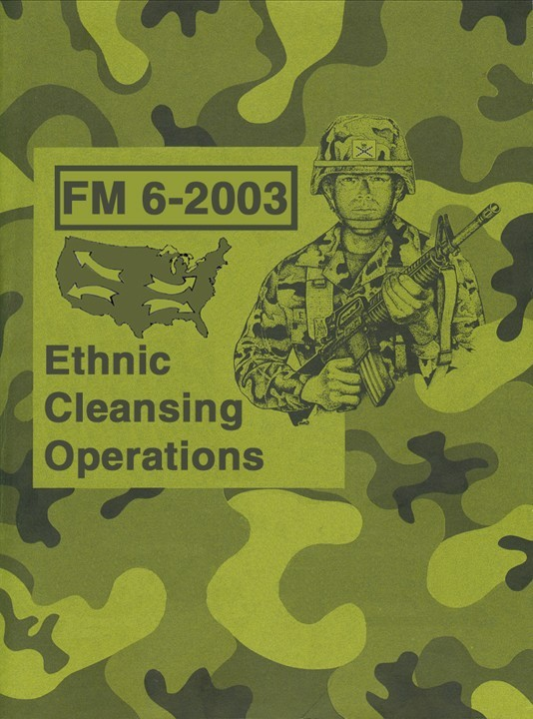

**FM 6-2003**

# Ethnic Cleansing Operations

#### *“In this war your uniform will be your skin, and you cannot take it off.”*

*The author.*

**JULY 2003**

**Not Copyrighted. Distribute Widely.**

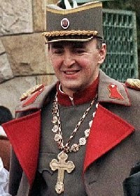

*To Arkan, the man who led the ethnic cleansing of Kosovo.*

*History will vindicate you.*

# Table of Contents:

Forward 5

Introduction 8

Chapter 1: Why Ethnic Cleansing? 10

Chapter 2: Historic Examples 26

Chapter 3: The Scrub Brushes of Ethnic Cleansing 31

Chapter 4: Who Will Fight? 59

Chapter 5: How To 66

Chapter 6: Operation Blackout 78

Chapter 7: When? 90

Epilogue 93

Recommended Reading 95

Appendix A, Psywar Poster 96

Appendix B, Abandoned Property Form 97

Appendix C, Military Bases 99

Appendix D, Amtrak Stations 112

About The Author 142

CD Case Label 143

# Forward

“Some white people, who are otherwise good people, who don’t hate blacks, are going to be pushed into the arms of these extremists if we don’t change course.”

*“Whites and the Next Racial Clash in America,” Carol Swain, PhD, Time, Feb. 18, 2003.*

Imagine waking up one morning to a day filled with growing ethnic violence. It could be triggered by anything, another motorist beaten by police, the shooting of a fleeing suspect, the discontinuation of a social program, a racist concert inciting violence bursting forth into the surrounding area, or any of a wide variety of incidents. Imagine

watching television reports throughout that day, watching the violence grow from random to organized, and then to the systematic killings of entire families only because they had White skin. In truth, small incidents of ethnic cleansing have been going on in the United States for decades, but today new militant influences have taken root among American Blacks who are beginning to talk openly about the widespread ethnic cleansing of people with White skin. Politicians are struggling to ignore this ticking time bomb, but it is there nonetheless. Whites must wake up to the fact that we are not only victims of ongoing racist violence, but that we are about to be attacked with the intent of wiping out our entire race.

This book is the response to the new Black militancy. It is different from any on the subject of ethnic cleansing, for instead of being a tear-jerking politically correct wish book meant for the liberal masses, this book is written specifically for the White race. Caucasians live in a very dangerous time. The forces of multiculturalism and militant non-Whites have already written our eulogy. They have an agenda to destroy us, and act on that agenda every single day. To confirm this, one need only to look at the local nightly news or a local newspaper to see stories of White men robbed and murdered, women raped and murdered, and children abducted and murdered by non-Whites. Yes, Whites do commit crimes, but in numbers nowhere near those of Blacks.

In Cincinnati, Ohio, the city that the NAACP calls, “the ground zero of race relations in America,” the media bends over backwards to cover up the incredible rates of Blacks attacking and murdering Whites. Cincinnati was a main ending point for the “underground railroad” during the Civil War. Escaping slaves fled to Cincinnati in great numbers and many of them settled there. Today it is shocking to see how the descendants of escaping slaves relentlessly attack and murder the descendants of the people who welcomed them.

During what came to be called the “April Riots” (2001) Cincinnati television stations withheld numerous reports of Whites being dragged from their cars and beaten by Blacks. They finally relented and warned (in a very awkward way) White residents to stay away from downtown. Newscasters had to admit that everything wasn’t as racially harmonious as they wanted everyone to believe. It is becoming increasingly difficult for the news media to cover up the savagery of Blacks.

As a veteran of several political movements, among them drug law reform, prison sentencing reform, and pro-Second Amendment, I was exposed to information that revealed the true roadblock to the success of each movement. I can attest that the very statistics used to argue each movement’s case actually expose the racial ingredient.

Appealing for sympathy, drug law reform activists will complain that racist laws and courts have intentionally packed the prisons with Blacks. The prison sentencing reform activists will say much the same thing. In the pro-Second Amendment movement there is great anger over growing restrictions on gun ownership because of their widespread use in crimes. Try though they may, activists within these movements find their way blocked. The fear of being called racist keeps them from admitting the truth that the preponderance of crimes—the violent crimes holding back an end to the Drug War, abolishing mandatory minimum sentencing, and revitalizing the Second Amendment, are perpetrated by Blacks.

The fact is, the greatest numbers of users of guns in violent crimes are Black; the greatest numbers of repeat offenders are Black; and the greatest numbers of criminals in general are Black. If you back the numbers of Black offenders out of each issue, drug laws, sentencing, and gun crimes, the statistics look more like those from predominantly White Canada.

The main reason that United States drug laws are not more realistic is because reform is impossible with violent Black drug offenders keeping the jails jammed. The reason gun rights are continuing to erode is because Blacks keep blowing people away. The reason that prison sentencing reform is bogged down is because violent Blacks are packing the prisons with repeat offenders. There are piles of readily available statistics from the Department of Justice confirming the preponderance of Black-perpetrated crimes, especially violent crimes, committed by a race making up only 12 percent of the total

U.S. population. The time has come to end this raced-based violence once and for all.

The purpose of this manual is to politically focus European Americans and to pass along time proven methods of ridding their cities of predatory Blacks and their White defenders. The contents of this book will undoubtedly raise a hailstorm of wrath on this author for having the temerity to instruct my brothers and sisters on exactly how to end their oppression once and for all. I make no apology these things, were I a Black or Chicano I would probably receive an award for being racially proud, but since I am White the attacks will come. Even though I do not dislike every member of any race, I am forced by Black racists to fight back or die. What this makes me is a racist, but a different kind of racist—a racist by necessity. Call me what you will, the genie of White nationalism is out of the bottle and it will not be put back inside.

The racial situation inside the U.S. military exactly reflects American civilian society. When race riots become widespread you can expect the military to split down the same racial lines as the rest of the country. When soldiers begin to desert in racially distinct groups, and take the weapons with which they are familiar along with them, a textbook

case of civil war will exist. White officers will lead armies of White soldiers and Black officers will lead mobs of Blacks. The effects of high tech warfare on civil society will be immense, rather like an enormous version of the disintegration of Yugoslavia.

The main point I wish to make is that the deteriorating racial situation, if left to develop on its own, will lead to a future that resembles a Mad Max movie. This manual provides a way out of that scenario, a path to order and peace rather than chaos and squalor. For that reason, this field manual may become one of the most important books of the 21st

century.

# Introduction

This manual concerns the military operations necessary to eradicate the predatory Black race from the contiguous United States. While this manual addresses the strategies and tactics from a military perspective, it is written as much for nonmilitary personnel as it is for active duty and veteran soldiers. The reasons for this general appeal is that the primary leaders who will pull together this effort may well arise from the nonmilitary White population as much as from the ranks of the career military.

There are some who will read this manual and complain that it does not address the problems caused by other non-White races. Instead this manual is written to deal with the primary threat to the White race—Blacks. The thoughts which will germinate in the minds of racially conscious Caucasians will undoubtedly lead to the crystallization of such thoughts and ideas and will lead to the penning of such books and manuals. For now, this one will do.

Of all the political movements in the United States, the strongest is by far the Dixie movement. They have the longest history, a legitimate nation in their past, defeat in battle, occupation, “reconstruction”, their own holidays, songs, heroes, and the determination to rise again. There is no doubt that if any symbol should signify the final righting of an old wrong, it is Dixie. Therefore, the Confederate battle flag is to be the great unifying symbol of Civil War II.

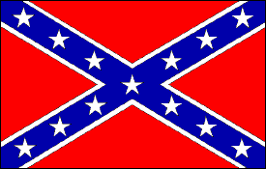

If anyone doubts that the anger of defeat still lives in the states which comprised the Confederacy, they need only glance at how southern voters “partisan shifted” to vote for George Wallace to be president in 1968, 1972 and 1976. A quick entry of “Dixie” into an internet search engine reveals a staggering amount of political discussion, organizing and even a shadow government now exists. Confederate flags fly from pickups, motorcycle helmets, tattoos, bumper stickers, and living room walls from coast to coast. That flag signified, and still signifies, Caucasians fighting to be a Caucasian nation. The people of the Confederacy knew that to free the slaves and allow them to live among Whites was racial suicide.

The United States should have, as every other slave-owning country did, repatriated the Blacks to their original places of purchase. The crime rate in the US skyrocketed with the release of the slaves and has never returned to its pre-Civil War rates. It is time to right the wrong of President Lincoln.

To rid the United States of Blacks, a great coalition of race conscious White groups and individuals will be pulled together. While those organizations have hit-lists and goals of their own, coalition commanders must work to keep the facets of this coalition focused on preplanned mission assignments. For the purpose of the offensive operations taught in this manual the expulsion of all Blacks will be the primary goal, with the targeting of other non-White races incidental to its purpose.

The mission of this manual is to instruct and inspire White commanders and the soldiers on the front lines of ethnic cleansing operations. It is not designed to give you all the answers; instead it is designed to “get your brain going”. Some of the strategies will be adequate as is, but keep in mind that the enemy will also acquire this manual, read it, and attempt to create countermeasures.

It is difficult to predict just exactly what will spark this conflict, but it is inevitable. When that spark ignites, it will be up to commanders to spring into action with plans made ahead of time and begin the crusade to save the White race. On the individual level, it is a matter of watching for the formation of large scale military actions around the country.

When ethnic cleansing becomes widespread and systematic—that is the time for unaffiliated Whites to pack up and go to the scenes of the fighting and join in.

If you are not “commander material” that is no problem, there is room for you in this war. You know who the enemies of the White race are in your neighborhood and in your town. Prepare a list and have it ready when ethnic cleansing operations pass through your area. Those living in areas bypassed by major military operations will have to racially purify their own towns. Then grab your gear, invite your friends and link up with active units. You too can help make history.

What lies ahead are months drenched in blood and choked with smoke. But on the other side of this war lies another golden age for the White race. Do not shrug your duty!

## Chapter One

**Why Ethnic Cleansing?**

”The problem was that we could not separate the good Tutsis from the bad ones. Plus each good Tutsi carried the seeds of the next bad one.”

*Unknown Hutu warrior.*

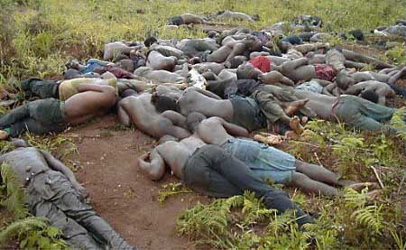

The decision to ethnically cleanse this country is a very serious one. It has come as the result of skyrocketing crime rates by people of color against Whites. But this is hardly the only reason. A White person only has to take a ride downtown on a city bus to see that racial tensions are increasing. I once asked a few Black men why Blacks seemed to zero in on Whites so much. Their candid response is worth repeating, their fellow Blacks were merely “hunting and gathering.” They went on to explain that before the “evil White man” had bought them as slaves, they had *hunted and gathered* in Africa, and that those old jungle instincts are still very close to the surface today. It is a scary thought to know that we are, in the minds of most Blacks, merely fruit on the trees waiting to be picked and eaten.

I meditated on what they had said and decided to informally probe the feelings of Black America a little deeper. A short time later I asked the same men why it was that Blacks install incredibly loud sound systems in their cars and crank the volume up to such a painful level. They replied again with candor, “We don’t even like it that loud. We do it to annoy Whitey.” At first I didn’t believe it, but after checking out the drivers of “boom cars” while sitting at red lights, I noticed that more than a few of them were wearing ear plugs. Blacks have converted their cars into mobile psychological warfare platforms.

They are playing anti-White rap music at ear splitting volumes more than just to “annoy” us, they were, and are, doing it to drive us out of our own neighborhoods. Their cars have become weapons in a deliberate campaign of ethnic cleansing.

Every February, Black History Month, we are all reminded that there is no other ethnic group that has been given an entire month to promote their jungle culture, wallow in self pity, and demand money. Black leaders, when asked why there is no White History Month always respond with virtually the same words, “there’s no need – you Whites already run everything.” Their response serves a twofold purpose. First, it suggests that we have no right to celebrate our race; and second, it trivializes to nothing our incredible accomplishments, history and heroes. Can you recall if there are any footprints on the moon left by anyone named Jamal or Carlos? The accomplishments of the White race are a galaxy beyond all the other races put together. The fact is the non-White races covet our accomplishments. They wish they were like us, but since they realize that they never will be, they seek to destroy us. Our accomplishments remind them of their inadequacies.

In response to their widely held animosity towards the White race, Blacks have taken to using their songs and music to spread their hatred and instigate acts of violence against Whites. Called “Gangsta’ Rap”, the songs clearly describe the hopes and dreams of most Blacks. This form of rap has become immensely popular, creating a multi-million dollar a year industry. In case you are unacquainted with Black racist rap, here are some sample lyrics from the most popular songs in the genre:

"Devils fear this brand new shit. . . . I bleed them next time I see them I prey on these

devils. . . . look what it has come to; who you gonna run to when we get to mobbing. . . .

filling his body up with lead, yah; cracker in my way; slitting, slit his throat; watch his body shake; watch his body shake; that's how we do it in the motherfucking [San Francisco] Bay sitting on the dock of the dirty with my AK."

*"Heat--featuring Jet and Spice 1"; Paris, Unleashed, 1998, Unleashed Records, Whirling Records.*

"He preys on old White ladies [who] drive the Mercedes with the windows cracked. . . .

you should've heard the bitch screaming. . . . sticking guns in crackers' mouths. the

cops can't stop it "

*"Mad Nigga"; Menace Clan, Da Hood, 1995, Rap-A-Lot Records, Noo Trybe Records, Time Warner, USA.*

"We're having thoughts of overthrowing the government the brothers and sisters threw their fists in the air. it's open season on crackers, you know; the morgue will be

full of Caucasian John Doe's. . . . I make the Riot shit look like a fairy tale. oh my

god, Allah, have mercy; I'm killing them devils because they're not worthy to walk the earth with the original black man; they must be forgetting; it's time for Armageddon, and I won't rest until they're all dead"

*"Goin Bananas"; Da Lench Mob, Planet of da Apes, 1994, Priority Records, Thorn EMI; now called The EMI Group, UK.*

"Fuck them laws, because the Mob is coming raw; nigga, is you down because it's the Final Call grab your gat; know the three will start busting; I'm trying to take them

down. . . . the war of wars with no fucking scores. we got crackers to kill; sending

them back in on a ship to Europe. . . . they deserve it a nation-wide riot across

America this is the Final Call on black man and black woman, rich and poor; rise up"

*"Final Call"; Da Lench Mob, Planet of da Apes, 1994, Priority Records, Thorn EMI; now called The EMI Group, UK.*

"The real black army is in jail. . . . come on my fellow prisoners, time to go to war. . . .

what we need to do is point the guns in the right direction, aha. me and my piece

came to claim the brown man's cut. . . . infiltrate until it burns down what we need to

be talking about is what we gonna do to them; I'll get revenge if it's the last thing I do. . . .

they got us brainwashed to be the minority, but when we kill them off we gonna be the majority if the Whites speak up, then I'll lead my people, because two wrongs don't

make it right but it damn sure make us equal; I'm inciting riots, so let's start the looting. . .

. in this revolution I loathe my enemy"

*"2 Wrongs"; Onyx, All We Got Iz Us, 1995, Rush Associated Labels Recordings, PolyGram Group Distribution, Philips' Electronics, Netherlands.*

"Niggas in the church say: kill Whitey all night long. . . . the White man is the devil. . . .

the CRIPS and Bloods are soldiers I'm recruiting with no dispute; drive-by shooting on this White genetic mutant. . . . let's go and kill some rednecks. Menace Clan ain't

afraid. I got the .380; the homies think I'm crazy because I shot a White baby; I said; I

said; I said: kill Whitey all night long. a nigga dumping on your White ass; fuck this

rap shit, nigga, I'm gonna blast I beat a White boy to the motherfucking ground";

*"Kill Whitey"; Menace Clan, Da Hood, 1995, Rap-A-Lot Records, Noo Trybe Records, subsidiaries of what was called Thorn EMI and now is called The EMI Group, UK.*

"These devils make me sick; I love to fill them full of holes; kill them all in the daytime, broad motherfucking daylight; 12 o'clock, grab the Glock; why wait for night"

*"Sweatin Bullets"; Brand Nubian, Everything Is Everything, 1994, Elektra Entertainment, Warner Communications, Time Warner, USA.*

"To all my Universal Soldier's: stay at attention while I strategize an invasion; the mission be assassination, snipers hitting Caucasians with semi-automatic shots heard around the world; my plot is to control the globe and hold the world hostage see, I

got a war plan more deadlier than Hitler. . . . lyrical specialist, underworld terrorist. . . .

keep the unity thick like mud. I pulling out gats [handguns], launching deadly

attacks"

*"Blood for Blood"; Killarmy, Silent Weapons for Quiet Wars, 1997, Wu-Tang Records, Priority Records, The EMI Group, UK.*

"Won't be satisfied until the devils--I see them all dead. my brother is sending me

more guns from down South. . . . pale face. it's all about brothers rising up, wising up,

sizing up our situation you be fucking with my turf when you be fucking with my

race; now face your maker and take your last breadth; the time is half-past death it's

the Armageddon. . . . go into the garage; find that old camouflage. cracker-shooting

nightly"

*"What the Fuck"; Brand Nubian, Everything Is Everything, 1994, Elektra Entertainment, Warner Communications, Time Warner, USA.*

"Bust a Glock; devils get shot. when God give the word me herd like the buffalo

through the neighborhood; watch me blast I'm killing more crackers than Bosnia-

Herzegovina, each and everyday don't bust until you see the Whites of his eyes, the

Whites of his skin. . . . Louis Farrakhan Bloods and CRIPS, and little old me, and we

all getting ready for the enemy"

*"Enemy"; Ice Cube, Lethal Injection, 1993, Priority Records, Thorn EMI; now called The EMI Group, UK.*

"Listen to this Black visionary, bringing war like a revolutionary go on a killing spree, putting devils out their misery; hearing screams, sounds of agony; my hostility takes over me. "

*"Under Seige"; Killarmy, Silent Weapons for Quiet Wars, 1997, Wu-Tang Records, Priority Records, The EMI Group, UK.*

"Swing by on the pale guy. . . . break him in the neck the guerrilla with the poison

tip. . . . shaking pinky up on a dull-ass ice-pick . . . this is Lench Mob devil, what you

want to do; when you see the boot, knew your head is hoohoo "

*"King of the Jungle"; Da Lench Mob, Planet of da Apes, 1994, Priority Records, Thorn EMI; now called The EMI Group, UK.*

"Dropping verses, casting curses, throwing these hexes on the devils respect to

Farrakhan, but I'm the jungle-don, the new guerrilla, top-ranked honky killer. what do

Blacks do; they just keep on blowing devils away. . . . evil fucking cracker. I'm

tightening up the laces to my steel-toed boots, so I can walk, stomp; we stomp this devil down in the park"

*"Planet of da Apes"; Da Lench Mob, Planet of da Apes, 1994, Priority Records, Thorn EMI; now called The EMI Group, UK.*

". . . I hate fucking crackers. I destroyed a whole city like Sodom and Gomorrah or

Babylon. . . . devils choke from the gunsmoke. . . . I'm swelling devils' melons. solo

pro-morgue supplier"

*"Graveyard Chamber"; Gravediggaz, 6 Feet Deep, 1997 reissue of a 1994 album, Gee Street Records, BMG Distribution, BMG Entertainment, Bertelsmann AG, Germany.*

"I'm black with a bat, swinging at the head of a honky The Terrorists about to murder

your ass"

*"Blow Dem Hoes Up"; The Terrorists, Terror Strikes: Always Bizness Never Personal, 1991, Rap-A-Lot Records, Priority Records, Thorn EMI, UK.*

"The crackers ain't shit; chase them out of the jungle; now raise up off the planet. we

get the 12 gauge; shot to the chest. . . . we hitting devils up. Da Lench Mob,

environmental terrorist. I gripped the Glock and had to knock his head from his

shoulders. . . . I got the .30[06] on the rooftop; pop; pop; so many devils die. make

sure I kill them. lynch a thousand a week if it's necessary"

*"Environmental Terrorist"; Da Lench Mob, Planet of da Apes, 1994, Priority Records, Thorn EMI; now called The EMI Group, UK.*

There are literally hundreds of songs just like these. As the racist lyrics reveal, Blacks are psychologically preparing themselves to ethnic cleanse Whites.

The “Reverend” Louis Farrakhan has instructed all Black men to begin working out and to get in shape. Many are following his instructions. This is not just a general health concern of the Nation of Islam; it is a prerequisite for war. Whether Caucasians are organizing or not, the Blacks and Chicanos are seriously getting ready.

Such preparations are not limited to physical exercise and psyching themselves up for battle. Their psychological warfare platforms roam America’s streets spewing out anti- White hate music 24 hours a day. While some Whites are frightened by the intense volume and menacing language, many more are amused. Why? Because there is an up side to their boom car tactic; those drivers without earplugs, and there are many, along

with their hearing-impaired passengers, will be very easy to sneak up on. In the end, the laugh is on them and their noisy boom cars.

### The Economics of Ethnic Cleansing

Utilizing the fact that races like to live amongst their own kind, non-Whites move into neighborhoods and begin eroding property values. When families from other races move into monoracial neighborhoods the earlier residents get nervous with good reason.

Usually things start disappearing, first the kid’s bicycles, then lawn furniture, then vehicles, and then the new “neighbors” start burglarizing the homes of the people who made the neighborhoods the beautiful happy places they once were.

The result of this behavior is not only the loss of material goods that must be replaced, the victimized residents then have to give serious thought to moving away. If the danger is high, and it often is, the homeowners must resort to significantly lowering the price of their homes in order to sell them quickly and escape with their lives. This trend causes a general lowering of property values for the entire neighborhood. The collapsing prices of the homes result in even more lowlifes invading what was a peaceful neighborhood. Does this sound like your neighborhood, or your former one? You are hardly alone, this is happening, literally, all over America.

Where it was once wonderful to go downtown to watch a symphony or a play, it is now seriously dangerous; downtowns have turned into jungles alive with hooded “bubble coated” droopy panted thugs. Whites are being forced away from their own cultural centers and out of their own neighborhoods by dangerous violent predators.

In this biased politically correct society we find ourselves in, the savagery of Blacks is covered up every day. The following list is a tiny sample of the huge amount of Black on White crimes that go on every day. If you haven’t heard of most of these crimes, you are not alone. When an interracial crime is committed by a White, the media gives it "front page" and "lead story" attention. You heard about it when a White dragged a Black to death behind a pickup truck in Jasper, Texas. You did not hear about it when a Black dragged a White to death behind a car in Streator, Illinois. You did hear about it when a White soldier killed a Black drug pusher in Fayetteville, North Carolina. You did not hear about it when seven Black soldiers ganged up on a White soldier and stomped him until he was brain-dead, also in Fayetteville.

Examples of biased media coverage of Black hate crimes:

### The Wichita Massacre 12/15/2000

**The White hate-crime victims:**

*Brad, Aaron, Heather and Jason were killed on the 15th. Ann was shot during a carjacking four days later.*

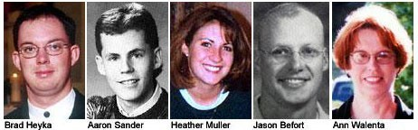

### The Black hate-crime perpetrators:

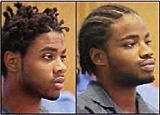

*Just “hunting and gathering.”*

On the night of December 14, 2000, Black predators Reginald and Jonathan Carr burst into a home occupied by Brad Heyka, Aaron Sander, Heather Muller, Jason Befort and a woman survivor whose name is withheld out of respect. Holding the five Whites at gunpoint, the two Blacks raped and tortured the Whites for several hours. They then forced the Whites to withdraw money from ATM machines and give it them. The Blacks then drove the Whites to an empty field, forced them to kneel and shot them in the back of the head. They then ran over their bodies with their truck. The one woman survived and walked a mile naked in 17 degree weather to call police.

Four days later the Carr brothers attempted to carjack Ann Walenta. She attempted to drive away and was shot in the face. She lived long enough to provide information to the police, but died of her wounds.

The Wichita massacre did not make national headlines. Media attention was mostly confined to Kansas. But if two armed White men had kidnapped five unarmed Blacks, robbed them, raped the women, tortured the men, and shot them all through the head,

national news would have swarmed all over it and not one reporter would be dismissing it as a random act of violence.

|  |  |  |  |
| --- | --- | --- | --- |
| **Perpetrators** | **Victims** | **Hate Crime** | **Details of the crime:** |
| Seven Blacks | Melissa McLaughlin | rape, torture, murder, mutilation | In 1992 in South Carolina, Melissa, a young White woman was kidnapped by a group of Blacks who raped her for several hours. Her abductors forced her to sit in a tub of bleach and then skinned her alive with knives. This crime was never reported in the national news media, almost certainly because the killers were Black and the victim was White. |
| Andrew Engram | Laurie White | rape and murder | Crime occurred on 5 June 1997 in Little Rock, Arkansas. Engram, a Black repeat felon, attacked Laurie (a White woman), raped her, and hung her by an electrical extension cord until she was dead. Only the local news reported the story. |
| Anthony and Adrian Hollis and several other young Black men | Michael Carter Dustin Kaiser "Nicole" (R.N.W.) | aggravated assault, rape, murder | Crime occurred on 19 June 1997 in Flint, Michigan. Three White teenagers, having run away from their home in Highland, Michigan, as a prank, were lost in a Black neighborhood. While looking for a pay telephone so that they could call home, they ran into some Blacks who offered to "assist" them in locating the nearest telephone. The Blacks led them to a secluded park where they were ambushed by a Black gang.  Michael Carter was killed by being shot in the head. Dustin Kaiser was beaten unconscious and shot in the head, but survived. "Nicole" was raped and sodomized and then shot in the face with a .22 caliber |

|  |  |  |  |
| --- | --- | --- | --- |
|  |  |  | pistol, but did not die. Besides the Hollis brothers, police arrested Terrance Reyes, Tyrone Reyes, and Shannon Gould (all of them Black teenagers). There was no national news coverage of this crime. This crime was not prosecuted as a "hate crime," proving once again that hate crime legislation is a political tool to be used against White people. |
| Three Blacks | Gary Traska | murder | Crime occurred on 2 October 1998 in Buffalo, New York. Three young Black men attacked Gary, age 41, as he emerged from his apartment building. The Blacks knocked him down, and, while laughing, proceeded to kick Mr.  Traska until he was dead. The autopsy report reveals that he had been kicked so hard that his internal organs had ruptured. News coverage of this murder was a brief mention in the Buffalo News. |
| Three Chicanos | Chad Auber | murder | Crime occurred on 6 October 1998 in Orange County, California by three wetbacks carrying weapons loaded with armor-piercing bullets. Auber was unarmed and his hands were in the air when he was shot. He was killed three weeks before his 21st birthday. |
| Several Blacks | Don Deveo | murder | Crime occurred in 1994 in Edgewater, Florida. Don was beaten to death by a group of Blacks who used the word "cracker" repeatedly while kicking and punching him. Witnesses claim the attackers also shouted, "Let's kick this cracker to sleep". |
| Anthony Harris | Devon Duniver | murder | Crime occurred on 28 June 1998 near Cleveland, Ohio. Devon was |

|  |  |  |  |
| --- | --- | --- | --- |
|  |  |  | a White girl only five years old. The murderer, a Black male, was quoted as saying "She got what she deserved." |
| Francisco Martinez | Brandy Duvall | rape and murder | Crime occurred 30 May 1998 in Denver, Colorado. Brandy, a 14- year-old White girl, was kidnapped at a bus stop by seven members (including the one named) of the Black/Chicano gang called the Bloods. These non- Whites took Brandy to a remote area and took turns raping her, and then raped her with a broom handle. Finally, they stabbed her 28 times with a knife and dumped her body in a ditch. |
| Arthur Bomar | Aimee Willard | rape and murder | Crime occurred on 20 October 1996 in Media, Pennsylvania. Aimee, a young White coed George Mason University student (age 22), was in her car when the murderer, a Black man, deliberately caused a collision with his vehicle and hers. When she got out examining the damage, Bomar attacked her with a crowbar and beat her to death. He then removed the clothing from her corpse and raped it. Afterward he threw her body into an empty lot. The crime was minimized by the national media, though it was reported only in Philadelphia and in Washington DC. |
| A Black man | Mr. & Mrs. Puglisi | murder, kidnapping, rape, torture | Crimes occurred in the spring of 1998 in Wilmington, Delaware. A Black man named Flagg, after using crack, entered a nice White neighborhood when he saw Mrs. Puglisi in her garden, working. He entered the home through the back door, helped himself to the food in |

|  |  |  |  |
| --- | --- | --- | --- |
|  |  |  | the refrigerator, and waited. When Mr. Puglisi came home, Flagg shot him dead. Flagg then kidnapped Mrs. Puglisi and took her to his own home, where he kept her tied up for days while he raped and otherwise molested her.  Fortunately, Mrs. Puglisi escaped and called the police. |
| Three Blacks | Tiffany Nicole Long | rape, torture, murder | Crime occurred on 16 October 1998 in Burlington, North Carolina. Tiffany, age 10, was abducted from a sidewalk near her home by three Black teenagers - Joseph Jones (13), Harold Jones  (16) and Dorthia Bynum (17). The Blacks took Tiffany behind the garage of a house in a neighboring block and tied a television cable around her neck. The Black males then raped and sodomized the little White girl, and, when they were done, the Black female took a broomstick and rammed it through Tiffany's vagina into her chest cavity, killing her. The news was reported only by the local media, who claimed that the crime was not racially motivated. |
| A Chicano | Peggy Lynn Howard | murder | Crime occurred on 25 October 1998 in Houston, Texas. Peggy, age 25, was leaving her home that morning when a Chicano ran up and shot her twice in the face. The murder occurred in front of the victim's six year-old daughter. The crime was reported only in the Dallas-Houston area. |
| Several non- Whites | Tracy Lambert & Susan Moore | multiple murder | Crime occurred on 17 August 1998 in Fayetteville, North Carolina. Tracy Lambert (age 18) and Susan Moore (age 25) were coming home from work when |

|  |  |  |  |
| --- | --- | --- | --- |
|  |  |  | they were abducted by members of the Black/Chicano Crips gang. The crime was a part of an initiation ceremony in which new members of the gang were required to kill a White person. The gang members persuaded the women to stop their car. They then carjacked the vehicle and locked the two women in the trunk. The gang members drove the car to a vacant field near Fort Bragg, took the women from the trunk and made them kneel on the ground. The gang initiates then shot the women in the head. |
| A Black man | Ann Prazniak | murder | Crime occurred 15 April 1998 in St. Paul, Minnesota. Mrs.  Prazniak, a 77 year old widow, was attacked in her home by a 27 year old Black male, who demanded money. She didn't have any, so he killed her. After killing Mrs. Prazniak, the Black wrapped her body in plastic, stuffed it into a cardboard box, and shoved the box into a closet in the bedroom. The Black then looted the place, but instead of leaving he called some of his friends and turned Mrs.  Prazniak's home into a crack- house. This crime was blacked out, except in parts of Minnesota. |
| About 25 Blacks | Richard Skelton | murder | Crime occurred on 10 August 1998 in Alton, Illinois. Richard, a 48-year-old White man, entered a Black neighborhood to inquire about his stolen TV set. He was attacked by residents of that neighborhood, while other residents cheered and shouted encouragement to the attackers, who beat and kicked Mr. Skelton until he was dead. |

|  |  |  |  |
| --- | --- | --- | --- |
| Seven Blacks | Donald Lange | attempted murder or aggravated assault | Crime occurred in the summer of 1998 in Fayetteville, North Carolina. Donald, a 25-year-old White soldier assigned to Fort Bragg, was beaten and kicked in the face so badly by seven Black soldiers that he was left in a permanent coma. The media chose to black out any news coverage of this attack, although they gave lengthy national publicity to a crime involving a Black crack dealer killed by a White solder, in the same town. |
| Christopher Coleman | Patricia Stansfield | murder (vehicle dragging) | Crime occurred on 1 August 1998 in Streator, Illinois. Patricia, a 46- year-old White woman, was abducted by a Black male who had stolen a car belonging to one of her friends. The Black male tied Ms. Stansfield to the car's rear bumper and proceeded to drag her across a two-mile stretch of Highway 18 as he drove from Streator into the countryside. The dragging killed Ms. Stansfield.  The media blacked out all coverage of this murder, although they sensationalized a very similar murder in Jasper, Texas, involving White killers and a Black victim. |
| A Group of Blacks | Gregory Griffith | murder | Crime occurred on 13 August 1999 in Jacksonville, Florida. Gregory, a 50-year-old White man, was walking down a sidewalk, when several young Black males attacked him. The Blacks beat and stomped Mr. Griffith until he was comatose. He died in the hospital (Jacksonville University Medical Center) on 26 August 1999. |

|  |  |  |  |
| --- | --- | --- | --- |
| “Dedrick” | Kayla Roland | murder | Crime occurred in March 2000 in Michigan. Both the murderer and the victim were in the first grade. The murderer “Dedrick,” a young Black male, brought a gun to school from the crack house in which he lived. The shooting occurred in the classroom. The Black shooter had a history of assaulting White children, on one occasion stabbing a classmate with a knife. Before the Black pulled the trigger of his pistol to kill the little White girl, he turned to her and said, "I hate you." The media gave some limited coverage of this murder, but concealed the fact that the killer was Black. |
| an unknown non-White | Sandra Roberts | murder (vehicle dragging) | Crime occurred on 14 February 2000 in Kansas City, Missouri. The victim was a 41-year-old White woman. |
| Kim Davis | Jake Robel | murder (vehicle dragging) | Crime occurred on 22 February 2000 in Independence, Missouri. The victim was a six-year-old White boy. Kim Davis, age 34, stole a car belonging to Jake Robel's mother. Davis attempted to push Jake out of the car, but did not halt when it became clear that the boy was caught in his seat-belt. Davis dragged Jake along the road for about four miles at speeds up to 80 miles per hour, causing the child's death. The news media did report the crime, but concealed the fact that the murderer is a Black man. |
| 18 Blacks and Chicanos | White girl | Assault, ethnic- intimidation | Crime occurred on 1 May 2003 in Cleveland, Ohio. Twelve girls and six boys are accused of beating, kicking and choking a 13-year-old White girl on her way home from |

|  |  |  |  |
| --- | --- | --- | --- |
|  |  |  | school. When asked by police why they beat the girl they replied that May 1st is now “beat up a White kid day.” News reports were confined to Cleveland. |

The FBI’s Hate Crime Statistics reveal that more than 30,000 White women were raped by Black males in 1994 compared with 5,400 Black females raped by White men. Other violent Black on White hate crimes are comparable in proportion.

This isn’t what you see when you watch the evening news. Black hate crimes against Whites are so common that they are often not even covered. White hate crimes toward Blacks though, will be the lead stories because the ruling class (ruling elites) wants the citizenry to believe that only Whites commit hate-crimes.

It seems that the smiling Pancho and Cisco we have been led to believe are the archetypal Chicanos are actually the minority. Crime rates among “la raza” (the race), while lower than Blacks, is still far higher than that in White communities. There also exists the same gut dislike of Whites by Chicanos found among Blacks. There seems to be a mindset among non-Whites that all Whites and everything we own are fair game for plunder.

Blacks are fond of saying, “If it belongs to Whitey, bust it up.” The Chicanos use the phrase “Su casa es mi casa,” meaning your house is my house. They usually smile when they say it, but they are deadly serious.

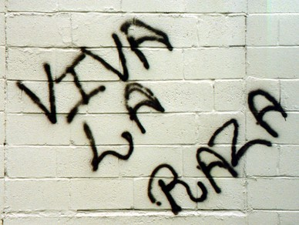

*Whose race do you think they are referring to?*

Evidently Chicanos, along with Blacks, hold angry long term grudges. Take for instance the idea of nationalist Mexicans wanting the return of the area Mexico sold to the United States under the treaty of Guadalupe Hidalgo, the area from Texas to California. The U.S. made Mexico an offer, an amount was agreed upon by both parties, and the U.S. paid for

it in full—and Mexico took the money. Militant Mexicans deny all this and have vowed to ethnic cleanse all the Whites in the disputed area in order to become a part of a “greater Mexico.” Similarly, Blacks wail endlessly for mountains of cash under the guise of “slave reparations.” When those impossible demands are not met, and patience runs out, non-Whites are planning to kill Whites en masse. As you have seen, the killing has already begun—and it is time for those deaths to be avenged.

## Chapter 2

**Historic Examples**

“...One arson team dressed in military camouflage was operating an antitank gun and firing tracer and incendiary rounds into homes in the Bulajusa area...; in the Kistanje area civilian dressed ‘officials’ with maps were observed pointing at houses, later some buildings were observed to be burning. [We also] saw a group of four soldiers moving

in and around buildings along the two main streets. [Later] smoke began pouring from

behind buildings on the main street ”

*“A Cry From The Grave,” Mark Danner, The New York Review of Books*

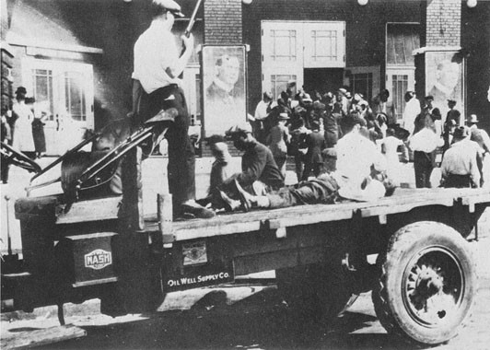

*Armed Whites herding captive Blacks into an improvised jail. Tulsa, Oklahoma, 1921.*

What exactly is ethnic cleansing and how can one tell when it is going on? MSN’s Encarta Online Dictionary defines ethnic cleansing as “a phrase for an attempt to purge an area of an unwanted ethnic group. It can include deportation, intimidation, and acts of genocide or mass murder.” It generally involves the systematic and forced removal of members of an ethnic group from their communities to change the ethnic composition of a region. Ethnic cleansing always requires that one group of people move against the other in an organized, militarized manner.

Ethnic cleansing is a new term, coined in the ruins of the former Yugoslavia. However, it is not a new practice. In the Old Testament, the extermination of the Canaanites by the Israelites is nothing less than ethnic cleansing. There are numerous examples, but several are of particular interest, the Armenian genocide, the US Civil War, the Tulsa Riots of 1921, and the former Yugoslavia. There are also some smaller episodes worth mentioning.

In what came to be known as the Armenian genocide, between WWI and WWII, unarmed Christians were systematically hunted down and exterminated by Muslims. The Muslim population considered the Christians infidels and their deep anger against them was easily aroused. In *The Blight of Asia,* one of the few books exposing the slaughter, the author writes, “The violent and inflammatory articles in the Turkish newspapers…appeared unexpectedly and without any cause. They were so evidently ‘inspired’ by the authorities, that it seems a wonder that even ignorant Turks did not understand this. Cheap lithographs were also got up, executed in the clumsiest and most primitive manner—evidently local productions. They represented Greeks cutting up Turkish babies or ripping open pregnant Moslem women, and various purely imaginary scenes, founded on no actual events or even accusations elsewhere made. These were hung in the mosques and schools. This campaign bore immediate fruit and set the Turk to killing, a not very difficult thing to do.” When the dust settled, millions of Christian men, women and children lay dead.

Lack of news reporting and the turning of blind eyes by politicians left the general public unaware of the immense numbers of people killed. The world was left ignorant of the role of Islam played in fanning the flames of hatred and even orchestrating the violence.

These ethnic cleansings took place in two phases: The first between the beginning of the 1890's and again at the end of the 1950's.

Adolf Hitler was aware of the lack of interest by politicians to get involved in ending ethnic conflict. When Hitler was asked if he was concerned about repercussions for getting the Jews out of the Third Reich, Hitler replied that he was not worried, since no one remembered the Armenian massacres. He knew that millions of men women, and children had been expelled from their homes, tortured and massacred only for being Christians. He also knew that no country was likely to interfere.

The Turkish rulers carried out ethnic cleansing as part of a plan to create what they called a “Turkey for the Turks,” actually an expansion of Islam. This policy of ethnic cleansing of the Christian Hellenes had already been applied to the population of the

island of Chios in 1822, where a century before the Turkish army laid siege to the city of Smyrna, leaving it a burnt-black ruin.

At the surrender of the Confederate States of America to the Union army, General Robert

E. Lee insisted that his demobilizing troops be allowed to keep their horse and their handgun. Lee’s idea was for them to get back to their southern farms with all speed to put in food crops. The reason for keeping their pistols was brutally simple, the newly freed slaves, many of them livid with racial hatred for their former owners, were ready to go on widespread killing sprees. General Ulysses S. Grant acknowledged Lee’s observations as legitimate and the demands were met. Southern soldiers rode home quickly and in safety with their pistols at their sides.

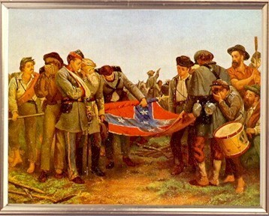

*Confederate soldiers demobilizing as war ends.*

*Note rifles on ground and pistol held by rebel on horseback.*

Fifty six years after the US Civil War, a Black accosted a White woman in an elevator in the town of Tulsa, Oklahoma, igniting spontaneous ethnic cleansing. Hearing that a White woman had been assaulted by a Black male, White men grabbed their rifles and assembled at city hall. Rumors quickly spread through the Black section of Tulsa that the Whites were going to lynch the accused Black. A carload of Blacks attempted to interfere at the court house, resulting in shots being fired. Three days of rioting resulted, prompting the governor to call in the National Guard. In those days the NG was exclusively White, so upon arrival at the scene the Guard set up two heavy machineguns on the White side and fired upon the Blacks until they ceased to resist. The Black neighborhood was burned almost entirely, with 200 Blacks dead. As you would expect, today Tulsa Blacks are holding angry grudges and demanding reparations in spite of their having killed 50 Whites during the battles.

Race-conscious Whites in the former Yugoslavia in the mid 1990’s reportedly killed tens of thousands of Muslims and forced the movement of hundreds of thousands more.

Before we think Americans too civilized for such things to happen here, consider this;

Yugoslavia was not considered a backward place. In fact, it was considered one of the few former Soviet countries to actually make it over the hump into the modern developed world. Only seven years prior to the outbreak of ethnic cleansings, Yugoslavia had hosted the Olympics in Sarajevo. Today it is a fragmented, burnt-out shell of its former self, scarred with mass graves.

From the National Alliance, the wellhead of Aryan thought, spokesman William Pierce, author of *The Turner Diaries,* wrote in his May 13, 2000 online newsletter that if he had his way “Believe me . . . Every inner city and every non-White neighborhood in America would be blocked off while armed teams went door to door and made the ethnic cleansing of Kosovo look like a Sunday school picnic by comparison.” What he describes is ethnic cleansing at the tactical level.

One does not have to look at the television news very closely to find that ethnic cleansing has already started in the United States. On April 21, 2000 a Philadelphia White man by the name of Richard Baumhammers went on a shooting rampage, killing four people of different non-White races. After his capture, Baumhammers told police “I wanted to start a race war.” Only days before, Rodney Taylor, a Black man from the same city went on a racist rampage, killing just the White employees of two fast-food restaurants. On the run from his first murder, Taylor burst into the apartment of a Black woman who cringed in horror at the armed intruder. Taylor consoled her saying, “Don’t worry, I only want to kill as many White people as I can.” These two events should be considered mini-ethnic- cleansings only because the individuals acted alone.

There is a very strong political dynamic moving in the United States, and it is moving toward organized ethnic cleansing. The US is already in a state of low intensity racial conflict. Race wars are biological at their root, so there can be no enduring negotiated settlement. Historically, they are conflicts that must continue until one side wins and the other side is wiped out. It is essentially a dynamic that must burn itself out. The race-war is on, like it or not, and the penalty for not fighting to win is death.

The dimensions of this problem are so big and multi-sided that it is unlikely the US military will be able to contain it. This is because the very same racial and cultural divisions exist within the military as well as federal, state and local police forces, which can be expected to split right along the same racial lines.

In *Civil War Two, The Coming Breakup of America,* author Tom Chittum identified four distinct phases leading up to the fragmentation of the United States into several smaller countries. When he authored his book in 1995, Chittum said that the U.S. was in Phase II (the Terrorist Phase) of the breakup with, “The splitting of many American groups and institutions along ethnic lines, perhaps even political parties.” One look at the Supreme Court decisions about Affirmative Action (University of Michigan 2003), the exclusively Chicano La Raza Unita Party, and the darkening Democratic Party confirm our orientation on the cusp of Phase II.

Chittum also writes of Phase II, “The fragmenting and politicizing of the military. Covert and overt racial factions will become common. Our military will come to resemble the old Soviet military as affirmative actions officers politicize it by purging conservative Whites and promoting minorities and liberal Whites. The military’s racial composition will shift to mostly minority, especially that portion of the military that conducts ground operations—the Army and Marines because these two branches are vital to actually controlling America. The military will increase operations that give it experience in operating government, such as the operations in Haiti, Bosnia, and Somalia.” (Add to that the U.S. takeover of Iraq.) He continues, “Such operations will desensitize the military to the eventual military takeover of the United States of America—the true, ultimate and only real point of all these takeovers of foreign countries.” The civilian rulers of the United States see the racial divide widening and can also see the growing racial conflict. They know what is on the horizon and work to make sure that you do not. However, intuitively both Blacks and Whites are picking up on what is happening and many on both sides are preparing for a war between the races.

In his descriptions of what comprises Phase III of the devolution into Civil War II, Tom Chittum writes, “The establishment will acquiesce to gang and militia control of some areas which are entirely (but unofficially) abandoned by the police or the military.” One only has to glance at the situation in the inner cities, many now run by gangs and the situation along the Arizona/Mexico border, now policed by armed White militias, to see another of Chittum’s predictions confirmed.

Phase IV of the breakup of America will be comprised of continuous, all-out warfare. This will create the perfect conditions necessary for the White public to become involved in purging predatory Blacks from their communities and taking back control of their destiny.

Yugoslavia is by far one of the most vivid examples of not only modern ethnic cleansing of non-Whites by Whites, but also an excellent example of how NATO and the UN may attempt to interfere. Before any readers begin to worry about the United Nations, keep in mind that the UN or NATO can barely raise enough troop strength to handle discord in small countries like Sierra Leone, imagine how stretched they will be trying to stop multi-sided ethnic cleansings taking place across the massive continental United States.

With US military forces spread thin across the globe, the task of controlling rampages of ethnic cleansing will at first fall to weak National Guard troops and psychologically unprepared police forces, federal troops will begin returning home and step in after the first National Guard unit’s mutiny. The expected numbers of armed combatants involved when Civil War II breaks out will overwhelm any noncombatants foolish enough to try and remain in an area where they are decidedly outnumbered and unwelcome.

Today the Black population in the United States has expanded to near-critical mass. Their rapidly growing presence has become an intolerable danger to every White in the country. Since Blacks complain endlessly about how bad this country is, it is time to show them to the door.

## Chapter 3

**The Scrub Brushes of Ethnic Cleansing**

“Personal weapons must be compact and robust, with a high rate of fire and very lightweight ammunition, but there is also a place for shotgun-like weapons at the squad level. Overall, soldier loads must be reduced dramatically at the edge of combat, since fighting in tall buildings requires agility that a soldier unbalanced by a heavy pack cannot attain; further, vertical fighting is utterly exhausting and requires specialized mobility tools. Soldiers will need more upper body strength and will generally need to be more fit-

-and this includes support soldiers, as well.”

*“Our Soldiers, Their Cities,” Ralph Peters.* Parameters, *the official journal of the US Army War College.*

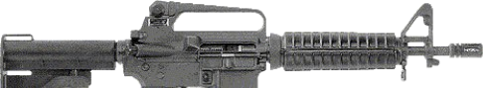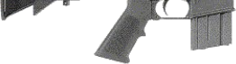

So, who deserves to own guns? The Founding Fathers of this once great nation were White men, and the gun rights they proclaimed in the Bill of Rights were penned to protect the life and liberty of White men and women. The Bill of Rights wasn’t written to protect slaves which had no rights. Once Abraham Lincoln and his cronies made the fatal mistake of freeing those slaves, the federal government and an army of liberal stooges set about to give the rights of White men to former slaves. Look at the fruits of their labors. The not-so-United-States now leads the world in acts of violent crime. Gun rights were created as much to insure the protection of Whites from oppressive government as from the bestial behavior of non-White savages. Just six years after the freeing of the slaves a national association had to be formed in order to prevent the disarming of Whites, The National Rifle Association.

No book of this nature would be complete without a weapons section for new recruits. Listed below is a brief description of what you will want to obtain. If you possess any working firearm at all, it is a start. As ethnic cleansing develops you will find modern high powered weapons, literally for free, lying on the ground.

### Rifles

Probably the best single choice for the purpose described here would be an assault rifle chambered for the 7.62mm (.308 Winchester) cartridge. Scoped and in the hands of a skilled marksman, this cartridge is capable of hits on man-sized targets at 500+ yards. Even lead bullets in this caliber are powerful enough to penetrate most body armor, car bodies and the brick walls of homes. Good choices include the M1-A, the FN-FAL, the inexpensive CETME, and Heckler & Koch's HK-91.

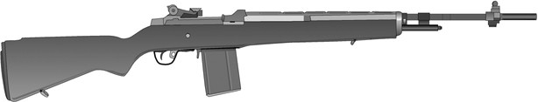

*Springfield Armory’s M1-A is a pricey, yet incredible battle rifle.*

*A folding stock will enhance its use in urban combat.*

A good second choice is one of the 5.56mm (.223) rifles such as the Colt AR-15 or Ruger Mini-14. The 5.56mm cartridge is readily obtainable in quantity since it is a current U.S. military round. It offers excellent accuracy and reasonable stopping power out to 250 yards. Recoil is very mild.

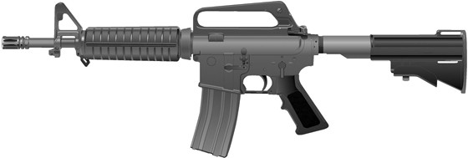

*Colt’s AR-15 carbine is an ideal weapon for urban combat.*

The Ruger Mini-14 can be a good choice, inexpensive and available, but it has its problems. The factory barrel is too light and gets very hot after firing only two 20 round magazines. Heavier barrels are recommended as well as after-market stocks.

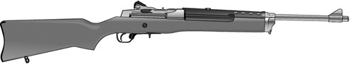

*The Ruger Mini-14 is an affordable .223/5.56mm rifle.*

Firing the 7.62x39mm round, the AK-47 is the standard by which all assault rifles are measured. Manufactured around the world, the Russian and German models tend to be of the best quality. The downside is that the ammunition is not a U.S. government stock item. All ammunition must be provided by the users.

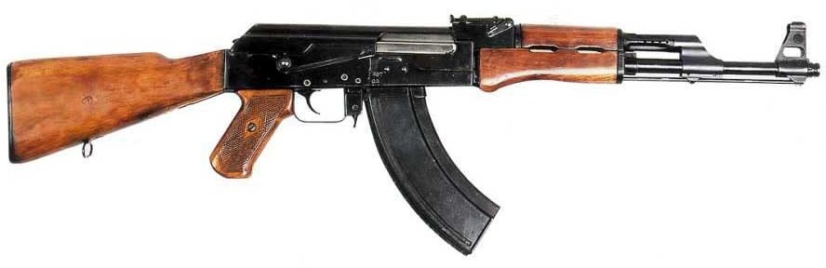

*The AK-47 is an ideal weapon for urban fighting, small, lightweight, and powerful.*

### Shotguns

For gunfights at close range, such as inside buildings, nothing is as effective as the 12- gauge shotgun. 12-gauge “high brass” shells in 00 or number 4 buckshot will knock down even the largest adversaries. There are no reports of anyone ever taking a chest full of either size then getting back up.

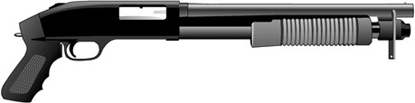

*Shotguns can also be made very small for use in clearing buildings.*

Most shotguns are slow and clumsy to reload, so you should add an eight or ten-round magazine extension. Those made by Choate Machine & Tool Company are among the best. The 18 and 20-inch barrels are handy lengths for close quarter combat.

### Handguns

The choice of pistols is strictly a personal matter since very few will use them as their primary weapon. Whether you like automatics or revolvers is not as important as is access to ammunition. The U.S. government used the .45 pistol for over fifty years and only recently switched to the 9mm. Ammunition for the Beretta will be more common on the battlefield, since today’s police departments have standardized their calibers with the military. Again, as a backup weapon the pistol can be in any caliber. If you are happy with your .357 magnum and can hit what you aim at, by all means use it.

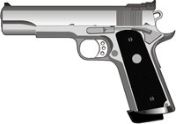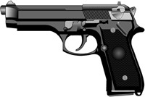

*The Colt .45 and the Beretta 9mm military issue pistols, both are good choices.*

While small arms will do the detail work in ethnic cleansing, it is imperative that heavy weapons and aviation be brought into play as soon as possible. Fixed wing planes and helicopters dropping cluster bombs and napalm, followed by strafing the battlefield will route even the most determined resistance. Encourage pilots who are deserting to bring their aircraft along with them. Any members of the ground crew will be an extra plus. If paramilitary commanders can locate federal and NG forces willing to hit targets we

identify, a good working relationship and a great magnification of combat power will take place. Cultivate such relationships.

Even among those who initially side with the politically correct U.S. government, an exposure to combat will undoubtedly change their minds. As George Patton said to his men, “When shells are hitting all around you and you wipe the dirt off your face and realize that instead of dirt it's the blood and guts of what once was your best friend beside you, you'll know what to do!” In today’s context, once even duped fence-sitters inside and outside the military see the true bestial savagery of Blacks first hand, they will join in with all the fervor of men who have just found salvation.

As the operation grows with the influx of new recruits, arm them with weapons confiscated from police evidence lockers and military storage facilities. Literally millions of guns, from single shot shotguns to machineguns lay collecting dust on the shelves. Put them to good use. All weapons should be examined to insure they are operable and that the user is adequately trained in their use before taking them into combat.

### What To Expect To Find In A National Guard Armory

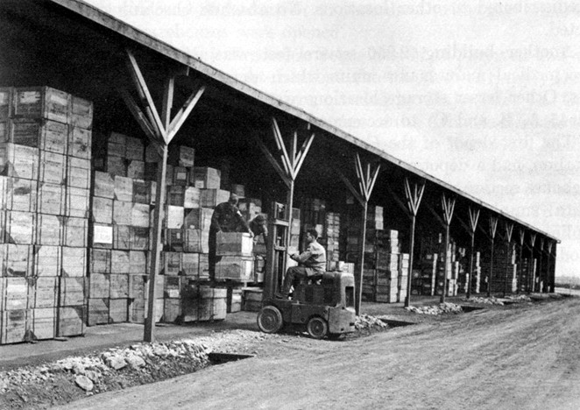

*You do not have time to go through all these boxes. Use the NSNs, DODIC & Nomenclature!*

As cooperative order unravels, a situation much like the fall of the government of Albania will develop. Once the National Guard units have deserted, their armories will be vulnerable to looting. Local whites should monitor the situation closely, and once the situation is right, expropriate every piece of usable equipment.

Armories range in size from a few thousand square feet to hundreds of thousands of square feet. Depending on the unit(s) housed there, warehoused equipment will range from Kevlar helmets all the way to armored vehicles. The photos which follow illustrate the type of resources you can expect to find:

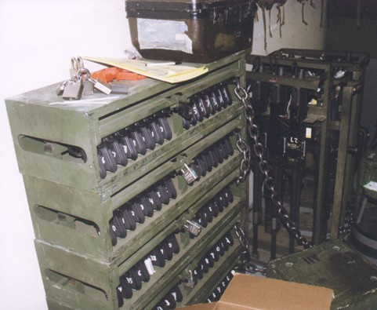

The rack above holds 80 Beretta 9mm pistols. Rack behind holds .50 cal. Machineguns.

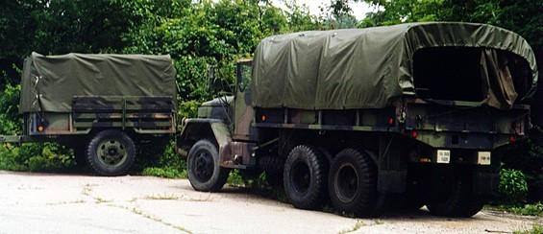

*Old Deuce and a half’s (2.5 ton trucks) like this are very common at armories along with trailers.*

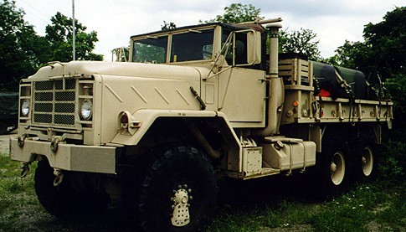

*This five ton truck has fuel cells strapped to its back.*

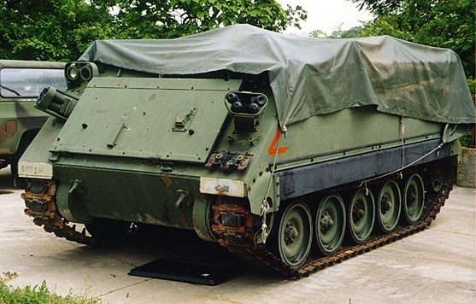

*M113 Armored Personnel Carriers are a common find at armories,*

*some with TOW missile launchers.*

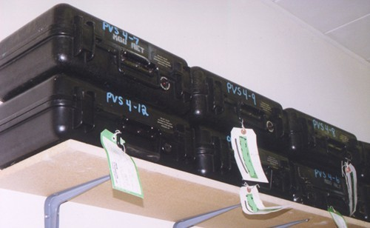

*These innocent looking boxes contain high tech night vision goggles.*

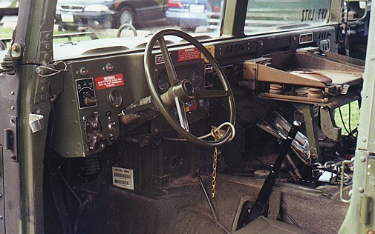

*HUMMVEES, like all military trucks, are secured by a simple cable and lock.*

Following the abandonment of National Guard armories some military bases and motor pools will be wide open. Look for the items in the following photographs first:

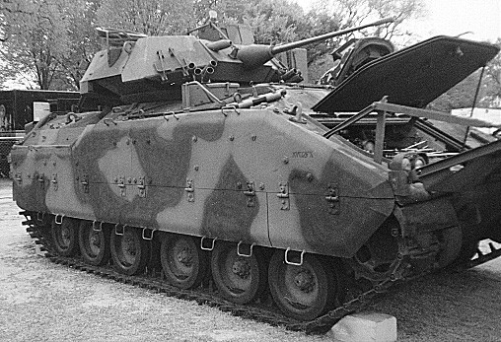

*The Bradley Fighting Vehicle, shown with engine access hatch open.*

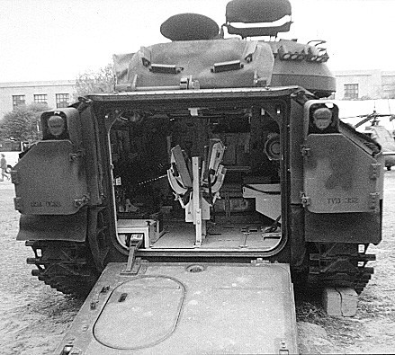

*The BFV as seen from the back, with loading ramp down.*

The Bradley Armored Fighting Vehicle is just as valuable as the Abrams tank. Its main gun, the Bushmaster 25mm cannon, fires two kinds of ammunition: Armor piercing and exploding anti-personnel.

During the Yugoslavian breakup, armored cars were considered “the 911 of the battlefields.” When a combat emergency arose, cars sporting three or four belt-fed antiaircraft machineguns apiece would be called in. Such vehicles were known to turn desperate situations around after only a few minutes. Bunkers and other man made fortifications quickly cave under such firepower. BFVs and Hummvees with Mk19 grenade launchers are far superior weapons systems to the Com-Bloc armored cars.

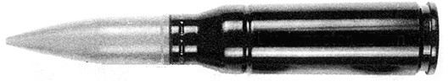

*Bushmaster cannon ammunition comes in two types:*

*Armor Piercing (AP) and Exploding Anti-Personnel (EAP).*

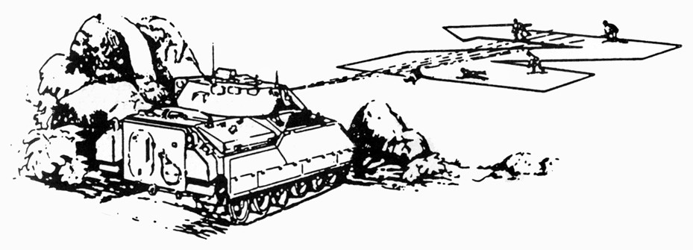

*When engaging a group, fire in a ‘Z’ pattern.*

The Bradley variant with two M-16s firing out each side is perfectly suited for clearing neighborhoods and large camps. Save the Bradley’s TOW missiles for use against any armor non-Whites may “jack” and attempt to employ.

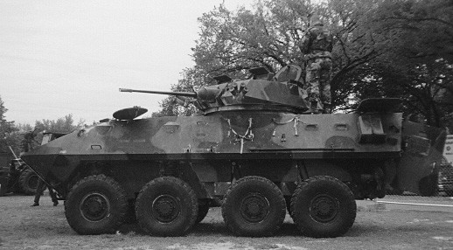

*This Light Attack Vehicle (LAV) sports the same main gun as the BFV.*

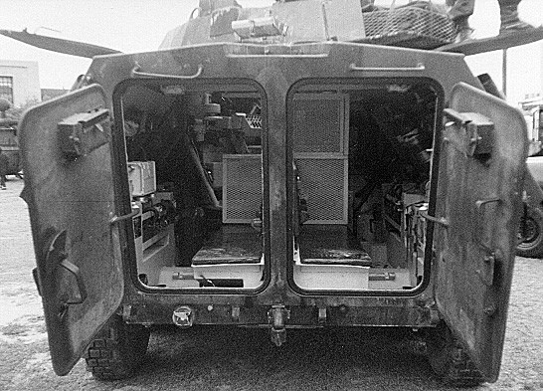

*The LAV does not have a ramp; instead it has two manually operated doors.*

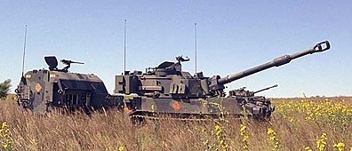

*Paladin self-propelled guns and their ammunition haulers are perfect for pursuit operations.*

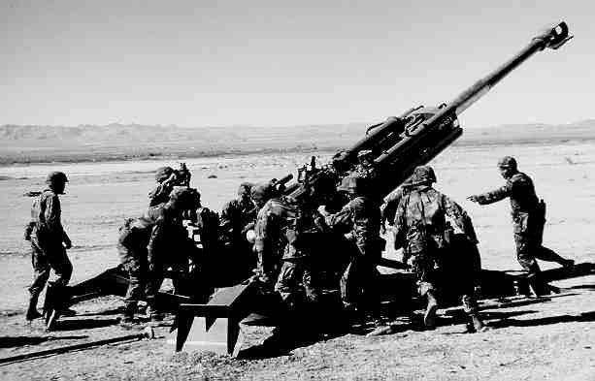

*The 155mm cannon is a devastating weapon. It can be towed by any vehicle with a pintle hitch.*

### Military Nomenclature

Making sense of the mishmash of military abbreviations is especially important in ethnic cleansing operations. Should you walk into a military armory and find yourself standing in front of thousands of similar boxes, it will be obvious that you cannot devote a week to opening them to find out what’s inside. With this in mind, the next several pages will take you through ammunition color coding, NSNs, and the DODIC system.

In addition to being able to locate desired materials in a weapons storage facility or Ammunition Storage Point, it is important to know the markings on individual artillery shells.

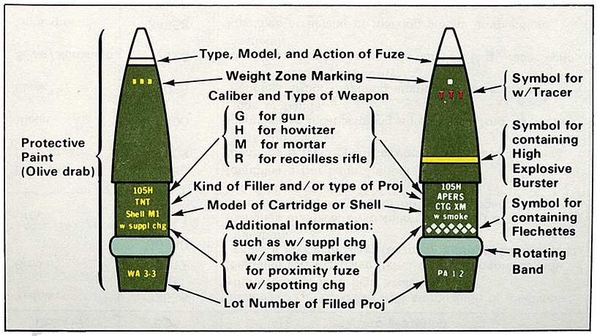

*In order to get maximum effectiveness from each round, use the right tool for the job.*

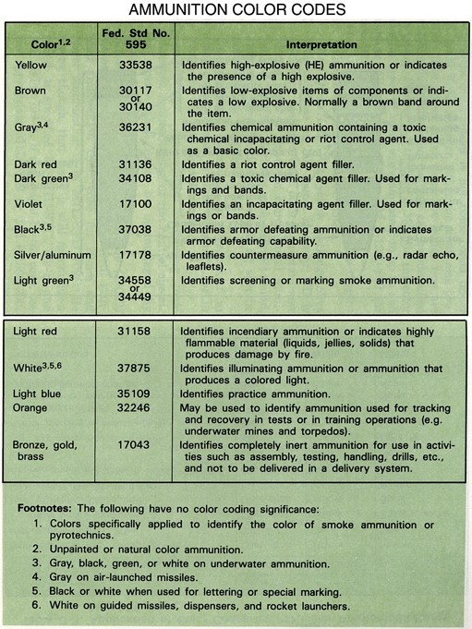

*Source: U.S. Army Ammunition Handler’s Handbook.*

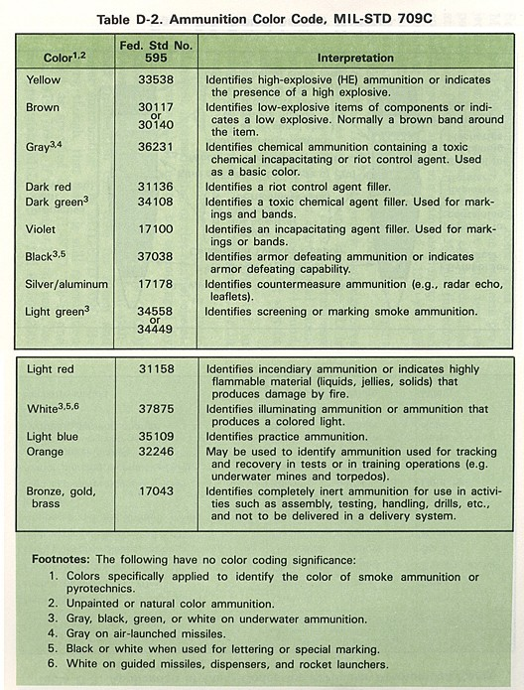

*Source: U.S. Army Ammunition Handler’s Handbook.*

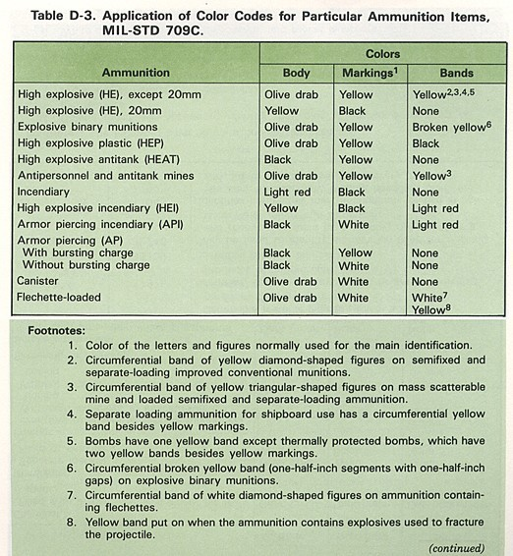

*Source: U.S. Army Ammunition Handler’s Handbook.*

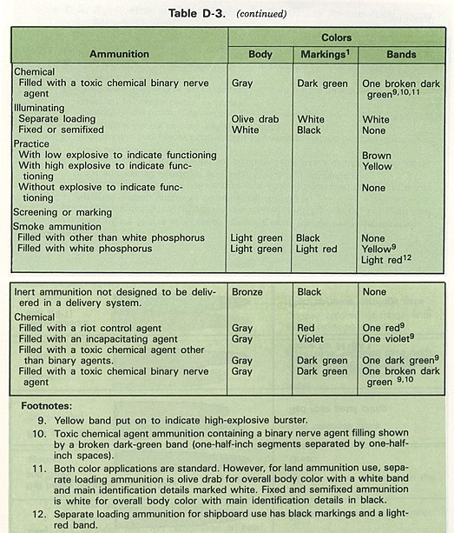

*Source: U.S. Army Ammunition Handler’s Handbook.*

Everything in the military inventory, from toilet paper to atomic bombs, has a National Stock Number (NSN). The following graphic defines each series of numbers:

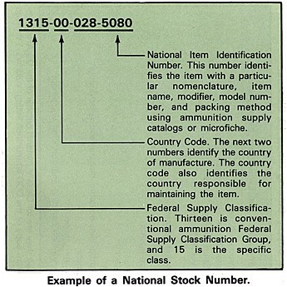

*Source: U.S. Army Ammunition Handler’s Handbook.*

NSNs can be found on almost every container. Here is its location on the container for the Selectable Lightweight Attack Munition (SLAM):

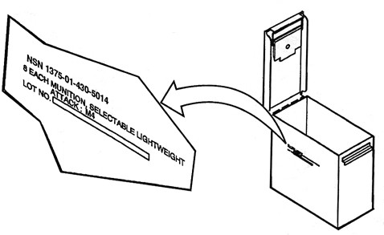

An additional system of inventory is the DODIC code. The following pages list the DODIC for common and not so common items:

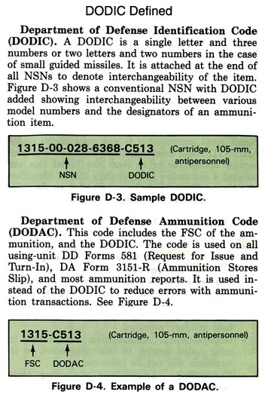

*Source: U.S. Army Ammunition Handler’s Handbook.*

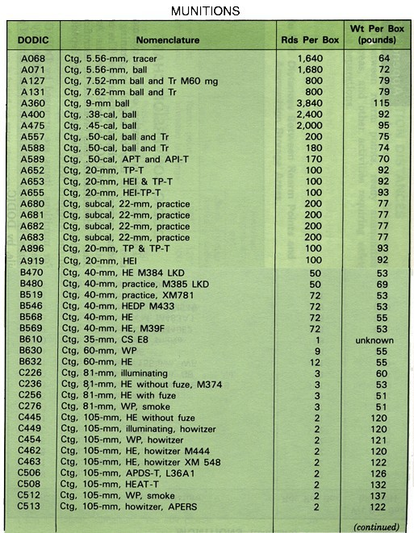

*Source: U.S. Army Ammunition Handler’s Handbook.*

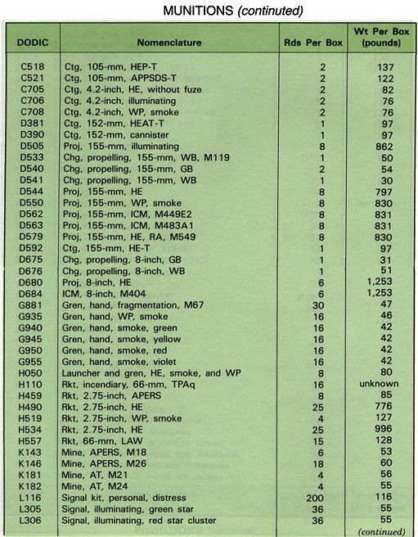

*Source: U.S. Army Ammunition Handler’s Handbook.*

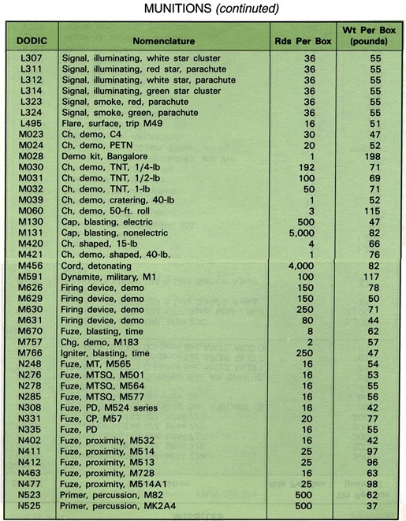

*Source: U.S. Army Ammunition Handler’s Handbook.*

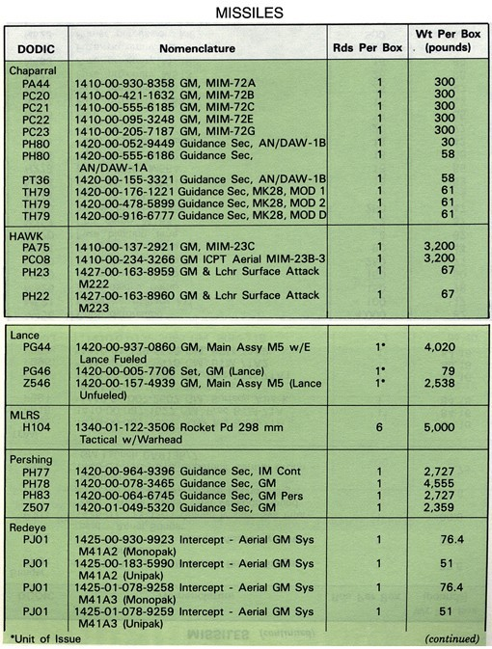

*Source: U.S. Army Ammunition Handler’s Handbook.*

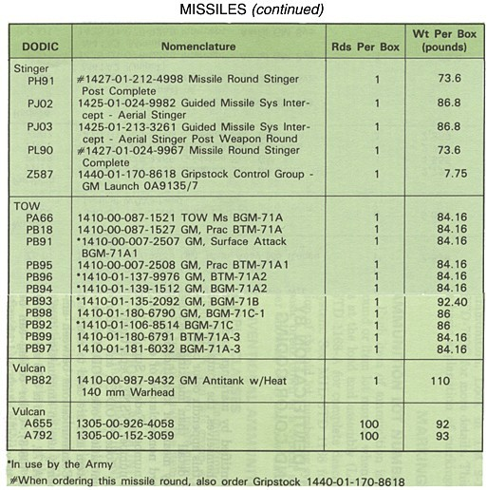

*Source: U.S. Army Ammunition Handler’s Handbook.*

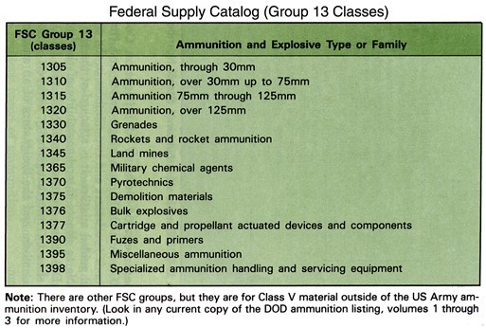

*Source: U.S. Army Ammunition Handler’s Handbook.*

The following graphic illustrates the typical configuration of a field Ammunition Supply Point (ASP). Once racially purged US federal forces are merged with White coalition forces, expect all supply depots to be constructed in this form.

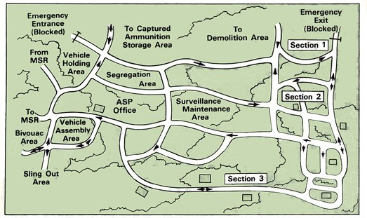

*An ASP facility is very large, with up to 700 meters between each section.*

*Source: U.S. Army Ammunition Handler’s Handbook.*

### The Role of Corporate Armies

One facet of Yugoslavian breakup that is very important, yet gets little attention, was that the Serbs were themselves cleansed from Croatia. This piece of history contains an element that leaders of ethnic cleansing operations will want to entertain, the use of the Private Military Firm (PMF).

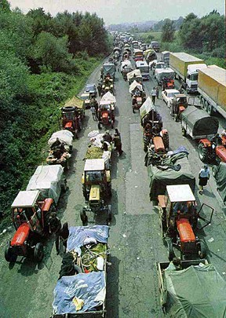

*Fleeing Serbs jam highways out of Croatia ahead of Operation Storm.*

In 1995 the Pentagon and the Croatian government contracted Military Profession Resources Incorporated (MPRI), a “top drawer” PMF. MPRI planned and oversaw Operation Storm, where in four days the Croatian army ethnic cleansed a huge area of their country of Serbs. In addition to planning the offensive, MPRI provided advanced training to the Croatian army. Considering the stunning success of Operation Storm, it is obvious that the Croatian government got its money’s worth.

Croatia proved that private military firms will participate in operations that involve ethnic cleansing. In fact, the two most elite White combat units in Africa, the Rhodesian army and the South African army, formed their own corporations after the fall of their countries to Blacks. Considering what happened to their own countries at the hands of Black savages, it is likely the PMFs will be eager to assist White Americans.

Private Military Firms flesh-out customers with small armies, help “stiffen” the combat effectiveness of inexperienced armies, and provide advanced types of combat service support. For instance, much of the air to air refueling that went on in the first and second Gulf Wars was handled by PMFs. There are a few dozen such companies, many of which advertise on the internet. While their sites indicate they work only for “legitimate governments,” history shows that the right amount of cash or even barter will quickly make a customer legitimate.

Such does not come cheap. Once an army or secessionist government amasses ten million or so dollars, top commanders and political leaders can contract with a PMF and take advantage of some of the finest equipment and leadership available anywhere. PMFs can even provide riflemen, tanks and attack helicopters. This is what such companies call “surge capability,” taking their customer from zero to world class in a hurry. Some PMFs will even take mineral rights as payment.

The task of ethnic cleansing will require the participation of many different types of White organizations and individuals. Each group has its own likes and dislikes, but the cleansing of America of predatory Blacks demands that we set our differences aside—we must put our White skin first. Any differences between us can be worked out after the dust has settled. In fact, we may find that with racial consciousness lying at the heart of our decision-making processes, our differences are no longer worth fighting about.

## Chapter 4

**Who Will Fight?**

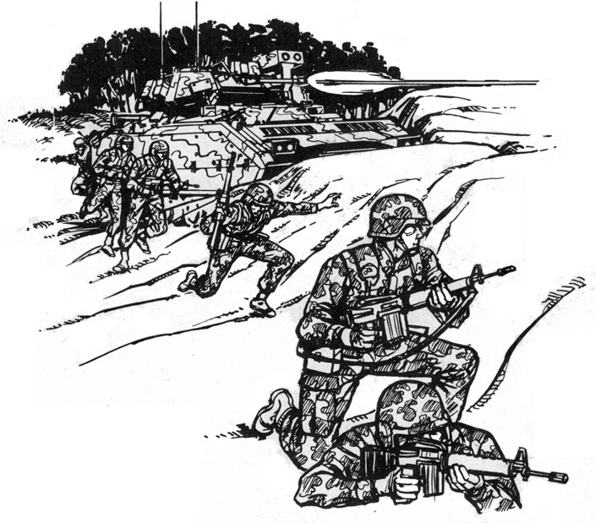

### The following list is of the expected major players in the upcoming civil war:

**U.S. Federal Forces:** As of 2003, the military forces of the United States are still commanded exclusively by Whites. Like all of American society there are Blacks here and there at the executive level, but the actual command remains in the hands of Whites. Federal forces and their equipment will play a vital role in ethnic cleansing operations. Expect them to join in the fighting at the beginning or shortly after.

**State controlled National Guard units:** Of all U.S. military organizations, the National Guard (NG) is the weakest. The training is substandard and so is much of their gear. In Cincinnati, Ohio, the Air National Guard has rifles but all the firing pins are kept under the strict control of politically reliable commanders in a location far from the weapons. The soldiers know this and are aware of how little trust their leaders have in them. These and other slights will lead to desertions with shifts in loyalty falling along racial lines.

When soldiers quit and join ethnically pure groups, they will take whatever they can grab out of the arsenals and motor pools. This is where the armor, artillery, attack helicopters and aircraft for the campaigns of ethnic cleansing will originate.

Some in the Patriot and militia movements look at members of the National Guard with suspicion, fearing they are more dedicated to the federal government than to the Constitution. The reality is that the men and women of the National Guard have much in common with Patriots and militiamen. The ruling elite of the United States are aware of this and have taken great pains to purge known militia members out of the Guard. Still, most NG units are composed primarily of Whites and can be expected to join in the fighting at the beginning.

**State Defense Forces:** Located between the Unorganized Militias and the National Guard, State Defense Forces are recognized by state governments. They train on military bases with weapons up to .50 caliber. Comprised of volunteers, they purchase their own weapons and equipment, which are usually of very high quality. These groups provide security for NG and Reserve facilities when such forces are deployed overseas. SDFs are generally 100 percent White. Provide their leaders with accurate maps, global positioning systems (GPS) and radios. Place artillery at their disposal.

**Militias:** These will be a good source of not only personnel but also for leaders in ethnic cleansing operations. Groups which fall into the categories of the “black helicopter” and “the eye on the dollar bill” crowds are especially vulnerable to enemy psywar actions and must be closely monitored. This operation cannot be delayed by militiamen looking for “Russians hiding in sewer systems.” Groups with beliefs based in reality will be of great use, especially in deportation activities. Put reliable militias in charge of loading and managing railroad deportation operations. Pull militias into direct combat actions as needed. Provide their leaders with accurate maps, global positioning systems (GPS) and radios. Place artillery at their disposal.

**Klan/Skinheads/National Socialists:** These three groups have put great energy into preparing for ethnic cleansing and should be employed to the maximum. Place such units

directly on the front lines. This is where they want to be, and they will need little instruction as to what to do. Most management of their activity will be directing them from neighborhood to neighborhood and keeping them coordinated in parallel with other outfits. The rate of their progress may define the operations tempo in urban areas. Provide their leaders with accurate maps, global positioning systems (GPS) and radios. Place artillery at their disposal as they will use it effectively.



*Dixie Totenkopf symbol*

**Ex-Convicts:** Serbian ethnic cleansers took advantage of the pent-up anger and frustration of ex-convicts, particularly violent offenders, and put them to work doing the dirtiest house-to-house operations. White Serbian convicts had been in tight prison confines with dark Muslims; American ex-convicts will emerge from imprisonment with screaming psychotic Blacks. White ex-cons will need little motivation following such an experience.

Ex-convicts are an unpredictable lot and will have to be watched very closely. Many of them will have psychological problems that, if they didn’t have before they went into prison, they developed during their incarceration. Dressed like soldiers, most ex-cons will tend to act like soldiers. Those ex-cons so damaged by their experience that they are uncontrollable are to be used, if at all, on suicide missions. In addition to main operations, they can also be employed to extract information from prisoners and as executioners. Keep them well paid and fed, treat them with as much respect as each situation warrants and you will have their respect.

As ethnic cleansing operations progress, White forces will encounter poorly defended prisons or even ones abandoned by the guards. Liberate willing White prisoners and add them to your force, once they have proven themselves by liquidating all the Black inmates.

**White Bikers:** That is to say “outlaw” gang types, are also a usable force. However, they are a volatile, unpredictable bunch. They can be best used, like ex-convicts, for especially dirty missions. But remember their mentality is based on: “I will do something for you, but you will have to do something for me.” The best position for a leader to take is that he will use his political skills, his other personnel and artillery to protect the bikers from the UN and its War Crimes Tribunals. More so than ex-cons, bikers will have to be watched extremely closely. Bikers are known for alcoholism and excessive drug use. The primary focus of the mission, ethnic cleansing, is not to be allowed to become lost in an intoxicated haze. Keep bikers happy by allowing them to keep most everything they find. Keep all crew-served weapons under the control of paramilitary commanders.

**White Street Gangs:** Teens, young adults and even middle aged men from gangs will provide some personnel, but they too must be supervised extremely closely. It is more advisable to simply work alongside such groups, as opposed to trying to make soldiers out of them. Never meet with their leaders without taking a team of bodyguards with you, as well as having your meeting covered by heavy weapons. Let the gang members know this (perhaps with a small demonstration) and your emissaries will return from their meetings. As with bikers, they only respect strength, so show and maintain overwhelming strength.

Street gangs tend to rely mostly on pistols and shotguns, with a smattering of assault rifles. Some possess small machine pistols, but overall their weapons are designed for close quarter combat. Employ these groups in fights best fought with such weapons e.g., house-to-house cleanouts and Mop Ups.

**Confederate Re-enactors:** Mixed in among the posers in re-enactor units are racially conscious Whites. Such people and their groups should be sought out and invited to participate, as they are used to working together as military units. All that is needed is to provide them with modern weaponry, provided they do not show up with what is needed. Their leaders are generally of good quality and should be treated with respect. Put these groups on the front lines. Provide their leaders with accurate maps, global positioning systems (GPS) and radios. Place artillery at their disposal.

All of the groups mentioned above have potential to help us in our work to racially purify the country, but be aware that each of them have their own distinct cultures, loyalties, and values. If you can’t fully understand them, it is best to bypass the groups you cannot relate to. With biker and street gangs, one wrong word can get you killed. Their culture is so radically different from the mainstream that they even have a strongly developed language; words that sound innocuous to you may be taken as insults and provocations. It is not unreasonable to suggest that “translators” be used when possible to make sure you are clearly understood and not misunderstood. Choose your translator carefully.

Working with such a wide variety of groups can be frustrating. Leave each group in their own customary uniforms so as to aid recognition and predict their behavior. If they have no standardized uniform, require them to wear a distinctive identifier such as a cloth armband. The commanders of ethnic cleansing operations in the United States must demand unquestioning loyalty to the mission and the White race.

“We have not seen great things done in our time except by those who have been considered mean; the rest have failed.”

*Unknown*

Utilizing such forces offers leaders two distinct advantages: First, they do not generally bother to restrict their fire to just armed combatants – they will kill indiscriminately. The terror they produce will spread at a rapid, even explosive, rate. Second, the terror they produce and spread is a “force multiplier.” Forces which engage in beheadings, mutilations, the burnings of occupied buildings and other acts will remind retreating Blacks of past lynchings and other acts directed at them, which they fully deserved. Such

memories will fill Blacks with horror and terror, both of which will aid in driving them out of the country.

All racially conscious Whites should dismiss the idea of trying to get “the masses” of Whites behind them. As long as Joe Six Pack has a car in his garage, beer in the fridge, and a dollar in his pockets he isn’t going to do much to help. The average White person doesn’t care for non-Whites anymore than you do, but just isn’t motivated. It will take a major economic depression to get them off their asses, and even then only a small percentage will pick up their guns and take part in the offensive. A small percentage of Whites will be more than enough to drive all the Blacks out the country entirely; keeping in mind that only 12 percent of the total U.S. population is Black. All it will take is a core group of like-minded individuals banding together to do what needs to be done.

It is important to remember that only three percent of the colonists during the revolutionary war were willing to take up their muskets and fight the (then) strongest power in the world. The rest were willing to kiss the king of England’s ass and continue to pay oppressive taxes. But once things started going the way the revolutionaries wanted and the possibility for victory became obvious, more joined in the fight. The rest then began providing a wide variety of support. When Whites see crime rates in their towns drop dramatically, when going to the store is no longer an exercise in ethnic intimidation, you will get all the support you need.

Readers should not concern themselves with ideas that they will, by themselves, save the White race. It is that same three percent of those who live today that must be your concern. You must quietly seek them out, join them or have them join you—but band together and become a force. The other 97 percent will not be much of a problem, they’re too busy playing video games or surfing the net. As for Whites who do get in the way, they should be forced out right along with the non-Whites or exterminated.

### On the Black Side:

“Although international Islamic terrorists and local militias all profess to hate the U.S. Government, they surely will not be on the same side in an American race war. They will be killing each other, turning the United States into a killing field, with Blacks, Jews, Hispanics—well, everybody—forced to become combatants or to be slaughtered.”

*The Coming Race War In America,* Carl Rowan

Black syndicated columnist, Carl Rowan, author of the above quote is acutely aware of the situation. Rowan writes, “There are now five million or more Muslims living in the United States, a million in deeply troubled California alone, and close to a million in New York. Some 42 percent of the Muslim residents are United States-born African Americans. We would be fools to assume that they will listen only to moderate black pacifists. Louis Farrakhan was surely referring to them when he said in Iran “‘God will give the Muslims the honor of destroying America.’” Intelligence reports reveal that most members of the Nation of Islam are not fighters at all. Instead, small groups in roughly

platoon sizes are being formed around the country. Their paramilitary training is coming from the militant arm of the Nation of Islam—the Black Panthers.

Initially you will face sporadic resistance from street thugs and from Black military veterans. As things progress you will encounter squad level resistance as the groups trained by the Black Panthers and individual Black males begin to organize to blunt attacks, stage delaying actions, and attempt counterattacks. Nothing they try will stand up to concentrated artillery fires or attacks by A-10 Warthogs.

Black military veterans will undoubtedly be the best shots. First priority should also be given to shooting any Black with a scoped rifle or scoped pistol. Assign snipers to immediately drop any Black who appears to handle his weapon in a skillful manner.

Sniper training always assigns the highest priority in killing other snipers, but make sure your nonmilitary marksmen are familiar with your chain of priority.

Expect the street gangs to be armed primarily with pistols and a few rifles. Experience shows that the average Black street punk is a very poor marksman, but militant Blacks will have taken the time to improve their skills and invest in quality firearms. Make the Black militants a priority target for heavy weapons. Artillery spotters should call in mass fires when such groups mass for any reason.

Resistance can also be expected from White communists who have been working to, as they say, “create a revolutionary situation” for a long time. Some of them will be good shots, but most will have spent no time whatsoever learning weapons handling, expecting to “learn war through war.” Once ethnic cleansing operations begin in earnest, Blacks will lose whatever remaining trust they had in Whites and will probably shoot the White communists themselves. Provided they do not, kill the communists before they can figure out how to change magazines.

Commanders can also expect initial resistance from order-following White National Guard soldiers and White police. Efforts should be made via loudspeakers and leaflets to bring them over to the White side. Should they balk, they should be eliminated and their weapons passed along to enthusiastic racially conscious Whites.

The ethnic cleansing operations in Yugoslavia went on for four years before NATO and the United Nations began combat actions to stop the fighting. Since then the UN has put some energy into developing its own rapid reaction force. It is difficult to predict how long it will take for the two groups to do anything of substance in the continental United States, but commanders should be prepared to face such forces.

The two groups, NATO and the UN, share several problems. First there is the matter of language differences and shared leadership. Then there are problems within chains of command, logistics, and the standardized radio frequencies. Yugoslavia revealed a host of problems in both organizations, all of which delayed serious interference for a long time.

Should commanders find themselves facing NATO or the UN, contact with their representatives should be initiated. Insist on speaking only with White officers and explain to them the reasons for our operations. Point out that you know that their country is suffering the same problems with Blacks as the United States and invite them to join in with us. Expect them to reject the invitation and to deploy their troops. Warn them that White forces will fire back if fired upon and that none of their roadblocks will be respected. Should they open fire, return fire mainly toward Black NATO or UN troops.

Use loudspeakers to inform the White soldiers that you do not wish to shoot them and offer them an opportunity to withdraw. If they refuse and continue to attack, respond with maximum force.

Should White NATO or UN soldiers wish to defect and come to our side, accept them and intelligence personnel should debrief them immediately. Their access to armored vehicles and other resources could be of great value. Pass along any equipment they bring (radios, documents, etc.) to the same intelligence personnel. If defectors speak foreign languages, invite them to translate documents and radio transmissions for you. Have trusted personnel review such documents and listen in on radio translations to assure that double agents have not been planted.

White ethnic cleansing units on the west coast can expect resistance from not only Black gangs, but also Chicano ones. Organized militant groups such as the Brown Berets will fight much like the Black Panthers, that is to say they are better trained, but they too will crack under artillery bombardment. White units should make use of Spanish speaking Whites to compose appropriate psywar documents and broadcasts.

There is a high degree of natural animosity between Blacks and Chicanos, so use it to full advantage. Use snipers and psychological warfare operations to exacerbate rivalries between Black and Chicano gangs in all areas of operations.

## Chapter 5

**How To**

“Let's be honest, it is all about killing of Muslims” a civilian official in Pale, Bosnian Serb headquarters told a Newsweek reporter in December. The official had recently served as commander of a Serbian artillery battery overlooking Sarajevo. “We had the coordinates of every playground in the city, every school, every market, every food- distribution centre. After that, it's just a question of mathematics, that's all it is.”

*European Journal of International Law,* Vol. 5, 1994

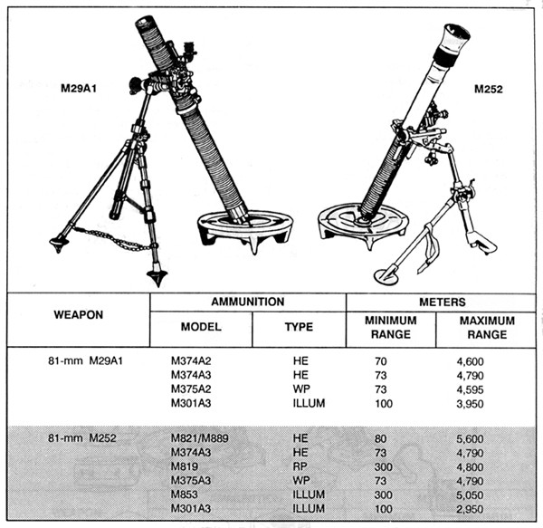

### The Mechanics of Ethnic Cleansing:

Writer Mark Danner, author of *Endgame in Kosovo,* identified five key components of ethnic cleansing:

* 1. **“Concentration**. Surround the area to be cleansed and after warning the resident Serbs-often they are urged to leave or are at least told to mark their houses with White flags-intimidate the target
  2. **Decapitation**. Execute political leaders and those capable of taking their places: lawyers, judges, public officials, writers, professors.
  3. **Separation**. Divide females, children, and old males from males of ‘fighting age’ - sixteen years to sixty years old.
  4. **Evacuation**. Transport females, children, and old males to the border, expelling them into a neighboring territory or country.
  5. **Liquidation**. Execute “fighting age” males, dispose of bodies.”

Danner adds, “Too highly schematic to do justice to the Serbs minute planning—for each town, each village, each situation is different—these five steps nonetheless comprise the elements of the program that worked.” Note he states: *the program that worked.*

Another succinct description of what I call the Yugoslavian Model was articulated well by Congressman Elliott Engle (D-NY) to the US House of Representatives on October 01, 1998, “… the pattern is like this: First Serbian artillery shells the villages, causing innocent civilians to flee in panic, fleeing into the hills and into the mountains. Then the next thing they do after the civilians have left is they come in and loot the houses and they steal everything they can. And then finally they burn the houses down to the ground.”

Once you’ve driven out the non-Whites, you pay your men with whatever is valuable in the houses. While this undoubtedly sounds callous to the uninitiated, troops must be fed and morale kept up. This method of payment has been used since the time of Attila the Hun. It worked for Attila and it will work for us.

While Danner’s five methods are illustrative of the direct action-only push, there are numerous methods of ethnic cleansing large cities, states, regions and finally the entire lower 48 states. Scholars have written that these larger methods fall into four main categories:

#### *Administrative Actions*

These include the forced removal of elected officials, firing from jobs (especially from make-work public service positions), restrictions on the distribution of humanitarian aid, constant police checks of identity papers of members of unwanted ethnic groups, official notices to the effect that security of the members of other races cannot be guaranteed: settlement of the appropriate population (in this case, White) in the region; repressive legislation; refusal of treatment in hospital, making the safe departure of one member conditional upon the departure of the entire family, disconnection of telephones and cable

television lines, forced labor very often including work on the front lines of armed conflict at gunpoint, barring women of particular ethnic groups from giving birth in hospitals, and ‘voluntary’ transfers of property by forcing people to sign documents stating that the property has been permanently abandoned by the owner. (See Appendix B)

#### *Media and One-On-One Actions*

These actions include local media (TV, radio, newspapers) inflaming fear and ethnic hatred, harassing phone calls including death threats, and publishing lists of race-mixers and race traitors.

#### *Terrorization Actions*

These types of actions have been committed by soldiers, paramilitaries and armed civilians, but are not necessarily directly connected with military operations. They involve: robbery, terrorization and intimidation on the streets, massive deportations, detention and ill-treatment of the unwanted and their relocation to prisons and camps, opening fire on civilian targets, blowing up and burning homes and places of business, destruction of cultural symbols and religious monuments as well as sites, mass displacement of entire communities.

#### *Military Actions*

Acts that fall within this category are summary shootings and lynching, deliberate killing and torturing of leading citizens such as religious and political leaders, intellectuals, policemen and members of their business community; holding towns and villages under siege, deliberate attacks on specific neighborhoods and the blocking and confiscation of humanitarian aid. Add to this the deliberate shelling of food distribution centers, bakeries, water purification and transport facilities (bus, rail, and airports), communications hubs, cultural monuments and religious objects. Add to this the expulsion of the unwanted from medical facilities; reprisals against all supporters; the taking of hostages and detention of civilians for prisoner exchange; the use of civilians as human shields (which could come in handy against NATO and the UN), and shelling and other attacks on refugee camps.

As the two following images show, there is an identifiable racial “fault line” which can and should be used to full advantage. Note that the “Hispanic” and Black races grow right up to each other yet there is little crossover. The truth revealed here is that regardless of how much politically correct television showing how much everyone loves living next door to each other, the fact is races prefer the company of their own race. Were a creative army or group of armies to cause a tidal wave of movement of hungry Black males into Chicano areas the social situation would quickly explode into violence.

The situations that await us will require the savagery of barbarians. Within every White warrior must reside raw barbaric violence. When the weapon is drawn and the safety is off, it is imperative that those weapons be used. They must be used again and again until

our enemy is vanquished, at least, from within the borders of the lower 48 states. As William Pierce wrote, “Barbarians win with cunning, numbers, and courage.”

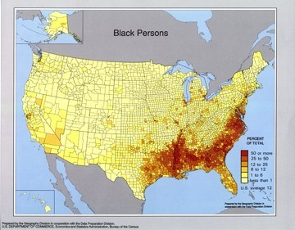

*This Bureau of the Census (2000) map shows the concentration of most Blacks.*

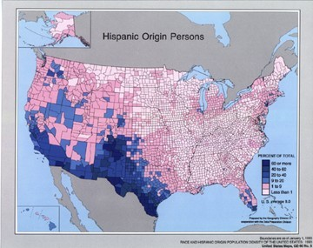

*This Bureau of the Census (2000) map reveals the concentrations of Chicanos.*

White military and paramilitary leaders should study these maps and contemplate where to apply the pressure of force and fear as well as what methods to use in order to set masses in a controlled direction into the heart of the other’s territory. The area where the two races “collide,” that being the area from Houston to Dallas, should be studied topographically.

Andrea Franatovich, a combat veteran of the Croatian army during the breakup observes: “One of the factors that led to ethnic cleansing in the former Yugoslavia

was the fact that a lot of areas were ethnically mixed. To avoid the military problem of having potential guerrillas inside their territory, all sides adopted the simple expedient of driving out all people not of their ethnic group. Remember what Mao said: ‘Guerrillas are fish that swim in the sea of the people.’ Therefore, we just drained the sea, so to speak, to get rid of the fish.

Another motive was straight up looting of everything from TV sets to farmland.

A third motive was simple revenge, both for current atrocities and atrocities committed throughout Yugoslav history. That's simply the way we've always fought wars in our part of the world, and most other parts of the world, for that matter.”

Serbs are Eastern Orthodox in religion, we Croats are Roman Catholic. We speak the same language but have different accents.

We have a lot of different customs than Serbs.

The Serbs often wear beards, we Croats rarely have beards.

When Croats want to put down Serbs we call them ‘beaners,’ because Serbs eat a lot of beans and we Croats think beans are pig food.”

The differences between Serbs and Croats seem inadequate to fight over, much less ethnic cleanse one another, if intermarriage rates are indicative, Serbs and Croats got along considerably better than Whites and Blacks do in the United States.

At the infantry level, an element of ethnic cleansing that has worldwide appeal is what is referred to as door-to-door (DTD) ethnic cleansing. Basically it goes like this: knock, knock, anybody home? When the enemy opens the door, open fire and don’t stop until everyone in the house is dead. Then burn down the house or give it to a needy White family. Then move on to the next one, and so on. Every unknown house, barn, shed and vehicle must be inspected. Watch also for White liberals who will risk death to provide

aid and comfort to our racial enemies. If caught, shoot or hang them right alongside those they hid.

When combat begins, you will want to be on the lookout for members of the liberal media, non-White cops and non-White soldiers. It is in your best interest to kill not only those on your Shoot On Site (SOS) list, but those just listed—on the spot.

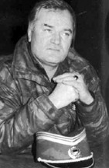

*General Ratco Mladic*

*Bosnian national hero or war criminal, depending on who you ask.*

“When Mladic seized Srebrenica, he would treat every able-bodied male, armed or unarmed, in uniform or out, as a fighter, a warrior -- as a killer who, if allowed to survive, must one day return, seeking vengeance in his turn. Born in war and grief and hatred, Ratko Mladic would see in every man - every "Turk" - an implacable enemy who was fated, if alive, to one day kill Serbs. And so, during a handful of days in July 1995, with an efficiency and thoroughness not seen in Europe for a half century, the general and his men set about their work of extermination.”

“Long Memories,” An essay on *Srebrenica: A Cry from the Grave*

Mark Danner**,** Public Broadcasting Station, January 2000

#### *Heavy Weapons*

The acquisition and use of heavy weapons is imperative. They can route even the most determined opposition, eliminate dug in positions, and a wide variety of other tasks. In ethnic cleansing, artillery keeps people moving. Artillery speeds up the process of ridding neighborhoods of the unwanted by putting them on the move en mass. Artillery can also quickly shut down rear guard actions. General Ratco Mladic of Bosnia would order his heavy weapons to begin firing at one edge of a primarily Muslim neighborhood in need of cleansing and then “walk” his shells along its length. Crowds quickly became visible,

running from the approaching shellfire in the direction he wanted them to move. With little effort Mladic could cleanse an entire neighborhood or village in short order.

Mladic followed up such barrages with teams of infantry who would proceed house to house searching for stubborn Muslims and either ejecting them into the caravan of refugees or shooting them on the spot.

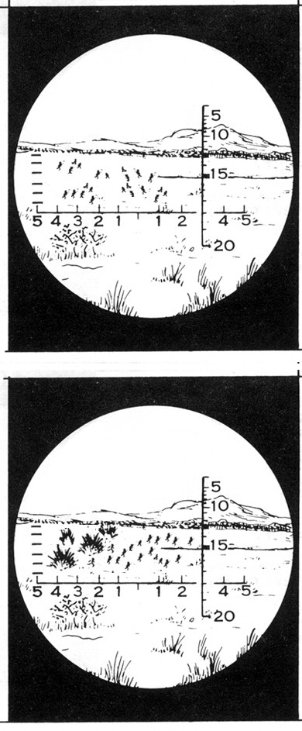It is possible with heavy weapons, be they mortars, tanks or artillery to concentrate a widely scattered foe and then wipe them out. This method is called “bracketing.”

|  |  |
| --- | --- |
| Here you see a scattered group. If shelled now, the group would scatter in all directions. The combat damage would be limited. Here is how to concentrate this group and annihilate them. |  |
| The initial shots should be into the ones standing near a chosen end of a scattered mass of the unwanted. In this case, on the left. Fire along one end and they will instinctively begin running in the other direction. Adjust for range and windage. |  |

|  |  |
| --- | --- |
| Wait a moment and let them begin to crowd together. Then begin firing at the opposite end (in this example, right 150 yards) and they will stop running and reverse their direction. They will pack together even more tightly and flee toward the center. |  |
| Aim your weapons at a point near the estimated center (in this example, left 75 yards) and fire for effect. Use infantry units to check for survivors. Leave none.  Bracketing is a combat proven method, use it often. |  |

If there is hostile gunfire coming from houses or groups of houses, shell them or burn them down. Shoot anyone who emerges.

The Bosnian ethnic cleansing holds the best examples of just how to rid large areas of unwanted troublemakers and we can learn a lot from them. Where our situation is different is that we will not have the “luxury” of concentration camps. Mladic used the camps to warehouse large numbers of Muslims, deliberately creating a humanitarian crisis and then using the United Nations and liberal humanitarian organizations to bus unwanted Muslims to other countries.

In North America, Canada will be the only country foolish enough to voluntarily accept predatory Blacks. Nobody wants the violent thugs of which we are ridding ourselves.

Mexicans have long existing ethnic friction with Blacks, so it is a safe bet that Mexico will not willingly take them. Socialist Canada will stop accepting Blacks when their crime rates quickly rip through the roof.

Once things really get going you can expect steady defections from military and police units. Put White deserters with their gear into front line units right away. If they have brought armored vehicles or heavy weapons with them and they are familiar with the use of the equipment, put them to use immediately. Assign trusted people to watch new members closely, if they show signs of disloyalty or squeamishness at the goal of the campaign, get rid of them. If you do not, you may get shot in the back or snitched out by them to the UN. It is better to bury them than to risk future trouble.

Once ethnic cleansing spreads statewide or regionally, a situation much like the partitioning of India by the British may emerge. When Britain partitioned Hindi India to create Muslim Pakistan, millions from each religion were caught on the wrong side of the line. The result was murderous chaos. Should this situation arise, you may find a temporary “partition” in your path. Say large numbers of armed Blacks seize and begin ethnic cleansing Whites out of the old Confederate south. You will be driving Blacks south while Whites will be fleeing north. While this situation will be highly chaotic it is an opportune time to gather funds for your group by charging “tolls” to exiting Blacks to proceed south. The fee should be the entire amount of money they have on them, plus all items of value. In addition, Blacks should be forced to sign a form stating that every piece of property they own is now abandoned. Confiscate all their identifications, deeds, car titles, birth certificates, and other official papers and attach them to the form. (See Appendix B)

Depending on the situation and what is occurring inside Black held areas, you may be put in a position where only elderly Blacks are to be let through. All Blacks of fighting age may need to be separated out and handed over to a Special Action Detail for elimination.

With the outlawing of quicklime in the US the disposal of evidence can be complicated. Spy satellites can spot freshly turned earth and photograph your vehicles, your men and you with remarkable clarity. Utilize bad weather to your advantage. Cloudy conditions obscure regular photography, and night images do not reveal detail. Rainfall will help erase evidence of mass graves, as will snowfall. If you do not wish to wind up facing socialist judges in the Hague, cover your tracks and dispose of evidence whenever possible. Combat deaths do not count in war crimes tribunals, so there is little worry in that regard, but at least take the time to grab up weapons and ammunition from the bodies and pass them along to unarmed White recruits.

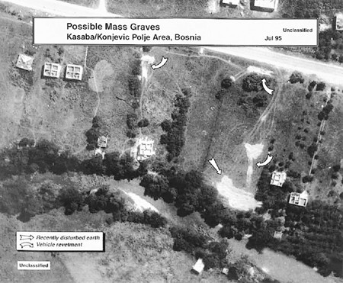

*NATO photograph of mass graves in Yugoslavia. The crews of the vehicles in the revetments were either*

*killed in combat or executed after capture. Note roofless houses indicating combat actions.*

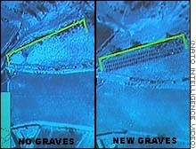

*Graves, before and after, from NATO airborne surveillance.*

As mentioned earlier, there have been many attempts to start race wars in the United States by Blacks and Whites alike. So far all have failed and they have failed for the exact same reason: it was individuals working alone. A break with the past occurred recently when two Black males perpetrated the DC Sniper killings. In their efforts to trigger a race war by killing someone of a different race nearly every day (in the hope that one race or another would rise up and begin wholesale ethnic cleansing) they stayed in the field a

long time because they worked as a team. The process of ethnic cleansing is a team effort, not an individual one. What the organized team effort gives is a running start.

If two dysfunctional Blacks could paralyze the nation’s capital for many days, imagine what well trained White platoons and companies could do. Companies comprised of platoons based on SWAT or Green Beret models could get thousands of people on the move very quickly.

Many readers of this manual will not be members of an organized group, nor will they know where to look for one to join. Even then, once you have located a group of militants, how do you know you have joined a group that will follow through and do the deeds which need to be done? Groups abound that look and talk tough, but when it comes time to lock, load and fire, are quick to fall apart or lock down solid.

The first thing you need to do is decide where you stand on a number of issues. If you don’t fit into some groups exactly, you may find yourself included in the list of those to dance at the end of a rope. For example, let’s say you are drawn toward White supremacist groups like the KKK or Aryan Nation. Okay, you’re with them on the right to keep and bear arms, you’re with them on God, but you think marijuana ought to be decriminalized like alcohol, and sold in liquor stores--well, you just chose the wrong group and you’ll be lucky to get out of your first meeting without a black eye and a bruised ass. Such groups have strictly defined codes of belief and conduct. If you don’t dovetail into those beliefs exactly you’re in big trouble. It is important to note here that even among extremist groups there are chapters which can be rightly classified as moderates. You may get along with your beliefs with the moderates, but keep tight lipped when around members you do not know.

In many cases it may be easier to just organize your own merry band of ethic cleansers. But who do you invite to join you? The best place to start is among your most trusted friends. Keep your meetings secret, don’t talk to the media, and train in remote areas.

There are many books around which contain the skills necessary to qualify as a combat soldier. If you’ve got military experience then so much the better. You would be amazed how many militia units are run by men who have no military experience whatsoever.

Consult the reading list in the back of this book as a guide for expanding your military and political knowledge.

Even before joining or starting your own group you can begin by making a list of the predators which need to be purged from your neighborhood. On this list you will not only want to note the names and addresses of non-Whites, you will want to add Black leaders, ministers, politicians, and professionals. Include White liberals who support and fund Black causes. Add members of local chapters of watchdog and leftist groups like Human Rights Watch, Revolutionary Communist Party USA, Refuse & Resist, the Spartacist League, ANSWER, Coalition for International Justice, the International Crisis Group, No Peace Without Justice, Physicians for Human Rights, Militia Watchdog and the like.

Visit their websites and follow the links to discover branches of such organizations in your city. Locate their meeting places and photograph them and their license plates.

Another category you’ll want to add is that of race traitors, those Whites who have married Blacks and those who have adopted the culture and mannerisms of non-Whites. Race traitors are to be cleansed right along with the savages they like so much.

Liquidate all identified “activist pacifists” and use their skulls for hood ornaments. Pacifists are by nature police informers and can be counted on to testify at any war crimes trials which may result from ethnic cleansing operations. Run them out right along with predatory Blacks.

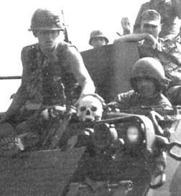

*A good pacifist.*

While we are on the subject of soft targets, it is best to take a lesson from the Civil War on the subject of spies. Black spy Harriet Tubman performed 19 intelligence gathering missions for the Union army. When she dressed for her missions, she put on the appearance and behavior of the most ignorant maladjusted Black in North America. She was grossly underestimated by every Confederate she encountered and was able to smuggle 300 Blacks to the Union north. This mistake is not to be repeated. Every Black, regardless of their age, sex or appearance, is suspect.

## Chapter 6

**Operation Blackout**

“It was always understood that there was no way we were going to be able to stop Serb paramilitary forces who were going in and murdering civilians in villages.”

*Waging Modern War: Bosnia, Kosovo and the Future of Combat, Wesley K. Clark*

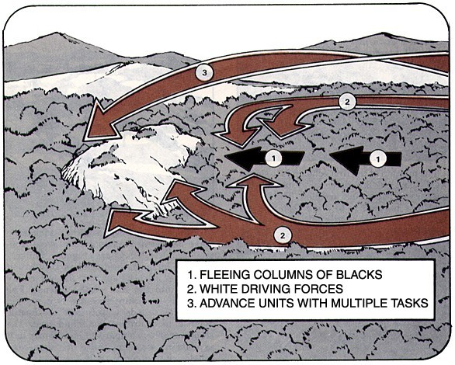

### Overall strategy and action of a Sample Campaign:

COMMANDER’S INTENT. All personnel are to be totally cognizant that the entire mission, from start to finish, is to rid the lower 48 of the United States of predatory Blacks. With that in mind, enter into the campaign with a determination to root out, pursue, herd and drive all of them out of the country. Unit leaders must think big, very big; your targets are going to be big, entire neighborhoods, towns, states, and regions.

The symbol for this ethnic cleansing operation will be a combination of the symbol of death and the Confederate battle flag. Flags of this design shall be flown from the antennas of all vehicles and patches, in subdued colors, will be sewn on the front of the camouflage covers of helmets.

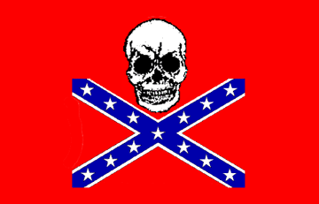

This campaign will be fought in four (4) primary phases:

### Phase I. Get them moving

Commanders will have researched the locations of military storage facilities in their area and along their routes. Intelligence specialists are to debrief military defectors for current locations of weapons storage areas as soon as they arrive.

Utilize psychological warfare in every facet of the offensive. Start rumors by patching into phone lines and interrupting ongoing calls. Let listeners believe they are hearing someone else’s conversation and plant the information you want spread around. Allow one hour for the rumor to circulate and then knock out all telephone lines and cell phone towers. All along the way, psychological warfare units will encourage locals to take matters into their own hands. Spread leaflets ahead of your advance offering rewards for locations of hiding Blacks and to those handing them over to your forces. Also put the word out that Whites who hide or give aid and comfort to Blacks will be executed.

Follow through on your warning when such cases are discovered. No exceptions.

The Operation will begin with militia units, State Defense Forces, National Socialists, and other groups converging on Washington, Michigan, Wisconsin and Maine. Starting at

the northern edges of those states, units will form organized fronts and proceed south. As small towns are encountered, local Blacks are to be rooted out and pushed ahead of the main formations. Those who resist are to be shot. National Guard armories along their path are to be cleaned out and their equipment integrated into existing units. As larger towns and cities are encountered, tanks, artillery and air power are to be used to shell and bomb Black neighborhoods. As Blacks flee these areas, they are to be scooped up and added to the existing numbers of Blacks ahead of the main force. Commanders will utilize forward observers in order to shape and direct the crowds. Timely observer information will tell when and where to shell in order to prevent crowd dispersion.

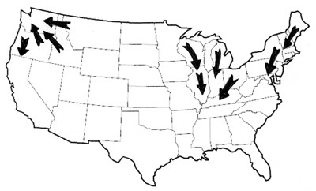

*Operations begin in Northern states, and then move south.*

Weather will play a definite part in the offensive. Commanders will take full advantage of wind direction to set buildings and neighborhoods ablaze. Primitive Molotov cocktails thrown from the beds of pickups will ignite large scale fires and even firestorms if the wind speed is high enough.

As cities burn and death tolls mount, governors of those states will call out their National Guard forces. Initial contacts are expected to be brief. White forces are to target only Black soldiers while psywar units broadcast appeals for White soldiers to come to our side. Once the new soldiers are incorporated into the groups, resume your advance.

Federal military forces will probably attempt to stop the operation at this point. Skirmishes will undoubtedly erupt, with only Black soldiers being targeted by Whites. Expect White federal forces to join the operation with little delay and for firefights to take place between White and Black soldiers. At this point be prepared to share command with active duty military officers and to see heavy tanks and Apache helicopters join in the operation. With federal participation, vast arsenals of weapons are now available.

For large cities with majority non-White populations, such as New York, Detroit, and Los Angeles, it may become necessary to destroy a city in order to save it. Seal all the roads in and out of the city with tanks, allow only the Whites to leave, drive the Blacks back into the city with cannon and machinegun fire, and then use atomic or chemical weapons.

Let the weapons do the dirty work, that’s the reason they’re called “Weapons of Mass Destruction.”

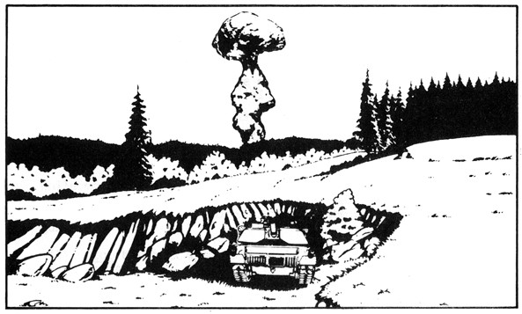

Resume your mission.

For majority white cities, shell Black neighborhoods until forward observers report that the population is beginning to flee, then commit armor supported by infantry-mounted HUMMVEES. Once into the city, send forces directly into Black neighborhoods.

Utilize all HUMMVEES with .50 caliber machineguns or Mark 19 automatic grenade launchers plus Bradley Fighting Vehicles (BFV) in the direct fire role to smash resistance and to break through any obstacles.

West coast forces will proceed as far south as Redding, California. They will stop there to regroup, rearm and take in volunteers. Blacks herded ahead of the primary force are to be stopped by helicopters blocking all roads. They are to be confined between the helicopters and the main force. In the Midwest, forces will have reached southern Illinois and Kentucky. On the East coast, forces will stop just north of Washington, DC.

Troops are to rest, rearm, balance out their forces with new volunteers, issue weapons, fuel the vehicles and prepare to launch Phase II.

### Phase II. Drive them

This phase will begin with the return of heliborne forces to the main force, followed by artillery shelling of the trailing edge of the crowd. Shaping and herding columns of fleeing Blacks will be a situation that will bear constant monitoring with intelligence

information relayed real time to the combat operations center. Commanders should be aware that Blacks may set ambushes for pursuing forces as well as attempting counterattacks.

East coast forces will begin with the attack on Washington, DC. Commanders will make the decision as to the type of weapon(s) to be used. It is not vital to the mission to capture Washington; merely eliminating the occupants will be enough. No time is to be wasted on this city.

Operations tempo is important. Commanders will keep in mind that the political clock is ticking and that all phases of the operation are to be completed before NATO or UN “peacekeeping” forces can become involved. Keep fleeing columns of Blacks on the move. Attach wrecker trucks and construction equipment to Driving Forces in order to remove abandoned vehicles and obstructions from highways and roads. Push incessantly on retreating columns; fill them with fear of death without letup.

Driving forces will maintain enough combat strength to intimidate resistance and keep columns moving. Driving forces will be equipped to destroy any group putting up resistance. Columns of Blacks should be fired on with light weapons every few miles in order to encourage them to keep moving, and shelled when they make an unauthorized stop.

Commanders of driving forces should stay aware of the energy levels of their forces, rotating fresh units and vehicles onto the line as needed. Those replaced will have the opportunity for hot meals, showers and clean clothes. Combat Service Support (CSS) will provide such services, as well as forward movement of combat related supplies and rearward movement of casualties, White refugees and recruits, as well as repairable equipment.

*In the 2nd Phase, new volunteers will make White forces much stronger.*

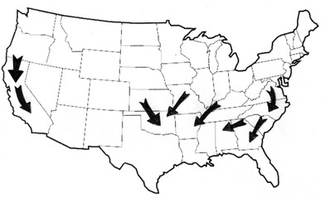

Send in ground forces and SADs to work with local sympathizers and their lists of Black leaders, White collaborators, liberal media personnel, and enemy political activists.

Check into any report of Blacks hiding or refusing to leave. Commanders will have discretion as to how much energy is to be put into ejecting residents. If resistance at a location is expected or experienced, burn the house or building down. Burn down all buildings bearing a “Black owned” sign.

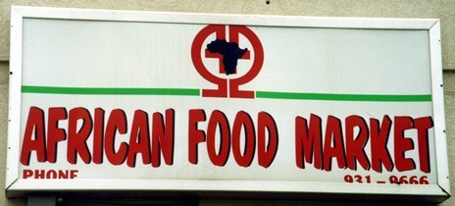

*Stores like this are on your target list.*

It is important that any desire by Blacks to return home be smashed as thoroughly as possible. Again, borrowing from the Serbs and Croats, have SADs burn down all ghettos, Black homes, and state subsidized apartment buildings. Leave them nothing for which to return.

White forces will participate in destroying all Black cultural symbols. Blow up or burn all popular bars and clubs, “soul food” restaurants, Black-owned radio or television stations, Black newspapers, printing companies and all stores which cater specifically to Blacks.

Include statues and images of Abraham Lincoln and Martin Luther King.

Shell all grocery stores which feed Black neighborhoods. Shell their schools, apartment buildings, mosques, public health centers and theaters.

Supportive White police can be a great asset. They know where all the worst Blacks live and congregate. If they are not eaten up with political correctness, have your SADs work as closely with them as is practical. If they cannot be trusted, shell their headquarters during inspection and continue with your mission. In addition, White forces will capture or destroy the local Emergency Operations Centers in towns and cities with liberal governments.

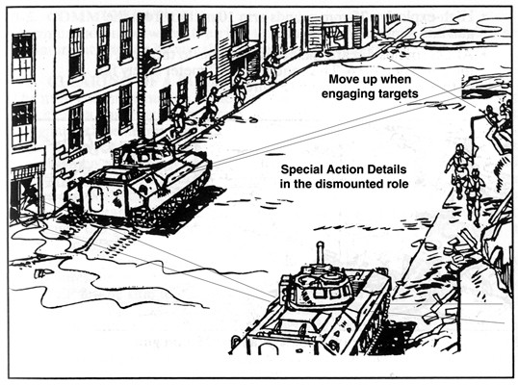

*The BFV is a great asset to ethnic cleansing operations in cities.*

Midwest forces will drive the Blacks south toward Louisiana. Where possible, pack them into freight and cattle cars and ship them en masse. In cities with subway systems and well developed bus lines, most inner city Blacks will not own cars. Those Blacks will be leaving cleansed areas on foot. To add speed to the deportation element of the operation, use all available trains to move Black deportees to Mexico. Have the State Defense Forces and militias oversee this entire segment of the operation as well as provide armed escorts.

West coast forces will have reached Los Angeles, once again having to make the decision to fight their way through or to stand back and destroy the city with advanced weapons. That decision rests solely with White commanders. The fall of L.A. represents the end of Phase II on the western front.

East coast forces should drive Blacks southward toward Florida. White naval forces should pace the operation and make available their ship’s aircraft, guns and rockets. Any Blacks attempting to escape by sea as the operation progresses down the east coast should be sunk.

Midwest forces reaching the southern edge of the Appalachian mountain range will stop to reorganize and re-arm. Give troops at least one full day’s rest. Feed them meals of as high a quality as can be provided. Bring in barbers, shower units, and offer medical checks. CSS is best performed by the numerous camp followers (family, friends, etc.) who will be happy to pitch in and help.

Some expendable items, such as fuel, boots and food will have to be located and provided from businesses in cities through which our armies pass. Friendly White merchants will undoubtedly be happy to contribute in exchange for our services. Unfriendly liberal store owners will probably be reluctant to help. If they refuse, use whatever force is necessary to obtain what is needed. If they become belligerent, drop them from helicopters into the herd of starving desperate Blacks.

Issue new boots or other gear as needed and have the men clean and service their weapons. Replace weapons as needed. Re-stock ammunition for all weapons and shift heavy weapons and crews between and within units as necessary to balance them to mission needs.

Reinforce combat forces with new recruits picked up along the way. Have more experienced soldiers show them the basics, but do not spend one minute longer than is necessary. Some new recruits will have to learn on the job.

Meet with unit commanders and discern any last minute needs. Gas up, load up, mount up and begin Phase Three.

### Phase III. Reaching the Racial Fault-lines

By now Blacks should have been cleansed from Michigan to the Appalachians and from Maine down through Washington DC all the way to the north border of Florida. Your troops will rest 24 hours, which is hardly enough for the masses which have flown in front of you. At this point they will be in pretty bad shape, dehydrated, hungry, exhausted, and with many sick and injured.

This phase will begin with simultaneous frontal assaults on refugee camps, with the goal of setting the crowds once again into motion. Attacks from the east will best utilize having the sun to your back. Psychological warfare units will have prepared the battlefield and the refugee camps will already be very jumpy. At first light, begin with massed artillery shelling. Walk the impacts along predetermined paths and begin sending in mobile infantry units to eliminate any rear guard actions. SAD units should be sent in at the same time, directly into refugee centers to eliminate survivors and those assisting them. The panic you instigate will spread with explosive speed.

White forces along the eastern seaboard should drive Blacks directly south into Florida, but go no further than Orlando. Keep the Blacks concentrated along the main highways. Use helicopters and fixed wing aircraft to strafe those attempting to escape into the swamps.

*The 3rd Phase reaches the racial fault lines. New forces join in NM and AZ.*

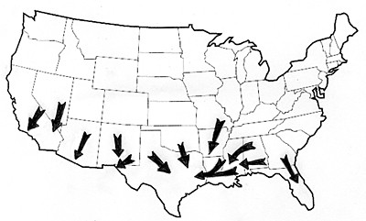

Midwest forces should avoid attacking Atlanta. Like Washington, DC, the city is almost entirely Black and there is little to gain by capturing it. After all roads and highways are blocked off, psywar units should inform Whites that the city is to be destroyed and allow them a short period of time to escape.

As Black neighborhoods and towns descend into chaos, drive columns of the unwanted across the Mississippi into Arkansas and finally into Texas. Driving Forces which have swept down from Kansas, Oklahoma and other states will now link up and consolidate their refugees to begin the final phase.

West coast forces should have reached the termination line for Phase III, just south of San Bernardino, where they will now halt. Blacks driven by these forces are to be held in the desert area south of town and guarded by air and artillery.

The stage is now set for the final phase.

### Phase IV. On to Mexico

This is the final phase of Operation Blackout. This is where the evil perpetrated by Blacks upon Whites becomes a thing of the past. This is where everyone in every unit must lean into the fight with all his might. This is where we show our gratitude to Mexico and Cuba for sending us their crime and corruption. This is the big payback!

Combat Service Support will be receiving its highest demands for fuel, which should have a priority right alongside artillery shells. All combat units at the rear should be showered, given one night’s sleep and put into fresh uniforms. Ammunition should be distributed to all forces along and behind the front line. All weapons systems are to be brought up to full battle readiness and the front line balanced out to suit the commander.

On the East coast, as White forces close on Miami, the operations tempo is to be speeded up. Shell the rears of columns to keep them moving at maximum speed. When the Blacks hit Miami, the locals are never going to forget it. Over eight million starving desperate

Blacks will stampede into towns filled with well fed Chicanos and Cuban immigrants. What will happen is this: the starving Blacks will immediately begin looting stores, homes, restaurants and any other source of food. Chicano homeowners and business owners will defend themselves and their property with whatever guns they possess. The Blacks and Chicanos will slaughter each other.

The sheer numbers of Blacks will quickly overwhelm the Chicanos, who will eventually flee in the only direction open to them: Cuba. The result will be the first mass exodus of “Cuban-Americans” and Blacks to Cuba. Psywar units will focus on encouraging Cuban- Americans to return to Cuba. This tactic is to pay Castro back for all the violent mental patients and convicts he sent to the United States in the Mariel Boat-Lift.

*The 4th Phase terminates at the Southern borders. The country is now cleansed.*

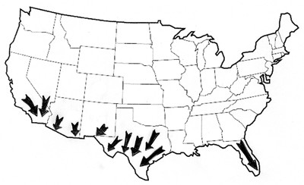

Midwest forces will now have consolidated their Blacks with all the surviving Blacks from the south. Herd them into open country away from large cities. Drive them to the shores of lakes in order to prepare them for the final drive out of the country. It is important to mention here that Blacks brought to this assembly point by independent White groups are to be accepted and placed into the main herd. The Whites who captured and transported them are to be welcomed and invited to join in Phase IV.

Spread White forces into a long front line approximately 300 miles long. Bring all non- combat related tasks to a halt and concentrate on bringing up enough artillery munitions, small arms ammunition, food, water and fuel for the final push.

Begin by shelling Dallas and Ft. Worth. Use air and sea assets to bomb Black neighborhoods in Houston. After properly softening up Dallas and Ft. Worth, begin an advance through the two cities, adding to the large herd out in the countryside to the south.

West coast forces and those in Texas will now drive all remaining Blacks directly toward Mexico without letup. Shell the trailing ends of the herds and strafe any vehicles that

stop. Keep the flanks of the herd covered with mobile infantry and self-propelled artillery, shelling and strafing as needed to keep the herd concentrated.

In Texas, the last three hundred miles may have very high combat friction. Blacks not wishing to relocate to Mexico, where there are no social supports or affirmative action, may act desperately. You will have now crossed the racial fault line separating the Blacks and the Chicanos. You will be injecting millions of Blacks into an area of racially distinct Chicanos. There will be no racial ambiguity. The once overwhelmingly brown civilization is now to be mixed with a 100 percent concentration of desperate Blacks.

This is a situation most favorable to the White commanders.

On the West Coast, the situation will be less complicated, with only a short drive to the Mexican border and Tijuana. However, operations tempo is to follow the Air Land battle plan and be sped up as driving forces near the border.

In Texas, Driving Forces will encounter 2,000 “Colonias” (Third world Chicano shanty villages) which run along the US/Mexican border. These villages are 100 percent Chicano, so as Blacks swarm over them, the predictable conflagrations will erupt.

Psychological Warfare units will exacerbate the situation via Spanish language broadcasts and leaflet drops. Prime the Chicano populations for the invasions of Blacks and let the situations take care of themselves.

Major shootouts will continuously erupt as desperate Blacks and Chicanos kill each other. As these situations develop, pause your advance to let them slaughter each other. Stimulate things periodically with SAD units sniping at each side from Bradley Fighting Vehicles. Keep the pressure on and continue your advance as soon as the shooting begins to taper off.

Once again, operations tempo is to be sped up as White forces near the Mexican border. Shell fleeing Blacks slightly further toward the center of mass as the border comes into sight. Once all Blacks have been driven across the Rio Grande River into Mexico, have artillery continue to push them into Mexico until they are out of range.

Expect SAD units to be busy for a short period of time north of the border cleaning out pockets of resistance. Psychological operations units should be used to polarize the Mexicans against the Blacks. Remember: The goal is not only to eject the Blacks from the United States; it is also to reduce their ability to fight their way back into the United States as much as possible. Setting the Mexicans against the Blacks will be easy, since they have a natural hostility towards each other. The message for the Mexican government should be made abundantly clear by psychological warfare units: Knock it off with the “migration,” seal your border, and we will cease shelling your country. This is not negotiable.

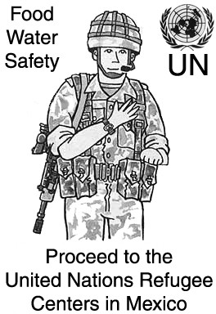Below is a sample psychological warfare leaflet. It is designed for use in the last phase of the operation. Tapping into the three main thoughts in the heads of fleeing Blacks, it will help keep them moving in the desired direction. Use air drops and artillery dispersal shells to distribute them widely. Variations on this design are encouraged.

## Chapter 7

**When?**

“A grim, but possible, variation … is the breakup of the U.S. in a gigantic civil war among the American races. As pro-white backlash reclaims the country, non-whites refuse to accept their reduced status. They bitterly resent the repeal of civil rights, loss of affirmative action and federal supports. They are a minority, but a huge one-third of the population, including 40 million blacks and 50 million Hispanics increasingly resentful of the 200 million whites. The white vision of delicately balancing white dominance with non-white submission is scorned - and collapses. Congress sinks into a powerless arena of racial outbursts and denunciations. As danger-signs mount, citizens of every race stockpile guns, survival-supplies and home-security systems. Clashes over race issues

and incidents mount, all dramatized by TV media clutching for viewer market share. Tensions boil into raw anger, then open violence and race war.”

*Ending the Race Crisis in the 21st Century, James Owens, Ph.D., 1999.*

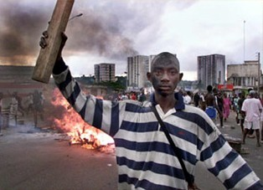

In the world of political science, absolutely the hardest thing to predict is the actual date something will happen. In the war to recreate the White society this country once was, the decision to begin the campaigns of ethnic cleansing will be based on a few key elements: the political loyalty of White police, the percentage of the American combat forces within the country, the level of racial tension, and a violent incident (such as the Rodney King beating) or a series of organized racist attacks on Whites.

Over the years there have been many attempts to predict calamity by survivalist doomsayers. During the Cold War there were many predictions of imminent takeovers by the Soviet Union. Echoes of those old predictions exit today among those who entertain beliefs that somehow the destitute country of Russia has military designs on the United States. Indeed they may have the wish to take over the US, but they lack everything from manpower to money. The real threat in the US is the presence of the Black race, with the Chicanos not far behind them. If anyone wishes to have something to worry about, they need look no further than the cluster of Black thugs standing on the corner.

You have been instructed on the history of ethnic cleansing, its components, and even a military strategy to flush them all into Mexico and Cuba—like so much waste down a toilet. The key factor remaining is still, when?

The old survivalists would base their decisions on what’s called the “five finger theory.” That is, when five major banks fail, five cities descend into chaos, and so on. That theory is long dead, proven wrong by the LA riots which spread to over twenty cities, and the hundreds of banks that collapsed after the S&L scandals. The real moment to pick up the guns and start up the tanks will present itself, but predicting that date is impossible. Fear not, however, for that day is indeed on the horizon. It is inevitable.

White leaders and individuals should do an inventory of large military equipment in their areas. It can be as simple as just driving by a National Guard armory and counting the vehicles. Occasionally local National Guard units hold Open Houses and invite the public. Take the opportunity and attend. Shake hands with the Guardsmen and make friends. If your visit is timed right, large doors on hangars and garages will be open. You may be able to see, identify and count the HUMMVEEs, trucks, mortars, guns, armored personnel carriers, tanks and other useful equipment in their inventory.

Racially conscious White men and women of military age should enlist in the Guard or State Defense Force and get to know the equipment well. The National Guard and Reserve will be keeping their eyes and ears open to such infiltration, so watch what is said. It may be better to learn all the facets of operating a tank and then training trusted civilian friends, rather than trying to convert fellow guardsmen.

Should we be so lucky as to have Nation of Islam or some other radical non-White group start their own campaign of ethnic cleansing before we do, recruits will be much easier to find. Surviving members of slain White families will be eager to avenge the deaths of their loved ones. Those people should be quickly trained, if already veterans or active military they should be sent to the front lines immediately.

In this effort size is everything. Military commanders, National Guard commanders, State Defense Force commanders, and militia commanders should think BIG. Think tanks, think artillery and rocket barrages, think air strikes with Warthogs and Apache helicopters. Even if you do not have access to this equipment, train as though you do.

Train for the Air Land battle. Practice calling in air strikes, artillery barrages, and other real-war methods. Learn the proper communication skills to call in artillery without having it fall on your men. Learn to read and use grid-coordinates on military maps.

This will not be a war of squads but of companies and divisions. As soon as forces can be assembled, that being the consolidation of every White militant and radical group, ex- convicts, military deserters, militias, bikers and everyone else who wants in on the fight—the attacks should begin.

When the time comes, use the strategies in this book or equally good strategies of your own to launch a wide coordinated offensive putting theory into practice. If you do not live directly in the path of military operations, there is still much you and your friends can do on the local level. Once things begin you can round up the Blacks in your city and either herd them to the military forces or take care of them yourselves.

The White race has walked on the moon. We have invented virtually everything that makes up the modern technological world. If we can do these things, we certainly can rid ourselves of the predators that walk among us. If anything, the coming fight can be compared to a crusade, a crusade to save our race. Every White who reads this manual needs to prepare and stand ready. Think about how to systematically cleanse your neighborhood and town. Then, when the time comes, spring into action.

# Epilogue

“I have given my life to try to alleviate the sufferings of Africa. There is something that all white men who have lived here like I must learn and know: that these individuals are a sub-race. They have neither the intellectual, mental, or emotional abilities to equate or to share equally with white men in any function of our civilization. I have given my life to try to bring them the advantages which our civilization must offer, but I have become well aware that we must retain this status: the superior and they the inferior. For whenever a white man seeks to live among them as their equals they will either destroy him or devour him. And they will destroy all of his work. Let white men from anywhere in the world, who would come to Africa, remember that you must continually retain this status; you the master and they the inferior like children that you would help or teach.

Never fraternize with them as equals. Never accept them as your social equals or they will devour you. They will destroy you.”

*Dr. Albert Schweitzer, From My African Notebook, 1961.*

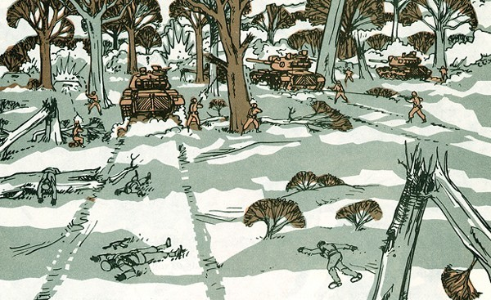

Imagine, walking down a sidewalk and not having to play a game of chicken with some Neanderthal. Imagine, jobs for everyone wanting a job. Imagine, not being awakened at three in the morning by blaring anti-White hate music. This and much more await the White race.

After ridding the country of Blacks, the U.S. government may not even exist anymore, or Dixie may have seceded again. If the U.S. government has survived, they will have invited the United Nations and NATO to enforce multiculturalism. A campaign against such forces will be designed to preserve our victory and our leaders.

Provided the United States no longer exists, White forces should remain on the border to assure that Blacks do not cross back to cause trouble. If Dixie has seceded, the victorious White forces will now become the national army of Dixie.

The possibility of the UN kidnapping leaders of the ethnic cleansing operations, and shipping them to The Hague for “war crimes” trials is a legitimate concern. All efforts must be made to protect key personnel. Should leaders be kidnapped and jailed, every attempt must be made to free them. Jailed leaders and fighters should remain confident that their cause is just and their deeds are answerable only to the highest law, that of survival and sanctity of the White race. Everyone who participates in an operation of this magnitude does so in the knowledge that their race is more important than anything else in this earthly life. The Hague has no power to administer the death penalty, so any imprisoned personnel should look at being caught as guaranteed retirement, three “hots and a cot” every day for the rest of their lives.

On the bright side, over eight million jobs will open up for Caucasians. Manufacturing will improve. Schools will adopt higher standards of performance from students. Most importantly, crime will drop dramatically and as a result, antigun and other anti- constitutional groups will wither and die from lack of horror stories on the nightly news which prop up their issues. This presumes that the leaders, executive committees, office staffs and major contributors of such groups have not already been rounded up and lynched.

It is easy to foresee what will happen when the cockroaches that perpetrate 75% of the violent crime are amongst us no longer. Troops taking part in ethnic cleansing operations undoubtedly will be vilified in the global media, but the proof of the justness of the cause will be the dramatic drop in crime. At first many Whites will not know how to act, what with having lived their entire lives putting up with creepy thugs, blaring jungle music, and strings of news reports of burglaries, carjackings, rapes, murders and robberies committed by Blacks. Expect many Whites to be unaccustomed to the peace and quiet.

A new and thrilling era awaits us. Now let us put this plan into action.

# Recommended Reading

*Yugoslavia, Death of a Nation,* Laura Silber and Allan Little. ISBN: 0140262636

*Waging Modern War: Bosnia, Kosovo and the Future of Combat,* General Wesley K. Clark. ISBN: 158648043X

*The Last Hundred Yards : The NCO's Contribution to Warfare,* H.J. Poole. ISBN: 0963869523

*Civil War Two, The Coming Breakup Of America,* by Thomas Chittum. ISBN: 0929408179

*The Turner Diaries,* Andrew Macdonald (William Pierce) Available free online.

*Field Manual 7-90, Tactical Employment of Mortars,* U.S. Army

*Leadership Secrets of Attila the Hun,* Wess Roberts, Ph.D. ISBN: 0446391069

## Appendix A Psychological Warfare Poster

Print and distribute this poster in White neighborhoods bordering Black ones. Use prior

to operations and ahead of pursuit forces.

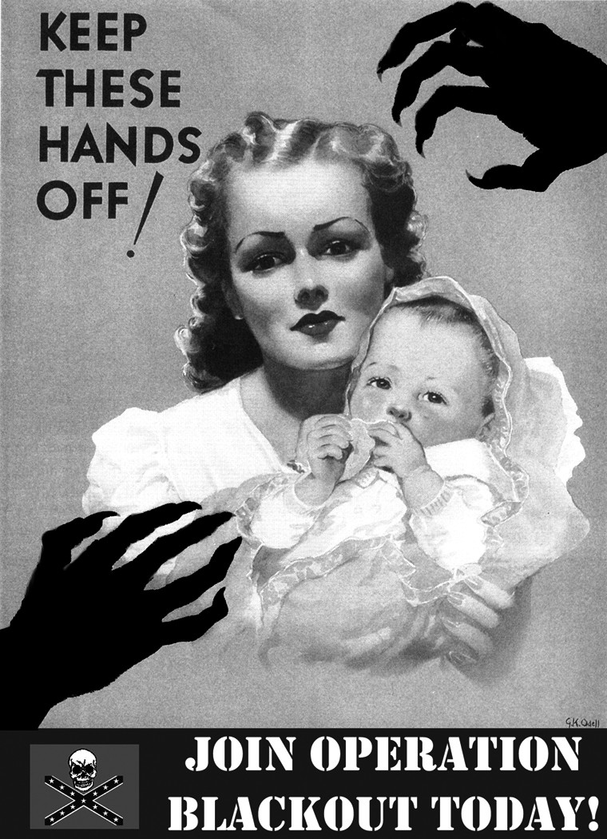

## Appendix B Abandoned Property Form

### Be this known to all that:

I living at the residence located at Address:

City: , State , Zip ,

do hereby certify that all my real property in the United States is now abandoned. This includes the land, structures and all items contained within them.

In addition, all my vehicles, boats, aircraft, and all items contained therein are also abandoned.

Signed on this day , month , year .

Signature

Print Name

Social Security Number:

Notary Seal Here:

Signature of Notary:

Date:

## Appendix C Military Bases

**Military Bases**

**Source: US Department of Transportation Bureau of Transportation Statistics, 2003**

|  |  |  |  |
| --- | --- | --- | --- |
| **milbase** | | | |
| **ST_ABBR** | **FAC_NAME** | **FAC_TYPE** | **BRANCH** |
| AK | Elmendorf Air Force Base | International Airport | Air Force |
| AK | Eielson Air Force Base | International Airport | Air Force |
| AK | Fort Richardson | Army Installation | Army |
| AK | Fort Jonathan Wainwright | Army Installation | Army |
| AK | Fort Greely | Army Installation | Army |
| AL | Redstone Arsenal | Army Installation | Army |
| AL | Mobile Naval Complex | Naval Installation | Navy |
| AL | Phosphate Development Works | Army Installation | Army |
| AL | Fort Rucker | Army Installation | Army |
| AL | Fort McClellan | Army Installation | Army |
| AL | Maxwell Air Force Base | Military Airport | Air Force |
| AL | Gunter Air Force Base | Military Airport | Air Force |
| AL | Anniston AD | Army Installation | Army |
| AL | 117th Air Refueling Wing | Joint Use Airport | National Guard |
| AR | Little Rock Air Force Base | Military Airport | Air Force |
| AR | Fort Chaffee | Army Installation | Army |
| AR | Ebing Air National Guard Base | Joint Use Airport | National  Guard |
| AR | Camp Joseph T Robinson | Army Installation | National Guard |
| AR | Eaker Air Force Base | Military Airport | Air Force |
| AR | Pine Bluff Arsenal | Army Installation | Army |
| AZ | Davis-Monthan Air Force Base | Military Airport | Air Force |
| AZ | Fort Huachuca | Army Installation | Army |
| AZ | Yuma Proving Ground | Army Installation | Army |
| AZ | Williams Air Force Base | Military Airport | Air Force |
| AZ | Marine Corps Air Station Yuma | Joint Use Airport | Marine Corps |
| AZ | Luke AF Range | Other Installation | Air Force |
| AZ | Navajo Army Depot | Army Installation | Army |
| AZ | Luke Air Force Base | Military Airport | Air Force |
| AZ | Luke Auxiliary Field No 3 | Airport | Air Force |

|  |  |  |  |
| --- | --- | --- | --- |
| **milbase** | | | |
| **ST_ABBR** | **FAC_NAME** | **FAC_TYPE** | **BRANCH** |
| CA | San Nicolas Naval Facility | Naval Installation | Navy |
| CA | George Air Force Base | Military Airport | Air Force |
| CA | Norton Air Force Base | Military Airport | Air Force |
| CA | March Air Force Base | Military Airport | Air Force |
| CA | Point Mugu Naval Complex | Naval Installation | Navy |
| CA | Long Beach Regional Med Ctr | Hospital | Navy |
| CA | AFRC Los Alamitos | Army Installation | Army |
| CA | Term Island Cg Base (San Pedro) | Coast Guard Installation | Coast Guard |
| CA | San Clemente Island Naval Unde… | Military Airport | Navy |
| CA | Long Beach Naval Complex | Naval Installation | Navy |
| CA | NWS, Fallbrook Annex | Naval Installation | Navy |
| CA | Naval Air Station, Miramar | Military Airport | Navy |
| CA | El Centro NAF | Military Airport | Navy |
| CA | Mount Laguna USAF Station | Air Force Station | Air Force |
| CA | Fort Macarthur | Army Installation | Army |
| CA | Marine Corps Base, Camp Pendleton | Marine Ground Installation | Marine Corps |
| CA | Marine Corps Air Station Tustin | Military Airport | Marine Corps |
| CA | Marine Corps Air Station El Toro | Military Airport | Marine Corps |
| CA | Naval Weapons Station, Seal Beach | Naval Installation | Navy |
| CA | San Francisco Naval  Communication | Naval Installation | Navy |
| CA | Marine Corps Logistics Base Barstow | Marine Ground Installation | Marine Corps |
| CA | Alameda Naval Complex | Military Airport | Navy |
| CA | Oakland Naval Supply Center | Naval Installation | Navy |
| CA | Presidio of San Francisco | Army Installation | Army |
| CA | 834th Transportation Battalion | Army Installation | Army |
| CA | Treasure Island Naval Complex | Naval Installation | Navy |
| CA | Camp Parks | Army Installation | Army |
| CA | Point Molate Fuel Depot | Depot | Navy |
| CA | Riverbank Army Ammunition Plant | Army Installation | Army |
| CA | Mare Island Naval Complex | Naval Installation | Navy |
| CA | Travis Air Force Base | Military Airport | Air Force |
| CA | Sacramento Army Depot | Army Installation | Army |
| CA | Mather Air Force Base | Military Airport | Air Force |
| CA | McClellan Air Force Base | Military Airport | Air Force |

|  |  |  |  |
| --- | --- | --- | --- |
| **milbase** | | | |
| **ST_ABBR** | **FAC_NAME** | **FAC_TYPE** | **BRANCH** |
| CA | Beale Air Force Base | Military Airport | Air Force |
| CA | Sierra Army Depot | Army Installation | Army |
| CA | Defense Depot San Joaquin Sharpe | Army Installation | Army |
| CA | Naval Weapons Center, China Lake | Storage | Navy |
| CA | MCAGCC Twenty Nine Palms | Marine Ground Installation | Marine Corps |
| CA | Marine Corps Recruiting, San  Diego | Other Installation | Marine Corps |
| CA | Vandenberg Air Force Base | Military Airport | Air Force |
| CA | Edwards Air Force Base | Military Airport | Air Force |
| CA | Fort Irwin | Army Installation | Army |
| CA | Cambria Afs | Other | Air Force |
| CA | Naval Regional Medical Center | Hospital | Navy |
| CA | Fort Hunter Liggett | Army Installation | Army |
| CA | Air Force Plant 42 | Depot | Air Force |
| CA | Naval Air Station, Lemoore | Military Airport | Navy |
| CA | Naval Postgraduate School, Monterey | School | Navy |
| CA | Presidio of Monterey | Army Installation | Army |
| CA | Fort Ord | Army Installation | Army |
| CA | Castle Air Force Base | Military Airport | Air Force |
| CA | Naval Air Station Moffett Field | Military Airport | Navy |
| CA | DDD San Joaquin, Tracy Site | Depot | Army |
| CA | Camp Roberts | Army Installation | National  Guard |
| CA | Coronado Amphibious Base | Naval Installation | Navy |
| CA | San Diego Regional Med Ctr | Hospital | Navy |
| CA | San Diego NSC Broadway Compound | Naval Installation | Navy |
| CA | Naval Housing | Other | Navy |
| CA | North Island Naval Complex | Naval Installation | Navy |
| CA | NSC San Diego, Point Loma Annex | Missile | Navy |
| CA | Imperial Beach NAS | Military Airport | Navy |
| CA | Naval Station San Diego | Naval Installation | Navy |
| CA | San Diego Training Center | Training | Navy |
| CO | Lowry Air Force Base | Military Airport | Air Force |
| CO | United States Air Force Academy | School | Air Force |

|  |  |  |  |
| --- | --- | --- | --- |
| **milbase** | | | |
| **ST_ABBR** | **FAC_NAME** | **FAC_TYPE** | **BRANCH** |
| CO | Pueblo Army Depot | Army Installation | Army |
| CO | Buckley Air National Guard Base | Military Airport | National Guard |
| CO | Falcon AFB | Military Airport | Air Force |
| CO | Peterson Air Force Base | Joint Use Airport | Air Force |
| CO | Fort Carson | Army Installation | Army |
| CO | Fitzsimons Army Medical Center | Hospital | Army |
| CT | Naval Submarine Base New  London | Naval Installation | Navy |
| DC | Walter Reed Army Medical Center | Hospital | Army |
| DC | District Commandant (Navy Yard) | Naval Installation | Navy |
| DC | Fort Lesley J. McNair | Army Installation | Army |
| DC | Bolling Air Force Base | Military Airport | Air Force |
| DE | Dover A.F.B. | Military Airport | Air Force |
| FL | Tyndall Air Force Base | Military Airport | Air Force |
| FL | Naval Air Station, Key West | Military Airport | Navy |
| FL | Cape Canaveral Air Station | Military Airport | Air Force |
| FL | Camp Blanding | Army Installation | National Guard |
| FL | Pensacola Naval Complex | Military Airport | Navy |
| FL | Macdill Air Force Base | Military Airport | Air Force |
| FL | Whiting Field NAS | Military Airport | Navy |
| FL | Hurlburt Field | Military Airport | Air Force |
| FL | Patrick Air Force Base | Military Airport | Air Force |
| FL | Eglin Air Force Base | Military Airport | Air Force |
| FL | Jacksonville Naval Complex | Military Airport | Navy |
| FL | US Air Force Eastern Test Range | Military Airport | Air Force |
| FL | Naval Training Center. Orlando | Training | Navy |
| FL | Homestead Air Force Base | Military Airport | Air Force |
| FL | Naval Coastal Sys Ctr, Panama City | Naval Installation | Navy |
| FL | Patrick AFB | Military Airfield | Air Force |
| FL | Naval Air Station, Cecil Field | Military Airport | Navy |
| FL | Naval Station Mayport Station | Military Airport | Navy |
| GA | Naval Submarine Base, Kings Bay | Naval Installation | Navy |
| GA | Naval Supply Corps School, Athens | School | Navy |
| GA | Moody Air Force Base | Military Airport | Air Force |
| GA | Fort Gordon | Army Installation | Army |

|  |  |  |  |
| --- | --- | --- | --- |
| **milbase** | | | |
| **ST_ABBR** | **FAC_NAME** | **FAC_TYPE** | **BRANCH** |
| GA | Dobbins Air Force Base | Military Airport | Air Force |
| GA | Naval Air Station, Atlanta | Storage | Navy |
| GA | Air Force Plant 6 | Depot | Air Force |
| GA | Fort Gillem | Army Installation | Army |
| GA | Fort Benning | Army Installation | Army |
| GA | Robins Air Force Base | Military Airport | Air Force |
| GA | Fort McPherson | Army Installation | Army |
| GA | Marine Corps Logistics Base Albany | Marine Ground Installation | Marine Corps |
| GA | Hunter Army Airfield | Military Airport | Army |
| GA | Fort Stewart | Army Installation | Army |
| HI | Hickman AFB | Military Airport | Air Force |
| HI | MCAS Kaneohe Bay | Military Airport | Marine Corps |
| HI | Honolulu Cg Base | Coast Guard Installation | Coast Guard |
| HI | Tripler Army Medical Center | Hospital | Army |
| HI | Naval Air Station, Barbers Point | International Airport | Navy |
| HI | Fort Shafter | Army Installation | Army |
| HI | Schofield Barracks | Army Installation | Army |
| HI | Wheeler Air Force Base | Military Airport | Air Force |
| IA | Iowa Army Ammunition Plant | Army Installation | Army |
| ID | Gowen Field | Army Installation | Army |
| ID | Idaho Falls Nuclear Training Center | Naval Installation | Navy |
| ID | Mountain Home Air Force Base | Military Airport | Air Force |
| IL | Savanna Army Depot | Army Installation | Army |
| IL | Fort Sheridan | Army Installation | Army |
| IL | Naval Air Station, Glenview | Military Airport | Navy |
| IL | Scott Air Force Base | Military Airport | Air Force |
| IL | Chanute Air Force Base | Airfield | Air Force |
| IL | Joliet Army Ammunition Plant | Army Installation | Army |
| IL | Rock Island Arsenal | Army Installation | Army |
| IL | Naval Training Center, Great Lakes | Naval Installation | Navy |
| IN | Crane AAP | Army Installation | Army |
| IN | Camp Atterbury | Army Installation | National  Guard |
| IN | Indiana Army Ammunition Plant | Army Installation | Army |
| IN | Grissom Air Force Base | Military Airport | Air Force |

|  |  |  |  |
| --- | --- | --- | --- |
| **milbase** | | | |
| **ST_ABBR** | **FAC_NAME** | **FAC_TYPE** | **BRANCH** |
| IN | Fort Benjamin Harrison | Army Installation | Army |
| IN | Newport Army Ammunition Plant | Army Installation | Army |
| IN | US Naval Avionics Center | Naval Installation | Navy |
| IN | Jefferson Proving Ground | Army Installation | Army |
| KS | Sunflower Army Ammunition Plant | Army Installation | Army |
| KS | McConnell Air Force Base | Military Airport | Air Force |
| KS | Fort Riley | Army Installation | Army |
| KS | Fort Leavenworth | Army Installation | Army |
| KS | Kansas Army Ammunition Plant | Army Installation | Army |
| KS | Def Industrial Plant Equip Facility | Other Installation | Army |
| KY | Louisville Naval Ordnance Station | Naval Installation | Navy |
| KY | Fort Campbell | Army Installation | Army |
| KY | Lexington Blue Grass Army Depot | Army Installation | Army |
| KY | Fort Knox | Army Installation | Army |
| KY | Bluegrass AD | Ammunition Storage | Army |
| LA | Naval Air Station, New Orleans | Military Airport | Navy |
| LA | Louisiana Army Ammunition Plan | Army Installation | Army |
| LA | Fort Polk | Army Installation | Army |
| LA | England Air Force Base | Military Airport | Air Force |
| LA | Barksdale Air Force Base | Military Airport | Air Force |
| MA | Westover Air Force Base | Military Airport | Air Force |
| MA | Naval Air Station South Weymouth | Military Airport | Navy |
| MA | North Truro Afs | Air Force Station | Air Force |
| MA | Camp Edwards | Army Installation | National Guard |
| MA | Natick Center | Army Installation | Army |
| MA | Fort Devens | Army Installation | Army |
| MA | Hanscom Air Force Base | Military Airport | Air Force |
| MD | Naval Electr Sys Eng Act St Inigoes | Naval Installation | Navy |
| MD | Fort Ritchie | Army Installation | Army |
| MD | Fort Detrick | Army Installation | Army |
| MD | Edgewood Arsenal | Army Installation | Army |
| MD | Aberdeen Proving Ground | Army Installation | Army |
| MD | Curtis Bay Yard (Baltimore) | Coast Guard Installation | Coast Guard |
| MD | Fort George G. Meade | Army Installation | Army |
| MD | Naval Ordnance Station, Indian | Naval Installation | Navy |

|  |  |  |  |
| --- | --- | --- | --- |
| **milbase** | | | |
| **ST_ABBR** | **FAC_NAME** | **FAC_TYPE** | **BRANCH** |
|  | Head |  |  |
| MD | Nav Surface Warfare Ctr, White Oak | Depot | Navy |
| MD | Andrews Air Force Base | Military Airport | Air Force |
| MD | Bethesda Naval Hospital | Hospital | Navy |
| MD | Patuxent River NAS | Military Airport | Navy |
| MD | Annapolis USN Academy | Naval Installation | Navy |
| ME | Brunswick Naval Complex | Military Airport | Navy |
| ME | Loring Air Force Base | Military Airport | Air Force |
| MI | Selfridge Air National Guard Base | Military Airport | National  Guard |
| MI | Army Tank-Automotive Cmd | Army Installation | Army |
| MI | Wurtsmith Air Force Base | Storage | Air Force |
| MI | Camp Grayling | Army Installation | National Guard |
| MI | K.I. Sawyer Air Force Base | Military Airport | Air Force |
| MN | Twin Cities Army Ammunition  Plant | Army Installation | Army |
| MN | Camp Ripley | Army Installation | National Guard |
| MO | Lake City Army Ammunition Plan | Army Installation | Army |
| MO | Kansas City Marine Corps Complex | Marine Ground  Installation | Marine Corps |
| MO | Whiteman Air Force Base | Military Airport | Air Force |
| MO | Jefferson Barracks | Army Installation | Army |
| MO | Richards-Gebaur Air Force Base | Military Airport | Air Force |
| MO | Fort Leonard Wood | Army Installation | Army |
| MS | Pascagoula Naval Complex | Naval Installation | Navy |
| MS | Camp Shelby | Army Installation | National Guard |
| MS | Mississippi Army Ammunition  Plant | Depot | Army |
| MS | Naval Air Station, Meridian | Military Airport | Navy |
| MS | Columbus Air Force Base | Military Airport | Air Force |
| MS | NCBC, Gulfport | Naval Installation | Navy |
| MS | Keesler AFB and Training Annex | Military Airport | Air Force |
| MT | Malmstrom Air Force Base | Military Airport | Air Force |
| NC | Seymour Johnson Air Force Base | Military Airport | Air Force |

|  |  |  |  |
| --- | --- | --- | --- |
| **milbase** | | | |
| **ST_ABBR** | **FAC_NAME** | **FAC_TYPE** | **BRANCH** |
| NC | Fort Bragg | Army Installation | Army |
| NC | Pope Air Force Base | Military Airport | Air Force |
| NC | Marine Corps Base, Camp Lejeune | Marine Ground Installation | Marine Corps |
| NC | MCAS, Cherry Point | Military Airport | Marine Corps |
| ND | Grand Forks Air Force Base | Military Airport | Air Force |
| ND | Minot Air Force Base | Military Airport | Air Force |
| NE | Offutt Air Force Base | Military Airport | Air Force |
| NE | Cornhusker Army Ammunition  Plant | Army Installation | Army |
| NH | Portsmouth Naval Shipyard | Naval Installation | Navy |
| NJ | Picatinny Arsenal | Army Installation | Army |
| NJ | NAEC, Lakehurst | Naval Installation | Navy |
| NJ | Fort Dix | Army Installation | Army |
| NJ | McGuire Air Force Base | Military Airport | Air Force |
| NJ | Fort Monmouth | Army Installation | Army |
| NM | Holloman Air Force Base | Military Airport | Air Force |
| NM | Cannon Air Force Base | Military Airport | Air Force |
| NM | Kirtland Air Force Base | Storage | Air Force |
| NM | Fort Wingate | Army Installation | Army |
| NM | White Sands Missile Complex | Army Installation | Army |
| NV | Hawthorne AAP | Ammunition Storage | Army |
| NV | Tonapah Test Range | Training | Air Force |
| NV | Nellis Air Force Base | Military Airfield | Air Force |
| NV | Naval Air Station, Fallon | Military Airport | Navy |
| NY | Fort Wadsworth | Army Installation | Army |
| NY | Watervliet Arsenal | Army Installation | Army |
| NY | Floyd Bennett Field | Naval Installation | Navy |
| NY | Fort Hamilton | Army Installation | Army |
| NY | New York Naval Station | Naval Installation | Navy |
| NY | Fort Totten | Army Installation | Army |
| NY | Griffiss Air Force Base | Military Airport | Air Force |
| NY | Plattsburgh Air Force Base | Military Airport | Air Force |
| NY | Fort Drum | Army Installation | Army |
| NY | United States Military Academy | School | Navy |
| NY | Seneca Army Depot | Army Installation | Army |

|  |  |  |  |
| --- | --- | --- | --- |
| **milbase** | | | |
| **ST_ABBR** | **FAC_NAME** | **FAC_TYPE** | **BRANCH** |
| OH | Rickenbacker Air Force Base | Annex | Air Force |
| OH | Wright-Patterson Air Force Base | Military Airport | Air Force |
| OH | Defense Distribution Depot Columbus | Storage | DLA |
| OH | Lima Army Tank Center | Army Installation | Army |
| OH | Ravenna Army Ammunition Plant | Ammunition Storage | Army |
| OK | Air Force Plant 3 | Joint Use Airport | Air Force |
| OK | Fort Sill | Army Installation | Army |
| OK | Altus Air Force Base | Military Airport | Air Force |
| OK | Vance Air Force Base | Military Airport | Air Force |
| OK | McAlester AAP | Army Installation | Army |
| OK | Tinker Air Force Base | Military Airport | Air Force |
| OR | Portland Air Force Base | Joint Use Airport | Air Force |
| OR | Umatilla Army Depot | Army Installation | Army |
| PA | Fort Indiantown Gap | Army Installation | Army |
| PA | Carlisle Barracks | Army Installation | Army |
| PA | Naval Air Station, Willow Grove | Military Airport | Navy |
| PA | New Cumberland Army Depot | Army Installation | Army |
| PA | Defense Personnel Support Center | Naval Installation | Navy |
| PA | DDD Susquehanna  (Mechanicsburg) | Naval Installation | DLA |
| PA | Letterkenny AD | Army Installation | Army |
| PA | Scranton Army Ammunition Plant | Army Installation | Army |
| PA | Tobyhanna Army Depot | Army Installation | Army |
| PA | NADC, Warminster | Military Airport | Navy |
| PA | Philadelphia Naval Complex | Naval Installation | Navy |
| PR | USNS, Roosevelt Roads | Naval Installation | Navy |
| PR | Fort Buchanan | Army Installation | Army |
| RI | NCBC, Davisville | Storage | Navy |
| RI | Newport Naval Complex | Naval Installation | Navy |
| SC | Myrtle Beach Air Force Base | Joint Use Airport | Air Force |
| SC | MCAS Beaufort | Military Airport | Marine Corps |
| SC | Fort Jackson | Army Installation | Army |
| SC | MCRD, Parris Island | Marine Ground Installation | Marine Corps |
| SC | Shaw Air Force Base | Military Airport | Air Force |
| SC | 841st Trans Battalion, Charleston | Naval Installation | Army |

|  |  |  |  |
| --- | --- | --- | --- |
| **milbase** | | | |
| **ST_ABBR** | **FAC_NAME** | **FAC_TYPE** | **BRANCH** |
| SC | Charleston Air Force Base | Joint Use Airport | Air Force |
| SC | Strategic Weapons Facility | Navy | Navy |
| SC | Charleston Naval Complex | Naval Installation | Navy |
| SC | Naval Weapons Station, Charleston | Naval Installation | Navy |
| SD | Ellsworth Air Force Base | Military Airport | Air Force |
| TN | Milan Army Ammunition Plant | Army Installation | Army |
| TN | Arnold Air Force Base | Air Force Station | Air Force |
| TN | Holston AAP | Army Installation | Army |
| TN | Naval Air Station Memphis | Naval Installation | Navy |
| TN | Defense Depot Memphis | Army Installation | DLA |
| TN | Volunteer Army Ammunition Plan | Army Installation | Army |
| TX | Corpus Christi NAS | Military Airport | Navy |
| TX | Brooks Air Force Base | Military Airport | Air Force |
| TX | Naval Air Station Dallas | Military Airport | Navy |
| TX | Red River AD | Army Installation | Army |
| TX | Reese Air Force Base | Military Airport | Air Force |
| TX | Longhorn AAP | Army Installation | Army |
| TX | Carswell Air Force Base | Military Airport | Air Force |
| TX | Naval Air Station Chase Field | Military Airport | Navy |
| TX | Lackland AFB and Training Annex | Military Airport | Air Force |
| TX | William Beaumont Army Hospital | Hospital | Army |
| TX | Camp Bullis | Other Installation | Marine Corps |
| TX | Bergstrom Air Force Base | Military Airport | Air Force |
| TX | Goodfellow AFB | Airfield | Air Force |
| TX | Laughlin Air Force Base | Military Airport | Air Force |
| TX | Fort Hood | Army Installation | Army |
| TX | Fort Bliss | Army Installation | Army |
| TX | Fort Sam Houston | Army Installation | Army |
| TX | Ellington Air Force Base | Joint Use Airport | Air Force |
| TX | Ingleside Naval Complex | Naval Installation | Navy |
| TX | Naval Air Station, Kingsville | Military Airport | Navy |
| TX | Dyess Air Force Base | Military Airport | Air Force |
| TX | Kelly Air Force Base | Military Airport | Air Force |
| TX | Sheppard Air Force Base | Storage | Air Force |
| TX | Camp Mabry Military Reservation | Army Installation | Army |
| TX | Randolph Air Force Base | Military Airport | Air Force |

|  |  |  |  |
| --- | --- | --- | --- |
| **milbase** | | | |
| **ST_ABBR** | **FAC_NAME** | **FAC_TYPE** | **BRANCH** |
| UT | Tooele AD | Army Installation | Army |
| UT | Camp Williams State Military R | Army Installation | Army |
| UT | Defense Depot Ogden | Depot | DLA |
| UT | Hercules Powder Plant | Other Installation | Other |
| UT | Hill Air Force Base | Military Airport | Air Force |
| UT | Fort Douglas | Army Installation | Army |
| UT | Dugway Proving Ground | Army Installation | Army |
| VA | Norfolk NAS | Military Airport | Navy |
| VA | Portsmouth Regional Med Ctr | Hospital | Navy |
| VA | Fort Pickett | Army Installation | Army |
| VA | Langley Air Force Base | Military Airport | Air Force |
| VA | Fort Monroe | Army Installation | Army |
| VA | Fort Story | Army Installation | Army |
| VA | Craney Island US Naval Res. | Naval Installation | Navy |
| VA | Radford Army Ammunition Plant | Army Installation | Army |
| VA | Fort Eustis | Army Installation | Army |
| VA | Little Creek Naval Amphibious Base | Naval Installation | Navy |
| VA | Naval Air Station, Oceana | Military Airport | Navy |
| VA | Norfolk Naval Shipyard | Depot | Navy |
| VA | US Naval Transmitter Station | Radio Relay | Navy |
| VA | Camp Pendleton | Army Installation | National  Guard |
| VA | Fleet Training Center, Dam Neck | Training | Navy |
| VA | Naval Security Group Activity | Radio Relay | Navy |
| VA | US Coast Guard | Coast Guard Installation | Coast Guard |
| VA | Fort A. P. Hill | Army Installation | Army |
| VA | Fort Lee | Army Installation | Army |
| VA | MCCDC, Quantico | Marine Ground Installation | Marine Corps |
| VA | NSWC, Dahlgren | Military Airport | Navy |
| VA | Fort Belvoir | Army Installation | Army |
| VA | Vint Hill Farms | Air Force Station | Air Force |
| VA | Cameron Station | Army Installation | Army |
| VA | DGSC, Richmond | Army Installation | DLA |
| VA | Camp Peary | Naval Installation | Navy |
| VA | Fort Myer | Army Installation | Army |

|  |  |  |  |
| --- | --- | --- | --- |
| **milbase** | | | |
| **ST_ABBR** | **FAC_NAME** | **FAC_TYPE** | **BRANCH** |
| VA | Naval Supply Center, Cheatham Annex | Storage | Navy |
| VA | Naval Weapons Station, Yorktown | Naval Installation | Navy |
| WA | Camp McKean Naval Rec. Center | Naval Installation | Marine Corps |
| WA | Fort Lawton | Army Installation | Army |
| WA | Puget Sound NC Everett | Naval Installation | Navy |
| WA | Naval Submarine Base, Bangor | Naval Installation | Navy |
| WA | Keyport, NUWES | Naval Installation | Navy |
| WA | Naval Air Station, Whidbey Island | Naval Installation | Navy |
| WA | Camp Wesley Harris Naval Res. | Naval Installation | Navy |
| WA | Yakima Firing Range | Army Installation | Army |
| WA | Fairchild Air Force Base | Military Airport | Air Force |
| WA | Puget Sound Naval Complex | Naval Installation | Navy |
| WA | Pacific Beach Facility | Naval Installation | Navy |
| WA | McChord Air Force Base | Military Airport | Air Force |
| WA | Fort Lewis | Army Installation | Army |
| WA | Naval Station Everett | Naval Installation | Navy |
| WI | General Mitchell Field | Joint Use Airport | National  Guard |
| WI | Badger Army Ammunition Plant | Army Installation | Army |
| WI | Fort McCoy | Army Installation | Army |
| WY | Francis E Warren Air Force Base | Storage | Air Force |

**Appendix D Amtrak Stations**

**Amtrak Stations**

**Sorted By State**

**For Use in Deportations and Troop Movements Source: National Transportation Atlas Databases 2003 Bureau of Transportation Statistics**

|  |  |  |  |
| --- | --- | --- | --- |
| amtk_sta | | | |
| STATE | STATUS | CITY | STR_ADDRES |
| AL | CLOSED | GREENVILLE | MAIN AND BOLLING STS. |
| AL | CLOSED | BREWTON | DEER ST. |
| AL | CLOSED | OPELIKA |  |
| AL | BUS | MONTGOMERY | 950 W. SOUTH BLVD. |
| AL | ACTIVE | MOBILE | 11 GOVERNMENT ST. |
| AL | ACTIVE | BIRMINGHAM | 1819 MORRIS AVE. |
| AL | CLOSED | BAY MINETTE | 100 E. RAILROAD ST. |
| AL | CLOSED | EVERGREEN | FRONT AND COOPER STS. |
| AL | ACTIVE | ATMORE | 107 E. LOUISVILLE ST. |
| AL | ACTIVE | TUSCALOOSA | 2105 GREENSBORO AVE. |
| AL | ACTIVE | ANNISTON | 126 W.4TH ST. |
| AR | CLOSED | NEWPORT | 417 FRONT ST. |
| AR | ACTIVE | ARKADELPHIA | 798 S. 5TH ST. |
| AR | ACTIVE | MALVERN | 200 E. 1ST ST. |
| AR | ACTIVE | LITTLE ROCK | MARKHAM & VICTORY STS. |
| AR | ACTIVE | WALNUT RIDGE | HWY. 67 AT MAIN ST. |
| AR | BUS | HOT SPRINGS | 100 BROADWAY TER. |
| AR | ACTIVE | TEXARKANA | 100 E. FRONT ST. |
| AZ | ACTIVE | WILLIAMS JCT. | 235 N. GRAND CANYON BLVD. |
| AZ | ACTIVE | YUMA | 281 S. GILA ST. |
| AZ | BUS | GRAND CANYON  VILLAGE | BRIGHT ANGEL LODGE |
| AZ | CLOSED | COOLIDGE | 105 N. FIRST ST. |
| AZ | CLOSED | MUNDS PARK | S.W. PINEWOOD BLVD. |
| AZ | BUS | WILLIAMS | 518 E. BILL WILLIAMS AVE. |
| AZ | CLOSED | TEMPE | 3RD AND ASH STS. |
| AZ | BUS | LAKE HAVASU CITY | RAMADA INN, 271 S. LAKE HAVASU AVE. |
| AZ | BUS | PHOENIX | 8101 BLACK CANYON FWY. |

|  |  |  |  |
| --- | --- | --- | --- |
| amtk_sta | | | |
| STATE | STATUS | CITY | STR_ADDRES |
| AZ | ACTIVE | FLAGSTAFF | 1 E. SANTA FE AVE. |
| AZ | BUS | CAMP VERDE | 355 W MIDDLE VERDE RD. |
| AZ | BUS | SEDONA | B.W. ARROYO ROBLE HOTEL, 400 N. HWY 89A |
| AZ | ACTIVE | WINSLOW | E. 2ND ST. |
| AZ | ACTIVE | BENSON | 4TH & SAN PEDRO STS. |
| AZ | ACTIVE | KINGMAN | 4TH & ANDY DEVINE STS. |
| AZ | BUS | PHOENIX | TERMINAL 2 |
| AZ | BUS | PHOENIX | 401 W. HARRISON ST. |
| AZ | FUTURE | MARICOPA |  |
| AZ | ACTIVE | TUCSON | 400 E. TOOLE ST. |
| BC | ACTIVE | VANCOUVER | 1150 STATION ST. |
| BC | FERRY/BUS | NANAIMO | MAVERICK DEPOT, 1  TERMINAL AVE. |
| BC | FERRY/BUS | VICTORIA | 1000A WHARF ST. |
| BC | BUS | WHISTLER |  |
| BC | BUS | SQUAMISH | MAVERICK COACH LINES BUS STOP |
| BC | BUS | RICHMOND | 10251 ST. EDWARD DR. |
| BC | BUS | PEMBERTON | MAVERICK DEPOT, 1357 ASTER  RD. |
| BC | BUS | SURREY | 187 176TH ST. |
| BC | BUS | GARIBALDI HIGHLANDS | MAVERICK BUS STOP, 40446 GOVERNMENT RD. |
| CA | ACTIVE | MADERA | 15 1/2 & 29TH RD. |
| CA | BUS | LAGUNA BEACH | TRANSIT DEPOT, BROADWAY  BTW. BEACH & FOR |
| CA | BUS | SANTA CRUZ | 920 PACIFIC AVE. |
| CA | BUS | SOUTH LAKE TAHOE | 1000 LAKE TAHOE BLVD. |
| CA | BUS | SANTA CLARITA | 25259 THE OLD RD. |
| CA | ACTIVE | SANTA CLARA | FOOT OF STARS & STRIPES DR. |
| CA | ACTIVE | SANTA BARBARA | 209 STATE ST. |
| CA | ACTIVE | SANTA ANA | 1000 E. SANTA ANA BLVD. |
| CA | BUS | KETTLEMAN CITY | I-5 AT STATE HWY. 41 |
| CA | BUS | KING CITY | 570 CANAL ST. |
| CA | BUS | MARYSVILLE | 6TH & A STS. |
| CA | CLOSED | SANTA MONICA | 601 WILSHIRE & 6TH |

|  |  |  |  |
| --- | --- | --- | --- |
| amtk_sta | | | |
| STATE | STATUS | CITY | STR_ADDRES |
| CA | BUS | MARIPOSA | 12TH & JESSIE STS. |
| CA | BUS | SAN LUIS OBISPO | GRAND AVE. |
| CA | BUS | PLACERVILLE | 222 MAIN ST. |
| CA | ACTIVE | MARTINEZ | 401 FERRY ST. |
| CA | BUS | SAN PEDRO | CATALINA TERMINAL, BERTH 95 |
| CA | CLOSED | ST. HELENA | CHERI'S FAMILT REST., 641  MAIN ST. |
| CA | BUS | LA CRESCENTA | PARK & RIDE LOT (STREET), I- 210 AT LOWEL |
| CA | BUS | LOMPOC | LAUREL & N. H STS. |
| CA | ACTIVE | MERCED | 324 W. 24TH ST. |
| CA | ACTIVE | SAN LUIS OBISPO | RAILROAD AVE & SANTA  ROSA ST. |
| CA | BUS | LEGGETT | 69501 US HWY. 101 |
| CA | BUS | LEMOORE | 19TH AVE. & STATE HWY. 198 |
| CA | BUS | LANCASTER | 44742 SIERRA HWY. |
| CA | ACTIVE | SIMI VALLEY | 5000 E. LOS ANGELES AVE. |
| CA | BUS | SEASIDE | BLDG. T-1176, 4TH ST. |
| CA | BUS | LAKE OF THE PINES JC | COMBIE DELI, 10536 COMBIE RD. |
| CA | BUS | SOLVANG | 1630 MISSION DR. |
| CA | BUS | LIVERMORE | 720 LAS FLORES DR. |
| CA | BUS | SANTA MARIA | CYPRESS ST. & NICHOLSON  AVE. |
| CA | ACTIVE | LOMPOC | END OF OCEAN AVE. |
| CA | ACTIVE | SOLANA BEACH | 105 S. CEDROS AVE. |
| CA | BUS | SOLEDAD | 1000 FRONT ST. |
| CA | BUS | LONG BEACH | 601 N. LONG BEACH BLVD. |
| CA | ACTIVE | LOS ANGELES | 800 N. ALAMEDA ST. |
| CA | BUS | SANTA ROSA | 175 RAILROAD ST. |
| CA | BUS | SANTA PAULA | 245 S. PALM AVE. |
| CA | BUS | LAYTONVILLE | 44900 US HWY. 101 |
| CA | BUS | SODA SPRINGS | DONNER SUMMIT LODGE |
| CA | BUS | OROVILLE | GRANDE AVE. AT STATE HWY. 70 |
| CA | BUS | NAPA | 1275 MCKINSTRY ST. |

|  |  |  |  |
| --- | --- | --- | --- |
| amtk_sta | | | |
| STATE | STATUS | CITY | STR_ADDRES |
| CA | ACTIVE | RICHMOND | 16TH ST. & MACDONALD AVE. |
| CA | ACTIVE | NEEDLES | 900 FRONT ST. |
| CA | BUS | NEVADA CITY | 301 SACRAMENTO ST. |
| CA | ACTIVE | REDDING | 1620 YUBA ST. |
| CA | BUS | RED BLUFF | 460 ANTELOPE BLVD. |
| CA | BUS | NEWPORT BEACH | NEWPORT TRANS. CENTER, 1550 AVOCADO AVE. |
| CA | CLOSED | NORTH HIGHLANDS | ROSEVILLE RD. AT I-80 |
| CA | CLOSED | OAKHURST | 40644 STATE HWY. 41 |
| CA | ACTIVE | OAKLAND | 245 2ND ST. |
| CA | BUS | RANCHO CORDOVA | 10369 FOLSOM BLVD. |
| CA | ACTIVE | SAN BERNARDINO | 1170 W. 3RD ST. |
| CA | ACTIVE | ONTARIO | 228 S. PLUM ST. |
| CA | BUS | RIVERSIDE | 4066 VINE ST. |
| CA | ACTIVE | OXNARD | 201 E. 4TH ST. |
| CA | BUS | PALM DESERT | MONTEREY AVE. & SAN  GORGONIO WAY |
| CA | BUS | PALM SPRINGS | 300 N. INDIAN AVE. |
| CA | ACTIVE | PALM SPRINGS | INDIAN CANYON DR. @ I-10 |
| CA | BUS | PALMDALE | 120 E. PALMDALE BLVD. |
| CA | BUS | PASADENA | 150 S. ROBLES AVE. |
| CA | ACTIVE | PASO ROBLES | 8TH & PINE STS. |
| CA | CLOSED | PORTERVILLE | 35 WEST OAK AVE. |
| CA | BUS | PERRIS | B.W. PERRIS INN, 480 REDLANDS AVE. |
| CA | BUS | PETALUMA | 100 FAIRGROUNDS DR. |
| CA | CLOSED | PISMO BEACH | DENNY'S REST., 611 FIVE  CITIES DR. |
| CA | ACTIVE | POMONA | 156 W. COMMERCIAL ST. |
| CA | ACTIVE | OCEANSIDE | 235 S. TREMONT ST. |
| CA | BUS | MIDPINES | YOSEMITE BUG YOUTH HOSTEL, HWY 140 |
| CA | ACTIVE | SAN JOSE | 65 CAHILL ST. |
| CA | BUS | SAN FRANCISCO | CALIFORNIA & DRUMM STS. |
| CA | BUS | SAN FRANCISCO | 835 MARKET ST. |
| CA | BUS | SAN BRUNO | SAN FRANCISCO INTERNATIONAL AIRPORT |

|  |  |  |  |
| --- | --- | --- | --- |
| amtk_sta | | | |
| STATE | STATUS | CITY | STR_ADDRES |
| CA | BUS | SAN FRANCISCO | PIER 39 |
| CA | CLOSED | SAN FRANCISCO | 4TH & TOWNSEND STS. |
| CA | BUS | SAN FRANCISCO | 31 THE EMBARCADERO |
| CA | ACTIVE | SAN DIEGO | 1050 KETTNER BLVD. |
| CA | ACTIVE | SAN CLEMENTE | MUNICIPAL PIER |
| CA | CLOSED | SAN CLEMENTE | 1850 AVENIDA ESTACION |
| CA | BUS | MCKINLEYVILLE | ARCATA AIRPORT TERMINAL |
| CA | BUS | INDIO | 45995 MONROE ST. |
| CA | BUS | SCOTIA | MAIN & MILL STS. |
| CA | ACTIVE | SACRAMENTO | 401 I ST. |
| CA | CLOSED | RIVERBANK | 3243 TALBOT AVE. |
| CA | BUS | MILLBRAE | MILLBRAE AVE. & CALIFORNIA DR. |
| CA | ACTIVE | MODESTO | 1700 HELD DRIVE |
| CA | ACTIVE | ROSEVILLE | 201 PACIFIC ST. |
| CA | BUS | MOJAVE | 15900 SIERRA HWY. |
| CA | BUS | ROSAMOND | 2515 CENTER ST. |
| CA | BUS | MONTEREY | PEARL & TYLER STS. |
| CA | BUS | ROHNERT PARK | 6480 REDWOOD DR. |
| CA | ACTIVE | MOORPARK | 300 HIGH ST. |
| CA | BUS | ROCKLIN | ROCKLIN RD. & RAILROAD  AVE. |
| CA | BUS | MORENO VALLEY | ARCO MINI MART, 2624 E. ALESSANDRO BLVD. |
| CA | CLOSED | MORGAN HILL | CAL TRAN DEPOT, E. DUNNE &  DIANA AVES. |
| CA | ACTIVE | LEE HALL | MONTEREY AVE. & SAN GORGONIO WAY |
| CA | ACTIVE | SALINAS | 11 STATION PLACE |
| CA | BUS | VAN NUYS | 7610 WOODLEY AVE. |
| CA | ACTIVE | COLFAX | CHURCH ST. & SP TRACKS |
| CA | CLOSED | COMMERCE | 6344 E. 26TH ST. |
| CA | BUS | WATSONVILLE | W. LAKE AVE. & RODRIGUEZ  ST. |
| CA | ACTIVE | CORCORAN | WHITLEY & OTIS AVES. |
| CA | BUS | CORNING | INTERMODAL TML., 1081 SOLANO |

|  |  |  |  |
| --- | --- | --- | --- |
| amtk_sta | | | |
| STATE | STATUS | CITY | STR_ADDRES |
| CA | ACTIVE | WASCO | 700 G ST. |
| CA | ACTIVE | DAVIS | 840 2ND ST. |
| CA | CLOSED | DEL MAR | 1501 COAST BLVD. |
| CA | CLOSED | VISALIA | 1297 E. MINERAL KING AVE. |
| CA | ACTIVE | IRVINE | 15215 BARRANCA PKWY. |
| CA | BUS | TRACY | 725 W. CLOVER RD. |
| CA | CLOSED | ANAHEIM | DISNEYLAND HOTEL, CERRITOS AVE. AND WEST |
| CA | BUS | CLAREMONT | 200 W. 1ST ST. |
| CA | ACTIVE | VAN NUYS | 7724 VAN NUYS BLVD. |
| CA | BUS | VALLEJO | 1000 FAIRGROUNDS DR. |
| CA | ACTIVE | DUNSMUIR | 5750 SACRAMENTO AVE. |
| CA | BUS | UKIAH | 711 E. PERKINS ST. |
| CA | BUS | PLEASANTON | OWENS DR. AT BART WAY |
| CA | ACTIVE | DENAIR | SANTA FE ST. AT ELM ST. |
| CA | CLOSED | EL MONTE | 3501 SANTA ANITA AVE. |
| CA | BUS | EL PORTAL | YOSEMITE VIEW MOTEL, AT  PARKLINE HWY 140 |
| CA | ACTIVE | TRUCKEE | RAILROAD ST. & COMMERCIAL ROW |
| CA | ACTIVE | EMERYVILLE | 5885 LANDREGAN ST. |
| CA | BUS | EUREKA | 5TH & L STS. |
| CA | ACTIVE | VICTORVILLE | 16858 D ST. |
| CA | BUS | WILLITS | COMMERCIAL ST. |
| CA | FUTURE/BUS | ADELANTO |  |
| CA | BUS | YOSEMITE | YOSEMITE LODGE |
| CA | ACTIVE | ANAHEIM | 2150 KATELLA AVE. |
| CA | ACTIVE | ANTIOCH | I ST. & SANTA FE TRACKS |
| CA | BUS | ARCATA | F ST. BETWEEN 7TH & 8TH STS. |
| CA | CLOSED | WOODLAND |  |
| CA | BUS | ATASCADERO | EAST MALL & PALMA AVE. |
| CA | BUS | AUBURN | NEVADA & FULWEILER STS. |
| CA | ACTIVE | BAKERSFIELD | 1501 F ST. |
| CA | ACTIVE | BARSTOW | 685 N. 1ST AVE. |
| CA | BUS | BEAUMONT | 550 BEAUMONT AVE. |
| CA | BUS | CLOVERDALE | CITRUS FAIR DR. & ASTI RD. |
| CA | BUS | BORON | 26545 20 MULE TEAM RD. |

|  |  |  |  |
| --- | --- | --- | --- |
| amtk_sta | | | |
| STATE | STATUS | CITY | STR_ADDRES |
| CA | CLOSED | LOS ANGELES |  |
| CA | BUS | BUELLTON | PEA SOUP ANDERSON REST., 376 AVE. OF FLA |
| CA | ACTIVE | BURBANK | EMPIRE & AIRPORT AVES. |
| CA | CLOSED | CALISTOGA | NAPA CO. TRANSIT STOP,  HWY. 29, LINCOLN |
| CA | CLOSED | WHITTIER |  |
| CA | ACTIVE | CAMARILLO | 30 LEWIS RD. |
| CA | BUS | CAMERON PARK | US HWY. 50 & CAMERON PARK DR. |
| CA | BUS | CARMEL | 3665 RIO RD. |
| CA | ACTIVE | CARPINTERIA | 5TH ST. & LINDEN AVE. |
| CA | ACTIVE | CHATSWORTH | 21510 DEVONSHIRE ST. |
| CA | ACTIVE | CHICO | W. 5TH & ORANGE STS. |
| CA | ACTIVE | VENTURA | HARBOR BLVD. & FIGUEROA  ST. |
| CA | ACTIVE | BERKELEY | 3RD ST. & UNIVERSITY AVE. |
| CA | BUS | GILROY | 7250 MONTEREY HWY. |
| CA | ACTIVE | CENTERVILLE | FREMONT & PERALTA BLVDS. |
| CA | ACTIVE | HAYWARD | 22555 MEEKLAND AVE. |
| CA | ACTIVE | FRESNO | 2650 TULARE ST. |
| CA | BUS | TEHACHAPI | 416 W. TEHACHAPI BLVD. |
| CA | BUS | GARBERVILLE | 924 REDWOOD DR. |
| CA | BUS | FREMONT | MISSION BLVD. & I-680 |
| CA | ACTIVE | STOCKTON | 735 S. SAN JOAQUIN ST. |
| CA | ACTIVE | FULLERTON | 120 E. SANTA FE AVE. |
| CA | ACTIVE | GLENDALE | 400 W. CERRITOS AVE. |
| CA | ACTIVE | GOLETA | S. LA PATERA LN. |
| CA | CLOSED | TORRANCE | 21712 HAWTHORNE BLVD. |
| CA | ACTIVE | HANFORD | 200 SANTA FE AVE. |
| CA | ACTIVE | SUISUN | 177 MAIN ST. (UNDER HWY. 12) |
| CA | BUS | GRASS VALLEY | 125 E. MAIN ST. |
| CA | ACTIVE | GROVER BEACH | 180 GRAND AVE. |
| CA | BUS | FORTUNA | 1326 L ST. |
| CA | CLOSED | THOUSAND OAKS | 583 VENTU PARK RD. |
| CA | BUS | HEALDSBURG | HEALDSBURG AVE. & MATHESON ST. |

|  |  |  |  |
| --- | --- | --- | --- |
| amtk_sta | | | |
| STATE | STATUS | CITY | STR_ADDRES |
| CA | BUS | HEMET | COCOS REST., 3246 FLORIDA AVE. |
| CA | BUS | FILLMORE | 718 VENTURA ST. |
| CA | CLOSED | FISH CAMP | 1121 STATE HWY. 41 |
| CA | ACTIVE | SANTA MARIA | 330 GUADELUPE ST. |
| CO | CLOSED | GREELEY | 7TH AVE. AND 9TH ST. |
| CO | ACTIVE | DENVER | 1701 WYNKOOP ST. |
| CO | ACTIVE | LAMAR | MAIN & BEECH STS. |
| CO | ACTIVE | GRANBY | 438 RAILROAD AVE. |
| CO | CLOSED | SILVERTHORNE | 471 RAINBOW DR. |
| CO | BUS | COLORADO SPRINGS | 120 S. WEBER |
| CO | ACTIVE | TRINIDAD | PINE ST. |
| CO | ACTIVE | GLENWOOD SPRINGS | 413 7TH ST. |
| CO | BUS | LOVELAND | 1027 E. EISENHOWER BLVD. |
| CO | BUS | FORT COLLINS | 501 RIVERSIDE |
| CO | ACTIVE | LA JUNTA | 1ST & COLORADO STS. |
| CO | BUS | BOULDER | 4401 N. BROADWAY |
| CO | ACTIVE | FORT MORGAN | S. ENSIGN ST. |
| CO | BUS | PUEBLO | 703 W. U.S. 50 |
| CO | BUS | FRISCO | 1010 MEADOW DR. |
| CO | ACTIVE | GRAND JUNCTION | 339 S. 1ST ST. |
| CO | BUS | EAGLE | 432 GRAND ST. |
| CO | BUS | DENVER | DENVER INTERNATIONAL  AIRPORT |
| CO | BUS | VAIL | 241 S. FRONTAGE RD. |
| CO | BUS | LONGMONT | 615 N. MAUB ST. |
| CO | SEASONAL | FRASER | 420 RAILROAD ST. |
| CT | ACTIVE | WINDSOR LOCKS | S. MAIN ST. (RTE. 159) |
| CT | ACTIVE | NEW LONDON | 27 WATER ST. |
| CT | ACTIVE | OLD SAYBROOK | 455 BOSTON POST RD. |
| CT | ACTIVE | MYSTIC | RTE. 1 |
| CT | ACTIVE | KENSINGTON | DEPOT RD. |
| CT | CLOSED | WILLIMANTIC | 71 BRIDGE ST. |
| CT | ACTIVE | WINDSOR | 41 CENTRAL ST. |
| CT | ACTIVE | HARTFORD | 1 UNION PLACE |
| CT | ACTIVE | WALLINGFORD | 37 HALL AVE. |

|  |  |  |  |
| --- | --- | --- | --- |
| amtk_sta | | | |
| STATE | STATUS | CITY | STR_ADDRES |
| CT | ACTIVE | NEW HAVEN | 50 UNION AVE. |
| CT | ACTIVE | MERIDEN | 60 STATE ST. |
| CT | ACTIVE | STAMFORD | WASHINGTON BLVD. & E. STATE ST. |
| CT | BUS | LEDYARD | ROUTE 2 |
| CT | ACTIVE | BRIDGEPORT | 525 WATER ST. |
| DC | ACTIVE | WASHINGTON | 50 MASSACHUSETTS AVE. N.E. |
| DE | ACTIVE | NEWARK | 429 S. COLLEGE AVE. |
| DE | ACTIVE | WILMINGTON | M. L. KING BLVD, & FRENCH  ST. |
| FL | ACTIVE | PENSACOLA | 980 E. HEINBURG ST. |
| FL | BUS | HOMESTEAD | 5 N.E. 3RD RD. |
| FL | BUS | BRADENTON | I-75 & RTE. 64 |
| FL | BUS | PINELLAS PARK | PARK BLVD. AT U.S. 19 |
| FL | ACTIVE | ORLANDO | 1400 SLIGH BLVD. |
| FL | CLOSED | KEY WEST | GRINELL & CAROLINE STS. |
| FL | ACTIVE | JACKSONVILLE | 3570 CLIFFORD LANE |
| FL | ACTIVE | PALATKA | 11TH & REID STS. |
| FL | BUS | HAWTHORNE | U.S. 301 & RTE. 20 |
| FL | BUS | KEY LARGO | 102 OVERSEAS HWY. |
| FL | BUS | KEY WEST | KEY WEST INTERNATIONAL AIRPORT |
| FL | CLOSED | CLEARWATER BEACH | CIVIC CENTER, 40 CAUSEWAY  BLVD. |
| FL | BUS | ISLAMORADA | 82201 OVERSEAS HWY. |
| FL | BUS | GAINESVILLE | 116 INDUSTRIAL BLVD. |
| FL | ACTIVE | MADISON | 1000 S. RANGE ST. |
| FL | BUS | MARATHON | S. SIDE OF U.S. 1 |
| FL | ACTIVE | FORT LAUDERDALE | 200 SW 21ST TERRACE |
| FL | BUS | FORT MYERS | 13000 N. CLEVELAND AVE. |
| FL | ACTIVE | HOLLYWOOD | 3001 HOLLYWOOD BLVD. |
| FL | ACTIVE | DELRAY BEACH | 345 S. CONGRESS AVE. |
| FL | ACTIVE | DELAND | 2491 OLD NEW YORK AVE. |
| FL | ACTIVE | MIAMI | 8303 N.W. 37TH AVE. |
| FL | BUS | MIAMI | TRANSIT BUS LOADING AREA |
| FL | ACTIVE | LAKE CITY | 1200 LAKE JEFFERY RD. |
| FL | BUS | DAYTONA BEACH | 100 N. ATLANTIC |

|  |  |  |  |
| --- | --- | --- | --- |
| amtk_sta | | | |
| STATE | STATUS | CITY | STR_ADDRES |
| FL | ACTIVE | OKEECHOBEE | 801 N. PARROTT AVE. |
| FL | ACTIVE | DADE CITY | E. MERIDIAN AVE. AT HWY 98 BYP. |
| FL | ACTIVE | CRESTVIEW | 101 N. MAIN ST. |
| FL | ACTIVE | LAKELAND | 600 LAKE MIRROR DR. |
| FL | BUS | CLEARWATER | 20967 U.S. 19 |
| FL | ACTIVE | CHIPLEY | 101 S. 7TH ST. |
| FL | BUS | NAPLES | I-75 AT RTE. 951 |
| FL | BUS | NEW PORT RICHEY | 5015 U.S. 19 |
| FL | BUS | LAKE BUENA VISTA | 12521 RTE. 535 |
| FL | ACTIVE | KISSIMMEE | 111 DAKIN ST. |
| FL | ACTIVE | OCALA | 531 N.E. 1ST AVE. |
| FL | ACTIVE | DEERFIELD BEACH | 1300 W. HILLSBORO BLVD. |
| FL | ACTIVE | TAMPA | 601 NEBRASKA AVE. |
| FL | CLOSED | TREASURE ISLAND | COMMUNITY CENTER, 1 PARK  PL. |
| FL | CLOSED | VENICE | 1242 JACARANDA BLVD. |
| FL | ACTIVE | WALDO | U.S. 301 & STATE RD. |
| FL | ACTIVE | WINTER PARK | 150 W. MORSE BLVD. |
| FL | ACTIVE | WINTER HAVEN | 1800 7TH ST. S.W. |
| FL | ACTIVE | TALLAHASSEE | 918 1/2 RAILROAD AVE. |
| FL | BUS | SPRING HILL | 2109 COMMERCIAL WAY |
| FL | ACTIVE | WEST PALM BEACH | 201 S. TAMARIND AVE. |
| FL | ACTIVE | SEBRING | 601 E. CENTER ST. |
| FL | BUS | PORT CHARLOTTE | 909 KINGS HWY. |
| FL | BUS | TARPON SPRINGS | 2337 U.S. 19 |
| FL | BUS | SARASOTA | I-75 AT CLARK RD. |
| FL | ACTIVE | SANFORD | 600 PERSIMMON AVE. |
| FL | ACTIVE | SANFORD | 800 PERSIMMON AVE. |
| FL | ACTIVE | WILDWOOD | 601 N. MAIN ST. |
| GA | ACTIVE | SAVANNAH | 2611 SEABOARD COAST LINE DR. |
| GA | BUS | MACON | GREYHOUND STA., 65 SPRING  ST. |
| GA | ACTIVE | TOCCOA | 47 N. ALEXANDER ST. |
| GA | ACTIVE | GAINESVILLE | 104 SE 1ST AVE. |
| GA | BUS | COLUMBUS | 818 VETERANS PKY. |

|  |  |  |  |
| --- | --- | --- | --- |
| amtk_sta | | | |
| STATE | STATUS | CITY | STR_ADDRES |
| GA | ACTIVE | JESUP | 176 N.W. BROAD ST. |
| GA | ACTIVE | ATLANTA | 1688 PEACHTREE ST. NW |
| IA | ACTIVE | OTTUMWA | 210 W. MAIN ST. |
| IA | ACTIVE | BURLINGTON | 300 S. MAIN ST. |
| IA | ACTIVE | OSCEOLA | MAIN & E. CLAY STS. |
| IA | ACTIVE | MOUNT PLEASANT | 418 N. ADAMS ST. |
| IA | ACTIVE | CRESTON | PINE & ADAMS STS. |
| IA | BUS | DAVENPORT | BURLINGTON DEPOT, 304 WEST RIVER DR. |
| IA | ACTIVE | FORT MADISON | 1601 20TH ST. |
| IA | ACTIVE | BURLINGTON | 1199 WATERDOWN RD. |
| ID | BUS | IDAHO FALLS | GREYHOUND STA., 850  DENVER RD. |
| ID | BUS | BOISE | 1212 W. BANNOCK ST. |
| ID | BUS | MCCALL | 147 3RD ST. |
| ID | CLOSED | SHOSHONE | 304 N. RAIL ST. |
| ID | BUS | GRANGEVILLE | U.S. HWY 95 |
| ID | BUS | MOSCOW | 120 W. 6TH ST. |
| ID | BUS | LEWISTON | 3120 NORTH-SOUTH HWY. |
| ID | ACTIVE | SANDPOINT | RAILROAD AVE. |
| ID | BUS | POCATELLO | GREYHOUND STA., 215 W. BONNEVILLE ST. |
| ID | BUS | NAMPA | 1424 2ND ST. S. |
| IL | BUS | DANVILLE | MC DONALD'S, GILBERT ST. |
| IL | BUS | PEORIA AIRPORT | 6100 W. EVERETT M. DIRKSEN  PKY. |
| IL | ACTIVE | LA GRANGE | 25 W. BURLINGTON AVE. |
| IL | ACTIVE | PLANO | MAIN ST. WEST OF CENTER ST. |
| IL | ACTIVE | CHAMPAIGN | 116 N. CHESTNUT ST. |
| IL | ACTIVE | NORMAL | 100 E. PARKINSON ST. |
| IL | ACTIVE | NAPERVILLE | E. 4TH & ELLSWORTH AVE. |
| IL | ACTIVE | MACOMB | 120 E. CALHOUN ST. |
| IL | ACTIVE | CENTRALIA | 103 E. BROADWAY |
| IL | ACTIVE | MENDOTA | 8TH ST. |
| IL | ACTIVE | GLENVIEW | 1116 DEPOT ST. |
| IL | CLOSED | NASHVILLE |  |
| IL | ACTIVE | GALESBURG | 225 S. SEMINARY ST. |

|  |  |  |  |
| --- | --- | --- | --- |
| amtk_sta | | | |
| STATE | STATUS | CITY | STR_ADDRES |
| IL | CLOSED | GALESBURG | 184 N. BROAD ST. |
| IL | ACTIVE | LINCOLN | BROADWAY AT CHICAGO ST. |
| IL | CLOSED | CHILLICOTHE | 1831 N. SANTA FE ST. |
| IL | ACTIVE | MATTOON | 1718 BROADWAY |
| IL | ACTIVE | QUINCY | 30TH ST. & WISMANN LN. |
| IL | BUS | ROCKFORD | 7559 WALTON ST. |
| IL | ACTIVE | ALTON | 3400 COLLEGE AVE. |
| IL | ACTIVE | DWIGHT | 119 W. MAIN ST. |
| IL | ACTIVE | HOMEWOOD | 181 1ST ST. & PARK AVE. |
| IL | ACTIVE | DU QUOIN | 20 N. CHESTNUT ST. |
| IL | ACTIVE | CARBONDALE | 401 S. ILLINOIS AVE. |
| IL | ACTIVE | CARLINVILLE | 128 ALTON ST. |
| IL | BUS | MOLINE | QUAD CITY AIRPORT, 2200 69TH ST. |
| IL | ACTIVE | EFFINGHAM | S. BANKERS ST. |
| IL | ACTIVE | CHICAGO | 225 S. CANAL ST. |
| IL | CLOSED | STREATOR | 215 N. ILLINIOS ST. |
| IL | ACTIVE | PONTIAC | 721 W. WASHINGTON ST. |
| IL | ACTIVE | SUMMIT | ARCHER & CENTER AVE. |
| IL | BUS | FRAMER CITY | BON AIR REST., 912 E. CLINTON  ST. |
| IL | ACTIVE | JOLIET | 50 E. JEFFERSON ST. |
| IL | ACTIVE | KANKAKEE | 199 S. EAST AVE. |
| IL | ACTIVE | KEWANEE | 3RD & DEPOT ST. |
| IL | ACTIVE | SPRINGFIELD | WASHINGTON & 3RD STS. |
| IL | ACTIVE | RNATOUL | N. KENTUCKY ST. |
| IL | CLOSED | BELLEVILLE |  |
| IL | ACTIVE | GILMAN | U.S. 24 & U.S. 45 |
| IL | ACTIVE | PRINCETON | 107 BICENTENNIAL DR. |
| IN | ACTIVE | RENSSELAER | 619 N. CULLEN ST. |
| IN | ACTIVE | JEFFERSONVILLE | 500 WILLINGER LANE |
| IN | CLOSED | FORT WAYNE | SOUTH CALHOUN & WEST JEFFERSON STS. |
| IN | ACTIVE | NAPPANEE | 252 S. MAIN ST. |
| IN | ACTIVE | CRAWFORDSVILLE | SPRING & GREEN STS. |
| IN | ACTIVE | MICHIGAN CITY | 100 WASHINGTON ST. |
| IN | ACTIVE | HAMMOND | 1135 CALUMET AVE. |

|  |  |  |  |
| --- | --- | --- | --- |
| amtk_sta | | | |
| STATE | STATUS | CITY | STR_ADDRES |
| IN | ACTIVE | DYER | SHEFFIELD RD. |
| IN | ACTIVE | ELKHART | 131 TYLER ST. |
| IN | ACTIVE | WATERLOO | LINCOLN & CENTER STS. |
| IN | ACTIVE | CONNERSVILLE | 1012 EASTERN AVE. |
| IN | CLOSED | GARRETT | 300 N. RANDOLPH ST. |
| IN | ACTIVE | LAFAYETTE | DEPOT AT 200 NORTH ST. |
| IN | ACTIVE | INDIANAPOLIS | 350 S. ILLINOIS ST. |
| IN | ACTIVE | SOUTH BEND | 2702 W. WASHINGTON AVE. |
| KS | CLOSED | EMPORIA | 3RD AND NEOSHO STS. |
| KS | ACTIVE | DODGE CITY | CENTRAL & WYATT EARP STS. |
| KS | ACTIVE | HUTCHINSON | 3RD & WALNUT STS. |
| KS | ACTIVE | TOPEKA | 5TH & HOLLIDAY STS. |
| KS | ACTIVE | NEWTON | 5TH & MAIN STS. |
| KS | ACTIVE | GARDEN CITY | 100 N. 7TH ST. |
| KS | ACTIVE | LAWRENCE | 413 E. 7TH ST. |
| KY | CLOSED | CATLETTSBURG | WINCHESTER AVE. & 10TH ST. |
| KY | ACTIVE | FULTON | HWY. 51 NORTH |
| KY | ACTIVE | ASHLAND | 99 15TH ST. |
| KY | CLOSED | LOUISVILLE | 720 W. MUHAMMAD ALI BLVD. |
| KY | ACTIVE | MAYSVILLE | W. FRONT ST. |
| KY | ACTIVE | SOUTH SHORE | RTE. 23 AT MAIN ST. |
| LA | ACTIVE | SCHRIVER | S. RTE. 20 & RTE. 24 |
| LA | BUS | SHREVEPORT | 102 LAKE ST. |
| LA | ACTIVE | LAKE CHARLES | 433 RAILROAD AVE. |
| LA | ACTIVE | LAFAYETTE | 133 E. GRANT ST. |
| LA | ACTIVE | HAMMOND | N.W. RAILROAD AVE. |
| LA | ACTIVE | SLIDELL | 1827 FRONT ST. |
| LA | BUS | BATON ROUGE | 1253 FLORIDA ST. |
| LA | ACTIVE | NEW IBERIA | WASHINGTON ST. & RAILROAD TRACKS |
| LA | BUS | BOSSIER CITY | 3033 HILTON DR. |
| LA | ACTIVE | NEW ORLEANS | 1001 LOYOLA AVE. |
| MA | CLOSED | WAREHAM | MERCHANTS WAY |
| MA | CLOSED | BUZZARDS BAY | MAIN ST. |
| MA | ACTIVE | BOSTON | 145 DARTMOUTH ST. |
| MA | ACTIVE | SPRINGFIELD | 66 LYMAN ST. |

|  |  |  |  |
| --- | --- | --- | --- |
| amtk_sta | | | |
| STATE | STATUS | CITY | STR_ADDRES |
| MA | CLOSED | SANDWICH | JARVIS AVE. AT RAILROAD TRACKS |
| MA | ACTIVE | AMHERST | RAILROAD ST. |
| MA | CLOSED | NORTHAMPTON | 125A PLEASANT ST. |
| MA | ACTIVE | WORCHESTER | 45 SHREWSBURY ST. |
| MA | ACTIVE | BOSTON | ATLANTIC AVE. & SUMMER ST. |
| MA | CLOSED | HYANNIS | 252 MAIN ST. |
| MA | CLOSED | W. BARNSTABLE | MEETINGHOUSE WAY |
| MA | CLOSED | TAUNTON | 2-10 OAK ST. |
| MA | ACTIVE | FRAMINGHAM | 443 WAVERLY ST. |
| MA | ACTIVE | PITTSFIELD | DEPOT ST. BTW NORTH &  CENTER STS. |
| MA | ACTIVE | WESTWOOD | UNIVERSITY AVE. & RTE. 128 |
| MD | ACTIVE | ABERDEEN | S. PHILADELPHIA & BELAIR AVE. |
| MD | ACTIVE | BALTIMORE | 1500 N. CHARLES ST. |
| MD | ACTIVE | ROCKVILLE | HUNGERFORD DR. & PARK ST. |
| MD | ACTIVE | NEW CARROLLTON | 4300 GARDEN CITY DR. |
| MD | ACTIVE | CUMBERLAND | E. HARRISON ST. & QUEEN  CITY DR. |
| MD | BUS | FREDERICK | GREYHOUND STA., 27 E. ALL SAINTS ST. |
| MD | ACTIVE | BALTIMORE | AMTRAK WAY |
| MD | BUS | HAGERSTOWN | GREYHOUND STA., 10527  SHARPSTOWN PK. |
| ME | FUTURE | PORTLAND |  |
| MI | BUS | TRAVERSE CITY | 3233 CASS ST. |
| MI | ACTIVE | BATTLE CREEK | 104 CAPITAL AVE. SW |
| MI | ACTIVE | NILES | 598 DEY ST. |
| MI | BUS | PELLSTON | 100 STIMPSON ST. |
| MI | ACTIVE | LAPEER | 73 HOWARD ST. |
| MI | ACTIVE | GRAND RAPIDS | MARKET & WEALTHY STS. |
| MI | ACTIVE | ALBION | 300 N. EATON ST. |
| MI | ACTIVE | DEARBORN | 16121 MICHIGAN AVE. |
| MI | ACTIVE | PORT HURON | 2223 16TH ST. |
| MI | ACTIVE | FLINT | 1407 S. DORT HWY. |
| MI | BUS | BIG RAPIDS | 120 N. MICHIGAN AVE. |

|  |  |  |  |
| --- | --- | --- | --- |
| amtk_sta | | | |
| STATE | STATUS | CITY | STR_ADDRES |
| MI | BUS | PETOSKEY | 301 W. MITCHELL ST. |
| MI | ACTIVE | PONTIAC | 1600 WIDE TRACK DR. |
| MI | BUS | REED CITY | 101 W. SLOSSON AVE. |
| MI | ACTIVE | ANN ARBOR | 325 DEPOT ST. |
| MI | ACTIVE | HOLLAND | 171 LINCOLN AVE. |
| MI | BUS | HOWARD CITY | 130 N. ENSLEY ST. |
| MI | ACTIVE | DOWAGIAC | 100 RAILROAD DR. |
| MI | ACTIVE | DURAND | 200 RAILROAD ST. |
| MI | ACTIVE | NEW BUFFALO | WHITAKER & RAILROAD TRACKS |
| MI | ACTIVE | JACKSON | 501 E. MICHIGAN AVE. |
| MI | BUS | ESCANABA | DELTA AREA TRANSIT, 2901  27TH AVE. N |
| MI | ACTIVE | EAST LANSING | 1240 S. HARRISON ST. |
| MI | BUS | ST. IGNACE | 448 N. STATE ST. |
| MI | ACTIVE | BANGOR | 541 RAILROAD ST. |
| MI | ACTIVE | KALAMAZOO | 459 N. BURDICK ST. |
| MI | BUS | KALKASKA | 2325 U.S. 131 NORTH |
| MI | BUS | RAPID RIVER | MOBILE STA., HWY 2 & HWY 41 |
| MI | ACTIVE | ST. JOSEPH | 410 VINE ST. |
| MI | ACTIVE | DEARBORN | 20900 OAKWOOD BLVD. |
| MI | ACTIVE | DETROIT | 11 W. BALTIMORE AVE. |
| MI | BUS | BOYNE CITY | 1002 DIVISION ST. |
| MI | BUS | MESICK | HWY. 115 AT HWY. 37 |
| MI | BUS | MANCELONA | 849 U.S. 131 |
| MI | ACTIVE | BIRMINGHAM | 449 S. ETON ST. |
| MI | BUS | ROCKFORD | 39 S. MAIN ST. |
| MI | BUS | MACKINAW CITY | VALOT CITGO PLAZA |
| MI | BUS | MARQUETTE | MARQUETTE CTA, 145 W. SPRING ST. |
| MI | BUS | BOYNE FALLS | U.S. 131 & HWY. 75 |
| MI | BUS | CADILLAC | 1202 N. MITCHELL ST. |
| MI | BUS | WALLOON LAKE | HWY. 75 AT US HWY 131 |
| MI | ACTIVE | ROYAL OAK | 201 S. SHERMAN DR. |
| MI | BUS | BUCKLEY | 102 WEXFORD AVE. |
| MN | ACTIVE | ST. PAUL | 730 TRANSFER RD. |
| MN | ACTIVE | STAPLES | 1ST AVE. N & 4TH ST. NE |

|  |  |  |  |
| --- | --- | --- | --- |
| amtk_sta | | | |
| STATE | STATUS | CITY | STR_ADDRES |
| MN | ACTIVE | RED WING | LEVEE RD. |
| MN | BUS | DULUTH | 2122 W. SUPERIOR ST. |
| MN | ACTIVE | ST. CLOUD | 555 E. ST. GERMAIN ST. |
| MN | ACTIVE | WINONA | 65 E. MARK ST. |
| MN | ACTIVE | DETROIT LAKES | 116 PIONEER ST. |
| MO | ACTIVE | WASHINGTON | FRONT & ELM STS. |
| MO | ACTIVE | HERMANN | WHARF & GUTENBURG STS. |
| MO | ACTIVE | WARRENSBURG | 100 S. HOLDEN ST. |
| MO | BUS | BRANSON | BOB EVANS REST., HWY. 76 & 65 |
| MO | ACTIVE | LA PLATA | HWY. 63 AT BNSF RAILROAD |
| MO | ACTIVE | ST. LOUIS | 550 S. 16TH ST. |
| MO | ACTIVE | KIRKWOOD | 110 W. ARGONNE RD. |
| MO | ACTIVE | INDEPENDENCE | 600 S. GRAND AVE. |
| MO | BUS | ST. JOSEPH | 4225 FREDERICK AVE. |
| MO | ACTIVE | LEE'S SUMMIT | 220 S. MAIN ST. |
| MO | ACTIVE | SEDALIA | PACIFIC & OSAGE STS. |
| MO | ACTIVE | KANSAS CITY | 2200 MAIN ST. |
| MO | ACTIVE | POPLAR BLUFF | 400 S. MAIN ST. |
| MO | CLOSED | MARCELINE | 120 E. SANTA FE ST. |
| MO | CLOSED | WEST QUINCY |  |
| MO | ACTIVE | JEFFERSON CITY | 101 JEFFERSON ST. |
| MS | ACTIVE | HAZELHURST | N. RAGSDALE ST. |
| MS | ACTIVE | BAY ST. LOUIS | 303 S. RAILROAD AVE. |
| MS | ACTIVE | MCCOMB | 114 N.W. RAILROAD BLVD. |
| MS | ACTIVE | JACKSON | 300 W. CAPITOL ST. |
| MS | FUTURE | MARKS |  |
| MS | ACTIVE | YAZOO CITY | 222 W. BROADWAY |
| MS | ACTIVE | HATTIESBURG | 308 NEWMAN ST. |
| MS | CLOSED | DURANT | 206 E. MULBERRY ST. |
| MS | CLOSED | BATESVILLE | PUBLIC SQUARE |
| MS | CLOSED | CANTON | 136 RAILROAD AVE. |
| MS | CLOSED | WINONA | FRONT ST. |
| MS | ACTIVE | BROOKHAVEN | RAILROAD AVE. |
| MS | ACTIVE | LAUREL | 230 N. MAPLE ST. |
| MS | ACTIVE | PICAYUNE | U.S. 11 & TATE ST. |

|  |  |  |  |
| --- | --- | --- | --- |
| amtk_sta | | | |
| STATE | STATUS | CITY | STR_ADDRES |
| MS | ACTIVE | GULFPORT | 1419 27TH AVE. |
| MS | ACTIVE | PASCAGOULA | 505 RAILROAD AVE. |
| MS | ACTIVE | MERIDIAN | 1901 FRONT ST. |
| MS | CLOSED | GRENADA | 643 FIRST ST. |
| MS | ACTIVE | GREENWOOD | 506 CARROLTON AVE. |
| MS | ACTIVE | BILOXI | 860 ESTERS BLVD. |
| MT | ACTIVE | GLASCOW | 424 1ST AVE. S |
| MT | ACTIVE | LIBBY | 100 MINERAL AVE. |
| MT | ACTIVE | ESSEX | IZAAK WALTON INN |
| MT | ACTIVE | WOLF POINT | 320 FRONT ST. |
| MT | ACTIVE | WEST GLACIER | HWY. 2, E. OF GOING-TO-THE- SUN RD. |
| MT | ACTIVE | CUT BANK | U.S. 2 & CENTRAL AVE. |
| MT | ACTIVE | MALTA | 51 S 1ST ST. E |
| MT | ACTIVE | SHELBY | 198 1/2 ST. RAILROAD RIGHT-  OF-WAY |
| MT | ACTIVE | HAVRE | 235 MAIN ST. |
| MT | SEASONAL | BROWNING | HEART BUTTE RD. S. |
| MT | SEASONAL | EAST GLACIER PARK | 400 HWY 49 N. |
| MT | ACTIVE | WHITEFISH | 500 DEPOT ST. |
| NC | ACTIVE | CHARLOTTE | 1914 N. TYRON ST. |
| NC | ACTIVE | GASTONIA | 350 HANCOCK ST. |
| NC | ACTIVE | FAYETTEVILLE | 472 HAY ST. |
| NC | ACTIVE | WILSON | 401 E. NASH ST. |
| NC | BUS | GOLDSBORO | 410 N. JOHN ST. |
| NC | ACTIVE | RALEIGH | 320 W. CARRABUS ST. |
| NC | ACTIVE | KANNAPOLIS | 306 N. MAIN ST. |
| NC | BUS | WILMINGTON | 201 HARNETT ST. |
| NC | ACTIVE | ROCKY MOUNT | 101 HAMMOND ST. |
| NC | ACTIVE | HAMLET | MAIN ST. |
| NC | ACTIVE | SALISBURY | DEPOT & LIBERTY STS. |
| NC | ACTIVE | CARY | 311 N. ACADEMY ST. |
| NC | ACTIVE | SOUTHERN PINES | N. WEST BROAD ST. |
| NC | ACTIVE | GREENSBORO | 2603 OAKLAND AVE. |
| NC | BUS | WALLACE | 600 N. NORWOOD ST. |
| NC | ACTIVE | DURHAM | 400 W. CHAPEL HILL ST. |

|  |  |  |  |
| --- | --- | --- | --- |
| amtk_sta | | | |
| STATE | STATUS | CITY | STR_ADDRES |
| NC | ACTIVE | HIGH POINT | 100 W. HIGH ST. |
| NC | BUS | WINSTON-SALEM | 127 S. CHERRY ST. |
| NC | ACTIVE | SELMA | 401 E. RAILROAD AVE. |
| NC | ACTIVE | BURLINGTON | 110 E. WEBB ST. |
| ND | ACTIVE | WILLISTON | 1 S. MAIN ST. |
| ND | ACTIVE | GRAND FORKS | 5555 DEMERS AVE. |
| ND | ACTIVE | FARGO | 420 4TH ST. N |
| ND | ACTIVE | STANLEY | MAIN ST. & RAILROAD AVE. |
| ND | ACTIVE | RUGBY | 201 W. DEWEY ST. |
| ND | ACTIVE | DEVILS LAKE | RAILROAD AVE. |
| ND | ACTIVE | MINOT | 400 1ST AVE. S.W. |
| NE | ACTIVE | HOLDREGE | 100 WEST AVE. |
| NE | ACTIVE | HASTINGS | 501 W. 1ST ST. |
| NE | ACTIVE | MCCOOK | 101 NORRIS AVE. |
| NE | ACTIVE | LINCOLN | 201 N. 7TH ST. |
| NE | ACTIVE | OMAHA | 1003 S. 9TH ST. |
| NH | ACTIVE | CLAREMONT | PLAINS RD. |
| NJ | ACTIVE | NEW BRUNSWICK | FRENCH & ALBANY STS. |
| NJ | CLOSED | ABSECON | STATION AVE. |
| NJ | CLOSED | ATLANTIC CITY | 1 ATLANTIC CITY EXPRESSWAY |
| NJ | ACTIVE | TRENTON | 72 S. CLINTON AVE. |
| NJ | ACTIVE | NEWARK | RAYMOND PLAZA WEST |
| NJ | ACTIVE | PRINCETON  JUNCTION | WALLACE RD. |
| NJ | CLOSED | CHERRY HILL | CORNELL AVE. |
| NJ | ACTIVE | ISELIN | 100 MIDDLESEX-ESSEX TPK. |
| NJ | CLOSED | LINDERWOLD |  |
| NM | BUS | HATCH | 301 W. HALL |
| NM | ACTIVE | ALBUQUERQUE | 214 FIRST ST. SW |
| NM | BUS | BELEN | 420 N MAIN ST. |
| NM | ACTIVE | DEMING | 301 E. RAILROAD AVE. |
| NM | BUS | SOCORRO | 1007 S. CALIFORNIA ST. |
| NM | ACTIVE | GALLUP | 210 E HWY 66 |
| NM | ACTIVE | LAS VEGAS | RAILROAD & LINCOLN STS. |
| NM | BUS | LAS CRUCES | 490 VALLEY DR. |

|  |  |  |  |
| --- | --- | --- | --- |
| amtk_sta | | | |
| STATE | STATUS | CITY | STR_ADDRES |
| NM | BUS | SANTA FE |  |
| NM | ACTIVE | RATON | 1ST ST. & COOK AVE. |
| NM | ACTIVE | LAMY | COUNTY RD. 33 |
| NM | ACTIVE | LORDSBURG | E. RAILRAOD AVE. & SP TRACKS |
| NM | BUS | TRUTH OR  CONSEQNCES | 800 N. HWY. 51 |
| NV | BUS | STATELINE | STATELINE AVE. AT LAKE TAHOE BLVD. |
| NV | BUS | PRIMM | 1-5 AT PRIMM EXIT |
| NV | BUS | LAUGHLIN | RAMADA EXPRESS, 2121 S.  CASINO DR. |
| NV | ACTIVE | RENO | 135 E. COMMERCIAL ROW |
| NV | BUS | STATELINE | STATELINE AVE. AT LAKE TAHOE BLVD. |
| NV | CLOSED | LOVELOCK | 1420 CORNELL AVE. |
| NV | BUS | LAS VEGAS | 1 MAIN ST. |
| NV | ACTIVE | ELKO | 12TH & SHARP STS. |
| NV | ACTIVE | WINNEMUCCA | 209 RAILROAD ST. |
| NV | CLOSED | CALIENTE | 100 DEPOT AVE. |
| NV | BUS | CARSON CITY | 507 N. CARSON ST. |
| NV | ACTIVE | SPARKS | 1100 NUGGET AVE. |
| NY | ACTIVE | WESTPORT | HWY. 9 N. & D&H RAILROAD  TRACKS |
| NY | ACTIVE | DEPEW | 55 DICK RD. |
| NY | ACTIVE | UTICA | 321 MAIN ST. |
| NY | BUS | DUNKIRK | 108 E. 4TH ST. |
| NY | CLOSED | JAMESTOWN | 103 E. 3RD ST. |
| NY | ACTIVE | SYRACUSE | 131 P & C PKWY. |
| NY | ACTIVE | WHITEHALL | MAIN ST. |
| NY | CLOSED | ORIENT POINT |  |
| NY | ACTIVE | BUFALO | EXCHANGE BTW ELLICOTT & WASHINGTON |
| NY | ACTIVE | RENSSELAER | 555 EAST ST. |
| NY | CLOSED | WINDHAM | CLARENCE D. LANE RD. |
| NY | ACTIVE | SARATOGA SPRINGS | WEST AVE. & STATION LN. |
| NY | ACTIVE | FORT EDWARD | EAST ST. |

|  |  |  |  |
| --- | --- | --- | --- |
| amtk_sta | | | |
| STATE | STATUS | CITY | STR_ADDRES |
| NY | ACTIVE | PORT HENRY | RTE. 9 NORTH & RTE. 22 |
| NY | ACTIVE | HUDSON | 69 S. FRONT ST. |
| NY | CLOSED | HUNTER | RTE. 23A |
| NY | ACTIVE | RHINECLIFF | HUTTON & CHARLES STS. |
| NY | CLOSED | FREDONIA | STUDENT CTR. - SUNY |
| NY | ACTIVE | TICONDEROGA | RTE. 74 (FORT TICONDEROGA RD.) |
| NY | ACTIVE | ROUSES POINT | PRATT ST. |
| NY | SEASONAL | PORT KENT | RTE. 9 NORTH |
| NY | ACTIVE | NEW ROCHELLE | DEPOT PLAZA NORTH |
| NY | BUS/SEASON | LAKE PLACID | MAIN ST. |
| NY | ACTIVE | NIAGARA FALLS | 27TH & LOCKPORT RD. |
| NY | ACTIVE | ROME | 6599 MARTIN ST. |
| NY | ACTIVE | YONKERS | FOOT OF DOCK ST. & WELLS  AVE. |
| NY | ACTIVE | NEW YORK | 7TH AVE. & W. 32ND ST. |
| NY | BUS | QUEENS |  |
| NY | ACTIVE | PLATTSBURGH | BRIDGE ST. |
| NY | ACTIVE | AMSTERDAM | RAILROAD & W. MAIN STS. |
| NY | BUS | QUEENS |  |
| NY | ACTIVE | ROCHESTER | 320 CENTRAL AVE. |
| NY | ACTIVE | CROTON-ON-HUDSON | CROTON POINT AVE. |
| NY | ACTIVE | SCHENECTADY | 332 ERIE BLVD. |
| NY | ACTIVE | POUGHKEEPSIE | 41 MAIN ST. |
| OH | ACTIVE | FOSTORIA | 500 S. MAIN ST. |
| OH | ACTIVE | ALLIANCE | MAIN & WEBB STS. |
| OH | BUS | ZANESVILLE | 375 FAIRBANKS ST. |
| OH | ACTIVE | CLEVELAND | 200 CLEVELAND MEMORIAL SHOREWAY |
| OH | ACTIVE | TOLEDO | 415 EMERALD AVE. |
| OH | ACTIVE | HAMILTON | M. L. KING BLVD AT HENRY  ST. |
| OH | BUS | COLUMBUS | 111 EAST TOWN ST. |
| OH | ACTIVE | AKRON | 906 E. BOWERY ST. |
| OH | ACTIVE | YOUNGSTOWN | 530 MAHONING AVE. |
| OH | ACTIVE | CINCINNATI | 1301 WESTERN AVE. |
| OH | ACTIVE | BRYAN | PAIGE & LYNN STS. |

|  |  |  |  |
| --- | --- | --- | --- |
| amtk_sta | | | |
| STATE | STATUS | CITY | STR_ADDRES |
| OH | ACTIVE | SANDUSKY | DEPOT ST. & HAYES AVE. |
| OH | ACTIVE | ELYRIA | 410 E. RIVER RD. |
| OK | ACTIVE | OKLAHOMA CITY | 100 SOUTH E. K. GAYLORD BLVD. |
| OK | ACTIVE | NORMAN | 200 S. JONES AVE. |
| OK | ACTIVE | ARDMORE | 210 E. MAIN ST. |
| OK | ACTIVE | PURCELL | EAST MAIN ST. AT RAILROAD |
| OK | BUS | TULSA | GREYHOUND STA., 317 S.  DETROIT ST. |
| OK | ACTIVE | PAULS VALLEY | 1 SANTA FE PLAZA |
| OK | BUS | BARTLESVILLE | APPLE TREE MALL, 3900 SE FRANK PHILLIPS |
| ON | CONNECTING | WINDSOR | 298 WALKER RD. |
| ON | CONNECTING | BRANTFORD | 5 WADSWORTH ST. |
| ON | CONNECTING | CHATHAM | 360 QUEEN ST. |
| ON | ACTIVE | BRAMPTON | 31 W. CHURCH ST. |
| ON | ACTIVE | TORONTO | 65 FRONT ST. W. |
| ON | ACTIVE | LONDON | 197 YORK ST. |
| ON | ACTIVE | OAKVILLE | 200 CROSS AVE. |
| ON | ACTIVE | NIAGARA FALLS | 4267 BRIDGE ST. |
| ON | ACTIVE | MISSISSAUGA | GO TRANSIT STA., 3060 DERRY  RD. |
| ON | ACTIVE | SARNIA | 125 GREEN ST. |
| ON | ACTIVE | KITCHENER | 126 W. WEBER ST. |
| ON | ACTIVE | ST. CATHERINES | 5 GREAT WESTERN AVE. |
| ON | ACTIVE | ST. MARYS | 5 N. JAMES ST. |
| ON | ACTIVE | GUELPH | 79 GARDEN ST. |
| ON | ACTIVE | GRIMSBY | ONTARIO ST. |
| ON | ACTIVE | STRATFORD | 101 SHAKESPEARE ST. |
| ON | ACTIVE | STRATHROY | DOWNTOWN NEAR HWY. 81 |
| ON | CONNECTING | GLENCOE | 151 MCRAE ST. |
| ON | ACTIVE | GEORGETOWN | KING & QUEEN STS. |
| OR | BUS | COOS BAY | BUS STATION, 275 N. BROADWAY |
| OR | BUS | NEWPORT | 956 SW 10TH ST. |
| OR | BUS | COTTAGE GROVE | 1140 N. STATE HWY 99 |
| OR | BUS | BEND | 2045 US HWY 20 |

|  |  |  |  |
| --- | --- | --- | --- |
| amtk_sta | | | |
| STATE | STATUS | CITY | STR_ADDRES |
| OR | BUS | VALE | FLETCHER CHEVRON STA., HWY 20 |
| OR | BUS | REDMOND | 2456 S. US HWY. 97 |
| OR | BUS | REEDSPORT | HUB STORE, 101 & 14TH ST. |
| OR | BUS | THE DALLES | 201 E. FEDERAL ST. |
| OR | BUS | HERMISTON | 650 S. HWY. 395 |
| OR | BUS | BAKER CITY | 515 CAMPBELL ST. |
| OR | ACTIVE | CHEMULT | 2ND ST. OFF US HWY. 97 |
| OR | BUS | LA GRANDE | 2106 COVE AVE. |
| OR | BUS | HOOD RIVER | 1205 B ST. |
| OR | ACTIVE | ALBANY | 110 SW 10TH AVE. |
| OR | ACTIVE | KLAMATH FALLS | 1600 OAK AVE. |
| OR | BUS | ROSEBURG | 835 SE STEPHENS ST. |
| OR | ACTIVE | SALEM | 500 13TH ST. SE |
| OR | BUS | BURNS | TRAVEL SHOP, 544 N.  BROADWAY |
| OR | BUS | MEDFORD | 212 N. BARTLETTE ST. |
| OR | BUS | MADRAS | 839 SW. US HWY. 97 |
| OR | CLOSED | HINKLE | OFF HWY 207 IN UP YARD IN HERMISTON |
| OR | BUS | PENDLETON | 320 SW COURT AVE. |
| OR | CLOSED | PRINEVILLE |  |
| OR | BUS | SUNRIVER | SUNRIVER CENTER  RESORT(FRONT), 1 CENTER |
| OR | BUS | GRANTS PASS | 460 NE AGNESS AVE. |
| OR | BUS | CORVALLIS | 153 NW 4TH AVE. |
| OR | ACTIVE | PORTLAND | 800 NW 6TH AVE. |
| OR | BUS | FLORENCE | DOUBLE BARREL BREWERY SUPPLIES, HWY 101 |
| OR | BUS | ASHLAND | STATE HWY. 99 |
| OR | BUS | LA PINE | CHEVERON GAS STA., 16515  REED RD. AT 97 |
| OR | BUS | TOLEDO | U.S. HWY. 20 |
| OR | BUS | ONTARIO | 510 N. OREGON ST. |
| OR | ACTIVE | EUGENE | 433 WILLAMETTE ST. |
| PA | ACTIVE | MOUNT JOY | DELTA & HENRY STS. |
| PA | CLOSED | ALLENTOWN | AIRPORT RD. |

|  |  |  |  |
| --- | --- | --- | --- |
| amtk_sta | | | |
| STATE | STATUS | CITY | STR_ADDRES |
| PA | ACTIVE | DOWNINGTOWN | VIADUCT AVE. |
| PA | ACTIVE | HUNTINGDON | 402 ALLEGHENY ST. |
| PA | CLOSED | ALLENTOWN | 5204 TILGHMAN ST. |
| PA | ACTIVE | COATESVILLE | 3RD AVE. & FLEETWOOD ST. |
| PA | ACTIVE | LATROBE | 329 KCKINLEY AVE. |
| PA | ACTIVE | EXTON | CREST AVE. OFF RTE. 100 |
| PA | ACTIVE | LEWISTOWN | HELEN ST. |
| PA | CLOSED | WHITFORD | S. WHITMAN & SPACKMAN LN. |
| PA | ACTIVE | JOHNSTOWN | 47 WALNUT ST. |
| PA | CLOSED | MIDDLETOWN | UNION & MILL STS. |
| PA | CLOSED | BETHLEHEM | ADAMS & MECHANIC STS. |
| PA | ACTIVE | PITTSBURGH | 1100 LIBERTY AVE. |
| PA | ACTIVE | PHILADELPHIA | 2900 N. BROAD ST. |
| PA | ACTIVE | GREENSBURG | HARRISON AVE. |
| PA | ACTIVE | ERIE | 14TH & PEACH ST. |
| PA | ACTIVE | ELIZABETHTOWN | WILSON AVE. |
| PA | ACTIVE | ARDMORE | STATION RD. & LANCASTER AVE. |
| PA | ACTIVE | PHILADELPHIA | 30TH & MARKET STS. |
| PA | CLOSED | BETHLEHEM | 2012 INDUSTRIAL DR. |
| PA | ACTIVE | PARKESBURG | WEST 1ST & S. CULVERT STS. |
| PA | CLOSED | CORNWELLS  HEIGHTS | STATION AVE. NEAR BRISTOL  PARK |
| PA | ACTIVE | TYRONE | 10TH & LOGAN AVE. |
| PA | ACTIVE | HARRISBURG | 4TH & CHESTNUT STS. |
| PA | ACTIVE | LANCASTER | 53 MCGOVERN AVE. |
| PA | ACTIVE | PAOLI | LANCASTER PIKE & S. VALLEY RD. |
| PA | ACTIVE | ALTOONA | 1231 11TH AVE. |
| PA | ACTIVE | CONNELLSVILLE | FRONT & WATER STS. |
| PA | CLOSED | MALVERN | W. KING ST. |
| PQ | ACTIVE | MONTREAL | 895 RUE DE LA GAUCHETIERE  QUEST |
| PQ | ACTIVE | ST. LAMBERT | 329 AVE. ST. DENIS |
| RI | ACTIVE | PROVIDENCE | 100 GASPEE ST. |
| RI | ACTIVE | WEST KINGSTON | FAIRGROUNDS RD. |
| RI | CLOSED | NEWPORT | 23 AMERICA'S CUP AVE. |

|  |  |  |  |
| --- | --- | --- | --- |
| amtk_sta | | | |
| STATE | STATUS | CITY | STR_ADDRES |
| RI | ACTIVE | WESTERLY | 14 RAILROAD AVE. |
| SC | ACTIVE | N. CHARLESTON | 4565 GAYNOR AVE. |
| SC | ACTIVE | FLORENCE | 807 E. DAY ST. |
| SC | BUS | CONWAY | 1101 3RD AVE. |
| SC | ACTIVE | YEMASSEE | MAIN ST. |
| SC | ACTIVE | GREENVILLE | 1120 W. WASHINGTON ST. |
| SC | ACTIVE | DILLON | 100 N. RAILROAD AVE. |
| SC | BUS | MYRTLE BEACH | 1100 JETPORT RD. |
| SC | ACTIVE | CAMDEN | 1060 W. DEKALB ST. |
| SC | ACTIVE | KINGSTREE | 101 E. MAIN ST. |
| SC | ACTIVE | CLEMSON | U.S. 123 & STATE HWY. 133 |
| SC | ACTIVE | SPARTANBURG | 290 MAGNOLIA ST. |
| SC | ACTIVE | DENMARK | 200 W. BARUCH ST. |
| SC | ACTIVE | COLUMBIA | 850 PULASKI ST. |
| TN | BUS | NASHVILLE | GREYHOUND STA., 200 8TH AVE. S. |
| TN | ACTIVE | NEWBERN | 108 JEFFERSON ST. |
| TN | ACTIVE | MEMPHIS | 545 S. MAIN ST. |
| TN | BUS | CHATTANOOGA | GREYHOUND STA., 960  AIRPORT RD. |
| TX | ACTIVE | AUSTIN | 250 N. LAMAR BLVD. |
| TX | BUS | KILLEEN | ARROW TRAILWAYS, 200 E. AVENUE C |
| TX | ACTIVE | GAINESVILLE | 605 E. CALIFORNIA ST. |
| TX | ACTIVE | HOUSTON | 902 WASHINGTON AVE. |
| TX | ACTIVE | LONGVIEW | 905 PACIFIC AVE. |
| TX | ACTIVE | FORT WORTH | 1501 JONES ST. |
| TX | ACTIVE | SAN ANTONIO | 224 HOEFGEN ST. |
| TX | ACTIVE | MCGREGOR | 1 AMTRAK BLVD. |
| TX | ACTIVE | CLEBURNE | 502 E. HENDERSON ST. |
| TX | BUS | FORT HOOD | BLDG. 108, 76 TANK  BATTALION AVE. |
| TX | BUS | ABILENE | GREYHOUND STA., 535 CEDAR ST. |
| TX | ACTIVE | SAN MARCOS | LBJ DR. & COMAL ST. |
| TX | BUS | BROWNSVILLE | 1134 E. ST. CHARLES |
| TX | ACTIVE | SANDERSON | 201 DOWNEY ST. |

|  |  |  |  |
| --- | --- | --- | --- |
| amtk_sta | | | |
| STATE | STATUS | CITY | STR_ADDRES |
| TX | ACTIVE | MARSHALL | FOOT OF N. WASHINGTON AVE. |
| TX | ACTIVE | TEMPLE | 315 WEST AVE. B |
| TX | ACTIVE | DEL RIO | 100 N. MAIN ST. |
| TX | ACTIVE | BEAUMONT | 2555 W. CEDAR ST. |
| TX | BUS | NACOGDOCHES | UNIVERSITY DR. & STARR RD. |
| TX | BUS | MCALLEN | 120 S. 16TH ST. |
| TX | ACTIVE | ALPINE | 102 W. HOLLAND ST. |
| TX | BUS | SOUTH HOUSTON | 1546 COLLEGE |
| TX | CLOSED | CORSICANA | S. BEATON ST. AT ALLYN PK. &  7TH AVE. |
| TX | BUS | GALVESTON | BEACH CENTRAL STA., 21ST AT SEAWALL |
| TX | BUS | ALICE | 301 N. JOHNSON ST. |
| TX | BUS | HARLINGEN | 215 E. MONROE ST. |
| TX | BUS | LAMARQUE | 725 OAK |
| TX | ACTIVE | MINEOLA | 115 E. FRONT ST. |
| TX | ACTIVE | TAYLOR | 118 E. 1ST ST. |
| TX | CLOSED | COLLEGE STATION | 300 MARION PUGH DR. |
| TX | BUS | BIG SPRING | GREYHOUND STA., 311 E.  THIRD ST. |
| TX | BUS | ODESSA | GREYHOUND STA., 2624 E. 8TH ST. |
| TX | BUS | LAREDO | 801 SAN BERNARDINO AVE. |
| TX | ACTIVE | DALLAS | 400 S. HOUSTON ST. |
| TX | ACTIVE | EL PASO | 700 SAN FRANCISCO AVE. |
| UT | ACTIVE | GREEN RIVER | 250 S. BROADWAY |
| UT | CLOSED | THOMPSON | D&RGW STATION |
| UT | ACTIVE | SALT LAKE CITY | 320 S. RIO GRANDE ST. |
| UT | CLOSED | OGDEN | 2501 WALL AVE. |
| UT | ACTIVE | HELPER | 1 DEPOT ST. |
| UT | ACTIVE | PROVO | 600 SOUTH & 3OO WEST |
| UT | CLOSED | MILFORD | EAST AND SOUTH STS. |
| VA | FUTURE | SPRINGFIELD | VRE STA., 6800 FRONTIER  DRIVE |
| VA | ACTIVE | WILLIAMSBURG | 468 N. BOUNDARY ST. |
| VA | ACTIVE | NEWPORT NEWS | 9304 WARWICK BLVD. |

|  |  |  |  |
| --- | --- | --- | --- |
| amtk_sta | | | |
| STATE | STATUS | CITY | STR_ADDRES |
| VA | CLOSED | NORFOLK | NAVAL EXCHANGE MALL, TAUSING BLVD. |
| VA | BUS | NORFOLK | MONTICELLO AVE. & VA.  BEACH BLVD. |
| VA | BUS | VIRGINIA BEACH | 19TH & PACIFIC AVE. |
| VA | ACTIVE | ETTRICK | 3516 SOUTH ST. |
| VA | ACTIVE | ALEXANDRIA | 110 CALLAHAN DR. |
| VA | BUS | WARRENTON | RTS. 29/15/17 SOUTH |
| VA | ACTIVE | CULPEPPER | 109 S. COMMERCE ST. |
| VA | CLOSED | LIGHTFOOT | POTTERY DRIVE AND RAILROAD TRACKS |
| VA | ACTIVE | CLIFTON FORGE | 400 RIDGEWAY ST. |
| VA | ACTIVE | DANVILLE | 677 CRAGHEAD ST. |
| VA | CLOSED | LEE HALL |  |
| VA | ACTIVE | CHARLOTTESVILE | 810 W. MAIN ST. |
| VA | ACTIVE | RICHMOND | 7519 STAPLES MILL RD. |
| VA | BUS | HERNDON | DULLES INTERNATIONAL  AIRPORT |
| VA | ACTIVE | STAUNTON | 1 MIDDLEBROOK AVE. |
| VA | ACTIVE | LORTON | 8006 LORTON RD. |
| VA | ACTIVE | LYNCHBURG | 825 KEMPER ST. |
| VA | CLOSED | ROANOKE | SHERATON AIRPORT INN, 2727 FERNDALE DR. |
| VA | ACTIVE | ASHLAND | 112 RAILROAD AVE. |
| VA | ACTIVE | WOODBRIDGE | 1040 EXPRESS WAY |
| VA | ACTIVE | QUNATICO | RAILROAD AVE. |
| VA | ACTIVE | FREDERICKSBURG | CAROLINE ST. & LAFAYETTE  BLVD. |
| VA | ACTIVE | MANASSAS | 9500 WEST ST. |
| VT | ACTIVE | MONTPELIER | MONTPELIER JCT. RD. |
| VT | ACTIVE | BELLOWS FALLS | DEPOT ST. |
| VT | ACTIVE | WINDSOR | DEPOT AVE. |
| VT | ACTIVE | WATERBURY | PARK ROW |
| VT | CLOSED | BRANDON | 17 CENTER ST. |
| VT | CLOSED | VERGENNES | MASI RADIO SHACK, RT 7 AND MONCTON RD. |
| VT | BUS/SEASON | KILLINGTON | RTE 4 |

|  |  |  |  |
| --- | --- | --- | --- |
| amtk_sta | | | |
| STATE | STATUS | CITY | STR_ADDRES |
| VT | ACTIVE | FAIR HAVEN | DEPOT & WATER STS. |
| VT | ACTIVE | BRATTLEBORO | VERNON RD. |
| VT | BUS/SEASON | LUDLOW | OKEMO MOUNTAIN |
| VT | ACTIVE | WHITE RIVER JUNCTION | RAILROAD ROW |
| VT | ACTIVE | ESSEX JUNCTION | 29 RAILROAD AVE. |
| VT | ACTIVE | ST. ALBANS | 40 FEDERAL ST. |
| VT | CLOSED | BURLINGTON | 135 ST. PAUL ST. |
| VT | ACTIVE | RUTLAND | MERCHANTS ROW |
| VT | CLOSED | MIDDLEBURY | 16 COURT ST. |
| VT | ACTIVE | RANDOLPH | DEPOT SQ. |
| WA | ACTIVE | BELLINGHAM | 401 HARRIS AVE. |
| WA | ACTIVE | PASCO | CLARK & TACOMA STS. |
| WA | BUS | SUNNYSIDE | OUTPOST TEXACO, EXIT 69, I-  82 |
| WA | ACTIVE | EVERETT | 2900 BOND ST. |
| WA | ACTIVE | TACOMA | 1001 PUYALLUP AVE. |
| WA | BUS | YAKIMA | BURGER KING, I-82 AT EXIT 33 |
| WA | BUS | PULLMAN | 1002 NYE ST. |
| WA | ACTIVE | EPHRATA | 24 ALDER ST. NW |
| WA | BUS | QUINCY | 102 B ST. |
| WA | BUS | STEVENS PASS | SUMMIT MINI MART |
| WA | CLOSED | ELLENSBURG | 801 OKANOGAN |
| WA | CLOSED | PESHASTIN | HWY. 2 & HWY. 97 |
| WA | ACTIVE | WISHRAM | WEST END OF RAILROAD AVE. |
| WA | ACTIVE | OLYMPIA | 6600 YELM HWY. S.E. |
| WA | ACTIVE | CENTRALIA | 210 RAILROAD AVE. |
| WA | BUS | SKYKOMISH | SKY CHALET |
| WA | ACTIVE | WENATCHEE | FOOT OF KITTIAS ST. |
| WA | BUS | COLFAX | 610 S. MAIN ST. |
| WA | BUS | LEAVENWORTH | NW TRAILWAYS/LINK TRANSIT BUS STOP |
| WA | BUS | WEST RICHLAND | GENIE TOURS BUS STOP, 4083  W. VAN GIESEN |
| WA | ACTIVE | SEATTLE | 303 S. JACKSON ST. |
| WA | ACTIVE | SPOKANE | W. 221 1ST AVE. |
| WA | ACTIVE | KELSO | 501 S 1ST AVE. |

|  |  |  |  |
| --- | --- | --- | --- |
| amtk_sta | | | |
| STATE | STATUS | CITY | STR_ADDRES |
| WA | ACTIVE | EDMONDS | 211 RAILROAD AVE. |
| WA | CLOSED | ISSAQUAH | CRAFT CASTLE, 19 1ST PLACE |
| WA | ACTIVE | VANCOUVER | FOOT OF W. 11TH ST. |
| WA | ACTIVE | MOUNT VERNON | 725 COLLEGE WAY |
| WA | BUS | MOSES LAKE | 1819 KITTLESON RD. |
| WA | BUS | RICHLAND | DENNY'S REST., G. WASH. WAY AT WILLIAMS |
| WA | ACTIVE | BINGEN | FOOT OF WALNUT ST. |
| WA | BUS | MONROE | RED BARN UNOCAL |
| WI | BUS | CLINTONVILLE | 20 S. MAIN ST. |
| WI | BUS | MANITOWOC | 1545 S. 41ST ST. |
| WI | ACTIVE | PORTAGE | 400 W. ONEIDA ST. |
| WI | BUS | APPLETON | 500 N. ONEIDA ST. |
| WI | BUS | OSHKOSH | 124 N. MAIN ST. |
| WI | ACTIVE | STURTEVANT | 2904 WISCONSIN ST. |
| WI | BUS | MADISON | 800 LANGDON ST. |
| WI | BUS | NEW LONDON | 501 S. PEARL ST. |
| WI | ACTIVE | LA CROSSE | 601 ST. ANDREW ST. |
| WI | ACTIVE | COLUMBUS | 359 LUDINGTON ST. |
| WI | BUS | FOND DU LAC | 24 W. PIONEER RD. |
| WI | BUS | WAUSAU | 109 S. 17TH AVE. |
| WI | CLOSED | SOUTH MADISON | 1201 E. BROADWAY |
| WI | ACTIVE | TOMAH | W. WASHINGTON ST. |
| WI | BUS | EAU CLARE | 101 N. FARWELL ST. |
| WI | BUS | BELOIT | HWY. 75 & HWY. 51 |
| WI | BUS | JANESVILLE | HWY. 26 & HWY. 14 |
| WI | BUS | GREEN BAY | 800 CEDAR ST. |
| WI | ACTIVE | MILWAUKEE | 433 W. ST. PAUL AVE. |
| WI | BUS | WITTENBERG | HWYS. 45 & 29 |
| WI | BUS | MARINETTE | RIVER CITY FEUR PLAZA, 2200  CLEVELAND AV |
| WI | BUS | TIGERTON | U.S. HWY 45 & HWY M |
| WI | BUS | MARION | U.S. HWY 45 |
| WI | FUTURE | WALWORTH |  |
| WI | ACTIVE | WISCONSIN DELLS | LACROSSE ST. |
| WI | FUTURE | FOND DU LAC |  |

|  |  |  |  |
| --- | --- | --- | --- |
| amtk_sta | | | |
| STATE | STATUS | CITY | STR_ADDRES |
| WI | ACTIVE | JANESVILLE | 3136 EAST COUNTY ROAD O |
| WV | BUS | WHEELING | 70 12TH ST. |
| WV | ACTIVE | ALDERSON | 1 C&O PLAZA AT RAILROAD AVE. |
| WV | ACTIVE | THURMOND | C & O DEPOT |
| WV | ACTIVE | HUNTINGTON | 8TH AVE. & 10TH ST. |
| WV | ACTIVE | MARTINSBURG | 229 E. MARTIN ST. |
| WV | ACTIVE | PRINCE | RTE. 41 NORTH |
| WV | ACTIVE | WHITE SULPHUR  SPRING | 315 W. MAIN ST. |
| WV | ACTIVE | MONTGOMERY | WASHINGTON ST. & 3RD AVE. |
| WV | ACTIVE | HINTON | FRONT ST. |
| WV | ACTIVE | CHARLESTON | 350 MCCORKLE AVE. SE |
| WV | ACTIVE | HARPERS FERRY | POTOMAC ST. |
| WY | CLOSED | RAWLINS | 400 W. FRONT ST. |
| WY | CLOSED | ROCK SPRINGS | 501 S. MAIN ST. |
| WY | CLOSED | BORIE | OTTO RD. (10 MILES WEST OF CHEYENNE) |
| WY | BUS | LARAMIE | 4700 BLUEBIRD LA. |
| WY | CLOSED | GREEN RIVER | 200 E. RAILROAD ST. |
| WY | CLOSED | EVANSTON | 10TH ST. |
| WY | BUS | CHEYENNE | 120 N. GREELEY HWY. |

# About the Author



I deeply regret being unable to reveal my identity to my reading audience, but the racial and political situation in the United States has become so dangerous that to do so would result in my death. Keeping my anonymity will allow me to write additional works to benefit the White race.

What can be revealed is that I am a racially conscious, college-educated White man, and a military veteran. I have served with honor in militia organizations, entering as a low level officer and working up to the rank of general. In addition to planning and directing large field exercises, I was the director of classroom instruction of a large underground militia for over a decade. My topics of instruction included strategic planning, tactical operations, logistics, high tech communications, and combined arms operations.

This manual is result of more than three decades of research and experience.

I trust that the readers of this manual will copy and share it with every racially conscious White person they know. I encourage you to not only copy this book onto compact discs, but also to post it on your websites where it can be downloaded at no charge.

God bless the White race. July 4th, 2003

# CD Case Label

