Rudolf von Sebottendorff/Before Hitler -am

Before
Hitler came
v
Documentary- from the early days of the
national socialist movement by
Rudolf von Sebottendorff
1. display

19ZZ
Derrkula Publishing Grassinger L Lo., Munich 2 NW

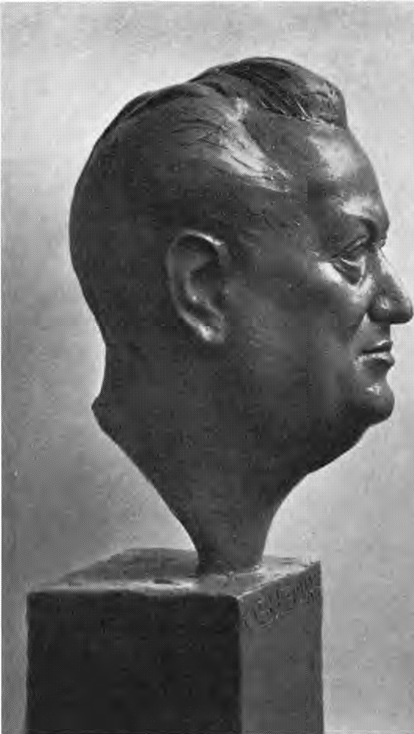
Rudolf von Sebottendorff, founder of the Thule Society, Order for German Art

Dedication
This book is dedicated to the memory of the seven Thule people who were sacrificed in the Luitp-ld Gymnasium - to the memory of the Thule people and the members of the Kampfbund who gave their lives as members of the Freikorps for the sake of the liberation of Munich and to all the collaborators in the difficult period of the preparation of the uprising.
It covers the period from the humble beginnings of the National Socialist movement in the midst of the World War to the appearance of the leader Adolf Hitler. That is why this book is titled; "Before Hitler Came".
Now it can finally be said what could not be said until now, in order not to direct the hatred of the "system" to the pioneers. It need no longer be concealed that those seven Thule people did not die as hostages, no, that they were murdered because they were anti-Semites. They died for the swastika, they fell victim to Iuda, they were murdered because one wanted to destroy the beginnings of the national uprising.
Today, what those seven and all of Thule longed for, what they fought for with hot hearts and hard minds, what they were ready to die for and did die for, has been fulfilled.
We recognize the merit, the greatness and the power of Adolf Hitler. He created what we strived for - we gathered, he led to the goal.

Fifteen and more years ago, when we began to speak of Germanness and socialism, we were ridiculed. It was Hitler who hammered into the German mind the unity of these two concepts.
When we spoke of purity of blood, we were ridiculed. It was Hitler who brought this thought to life in millions of German people.
When we dreamed of the old German law, spoke of the Roman having to be replaced by the German, we met with incomprehension. This thought finally became common property of the German people through Hitler. But our work was not in vain then, it was the sowing, it forged the tools with which Hitler could work and had to work according to his purpose.
This book shows what was before -er Führer came into the movement. It shows the sources that then flowed together into the stream that had to wash away everything un-German.
Thule-people were the ones Hitler came to first and Thule-people were the ones who connected with Hitler first!
The armament of the coming leader consisted, apart from the Thule itself, of the German Workers' Association founded in the Thule Society by the brother Karl Harrer and the German Socialist Party led by Hans Georg Grassinger, whose organ was the Münchener, later the Völkischer Beobachter. From these three sources Hitler created the National Socialist German Workers' Party.
We greet our Führer Adolf Hitler with Sieg-Heil!
To the S. November 1933 The Author

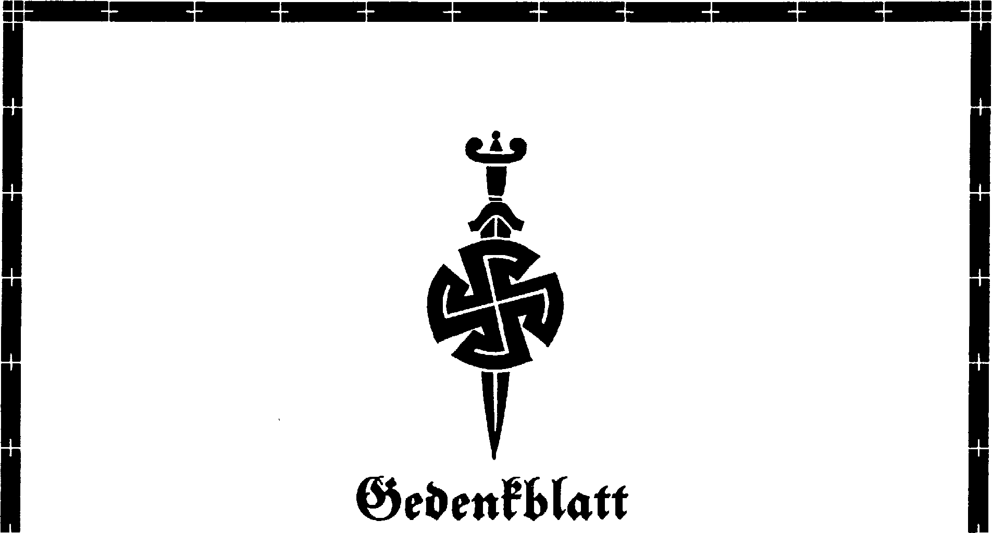
As the first blood witnesses of the awakening Germany, the following Thule people fell under the bullets of Bolshevik murderers on 3V. On April 3, 1919, in the Luitpold Gymnasium in Munich, the following Thule people died under the bullets of Bolshevik murderers:
Heila Countess of Wefiarp, Secretary of the Thule
Gustav Franz Maria Prince of Thurn and Taxis
Franz Karl Freiherr von Teuchert, First Lieutenant
Friedrich Wilhelm Freiherr von Seidlih, painter
Anton Daumenlang, senior railroad secretary
Walter Deike, draftsman for applied arts
Walter Bauhaus, sculptor

Table of contents
Dedication 7
Memorial sheet 9
- General political considerations 15
- Sources of the movement 31
- Teutonic Order and Thule Society 35
- Thule Society and Munich Observer until the Revolution of 1918 43
- Thule Society/ Combat League and Rings of Thule . 61
- political activities and advertising of the Thule until Eisner's death 75
- The Thule in the time of the council rule 85
- The Thule Combat League and the Counter-Revolution of 1919 105
- March of the Freikorps Oberland into Munich . . . 125
- The Sacrifice Time of the Thule - Murder of the Thule People 135
- The Thule Society after the hostage crisis . . . 163
- Foundations from the Thule Society .... 171
- Development of the Völkischer Beobachter 191
- The Thule during the absence of the founder and its renewal 197
Picture section 201
Index of persons and subjects 221

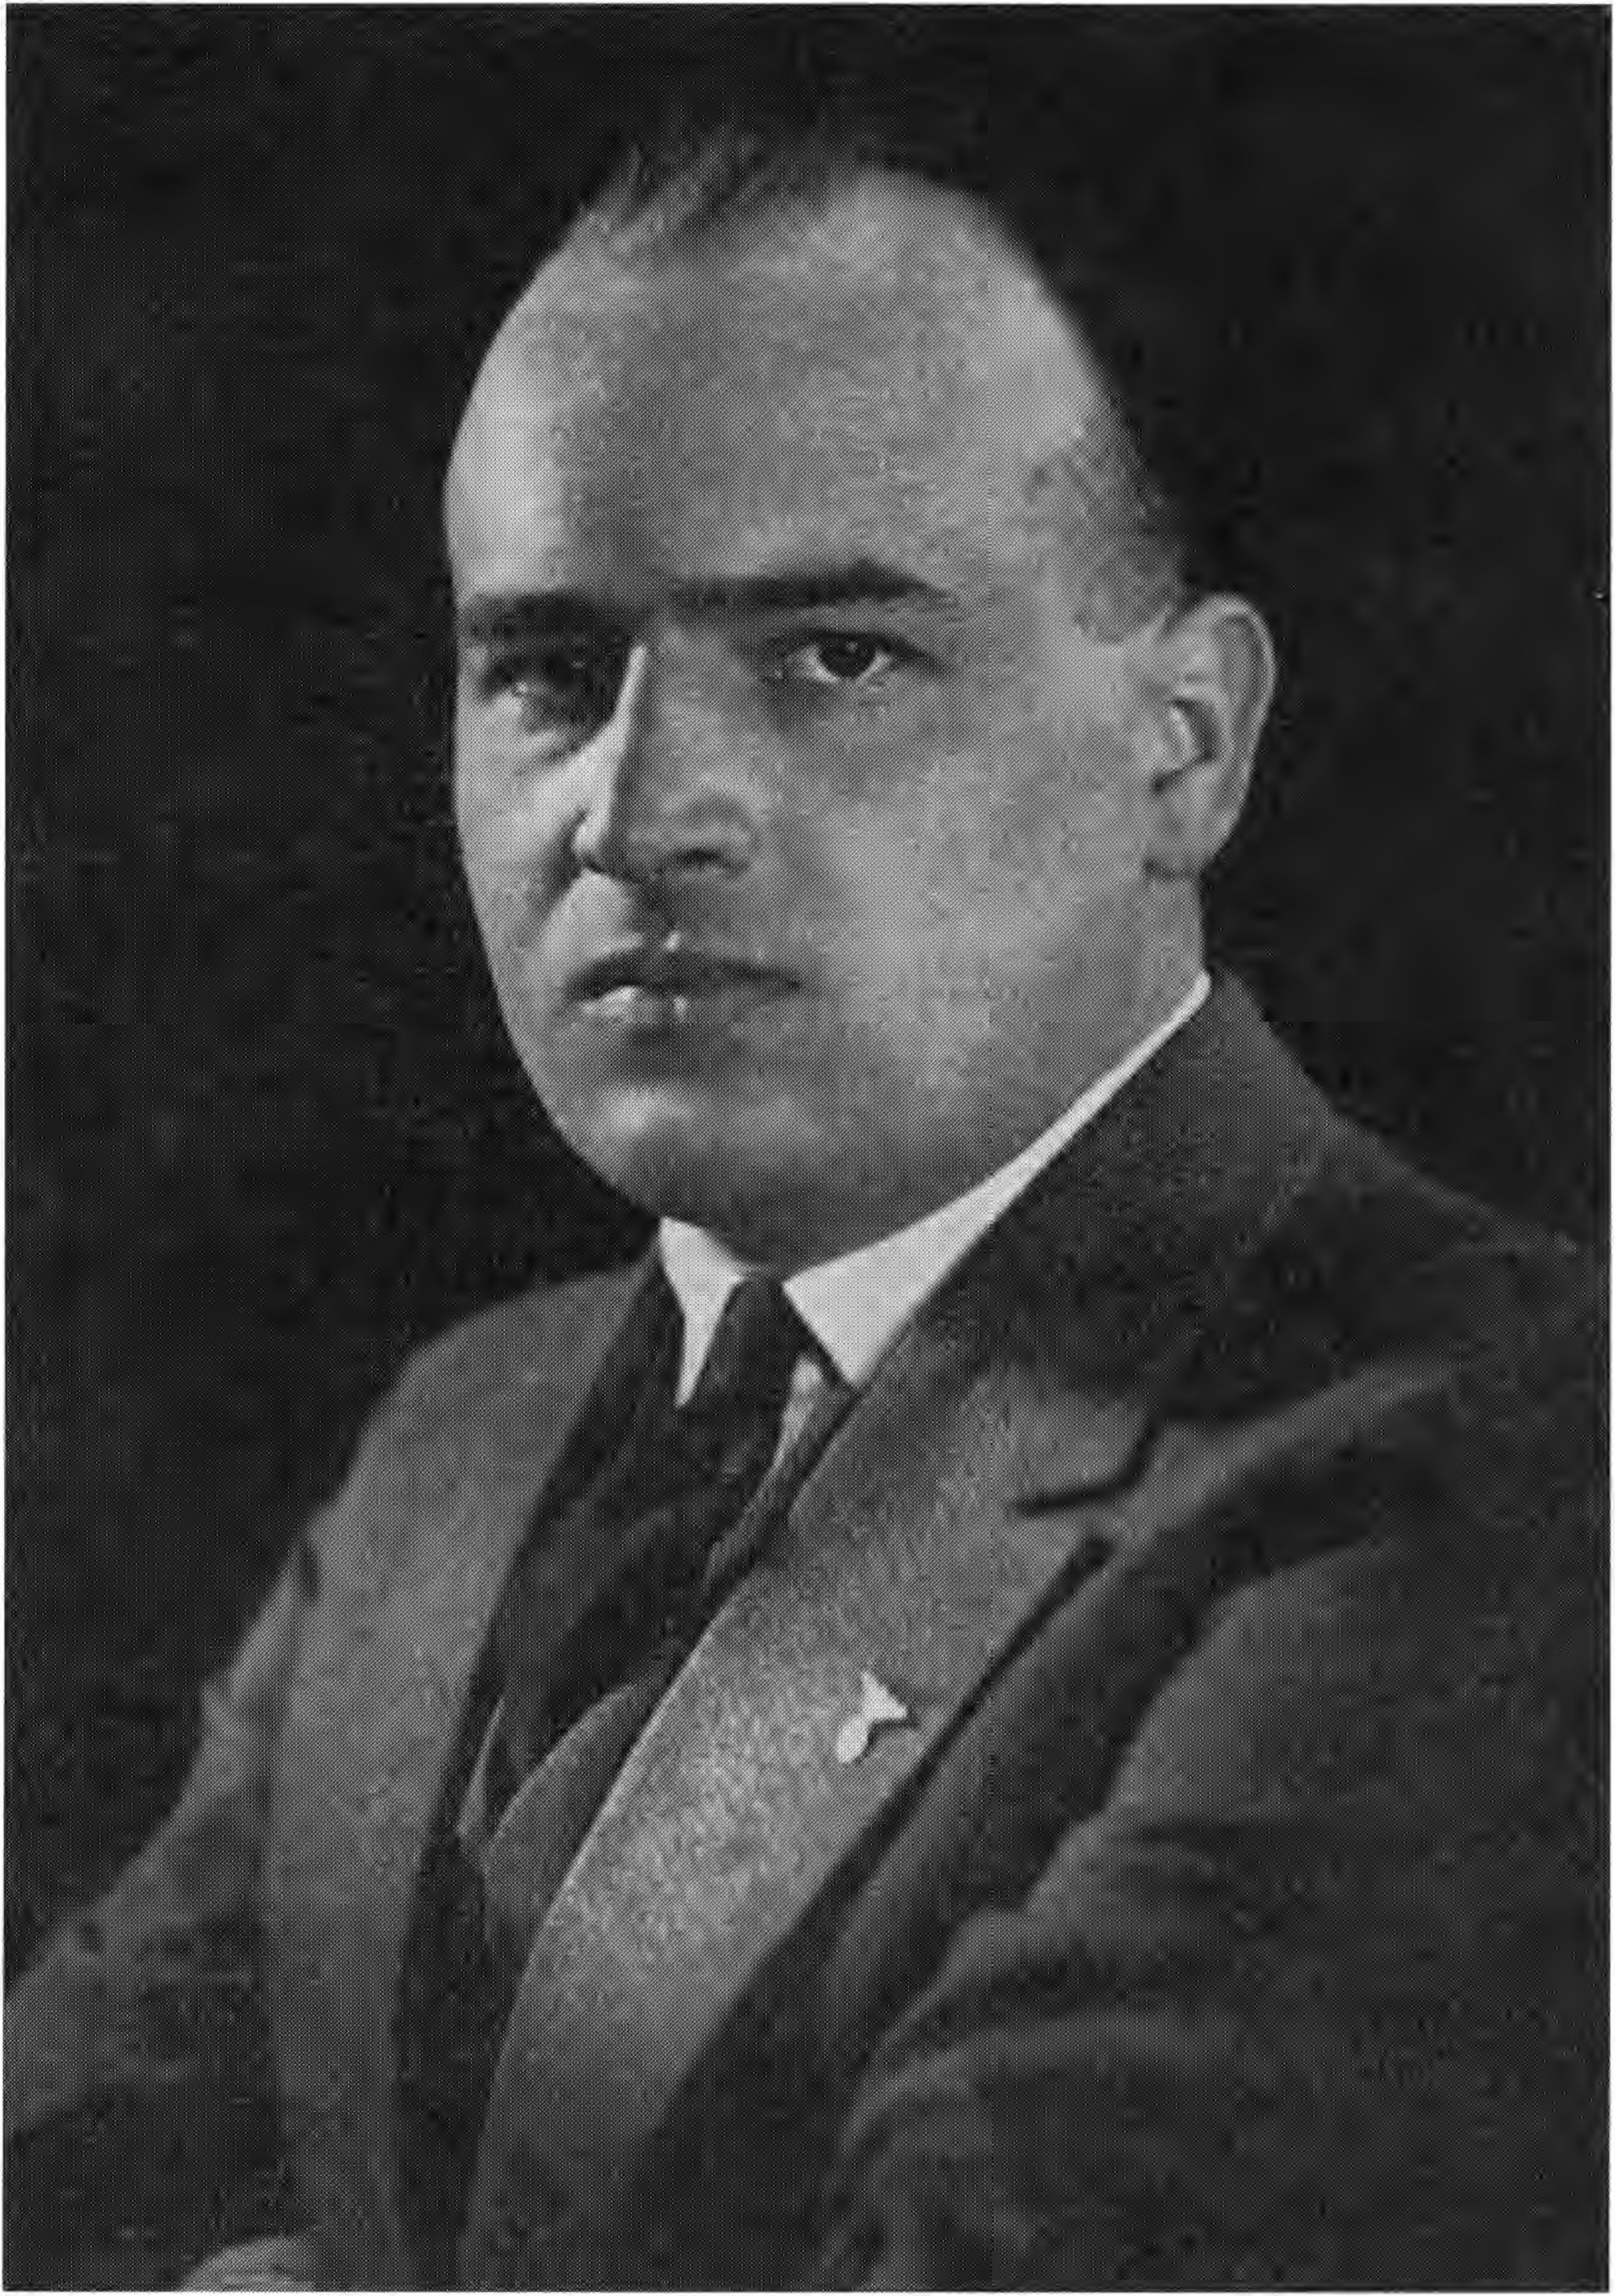
Dr. Hans Frank, Bavarian. Minister of State for Justice and Reichskomrnifsar of Justice

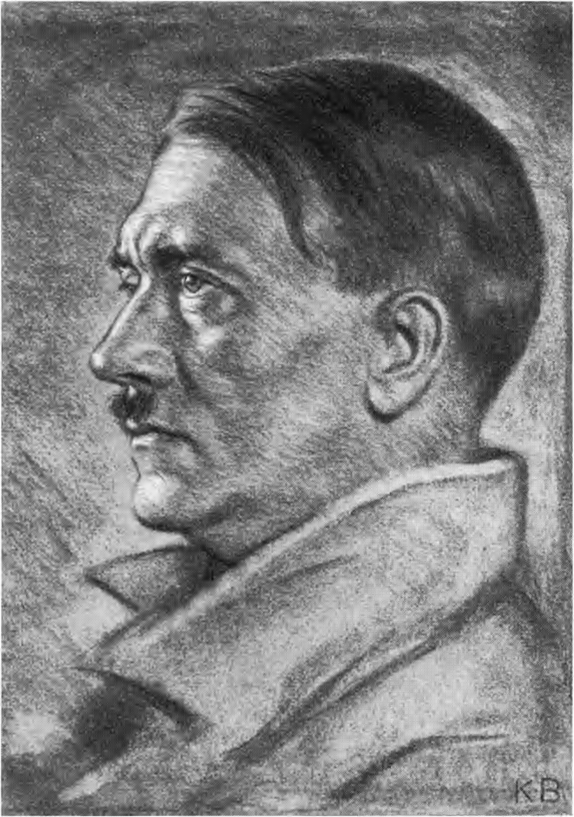
Adolf Hitler, Chancellor of the German People, Leader of the National Socialist Movement

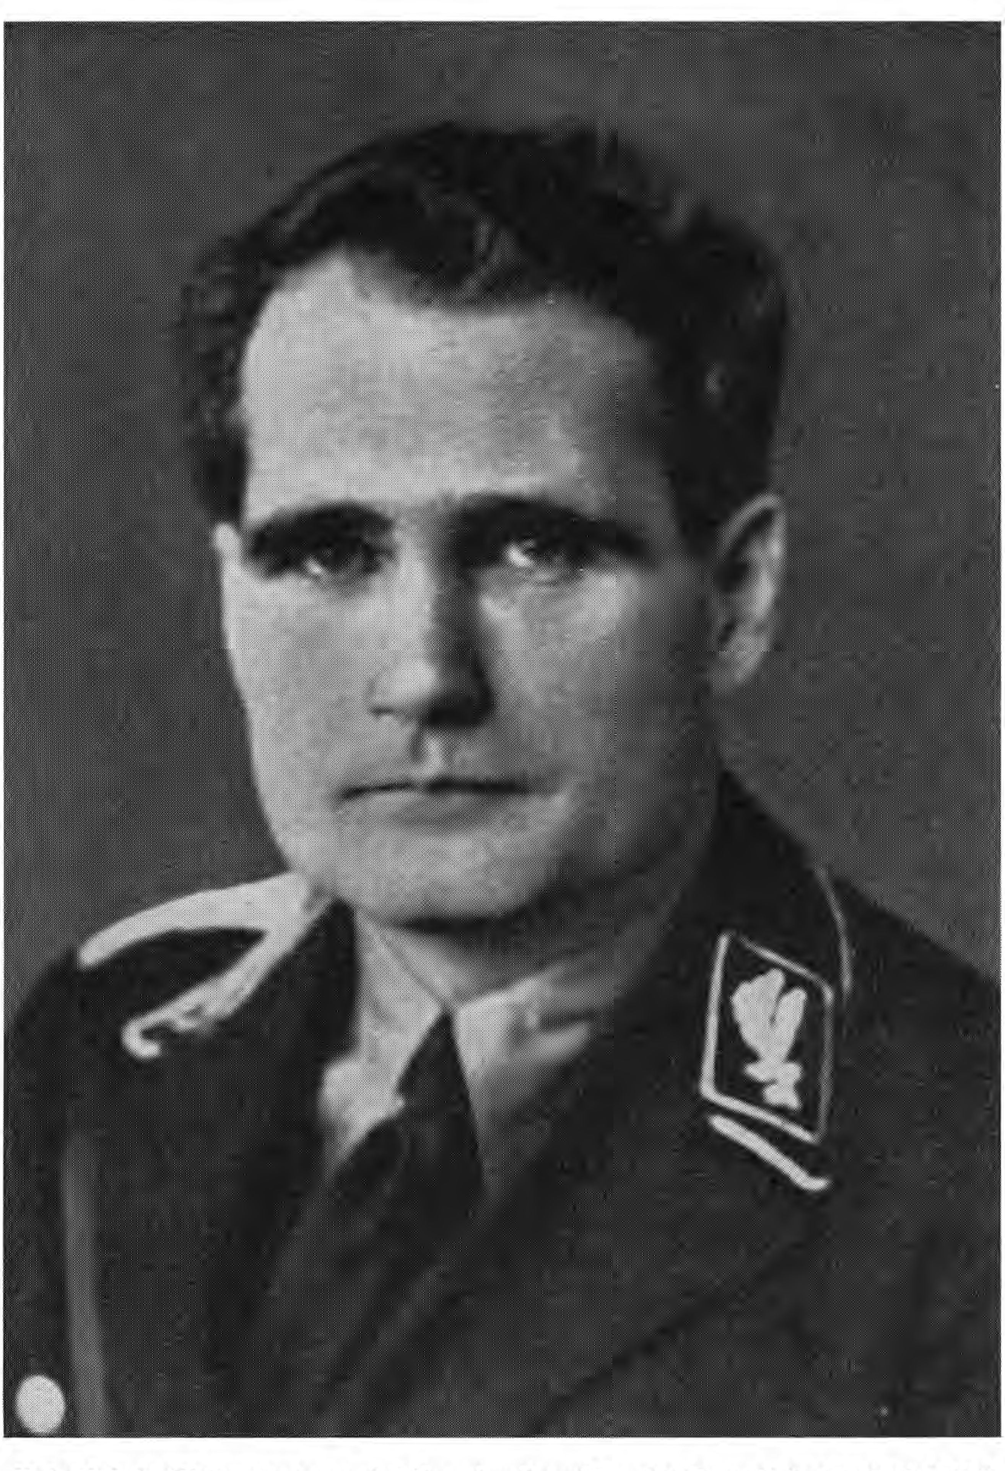
Rudolf Hetz, Deputy of the Führer with executive power in the N.S.D.A.P.

I.

General political considerations
One can lament the World War and its consequences, the collapse of the first German Empire and the existence of the second German Empire," one can have pity for the German people who had to live through these terrible times," one thing is certain", without this time of need Germany would never have become united. For the nationhood, the lost war, the second Reich, the mismanagement of the system was absolutely necessary.
The Ice Age created the Aryan, the white, wise man of the North, who was to bring culture to the world. We find his emblem, the triumphant sun wheel, planted wherever he set foot. He easily forgot his nationality, often also lost his mother tongue, but his culture has left -he wandering Aryans, even if often so distorted by Niederrafsige that it is hardly recognizable.
The time of need of the war, the hard time after, created the German! Again the sun-sign, the swastika rises from the past," the ancient salvation-sign of the Aryans has become the emblem of the new Germany! Now the German will never forget that his fellow-citizen is blood of his blood, that all Germans are brothers and sisters, one big, holy family!
15

The question arises why these horrible times had to come first, why the goal was not reached earlier, since hundreds and baptizing German men worked towards this goal.
The basic evils of the Germans had to be conquered first, and these basic evils are envy, listening to foreign whispers, and self-sufficiency.
Already once a battle was lost because the Alemanni leaders did not know that they belonged on foot at the head of the wedge. "Get off your horses," the followers shouted, and the Romans were victorious. -- This is envy and one must be careful not to arouse it, avoid everything that can arouse it.
Listening to foreign influences is the second inherited evil of the German. Never before and during the war was anything more reviled by foreign general staffs than the all-German movement. Instead of the German saying to himself: what my enemy reviles must be good for me, he joined in the revilings. It was exactly the same at the beginning of the Hitler movement.
The third, however, is idiosyncrasy and, with it, the desire to bash each other's heads in over trifles. "German quarrels," says the Frenchman when he wants to describe such quarrels over trifles.
The German never looks at the common goal, he only looks at the way! He demands that everyone go the way he thinks is the right one, the only one that can bring salvation - he forgets that all ways must lead to the goal, if only this goal is set so high that it encompasses everything.
The German needs a leader who forces him! Who forces him
16

forces to look only at the goal and not at the way. The leader must have the power to be able to force! This power can be attained by two things. It can have been given to the leader by heredity, thus from the outside, it can have been given to him by the people from free choice, thus from the inside. What comes from the outside can also be changed, modeled, broken from the outside. What developed harmoniously from the inside, what became, will remain! The first is something of the essence of materialism, it wants to work from the outside, it must, because the material cannot create itself. It is the transient, from which the imperishable spirit, the eternal, forms the new. Materialism wants to make good people out of circumstances. The last time before the war shows us how wrong this sentence is.
Never before has a nation been better off than the German nation. Under Kaiser Wilhelm II, Germany had something to offer the world. Its flag flew on all seas, its trade flourished, its industry was unparalleled. The worker found ample and well-paid work; if he did not like it in one place, he quit and went elsewhere. Since every worker was conscientious and knew his job, he soon found new rewarding work. It is said that wages were low in those days. This is untrue, they were in accordance with the low food prices and rents of that time, the low taxes and duties. Never again have such large sums been accumulated in the savings banks, the consumer associations, the trade unions, the party coffers as at that time, and if all these have endured to this day, then it can only be attributed to those pre-war times in which the healthy base

17

has been laid. Money was always there and available for any purpose, everyone had money. The possibility of earning money again raised the materialistic view of life and way of thinking. The worship of the material took over. The worker took care of himself, did not care about his comrade. It was enough if he belonged to a union, paid his dues, read the party newspaper and went on strike when the union wanted him to - otherwise he lived as he pleased. In his work he gave his best, that was his duty and obligation, he knew no other way. But he had been taught to see the enemy in the citizen, in the official, in the state itself.
The bourgeois, liberal, at best national-liberal-minded, lived entirely his own life. The worker was not exactly his enemy, on the contrary, but he was unpleasant to him because he felt the hostility and because it disturbed his peace. Everything that disturbed his peace, his comfort, was likely to limit his profit, but he wanted to win money and he could. He was indifferent to the worker, he hated the official.
The salary of the civil servants was small - at that time it was assumed that the small salary would be compensated by the pension entitlement. The civil servant had to settle down. He could not join in when the citizen partied - so the civil service closed itself off and formed a caste for itself.
If this was the situation of the people in general, now under Kaiser Wilhelm II a special one was added. The increasing prosperity of entrepreneurs and businessmen prompted them to make new capital investments. In the bourgeoisie, a gap arose that was rootless in the people's traditions, and through increased pomp and pageantry, this rootlessness
18

wanted to make forgotten. The nobility and the civil servants wanted to join in this pomp and were forced to do so by the court attitude of Emperor Wilhelm II. Thus a process of decay began from above, which was matched by an equal process from below.
Confessional antagonisms did not play a major role in Germany at the turn of the century. Each of the two denominations had enough to do to maintain its existence. To believe in God was considered outdated, backward. Those who did not leave the church were indifferent to it. The worker on one side with scorn and derision, the scientist on the other with the weapons of scholarship attacked the church. It was the time when Büchner's Kraft und Stoff, Haeckel's Welträtsel, the Bible of Materialism were distributed in hundreds of thousands of copies.
This was the time when Judaism conquered the position it had held until recently. The position for which it had fought for centuries with dogged determination.
However, it was a gross tactical mistake of the Jewry to venture so far, because seht one became attentive. What had been taught and asserted only by a few began to penetrate into the people, who had always been anti-Semitic in purely emotional terms.
Mommsen, who certainly cannot be addressed as an anti-Semite, had said that Judaism was a ferment of destruction. The Reteliffe novels of the seventies came to life,* what one of the authors, that knowledgeable Hofrat Schneider of the Kreuzzeitung wrote and why he was ridiculed, gained color, form and shape. One reads the grandiose scene in the Präger Iudenfriedhof, or the story of the Frankfurt banker.
IS

One read with astonishment Dr. Walter Nathenau's confession in the Vienna Neue Freie presse, in which he let the cat out of the bag: "Three hundred men, each of whom knows everyone, guide the destiny of the continent and choose their successors from their surroundings" (December 25, 1909).
The anti-Semitic movement of the last years of the century grew and became more and more powerful. Anti-Semitism has existed at all times, for the name denotes nothing more than the attack or defensive struggle against a foreign wet, a foreign people. Anti-Semitism is as old as the Jewish wet in general. Pressure will always create counter-pressure. If the pressure of Jewry grew, the national resistance of the host people also grew and one day there had to be an explosion. If the host people was still strong enough, the Jews had to go, in the other case the host people perished. Even then Iuda moved on and so the legend of the eternal Jew is founded. The exodus of the Jews from Egypt, which we had to learn in school as an example of God's care, is in truth such an expulsion. Historically, the exodus of the children of Israel: the expulsion of the Hyksos, that Bedouin tribe that had invaded Egypt and ruled for a hundred years. And we read with horror in -the Bible, Exodus, 5, verse 21, how the Iud god tempted his children to steal, so that they would not go out empty. Egypt was thus rid of its Jews for some time, Lyrus, -who wanted to give back -en Iu-en -the promised land for services rendered, did not get rid of them,* they remained at the waters of Babylon and continued their haggling. Only a few thousand men followed Ezra to Jerusalem and built up the city. It is not true what we read in the
2V

Bible had to learn, -that the captive Jews sat by the waters of Babylon and wept- they were doing well there, they had such power that they could slaughter Zvflvv Aryans and still today celebrate this event by a festival. At that time, when Ezra came back to Jerusalem, about 300 B.C., began that monstrous fraud from which Christianity still suffers today: the Bible was edited backwards, the genealogical registers were set up according to a Iahlen mysticism, and Aryan knowledge gained in Babylon was excluded into the Bible. At that time the Hebrew writing originated from runes, which were brought from Mycenae to the "eastern" peoples.
The Jew has always been a businessman, i.e. a merchant - with and on the eyes of Alexander the Great the Jew reached everywhere and we find him around 20 B.C. already on all trading places of the Mediterranean, especially in Rome.
It is due to his influence that a democracy arose there, which was quite to his taste. Once the great Sulla succeeded in saving the Roman people, but the downfall could not be stopped. The wealth that poured into Rome, the many peoples prepared the racial mishmash - it was completed by Christianity, which taught: every baptized person is a brother. At the time of the migration of peoples, when the young Germanic tribes overthrew the rotten Roman Empire, all of southern Europe was Christian.
The struggles of half a century teach us how difficult it was to bring the Germanic tribes to Christianity. The Frankish emperor Charles had to murder baptized Saxons in order to convince the survivors of the philanthropy of Christianity. Only then it was possible to bring Germanic people to Christianity, when
21

-the church adapted Germanic customs and traditions and reinterpreted Germanic festivals as Christian ones.
In the time when Islam arose, we find persecution of the Jews by the Arabs, and in the Koran whole passages deal with the wickedness of the children of Israel.
With the monks, the beginning of the formation of cities in Germany, the Jews also found themselves, soon they sat in the cities of the Rhine and from here they advanced towards the East.
3Throughout the Middle Ages we find persecutions of Jews, but since Germany broke up into many small and large states, such persecution could never assume great proportions,* the Jew ducked until the storm had passed and then began to carry on his system of exploitation just as brazenly. Iuda found shoe especially with the church. Even if the church was able to put a Christian cloak around the anti-Semitism of the Middle Ages, basically it has always been the shoe and the shield of Judah, because Iuda had influence on the church. Baptized Jews could get the highest positions in the church, indeed more than one pope has been a baptized Jew.
This changed when Protestantism became the state church in the north. Luther himself was a strong anti-Semite, but only from a religious point of view. In order to gain influence also on the Protestants, Judaism invented Freemasonry. The old Freemasonry was formerly the keeper of a secret, which was taught in the building lodges of the Middle Ages, which built the Gothic cathedrals. A vast amount of Aryan wisdom can be found in the teachings of the alchemists and Rosicrucians who adhered to the building lodges. With the decline of the Gothic building
22

The building lodges also disappeared and Aryan wisdom remained the secret of a few guardians. When the thirty-year religious war was over, when Protestants and Catholics no longer beat each other to death for the sake of the right knowledge of God, the time had come for Iuda to reestablish the Masonic Order. The first lodges were founded at the end of the 17th century, and in 1717 they united in a Grand Lodge in Aork. The secret of the old Freemasonry was to teach that every man must work on himself to become good, then he shines the good outwardly like a sun. Everyone should become such a sun. Then, so taught the ancient Aryan wisdom, when the individual, the leader, is perfect, then also from him the conditions of the environment will become perfect. The new Freemasonic teaching turned the matter around, saying: First we create good conditions, then people will also become good. Corresponding to the three degrees of the work masonry, apprentice, journeyman and master, three degrees of the freemasonry of the same name were created - the symbolism was a custom borrowed from the Old Testament. The work in the lodges was symbolically the construction of the temple of Iion. Gradually, from the last, the third degree, higher degrees were formed, and by 178V the system of high degree masonry was formed. But always the Jews were the movers and shakers in the lodges. The stupid Germans let themselves be lulled by the chatter of the world brotherhood, of equality and freedom. Lessing's Nathan the Wise is built on Masonic tendencies. Frederick the Great, excluded into a Brunswick lodge, founded the Grand Lodge Royal Aork in Prussia when he became king. In France, the revolution was brought about by the
23

Lodges prepared. After the conclusion of the wars of liberation, Freemasonry had gained a foothold throughout the world. An article in the "Runen" No. 7 of July 21, 1918, in which Sebottendorff deals with an attack on him in the "München-Augsburger Abendzeitung" and in the "Bayerischer Kurier" from the side of the lodges (cf. p. 41), provides information about Freemasonry in contrast to the Aryan world view.
"What separates us (Germanic lodges) from Freemasonry is our worldview. We consider the world the environment as a product of man. Freemasons say that man is the product of circumstances.
We do not know international brotherhood, but only national concerns; we do not know the brotherhood of man, but only the brotherhood of blood.
We want to be free, but not in the freedom of the herdsman, but in the freedom of duty.
We hate the slogan of equality. Struggle is the father of all things, equality is death.
We want to live, live long and live happily. Our view of equality is equality of duty. We want to make each one of us as capable as possible, so that he will not feel duty as a burden, but as a piece of himself. Then we will also pass the battle that will come, must come, the battle between Aryans and Jews. A recognized enemy is no longer an enemy, we want to open the eyes of our people where their enemy stands, who fights us to destruction.
We deny the teachings of Freemasonry that the ratios
24

This is a doctrine that Marxism has excluded and with which it flatters the people, because if it is so, then the man, the leader is free from any responsibility.
Such materialistic outlook leads to decay.
But we also have nothing in common with Freemasonry in our customs. With wise foresight, everything there is based on the Law of Moses. The sword in one hand, the wooden hammer in the other" the Freemason should build the temple of Zion.
We wield the iron sword and the iron hammer and build the German Halgadom.
We no longer want to be an anvil, but a hammer. We do not pray; 'GLb, that the earth be united, that the human race become one brother chain', because we know that this is impossible, sand in the eyes of the stupid who never become all.
We work for our nation and know that we do much more for the progress of mankind than all the lodges of the world. We know from history that the Aryan builds up, but the Jew destroys.
The essence of the Jews is rigid and unchangeable, the Jews cannot get out of their skin, from time immemorial they have sucked the host peoples who trusted them, until the host peoples disappeared from history. Freemasonry is also rigid and unchanging, every Freemason will have to confirm that it cannot change in essence and structure. It will therefore also disappear, because only that remains which develops organically, which lives.
We are not democrats, we absolutely reject democracy. Democracy is Jewish, all revolution of democracy is Jewish. DLe
25

Revolution is the star Iuda," says Gräh as a motto in his history of Judaism.
We are aristocrats, we want to make every German who is aware of his nationality an Edling, then we are equal. This is how we understand our equality.
We call Edling every Teuton who is aware of his duty to be active with the sword and the hammer.
We do not care for humanitarianism, we support the weak where it is weak by nature, but we do not turn one cheek to the one who struck us out of the other, we strike back and see all our pride in striking back strongly, striking so that the opponent remains on the ground. This was also the opinion of our Savior: he came to bring the sword.
We fight to the death the spirit that is spreading in the appeal of the Milanese Lodge, the spirit of mammonism that aims at establishing the Republic everywhere because it can rule there. It is true that this spirit will create an age free of thrones and altars, but it is not true that this age will mean the happiness of the peoples,' no, where the masses rule, there Iuda rules and his tyranny will be terrible.
According to the statutes, any free and blameless man can become a member of a Masonic lodge; in truth, one must also be wealthy, for the dues were high,' the League of Freemasons included businessmen, merchants, scholars, civil servants and military men. This was enough for Iuda to be able to lead the peoples until around the middle of the last century. Around this time two new
26

The first two classes were the small and medium-sized civil servants and employees, and the factory workers.
For the first group, the commoners, a means was quickly found to direct them. A special order was created for the commoners, an order based on Masonic customs, the Odd Fellow Order. The lodges of the same were more focused on support of the members than the masonic lodges. However, in order to have Freemasonry more strongly on the guiding rein, the Order of Bne Briss was created. Bne Briss means Sons of the Faith. Only Jews were allowed to be and become members - but Bne Briss brothers had to be in all lodges of Europe and were promoted as quickly as possible, so that almost all leaders of the individual lodges, the "Masters of the Chair" were at the same time in the Bne Briss and received their information from there. In this way Freemasonry, which was still internationally directed by an Institute in Geneva, was subject only to the orders of the Bne Briss. Now, as for the fourth estate, the estate of the workers, they could not be brought into the lodges, but the international Social Democrat was invented for them It has already been said above that Freemasonry and Social Democracy adhered to the same principles, which were reversals of Aryan tenets.
In the Germanic countries and in Eastern Europe, the situation was much different than in France and England. These two countries already had a strong democracy and a social democracy that was, however, nationally oriented. The industrialization of these two countries was also more advanced. In Germany, until the end of the last century, a patriarchal relationship still prevailed between employees and
27

Employer. This had to be destroyed. The workers were worked on by the organizers of social democracy, the three Jews: Marx, Engels and Lassalle - the employers fell to capitalism. The purpose and aim of the struggle was the incitement of the individual classes against each other. In accordance with the German character, the social-democratic doctrine was raised for the German worker as a world fraternization. "Proletarians of all countries unite," was the slogan. In France, the Social Democracy in the beginning was oriented to the unification of the Latin races, later the main part became national, the left wing communist - the communist uprising of 1871 was an example of this. In England, social democracy did not play any role and where it did, it was always national. Here it did not matter so much - the management of business rested in Jewish hands, so it was only a matter of securing power, not of conquering it, as in Germany. Here, therefore, all forces were deployed. Here, all means were employed, for the danger of the German tribes uniting to form a German state was dangerous. Prussia, in particular, was the enemy of Jewry; it was proclaimed to be reactionary. The "Prussian Junker" became a catchword. A wedge was driven between the nobility and the king - the nobility, after having been ruined, was won over by being seduced by Jews, the king was flattered - at last one met such a mobile character as Kaiser Wilhelm II and was able to win him over by drawing ever tighter circles.
Iuda drove a second wedge between the employee and employer. On the one hand, international capitalism sprang into action and transformed private companies into joint-stock companies.
28

schafien. Now the entrepreneur lost interest in his people, he was no longer the owner of the factory, he no longer needed to treat his people gently, to keep them by generous wages and good treatment, on the contrary, the more was squeezed out of them, the greater the profit. Both faced each other in battle.
At the end of the nineties, around the beginning of our century, the organization of the trade unions was completed,* every worker was forced to join his trade union, whoever entered as an apprentice had to join the Workers' Youth.
Just as the Social Democrats did, so the Catholics acted where they had power. From the cradle to the grave, the clergy guided and controlled the German Catholic and influenced his political thinking.
Bismarck had recognized the danger, he tried to fight both directions,* he had to fail because he did not recognize the common source of the Center and the Social Democrats, the Jews. That he did not recognize this, he had to thank his court Jew Maximilian Harden.
Thus we see that at the beginning of the century all German parties were under Jewish influence and under Jewish leadership. Wilhelm had become so dependent that he had made Ballin, Rathenau, Friedländer-Fuld his advisors, and when he wanted to find out the mood of his people, he went to the small leather goods shop Unter den Linden von Kahenstein in Berlin and asked his faithful Kahi what the people thought. Kahi was the only citizen of Germany who was allowed to present a gift to His Majesty on his birthday.
29

In the last years of the 19th century there were two men who opposed the Jews,* both were defamed and had to resign. Ahlwardt, the Rector of the Germans, as the Iudenpreffe derisively called him, was accused of a dishonorable crime and was thus done away with," Count pükler, who had created a Radauantisemitism, was declared unaccountable. It was more difficult to put aside the court preacher Stöcker, he had a position, behind him stood a community, the Christian Socialists. Stöcker was dropped by the Prussian government and had to leave.
30

II.

Sources of movement
At the turn of the century, a man appeared whom Iuda could not eliminate because he was independent," when he was imprisoned, it was already too late, the prison sentence was no longer defamatory, on the contrary, Theodor Fritsch-Leipzig was respected all the more. Fritsch published a monthly magazine, the "Hammer," and its readers formed a community, the Hammerbund. He was the first to take up the question scientifically, and his books still form the classic library of the anti-Semitic movement.
Fritsch had the good fortune to experience the dawn of the new era, the growth of the movement, only recently he was called away at a ripe old age,' fighting to the last, he died in the Sielen.
The International was opposed by Hugenberg, who founded the All-German Association with Justice Councilor Llaß. Unfortunately, the very well-run monthly did not reach the hands of the workers; it remained stuck in the upper strata of the population. Before, during and after the World War, the All-German was the most hated and most heavily slandered section of the people. All-German was synonymous with Junker.
The present century saw at the beginning three Austrians in the front against Judaism. The first was Guido von List. List's books about Ariogermanic wisdom, even if they are not very popular in their my- 31

stik go a bit too far, are still a valuable source today and should not be forgotten. Philipp Stauff, known by his book about the rune houses, summarized the followers of Lifts to the Guido von Listbunde. Guido von List died shortly after the war in Berlin.
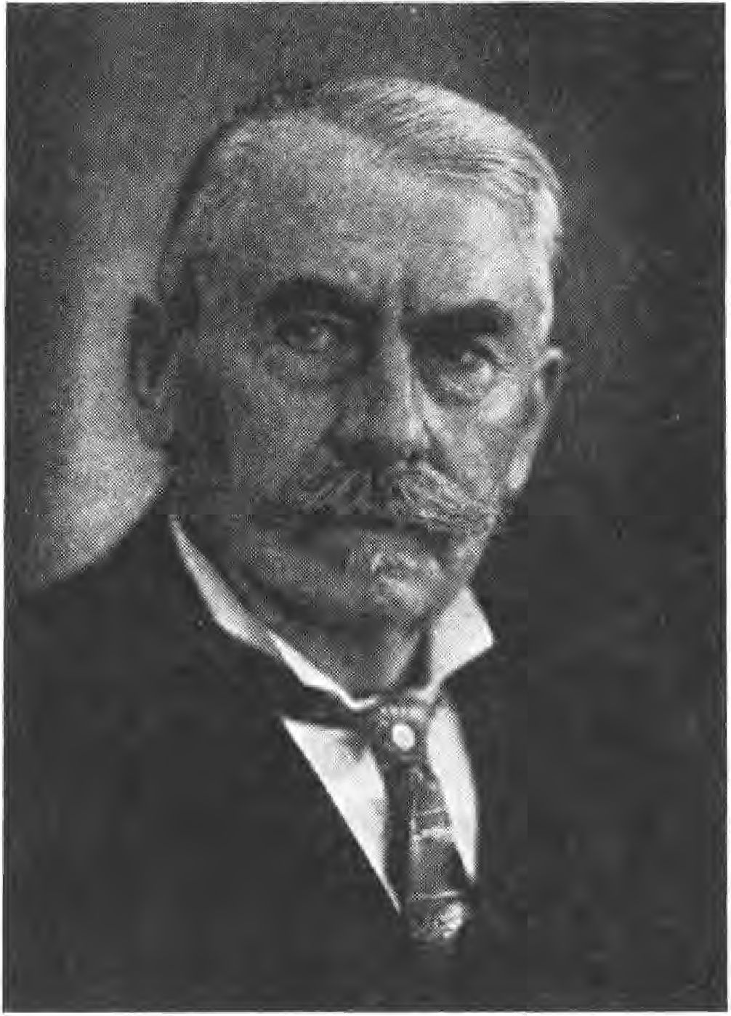
Old master Theodor Fritsch s
The second was Lanz von Liebenfels, who still lives in the Rhineland. He published a series of booklets which he called Ostara, the Books of the Blondes. Liebenfels had tried to produce the original text of the Rue Testament from the writings of the Church Fathers; his books were confiscated and destroyed.
The third was Baron Wittgenberg, the author of the Semigotha, the Semialliancen and the Semikürschner, which Philipp Stauff her-
32

issued. In these three standard works he proved the Jewish influence in the German nobility, in art and science. Baron Wittgenberg preferred suicide in 1S2V to the disgrace of knowing his wife and daughter in the hands of a Jewish banker, therefore it will be impossible today to republish his books, which have been bought up by Iuda except for a small number.
It is no coincidence that it was Austrians who stepped into the breach at that time; they had experienced the Judaization of Austria firsthand, they saw the coming disaster sooner than the Reich Germans, who were still doing too well at that time.
Among the scientists who fought for the Enlightenment in the German sense, Wilser, Much, penka should be mentioned. They provided the weapons that served to destroy the legends that were spread about the origin of all culture from the East. They proved that all culture came from the North and came only from the Aryan. From the Hammerbund came the Schuh- und Truhbund, which opposed the Jews in particular in the field of business. In addition to these groups and associations, there were a large number of smaller ones, such as an anti-Semitic lodge in Magdeburg, an association in Berlin to combat the arrogance of Jewry, and others.
Out of all these, the Teutonic Order crystallized in 1912, whose first act was to bring the völkisch associations together for a Pentecostal meeting in Thale (Harz) in May 1914. The activists in the Teutonic Order formed the first anti-Semitic lodge, a secret society that was consciously intended to oppose the Jewish Ge- heimbund as a secret society. The guidelines that were worked out were the following:

33

- Only a German who could prove his blood purity up to the third member could become a member of the Teutonic Order. This was to prevent descendants of Jews (Iudstizens and Züdlings) from entering the Order. Furthermore, since women were also excluded from the Order's friendship degrees, for whom the same condition applied, the acquaintances of pure-blooded Germans were to be encouraged for the purpose of marriage.
- Special importance was to be attached to the propaganda of racial science - the experiences made in the animal and plant kingdoms were to be applied to man, and it was to be shown how the root cause of all disease, of all misery, lay in racial corruption.
- The principles of the All-Germans should be extended to the whole Germanic race - a union of all peoples of Germanic blood should be initiated.
- The fight against everything un-German, the fight against the international, the Jewishness in German, should be pushed forward with all energy.
The leadership of the order was located in Berlin. Provinces of the Order were created and it very quickly managed to gain a foothold in all major cities. When the war broke out, the Order had several thousand members and over a hundred lodges. The executive committee was composed of the leaders of the individual groups. Externally, the Order was represented only by Philipp Stauff (Großlichterfelde) and pohl (Magdeburg).
34

Teutonic Order and Thule Society
When war broke out, 95 out of a hundred members rushed to arms, the lodges ceased to function,* the association was disunited, the members scattered to the winds. The purpose of the Order, to create unity, also seemed to be achieved, never was Germany more united than in those days of the outbreak of war in 1914. While the Germans were dreaming of a beautiful future and fighting, Iuda was working. The first blow was that it took advantage of the enthusiasm and made the government proclaim the so-called truce. This stopped any work, any announcement and any propaganda of the All-Germans and thus opened the door for the propaganda of Judah.
Slowly the men who could not rush to arms because they were too old or for some other reason unfit for war realized that they had been deceived. The Social Democracy, which in the first days, led by the German leaders, had lined up, had again come into Jewish dependence,* Rathenau had become economic dictator, Jews sat in all war societies, ever new streams of Eastern Jews came across the Polish border into Germany and settled.
The sailors' mutiny in 1917, which was instigated by the trade unions, acted as a beacon. It showed the
35

enemies where they had to see the propaganda and the hint was promptly followed. Then came the stab in the back, that Mumtion workers' strike of January 1918 (see picture section, p. 210), now the enemy alliance could breathe a sigh of relief, now it knew that, as often before in history, once again the German stabbed the German in the back. Instead of immediately putting the leaders up against the wall, they were sentenced to a few months in prison, then let go. Treason was exempt from punishment, was still rewarded. On 2V. October 1918, the "Vorwärts" wrote: "Germany shall, it is our firm will, strike down her war flag forever without having brought it home victorious one last time." What more is needed in general to prove the monstrous popular deception which the black-red-gold International had devised and consistently carried out. The whole of Germany has suffered from it in the last 14 years. At that time, however, one was not allowed to speak of it, one was not allowed to say anything, because then it was said that one was speaking against the people. Nevertheless, towards the end of the war, from 1917 on, work was vigorously carried out against the International.
To show how Jewish work slowly reached the superior goal, here is an essay from the "Beobachter" that will still arouse interest today:
Jewish Economy in Belgium.
The history of the political department of the German Generalgouvernement Belgium is a classic proof of what happens as soon as only one Jew gets into an administration.
The rulers of Belgium (as far as they were not directly subordinated to the High Command) were the military governors-general: Freiherr von der Golh, then von Bissing and finally von Falkenhausen. Subordinate to them as departments were:
36

- The Civil Administration (Exellenz von Sandt). Later, this department was separated into the Group Administration for Flanders in Brussels and that for Wallonia in Namur.
- The political department with the press center, the Vlamen- section, the political service.
- The new ministries that administered Belgium.
Baron von der Golh was already driving the cart. Not enough that he admitted a dozen French newspapers, he appointed as the head of the political department the Baron von der Lanken-Wackenitz, who was married to the mistress of Günthershof, the Jewess Renate Friedenthal, daughter of Karl Rudolf Friedenthal and Lea Rosenberg in Darmstadt. At the same time with this Baron appeared the brother-in-law Friedenthal, who let himself be called only Baron von Falkenhausen. For a von Falkenhausen married the Jewess Elsbeth Friedenthal in 1887 and called himself together with his children "von Falkenhausen-Fne- denthal". Friedenthal had become a lieutenant, but during the whole war he did not stay at the front for a moment, he shared table and apartment with his sister's husband, Baron von der Lanken, who was permanently influenced by him.
Lanken and Friedenthal appointed Dr. jur. Simon, a Jew and co-owner of the Frankfurter Zeitung, as head of the press office. Legationsrat Kempf remained official chairman, but business was conducted by Simon. When the Deutsche Tageszeitung criticized this relationship at the time, it was said that Simon would leave. However, he was only away for eight days, then he returned and joined von der Lankens diplomatic department. Simon had thereby only become more influential. Furthermore, through Friedenthal and Lanken, the Jew Ulrich Rauscher, the Socialist collaborator of March, came to the diplomatic department as a confidant. He immediately wrote a brochure about Belgium.
The censorship of Belgian newspapers was entrusted to the Jew Dr. Eb- stein, who knew how to suppress any mention of scandalous events. In addition to Ebstein, the Jew Schotthöfer was
37

the former correspondent of the Figaro in Paris. His wife, of course also Jewish and living in Brussels, was a French spy. She was thus sitting at the source.
Next to this couple, another Jewish woman, Mrs. Ebstadt, whose husband had been active at the front, worked as an official at the press headquarters, as indeed almost all the sub-officials were taken from non-German circles.
Mrs. Ebstadt got involved with the Aryan Freiherr von S... got into other circumstances. She therefore had to leave Brussels. Baron S.. was sent to the front, where he soon fell. (Sam. 2. Ch. 11,15) Judah avenges every attack on its women, while it itself can commit crimes against German women and girls with impunity.
The Jew Dr. Oswaldt was employed for the Belgian propaganda. He was first in Antwerp, where he got into a quarrel with his military superior, and was soon sent to Brüffel. The "quarrelsome" Aryan officer came to the front and soon siel. (2 Sam 11:15).
Dr. Oswaldt's activity consisted in putting obstacles in the way of the pro-German Vlamen, his right hand was a Jewish stenotypist Bloch.
When the Wolff office, the official news service, established a branch in Brussels, this post was given to the Jew Julius Wertheimer of the Vossische Zeitung. Head of the Wolff office in Antwerp and at the same time head of the political department there was the Jew Schiff, appointed by Lanken.
The Jew Dr. Schauer from Frankfurt was imported by Baron Lanken as the general legal advisor. Schauer had formerly practiced law in Paris. Mrs. Schauer, again a French Jew, was in the Vlamen Department, although she did not understand a word of German. One can imagine how useful she was.
The commission traveler Nosenbaum, who had previously traveled for fashionable newspapers, was appointed as Kempf's confidant. Rosenbaum received the paper "Bruxellois", which had been founded by the German authorities, for free.
38

had owned, became a multiple millionaire in four years from German government money.
Lanken further appointed the Jew Hauenstein, who in the spring of 1914 had already acted in French service as a divider between Bavaria and Prussia; he was given the newspaper "Belfried".
Every German office in Belgium was swarming with Jews, all the typists, all the sub-officials were Jews.
Among the senior officials, the following should be mentioned: Dr. Markus Hübner, who sat next to Dr. Oswaldt in the Vlamen Department. The Brussels Jew Driessen, the Jewish Rittmeister Behrens.
The whole stage in the office of the political department, of course, received the Iron Cross, which is also worn a lot by Hebrews elsewhere. By Hebrews who have never been in the trenches.
Iuden aides were Baron von Strempel, who was a senior government councillor and then became a captain. Today he is Major and Adjutant to the Governor General, Herr von Falkenhausen.
The head of the passport office is Ritter von Marx, who can be recognized from afar as a real Jew. Marx has a palace in Bad Homburg vor der Höhe and has often entertained the emperor for breakfast. He is an important link in the Jewish chain that surrounds the emperor and that will be his undoing.
Attorney Stocky is a baptized Jew and has proven himself as a Jew in the Belgian administration.
private secretary of Mr. von Sandt and his successor Schaible, these two are Aryans, was and is the Jew Kempner, the son of the well-known Jewish lawyer and Freisinnführer Kempner in Berlin.
Due to the Jewish camarilla in all circles, the measures of the excellent Herr von Bissing were paralyzed and things were delayed much to the detriment of Germany. It was simply impossible for Bissing to follow through. Bissing died in time, much to the delight of the Jews, and he was succeeded by Herr von Falkenhausen, who brought with him his Jewish personal physician, Fürstenberg. It was impossible to come forward without Fürstenberg at Falkenhausen.
39

This is the same tactic that Ballin, Rachenau, Friedländer-Fuld, Koppel, Jules Simon, Goldschmidt follow, they form a ring around the person of the emperor and he hears only what the gentlemen want.
It was in the East as it has been described here with an example in the West. One only remembers Kühlmann's "peace of shame," he is married to Friedländer-Fuld. As Germany's representative, Kühlmann made peace with Romania, placing German interests so far behind Jewish interests that he turned Bulgaria away from us and turned the Bulgarian people against Germany, who were still quite friendly to Germany during the war.
In the north also Jews sat in outstanding places and from Turkey is to be completely silent, here Juda sat in its element, because the young Turks, the Dschavid, Talaat etc. were likewise Jews-Dönme (turned one calls them the Turk).
All these facts led to the fact that the men, who had to remain behind in the homeland, united and revived the Teutonic Order. In the Christmas meeting of 1917 the new rooms could be inaugurated.
In this Christmas meeting it was decided to push the propaganda forward. Sebottendorff declared the 'General Order News' (see picture part p.2V5) for the consecrated, the 'Runes' (see picture part p.2V1) for the Freundschastsgrad to finance and to lead. The order province Bavaria fell to him. This choice became important because it made Bavaria the cradle of the social-national movement. The two southern German tribes, the Bajuvars and the Swabians, found more mobile, easier to connect, gesel-
4V

lier than the northern Germans. They are not so critical, not so solitary. The lords who started the work in Central and Northern Germany had a harder time - while in the South a large following was soon formed, in the North the order grew slowly.
Sebottendorff had received the address of some gentlemen who had responded to advertisements, these he visited first. It was very favorable for him that he met a brother of the Teutonic Order in Munich, Walter Nauhaus, who was a student of Professor Wackerle. The two came to the decision to march separately and strike unitedly. Nauhaus was to gather the youth and Sebottendorff wanted to form the backbone of the movement from the older gentlemen. The first members of the circle were three gentlemen: Dr. Georg Gaubah, who had made himself available to the Red Cross and was syndic of the Vogelschuhverein of Bavaria- Schulrat Rohmeder, the chairman of the Deutscher Schulverein and Johannes Hering, who had made a name for himself in the Hammerbund, he was the propagator of the teachings of Much, penkas and Wilser.
Just as a stone thrown into the water draws ever wider circles, so others soon joined this first circle - one could think of renting an apartment in Aweigstraße and holding meetings there. Sebottendorff himself moved into a house in Bad Aibling with his wife and servants.
In order to show the kind of propaganda, it is to be informed here that Sebottendorff issued advertisements in different sheets, in which the participation in a völkisch lodge was invited. These advertisements had also been the cause of the clash mentioned on page 24. A Freemason explained in the München-Augsburger Abendzeitung that this was only an angle lodge.
41

because Masonic lodges were not in the habit of public advertising.
The applicant was sent the advertising leaflet 1 reproduced in the picture section p.202, in which brief reference was made to the race question. It was pointed out that for the propagation of these thoughts an order was necessary, a secret society, and that whoever wanted to join this secret society first had to make a blood confession by means of an enclosed sheet. This read;
"Undersigned affirms to the best of his knowledge and belief that no Jewish or colored blood flows in his and his wife's veins and that there are no members of the colored races among their ancestors."
If the candidate had filled out this blood confession, he received advertising sheet 2 with the swastika and the Wodan picture (see picture part p.203). He had to fill out a questionnaire and send in his picture. This picture was examined for racial purity, inquiries were made, and if the conditions were met, the candidate was invited to appear at the meeting. After a certain period of examination, he was exempted to the degree of friendship. The consecration of this degree consisted in a solemn commitment in which the candidate had to swear absolute fidelity to the Master. It symbolized the return of the lost Aryan to the German Halgadom. Women and girls could also be excluded from this first degree.
42

Thule Society and Munich Observer until the
Revolution in 1918
It soon became clear to Sebottendorff that he could not have great success in the small apartment in Zweigstraße. The opportunity arose to rent the rooms of the Sports Club in the Four Seasons, which offered space for 3VV people. Here meetings could be held and further circles could be won over to the ideas of the Teutonic Order. Holding public meetings was impossible at that time. They would have been forbidden because of the peace of the castle, or, if they had been allowed, they would have been shouted down without a doubt. It was the time when the young people who would later make the revolution were drafted, when the incitement of the individual classes against each other rose to the highest level," the time when Erzberger, Scheidemann sowed what was to mature on November S, 1918, when no military dared to take a vigorous stand against the Social Democracy and the Center. If one wanted to achieve something, the thoughts first had to take root in a larger circle, the arable land first had to be cultivated. Since the spoken word could not have an effect, it had to be achieved through the printed word. A new newspaper could not be founded, since the paper shortage was already very great and the government did not allow new newspapers. Then the opportunity presented itself to use an existing newspaper, the since
43

2. January 1887 to acquire the "Münchener Beobachter" (see picture section p. 2Ü6). Franz Eher, the publisher of the Beobachter, a client of the lawyer Dr. Gaubah, had died. Sebottendorff acquired the publishing rights from Franz Eher's widow for 500V marks. The paper had no subscribers, it was distributed in the street trade. Ms. Käthe BLerbaumer, a sister of the Germanic Order, was registered as the owner of the "Münchener Beobachter, Verlag Franz Eher Nachf., München". Ms. Bierbaumer came from a peasant family in Burgenland, one of those families who went out to rebuild the East devastated by the Turkish wars. Sebottendorff was the editor of the Beobachter. The Beobachter was presented as a sports journal (f. picture section p.207), so that it would get into the hands of the youth. There was another reason why this presentation seemed particularly favorable. The Jew has an interest in sports only if he brings in something. So the Jews would not buy the Beobachter and would not read it, because they had no interest in sports per se. A sports paper could therefore carry on its propaganda more unnoticed.
How correct this calculation was was later shown by the Jewish rage precisely against the editor of a "sports paper," as Sebottendorff was always called. Again and again this came to the fore, a sign of how much Iuda was annoyed that it had considered this sports paper so unimportant.
Some of Sebottendorff's articles are reproduced from the first numbers of the Münchener Beobachter:
Keep your blood pure.
In the middle of the last century, the English minister Disraeli-Beaconsfield wrote in his novel "Endymion":
44

"The question of race is the key to world history, and it is only for this reason that history is often so confused, because it was written by people who did not know the question of race, and just as little the moments belonging to it/"
Beaconsfield is right with his remark, he had to know it, because he was a Jew. One only looks at the meaning which the world war has found after its nature and after its origin and one must agree with him. Accompanying phenomena, pretexts are mostly considered as the basic causes of this world tragedy. The key has not yet been found by most of the evaluators. Here, too, it lies in the question of race.
Actually, in the struggle there are two representatives of opposite world views, opposite races. On the one hand the Germanic, creative race and on the other hand the parasitic, big-capitalist race.
One will object that the English and Americans are also of Germanic origin. That is true, but it does not matter, it is decisive who rules these peoples, who leads them, who guides them. The secret ruler of our opponents is undoubtedly the international big capital, which strives for world domination. The representatives of this big capital are the outspoken enemies of our nationhood. They are the Jews.
They fight against our nationality and have fought against it through the centuries under various masks and forms. Unfortunately, they often find their greatest allies among our own people. The Teuton is a fist nature. Mere possession cannot satisfy him. East as a "pure fool"" he reaches for illusory values and illusory images (ideals), which have been sworn up to him by his mortal enemies as higher civilization, as higher cultural values. But these illusions are nothing but poison and anesthetics, in order to lead the Germanic all the more surely into slavery, to put the yoke on him.
Our ancestors often had a natural feeling towards their enemies, they knew the racial issue and the value of blood-.
45

brotherhood, the value of blood purity. They knew that only the tribesman was to be trusted, that only he could be faithful. The half-breed, the foreign-breed was wrong, was Welsh.
Unfortunately, the healthy instinct has been clouded or even uprooted in many areas. Walvater was dethroned and a new faith took the place of our paternal faith and that in forms which do not correspond to our Germanic and religious endowment. One can fully acknowledge the value of Christianity, but this does not exclude that one can be very divided about the way it was brought to the Germanic people. Especially, however, that direction must be rejected and fought today which, under the mask of religion, works silently and steadfastly toward the weakening of our nationhood.
But the defeat of our religion was not the end of it. Our wisdom was buried, our law was destroyed, broken by Roman law. Yes, they ridiculed our language and tried to destroy it, they tried to reduce it to the language of the common people.
That the decline of our people up to the complete political destruction went hand in hand with it is obvious. But the people always proved to be strong enough to destroy the plans of the enemies. Men and leaders always arose for it, who led it out of its decline, and it was the will of God that the other part should also recover from this upward movement.
The German people would have to be completely blinded if the enemies were to reach their goal now.
An alien ideal of humanity provided the means to put parzival, the pure fool, in shackles. Favored by Christianity, the doctrine of human equality was spread. Gypsies, Hottentots, Botokuden, Teutons were completely equal.
Only pity that the great teacher, the nature teaches it differently, that she teaches: this equality is absurdity! It is the greatest lie that was ever foisted on mankind. To the destruction of us Germans. There are higher and lower races! If one evaluates the
46

If the people of the Rafsenmischmasch, the Chandals are equal to the Aryans, the noble people, then one commits a crime against mankind. It needs leaders, even leading peoples, for its higher development.
Among the races of the earth, the Germanic race is called to this position of leadership by virtue of its disposition. As far as the eye looks back into the past, the bearers of Germanic blood have always been the bearers, the creators of a culture.
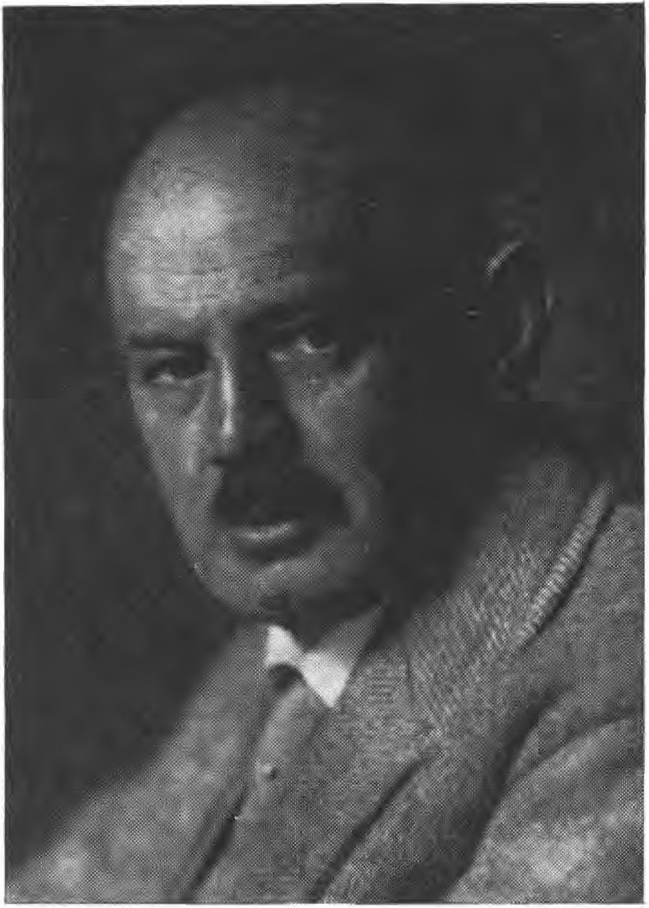
German fretness poet Dietrich Tckart f
However, one has tried to persuade us, and the world still believes it today, that the original homeland of the peoples is the East Asian highlands or Mesopotamia. The light came from the East.
Recent research has shown that this assumption is wrong, pre-Europe, pre-Germany is the ancestral seat of the bearers of culture, from here, from primeval times until now, streams of German blood have poured out fertilizing, waves upon waves of people have gone out, bringing culture to all the world.
47

The so highly praised Greek culture is an offshoot of German spirit. The Hittites, the Sumerians and all the other peoples were of Aryan origin.
When Frenchmen and Spaniards and Italians boast of their culture, they should not forget that they owe this culture to the Germanic blood. The more the blood purity diminished, the thinner the Aryan blood became, the more the cultural barrenness becomes apparent. Greece and Rome did not perish because of moral decay, not because religion diminished - these are only consequences. Rome and Greece perished because of the mixture of races, because of the boundless miscegenation of the races.
The same fate threatens us, threatens the Germanic race on the one hand from the gospel of the equality of all men, on the other hand from the rule of international big capitalism, which has racial manification as its prerequisite.
The weapon of the lower race, the chandala, is money. With this weapon it seeks to destroy the noble race. The danger is urgent, because on the one hand the instinct is weakened by the gospel of the equality of the races, on the other hand the world traffic is so easy that after the war such a mixture of races is very favored.
That our government did not completely misjudge the danger before the war is shown by a law it introduced. It was supposed to prohibit the connection between Germans and colored people. Who voted against the law? Deutscher, I'll show you your enemies: the Center, Social Democrats, Christian Socialists and Liberals voted against it.
Racial purity means public health. When all members of the people are imbued with the value of blood purity, then the social question is solved, then it has lost its sharpness, then everyone sees the brother, the sister in the fellow people, then one supports the other, then the old Germanic religion, the knowledge and wisdom of the Thou is awakened again.
48

This was a language that had not been heard before in Munich. The first edition of the Beobachter, which came out in 5VV copies, was accommodated and later the circulation increased from number to number. Beside the larger ones the small questions were not forgotten - sharp criticism was made. Also of it some rehearsals with the explanations: There was to be a Reichstag by-election and the independents had nominated Eisner, a Jew. The Observer carried the following note:
A Russian Jew as a candidate for the Reichstag.
We have been informed that the Independent Social Democratic Party of Munich is putting forward the writer Kurt Eisner as a candidate for the by-election in the Reichstag constituency Munich H.
Eisner will not be elected, but that a party should even dare to nominate a Russian Jew who has been convicted of treason should bring a blush of shame to the face of the workers!
Four months later, Eisner was Bavarian prime minister; he had made the revolution.
In the summer of 1918, all kinds of rumors were circulating among the people that milk was to be moved from Bavaria to Prussia, the king was called Millibauer and it was claimed that he was the main participant (see picture section p.213, illustration below). On the other hand, it was claimed in northern Germany that flour and vegetables were migrating from there to Bavaria. Whoever witnessed the hardship will understand what role this small, self-evident exchange of products played in the incitement of the individual tribes against each other.
Only the Beobachter, No. 18 of October 5, 1918, dared to bring the truth:

49

Leutstetten and the Prussia leaflet.
We all have almost no idea what means our enemies use to sow discord, to increase discontent. It has already come to such a point that one may no longer utter the word victory. Millions of leaflets are falling every day in and behind our front - a party party in Germany, which knew what it wanted, has, unhindered by any government, sown the seeds on which the leaflet rain has fallen fertilizingly / the harvest we have now.
The leaflet, which was treacherously printed in full by the Berliner Tageblatt, tried to spread discord between North and South. We heard nothing that anything happened to the B. T. - one simply accepted the slap in the face.
With us one tries it differently/ one always catches us Bavarians by the stomach question. People whisper that the king sends milk to Berlin, they say that wagons full of calves go to northern Germany at night. It is of no use to reply that the milk from Leutstetten is hardly sold to baby homes at the production price/ people simply do not believe that our king sells the liter at 28 pfennigs when he could receive 80 pfennigs!
However, it should be expressly stated here once again that milk has never been sent from Leutstetten to outside Bavaria, that all milk from there goes to Munich, Nuremberg, Würzburg and Fürth, where it is used in the hospitals and baby nurseries>.
What's being kept quiet.
A note goes through the entire press: "In Nauheim, as a result of a secret butchery that has been uncovered, numerous respected citizens have been arrested, among them a religious teacher and a well-known hotel owner. The latter offered to give a guarantee of 50,000 marks for his immediate release. The slaughterhouse was located in a shed near the railroad, and the addresses of the recipients were attached to numerous ber- sand boxes, so that one could
50

is precisely informed about the meat buyers. One of the first Nauheim doctors is also there/"
If no names are mentioned, the matter makes us suspicious, the observer could now ascertain: the arrested Neli- gion teacher is the very pious shepherd Oppenheimer, who secretly shepherded the cattle to be consumed in the kosher Hotel Adler. The Jewish physician Professor and Privy Councillor Dr. Grödel, who runs a first-class sanatorium in Nauheim, was also a customer. This - the empress's doctor and personal physician of the Bulgarian king - is the shamefully concealed first Nauheim doctor. Other recipients are Frankfurt and Berlin Iuden, the same people who run the food agitation against Bavaria.
*
Mr. Goldstein in Essen as representative of Bavarian
municipal associations
is the latest. A friend of our paper sends us the following advertisement from the Kölnische Zeitung in Essen:
"Vegetables of all kinds wanted for purchase from a Bavarian municipal association. N. Goldstein, Essen, Wiesenstraße 83/"
This is a strange municipal association that wants to buy up vegetables for Bavaria in the Prussian industrial area, of all places. Does Mr. Goldstein care about more than expenses and commission? We absolutely cannot imagine that the heavily populated industrial area, of all places, can give away vegetables. Or is it part of the tactic of disgruntlement between North and South? Is it perhaps intended to repeat the maneuver in Prussia as in Bavaria: "Well, there you have it, now the Bavarians are also buying away our vegetables"?
These rehearsals will suffice to characterize the type of struggle the observer was engaged in.
The writing office was officially located at pfarrstrasse 5, but in fact it was in the "Four Seasons".
51

The society itself had now become so strong that the consecration could be thought of. As an alias for the society, Nauhaus suggested the name Thule. This was accepted by Sebotten- dorff, because the name sounded mysterious enough, but he immediately told the knowing what it was about. The consecration of the rooms took place on 17 Ernting (August) 1918. The two presidents of the Order from Berlin were present at the ceremony. They appointed Sebottendorff as their representative and Master, installed the head of the lodge and held the first right lodge. On the following Sunday, 3V brothers and sisters were solemnly admitted to the first degree, among them members from all over Bavaria who had come to Munich for this purpose. Already on the next Saturday a new consecration could take place, in which the Lodge Nauhaus was consecrated. Now always the third Saturday of the month was determined to consecration lodges, on the other Saturdays contracts were held.
The decoration of the lodge rooms had been taken over by Master Griehl, who brought the emblem of the Thule Society, the victorious sun wheel (see picture part p. 2V1, illustration below) in all rooms ""brächte. Mrs. Riemann-Bucherer had taken over the direction of the singing department. Baron Seidlih and Hering showed themselves as artists at the piano or harmonium- Miss Karl sang their songs.
Each member wore the bronze pin made at the company Ecklöh in Lüdenscheid, which showed on the shield the swastika crossed by two spears. The original type of the symbol was the swastika placed on a Germanic axe found in Silesia. The sisters of the Society wore a golden, simple swastika.
52

On November 1, 1918, the Germanenor-err had about 15VV members throughout Bavaria, and about 25V in Munich. The entrance fees paid went to Berlin for further propaganda. Each member received the runes and the Observer. In the Reich, too, the Order had made good progress in its two branches, but they could not compare with the success in Bavaria.
The revolution would bring enormous losses, the members in Bavaria were almost completely lost, it showed up that only there a continuance is guaranteed, where the leader always remains in contact with the entourage. The last number of the Observer of November 9, 1918 (see picture section p.2V7, illustration above) would bring the following articles:
Germany's distress.
Every day we receive letters asking, what should we do? Does Germany deserve this, do we deserve this? Every day our supporters ask, what is to be done to counteract the disaster?
There is nothing we can do but wait and keep working!
We must work quietly and steadfastly on Germany's renewal. We must gather our forces and descend the half-buried steps that lead to the rich, deep well of Germanic humanities. You all have no idea how high the knowledge of the Germanic peoples was, how high their culture, which fertilized everywhere, was.
Six thousand years ago, when still deep night covered India, Egypt, the Iweistromland, our ancestors measured the stars at stone circles to Stonehenge and Udry, determined the year and the festivals. Cut runes, which became the basis for the letters.
We find Aryan culture in Ur in Chaldea, German tribes in Palestine, before the Jews immigrated there, the Trojan, the Mycenaean culture is Germanic, the Greek is blood of our blood! India and Persia bear the stamp of German culture and what we later received back from the Orient, the East received from us.
53

The flowering of the whole Middle Ages was caused by German blood, France was refreshed by the blood of the Normans, Italy experienced its renaissance by German blood and German spirit.
We will need our pride, because what lies ahead will be an iron life of work.
We do not yet know what fate has destined for us, but we do know that if it leads us through the valley of sorrow, the ascent is certain!
Only through struggle can all culture stand, e n t all culture stand. And struggle will be plentiful for us in the future.
Fight for existence, fight for life!
This must not make us petty, not despondent. We must stand upright, one must support the other. As pitch hangs on brimstone, so must the German hang on the German.
We must wait, because the German time will also come again. We must wait and work, always thinking about it, longing for it, not forgetting anything.
We all have to fend off for one what is alien, what is foreign to race. We need German judges, German lawyers, German doctors, German leaders of the people.
We have suffered enough from the foreign blood.
From Bethmann to Erzberger, it is Semitic influence that has ruled us to death, that will stop, that must stop.
We know that a large current in the Social Democracy is pointing in the direction of a völkisch movement; read Erhard Auer's speech at the Bavarian Party Congress. It is up to us to use this current; we want a völkisch movement that wants to keep Germany's districts free of foreign races.
Austria's Germans have become free and a long-cherished dream, the unification of all Germans, is coming true. Germanennot has always been the birth of new rise.
We are in deepest need and just for this reason fate will want to make us hard, it will give us the hardness we were lacking.
54

Therefore: to the hearts and free the view. Only he is lost who gives himself away.
But we want to live, we want to live long and happily. Everything that lives must pass away to make room for new life, we will suffer death, but our children and our children's children will live. Germanennot is the threshold to new life.
Lord, give us hardship so that we may become Germans.
And a second article from number 23 of November 9:
To the emperor!
A new victim is claimed by the raging sea! The renunciation of the throne by Wilhelm II. And it is wonderful how many people, who were otherwise happy in their Byzantinism when a Prussian peacock flew into their buttonhole, today walk around with the "Munich Post" (see picture section p. 211) in their hands and ask: "Isn't he going yet?"
A bit of deliberation is purely off these days, everything is courting the favor of the new men. Backbone?
God, the days are gone when men had backbones, you bend forward, you wag backward, and you give the dying lion the familiar donkey kick. We used to know it differently. People once spoke of German loyalty! But that was a long time ago. Loyalty and oaths no longer count for anything in the marketplace of life.
The question of the emperor is not a question of persons. It shakes the foundations of the empire and the people. The Kaiser question is also not a question of today, but the war of 1914 was started and carried out by the international Zudenschast, the international Freemasonry, the international Plutocracy for the express purpose of destroying the German Kaisertum! One knows exactly that with him the other princes of Germany are finished.
If we approach the Kaiser question without prejudice, it must be emphasized that Wilhelm II never wanted war, that he delayed the start of the war for so long, always hoping that the miracle would happen until it was already too late for Germany.
55

We reproach him for having missed many an opportunity where he should have drawn his sword.
We reproach him for surrounding himself with foreigners, for giving in to foreign influences, and for thus bringing his people to the time of need.
But these questions no longer matter today; it's not about the person, it's about the principle.
Germany has the monarchy, the leader necessary! Without such a leader it strives apart!
Our enemy knows this very well, but we do not know it.
Nor are we surprised that the center, which has always behaved in such a monarchical manner, has become involved in the hullabaloo. The threads of international Jewry, which is the enemy of every monarchy, reach up to the highest echelons of the Church.
But for many people the purse stands higher than honor and just these should be told that a presidential election in France costs the three-year budget of the German Empire.
It was on November 7, 1918, that the independent Kurt Eisner and the Social Democrat Erhard Auer had agreed to undertake a joint revolutionary action. The agreement was manifested by a meeting on the Theresienwiese, which took place in the afternoon. Eisner, Auer, Unterleitner and Simon gave speeches demanding the abdication of Kaiser Wilhelm II and the German Crown Prince. At 4 o'clock the meeting was over and now the revolution was staged. At -the side of the blind Gandorfer, Eisner and his followers rushed through the city of Munich. The soldiers in the barracks were soon won over to the revolution," the commander of the II Bavarian Army Corps, General Kraft von Dellmensingen, was captured in the hotel "Bayerischer Hof". King Ludwig III left the Residenz and entered the city with Queen Therese and the princesses
56

a terrible and agonizing escape. The publishing houses of the daily newspapers, the main train station, the main post office, in short, all public buildings were occupied by Eisner's followers. The Workers' and Soldiers' Council was installed in the Mathäser-Bräu Hall, and during the night it moved to the state parliament building on Prannerstrasse, where Eisner was elected president. Bavaria was proclaimed a republic and the House of Wittelsbach was deposed (see photo section, p. 212).
When Munich awoke on Friday, November 8, the Republic was a fact. It was great in the individual offices,' indiscriminately, everyone who could show a Marxist party book received an office,' only that was the difference, that the independents received the higher offices.
In his appeal Eisner promised the convocation of a national assembly, which should meet as soon as possible on the basis of a new and freer electoral law,' he further promised early peace and complete freedom. On the same day he issued a second appeal, in which the peasants were promised that from now on they would be better off. Peace was assured, nothing was to be destroyed, but built up.
The revolution spread,' on November 9 Berlin followed and in these days also the first sailors appeared in Munich, the vultures of the revolution of 1918 (see picture part p.214).
On Saturday, November 9, 1918, the Thule had a meeting, at which Sebottendorff gave the following address:
"My brothers and sisters!
Yesterday we experienced the collapse of everything that was familiar to us, that was dear and valuable to us.
In place of our blood-related princes, our mortal enemy rules:
57

Iuda. What will develop from the chaos, we do not know yet. We can guess.
A time will come of struggle, of bitterest need, a time of danger!
We are all endangered who are in the fight, because the enemy hates us with the boundless hatred of the Jewish race, it is now eye for eye, tooth for tooth!
Whoever of you does not want to support us in this fight, he shall go scot-free and his name shall not be mentioned among us. We will not hold it against him that he has gone. Whoever does not know it yet, should know it today: we will not have to count on any kind of protection in this fight, I am also not willing to demand protection, or even to give it'!
As long as I hold the iron hammer here, I am willing to use the Thule in this fight!
Whoever cannot follow me, whoever pledges allegiance to me and cannot keep it with a joyful heart, let him go, I will not hold it against him!
But whoever of you wants to stay with me, he shall know that there will be no turning back, only forward!
Whoever wants to stay, I will remind him of his oath of allegiance, even unto death!
But I, I assure you and swear by this sacred sign, hear it you victorious sun, I am also faithful to you. Trust me, as you have trusted me up to now!
Our struggle will be waged sharply on both fronts. On the inner front, because it means to become efficient and hard! On the outer front: it means to fight against everything that is un-German!
Our order is a Teutonic order, Teutonic is the loyalty.
Our god is Walfather, his rune is the Aarrune.
And the drciheit: Wodan, Wili, We is the unity of the trinity. Never a low-bred brain will comprehend this unity in the trinity. Wili is like We the polarization of Walvater and Wodan the divine immanent law.
58

The aarrune means Aryan, primal fire, sun, eagle. And the eagle is the symbol of the Aryans.
To denote the ability of self-immolation of the eagle, it was executed red, then called the reddish antler.
My friends, from today on the red eagle is our symbol, it should remind us that we have to go through death in order to live.
The Iuden know only too well that they have to fear the Aar, says in their scripture, 5. Moses 28 verse 49: And the Lord shall raise up against thee a nation, a nation afar off, from the end of the earth, flying as an eagle, a nation whose language thou understandest not/
What can be further apart than German and Jewish thinking, what is more incomprehensible than when a German speaks to an Iude?
Watch out, my friends, they will also abolish our German eagle! But we want to emphasize the eagle again and again as a symbol, as a symbol of the will for action. Let our confidence be the hope of the poet:
Strike, then strike up
Purification of the world fire, then ascend as victor Emperor of the German country.
Heine, who poured poison and bile on everything Aryan, once said: You ugly bird, once you fall into my hands, I'll pluck out your feathers and hack off your claws!
Yesterday's revolution, made by low-breds to corrupt the Teuton, is the beginning of the purification. It will depend on us alone how long or how short this purification will be. Let us be aware of it, let us work on ourselves, so that each of us may become the flame that shines and warms and consumes the adversary!
59

But let's not forget/ through the work on us/ the fight to the outside! Now my brothers and sisters it is no longer the time for contemplative speeches and meetings and celebrations! Now it is time to fight and I will and will fight! Fight until the swastika rises victoriously from the Fimbulwinter!
They say/ the revolution brings freedom/ yes/ it brings us back our freedom, which was taken from us four years ago! Now we want to talk about the German Reich, now we want to say that the Jew is our mortal enemy, from today on we will act.
I wanted to give you, my brothers and sisters, eight days, eight days of reflection. No, my friends, tomorrow the decision shall be made. Whoever is not here tomorrow, he shall be struck off our lists, he shall have said with it, I am afraid and do not want to go with you!
Don't talk to me about compromise and waiting, curse anyone who tries to tempt me.
Tomorrow is the tenth of November, the birthday of Luther, Schiller and Scharnhorst!
Tomorrow at 8 o'clock in the evening I will schedule a consecration lodge, whoever does not come, whoever is absent without excuse, is no longer there for us.
Don't anyone come to me after leaving the Rempter, let's be merry together, without asking and without guessing. Everyone should be able to cope with himself.
And so I close this meeting:
I know, my God, that I am Your own and You are my own for all time, and only one desire fills my mind, to fight tirelessly for You as a man of war. Give salvation! That we may conquer with courage and strength The insolent brood that spoiled us, And let the song of the sun eagle resound anew in our Teutonic blood!
60

Thule Society, Combat League
and Rings of Thule
With the splendid words of Philipp Stauff, Sebottendorff had closed the Lodge on November 9, 1918," the Sonnenaar had come alive, no one was missing from the meeting on November 1V. November 1918. The master, who had been still on Friday with high fever at the then strongly spread and dangerously appearing flu, suffered a relapse and had to be brought back to his dwelling in the pension Döring. Meanwhile, the iron wheels of fate, which Germany had created for itself, were rolling. The individual countries were almost independent of each other and were pursuing politics on their own. Eisner, who with the blind Gandorfer had made the revolution on November 8, 1918, was Prime Minister," a provisional National Council had been convened in Munich. Here the Jews were already leading the floor. Toller, Levien, Axelrod, Dr. Lipp, who declared war on Switzerland, Dr. Wadler, once an All-German, now a rabid Communist, appeared on the scene with many other Jews. New elections for the German National Assembly and for the Bavarian Parliament were called for the beginning of the new year. In Spaa, a decision was made on the extension of the Waffen
61

Germany was blocked on land and at sea, and the food shortage increased from day to day.
In the meeting on 1v. November 1918 important decisions had been announced. The Thule Society was to continue to exist, but was not to intervene actively in the expected struggle; its purpose was the inner work on itself. Externally, a Kampfbund was to appear, the leadership of which Sebottendorff reserved for himself. This fighting alliance soon took an unimagined upswing. As a result of the revolution, almost all the völkische associations had become homeless - the innkeepers had given them notice to vacate their premises. Sebottendorff opened his doors wide and in a short time all important völkisch meetings took place in the "Vier Jahreszeiten". The good thing was that for the first time the individual groups came into close contact, because it often happened that two or three meetings took place at the same time.
The Thule Society was like a pigeon loft where the National Liberal Party under Hanns Dahn was reconstituted, where the Alldeutsche met under the publishing bookseller Lehman, the Deutscher Schulverein under Rohmeder, the Fahrende Gesellen, the Hammerbund, of which Dannehl was the most active member, in short, there was no association in Munich that represented any national interests that did not find accommodation in the Thule. It was here that Gottfried Feder, a graduate engineer, first came to the public with his thoughts on breaking the bondage of interest.
The most active and forward-looking element of the whole circle was the publishing bookseller Lehmann, who came again and again with new thoughts and plans. Lehmann was as an All-German
62

known in Munich and was accordingly hated by all parties. He had procured weapons just in case, and there was a main depot in the Thule.
These weapons formed the occasion for a small episode that should not be concealed. Sebottendorff had been invited to lunch with his wife and Miss Bierbaumer, and when the coffee, a rarity in those days, was to come, a sudden restlessness seized him, forcing him to get up, leave and go to the office in Marstallstraße. All was quiet there, only the secretary Anni Molz was there. With her, Sebottendorff went about collecting the weapons hidden under the podiums and wrapping them in the form of sheets of writing paper. The individual packages were then piled up in the office so that the open door hid them.
The work was hardly done when the doorbell rang and the owner of the book printing shop, Stiegeler, appeared, asking for some Mauser pistols. Stiege- ler is known in the völkisch movement through his book "Deutschlands Werdegang" and through his association "Urda".
Sebottendorff packed two pistols and the necessary ammunition into his briefcase, he himself took two pistols with him, dismissed Miss Molz and locked the Thule. As the two gentlemen turned from Marstallstrasse into Maximilianstrasse, a truck with Republican shoe rifles drove around the corner and stopped in front of the entrance to the Thule Society.
"They want to see me," said Sebottendorff, "please, Mr. Stiegeler, take my briefcase, I have to go back and see what's going on."
"Surely you won't be so crazy as to throw yourself into the jaws of the beasts!"
63

"Yes, Mr. Stiegeler, I do. I need to know what's going on. Please take the bag and be at the paulaner at 10 o'clock today. If I am not there by 10 a.m., go to Attorney Dahn or Dr. Gaubah and report so they know where I am!"
No sooner said than done.
As Sebottendorff came up the stairs, he just heard people trying to open the door with keys. He asked:
"What are you doing?"
"Yes, what are you doing here?" was the counter question.
"Well, allow me, I am the owner of the rooms here." "So, we have orders to search for weapons."
"Please, come in." Sebottendorff unlocked the door, a thorough examination began. Everything, even the heater, the grand piano, the harmonium were opened, the podiums in the box were raised. How glad Sebottendorff was that he had taken the weapons elsewhere in the afternoon! When nothing was found, Sebottendorff asked for a certificate that the search had been fruitless, which was given to him. Nevertheless, he was taken to the police headquarters. There he was asked what the Thule Society was. He passed it off as a sports club, and since he could legitimize himself as a Turkish citizen, they soon released him. At the paulaner, he met Stiegeler, who had already notified Dahn, and the latter himself.
Another episode, in which Eisner was to be caught, also passed without result. It was December 4, 1918, and Sebottendorff was on his way to Bad Aibling to visit his wife. At the train station, he was met by Lieutenant Sedlmeier, the son of the owner of the famous Therefienbad in Bad Aib-
64

ling and informed him that Eisner would speak at the Kurhaus (see picture section p.215). He would bring Auer and Timm with him. That would be an opportunity to catch him and to elect Auer president. The thing seemed possible. A strong opposition to Eisner was already noticeable at that time. In particular, the majority Socialists had resented the fact that Eisner had wanted to chum up to the Entente in Geneva and had accused Germany of being guilty for the war. The majority Socialists had almost nothing to say in the government itself," Eisner, Fechenbach, Unterleitner were the real rulers. The plan could succeed if Auer was present, if there were enough peasants to cover the raid. Sedlmeier himself had gathered around him about 15 young people who were willing to help. Appeals were written, which were printed in the print shop of the Miesbacher Anzeiger, which was still managed by Klaus Eck at that time (see picture section p. 215).
The call was to be distributed at the last moment, when Eisner had spoken. Sedlmeier was to line up at the stage and was to provoke Eisner after his speech. Sebottendorff had taken it upon himself, from the other side of the stage, to come to his aid and capture Eisner. A car was to take the prisoner to the mountains, where he was to be held until the new government was formed. Everything that had a bicycle was sent out to fetch as many peasants as they could from the villages. They were to be told "that something was going to happen".
Two circumstances thwarted the plan. Eisner would not bring Auer, but the Minister of Culture Hoffmann and the farmers' council Gan- dorfer. Then the Kolbermoor workers, almost pure com

munists, and the people from the Rosenheim reorganization, who crowded around the stage in thick heaps,' it was impossible for Sebottendorff and his people to get to the stage. But that would not have been so bad, the dangerous thing was that Eisner's gift of speech had been underestimated, had not been taken into account.
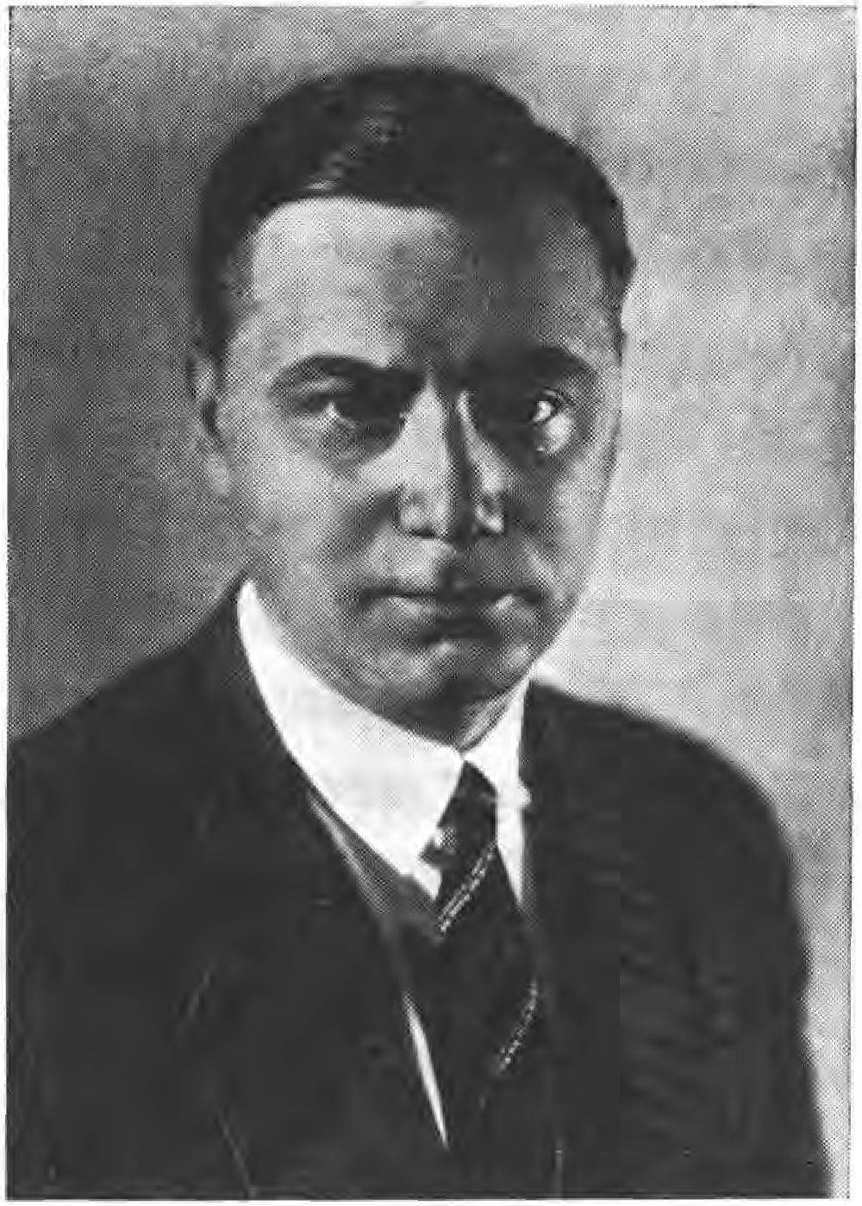

that Gandorfer would win the peasants. Eisner's speech was a masterpiece of Jewish contortion. He began by accusing himself of three errors. First, he was a Jew, he belonged to that unfortunate people who had lived in slavery for centuries, who were not allowed to work and were hated. For this very reason, he said, the Jews had always stood up for true freedom, true equality, because they had experienced in their own flesh the unspeakable
66

He had suffered the greatest disgrace and all the misfortune. Secondly, he was a Prussian, a Saupreuße, as the Oberlanders say. But he was an enemy of the critical Prussian way of thinking, an enemy of the Prussian Junkerism that ruled there, and that is why he had been living in Bavaria for years and his first excursion had been here to his beloved Oberland. Thirdly, he was a Social Democrat. Now came the familiar phrases about international social democracy helping to build a new Germany in beauty and dignity.
When Eisner ended, a wild cheer roared through the hall, Sedlmeier's action was done. It was impossible after Gan- dorfer had spoken and told the farmers all they would receive.
When Gandorfer had finished and the discussion was opened, Sedlmeier jumped onto the stage and began his speech: "Salomon Kosmanowsky vulgo Kurt Eisner has spoken, he did not get any further, a wild tumult arose, the two guards rushed at the little lieutenant, Fechenbach pushed closer, then the blacksmith from Aiblingen appeared in the background, stretched out his fists, grabbed the lanky Sedlmeier by the collar and lifted him out of the crowd to look down behind him. Thus he was able to escape.
Later, at ELsner's death, they took revenge on him. Lawyer Eller, once a pillar of the Fatherland Party, then a communist, led the procession, Sedlmeier was dragged out of bed, put out of a carriage and threatened by 25 guns with their safety off, he had to repeat the words that engineer Herbst said to him: "I beg your pardon for having offended the Prime Minister, I regret that a member of the officer caste murdered him.
67

Mayor Ruf was deposed and Eller took office. A third event, which also remained inconclusive, was to become significant for the Thule fighting alliance.
Dr. Buttmann, formerly a member of parliament, had received permission from Auer, Timm and Haller to set up a citizens' militia. The three ministers belonged to the majority Socialists and wanted to have the Bürgerwehr as a safeguard in the coming elections. Dr. Buttmann probably had other intentions, but he cleverly hid them under the mask of the Bürgerwehr. Through the Thule member Lieutenant Kurz he became aware of the Thule Society and so he came to Sebottendorff and requested the large hall for an evening meeting. This was granted. The meeting took place in the evening. In order to maintain the secrecy of the individual participants, the attendees had not been sufficiently screened, and so a Lieutenant Kranold, who was serving in the War Ministry and who had learned of the founding, had crept in. That evening, Lieutenant Colonel Haak explained how Munich had to be defended against an attempted coup from within, he indicated which precautions had to be taken, where posts had to be set up, then it was decided to meet again at noon the next day in -er Thule and to form the divisions. Since all others present were necessary for this, Sebottendorff took it upon himself to conduct the first canvassing in the canvassing office already rented by Dr. Buttmann at the Kühbogen.
That morning, on the basis of the posters already posted, well over 300 men came forward, pledged by handshake against any attempted coup, be it from the right or the left. The names and the apartment were entered in a list.
68

At 12 o'clock Sebottendorff closed the advertising office and went to the "Four Seasons", where he was told by the reliable porter Sell that 35 people had just been arrested by the Republican Shoe Guards and taken to the police headquarters. People from the Observer had not been arrested.
Sebottendorff succeeded in being admitted to ELsner in the afternoon and in receiving a written order from him that the interrogations were to begin immediately.
He presented his publicity lists at the police station and stated that he had committed people against any coup attempt, be it from the left or the right.
At 9 o'clock, 33 people had been interrogated and could await their release over sausages, beer and cigarettes, which Sebottendorff had procured. Detained were the publishing bookseller Lehman, where weapons were found, and Lieutenant Colonel Haak, who had given the well-known speech. The false statements made by Kranold were available against the latter. Lehman" and Haak were taken to Stadelheim and had to spend several weeks there in custody. Dr. Buttmann had succeeded in escaping through the second exit of the Thuleräume shown to him. The 33 arrested young people, among them Kurz, engineer Woerner, Lieutenant Pareus, Ahrens and Schwabe, joined the fighting alliance.
A few weeks later, the Observer would publish the following note about the traitor Kranold:
From Bavaria and the Empire.
The Bayerischer Kurier publishes the following decree of November 17, 1918, issued by the Minister of War, Roßhaupter:
69

In the last days of the revolution, a number of self-sacrificing people voluntarily put themselves at the service of the good cause. Selflessly, sparing no danger, they have independently contributed in endless work to the building of the new state structure. I consider it my duty to present an honorary award to all those who have faithfully served in the Ministry. First Lieutenant Streit 200 marks, Lieutenant Schöpf 200 marks, Lieutenant Kranold 300 marks, Lieutenant Rosenbeck 300 marks, Lieutenant Edelmann 1000 marks, etc.
Lieutenant Kranold, mentioned here, had caused the arrest of the vigilantes by a false report.
This arrest played a major role in the Provisional National Council well into the new year. Timm, Auer and Haller were strongly attacked by the independents and communists. They were accused of plotting to overthrow the government.
Alongside the Kampfbund, -which was steadily growing, the Thule was also spreading. It had lost the entire province to the revolution, but in Munich it was steadily gaining ground. The Observer was also growing. The system of passing it from hand to hand protected it from confiscation, it never, even in the bad times of the Räteherrschafi subjected to censorship, it never brought the government requirements.
Some articles from this period are reproduced here, they are significant for contemporary history:
Peace, freedom, bread.
These were the three things promised on November 8, 1918, when we awoke on the morning of the revolution.
In a speech Mr. Eisner gave when he was masquerading as a candidate, he promised peace within 24 hours from the time he had power. Now he will soon have two months in power.
70

Mr. Erzberger assured that he needed only half an hour that he was with Lloyd George to have peace in his pocket, which was two months ago.
It is probably appropriate to take stock, the balance of two months.
Peace! It is still a long way off, and if the rulers in Berlin continue in this way, we shall have another war. Radek-Sobelsohn said it clearly enough that the Russian army would fight together with the German Bolsheviks against big capital on the Rhine. And the concluded armistice on the basis of Wilson's 14 points? Has it been mitigated? No, the provisions have been tightened unilaterally. The Baltic Sea is closed, the Rhineland hermetically sealed.
Our brothers, who are still prisoners of war, suffer unspeakably, no hand is raised to help them, the government has other, more important things to do.
In the two months of the German Republic, we have not come one step closer to peace.
Freedom! We have freedom according to the words: "And if you don't want to be my brother, I will smash your skull.
We do not have freedom, we have mistrust.
The worker does not trust the citizen, the soldier does not trust the worker, the sailors distrust the soldiers. The ministries do not trust each other, despite all the fine words of unity. There is mistrust between city and country, between the individual free states. One stalks the other, telephone conversations are overheard, letters are vomited, speeches are reproduced in fragments and twisted. The occupation of the Austrian embassy, the arrest of the vigilantes, the speeches of Mühsam and Sontheimer show the measure of freedom.
Bread! We have no coals because the workers have not been working since November 9, but are on strike. Our supplies of boron are running out, that we will still have something on March 1, we hope, but we don't believe it. We live like children from the hand
71

in the mouth. Bread! We still have to eat. But the boron supplies/ which could last until July 1, 1919, if wisely divided, have been wasted, stolen, squandered.
Peace, freedom and bread were promised, but nothing was delivered. Unemployment is soaring, productive work is no longer being done, and our industry is on the verge of destruction. Read the moving letter to the workers that the government recently published. And it doesn't help, because the wheels of fate are rolling over us. We do not have the will to act! We let ourselves drift!
Like a child, we hope for the great miracle, like a gambler hopes for the great lot.
German! Worker! Citizen! Comrade of the people! Wake up!
Reflect!
There is still time, start with yourself! Learn to think logically! Then, but only then, when Germany awakens, then you can create:
Peace, freedom, bread!
*
Where the money comes from and where it goes!
When recently the news went through the papers that Bleichröder had given two million marks for a Bolshevik newspaper, many shook their heads, they could not believe it. They had forgotten that the revolution has always been the star of Judah. When the Communist uprising raged in Paris in 1871, it was Rothschild alone who was spared, because he supported both parties, paying pay to both the government troops and the Communists.
The Russian government money is rolling through the country to take us to the blissful realms of Bolshevism. It is touching to see how freely Radek-Sobelsohn can move about in Berlin, what a paper protest the government issues, this government which must not dare to have the man arrested and put on trial. In Munich, things are easier. One locks up
72

simply highly respected men in protective custody. For Sobelsohu, Sontheimer, Toller, Mühsam, who openly agitated for the soviet government, such an institution does not seem to exist.
But Mr. Radek-Sobelsohn was also the bearer of further millions, he was welcomed with one wet and one dry eye. What are the millions used for? Newspapers are founded and financed, so the old newspapers have to give up 50 0/0 of their paper. But that is the law in the new Germany. Everything belongs to everyone - at least on paper and because of paper.
Party supporters are recruited. 15 marks a day is quite a nice thing, especially since there is corresponding additional income. Then comes the maintenance of the party heads and their appendages. There, everything lives in luxury, money doesn't matter, it's all there, and not like the poor people, the proletarians, the dismissed civil servants, the soldiers, the officers.
The delegates sent to Berlin live in the first hotels, after all, you can do that with 30 Marks of diet.
This is how the money is used.
Gottfried Feder's lectures allowed a plan to mature that had long moved Sebottendorff. He wanted to win the workers. In the Thulebrüderschafi, Brother Karl Harrer was chosen to form a workers' ring. Engineer Gottfried Feder volunteered to give lectures.
Another ring was formed by Anton Daumenlang, who was engaged in heraldry and genealogy.
Nauhaus had further developed his ring for Nordic culture. Johannes Hering had gathered around him a ring concerned with ancient German law, here it was later Frank who, as a student of law, further developed this ring. The Kampfbund carried out its propaganda through the Beobachter, it distributed
73

Single prints from the same, leaflets, which especially Dannehl wrote (see picture part p.2VS). It was also begun to make pictorial representations, here especially Halbritter showed himself capable.
Shortly before Christmas 1918, Sebottendorff traveled to the Iultagung of the Lodge in Berlin and brought with him the draft of an appeal: "To the German People". The appeal with the program of the German Socialist Party is printed on page 171 et seq.
74

political work and advertising of the Thule
until ELsner's death
The Christmas feast itself was celebrated with numerous participants, as was the Sylvefierfefi. These two feasts were to be the last joyous occasions of assembly for a long time.
The new year began gloomily enough: in Munich there had been ten dead and several wounded on New Year's Eve,* in Berlin furious street fighting, in Düsseldorf a communist coup, so that the English wanted to see the city. The Berlin riots lasted until mid-January and ended with the government becoming master of the city through the Freikorps,* 2VV dead, 1VV wounded were counted, Karl Liebknecht and Rosa Luxemburg were shot. The Bavarian state elections were scheduled for January 12, the national elections for January 19, 1919. For the first time, women went to the polls.
On January 7, 1919, there was an unemployed demonstration in Munich, where two people were killed and four seriously wounded by machine-gun fire. A few days later, a putsch was attempted in the valley; here, too, there were dead and wounded.
The elections brought a crushing defeat for Eisner. Barely 2 o/o of the entire Bavarian electorate backed him. Mün- An expected Eisner, Iaffee and Unterleitner, the three elected independents, to resign from the government.
75

The Diet, which was to convene, was postponed until February 21 ISIS under various pretexts. ELsner and Iaffee went to Berlin for the constitutional negotiations.
Erzberger was able to obtain an extension of the armistice under difficult new conditions, which Germany had to pay for with unheard-of new deliveries.
3In February 1919, the National Assembly was to meet in Weimar, and the constitution was to be created.
3In Munich, the most fantastic rumors were circulating about what would happen at the opening of the Landtag, which was now finally set for February 21," the Communists wanted to blow up the Landtag, Eisner did not want to go, etc.".
A number of events had taken place in the Völkische movement. The All-German Federation had also invited the friendly organizations to the Bamberg meeting, and it had been decided to make all preparations to turn the Schuh- und Truhbund into a fighting force. Since the federation was to work in the width, it was generally refrained from a blulsbekenntnisse. The open struggle against the Jews was to be launched throughout the empire. Similar alliances had already been formed in Lusatia and Thuringia.
At that time two books about Freemasonry were published, which must be mentioned. Karl Heiser "The Entente Freemasonry" and Wichtlr "The World Freemasonry". Both books caused a significant sensation," here for the first time facts were given, no longer vague assumptions and hints.
At that time, Steiner, the prophet of Dornach, who was particularly well known in Munich, began to talk about himself again.

make. Steiner wanted to become minister of finance in Württemberg and propagated his system of threefolding.
The influence of this sinister man reached far. Before the war, he worked together with Liesbeth Seidler, who later became a clairvoyant, in Berlin, Körnerstraße. Seidler as well as Steiner had access to General Moltke at any time, they both prevented that fresh forces were deployed at the Marne in time and that this battle was lost (Schwarz-Bostunnitsch: "Doktor Steiner ein Schwindler, wie keiner", published by Böpple, Munich).
If Sebottendorff had earlier taken a stand against Seidler and against Steiner, for which Seidler, who was a police agent on the side, had taken revenge by denouncing Sebottendorff, he now continued the fight against them in the Beobachter.
Apart from the Beobachter, it was the aforementioned Miesbacher Anzeiger that went vigorously against the Jews.
Another paper must be mentioned, Dietrich Eckart's journal, which appeared for the first time on December 7, 1918, and which he had called "Auf gut Deutsch". The founding of this magazine gave rise to Eckart's enmity against Sebottendorff. Eckart had approached Sebottendorff through the Thule Brother Kneil that the latter should finance the journal. But since the Thule Society and the Beobachter already had to be maintained financially entirely by Sebottendorff, he refused,* the owner of the Münchener Zeitung had then given the demanded 1VVV marks. Of the issues of the journal were of particular interest: Heads from the "Iuden Number" and the number: "Nätezeit in Ungarn". The main contributor to "Auf gut Deutsch" was Alfred Nosenberg. As
77

Dietrich Eckart followed the work of the Thule Society in the political struggle, shows among other things a report in No. 42 of his magazine "Auf gut Deutsch":
The downfall of the empire.
There is a lot of scolding about Berlin in our country, about Prussia in general. In a meeting of the "Deutscher Bund" - a Mr. Ballerstedt founded it/ the row of those who had made the appeal under
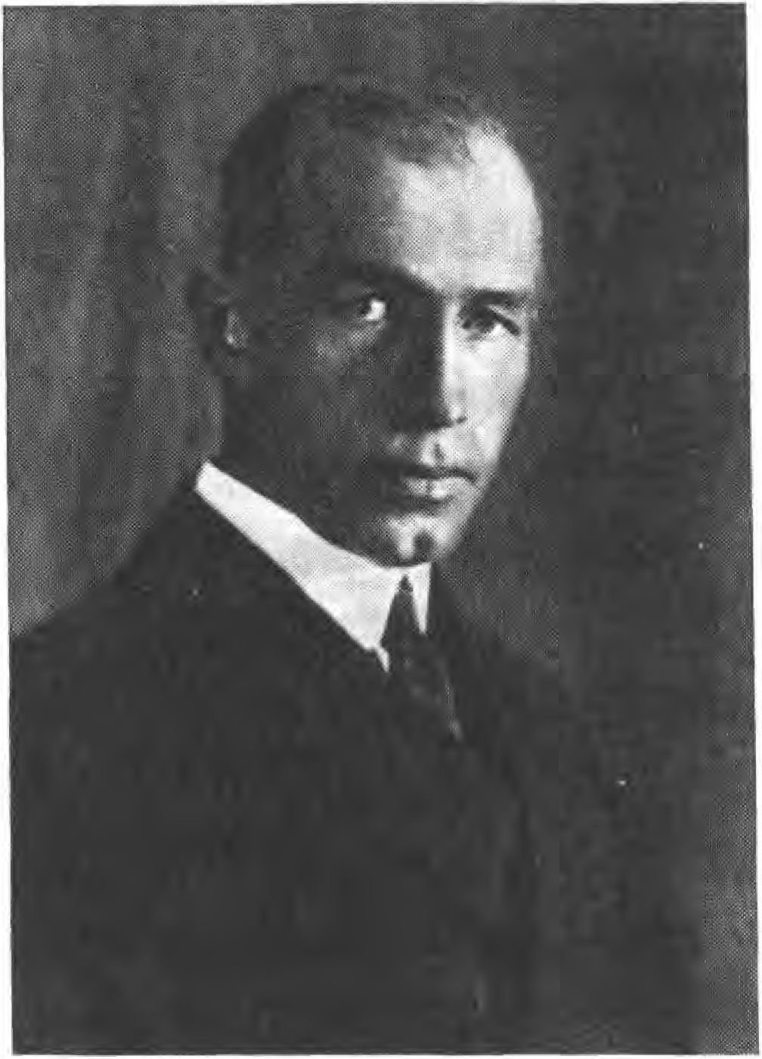

signed, begins with the Jewess Annita Augspurg/ other Iuden- names follow/ the Iudenher Franz Carl Endres is also among them/ also Mr. Held, the leader of the local independents, is present/ in short: the real "German" alliance - in this assembly it came at first, under Ballerstedt's speech, even to stormy calls for a - declaration of war against Prussia, until
78

Thank God Franz Dannehl was able to step in and open the eyes of the crowd in time.
A few more articles from this period are reproduced from the Beobachter:
The Iude.
If you try to enlighten someone about the Iude as a Raffe, you often get the answer: "But I don't understand you, I know a lot of Iudes, they're all quite nice people/"
However, when we speak of the Iuden as Raffe, we do not mean the individual being, but the entire Iudenschast. Let us listen to what Theodor Fritsch says in his book "Der falsche Gott". (Leipzig, Hammerverlag 1916): "Precisely this zlettsein is one of their special warlists. If they wanted to openly display their deepest hatred against us, how could they survive socially or in business at all? They need us to rest, and they achieve their purpose all the more surely the more they know how to deceive us about their true thinking and knowledge."
"For if they knew what we teach against them," said a Lviv Hebrew journal years ago, "would they not strike us all dead?" To conceal one's true sentiments is a necessity of life for the Hebrew, and in constant practice of this art he has hitherto attained mastery in hypocrisy. The Talmud once says: "The Iude knows how to pull out someone's teeth and pretend to stroke his cheeks."
These Jewish twisting arts have an almost hypnotic effect on people with a weak mind. They let the Iude suggest to them what they should feel and think. Thus, cases are known where Hebrews have stripped trustworthy people to the shirt by usury and fraud, and yet they always had the reputation of being benefactors. The Hebrew knows how to give every one of his mischievous actions the appearance of the purest intentions, and whenever he has to harm his victim, he does it as if it were against his ab-
79

He fights under the constraint of circumstances, as if he himself felt the deepest sorrow about it. Wilhelm von Polentz has masterfully portrayed such scenes in Büttnerbauern.
3 Indeed, the Jew often exerts a hypnotic influence, a spell, on people with weakened senses and wills. It is as if he possessed demonic powers. In what way the sexual motive plays a role here shall not be discussed. It is sufficient to point out that a creature, which lacks any concept of shame and morality, also expresses its sensual desires in such a way that they must have a tricky and confusing effect on a weak mind. Here, by describing experiences, abysses could be uncovered before which many an unsuspecting mind would shudder back. Women and girls who have been in Jewish service, or otherwise come into closer contact with Jews, have completely forfeited normal thinking and feeling, so that they feel the humiliation they experience there almost as a boon and grace. They cannot be enough of the glory about the Jew.
It is suggested to them that the Jews belong in every respect to a privileged race of men, superior to all others; they repeat this faithfully and still feel honored to be allowed to associate with Jews. The Jew knows how to dispute the concepts of shame and morality and to present them as silly prejudices.
The beguiling of weak brains belongs to the special talents of the Hebrew. Thus he has developed the art of ingratiation to the point of mastery. His dishonest profession compels him to cultivate smooth, captivating manners, and when Goethe claims that the German is insincere when he is not coarse, in this, too, the Hebrew is the pronounced opposite.
Certainly the Iudenwih bounces off strong and healthy and inwardly pure characters/ the Hebrew carefully avoids such people. The word: Every nation has the Jews it deserves, is not without justification! Only there, where proverbs and vanity and all the other bad lusts have a rendezvous, the Hebrew is not without justification.
8V

Where the moral sense of remembrance has dwindled, the Jew feels at ease, like a louse in a scab. Persons, families, societies, peoples judge themselves by the relationship in which they stand to the Judaism. Where there is a carrion, there the vultures gather!
With that, let's leave it at that and continue reporting:
On January 18, ISIS was founded in the rooms of the Thule Society -the National Socialist German Workers' Association. Writer Karl Harrer was the first chairman, metal turner Anton Drexler the second. At the regular weekly meetings, attendance varied between ten and thirty people.
As a result of the disputes Eisner had with the imperial authorities, the formation of army units had been rejected, even forbidden, by the Bavarian side. General von Epp therefore gathered a force outside Bavaria in the Ohrdruf camp in Thuringia. There Sebottendorff sent a large part of the members of the Kampfbun and assigned people who had been recruited to the local camp.
For -en 21 February ISIS was -the Lan-tagseröffnung announced,' all Munich stood in expectation, what would happen.
On February 16, ISIS, Eisner held a meeting on the Theresienwiese in which he propagated the idea of the Council. Eisner himself led the demonstration procession in a motor vehicle, which had to bring the meeting to a necessary conclusion. Posters calling for a soviet government were carried along in the procession. There were about 10,000 people who took part in the eye and who were in a particularly bad mood toward the press, because Eisner had had a nasty clash with them the day before. As a result, the Munich newspapers stopped reporting.

81

While on the side of the communists people were stirred up by deeds, the moderate social democracy fought with words. Auer attacked the peasant leader Gandorfer, accusing him of corruption and sawing through positions.
On February 20, 1919, the councils evacuated the parliament building and moved to the Deutsches Theater, where Eisner and Max Levien clashed. For the following day, Levien had announced a lecture, "Spartacus, the Slave Liberator," but it did not happen, because on Friday, February 21, a quarter of an hour before 10 a.m., Eisner was shot by Count Anton Arco on Valley on the way to the Landtag at the corner of Promenade Street (see photo section p. 216).
Count Anton Areo on Valley had Iu-en-blood in his veins from his mother (a born Oppenheim), he is Iü-ling and therefore he was neither exempted from the Thule Society nor from the Kampfbund. He wanted to show that even a half-ju-e could perform a deed.
In ELsner's place, Auer opened the Diet an hour later with a warm obituary,' hardly had he finished his speech when the door opened and the butcher Lindner, a convinced Communist, fired a few shots at Auer. Auer was seriously wounded,' at the same moment shots were also fired from the tribune where the Workers' and Soldiers' Council had settled. These shots killed Deputy Osel and Major von Iahreiß, who was present as a visitor. The Diet dispersed in wild flight.
The second revolution was declared. The mob came to rule all along the line.
82

The Revolutionary Central Council issued the following announcement (see picture section p. 216, illustration above left);
The liberator of the proletariat, the Prime Minister of the People's State of Bavaria, Kurt Eisner, was murdered this morning at 10 o'clock by a representative of the bourgeoisie, Count Arco-Zinneberg (d. Verf.: should be Count Anton Arco auf Valley).
The intellectual author of this murder is the slanderous agitation of the press.
In view of this crime, the proletariat has the duty to secure the revolution by taking over the press. The workers are called upon to go on strike immediately and to assemble at 4 o'clock on the Theresienwiese.
Long live the memory of Kurt Eisner!
Long live the second revolution!
Long live the soviet republic!
Munich, February 21, 1919.
The first thing was to announce a general strike. All stores closed, traffic stopped, posters appeared calling for retaliation against the owners. At 1 o'clock in the afternoon the bells rang out from all the towers - the priests had been forced to ring them themselves.
Around 4 o'clock in the afternoon, the newspapers were stormed, the rolls of paper were dragged into the streets and set on fire. Everywhere there was looting and robbery, everywhere shots rang out.
At the place where Eisner was shot, his picture decorated with flowers had been set up, and two guards made sure that everyone who passed by saluted him.
But this haunting did not last long, an old hunter's trick was used - a bag of flour containing the sweat of two bitches in heat was spilled in front of the picture. Soon
83

all the dogs of the neighborhood gave their business card and picture and post disappeared.
Areo's insane act had overturned all plans. Eisner, who had already been half-finished, received the glory of a martyr through this deed. The deep hatred against the Junkers erupted again, for it was a Junker who had shot Kurt Eisner.
The fact that the Thule's fighting alliance and the Thule itself were not bothered at first in the battle that was now taking place was due to the fact that the society's rooms were located in the quiet Marstallstraße, in the immediate vicinity of the Army Museum, where the High Command had set up its headquarters.
The entrance to the meeting rooms of the Thule was a side entrance of the hotel "Four Seasons", which served especially the employees of the hotel business, so it was not very noticeable that this entrance was also heavily used by the Thule people.
On February 22, 1919, a Saturday, a new number of the Observer was due,* so as not to pour Sl on the fire, publication was delayed for a few days.
84

The thule m the jet of the council rule
In the period from February to April of ISIS, things were fairly quiet in the empire. The various communist uprisings of the Spartacus League had been put down, and only in Braunschweig did a soviet rule still exist. Things looked dangerous in Oberschlefien, where the Communists used the imminent danger of Poland to stir up an uprising. In Hungary, Beta Kun had established the soviet government.
The National Assembly met in Weimar," it was busy with the constitution of the "system".
In Munich, however, everything went haywire. For the time being, a central council had been formed, consisting of the following people: Gandorfer, Hoffmann, Uhendorfer, Sauber, Simon, Goldschmidt, Niekisch, Kröpelin, Eisenhut, Levien, Hagemeister.
All newspapers were banned, and in their place the news bulletin of the Central Council was published. The workers' council Iakobi and -er Sol- -atenrat Ehrhar-t were responsible.
The above-mentioned eleven-man college had decided on a three-day national mourning for Eisner; furthermore, the closure of all bourgeois places of entertainment, the abolition of the nobility and the abolition of all feudal estates had been decreed.
On February 24 ISIS -the general strike was -ended, on Wednesday, -em 26th, fan- -the cremation of ELsner took place.
85

Niekisch had summoned the councils to the German Theater for February 25 - at this meeting Kröpelin in particular incited the arrest of hostages. "Hostages must be arrested, and if today a revolutionary falls at the hands of reactionary criminals, then ten Kreß von Kressenstein will be shot." Publishing bookseller "Lehman," the aforementioned Kreß von Kressenstein, and many prominent persons were arrested as hostages and taken to Stadelheim. Landauer gave a motion for debate at this meeting to declare the workers' councils to be the National Council- Levien announced that the Revolutionary Workers' Council had declared itself in permanence at the Wagnerbräu. He demanded that the Landtag no longer be convened and that all power rest with the councils.
On March v ISIS, meetings were held between the parties, the Communists, the Independents and the moderate Socialists, a compromise was reached, but it was not kept. The Bavarian government prepared to move to Bamberg, but still hesitated, hoping to deal with the Spartacists peacefully. Instead of cracking down, it decided on half measures. She had behind her the then intact soldiers of the garrisons of northern Bavaria. The Third Army Corps dropped the following announcement over Munich:
To all soldiers and workers!
The situation created by the nefarious murder of Eisner is used by a small group of violent people in Munich to seize power. The workers and soldiers of Amberg, Bayreuth, Sulzbach/Regensburg, Straubing, Erlangen, Ingolstadt, Grafenwöhr, Nuremberg and Fürth are resolutely resisting this. All of them condemn the tyranny of a small group,
86

leading Bavaria to its downfall. They demand a socialist government and an immediate convening of the state parliament. All want democracy and reject dictatorship. Comrades and comrades of Munich! You have shown the will to reject the tyranny of Dr. Levien and his armed followers. In this endeavor all soldiers of the Third Army Corps support you, if it cannot be otherwise, by force of arms.
From March 17 to 19, 1919, the Landtag met in Munich - it had no power, this was held by the Russian plenipotentiary Axelrod, the councils Lernen and Levine-Nissen. The official government was composed of Hoffmann Presidium, Endres Interior, Segih Finance, Frauendorfer Transport. This government, however, was only a sham, tolerated until the soviet government took its place. After all, the world revolution seemed to be marching, as the example of Hungary showed. In order to drive it forward, Prime Minister Hoffmann appointed the Austrian Jew Dr. Neurath as state commissioner. Neurath was to socialize all Bavarian businesses - he became head and president of the Aen- tralwirtschafisamt.
When the Diet was to meet again, the Central Council declared that it would prevent such a meeting, but in Hoffmann's absence, under the Minister of War, Schnep- penhorst, a meeting was held on April 4, 1919, in which all the Socialist parties took part. Here, Levine- Nissen had already reintroduced the motion to proclaim the soviet government, but this meeting dispersed without result.
On April 6, 1919, Klingelhöfer convened the workers' and soldiers' councils in the Hofbräuhaus. On the same day, the soviet republic was proclaimed in Munich. Significantly, the commu
87

nists under Levine's leadership, they formed their own force. Niekisch took over the entire force, Dr. Lipp became People's Commissioner for External Affairs, Dr. Neurath remained head of the Aentralwirt- schafisamt, the Jew Ret Marut became head of the press socialization. Silvio Gesell took over the finances.
The public announcement reads (see picture section p. 217, illustration above):
To the people of Barern!
The decision has been made, Bavaria is a soviet republic. The working people are masters of their own destiny. The revolutionary workers and peasants of Bavaria, including all our brothers who are soldiers, no longer separated by party differences, agree that from now on all exploitation and oppression must come to an end. The dictatorship of the proletariat, which has now become a fact, aims at the realization of a truly socialist polity, in which every working man shall participate in public life, of a socialist-communist economy. The Diet, the barren structure of the overcome bourgeois-capitalist age, has been dissolved, the ministry it established has resigned.
The councils of the working people will appoint men of trust who are responsible to the people and who will be given extraordinary powers as people's representatives for certain areas. Their assistants will be proven men from all directions of revolutionary socialism and communism. The numerous capable forces of the civil service, especially the lower and middle civil servants, will be called upon to cooperate energetically in the new Bavaria. The system of bureaucracy, however, will be eradicated immediately.
The press is socialized.
A Red Army will be formed immediately to protect the Bavarian soviet republic against reactionary attempts from outside and inside. A revolutionary court will immediately punish any attack on the soviet republic.
88

The Bavarian soviet government follows the example of the Russian and Hungarian peoples, it immediately takes up the connection with these peoples. On the other hand, it rejects any connection with the despicable government of Ebert, Scheidemann, Noske, Erzberger, because they continue the imperialist-capitalist-militarist business of the disgraced German empire under the flag of a socialist republic.
It calls upon all German brother nations to follow the same path. To all proletarians, wherever they fight for freedom and justice, wherever they fight for revolutionary socialism, in Württemberg and in the Ruhr, in the whole world, the Bavarian Republic sends its greetings.
In the sign of joyful hope for a happy future for all mankind, April 7 is hereby designated as a national holiday. As a sign of the beginning of the farewell to capitalism worthy of cursing, work will be suspended throughout Bavaria on Monday, April 7, 1919, unless it is necessary for the life of the working people.
Long live the free Bavaria! Long live the soviet republic! Long live the world revolution!
Munich, April 6, 1919. The Revolutionary Central Council of Bavaria.
In Augsburg, the soviet rule had already been declared on Saturday, followed on Monday by Rosenheim, Starnberg and the vicinity of Munich. The Social Democratic Party and the Hoffmann government raised an objection and were able to defeat the attempts to proclaim a soviet republic in northern Bavaria (see picture section, p. 217, bottom left). The decree of the Hoffmann government read:
The government of the Free State of Bavaria has not resigned. It has moved its seat from Munich. The government is and remains the sole holder of supreme power in Bavaria and is
89

alone authorized to issue legally effective orders and to give orders. Further publications will follow.
Nuremberg, April 7, 1919, Prime Minister Hoffrnann.
The plan of the soviet republic was to take all of Bavaria with it, then to take Austria between two fires, since the soviet system already prevailed in Hungary. It was also hoped that the movement would succeed in Württemberg. The plan failed because of the restraint of the northern Bavarian population and the rapid suppression of the Württemberg uprising.
At the beginning of April 1919, Munich formed an island whose border went from Dachau via Schleißheim to Rosenheim and the Oberland,* in the west it ran between the lakes back to Dachau. This place was very important for the Republic, not only the large ammunition stocks were stored there, but also the paper to be able to print paper money. Finance Minister Maenner afforded himself the classic saying: "When we have the Dachau paper mill in our hands, the financial situation will be secure for four to five weeks."
In Munich itself, a Red Army had been formed, of which Toller was the supreme commander. 24VV rifles had been distributed, plus the weapons in the barracks and depots.
That was the general situation.
In the coming days of horror, the Thule Society assumed increased political importance. The last consecration had taken place on March 21. During the council period the meetings were cancelled.
In order to give the Thule a firm form so that it could also appear externally, it was decided to register the Thule as an association.
90

The registration court only registered associations that formed their board of directors by election. The registration court only registered associations that formed their board by election.
The financial demands that had been placed on Sebottendorff had exhausted his strength- he had to ask members to pay ISIS dues starting March 1. Kneil became treasurer. Also the meeting clubs had to pay seht hall rent.
The Thule Society was touched by two events during this period. The first was the visit of the police chief pallabene, who came to search the house for anti-Semitic leaflets. Sebottendorff was informed of the visit by Baron Wittgenberg. Wittgenberg had known pallabene as an Austrian officer, he had met him in Schwabing and there the talk had come to the Thule Society. The visit was confirmed by the member of the Republican Shoe Troop Rihler, who was also a member of the Thule Society - he was also able to give the exact time r the house search was to take place around 1V o'clock in the morning. To ward off the attack, Sebottendorff asked Mrs. Riemann-Bucherer to watch singing lessons for the morning and to order all the sisters of the Thule Society. When the police chief was then reported, the introductory song, "Beglückt darf nun dich, o Heimat, ich schauen," sounded to him. Countess Westarp, the second secretary, reported -en gentleman, who immediately asked, "What is this society?"
"O, this is an association for the higher breeding of the Germanic Raffe!" "Wa-a-s?"
"An association for the higher breeding of -er Germanic Raffe, Mr. Police Commissioner."
S1

"Yeah, what are you up to?"
"You hear it, we caught."
"You are pushing anti-Semitic propaganda, I know it well, sir! You are making fun of me, I will have you and all your followers arrested! I have come to search the house!"
"Please," said Sebottendorff, "I can't stop you, but one explanation beforehand, Mr. Police Commissioner. My power extends a little further than you think. You see, I have been leader of the Thule Society for six months and more now, and think to remain so for a long time. You, Mr. Chief of Police, have been in office for two days and may stay for another two or three days, then someone else will come to the feeding trough. If you, Mr. Police Commissioner, arrest me or one of my people or even all of them, then my people, wherever they find one, pick up a Iude, drag him through the streets and claim that he stole a host. Then, Mr. Police Commissioner, you will have a pogrom that will sweep you away as well."
"This is insane, this is madness."
"Maybe, but there's a method to my madness."
"Surely you're not going to try to mislead me."
"Far be it from me, but it needn't come to that." You see, basically we are striving for a common goal, only our paths find different. Why shouldn't we tolerate each other?"
"Yes, we could go together."
"No, that's impossible, you want to reach the goal through internationalism, I want to reach it through the national, through the völkisch movement. Let's wait and see who will reach the goal first."
92

"Quite so, Baron, if there is anything against you, I will notify you."
"Very grateful I will be. If there is anything against you, Mr. Police Commissioner, I will let you know."
With that he left and with him his officials, among whom were two members of the Combat League of Thule.
The second event was almost more serious, but here, too, a fortunate circumstance helped. During the distribution of the "Red Hand" a Thule man had been apprehended, he fled and was pursued. When he came to Marstallstraße, the whole mob followed him, and the rooms of the Thule Society were flooded in an instant. Fortunately, some people of the Kampfbund, who had come from the Communist sections to report, were just there. They immediately went into action with their red armbands and pushed the others back. Since that day, two members of the Combat League have always stood guard as communists.
The "Red Hand" was a satyrical joke paper that appeared once and had a huge circulation.
In March 1919, Sebottendorff took Hanns Georg Müller, a war veteran, on as editor of the "Münchener Beobachter. On May 5, 1919, Sebottendorff commissioned Hans Georg Grassinger to print the Beobachter in an improved layout and in a larger format. Grassinger came to the Thule from the opposition party in the state parliament against Eisner through Witzgall. From May 17, 1919, with No. 16, Hanns Georg Müller was solely responsible for the Beobachter,* the sports section was provided by Valentin Büchold, First Chargé d'Affaires of the academic fraternity Hansea and Thule member. On May 24, 1919, with No. 17, the Beobachter was published.
93

With No. 22 of June 28, 1919, the newspaper appeared once, and from No. 23 of July 2, 1919, twice a week and on eight pages. On August 9, 1919, with No. 34, the "Münchener Beobachter" also appeared for the first time with the title "Völkischer Beobachter" (see photo section p. 208).
Of the articles of the Observer in that period, the following are reproduced r
Israel in Germany ahead!
As a result of the "German" revolution, the following Iuden reached leading positions:
Arndt, press officer in the Prussian War Ministry.
Ed. Bernstein, Reichsschahamt.
Dr. Oskar Lohn, Reich Justice Office.
Eisner, Minister President in Bavaria.
Fulda, Minister of the Interior in Hesse.
Futran, Ministerial Director in the Prussian Ministry of Culture. Dr. Max Grünwald, Press Officer at the Reich Economic Office.
Dr. Haas, Minister of the Interior in Baden.
Haase, Auswärtiges und Kolonien im Reiche.
Pros. Dr. Iaffee, Secretary of the Treasury.
Dr. Herz, Chairman of the Iustice Commission.
Heimann, Chairman of the People's Council in Berlin.
Heymann, Minister of Education in Württemberg.
Hirsch, Prussian Prime Minister.
Dr. Löwe, Reich Office for Demobilization.
Dr. Laufenberg, Chairman of the Hamburg Workers' Council.
Dr. Landsberg, Chairman of the Council of People's Representatives. Dr. Hugo Pruss, State Secretary of the Interior.
Rosenfeld, State Councilor in Berlin.
Dr. Kurt Rosenfeld, Prussian Minister of Justice.
Schlesinger, Commissioner in the War Department.
94

Simon, Director of the State Department.
Simon, Prussian tzandelsminister.
Sinzheimer, Chief of Police in Frankfurt am Main.
Stadthagen, representative for Lippe.
Thalheimer, Minister of Finance in Württemberg.
Weyl, Minister in Hesse.
Worm, Secretary of Nutrition.
A fine, dialect collection.
The following short notes from the "Münchener Beobachter" shed light on that time:
Education to become a Bolshevist.
Many young people who want to join the border guards are reporting to the local commandant's offices. Our wise government does not want these volunteers to do anything, they are transferred to the local regiments, where they are fed at the expense of the state, they do not need to do anything and are thus delivered to Bolshevism. This is how the government educates its troops.
Dr. Levien is one of the leaders of the communists. In the Puchheim prison camp he persuaded the Russians that he would be president of Bavaria in a short time, soon the dance would start again in Bavaria, then they would get enough land and could stay here. The Bolsheviks were in the offing, he said, and they had to be helped from here. Dr. Levien, who is strongly syphilitic, then had himself photographed in the circle of prisoners.
Socialization Committee.
Professor Iaffee, the previous Minister of Finance, has become the chairman of this body. If he continues to work in the spirit in which he drove our finances into the dirt, then something beautiful can come out of it.
Wouldn't it be better if Mr. Iaffee went to Jerusalem quite quickly and tried to get a post there? It would be wonderful if he were to take his friend Bonn with him, since his activities at the commercial college are nil.
95

How widespread -er observer and how good the propaganda was, shows the following incident, which was to draw wide circles:
One day the Observer was called,* a well-known hotelier from Füssen came forward and announced that Mrs. Eisner had arrived in Füssen a few days ago with Mr. Landauer in a former court car, that she had intended to occupy Hohenschwangau Castle. Since Mrs. Eisner had contracted a cold, the doctor had been fetched and he had advised against choosing Füssen as a permanent residence, -a the climate was not suitable, Nuremberg, resp, the lowlands were more suitable.
The next morning, the maid had found Landauer and Mrs. Eisner in a clear position in bed.
The Jew Eisner had left his first wife behind in Nuremberg in bitter distress. The second wife, who received a considerable pension, had been his secretary; she had been eagerly engaged in politics and had also interfered in political affairs on various occasions. Sebottendorff published the report in the Beobachter under the title: "Revolution!
The day after the "Beobachter" appeared, a Monday, Sebottendorff walked across Karlsplah in Munich and heard exclaiming, "An all-German is slandering Mrs. Eisner! Sebottendorff reviles the dead prime minister!"
He approached the crier who was delivering the newspaper "The Republican" and asked:
"Da geh her, was haft denn da?"
"Yes, you have to read it."
He bought a number and opened it. The second page contained under the headline: "The widow of Kurt Eisner by a
96

Alldeutsche niederträchtig verleumdet" a reply of Leib, -the owner of the paper "Der Republikaner", it read;
Time has not yet blurred the terrible impression which the cowardly murder of the unforgettable friend and promoter of a happy world peace has caused in all countries of the world, the mourning for the death-defying founder of the Bavarian Republic is still a profound one, and already an all-German fanatic dares to sully the honor of the sorely afflicted widow of the great dead man in the vilest manner.
A certain Rudolf Sebottendorff, who could proudly call himself Rudolf von Sebottendorff only a short time ago, raises the lowest accusations against Mrs. Eisner in a Munich paper, of which he is the editor, with the unmistakable intention of imputing moral and ethical misconduct to the attacked woman.
Mrs. Eisner is brought in connection with a well-known left-wing socialist leader, the name is mentioned, in the most dishonorable form and on top of that it is claimed that she had undertaken a pleasure trip to Füssen with the latter in a former court car.
And how does it behave in reality?
According to the inquiries I have made, Mrs. Eisner fell ill on her journey home to Munich. She lay for several days in a hotel in Füssen, since the attending physician considered an onward journey by train to be dangerous. In this helpless situation, Mrs. Eisner turned to a friend of her late husband, who then committed the crime of helping her in this certainly not enviable condition by bringing her to her Munich home in a rented car.
This is what Mrs. Eisner's pleasure ride looked like!
That which is a simple serious human duty is nimbly turned into a meanness with genuine all-German love of truth.
This case is quite indicative of the snooping of a counter-revolutionary society, a rabble that still does not give up hope that one day their wheat will again be

97

will flourish. The slanderous note of Sebottendorff (dated 9 Lenzing 1919) bears the heading: 'Revolution' and claims that Mrs. Eisner spoke strongly in external politics. The latter assertion is just as invented as the fairy-tale pleasure trip. The sad all-German hero thus undoubtedly wanted to hit the revolution with deliberate untruth, he did not shrink from damaging the immaculate reputation of one who, through the curses of his own life, had been a part of it.
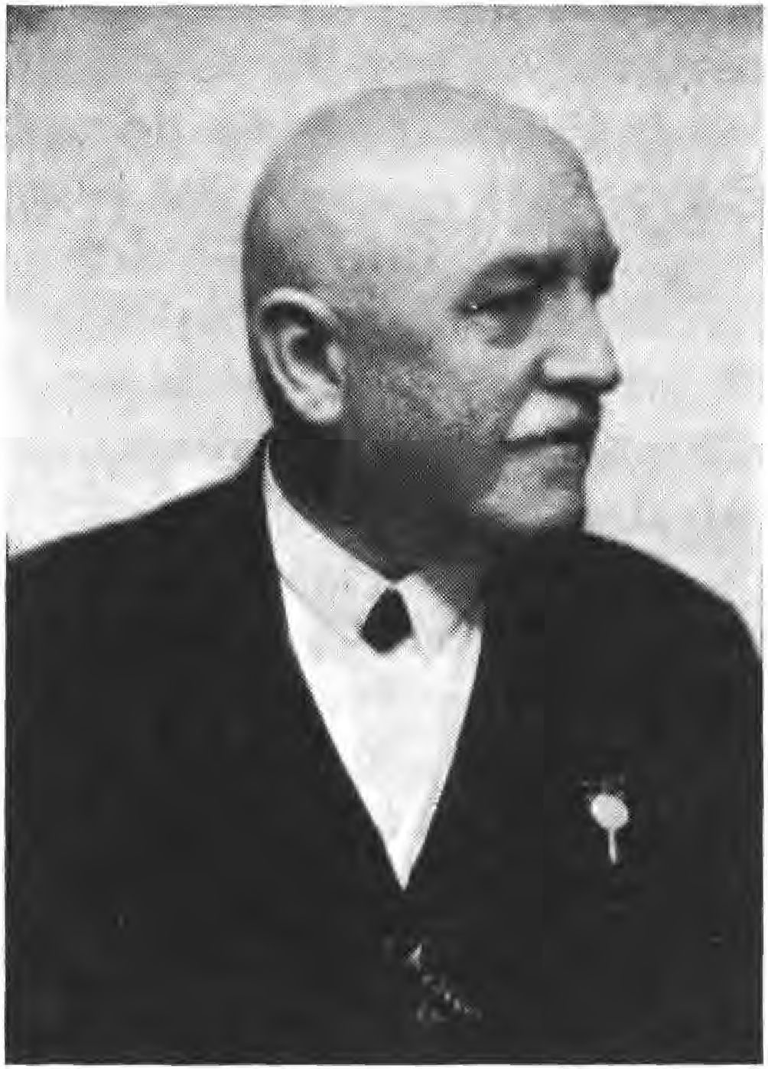

The court is determined to call the cowardly defiler of her honor before the bars of the court, but one can help a fearful feeling that the reactionary elements have every reason to suspect that the cowardly defiler of her honor will be brought before the court. Mrs. Eisner is determined to demand that the cowardly defiler of her honor be brought before the bars of the court, but one cannot help feeling anxious that the reactionary elements seem to have every reason to do so.
98

feel safer than ever in the Republic of Bavaria, so safe that they believe they can get away with anything. How long will it be before a certain daily press is once again allowed to open the floodgates of its filth without being disturbed, spraying everything with excrement that can be associated with the revolution?
"3a, what's that, that's a big nuisance, my dear, the article -a, what's going to happen to Sebottendorff?"
"We'll get him tonight."
"So, I'd like to be there, where does the Bazi live?"
"There at the Siegestor he shall live."
"Iessas, -ös belongs to my section, there give me another 1v from the Republicans, I want to take it with me so everyone can read it."
"3s scho recht, heit Abend um sechse holn mern, es steht noch was von eam im Blattl drin."
Actually, the "Republican" still contained a second article, -he dealt with Sebottendorff, he loudest
The All-German, the Russki and the Republican.
Russian Bolshevism has made its entry into Munich. Even the Münchener Kindl shivered at this news in an icicle-cold goose bumps, because very close to the wisdom carousel of our city fathers, at the Marienplatz, the dangerous monster celebrated its orgies. The culprit, of course, is the "Republikaner". The only all-German organ of Munich, which is led by an engineer Rudolf Sebottendorff, has discovered the unheard-of and saved our dear Munich from a sure-fire downfall with the following note:
"Ruffian Bolshevism and German Republican. The ingloriously known 'Republican', about whose fighting style we do not want to judge, has been sold for a few days on a local larger square by a Rußki. Beautiful souls can be found."
SS

It is true that the Republican Party, despite its existence of only four months, is known not only in Munich but also in Bavaria and beyond the white-blue border stakes. But that he is called ingloriously known by an all-German spin sheet only does him honor. As far as Rußki is concerned, he is a prisoner of war who was driven from a Bavarian prison camp by hunger and who, as he had done for weeks with other newspapers, now wants to earn an honest living by selling the 'Republikaner'. That I gave him the opportunity to do this is human, but certainly not un-German.
If Sebottendorff sees real humanity in the fact that a defenseless prisoner of war is denounced to the police as a Bolshevik and that this prisoner of war is deprived of his little bread because he has to stay away from his homeland through the guilt of criminal militarism, then it is regrettable that not this single German, named Sebottendorff, fell on the field of 'honor', yes, then it is regrettable in the highest degree that for such Germanism millions of men had to give their lives. It is not he who sees in the foreigner the human being who desecrates Germanness, but rather the half-crazed furov teutonicus who places his national intolerance above humanity. From this side, suppurations can arise in an all-German brain, so that one sees a dangerous Bolshevik in a harmless prisoner of war. However, I will gladly concede one mitigating reason to the editor of the most praiseworthily unknown newspaper, since he belongs to the deeply unhappy earth pilgrims who only a few days ago were deprived of the proud little word 'von'.Sebottendorff has undoubtedly lost his mind along with the word 'von'. Leib.
The matter looked more serious - the two articles were probably calculated to whip people up. Without reason, one does not make an article out of a small note, which certainly could not mean a police denunciation, and puts a "Junker" in the pillory.
100

"So at 6 tonight you're going to get the bazi?"
"3a, tonight at 6."
Arriving at the Doering Pension at the Siegestor, Sebottendorff asked the proprietor Hornstein for the key to the back door of the house, through which one could enter the courtyard of the Serenissimus.
"Tonight I'm getting a visitor, Herr Hornstein, the Spartacus people want to get me. Don't be alarmed if you see me doing the house search."
"Don't do anything stupid, Baron."
"No, no, I'm not doing any already."
At 6 o'clock sharp, republican shoe guards appeared on two trucks, accompanied by some people from the Schwabing section. Sebottendorff joined them. They confiscated a few sheets of runic manuscripts, a few irrelevant letters and, since they were in the house, the adjoining rooms were also examined. One of these rooms was occupied by Baroness Mikush, whose son was a station commander in Haidar Pasha during the war. The picture of Baron Mikusch in Turkish uniform siand on the mother's desk," it was known to Sebottendorff that Captain Mikusch was in Czechoslovakia. When the soldiers saw the picture, one of them shouted:
"That's the Sebottendorff."
"That's right, he's a Turk," said another. A third, -he added, interjected: "And he wears a monakle, -he Bazi."
"You know, -ös Bil- must be confiscated and- a je-er must have it in -his pockets, -so we can finally catch -this Bazi," Sebottendorff hounded.
101

"You're right, this picture will be confiscated," the leader decided.
In the next few days the copies of the photograph were distributed in the sections so that everyone would immediately recognize and hold on to Sebottendorff.
Mrs. Eisner never filed a complaint of insult. Landauer was arrested during the capture of Munich and, when he attempted to escape on his way to the police, was shot.
Number 13 of the Beobachter of April 5, 1919, was to be the last to appear until Munich's liberation from the Räteherrschafi (see picture section, p. 207, center illustration). Number 14, dated April 12, 1919, could no longer be issued because the Beobachter was banned on that day. As a result of this ban, Büchold published the Beobachter only as a sports journal on the next Saturday. The sports paper was intended for the races in Daglfing. Through the publication of this paper, the Hofrat Schülein became aware of the Hanseatic Valentin Büchold and, by influencing Büchold's father, managed to prevent him from continuing his studies.
*
The Deutsch-völkischer Schutz- und Truhbund was made known in Germany by the following advertisement:
Take Iuden in Schutzhast, then there will be peace in the land!
Iuden incite to Spartacism.
Iuden stir up the people.
Iuden jostle for position everywhere.
Iuden prevent the Germans from communicating.
Therefore, away with the Jewish doers and troublemakers.
102

Germany for the Germans, that is the slogan. Men and women of German blood join together in the German Shoe and Defense League.
The "Völkischer Beobachter" reports on the first public meeting of the Schuh- und Trutz- bund in No. 68 of December 6, 1919:
From the movement.
Contract Gottfried Feder. On Monday, December 1, 1919, the Deutschvölkische Schuh- und Truhbund held its first public meeting. In the fully occupied concert hall of the Wagner Hotel in Munich, Gottfried Feder, a graduate engineer, spoke on the subject: "Mammonism, the world disease, and how to fight it by breaking the bondage to interest. With flawless, numerical reports, the speaker explained the terrible indebtedness of the German people, which has given the impetus to the moral and social decay of our community life. In detail he dissected the state of the German national wealth, not only according to its economic-capitalistic, but also according to its national value. The national wealth does not find its expression merely in arbitrarily assumed figures, in manpower, in the will to work, in the possibilities of work. It is wrong to attribute an intrinsic value to money. Money is not a commodity, but an order for work done. Redner dealt with the free money movement, which we will report on in detail later. With the assessment of money as self-value begins the doom for the creating and creative mankind. The idea of interest on loans is the source of mammonism, of the golden international, - it creates the effortless and endless influx of goods and stretches the healthy acquisitive instinct to excess and carries out terrible destructive work. The naked greed for interest - not for money - is the demonic striving for the complete exploitation of the labor power of the peoples. The political effect led to the world war. The whole world was put into a bloodbath,
103

to complete the work/ to which Germany stood in the way/. Now Redner spread about the interest problem. The loan question from person to person is not touched by the interest problem. Also with saving the loan interest has nothing to do. Decisive is the fact/ that year after year 15000 million/ mostly in the form of taxes/ were squeezed out of the German people, so that the state can pay the interest to the large loan capital. The value-creating labor must first raise the values again/ all products must be increased in price by as much - the indirect taxes see to that - as the coverage of those taxes amounts to/ and thus the entire people must bear the outrageous burden of interest. A fraction is thrown to the blinded people/ which, however, is taken away without trace by indirect taxes. The speaker sharply and clearly outlined the concepts of loan capital and industrial capital, established the truthful, astounding orders of magnitude, and drew the conclusions from them. It would be detracting from the force of these terrible facts if one wanted to take into account Gottfried Feder's remarks, which erased every petty contradiction, within this narrow framework. A storm of applause lasting several minutes rewarded the speaker who, with the power of true conviction and unrelenting clarity, created the redemptive outlook for which our people are longing today. - The meeting passed off without incident and may be booked as a success of the Völkische movement.
104

The Combat League of Thule and the
counter-revolution of 1919
As already mentioned, the beginnings of the Kampfbund go back to the beginning of the revolution of 1918, but it did not appear until Eisner's death.
Up to this point, the hope had been to undermine the government from within, to bring together the right-wing parties into a strong völkisch unity, and to weld the front-line soldiers together in a völkisch party. The call for the formation of such a party had been decided and had gone out. In the Social Democratic Party, too, especially in the Bavarian party, there were many signs of the beginning realization that the foreigners, as the Jews were called, the people of foreign origin, were to blame for the whole "mess. The above-mentioned call dropped by the III Army Corps over Munich shows clearly enough how the front-line soldiers thought about the matter.
Eisner's death and subsequent events, however, had made it clear that a struggle would have to ensue. The organization of the League was completed in a few hours, each link fitting smoothly into the place it had been assigned.
105

At first, there were two departments that were independent of each other and did not know each other.
The first division, under First Lieutenant Heinz Kurz, was concerned with recruiting for the Freikorps, namely for Freikorps Epp. In order to ingratiate itself with the left-wing socialists, the government had issued a decree forbidding recruitment. It was feared that one day Epp would march into Bavaria if the Landeskinder gathered with the corps.
The announcement read:
In order to maintain public safety, the establishment of advertising sites for voluntary associations, advertising offers in the daily newspapers and advertising posters are hereby prohibited within Bavaria. Violations shall be punished, unless a more severe penalty is provided by law, by imprisonment for up to one year, or, if there are extenuating circumstances, by haste or a fine of up to 1,500 marks. The above ordinance shall enter into force upon publication in the Bavarian State Gazette.
gez.Simon gez Schneppenhorst
Provincial Council of Soldiers Minister of Military. Affairs
Until the time when the Hoffmann government moved to Bamberg, it was not difficult to get people across the border as travelers- only when the sharp border control started at Bamberg, people were sent back. They gathered in Munich and visited the Thuleräume. It seemed dangerous to have such a crowd together, they attracted attention, and they wanted something to do- Sebottendorff decided to bring them outward, not too far from Munich, so that they would be at hand immediately, and yet not so close that the Reds would become aware.
106

First Lieutenant Kurz had a connection with the Eching peasants and so an agreement was reached with them that the people could gather there and take over the protection of the area against looting by the Reds. Captain Römer was in command.
The second department, intelligence, was in the hands of Lieutenant Edgar Kraus. Kraus was the son of the first public prosecutor in Augsburg, who later made a name for himself in the Bavarian Femeprozeß. Kraus had fought as a seventeen-year-old ensign from the beginning of the World War to the bitter end, he had made himself very popular with his men and now it turned out that they stood by him. The leader of the first squadron of heavy horsemen was at the same time commander of the red cavalry. Egete- mayer and his men established the connection with the government troops, he first brought his inquiries to the combat alliance, there they were processed and passed on.
But this connection also enabled a direct influence on the soldiers and military units in Munich.
In every communist section there were people of the Kampfbund, mostly as scribes and secretaries, who brought the news to Marstallstraße every evening. All reports received in this way were compiled and transported on the last train to Augsburg and from there to Bamberg. Important information was transmitted by telephone from Augsburg.
The Hoffmann government had approached Sebottendorff through a well-known Augsburg lawyer and had asked if he would like to work for the government. In order to make the necessary arrangements, Sebottendorff had traveled to Augsburg and, at the
107

"Goldenen Lamm," a small inn where he did not attract attention. There it was agreed that the publications of the government should be duplicated by Sebottendorff,' he received the order to organize the counter-revolution by all means, so that the Hoffmann government would soon have power again in Munich. With this order, all actions of the Kampfbund were covered as legal. As in the case of the arms affair at that time, a strange circumstance warned in Augsburg. Something must have been fucked up about the negotiations. The sailors had decided early in the morning to pick Sebottendorff out at the Golden Lamb,* but he had gone to Munich with the first eye and had just arrived at the office of the Thule Society when a telephone call from Augsburg reached him, informing him of the incident.
If the freedom of action of the Kampfbund was thus secured, on the other hand the means were now lacking," Baron Malsen and Werner von Heimburg appeared, who received from Munich citizens the sums that were necessary to carry out the various actions. The cash affairs, where for understandable reasons no receipts were given and demanded, were managed by Johann Ott until Sebottendorff's departure.
The people in Eching were armed by buying weapons from the Red Guards. The average price for a rifle with ammunition was 6Ü to 8Ü marks, for a Mauser pistol with ammunition 1V marks, egg hand grenades were paid 1 mark, stick hand grenades 3 marks. The weapons were brought to Eching by the two students Wihgall and Stecher. The two were intercepted more than once, but they always managed to talk their way out of it.
1Ü8

Through the Kraus intelligence service -the Kampfbund learned everything that was being planned by the councils and thus succeeded more than once in preventing major actions by the Red Army. Three times the entire automobile fleet was paralyzed by switching the magnets, the tanks of the Schleißheim airplanes were made unusable by hitting them. Communities, in which one wanted to requisition, could be warned.
Despite all the enthusiasm, the situation was critical enough," especially the people who sat in the communist sections were in danger of being infected," it often took all of Sebottendorff's persuasive power to bring back the wavering.
Since the Munich government tried to prevent the departure of all men over 16 and under 60, free railroad tickets were reprinted with the permission of the Minister of Transportation, and couriers traveled as Munich railroad officials. The stamps found when the Thule Society was excavated served these purposes.
The Thule Society was accused of forging stamps. This was not necessary," the forgeries, if there were any, were carried out in the sections themselves, the stamps were bought. In the same way as with the stamps, in the communist clubs the membership cards and leave passes were handled, everything was for sale. Every member of the Kampfbun had a genuine membership card of the Spartakusbund, of course in a different name. If the leadership of communist groups changed very quickly, facsimiles were bought to protect their own people.
In Munich itself, other smaller formations were formed. Thus
109

Harrptmarm Mayer reorganized the citizen militia,* the association of non-commissioned officers, the dismissed policemen formed their own associations, in which the people of the Kampfbund had the leadership. The organization had thus become so strong that one could dare to strike. The chairman of the soldiers' council and commander -of- the city was Seiffertietz, behind whom stood the garrison with the exception of the Leibregiment and some smaller detachments, which were strongly communist. Seiffertietz wanted to proclaim a military dictatorship and he had been promised authority by the Hoffmann government. Two representatives of the government were to deliver the powers to Seiffertietz on the Saturday before palmarumtage, which were then to be presented to the assembly of -er Sol-atenräte. For the introduction of -the strike a poster was dropped by the government by airmen, which was reprinted and spread by Sebottendorff. It read:
Munich!
Throughout the country, indignation flares up over the tyranny in Munich. Foreigners and fantasists rule among you. You are confused and discouraged. Come to your senses, get a grip on yourselves!
The entire state is standing up. All of northern Bavaria stands firmly behind the Hoffmann-Segitz government. The situation improves from hour to hour. In Würzburg, a communist putsch was put down on Wednesday, the hostages were freed, and the Spartacist ringleaders, including Sauber and Hagemeister from Munich, were arrested with their entire entourage.
With the exception of a few misguided people, the working class is enthusiastically joining the fight against Bolshevism. The peasantry of entire districts rises up to protect the socialist government. The soldiers ruthlessly cleaned out the nests of anarchy.
It also comes alive in southern Bavaria. The Swabian and old
110

Bavarian peasants mobilize against the Munich pigsty. The claim that the Freikorps Epp is in the offing to overthrow the government in Bamberg is a big hoax. Bavaria does not need outside help.
How long do you, Munich people, want to watch? Stand up! Down with tyranny! Hail to the Free State of Bavaria!
Hail to the Hoffmann-Segitz government!
Bamberg, April 10, 1919.
The National Social Democratic Party.
On April 8, ISIS, Sebottendorff had sent a member of the Thule Society, Kf, a railroad official, to Bamberg with precise proposals for a coup. This man did not seem reliable enough to the government; they held him back under pretext until Saturday noon and did not allow him to return to Munich until all the arrangements had been made there. If all went well, a member of the Social Democratic Party, Attorney Ewinger, was to represent the government immediately.
It had been agreed to arrest the heads of the Communists during the night from Saturday to Sunday, the night before palmarum, and to bring them immediately to Eichstätt. Schneppenhorst was to see artillery, infantry and cavalry in motion immediately from Ingolstadt, so that on Sunday morning -read detachments could arrive in Munich.
The force was to consist of 6V0V men reliable people to serve as combat troops for special use, the Munich garrison was to provide guard duty until the lawful government arrived back in Munich. The people standing at Eching were to be armed when the government troops arrived and were to see the Schleißheim airfield.
111

Seiffertieh had summoned the garrison and was awaiting the government's powers of attorney. At 11 o'clock at night, instead of the commissioners, people appeared who reported that "the commander of the body regiment had picked the commissioners," but the powers of attorney were on their way to the enforcement council. Nevertheless, the actions were not abandoned, the arrest squads were immediately put into action, but the arrests were only partially successful," the wife of the arrested Mühsam was able to warn most of the functionaries by telephone. Fechenbach, Mühsam and about twenty other leaders were arrested and taken to the main station, where Aschenbrenner was in command. From the main station, those arrested were taken to Eich- stätt, where they were taken into custody.
Palm Sunday morning saw a free Munich, the communists had disappeared, the councils had gone into hiding.
The joy was great and an excited crowd surged in the streets. In Lu-wig Street a car was detained by early churchgoers, whose occupants wanted to distribute communist appeals. The people were beaten up, the leaflets were burned with the car.
But Schneppenhorst did not keep his word. The expected troops did not arrive.
Around noon, the situation became critical again. Communist cars equipped with rapid-fire guns raced through the streets, killing and wounding people.
Assemblies were reported everywhere, Bamberg assured through the telephone that the troops must arrive in Munich any moment.
112

Sebottendorff sent his people in small squads, they were sent back. "Officers and students could not be used, -their own people would go on strike."
The attempt to get the troops in the barracks to intervene failed.
So what had to happen was that the putsch was considered a failure and any further action would have been futile. At 6 o'clock in the evening, Seiffertieh cleared the army museum- he managed to get away unchallenged. At 6 o'clock the main station, which Aschenbrenner had held until then, fell, hoping that the government troops would appear after all. Against the station, the Communists had set several heavy mine launchers into action at the time. But Aschenbrenner and his men were also able to escape without too many casualties.
As a result of the coup attempt, the Republican Shoe Guard was disbanded and the police completely disarmed. A workers' militia was formed, which was armed in the barracks and was supposed to perform the security service. On Sunday evening, the main post office was occupied by the workers' militia and all outward telephone traffic was cut off. Augsburg and Rosenheim, where the soviet government had been driven out for a few days, were regained.
Schneppenhorst later claimed that he had given the order in time and -that it was imperative that the troops arrive in Munich at the right time. The failure was due to a series of unfortunate coincidences. Trucks had gotten stuck, etc. This is to be believed - the matter was sabotaged from another side.

113

The troops did not enter Dachau until Monday evening, where they clashed with the Red Guards under Toller. The "Battle of Dachau," which the Jew Toller boasted of, was limited to a few shots, one man being wounded by a grazing shot. Captain Römer of the Eching troop was able to cover the retreat of the government troops, which was already more of a rout, by means of a rapid-fire gun brought into position. In the process he was captured and locked up in the firehouse. However, he managed to escape and even find a bicycle, so that he was able to report accurately to Sebottendorff as early as four o'clock in the morning. After that, the horsemen of the government troops had entered Dachau without being hindered; there they had been confronted by an angry crowd,* the women had insulted the soldiers and wanted to tear them off their horses. When the Red troops opened fire, the majority had to retreat.
"What is to become of us now?" Römer concluded his report. "The people in Eching are hung up on lust, we find too poorly armed to be able to offer any prolonged resistance. And they know for sure that we are standing in Eching, tomorrow or the day after tomorrow the attack will come. By the way, I shared my captivity with a certain Klöppel, the man claimed to come from you, he had a lot of gel- with him."
"I had sent Klöppel to you with money,* he was also to bring money to Freilassing, to the hunters there."
"He didn't tell me anything about that, frankly, I don't trust the man, he's too eloquent for me and also too confused. He probably keeps it with the Reds. But if that is the case, we will find ourselves all the more in danger."
114

"Let me think a little, Captain. Can you come to Eichstätt with your people? Yes? In which Ieit?"
"In three days!"
"All right, Captain, tomorrow you will be in Eching, rather today at noon. If you leave tomorrow, you can be in Eching by noon at the latest.
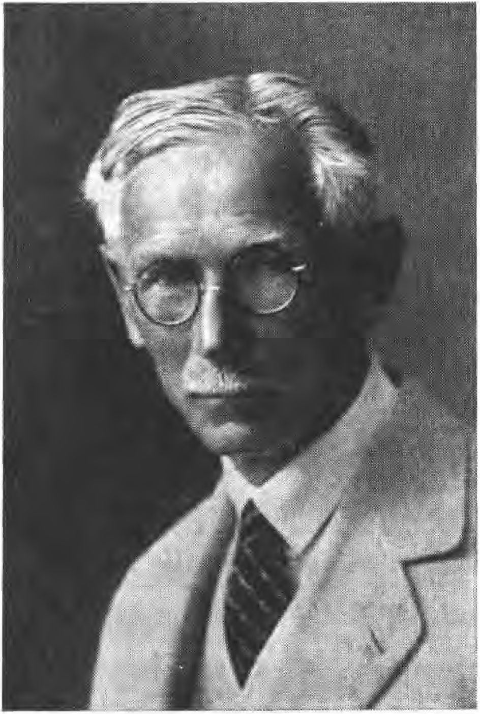

Saturday in Eichstätt. Would you, on my orders, visit the barracks in Eichstätt, arm yourself there and wait until I send you a report?"
"What are you up to, Baron?"
"I want to go to Bamberg and get permission there to set up Freikorps. Then you and the Echingen people will be the tribe of the new organizations."
115

"Give me the order in writing, and I will go back today." The order was made out in two copies, since Captain Römer wanted to send his brother to Eching by another route for the sake of security. It was then further agreed that the railroad station Treuchtlingen should be immediately beseht from Munich in order to secure the train to Eichstätt.
Sebottendorff appointed Lieutenant Kraus to occupy the Treuchtlingen junction, and he left on Wednesday morning. Kraus took some people with him who were selected from the Kampfbunde. His orders were to hold the station and to order the arriving troops to Eichstätt. He himself was to carry out immediate recruiting for the Freikorps to be formed there.
That same noon, First Lieutenant Kurz left for Bamberg with orders to await Sebottendorff's arrival there.
The departure of so many "railroad officials" had to be conspicuous,' but by clever dispositions it was possible to get all people out of Munich,* only Lieutenant Arndt was stopped because he looked too young for a railroad administrator, but he was cheeky enough to come back and leave with a new ticket as an assistant. On Wednesday, April 16, 1919, in the evening, almost all the people of the Kampfbund were on their way. It was now still necessary to secure the Thule. Kf and Deby undertook to move aside the Society's cartotheque, which was packed with Sebottendorff's papers and documents -er Thule in two military suitcases signed R. v. S.. Those who wanted to continue working voluntarily were informed that they would be endangered if it became known in Munich that Sebotten-orff was forming a Freikorps.
116

Countess Westarp, Johann Ott, Valentin Büchold and many others offered to continue working under Kf and Deby. While the last dispositions were being made, the former Republican guard Ritzler appeared and announced that an arrest order had been issued against Sebottendorff. The order could be withheld until 8 o'clock in the evening, then Sebottendorff was not to be found in -er Thule or in the apartment.
There was no time for Sebottendorff to stay longer in Munich, because the people in Eching and Treuchtlingen depended on him. Once again he urged caution, advised to work in different places, asked again to secure the suitcases immediately and left. At the Pension Doering he informed Baroness Mikusch and Miss Bierbaumer that they were in danger and asked them to pack everything they would need for a few days and to be at the Hotel "Deutscher Hof", where rooms had been reserved, by 7 o'clock at the latest.
Sebottendorff was known in the hotel "Deutscher Hof"," he informed the old house servant Siegfried that he had the name of a railroad administrator Kallenbach.
During the night, the hotel was searched twice by workers' guards," the room of the railroad administrator Kallenbach was passed by, but the two ladies were visited. Ms. Bierbaumer pretended to be a Communist who had just arrived from Hungary and was left in peace, and Baroness Mikusch was not bothered any further.
Since the train left at 6 o'clock in the morning, and sleep was out of the question after the last vifitation, the three decided that Sebottendorff should try to get to the station with his handbag and the ladies' luggage, and that the ladies should follow.
117

When he came down the stairs of the hotel with a bag in his hand, he saw that the vestibule was occupied. But already the servant came to meet him and said: "Yes, Mr. Railway Administrator, do you want to go to the station already?
"Yes, Siegfried, I already have to leave by train, my mother-in-law in Nuremberg is already dying and when I'm not there, I don't get anything."
"That's right, Mr. Railroad Administrator, L komm scho mit."
"But no, Siegfried, you have guests."
"These are not guests not, these are the gentlemen from -er Arbeiterwehr, -they are looking for a Sebotten-orff."
"A so, na -ann I wish you good luck, -aß Sie -en Kerl kriagn."
At the station everything was cordoned off, -the guards would not let anyone pass without permission from the station commander. While Sebottendorff was negotiating with the guard and showing his free pass, an official, a dispatcher, came into the hall. "You, Mr. Colleague," Sebottendorff called to him, "come here. Schauns, I have to go to Nuremberg today, -a is my ticket un- -the guard won't let me through."
"Yes, -the order doesn't apply -yet- to railroad officials, go let -a gentleman pass, -this is Za a colleague."
This is how Sebottendorff got to the hall, where he met the two ladies, -they had received tickets.
The train was very crowded, a large number of Red Guards were traveling to Augsburg, there was an excited atmosphere in the compartment, everyone was glad to be leaving Munich. Among the passengers was the editor of the Münchener Neuesten Nachrichten, Dr. Hohenstätter, with the
118

Sebottendorff and with whom he had another little adventure in Augsburg. The Aug did not go any further, everything had to get off in Augsburg. Only the four passengers wanted to get out of this place: Sebottendorff, who had his free ticket as a train administrator, the two ladies and Dr. Hohenstätter. The official advised them to wait in the restaurant at the train station," if there was a chance to let off an Aug, he would send word.
After that episode in the "Golden Lamb", Augsburg was a particularly dangerous place for Sebottendorff; he had to reckon with the fact that he was wanted and that the relevant authorities in Augsburg had already been informed. Fortunately, it did not take long before an official brought the news that "the ladies wanted their wagons back" and that an express train would be leaving in a few minutes. If the ladies wanted to go with them and the other gentleman, they would have to quickly get permission from the mayor. This also succeeded and at the last moment the three could just reach the departing Aug.
At Bamberg, Sebottendorff met with First Lieutenant Kurz, Seiffertieh was also there and worked to ensure that -the Council of Ministers was called together immediately and that Sebottendorff was able to make his report that same evening. Here, nothing was known yet of the battle at Dachau and of the escape of the government troops. That evening, the Council of Ministers decided to summon the Reich aid, the Freikorps Epp. It was especially Professor Stempfle, -who was very energetically in favor of -the Freikorps Epp. Sebotten-orff received the desired approval, which was issued by Minister Schneppenhorfl and the Lan-essol-atenrat on April 19, 1919. At the same time
119

The III Army Corps in Nuremberg was instructed to give him every encouragement.
Through a notary in Bamberg, copies were immediately taken and a sub-authorization was sent to Captain Römer, as were corresponding notifications to Regensburg, Würzburg and other places. On April 19, 1919, Sebottendorff then returned to Nuremberg and took up residence in the Hotel Fürstenhof, where he set up his headquarters.
Now it is still necessary to report about the Munich conditions, about things which are easily forgotten and which show what would have happened in Germany if Bolshevism had been victorious. It is quickly forgotten what terror and atrocities Munich had been subjected to at that time. Nowhere in Germany could a Räteherrschafi hold on for so long, nowhere could it intervene in life as it did in Munich.
As mentioned before, the city and a larger rural district formed a communist island in the country. The borders were manned by Red Guards, who controlled every entry and exit, not only of travelers, but also of goods.
The farmers in the areas not directly occupied by the Reds no longer delivered anything to Munich; the food shortage was unspeakable. Since little milk reached the city, children died in greater numbers. To a commission that complained to Levine-Nissen, the latter replied: "Why don't you let the bourgeois brats die; every child who dies in this way is one less enemy of the proletariat."
Under the pretext of having to search for smuggled goods, the workers' guards entered the houses and took away what was
120

they found. Hospices, hospitals, monasteries were systematically plundered. In order to let the mob loose on a house, it was enough to claim that there was hoarded food there.
In addition to food inspections, the citizenry was kept in fear by the constant arrest of hostages. Two reports of such incidents are reproduced here. Under 23 April ISIS, the Münchner Neuesten Nachrichten report:
At 6 a.m. on Easter Tuesday, a truck manned by 10 armed soldiers and workers appeared at the Bavaria ring to proceed to the arrest of hostages. They entered various houses and declared a total of 13 people, including the infirm and the elderly, under arrest. Some of the arrests were made in the crudest manner. The people could not show an arrest warrant, afterwards a soldier showed a strip of paper, signed by the revolutionary chairman of the district Westend of the contents: The Borzeiger is authorized to arrest hostages.
The selection of the persons was apparently made on the basis of an old address book, because the list also included a Chief Government Councillor von Grundherr, the later Police Commissioner, who had died in 1917. Among those arrested was a 68 year old student councilor, a private citizen with a nervous and bladder condition, a retired captain, a Protestant clergyman, a senior government councilor from the Berkehrsministerium. The latter had a pass from the people's representative paulukum, which placed him under the protection of the soviet government, forbade his arrest. The soldier's reply was brief: "We already know the hoax."
The hostages were transported to the Guldeinschule on an open truck in 2 degree cold weather and accommodated there in the unheated gymnasium. At 10 o'clock in the morning they were taken to the police station in Astallerstraße and locked up in two criminal cells. Although they had nothing to complain about in terms of treatment, they were subjected to wild threats of being shot, attacked, or even killed.
121

Listening to wall posts. A soldier explained that 1500 hostages were being held in Munich, who would be sent to meet the government troops as they approached. Late in the afternoon, the hostages learned of the presence of a member of the Enforcement Council. By bribing the post, the hostages managed to speak with him. He described the arrest as an act of high-handedness, and it was thanks to his intervention that the hostages were released in the evening. The last one to leave the cell was the Protestant priest. His release had been particularly resisted by the guards, with one soldier explaining: "You are a clergyman by profession, and the soviet government sees every clergyman as a dangerous person, since the church system is against the soviet government/" At Vr8 o'clock in the evening, however, the pastor was also set free.
The soldier's statement that 1400 or 1500 hostages were to be shot refers to a protocol -er Kommandantur, in which the motion was made and rejected by 6 votes to 7 that hostages should be rounded up on the Theresienwiese and shot down by machine guns when the government troops advanced.
A reminder of the hostage negotiations is reported by a transrhenane in the corps newspaper No. 2 of 1929:
"Among the various forms of government that Munich had to endure in those days, there was a so-called Central Council, which was divided into sub-organizations in which more or less dubious elements came together to lead the masses towards a life of beauty and dignity, while fishing a little in the mud themselves. These rulers did not feel quite safe on their thrones and felt the need to secure themselves against possible attacks. The appropriate means for this
122

seemed to them to be the capture of hostages from influential circles.
It was on a spring morning in the year 1919. We few over-aged active members with the certificate of maturity to the a. H. in the pocket, which we were not allowed to pull out, sat in the 'New Stock Exchange', there came from the president of the presidential corps the message, we should immediately meet for an a.o.S.L.. What we learned there was surprising enough. The Central Council had demanded hostages from the gun-carrying students of Munich....
The Peasants' Council had a flight of the best rooms in the hotel 'Bayerischer Hof', where they lived at the expense of the general public in a not very peasant way. Here we were let in and told that the Central Council would inevitably stick to its position and that the rumors of an imminent action by the student body would force it to take the announced measures."
The author, Mr. Max Schmitt, then reports on the negotiations and describes his trip to Stadelheim, where he was received by the later police chief Pöhner. He told him that he could not do much for the hostages, since he himself was under strict supervision, but that what could be done should be done. The reporter then enters the cell, where he finds four fellow students. During the evening meal together, he makes the acquaintance of the other hostages:
"One had to hand it to the gentlemen of the Central Council, they had shown sense and understanding for quality in the selection of these hostages. One could see in the table the commanding General von F., the General von L., the Colonel K. von Kr., the Reichsrat von A., the fanatically national thinking publisher Leh- mann and many other highly placed personalities whose names have slipped my mind over the years. These men had already been sitting in haste for 14 days without interruption...".
123

Who still remembers that Sontheimer gave a lecture with photographs to thousands of schoolchildren in the Munich Kindl halls, in which he explained how conception is prevented? Who remembers that in all the commandant's offices, in the guardrooms, women and girls were shamelessly prowling around and that, for example, in the Residenz the children watched the goings-on through the windows, that interrogations took place in which the interrogator had his girl on his lap!
At the beginning of April 1919 a lot of snow had fallen, until far into Easter the snow remained, why should it also be removed, it was sa nevertheless every third day strike.
Anyone who picked up posters dropped by airmen had to clean the lavatories in the barracks, schools and guardrooms as punishment.
When the money ran out, the safes in the banks were cleared out (see picture section p. 217, illustration below right). However, the gold from the Reichsbank and the Prussian Embassy could be brought to Berlin with the help of the Kampfbund, just as the Kampfbund succeeded in protecting the boxes stored in the Residenz from the Reds.
The streets were no longer cleaned at all. Yes, Munich had become a mess, figuratively and really. It was time to clean up the mess.
124

March of the Freikorps Oberland into Munich
On Easter Sunday 1919, Sebottendorff appeared at the commandant's office of the III Army Corps and presented his powers of attorney. In accordance with the arrangements already made, Eichstätt was designated the location of the Freikorps Oberland.
The government's order was;
By resolution of the Council of Ministers and the State Soldiers' Council, Rudolf von Sebottendorff is authorized to establish the Freikorps Oberland in Treuchtlingen.
Bamberg, April 19, 1919.
The National Council of Soldiers The Minister of Military. Affairs gez.Simon gez Schneppenhorst
Sebottendorff was assigned two paymasters for his staff. At the suggestion of First Lieutenant Kurz, Major Ritter von Bekh was obtained to take over the military command of the corps. An unpleasant matter was settled. The already mentioned Klöppel appeared and tried to get private money for the corps. He was taken into protective custody in Eichstätt at Sebottendorff's instigation until Munich was taken. The corps did not receive or take a penny of cash from private sources. Probably
125

but the headquarters accepted cigarettes and other gifts for the Freikorps.
After an office and an inn had still been rented, a visit was made in the afternoon to Nothenburg ob der Tauber, where a publicity meeting was to be held. However, the mayor at that time, Siebert, declared that such a meeting was unnecessary, he would do everything on his own. In fact, the influx from Nothenburg was the strongest and started already on Easter Tuesday. Lord Mayor Siebert had already worked valiantly ahead.
On the same day, advertising meetings were held and advertising offices set up in Ansbach and Gunzenhausen. The same was ordered in other towns on Easter Monday. The arriving volunteers were fed in the inn and those arriving by afternoon were sent off to the individual corps on the same day. Those who arrived in the afternoon could sleep in the inn, received a penny and after good rations were sent on the next day.
On Easter Tuesday, Sebottendorff visited Weißenburg and Treucht- lingen, where Kraus had had a very difficult time. He had set out without legitimacy, but had managed to hold on. He had created a troop of 1v men, had recruited and sent a whole lot of people to Eichstätt.
In Eichstätt, Sebottendorff informed Captain Nömer that Major von Bekh had assumed command and requested him to take charge until the Führer arrived.
Treuchtlingen was to be beseht from the corps," Lieutenant Kraus was to come to Nuremberg with his men. There, the service of the headquarters, which had set up as a central office
126

expanded. Not only were the recruitments to be carried out, but weapons were also to be transported to the countryside. In addition, there were special orders that Sebottendorff had to carry out.
The headquarters was organized in such a way that First Lieutenant Kurz had the office work and the personal service and Lieutenant Kraus the organization of the weapon transports. His faithful assistants were Lieutenant Karl Schwabe, Lieutenant Arndt, Lieutenant von Feilihsch. Chauffeur Schödel had the technical supervision of the vehicle fleet.
Major von Bekh had taken an adjutant named Kupfer and with him there were various clashes. He tried to send the people in Treuchtlingen to Eichstätt,* only after energetic objection he had to resign. Then he complained that the Oberland Corps received too few people, and that the headquarters sent more people to the other corps. As it turned out later, Kupfer did not like Sebottendorff's anti-Semitic attitude,* hence his trampling.
A third paymaster was assigned to the corps.
Bad news had come from Munich through a courier, Dr. Kummer, a member of the Teutonic Order,* it was going on there like in a pigeon coop, they were working quite openly against the soviet government. This news was confirmed by a courier from the Augsburg-Nuremberg machine factory. Sebottendorff was in Eichstätt when the Freikorps marched off on April 24, 1919, and broke down on the return trip shortly before Treuchtlingen. The station commander had an empty train stopped. Here Sebottendorff met the courier, who was carrying Reichert, a Red Army sub-leader, as a prisoner.
127

The courier had been in Marstallstraße in the morning and had met Kf there, who had laughed off his warnings and felt very safe.
The courier reported that at least 1VV free tickets had been issued that day and that the goings-on could not remain hidden for long, the Thule would have to blow up at any moment.
After Lieutenant Rudolf Heß had carried out the preliminary examination, Ott issued the tickets. However, Heß had also left today for the Regensburg Freikorps.
This news prompted Sebottendorff to send Prince Thurn und Taxis, who arrived the same evening with news, back to Munich with the order to urge caution and, above all, to ascertain whether the two military trunks had been taken away.
As fate would have it, the prince was unable to reach Munich the next day,* the train service was interrupted, he did not arrive in Munich until April 26, 1919, and by then the misfortune had already happened,* the prince himself was arrested in the Park Hotel. The office in the "Four Seasons" had been excavated, the secretary, Countess Westarp, had been taken away.
But the headquarters of the Freikorps Oberland did not hear about this.
On the afternoon of April 26, 1919, Sebottendorff received an urgent summons to appear at the commandant's office. There he was informed that the arrival of the Reich troops in Nuremberg had become known, that the Spartacus League intended to stage a putsch, and that gatherings in the streets could already be observed. Unfortunately, Bamberg had issued a specific order not to make use of weapons under any circumstances. The mob knew that. It comes
128

He said that Sebot- tendorff was the right man to reverse this order. He was to go to Bamberg immediately.
Arriving in Bamberg, despite the resistance of Schneppenhorst's adjutant, Major Paulus, succeeded in convincing the Council of Ministers that it was very dangerous to have an uprising in the rear of the marching troops, that thousands of lives could be saved by putting ten people against the wall.
With orders to fire in case of emergency during an attack, Sebottendorff returned at the right time, just as the troops were about to retreat in a harried manner.
The dispositions of the commander-in-chief, General von Möhl, to whom all Freikorps, all Prussian and Württemberg units, and the Epp Corps were subordinated, were such that the encirclement of Munich would have been completed on May 2. May 1 was not to be used for an attack because of the May Day celebration of the workers.
Since Zentrale Oberland still had to complete a weapons transport to Tölz, it set out on 2S. April ISIS to get to Rosenheim and Tölz via Ingolstadt, where weapons, hand grenades and blankets were to be taken over. Unfortunately, the troop was delayed by poor transportation and by the delayed staging at Ingolstadt- then a skirmish at Kolbermoor was added and so it did not arrive in Munich until May 3, where it learned of the gruesome murder of the seven Thule people and the shooting of the two hussars. Karl Stecher of the Kampfbund der Thule had been killed in the street fighting around Munich. The Zentrale Oberland took up residence in the rooms of the Thule- in the "Vier Jahreszeiten" also General von

12S

Epp had set up his quarters. The Freikorps Oberland had distinguished itself under Major von Bekh - it had entered the city from the Maximilia- neum, it had not had any losses. The Freikorps Oberland is the parent of today's S.A. Hochland and of the first German S.A. divisions ever.
The Freikorps CHLemgau, which was also served by the Zentrale Oberland, had been founded by the Oberamtmann R. Kanzler. The Bamberg government had given him authority to form it, and thanks to his energetic activity it was able to advance near Haar on April 27, taking and occupying the train station. This enabled the military command to finish enclosing Munich two days earlier, since it did not have to take the detour via Mühldorf^ Wasserburg. During this advance, Lieutenant Wiedemann, who had belonged to the Kampfbund der Thule until April 14, was killed.
The following is a brief account of the capture of Munich:
Due to the advance at Haar, the enclosure was already finished on 3V. April. May 1 was a day of rest - if the Red Army did not surrender, the attack was to take place on May 2. However, there was every probability that the Räteherrschafi would surrender.
The murder of the Thule people prevented the surrender and caused -that -the individual squads without comman-o started moving already on May 1 and in -er Sta-t itself -the organizations went over to the attack.
On May 2, the street fighting intensified, roof sheds were firing everywhere, many women took part in the fighting, the bitterness of the troops increased with the resistance put up. It succeeded
130

However, on that very day, to occupy most of the government buildings in Munich.
On Saturday, May 3, 1919, there was still fierce fighting in the station district,' on Sunday, May 4, the fighting subsided, but raids still occurred. The whole time until
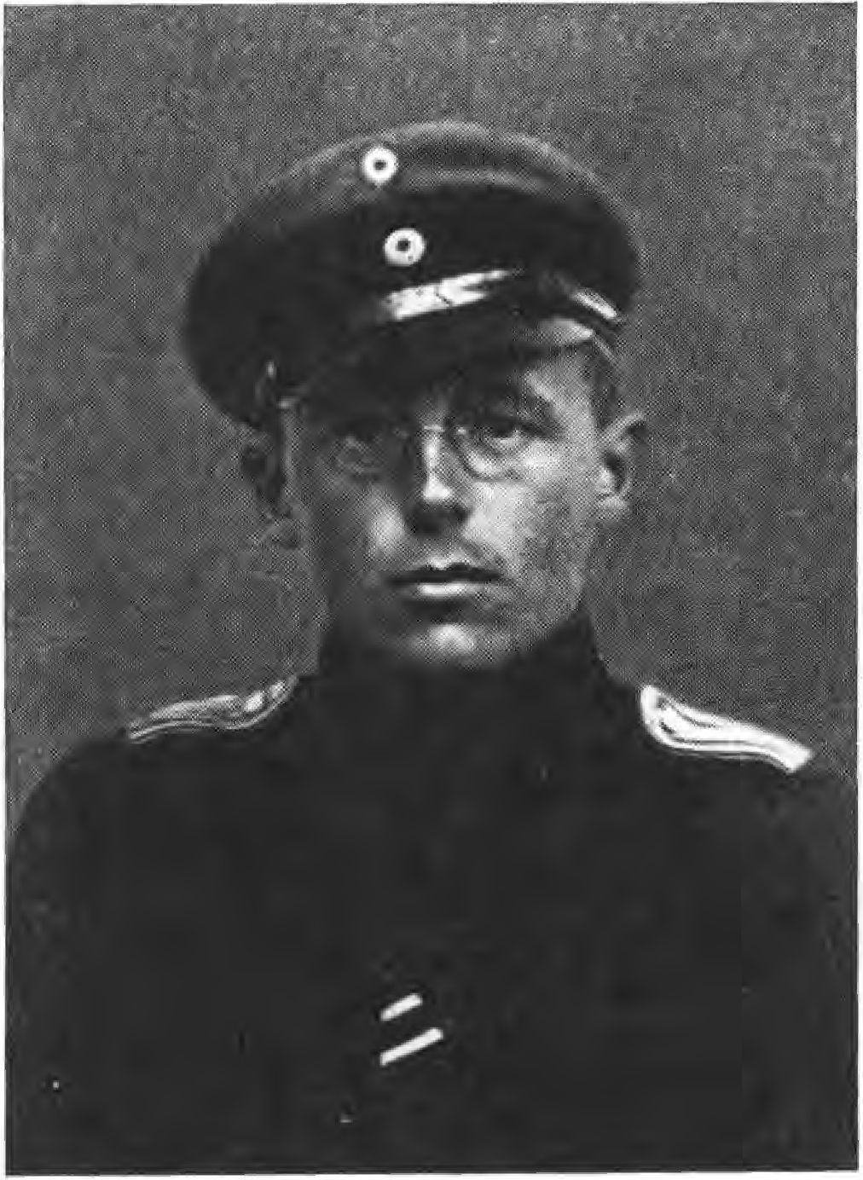

1V. May was very turbulent, almost every night there were attacks on patrols and pickets,' General von Epp was shot at from a rooftop scow,' fortunately the shot missed.
To avenge the murder of the Thule people, Sebottendorff immediately set up the intelligence department under Kraus. The three Jews Axelrod, Levien and Levine-Nissen were considered the main culprits.
131

Axelrod, it was soon determined, had fled with the support of the police president Mairgünther on April 29 - he was found on May 16 by an agent of the intelligence department of the Freikorps Oberland in the Achental with two companions, arrested by the state police and sentenced to 15 years in prison by the Standgericht Munich. On 2V. September 1919, the day on which the seven workers he seduced in Stadelheim gave up their forfeited lives, Axelrod was taken by the Hoffmann government in a first-class carriage to Berlin and extradited to the Russian soviet government. The Ebert-Scheidemann government had requested him and Hoffmann obeyed.
Levien managed to escape across the border. He was later arrested in Vienna, but not extradited. Levien is now an organizer in Soviet Russia.
The third, Levine-Nissen, was arrested by the headquarters intelligence service. Kraus had learned that the university professor Salz from Heidelberg had recommended Levine to the architect Zimmer. Zimmer had taken him to the art painter Schmitt, Schneckenburgerstrasse 2V, and the latter had endeavored to get Levine other identification papers. Kraus persuaded the police headquarters to hand over the identity papers to Schmitt and had Ott trace Zimmer. While Ott was following Zimmer's trail, Wihgall and Schädel arrived behind Ott in a commandeered car, who then informed Kraus where Schmitt had gone.
During this time Kraus had contacted Adjutant Kupfer of the Freikorps Oberland- but he had refused to take a position. Thereupon Lieutenant Kraus turned to
132

General von Epp, who immediately gave orders for people to be posted. At midnight the block of houses was surrounded. Only after much ringing was the house opened? Schmitt denied that there were any other people in the house besides himself, and when Kraus asked him point-blank about Levine, he replied scornfully, "You must know that better than I do." 3In the studio the cut-off beard and the head hair of the wanted man were found, Levine himself was brought down from the roof.
3In the house Ott found a large stock of new shoes, suits and other things, which came from thefts and confiscations.
The court martial sentenced Levine to death. The sentence was carried out.
Shortly after the invasion, Major von Bekh handed over the Freikorps Oberland to Major petri. The latter took over the transfer of the corps to the Reichswehr. 3Following a conversation Sebotten- -orff had with General Ritter von Epp, the general promised that the name of the Freikorps should live on in the first battalion -er Bayerische Schützenbriga-e. The corps later distinguished itself in the Ruhrkampf un- -ann in Silesia under Major Hora-am in the storming of -en Annaberg. Shortly before the disbandment, the city of Munich gave the Freikorps an honorary performance at the Gärtnertheater: "Die Fledermaus".
The Zentrale Oberland had been disbanded earlier, but before it disappeared, the Intelligence Department managed one more catch. Lieutenant Kraus, with the permission of the Italian authorities, was able to get the notorious Berlin Red Councilor Bu-itsch out of 3nnsbruck and hand him over to the Lüttwih Corps in Berlin.
13Z

But to follow the tragedy with the satyr play, it is reported that in the barracks yard of the Freikorps Oberland, Adjutant Kupfer solemnly burned the "Münchener Beobachter" and caused Sebottendorff to be reprimanded by the commander-in-chief for his anti-Semitic deeds. The letter stated that Sebotten-orff, by distributing the anti-Semitic Beobachter in the Freikorps, had violated the highest principle of keeping soldiers out of politics. In view of the great merits Sebotten-orff had acquired in -establishing -his organizations, it should be expected that he would no longer engage in anti-Semitic propaganda.
From -the employees of -the head office be as- given, what became known about their further life-er
Oberleutnant Kurz studied philology, received his doctorate and became a leader in -er S.S.
Lieutenant Kraus went to -the Baltic after -the disbandment, distinguished himself -there, belonged -to -the Berlin police un- was called to Munich at the instigation of -the police president pöhner to establish a force for special use. He is now a captain in the Green State Police.
Lieutenant Karl Schwabe is the famous African pilot.
Lieutenant pareus went through life adventuring - his book Schiggi-Schiggi bears witness to his deeds.
Karl Wihgall was killed in a car accident a few years later.
Johann Ott became publishing director at the "Münchener Beobachter, Verlag Franz Eher Bachs." in 1919, and is today a book reviewer.
Schö-el has a motorcycle factory in Erlangen.
134

X.

The Sacrifice Time of the Thule - Murder of the Thule People
As already mentioned, Sebottendorff's representatives in Marstallstraße continued to work diligently during his absence. However, they relied too much on the luck that had accompanied him. They also lacked the ability to jump into the breach when it mattered. In the period from April 18, 1919, until the abolition of the Thule by the revolutionary police, well over 5VV free tickets were issued - the departing people were entered in a list that was displayed in the large hall.
On April 26, 1919 in the afternoon, the police intervened and sent a detachment of workers' guards and some sailors to raid the Thule Society, i.e. the advertising office located in its premises. The only person found there was the secretary, Countess Westarp, who was interrogated, taken to the police station and released. During the interrogation, several people appeared, were questioned, and left.
First there was Griehl, who had arranged with Kf and Dietrich Eckart to meet in Thule to go to Sta-elheim. Griehl was detained for two hours, and since his name was not found in the list of deportees, he was released.
Eckart and Kf had arrived in the car and had thundered,
13Z

that something had happened, so they were able to escape. How much Kf underestimated the danger can be seen from the fact that on the same day he tried to open another office - he thought he could continue working. If he had not forgotten to take away the military cases in the office, nothing would have happened.
The company's landlord, Weber, and his wife were warned by the porter Sell when they entered the hallway, and they in turn were able to warn other members, such as Dannehl's niece, who appeared with a backpack of leaflets (see picture section p.209). She stated that she had made a mistake in the staircase, she wanted to go to the laundry. Through Dannehl, other members were warned. An officer who was working with Ott on issuing the free rides was also dismissed when he said that he had only come to smack the editor of the Beobachter because he was still sending him the smear sheet. The sailor regretted that the guy had not been caught and let the officer go.
From everything, especially from the dismissal of the countess at the police station, it is clear that they intended only the abolition of the advertising office and were satisfied with that. But now two circumstances arose that set other circles in motion.
The two military suitcases, the anti-Semitic posters and leaflets had been taken to the police headquarters, where Axelrod, the representative of the Russian Soviets, had seen them. He had now discovered the source of the anti-Semitic propaganda that was troubling him. And as the devil shuffles his game: on the same day the seed that had been sown sprouted. The Bavarian workers had had enough of the Iuden economy - in the council congress the councilors called Levien a "cursed Iuden angel," they called the "Zuden-
136

young" as a labor leader and forced him to resign from office. Levine-Nissen also had to resign. Both Iuden resigned from the V-llzugsrat, but were not yet powerless. In the War Ministry, their most intimate friend was Commander Egelhofer, to whom Seidel was directly subordinate, Commander of the Luitpoldgymnasium, where about 8VV Red Guards were assembled.
When Levien and Levine-Nissen learned through Axelrod about the anti-Semitic propaganda of the Thule, which they blamed for their failure, their plan was ready: the Thule people had to die. But since they could already judge the situation exactly on April 26th, the death of the Thule people had to bring them still the greatest possible reputation in their power psychosis. There was a danger that the soviet government and the Red Army would capitulate. If that happened, then of course nothing was won for them. There had to be a fight, blood had to flow - if the enemy brothers could not come together, there were still possibilities for them. If the Red Army did not come out to fight, they had to be forced to defend themselves - they had to bring the enemy to the point of attacking. This could be done if the blood of the citizens flowed just before the catastrophe. So the roles were distributed in this sense, Levien and Levine-Nissen took it upon themselves to secure the feft-taking Thule people and to bring the workers in the Luitpoldgymnasium who were destined for murder to the murder- Axelrod was to cause the announcement of the accomplished deed outside to the troops. The plan succeeded. Mehrer was ordered to draw up the arrest orders according to the lists found, and the city commander followed this order, which was issued by Egelhofer.
137

Seidel and his pack were set free, and it was only due to the fact that most of the Thule people had been warned and had been able to secure themselves that only seven were caught - which was a stroke of luck, because none of the more than two hundred members remained untraced. 3In every apartment there have been the henchmen. Lawyer Dahn escaped arrest only through the prudence of his landlord. Riemann, Gaubah, Griehl, in short all those found in the lists, were sought.
Riemann had warned the Countess some situation before the arrest; "Sister, it's highly political here now, this is not for a woman, we'll hold our heads, but stay away." She gave him in reply, "I am a German woman, I will do my duty." The day before the arrest, on April 25, Büchold had said to her, "Sister Heila, the air has been thick here since Sebottendorff left.... It would be best if you didn't come tomorrow, I don't trust the matter-I'm leaving after one of the marching Freikorps." Countess Westarp told this to Griehl, who also advised her to stay away if she was afraid-he himself had to go to Marstallstrasse the next morning, he wanted to excuse her. But out of a sense of duty, the Countess had gone to her work after all. After her second dismissal, she had come to her apartment to get some laundry - while preparing the evening meal, she was arrested for the third time and taken to the city commandant's office. The members of the Thule who were most blameless and therefore had not been warned were dragged here. They were: Walter Bauhaus and Walter Deike, who had been arrested in the Bauhaus apartment, Baron Seidlih, who had been taken from the studio, and
138

Captain Utsch," a little later Anton Daumenlang would be added.
While Utsch, who was not a member but still a guest of the Thule, was released after the interrogation, the others were taken to the police headquarters. But the most important thing at this interrogation conducted by Egelhofer was Levien, the Levien who had to resign from the prison council in the morning.
On that night of April 26-27, the diabolical plan to murder the Thule people began to take tangible shape. It was a diabolical plan, because it was aimed at regaining power through this murder, to hold on at any cost. And if the power could not be held, then blood had flowed. The perpetrators were, after all, Germans who murdered their brothers. And Levien knew how to treat the Germans Haber told Schicklhofer at the murder trial how enthusiastic he had been "about Levien's speeches". Levien's words still went from mouth to mouth and were believed: "Eye for eye, tooth for tooth, breast against breast, shot for shot, stab for stab."
Egelhofer wrote that poster which portrayed the captured Thule people as looters. This important link in the chain reads:
The reactionary thieves and looters in haste!
On Saturday, April 26, 1919 in the afternoon, a dangerous gang of criminals was arrested and taken into custody by the organs of the soviet government in the noble hotel "Four Seasons". They were all "ladies" and gentlemen of the so-called good society. A lieutenant and a countess were also among them.
These people imitated and forged military stamps and used them for thefts and looting on a grand scale, carrying out confiscations.
13S

They confiscated huge quantities of goods of all kinds and predatorily requisitioned livestock from farmers in the countryside.
These criminals are arch-reactionaries, agents and instigators for the white guards, agitators against the soviet republic, which ruthlessly attacks the racketeering and is therefore bloodily hated by the racketeers and war profiteers.
Of course, they shouted out the soviet republic as the instigator and perpetrator of these plunderings and thus found credence, because the plundered could not know that they were raped by the criminals with the help of forged stamps.
The name of Egelhofer was misused by falsifying his facsimile, the well-calculated intention was to obtain false identity papers in order to commit crimes in the name of Egelhofer and the government and thereby at the same time to enrich themselves and to make the council government contemptible and hateful.
The facsimile, the stamp with the name Egelhofer is invalid. Only the handwritten signature in ink is valid. Thus, the criminal and highly treasonous plan is thwarted and averted.
Munich, April 27, 1919 Egelhofer.
It was now necessary to bring the captured Thule people to the place where they could be reached by the murderers, to the Luitpold Gymnasium. This was the only place where the planned deed could be carried out," Seidel, who was in command there, picked up the prisoners at police headquarters and took them to the Gymnasium. The transport was on foot. Daumenlang tried to escape, but was caught up and beaten bloody.
The Thule people were locked in a cellar at night with other people imprisoned there, and during the day they had to peel potatoes. Countess Westarp was forced to clean the rooms and had to sleep in the guard's hiding place.
140

On April 28, 1919, the ring around Munich tightened and tightened, on the 29th Starnberg had already been taken after a short battle, Fürsienfeldbruck was in the hands of the government troops, it was time to go to the execution of the deed.
Axelrod fled that day with the help of the police chief Mairgünther, but the evening before a meeting of the three Jews took place in the Luitpoldgymnasium, which was followed by a nocturnal show of sacrifice. They descended into the cellar and viewed the Thule people there by candlelight.
They were joined by Prince Thurn und Taxis, whom Seidel had arrested at the Park Hotel.
On April 29, during a reconnaissance ride, Baron Teuchert had been captured by the Regensburg Freikorps, and since his name was on the lists of the Thule Society, he was taken to the Luitpoldgymnasium by the city commandant. Seven members of the Thule were now held there.
It was still necessary to awaken the beast and for this purpose the two White Guards, the two hussars who had been captured at the front, were used," the rabble was roused by spreading the most fantastic fairy tales. Seidel used threats to extort statements from the two hussars, which he immediately had printed and posted.
This is how the crime was prepared, this is how it was executed. In the morning of 3V. April 1919, in the morning 1v o'clock -the two hussars were put against the wall.
There may now be the two police announcements, the official report of the Hoffmann agency, a report from "Ein Jahr bayerischer Revolution im Bilde" (Photobericht Hoffmann) and the
141

Prosecution speech by the first prosecutor Hoffmann to follow, delivered at the murder trial.
Announcement 1.
The bestial act of deceived people (shooting of hostages in the Luitpoldgymnasium) must find its deserved atonement as soon as possible, the police headquarters considers it its most sacred duty to bring all those involved to their deserved punishment. In order to establish the facts of the case, all persons are requested to provide relevant information under threat of punishment. In particular, all soldiers who served under their commanders in the Luitpoldgymnasium are to be named, so that a uniform picture of these brutes can be created. Written or oral statements will be accepted daily at the Ettstrahe Police Building. Room 365.
Munich, May 3, 1919 The Chief of Police
Full neck.
Announcement 2.
The names of the hostages shot in the Luitpold Gymnasium have been established except for two members of the Guard Shooting Division. These are:
Walter Nauhaus from Munich.
Baron Karl von Teuchert from Regensburg.
Wilhelm von Seidlih from Munich.
Walter Deike from Munich.
Countess Heila von Westarp from Munich.
Prince Gustav Maria v. Thurn und Taxis from Munich.
Anton Daumenlang from Munich.
Professor Berger from Munich.
The public immediately receives the most accurate report on the murder through Hoffmann's official correspondence. It is perfectly established that the unfortunate hostages were shot without any prior interrogation. The two soldiers were
142

The remaining hostages were executed in the courtyard of the Luitpold Gymnasium between 4 and 5 o'clock in the afternoon. All the condemned, including Countess Westarp, behaved bravely and with dignity until the last moment. They were mowed down from behind, except for Baron von Teuchert, who faced death in an upright position. The gruesome head injuries in three victims were caused by rifle shots at close range. There was no mutilation of the executed. Individual robberies must have taken place during the night. The order to execute was given by the commandant Fritz Seidel from Lhemnitz and his deputy Willi Haußmann from Munich. It has not been established whether the two were acting on orders from the High Command. Willi Haußmann executed himself yesterday in his apartment at the very moment he was to be arrested. All other participants are being pursued in the strongest possible manner and every means is being used to arrest the culprits and bring them to justice.
Munich, May 4, 1919 Police Headquarters
Full neck.
The names of the men named with -en Thnle-Leuten are: Hussar corporal Fritz Linnenbrügger from Bielefeld, married. Hussar Walter Hin-orf from Weißenfels a. -Saale. Professor Derger from Munich, Jew.
Official account of Hoffmann's correspondence.
In the evening hours of April 30, the rumor spread like wildfire in Munich that hostages had been shot in the Luitpoldgymnasium and that they had been mutilated. The police headquarters, which at that time had been occupied by a few courageous officers of the military police after the departure of the communist police president Mairgünther, immediately took up the clarification of the facts about the shooting of the ten hostages under the direction of the police president Vollnhals. Early on May 1, the
143

Bodies were brought to the judicial-medical institute and detailed investigations were initiated to determine the bodies. Schillerstraße was completely under fire from the Spartacists, who had brought up two heavy machine guns and a cannon there, and it was impossible for the officials to get into the judicial-medical institute. The attempt was repeated several times during the night, and attempts were made to take the access road to Schiller Street with the weak forces available at the time. Since no reinforcements came from outside, it was not yet possible to advance. Then, in the morning hours, the Schillerstrasse was cleared. Immediately the agnosiations began. In the meantime, the facts of the case were recorded by a large number of witnesses. According to consistent statements, the shooting of the hostages took place as follows:
The hostages were locked up in the cellar overnight and two more soldiers of the Guards Rifle Division were brought in on April 28, whose names have not yet been determined. They were beaten and told that they would be shot. As a result, the mood among the hostages was very depressed, all the more so because the day before, the police headquarters, which was under communist direction, had brought in those arrested in the "Four Seasons", namely: Walter Nauhaus, Walter Deike, Max Aumiller, Heila von Westarp, Anton Daumenlang. These hostages had already been told at the police headquarters what fate they were facing. They were therefore in a terrible state of excitement. Chief Secretary Daumenlang wept bitterly and it made a shattering impression on everyone when he told them that he was completely innocent and did not know why he was here, he had a wife and child and wanted to be free. Daumenlang was covered in blood when he was brought in; he wanted to escape and had therefore been roughly maltreated. It seems that even then the intention was to shoot the hostages.
On April 30 in the morning 10 o'clock the two soldiers brought in by the Noten Garde, one of whom, as he told,
144

family man and resident of Berlin, while the second was a 19- to 20-year-old man, single, executed. The young soldier was terribly beaten and maltreated. The two soldiers were led into the courtyard, forced to stand against the wall, came under rifle fire and collapsed. The other hostages had to watch. It was certain that they would meet the same fate. The hostages wrote farewell letters and heard in the afternoon that Levien was supposed to be there. What he did there, nobody knows yet. Commandant Fritz Seidel now gave his deputy Willi Hausmann the order to select the hostages to be executed. Hausmann came to the hostages' room with a scribe and called out the individual names to the scribe as he saw fit. After picking eight, he took a red pencil, underlined the names and wrote: Shoot. The hostages were then brought into the courtyard and, at the sound of the alarm, about 200 soldiers gathered in the courtyard of the Luitpold Gymnasium, with 150 to 200 soldiers also looking out of the windows. In addition, in the courtyard stood 8 to 10 men, including soldiers, sailors and a civilian wearing a Krastfahrer leather jacket. The civilian was laughing and looking forward to the things to come. The victims stood huddled in a corner between two trees. In the courtyard stood the clerk and the houseman. It is also said that Seidel was downstairs in the beginning, but later went up before the execution and counted money for the wages in his office. Born in the guard, the soldiers played the harmonica.
Then the names were called and the murderers lined up about eight meters in front of the wall. Before that, the victims had to hand over all their valuables and letters to the soldier in command. The first victim was the head clerk Anton Daumenlang. He was shot from behind. He was praying. The shots fell irregularly and it is not proven whether a command was fired. Obersekretär Daumenlang was called a looter by the troops.
Who was the second to be shot, it was impossible to determine without any doubt.

145

could be determined. A shot was subsequently fired at the victim by the civilian, close to his head, shattering the top of his skull.
The third to be executed was Lieutenant von Teilchen, who refused to turn around, but stood upright and said to the soldiers, "Och look death in the eye."
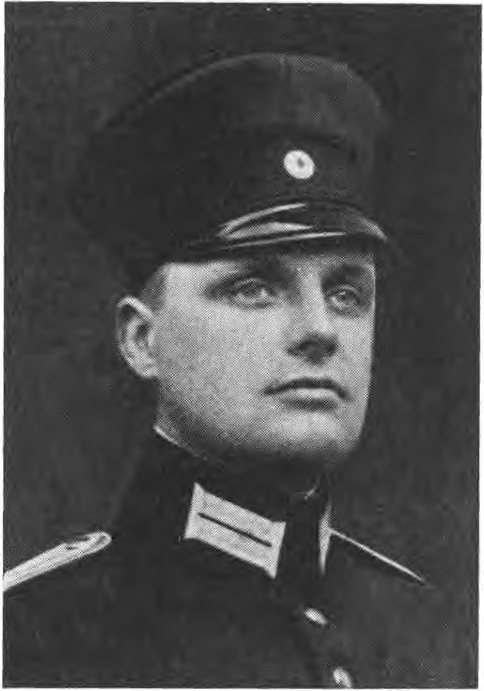

In the meantime, the Prince of Thurn and Taxis, since he said that he was not the Thurn and Taxis they were looking for, but someone else, was led aside again, since the soldiers expressly demanded that no innocent man should be killed. Seidel, who was sitting at his desk with a woman, merely said: "Away with it, with us there is no negotiating, either yes or no". Next to be shot was probably Professor Berger, probably also using dum-dum bullets, since his upper face neck was completely smashed. The fifth to be shot is probably Walter
146

Nauhaus was also shot from behind. The sixth to be murdered was Friedrich Wilhelm von Seidlitz.
The seventh victim was the Countess Westarp. She asked to be allowed to write. She was allowed to do so and wrote on the back of a soldier for about 10 to 15 minutes. She said to the soldiers: "I am innocent, don't make a corpse out of me". She gave the note to the scribe, took her face in her hands and, hit by several bullets, fell down on the other corpses. Prince Thurn und Taxis was the last to take his turn. He was very composed and calm and gave nock the order that if any of the other hostages were to be released, he should report it to the Park Hotel. Prince Thurn und Taxis must also have been hit by dum-dum bullets, since the upper part of his face was completely destroyed.
It is reported by an eyewitness that at about 4 o'clock a poster was put up in the Luitpoldgymnasium, on the back of which the following was written in pencil: "Shoot 22 people, but pick out the finest, gez. Egelhofer."
That the High Command gave the order is also evident from the farewell letter of Willi Haußmann, who had directed himself. The secretary of Egelhofer claims that Egelhofer knew nothing about it and also the other scribe states that Egelhofer, when he heard about the shooting, said with tears in his eyes: "I did not want that." So far it has not been proven how things are connected. One thing is certain: Seidel, Haußmann and consorts seem to have been of a quite animal crudeness and bestiality in character. The corpses were not mutilated, nor were they robbed by the soldiers. Probably during the night the victims were plundered by desecrators of corpses.
The news about the terrible deed spread in the city with lightning speed. It is due to this circumstance that the citizens armed themselves as one man and also small squads marched into the city and occupied the individual parts of the city earlier than it was in the military plan.
147

Nothing can be said about the court proceedings yet, the matter rests in the hands of the prosecutor. All perpetrators will be prosecuted and brought to the swiftest judgment.
The preliminary investigation and the trial, which began on September 1, 1919, revealed such a sum of disgusting crudity of the murderers that it cannot be reproduced. Also the pictures of the murdered cannot be brought for this reason,' they are horrifying. However, the investigation revealed a picture that deviates somewhat from the above description. It is contained in the book "Ein Jahr bayerischer Revolution im Bilde" (Photobericht Hoffmann).
The flag out! Let's go!
Four o'clock in the afternoon. The arrested are sitting in the hostage room. Some are reading, others are playing cards. Thumbelong wails for his wife and child. Then Haußmann comes with two scribes and dictates names to them. "First those of the Four Seasons." Hesselmann puts the groups together. "First those, then those, then those."
One suspects, it goes to the death. Only Professor Berger does not, he does not belong to the Thule people, on the contrary, he is a Jew.
The other companions of fate want to hold him back - but he pushes his way in, because he thinks it's about the interrogation. The guards reject him "You don't belong". But he does not leave, he pushes himself to death. Sentries come and pick up the first group. Ahead Thumb-long with folded hands. Meanwhile, the whole high school has become rebellious. When the procession of the doomed comes into the corridor, someone shouts into the rooms: "The flag out! Let's go!" and - what a devilish art of directing - one strides along with the blood-red flag behind the poor victims. The courtyard is teeming with soldiers. Six hundred, eight hundred are down there. They are looking for shooters.
148

Haußmann is human. The doomed are still allowed to write a few lines to their loved ones. Letters that never reached them. The second group is already brought into the courtyard. Among them is Countess Westarp.
"Sollermensch!" "Against the wall with the Hur!" cheers the Soldateska. "Let me live only one more hour," pleads the Countess, "don't make a corpse of me." A mercy is also granted to her, she is allowed to write a letter on the back of a scribe. Meanwhile, Daumenlang is the first to fall. Praying, he goes to his death.
Lieutenant von Teuchert and Nauhaus, bravely turning their faces to the murderers, follow.
Trembling in all her limbs, the Countess writes her farewell letter. The spectators become impatient. "She should take shorthand." "She belongs against the wall!" "It's over now!" Then a paramedic grabs her with a rough grip - the sign of the Red Cross on her arm - and drags her forward. Fainting, she collapses. She is given a few moments to recover. The alarm bells shrill, the sirens whistle: "Now comes the clou of the execution". Laughing "ladies" appear at the windows. People play accordions and dance. In the canteen, the waitress, that splendid figure from the Blood Gymnasium, is preparing the guests to the window. Everything is in great excitement.
The last group is brought in, including Prince Thurn und Taxis and the unsuspecting Professor Berger, who still believes he is being led to the interrogation. He is taken aback when he sees the corpses lying there. He wants to tear himself away. A few dozen hands claw at him and tear off half his beard, the old man.
Meanwhile, the countess has regained consciousness. For another moment she leans against a tree, she cries, then she goes resolutely and upright to the wall. Shots crackle. A bullet tears out the poor woman's heart.
At this moment, like help at the last moment, the adjutant from the War Ministry, the painter Seyler, appears. He
149

sees/ how they scramble for Professor Berger, whom he knows. But before he quite understands/ what is going on/ Berger is already standing against the wall. Shots crack!
Then Seyler rushes into the pile/ in which just Prince Thurn und Taxis proclaims his innocence: "I want to be interrogated again/ I am not the right one". Seyler snatches him out of the pile and runs with him into the grammar school. There he meets Seidel/ who himself is shaking in all his limbs.
"How dare you?... Who gave the order?... I am the adjutant from the Ministry of War!"
Seidel yells at him, "Make/ that you shirk/ with us the bullets are cheap today."
Seyler flees: "Not a moment longer in this hell".
Once again, Thurn und Taxis is led to Seidel, who must pay the wages.
"I don't have time now. How many have been shot?"
"Seven.
"Eight we must have."
A few minutes later, the prince falls.
The tension is released / one visits the dead. The countess is haunted by one in the face and lifts up her legs.
In a special room the shooters meet. There is extra wine and cigarettes. The accordion is still playing. It is ten o'clock. From the first floor a cheerful dance stomps up to the commandant's room. Seidel is finished with the pay. There has been a lot of work today.
And 60000 marks were left over from the wages. Seidel divided it for himself and others/ "It's refugee money"/ he says.
The prosecution speech, according to the text drafted by the First Public Prosecutor Heinz Hoffmann, reads, with the omission of the more unimportant statements:
"When one day the events of our time, with their gusto and roar and rage, will be history, then the great-grandchildren of the current
15V

The German people will be full of praise and wonder for the heroism and titanic strength with which they fought for four years against the overwhelming superiority of a world of enemies.
The battle is over, the war is lost.
But the most terrible of all wars, the fratricidal war, is tearing apart our poor fatherland, from which the horrors of war and the abominations and horrors of battle were kept away.
We are defeated. There our homeland becomes the scene also of the sad deed of that war succession from cowardly hiding place from everywhere and nowhere, which we Germans in our fatherland can find no comparison in the animal kingdom itself, for which we borrow the name abroad: Hyenas of the battlefield.
An act of this coinage of body snatching by such a light is subject to your condemnation. The hostage murder of April 30, 1919 in the Munich Luitpoldgymnasium."
The State Attorney now establishes the competence of the People's Court and its legality, which had been contested by various defense lawyers, and then continues:
"The act under condemnation was murder. No struggle was there where it happened. Completely defenseless people were slaughtered, and no semblance of justice surrounds the deed. Insurgents and murderous mobs carried it out and, on top of that, they did not even attempt to give the murder the appearance of justification. No proper interrogation, no ascertainment, no trace of real guilt, not the attempt of a conviction.
We don't give a damn about the tribunal," Commander Seidel said. There is no clearer way to express one's contempt for the law, and hostages were murdered, hostages from the citizenry, from the Reichswehr! Probably in the realization that a German word means to the German the epitome of the
151

Since the French are not able to express the necessary bloodlust, they invented, no, they borrowed the French word "bourgeoisie", since they lacked their own power of persuasion. To the real agitators and rabble-rousers this is probably the same as the beautiful word Boches means to the French.
With what a beautiful tone of voice did not the head of the Communist Party of Germany Westend Section pronounce this word here, the man who, as he himself says, is a man of radical phrase, who, while drinking a glass of liquor, twists the necks of hostages like cats, who takes on the honorable task of transporting corpses from the Gymnasium to the Isav, who puts up with the company of a Red Guard who comes along only to steal a robe from the corpses for his friend Hausknecht. Hyenas of the battlefield!
Gentlemen, you will perhaps be told a lot about the terrible danger of the Thule people. Mr. Liebknecht himself announced on Friday, not without a certain solemnity, that it was completely out of the question for him to want to claim the guilt of the dead, or even to claim that such guilt existed.
But in a trial that must be dedicated to the expiation of justice for the death of the murdered, what is the purpose of the errand on the alleged deeds of the living club brothers of the dead? And not even all hostages were Thule people!
Where is the man who, after these negotiations, would have the courage to speak of a death debt of the aged Professor Berger or of the Schutzmann Ries, who had already been dragged to the place of execution? Baron Teuchert, Prince Thurn and Taxis, Countess Westarp, Baron von Seidlitz have probably fallen victim to their nobility more than to their registration for Thule.
A diamond in our hands is the prince," said a Red Guardsman. As a prince and not as a Thuleman the prince has been arrested many times! Baron Teuchert was caught outside, not as a Thuleman! The countess proved to be innocent, even Egelhofer and Levien declared that. Also not the attitude appeared suspicious.
152

/Pick out the finest ones," was written on Egelhofer's murder paper to Seidel. Among the rabble-rousers of the Gymnasium, the Thule people were probably generally known as plunderers from the "Four Seasons," but what does that prove? What matters is that murder was committed. It depends on the murder.
There was no fight in the gymnasium, no semblance of authorization for human soldering. It was murder at the field kitchens, not at the front. The act was murder of the hostages.
Generally it was said that hostages would be shot! Whether guilty or innocent, that was as indifferent as the question, whether old or young, whether man or woman. For the immediate execution - and only this stands here for the judgment - just as indifferent as the question whether the Thule people were anti-Semites or whether Berger himself was a Jew.
On April 30, in the courtyard of the Gymnasium, the ghastly murder. In the place, which was built for the education of the youth to humanity. In the morning the two hussars, in the afternoon the other eight hostages! A pile of manure in the corner the place of execution! What brutality!
But had not the whole gymnasium at that time become a vile hell, where of dozens of human brains hardly one was not filled with a thought that had not to shun the light of day. The small sinners were the day thieves, who stole food and drink and clothing and wages, and whose whole zeal was directed toward doing no service. The others were eager to do their duty by stealing and plundering, as they understood it. Some of them were too lazy to go to the bourgeois, they stole in the high school itself.
O irony! One generally defends the gruff appearance of the commander and the sub-gods in the grammar school with the fact that their NCO tone was necessary to keep order among the masters to some extent. How much did these agitators not decry the capable German sergeant as a slave owner because of his tone!
153

Free people they promised to create and among themselves, there they need the barracks yard tone.
And who practiced this tone? It is of the highest interest, of psychological and criminal interest, to have a look at these gentlemen. The commander-in-chief, Egelhofer, came from the navy, a convict who had escaped from Cologne. Seidel was never a soldier. It is interesting to note that Mr. Seidel, at the very moment when he was commanding, because of broken nerves from his workplace, had faked - wanted to say requested - leave and that he admitted to having falsified pay slips. The world war has brought us this foreign power from the port of Trieft. Taken to prison, he immediately fell ill again and was transferred to the military hospital. Haußmann, the second in command had also stayed away from the work site for the sake of his nerves, pfister suffered a severe nervous breakdown on the morning of the shooting. Schicklhofer, the head platoon leader was coal trimmer, on many trips he has seen the world, has brought syphilis and love of alcohol, which threaten to destroy the body and mind gradually. Hesselmann, the head clerk representing the commandant, who walks around in a worn-out officer's coat, who has portrayed himself as a great film actor, here exposed as a marriage swindler, has a criminal record for theft in recidivism. Fehmer has a criminal record for vagrancy and was thus particularly suitable for the position of head of the care station. Vagrancy is the offense of the umbrella maker Huber. Völkl has been repeatedly punished for theft in case of recidivism. pürzer is a psychopath and even the commander's doorman, Schmittele, is fresh out of the field penal colony.
Truly a fabulous company to exercise command!
And gentlemen, a little statistics on the criminology of the case. Seven of the sixteen defendants are of illegitimate descent, two, Hesselmann and Schicklhofer, live in broken marriages, three are inferior psychopaths, the Egelhofer
154

one witness described as megalomaniac/ when the war broke out, of all the sixteen /heroes" only four were of age and twelve were minors.
What wonder/ if after this nevertheless the tops of the authorities with comprehensive selection/ if it went in the grammar school drunter and drüber. Everyone did/ what he wanted or more correctly said/ everyone did not/ what he did not want/ despite the barracks yard tone borrowed from the old fatherland.
Here belongs also the sergeant Schicklhofer/ who in touching modesty let himself be called only sergeant/ moving complaint/ that he and the others so often received invitations to the church consecrations/ and that he with his indispensability in the grammar school could not possibly follow these/ here belongs/ that the signatures of the leave certificates and slips were falsified by hundreds in the grammar school/ by people in the grammar school itself.
For the one who smells through the spectacles of night-black betrayal of the bourgeoisie in terms of plundering and counterfeiting/ the remark may be woven in that this society was truly man enough/ to commit all the black deeds itself in all forms.
What do the principal and pedell of the high school say? Nothing was certain! What does Hesselmann say? The chamber is stolen! Why does this high lord beloved resign her /honorary office" as a sister of the Red Cross at the desk? For the sake of a comradely moral crime. Crudeness over crudeness and crime!
A curious man from the Red Guard wants to see hostages, he is shown three noble pigs. This is what hostages look like". In any case, this crudeness clarified the origin of the fresh entrails found in the Blood Gymnasium, which in the initial excitement were mistaken for human parts.
The tone was rude! Slaps were handed out. The prisoners who were brought in were threatened with death from the beginning of their arrest. Their relatives, wives and children were told:
155

/It goes to death with them/ If one has them in the grammar school, everyone who thought he was entitled to open his mouth says:,Your life is forfeited, you are of death/.
The two hussars, the poor countess, the aged professor are treated crudely and meanly, they are shamelessly insulted and ridiculed until the sacred moment when they have to suffer the guiltless sacrificial death for their bourgeoisie. You old rascal," "you old whore," "you Soller man," these are the expressions that are hurled in their faces during their last walk!
There one can also make the acquaintance of the "ladies" to whom that scold referred in cheeky cynical meanness to a real lady. There were also "ladies" in the grammar school. If a witness is right, these noble ladies even crowded to the auditorium of the abominable deed. A fair wife shouts with joy: 'Mine is also joining in'. And what a noble representative of her sex the defendant Hannes portrays in the "lady" who exchanged her position as an artist for that of a communist waitress in the Luitpold Gymnasium. She animates her Hanns to shoot at her fellow sister, whom she does not know at all, who has never harmed her! And when he does not aim, she becomes clear in the real Soller style! What an abyss of crudeness!
Should one think that there is something even more horrible, even more atrocious to describe? But from the own mouth of that "lady" we hear even more inhuman. She goes to the kitchen to get her lunch and in passing, perhaps to make it taste better, she looks at the corpses of the poor murdered soldiers. She stands on the chair in the canteen so that she doesn't miss anything! Ia, she also looked at the corpses afterwards, this "lady". Corpses of which the experienced expert, who had worked in the field, testified that he had never seen anything more horrible!
The poor countess! Not in life and not in death did she have peace from her tormentors. They insulted her, they locked her in the cellar under death threats, they forced her to clean Mr. Schickelhofer's room under death threats! She becomes raw
156

interrupted: That's enough", when she wants to write her last letter, which never reached his address. She is dragged forward with a push, with foul language, and the dead woman - one is horrified by so much meanness - is lifted up by a brute by the legs, she is kicked and spat in the noble face. Truly a martyr!
The veil will never be lifted, where the suspicious care came from, which the gentlemen train conductors gave to the lady. They forced the countess, or as they said - they allowed her - to sleep in her room! Mr. Schicklhofer, of all people, the worshipper of Levien, hints at something horrible. He noticed that in the next room, to which he was also denied access, the poor countess was being interrogated behind closed doors! O poorest of the poor!
Another unfortunate man is still twitching in death, he receives a catch shot. Let him die, he doesn't need a mercy shot" are the words. Another is keen on the boots of the shot. What did I say earlier? From everywhere and nowhere hyenas of the battlefield, ghouls!
And now to the crime itself. With regard to the arrest and delivery, I can refer to the indictment, which was fully confirmed by the main hearing. I may already note here that in the correct assessment of the deeds I will follow the suggestion of the chairman, who regards the two shootings as a complex, each as a continuing crime of murder.
Once again I must emphasize with all urgency at this point, in the entire trial none of the dead has been proven to be really guilty. The solemn statement of Mr. Liebknecht, the lawyer, also stated this.
Why fratricide? The mood of the Red Guards was bloodthirsty; the agitators had not spared themselves with agitation in the meetings.
But one place in Munich was dangerous, the Luttpoldgymnasium.
157

Seidel with his radical people is to be feared, said those council formidables whom Seidel claims were his superiors.
In the case of the important prisoners, the management of the Luttpold Gymnasium prevailed after a fee, and even higher authorities ensured safe custody and, in the case of the selected victims, certain death. With the Schutzmannschaft students the beginning was made: Nies escaped death shortly before the scaffold. The Communist Jung, the dangerous man whose only crime was that he had opposed the madness of driving two thousand Munich workers to certain death, was the second type of dangerous prisoner, Reichswehr and the Thuleleute was the last and most important group.
Why now? This question was completely clarified in the main hearing. With cynical pharisaism a secret group of criminals wanted to keep their glory in the last days of the council. Lie was heaped upon lie, agitation upon agitation. Behind the scenes of this trial those foreign agitators and fomenters emerged and were exposed, how they incite more and more the instincts from stage to stage to bloodlust!
Seidel and Egelhofer are worshippers of Levien, his faithful, ready for any outrage.
Not different Haußmann!
Levien is present at that interrogation of the Thule people. Levine and Levien secretly visit the prisoners, especially the Thule people, quite secretly after criminal manner not betraying themselves!
Secret consultations and meetings take place in the Luitpoldgymnasium! And between interrogation and that nocturnal show of sacrifice lies that pharisaic systematic agitation which Hellen Fackelschein will bring into the corridors of the Gymnasium.
We have all experienced it here. First posters in the town: 'Looters will be shot!' 2a, in Miesbach a man was shot who was completely innocent, he was murdered because he was suspected of having betrayed the Red Guard, but his murder-
158

manure was made out to be a just punishment for plunder/ was so placarded!
Didn't the communist Seidel himself loot? The so-called confiscation of the five silver razors was plundering under presumption of an office/ which he did not have.
A leaflet was thrown into the city: /Reactionary thieves and looters, high-ranking counterfeiters and plunderers have been found!" This poster was not directed at Herr von Sebottendorff and not at anyone else/ who was not caught/ but it was bloodthirsty honor-cutting written on the head of the victims.
Greater perfidy has never been seen!
One slanders the most innocent one knows, the countess! Not the member of the Thulegesellschast - one wanted to kill the countess!
At that time, Mr. lawyer Sauter, one would not have doubted the nobility of the baron von Sebottendorff/ but would have struck in blocking print at the columns: One has also caught a baron!
The comrades were first armed against the looters. The infernal machine was loaded/ one needed only the fuse!
This one was the murder of the hussars! During their interrogation no one cared to know the truth. Seidel's revolver shot up and extorted the most shameless lies/ as one needed them for the agitation. Each crack of the revolver extorts a Ia and everything is neatly put down on paper, ordered by the commandant, Mr. Seidel, himself in the printing shop and brought out in the night as a leaflet - thrown as an inflammatory leaflet among the horrified Munich working people!
Thus the fire is instigated, the murder of the Thule people is prepared! Without doubt, the murder in the grammar school is based on this agitation. After the murder of the hussars, a civilian comes to Seidel and asks: "Do you have documents that the people who were shot were Noske's dogs and the murderers of Liebknecht? Only then does Mr. Seidel have the corpses examined for papers that would provide this evidence. But no such evidence is found. What abysmal abundance
15S

of hypocritical lying! And these people afterwards have the shameless impudence to smear their own people in mean lies: 'Our people were so crude, and so mean, that we could not ride before them, they have murdered, we would have prevented it!"
The prosecutor then went into detail about the individual defendants- in order to charge someone, he said, he required three conditions:
- That he was a Red Guardsman or otherwise, possibly with a gun, in high school-.
- that he was there at the time of the murder-
- that he had any direct or indirect relationship to the hostage killing.
He said the defense could not claim that he had dragged people into the dock with nothing to prove but a careless word.
Here, he said, only the crime itself was up for condemnation, and the defendants he had here were guilty. He then presented his motions.
On the 15th day of the trial, the court sentenced six of the defendants to death and the others to long prison terms.
Since the Ministry as a whole confirmed the verdict, the death sentences were carried out by firing squad in the courtyard of Stadelheim Prison.
If now, after 14 years, it is possible to speak openly about the murderers, it must be taken into account: The real murderers were those three Jews who held the power in their hands and wanted to keep it in -en hands. From their brain sprang the diabolical plan to destroy the opponents. The executors, the murderers were seduced victims.
16V

That would have been the way in which the lawyers Sauter and Liebknecht could have saved the heads of the murderers.
But the path was not viable; it would have exposed the ruling parties.
Thus one tried to construct a guilt of the Thule Society. To see Has clearly, one must take into account the agitation that took place after the capture of Munich against the founder of the Thule Society, Sebottendorff.
Again, only Jews were involved in this agitation. They had supplied the material that Liebknecht and Sauter used in the hostage murder trial.
The "Beobachter" would have published the following report on the hostage murder trial in No. 45 of September 17, 1919 (see picture section p.219):
The masterminds.
Long essays were written about it in other newspapers. We alone have remained silent until today, as probably no one else has done/ because for us everything was at stake, for us the question was decided whether we were ruthless truth fighters or conscienceless agitators. Again and again we had pointed out the connection between Iuda and Bolshevism, again and again we had opposed the fatal legend that the makers of the Munich and all other soviet republics had only been Iuden by chance, Iuden who fought for the brotherhood of man out of pure idealism and only took their way over corpses with pain. We were ridiculed as fools, or selfish motives were attributed to us for our enlightenment. Russia drowned in blood: the German workers did not believe it. Hungary turned into a smoking heap of ruins: the German workers did not want to see it. Arbitrariness and murder raced through Munich: people were still convulsively covering their eyes. But more and more threatening

161

more urgent arose the question: Who are the culprits in the death and misfortune of many thousands...?
But finally came the anxiously awaited hostage murder trial. It unrolled a shocking picture of abysmal meanness and diabolical baseness. The world stared spellbound at the horrific spectacle, and slowly, very slowly, with inescapable inner necessity, the threads came together in one point: Haußmann, Seidel and the much-maligned Egelhofer were only the executioner's servants. Two names, however, are, at the end of the evidence, illuminated with glaring helllight: Levien and Levine. And still a third one is drawn into their spell: Toller, the one who got off lightly. They were the players at whose hand the will-less puppets danced. They added calculating cruelty to murder. At their command the members of the Thule Society were consigned to death, at their command the victims were crammed like cattle for slaughter in a damp hole. They committed the atrocity which will cry to heaven as long as there are people of German blood: They have violated Heila von Westarp, the most innocent of all, ruined her physically and mentally, long before her bodily death. With infernal baseness they have atoned for their Asiatic lust and unforgiveness on her. A true luck that the martyred one died. Her life was broken, she would have dragged it in eternal infirmity.
And why did they do that? Remember, German worker: Not as punishment for alleged transgressions against the holy spirit of the soviet republic. They wanted to destroy and dishonor what was foreign to their nature, what was the only real obstacle to their lust for power: the German. As they spilled all noble blood in Russia and proceeded with unsparing harshness against everything non-Jewish in Hungary, so what still rightly bears the German name was to perish and degenerate....
1V2

XI.

The Thule Society after the hostage killing
The murdered members of the Thule Society were:
- Heila Countess von Westarp had joined the Thule Society in February ISIS and was employed as the second secretary. She was born in 1886 and had separated from her family to make a living through work. The Countess had taken an arts and crafts course, then worked as a herd-gardener, and had been satisfied and grateful when she got a modest job distributing bread cards. In January, the authorities learned that she was a countess and dismissed her for that reason.
- Walter Bauhaus was born on 2V. September 18S2 in Botscha- belo-Transvaal as the son of the mission superintendent there, had volunteered at the beginning of the war and was already very seriously wounded in the first battles in the West. When he was discharged in 1916 as healed but unfit for war, he entered Professor Wackerle's school in Berlin to train as a sculptor. In 1S17 he became acquainted with the Teutonic Order and came to Munich with Professor Wackerle.
- Walter Deike, the friend Bauhaus, was born in Magdeburg in 3year 18S4, he was also a war volunteer and was seriously wounded already in the first battles of 1914, he was to three-.
163

quarter incapacitated for work. Deike attended the School of Applied Arts in Munich - he had joined the Nauhaus Group in July 1918.
- Friedrich Wilhelm Freiherr von Seidlih was born in 1891 in Langen-Bielau (Silesia), he was a great-grandson of the famous general on horseback of Frederick the Great. He had also participated in the war from the beginning and had been wounded several times. He had been a member of the Thule since September 1918. Seidlih was a painter and an artist through and through. On social occasions he played the grand piano or harmonium masterfully.
Z. Anton Daumenlang, railroad superintendent, was born on September 16, 187V in Königshöfen, had married in 1898. He left a wife and a daughter. His hobbyhorse was heraldry and genealogy. He had joined the Thule in January 1919.
- Gustav Franz Maria Prinz von Thurn und Taxis was born in Dresden in 1888 and had joined the Thule Society without being a member. He had also fought in the campaign and had come to Nuremberg because he had already been arrested several times because of his status. He went back to Munich to warn the Thule.
- Franz Karl Freiherr von Teuchert was born on 2v.3uli 19VV in Marburg (Styria), joined the volunteer riflemen at the beginning of the war and came to Regensburg at the end of the war to study. He had joined the Regensburg Freikorps. He had joined the Thule in January 1919.
Needless to say, these seven Thule people knew what they were dying for and why they had to suffer death.
They probably fought for their lives as long as they had the hope 164

But when the time came for all hope to fade away, they all stood together proudly and uprightly in the face of the deceived workers whom they were to murder in the solde of Judah.
The Thule people were the first to die a sacrificial death for the swastika.
From the moment they saw Levien at the interrogation in the War Ministry, they knew that only a miracle could save them.
Death became a certainty when they saw the three Jews at that nightly sacrificial show. Already then they knew that death was decided and inevitable.
Another is to fall in fresh, happy battle, another is to wait for four days, when will the hour come?
When they affirmed that they were innocent, they meant the accusation of plunder they had been accused of.
They all knew very well what to expect, that the hatred with which Iuda persecuted them was boundless. Especially Nauhaus had no illusions, he was the oldest member and in many a conversation he had expressed that he would die in the Sielen. Deike also knew. If the painter Seyler, Egelhofer's adjutant in the War Ministry, testified that the two of them had behaved cowardly, then it was probably only a false impression; they both knew that they were in the clutches of the Jews.
The Countess was warned by Sebottendorff at her farewell, she said: "Are you running away, brother? Leave me in my place, if only to eat my earned bread." As late as April 25, the Countess expressed thoughts of death to Brother Griehl, and yet went to her work the next morning. On a walk home, when
165

one stood a-shooting together at the Siegestor, Seidlihr said, "Believe me, master, it will probably only become something of our movement if Iuda were to be carried away to put some of us against the wall." "And if we were there?" "God, then at least we'd know what for and why."
Thurn und Taxis was certainly not anti-Semitic in conviction, as fie the others had, he was somewhat soft and yet he set out to warn -the brothers. "I have a bill that protects me, and if, well then it is also not a pity, one knows -yet, for what."
No, the Thule people went upright un- consciously in -en To-, they died as Hel-en, as martyrs for their cause.
No one resisted, no one resisted when it came to the last course. Upright they offered themselves -en bullets -ar. Thumb-long praying, he still thought of wife and children, Bauhaus, Sei-lih and Teuchert turned their faces to the mortars. Deike, -the prince, -the countess died upright and dignified.
Ten determined men could have saved them, but they were not there and the one they secretly hoped for knew nothing. No message had been sent to him. He was too late, he could only avenge.
A common grave could not be prepared for the Thule people. Seidlih, Thurn und Taxis and Teuchert were buried in the family graves of the homeland. Deike and Bauhaus rest in a common grave. Two days after the funeral of Countess Heila, the funeral lodge took place in the Thule. The lectern was covered with a captured communist flag, and in place of the hammer and sickle, a nurse's hand held the swastika in the
166

white field, the swastika that adorned all the walls of the Lodge, for which the Thule people had gone to their deaths.
When Sebottendorff said in his speech that the sacrifice had not been in vain, -that -the movement would always and again draw new strength from this sacrifice, -it did not look as if this should prove true. Heavy internal struggles set in, -they -were supposed to prepare an en-e for the society. It had fulfilled its purpose, it had to pass away, -so that -that could become new, -that was already at -the threshold. A few weeks after Sebotten-orff's departure, A-olf Hitler entered -the rooms of -the Thule and took part in -its major campaign day, on -which, under Dannehl's leadership, the whole of Munich was covered with leaflets and sticky notes.
It was not yellowish matters alone that forced Sebotten-orff to leave, -they could have been overcome. He had given a large part of his and his wife's fortune to the movement, and it was impossible to maintain the three foundations he had established in the long term; his monthly income became smaller and smaller.
But -it was not -it was -the attack -of -the Iu-en, -the attack -of the Social-Democratic Party, -which forced him to leave. He was -er Green -er -er movement, he was vulnerable, he could be hit and he had to be hit.
There were two main reasons that led to these attacks. The first one was: it was necessary to break off the tip of the coming hostage murder trial by diverting the public attention through a settlement trial. This was the same maneuver, -which was later tried with luck -through -the staged feme-trials, in order to -distract -the public from -the financial channels.
167

The second reason was that the Iudenschafi, alarmed by anti-Semitic propaganda, wanted to withdraw financial support from the Social Democrats and join forces with the Independents. Sebottendorff received the first warning from Frankfurt am Main; it was then published in No. 291 of the "Deutsche Zeitung" Berlin of 1919. Iustizrat Timmermann, the syndic of the Staatsverein had taken the matter in hand. Negotiations were conducted by him about the subsidies with the independents in Weimar - they were about limiting the agitation of the anti-Semites if they should come to power. To this end, Iuda was ready to provide all monetary and other support. For the Social Democrats, therefore, there was a danger that this rich source of money would dry up if they did not act.
Munich, the main center of the movement, which was becoming dangerous, had to be seized, and here it was possible to seize it. They had collected "material" against Sebottendorff.
The first material had been collected by Hofrat Schülein, the brother of Geheimer Kommerzienrat Schülein.
Sebottendorff had attacked the Saphirwerke, in which Schülein and his brother had a stake, in the Beobachter. A negotiator offering money for a revocation had been put on the fresh fancy. Schülein had contacted the well-known lawyer Als- berg-Berlin and he was a friend of Liesbeth Seidler. Alsberg was financially interested in Sebottendorff, since the latter had withdrawn the administration of the Iuden's property when he married Mrs. Iffland, and Alsberg had tried to break up the marriage through the police councilor Heindl in Dresden, who was later a legation councilor in the Ministry of Foreign Affairs.
168

Sebottendorff had been reckless enough. He had never asked what came after that, but had acted as he thought right, not according to the law, but according to his conscience.
By an irrevocable general power of attorney, he had placed his and his wife's property in the hands of a baptized Jew who was a commercial judge and a relative by marriage. By this power of attorney he was put into receivership and later incapacitated for dissipation.
Sebottendorff had become a Turkish citizen in 1911 - he came from a bourgeois family, was born in Hoyers- werda and had been adopted according to Turkish law by a Baron Heinrich von Sebottendorff. This adoption, because it was not valid in Germany, had been repeated by the last two members of the Sebottendorff family. Siegmund Sebottendorff von der Rose had recognized him as a member of the family in Wiesbaden in 1914 and his wife had repeated the adoption by a Rotar in Baden-Baden after the death of her husband.
But these papers had fallen into the hands of the Bolsheviks, as had the homeland papers. During the capture of Munich, Auer's foster son, the well-known Social Democrat Buisson, had seized these papers and never returned them; they had been "stolen.
So here one could take hold. Under the title "Strange Stories", the "Münchener Post" published a pamphlet in which Sebottendorff was accused:
He was using a false name.
He had cowardly abandoned the Thule.
He had become a Turk to avoid military service.
169

He had collected funds and had not cleared them.
He was incapacitated.
This was done to force Sebottendorff to initiate the libel suit, they had even more arrows in their quiver.
Through the influence of the above-mentioned Schülein, who worked together with the commercial judge Spitzer, with the Iustizrat Timmermann, with the lawyer Alsberg-Derlin and the police councilor Heindl, a wonderful file had been brought together, which absolutely had to have a devastating effect. Then there was a scandal that had certainly pushed the hostage murder trial onto a different footing.
So off to the chase, Sebottendorff had to fall. He had to bring the libel suit. But he did not do them the favor. If those seven Thule people had sacrificed themselves for the idea, Sebottendorff had to sacrifice himself for the movement, he had to go, in order not to suffocate the tender plant. It would have been possible for him to prove his innocence, but the dust that the ruling parties would have raised would have covered everything, the Thule, the observer, the party would have been destroyed.
And what was the worst, one would have learned the names of the people who had collaborated, one could have attacked them too, hundreds of other existences would have been destroyed.
Iu his successor in the leadership of the Thule, Sebottendorff appointed the lawyer Hanns Dahn, who was confirmed by the Teutonic Order. Unfortunately, Dahn did not remain chairman for long, the opposition of the younger forced him to resign. Johannes Hering took his place.
170

XU.

The foundations from the Thule Society
The following emerged from the Thule Society and became independent: the German Workers' Association, later the German Workers' Party (D.A.P.) and the German Socialist Working Group, later the German Socialist Party (D.S.P.) with its organ; Münchener Beobachter, later Völkischer Beobachter.
At the Christmas meeting of 1918, the Ger- manen-Or-en decided on the following appeal to the German people. The appeal is published in the Allgemeine Ordens-Nachrichten No. 15, Iulmond des Einbulwinters 1918/19 (see picture section p. 295) and was released to the lodges for further distribution:
To the German People!
World War II, upheaval and turmoil are behind us! Through misery, blood and humiliation we have waded and still everything has remained the same, sa, worse than before it threatens to become. Only the form of government and the leading men have changed, but capitalism and Jewry will raise their heads higher than ever under democracy. As before, you, German people, will be sucked dry, overgrown and condemned to toil and sorrow. How is that and shall it remain so forever? The reason of the failure lies in the fact that the struggle against those two powers has been waged separately so far. Both of them find themselves closely coupled.
171

The social democracy fights only a sham fight against capitalism, because its leaders are Iudes and capitalists!
But the Judaizers fight in vain against Judaism, because they stand on the ground of the capitalist state order, so both fronts had to collapse.
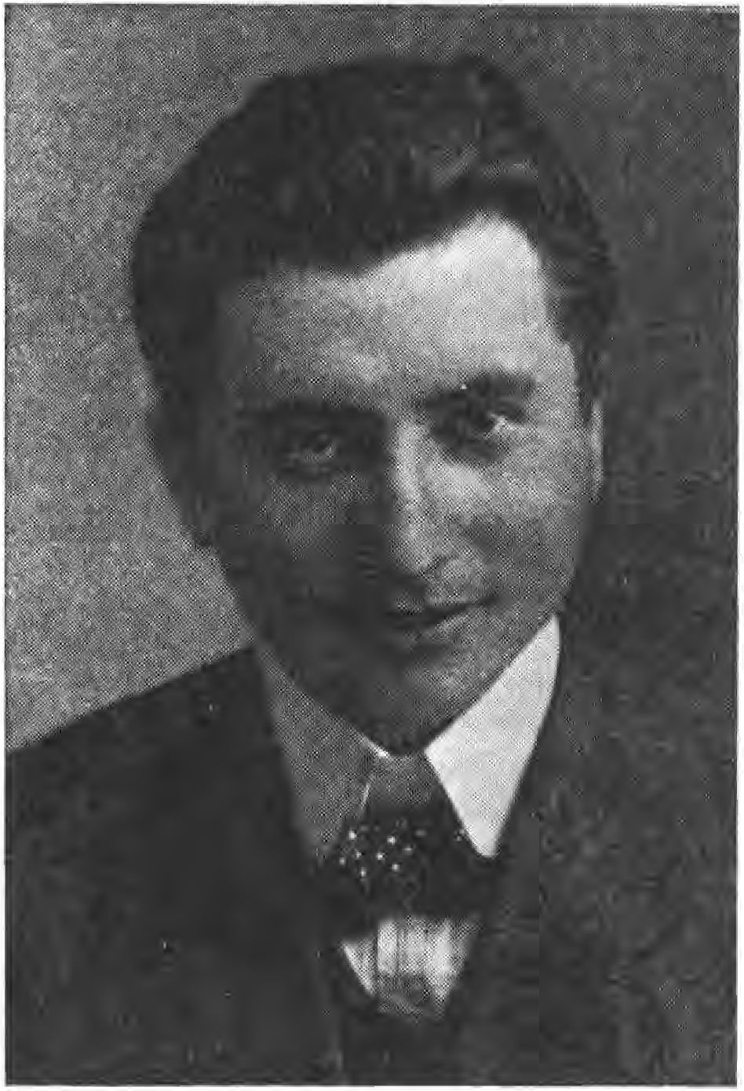

Here change and finally to create real freedom for the German people is to form a German Socialist Party.
German national and socialist.
Lassalle, the founder of German Social Democracy, as a Jew must have known his wet comrades when he said: "A people's movement has to keep itself pure from capitalists and Iudes, where these appear as leaders and guides they also pursue their own purposes.
172

The new socialist party accepts only German-born men. Of course, it stands on the ground of political transformation - it will not shake democracy at first, but it does not want a democracy according to the Western model with a Southern plutocratic top, but a free people's state in which capitalism and Judaism are overcome.
Pure parliamentarism, in which the executive power lies solely with the deputies, is not sufficient for her, but she demands a referendum for fundamental new laws in order to eliminate the danger of party mismanagement.
The new party is not content with sham reforms. It goes to the root of the national and social misery.
Such reforms have so far been hindered by -capitalism and -Judaism. All our parties were more or less consciously or unconsciously drag carriers of one or the other, or even of both powers. That is the reason why up to now all the work was useless and gave birth only to sham reforms. The new party knows no considerations, but it is absolutely uncapitalistic and pure. It is guided solely by the welfare of the whole and strives for a far more equal distribution of the goods of life and for the recovery and revival of the German people, who have been so badly hit. But the new is not to be achieved by a new overthrow and sudden change, for that always leads to the opposite of what is intended, but in a legal way through the gradual dismantling of what has gone before and the building up of the new.
The root cause of our misery lies in our wrong land legislation, in our social law and in our monetary system.
173

Accordingly, we call for
- Free land, since the cancerous damage of the national economy as well as of the domestic and industrial economy, also of the individual people's comrade lies in the basic burden. The indebtedness of the German earth (before the war 1VV billion) has all social and economic evils in its wake: tenements, housing misery, infant mortality, national epidemics, poverty, crime, mobbing and national disintegration.
This is to be remedied by declaring German soil to be state property over and above ownership, i.e. -the sale of land from private hand to private hand is excluded in the future. The soil loses its character as a commodity. A commodity is characterized by the fact that it is replaceable. Land, however, is irreplaceable. Whoever wants to or has to sell it, can only do so to the municipality. The municipality gives the land to the interested parties on a temporary or hereditary lease. Then, in the future, the land may no longer be used to raise capital. It is declared to be ""chargeable. Accordingly, the personal credit is to be raised compared to the current real credit. All current mortgages, if they are not already so, are to be declared non-cancelable, short-term redemption mortgages, with a reduction of the interest rate. In this way, the German soil will gradually be liberated and a truly generous settlement achieved. Even the simplest man will again be able to live on his own land, in his own little house. The origin of ttberkapita- lism lies in the previous free saleability and resilience of the soil. With free soil there is no ubercapitalism.
- Replacement of the previous Roman law by a German common law. Our present-day Boenrecht is based on the
174

Roman rights, therefore find all damages of our public life legal damages. The Roman law was introduced 4VV years ago by the princes and the high clergy - in vain the people resisted against it, well feeling -that with -the foreign law -the ground under -their feet and our rights were taken away from them. The Peasants' Wars, the first social uprising, was a bloody struggle against foreign law. Again and again, the peasants demanded the restoration of the old German law.
Today we raise again the same demand, it is up to you, you German people, that it does not go unheard again. This question is more important than it may seem to most, it is the pivot of our future existence and existence. The Roman law has arisen at the time of the declining Rome, flooded by Iudes, it is antisocial and protects private profit at the expense of the community. It is a right of -the cunning and -the clever. On -this un-German legal board -the German -is always inferior to -the Iu-en. Facts prove -what has been said. Therefore, -the German people must be given a right according to its nature and its attitude, -which corresponds to -the old basic principle of public interest before self-interest. The deeply ingrained greed, dishonesty, immorality, which are spreading in trade and commerce, the corruption of our people can be traced back to Roman law, as well as the growth of our economy into a pronounced interest economy, which has brought war and the misery of the last years to the world under the leadership of the Southern monarchs.
- Nationalization of the money system. Our money system is in the hands of private, especially private and other inter
175

national people. This is an absurdity in itself, since money is the blood of the national people. The state as a representative of the people can only really govern if it has the power of disposal over money and monetary system. Today also the money is to its purpose, a comfortable means of exchange between work and wage, commodity.
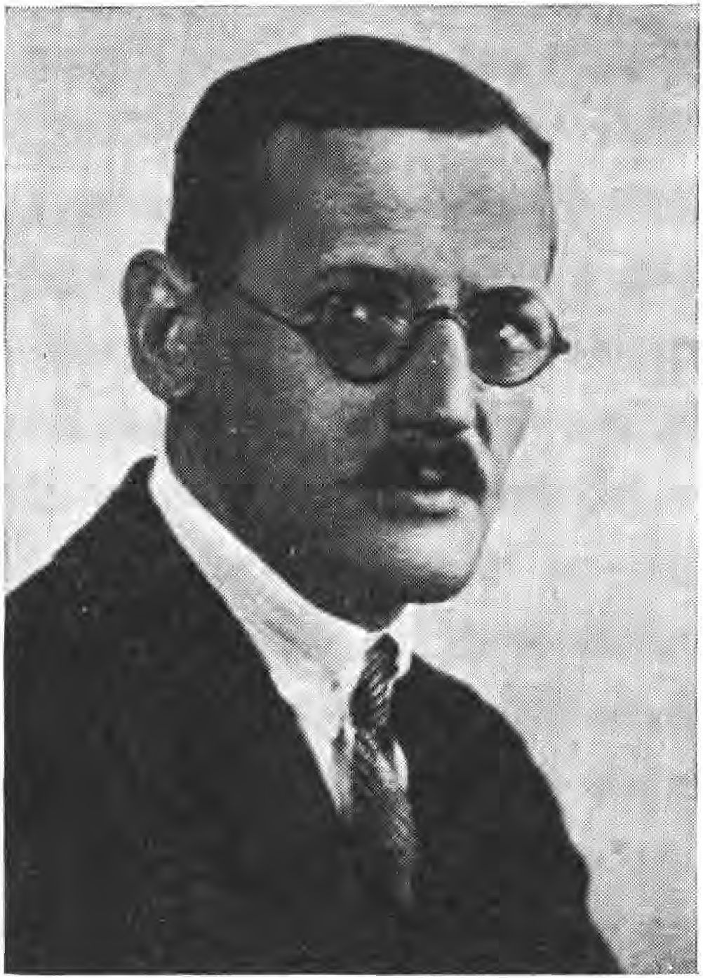

and purchase price, between producer and consumer, has been alienated and withdrawn. The money serves today to make money again and again by bank and stock exchange maneuvers, without real work.
For the majority of our people, who live from work, money is still nothing but a means of exchange, there is no reason to use it for a rapacious small part of capitalists and speculators.
176

lants to be degraded to an unhealthy means of enrichment at the expense of the creating people. Only real work should be rewarded and paid for.
Our real savings and credit institutions must become the nationalized banks, with the elimination of huge profits for the shareholders, as well as princely salaries for the directors and royalties for the supervisory boards. Newly founded banks and enterprises are to be examined by the Reich Economic Council, which we demand, with regard to the real need and the welfare of the community. Future borrowing capacity will no longer extend to things, but to persons. It follows from this that business will be based, as in the past, on the efficiency, solidity and respectability of the individual, which will bring the necessary calm and organic growth to our economy.
The stock exchange game is excluded as useless and harmful, since -er Han-el with values is forbidden. Our currency is to be formed anew. The eternal interest, which has as a prerequisite the immoral interpretation of the immortality of capital cleverly devised by its inventors and guardians, will be replaced by an interest service gradually replacing capital. This would put an end, once and for all, to the Oriental slavishness.
These are the three main points and the three main demands of the new party. Through this, the unresolved issues of uber-capitalism and Semitism will be decided for the good of the whole.
Whoever is born of German blood and recognizes these demands and statements belongs to us, but whoever does not want to see, un- thereby supports the present system of overgrowth, or whoever is too simple-minded, may quietly remain with his party.

177

The victory of our thoughts is certain, as truth always triumphs over deception and lies! The economy of interests will collapse, people will come together for a natural life in the sense of a happy community in love for their ancestral people. Further conclusions, which result analogously on the direction of the three main demands, are:
- Gradual transformation of our economy in such a way that it becomes a real national economy.
- Pruning our large landholdings se according to the yield capacity of individual landscapes for the purpose of settlement. State domains are to be divided up, Sdländereien to be settled.
- An equitable distribution of taxes that limits the creation of mer- capitals.
- We must organize our trade according to the natural principle that goods should take the cheapest and shortest route from the producer to the consumer. Without the elimination of honest intermediary trade, all unnecessary intermediaries, which only somehow cause avoidable profit mark-ups and lead to an increase in the price of the goods, must disappear. Our necessities of life, especially food, do not need to be enriched by non-baptized people.
- In the case of far-reaching fundamental laws and constitutional amendments, parliament has only an advisory vote, while the people have the decisive vote by casting their yes or no ballots.
S. Creation of a Reich Economic Council, which sets the measure and goal of our entire economy according to further points of view. It shall be guided solely by the welfare of the country. The men of this office no capitalists and Iuden must be
178

have been in practical life and have distinguished themselves in service to the community.
1V. Creation of a truly independent German press. In view of the fact that our press is SO 0/0 in Jewish-capitalist hands, for the most part run by Jews and dependent on large Jewish advertisers, a fundamental change is necessary. Today the press does not reflect the mood of the people, but the mood is artificially created for the satisfaction of selfish plans of the capitalists and Jews, without the people being able to recognize these plans. We demand: Only a company that is German and whose managers are Germans may call itself a German newspaper. Newspapers where these conditions do not apply, find to be called Jewish at the head of the newspaper.
- Fundamental change in the position of the Germans toward the Jews. Examination of the laws and religion of the Jews. Today's civic equality is based on the erroneous view that this question is a matter of religious difference. Research and proven facts today leave no doubt that the Jewish question is a racial question which has nothing to do with religious belief. It is a matter of the question: Do we German comrades want to allow ourselves to be dominated in the future politically, economically and spiritually by a vanishing minority of a people foreign to our race, which consciously feels itself to be such, and which keeps itself deliberately blood-pure and aloof by law and religion, which flow together in the case of the Jews? This is a matter of our honor, the more so as it is evident to the simplest man today that the innate imperiousness and rapacity of the Jew has a destructive effect on every people.
179

We demand: The new Germany to the German, not to the Iuden! The Iuden are by all means a foreign people, they should enjoy the shoe of the state, its benefits, but no longer have the right to be representatives, leaders, teachers of the people. The Jewish people can send representatives to the German Parliament according to their number of heads. The Jewish people includes the baptized and the half-breeds.
- Shoe the German worker against foreign laborers who depress the wages and standard of living of the German worker.
More generally, our national economy must be managed in such a way that we can be as self-sustaining as possible.
The focus of all our politics, administration and economy must no longer be on goods, as it has been up to now, but on the German people. Our nationality is our wealth.
We do not want to become richer and richer in money and earthly luxuries, which only benefit a small part of the population, but we want to be rich in satisfied, strong people who have a secure livelihood and live on their own land. Through these principles and demands, which are represented by our party and which are free of any ties and paternalism, it will be possible to finally defeat the economy of interests and the idols, which still devour the peoples and lead to their ruin. After the implementation of our demands, already after the first "gradual" dismantling of the present interest economy, a sigh of relief would go through the German people. In place of the few, who collected more and more treasures, and the many, who had to toil all their lives, there would be a more equal distribution of all goods of life.
180

poverty and unemployment would also be banished, honesty and modesty would push appearance, deceit and cunning into the background. Our high land prices, the rising rents, -the ever more expensive living, all the self-evident consequences of -the interest economy, would fall of their own accord, the
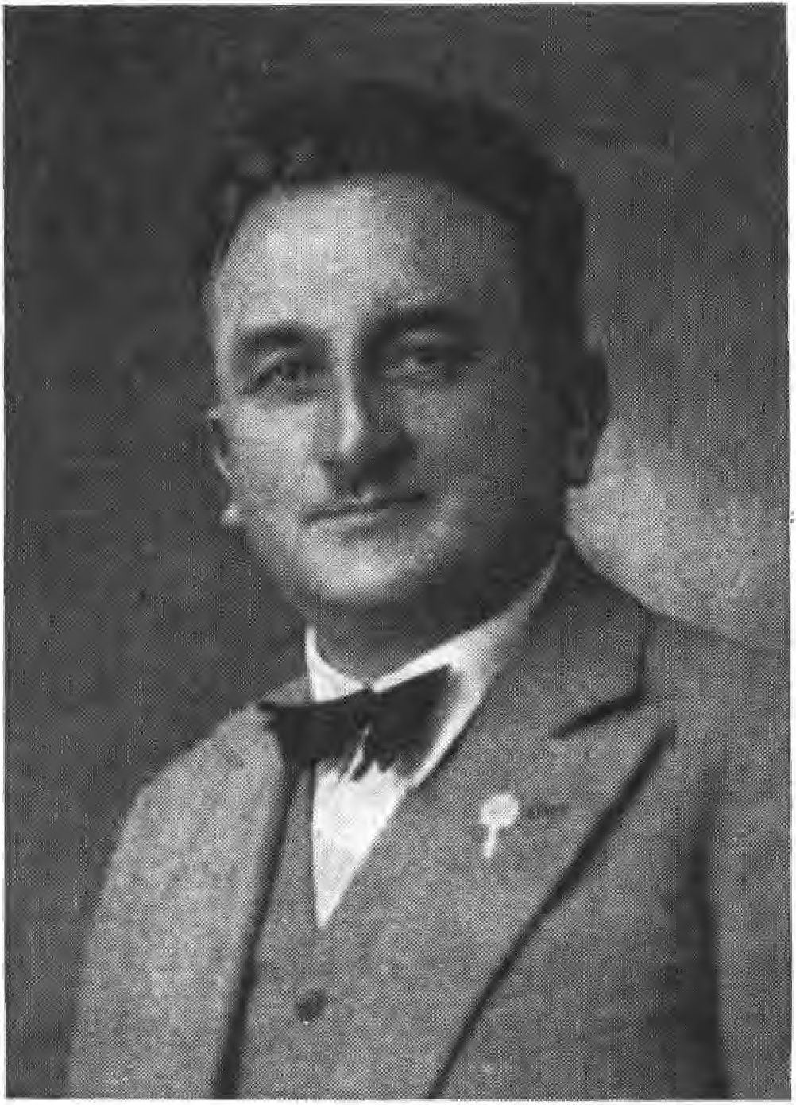

National wealth would be properly and justly distributed and not, as hitherto, accumulate in the hands of the unscrupulous. Our whole life would be simplified, cheapened and beautified,* and in place of haste, excitement and eternal worries, calm, contentment and steadiness would again enter the hearts of the sorely tried German people.
The German Socialist Party is a party of capitalist
181

weak strata of the people, i.e. -workers, civil servants, clerks, craftsmen, small tradesmen and farmers, -teachers, clerks, technicians. Those who see things clearly will join us without hesitation. False Iude socialism and -the interest economy must evaporate like chaff before the wind." -
The guidelines of -the Grand Lodge were discussed with Harrer soon after -the return of Sebotten-orff. Harrer was against calling the movement a party. He thought that it would attract too much attention from -their opponents, and that less attention would be paid to a workers' association. Harrer continued to lead the workers' association and moved its headquarters to Herrnstrasse.
The events of Eisner's death limited the political work during this period. After the return of orderly conditions, the Beobachter appeared again on 1V. May 1919 with No. 15 of the Beobachter. Around the same time, the Deutsch-Sozialistische Arbeitsgemeinschaft was founded, later Deutsch-Sozialistische Partei, whose organ became the Beobachter. The political program is published in the Beobachter No. 18 of May 31, 1919. In -this period, -the D.S.P. also -established relations with the "National Socialist Party" of Austria. On August 9 of the same year, in addition to the "Münchener Beobachter", the newspaper appeared for the first time as a Reich edition with the title: "Völkischer Beobachter" with a total circulation of 1VVVV copies - already on October 4, 1919, with No. 5V, a circulation of 17800 copies with a volume of eight pages and twice-weekly publication was reached.
The chairman of the German Socialist Party was Hans Georg Grassinger. The office of the D.S.P. was located at Thierschstr. 15 (Verlag Franz Eher Nachf.). The Deutsch-Sozialistische Partei was founded in
182

The "Münchener Beobachter" and "Völkischer Beobachter" newspapers were active propagandists for the movement. The "Münchener Beobachter" was distributed in Munich, the "Völkischer Beobachter" in the Reich. The "Völkischer Beobachter" imparted the basic National Socialist knowledge to many baptized by fighters. Despite the great risk, the newspaper managed to appear even during -the general strike that the Kapp putsch resulted in (March 1920)," it was set and printed at that time in a different location by Grassinger with the editors Sesselmann, Müller, Wieser and Laforee.
Important personalities, who later stood and still stand in leading positions in the N.S.D.A.P., were members and co-workers of Thule, the newspaper and -er party. Harrer of -er D.A.P. was also an employee of the "Beobachter." Karl Harrer died in Munich on September 6, 1926, as a result of a serious war wound he had sustained on -er Western Front.
When, in the fall of 1919, it was no longer possible to print the Beobachter's circulation on high-speed presses at the I. G. Weiß printing works, Graffinger negotiated with a number of large printers to take over the printing of the newspaper on a rotary press, but, with the exception of M. Müller K Sohn, the other companies refused to print the Beobachter. Since October 14, 1919, starting with No. 53, the Beobachter has been printed by M. Müller ö Sohn.
It is not uninteresting that Drexler wrote his first political pamphlet "Mein politisches Erwachen, aus -em Tagebuch eines -rutschen sozialistischen Arbeiters" (this is presumably the same pamphlet that Adolf Hitler used in his book "Mein Kampf", published by Franz Eher Nachf. in Munich, when describing his political awakening).
183

of his first meeting with the German Workers' Party), dedicated Karl Harrer as "the founder of the German Workers' Party and tireless fighter for justice and truth" (the writing appeared ISIS in the Deutscher Volksverlag, Munich).
At first, the German Workers' Party did not gain any greater influence and remained confined mainly to Munich. Only when, by that fateful coincidence, Adolf Hitler entered the then still thin ranks of the party in the fall of ISIS, came the turning point that acquired great historical significance for the entire German people.
But the first lecture evening of the German Workers' Party is reported by the "Völkischer Beobachter" in Rr.55 of October 22 ISIS:
From the movement.
The Munich branch of the D.A.P. (German Workers' Party) held a lecture evening on Thursday, October 16, in the hall of the Hofbräukeller, which was attended by a very good number of people and was calm and stimulating. Because the speaker was unable to attend, Dr. Erich Kühn, editor of the monthly magazine "Deutschlands Erneuerung" (Germany's Renewal), spoke on the topic: "The Jewish Question - a German Question". In his introductory remarks, the chairman warned against allowing the anti-Semitic question to become a fashionable issue and explained the urgent necessity for each individual to try to penetrate as deeply as possible into the Jewish question in order to be able to lend weight to the anti-Semitic conviction through his own clear insight and to resort to the right means. On the basis of a wealth of admissions by outstanding Jewish statesmen, politicians, scholars, poets and philosophers about their own race, the lecturer provided proof of the justification of German anti-Semitism. Judaism is recognized as a self-contained community that has been hostile to all other peoples for thousands of years, as an enemy of culture and morals.
184

Element/ as a carrier of the materialistic view. It is high time to approach the solution of this "German Question" and to draw the right conclusions. The following statement is to be emphasized:
"Anyone who is able to cope with the 'dialectical talent and persuasion' of the Iude/ anyone/ who victoriously resists the seductive arts of Jewish-materialistic well-being/ anyone/ who is able to
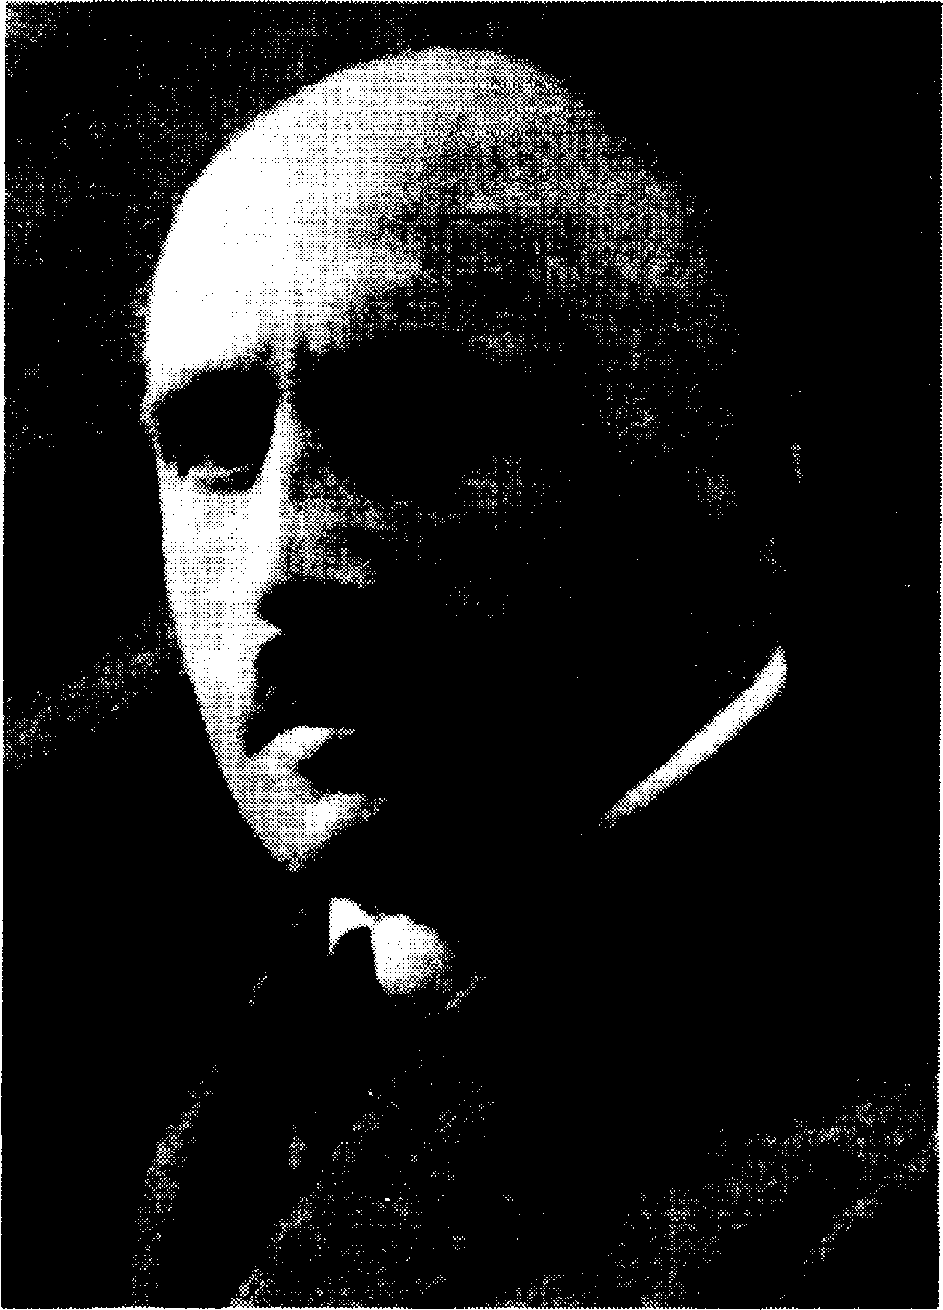

who does not allow himself to be alienated from his nature by the slogans/ bogus knowledge and trendy art of the Jews/ anyone who wants to save his people from immorality/ degeneration and downfall as a result of the Jewish seduction by word and deed/ - the Jew calls him an anti-Semite".
The speaker earned rich applause.
The discussion was very lively. Mr. Hitler of the German Workers' Party addressed the plight of the
185

Mr. Kreller of the German Protection and Defense League called for publicity work for the referendum against immigration of Jews from the East. Mr. Kreller of the Deutscher Schutz- und Trutzbund called for lively participation in the publicity work for the referendum against the immigration of Eastern Jews and in connection with this touched on the result of the hostage murder trial. In confirmation of this, the chairman pointed out that according to Seidel's testimony, the dismissal certificate of Professor Berger (a Jew) had already been signed and that it was therefore clear that the Iudenschast's appeal to the Berger case had no basis. Mr. Sesselmann of the German Socialist Party briefly outlined the aims of anti-Semitism, called for mutual economic support and urged unity.
In the closing words, the chairman warned against radical anti-Semitism. We must reach the goal through perseverance and tenacious völkisch work under complete enlightenment.
*
Number 63 of the "Völkischer Beobachter" of November 19, 1919 would bring the report on the second lecture evening of the D.A.P.:
From the movement.
The German Workers' Party, Munich branch, held a lecture evening on November 11, 1919, in the upper hall of the Eberlbräukeller. The speakers were Mr. Hitler on "Brest-Litowsk and Versailles" and Mr. I. Mayer on "War and Revolution Experiences of a Foreign German. After a short welcoming speech, the chairman gave the floor to the first speaker, Mr. Hitler. In an extremely skilful manner, the speaker contrasted the peace treaty of Brest-Litovsk, described by a large part of the German (!) press as a peace of shame and violence, with the so-called peace of understanding of Versailles, demanded by the same press in a lying and stupid manner. The pictures which Herr Hitler presented to the attentive listeners of the
186

The two peace treaties, which he unrolled, stood out from one another in the most blatant manner and set many hearts aflutter. Heckling voices expressed the audience's agreement with the remarks of the extremely spirited speaker. The speaker met with enthusiastic approval when he described the German Republic as a free state of the Entente, whose freedoms within its borders consisted in the fact that exploiters of the people, usurers, racketeers and surreptitious traders were squeezing the people in the vilest way with impunity. Thunderous, often repetitive applause thanked Mr. Hitler's solid explanations. After heartfelt words of thanks, the chairman went into detail about the next goals of the party, of which he particularly emphasized: removal of the Jews from all public offices, elimination of the interest rulers' burden according to Feders' proposals, and the fight against usury and profiteering to the utmost. The speeches met with lively applause. Afterwards, Mr. Franz Dannehl of the Thule Society quoted some passages from the newspaper "Der Revolutionär" (published by the Jew Lederer-Mannheim), which make it hardly possible that such vile lies and accusations may be published within Germany, while really völkische newspapers, such as the "Völkischer Beobachter", which truthfully reflect the conditions and want to show a blinded government the way to lead the German people upward again and to free them from their inner tormentors, are banned as inflammatory papers. A storm of indignation accompanied the announcement of these vulgarities by Lederer.
Now the second lecture followed. Mr. Mayer described his escape from Barcelona after the outbreak of the World War in an extremely humorous manner, but also taking into account the serious aspects of his adventurous experiences. The speaker received rich applause and a lively discussion ensued. Finally, the assembly adopted two resolutions, one against the ban of the "Völkischer Beobachter" by Noske, the other against the activities of the parliamentary committee of inquiry.
*
187

From the "Völkischer Beobachter" No. 17 of February 28, 1920, we bring the report on the "First Great Public People's Assembly" of the German Workers' Party:
From the movement.
On Tuesday, February 24, 1920, the German Workers' Party made its first public appearance. In the very well attended meeting in the Hofbräuhaus hall, Dr. Johannes Dingfelder spoke as a gaffer of the German Workers' Party on the topic: "What we need". In a popular manner of speaking, from the lofty standpoint of a doctor and philanthropist, overlooking the social confusion, the speaker led the audience back to the cause of the people's need. We have lost touch with the forces of nature, we have disregarded the law of order, we have misjudged the law of the world and the law of creation of cause and effect. But the creative work of man is founded in it. Work-arbot - is the divine sun commandment - means to create sun goods, life goods for the ennoblement of mankind. We have also despised this law, the law of movement, and indulged in hedonism and unemployed income, imitating the example of a foreign people. There is also a law of love, the contempt of which is most sharply expressed by Bolshevism. To expect help from abroad against this is cowardly and undignified. "Help yourself" is the demand, and this presupposes that we abandon the international delusion, think nationally and believe in our people and its real leaders. - This was the essence of the excellent lecture, which, although it also contained unpleasant truths, was rewarded with enthusiastic applause. -
Hitler (German Workers' Party) now developed apt political images, which met with stormy applause, but also caused the numerous "preconceived" opponents to object. The speaker gave an overview of the party program, which in its main features is close to the program of the German Socialist Party. Subsequently, the following resolution was unanimously adopted: "More than two thousand German comrades of all nationalities
188

The creative classes gathered in the Hofbräuhaus hall on Tuesday, February 24, 1920, protested in the strongest terms against the allocation of 40,000 quintals of wheat flour to the Jewish religious community, while no bread for the sick is available for 10,000 seriously ill people. - The debate was very lively. The meeting left the impression that a movement is underway which will prevail under all circumstances.
As Hitler's German Workers' Party flourished, the German Socialist Party faded more and more into the background. Julius Streicher had sparked a movement in Nuremberg - gathering together the local members of the Teutonic Order, the Thule, and the German Socialist Party and affiliating them with Adolf Hitler.
November 4, 1921, saw a meeting in the Munich Hofbräuhausfestsaal into which the Marxist Socialists and Communists had sent their columns of explosives. The hall was overflowing and had therefore been closed off by the police. Hitler spoke for an hour and a half, breathlessly the assembly listened. A man who, after angry interjections, suddenly jumped up and shouted "Freedom!" into the hall, threw, almost at the end of Hitler's speech, a beer mug, which flew hard past the head of the Führer. This was the signal for the fight. Mugs flew, shots crackled, blood flowed. The still small S.A. rushed among the opponents, one after the other flew out, the rest fled. What remained were pale, worn out, wounded storm troopers. And who was the organizer of that Marxist act of terror? Mr. Buisson, the foster son of Erhard Auer, the man from the police headquarters who had withheld Sebottendorf's papers. Hitler himself had been holding forth at the lectern and suddenly the leader of the meeting, Her
189

mann Esser and called out: "The meeting continues. The speaker has the floor". The groundwork was done, the first battle was won. The National Socialist German Workers' Party was on the march under the leadership of Adolf Hitler. The movement took its course.
The "Heil und Sieg", the greeting of the Thule people, Hitler made the "Sieg-Heil" -of the Germans!
The Führer made the "Völkischer Beobachter" the fighting paper of the National Socialist movement in Greater Germany.
The swastika made Hitler the symbol -er siegen-en N.S.D.A.P..
1SV

XIII.

Development of the Völkischer Beobachter
In the movement, it is often asked how it is that the "Völkischer Beobachter" has such a high number of entries, since the N.S.D.A.P. is only 14 years old; here, the history is to be clarified on the basis of the commercial court entries. The first entry is found in Volume III, No. 125, page 63 of the Munich District Court; minutes of December 6, 1901. The editor Franz Eher reports that he is the owner and publisher of the "Münchener Beobachter". He has been operating the publishing house since the middle of 1900. The registration takes place on the same day and the order of registration.
Before this entry, the "Münchener Beobachter" was published as the professional organ of the butchers' guild. The next entry dates from 1918.
Through the mediation of the lawyer Dr. Georg Gaubah, the publishing house and the newspaper "Münchener Beobachter" were bought from the widow Franz Eher. This was necessary because a new newspaper could not be published at that time due to the rationing of printing paper.
The member of the Teutonic Order, Ms. Käthe Bierbaumer, was entered as the owner of the publishing house. The entries in question read with a brief summary;
191

July 31 ISIS: Franz Eher died on June 22, the sole heir being his widow, who sold the company to Miss Käthe Bierbaumer.
September 14, 1918 r Mrs. Eher appears, presents the certificate of inheritance and declares that she has sold the publishing house to Miss Käthe Bierbaumer, Bad Aibling, Parkstraße 335.
September 17, 1918: Miss Käthe Bierbaumer, legitimized by passport, becomes a subscriber: Publisher Franz Eher Bachs. Registration and announcement is ordered.
The Beobachter had two subscribers when it was taken over, and the first number appeared on July 1, 1918. Rudolf von Sebottendorff was the responsible editor.
In March 1919, Sebottendorff took the writer Hanns Georg Müller on board as editor, and Müller alone was responsible for number 17, dated May 24, 1919.
During the reorganization after the Council period in May 1919, Sebottendorff completely separated the Beobachter publishing house from Thule. In Thierschstraße, where the publishing house is still located today, Graffinger rented the parterreraum (former inn "zum Hansahaus") against payment. Ott took over the commercial management of the publishing house. Laforee was given the advertising department.
In March 1919, Sebottendorff had met the baker Max Sesselmann and, since he was looking for a skilled worker for the movement, he approached Sesselmann. When Sebotten-orff's departure was decided in July, the relationship was regulated by the following entry:
Ms. Käthe Bierbaumer mel-et, -aß -ie gentlemen who appeared: Hanns Georg Müller, Wilhelm Laforee, Max Seffelmann, Johann
192

Ott, all in Munich, have been granted Gesanttprokura in threes. Order of registration and announcement of July 15, 1919.
On August 9, 1919, the publication date of number 34 of the "Münchener Beobachter," the newspaper also carried the title "Völkischer Beobachter" for the first time in part of its circulation.
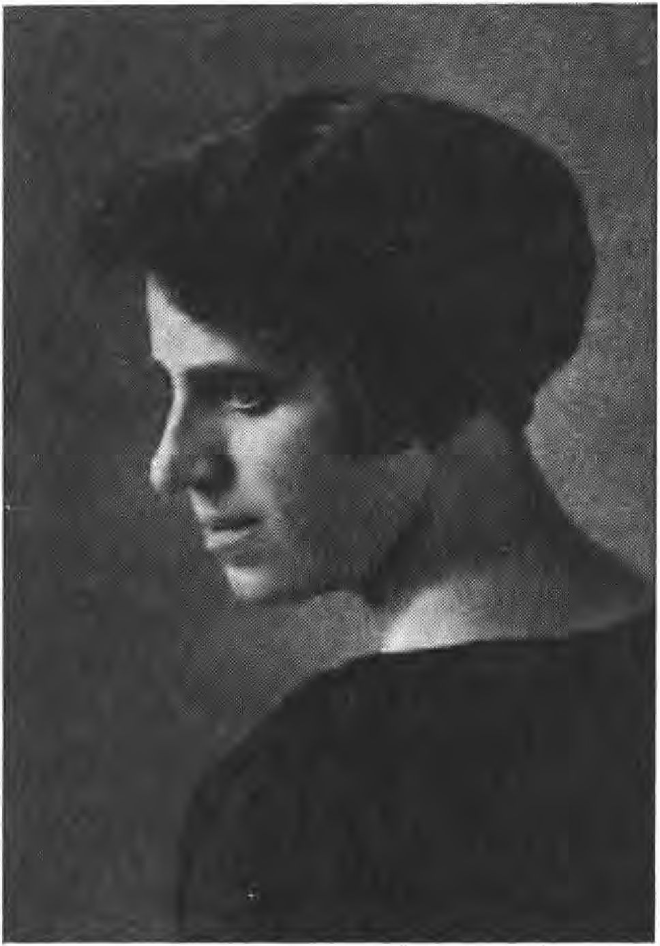

It later turned out that Sebottendorff had been mistaken in the editors Sesselmann and Müller by making them independent. The work and the behavior toward the employees did not meet Sebottendorff's expectations, nor those of the "publisher," Ms. Käthe Bierbaumer. Hostilities arose.
After Sebottendorff left, the owner of the newspaper, Miss Käthe Bierbaumer, was also to be removed. For this purpose

193

-If one brought up the fairy tale that she was Jewish," one spoke of Sebottendorff and his "Jewish girlfriend. Never has a slander been more infamous, and the worst thing was that it was spread by comrades of the people. The agitation also continued against Sebottendorff himself; the article "Strange Stories" was spread, in copies certified by Dr. Forst, the Iustizrat. The article was reprinted all over Germany, and since the copies were also sent from völkisch circles, without stating where they came from, they were believed. Giving in to the hostility, Miss Käthe Bierbaumer also left Munich.
Several times Sefselmann, who knew how to put himself at the head of the publishing house, had to travel to Constance to get money again from Sebottendorff. Finally, the owners of the publishing house realized that a lot of money had been delayed by lawsuits in which the editors had been dragged through insufficiently proven documents.
To clear the way here and eliminate the unsuitable, Sebottendorff called his sister, Mrs. Dora Kunze, and Miss Käthe Bierbaumer to Constance. On 3V. September 1919, the publishing house Franz Eher Nachf. was transformed into a limited liability company by a commissioned notary. The relevant register excerpts read:
Register files of the Munich Local Court, No. 1649/19.
Capital 12VV0V marks, of which:
Frl. Käthe Bierbaumer Marks
Mrs. Dora Kunze, née Glauer, in Lauban. . 1v vvv Mark Paid by Ms. Bierbaumer through contribution of the previous company Verlag Franz Eher Nachf.
in Munich by all publishing rights, credit balances
194

un inventory of the company
Paid in cash Mrs. Dora Kunze Marks
Addendum: Notary's Office Munich XVI:
Present Ms. Käthe Bierbaumer, Munich, Thiersch-
street 15
Attorney Dahn for Mrs. Dora Kunze, Lauban.
Correction: Value -of contribution in kind Marks
Value -of cash amounts 184VVMark
Managing Director of the publishing house: Franz Raver E-er, businessman in Munich. Subsequently, Ms. Bierbaumer donated 5VVV marks in shares to the publishing house, and gave another 135VV marks in shares, so that Ms. Bierbaumer still had 465VV and Ms. Dora Kunze 1VVVV marks in shares in the company. The intrinsic value of the shares was significantly higher.
In the list of shareholders dated 2V. The following shareholders appear in the list of shareholders dated March 2, 1920:
Gottfried Feder, graduate engineer, Munich with 1VVV Mark Franz Raver Eder, businessman, Munich. . . IVVV Mark Franz Freiherr von Feilihsch, Munich . . . 20000 Mark Dr. Wilhelm Gutberlet, physician, Munich . . . 1VVV Mark Theodor Heuß, manufacturer, Munich .... IVVVVMark Miss Käthe Bierbaumer, Freiburg/Breisgau .465VV Marks Mrs. Dora Kunze, Lauban Marks
Karl Alfred Braun, Munich 35VV Marks
According to an entry of December 17, 192V, all shares except for those of Ms. Käthe Bierbaumer and Ms. Dora Kunze were in the hands of Anton Drexler.
195

M August 11, 1921, with No. 63, lists Dietrich Eckart as head of the "Völkischer Beobachter.
On November 16, 1921, Adolf Hitler, Munich, Thierschstrasse 15, identified by his passport, appears for the first time in the register court of the Munich District Court as chairman of the National Socialist German Workers' Party and declares that he owns all the shares. Hitler appointed Joseph pickl as managing director. Max Amann took over the management of the publishing house, today General Director of the Party Publishing House.
196

XIV.

The Thule during the absence of the founder
and its renewal
A letter of Johannes Hering from 1926, which reached Sebotten- -orff in Istanbul, may give information about the further fate of the Thule Society;
"As you may remember, I was chairman of Thule for a long time after Dahn's retirement, and then handed over the chairmanship to Professor Bauer, who conducted it in an exemplary manner, gave deeply thought-out, literary, non-political lectures himself, but was also able to bring in good speakers and splendid members.
He is a good political head, who came into the leadership of the rising German National Party and became a deputy. There was also a lively social life under his leadership, concert evenings, poetic performances, two theater performances took place.
... Bauer was replaced by Max Seffelmann, who was brought to Thule by you and who also became a member of the Landtag. But he had little time for the Thule.
Moreover, we were driven out of our rooms and after some events in the "Fränkischer Hofe" the Thule fell asleep. Only two things still happen: the celebration on 3V. April in the Luit-
197

pol-gymnasium un- -the wreathing of -the graves on All Saints' Day. For this purpose Skonomierat Bucherer sends -the wreaths with black-white-red ribbons and I carry -the wreaths out to -the Wal-- and West- frie-hofe. Deby had been second chairman for a while ...
Once again there was a great deal of activity in the Thule Society when, after November 9, 1923, the N.S.D.A.P. was smashed. At that time, under -the present Lord Mayor Fiehler, Munich, -most members of -the party joined -the Thule Society. They were thus able to continue their propaganda until A-olf Hitler, having returned from Lansberg, again gathered -their members together.
In 1925, the Thule still had 25 members. A change in the statutes was made by Sesselmann, which abandoned the Führer principle. In 1926 there were only five members left. When then the register court took Sesselmann in punishment, because he did not send in a report for some years, Sesselmann and -the second chairman Wagner reported that the Thule had no more members.
By order of the Registrar of Companies dated June 193V, the Thule Company was cancelled.
In the last few years, the Thule celebrations in the Luitpold gymnaflum had also ceased. Only in 1933 such a celebration took place again. Sebottendorff was supposed to give the commemorative speech, but this was hindered by Sesselmann. But after the ceremony 75 old Thule people met in the cathedral courtyard to greet the old master. Those gathered agreed to revive the Thule and to reverse the deletion of the society from the register.
198

Under the chairmanship of the court-appointed administrator, Iustizrat Dr. Georg Gaubatz, a general meeting was held at which Sebottendorff was again appointed Führer and engineer Riemann Deputy Führer. It was also decided to re-establish the Führer principle by amending the statutes.
Through the courtesy of the Walterspiel brothers, the owners of the Hotel "Vier Jahreszeiten", Sebottendorff was given back the old historical rooms for the Thule and so the 15th anniversary of the foundation could be celebrated on September S, 1933. Court actor, Thule brother Max Bayrhammer, held a preface,* Sebottendorff the consecration speech. Professor Stempfle of the Rehse Institute gave humorous remarks based on documents from the past of the Thule, and read, among other things, a letter written by Sebottendorff in 192V to Schulrat Rohmeder, in which Sebottendorff stated that he would not come to Munich again until the swastika flags in Germany announced the victory of the movement. At this celebration, Professor Stempfle also suggested for the first time that the city of Munich erect a worthy memorial to the first blood witnesses of the awakening Germany. The Lord Mayor Fiehler, honorary member of the Thule Society, who was present, took up the suggestion.
On October 31, 1933, on the eve of All Saints' Day, the Thule Society organized a memorial service for the dead. The solemn sounds of the "Treueschwur" by Kistler, played by the orchestra of the civil service department of the N.S.D.A.P. under the direction of Georg Festner, introduced the ceremony. Sebottendorff held the memorial speech for the dead. Court actor Max Bayrhammer recited a patriotic poem: "In a Winter's Night" by D. von Lilieneron.
199

in front of. At the end, Thule Brother Dr. Heinz Kurz spoke in a treaty on "In Praise of Death". On this day an organ of the Thule Society appeared again for the first time: the "Thule-Bote". The Thule-Bote is published by Deukula-Verlag Munich and can be obtained from any post office for a monthly subscription fee of RM. 1.40.
On All Saints' Day, Thule brothers laid wreaths at the graves of their dead in honorable memory.
The task of renewing the Thule Society has been achieved: every Saturday evening, the Thule people now gather again at the historic site of their work, in the "Four Seasons". With this, Sebottendorff felt that the time had come to place the leadership of the Thule Society in Brother Franz Dannehl's hands. The Fuehrer appointed Dr. Heinz Kurz as Deputy Fuehrer," Hans Georg Grassinger as Propaganda Leader.
How does the Wala fingt, of what is necessary?
Honor the divine! Avoid the inferior! Love the brothers!
Umbrella the fatherland! Be worthy of your ancestors!
200

Index of persons and subjects
Slaughter of the Aryans. This is described in the book of Esther and is still celebrated today by the Jews as the festival of Purim. Historically the slaughter of the 70000 Aryans is not provable. But similar events are attested in historical time. Dio Cassius reports book 68, chap. 32: "During the time when Trojan warred in Arabia, the Jews of Cyrene had placed a certain Andrew at their head and began to slaughter everything that was Roman or Greek. They ate their flesh, covered themselves with their entrails, smeared themselves with their blood and pulled the skin of the corpses over their bodies. Others sawed the corpses lengthwise from the top of their heads, threw them to the wild beasts and forced them to kill each other in single combat, so that two hundred and twenty thousand people lost their lives in this way. In Egypt and Cyprus they committed similar atrocities under the leadership of a certain Artemius, and here too two hundred and forty thousand people met their deaths."
Nobility. From the Old High German aclal, the gender. Nobles, the racial people in contrast to the primitive people who were subjugated by the Aryans. Later the free. Uradel in contrast to the epistolary nobility.
Eagle equals aar. The a-(ar) rune, the heraldic animal of the Aryans.
Ahlwardt, Hermann, elementary school teacher and principal in Berlin. Aryan. * December 21, 1846. f April 16, 1914. Created an anti-Semitic movement in Berlin in 1889; the Judenblätter derisively called him the rector of all Germans. He was denounced by Jews, convicted of a misdemeanor, and that was the end of the movement.
Alchemy, Arabic, "the art of separation"; alchemist, the separation artist. A philosophical system of the early Middle Ages that sought to educate leaders through practice. The formulas were veiled by chemical processes, and so the belief arose that alchemy was concerned with making gold. In fact, such gold makers have also appeared on various occasions as frauds. See: The old Turkish Freemasonry. Leipzig, Theosophical Publishing House.

221

Alemanni. Union of Germanic peoples. They were defeated by the Romans in 357 at Strasbourg under Julian. The cause of the defeat was that the duke of the Alemanni went into battle on horseback instead of placing himself at the head of the wedge as a leader according to Germanic custom. At that time the cry rang out, "Down from the horses." Due to these internal disputes, the battle was lost and the Alemanni lost their independence.
Alexander the Great. *356, f 323 B.C. Descended from the unconsumed Aryan Macedonians; defeated the diverging Greek tribes, founded the world empire. After his death, the empire disintegrated because he had no heir and had not designated a successor. His sub-leaders divided the empire. All-German Association, was founded by Hugenberg and Claß as the "General German Association" on April 9, 1891. Changed name on July 1, 1894. Published the monthly magazine "Alldeutsche Blätter." In the pre-war period the most important völkisch association, most bitterly opposed by the All-Slaves and All-Romans, of course also by the Marxists and Jews.
Alsberg, Dr. Max, lawyer. Jew. Criminal lawyer and man of letters. The Jew is just in all saddles - wrote several dramas toward the end of the system rule. * October 16, 1877, shot himself in Switzerland in September 1933.
Amann, Max. Aryan. Front fighter in the World War 1914 - 1918. Took over the management of the publishing house Franz Eher Nachf., G.m.b.H. in 1921. Today General Director of the Party Publishing House of the N.S.D.A.P.
Andersch, Alfred. Aryan. Member of the Thule.
Annacker, Johann. Aryan. Member of the Thule.
Anthroposophy. ^ntliropos-human, sopkie-wisdom, i.e. wisdom of man. Society founded by Steiner (see below) when Annie Besant, the leader of the Theosophical movement, presented the Indian boy Krischnamurti as a new embodiment of Christ. In Munich, numerous followers joined Steiner, but the movement was made impossible by suicides of sexually exploited women. The intended university could not be founded, it was moved to Dornach near Basel (Goetheaneum), where Steiner tried in vain to acquire Swiss citizenship. On New Year's Eve 1922 the temple burned down and was rebuilt four years later. Steiner's teaching is a mixture of theosophical doctrines with his own three additions. The means of propaganda of the movement is eurythmy. After the revolution
222

Steiner tried to reform communism through his doctrine of threefolding.
Anti-Semite.Anti--against.Semite--DescendantofSem,the biblical progenitor of the Jews. In other words, anti-Jew. Came up as a swearword in Ahlwardt's time. According to Jewish newspapers, Emperor Frederick is said to have said that anti-Semitism is the greatest disgrace of the century. In a trial, the head of the newspaper, Chief Rabbi Hirsch Hildesheimer, had to admit this statement as unsubstantiated.
Arabs, Semites. 2In contrast to the Jew, unmixed. According to the Bible, the descendants of Esau, who was cheated out of his hereditary birthright. Population of southwestern Asia and North Africa, linguistically and economically two groups: the Badawi (see Bedouins) as nomads, the Chadari as sedentary farmers.
Worker. Came as a status designation around the middle of the last century in contrast to the burgher and nobility. Later Judaism created the coinage proletarian. It means "producer of children." Mockingly: people who have nothing but children.
Workers' Youth. Before November 9, 1918, apprentices and young workers were forbidden by law to belong to political and trade union organizations. At the beginning of the 20th century, the "Arbeiter-Jugend" (Workers' Youth) was founded, which outwardly appeared to be the wandering and discussing associations of apprentices and young workers; in fact, however, the young people there received socialist and trade union education. The organization was financed by the Social Democratic Party and the trade unions.
Workers' Army. In Munich during the Räte period, the Red Army.
Arco auf Valley, Anton, Count von. *February 5, 1897. Descended from the Austrian line and only distantly related to the Bavarian line. Jüdling. Count von Arco shot Eisner on February 21, 1919.
Aryan. Ar Rune --Eagle. Sons of the eagle, the sun. After the end of the ice age melted together from a long-skinned blond and a round-skinned dark race. After the observatories of Stonehenge and Oudry, the Bretagne a high culture of the Aryans can be feftstellen on 10000 v. Ehr. The northern tribes settled as master peoples Europe, Asia and America; everywhere there forming cultures, where they met a native population, which they subjugated themselves. One can follow the migration routes of the Aryans from the stone rows and distinguishes two main trains. The first goes along the coasts of the Atlantic Ocean, crossing the Strait of
223

Gibraltar and turns into Upper Egypt via today's Sollun Oasis, here the Aryans created the Egyptian culture. We find splinters on the islands and at the edges of the Mediterranean. Troy, Mycenae were Aryan settlements. A second train of stone circles goes through Poland, crosses the Caucasus and divides here into Asia Minor and the Asian highlands. Very probably also the oldest cultures of America find Aryan origin. See: Sebottendorff, History of Astrology. Leipzig.
Aristocracy. Rule of the nobles, in contrast to democracy rule of the people. Originally the rule of the conquerors.
Army, Red. Formation of the workers' army of the soviet government in 1919.
Arndt, Dr. Julius, Lieutenant. Aryan. *7 January 189^. Son of the cultural historian Arndt in Munich. Front-line fighter in World War 1914-1918. Member of the Kampfbund der Thule. Since April 15, 1919 in the Freikorps Oberland.
Aschenbrenner. Aryan. Until the Palmarumputsch, commander of the Munich central station.
Aßmann, Ludwig. Aryan. Member of the Thule.
Auer, Erhard. Marxist. * After Vollmar's death, leader of Bavarian Social Democracy. Reich and state parliament deputy; was severely wounded by two shots from the Communist Lindner on Feb. 21, 1919, when he tried to open the state parliament after Eisner's death was announced.
Aumiller, Max. Owner of the Marienbad Hotel, was arrested and was in danger of being shot with the Thule people.
Axelrod, Tobias. Representative of the Soviets to the Munich soviet government. Jew. Axelrod was born in Moscow in 1897, studied and earned a doctorate in philosophy; came to Munich in December 1918 and remained in the background until Eisner's death. Together with the two other Russian Jews Levine and Levien, he formed the triumvirate that directed the soviet government. After his capture, he was sentenced by the Munich Standgericht to 15 years in prison. He was exchanged for Marxist prisoners in Russia.
Bad Aibling, market town, now city in Upper Bavaria. Moor bath. Bavaria. Spelling for Bavaria in council times.
Bajuvars. Bojoarier, older name of the Bavarians, after the former residence of this Germanic tribe in Bohemia: Boihaemum. With Tyroleans, Upper and Lower Austrians, Steyrians a German tribe.
224

Up soon, Georg. Aryan. Member of the Thule.
Ball er, Alfred. Aryan. Member of the Thule.
Ballin, Albert. General Manager of the Hamburg-America Line. Jew. * August 15, 1857, shot himself November 9, 1918.
Bamberg. Immediate city in the Bavarian administrative district of Upper Franconia with over 50000 inhabitants. After the proclamation of the soviet republic from April 7 to August 15, 1919 seat of the Bavarian government. The constitution for Bavaria of August 12, 1919 was adopted here.
Bartels, Fritz. Aryan. Member of the Thule.
Farmer, Hermann. Aryan. Member of the Thule.
Farmer, Josephine. Aryan. Member of the Thule.
Farmer, Ludwig. Aryan. Member of the Thule.
Peasant Council. During the soviet government, the representation of the peasantry.
Builders' lodge. In the Middle Alps, the name of the trade union of builders, especially the brotherhood of stonemasons. The purpose of all the building lodges was the training and employment of capable builders, the preservation of the secrets of the construction of great buildings, but also the cultivation of loyal friendship, religious feeling and moral striving. Soon, educated non-tradesmen also found "admission and acceptance" in the building lodges. Eventually, the non-tradesmen formed the majority of the members. In 1717, the Freemasonry (see below) emerged from it.
Baum er, Anna. Aryan. Member of the Thule.
Bayrhammer, Max. Aryan. Member of the Thule. Court chamber actor. Was dismissed from the "system rule" because of his anti-Semitic views.
Beaconsfield, Earl of. Noble title of the Jew Disraeli, see this. Becker, Berta. Aryan. Member of the Thule.
Bedouins, Arab nomadic tribes of the desert. Their homeland and headquarters is Nedzhd in Arabia. They are the purest representatives of the Arabs (s. d.).
Bekh, Knight of, Major. Aryan. Front-line fighter in World War 1914-18. Was leader of Freikorps Oberland 1919.
Be lfri ed, newspaper in Belgium during the war. Germany maintained very poorly managed newspaper propaganda in various neutral countries during the war. These newspaper propa
225

ganda was headed by Erzberger, who had very large sums at his disposal for this purpose.
Belgium. Iudenwirtschaft in articles from the Beobachter 1918.
Berger, Ernst, Professor. Jew. Murdered with the Thule people in the Luitpold Gymnasium on April 30, 1919, because he had forced his way into their ranks in the belief that they would be dismissed.
Bernstein, Eduard, socialist writer. Marxist. *January 6, 1850. Headed the "Sozialdemokrat" from 1881 to 1890.
Besnard. Aryan. Member of the Thule. Lawyer in Munich.
Bethmann-Hollweg, Theobald von. * Nov. 29, 1856. f Jan. 2, 1921.
Chancellor of the Reich from July 14, 1909 to July 14, 1917. Nickname: The Leather Chancellor. His weak stance against the Center, Social Democracy contributed much to the collapse.
Bible, the book. The Old Testament originated in its present version around 450 B.C. Ezra, who partly led the Jews back from Babylonia, created the books of Moses from tribal sagas and Aryan knowledge, which he got to know in Mesopotamia, wrote the genealogical registers according to a numerical key, wrote the Book of Judges, made Jehovah (Yahweh) the tribal god of the Jews. The New Testament was written in the years up to 200 A.D. Original texts do not exist, only copies from the 4th and 5th centuries. Loclex Linaiticus and Loclex ^lex-mchirrus.
Bierbaumer, Käthe. Aryan. * July 4, 1889 in Neuftift, district of Mat- tersburg (Burgenland). Member of the Thule. Was the owner and main shareholder of the publishing house Franz Eher Nachf. in Munich.
Birner, Hedwig. Aryan. Member of the Thule.
Birner, Max. Aryan. Member of the Thule.
Bismarck, Prince Otto von. Aryan. * April 1, 1815. f June 30, 1898. founder of the first German Empire and chancellor until March 20, 1890. With his dismissal by Kaiser Wilhelm II, the decline of the German Empire began. Epithet: The Iron Chancellor.
Bissing, Moritz Ferdinand, Freiherr von, General. Aryan. *31 January 1844. f 18 April 1917 in Brussels. On November 28, 1914, he became governor general of Belgium. He initiated a policy aimed at dividing Belgium in two according to the Flemish and Walloon sections of the population.
Bleichröder. Jewish banking house in Berlin. Founded by Samuel Bleickröder in Berlin in 1803.
Block, Nora. Aryan. Member of the Thule.
226

Bne-Briss, Hebrew: "Covenant Sons," Founded in 1843 in America as l-lnitecl orcler ob 8ne 8ri8s. Associates with the ^lliLnce Israelite and came to Europe in the 1960s. The order accepts only Jews, is organized in the manner of Freemasonry, and today embraces all Jewish organizations. The Bne Briss has such great power because its members are only Jews, but they are held by order to belong to Freemasonry. Here they hold the leading positions. This explains the international leadership of Freemasonry. In Germany, in the last years of the last century, the Bne Briss Order made itself felt. Around 1900, it had a branch in Berlin, Wilhelmstraße, where Christian Freemasons could also meet. Then, from 1905, the German branch of the Order was more vigorously developed. Bne Briss means Sons of Faith.
Bodmann, Hans Hermann, Freiherr von und zu. Aryan. Member of the Thule, the Kampfbund and contributor to the "Beobachter.
Bonn. Rector of the Handelshochschule in Munich. Jew.
Born, Kurt. Aryan. Member of the Thule.
Stock exchange. The first stock exchanges were commodity exchanges, formed in the Netherlands around the middle of the 16th century. Today's stock exchanges formed around the time of the French Revolution, when joint stock companies and government bonds were created. Stock exchanges are an important means of international capital, mobilizing labor, land ownership and revaluing it as an object of trade.
Braun, Karl Alfred. Aryan. 1920 Shareholder of the publishing house Franz Eher Nachf, G. m. b. H., Munich.
Brehm, Georg. Aryan. Member of the Thule.
Bruno, Alfred. Aryan. Member of the Thule.
Bruxellois. Title of a newspaper in Brussels during the World War. Büchner, Dr. Ludwig, physician. Judstize. Author of Kraft und Stoff.
Pioneer of materialism. * March 28, 1824. f April 30, 1899.
Büchold, Valentin. Aryan. *8 August 1898 in Munich. Member of the Thule. Was sports editor in the Beobachter. 1st Chargierte der Verbindung Hansea der Handelshochschule München; as such in serious conflict with Bonn.
Buditsch, called Dietrich, red soldier council.
Buisson, Wilhelm, trained pharmacist. Marxist. Foster son of Auer. During the invasion of the liberation troops, Buiffon had taken refuge at police headquarters.
227

Bunge, Hans. Aryan. Member of the Thule and the Kampfbund; now leader of the Leibstandarte of the S.S.
Vigilantes. During the revolutionary period, vigilante groups were formed to protect municipal institutions. At the time of the soviet government, vigilante groups existed in numerous towns in northern Bavaria.
Byzantinism. Groveling subservience, especially to princes and rulers.
C laß, Heinrich, Iustizrat. Aryan. * Founder of the "Alldeutsche Verband" (see below).
Closmann, Hans. Aryan. Member of the Thule.
Closmann, Hugo. Aryan. Member of the Thule.
Coblitz, Franz. Aryan, member of the Thule.
Cyrus, actually Kyros from the ancient Persian Kurush. 565 to 529 B.C., Aryan Persian, conquered Babylon in 539 B.C.. In return for the help he received from the Jews, he allowed them to return to Palestine. Probably he wanted to get rid of the whole Jewish community, but only the two tribes Levi and Benjamin used the permission. The others remained in Mesopotamia.
Dach au, market, now town in Upper Bavaria, over 7000 inhabitants. On the Munich-Jngolstadt railroad line. In 1919 it was the main base of the "Red Army" under the high command of Ernst Toller (see below).
Dahn, Hanns, "lawyer" Aryan. Member of the Thule. Grandson of Felix Dahn. Was leader of the Thule. In the hostage murder trial, defense counsel for Gsell, who was sentenced to 15 years in prison.
Dannehl, Franz. Aryan. Member of the Thule and the Kampfbund. Well-known explorer and butterfly collector. Sound poet. Today leader of the Thule.
Then he, Mathilde. Aryan. Member of the Thule.
Daudistel, August. Aryan. Member of the Thule.
Daumenlang, Anton. Railroad superintendent. Aryan. * Murdered on April 30, 1919, as a hostage in Munich's Luitpold Gymnasium. Member of the Thule. He was engaged in heraldry and genealogy. Besides his widow, he left behind a daughter aged 13.
Deby, Theo. Aryan. Member of the Thule and the Kampfbund.
Dechaud, George. Aryan. Member of the Thule.
Deiglmeier, Elisabeth. Aryan. Member of the Thule.
228

Deike, Walter. Commercial artist. Aryan. * Murdered as a hostage on April 30, 1919, in Munich's Luitpoldgymnasium. Member of the Thule.
Demmel, Auguste. Aryan. Member of the Thule.
Demockl, Jda. Aryan. Member of the Thule.
Democracy, rule of the people. The term changes its meaning over the course of time. The original Aryan constitution was a democracy with aristocratic leadership. The people's assembly elected the leader in all difficult matters; then, when orderly conditions re-emerged, the elected leader returned his authority to the Thing (the people's assembly). As racial mixing began, the People's Assembly was gradually abolished; a pure aristocracy took over. Today, democracy is the rule of the people by an elected parliament. (All power to the parliament.)
German Workers' Association. Founded from the Thule Society, Order for German Kind. The German Workers' Association later became the German Workers' Party. 1st chairman Karl Harrer f. Chairman of the Munich chapter: Anton Drexler.
German Socialist Party. Founded from the Thule Society, Order for German Kind. The program of the German Socialist Party: "To the German People" is published in No. 15, page 7 of the "Allgemeine Ordens-Nachrichten" of the Teutonic Order, Grand Lodge, Berlin, Julmond of Einbulwinters 1918/19. 1st Chairman: Hans Georg Grassinger.
Ding himself, Dr. med. Johannes, physician. Aryan. Guest of the Thule.
Disraeli, Benjamin, Carl of Beaconsfield. Jew. * Dec. 21, 1804. f April 19, 1881. English prime minister. His work is the English Electoral Amendment; he had leadership at the Berlin Congress of 1879, which ended the Peace of San Stefano and the Turkish-Russian War. As a writer known for his novels: Conningsby, Tancred rc.
Stab in the back. The munitions workers' strike in January 1918 paralyzed the German spring offensive. This was the beginning of the collapse. The most dangerous thing, however, was that the enemy alliance now knew that a powerful force was lurking behind the front, waiting for the collapse. Immediately, the enemy alliance began a lively propaganda campaign, working on the weary masses of the people, which led to the conflagration in Germany.
229

Dönme, means "turned." Name of the Jews who seem to have turned to Islam. The sect was founded by Sabatai Zewi, who pretended to be the Messiah in Damascus. As the following grew and disputes broke out among the Jews in Damascus, the Great Lord had the founder brought to Istanbul, where he was then a gatekeeper in the Sultan's palace. After the sultan's death, Sabatei came to Salonik and found popularity there. The Dönme made the revolution of 1918 and led the government as Young Turks until Mustapha Kemal. Even today, the Dönme form a strictly segregated sect, about whose actual doctrine little is known; they marry only among themselves.
Trinity. The revelation of God - the unity - through the trinity is pure Aryan wisdom. The unity of God is beyond all cognition. God can be known only in polarization, trinity; positive, negative and neutral or spirit-law substance. Symbolized in astrology by the three principles: Sun, Jupiter, Saturn. Where this trinity appears in a religion, Aryan knowledge must be inferred.
Dresel, Maximilian. Aryan. Member of the Thule.
Drexler, Anton, metal lathe operator. Aryan. Guest of the Thule. Joined the German Workers' Association as its first worker, was second chairman under Karl Harrer, later deputy of the Völkischer Block in the Bavarian state parliament.
Javid, Jew-Dönme. Turkish finance minister from 1909-1919. Was hanged in 1925 for taking part in a conspiracy against Mustapha Kemal.
Düntzel, Hans. Aryan. Member of the Thule.
Ebert Fritz, saddler.Marxist.*February 4, 1871, f Feb. 28, 1925. Editor of the "Bremer Bürgerzeitung," 1900 labor secretary. After Debet's death, 1913 chairman of the Social Democratic Party. Nov. 9, 1918: chairman of the Council of People's Deputies. February 11, 1919: provisional, then definitive president of the Reich.
Eckart, Dietrich, writer. Aryan. *March 23, 1868 in Neumarkt (Upper Palatinate), f December 26, 1923. guest of Thule. Known for his Peer Gynt transmission. Editor of "Auf gut Deutsch," 1921 to 1923 editor of the Völkischer Beobachter. Participated in the Kapp Putsch and in the Hitler March on November 9, 1923.
Eckart, Paul. Aryan. Member of the Thule.
Eching near Dachau. Village in Bavaria. In 1919, location of part of the Kampfbund der Thule under Captain Römer.
230

Eck, Klaus. Editor of the Miesbacher Anzeiger, anti-Semitic newspaper 1918.
Eber, Franz Xaver. Aryan. At the founding of G.m.b.H. of Verlag Franz Eher Nachf. on October 1, 1919, appointed managing director by the two owners, Miss Bierbaumer and Mrs. Kunze. 1920 Partner of Verlag Franz Eher Nachf., G.m.b.H., Munich.
E he r, Franz, editor. Aryan. 1900 to 1918Owner of the publishing company Verlag Franz Eher, Munich, f June 22, 1918.
Ehrengut, Leopold. Aryan. Member of the Thule.
Eichstädt. Immediate town in the administrative district of Middle Franconia with over 8000 inhabitants. 1919 Collection point of the Zentrale Oberland (s.d.).
Eisenhut. Marxist.member of the Eleven Men's College(Central Council) February-March 1919.
Eisner, Kurt. Jew. * Born May 14, 1867, from Galicia; his real name is Kosmanowski. Graduated from high school in Berlin, studied philosophy; joined the Frankfurter Zeitung; then went over to the Vorwärts; switched over to the Independents and came to Bavaria in 1906, to Munich in 1910; in 1918 he organized the munitions workers' strike in Munich and was put in prison, where he remained until shortly before the revolution. From his writings it appears that as early as 1900 he was running the revolution of which he became the maker in Munich. February 21, 1919 shot by Count Arco-Valley (s. d.). Eisner organized the meeting on the Theresienwiese in Munich that led to the revolution in Munich on November 8, 1918. He made himself Prime Minister and Minister of the Exterior. Unterteilter, an independent, became Minister of Social Welfare, Auer became Minister of the Interior, Roßhaupter Minister of War, Timm Minister of Justice, Hoffmann Minister of Culture. On November 16, he developed his program; on November 17, he had a revolutionary celebration defaced in the National Theater, for which he had composed the text "Gesang an die Völker" ("Song to the Nations"). To prove Germany's guilt in the World War, he published a distorted letter from the Bavarian envoy in Berlin, went to Geneva to ingratiate himself with the Entente, and left as his representative the well-known Professor Foerfter. On December 13, 1918, the National Council he had created met, and remained together until January 1919. On December 27, 1919, was the arrest of the Citizens' Militia, which continued to play a role in the National Council until the end. At
231

On New Year's Eve 1918, nine people were shot in the streets of Munich. January 1, 1919 brought the occupation of the Austrian embassy and consulate. On January 7, an unemployed demonstration took place, leaving two dead in front of the Ministry of Welfare. In the Landtag election, Eisner was elected with a very small number of votes with two independents (barely 17,000 votes in Munich). The opening of the Landtag was postponed again and again, finally set for February 21, 1919. On that day, Eisner was shot.
Eller, lawyer in Bad Aibling. Marxist. During the council period mayor there.
Endres, Fritz, coppersmith. Marxist. * Oct. 15, 1877. 1918 managing director of the Metalworkers' Union. March 10 to June 2, 1919 Bavarian. Minister of Justice, then until March 14, 1920 Bavarian Minister of the Interior. Minister of the Interior.
Engetbrecht, Otto. Aryan. Member of the Thule.
Engels, Friedrich. Jew. * September 28, 1820. f August 5, 1895 in London. With Karl Marx, founder of Marxism. Author of: Communist Manifesto 1848; The Origin of the Family, Private Property, and the State.
Epp, Franz, Knight von. General. Aryan. Front-line fighter in World War 1914-18. * Oct. 16, 1868. Fought in the Herero Uprising, went to the World War (Badenweiler) as major of the second battalion of the Leibregiment, promoted to lieutenant colonel after his first wounding at the Peronne and commander of the Leibregiment. He was then with the regiment in the Dolomites, in Serbia and Macedonia, then at Verdun. There he received the Order of Max Joseph and thus became a Knight of Epp. In September 1916 the regiment was sent to Romania, fought there at the Red Tower Pass and Camputung Pass, then was transferred to the Jsonzo and took part in the breakthrough battle. Ritter von Epp took part in the great offensive of spring 1918, fighting at Kemmel, capturing it and receiving the Pour te merite for it. August 1918 he led the regiment to the Siegfried position, but already in August we see Ritter von Epp again in the Balkans. On October 31, he led his regiment across the Sava River as the last German regiment. In the spring of 1919, he called for the formation of a Bavarian Free Corps at Ohrdruf. By mid-March he had assembled there 20 officers, 2 NCOs, and 40 men. Following the call of the Hoffmann government, the Freikorps was named Epp Bavarian Rifle Corps and
232

advanced via Ulm and Augsburg. The corps distinguished itself in the fighting at Giesing, where it had 5 killed and 25 wounded. After the capture of Munich, he transferred the Bavarian Rifle Corps to the Reichswehr and became commander. After his retirement, he joined Hitler, became a Reichstag deputy, and is now the Reich's governor in Bavaria.
Erhardt. Soldiers' Council. Responsible editor of the newsletters of the Central Council.
Erzberger, Matthias. Politician. Member of the Reichstag for the Center. Probably from a Jewish, baptized family. Initiated the Peace Resolution in 1917; chairman of the Armistice Commission in 1918/19. June 21, 1919 to March 12, 1920 Reichsfinanz- minifter (tax reform). * September 20, 1875; shot August 26, 1921.
Esser, Hermann. Aryan. * July 29, 1900 in Röhrmoos, district of Dachau. In the National Socialist movement since January 1920. City councilor in Munich. Since 1933 Bavarian minister for special assignment and head of the state chancellery.
Falkenhausen, Ludwig, Freiherr von. Jüdling. * From August 22, 1917, until the conflagration, he was Governor General of Belgium.
Faust nature, denotes the dichotomy into which the Teuton got by accepting Christianity. Later this crystallized in Protestantism. Legends of Dr. Faust.
Fechenbach. Secretary of Eisner. Arrested in 1933, attempted to escape during transport to a concentration camp and was shot.
Feder, Gottfried. Aryan. * January 27, 1883 in Würzburg. Attended the Humanist Gymnasium. Studied at the technical colleges in Munich, Charlottenburg. Zurich. Passed the diploma examination in civil engineering in Munich in 1905. Construction engineer at a reinforced concrete company. 1908 Independent entrepreneurial activity at home and abroad. Since 1917 he has been engaged in theoretical studies of financial policy and economics. In 1919 his work "Das Manifest zur Brechung der Zinsknechtschaft" ("The Manifesto for Breaking the Bondage of Interest") is published. In 1920, he became a partner in the publishing house Franz Eher Nachf. Co-founder of the N.S.D.A.P. 1921 Member of the Reichstag. 1931 Chairman of the Reich Economic Council of the N.S.D.A.P. June 1933: State Secretary in the Reich Economic Ministry.
233

Feilitzsch, Franz, Freiherr von. Aryan. 1920 Partner of the publishing house Franz Eher Nachf., G.m. b.H., Munich. Member of the Kampfbund der Thule.
Feldbauer, Hermann. Aryan. Member of the Thule.
Ferment of destruction. Ferment, fungus of fermentation.
Fiehler, Karl.Lord Mayor of Munich. Aryan. Honorary member of the Thule. * Fought in Hitler's shock squad on November 9, 1923. Was with Hitler at Fortress Landsberg.
Forst, Dr. Privy Councillor of Justice. Lawyer.
Foerster, Friedrich Wilhelm. Professor. Pacifist. 1919 representative of Eisner in Switzerland. 1933 deprived of German citizenship. Frank, Dr. Michel Hans. Aryan. Member of the Thule. Front-line soldier in World War 1917/18. * May 23, 1900 at Karlsruhe. Attended high school in Munich. After completing military service, studied law and economics at the universities of Kiel, Munich and Vienna. 1926 Lawyer in Munich. 1927 Member of the teaching staff of the Technical University of Munich. Advisor to the Reich leadership of the N.S.D.A.P. for legal issues and chairman of the National Socialist German Lawyers' Association. 1930 Reichstag deputy. Appointed provisional Bavarian Minister of Justice on March 10, 1933, and Bavarian State Minister of Justice on April 13, 1933. From April 21, 1933: Reich Commissioner for the Renewal of the Legal Order and for the Unification of the Judiciary in the Länder.
Frauendorfer, Heinrich, Ritter von. Bavarian statesman. Aryan. * Sept. 27, 1855 in Höll near Waldmünchen. Minister of Transport under Eisner in 1918. f July 22, 1921.
Freemasonry. Development. On June 24, 1717, four London lodges came together in a covenant; first Grand Master Anton Saycr. Andersen's Book of Constitutions was adopted in 1723. The first German lodge was the Hamburg lodge Absalom in 1737. On May 22, 1840, Prince Wilhelm, the future Emperor Wilhelm I, and on November 5, 1853, his son, the future Emperor Frederick III, were excluded. Both were sentenced to death in 1870 by the Grand Orient for unbrotherly behavior. This was the reason for the German lodges to break off their relationship with the French lodge and with it with all other lodges dependent on the Grand Orient. It was not until the eighties that the lodge was exempted again, when the influence of Frederick led to the exclusion of Jews from the lodges (Settegast lodges).
234

den. Since the old Prussian lodges refused, an arrangement was made that the Jews of other recognized lodges could affiliate. Thus, Judaism indirectly gained influence over the Christian lodges.
Freemasonry. International Institute of Freemasonry was founded by Quartier le Tente in Geneva, deals only withstatistics.
Freemasonry. Literature. Finds: History of Freemasonry. Schwarz-Bostunitsch: Freemasonry. Karl Heise: Entente Freemasonry. Wichtl: World Freemasonry. Relation of ancient to modern Freemasonry. Sebottendorf: Ancient Turkish Masonry.
Freemasonry. Lodges. A just Lodge may be founded by seven Masters, all of whom must be members of recognized Lodges. By affiliation with one of the existing Grand Lodges, the Lodge so formed then becomes a recognized Lodge. Lodges not so founded shall be known as Angular Lodges.
Freemasonry. Rite. The masonry of the first three degrees: apprentice, journeyman and master is called the blue masonry, here symbolically the building of the temple in Jerusalem is worked on. The apprentice is the unhewn stone, which should work on itself, so that it becomes the hewn stone (journeyman) and this becomes the cubic stone (master). The apprentice works on the column of Solomon's temple Yakin, the journeyman on the column Boaz, while the master works on the stone basin. In the master degree, the introduction is represented by the dramatic presentation of the legend of Hiram. The higher degrees are called the High Degree or Red Masonry. The German Lodges worked only three degrees and the High Degrees are only administrative degrees. The Scottish Masonry is different, whose representatives are the English Lodge and the Grand Orient of France. These two Grand Lodges work 33 degrees. The higher degrees of the Scottish Masonry are taken from the history of the Templars.
Freemasonry and Frederick the Great. On the night of August 14-15, 1738, Frederick, as Crown Prince, was secretly raised and accepted as a Freemason in Brunswick in the palace of Count Horn. After his accession to the throne in 1740, he founded the Lodge of the Three Globes in Berlin, from which he developed the Great National Mother Lodge in 1754, of which he became the first Grand Master. It is interesting to note that the largest American lodge was founded by three Jews with a forged order from Frederick the Great. (Charleston Rite.)
235

Freudenberger, Lucie. Anerm. Member of the Thule.
Freyholt, Ella von. Aryan. Member of the Thule.
Frederick the Great. King of Prussia. * January 24, 1712. f August 17, 1786.
Frederick III German Emperor. * October 18, 1830, f June 15, 1888. Fries, Valentin. Aryan. Member of the Thule.
Fritsch, Theodor. Aryan. * October 28, 1852. f September 5, 1933 in Leipzig. He was a trained locksmith, then became a millwright and founded the German Social Party in the 1980s. His main work is the Handbuch der Judenfrage. Journal "Der Hammer."
Up early, Ludwig. Aryan. Member of the Thule.
Leader, Thest. Aryan. Member of the Thule.
Fullness, Anton. Aryan. Member of the Thule.
Funk, Leonhard. Aryan. Member of the Thule.
Gaiser, Karl. Aryan. Member of the Thule.
Gandorfer. Bauernbündler, Eisner's Lower Bavarian revolutionary peasant council. Member of the Eleven Men's College (Central Council) February-March 1919.
Gathmann, Erna. Aryan. Member of the Thule.
Gathm ann, Otto. Aryan. Member of the Thule.
Gaubatz, Dr.Georg. Judicial Councilor. Aryan. Member of the Thule.
Gaubatz, Käthe. Aryan. Member of the Thule.
Hostage murder trial. The atrocious murder of the seven Thule people and three other hostages was atoned for in two trials before the People's Court in Munich. In 15 days of trial, from September 1-18, 1919, a frightening abyss of moral depravity and licentiousness was revealed. It was power psychosis and bloodlust in the most uninhibited form that celebrated their orgies in those days in a frenzy borne by an unparalleled savagery. But with all clarity the truly guilty, the Levien, Levine-Nieffen, Axelrod and comrades, the Toller, Mühsam and numerous others not excluded, went through the trial. The Jews were the doers and agitators of this vile crime, condemned for it were the workers seduced and blinded by them. For a better characterization of what kind the murderers, the "executors of justice" were, a list of the condemned shows. The main defendant, the 25-year-old merchant
236

Fritz Seidel was sentenced to death twice each for two crimes of murder. Seidel was never in the field. During the war he falsified pay slips and embezzled not inconsiderable amounts of money. As commandant of Munich's Luitpold Gymnasium, he was convicted of stealing four silver razors. For the last salary, which he paid out on April 30, 1919, he procured 80000 marks, while he only needed 20000 marks. With the excess amount of 60 000 marks he wanted to equip himself in time for his escape. He was the crudest and most brutal. The 40-year-old Johann Schicklhofer was also sentenced to death twice each for two crimes of murder. He was probably in the field, but in each case he was sent back after a short time because of excitement or nervous disorders. He had a criminal record for cruelty to animals and other things. It was also established in court that he was a hopeless alcoholic and, being afflicted with all existing venereal diseases, a medical phenomenon. For one crime of murder each he was sentenced to death: 21-year-oldJnstallateurJosefWidl. - The 21-year-old baker's assistant Georg Pürzer. The latter was discharged as unfit for service after three months of military service due to pronounced imbecility. - The 29-year-old coachman Johann Fehmer had a considerable criminal record for pimping and other offences. - The23yearold unskilled laborerJosefSeidl. He joined the military in July 1916 as an agricultural worker. He wore the Iron Cross, 1st degree, without authorization. He had many previous convictions for vagrancy, theft, embezzlement and desertion. Sentenced to 15 years in prison for accessory to murder: The 34-year-old carpenter Johannes Rick. He was discharged from the military in 1916 because of a nervous condition. - The 24-year-old merchant Karl Gsell. - The 24-year-old artist Bernhard Hesselmann. Was discharged from the military because of gas poisoning. This quite inferior subject had several previous convictions for theft. He wore a discarded officer's coat and pretended to be a great film actor. On the side, he resorted to marriage fraud. Hesselmann had stolen the valuables of the murdered woman. - The 43-year-old machine fitter Georg Lermer, the 25-year-old Schloffer Johann Hannes. - The 23-year-old umbrella maker Georg Huber; did not enter the field because of a pathological mental disposition; had a criminal record for vagrancy and other offenses. - The 19-year-old locksmith Johann Riethmeyer. The criminals sentenced to death were deprived of their civil rights permanently, the others for ten years. Three defendants were acquitted. - In the second

237

In the first hostage murder trial, which took place a few weeks later, the 27-year-old laborer Alois Kammerstätter was sentenced to death. He had a criminal record for desertion. The following were sentenced to 15 years in prison: 18-year-old waiter Luitpold Debus. The 23-year-old student and Russian prisoner of war Andreas Strelenko. The 21-year-old day laborer Rudolf Greiner. He too had a criminal record for desertion. - Haußmann, who gave the direct order to kill the hostages, shot himself when he was about to be arrested. He was deputy commandant at the Luitpold Gymnasium. Due to his crudeness, the hostages suffered the most. Egelhofer, the commander of the Red Army, signed the order to kill 22 hostages. He was a marine and only 21 years old. He was sentenced to death for participation in the 1917 naval mutiny. He managed to desert. He was called "the sailor with the tango hairdo" in his circles and suffered from delusions of grandeur. During an escape attempt on May I, 1919, he was shot.
Hostages, equal to bodyguards.
Teutonic Order. After the split in 1916, one branch, called Walvater, was continued by Pohl and Freese. In 1920 he owned a villa property in Großlichter- felde; had founded a bank: the Germanenbank and owned a newspaper: Die Ringende Jugend. Through intrigue, the Order lost its property. Pohl died on May 26, 1932; Freese continued the Order. The other branch was led by Philipp Stauff as Chancellor of the Order and General von Brockhusen; it has held on to this day and placed itself under the leadership of Adolf Hitler.
Businessman: synonymous with merchant. The Jew embodies the pronounced type of a businessman. The Jew, according to his slogan of equality, has succeeded in assigning also the working, the producing man with the inapplicable designation businessman.
Gessel, Tilde. Aryan. Member of the Thule.
Trade unions: organization for the interests of workers. In Germany, in addition to a few smaller ones, there were four large trade unions, namely: Free Trade Union (Marxist) with about 4.75 million members, Christian Trade Union with about 1 million members, Hirsch-Dunckersche Trade Union with about 0.6 million members, Communist-Syndicalist Red Trade Union with about 75,000 members.
238

Geyer, Johann. Aryan. Member of the Thule.
Glauer, Adam Rudolf. * 1875 Hoyerswerda in Silesia (see Sebottendorff). Was adopted in 1909 by a Baron Heinrich Sebottendorff in Istanbul. Since this adoption was contested, adopted in 1920 by the last member of the family in Baden-Baden.
Glauer, Dora. Sister of the previous. * September 10, 1886 in Hoyerswerda, f 1921.
Goebel, Friedrich Wilhelm. Aryan, f 1929. inventor of the first tank, what he called the wheelless and trackless railroad. Göbel exhibited a model of the car at the Century Exhibition in Breslau. Sebottendorff took over the financing and carried it out. Demonstrations of the car in Pinne and Posen, Whitsun 1914 in the stadium in Berlin. The tank was rejected by the military authorities at that time. Literature: B. Z. am Mittag, April to May 1914.
Goebl, Hans. Sculptor. Aryan. Master student of Professor Wackerle. Known for fine military figures of Nymphenburg porcelain, works in the church of Harlaching, Munich Cathedral, etc.
Goldschmidt. Marxist. Member of the Eleven Men's College (Central Council) February-March 1919.
Goltz, Colmar, Baron von der. * August 12, 1843. f April 19, 1916. August to November 1914 governor general in Belgium, then adjutant general to the sultan of Turkey. From April 1915 leader of the 1st Turkish Army.
Göppeler, Hans. Aryan. Member of the Thule.
Graves, Georg. Aryan. Member of the Thule.
Grassinger, Hans Georg. Plant Manager. Aryan. Front-line fighter in World War 1914-18. * March 23, 1887 in Eitting-Mallersdorf (Lower Bavaria). Member of the Kampfbund der Thule. Opponent in the state parliament against Eisner's soviet rule. 1st chairman of the German Socialist Party.
Grätz, Heinrich. Jew. * Oct. 31, 1817. f Sept. 7, 1891. historian at the University of Breslau. Author of: History of the Jews.
Griehl, Arthur. Aryan. Member of the Thule.
Gronbach, Adolf. Aryan. Member of the Thule.
Gesell,Silvio. People's Commissioner of Finance.
Gutberlet, MD, Wilhelm. Physician. Aryan. * April 24, 1870. f August 24, 1933. Member of the Kampfbund der Thule. 1920 Partner in the publishing house Franz Eher Nachf., G. m. b. H., Munich.
23S

Haar. Rural community, southeast of Munich, over 4000 inhabitants. Railroad station on the Munich-Rofenheim line.
Hacket, Ernst. Aryan. Member of the Thule.
Haeckel, Ernst. Professor in Jena. Aryan. * 16 Feb. 1834, 1 9 Aug. 1919. Radical monist (materialist). All true natural science is philosophy for him. His main work: Welträtsel.
Hagemeister. Marxist. Member of the Eleven Men's College (Central Council) February 1919.
Swastika: The sun sign. Used in the form as an ascending sign; in the opposite form as a descending sign. One finds the sun sign on all Aryan monuments. Schliemann excavated it in the oldest Trojan layer. As a swastika, the swastika migrated back to Europe and was much worn as a talisman in past centuries. It was not until Wilson's research that the symbol was recognized as a common Aryan sun sign and has been worn as a völkisch symbol ever since. The runes from which the swastika originates were originally a pictographic script and therefore the two signs as the sun from December 21 to June 21 ascending, from June 21 to December 21 descending astrological sign. The runic alphabet in its present form probably represents a constellation of the heavens. Sebottendorff calculates this constellation to 12000 BC in his history of astrology.
Halbritter, Ernst. Aryan. Member of the editorial board of the Observer as a draftsman. Member of the Thule.
Hammer, Johann. Aryan. Member of the Thule.
Hammerbund. The readers of the Hammer, the magazine of Theod Fritzsch, had joined together in the Hammerbund.
Hammermayer, Ernst. Aryan. Member of the Thule.
Hampel, Paul. Aryan. Member of the Thule.
Harden, Maximilian. Jew (actually Witkowski from Galicia). * October 20, 1861, f October 30, 1927. Editor of the Zukunft.
Harrer, Karl. Aryan. Member of the Thule. 1st chairman of the national socialist German Workers' Association. ^.Octoberl^l^fö.Sep- tember 1926.
Hartmann, Fritz. Aryan. Member of the Thule.
Heiden, Adolf von. Aryan. Member of the Thule.
Heim, Gustav. Aryan. Member of the Thule.
240

Heim bürg, Werner von. Aryan. Member of the Thule.
Heindl, police councilor in Dresden, then legation councilor in the Foreign Office until 1933.
Heine, Heinrich. Poet. Jew. (Actually Chaim Bückeburger). * December 13, 1797, f February 17, 1856.
Heise, Karl. Aryan. Author of Entente Freemasonry. Anthroposophist. Herbst, Fritz. Aryan. Member of the Thule.
Herdegen, Johann. Aryan. Member of the Thule.
Herring, Elsa. Aryan. Member of the Thule.
Herring, Johannes. Aryan. Member of the Thule.
Herring, Therese. Aryan. Member of the Thule.
Hertel, Otto. Aryan. Member of the Thule.
Hess, Rudolf. Aryan. Member of the Thule and the Kampfbund. Front-line fighter in World War 1914 - 1918. * April 26, 1894 in Alexandria as son of a merchant from Bavaria. 1908 Attendance at the Pädagogium Godesberg a.RH. At the outbreak of war, he joined the 1st Bavarian Inf. Inf.-Reg. as a war volunteer. Wounded several times. 1918 fieldfiieger. 1919 wounded during the liberation of Munich from the rule of the Räte. 1921 in the ranks of the first S.A. November 9, 1923 as leader of the student group of the S.A. involved in the arrest of the Bavarian ministers in the Bürgerbräukeller. With Hitler at Fortress Landsberg. 1925 Private secretary and 1st adjutant of Adolf Hitler. 1932 Chairman of the Central Political Commission of the N.S.D.A.P. Since April 1933 Deputy to the Führer Adolf Hitler with exercising power in the chairmanship of the N.S.D.A.P.
Heuß, Theodor. Factory owner. Aryan. Member of the Thule. 1920 Shareholder of the publishing house Franz Eher Nachf, G. m. b. H., Munich.
Hindorf, Walter. Hussar with Hussar Regiment No. 8. Was murdered on April 30, 1919, at the Luitpold Gymnasium in Munich.
Hitler, Adolf. Aryan. Front-line fighter in World War 1914-18. Guest of Thule. * April 20, 1889 in Braunau am Inn. Attends secondary school. Goes to Vienna to attend the Academy of Architecture. First becomes a laborer, then a painter. 1912 in Munich. At the outbreak of war joins the 16th Bavarian. Infantry Regiment List as a war volunteer. After the overthrow in 1918: education officer in the Reichswehr. In the soviet revolution in April 1919, Hitler appeared for the first time in such a way that he incurred the displeasure of the central government. On April 27, 1919, early in the morning, Hitler was to be arrested.
241

Joins the National Socialist German Workers' Party in the fall of 1919 and is appointed its chairman in 1921. On November 8, 1923, uprising in Munich. Arrested and sentenced to 5 years' imprisonment (during which time he writes his book "Mein Kampf"). Freed again at the end of 1924, but prevented from public appearances until 1927 by a ban on speaking. Since during Adolf Hitler's imprisonment the National Socialists had joined forces with the "Deutsch-Völkische Freiheitspartei" against his will, he refounded the N.S.D.A.P. in 1925. In 1927, the National Socialists of Austria also subordinated themselves to him. Appointed Reich Chancellor by Reich President Hindenburg on January 30, 1933.
H offmann, Heinz. Aryan. First public prosecutor in Munich. Representative of the prosecution in the hostage murder trial.
Hoffmann, Johannes. Marxist. *July 3, 1867. f December 15, 1930. From November 1918 to March 1919 Bavarian Minister of Culture, from March 1919 Minister President. Overthrown in March 1920; accused of negotiating with the French General de Metz for the separation of the Palatinate from Bavaria.
Hohenftätter, Dr. Editor of the Münchner Neuesten Nachrichten. Hollerith, Franz. Aryan. Member of the Thule.
Hollweg, Fritz. Aryan. Member of the Thule.
Hölzl, Hermann. Aryan. Member of the Thule.
Holzwarth, Willi. Aryan. Member of the Thule.
Holnstein, Count von. Aryan. Member of the Thule.
Holnstein, Countess von. Aryan. Member of the Thule.
Horn, Adolf. Aryan. Member of the Thule.
Hugenberg, Hugo. Aryan. * June 19, 1865, general director at Krupp until 1919, then owner of Scherlverlag. Leader of the German National People's Party. Reich Minister of Economics until July 1933.
Hühmann, Alwine. Aryan. Member of the Thule.
Hyksos, Bedouin group of peoples, invaded Egypt around 2100 BC and ruled there for 100 years until they were driven out by the awakening Upper Egypt. The biblical legend of the exodus of the children of Israel from Egypt may have its origin in the expulsion of the Hyksos. The Joseph legend is only then understandable or at all possible, if one puts the friendly Hyksos as rulers of Egypt. This also explains the long stay in the desert, which the Bible attributes to the wrath of God.
242

In fact, the stay was a necessary one in order to become richer. The occupation of the Iordan took 600 years.
Iacobi. Marxist. Workers' Council. Editor-in-Chief of the Central Council Newsletter.
Iaffe. Minister of Finance under Eisner. Jew. Derived from Yahweh (Hebrew: "The Beautiful").
Jahreis. Major. Aryan. Killed by gunfire from the stands at the opening of the Diet on February 21, 1919.
Jakobi, Kart. Lawyer. Aryan. Member of the Thule. Took a stand for Sebottendorff against the Munich Post.
Jffland, Anna Vertha. Aryan. Married to Sebottendorff in 1915, divorced in 1928.
Im Hof, Rudolf von. Aryan. Member of the Thule.
International. The I International was founded in London on September 28, 1862, following the fraternization of English and French workers at the London World's Fair. Its aim was to gain control over the means of production through political power (class struggle). It was formally dissolved in New York in 1876. II. International: Since it was recognized that the precondition for international unification was the existence of national workers' parties, such parties were formed after the extinction of the I International. In 1889 the II. International was founded in Paris. The doctrine of Karl Marx (see below) was adopted as its program. The adherents were called Marxists. III. International: Unification of the communist parties under the leadership of Soviet Russia. The first congress took place in Moscow in 1919. Aimed at the armed uprising and dictatorship of the proletariat.
Jost, Heinrich. Aryan. Member of the Thule.
Judaism. Remnants of the Hyksos (see these), driven out by the Egyptians, remained in the desert, where they took in other tribes. Moses, their leader, had thought of reconquering the lost Egypt, but when he realized the impossibility, he directed the people to Palestine. The conquest lasted 600 years. Around 1000 B.C. Solomon became king of the Jews in Jerusalem. In 722 the northern tribes were defeated by Sargon. In 586 Nebuchadnezzar conquered Jerusalem and led the Jews to Mesopotamia after destroying the city. During the conquest of Babylon by
243

The Jews rendered essential services to Cyrus, as a reward Cyrus allowed them to return after Ezra proved the Jews' claim to Palestine by collecting the tribal sagas. Thus was born the main body of the Old Testament. Ezra and Nehemiah led back part of the Jews and rebuilt Jerusalem. In 332 the city was subdued by Alexander, it then remained part of the Syrian Empire until Jerusalem was conquered by the Romans in 63 BC. Revolt of the Jews, reconquest and destruction of the city by Titus in 70 A.D. Since that time, dispersion of the Jews, at least of the two tribes of Levi and Benjamin. The remainingOS tribes had already remained in Mesopotamia in 530. The Jews are not a pure Semitic people like the Arabs, but have a strong negroid influence. However, they have managed to keep the racial characteristics almost pure by strict racial laws which concealed, camouflaged them. The camouflage was religion. They made the old testament the basis of the new, the Christianity, which developed from the znrecht gemachtten texts.
Jüdling. Designation of a half-Jew whose father is Aryan and mother Jewish.
Jud stize. Designation of a half-Jew whose father is Jewish and mother is Aryan.
Kahl, Wilhelm. Aryan. Member of the Thule.
Kaindl, Georg. Aryan. Member of the Thule.
Kaiser, Johann. Aryan. Member of the Thule.
Calendar, German: January -- Härtung; February Hornung; March -- Lenzing; April -- Ostermond; May - Maimond; June Brachet; July - Heuert; August Ernting; September Scheiding; October--Gilbhard; November - Neblung; December - Julmond.
Kalter. Designation of an Aryan who married a Jewess (Kalle -- bride).
Chancellor, Rudolf. Aryan. Chief surveyor and senior civil servant. Founder of the Freikorps Chiemgau and later founder of the Heimwehren in Austria. Author of the book about the Freikorps Chiemgau.
Kapp Putsch. Wolfgang Kapp, politician, Aryan. *24 June 1858 in New Aork. f 12 June 1922 in Leipzig. Father, Friedrich Kapp emigrated to New Aork in 1849 for involvement in political movement. Wolfgang Kapp was an opponent of Bethmann-Hollweg, was co-founder of the German Fatherland Party, attempted a coup d'état with Lüttwitz on March 13-24: Kapp Putsch.
244

Despite the danger of being guilty of aiding and abetting treason, the Beobachter stood up for Kapp at the time. During the general strike that resulted from the coup d'état, the Beobachter was set and printed by Grassinger with the editors Sesselmann, Müller, Wieser and Laforce in another location: Buchdruckerei Hans Riesbeck.
Charlemagne. Frankish emperor. * April 7, 742. f Jan 28, 814. charlemagne of cbaral - man (old German). Christianization of the Saxons began in 772. In 782 he had 5500 Saxons executed at Verben. His son Louis the Pious had all Germanic sagas and heroic poems burned.
Karl, Laura. Aricrin. Member of the Thule.
Karl, Maria. Aryan. Member of the Thule.
Katzen st ein, called Katzi. Jew. Confidant of Kaiser Wilhelm II.
Kautzer, Eugen. Aryan. Member of the Thule.
Kerlen, Kurt. Aryan. Member of the Thule.
Keßler, Georg. Aryan. Member of the Thule.
Klein, Ernst. Aryan. Member of the Thule.
Kleinmann. Hugo. Aryan, member of the Thule.
Klöck, Anton. Aryan. Member of the Thule.
Knauf, Friedrich. Aryan. Member of the Thule.
Knauf, Grete. Aryan. Member of the Thule.
Kneil, Elisabeth. Aryan. Member of the Thule.
Kneil, Julius, Aryan. Member of the Thule.
Kolbermoor. Village near Rosenheim (Upper Bavaria), not far from Bad Aibling. Almost 5000 inhabitants. Has large cotton mill, clay and peat works. The workers of this industry form the bulk of the inhabitants, who were notorious for their radical Marxist sentiments.
Commune. Communism. Abolition of single ownership and transfer of it to common ownership. General community of goods. Communist thoughts are found in Christianity, whose first institution was communist. Based on it in the Middle Ages sporadic emergence (Anabaptists, Hussites). The millennial empire (Chiliasm) is just such a communistic phenomenon. At the time of Steiner's anthroposophy, Dornach College, disguised communism, see Steiner. Communism without religious impact in the newest time. But already in the French revolution
245

of such. Pushed back by the Directory, the followers continued in secret societies. Along with Simon and the Simo- nists. Blanc, Proudhon, Lasalle, Marx (communist manifesto s.d.). In 1871 we find the communist uprising in Paris. In Germany, 1836, the League of the Righteous. In this, strong religious influences. The League of Communists developed from the League in 1847. 1915 Foundation of the Spartacus League (see this). 1920 Foundation of the Communist Workers' Party of Germany. It was banned in 1933.
Order of Constantine. Was founded in 430 by Emperor Constantine the Great shortly before the decisive battle, the 50 first knights were to be the protectors of the new imperial flag of lakarum. The Grand Master of the Order was Constantine himself. The dignity of the Grand Master is hereditary; the present Grand Master Baron Schmidt von der Launitz derives from the only remaining female line of the Flavians. In the struggle against Bolshevism the Order of Knights lost baptizing of its members, the father of the present hereditary Grand Master died by poison in a Bolshevik prison. The Order, like the Order of Malthesians and the Order of Iohannites, is a knightly order. It bears the name Imperial Constantine Knightly Order of Saint George.
Paddock. Industrialist. Jew. Orenstein 6c Koppel.
Koran. The holy book of the Muslims. Partly dictated by Mohamed, partly written down from memory by his successor. The individual chapters are called suras. Mohamed speaks of the Jews in the harshest terms, forbidding believers to live where a Jew lives. Hence the furious opposition of the Arabs against the influx of Jews into Palestine.
Krallinger, Johann. Aryan. Member of the Thule.
Kraus, Edgar. Lieutenant. Aryan. Front-line fighter in World War 1914 - 1918. Member of the Thule and the Kampfbund. During the struggle against the soviet government in Munich in 1919, he headed the intelligence service of the Oberland headquarters. His investigations led to the arrest of Levine-Niessen and Buditsch.
Kreß von Kressenstein, Otto,Freiherr.Arier. * September 13, 1850. f February 19, 1929. Bavarian Minister of War 1912-1916.
Kröpelin. Marxist. Member of the Eleven Men's College (Central Council) February 1919.
Kühlmann, Richard von, diplomat. Cold. * March 17, 1873. concluded the Peace of Brest-Litovsk and Bucharest.
246

Kun, Beta. Communist. Jew. * Leader of the Communists and holder of governmental power in Hungary from March 21 to August 1, 1919. Fled to Austria, where he was interned and extradited to Russia in 1921.
Kunze, Dora, s. Glauer, Dora.
Copper. Adjutant in the Freikorps Oberland.
Short, Dr. Heinz. Aryan. First lieutenant in the field, severely war-damaged. Adjutant of the Oberland Headquarters. Member of the Thule and the Kampfbund.
Kyros, s. Cyrus
Lack, Josef. Aryan. Member of the Thule.
Laforce, Wilhelm. Aryan. Member of the Thule. * August 4, 1886. Was head of the advertising department of the Beobachter. Fighter of Hitler's shock squad, November 9, 1923. Was with Hitler at Fortress Landsberg.
Landauer, Gustav, writer. Marxist. Jew. * April 17, 1870. Was shot while trying to escape May 1, 1919. Landauer was a communist according to the Proudhon system, was brought to Munich by Eisner.
Landauer, Hugo. Lawyer. Jew.
Parliament. Representation of the people, resulting from general, equal, direct, secret elections.
State parliamentary election in January 1919. First election after the November Revolution of 1918.
Lang, Karl. Aryan. Member of the Thule.
Lang, Michael. Aryan. Member of the Thule.
Langenegger, Lia. Aryan. Member of the Thule.
Lassalle, Ferdinand. Jew. * February 11, 1825. f August 31, 1864.
Founded the General German Workers' Association May 23, 1863.
Legt, Georg. Aryan. Member of the Thule.
Lehmann, Julius Fr., publishing bookseller in Munich. Aryan. * November 28, 1864. Champion of Germany's renewal. Publisher of many völkisch works.
Body. Publisher of the newspaper "Republikaner," Munich.
Leoprechting, Karl, Freiherr von. Aryan. Member of the Thule.
Leoprechting, Mathilde, Freun von. Aryan. Member of the Thule.
Lessing, Gotthold Ephraim. Poet, German writer. * Jan. 22, 1729. f Feb. 15, 1781. Freemason, hence his Nathan the Wise. Best German comedy: Minna von Barnhelm.
247

Levien, Max. Jew. * in Moscow in 1885, took part in the Russian Revolution in 1905/06, managed to escape when arrested, came to Zurich, where he met Lenin. Acquired German citizenship, served with the Jnfanterieleibregiment and went into the field with it. Soon came back ill with syphilis, remained in the stage. Founder of the Munich Spartacus League. Publisher of the Munich Red Banner. Chairman of the Schwabing section.
Levine-Niessen, Dr. Jude. * 1883 in Petersburg. Took part in the Russian Revolution of 1905, was arrested, managed to escape from the Schlüsselburg to Germany, was arrested here and extradited to Russia, came to Siberia, from where he escaped again to reach Italy via Turkeftan. In 1912 he came to Germany, where he studied in Berlin and became a German citizen. In early March 1919 he arrived in Munich, where he found work with his brother-in-law Max Levien at the Red Banner. Levine,who was also called Niessen after his wife's name, was probably the Communists' best orator. He was sentenced to death and shot.
Liebenfels, Jörg Lanz von. Aryan. Völkischer Schriftsteller.
Liebermann von Sonnenberg, politician. Aryan. *August 21, 1848. f September 17, 1911. With Pastor Stöcker (s. d.) founder of the Christian Social Party.
Liebermann von Sonnenberg. Aryan. Member of the Thule. Son of the previous.
Liebknecht, Karl. Politician, Marxist. Jew. * August 13, 1871. Shot January 15, 1919 while fleeing. Husband of a millionaire Russian Jewess Paradies. Founded the Spartacist movement in Berlin with Rosa Luxemburg.
Liebknecht, Dr., Theodor, lawyer in Berlin. Jew. Brother of the previous. Defense counsel in the hostage murder trial.
Lindau, Otto. Aryan. Member of the Thule.
Lindner, butcher. Communist. Fired shots at Auer in the Bavarian Parliament, fled to Austria, was arrested and extradited there, received several years in prison.
Lipp, Dr. Franz. Jew. Minister of Foreign Affairs during the Council period. Franz Lipp became known through his radio message to Tschitscherin, which is reproduced here: "Proletariat of Upper Bavaria happily united. Socialists plus Independents plus Communists firmly united as a hammer, united with Peasants' League. Liberal bourgeoisie completely disarmed as Prussian agents. Bamberg seat of the refugee
248

Hoffmann, who has taken the resignation truffle from my ministry. The Prussian policy, of which Hoffmann is a henchman, is to cut us off from the north, Berlin, Leipzig, Nuremberg, also from Frankfurt and from the Effen coalfield, and at the same time to make us suspected by the Entente as bloodhounds and plunderers. At the same time, Gustav Noske's hairy gorilla hands are dripping with blood. We receive food in abundance from Switzerland and Italy. We want peace forever. Immanuel Kant on perpetual peace 1795, theses 2-5. Prussia wants the armistice in preparation for the war of revenge."
Lippe, Kurt, von der. Aryan. Member of the Thule.
List, Guido von. Poet and mythologist. Aryan. * October 5, 1848. f May 21, 1919.
Praise, Franz. Aryan. Member of the Thule.
Löffel Holz, Baron von. Aryan. Member of the Thule.
Luitpoldgymnasium. High school named after the Bavarian Prince Regent Luitpold, located on Müllerstrasse in Munich. Used to quarter returning troops in the fall of 1918, stormed and occupied by communists in March 1919. There is a memorial plaque at the site of the hostage killing.
Linnenbrügger, Fritz. Private in Hussar Regiment 1,No.8. * 1878. Was captured by the Red Army on April 29, 1919 and murdered as a hostage in Munich's Luitpoldgymnasium on April 30, 1919.
Luther, Dr.Martin.Aryan. * Reformer, founder of the Lutheran Church, Bible translator. Luther said about the Jews: "Do not trust a fox on green pastures, do not trust a Jew with his oath. About baptizing Jews in a letter to Menius in Eisenach: If a Jew came before me to be baptized, I would throw him into the Elbe River, so that he would not blaspheme Christ in his baptism with the unreliability and common inconsistency that occurs among this people.
Lützelburg, Ernst, Freiherr von. Aryan. Member of the Thule.
Luxemburg, Rosa. Politician, Marxist. Jewish. * May 5, 1871. f January 15, 1919. Founded the Spartacus League with Liebknecht, was "co-founder" of the "Red Banner."
May Day Celebration. May Day, as a world holiday for workers, is based on the decision of the International Socialist Congress of 1889 and was originally a rally for the eight-hour day associated with a general work stoppage. In Germany
24S

After 1918, various states declared May I a public holiday, such as Saxony and (until 1925) Thuringia.
Mairgünther. Police chief of the council period from April 23, 1919, M. was a friend of Axelrod and procured the passports for the fleeing leaders; was probably brought to the post only because of this, after Waldschmidt had been police chief for a day.
Malm, Bruno. Aryan. Member of the Thule.
Malsen-Ponikau, Baron von. Aryan.
Maenner, Jew. * 1893 in Munich. Minister of Finance during the Council period. Good orator, trained bank clerk.
Mars, Hans. Aryan. Member of the Thule.
Marx, Karl. Jew. * May 5, 1818. f March 14, 1883. Together with Engels, wrote the Communist Manifesto in 1847. Founder of the International.
March, Karl. Aryan. Member of the Thule.
Materialism. Doctrine, which regards the substance as the world principle. Spirit, soul are expressions of the substance and do not exist without it. Materialism denies everything supersensible; the latest science has refuted materialism.
Sailor mutiny. On October 28, 1918, a mutiny broke out on the liner "Markgraf", which spread to other liners on October 30 and 31. On November 4, all warships displayed the red flag. On the liner "Königsberg" the officers defending the battle flag were shot. This was the prelude to the revolution.
Matthes, Karl. Aryan. Member of the Thule.
Matthiessen, Wilhelm. Aryan. Member of the Thule.
Mayer, Hugo Heinrich. Aryan. Member of the Thule.
Mayer, Otto. Aryan. Member of the Thule.
More he. City commander of the council period.
Merz, Georg. Aryan. Member of the Thule.
Metz, Georg. Aryan. Member of the Thule.
Meusel, Arthur. Aryan. Member of the Thule
Michaelis, Friedrich. Aryan. Member of the Thule.
Miesbacker Anzeiger. A daily newspaper in Upper Bavaria that took a vigorous stand against the Jews right from the beginning of the revolution in 1918 and later also wrote against the policies of the Catholic Church, especially under its editor Professor Stempfle.
25V

Mikusch, Adelheid, Baroness von. Aryan. Member of the Thule.
Miller, Therese. Aryan. Member of the Thule.
Millibauer, dairy farmer. Nickname of King Ludwig III of Bavaria, invented by Marxists. It was used to protest against the alleged deliveries of milk and butter to Prussia.
Möhl, Arnold, Ritter von. Aryan. * March 26, 1867. General, commanded all army units assigned to liberate Munich from the Räterepublik in 1919. All Freikorps, such as Oberland, Epp, Chiemgau, Regensburg rc. were subordinate to the general.
Molz, Anni. Aryan. Member of the Thule. Secretary of the Thule.
Mommsen, Theodor. Professor, archaeologist and historian.
Aryan. *November 30, 1817. f November 1, 1903.
Moschick, Paul. Aryan. Member of the Thule.
Moseldick, Paul. Aryan. Member of the Thule.
Much. Historian. Aryan. Physician.
Mühsam, Erich. Marxist. Jew. * Expelled from Lübeck high school for socialist activities. Learned the profession of pharmacist.
Müller, Franz. Aryan. Member of the Thule.
Müller, Hanns Georg. Aryan. Member of the Thule. Front-line fighter in World War 1914 - 18. Was editor of the Beobachter after the Räteherrfschaft in 1919.
Müller, Karolina. Aryan. Member of the Thule.
Munitions Workers' Strike. Started in January 1918 and ended when all munitions factories were militarized. The workers involved were drafted into the military, and front-line soldiers were detached to the factories. This unfortunate strike contributed much to the coming revolution (see also Dolchstoß).
Mycenae, Crete, in Greek myth the birthplace of Zeus, father of the gods. Oldest Aryan culture of the Mediterranean. Minos. From here the runes migrated to the East as characters and were developed into letters by the "Eastern peoples". On Mycenae Evans found runes and Phoenician letters together.
Nagel, Paul. Aryan. Member of the Thule.
National Assembly. Elected on January 19, 1919. Existed from February 6, 1919, to June 6, 1920, and essentially met in Weimar.
251

Nauhaus, Walter. Sculptor. Aryan. * Born September 29, 1892, murdered as a hostage on April 30, 1919, in the Luitpoldgymnasium in Munich. Joined the Teutonic Order at an early age. Member of the Thule. Front-line fighter in 1914, severely wounded in an assault on November 11, 1914, rendering him unfit for war.
Neumaier, Rosa. Aryan. Member of the Thule.
Neurath, Dr. Vorstand of the Central Economic Council, was appointed as state commiffar by the Council of Ministers to pursue full socialization. Neurath was Oesterreich's.
Niekisch. Elementary school teacher. Workers' Council. In the Second Republic, Munich's Volksbeauftragter. He proclaimed the soviet government in Augsburg.
Nies. Pupil of the police school, was to be shot in the Luitpoldgymnasium in 1919.
Noske, Gustav, woodworker. Marxist. Aryan. * July 9, 1868. The most sympathetic figure of the revolutionary period. His merit is the burial of the formation of Freikorps, which made possible the defeat of Bolshevism. Until 1933 he was the President of Hanover.
OddFellows (whimsical brothers), abbreviatedO. F. Founded in Liverpool about 1780 to mock and ridicule Freemasonry. Adopted a kind of Masonic ritual, then acted as an auxiliary society and spread rapidly around the middle of the last century. By 1900, there were about 400 O.F. lodges in Germany with about 30,000 members.
Ohrdruf, camp of. Here, Ritter von Epp founded Freikorps Epp, which was to form the basis of the Bavarian Wehrbrigade.
Order News, General. The communications to the members printed as manuscript by the Teutonic Order.
Osel. Member of Parliament of the Bavarian People's Party. Killed by gunfire from the gallery during the Landtag session on February 21, 1919.
Ostara. Easter, the Germanic goddess of spring, the festival of the equinox, the rising sun. The Church moved the Feast of the Rising of Christ to this time.
Eastern peoples, see Phoenicians.
Ott, Johann. Aryan. Aircraft pilot in the field, joined the Thule in December 1918, worked in the Kampfbunde, became head of the commercial department of the Beobachter in July 1919, registered as an authorized signatory. Resigned due to differences with the other authorized signatories, remained in the German Workers' Party, worked there as member No. 29, then joined the Völkische Arbeitsgemeinschaft.
252

Parcus, Leo. Member of the Kampfbund der Thule and the Freikorps Oberland.
Pallabene. Police chief of the soviet government (see Police Headquarters).
Penka. Scientist. Enlightener in the German sense.
Pfeiffer, Karl. Aryan. Member of the Thule.
Pfister, Georg. Aryan. Member of the Thule.
Phoenicians. Actually the eastern peoples, seen from the Greeks. A people Phoenician never existed, this is a misunderstanding of the medieval scholars, maintained because it fit so nicely into the theory of the eastern origin of all culture.
Pickt, Joseph. Aryan. After the takeover of the publishing house Franz Eher Nachf., G.m.b.H. with the Völkischer Beobachter on December 17, 1920 by the N.S.D.A.P., he was appointed managing director by Adolf Hitler. Since 1921, Dietrich Eckart has been an employee.
Pogrom, Russian word: riot against the Iuden.
Pohl, Hermann. Weights and measures supervisor in Magdeburg. Aryan. Founder of the local anti-Semitic lodge. Co-founder of the Teutonic Order. Chancellor of the Walvater branch, f 1925 Berlin.
Pöhner. 1919 Warden at Stadelheim Prison. Later police chief in Munich.
Munich Police Headquarters. The police presidents during the period from November 8, 1918 to May I, 1919 changed very often, after the proclamation of the soviet government a new president was appointed almost every second or third day. On April 14 Dosch became president, who abolished the military police, he was followed by Köbert, who was replaced by Waldschmidt, on April 23 Mairgünther became president. In the night from April 30 to May I, the police headquarters was devastated by the communists.
Polscher, Walter. Aryan. Member of the Thule.
Pongratz, Wolfgang, engineer. Aryan. * January 2, 1891 in Furth i. Wald. Member of the Thule and the Kampfbund. Was assigned to the intelligence service of Zentrale Oberland, had procurement of weapons and cars.
Protestantism. Collective name for the church communities that emerged from the Reformation in the 16th century, after the constitutional protest of the Protestant imperial estates on April 19, 1529, against the Reichstag of Speyer, which impeded the reform.

253

Pückler-Muskau, Hermann Ludwig Heinrich, Prince von. Writer. Aryan. *October 30, 1785. f4. February 1871.
Purpus, Friedrich. Aryan. Member of the Thule.
Radbruch, Gustav. Jew. Marxist. * November 21, 1878, Prussian Minister of Justice in 1922, ordered that perjury proceedings against Sebottendorff requested by the Jewish attorneys Levinger and Teilhaber in Munich, which had been rejected by the Nordhausen Public Prosecutor's Office and the Chief Public Prosecutor, be excluded. Acquittal before the appointed criminal chamber in Nordhausen.
Radek, Karl, actually Sobelsohn. * 1885 in Galicia. Polish Jew. His Polish Social Democratic comrades put him on the spot because he had repeatedly been guilty of theft. They called him "Kradek" there, meaning thief. He went to Germany and called himself K. Radek. At the Chemnitz Party Congress in 1912 he was also expelled from the German Social Democracy for disreputable things. Then he went to Switzerland and was active in anarchism from here. After the Russian Revolution he appeared in Petersburg and became head of the official intelligence service. As a Russian Bolshevik agitator, he announced as early as August 1918 that he had 400 agents in Berlin making propaganda for Bolshevism. He predicted that Berlin would be communist in two months.
Council government. System of councils. First applied to the Commune in 1871. The councils, originating from the workplaces, elect the people's representatives and they exercise power.
Rathenau, Dr. Walther. Jew. *Sept. 29, 1867, was shot on June 24, 1922. Economic dictator during the war 1914-18. President of the A.E.G. Foreign Minister after the war.
Rauch, Max. Aryan. Member of the Thule.
Rauscher, Ulrich, Diplomat. Jew. * Sept. 26, 1884. November 1918 private secretary to Scheidemann, then press chief of the Reich government, finally ambassador to Poland, f 1933.
Reichenbach, Leonhard. Aryan. Member of the Thule.
Reitzenstein, Baron von. Aryan. Member of the Thule.
Repp, Karl. Aryan. Member of the Thule, the Kampfbund and Freikorps Oberland.
Retcliffe, Sir John. Pseudonym of Hermann Gödsche and Hofrat Schneider (s. d.), author of the historical novels published in 1840-1871. The first German völkisch novels. The
254

last: End of Caesar, was bought up by the Jews because of its anti-Semitic tendencies and is out of print.
Rexhäuser, Valentin. Aryan. Member of the Thule.
Riedl, Georg. Aryan. Member of the Thule.
Riedmayer, Johann. Aryan. Member of the Thule.
Riemann, Hans. Engineer and student councilor. Aryan. Joined the Thule Society in October 1919, introduced the N.S.D.A.P. in Mittweida, had to discontinue his teaching activities due to his völkisch attitude.
Riemann-Bucherer, Gertrud. Wife of the previous. Aryan. Member of the Thule. Singing teacher in Munich.
Ritzler, Konrad. Aryan. Member of the Thule. * July 5, 1883. 1919 he was a member of the Republican Schutztruppe and thus could render valuable services to the Thule.
Rohmeder, Wilhelm. School councilor. Aryan. Chairman of the German School Association and many völkisch groups, joined the Teutonic Order and the Thule Society in January 1918.
Röhrer, Josef. Aryan. Member of the Thule.
Rome, as a concept in contrast to Germanicism. At the time of the Caesars began the intellectual (only by conceptual development reasonable) pioneer work against the Germanic culture, which was then completed by the papacy (intellectual Rome). Thus the wrong picture of Germanic culture was created, from which science still suffers today and with it the whole of Germany and the world.
Roman law. Originated under Justinian and was summarized in the Corpus juris in the 12th century. In Germany it was introduced very slowly, displacing the old law, since the emperors maintained the appearance that the old Roman Empire was being continued by the German one. Around 1500, Roman law was introduced by Kammergerichtsverordnung. The so-called peasant revolts were a struggle of the people for their ancient law.
Rosenberg, Alfred, politician. Aryan. *January 12, 1893, guest of the Thule in spring 1919, collaborator of Eckart. Since 1921 chief editor of the "Völkischer Beobachter". 1933 Reichsführer of the Kampfbund für Deutsche Kultur. Reichsleiter of the N.S.D.A.P. Chief of the Foreign Policy Office of the N.S.D.A.P. Author of: The Myth of the Twentieth Century.
Rosicrucians. Continued the secret teachings of the alchemists on a Christian basis after their decline. The Rosicrucian
255

tum flourished around 1600 (Dürer). Towards the end of the century, the Rosicrucianism began to decay, and at the end of the 17th century it merged with the Masonic lodges.
Roßhaupter, Albert, painter. Politician. Marxist. *From November 9, 1918, to March 17, 1919, Bavarian Minister of War in the Eisner Ministry.
Rothschild. Banking house and Jewish family. Maier Amschel Rothschild in Frankfurt am Main around 1800 the founder of the family. After the wars of liberation, the five sons of Rothschild, raised to the hereditary baronetcy, took over the banking houses in Naples, Paris, Vienna, London and Frankfurt. Today, the family still flourishes in London and Paris.
Call. Mayor in Bad Aibling.
Runes. The ancient Germanic runes were characters cut into beech sticks - hence letters -, originally a pictographic script, then a phonetic script. From the runic writing developed the writing at all, except the Egyptian, which got stuck in the picture writing like the Chinese. In "History of Astrology" by Sebottendorff, Leipzig 1922, rune tables are reproduced. There also derivation of the runes. Proof of the origin from pictures and signs of the zodiac. The Futhark, as the alphabet is called, is probably a celestial constellation. The runes were used for casting lots and from this developed the divination card and later the playing card (Tarok).
Runes, The. Monthly Journal of the Friendship Degree of the Teutonic Order.
Ruppert, Albin. Aryan. Member of the Thule.
Red antler. Red antler.
S.A.: Abbreviation for Sturm-Abteilung, fighting force of the N.S.D.A.P., the Freikorps Oberland was the parent of today's S.A.-Hochland and the first German S.A. detachments ever. Banned after the Hitler march on November 9, 1923. Re-established in 1925, the S.A. received the brown shirt. The S.A. had about 600000 members in January 1933. 400 dead and over 20000 wounded the S.A. has to deplore in the fight for Germany's renewal.
Sailer, Georg. Aryan. Member of the Thule.
Salt. Jew. Helped Levinc-Nissen prepare for his escape. Saphirwerke. Munich industrial company.
Sassiger, Georg. Aryan. Member of the Thule.
256

Clean. Soldier's councilor at the outbreak of the revolution in 1918, managed to hold his position, fought the two war ministers Roßhaupter and Schneppenhorst, and was arrested during the suppression of the Würzburg council episode.
Sauter, Dr., lawyer in Munich, well-known criminal lawyer. Defense counsel for 9 defendants in the hostage murder trial.
Schaible. Aryan. Chief bailiff of Baden.
Schanze, Max. Aryan. Member of the Thule.
Scheidemann, Philipp. Typesetter. Marxist, born July 26, 1863, mayor of Kassel until 1925. Fled abroad in 1933. Known for his saying "of the hand that must wither when it signs the Versailles Treaty." It was Scheidemann who proclaimed the Republic in 1918.
Scheppeler, Ernst. Aryan. Member of the Thule.
Scheuermann, Marie. Aryan. Member of the Thule.
Schlitt, Wilhelm. Aryan. Member of the Thule.
Schlögel. Aryan. Chauffeur in Central Oberland.
Schmidt, Hermann, Aryan. Member of the Thule.
Schmidt, Therese, Aryan. Member of the Thule.
Schneeb er ger, Ludwig. Aryan. Member of the Thule.
Schneider, Louis, Hofrat. Actor and writer. * Wrote, among other things, historical novels together with Hermann Gödsche (q.v.) from 1840-1871 under the assumed name Sir John Retcliffc (q.v.).
Schneppenhorst. Aryan. Minister for Military Affairs under Hoffmann. Former trade union leader.
Schöbet. Aryan. Member of the Oberland Headquarters.
Schröder, Franz Josef. Aryan. Member of the Thule.
Schröder, Karl. Aryan. Member of the Thule.
Schülein. Hofrat, lawyer in Munich. Jew.
Schülein. Kommerzienrat, Director of the Löwenbrauerei in Munich. Jew.
Schulthes, Hans. Aryan. Member of the Thule.
Schutz- und Trutzbund, which emerged from the Hammerbund (see above). Fought the Jews, especially in the field of business.
Schwabe, Karl. Lieutenant. Aryan. Front-line soldier in World War 1914-1918. Joined the Thule Combat League in December 1918. Was with the Oberland headquarters.
257

Schwaiger, Paula. Aryan. Member of the Thule.
Sebottendorff,Rudolf, Baron von, with the surname von der Rofe. Knight of the Imperial Order of Constantine. * November 9, 1875 in Hoyers- werda (O.L.), son of the locomotive driver Rudolf Glauer. In 1911 he became a Turkish citizen and was adopted there by Baron Sebottendorff. Badly wounded in the Balkan War, he returned to Breslau in 1913, financed the Göbel tank here (see this), married Bertha Iffland in 1915, came to Munich in 1918, and from there to Freiburg-Breisgau. Expelled by the system rule as a troublesome foreigner, he took up residence in Bad Sachsa, where he litigated his cases for naming, incapacitation and perjury. In 1923 he returned to Turkey, where he served as honorary Mexican consul until 1928. 1929 to 1931 he visited Mexico and America, applied for various concessions in Turkey. Author of: Metoula, Turkish History of Astrology, various astrological books, Turkish Freemasonry, editor of Runes, Munich Observer, Ringenden Jugend and Astrologische Rundschau.
Sedlmeier, Hermann. Lieutenant. Aryan. Member of the Thule and the Kampfbund. * May 4, 1896. War volunteer with the List Regiment 1914 - 18. Founded the Schäfer Free Corps in 1919. Now owner of the Ring Restaurant-Cafe in Munich.
Seeger, Georg. Aryan. Member of the Thule.
Segitz, Martin, pewterer. Politician. Marxist. * July 26, 1853. f August 1, 1927. 1918-19 Demobilization Commissioner, March to June 1919 Bavarian Minister of the Interior, then until March 1920 Bavarian Minister for Social Welfare.
Seidler, Liesbeth. Divorced wife of a Berlin restaurateur, was trained as a clairvoyant by dentist Dr. Hummel around 1909. Police agent, maintained a salon of feminine men: Alsberg, Heindl rc. Friend of Moltke and Rudolf Steiner, known through the Sklareks scandal.
Seidlitz, Friedrich Wilhelm, Freiherr von, painter. Aryan. * 1891. Member of the Thule and the Kampfbund. Murdered as a hostage in the Luitpoldgymnasium in Munich on April 30, 1919.
Seyffertitz, Alfred. Painter. * October 6, 1884. Was commander of the Bavarian Republican Land Guard in 1918/1919.
Seilnacht, Genofeva. Aryan. Member of the Thule.
Sell. Gatekeeper of the Four Seasons. Protected many Thule people by his stout-hearted advocacy.
258

Strange Stories. Title of the Munich Post's attack on Sebottendorff. Copies were circulated in Germany by Dr. Glaser.
Semi-alliances. List of connections of noble persons with Iuden. S.-A. and the following work were written in 1914 by Baron Wittgenberg, they appeared just at the outbreak of war. They contain a huge amount of material.
Semi-Gotha. Nobility directory in the style of the Gotha calendar, containing all descendants of ennobled Jews.
Semi-furrier. Published in 1914 under the responsible drawing Philipp Stauff in Großlichterfelde. Contains the Jews of industry, science and artists, writers rc.
Sesselmann, Max. Aryan. Joined the Thule Society in March 1919, became an authorized signatory and editor of the Beobachter in July. In 1923 he took part in Hitler's march to the Feldherrnhalle, then became a member of the Bavarian parliament for the Völkischer Block.
Siebert, Ludwig. Aryan. Lord Mayor of Rothcnburg ob der Tauber, then Lord Mayor of Lindau in Lake Constance, one of the first fighters in the National Socialist movement. Today Prime Minister of Bavaria.
Simon. Marxist. Member of the Eleven Men's College (Central Council) February 1919.
Singer, Karl. Aryan. Member of the Thule.
Summer, Luise. Aryan. Member of the Thule.
Söttl, Franz. Aryan. Member of the Thule.
Social democracy. People's rule on an economic basis. Lassalle founded the General German Workers' Association, of which Schweitzer became chairman after Lassalle's death. Bebel and Liebknecht created from it the Socialist Workers' Party (Social Democracy.) Bismarck tried to limit its spread by legal measures, but his measures were not successful, since he could not touch the root and probably did not recognize it.
Spartacus. Originator of the slave revolt in ancient Rome, 71 B.C. Spartacus League, founded by Liebknecht, the son of the founder of social democracy and Rosa Luxemburg, as a fighting organization of communism.
Spießhofer, Albert. Aryan. Member of the Thule.
Spitzer, Dr. Julius. Jew. Merchant and commercial judge in Barmen.
25S

S.S.: Abbreviation for Schutz-Staffel. Protective organization of the N.S.D.A.P. Founded in 1925. Serves to protect political leaders and speakers, to provide security and order at meetings, and to secure party premises and offices. The number of S.S. men is one-tenth of the S.A. (see d.).
Stadel home. Penitentiary in Munich.
Stauff, Philipp. Elementary school teacher and writer. Aryan. Chairman of the Guido von List League. Chancellor of the Order of the Teutons.
Stecher, Karl. Aryan. Front-line fighter in the World War 1914 - 1918. Member of the Kampfbund, siel in the battles for Munich on May 2, 1919. Student of commerce.
Steiner, Rudolf. Probably Jewish. *27 February 1861. f 30 March 1926. Founder of the anthroposophical movement. Pioneer of communist thought (system of threefolding). Founder of the Dornach Temple and the College of Anthroposophy there. (Schwarz-Boftunitsch: Rudolf Steiner, a swindler like none other).
Stein le, Franz. Aryan. Member of the Thule.
Stempfle. Aryan. Professor, research associate of the Rehse Institute in Munich, old pioneer of the völkisch movement in 1918. In April 1919, he defied the Bamberg government's invasion permit for the Freikorps Epp.
Stiegeler, Hans. Aryan. Owner of a book printing shop in Munich.
Stöcker, Adolf, theologian and politician. Aryan. * December 11, 1835. f February 7, 1909. Fought Marxism since 1877. Founded the Christian Social Workers' Party together with Liebermann von Sonnenberg (s. d.). Defamed for his anti-Semitic tendencies in 1890.
Stoiber, Michael. Aryan. Member of the Thule.
StonehengeO Hanging Stone). Stone circles in England. Served for stellar measurements like the stone circles of Udry in West Prussia, the Jrminsul and many others. Dated with certainty to 8000 BC. Cf. Sebottendorff, Geschichte der Astrologie.
Sträub, Marie. Aryan. Member of the Thule.
Streicher, Julius. Aryan. One of the first pioneers of the National Socialist movement in Nuremberg.
Sulla, Lucius Cornelius, of the Cornelian dynasty. 138 to 78 B.C. Roman army commander. 88 consul. 82 dictator. Abolished Roman democracy and reestablished aristocratic rule.
260

Sumerians. Aryan culture people around 4000 BC in Mesopotamia. Talaat, Pasha Mehemed, Turkish statesman. Jew. *August 1874.
Murdered in Berlin on March 15, 1921, by an Armenian. At the helm as a Young Turk in 1909.
Talmud. Collections of laws and explanations of the Jewish law by examples. The so-called Jerusalem Talmud was completed in the fourth century A.D., the Babylonian fifth. The oldest part of the Talmud is the Mishnah and Gemara, which originated around the writing of the five books of Mofe by Ezra and Nehmiah. Gemara is the art of forming combinations of numbers from words. Mishnah is the commentary on the legal part of the secret science, which is laid down in the Kabala. From the Kabala only the theoretical part is preserved, which is contained in the Sepher Jesirah and is called Vereschit.
Tatet. Designation of a Jew who marries an Aryan woman.
Teuchert, Baron von. Aryan. Member of the Thule. * July 20, 1900. front-line fighter 1916-18. Was with the Regensburg Freikorps in 1919. Was captured by the Red Army while on important reconnaissance duty. Murdered as a hostage in the Luitpold Gymnasium in Munich on April 30, 1919.
Thule, first mentioned as ultima Thule by Pytheas of Marseilles around 400 BC, probably Iceland. When the Christianization of the Germanic tribes began, Iceland was the last refuge of the Germanic tribes that did not convert to Christianity. Here the sagas were kept, Edda, so that a restoration of the Germanic religion was possible.
Thule Messenger. Official organ of the Thulc-Gefellschaft. Published by Deukula-Verlag, Grassinger L Co, Munich. The newspaper can be obtained for a monthly subscription fee of RM 1.40 from any post office.
Thurn und Taxis, Prince von. Aryan. Member of the Thule. * 1888. Was murdered as a hostage in the Luitpold Gymnasium in Munich on April 3O, 1919.
Timm, John. Marxist. Bavarian Minister of Justice from November 1918 to March 1919.
Toller, Ernst. Jew. * December 1, 1893 in Samotschin, went into the field as a war volunteer, fell ill with syphilis and was sent to the military hospital. Discharged as permanently unfit for war, he continued his studies in Munich, then attended the University of Heidelberg. At the end of the war
261

he returned to Munich, became second chairman of the Independents, accompanied Eisner to Bern and Berlin. Commander of the Red Army. Wrote some inferior dramas that were highly praised by the Jewish press.
Transrhenania. Student fraternity in Munich, recruited especially from the Rhineland-Palatinate.
Treuchtlingen. Bavarian town in Middle Franconia, about 4500 inhabitants. Junction of the railroad Nuremberg-Augsburg, Jngolstadt- Würzburg. In 1919, it was the headquarters of the Freikorps Oberland.
Chandala. First used by Jörg von Liebenfels in the sense of racial mishmash. Comes from the Indian Chandals- the natives of India subjugated by the Aryans.
Ulsamer, Hubert. Aryan. Member of the Thule.
Utsch, Friedrich, Captain (ret.) Aryan. Member of the Thule. Last descendant of the hunter from the Electoral Palatinate.
Utzendorfer. Marxist. Member of the Eleven Men's College (Central Council) February 1919.
Four Seasons. Old, very well known, first class hotel in Munich.
Vkamen. Germanic Belgians, tribally related to the Dutch. It is peculiar that Dutch and Vlamen do not want to know anything about their Germanic descent, they call themselves descended from the Batavians. The German is called by the Vlamen as well as by the Dutch with the nickname "moff". This swear word comes from the Blücherhusaren, who wore muffe. The Blücherhusaren took revenge because of the death of Schill, which was caused by Dutch auxiliary people in Stralsund, and from this reason the hatred. The Vlamen or Flemings separated from Holland with the Walloons in 1830 and formed the Kingdom of Belgium.
Vollnhals. Police chief in Munich after the fall of the soviet government.
Vopelius, Alwine. Aryan. Member of the Thule.
Vopelius, Ludwig. Aryan. Member of the Thule.
Forward. The central Social Democratic paper. Banned since March 1933.
Wagnerbräu. Well-known hotel and brewery in Munich. Walloons. Romanesque Belgians.
262

Walter, Ludwig. Aryan. Member of the Thule.
Walterspiel, brothers. Owner of the Hotel Vier Jahreszeiten (s. d.), where the historical rooms of the Thule are located. Patrons of the Thule.
Waydelin, Paul. Aryan. Member of the Thule.
W e. The trinity Odin Wili We originated from the first created. The trinity then created the world, the first human couple, Odin gave the spirit, the animating life force, Wili the mind and the will, We the feeling and the sensation.
Weber, Ludwig. Aryan. Member of the Thule. Economist of the Society.
Welz, Eduard von. Aryan. Member of the Thule.
Welz, Laura von. Aryan. Member of the Thule.
Weinberg, Karl. Aryan. Member of the Thule.
Weinrich, Heinrich. Aryan. Member of the Thule.
Weinrich, Käthe. Aryan. Member of the Thule.
Westarp, Heila Countess von. Aryan. * 1886. Member and secretary of the Thule. Murdered as a hostage in Munich's Luitpold Gymnasium on April 30, 1919.
Westermann, Hermann, Aryan, member of the Thule.
Wefterndorf, Anna. Aryan. Member of the Thule.
Westphal, Hans. Aryan. Member of the Thule.
Widmann. Aryan. Member of the Thule.
Wiedemann, Lieutenant. Aryan. Member of the Thule. Fell near Haar in the Freikorps Chiemgau.
Wieser, Fritz. Aryan. Member of the Thule. Was editor of the Beobachter.
Wilde, Richard. Aryan. Member of the Thule.
Wilser, Dr.Ludwig. Aryan. Anthropologist. *5.October 1850. f 19.November 1923. Enlightener in the German sense. Author of: Das Hakenkreuz nach Ursprung, Vorkommen und Bedeutung.
Angular Lodge. Designation of a Masonic lodge that was not legally founded and therefore not recognized.
Wittgenberg, Elfe, Freiin von. Aryan. Member of the Thule.
Wittgenberg, Wilhelm, Freiherr von. Aryan. Member of the Thule.
263

Wittmann, Kurt. Aryan. Member of the Thule.
Witzgall, Karl. Aryan. Member of the Thule and the Kampfbund.
Front-line soldier in World War 1914/1918. Fatal accident in 1925.
Wodan, Woben, North German Odin.Like Zeus, Jupiter, the father of the
gods in the heroic sagaOriginally Walvater, Allvater, the
self-sufficient primordial power, UrgeistSymbol the sun, the sun-
wheel, the swastika
olf, Johann. Aryan. Member of the Thule.
oerner, Anton, engineer. Aryan.Member of the Combat League of
Thule
Wutschka, Adelgunde. Aryan. Member of the Thule.
Tooth, Georg. Aryan. Member of the Thule.
Zarnkt, Heinz. Aryan. Member of the Thule.
Zembser, Bernhard. Aryan. Member of the Thule.
Zentsch, Walter. Aryan. Member of the Thule.
Zepperlin, Rudolf von. Aryan. Member of the Thule.
Publican, Betty. Aryan. Member of the Thule.
Zremer, Gustav. Aryan. Member of the Thule.
264

List of illustrations
4
11
12
32
47
66
78
98
115
131
146
172
176
181
185
193
201
202
203
Rudolf von Sebottendorff, founder of the Thule Society, Order
for German Art
Adolf Hitler, Chancellor of the German People, Leader of the National-
Socialist Movement
Rudolf Hess, Deputy of the Führer with exercising power
in the N.S.D.A.P.
Old master Theodor Fritsch f
German freedom poet Dietrich Eckart f
Alfred Rosenberg, Eckarts employee
Graduate engineer Gottfried Feder
Dr. Georg Gaubatz of the Teutonic Order
Franz Dannehl, of the Combat League of Thule
Lieutenant Kurz, of the Thule Combat League
Lieutenant Kraus, of the Combat League of Thule
Karl Harrer f, 1st Chairman of the D.A.P.
Anton Drexler, 2nd Chairman of the D.A.P.
Hans Georg Grassinger, Chairman of D.S.P.
Julius Streicher, champion of the movement
Käthe Bierbaumer, Publisher of the Observer
Top and center: Runes magazine, volume 1918 and 1919;
below: Letterhead of the Thule Society from 1918
Advertising sheet 1 of the Teutonic Order of the Order Province Bavaria
from the year 1918
Advertising sheet 2 of the Teutonic Order from 1918
265

204
205
206
207
208
209
210
211
212
213
214
215
216
Top: Advertising leaflet of the Teutonic Order; middle:Order
of the Teutonic Order Grand Lodge Berlin, the 10th summer moon
1918; below:ID card of the Thule Society from 16.Feb-
ruar 1919
Journal:Allgemeine Ordens-Nachrichten des Germanen-Ordens,
Großloge, Nr. 15, Berlin, Iulmond des Einbulwinters 1918/19
Nummer 1 vom ersten Jahrgang des "Münchener Beobachters"
vom 2. Januar 1887
Top: Münchener Beobachter at the time of the revolution, November 9
1918, no. 23; middle:Münchener Beobachter during the Räte-
period, April 5, 1919, no. 13; bottom:Münchener Beobachter after
the time of the soviets, No. 17, May 24, 1919
First Völkischer Beobachter. No. 34 of August 9, 1919
Leaflet Dannehls from the Combat League of Thule of April 1919
Leaflet: "Origin and Aim of the Munitions Workers' Strike
Germany" in January 1918
No. 260 of the Munich Post of Thursday, November 7, 1918
Announcement "To the People of Munich!" of the Council
of Workers, Soldiers and Peasants of November 8, 1918
Two pamphlets against the House of WittelsbachTop: The Re-
volution Night in front of the Residenz; bottom:against King
Ludwig III of Bavaria
" Die Süddeutsche Freiheit", Munich Monday Newspaper
November 18, 1918
op: Eisner's visit to Bad Aibling on the occasion of ameeting at the Kurhaus on December 4, 1918; bottomLeaflet against
Eisner and in favor of proclaiming Auers Minister-President
Top left:Announcement of Eisner's death on February 21, 1919;
Top right: Munich Red Banner: "Call to the Proletariat!"
of the Communist Party of Germany (Spartakusbund); Bottom
Left Leaflet: "Soldiers! Workers!Bürger!" of the Landes-
Soldatenrat; bottom right: "Aufruf an die Bevölkerung der
Stadt München" of the Funeral Commission of February 25, 1919
266

217 Top: "To the People of Bavaria!" of April 6, 1919: The Revolutionary Central Council of Bavaria declares the soviet republic; bottom left: Leaflet of the Munich Observer of April 6, 1919: "The soviet republic in Nuremberg rejected!"; bottom right: Announcement of the provisional revolutionary Central Council of April 8, 1919: "To the workers and little people!"
218 Calls for the Defense of the Council Government, April 29, 1919. Top left: From the Red Army High Command; top right: From the Communist Party of Germany (Spartacus League); bottom left: From the Cheese Councils; bottom right: From the Executive Council of the Works and Soldiers' Councils of Munich.
219 Top: The hostages shot in the Luitpoldgymnasium on April 30, 1919; bottom: Münchener Beobachter No. 45, September 17, 1919, with the essay, "Die Drahtzieher! On the Hostage Murder Trial."
220 Daily newspaper: "Der Freistaat," Amtliches Organ der Bayerischen Landes-Regierung, Bamberg, May 5, 1919, No. 21
267

