

*The Spiritual Foundations*



*of the New Europe*

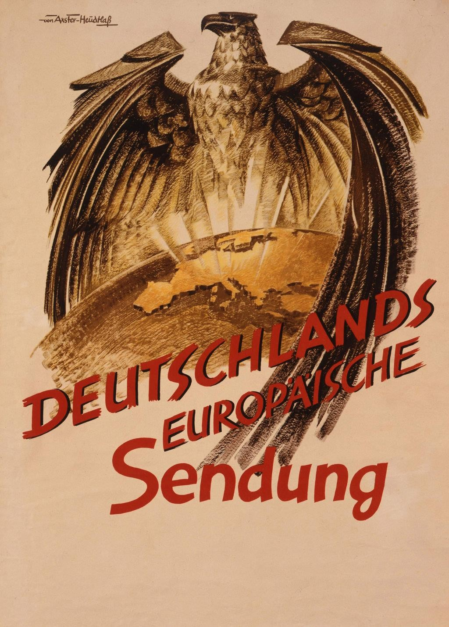

# Reichsleiter Dr. Otto Dietrich

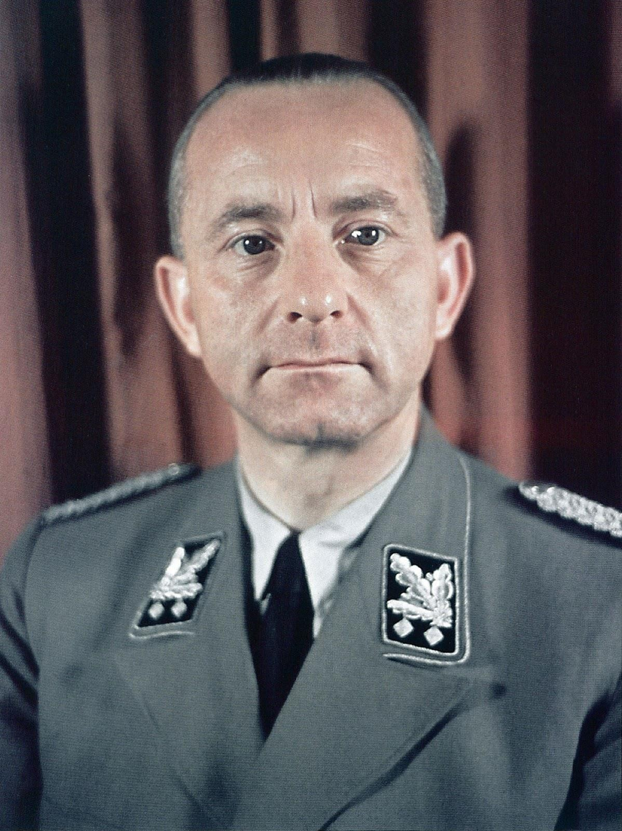

*The Spiritual Foundations of the New Europe* is the text of the speech delivered by Dr. Otto Dietrich, the head of the German Government Press Bureau, before the German Academy in Prague on January 20, 1941.

he struggle now being waged on battlefields and seas by force of arms - that *ultima ratio* of the nations - is quite incontestably, in the final instance, a struggle between two antagonistic philosophies. Behind the armies and navies

T

of iron and steel and by means of them, an ideological struggle is going on, in which a new conception of human society, created by the two greatest cultural nations on the European continent, is fighting for its freedom and future against the spiritual powers of the past.

In his New Year’s proclamation, the Führer described this struggle of the German and Italian world as possessing revolutionary importance for the future development of mankind. He defined it on the political plane as the “struggle of the National Socialist rights of the people against plutocratic privileges.” He went on to say that “the German world, like the Italian, has overcome the era of privileges of a few plutocratic capitalists and has substituted for it the era of the people.”

“Whereas the others are preparing to take from the have-nots what little they still have, we confront the capitalist world, resolved to assert the claim of the have-nots to the general rights of man.”

This clarification of the lines drawn by the Führer clearly defines the last vestiges of the political struggle for power today. The senile philosophy of a decaying era once more challenges the victorious principles of a young and flourishing epoch, with all means at the disposal of its satiated plutocracy, to subdue the new order and to reduce it once more to the condition of poverty and impotence from which this new order has risen.

The reactionary democracies of the West have rejected all attempts at peaceful evolution and have declared war on the revolutionary champions of a new era.

They wanted a fight and now they have it.

The German people, numbering some 85 millions, have accepted the challenge. We have decisively defeated France. And, the arrogant Anglo-Saxons, wherever they are to be met, have been driven back to their islands like whipped dogs. We have broken through their blockade and have blockaded the British themselves. And we will complete our triumphal march against our adversaries in the same way Britain started it.

Here, in this decisive struggle, not only is the force of arms victorious, but also the spirit by which they are inspired and on which they are borne. With these soldiers, who are the admiration of the world and with these armies for which no obstacles exist, a new era is marching and a new idea, born of the people and incorporated in their Führer. Herein lies the ultimate secret of their invincible strength.

Certain nations have understood these deeper manifestations, and have recognized them as the effect of creative forces in the evolution of humanity. But there are other nations, whose ruling classes, in the smug self-satisfaction of their restricted outlook, in the progressive sclerosis of their ideas, and in the torpidity of their thought, have rendered their peoples deaf to Nature’s warning signal and blind to any mental perspective in the course of events lying beyond their own limited horizon. They consider themselves as having reached the final milestone along the road of progress, and their democracy as the end of human evolution. They therefore curse that which they do not understand and spit on that which they cannot comprehend. Since they cannot win the war by force of arms, they have begun a “moral war” against the Axis powers. And in proportion to the extent of the breaches made in their starvation blockade, they seek to envelop Germany and Italy by a blockade of hatred. For this purpose they have set in motion all the evil spirits of their degenerate democracy against the credulous peoples who are so receptive to lies. They befog minds with phrases, and with the help of the lying news net in which so many peoples are entangled, they have, so to speak, pushed a large part of the world into a condition of mental hysteria in order to cook the broth of their moral slander in this witches’ cauldron of excited passions and grotesque ignorance.

I do not think that I have described these events too drastically. Whoever follows the publicity of the Anglo-Saxon world from day to day knows that a condition of mental confusion has here been reached which cannot be exaggerated. Demands are made on human logic which from a medical point of view are almost alarming and which belong to the domain of psychiatry. I am reminded of the fantastic tale by Edgar Allan Poe in which he describes the visit of a scientist to a private mental home where the principle of “individual freedom” is put into practice. There is no need to keep an expensive staff of wardens and attendants, since, confiding in the understanding and discretion of the inmates, certain of the lunatics are appointed to supervise and influence the actions of the others. During the course of events it transpires that the doctor, a lunatic himself, explains to the visitor the lines along which the establishment is run. This “doctor,” who, with the help of some of his companions, has overpowered the asylum’s entire staff and locked them up in the padded cells.

This gifted writer would here seem to have disclosed in a moment of singular clear-sightedness the true character of the Anglo-Saxon mentality. Reason has been imprisoned in padded cells and lunacy has taken over the helm! Such words, indeed, appear to be the solution to the riddle.

This war has already produced many decisive results. It has proved Germany’s overwhelming military superiority. Thanks to this superiority, a decision has already been reached on the European battlefield. Germany has broken the enemy blockade and made accessible inexhaustible means of military power and economic resources in Europe. Among the problems which this war has not yet solved, one of the most

important, as it appears to me, is a mental and psychological problem: namely, the liberation of minds. The German army had first to pierce the Maginot Line before the French people recognized the truth and were freed from the chain of lies by which they were bound. It is in truth, not in the least to the credit of democracy, that in this war truth must first be conquered for its namesake by the sword. Will it still be necessary in this world of the democrats, which is alleged to be so enlightened and progressive, that nothing less than force of arms should lead humanity back to a recognition of reality, to reason, and to discernment?

When at last will the spiritual world of this agitated European continent cooperate in order - with its whole moral authority - to make a breach in the stone wall of phrases and untruthfulness which today surrounds the peoples? When at last will the idealist forces of this continent, which can claim to have first established and fertilized the whole cultural world, seize the sword to cut a clear path through the brushwood of mental confusion which today grows luxuriantly around the brains of large numbers of human beings?

This is the question that must now be put before the world, because it is of profound interest to millions. Has the spiritual life of Europe, which has brought forth so much greatness to benefit mankind, at this moment, during an evolution which will decide the course of centuries, no longer have the courage and strength to recognize the path to new heights and to point it out to the masses?

I refuse to believe that. And that you, gentlemen, have followed the call of the German Academy to this place, the venerable site of European spiritual life, confirms my conviction, just as does the fact that before a forum such as is here assembled, the spiritual problems of the new Europe have been selected as the theme of my address.

The will to achieve, the will to order, the striving towards a higher and more progressive development, is the moral law, the “higher command” in the life of nations. In order to accomplish it, two ultimate creative forces have been given to humanity, namely, Idea and Personality: they are the pillars of human development. In their synthesis, life attains its apogee, human life attains its highest form.

Men make history, but the destinies of peoples are forged by the creative force of dominating ideas. Through the genius of inspired men they perceive the light of the world and reveal that which slumbers deep in the soul of the peoples. Great ideas are like milestones on the path of humanity. They are the platforms of human progress. The torch of the spirit, borne by bold men, has always illuminated the path of humanity. Such inspiring ideas, which once more bring back the laws of life into the conscience of nations, have at all times decisively influenced the development of the European cultural nations. They have elevated them when they were young and promising and thrown them to the ground when they were weak and aged and had

outlived their time.

The events of our days are vast, tremendous. Revolutions which otherwise only mature in the course of centuries take place within the space of a few years.

Ideas which enveloped the world are dying out. Edifices of thought which appeared unshakable are beginning to totter. And from the ruins of what was old and decayed, a world constructed on a new plan rises before us. Who among us could conceive the events now shaping the nations and shaping destiny from the mere standpoint of the course of events, from the narrow horizon of daily happenings? Only from the perspective of great human advancement does it take on significant shape. And only with the concept of a new world of ideas does it become comprehensible.

There can be no doubt that we are on the threshold of a new era, that we have already begun a new stage of development. I believe that if we wish to understand the immensity and significance of the revolutionary occurrences of contemporary times, we must understand them from their earliest beginnings.

The formation of human concepts is also subject to progressive evolution. Just as the intelligence of the individual, from childhood to old age, consistently develops in a continuous metamorphosis of concepts, so does the intellectual patrimony of the people grow from the inheritance of generations and from the experience of centuries. Mindful contemplation and stages of maturity alternate with revolutionary eruptions of our forces of perception, when the intellectual methods of yesterday have become unfruitful for the understanding of the spiritual and social problems of a new era.

At such a turning point we stand today. A revolution has been accomplished not only in political and social life, but also in thought. It has its starting-point in the two great cultural nations of Europe, Germany and Italy, and will become vital for other nations in proportion to the advantage they take of it.

If we wish to measure the forces and recognize the forms according to what the new Europe is constructing and determining itself, we can do so only by fully comprehending the elements which have produced these forces and have become reality.

In the conception of the world disclosed to us by the National Socialist idea, a rotation of the axis of perception has been accomplished: a change from “I” to “We,” from the individual to the community. A breach in the world of the mind has thereby been accomplished, which has corrected a centuries-old error in thought. Its spiritual and historical accomplishment is that it has dethroned the individualistic manner of thinking which has dominated centuries of our development and has now substituted socially conscious thought, which makes entirely new foundations of existence and

tremendous possibilities accessible to us.

In a former series of lectures I have explained in detail the theory of perception which is the foundation of this fundamental fact and will here consider it insofar as it is necessary in this context.

Individualist thought is based on the erroneous supposition that the individual is a solitary being and must consequently be regarded as such in all aspects of life. On this seemingly inviolable and readily accepted proposition, which from the point of view of the theory of perception was entirely fallacious, individualistic thought had been erected throughout the centuries like the Tower of Babel. It has escaped the acumen of so many philosophers of this individualistic epoch that the individual as an isolated ego possesses no reality in this world, that in all his actions he is a social being, in the family, in the natural community of a people, a race, a nation, of which he is a member, and of the entire system to which he is more or less bound. These philosophers had overlooked the fundamental fact that the community in which human life pursues its course from the cradle to the grave is not only the condition of existence and of opportunities to exert an influence, but also the conceptual prerequisite and category of thought. They had not recognized that in all spheres of human social life, it is not individualistic and not liberal thought, but only integral thought that takes the community into consideration, can the world of reality be made accessible to us, and that on the strong bedrock of the natural community, all the individual’s forces of perception are therefore included.

Individualistic thought was the error in spiritual construction of an entire epoch. That is how I should express it. It is the great spiritual achievement of our time to have separated itself from the entanglement of individualism from which even the social movements of the previous century were unable to liberate themselves and to have recognized in the community the only possible foundation of our thoughts and actions. Thus has one of the most fundamental revolutions in the spiritual history of mankind been accomplished.

This revolution in thought is the key to the gateway of a new era. It comprises all aspects of life and in all domains provides solutions to problems hitherto unsolved. For all who possess this new foundation of thought, life is clear and fraught with significance. The new foundation forms the bridge to a new stage of development in human perception, leading us over to new realms where culture and progress flourish. And that, gentlemen, is not a daring concept or mere empty theory, but blessed reality based on real life.

For our generation, it is true, this revolutionary transformation of thought poses problems, some of which are very grave. The dawn of a new era often causes apparent contradictions to appear for those who, burdened with a mass of prejudices from the

past, gain a footing only with the greatest suspicion on the new territory of the present. They do not yet know that which, seen from the past, appears radical and impossible, when seen from a new platform becomes natural and comprehensible. Whoever grew up in the past epoch and learned to speak its language and think its thoughts cannot, with the concepts of the past world, understand the new.

Others, whose powers of perception still lie to a certain extent in the shadow of the past, while the stages of a new era have already been traversed, consider the new ideas as an erroneous doctrine and combat it with the passion of conceited and spiritually misguided fanatics of truth. They imagine that the present war must pursue the same course as the preceding one, whereas, in reality, they are confronted by new and different forces for which they are no longer a match. Their brains refuse to acknowledge the most primitive laws of human logic. Although they are in very deep water, these idiots talk of victory, a sin against the clear, factual evidence that almost amounts to political blasphemy.

Then there are those who have erected their dominion and power on the plutocratic degeneracy of individualistic thought. They rightly fear the victory of new ideas, since they recognize in them a danger to their own existence, and consequently fight against them with the most reprehensible methods, as against a monster of Satan.

During thousands of years, humanity believed that the earth was a flat disc and only four hundred years ago it was still convinced that the sun revolved around the earth. Four hundred years ago a German discovered that the earth is only an insignificant star circling around the sun like many others. With this knowledge a world collapsed and a new world of progress arose. The forces of reaction and brutal intolerance flung themselves against the triumph of truth and the right to new life. The teachings of Copernicus were placed on the Index, Galileo was imprisoned and Giordano Bruno was burnt at the stake. Today a Copernican crisis of the spirit is taking place on the plane of thought. We discover today that the world does not revolve around the individual, but around the community, the people, on whose destiny the fate of each single individual depends. Again the powers of retrogression and the reactionaries of the plutocratic world raise their heads, as once before, in order to suppress the progress in the life of nations and to extinguish the spiritual flame in the blood of the peoples. Again the dark powers of a past era and the exploiters of humanity’s backwardness have united to erect the funeral pyre of intellectual intolerance for the champions of progress. But this time the disciples of new thoughts not only have the right, but - praise be to God - they have themselves strength to withstand their corrupters and to dash them to the ground. And not being strong enough itself to hold back the turning of the wheel of evolution by the force of its own weapons, this frustrated inquisition therefore imagines that it can overpower us with a coalition of world hatred.

A few days ago a well-known Englishman wrote: “What must we do to win this war? Two ways are open to us to arrive at our goal. The one method is that of brutal force, of battle between armies, the other is that of spiritual persuasion, the battle of minds. The art of total warfare consists in the skillful blending of these methods, whereby it must be realized that a victory on the battlefield of intellect automatically implies a successful issue of the war. Our military activity must be combined with a victorious campaign on the battlefield of brains.”

The weapon that the Anglo-Saxons use on the battlefield of brains is moral demagogy. For that reason they began the offensive of words. For that reason they are presently waging a battle of words against us. They are violating the most sublime feelings of hu- inanity with waves of ministerial speeches trumpeted forth from between their four narrow walls to the corners of the earth. They say they are fighting in the name of God, in the name of truth, progress and civilization. They are just fighting in this sphere for anything tangible. “We are,” so they say, “leaving our fate to the world of the mind.”

Gentlemen! When the world raises the question of civilization and intellect, then the great cultural nations on the European Continent have a right to join in the discussion! These great nations have given the world immortal works of culture and intellect. They have as a matter of fact presented to many transcontinental nations the cultural inheritance of thousands of years, but not the intellectual arrogance that today is spreading on the other side of the world. Conceit is not considered by the civilized nations in Europe as education, intellectual eclipse not as intelligence, nor arrogance as intellect. The spiritless apostles of hate would do well to take note of this!

Before I wrote this speech down, I took pains to make a thorough study of the intellectual content of all the speeches made by British Ministers and their Anglo- Saxon underlings during the past year. What I found was an endless repetition of moral treatises, but most of all, an absolutely scandalous lack of intellectual matter and objectivity. The intellectual essence of the last year, produced by the best brains in the Anglo-Saxon world is approximately as follows:

Hitler’s new regime exists for world domination by the German nation.

The Nazis wish to enslave humanity. Britain is fighting for a principle, for the liberty and the future of the whole world.

She is fighting the battle of good against evil.

Britain is fighting for liberty and democracy, for truth and dignity against intellectual tyranny. The democracies are fighting the fight for a better human condition.

United we will save the soul of humanity. We wish to direct the way of humanity along the great road of progress.

If democracy is vanquished, the world is doomed. Together we seek the light against the powers of evil.

And so it goes on, all in the same tone. Naive readers and listeners to this deluge of phrases must think that choruses of intellect are erecting mountains of wisdom against barbarous retrogression. But if one digests these speeches, steeped in the morality of their wordy froth, then it is difficult to avoid a feeling that the villains of the century have formed a coalition. On closer inspection, one can glean an abundance of unintelligible slogans and misapplied conceptions, devoid of logic and without a trace of objective reasoning - a mockery to the thinking world - trumpeted forth as the latest revelations of knowledge: “Morality,” “Liberty,” “Truth,” and “Democracy” are shaken together according to formula, like a cocktail, and served to the listeners.

But on the questions of morality in the life of nations, what is good and evil, on which side the angels of world order are seated, and where the devils sit, where the ethical governments and where the hypocritical governments are to be found, who let loose war in the name of humanity and in humanity’s name prevents them from being ended, those are, in my opinion, questions that will not be decided by limited intelligence, but by a higher Providence. One cannot discuss morality with people who make a commercial business of Christ. “They fold their hands and make a compromise with God” as the poet Wilhelm Jensen once wrote. A race such as the British, which has so sullied morality, should not make bold to fight with the weapons of morality.

As far as truth is concerned, that is also a dark spot in the life of the British. Just as they have their own moral code, they have also created their own special version of truth. One of their great men, the former Prime Minister Stanley Baldwin, once said in an address from the platform of a British public school: “Humanity places patriotism, as the fundamental virtue of statesmen, above the love of truth on the battle grounds of international competition and conflict.”

This is the charter of untruthfulness. They lie in the name of the nation. Confirmation of this fact is provided by the whole of their political history. What value, therefore, has the word truth in their mouths?

If these phrases are projected on the screen of objective discussion, for an examination within the sphere of human logic, only two tangible conceptions remain, that of liberty and that of democracy.

Those who wish to discuss liberty must first of all know what liberty is and its

importance in the communal life of nations. The democratic spokesmen on the other side of the Channel assert that they hold liberty in hereditary tenure, and declare there is no liberty in our country. As a proof to the contrary, I would like the liberty of liberating their idea of “liberty” from the weight of the phrase. Although the problem of liberty is the pillar of individualistic thought, the philosophers of liberalism have never been able to give us a satisfactory answer to the most important question known to the history of human thought. The Anglo-Saxon democrats, however, offer us no logical definition. They explain liberty by the rights of humanity and the rights of humanity by liberty. The whole thing is a vicious circle of empty phrases.

A British philosopher once said, very rightly, that error is most difficult to overcome, when it is rooted in the language.

Unsuitable words forge the chain that binds men to irrational actions. Every unsuitable expression contains the seed of deceptive assertion. It forms the cloud that obscures the real nature of things, and very often creates an insurmountable barrier to the discovery of the truth.

The word liberty has also caused a similar confusion of ideas in the heads of many people.

Liberty is an exalting and inspiring word, but often a misinterpreted and misunderstood word. Just as it has at all times attracted the best intellects, so at all times has it been misused by the worst intellects for their own purpose. It is the commonplace of sentiment and thought, where individualism celebrates truly bacchanalian orgies.

The liberty of the individual, according to individualism, is the first progeny of human rights. But even this starting point in its line of thought is wrong. Aristotle himself teaches: “A nation is more akin to Nature than the individual!” The origin of our ideas is not the individual, but, as I have already explained, the community. Therefore every notion of liberty which is not based on the community is not based on things as they are. The conception of liberty which is not derived from the community is *a priori* wrong, and is useless as any kind of conception within the sphere of human social life. It is not an incentive to life but destructive of it. What, therefore, is known as “individual liberty” is not, as is so highly maintained and regarded as self-evident by its apostles, something given to man by Nature. Nature gave man the consciousness of the community into which he is born.

The conception of individual liberty, however, purposes the liberation of the individual from his duty to the community. Speech describes the man who rejects his duties towards the community as an “individual.”

Kant, that Titan among philosophers, gave the highest moral interpretation to the problem of liberty by propounding the doctrine of a harmonious combination of liberty and restraint. It was his greatest intellectual feat to recognize that man is free and bound at the same time. I have already explained in detail the importance of this concept in relation to new ideas and what a conclusive solution to the problem of liberty its synthesis provides. The answer is: The human being only acts freely when his actions are in harmony with the nature of the community to which he belongs.

From this it will be evident why liberty can only be constructive liberty and why the only people who have a right to liberty are those who work constructively for the good of the community.

The French Revolution inscribed “Liberty” on its banners, but in reality it strangled freedom in the unbridled nature of individualism. What remained was only a paraphrase of the word that the plutocrats have seized, in order to perpetuate the shackles of servitude under the banner of liberty.

Our revolution has not destroyed liberty, but has divested the liberty of liberalism of mere words and has for the first time given liberty its real value.

True liberty lies only in a higher form of restraint. This does not apply only to the life of the individual, but also to the lives of nations among one another. The outward liberty and sovereignty of nations also have their limitations that are determined by space and sound organic principles of order. How cheap and clumsy, how senseless and absurd is the implication by our adversaries that Germany wishes to conquer the world. They are trying to convince the nations that once again one of humanity’s great political adventurers is striding forth to chase after the old dream of world domination.

I believe that such assertions are only possible because there are nations who are as credulous as children. I have been working for ten years at the side of the Führer. I believe that if he had any intention of conquering the world, I should have heard something about it. Such transparent and ridiculous assertions are not only incompatible with the concept and the basic principle of National Socialism, but are absolutely in contradiction to it.

The basic element in the political concept of National Socialism is that of the national state. It has no ambition to make imperial conquests, but strives after inner collectivity and national concentration. And the clear proof of this is the unprecedented organization by National Socialism of that tremendous return migration of racial Germans, the return of German blood to the Motherland.

The political conception of the national state is not directed towards a frittering away of power by outward expansion, but towards rational internal construction and

the safeguarding of the national standard of existence. It has enforced the idea that relations between states can be made more permanent if the prospect of the nations is clear and determined and if leadership is responsibly and authoritatively rooted in the nation.

The organization of life in our present-day Germany reflects internal national and political determination and externally also shows definite lines of conduct. The ideas and the driving force of National Socialism are directed exclusively towards peace, as long as the indispensable bases of existence and security are guaranteed to our nation of 85 millions living within the heart of Europe. National Socialist Germany has been forced to fight, because the principles of imperialism and world domination of the Anglo-Saxons negate the simplest preliminary conditions for the development of our peace-loving nation. It was for this reason that they declared war on us. Britain is conducting a war of destructive force against constructive organization in the life of nations. The fact that National Socialist Germany has proved itself to be stronger than its aggressor in a war which has been forced upon it, is no proof of the violence of its principles, but only of the strength inherent in its ideal of order.

They say: “We are fighting for the democratic way of life. We are fighting for the liberty of living our lives as we wish.” But National Socialism has no intention of preventing them from doing so. It holds the opinion that every nation should live its own internal life in accordance with its own desires. The crimes they attribute to us are in reality committed by themselves. In no single country in the world does there exist such a great and disgusting intolerance of the mode of living of others as in the Anglo- Saxon countries. This intolerance is carried on hypocritically in the name of liberty, a liberty the real character of which I have already described.

Our adversaries maintain that this is a war of democracy against tyranny that makes it necessary either to unmask these political play-actors or else to open the eyes of their public to their true nature.

I may be allowed here to quote a neutral scholar, who a short while ago wrote an article “Hitler and the Democracies.” He asked the question why the Führer should be an opponent of the democracies, as he was one of the people himself and as president of the most democratic republic in the world was constantly in sincere and direct contact with the people. During his examination this scholar comes to the conclusion that only the modern democracies, France, Britain and America in particular, apparently had something in common with the will of the people. In reality it was only a pretext for party interests and the compensatory business of a few political circles among the upper classes. The mistakes of liberal democracy had already been made by its founders who had introduced into it their own material and utilitarian outlook and economic individualism. All this had been shamefully decorated by the founders of liberal democracy behind a facade of idealism. They themselves had never honestly

believed in the catchwords of “Liberty,” “Equality” and “Fraternity,” which they had invented. In these so-called Western democracies, power was not actually upheld by the people, but a few thousand capitalists. The functioning of democracy merely concealed the selfishness of a small minority living in ease and comfort.

These statements hit the nail on the head. One should not always only talk of democracy, but for once answer the question: “What is ‘democracy’? What does it actually mean?”

If democracy is no more than invisible domination by a few, achieved by means of money and the fabrication of public opinion, then our opponents are right in calling themselves democracies. But if democracy really denotes government by the people, then it is not they, but we, who are the democrats. We attach no particular value to decorating ourselves with this word that has become so compromised on account of its political past. But if the plutocrats make use of it to camouflage their domination and to deceive the people, then it is necessary to make its meaning perfectly clear. Whoever studies the conception of the National Socialist state in its innermost structure and practical functioning is bound to recognize that it is the most modem government of the people in history. It demonstrates the principles of responsibility and leadership in the truly national state, in opposition to the anonymous principles of degenerate democracy. It regards the will of the people not as a dead parliamentary majority to be gained by money or financial influence, but recognizes it continually in the permanent and direct alliance with the life of the people itself. The National Socialist Party is, therefore, not a party in the parliamentary sense, but simply and positively the party of the German nation. It is the great guardian of the social conscience of the nation, it holds its hand on the pulse of the people, it feels its slightest stirrings, its anxieties and its needs, its requirements and its desires, its pleasure and its pain. It is its helper and adviser and the unceasing bearer of its suggestions to the higher authorities. It has entrusted hundreds of thousands of citizens of all professions and classes with political responsibility, thereby providing tens of thousands of politically tested Germans with the opportunity of advancement to leading positions in the Reich. It has linked the perpetual stream of youth, organically and eternally, with the life of the nation and has created a system for the selection of leaders, which compels future generations to play their uninterrupted and vital part. Tangible shape is thereby given not to the will of a questionable parliamentary majority, but to the true will of the people. By its principles of training, efficiency and selection of leaders, it has given the nation a wonderfully functional system with the rhythm of strength continually renewing itself.

Nearly 2,500 years ago Plato wrote in his “Laws” that the most excellent constitution of a nation was that which was successful in persuading the masses to submit voluntary and in raising the most intelligent in their midst to leadership. The new principle of national and political leadership developed by the highly gifted

leaders of Germany and Italy has made these sublime political concepts reality. When today the messiahs of democracy and the plutocrats talk contemptuously of “dictatorships,” their intellectual arrogance only conceals the stain of ignorance or the essence of hypocrisy which fears nothing so much as the realization of truth by the awakening of the nations.

And there is still a great final problem to be solved if we wish to discover the intellectual foundation of a new European order.

The French Revolution coined the phrase “Equality for every human being.” This idea of equality is the root from which the social thought of the 19th century has sprung. The nearly tragic confusion of direction with which the problem of socialism was so long stigmatized arose from that false assumption of “equality.” People are by nature not equal, but unequal. There are capable people and less capable people, able and less able, those who can do something and those who can do nothing. The problem, therefore, which socialism has to solve, is not of establishing a harmony of interests among equals, but rather among unequals. That principle alone which is capable of providing this solution can claim to offer a fruitful organization of human society in harmony with its natural development.

The starting point of National Socialism is the inequality of individuals, but it demands equal opportunity for all to rise above one’s station in life. It offers all workers the same chance and the same prospects of success for all those of equal capability. It returns to all those who have been dispossessed by a disastrous capitalist history, their equal economic standing by removing the obstacles which the liberal system, with its privileges of possession and capital, had erected as an insurmountable barrier. It thereby lays the foundation of an economic and social order, in which every member of the nation, no matter what he is or whence he comes, can rise to the highest economic and state positions, if he has the strength, the will power and the capability to do so.

This true socialism which opens up to the simplest man the world of economic success, teaches that a man’s own interests are best served when the welfare of the community is made his chief concern. It connects the interest of the individual with that of the nation, and thereby develops the economic powers of the community to the benefit of the individual. You will recognize, gentlemen, that this principle, one of the most blessed of all ideas ever conceived, opens the prospect of multiplying the motive power of the human economic system.

This socialism founded on efficiency, which gives everyone the same chance, but success only to the capable, creates the only possible harmony of social interests amongst men of unequal capability. At the same time it is altogether the most sensible and the highest form of social life, because from it the nation can always develop

strength for a new golden age.

Before I apply this idea to international affairs in order to demonstrate its usefulness the internal life of the nations, I should like to add a few words about the economic aspect. The new foundation on which our way of thinking is based has also in this sphere supplied National Socialist Germany with immensely interesting and fundamental solutions. The National Socialist way of thinking has made a valuable discovery in the economic field. It has found the center of strength underlying the closely-knit web of the modem economic system and, penetrating the veil cast around it by finance, has recognized that man’s work is the foundation which gives life to the whole system. Amidst the labyrinth of economic theories we have discovered the thread of Ariadne leading our economic thought back to clear thinking: productive work.

We have realized that in actual fact only productive work can produce consumer goods and that consequently trade and industry are not capital and money problems, but a production problem. This system sets the true principle that “work creates work” over and against the capitalistic principle of “capital must create capital.” That is why we have dethroned the liberal dogma of the primary importance of a good return on capital and replaced it by the principle of the productivity of the nation as a whole. We have thus laid the foundation for a national economic revival. The successes we have achieved are a tangible proof of the true value of our economic system that is established on the great lines of the age in which we live. This new system has done away with unemployment, it has done away with inflation. If you, ensnared by the conceptions of the past, ask me: “What do you call your economic system? What is its name?” I can only answer: The economic system has as yet no name, because it has never existed before in the history of the world.

We have recognized that money in itself has no economic value, that it merely fulfils a function, and that adherence to the gold standard may have had practical value as an exchange basis for money in a bygone, more primitive economic era. But, in a modem, progressive economic epoch it has proved to be impracticable, even dangerous and disastrous. The Jewish plutocracy seized upon this primitive survival of a long- outworn economic age in order to use it as an anchor for their domination. With the aid of the gold-illusion they maintain the conception that money is not the means to an end, but an end in itself, and with criminal egoism they thus strangle the economic progress of the nations. National Socialism has realized that the best foundation for every currency is confidence in the leadership of the State and in its ability to revive the productive forces of the nation. It has exploded the gold-illusion in Germany. We have nothing but a pitying smile for those nations who even today fail to grasp the true role of the yellow metal which fetters world economic progress and which is dug out of the bowels of the earth only to be buried again in underground vaults.

In modem economic life, gold is not only a factor in producing nothing but is actually a drag on all development. It is the opponent of the principle of productive work that promotes economic progress and the social development of the nations. I have described to you the blessings conferred by this way of thinking upon the German people. I am of the opinion that it will also prove to be the regulating principle governing the future way of life of the European nations. Permit me to say a little more on this subject.

Nations, like human beings, are not by nature alike. In the relations of the nations a peaceful alignment or harmonization of their interests is only possible if each nation is given an equal chance of competing with every other nation. Nations, too, as Nature has ordained, can only take their place in the world in proportion to their capacities and their achievements for the world. In the competitive struggle between nations, only the best nations can occupy preeminent positions on the strength of their achievements and capacities. Just as the principle of achievement and selection within a nation promotes its highest development, so the principle of achievement in the mutual life of the nations guarantees progress for them all. It is only on this principle that those forces can be set in motion among nations which assure the greatest possible progress for all and consequently the highest development for each.

If it should ever prove possible to replace force in the life of nations by peaceful settlement, I believe that this idea of equal opportunity for all will contain the only possible constructive principle for the preservation of peace. On one occasion, in the League of Nations, an attempt was made, although only by the credulous, to eliminate armed disputes between nations by organizing peace. This futile attempt with a futile instrument, however, failed. The League of Nations, professedly constructed on the principle of equality, developed into an instrument used by the vanquishers against the vanquished for the perpetuation of hate, of injustice amongst nations, of unfair conditions and for the suppression of human progress.

Compared with this attempt, the recognition of the principle of progress in the life of nations is a dynamically constructive, truly creative principle of statecraft, a principle that is capable of replacing force by peaceful competition among nations. It alone can create equal conditions, i.e., equal opportunity for every nation to participate in gaining the earth’s treasures in order to utilize them in proportion to its capacities and abilities.

On a previous occasion I answered one of the most burning intellectual questions for our national community, namely: how are personality and personal liberty possible within the limits of community life? I then pointed out that the solution was to be found in the reciprocal unity of the National Socialist idea, in which the community supports the personality so that the latter in its turn may work for the community. A similar key problem is today posed by the international order of nations, namely, how

is a general concert of nations possible which at the same time preserves their external freedom? There is only one reply possible: not on the principle of privileged position for individual nations, but on the principle of an equal chance for all. Not only the few who have forcibly acquired possession of the largest part of the earth’s treasures are to have their share in the possibilities of world development, but every nation according to the measure of its achievements.

The recognition of this principle of achievement implies the adoption of a common order in which freedom and obligation can exist side by side. What we conceive is a racially constituted but organically combined order of nations. This concept, the product of a new synthesis of spirit between two of the great cultural nations of the Continent, is designed to summon Europe to new faith, new development and renewed progress.

This concept is worthy of the great spiritual traditions of our Continent. I need not enlarge upon the creative and cultural abilities and state-forming capacities the Roman Empire gave to Europe and the world at large. For almost a millennium, order in Europe was guarded and assured by the existence of the German Empire and its Emperors. The influence exercised by the Copernican concept of the universe prepared the way for a change in this hierarchical order, and its end was sealed by the Thirty Years War. In Europe’s chaos, after the old order had been overthrown, France gave birth to the conception of absolutism. Out of the French Revolution, directed against this absolutism, there grew the discovery of the rights of man, which were unfortunately incorrectly understood. The ideas of the French Revolution removed obsolete and retarded ideas, but brought about no new creative force. This was their weakness and, if you like, their tragedy. Liberalism, by releasing pent-up forces, undoubtedly contributed much towards human progress. But by degenerating into individualism it exerted a fateful effect upon the social life of the nations. Freedom of trade resulted in the dictatorship of capital, the freedom of the press in the dictatorship of the Jewish spirit. Out of democracy grew the domination of the plutocrats.

The revolution of our own times is now dethroning individualism as a mistaken construct and is discovering the human rights of the people which will bring about a new epoch in the development of Europe and the ordering of its life. Immense possibilities of cultural and social prosperity, of a multiplication of economic forces and an improvement in the standard of living are latent in this new order, in building its comprehensive economic sphere and in the security and safety of its political stability. With the help of this new order and its creative principle, the nations of Europe will rise to new and flourishing life from the ruins of a past epoch.

All the ideas that have ever influenced political and social developments in this part of the world and have opened up progress for the nations have been of Continental origin. What, compared with them, are the arrogant claims of the

inhabitants of the island of Britain? Has Britain ever enriched the European Continent by a single vital principle? Her control-principle for the world was violence and robbery. Her only contribution to the life of the European nations has always been destruction. Almost every scheme for human suppression, of a lack of human morality and of human degeneracy was born in Britain. Britain has blessed Europe with the doctrines of utilitarianism, of egoism as the supreme driving force of human progress and of a criminal economic materialism. Britain is the birthplace of the so-called “classical economic theory,” of the doctrine of profit, which regarded the maxim “Capital must create capital” as the highest interpretation of the economic system. It looks upon human labor as a species of goods. It has made of money an end in itself and has enslaved the nations in the chains of the gold-illusion. All the dogmas of ultra- crass capitalism, and hence of the most profound depths of human misery, have been taught the European nations by Britain. The one “orderly principle” which Britain gave to Europe was the principle of the balance of power in Europe, the struggle of all against all, the permanent incentive urging the European powers to spring at one another’s throats. It caused a state of war in peace time to become a permanent situation on the Continent, in order, if need arose, to fan it into a murderous inferno.

Britain’s contributions to Europe have at all times been a drag on every form of organic order for the nations composing it. The essence of her League of Nations policy was the perpetuation of hatred. Her promised guarantees were treachery towards the nations who trusted in her; Britain unhesitatingly delivered them up to destruction. Her morals are a mere mask, her phrases those of a demagogue.

I have endeavored, gentlemen, to outline for you the main ideas which, proceeding from a revolution of thought, form the spiritual principles of the new Europe. I have sketched for you the train of thought which introduces a new epoch into the lives of nations. I believe that these ideas are right because they correspond as closely to the laws of logic as they do to the feelings and to the dynamics of our age. They are as simple as everything that is best in life and they are so unassailable and convincing that even Britain would like to adopt them today. “We need a new order in Europe, because the British people are not ready to lay down their lives for the old,” this is what we are being told today. All in vain, for they can no longer deceive anyone. Great and constructive ideas can only be developed by the forces that have called them into being.

Others again have the ambition to be the messiahs of a new age. But because they are still living in the spiritual darkness of a past epoch and cannot yet grasp the greatness of the new, they adopt demagogic phrases and indulge in outbursts of hatred. They live in a hemisphere engulfed in spiritual night and carry on a crusade for the so-called “freedom of the spirit.” But what they call the struggle for human liberty is in actual fact a struggle against human progress. What they term the struggle for democracy is a struggle for narrow-minded intolerance. What they declare to be

the struggle for truth is a struggle waged by total darkness against the light of a new doctrine. A later age will recognize in them the deepest-dyed spiritual reactionaries that history has ever known, the builders of the funeral pyre of the 20th century, a disgrace to humanity against which the whole spiritual world must rebel. And it must have the courage to give this disgrace its true name in public. The philosophy of our days is not a secret science. Its wealth of ideas is open to the simplest of our fellow- countrymen. The professors of philosophy in European universities had become lazy. They lacked the foundation for a new system of thought, but a new firm foundation has now been laid, from which new fertile spiritual life can grow, and work for the future of the nation in the service of truth.

To mobilize the power of the press as the spiritual instrument by which the nations can be led to this end has always been and is still my endeavor. And I believe that if we use all the ways and means provided by human common sense to unite in our struggle against reaction we shall have the power to ensure the victory of common sense.

The reactionaries of today are deluded enough to describe their system as the foundation of world order. They say that the whole world will perish if democracy perishes. But it is only the world of their obsolete opinions which will perish, while a new world will arise.

I spoke of a desire for order, of a striving towards higher progressive development as the supreme command in the life of nations. Fate will favor those nations who obey it. But the judgment of history will inexorably be passed at the decisive hour on those who disregard it.

I have now come to the end of my discourse, given not from motives of political opportunism. I felt it necessary for me as a sign of respect to the thinking world. The flood of filthy insults hurled at us cannot impress us, but such frontal attacks made by men of inferior intellectual caliber and such a primitive and shameful poverty of ideas, demand a reply to uphold the dignity and respect of the thinking world.

I should not have attempted, before such a body, to outline the ideas that are at work today for the construction of a new Europe, had I spoken to you as a mere theorist who is out of touch with real life. But I feel myself directly linked with the rhythm of the new age because I am in close contact with its creative personality and with the driving force which is shaping the future. It is the breath of this living spirit that I have tried to communicate to you.

I spoke, at the outset, of Ideas and Personality as the creative forces in the lives of the nations. In the Personality that is not only privileged to create ideas, but which endeavors to put them into practice by deeds, life is incarnate in its fullest form. The

greatness of such personalities is manifest to all in the greatness of their works. But an insight into the mechanism of their minds, into the rhythm of their ideas and into the workshop of their creative spirit is granted to only a few. For ten years I have daily and directly watched the birth of a nation from its depths. I have seen the growth of an Empire through the force of one personality. I may be permitted to make the following statement. If the rulers of the world that calls itself democratic had only a fraction of the greatness and the sense of responsibility of the Führer, then there would be more happiness in the lives of the nations and welfare among the inhabitants of this earth.

The fact that I know these things compels me to speak openly of them.

The same greatness of spirit which the cultured nations of the Continent so often exhibited in the history of the West is again making itself felt today in order to frame decisions which will determine the course of centuries. The nations perceive the nimbus of this greatness. It is only the brains of the statesmen in some of the democracies that are not large enough to perceive it.

Really great ideas are conceived in the heart and are understood by the heart. Today those nations on the European Continent who do not blind themselves to the signs of the times are awaking. The forces that believe in these signs are beginning to gather. Protagonists and supporters of a bygone past have become allies for the future. The struggle for this future is not yet over. But the verdict of history has already been pronounced. It has already launched the ideas belonging to a new age that will lead the nations to new development and prosperity. Their rhythm is that of armies and the marching columns who have taken up the battle for the vital rights of their countries and for the era of the people.

Every real revolution receives its consecration in battle and sees order as its goal, that true order which does not conceal the seed of new wars in itself, but throws open wide the gate of progress because it ensures the nations peaceful and progressive development.

# Digitized by Propagandaleiter