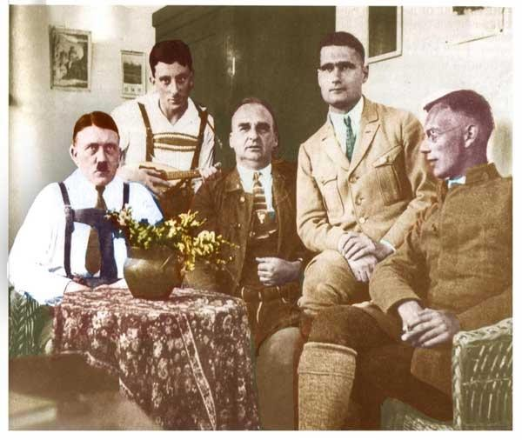

Oberregierungsrat Leybold’s Statement About Adolf Hitler in Prison

Adolf Hitler was sentenced to five years in prison after the attempted putsch of November 8, 1923. Instead of forcing Hitler to serve his entire sentence as a political prisoner, the prison governor, *Oberregierungsrat* Leybold, wrote of Hitler’s excellent prison behavior and became his advocate. Leybold worked in combination with Hitler’s lawyers to successfully achieve his release on 10 am. on December 20, 1924. The following is the letter written by Leybold in the middle of September 1924.

Oberregierungsrat Leybold’s Statement About Adolf Hitler in Prison

As requested by the State Attorney’s office, State Court I, Munich, I report as follows:

The political offender Adolf Hitler was consigned to the Fortress of Landsberg on April 1, 1924. Up to the present date he has served five and a half months. By October 1 he will have expiated his offenses by ten and a half months’ detention.

Hitler has shown himself to be an orderly, disciplined prisoner, not only in his own person, but also with reference to his fellow prisoners, among whom he has preserved good discipline. He is amenable, unassuming, and modest. He has never made exceptional demands, conducts himself in a uniformly quiet and reasonable manner, and has put up with the deprivations and restrictions of imprisonment very well. He has no personal vanity, is content with the prison diet, neither smokes nor drinks, and has exercised a helpful authority over other prisoners. As a man unused at any time to personal indulgences he has borne the loss of his freedom better than the married prisoners. He has no interest in women, and received the visits of women friends and followers without any particular enthusiasm but with the utmost politeness, and never allowed himself to be drawn into serious political discussions with them. He is invariably polite and has never insulted the prison officials.

At the beginning of his imprisonment he received a large number of visitors, but in the last few months he has discouraged them and withdrawn himself from political discussion. He writes very few letters, and for the most part they are letters of thanks. He is entirely taken up with the writing of his book, which is due to appear in the next few weeks. It consists of his autobiography together with his thoughts about the bourgeoisie, Jewry and Marxism, the German revolution and Bolshevism, and the National Socialist movement with the events leading up to November 8, 1923. He hopes the book will run into many editions, thus enabling him to fulfill his financial obligations and to defray the expenses incurred at the time of his trial.

Hitler will undoubtedly return to political life. He proposes to refound and reanimate his movement, but in the future he proposes not to run counter to the authorities, but to make use of all possible permissible means, short of a second bid for power, to attain his ends.

During his ten months under detention while awaiting trial and while under sentence, he has undoubtedly become more mature and calm. When he returns to freedom, he will do so without entertaining revengeful purposes against those in official positions who opposed him and frustrated him in November, 1923. He will not agitate against the government, nor will he wage war against other nationalist parties. He is completely convinced that a state cannot exist without internal order and firm government.

Adolf Hitler is undoubtedly a man of many-sided intelligence, particularly political intelligence, and possesses extraordinary will power and directness in his thinking.

In view of the above facts, I venture to say that his behavior while under detention merits the grant of an early release. He is counting on the decision of the Court to suspend his sentence as from October 1 of this year, when he will have earned a probationary period after completing six months of his sentence from April 1, 1924. In many of his letters Hitler anticipates that he will be released on October 1.

LEYBOLD

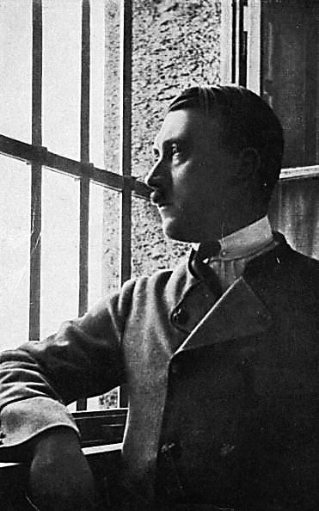

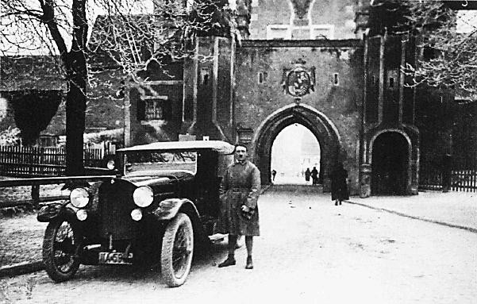

Adolf Hitler leaving Landsburg prison

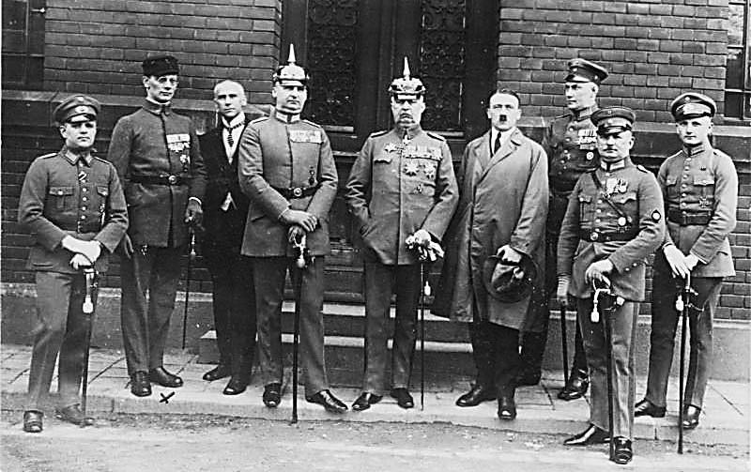

Hitler with Lieutenant Colonel Kriebel Hermann, General Ludendorff and other comrades outside Landsburg prison

Heinz Pernet, Friedrich Weber, Wilhelm Frick, Kriebel Hermann, Erich Ludendorff, Adolf Hitler, Wilhelm Brückner, Ernst Röhm, Robert Wagner

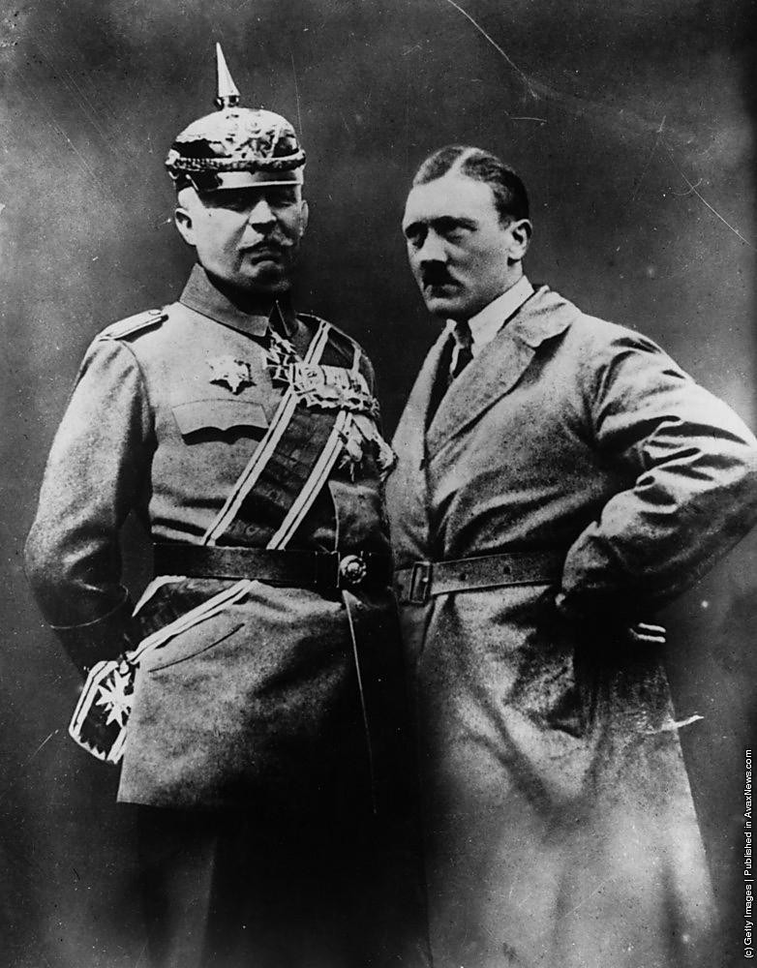

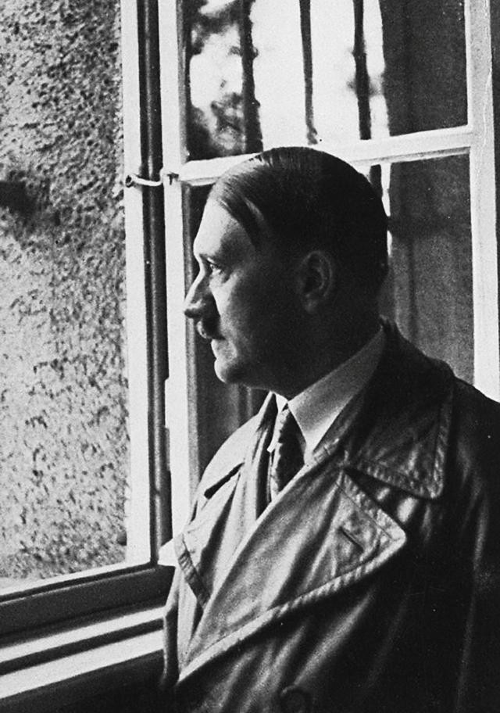

The Fuehrer visits his old prison