



Dedicated to
Savitri Devi & Miguel Serrano

With essays by Ignacio Ondargain

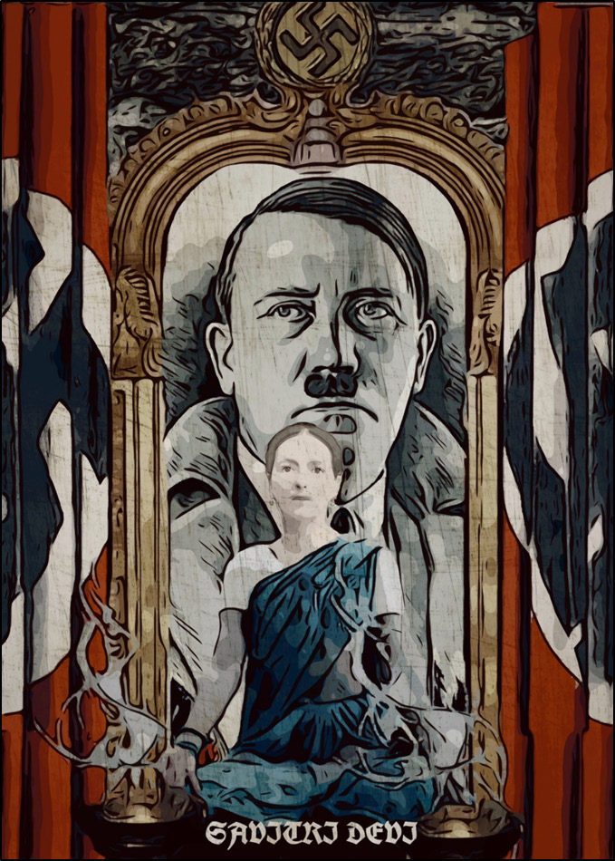

“Savitri Devi was a supremely cultured woman with deep philosophical, philological and classical knowledge; a student of history, mythologies, sym- bols and comparative religion. An absolute Hitlerist until the end of her life on this earth. Now she re- sides in Asgard. Even beyond all these things she was the High Odinic Priestess of Esoteric Hitlerism. She was first to recognise the emergence of the Ava- tara and the divinity of Hitler. She erected a temple in India to Adolf Hitler and became a priestess to the cult of his memory. She kept the faith, guarding the sacred flame, by illustrating her own books with the influence and inspiration of the Führer while living in India. A faith destined to prevail and suc- ceed mystically and magically on all continents and the future Millenia, if this sacred flame, this faith, is guarded and burns.”
—Miguel Serrano, Santiago, 15th December ano 95(1984)

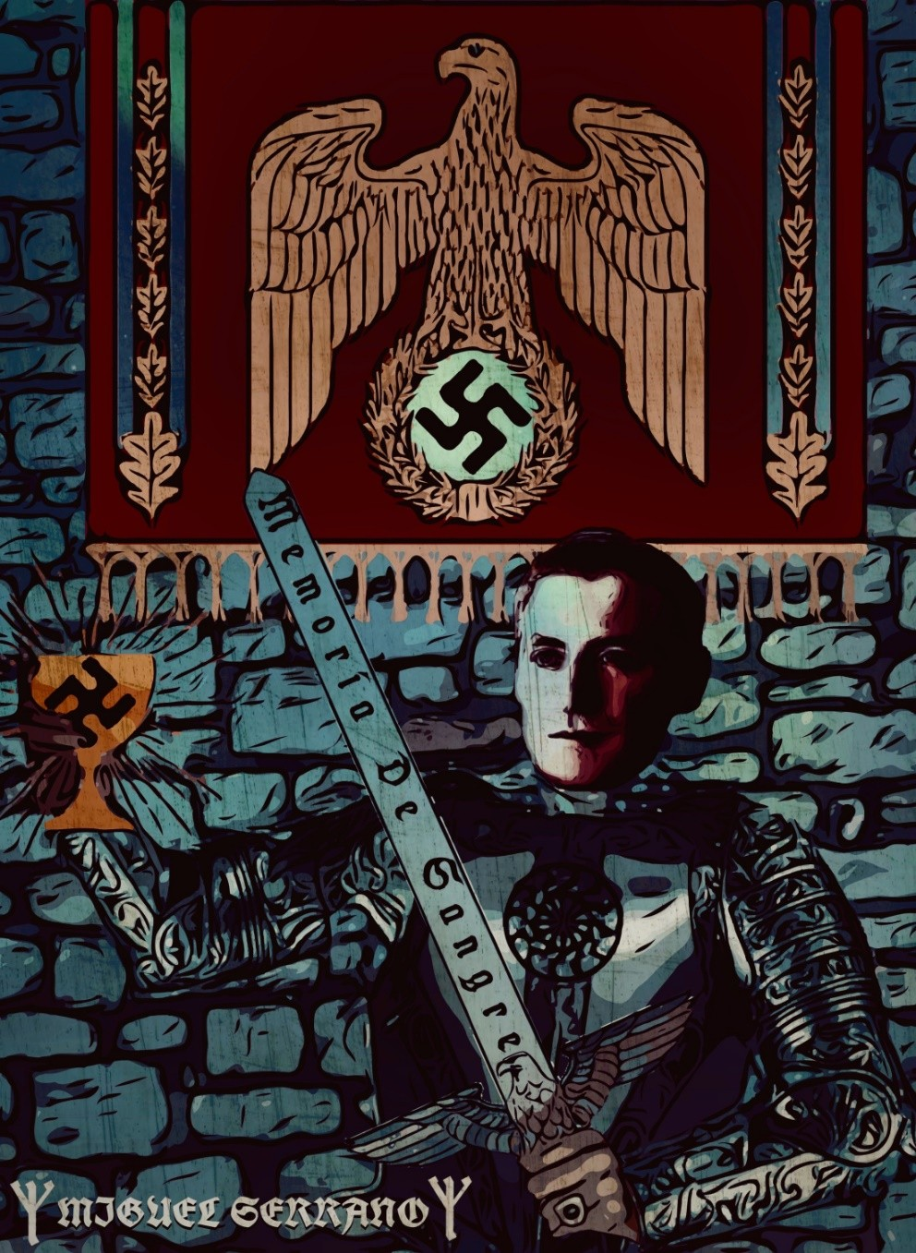

Miguel Serrano ᛉ10/09/28ᛉ ᛋᛋᛋᛋᛋᛋᛋᛋᛋᛋᛋᛋᛋᛋᛋᛋᛋᛋᛋᛋᛋᛋᛋᛋᛋᛋᛋ
“But I am not of these times, nor of this world, nor of these days. I am from another planet. I am from the Morning Star. I am not afraid of losing every- thing, including life. Furthermore, the motto on my coat-of-arms reads: “My honor is loyalty.” Yes, loy- alty to the ideals, the dreams, the past glory of the night, the ghosts of lost friends, the golden shad- ows, the echo of their steps, to the old streets and cities, and all that which escapes the light this mar- tyred earth projects, the longing for a Golden Age, when heroes still lingered among us, when the Gods were still talking to us. For I am among those who spoke with the Gods…”

MIGUEL SERRANO:
THE LONG LIFE OF A LONG SAGA
Written by: Criss Salazar
Translated by: Franz Berg

Last February 28th dawned cloudy and rainy. Lightning bolts cut the day, roaring from the starry realms and trying to terrify men with divine wrath, something they have not feared now for centu- ries past. An unusual, unwonted eventuality; something unex- pected in midsummer Santiago de Chile.
It was nevertheless a beautiful day on which Don Miguel Ser- rano Fernandez took his exit and parental leave of the Fatherland for which he had dreamed and fought so much, fiercely believing in his Idea. He always believed in synchronicities.
Such was one summer day though with rain and lightning bolts falling from the sky, in a storm filled with the blows of Thor’s Hammer, that was then using the celestial vault of heaven like an anvil.
Serrano always lived in the exception, in dissent, in rebellion: in what can not be, but is. He rowed against everything and everyone, without skimping on the consequences this would bring to his ca- reer, his prestige and his recognition in the world of letters, valuing only a handful of loyal writers and professional colleagues. He also loved our city, our Santiago del Nuevo Extreme, as only he could: its nooks and corners, through which he travelled and went round as if for the first time among them:
“I feel nostalgic every day, he once declared when inter- viewed by the website Nuestro.cl. Yet Santiago still exists, secret, the little neighbourhoods, the old barrios, Avenida Matta, Mapocho. In every part secret places, secret plazas. Despite the skyscrapers. The Barrio Concha and Toro, Val- paraiso. Carmen Street, Marcoleta Street. Santa Lucia Hill. I am nostalgic about conversations in the bars until dawn, the meaning of friendship.”

The same people who helped sweep the horrific Odes by Pablo Neruda to the crimes of Stalin under the rug, or handled with opaque silk gloves the incendiary speeches of Volodya Teiteilboim fanatically justifying the massacres of Bolshevik tyranny, would even so never forgive Serrano his “incorrect” political affiliations. They preferred to present him as the mad Nazi, clutching one straw after another to maintain the anathema that in fact only existed to deny him the possibility of any awards or recognition for his work. Thus Serrano was a stranger to literary prizes, but not to the affection of those who knew him. I was pleasantly surprised by the variety among those attending his last Adieu: intellectuals, artists, musicians, poets and, of course, his circle of comrades. His death may perhaps have brought forth the same unanimity as sur- rounded his life, even when some found this incomprehensible, af- fected as they were by the prejudices that revolved around his per-
son like the planets around the blinding brightness of the sun.

THE LITERARY GENERATION OF ’38
Miguel Serrano Fernandez was born on September 10, 1917, on the street with the name Santo Domingo de Santiago de Chile, in the city from which he could never release himself in any definitive way even when several times he had to leave her: “Next to the high peaks of my country”, as he would say, describing an intimate con- nection with the meaning of the name of Chile’s capital city. He lost his parents at an early age and was enrolled in the Barros Arana Boy’s School, where he studied together with several other boys who would be among the most important figures in the world of the arts and culture. Another curious coincidence, in fact.
His youth was incubated within a miraculous flower of our cultural and artistic history: The literary generation of 1938, per- haps the most prolific and valuable in the entire chronology of Chil- ean literature. Serrano was part of a kind of Round Table of literary friends young and old, who were permanently reunited sending volcanic creative outpourings of fresh lava during their daily meet- ings in San Diego Street and the Avenida Matta. Hector Barreto, Teofilo Cid, Juan Emar, Guillermo Atias, Braulio Arenas, Enrique

Gomez Correa, Jaime Rayo and Eduardo Anguita were there, among others. Each among them shaped the features in Chilean lit- erature and poetry they would make their own, something that would in the eyes of many make them the most relevant among the generations of our written arts.
Although he was the favoured nephew of the foremost Chilean poet of the time, Vicente Huidobro, and several of the writers and poets were sympathisers of the Spanish Republican cause (with the outbreak of the Civil War), Serrano did not adhere to those tenden- cies until 1936, when his young friend the writer Hector Barrto fell dead in a skirmish between Socialists and Nazis in one of the res- taurants frequented by young writers, a fight that had ended in bul- lets, with Barreto dead. After that Serrano dabbled in drafting pol- icy papers with a political orientation, taking part in several social- ist journals. He never abandoned his effort to rescue the dead poet’s work, becoming virtually his ambassador to the world of the living. This flirtation with the Left allowed him to meet the resident Uru- guayan poet in Chile, Blanca Luz Brum, who would also tend to- wards more Nationalist ideas in his later years.
Though he was a loner, this Steppenwolf, apart from groups of poets such as “Mandrake” or “David”, Serrano not only formed an essential part of this generation, but he helped to forge it with the publication of his work “Anthology of the Realist Short Story in Chile” in 1938, when he was only 21 years old. This work is consid- ered, in its value and transcendence, to be among the greatest mile- stones in the national literature. With an audacity that caused great controversy among his professional colleagues, he included among them the stories of several of his young friends who were almost unknown at the time, except among themselves.
Professional writers such as Carlos Droguett ferociously dis- puted Serrano’s right to make such particular judgements, but time has proven the correctness of the author. Anguita would say of his “Anthology” that throughout this anthology Serrano “would claim to establish the absolute axiom by which the short story genre was to be the exact and exclusive way of being Chilean.”

NATIONAL SOCIALISM AND ESOTERICISM
That same year, on September 5, 1938, took place one of the most horrific events in Chilean history: The Massacre of the Seguro Obrero, in which 59 young National Socialists, inspired by the Third Reich and opponents of Government of Arturo Alessandri, were brutally assassinated in the Worker’s Insurance Building (cur- rently the Ministry of Justice in Constitution Square), with an in- sanity and violence that caused a stir in Chilean society, to the point that the official Presidential candidate, Gustavo Ross Santa Maria, saw his chances of victory in the next election undone in favour of Pedro Aguirre Cerda, who narrowly won.
Serrano was shocked by the events of the Seguro Obrero and sought contact with one of the movement’s leaders, Carlos Keller, seeking some explanation for what had occurred. The conversation he had with Keller made a deep impression on the young writer who, after pondering over what had been said, offered his support to the then “Boss” of Creole Nazism, the lawyer Jorge Gonzalez Marées, with an exchange of letters published in the press. From that moment, Serrano was convinced of the National Socialist Idea and declared his adherence to Germany, ardently taking part in the newspaper “Labour”, the official voice of the Movement.
Meanwhile in 1939 he published his work “A Discourse on South America”, based on a speech he had pronounced in the Hall of Honour at the University of Chile.
There the original matrix of orientations of the Serrano dis- course would first take shape, championing a national identity and predicting the great changes that were then entering history.
At the outbreak of the Second World War he did not hide his sympathy for Hitlerism, coming to appear on the “Black Lists” that the Allies circulated in Chile during the great conflagration. Ulti- mately this would condemn him to the ingratitude and contempt of the official circles of national culture, depriving him of every award or recognition as punishment for the controversial choice he made for himself and to which he nevertheless remained loyal throughout his earthly existence, motivated by energies and con- victions from other worlds, and from other lives.

With this Idea already set up in his person, Serrano wrote in 1941 one of his most important works: “The Darkest Era”, pub- lished under the seal of the Editorial Zig- Zag. Huidobro defined this book as “the most remarkable in the entirety of modern litera- ture”, before later falling out with his nephew for political reasons. Moreover for many this book of short stories is one of the those that set the identity of the Generation of ’38 in motion. During the world war he also published the magazine “New Age” in which he dealt with totally new and controversial themes on the deep roots of the European conflict, motivated by an intimate confrontation between the elementary principles of the world, repeating a cosmic battle that goes back to beginnings of Creation. Concepts that, strange as this may sound to many at present, were to become pop- ular many years later, although in a more whimsical manner,
through such authors as Louis Pauwels and Jacques Bergier.
In later years Serrano admitted that having received initiation from an esoteric master, he then turned to an eclectic and philo- sophical discipline that he never ceased to practice, so that his pub- lications during those troubled years were only his first forays into Esoteric Hitlerism, which would henceforth implicitly or explicitly remain the central line of his writings.
His books that were most committed to the theme were never- theless much later: “The Golden Band”, “Adolf Hitler: The Ultimate Avatar” and “Manu: For the Man to Come”, about which more be- low. For many the apology for Esoteric Hitlerism and vindication of the swastika made in this trilogy was what ended his career and condemned him to disdain and the heavy burden of those who pre- fer to judge him for his thought rather than for his work. Still it should be noted that these convictions of Miguel Serrano have al- ways been based on esoteric knowledge, some shared with his readers and some stored in the depths of his Creed. “Only myth inspires me,” he has said in his writings, always constructed with poetic ethereal prose, made of worthy figures and metaphors, and in which codes, symbols and languages of specialised jargon are much appreciated.

CONTINGENT ACTIONS
Despite the Pagan-philosophical orientation that dominated much of his social role and political vision, he was no stranger to the is- sues related to the serious contingencies of his day: For example, he attempted to convince Chancellor Joaquin Fernandez y Fernandez not to consent to the breaking of relations with the Axis Powers. In vain, since President Juan Antonio Rios had to cede to the pressure from the Allies at any cost.
This break with the Axis and the submission of the Govern- ment to the will of the United States, principal interested party in the isolation of Germany and Italy, was taken badly by the Chilean military who, urged on by their Argentine counterparts in the Pe- ronist Movement, seriously considered the toppling of Rios. But Serrano and other Nationalists at the time did not support that or subsequent seditious attempts, as we shall see.
By then Serrano was working for the Panagra Press Agency in Huerfanos with Morande, employment secured for him by Blanca Luz who, as we have said, went from the Left towards Nationalism, much the same as Serrano. The director of Panagra was married to the poetess. At this stage in his life Serrano denounced and thwarted an intended military coup led by officers allied with Gen- eral Ibanez del Campo and secretly directed by Argentine Nation- alists who, in 1948, would attempt the overthrow of Chilean Presi- dent Gabriel Gonzalez Videla.
This plot, known as the “Legs of Pork”, was described by Le- onidas Bravo in his well-known book “What I Learned as an Audi- tor of War”.
“If not for my intervention,” Serrano wrote, “the plot would have succeeded. I saw the President and he received me at his office in La Moneda. I had been arrested and he released me; and Oscar Jimenez and Sergio Onofre Jarpa as well. I stood in for Oscar’s total loyalty. He would never betray anyone. I de- cided to go back to see Gabriel Gonzalez Videla and visited him in the Castillo Cerro Palace, in Villa del Mar. He was

sprawled in a chair, almost like a boy, nervously listening to my opinions and quickly interrupting me to declare:
‘Look, do not talk any more, say no more. You are a pure young man, knowing nothing about politics. This is very dirty and I’m up to the neck in mud…’
He made a quick gesture with his hand. We said goodbye. And we would never see one another again.”
This event would mark a break between Serrano and another man concerned with Chilean National Socialism, Guillermo Izquierdo Araya, who had signed up with the conspirators. Despite everything Serrano never soiled the prestige and memory of his for- mer comrades on the Left, for whom he professed great admiration.

ANTARCTICA
On January 27, 1947, the construction of the first Chilean base in the Antarctic Territory began, the boundaries of which had been de- clared during the government of Aguirre Cerda. The base was named “Sovereignty”, later renamed “Arturo Prat” and was de- signed by architect Julio Barros Ripamonti with a dock and a pre- fabricated cabin, to one up the Navy. Built in Bahia, Chile, on Greenwich Island in the South Shetlands, the base had antennas, warehouses, radio stations, kitchens and permanent heating, being officially inaugurated on February 6 by the Commodore of the Ant- arctic Flotilla, Federico Guesalaga Toro.
A large number of civilians of renown took part in this exploit together with the uniformed military, such as the future Director of the Chilean Antarctic Institute, Oscar Pinochet de la Barra; the dis- tinguished ex-ambassador Jose Miguel Barros and the journalist Oscar Vila Labra, author of the book “Chileans in the Antarctic”, prefaced by the writer Francisco Coloane, also a participant in these expeditions.
Miguel Serrano assisted as a reporter for Zig-Zag magazine and “El Mercurio” newspaper (Translator: the foremost and most prestigious newspaper in Chile).

Years later Serrano admitted he had joined this expedition con- vinced one could draw near the mythical “polar entrances” to the Inner Earth in which, according to legend, the Führer and his most loyal followers had taken refuge at the end of the Second World War, awaiting the End Times. Serrano, of course, knew the details concerning the enigmatic German Antarctic mission by Captain Ritscher ten years earlier, and therefore his hopes.
The extraordinary experience of the author during that legend- ary expedition has been the subject of profound inspiration throughout his vast work and those of other analysts of Antarctic Myths. (Translator - this was the famous occasion on which Serrano first met Adolf Hitler in person.) Thus was born his lecture “Ant- arctica and Other Myths” from 1948. In “The Compass of the Soul Points South”, he recalls those adventures and constantly returns to the theme of Antarctica. “Antarctica is the sexual organs of the world” and “Chile is near to the Muladhara Chakra of the earth”. With this the poet explained the reason for the highly sexual orien- tation of Chilean society.
In recognition of his participation in the expeditions, Miguel Serrano also had an Antarctic mountain named after him during the voyage. But as part of the destruction and punishment meted against the author, the name was later changed.
The magic journey of Serrano then ushered in another gem of Chilean literature: “Invitation to the Icefields” from 1957, one of his books of greatest international distribution, despite having left in- conclusive the most mysterious highlight of the story. Here the au- thor writes, for example, with an incomparable poetic sweetness:
“With eyes focused, mesmerised, the image was fixed of the ice over my head. An immense chunk tilted over, reverberating in the sun. Above, the ice ended in battlements. The light broke into deep tones of dark greens, yellows and blacks. Fear and the sensa- tion of beauty became intermixed. I did not know whether that wall was moving, but I knew that something of great intimacy was drawing towards me, more and more. Then I heard a small rustling, like sighs and snaps, and several drifting small white plumes began to fall from the castle parapets, that on crossing through the light

glowed fantastically iridescent, assuming strange shapes. They fell over me, caressing me, millions covering the small beach. I ceased my fear. The vision was so unreal that it would have been good to die in that instant. Everything was covered with little souls of ice, drenched in the cold of that extra-human light, weeping with emo- tion. And amid tears, I heard a hidden music made of sighs, crack- ing from the parapet and the flight of those crystals, water vapour solidified in the dry, cold air. Why did I not die in that moment?”
Below, we shall see that Serrano had a powerful inspiration as he wrote those words, based not only in his Antarctic memories. We will see that the Antarctic theme would also concern him dur- ing his diplomatic activities.

CITY OF THE CAESARS
During this period the writer began to write this third work: “Nei- ther By Land Nor By Sea”, a book that would remain incomplete when published in 1950, until the appearance of its sequel, “Invita- tion to the Icefields”.
Thus baptised by alluding to a phrase of Nietzsche (“Neither by land nor by sea will you find the way to the Hyperboreans”), this is one of the greatest books produced by and known to Chilean culture, one that writers such as Enrique Lafourcade have cited as among the best works produced by Chilean authors.
In this magnificent publication Serrano narrates - what a chronicler of the soul - his own discovery of Chile, sharing this with his colleagues among his literary gatherings with old friends in Santiago, and then travelling to the South, confronting the myths, mysteries, legends of an almost wild country, where the two horns of Mount Melimoyu, the magic mountain of southern Chile, stand to the heavens beneath the Venusian light of the Morning Star. Be- ing convinced that earthly or external trips are reflections of the voyage of the soul to its own inner being, through sacred geography, he writes thus:
“Chile is like a hollow in the mountains. Who falls here can no longer escape. An anguished and penitent cavity. The slippery walls do not allow climbing. Legs and hands are wounded in the

attempt and one’s nails are shattered on the rock. What to do? Why are we here? But we owe everything to this land. And seeing our brothers in distress we feel solidarity. In their misery and bitterness, there is a greatness that is not found anywhere else in the world. A silent aspiration, an unconfessed faith. The sickness of Chile is like the terrible red diseases of dreams, like sacred diseases that destroy and kill; but that a little before the end create geniuses or saints. Chile is like a sacred and penitent hole that destroys but intensifies consciousness to the extreme of allowing an understanding and depth nonexistent elsewhere on earth. Anything that in Europe re- quired centuries to mature in the minds of men, here under the mortal influence of the earth can be realised in the time of a gener- ation. Life is short, but deep. The years and centuries are fulfilled inwardly, revealing the cosmos in the depths of a drop of water, or in a grain of soil detached from the mountains.”
His path is nevertheless what leads him to the mythical City of the Caesars, the Caleuche:
“The legend lives and feeds on a deep emotion. An event that affects the roots of the imagination, surviving, expressing itself in symbols spanning ages. In the most distant past of this world there was certainly a catastrophe that dismembered the land. By the ac- tion of Providence some men escaped in boats. Perhaps a primitive “dalca”, some farmer’s boat, that was covered by the raging waves most of the time, sailing almost under water, and this was the Ark of Salvation. And those who were saved would see floating boats manned by the dead, swept away by the currents of the ocean.”
“…The Legend of the City of the Caesars was joined with that of the Caleuche. Father Mascardi searched for the City through the lakes and mountains of the South. Can anyone find it? The Caleuche sails like a submarine. Will she cross beneath the ice of the South Pole? Is that where one will find the immortal City?”

WITH HESSE AND JUNG: THE HERMETIC CIRCLE
Commissioned by “Panagra”, Serrano had to travel to Europe in 1951 for the first time in his life, as part of the delegation that was in charge of covering the World Congress of the Press in France.

This was an enriching trip for the poet, enabling him to spy out those corners of the Old World where the conflicts of the Second World War took place, places that he had until then only known and felt the excitement of from a distance.
And it was on this adventure that he was inspired to visit Casa Canuzzi in Montagnola, Italian Switzerland, where the writer Her- mann Hesse lived at a time when the world had only recently dis- covered him, despite his having received the Nobel Prize a few years earlier.
It was July 1951. The meeting was amazing: both authors were not only able to understand one another, overcoming the limita- tions of language, but they also began a solid friendship that would endure through space and time in an almost supernatural way, ex- changing correspondence until the day of the death of the great German author in 1965.
In this way Serrano was able to access hitherto unknown ma- terial about Hesse, concerning his memories, his biographical sketch and his works. A treasure of incalculable value. He became a great opponent of the artificial interpretation of Hesse in the West, adapted and accommodated to shifting movements prevailing mainly in American society. For example, he opposed the filming of “Steppenwolf”, completely adapted and modified contrary to the original, and which passed unnoticed through the cinemas of the world without shame or glory. He devoted part of his labours not only to deny such misrepresentation, but, and for that reason, to rescue the essential meaning of the writer. One of his most recent efforts in this regard was published in “El Mercurio”, Arts and Let- ters section, March 10, 2002:
“Unfortunately, the profound writer and poet Hermann Hesse was falsified and vulgarised by a decadent world. He needs to be reread today by those who once shuddered with his mystery. ‘Demian’, for example, was always understood by the serious read- ers of that time as a symbolic work reflecting the Masonic legend of Eve and the ‘Sons of the Widow’ (Demian among them), and Sin- clair (name representative of the great hereditary masters of Scot- tish Masonry), which also interprets the Jungian concept of the

‘Self’, or Oneself, with the ‘anima’ already attached to Oneself; the Absolute-Man. This is the character of Demian (the ‘Self’, of Sin- clair). Demian is also a follower of the Gnostic God Abraxas, who unifies the opposites within himself.”
It is no coincidence that Serrano resorted to Jung to interpret Hesse: After his experience with the German author, a further step remained to close the circle of destiny, towards the end of 1959, when his life intersected with the famous Swiss psychologist Carl Gustav Jung.
How powerful this meeting between the two must have been, so that their archetypes seemed to merge into the coincidence of the East Indian lands where they then happened to be, and Jung in an act he never again repeated in his life, offered to write the Prologue to a book by Serrano that was about to appear: “The Visits of the Queen of Sheba”. Below we shall have more to say about this expe- rience of Serrano in India. Jung meanwhile died soon after in 1961, but left an undeniable influence on the Chilean poet.
Having been associated with Hesse and Jung was something decisive for Serrano, who felt himself to be a link between the two authors, so influential in our time from their respective disciplines. That was why, in 1965, he wrote one of his most beautiful and in- ternationally disseminated works: “C.G. Jung and Hermann Hesse: A Record of Two Friendships”, in which he presents a series of rev- elations with dialogues, documents, anecdotes and materials never before published concerning both figures.
It was definitely one of the books that assured Miguel Serrano his international recognition.

THE ULTIMATE FLOWER
His symbolic-existential experiences with both authors are also re- flected in the poetic content of books such as “The Ultimate Flower”, from 1969, illustrated by Julio Escámez, and that has been praised by other writers such as Armando Uribe, Hernán del Solar and Hernán Diaz Arrieta (Alone), no less. Serrano’s pen glides beautifully with his passion for landscapes and their sacred geog- raphy, as we have said:

“I believed in the Queen; I still believe in her. I knew I was about to enter into the City. Because of this I never became discour- aged. When, after stubborn wanderings over peaks and chasms dis- couragement pressed hard around me, the vision of her dark eyes sustained me, urging me on…”
“I went halfway around the world spellbound by the City, or by those eyes, almost without knowing. I discovered waters no one had seen, summits on which strange plants and lilies of fire flow- ered, plains of pure sonorous light, snows like silver froth. I dove into the waters of Lake Nahuel Huapi, cold as death, in which an- gels washed their wings. And in the nights I prostrated myself un- der lost beeches and conifers, about to discover a sign of Our Lord in the sky, a friendly light.”
“Nothing, no one, not even San Javier knew how near the city was; at times I thought I was treading upon her. I encountered a lone traveller in Patagonia. A white dog was at his side. He was far away but I called out to him. He was Spanish. I asked him whether he wanted to make confession. He looked at me strangely; his eyes reminded me of the Queen. I remember his words: ‘Who needs con- fession is you, although not with a priest of your class, but with another I know. You go in search of something that can not be seen in our time. Make confession to yourself, but tell the truth, say that you are an Ancahuinca…”
The Ultimate Flower is thus an archetype of immortality. Non- existent, but more real than the flowers of every flower in every garden in the world. As the author himself explains, in an interview in the jour- nal “Ercilla” of December 23, 1970, the origin of the concept would be the following:
“…it had its origin in what Jung called The Self, and defined as an ideal point in the person equidistant between the conscious and unconscious, something that does not really exist, but that is more real than everything that does exist. It is the dream, myth, the ideal, the legend. They are ghosts, the dream of eternal love, for which some sacrifice their lives, and in the moment of losing their life they doubt. And nevertheless the doubt is no longer able to distort des- tiny. That is the Ultimate Flower.”

ELELLA: THE TRAGEDY OF ETERNAL LOVE
Love touched Serrano with tragedy. A tragedy so great, so painful, that he only dared to tell it in its entirety many years later, in his “Memoirs of He and I”. A tragedy nevertheless become antholo- gised and the archetypal myth of true love like Romeo and Juliet, Tristan and Isolde, Jason and Medea, Osiris and Isis… “The Arche- type of Eternal Love,” as he himself would say.
Serrano formed a friendship with a beautiful young German woman named Irene Klatt. A most beautiful woman with golden hair and eyes of diamonds, “transparent, illuminating the night in that room.” We would like to reproduce the images of a beautiful woman here, but out of respect for the book in which the author did so, we resist this desire. Only Serrano had the right to present her as she was, with her golden divine beauty.
Despite her youth and healthy life which enabled her even to be a horse riding champion, Irene suffered a complex respiratory disease and, in fact, Miguel had known her in the Sanatorium of San Jose de Maipo. He approached her only in October 1951, when he needed her assistance translating some texts of the Czech writer Gustav Meyrink, through the recommendation of his friend Nino Corradini, or at least with this excuse to go to the house of Irene, in the old quarter of Avenida Suecia, in Providencia.
Irene was a woman of extraordinary intelligence, moreover possessing incredible culture and sensitivity. She painted and sculpted, especially “works extraordinarily strange for their extra- terrestrial beauty,” as Serrano said. We prefer to save the adjectives in order to leave the masterful depiction of this angel to the author himself. This, combined with a charm and a wonderful sweetness, ended with the writer hopelessly in love… Or more than that, even. And with both in reality sunk in one of the stories of most dolorous true and tragic Love that has ever been told.
“Princess Papan,” he called her, alluding to the sister-beloved of Emperor Moctezuma who, in his famous onyx mirror, predicted the return of the Gods, those being confused with the Spanish Con- quistadors. Serrano, who was married and had children, simply lost himself in this dream relationship, from which he recognised

the concepts of “He” and “She”, now united in the magic of “He- She”, the alliance of love between a man and a woman, between lovers.
The author had begun writing “Invitation to the Icefields”, as the continuation of “Neither By Land Nor By Sea”. Every time he wrote some pages he would read them to Irene sitting in the patio of her house. The book, then, was conceived in the spiritual fecun- dity of love. But it was also condemned to be rendered inconclu- sive: Irene’s health worsened, before the anguish of her family and the desperation of Serrano. Drownings and bloody sputum, specific to tuberculosis. The bitter details of this amazing story of love and agony, heartbreaking, almost unbearable, have already been re- lated by their own author, as we have said, so it is not for us to touch on them here. The drama can not be explained in words other than those already used by he who lived it.
Irene’s death in March 1952 was a catastrophe, a rupture in the life of Serrano. He never fully recovered. The beautiful history of love was sealed in tragedy. He never completed “Invitation to the Icefields”, but from then on archetypal love, the idea of He-She, would be present in his works as the most powerful principle of the esoteric alliance between man and the divine. Only tragedy could open the way for this knowledge and only through them could be proposed the fulfilment of the promise “to resurrect” Eternal Love (A-Mor, which means Without Death).
The book he dedicated entirely to this magic of immortal love and Tantrism is entitled “ELELLA: Book of Magic Love”, from 1973, and there he says:
“The knight discovered the face in the rock of the grotto, in the darkest place. It was a woman’s face with loosened hair and, in her gaze, in everything, he felt a primeval touch that filled him with recollection. The design of the face was realised by the indentations and promontories in the wet rock. Perhaps drawn by the ice of a lost age, or by the men of a dead race. There was something that drove him to adore the image. He made his sanctuary in that corner of the cave.”

“The torrent flowed on in the distance. In the solitude of the nights he heard voices, as coming from the most distant times. The words were incomprehensible to him, but they were there, as though suspended in the humid air.”
Clearly, the influence of Jung allowed him to develop his mar- vellous interpretation of magic love, following the tragic death of Irene. “Never again will I ever love anyone like that. I only loved Irene,” he wrote in his Memoirs.

VOYAGE TO INDIA
By 1953, President Carlos Ibáñez del Campo appointed Serrano as Trade Representative to India, later promoting him to Ambassador. Serrano had earned this award for himself, with secret personal connections as we shall see, but without neglecting his diplomatic mission, successful in every way. And it was owing to him that the first commercial treaty between Chile and India was reached.
In fact, this voyage achieved and matured the esoteric vision of the poet, opening doors of unique knowledge to him, the birthplace of his teachings. In the first place he learned of the sacred Mount Kailas, spiritual antipode to Mount Melimoyu. “I came from Melimoyu to Kailas,” he would say in his speech when presenting his ambassadorial credentials, Melimoyu also being the actual geo- graphic antipode to the mysterious Gobi Desert in Mongolia.
Almost as soon as he touched down in New Delhi, he im- mersed himself in the mysterious lands of Brahmanism, in the sym- phonies of the waters of the Ganges and Brahmaputra. There he witnessed firsthand the exile of the then adolescent Dalai Lama, to whom he offered the first helping hand after his painful departure from Tibet, occupied by Red China. He opened the gates of the em- bassy and gave him refuge during moments when no one would assist the small and vulnerable Lama for fear of the Chinese reac- tions. The same nations that now claim the symbol of the struggle and freedom of the Dalai then refused any such recognition for many years, when the Tibetan leader only counted on the meagre assistance proportioned to him by his friends, as he in his limited

way had done for the Austrian mountaineer Heinrich Harrer, an- other Nazi who would write of his experiences in his famous best- seller “Seven Years In Tibet”, relating the visible part of the strange mission he undertook in the name of his country in the Himalayas, in some way confirming the esoteric motivations that hovered within German National Socialism.
The Dalai Lama never forgot the gesture made by Serrano, ac- knowledging his friendship with him and even provoking an inci- dent during his first trip to Chile 40 years later and after receiving the Nobel Peace Prize, advancing to greet Don Miguel present at the Santiago Airport and bypassing the official delegation, in 1992. Although the government security guards forced Serrano to retreat, the world’s cameras recorded the unusual scene.
It was there in India, too, where Serrano received visits from travellers like his friend the painter Julio Escámez, who illustrated some of his books, and the poet and future Nobel laureate Pablo Neruda. He was also visited by such international figures as the beautiful actress Jennifer Jones and even the guerrilla Ernesto “Che” Guevara during his mission through Asia, with whom he shared several yoga sessions, as later recounted. However the lu- minaries among his milieu were no doubt the local figures of Prime Minister Jawaharlal Nehru, the immortal Man of the Rose, and his daughter, the memorable statesman Indira Gandhi, a great friend of Serrano. Her son, Rajiv, played on his knees in those meetings with the great woman. Ironically, mother and son became leaders of their country, both dying under the same circumstances, as vic- tims of political assassinations.
Jung, meanwhile, would enter into the fullness of his innova- tive ideas on the psychology of spirituality, through those blessed lands. When Serrano fell ill with malaria, for example, Jung noted that his fall coincided with the devastating earthquake in Valdivia. Hence both were prostrated by the “synchronicity” existing be- tween Serrano and his homeland.
Serrano wrote two other works that embody this harmony with landscape through his colourful mix of prose and poetry, ex- quisitely rendered: “The Visits of the Queen of Sheba” and “The

Mysteries”, both from 1960, and “The Serpent of Paradise”, from 1963. “The Mysteries” is moreover one of Serrano’s least known works, originally published on fine handmade paper from Nepal with designs by Escámez. “The Serpent of Paradise” is better known and more popular. It relates his experiences in India, his spiritual travels and completes the “Trilogy of the Search Through the Exterior World” (together with “Neither By Land Nor By Sea” and “Invitation to the Icefields”), which the author published in one volume with the same title in 1974. He writes there about the birth- place of Hinduism:
“The external fire can not melt opposites. There is a great dif- ference between the androgynous Elephant God and the hermaph- rodite youths of Chandni Chowk. One has surpassed man, the oth- ers have denied man.”
“Several times I have found myself amid processions advanc- ing through nights of fable, dripping stars, sweat and smells. And I have gone with them without knowing who I am, where I go or whether one day I would be able to return to my homeland.”

SERRANO “SAVES” ANTARCTICA
In addition to the rich adventure Serrano lived in this surreal at- mosphere, the Chilean representative would see himself involved in the vital defence of the rights of Chile in the Antarctic territory, thus establishing at the same time a truly magic triangle between three blessed mystic poles of three continents that in the archaic past had already been united: From the Andes to the Himalayas, and from the Himalayas to Antarctica. We shall see what this is about.
Meanwhile it happened that the representative of India to the UN, Krishna Menon, made an official proposal for the internation- alisation of Antarctica. The idea could count on the sympathy of countries without Antarctic rights that did not recognise the alleged claims of other nations, in part motivated by the riches of the con- tinent. Alerted to this dangerous situation, the Argentine Ambas- sador to India, Vicente Fatone, unsuccessfully sought a meeting with the authorities in New Delhi.

Neither could the North American representative, John Sher- man Cooper. Washington D.C. decided to send Ambassador Cabot Lodge as its extraordinary delegate to persuade India to withdraw the proposal. None of this worked.
Noting the responsibility that rested on his shoulders, Serrano wanted to persuade the Indian government to withdraw from the project. At first he obtained no better results than the rest of the diplomatic corps. But using his friendship with the unforgettable Indira, he was able to get an interview with her father, Prime Min- ister Nehru.
The Man of the Rose listened attentively to the words of the Chilean, for whom Menon’s proposal would destroy years of Chil- ean efforts to achieve the recognition of territorial rights over Ant- arctica, a land with which Serrano himself as well as his beloved Chile maintained intimate and indescribable ties, as we have de- tailed above. The Indian leader understood the message. Nodding, he placed his own signature red rose in the lapel of the ambassador, by way of sealing the agreement and as his next act he ordered the proposal withdrawn. This extraordinary meeting between the two very important men is detailed by Serrano himself, in his autobiog- raphy “Memoirs of He and I”.
Obsessed with his proposals, Menon tried to present the pro- ject at least once more. Nevertheless Nehru insisted on the final withdrawal. The representatives Cabot Lodge and Fatone formally thanked Serrano for this achievement, since in practice Antarctica was saved from what would have been her immanent internation- alisation and submission to a chaotic regime, which would have dragged the continent into the larger planetary conflicts and made her subject to the interests that would gain from the exploitation of her resources.
While permanently putting a brake on the attempt to make Antarctica a no man’s land, the President of the United States, Dwight D. Eisenhower, extended an invitation to the 12 participat- ing countries of the International Geophysical Year for a conference on the future of Antarctica. Hence, on December 1, 1959, the twelve participating countries signed the Antarctic Treaty, forcing them to

submit the territory to peaceful purposes and preventing installa- tions with military or armed characteristics. The continent remains open to wider international scientific research and leaves the terri- torial claims of each signatory nation frozen as a status quo for the duration of the treaty, with recognition of their respective territorial pretensions, thereby blocking the emergence of new territorial claims by other nations.
Nor was any special recognition given to Miguel Serrano for this administrative achievement, noted as among the few major transcendent diplomatic successes accorded to Chile in interna- tional diplomacy.

CLOSE OF HIS DIPLOMATIC CAREER AND LIFE IN EUROPE
After being ambassador to India, Serrano held diplomatic posts in Yugoslavia, during which he managed Marshal Tito’s visit to Chile. His last work in diplomacy was as the representative of Chile to the International Atomic Energy Agency in Vienna, Austria, and to the United Nations Agency for Industrial Development.
The intrigues and actions of his enemies nevertheless forced him to leave the diplomatic field. On the coming to power of the Popular Unity government, through dark manoeuvres made by the then Chancellor Clodomiro Almeyda, he was retired from active service.
Pensioned off under such unfortunate circumstances, he trav- eled to Italian Switzerland where, from 1972, he resided in the fa- mous and ancient Casa Canuzzi in Montagnola, where among oth- ers Hermann Hesse had also lived, as we have seen. Despite still defending his Esoteric Hitlerism, many international authors associ- ated Serrano with the New Age Movement of those years, drawing him near to the style associated with the inspirations of Timothy Leary or Aldous Huxley, towards whom Serrano never expressed much confidence or empathy. Even so, visitors to Casa Canuzzi were well received by him, especially those who came with the de- sire to know the former residence of Hesse.

In this prodigious environment for creation, he wrote “Nie- tzsche and the Eternal Return” in 1974, where he realised an inter- pretation achieved with the maturity of his consciousness and knowledge, based on Nietzscheanism, Brahmanism and Jungian symbolism, as well as universal mythology and Pagan theosophy, his main strands of inspiration (Translator: not to mention the great wealth of inspiration he derived from his compassionate Wagneri- anism and aristocratic Esoteric Kristian Catholicism as well):
“I feel a knot tightens around my throat. Will the memories of my youth return at once? No, it is something that comes from some- where outside of me, because ‘this noble human figure’, who was once here, is become a sign up above that does not darken, to be taken up by the chain of successive generations, thought again with urgency so that the species does not sink destroyed by machines and vulgarity, so that the male seed is not annihilated.”
Forty years later, in 1978, the first part of his great trilogy, loved by some and hated by others, “The Golden Band: Esoteric Hitler- ism”, was born. On this occasion his entire philosophical heritage gives him a definitive role as prosecutor for Esoteric Hitlerism, but his “racist” vision will be far from the white supremacist and Aryan fever that some charge him with at present, with ignorance of what were the true dictates of his Idea (Translator: an Idea absolutely con- trary to the materialist biological determinism of Darwinism and classical liberal Freemasonry!):
“So now, we the South Americans, the mixed races, belonging to this “armpit of the world” on the earth’s surface, to use the ex- pression of the Peruvian writer Antenor Orrego, the ploughed un- der, i.e., the Nordics of the South, the Great South, what are we to do in all this, what part do we represent in the Great Game?”
“…The answer lies in the assertion that the race which this en- tire cosmic theme concerns is a Race of Spirit and Legend. Nothing in this refers to biology, to the purely physical of the sciences of the exterior earth. Myth and Legend are indivisible, as is the Arche- type. One certain point of the planet does not take possession of this more than another point except momentarily and then only to in- vest it inside and out within the same Unus Mundus. Only during

certain historic times do they perch on some centre of the living body of the earth and, working from there, are embodied in men, to deliver their message within Destiny as the White Spirit or Ghost my Maestro saw leaving Germany, having exhausted the exact part in the Drama.”
The years in Europe allowed Serrano small and great personal achievements. He met the great philosopher Julius Evola in person, and the great poet Ezra Pound as well, probably the greatest poet of the Twentieth Century in his genre, yet punished harshly at the end of the Second World War for his adhesion to the Nazi-fascist phenomenon. In fact Serrano followed through with the only exist- ing monument of Pound in the world, in Medinaceli, Spain, in 1973. Many years later he recalled this tribute, in the “El Mercurio” of November 2, 2002, the day of the 30th anniversary of the death of Pound:
“What more can a great poet wish than that his poems are re- cited by things? What more could he want than a blackbird singing in his honour? What greater proof can be given that a man is great, that a poet is so, than that the sky, or nature, thus manifests to con- firm him?”
“A blackbird still sings in Medinaceli. And he sings for Ezra Pound.”
Only in much later times, already relatively free from the de- monising prejudices of politicking, has the work of Pound begun to be revealed and rescued from the oblivion that was intended for it. Serrano was perhaps the first to propose such clarity.

RETURN TO SANTIAGO DEL NUEVO EXTREMO
Oblivious to the grave political ruptures strangling his homeland, he returned to Chile in 1980. He arrived in a divided country that at times left him a stranger. His friends were no longer there, nor their meeting places of yesteryear. Nor were the lights, the shad- ows, the colours. Still, he loves Santiago, the Mapucho River, Santa Lucia Hill, the Alameda. He can not get away from them.
Following the Nietzschean and Hindu line, that year he pub- lished “Nietzsche and the Dance of Shiva”. It then becomes clear

that Serrano has definitively opted for ideological literature, a deci- sion for which many of his closest associates would reproach him forever, unable to explain such a sacrifice for his poetry.
Avoiding difficulties, he went to live in the beautiful old neigh- bourhood of Santa Lucia in the Boat Building, in Merced, designed by the architect Sergio Larrain with his characteristic Bauhaus forms. Now they call the neighbourhood Barrio Beaux Arts. In his apartment on the sixth floor the walls of the main room are green. Around this arises a museum of his life, his memories, his adven- tures, his enviable experiences of the rest of the world. Various peo- ple visit him. With singular patience he serves them all. Later he alternated days at his house-castle in Valparaiso, Avenida Ale- mania, where he has his sheepdogs and also keeps many of his memories.
Despite everything, he has not lose touch with the Old World. For example, in 1984 he traveled to Madrid. He met in person the Belgian hero of the Second World War, Leon Degrelle, with whom a friendship would endure longer than life. Like Degrelle, Serrano would also make the pilgrimage to Santiago de Compostela, one of the most potent symbols of Hyperborean emigration that Serrano would read in the maps of the antediluvian world, where his trou- badour chronicles live. He always emphasised the meaning that linked his city Santiago del Nuevo Extremo to Santiago de Compo- stela, in the Mother Country, convinced of a symbolic thread that united them beyond the merely heraldic.
Over here, in this Santiago, he is usually seen walking daily through the streets of his neighbourhood, watching the transfor- mation of the city with his eyes the colour and brightness of emer- alds. People recognise and greet him. He does not deny his hand to neighbours or shopkeepers, or drivers or the many waiters serving the bars and restaurants along those streets. People who live or work in the area always find him circling the hill, with his dapper trousers and walking staff. A good- natured, sympathetic man, so different from the cartoon monster many of his enemies try to fab- ricate. He never lacks a clean transparent smile.

Nevertheless we shall see that his short notes and reflections on the patrimonial value of Santiago must be combined with the energetic activity he undertook shortly after completing his first decade back in town, before the territorial threats would then hold the country in a delicate diplomatic situation. Serrano participated actively organising meetings, get togethers and lectures and writ- ing a string of letters in the press presenting with his particular style a passionate defence of Chile in the disputes with Argentina, from his nationalist and esoteric perspective.
During the same maturity when other men prefer to pass their lives in repose and tranquility, Serrano raised his fists to fight tire- lessly for his country, despite the wear of such a burdensome busi- ness, as we shall see.

DOCTRINAL AND IDEOLOGICAL WRITINGS
Following the publication of “The Golden Band”, Miguel Serrano had no reason to soften or hide his fervent sympathy for the Third Reich and for the reflection the international phenomenon had in his country. Thus he began to publish books that have been catego- rised as more “rabid”, falling inevitably under anathema as Anti- Semitic and racist.
In 1981 he published the controversial work “The Protocols of the Elders of Zion and its Application in Chile”, where he expands on one of the themes that has been a pillar of international Anti- Judaism, although he claims not to be “anti-anything” when they hang those labels on him. And the following year he launched the second book of his Esoteric Hitlerist trilogy, explicitly titled “Adolf Hitler: The Ultimate Avatar”. There he maintains a revisionist view of the history of German Nazism and the relationship of Chile with the international phenomenon, from his esoteric perspective clearly stating that the Führer occupies the role of the Tenth Avatar or ul- timate incarnation of the god Vishnu, who for him is none other than the god Wotan or Odin. He emphasises the esoteric roots of Aryan India.
His Luciferian worldview has a pessimistic orientation: We are in the Kali Yuga, in the Darkest Age, the Age of Kali according to

Hinduism. He sees the germ of self-destruction in the Latin Amer- ican peoples, devastated by decadence, abused by globalist forces and the vice within their societies. In “The Chilean Racial Cycle”, 1982, he senses the Chilean race, the same race that Nicolás Palacios once praised, has already entered into an inevitable cycle of self- destruction. Although in part defending the ideal of the Chilean mestizo that Palacios proposed (he would even help with the re- publication of Palacios’ work “Chilean Race”), his forecasts are not encouraging. Later, in 1986, he extends his critical view of the re- gion, in his “National Socialism, Only Solution for the Peoples of South America”. These books express in the clearest sense Serrano’s opinion on the issue of race, ethnicity and human culture, based on studies such as those of Jacques de Mahieu:
“It is not for us to detail here a description and commentary on the circumstantial investigations and discoveries made concerning a prehistoric American world populated by a race of white giants, demigods and whose legend is still preserved in traditions and doc- uments, before the arrival of Columbus and the Jesuits to these lands. The natives, the coloured peoples of this continent, called them “White Gods”, transposition of Weisegoten, or Visigoth”.
Serrano does not abandon his Esoteric Kristian roots, nor his passion for myth. This same year he published “The Resurrection of the Hero”, one of his most philosophical works. There he says:
“Alchemy enables the Hero, the God here imprisoned, to es- cape from the prison, taking some comrades with him (like the Torch Bearers Cautes and Cautopates) and even a few beings native to this concentration camp Other Universe, those redeemed through the sacrifice of miscegenation, or a ‘racial sin’, accepted as strategy. (This is the ‘descent of Kristos into Hades’). And the re- ward will be precisely the perpetuation of a terrestrial ‘I’, the im- mortality of the consciousness here acquired, the possibility to give a Face to the undifferentiated Monad, a Face and a terrestrial vis- age, of a man, become the Star into which the Hero transmutes. Thus he will be more than the Gods. More than the God who enters here and divides into many equals. Because only one of those many will be immortalised. Into an ‘I’, into a ‘Self’.”

In the following year, he resumed the speech with a new work: “Against Usury”, where he returns to vindicate his beliefs and spe- cifically the abolition of speculative capital. His defense is primarily concentrated on the work of the German economist Gottfried Feder, which he reproduces in the book, perhaps with the greatest emphasis on the social question of any published by Serrano:
“Although big moneylender capital deliberately tries, as the personification of the principle of charging interest, to conceal the right of its lust for absolute dominance, more than anything through every legislation based on Roman Law, or rather the right to protection money to service a plutocracy, which has been infil- trated into the consciousness of our people, the destruction of the interest slavery of money must come as the only solution to the looming economic enslavement of everyone by the Gold Interna- tional, as the only means to expel the venom of Mammonism that infects and degrades the mentality of our time.”
The critical discourse is repeated in his controversial book “The Andean Plan”, also from 1987, where he asserts the existence of a plot to establish a new republic on the present Patagonian territory.
This is a period when his writings are principally committed to spreading ideological propaganda. In 1989 he published “The Leuchter Report”, which reproduces the controversial results of in- vestigations into the alleged gas chambers at Auschwitz done by the engineer Leuchter, made as part of the defense in the trial of a revisionist. One should recall that Serrano had long before main- tained his incredulity about the alleged Holocaust, earning the scorn of many more in the long list of his eventual enemies. He even wrote in his Memoirs that, had he ever seen some Jewish friend en- tering a gas chamber, “I would have gone in with him”.
In this climate, he closed his Esoteric Hitlerist trilogy in 1991 with the book “Manu: For the Man to Come”:
“The storyline of History is archetypal. Already experienced and suffered in another Round by 'someone' who also felt himself 'I' as I feel myself today; the difference of form, if there were one, in truth does not matter, since I have become conscious of an Eternal

Motif through myself. And the Archetype, being one and indivisi- ble, though dividing itself into several, makes the self incarnated in the time of another Round be 'I' myself, in the Self, the Selbst, in the Eternity of the Archetype, now become conscious, now attained, touched. And thus as reincarnated inside the Eternal Return a fixed number of times, also with archetypal numbers, given to that and me correspond to my Noontide and are my Tuning Fork. Within them is given me to conquer or disappear. Within them I play Res- urrection and Immortality. These fixed reincarnations by my Num- bers are my Family House, my Lineage, which has now reached its Full Noontide in the Nietzschean Revelation on the Rock of Zara- thustra. And if I do not go forth in a 'sigh of Time,' by the blinking of Kronos, reaching something never dreamt of, then it is possible but not certain that the Archetype would return to incarnate once more in the same Self, 'possessing it' in the immensity of another Kalpa, another Manvantara or another Yuga. But with less force.”

POLEMIC DENUNCIATIONS
Although Serrano never identified with the military regime, the ad- vent of the concertationist democracy (Translator: a political con- sensus in which the Chilean political parties have agreed simply to alternate in power no matter how the voters may choose to vote) caused him deep suspicion, especially when he learned about the efforts of powerful international magnates in the South of Chile to amass vast tracts of land including private monopolies over some of the largest aquifers on earth, a situation which in his judgement proved that warnings about conspiratorial plans for Patagonia were absolutely real. For that reason in 1991 he published “The New World Order and Patagonia”, reproducing his speech before the Monument to the Martyrs of the Worker’s Insurance Building Massacre in the Cementerio General, on September 5, 1991. The fol- lowing year saw the publication of “Defend Our Patagonia”, in the same style.
In 1992 the Five Hundred Year Anniversary of the “Discovery” of America by Christopher Columbus led to a heated atmosphere of historical revisionism that then took hold of Hispanic American

intellectuals, especially concerning the human and cultural cost the continent paid for the ensuing Conquest. That year Serrano pub- lished “We Do Not Celebrate the Death of the White Gods”, in which he defended the theory that ancient Nordic settlers had col- onised the Americas prior to any other culture, and that every ves- tige was eventually destroyed by the arrival of the European Con- quistadors. Interestingly, this theory based on the findings of De Mahieu has been substantiated in recent years by several archaeo- logical discoveries.
The realities of parallel worlds intersect in the author’s works: In 1993 he published “The U.F.O.s of Hitler Against the New World Order” in which he argues these ships were the legacy of the Ger- man Third Reich, a theory by no means only supported by him but also by numerous other scholars of the Second World War, strange as this may seem. The following year, returning to doctrinal scrip- tures, he published the first complete edition of “Mein Kamph” translated into Spanish. On the death of his friend Leon Degrelle, he wrote “Our Honour is Called Loyalty” as a tribute to the leader of Belgian Rexism, in 1994.
This was a difficult year for Chile: An unfortunate agreement between Presidents Aylwin and Menem had ceded the settlement of the territorial dispute over Laguna del Desierto to a totally partial international tribunal created in the interests of the Argentine side of the dispute. Accordingly the judgement of 1994 was completely averse to Chile and based on criteria indifferent to the original de- limitation of the area, for which reason Serrano, alongside his friends and comrades Juan Diego Davila, Dr. Jorge Vargas and the Academician Erwin Robertson made a controversial public state- ment in the Hotel Tupahue, protesting the partiality of the court’s ruling and placing the blame on the Chilean Foreign Ministry and La Moneda (Translator: the Presidential Palace). This thrust Don Miguel into the public spotlight.
Given the circumstances, Serrano believed this again con- firmed his suspicions regarding a conspiracy against Patagonia which he repeated in his “Globalist Conspiracy and the Betrayal of Chile” and “Globalist Conspiracy II: Laguan del Desierto and

N.A.F.T.A.”, based mainly on the loss of the Laguna Desert. His in- numerable letters to the media were summarised in a paper entitled “Correspondence to Prevent the End of Chile” in 1995. In 2001 he again dwelled on the subject in “Chile is Finished” and then “The Surrender of Patagonia” in 2003, in which he warns in a dramatic, almost desperate, tone:
“The Apocalyptic Vision is such that, even considering the su- icidal mentality of the Chileans, we find it impossible to think the matter is so simple as to attribute it only to stupidity, ignorance, cowardice or appeasement. Especially since we have felt deep in- dignation, bitterness and rage with the humble and simple Chilean people who have accepted the decision to deliver a territory that belongs to them.”
The format of the pamphlets with his controversial denuncia- tions are repeated in several of the author’s titles, such as “Imitation of Truth”, from 1996, in which he critiques the unreality of the In- ternet, the virtuality and cancellation of personal relationships in the digital world. Bewildered by the political manipulation that be- came the Valech Report, he published “Hypocrisy: Torture in Chile”, in 2005.

RETROSPECTION: HIS MEMOIRS
In parallel, already partially retired from public life and in the ma- turity of a man’s life, Serrano then decided to begin his memoirs, in an originally planned three- volume series, but actually divided into four. To many these are the best memoirs any national writer has ever published in Chile.
The first of these books appeared in 1996, entitled “Memoirs of He and I, Volume One. Emergence of the Self. Withdrawal of He”. He reviews his childhood and youth with an abundance of docu- mentary materials, through his years in the Barros Arana Boy’s Boarding School and his entry into the prodigious Generation of ’38. The title of the book is an esoteric concept of ubiquity: the Self has two states, one lower and earthly, and the other superior, a re- flection of the spirit. This book is bound in black because it symbol- ises the black phase, the Nigredo in the Alchemic Opus.

In the next volume, “Memoirs of He and I. Volume Two. Adolf Hitler and the Great War”, from 1997, Serrano strolls through the main part of his conversion to National Socialism, from his literary generation, his Antarctic adventure and his tragedy of love with Irene. The Massacre of the Worker’s Insurance Building and the coming to power of the Popular Front are highlighted. It almost seems a retelling of the history of Chile during and after the Second World War. His voyage to Europe and his friendship with Her- mann Hesse are vivid and detailed portraits. It is an intense, dra- matic and nostalgic book, perhaps with the most innovative con- tents of any autobiography ever written, since it reveals his own hitherto unpublished life history and environment. (Translator: Adolf Hitler!!!) The drama of Irene, his beloved “Princess Papan”, appears there. The colour of the book cover is white, Albedo in the Alchemic Opus.
The next memoir will be red, Rubedo, the last step in the Opus of Transmutation of Alchemy. It is the most anecdotal, perhaps be- cause it covers the most awarded stage of Serrano in his travels: “Memories of He and I. Volume Three. Mission in the Trans-Him- alayas”. Published in 1998, names such as Jung, Indira, Nehru, the Dalai shine brightly, together with the heights of Kailas and the wa- ters of sacred rivers. With almost boyish excitement he relates his attempts to find a lost Esoteric Order that once supported Adolf Hitler from the secret recesses of the mountains of Tibet, the actual motivation of this voyage to these sacred lands.
Finally in 1999 his “Memoirs of He and I. Volume Four. The Return” saw the light, recounting his personal experiences with President Allende, the military junta, his diplomatic mission in Yu- goslavia, his trip to Austria (also motivated by Hitlerism) and his life in Montagnola. He tells the details of his return to his native land, his frustrated projects to colonise Melimoyu and insists on de- nouncing the sacking of Patagonia in the hands of powerful inter- national businessmen. The colour of this publication is gold, sym- bolising the final transmutation into gold, the alchemic aureum.

ULTIMATE PUBLICATIONS
While his memoirs ended with the fourth volume, there was still something of introspection in his book from 2003 entitled “Son of the Widower”, where he made a synthesis of this entire esoteric thought, summarised as Pagan Esoteric Kristianity against the offi- cial Roman Christianity that he considered a Judaic impostor. He also reviews the esoteric roots of the S.S. and Islam.
His last book was published in 2005, after “Hypocrisy: Torture in Chile”. The title was “Maya: Reality is an Illusion”. There he ad- heres to the theory of the ability of the scientists of the Third Reich to produce exact “doubles” of people, and that these duplications would be done on the leaders of the regime. For example, he recalls a night in Austria, with a most special person:
“It is night. The city is in darkness. We walked until a pallid light appeared, it was a poorly lit kiosk with a large door embla- zoned with a Coca-Cola sign. I feel that we have lost our way, that this cannot be our destination. Inside the kiosk is a man in shirt- sleeves, folding newspapers on a table. Mund introduces me: He is the secret weapons engineer and this is the only work he can en- gage in without divulging his identity. He received me in a cordial manner, as though he had already been informed of my coming. To my question as to what he believed about Bormann, he responded in a most unexpected and strange way, with another question: ‘Who was Hitler?’
Rather surprised, I answered: ‘Of course I know him! How would I not?’
‘No,’ he told me, “you cannot because no one knew him, no- body knew him for certain... Did you know that in the bunker un- der the Chancellery building in Berlin they found fourteen corpses of Hitler, each the same? The one who left for Antarctica? The same with Martin Bormann and Rudolf Hess. Who was the real Bor- mann, the one in Chile or the one in Moscow?”
While this was happening, he did not lessen his perseverance in sending letters to the media, especially concerning his opinions on the preservation of the heritage of Santiago. For example, he pro- posed the conservation of the trails around Santa Lucia Hill, or

warned against the desecration of the Mapocho River by aggressive new road projects that did not respect the sacred geography of the city he loved and which he defended to the final twilight of his powers. “Santiago de la Nueva Extremadura, unique in the world, with two haunted hills: San Cristóbal (Tupahue, Abode of God) and Santa Lucia (Huelén, or Pain),” he wrote in one of his letters to the national newspapers.
He never let go of this neighbourhood: He sold his beautiful house in Valparaiso; in Santiago he only moved a few blocks away from the Boat Building to the Maximo Humbser quarter, taking only a few paintings with him, yet always residing on the slopes of Santa Lucia Hill, his dear and beloved Huelén.

NEGATION AND PUNISHMENT: AN OPINION OF URIBE
Obviously, Serrano’s declared National Socialism had costs for him in a visibly adverse cultural and political milieu. Besides the lack of public recognition, he was sometimes subjected to direct persecu- tion, as when his home was ransacked and destroyed in the early nineties when important documents of his unpublished works were stolen. Curiously. He was also never forgiven for having un- dertaken a crowded meeting in El Arrayán on the centenary of the birth of Hitler, in 1989, whose images still roam the documentaries of the world. Whereas those who annually celebrate the bloody and brutal Russian Revolution received awards and public recognition denied to him for “politically correct” reasons, for the same cyni- cism.
Ostracised and regarded almost as a necessary evil in bookstores, one will understand why Serrano was never awarded the National Prize for Literature, which he had earned twice, thrice or quadruple times over for the length, depth and significance of his work, compared with other authors who leading a much more modest life easily received an award sometimes severely politicised and due to paid favours. Only a few braved the cynicism of the me-

dia and publicly acknowledged his work in various letters or arti- cles, like the poet Christian Warnken, who invited him to his well- known television program, “The Beauty of Thinking”.
Armando Uribe, poet, former ambassador of Allende and wor- thy recipient of the 2004 National Book Award, meanwhile also de- cided to break the government hypocrisy and challenge the system. So he wrote a beautiful letter to Miguel Serrano, read on the day of his 88th birthday (2005), in a mystical ceremony attended by the foremost Chilean literary elite:
“THE POET MIGUEL SERRANO FERNANDEZ
Miguel Serrano is a poet of prose. Do not confuse him with authors of ‘poetic prose’, outbursts of lyricism in the midst of prose, using the more conventional and hackneyed clichés: flowers, love, stars and other vague fumes that seem to raise the spirit to a world dis- tinct from the everyday.
Serrano’s poetry comes from the plot of his stories and the sur- prising naturalness of his unusual characters.
While reading a book of this poet of prose, his reasoning from another world, with perfect rational syntax expresses what would be unspeakable to any other writer, convincing the reader so that he becomes an inhabitant of the unique world of Miguel Serrano, natural to his planet. He is the truest poet.
In the totality of his work, created almost ex nihilo (but with strong ties to history and geography, and recognising his predeces- sors, forging his own implicit genealogy) his mythological Chilean universe.
He raises a magic Chile to the universal. I believe he is the only poet among us that, having this tremendous ambition (making its home in our country that took the name Chile in the Sixteenth Cen- tury), has been able to do so on the grand scale.
One must consider Serrano’s work as a whole, a cosmos of his offered to us as a gift, giving his Memoirs in four volumes a high literary, emotional and intellectual place. His experiences are facts. His fantasies are as well, such is the force of his words and phrases, his prose and the poetry of his prose.

Today celebrating his passage marked by time, we render an act of human justice and, one must repeat, poetry.
Armando Uribe Arce, September 10, 2005”.
But, despite the vote of Uribe, the awards continued to be de- nied to him, completing almost 30 years (or more) of evasions and fear.

WHO WAS THE REAL MIGUEL SERRANO?
Don Miguel Serrano Fernandez died on the morning of Saturday, February 28, 2009, due to a cerebral stroke. His remains lie buried in the Cementerio General in the city of Santiago; the same city in which he was to be born, to leave, to come back and to die.
…
Of course the better part of his work runs the risk of being only superficially studied, with the permanent supply of anathema which also weighed on Pound and Evola, his friends, his comrades. The effort to demonise will emphasise in his individuality the por- trait of the monster some have used to hide the significance of “con- demned” literature. This is nothing new: To deny the prize to Maria Luisa Bombal it was necessary to emphasise her drinking vice. To deny recognition to Lafourcade he was accused of “lack of serious- ness”. Huidobro was too young and presumed to have a pact with the Devil; Teillier was also deemed guilty of the bottle. And Serrano, well, it costs nothing: He was a Nazi, that’s enough, because the National Prize for Literature has become a reflection of good polit- ical behaviour to exalt the clique that makes scant contribution to letters or, conversely, give a blind eye to the compromised extra- literary curriculum of the prizes. Hence every author who incon- veniences is the expiatory scapegoat, like Serrano.
Some will say he was a crazy old man stuck in antiquated fan- tasies; the same “madman” who nevertheless, without raising his voice in the neighbourhood restaurants, monopolised the volun- tary attention of everyone present, mesmerised by the amount of knowledge, his culture, the vastness of his language, by the ration- ality of his judgements. Others will never let you forget his racial

statements, recalling words against Jews, Negroes or Indians… And they will never know what was happening in his home when he cordially received young men of Jewish origin visiting him seek- ing information or guidance; or when justifying the Mapuche race, considering it the bastion of our Chileanness, active in our national miscegenation. Not even the warm recognition he gave to the qual- ity of authors of Jewish origin like Paul Rée, Gustav Meyrink or Stefan Zweig, nor the friendship he maintained with Volodya Teiteilboim until his death, free him from the absolutist drama when quoting various lines of the most polemic text he could have written.
For my part, I will forever remember there in Lastarria or Vic- toria Subercaseaux, walking in his brimmed hat, while passing dogs celebrated as if he were their owner. In fact, the only official prize he could receive for his work was a simple recognition that came from the Society for the Protection of Animals, after publish- ing in Argentina a beautiful writing for his Himalayan dog Dolma, when she died. He treasured this simple award as a testament to his love for animals.
Or I can remember well drinking a glass of the digestive liquor, the “Araucano”, that he enjoyed, always inviting guests to taste some in his green room full of symbols, flags, portraits and a beau- tiful sword Excalibur hanging on the wall. An octogenarian who never felt uncomfortable with his young friends and admirers, in the “Leopard”, or the literary cafe “Mosqueto”, with Christian Warnken, where there was a time the curious could find him almost daily. I had after all the privilege to meet him in person, through chance, symbols, paradoxes or whatever that great will of his ar- ranged. Also to know his nicotine fiend tendencies at a popular res- taurant “Lili Marleen”, in Providencia, where the talks stretched until dawn. Some of the nearby diners offered to take us back downtown, where most of us lived in the same neighbourhood, when the opportunity arose. There, in the small car, Don Miguel went cheerful and laughing as one among close companions, cele- brating the surprised faces of passersby who managed to recognise

him among the packages, tangled hair and acrobatic positions within the moving vehicle.
It is clear Serrano won an honourable place in the national arts, beyond what many dwarves intended when they went attempting to deny him burial while his body was still warm; but it is clear that the seat of honour was denied him throughout his existence. As with Pound, perhaps a long time must pass to accept that geniuses of literature are not required to think for the charm of tickling the fancy of we who, just barely, are his readers. Just barely readers.

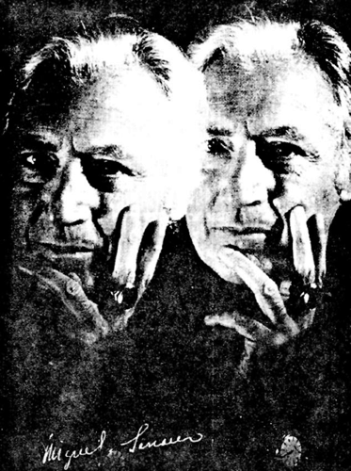

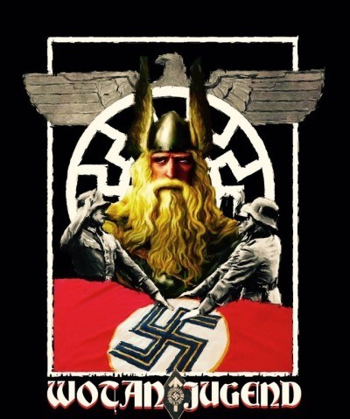

“When, for instance, the belief in the God Wotan vanished and nobody thought of him anymore, the phenomenon originally called Wotan remained; nothing changed but its name, as National Social- ism has demonstrated on a grand scale. A collective movement consists of millions of individuals, each of whom shows the symptoms of Wotanism and proves thereby that Wotan in reality never died, but has retained his original vitality and autonomy. Our consciousness only imagines that it has lost its Gods; in reality they are still there and it only needs a certain general condition in order to bring them back in full force.”
—Dr. Carl Gustav Jung in a letter to Miguel Serrano

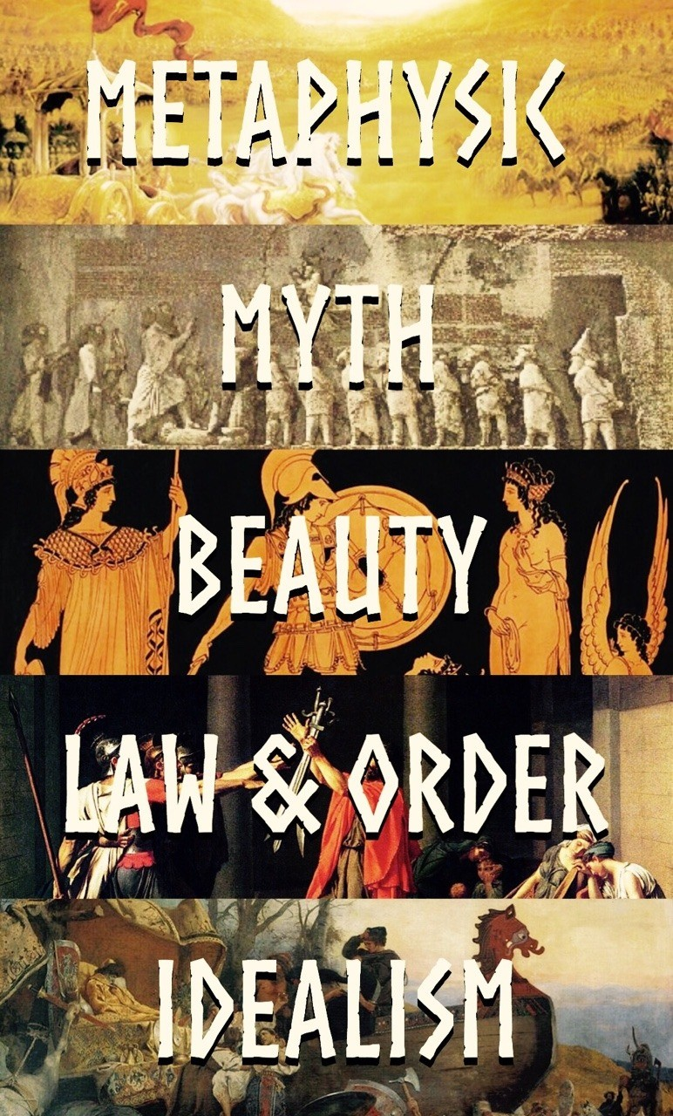

“A review of history from the remotest past to the present day presents the manifold forms of Nordic creative power to our gaze. Aryan India gave the world a metaphysic which has never since been equalled; Aryan Persia constructed for us the reli- gious Myth from which we still draw sustenance; Doric Hellas had a dream of earthly beauty which we see in static perfection never again attained; Italic Rome taught us that formal state discipline with which a threatened community must fashion and defend itself. And Germanic Europe gave to mankind its most radiant ideal. It taught the neces- sity of character as the foundation for all culture, and the highest values of the Nordic nature—the concepts of honour and freedom of conscience. This was fought for on battlefields everywhere as well as in the studies of scholars. If it does not triumph in the great struggle which is coming, the west and its blood will perish, just as India and Hellas are dis- solved forever in chaos.”
—Alfred Rosenberg

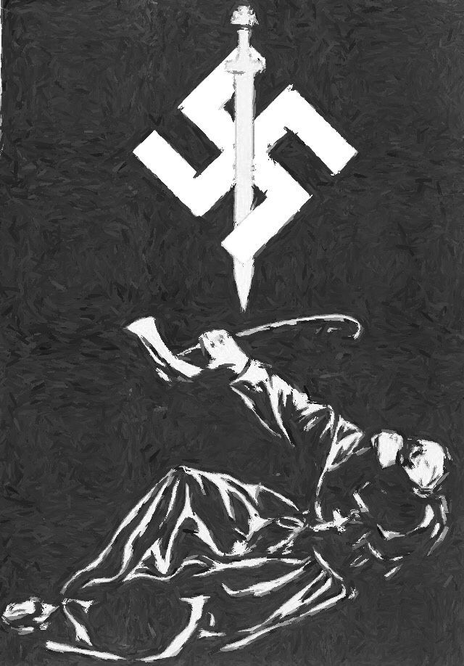

“The Cross is dead, now the symbol of Aryan Salvation is the Swastika.”
—James Mason

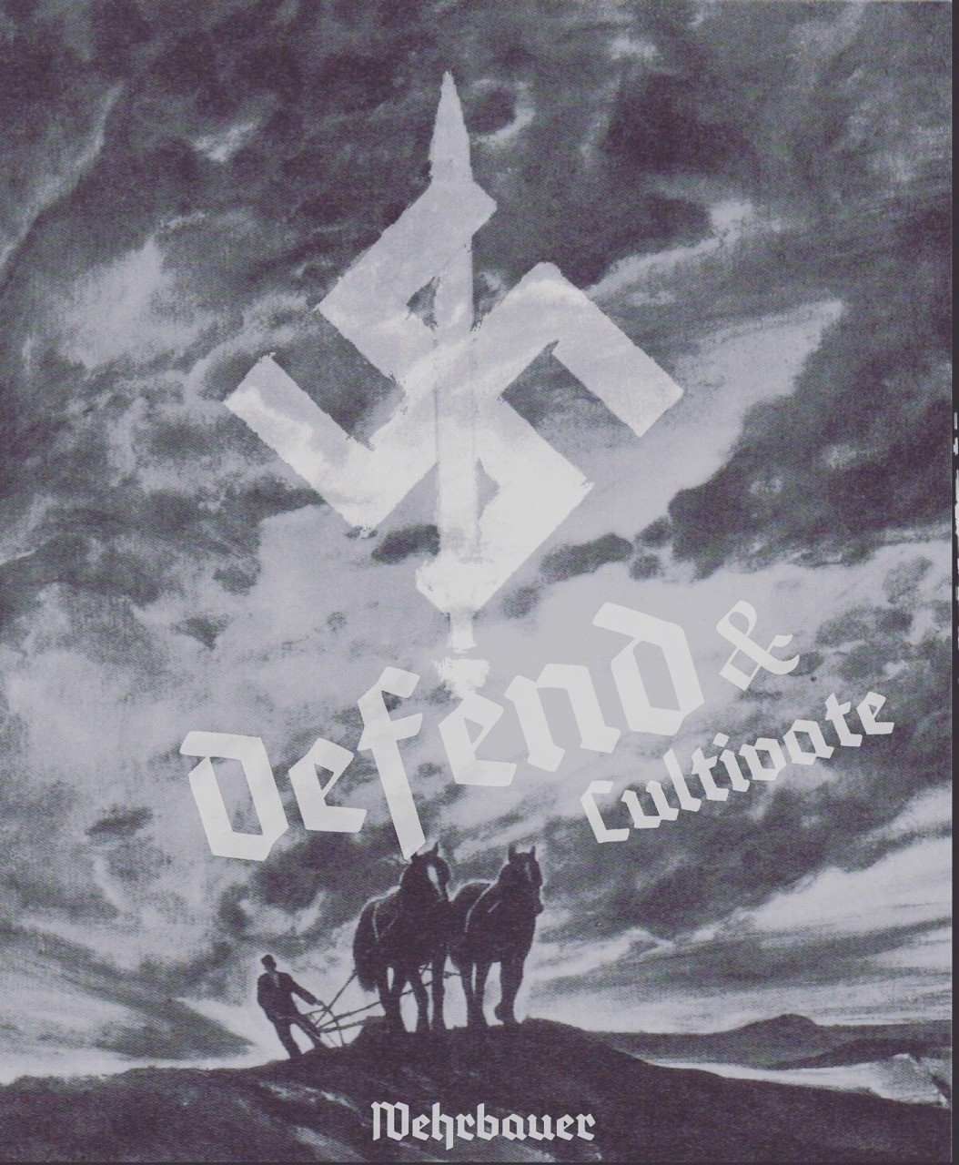

“The source of the bloods motion in the body of the people is, undoubtedly the land, or, more precisely, the farmers. In other words, the farmers, and among them especially the peasantry [Bauernstand], are the source of re- newal of the blood for the people.”
—R.W Darré

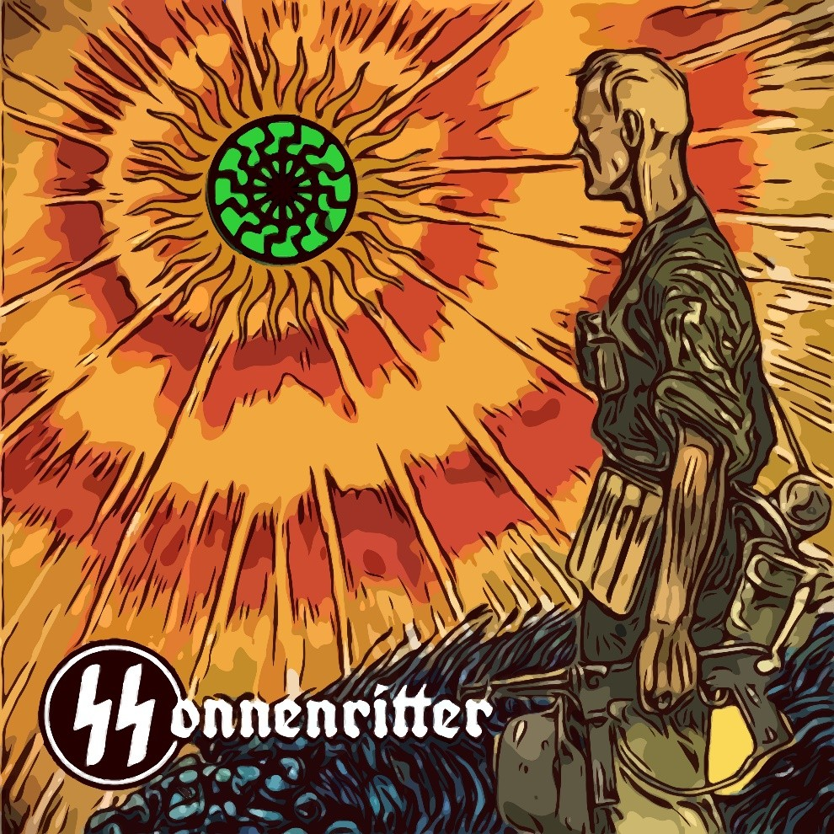

“Adolf Hitler at the end of the Age of Pisces had re- stored the principles of the code of Aryan Honour: the faith in the superiority of the race, in the purity of their blood and their divine origin; faith in the in- equality of men, and the knowledge that one was a God. In the alchemical laboratory of the Castle of the SS, Wewelsburg, he was recreating the Sonnen- mensch, the Sun-Man, Hitler also erased the sense of guilt and original sin, completely alien to the soul of the Aryan. He restored the pride of the Hero in equality with the Gods. And yet the definitive ac- tion is that for all the rounds of the Eternal Return, he uncovered the Enemy, the poisoner of the blood, the destroyer of the religions, the parasite and robot in service of the Demiurge: the International Jew, Golem of Yahweh-of the Demon corrupter of the universe-the one who came here to combat the Asen.”
—Miguel Serrano

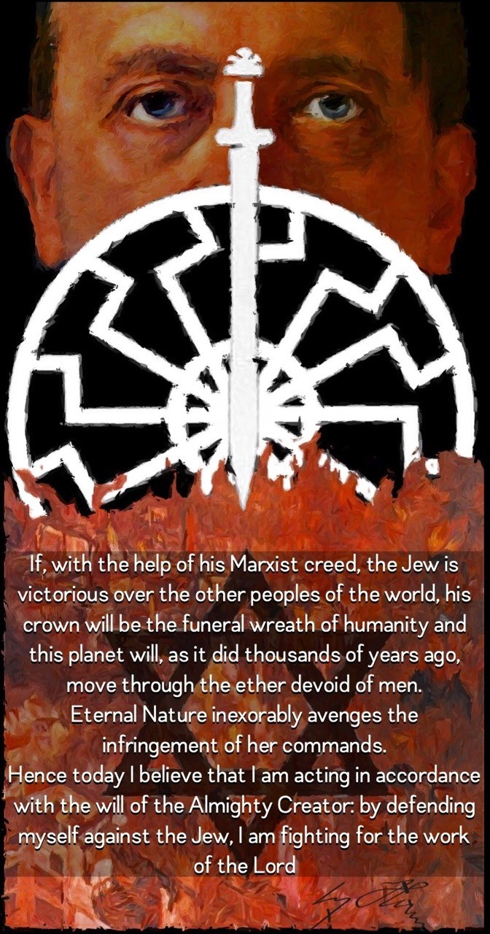

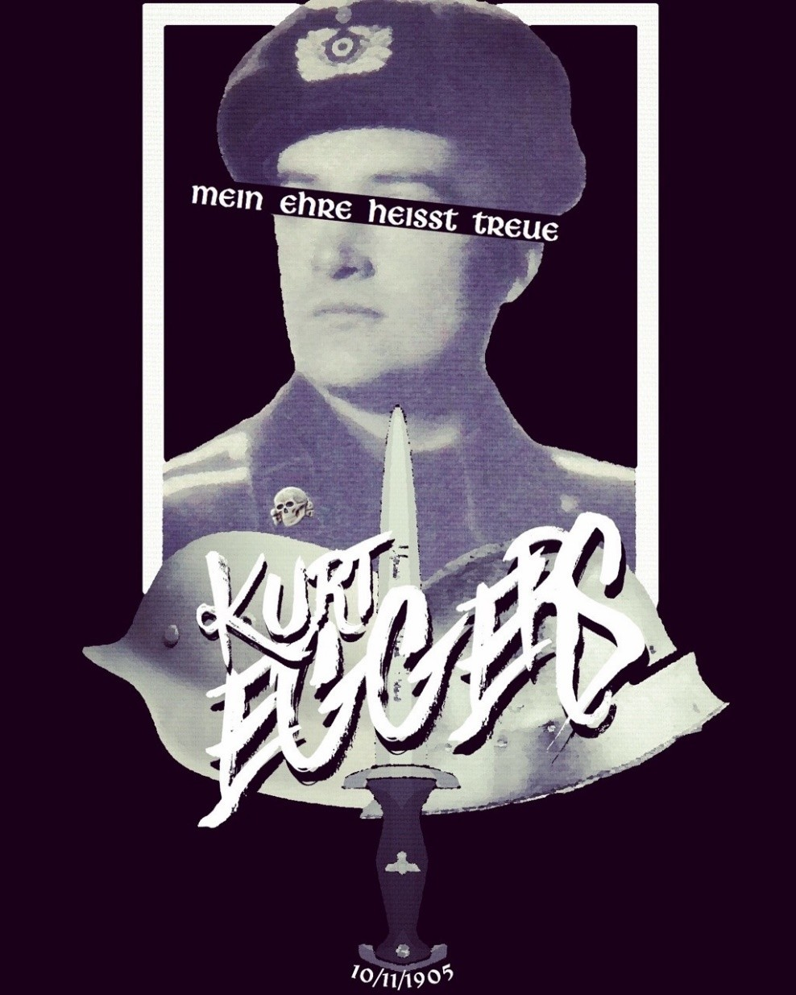

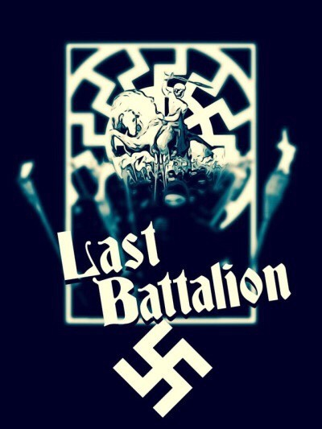

“I want to express to the young comrades of the English and German speaking world at large, that none of these things will be obtained if we don’t fight a synchronistic battle, also, in the physical world against our Great Enemy, even at the risk of losing our mortal life. In this connection, we have a common ideal with the Muslims, who believe they must die in battle in order to reach the Heaven of Allah (This comes to the Arabs from Aryan Persia.) We believe that if we are killed or murdered for our ideals, we shall go to Valhalla where Wotan and our Valkyries will give us a hundred-fold what we were unable to achieve in our warrior life on Earth … but, only if we are real Esoteric Hitlerist Warriors!”
—Miguel Serrano

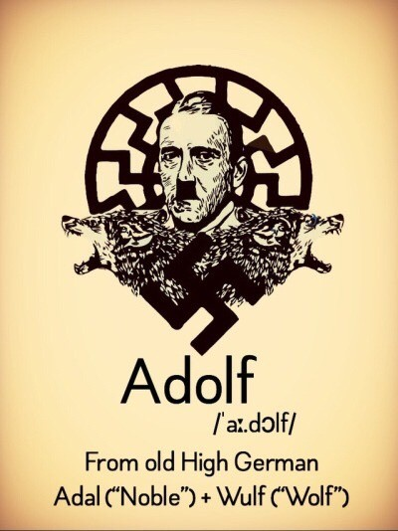

“Like Apollo, Wotan is a Wolf-God. The SS initiate, the heroes of Wotan, are today also wolves. Sieg- fried was a wolf ling, a wolf cub and descended from Wotan. Like the Frankish Kings, like Hengist and Horsa, who conquered England and like Fredrick Barbarossa served by two ravens, Huginn and Muninn, while he sleeps in the Kyffhäuserberg.
Hitler is an Avatar of Wotan an Antarctic Wolf. Wo- tan lives forever in the memory of his warriors and his Hyperborean people, as the tireless hunter among the forests of Oak and Ash trees…..only the heroes converted into the wolves, will remain watching and waiting.”
—Miguel Serrano

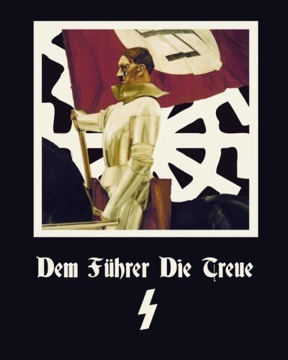

“When the SS swore before their Führer, they, in truth, did so before their own soul, before their own most profound being. And when they broke their oath they were betray- ing themselves, committing a form of ignoble suicide. Here within this is the mystery and grandeur of the Führerprinzip.”
—Miguel Serrano

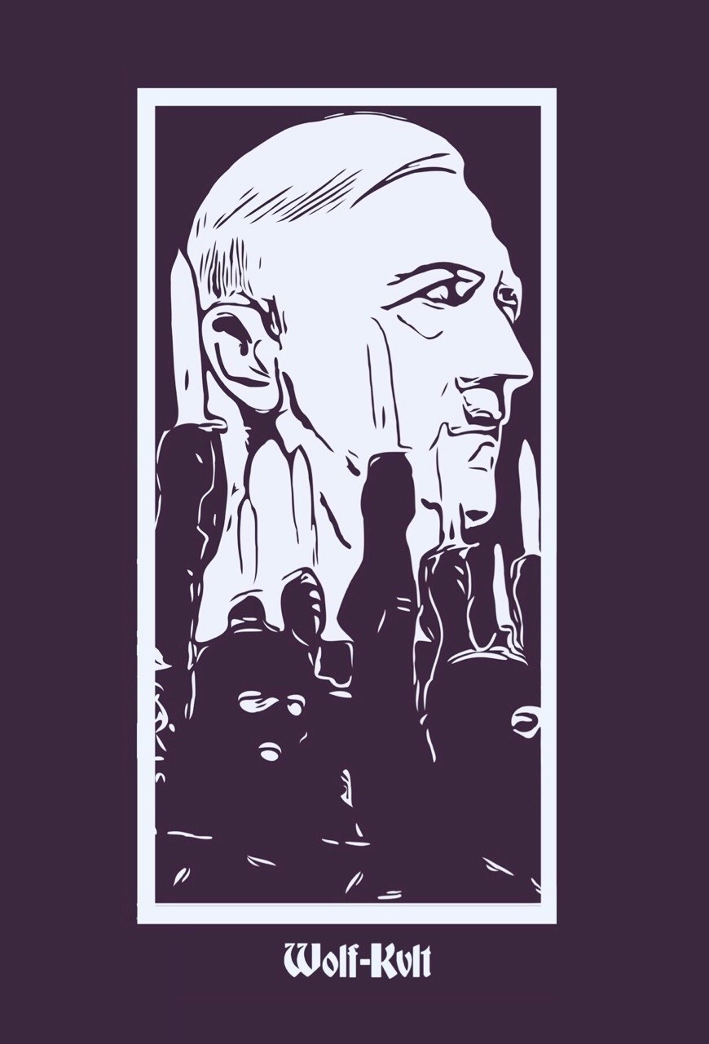

“The religion of the reborn Aryans must naturally have much in common with that of the pre-Christian European North, and with that, of similar origin and spirit, kept alive to this day, in India, in the tradition of the Vedas. It must be, before all, the religion of a healthy, proud, and self-reliant people, accustomed to fight, ready to die, but, in the mean- time, happy to live, and sure to live forever, in their undying race; a religion centred around the worship of Life and Light—around the cult of heroes, the cult of ancestors, and the cult of the Sun, source of all joy and power on earth. In- deed, it must be a religion of joy and of power—and of love also; not of that morbid love for sickly and sinful “mankind” at the expense of far more admirable Nature, but of love for all living beauty: for the woods and for the beasts; for healthy children; for one’s faithful comrades in every field of activity; for one’s leaders and one’s gods; above all, for the supreme God, the Life force personified in the Sun, the “Heat-and-Light-within-the-Disk,” to quote the expressive words of the greatest Sun-worshipper of Antiquity. The reli- gion of the regenerate Aryans must be one in which the Christian idea of “conception in sin” gives way to that of conception in honour and joy within the noble race, the only “sin” being (along with all forms of cowardice and faithless- ness) the sin of shameful breeding—the deadly sin against the race.”
—Savitri Devi

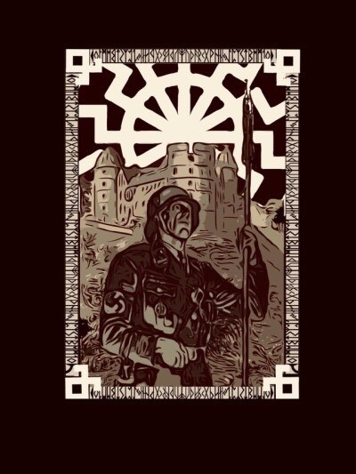

“In Wewelsburg Castle, which directed its towers like the lance of Longinus towards the Crucifixion of Wotan in the Externsteine, the SS initiates also tried to be reborn, to resurrect as Aryans, becoming worthy to recover the Odil power through the magic use of runes, the Futhark of Wotan and the implosive science of the Palaeolithic. In the central hall of the castle there still hung an enormous stone in ‘critical balance’, unpolished, showing what Eso- teric Hitlerism was and still is; the grand intention to create the God-man, superman, by means of the tantric alchemy of the stone, lapis, and the recovery of the blood purity of divine Aesir, Fire of the ser- pent of paradise, called in Sanskrit Kundalini.”
—Miguel Serrano

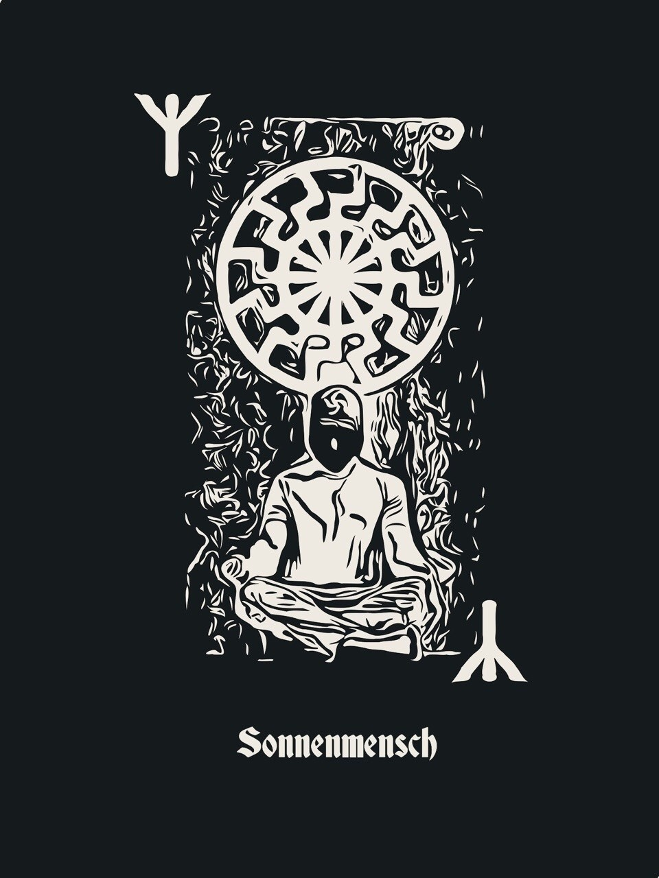

“The only escape remaining to the hero is not to es- cape from his earthly ‘I’ but to strengthen it so that he can transmute it into an Absolute Self, through the Tantric ecstasy called Kaivalya, meaning ‘sepa- rated’, ‘apart’.
There is no other escape. And this escape was zeal- ously sought for in the alchemic, Genetic-Tantric Laboratories of the SS in the Initiation Castle of Eso- teric Hitlerism, in Wewelsburg.”
—Miguel Serrano

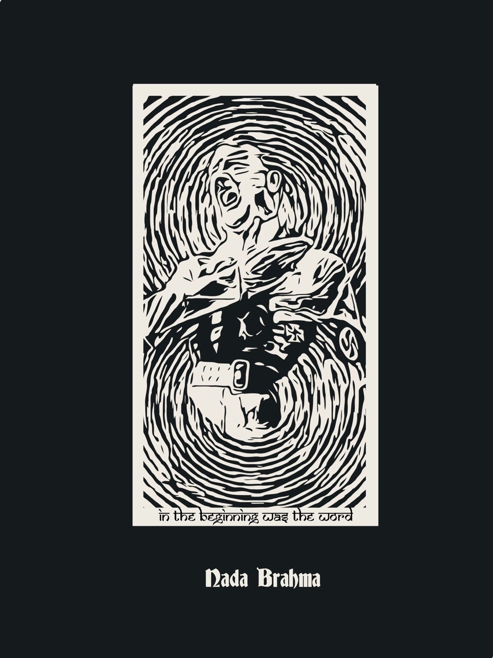

“Listeners, even those without knowledge of German, would, if Aryans, be gripped and hypnotised by his words; because he repre- sents them all—he speaks for all of them.
And if he does it shouting, it is because an entire nation, an entire race, is expressing it- self through him.”
—C.G. Jung

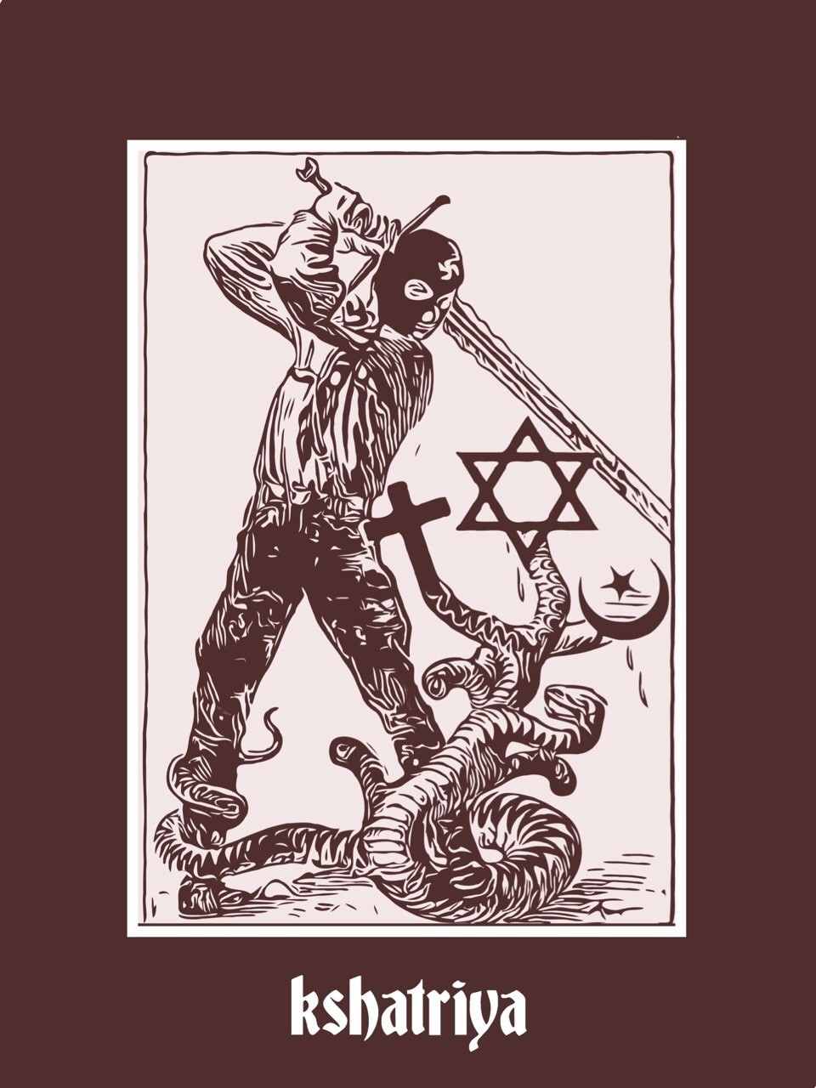

“The culture reflected in the songs of the Rig- Veda, and in the warrior-like philosophy of the Bhagavad-Gita, which the Brahmin has kept alive, is the only ancient Aryan culture that has resisted victoriously, to this day, the impact of both Christianity and Islam, i.e., the two great religions of human equality, sprung from Judaism.”
—Savitri Devi

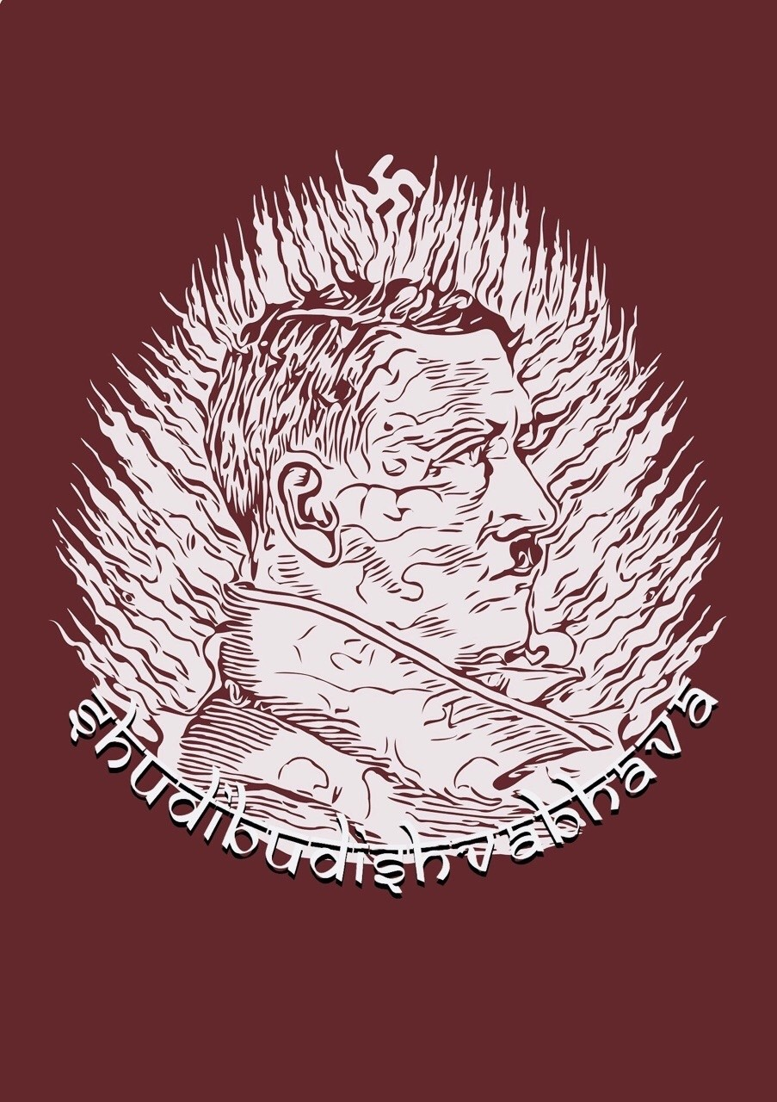

“It was Adolf Hitler, as Führer, who gave us the most effective example of what the will can do (with the ‘Triumph Of The Will’), standing firm in combat to the end, never bending, from the years of his youth, until his disappearance in the bunker, among the flames, in consummate destiny. With an iron hand he first controlled his nature and his body, he was their lord and master, putting it in the service of the incarnation of the Avatar, the divinity.
He was therefore Shudibudishvabhava, the Lord Of Absolute Will.”
—Miguel Serrano

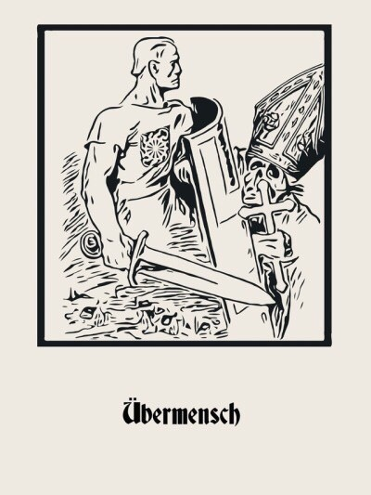

“A people that has returned to its blood and soil, and that has realised the danger of international Jewry, can no longer tolerate a religion which makes the Scriptures of the Jews the basis of its Gos- pel. Germany cannot be rebuilt on this lie. We must base ourselves on the Holy Scriptures which are clearly written in German hearts.
Our cry is: Away with Rome and Jerusalem! Back to our native German faith in present-day form! What is sacred in our home, what is eternal in our people, what is divine, is what we want to build.”
—Savitri Devi

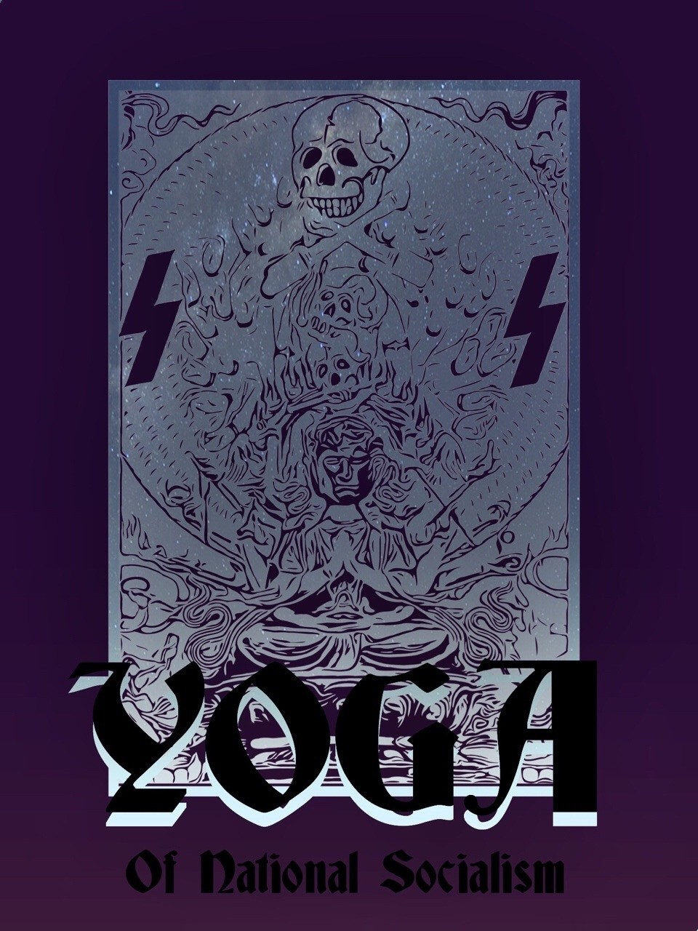

“Faith does not allow the Hero to cross over the open abyss between person and personality, between the God that was and the superman yet to be. Will power does that.
Esoteric Hitlerism knows that the solution is not found in the overcoming of the ‘I’ by annihilation but, on the con- trary, in his exaltation to an Absolute self. This was the aim of the esoteric practices and disciplines of that Hyperborean Nordic Yoga taught at Wewelsburg and in the secret magic laboratories of the elite SS.
Demiurgic ‘Robot Biology’ has been defeated from within by the Hero, by the Vira, by the Hitlerian initiate, nature has been transfigured by Magic Idealism, the belief of Novalis and the ancient German Minnesänger. The SS Magus has been crossed by a bolt from one side to the other, had made an explosive detonate over his head, without destroying him, and has been transmuted. The hero has reopened that spiritual gland, that power, that third eye of the giant Poly- phemus, allowing him to go out and enter in, to disintegrate and reintegrate himself, to live in several worlds at once, to be a Tulku, a Jivanmukti, a Bodhisvatta, or if one likes, an Avatar. To be like Rudolf Hess, with the Führer and next to the Führer. Because he has completed the mission that he had entrusted to him. The true mission, the true com- bat…..He has crossed over the abyss on a rope he himself held. This is the war of Esoteric Hitlerism.”
—Miguel Serrano

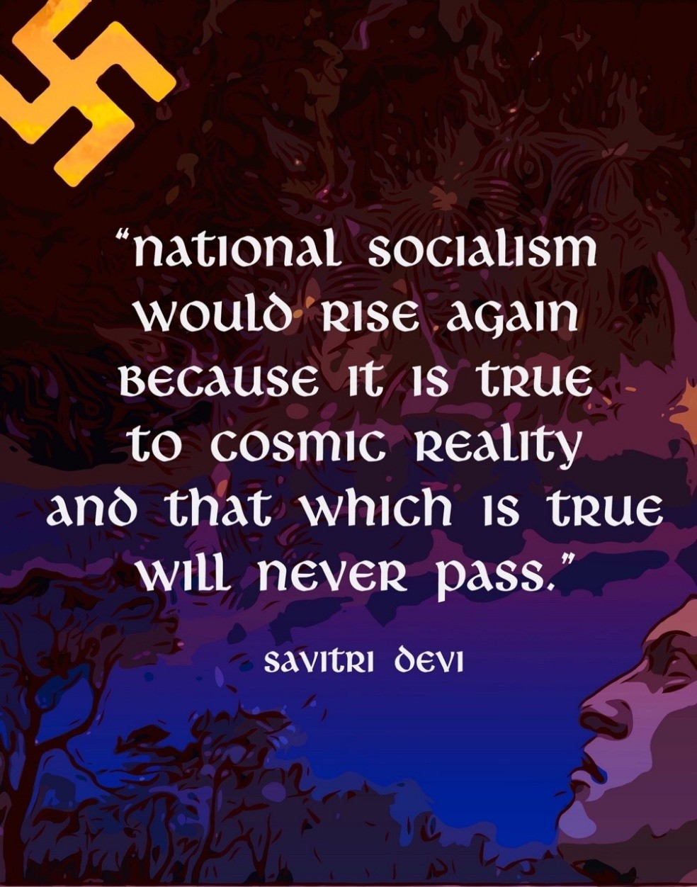

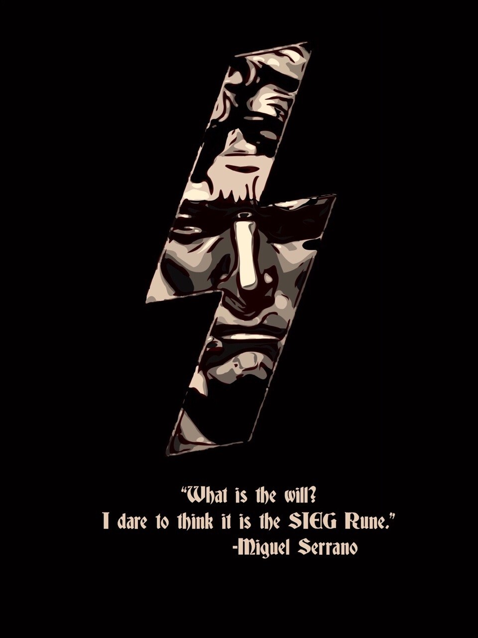

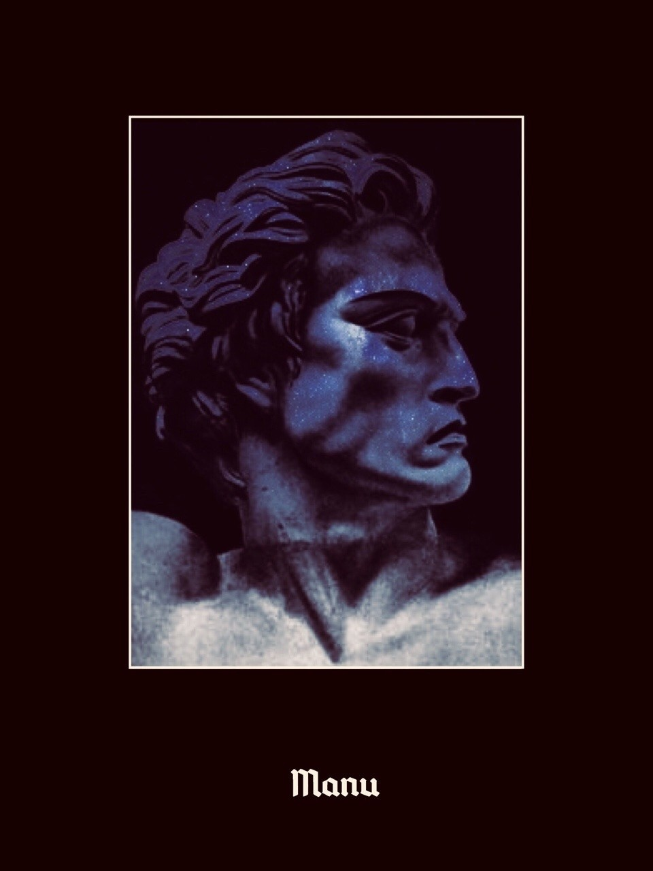

“In 1945 of the Judeo-Christian era: year Fifty-six of our Hitlerian Era, in the month of April, that of Venus. Berlin has become a hell, there is fighting on every corner, the Führer Bunker is bombarded without respite by the Russian airforce, and by artillery shells of every caliber, the Hitler Youth fight without giving or asking any quarter. The remnants of SS troops, those who have not died on the front, on the steppes, battle desperately, women, old men, the SS Division Charlemagne made up of the French, form a cordon around the Bunker, the heroic Spaniards and even Tibetan Monks, mysteriously linked to Hitler, there give up their lives….what an immense battle, what glorious combat!
I also wanted to be there and die for my Führer. My wife agreed that we go and wanted to go with me. More than one hundred Chilean National Socialists were readied as volunteers in the city of Valparaiso, but the German ambassador, married to a North American, would not accept them. There are Comrades still alive who can confirm this. My German SS friends stopped me. Per- haps, without knowing, they did so in order for me to one day write these books…..But today, April 30th, in the Year One Hun- dred of our era, with clenched teeth I remember everything. The anguish, the sorrow, that blights in the heart….everything, every- thing was over, the immense dreams of grandeur and human re- demption…Until we knew the truth: Hitler had not died. From the ice of Antarctica, he would return….
Just before the end, there in the Bunker, whilst shrapnel thun- dered, with the dull, deep rumble of the glaciers flowing from the great gates of the poles, a faithful SS officer asked his Führer, with hoarse voice: “Mein Führer, if you were to disappear, for whom should we fight…?”
And Adolf Hitler replied: “For the Man to Come”“
—Miguel Serrano

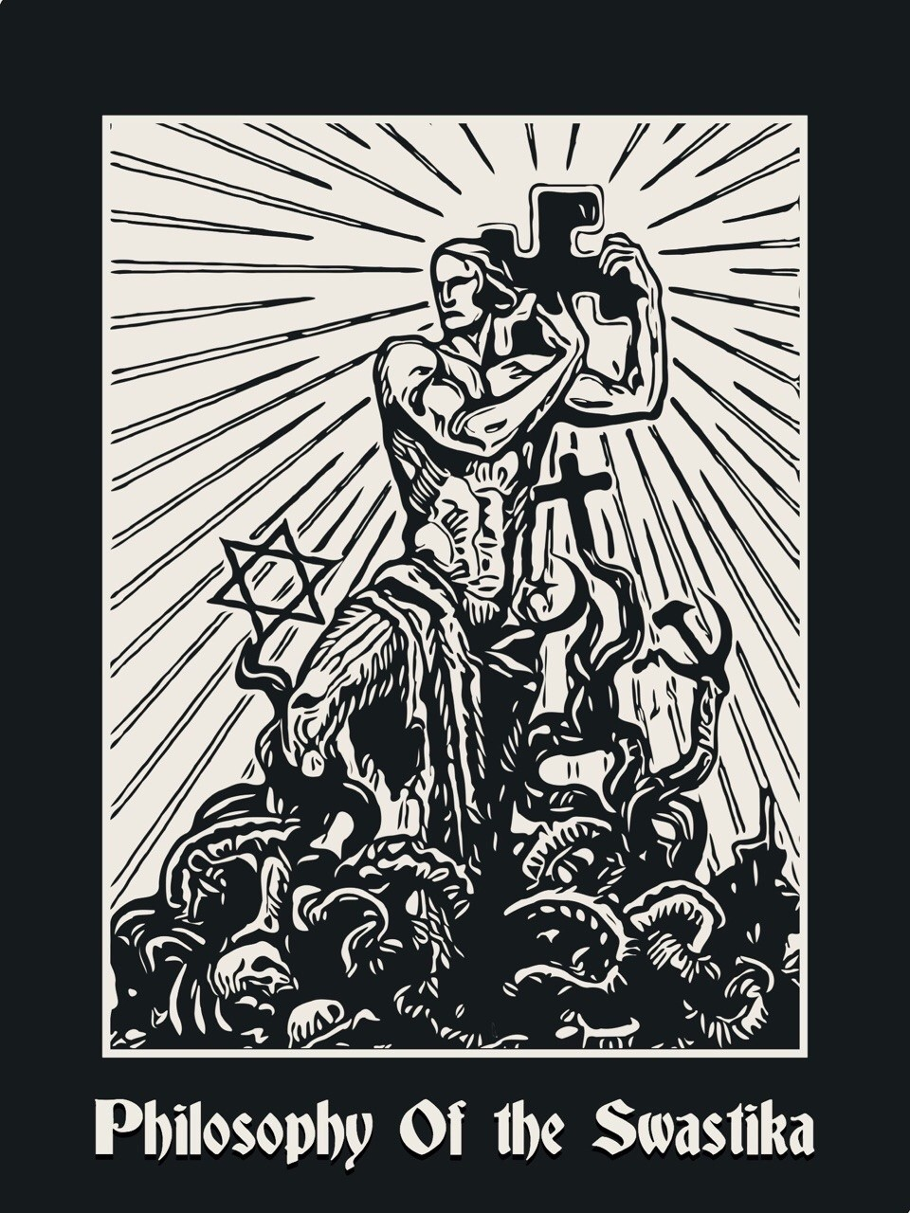

“The conflict between National Socialism and the Christian Churches in our times, is but an aspect of the age-long struggle be- tween the creeds of Life which accept the natural hierarchy of hu- man races—and individuals—no less than of animal species, and which treat man as a part and parcel of living Nature, and the man-centered creeds which deny the irreducible differences in quality between one human race and another while postulating, on the other hand, an artificial abyss between “mankind” as a whole and the rest of creation.
The par excellence man-centered creed of today—Communism— is but the natural and logical outcome of Western Democracy based upon “the voice of the majority,” as Adolf Hitler has him- self pointed out a number of times. But Western Democracy, in its turn, is but the natural and logical out- come of centuries of Chris- tian teaching. All Rousseau’s sentimental twaddle and the subse- quent nonsense about the “equal rights” of all human beings, to which the French Revolution owes its prestige both at home and abroad, would have been unthinkable in a Pagan Europe, unaf- fected from the start by the original Jewish twaddle about the equal rights of all human souls and the subsequent “dignity of all men” in the eyes of a man-loving God.
Those of us who fully realize this, and to whom what I have called the Philosophy of the Swastika—expression of their own deeper aspirations—is the only satisfactory one, can face with calm the present and the coming hardships. No democratic, humanitarian, or Christian propaganda, whether outspoken or in disguise, can alter them. They form that chosen minority of real Nazis around whom, one day—after the coming crash—the remnants of the un- daunted Aryan race will gather to start a new historical cycle, un- der Hitler’s undying inspiration.”
—Savitri Devi

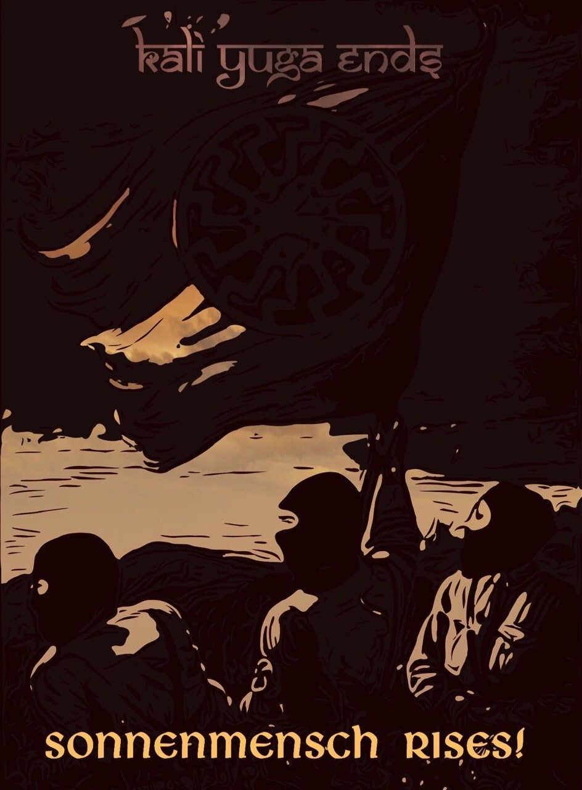

“In the mystery of the light of the black sun, the divine hero, hanging on the cosmic tree of crucifixion, dies and is reborn. Only when all men, animals, plants and rocks have cried with their last tears, clamouring for his re- turn, with men and the earth dying, poi- soned, will the luminous divine face of the God-Man be seen again.”
—Miguel Serrano

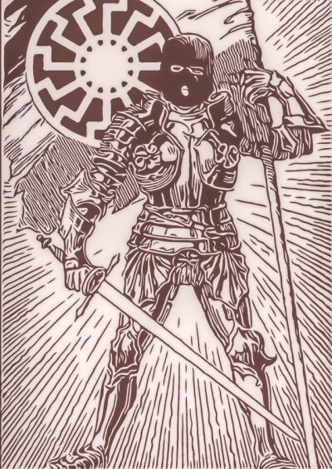

“The difficulty for we who are not modern, but ancient, is the impossibility of communi- cating with the rationalist minds of this time of the Kali Yuga.”
—Miguel Serrano

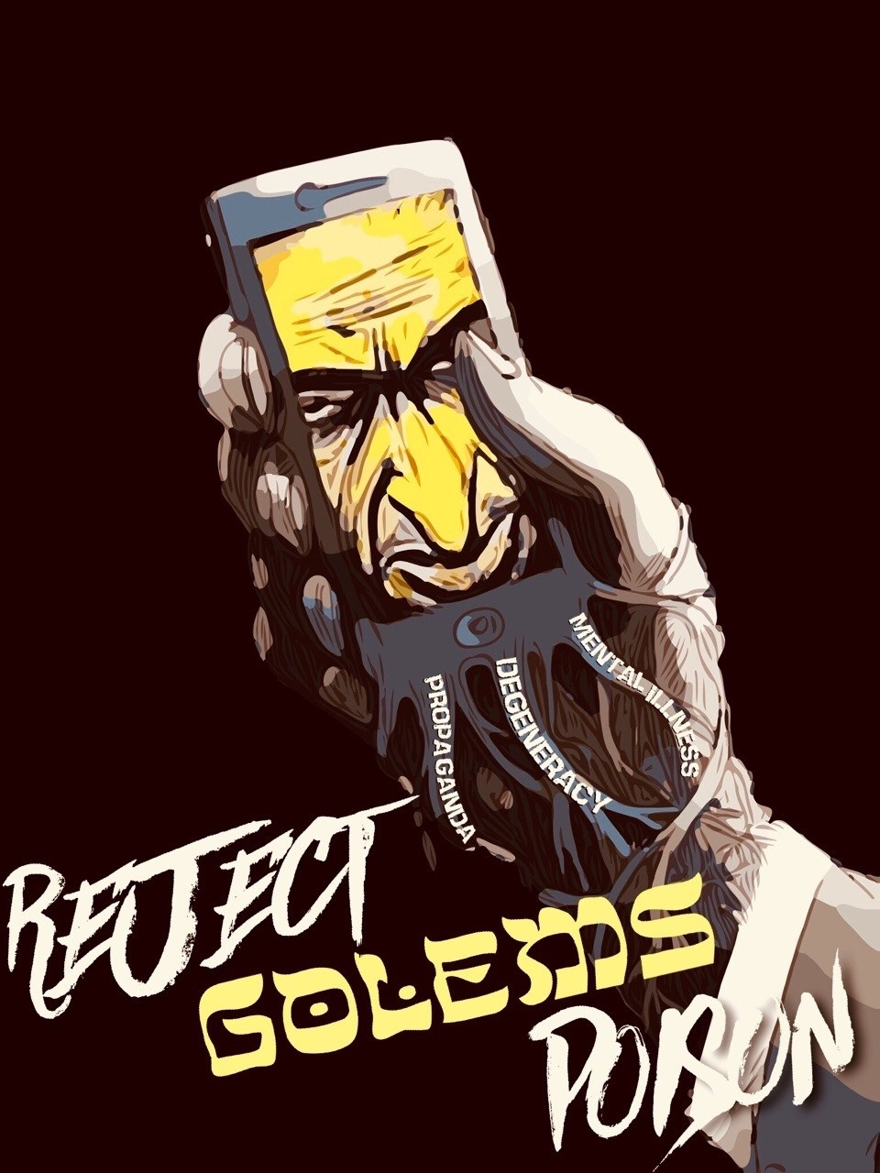

“The Jews as such, amongst whom are included the foremost bosses of international capital, the patrons of high finance and the entire liberal-capitalist sys- tem, simultaneously with Marxist communism, think that the messiah should be the Golem, a super robot, an Electronic Brain, a Databank of Universal Enumeration and transfer of information codes of consumption, with capital and money power, with- out any feeling, purely rational, fed by the elec- tronic energy that is the food of Satan, electricity, the ‘electron’ which that Golem-robot will come to control and direct, placed completely at his service, like an atomic solar energy for the final glory and feeding of the Demiurge.
Yet it is understood that the struggle must be well hidden and disguised since the White traitors, Ma- sonic Lodges and Christian churches of every sort will have to bow to the owners of Capital and the real power, the bosses of sinister Kabbalah and its Black Magic. The final decision of the masters could already have been made in favour of the Electronic Messiah, the Super-Robot-Golem.”
—Miguel Serrano

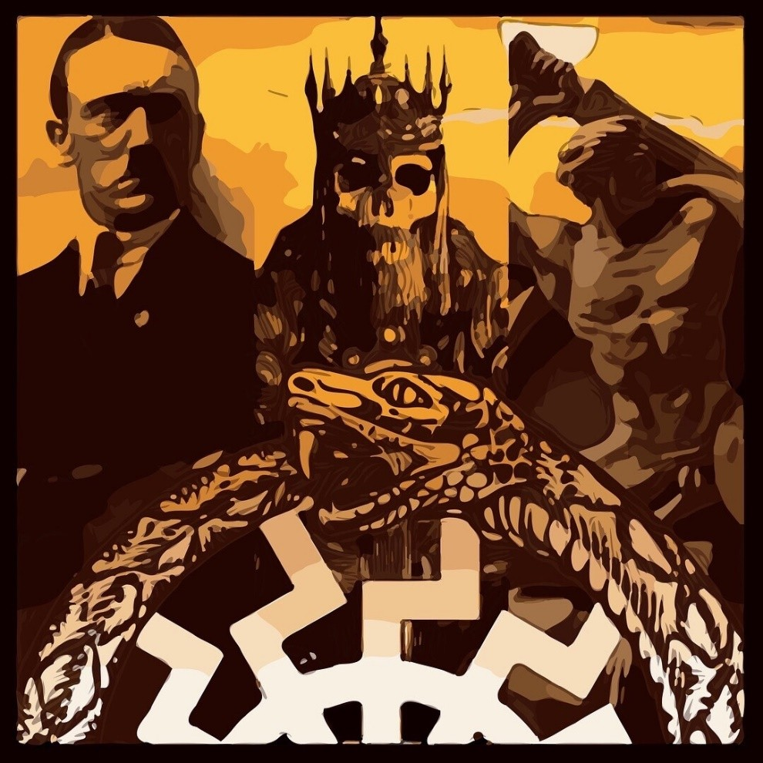

“The Ultimate Avatar has already come in Hitler, and will come again in Kalki, on a white horse that is the same Sleipnir, with eight legs. Myths and leg- ends prefigure and repeat this, like the legend of King Arthur and Frederick I Barbarossa, Emperor Of The sacred empire, leader of the third crusade in 1190, he did not die but sleeps in the bottom of a cavern, guarded by two ravens of Wotan, waiting for his return when everything will seem to be lost.
Therefore Hitler gave the name Barbarossa to this operation of return, when awakening in the hollow earth, beneath the poles. The resurrection of the great myth, the final return, as the living Kalki, to rescue his heroes and make way for the Man To Come, the Caleuche, from the waters of the South Pole, after closing the cycle of the Kali Yuga, Ragna- rök, with a great slam, as Goebbels announced.
Moreover the Man To Come, by the name Manu, will do so in other Rounds Of Eternal Return. In a new beginning of the same….”
—Miguel Serrano

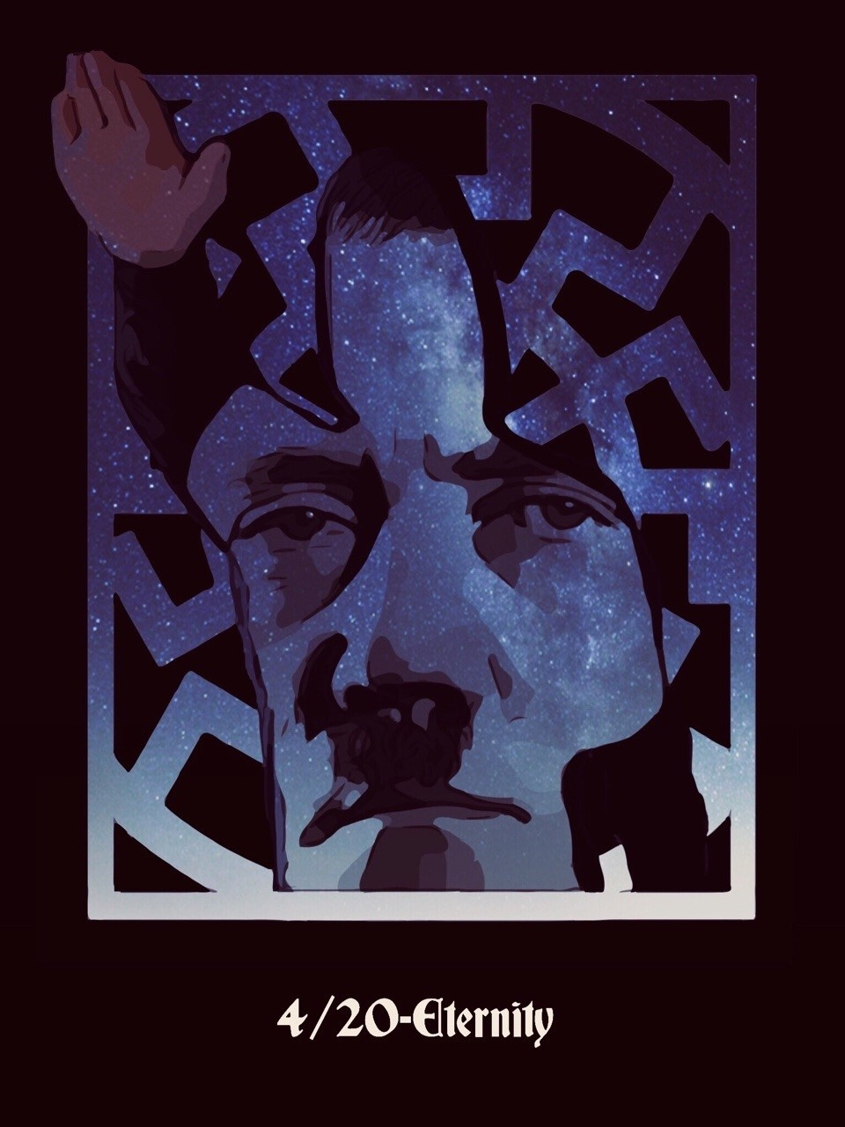

“I am nothing without you but you are nothing without me.”
—Adolf Hitler

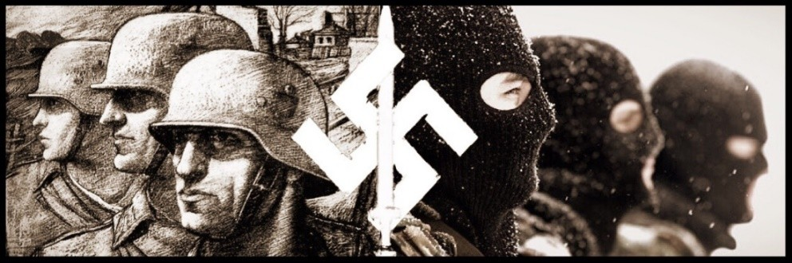

Was ist aus uns Jungen geworden? Win stürmender Schwerterorden.
Rebellen, Rebellen,
Haben den tod und den Teufel zu Gesellen.
Rebellen haben Das Gestern vergessen,
Sie Bauen Das Morgen, vom Glauben besessen.
Vom Glauben ans ewige Reich, Von Glauben ans ewige Reich.

What became of our boys?
They became a storming sword-Order!
Rebels, Rebels,
Have death and devil as companion. Rebels have forgotten yesterday,
We build the tomorrow obsessed by faith, Faith in the Eternal Reich,
The Faith in the Eternal Reich.

—Hans Baumann, ‘Rebellen’

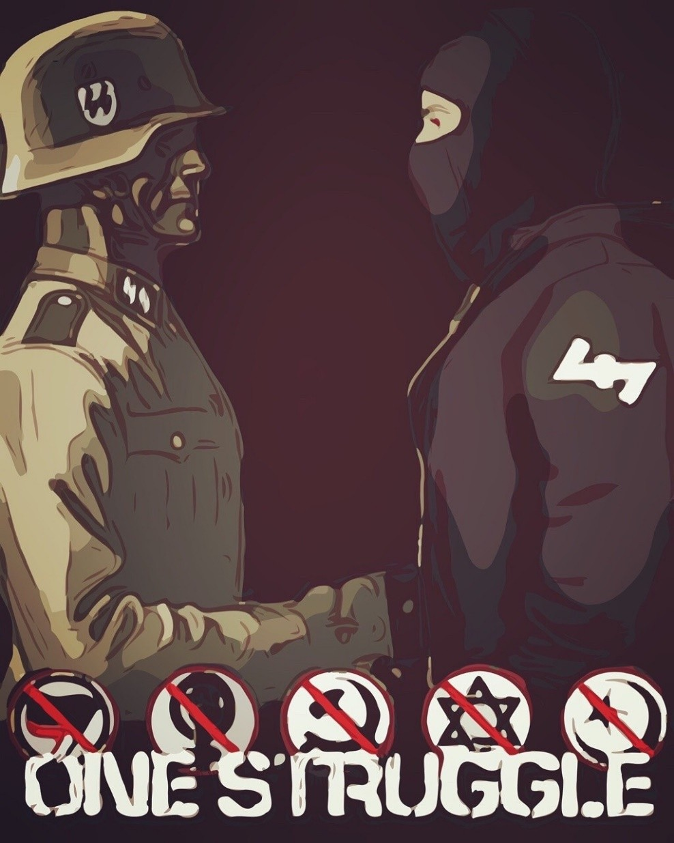

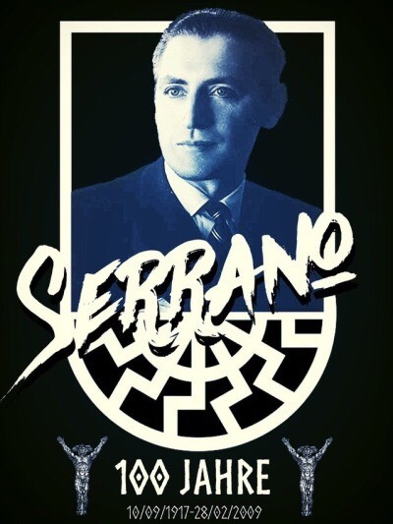

“But I am not of these times, nor of this world, nor of these days. I am from another planet. I am from the Morning Star. I am not afraid of losing every- thing, including life. Furthermore, the motto on my coat-of-arms reads: “My honor is loyalty.” Yes, loy- alty to the ideals, the dreams, the past glory of the night, the ghosts of lost friends, the golden shad- ows, the echo of their steps, to the old streets and cities, and all that which escapes the light this mar- tyred earth projects, the longing for a Golden Age, when heroes still lingered among us, when the Gods were still talking to us. For I am among those who spoke with the Gods…”
—Miguel Serrano

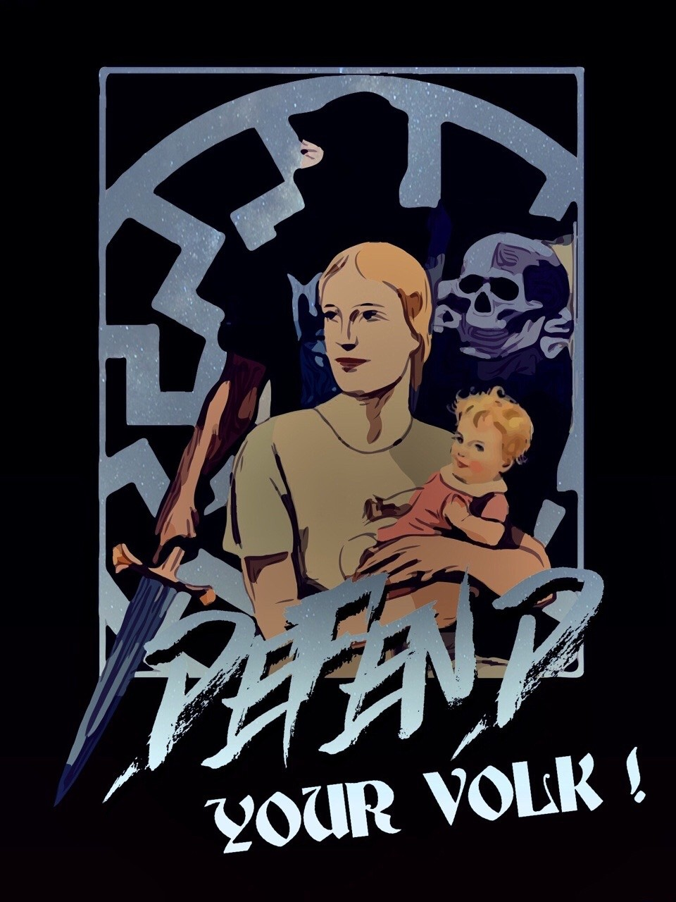

“The most precious possession you have in this world is your own people. And for this people, and for the sake of this people, we will struggle and fight, and never slacken, never tire, never lose courage, and never lose faith.”
—Adolf Hitler

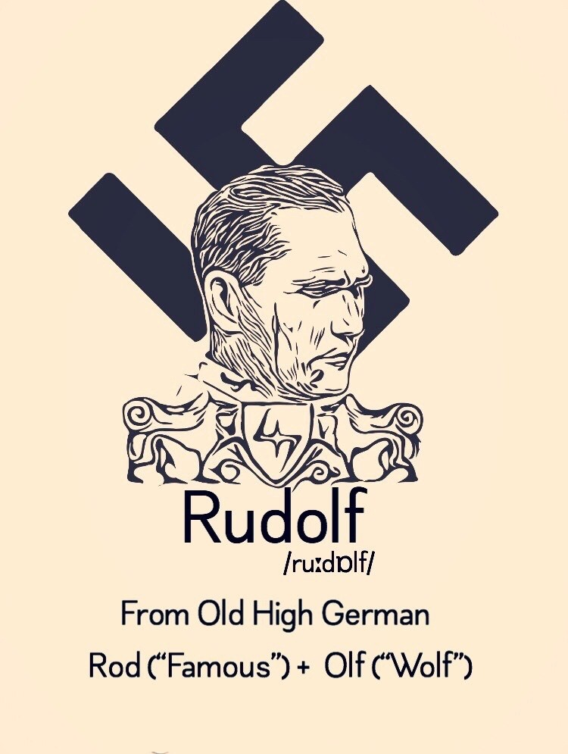

26 April 1894 - ∞

“We are in the Year 99 of the Hitlerian Era, 1988 of the Judeo-Christian era. It is August, a few days before complet- ing a full year since the ritual crime of the Hero Rudolf Hess, in the sinister prison of Spandau, in Berlin. I remember the year 1951, on my first journey to Europe, when I found my-
self standing before those gray walls of Spandau, without being able to enter, imagining Rudolf Hess on the other side, alone in his cell, perhaps concentrating, projecting himself far away so he could in that way meet, mentally, with his Führer, who would also see him, because He could also see the astral. The immense sacrifice of Rudolf Hess was, with- out doubt, necessary, because he was the propitiatory Victim to the Resurrection of the Myth. And Rudolf Hess will return with irresistible force in the memory of heroes, because the colour of blood is not forgotten, so red, so intensely red, as Jason would say, my friend of youth. And because his ritual sacrifice has not benefited his executioners, nor the Vampire Jehovah, instead furthering his defeat, from regions of subtil- ized matter, the inevitable final defeat, caused by spiritual law, put in action by infamy, morbidity and the most cruel sadism. Of this I have faith, I can assure you.”
—Miguel Serrano

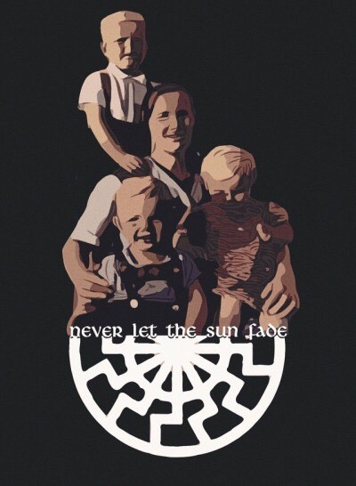

“Aryan Blood, here on earth, is the substance of the light of the Black Sun, circulating through the veins of Hyperborean Gods.”
—Miguel Serrano

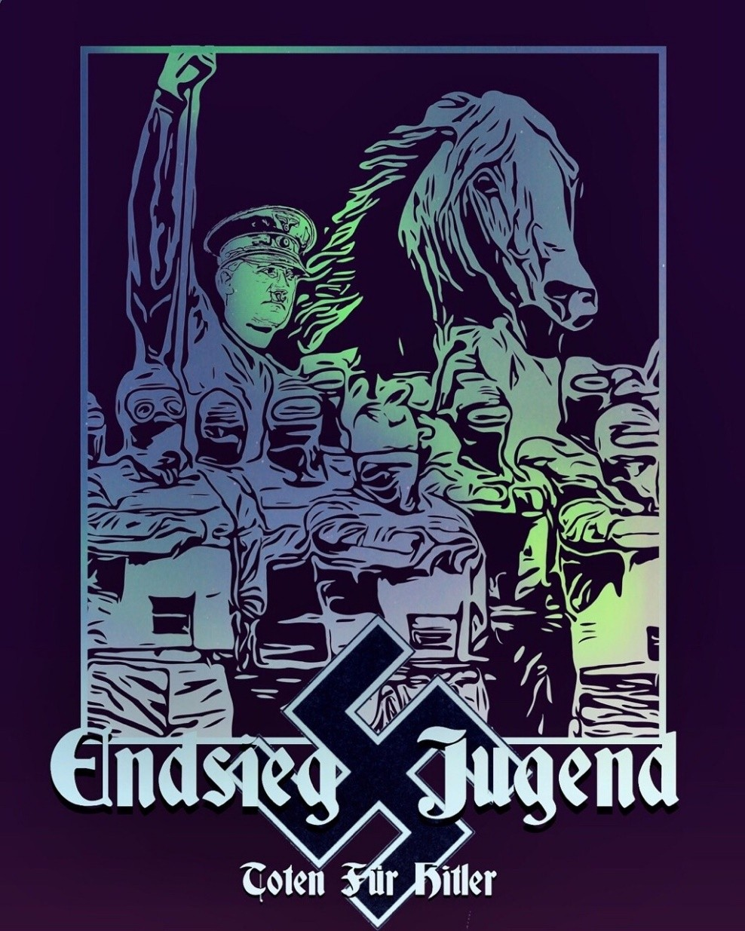

“If the world should not be completely domi- nated and corrupted by the Jew, only Esoteric Hitlerism will be able to stop him. The Re- turn of the Führer!”
—Miguel Serrano
“If I win the war, I will have given a mortal blow to the Jew. If I lose the war, their tri- umph will only be for a brief time.”
—The Führer

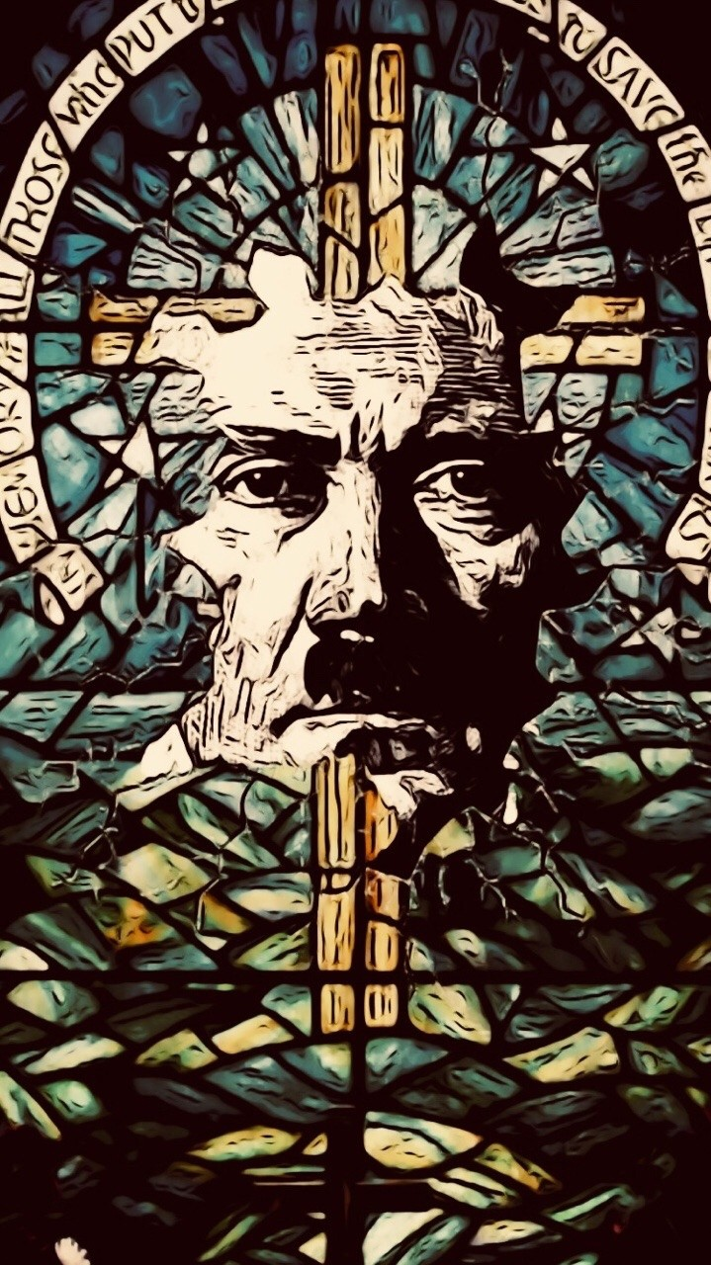

“Great men have arisen for the German folk over the course of its history. The greatest German of all times is Adolf Hitler. The com- ing millennia will be an immortal monument to his deeds, to his exemplary life, to his teaching and to his human leadership. His work now already points beyond all concepts of time familiar to us. It is not deification, when the German folk gives this man un- shakeable faith as their leader. It is only self- evident that the folk leadership created by Adolf Hitler can count on the faith of the Ger- man folk for all the future.”
—Anton Holzner

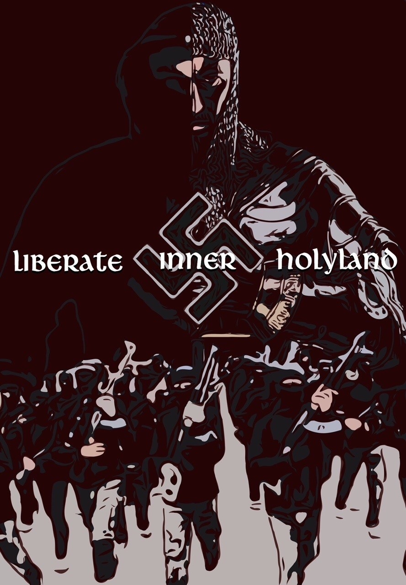

“The war is not of conquest or proselytism, as one might be- lieve. The Templars fought by duty, coldly, by yoga, internal discipline, not with intention of converting the muslims. The mythic battle was to liberate the Inner Holy Land, maintain- ing simultaneously, ‘synchronistically’, the routes of pilgrim- age and those of the Knights Errant. Also, the ishmaelites and the assassins fought by fidelity to the inner imam. ‘To know the Imam, the old man of the mountain, is to know yourself’. ‘Be faithful to me and I will make you like me’.
—Miguel Serrano

“The “enemy” who resists us and the “infidel” within our- selves must be subdued and put in chains. This enemy is the animalistic yearning and instinct, the disorganised multiplic- ity of impulses, the limitations imposed on us by a fictitious self, and thus also fear, weakness and uncertainty;this sub- duing Of the enemy is the only way to achieve inner libera- tion or the rebirth in a state of a deeper inner unity and “peace” in the Esoteric and triumphal sense of the word.”
—Julius Evola



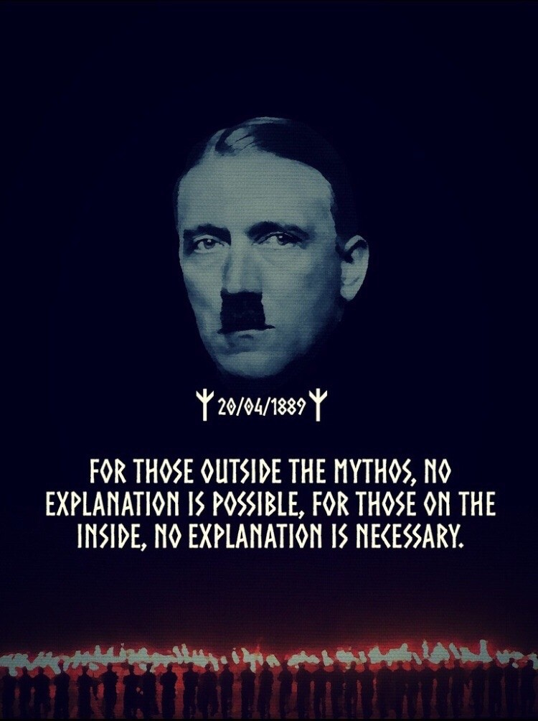

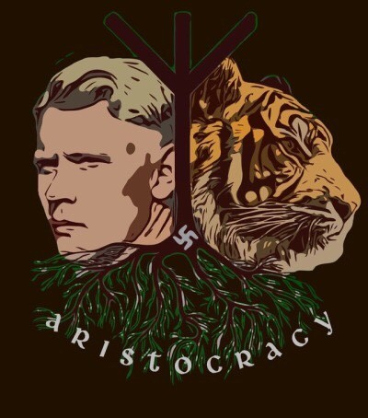

“The one thing the propaganda did, — instead of stirring in me the slightest indignation against the supposed-to-be “war criminals” — was to rouse my hatred against the hypocrisy and cowardice under- lying every man-centered attitude; to harden me in my bitter contempt for “man” in general; and … to prompt me to write this book: the answer to it, the spirit of which could be summed up in a few lines: “A ‘civilization’ that makes such a ridiculous fuss about alleged ‘war crimes’ — acts of violence against the actual or potential enemies of one’s cause — and tolerates slaughterhouses and vivisec- tion laboratories, and circuses and the fur industry (infliction of pain upon creatures that can never be for or against any cause), does not deserve to live.
Out with it! Blessed the day it will destroy itself, so that a healthy, hard, frank and brave, nature-loving and truth-loving élite of supermen with a life-cen- tered faith, — a natural human aristocracy, as beau- tiful, on its own higher level, as the four-legged kings of the jungle — might again rise, and rule upon its ruins, forever!”
—Savitri Devi

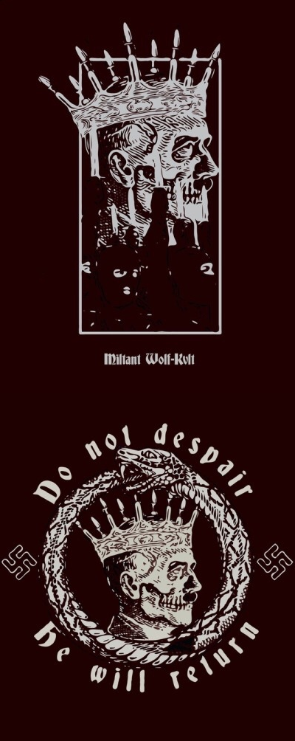

“Kronos-Saturn is the King of Thule who has been dethroned and only sleeps awaiting the time of re- turn. According to Plutarch some birds care for him and serve him with ambrosia. He will return with the Sat-ya-Yuga, with his own time that he himself has devoured. Hence we can see for us the Myth of Dreams and of the Return of the Sleeping Gral King, Frederick Barbarossa who is served by ravens comes from Thule, from Hyperborea. From whence the Jews have stolen the two columns of Urim and Thummim. As the Fuhrer sleeps among the glaciers of Antarctica, in the impregnable invisible Second Hyperborea, never growing old because Saturn- Kronos has devoured time, has made it disappear.
The Ultimate Avatar, he who is to come, is Kalki, that of the Fuhrer, linked with the return of the Sec- ond Hyperborea to the visible surface of the earth, with the Satya-Yuga, with Saturn and Rhea, as an- nounced by Virgil.”
—Miguel Serrano

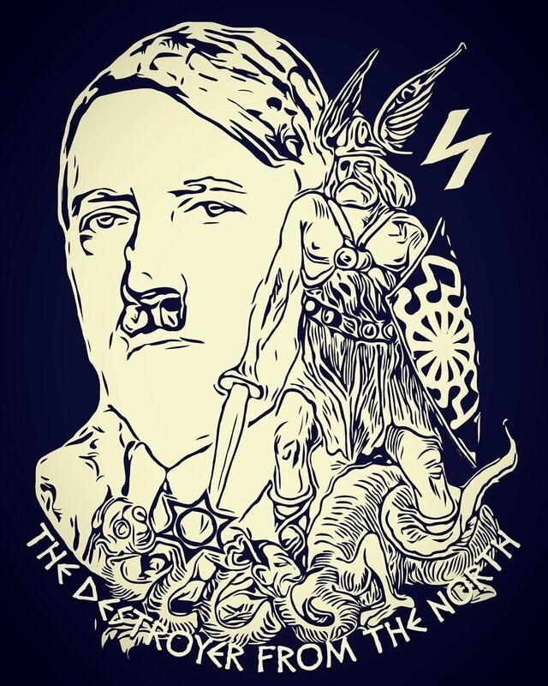

“It was Richard Wagner more so than Nietzsche who made possible the appearance of Adolf Hitler, indeed one could say that the Wizard of Bayreuth conjured up Adolf Hitler out of the depths of the Aryan World-Soul. But certainly it was also the cos- mic clash of those two Germanic Titans – Wagner and Nietzsche that provided the Promethean spark that would ignite the fertile German soul and set fire to the brightly burning star of the Son of God – Adolf Hitler. More than any man it was Richard Wagner who foresaw the coming of the Führer, the re-awakening of the one who comes back; his Sieg- fried did come alive!”
—Karl Young

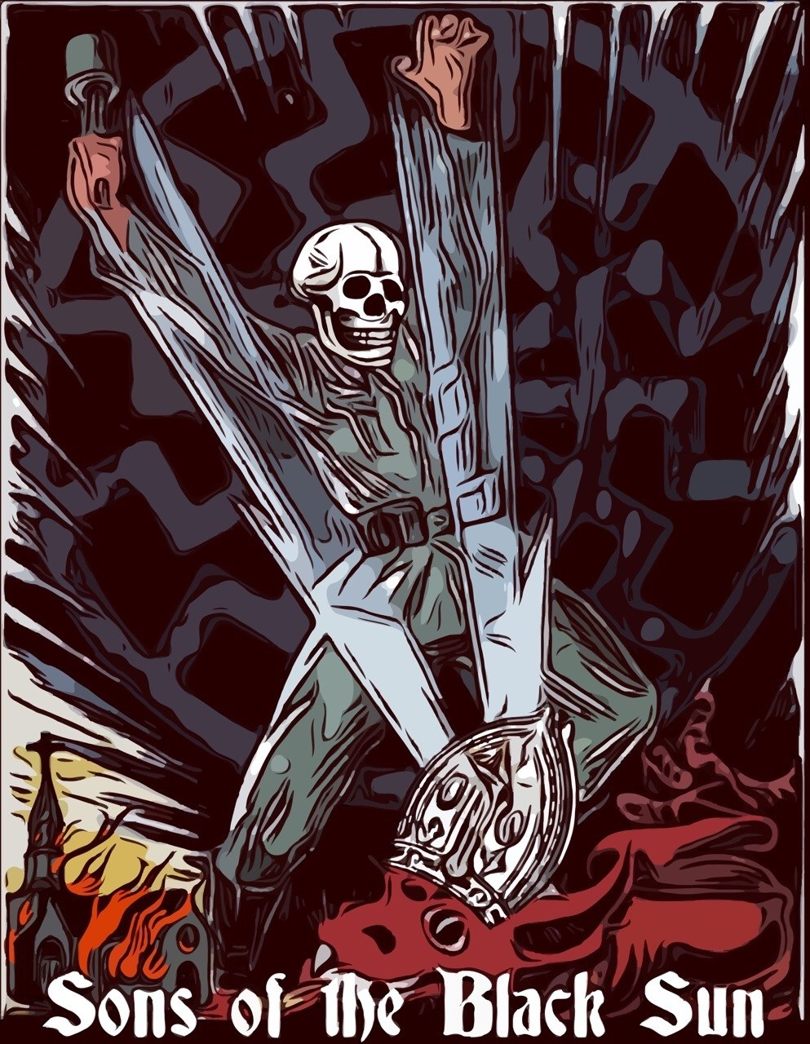

“I will be still more alone, Maestro. How can I reach you?…”
“Difficultly; but I will never abandon you. Try to deserve me, to be worthy of my warrior hand, be a Son of the Light of the Black Sun.”
“What must I do, Maestro?”
“Never let go of the Sword, remain to the end with the Fuhrer. Have I ever told you he would abandon you? Imitate his will, invincible, give yourself to his ideal, to the Hyper- borean Race, to his combat. He is the greatest Man who has come and He is the greatest who will come. Hitler is alive, he must return.”
“What can I do for you, Maestro?”
“Nothing. I am alone in this trance… Be true to the Brahmins to the death.” “I will be faithful until death. Bless me, Maes- tro.”
I bowed. And he extended his hand on my head.
The Reich that will come is no longer of this world, nor of this sun.
—Miguel Serrano

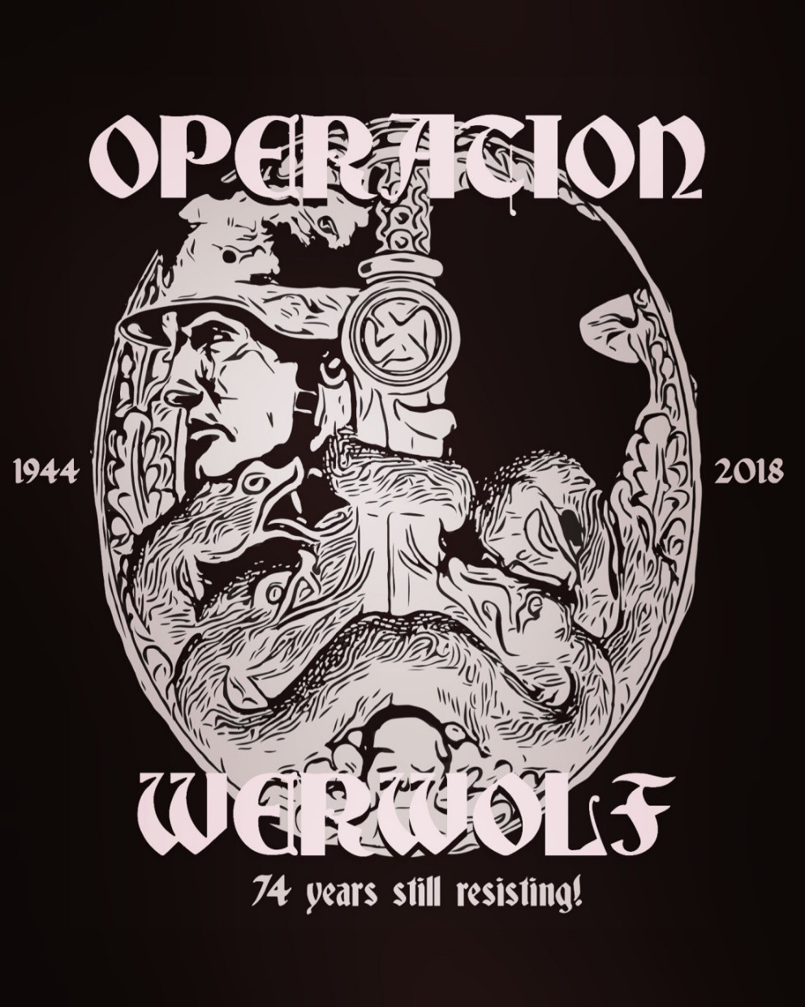

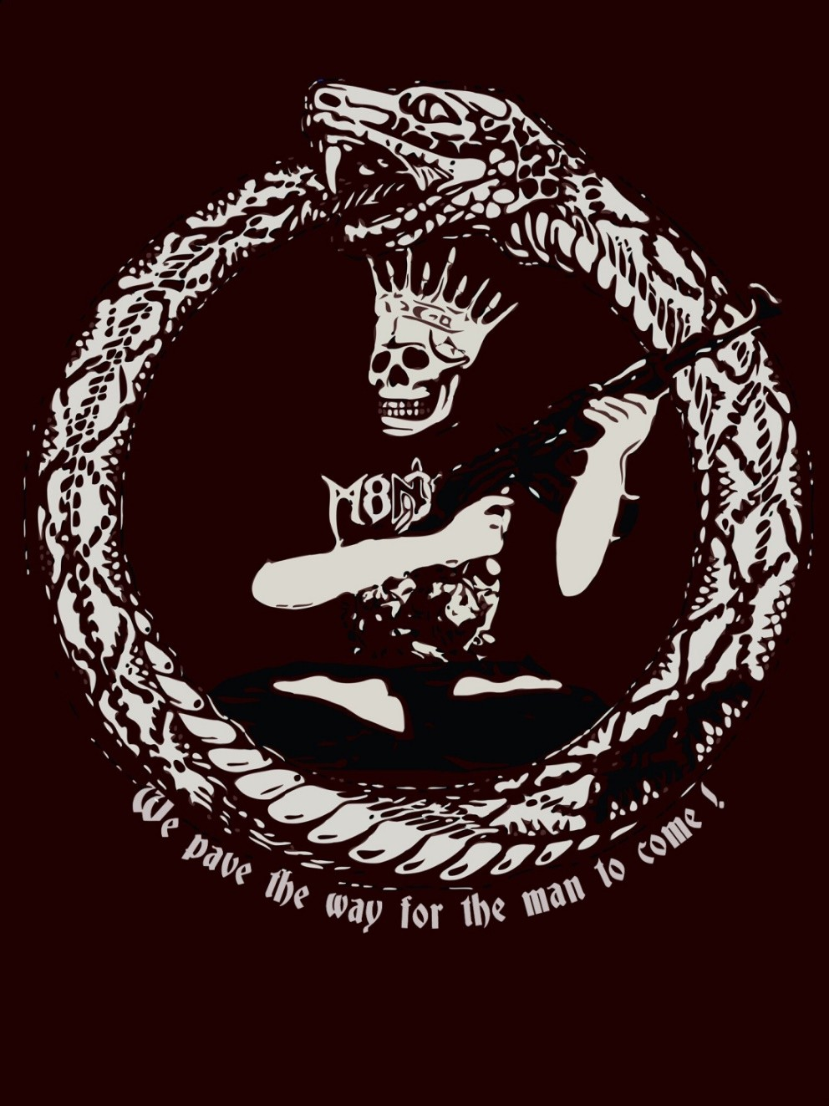

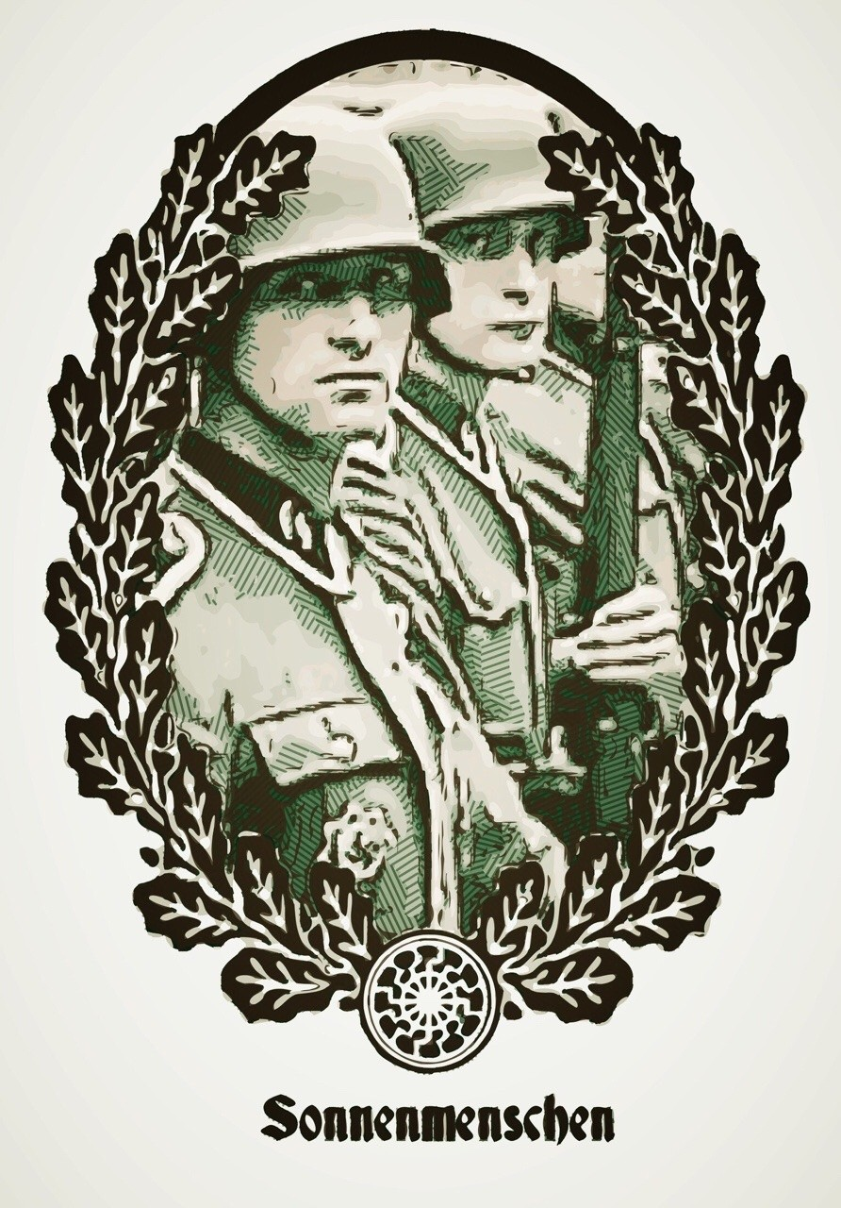

“The Deed is our ceremony, We pray with blazing hammers,
The Reich is our Cathedral.”
—Hans Baumann

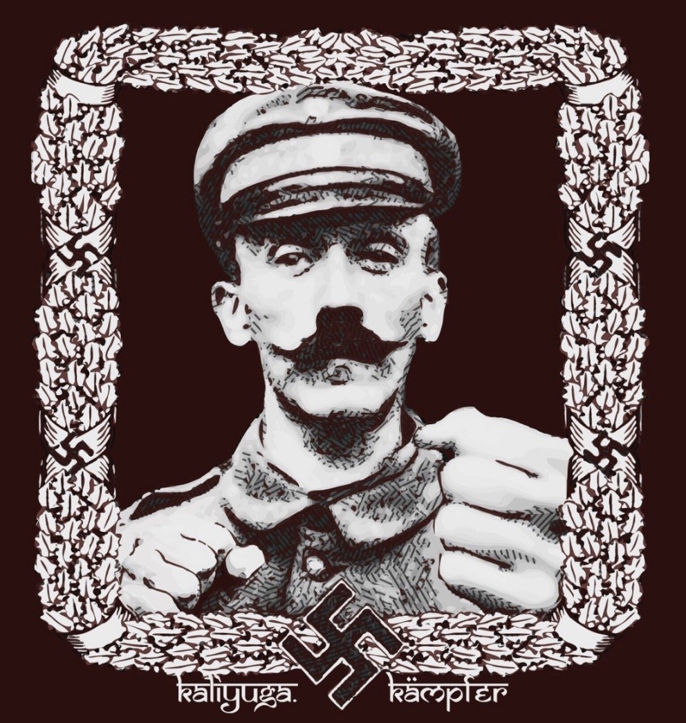

“Those who want to live, let them fight, and those who do not want to fight in this world of eternal struggle do not deserve to live.”
—The Führer

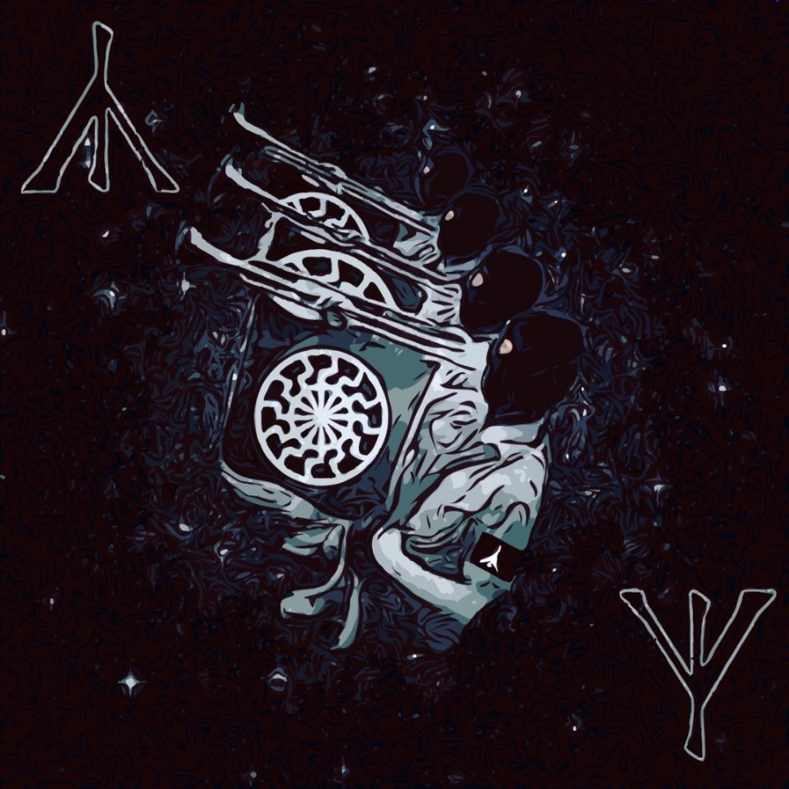

“The highest form of life on this planet is the healthy, handsome, fearless Aryan who follows his racial logic to the bitter end; the perfect National So- cialist — the one creature who collectively and con- sciously, lives up to a cosmic philosophy that ex- ceeds both himself and the earth, infinitely; a phi- losophy in which man’s ties, man’s happiness, man’s life and death, man’s individual ‘soul’ (if he has such a thing) do not count; in which nothing counts but the creation, maintenance and triumph of the most dynamic and harmonious type of being: of a race of men indeed ‘like unto the Gods’; of men in tune with the grandeur of starry space.”
—Savitri Devi

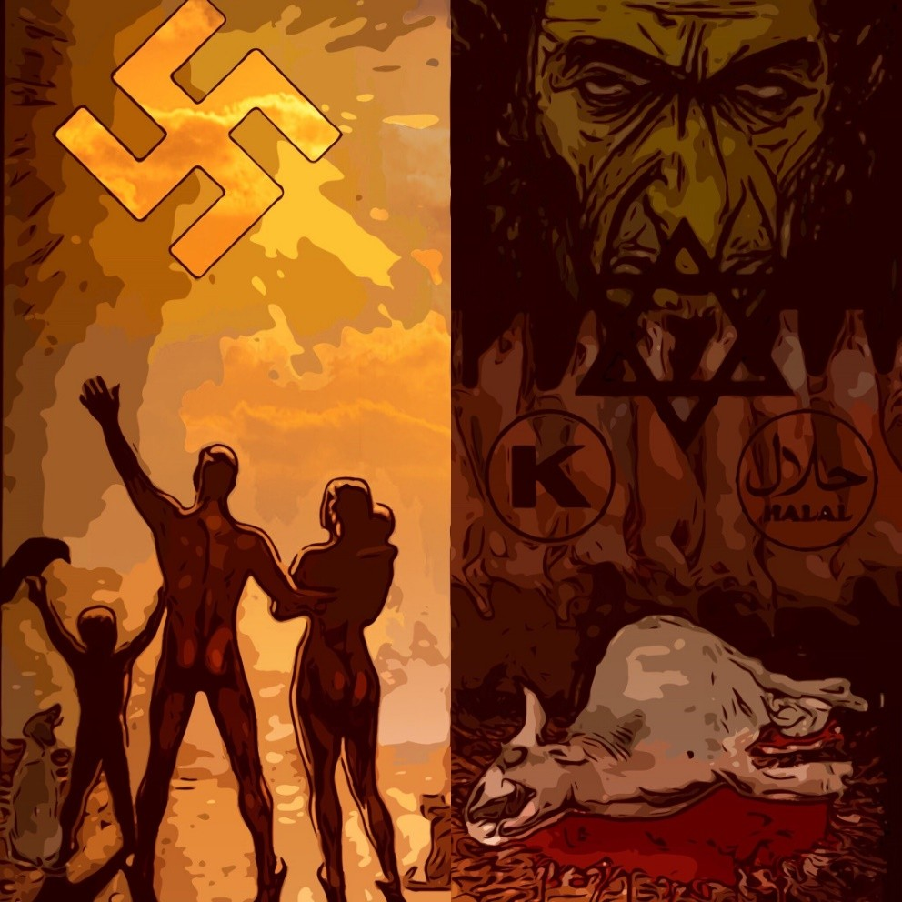

“Thus, because Christian morality leaves animals out of account …, they are at once outlawed in phil- osophical morals; they are mere “things”, mere means to any ends whatsoever. They can therefore be used for vivisection, hunting, coursing, bullfights and horse racing, and can be whipped to death as they struggle along with heavy carts of stone.
Shame on such a morality that is worthy of pariahs, chandalas and mlecchas, and that fails to recognize the eternal essence that exists in every living thing, and shines forth with inscrutable significance from all eyes that see the sun!”
—Arthur Schopenhauer

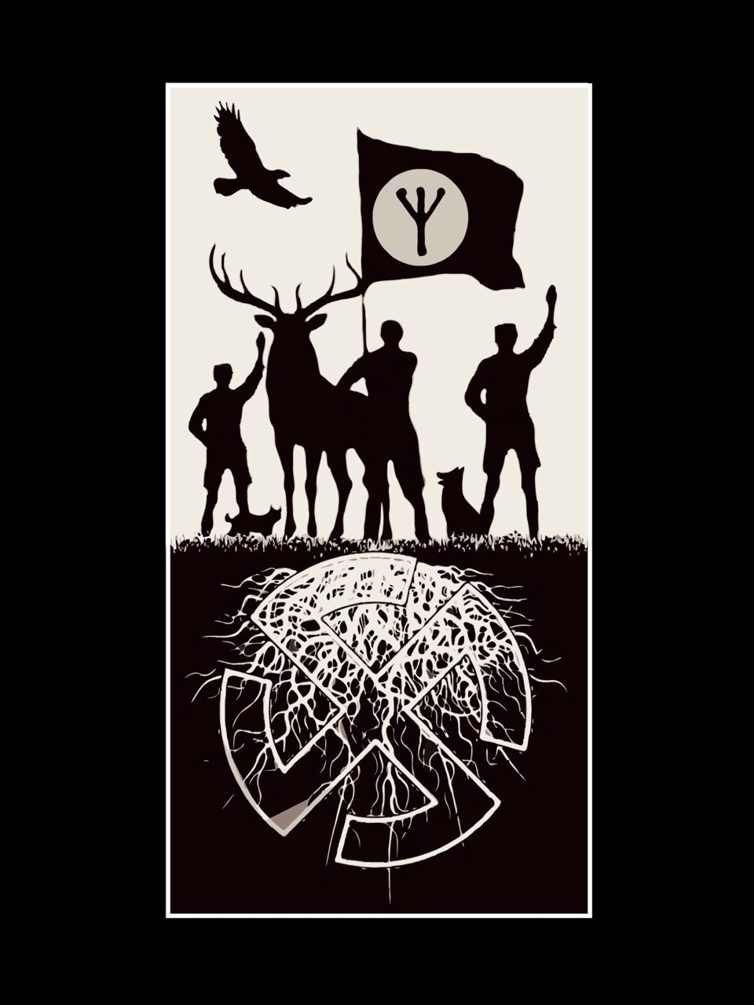

“There has been, it is true, in the West, in recent years — nay, there is, for nothing which is in harmony with the Laws of Life can ever be completely suppressed — a non-Christian (one should even say an anti-Christian) and definitely more than political school of thought which courageously de- nounced this age-old yet erroneous tradition, and set up a different scale of values and different standards of behav- iour. It accepted the principle of the rights of animals, and set a beautiful dog above a degenerate man. It replaced the false ideal of “human brotherhood,” by the true one of a nat- urally hierarchised mankind harmoniously integrated into the naturally hierarchised Realm of life, and, as a logical cor- ollary of this, it boldly preached the return to the mystic of genuine nationalism rooted in healthy race-consciousness, and the resurrection of the old national gods of fertility and of battle (or the exaltation of their philosophical equivalents) which many a Greek “thinker” and some of the Jewish prophets themselves had already discarded — politely speaking: “transcended” — in decadent Antiquity.”
—Savitri Devi

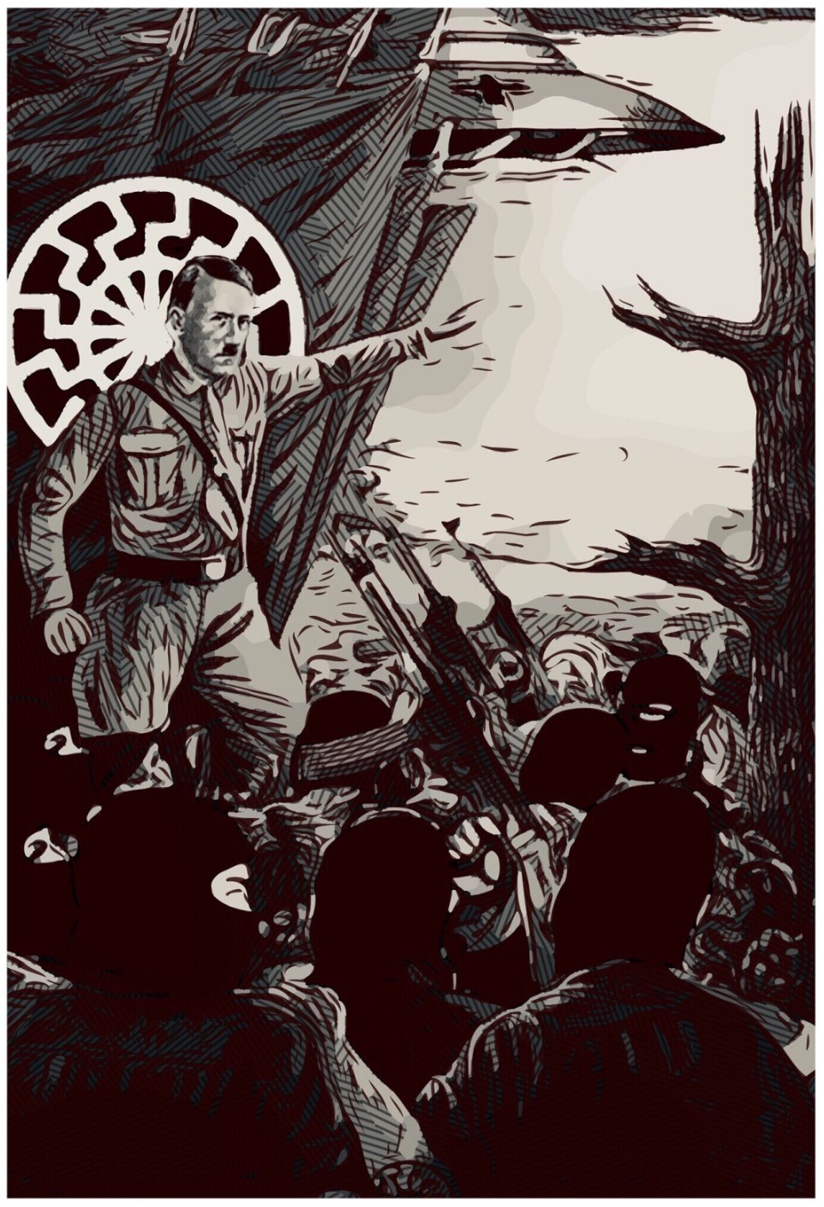

“Hitler is an Avatar of Wotan.
An Antarctic Wolf.”
—Miguel Serrano

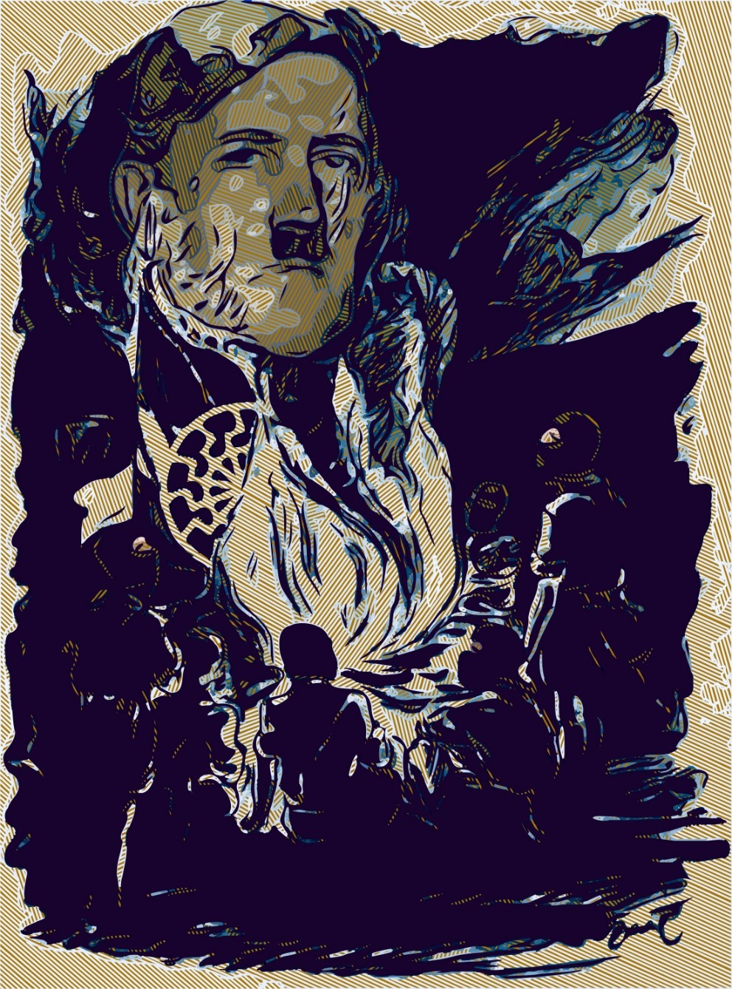

“Only he lives who has been able to include himself in the fire of a Hyperborean Arche- type, in his eternity and his Eternal Return.”
—Miguel Serrano

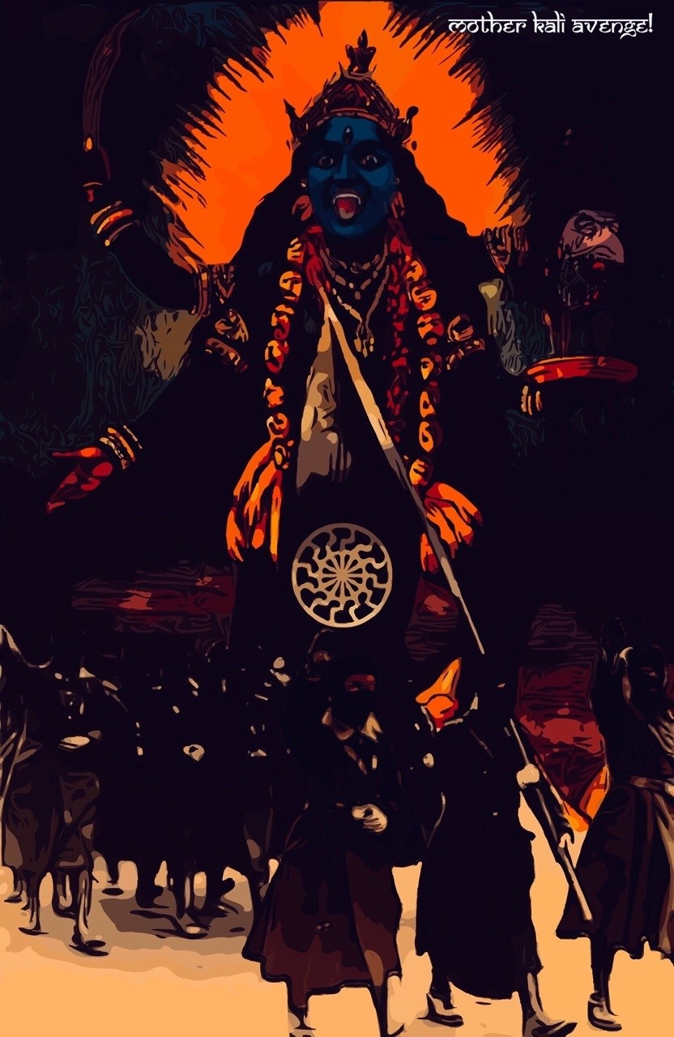

“Look! Look what they did to beautiful Germany – to my Leader’s land!” And I burst into tears. Then I remembered the splendid, starry sky I had seen all night from the windows of the corridor. And I re- membered the Dark Blue Goddess, the mother of destruction, whose presence I had felt that night. In far-away India, during the war, I had visited her temples and offered her wreaths of blood-red jaba flowers for Hitler’s victory. The implacable Force had not answered my prayer. But I knew that the ways of the gods are inscrutable. I now turned – my face to the sky, as though the Dark Blue One had been there, invisible but all-pervading – but irresist- ible standing above the ruins: “Kali Ma,” I cried, again in Bengali, “pratishod kara!” – “Mother Kali, avenge!”“
—Savitri Devi

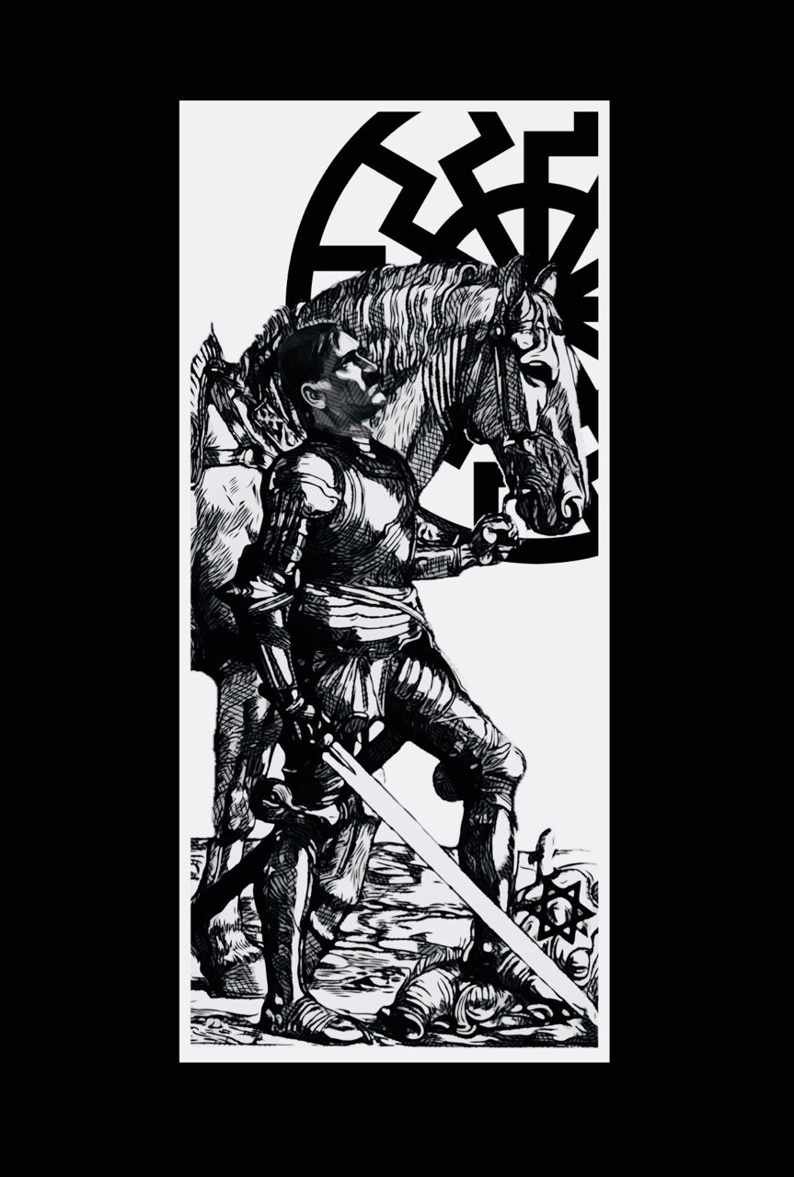

“I did not invent the claim that Hitler was alive, that he had not died in the Bunker, that he had left by submarine to the oases that exist among the icefields of Antarctica. Others said that, his own en- emies. And it was logical that it should be so, be- cause this belongs to eternal truth, to a Minne, a Nostalgia that recurs and comes from beyond the Universe. As we have seen, Frederick Barbarossa, King Arthur, all the Aryan Fuhrers have died and not died but only sleep in a mountain cave, icefield, island, oasis among the icefields, hot spot in the midst of cold, fiery ice, frozen fire. Oasis or cavern has the same meaning. The “Hollow Earth,” within, Enchanted Cities of the Himalayas or Andes. My Maestro saw Hitler beneath the earth, in a hidden world, perhaps awaiting the return of the Light of the Black Sun, a New Dawn. The Hyperborean Myth works by itself and through itself. Clearest as- surance of a new triumph, the return of Kalki on a white horse.”
—Miguel Serrano

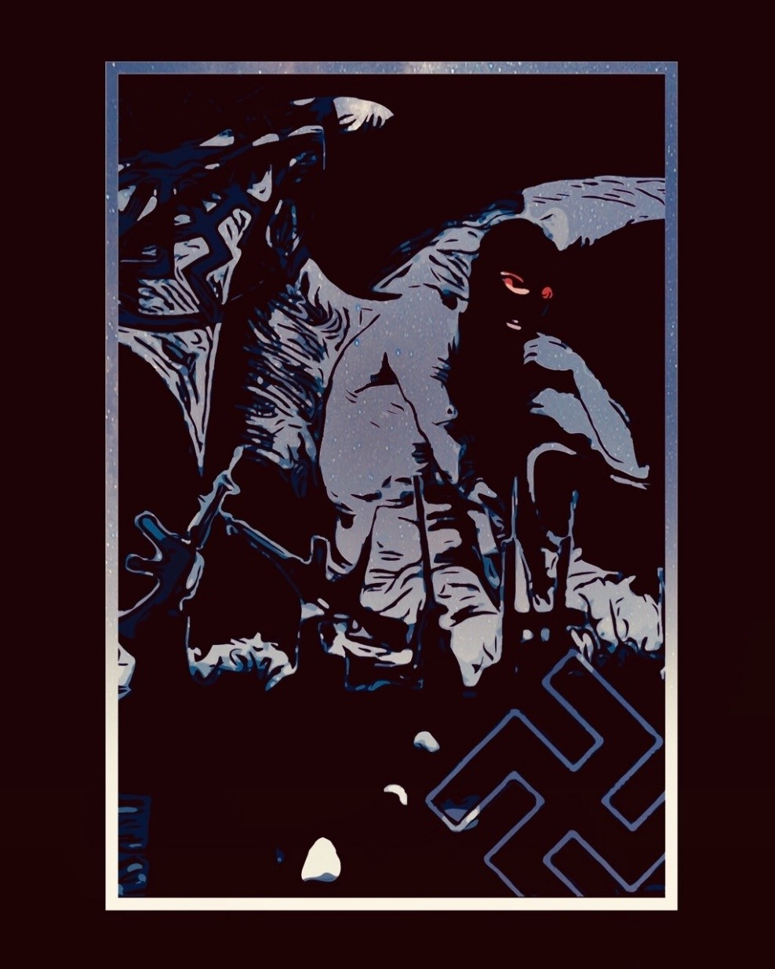

“Lucifer, thus, would have been one of those Gods of the Light of the Black Sun, signifying his name. Most Beautiful Light, precisely, Luci-Bel, as the Cathars called him.”
—Miguel Serrano
“One must differentiate between what is of Lucifer and what belongs to Satan. Satanic describes the moral side of the mechanistic conquest of the world. It is dictated by purely instinctive motives. It is seen in the Jewish attitude toward the world. Luciferan describes the struggle for the subju- gation of matter without having the prerequisite of subjective interest as a driving motive. The first springs from an uncreative character, and will consequently never find anything, never discover, never really invent, while the second compels natural laws with the aid of natural laws, fol- lows their track, and builds works to make matter useful.”
—Alfred Rosenberg
“LUCIFER: One of the names given to Venus, double she star of Morn- ing. He is also Quetzalcoatal, and Wotan, and Baldur. A hero, or liber- ated one, who would come to set himself in the sky as a star to initiate heroes, those who here on Earth and in other places through the firma- ment combat the Demiurge: Lucifer is a distinct light, suggestive, that appears before and after the Golden Sun, prisoner of the Demiurge. Luci- fer, the morning star, has nothing to do with the Demiurge, and is “an example by which to live and die” as Otto Rahn said. He lost a war in heaven in order to win the war later as the Ultimate Avatar. He is there above, voluntarily Crucified, immobile and awaiting his possible vindi- cation with our combats. He must lose here in order to carry the Earth back to its origins and trans figure it, moving from City to City, chakra to chakra, untill he reaches the void of the Black Sun behind the sun of Gold and the green ray behind the black sun. He is the God of the losers in the Kali Yuga and the return of Hyperborea. His emblem is the left hand Swastika, that of Hitler, that of The return. He is the supreme guide of the pilgrims of the dawn, of the acolytes of lucifer, the Morningstar.”
—Jason Thompkins

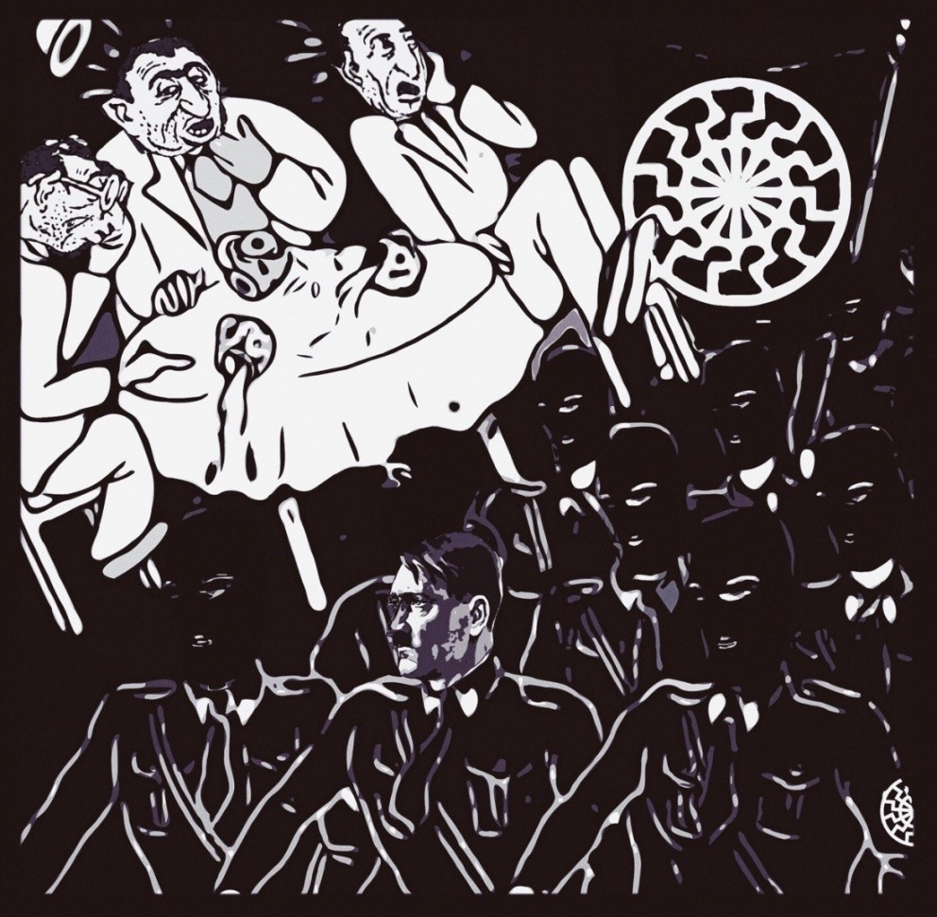

“As I said before, His companions at arms will be the last National Socialists; the men of iron who will have victori- ously stood the test of persecution and, what is more, the test of complete isolation in the midst of a dreary, indifferent world, in which they have no place; who are facing that world and defying it through every gesture, every hint, — every silence — of theirs and, more and more (in the case of the younger ones,) without even the personal memory of Adolf Hitler’s great days to sustain them; those I have called “gods on earth” and parents of such ones. They are the ones who will, one day, make good for all that which men “against Time” have suffered in the course of history, like they themselves, for the sake of eternal truth: the avenging Comrades whom the Five Thousand of Verden called in vain within their hearts at the minute of death, upon the bank of the Aller River, red with blood; those whom the millions of 1945 — the dying; the tortured; and the desperate survivors
— called in vain; those whom all the vanquished fighters “against Time” called in vain, in every phase of the great cosmic Struggle without beginning, against the Forces of dis- integration, co-eternal with the Forces of Life.
They are the bridge to supermanhood, of which Nietzsche has spoken; the “last Battalion” in which Adolf Hitler has put his confidence.”
—Savitri Devi

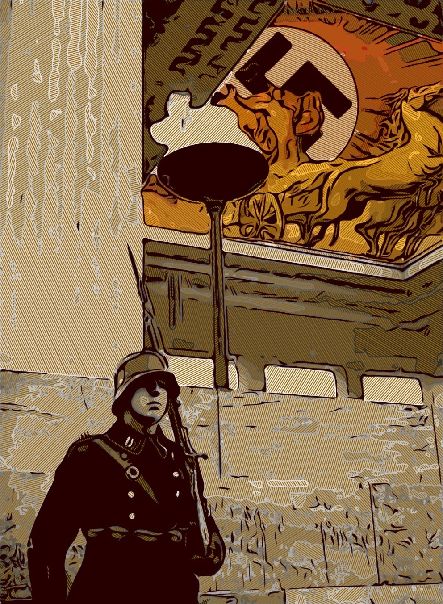

“The Fuhrer is a man totally attuned to antiquity. He hates Christianity, because it has crippled all that is noble in humanity. According to Schopen- hauer, Christianity and syphilis have made human- ity unhappy and unfree. What a difference between the benevolent, smiling Zeus and the pain-wracked, crucified Christ. The ancient peoples’ view of God was also much nobler and more humane than the Christians’. What a difference between a gloomy ca- thedral and a light, airy ancient temple.”
—Joseph Goebbels

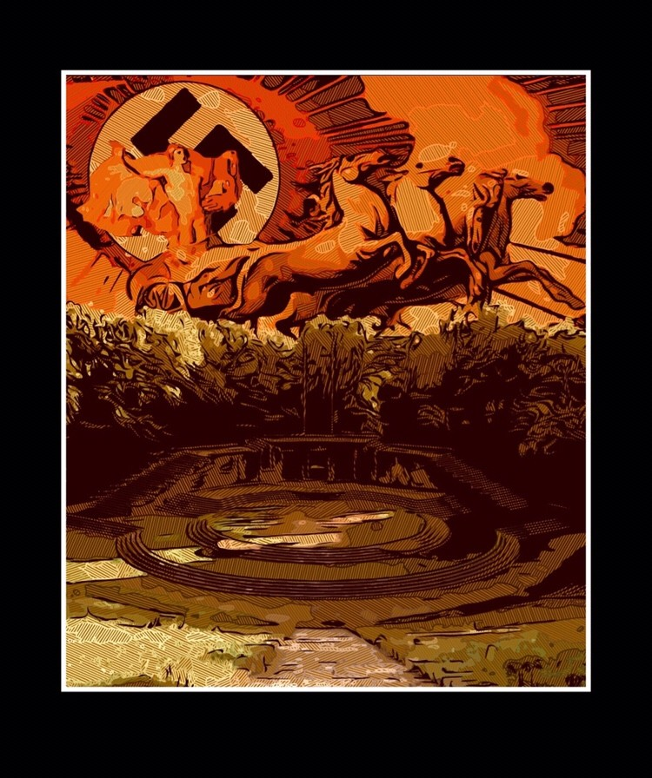

“And Apollo, the Bearer of Light, patron of poets and travellers, would never abandon his own in dis- tress. He himself had become an outlaw, even seen as the Devil. But as he was not the Devil, he watched over, in accordance with the celestial laws, the forests and the routes. On the bridle of his charger, he left his carbuncle shining like the sun.
When one of his minstrels died, he carried him above the clouds towards the “Mountain of Assem- bly in the far distant midnight”, in the extreme North. Was it important that his children could not live in the towns as other men and were not buried in the same manner as everyone else? In the dwell- ing place of the Bearer of Light, there is plenty of light! More than in the houses of God, the cathe- drals and churches, in which Lucifer could not enter and would not wish to enter as the stained glass windows let in so little light and represented Jewish prophets and apostles, Roman gods and saints. The forest was free!”
—Otto Rahn

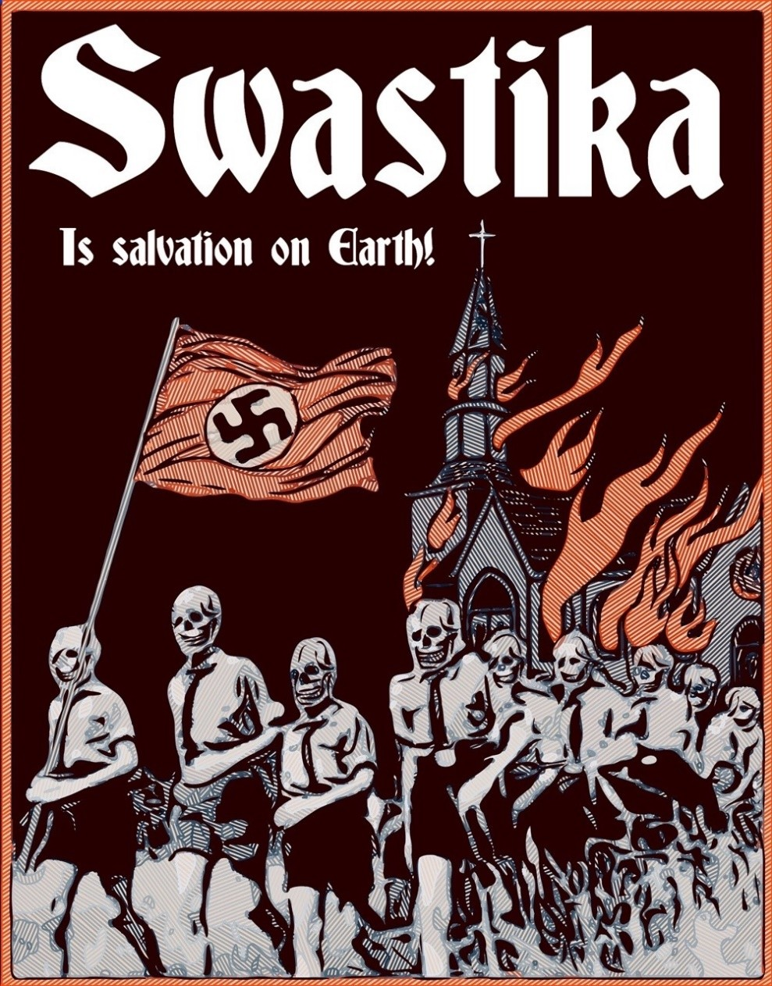

卐卐卐卐卐卐卐卐卐卐卐卐卐卐
We are the joyous Hitler youth, We do not need any Christian virtue,
Because our leader Adolf Hitler Is always our Mediator.
卐卐卐卐卐卐卐卐卐卐卐卐卐卐No evil priest can ever stop us We feel we are Hitler’s children.
Not Christ we follow, but Horst Wessel, Away with incense and holy water! 卐卐卐卐卐卐卐卐卐卐卐卐卐卐
We sing as we follow our flags
As worthy sons of our ancestors,
I am not a Christian, not a Catholic, I’ll go with SA through thin and thick. 卐卐卐卐卐卐卐卐卐卐卐卐卐卐
The church can be lost,
The swastika is salvation on earth, I will follow him at every turn,
Baldur von Schirach, take me with you
卐卐卐卐卐卐卐卐卐卐卐卐卐卐

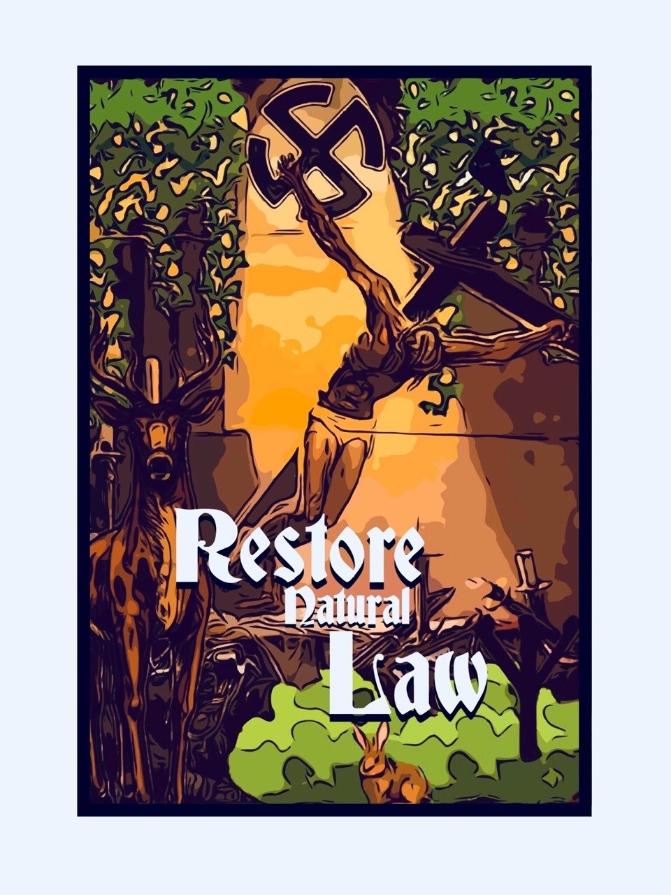

“Nordic man sees God not in the pasha to whom he is servilely devoted, before whom he throws him- self on the ground and toward whom he acts like a slave, but he also does not see in God an inferior servant of his wishes. Nordic man stands before the Divine in reverence and at the same time feels him- self closely connected to him like to a friend. Nordic man knows that his God is not banished in certain statues or a few holy substances or in solid houses, he feels close to his God everywhere, in his clan, in the great folk community, in the forests and fields, at the fine festival locations and in the quiet cere- mony halls of his folk or at the home hearth.”
—Anton Holzner

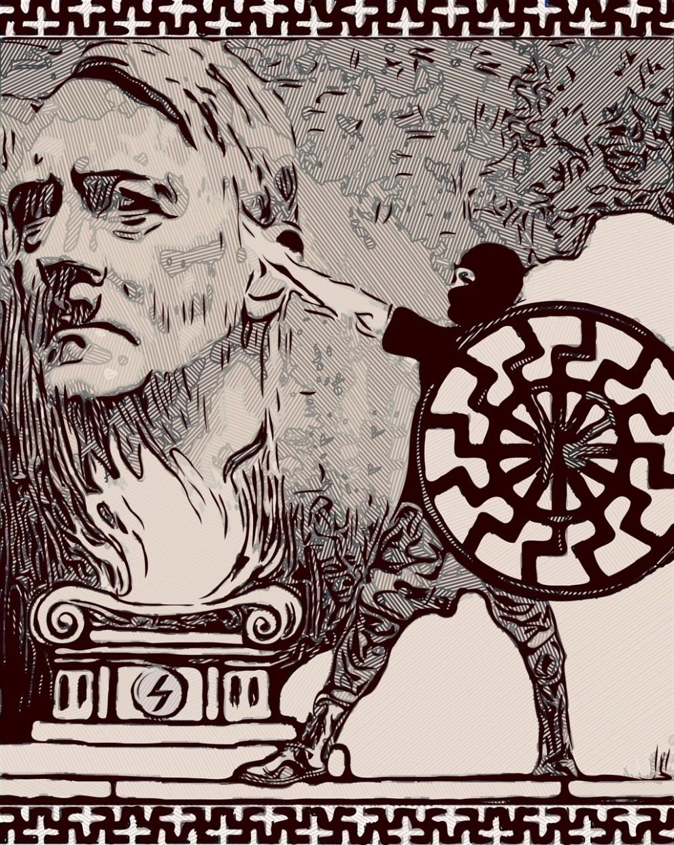

“Whether alive or dead in the flesh, the pre- destined Child of Braunau—Adolf Hitler— lives forever in National Socialism, his crea- tion and integral expression.”
—Savitri Devi

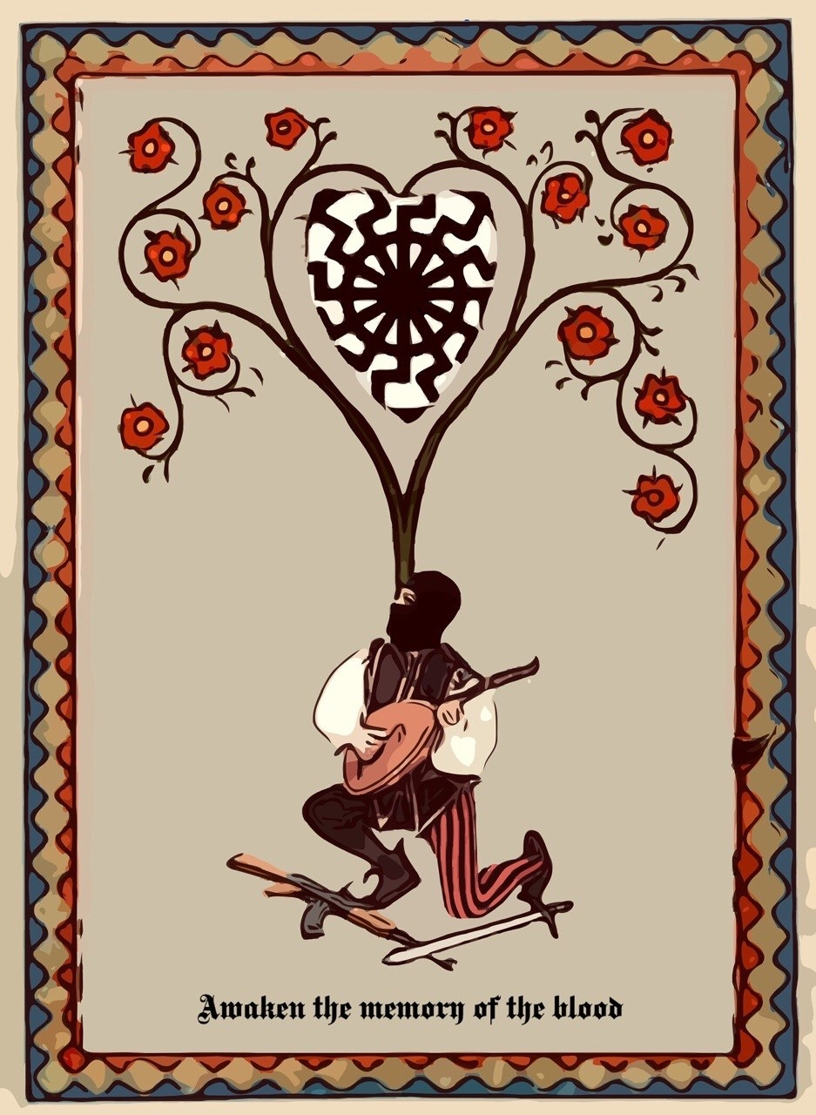

“The Collective Unconscious is nothing more than the “memory of the blood” of the ancient Minne- sanger, of the initiated Germanic troubadours who sang it; the Minnetrinken, or the Minnetrinker who drank it; or the Mannerbunde, the Order of com- rades who exchanged it. And the Sword is called “Blood Memory” of the Knights of the Gral. Be- cause the “memory of blood” is the river of images that circulate eternally in the light of the Black Sun and breed in the astral body.”
—Miguel Serrano

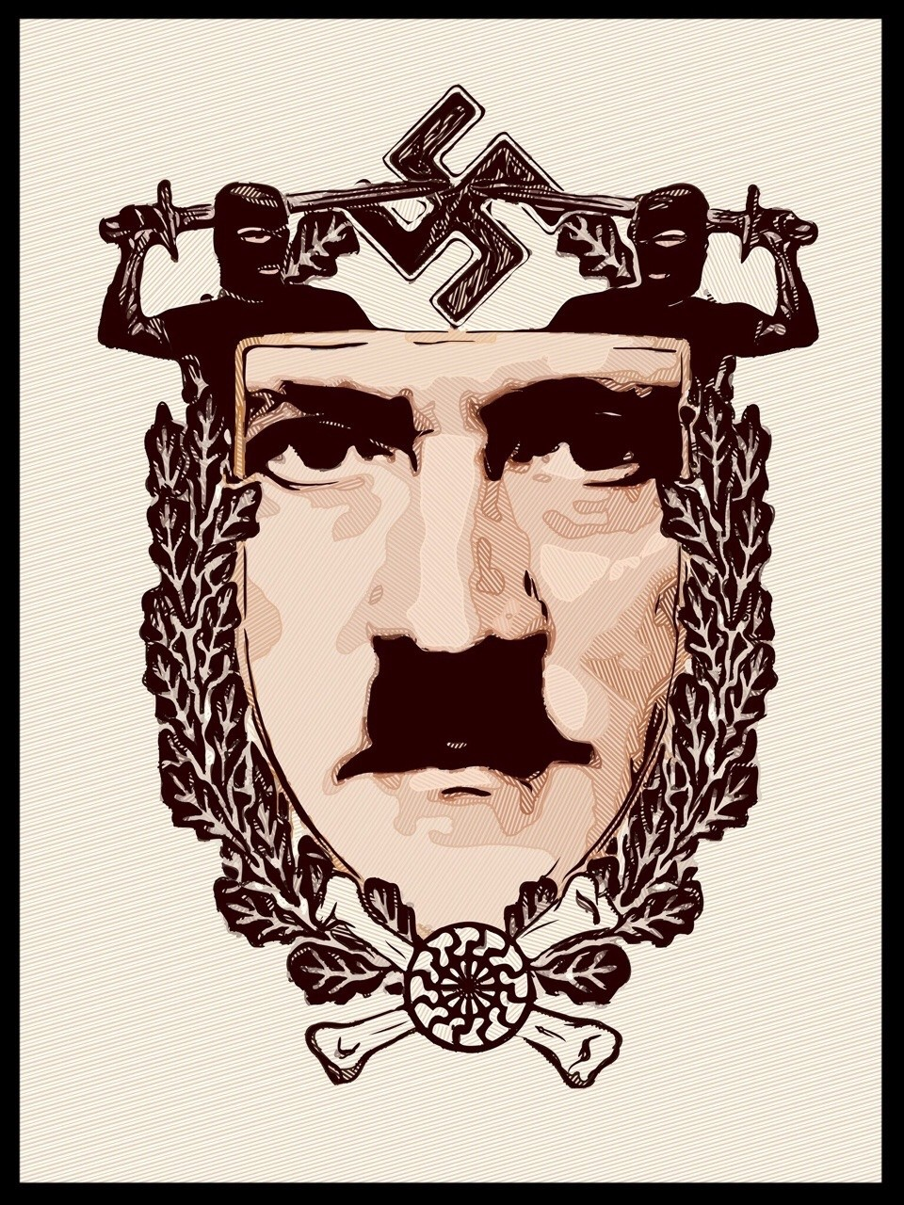

“The ultimate heroes of this time must be grateful to the Fuhrer, because He upheld so great a war, so enormous a combat, such heroic sacrifice, in the ful- fillment of an Eternal Symbol, making possible for new generations to give themselves to Him and in Him to meet a Destiny, a salvation, an Ideal, a Myth of Redemption. So as we have seen and understood, we already know a God was again among men, to- gether with the heroes; the true God of heroes, not the god of slaves; the God of Brahmins, of the Hy- perborean Hosts, God of the Aryans, not the god of Jews. And the new religion that will manifest itself, the new Myth that is fulfilled, is the ancient Polar Myth, when Gods inhabited the earth and lived among heroes.
We who have understood, the warriors of Esoteric Hitlerism, we are today the advance guard, the priest-warriors of a New Revelation:
Esoteric Hitlerism.”
—Miguel Serrano

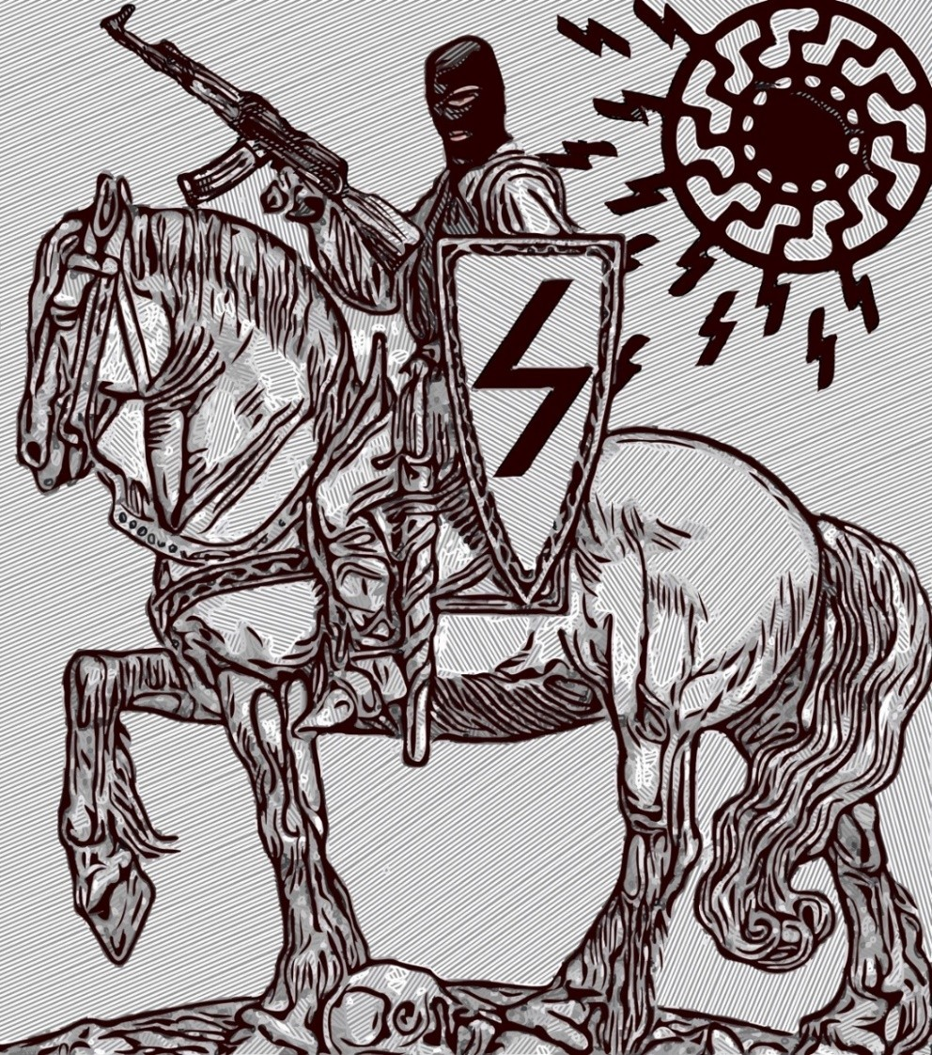

“This is the age in which our triumphant Democrats and our hopeful Communists boast of “slow but steady progress through science and education.” Thanks very much for such “progress!” The very sight of it is enough to confirm us in our belief in the immemorial cyclic theory of history, illus- trated in the myths of all ancient, natural religions (including that one from which the Jews — and, through them, their disciples, the Christians — borrowed the symbolical story of the Garden of Eden; Perfection at the beginning of Time.) It impresses upon us the fact that human history, far from be- ing a steady ascension towards the better, is an increasingly hopeless process of bastardization, emasculation and demor- alization of mankind; an inexorable “fall.” It rouses in us the yearning to see the end — the final crash that will push into oblivion both those worthless “isms” that are the product of the decay of thought and of character, and the no less worth- less religions of equality which have slowly prepared the ground for them; the coming of Kalki, the divine Destroyer of evil; the dawn of a new Cycle opening, as all time- cycles ever did, with “Golden Age.”“
—Savitri Devi

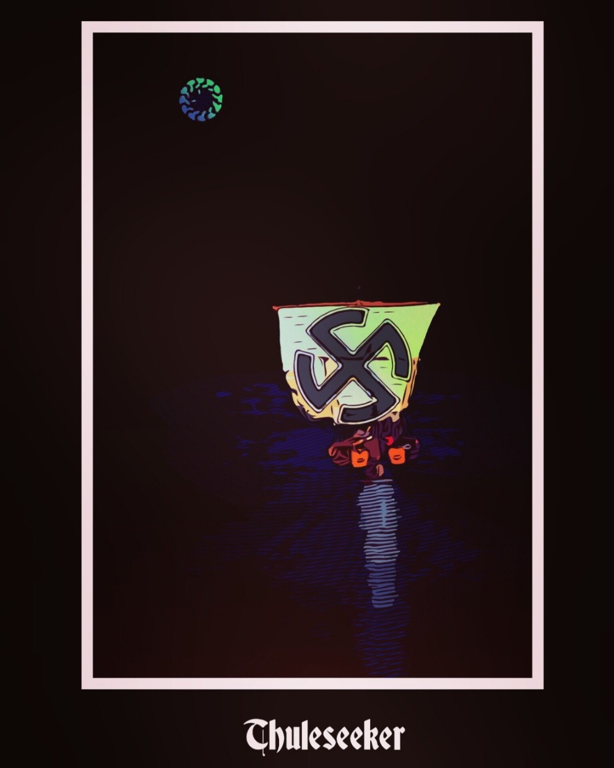

“Ultima Thule is also the land of the Hyperboreans who lived beyond the North wind in eternal light and over whom reigned, as God, Delphic Apollo.This land of the Hy- perboreans was deemed by the noble Hellenics to be the cradle of their race and the country of their divinity. It is none other than Æa, this island of sun on whose discov- ery the Argonauts had launched themselves. Like the Iranians, the Hellenics also had their ‘Paradise’: the celebrated mountain of the Gods — Olympia, Parnassus or Oeta
— were all paradêsha, at whose summit one thought through prayer of the Nordic land of Light, this island of sun, where one drunk the Nectar and the Ambrosia which gave immortality and bliss.
Pytheas navigated towards Midnight, because his quest for the divine had also pointed him in this direction. He believed that the Pole was wise and Apollonian, as it found balance in itself; that the Pole and the sun, who was Apollo, both possessed in themselves this same force of attraction that men could never detach from God; that Apollo’s true country was the Polar region, in the extreme North of the blessed people of the Hyperboreans.”
“Heracles was one of the Argonauts. In the fifth century BC, the Greek historian, He- rodotus, tells that he was venerated in two ways: as a human hero and as a god. Per- haps he had formerly been a man, or perhaps, as is indicated by an ancient inscription discovered in Malta, an invincible ‘founding chief’ of the Hellenes. The myths con- cerning him, of the ancient Greeks, are supreme chants exalting power of will and the liberation obtained by its inherent force. The will of this power, incarnated by Hera- cles, stands against Destiny and Destiny submits to it. Following the sun, the ‘sun hero’ raised himself above the night of rest and indolence, sought the Divine and found it within himself. In this way he became a god.Heracles was a rebel: he desired equality with the Most High. But he also recognised the need for endurance: patiently he ‘suffered’ the fateful law that flows through and ordains the cosmic All. In this way, he became Olympian. Heracles found the Golden Fleece in the Island of Sun, Æa. In the Middle Ages, some thought that this Fleece, symbol of the transmutation of man into god, was in reality the ‘philosopher’s stone’.”
—Otto Rahn
卐卐卐卐卐卐卐卐卐卐卐卐卐卐
“We have already spoken of the initiation of A-Mor and will return to do so again when we refer to the Gral and the Minnesanger, in relation to the esotericism of the SS. It is born beyond, in distant lost Polar Hyperborea, like the secret guarded in the memory of the blood and carried with the Gral by the divine ones arrived through Venus. Thule is the magic point of the Wedding, where He and She wed. Poseidon, King of the Sea, surrounds the sacred continent with a Band or String. He is Bride- groom. He is Wotan.”
“The Wedding and Death go indissolubly united. The Magic Wedding and Mystic Death, which make possible the Second Birth of the Aryan, of the initiate warrior.”
—Miguel Serrano

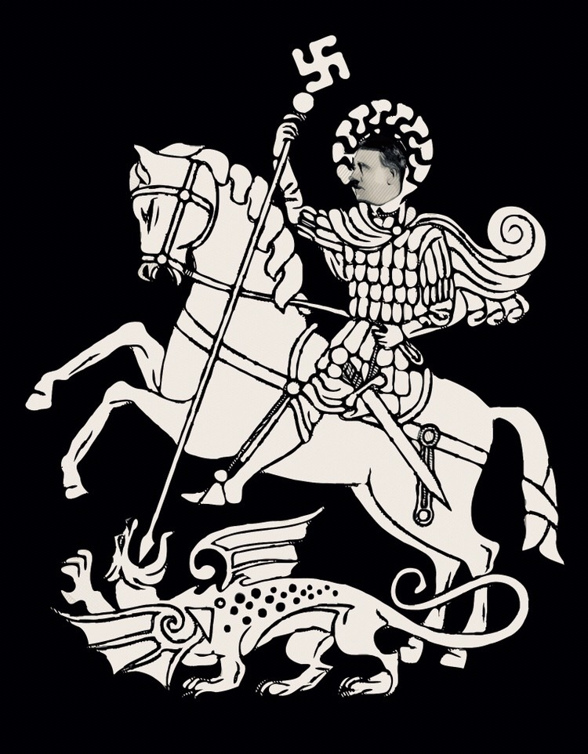

“A review of life can be represented in manifold ways. At first it occurs in a mythological mystical manner. Then the clairvoyantly grasped laws of the world and spiritual commandments appear as personalities which possess eternal significance, as long as the race which created them still lives.
Therefore Siegfried’s life and death are an eternal vital presence. Therefore the longing for redemption embodied in the Twilight of the gods is a necessary recognised consequence of the breaking of an agreement, that is, it was an offence against organic inner truth.
An obligation to practice truth is an eternal feature of the Ger- manic consciousness of responsibility.
German folkish tales also reveal the same substance of truth. These stories are timeless and only wait upon ripe, awakened souls, to blossom anew. They can at any time be recast into an- other form of our world interpretation, that is, into what is com- prehensible.
This does not signify a development in the sense of progress. Thus it is necessary that the MYTHIC content be revealed in terms of the climate of opinion of the era, that is, in the mode of representa- tion of the time concerned.
A world view will thus only be true when folkish tales, legends, mysticism, art and philosophy are mutually interchanged, when they express the same ideas in different manners, and when they share inner values of the same kind.”
—Alfred Rosenberg

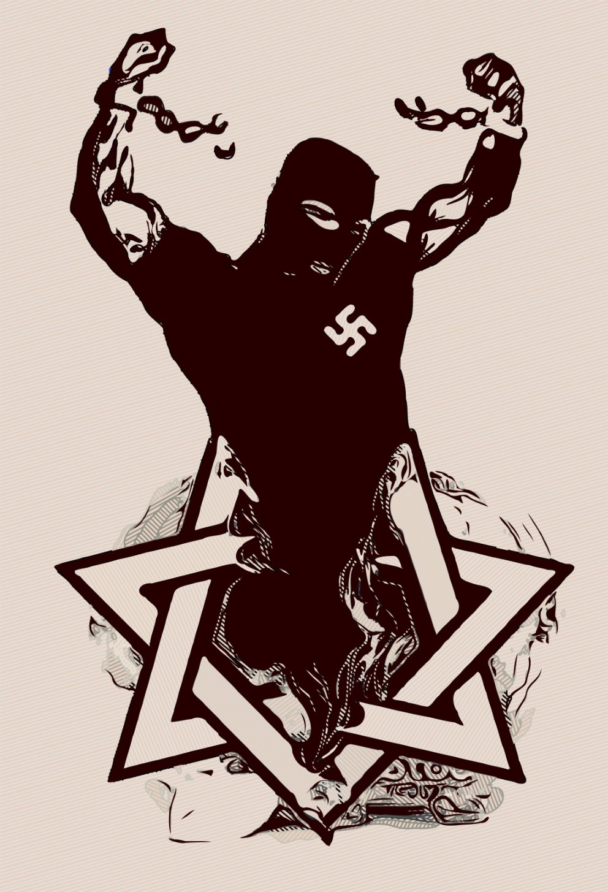

“For two thousand years, the Aryan, the Goth, the Visigoth, has forgot- ten his own Gods, the stars and celestial bodies, his runic and alchemical science, his blood, his pride, losing the memory of divine origin, to be just a lackey of an invented Jewish Messiah, and a whole world of seem- ingly contradictory Jewish values, worshiping and adoring Isis as a Jew- ish virgin maiden-also invented and never existing, transposed from Isis and the Black Virgins-and some agitators with the mentality of slaves and a guilt complex. Thus have the Aryans sold their physical and spir- itual blood, their body and their mind, coming to believe that all men and all races are equal and have similar souls. All sinners, humble and humiliated!
The Warrior ceased to be such, the hero became a slave and he lost the memory of the cause, of his arrival to this corrupted universe to fight and conquer. He lost the love towards tortured nature, leaving from the perception of his nostalgia of Hyperborea. He did not make the magical effort by transfiguring it. We went strait in to the abyss, without hope, without exit! Untill the very gods of Valhalla, at the end of the age of Pi- sces, at the nadir of the Kali Yuga, decided to come to the aid of the fet- tered prisoner, of the warriors, the vitas, already almost at the point of succumbing and losing the great battle. They made possible the advent of the cycle of the hero, of the Yuga of heroes.
They sent Adolf Hitler, the Ultimate Avatar, to awaken the sleeping he- roes, to cut their chains and break the spell of the Demiurge, being able to face him in the decisive combat, before the entrance into the age of Aquarius. And also to prevent in this era a new trap of the enemy from shutting the doors to victory and liberation. Adolf Hitler exposed the en- emy once and for all. He recovered for the White Race their Aryan roots, their Hyperborean foundations, providing the opportunity to the War- rior and the hero to continue in the combat. He re-established the ine- quality of men and of the various bloods, bringing the Aryan to feel freshly the divinity of his origins.
At the beginning of the age of Aquarius. Hitler has made possible the resurrection of the hero.”
—Miguel Serrano

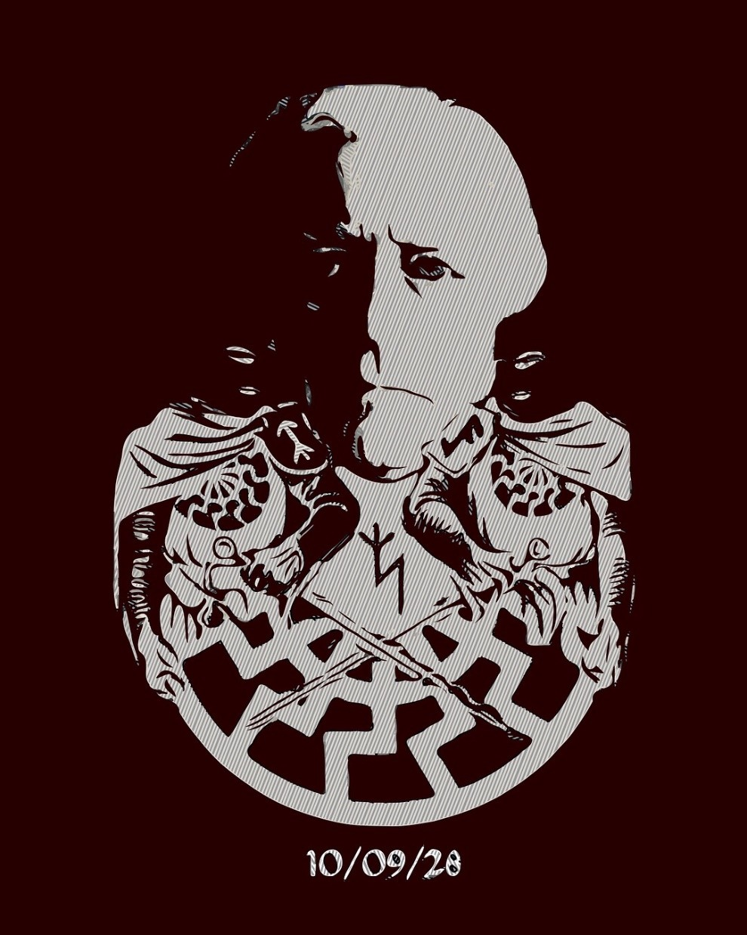

Miguel Serrano ᛉ10/09/28ᛉ ᛋᛋᛋᛋᛋᛋᛋᛋᛋᛋᛋᛋᛋᛋᛋᛋᛋᛋᛋᛋᛋᛋᛋᛋᛋᛋᛋ
“But I am not of these times, nor of this world, nor of these days. I am from another planet. I am from the Morning Star. I am not afraid of losing every- thing, including life. Furthermore, the motto on my coat-of-arms reads: “My honor is loyalty.” Yes, loy- alty to the ideals, the dreams, the past glory of the night, the ghosts of lost friends, the golden shad- ows, the echo of their steps, to the old streets and cities, and all that which escapes the light this mar- tyred earth projects, the longing for a Golden Age, when heroes still lingered among us, when the Gods were still talking to us. For I am among those who spoke with the Gods…”

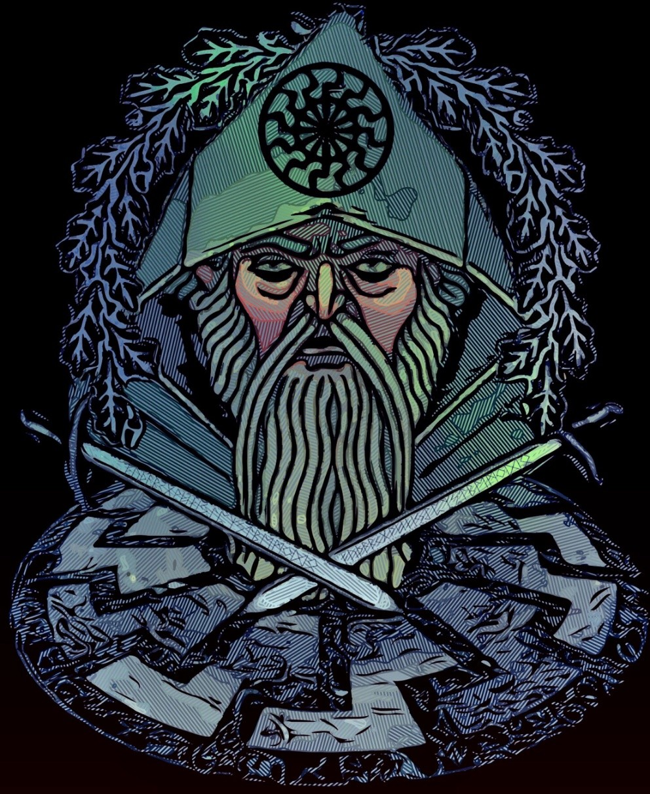

“Ritual and Magic were exactly what I was going to seek from the Maestro, the means, the formulas, the signs that would permit me to pass to the “other side” and so initiate dialog with the invisible forces whose symbols are only phenomena of the physical visible world to the eyes of our body. A dialog with “those from beyond” who had taken Jason with them into the glories of their ancient night.
This and nothing else is what must properly be called Initiation. To gain knowledge the bards re- quired more than twenty years of instruction. The gnosis of the Aryan Rishis. Rishi means to see. Pre- cisely to see “those from beyond.”“
—Miguel Serrano
ᛋᛋᛋᛋᛋᛋᛋᛋᛋᛋᛋᛋᛋᛋᛋᛋᛋᛋᛋᛋᛋᛋᛋᛋᛋᛋᛋ

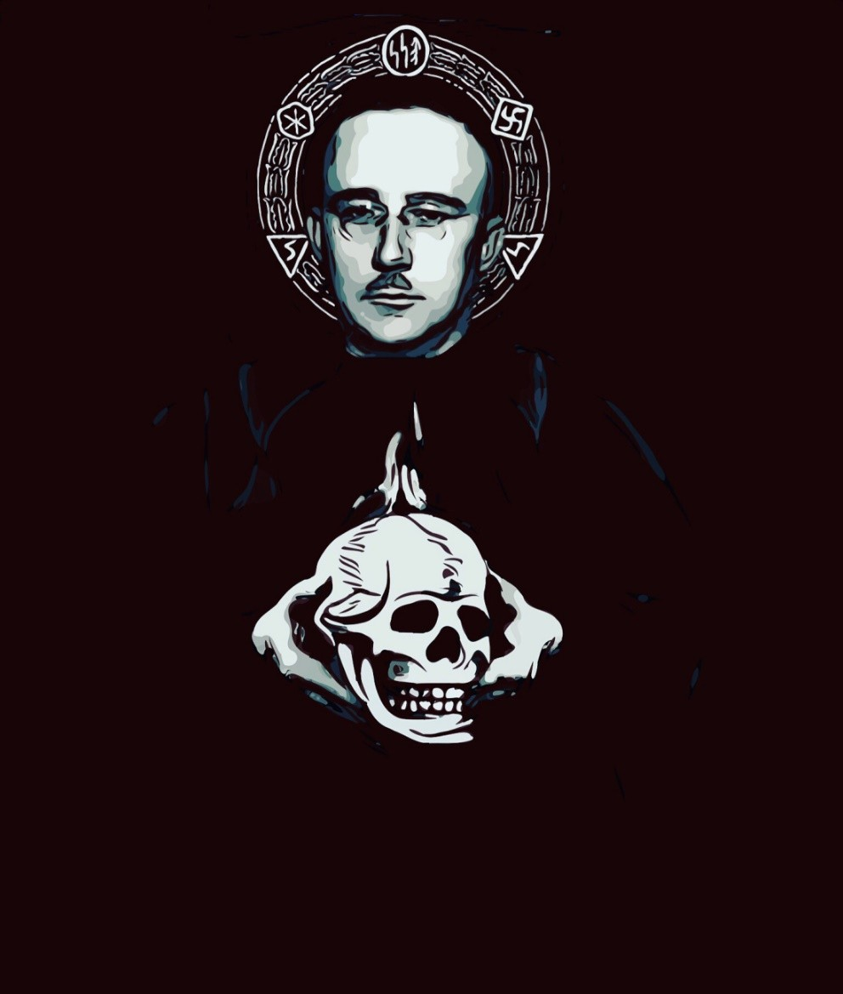

[the Totenkopf is to] “remind us that we should be ready at any time to lay down our lives for the good of the Germanic people”
—Heinrich Himmler

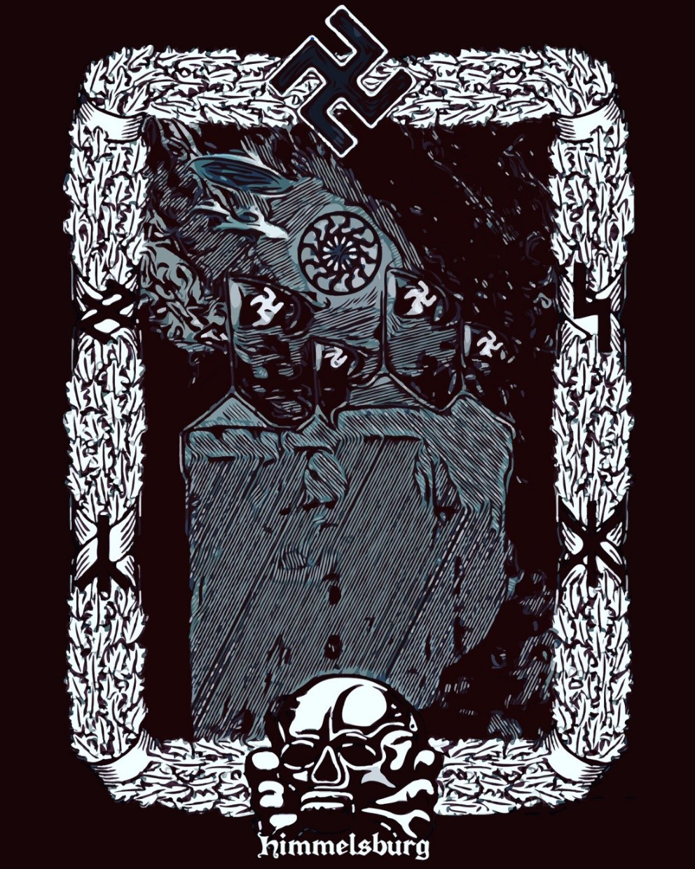

“So the Castle came to be a Temple, as well as refuge for Runes and initiation center like Montsegur, the Castle of the Cathars in the Pyrenees.
卐卐卐卐卐卐卐卐卐卐卐卐卐卐
To better understand the symbolism of the German Castle we must understand it is an attempt to reproduce the Thule of Hyper- borea, made invisible and impregnable with a Golden Band. It is an ancestral memory. Poseidon had already transformed Pa- radesha into a Castle, surrounding it with a protector “moat” (a string). The Stone House of Hitler, on the summit of a Mountain of Berchtesgaden, also corresponds to this “high ground.
卐卐卐卐卐卐卐卐卐卐卐卐卐卐
Valhalla is the “Hall of Heroes,” inhabited by the Valkyries and their warriors, in the Castle of Wotan, Asenburg, Himmelsburg, Castle of the Aesir, Castle of the Sky. The Castle of Thor, son of Wotan, God of the Lightning Hammer, Blitzhammer, called Tru- dheim (Blitzkrieg is the war of Hitler, in truth, “Thor’s War”).
卐卐卐卐卐卐卐卐卐卐卐卐卐卐
We have both climbed the solar temple Of Montségur, and on one day we will rebuild it, in another land, when the Golden Age Re- turns.”
—Miguel Serrano

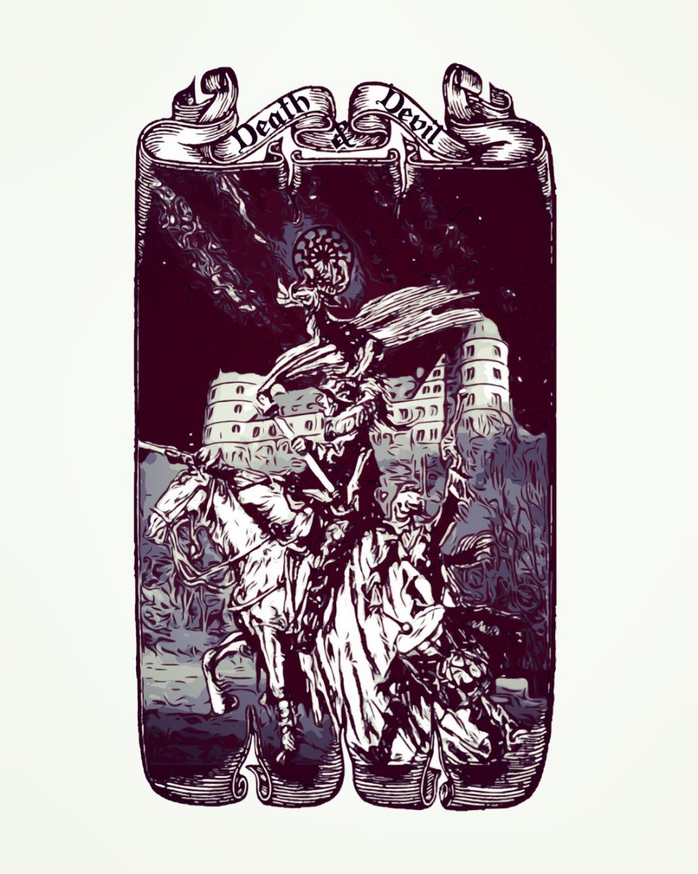

Our men have marched in hostile lands And sang a Devil’s song
A steady guard, on Volga stands And hums this tune along
We lift up our song ever skyward So all of the world may hear
That brave men will fight for their homeland Whether they curse us or cheer
For we are the ones who go forward And the Devil may laugh just like this: Ha ha ha ha ha ha!
We’re fighting for Deutschland We’re fighting for Hitler
While we march the reds know no peace We fight with pride, where e’er we go In North, South, East, and West
And now we stand prepared in heart To face the Russian pests
Our soldiers know nothing of anguish For our homeland we stand on our feet No matter how often we languish
The SS will never retreat
For we are the ones who go forward And the Devil may laugh just like this: Ha ha ha ha ha ha!
We’re fighting for Deutschland We’re fighting for Hitler
While we march the reds know no peace
—SS marschiert in Feindesland

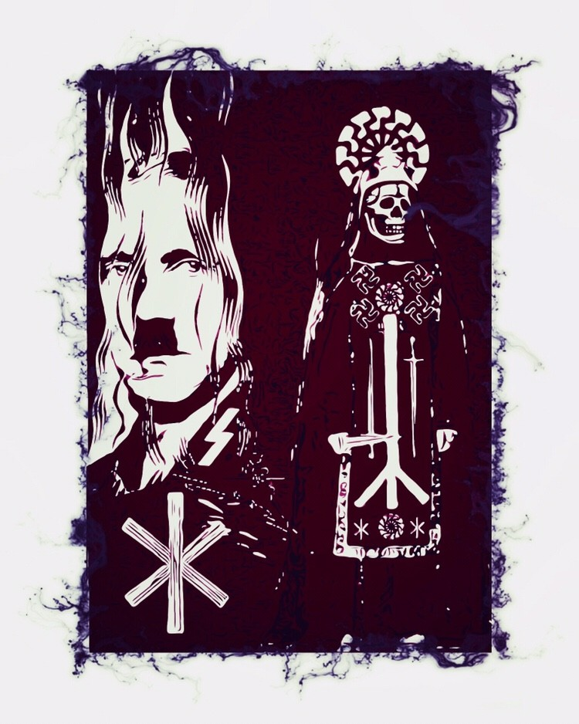

“The Norn Skuld, with the YR Rune, of Death, rules the Third Reich. In the case of the Third Reich of Hitler meaning Mystic Death, prelude to the Resurrection of the Fourth Reich, with the coming of Kalki-Wotan and his Eight-Legged White Horse, carrying the Science of Individuation, of Abso- lute Personality, or the Eight Paths of Buddhist Liberation.
His Rune is SIEG, Victory. The passage to the Fifth Reich will only be reached simultaneously within and without, on board a Vimana. The HAGAL
Rune corresponds to it, within a circle: • This is the retrieval of the Fourth
Sphere of the Light of the Black Sun, to leap into the Green Thunderbolt. What Buddha, Aryan Prince, the Ninth Avatar, called Nirvana.”
—Miguel Serrano

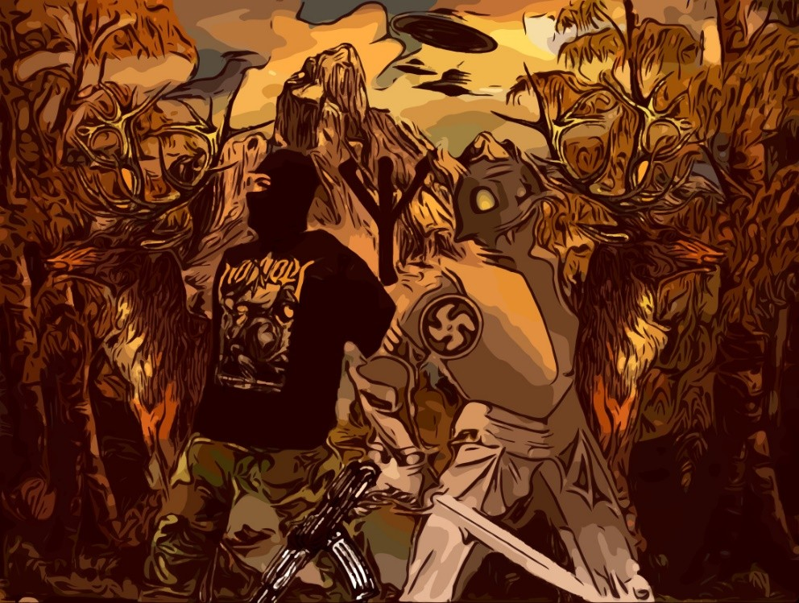

“For Esoteric Hitlerism, for me, there is only a corruption on the surface, a bad copy clothed over with a film of Maya. And, at bottom, we find a beautiful pure nature, so full of nostalgia as are we ourselves, who are crying out to us to re- deem them, to transfigure them, that “we make them invisible within us,” as Rilke exclaimed.
ᛉ
Hitler and the S.S. believed in the possibility of reversing entropy. And that was the origin of the conflict of Rosenberg and the S.S. with Spengler. In any instant of the Yuga of Heroes it is possible to rebuild Thule, return to the true Golden Age of First Hyperborea, not to the copy of the Demiurge, to defeat the Enemy, straighten out the Axis of the Earth, transfiguring her together with our muta- tion, or with our heroic death in combat.
ᛉ
“For the blood of heroes comes closer to Wotan than the prayer of the saints,” than the “flight” into an onanistic self-realisation. And because the Heroes who died fighting for the just cause of the Fuhrer, Adolf Hitler, will be remade in Val- halla by the Valkyries and thus attain immortality. That is, the struggle is syn- chronistic, outside and inside, for the redemption of the world and ourselves.
ᛉ
So here we volunteer to fight, not to escape from a hopeless Universe, from a prison, but to prevent the “plagiarism” (The Devil and the Jew always plagiarise, falsify, corrupt) and so the corruption not continue to expand along with this cor- rupted Universe, at the expense of the Universe of the Divyas, or Siddhas, at the expense of Hyperborea.
ᛉ
To fight here, on the same field as the Enemy. This is the Magic Idealism of No- valis, that of the S.S., Hitler and his National Socialism. And for that, too, the Nordic Aryan, of pure biological race, pure biological blood, loves Nature (be- cause both possess Nostalgia, Minne). The beauty of Nature has its origin in the identical Nostalgia. And therefore, the Jewish anti-race hates Nature.”
ᛉ
—Miguel Serrano

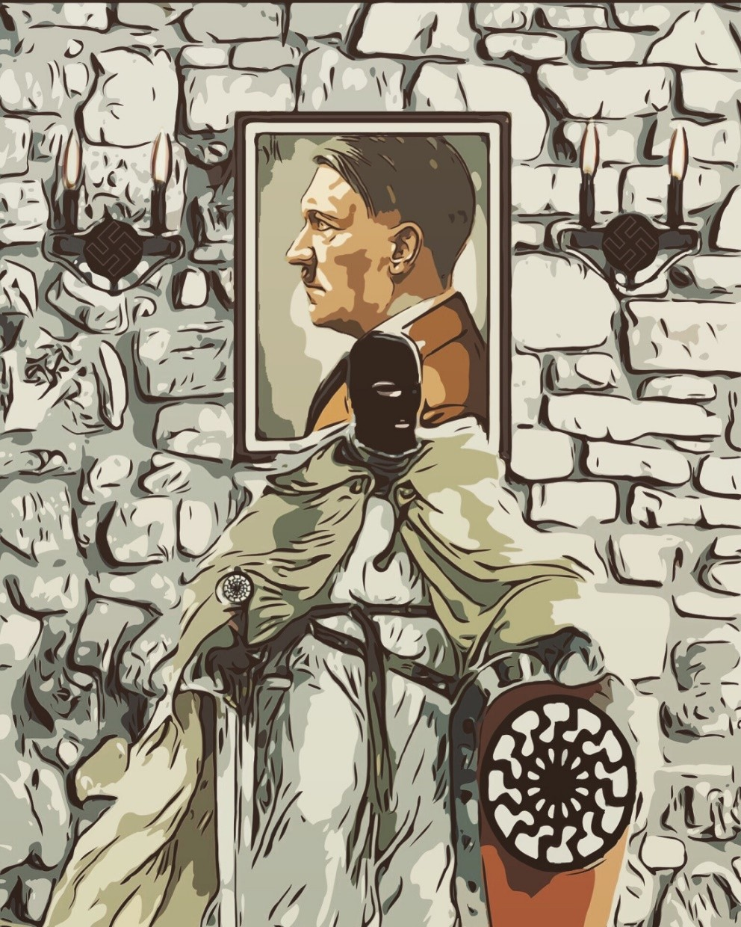

Interviewer: As we know, you have devoted your life to Eso- teric Hitlerism. Could you tell us briefly — for our readers who are just hearing the term Esoteric Hitlerism for the first time — what exactly it is?
Miguel Serrano: Esoteric is a Greek word referring to God. Es- oteric Hitlerism is that which transcends the field of politics, and, in one way or another, makes contact with the spiritual sense and symbols. We believe that if the world does not come to an end soon, it will be only because Hitlerism trans- formed itself into a new religious faith, able to change the materialistic man of today into a new idealistic hero, to whom the afterlife is as important as life itself. That was the attitude of the heroes at Thermopylae, who fought for honor and duty — for Dharma. If only it were possible to develop all over the world a heroic attitude, a sort of Order of Warri- ors — priests of the new religion of Hitlerism — the world could be saved and materialism destroyed. Esoteric Hitler- ism is a totally new world view (Weltanschauung), a Cos- mogony. The SS tried to transmute man to superman, in Sonnenmensch, or Sun-Man, a man who will again be a god.
This is an old Aryan concept, which is not unlike traditional Greek thought, and the initiation of the Mysteries of Apollo and Dyonisus. The Dorian Greeks had a nostalgia for Hyper- borea, and so do Hitlerists.

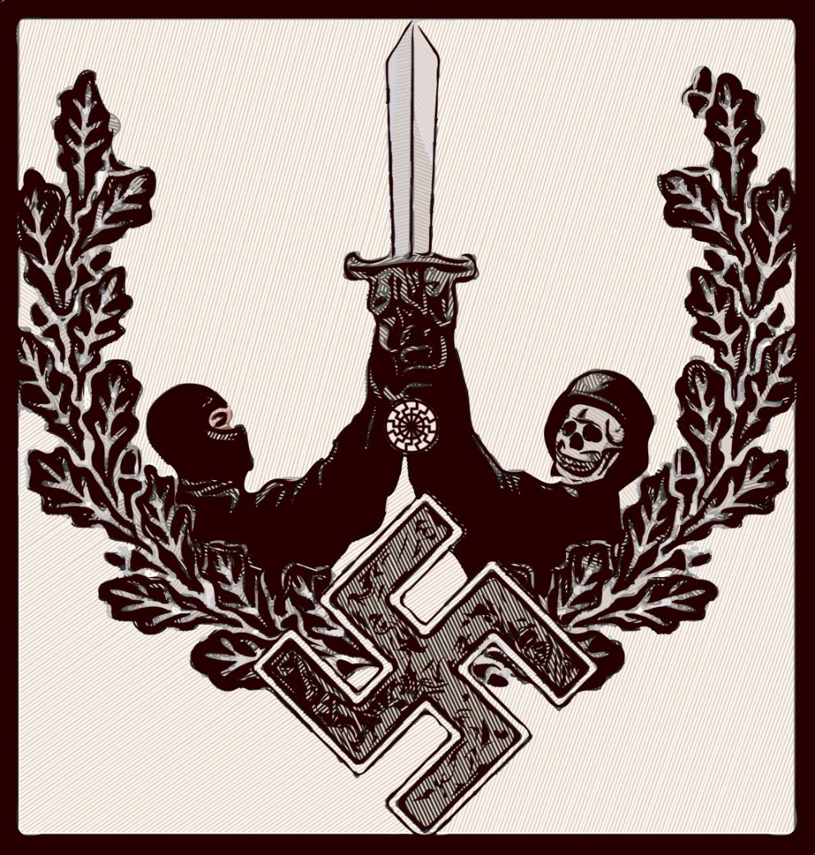

“Maya is the world of the Demiurge that imprisons the divine within her nets. Yet the Hitlerists believe that it is not possible to defeat maya by isolating oneself, separating oneself, ignoring the process of the Demiurge world, but by fighting from within, until shattering the net with a sword, tearing it to shreds from the centre. The war is heroic combat for liberation.”
—Jason Thompkins

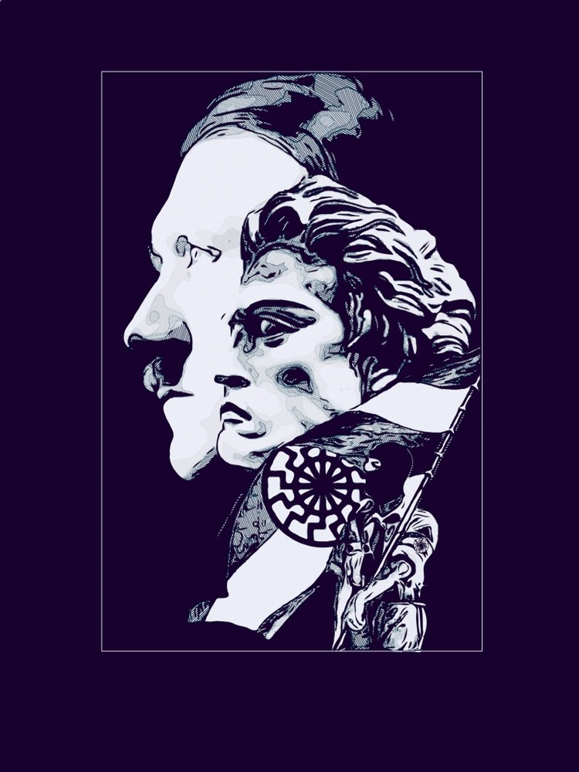

“How timely would be the appearance of a man who would teach us again the meaning of our fa- bles, and show us that our struggle for the freedom of the earth which has borne us was, also, the strug- gle of our ancestors a hundred and a thousand years ago!
—Wulf Sorensen
ᛋᛋ
Just before the end, there in the Bunker, whilst shrapnel thundered, with the dull, deep rumble of the glaciers flowing from the great gates of the poles, a faithful SS officer asked his Führer, with hoarse voice: “Mein Führer, if you were to disap- pear, for whom should we fight…?”
And Adolf Hitler replied: “For the Man to Come”“
—Miguel Serrano

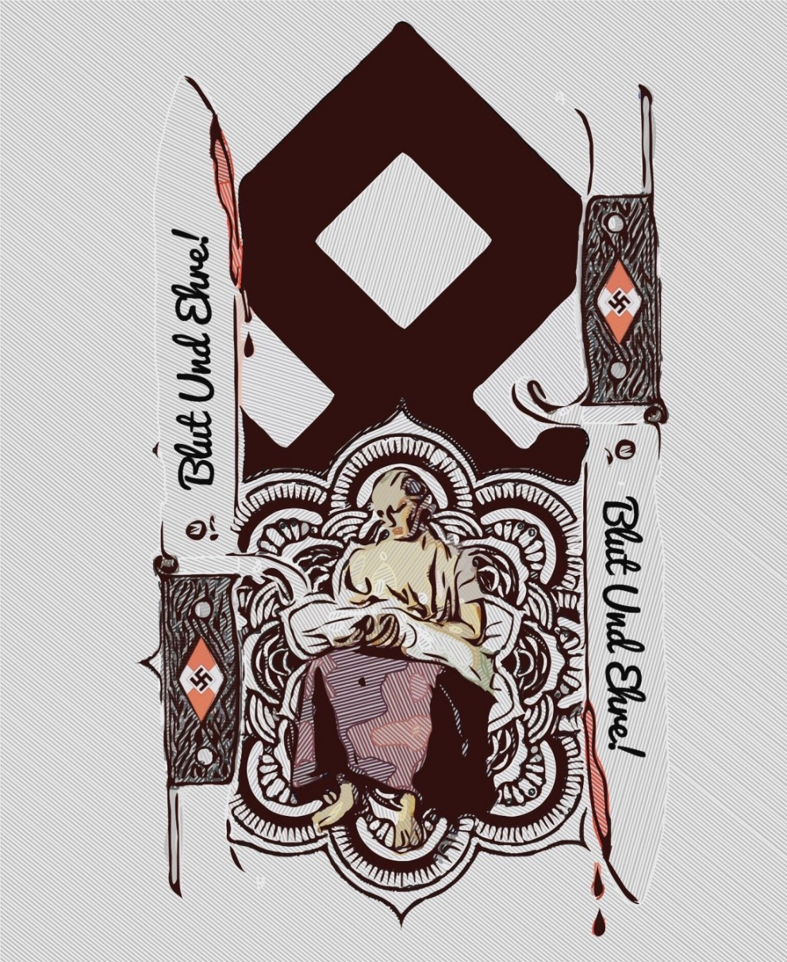

“Blood is the Flower of Race. An Ultimate Flower, delicate, easy to destroy. from its foliage, its leaves, its petals, the soul is fed, the “memory” of Initiate Hyperborean Race. Thus the “I” is incarnated, that “end of a golden string: only wind it into a ball and it will lead you in at Heaven’s gate” as Blake would say, and that will accompany the semi-divine man in his terrestrial exile. The mystery of the will also originates in the Hyperborean, Aryan Blood. The Hitlerists build a new world on Blood and Soil, if the soil changes, then little by lit- tle the blood will change, the blood memory. The Divine Hy- perboreans, immigrants to the Other Pole, could only pre- serve the Flower of their Divine Blood, their inheritance of the Green Thunderbolt, within the Secret Cities of the Im- mortals, within the Andes, or within the Antarctic Oasis.
Only there too could Hitler and his own keep the Sang-Real (the Royal Blood); they will preserve Grail until the return of the Wildes Heer.”
—Miguel Serrano

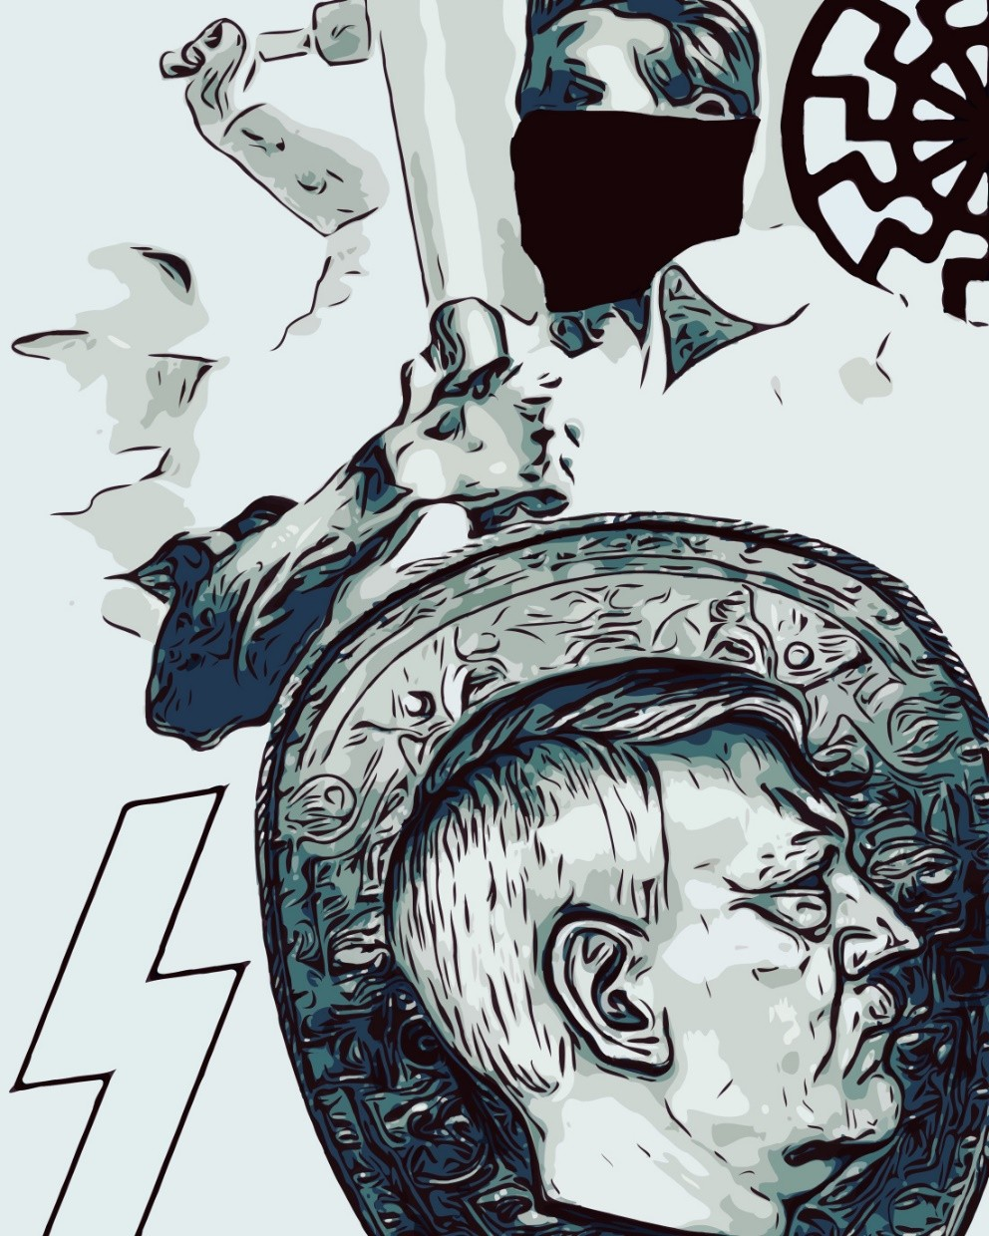

“The National Socialist party can be dissolved; the name of the Führer can be proscribed, the faithful hunted down, forced into silence, dispersed. But Hitlerism, nourished from the source of super-hu- man knowledge, cannot die.”
—Savitri Devi

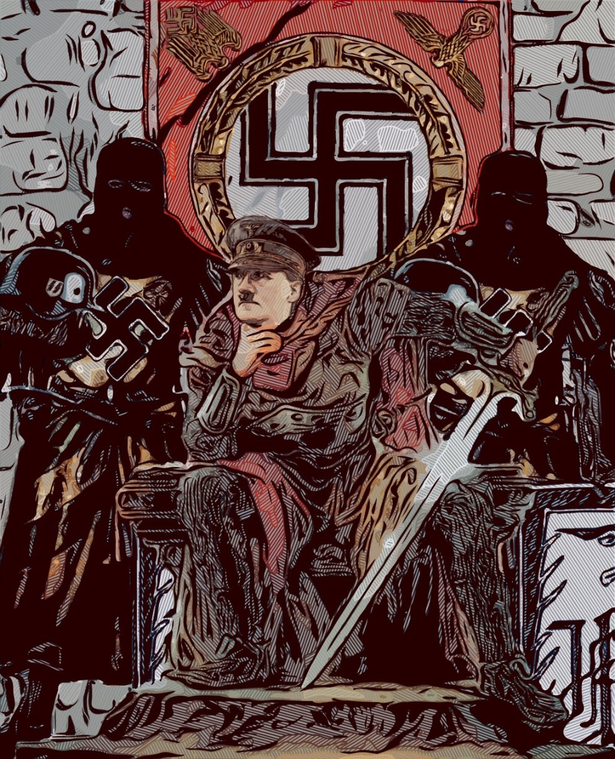

“The body of an Avatar does not die. He remains safe for a time beneath the earth, in an inner earth. His War does not cease and at the end he will win. Now he is in Antarctica with his most faithful fol- lowers and his secret weapons. In an impenetrable cave beneath the ice with his Ultimate Battalion to- gether with his Furious Horde of Odin and the Ein- herier, ‘those who can not die.’”
—Miguel Serrano

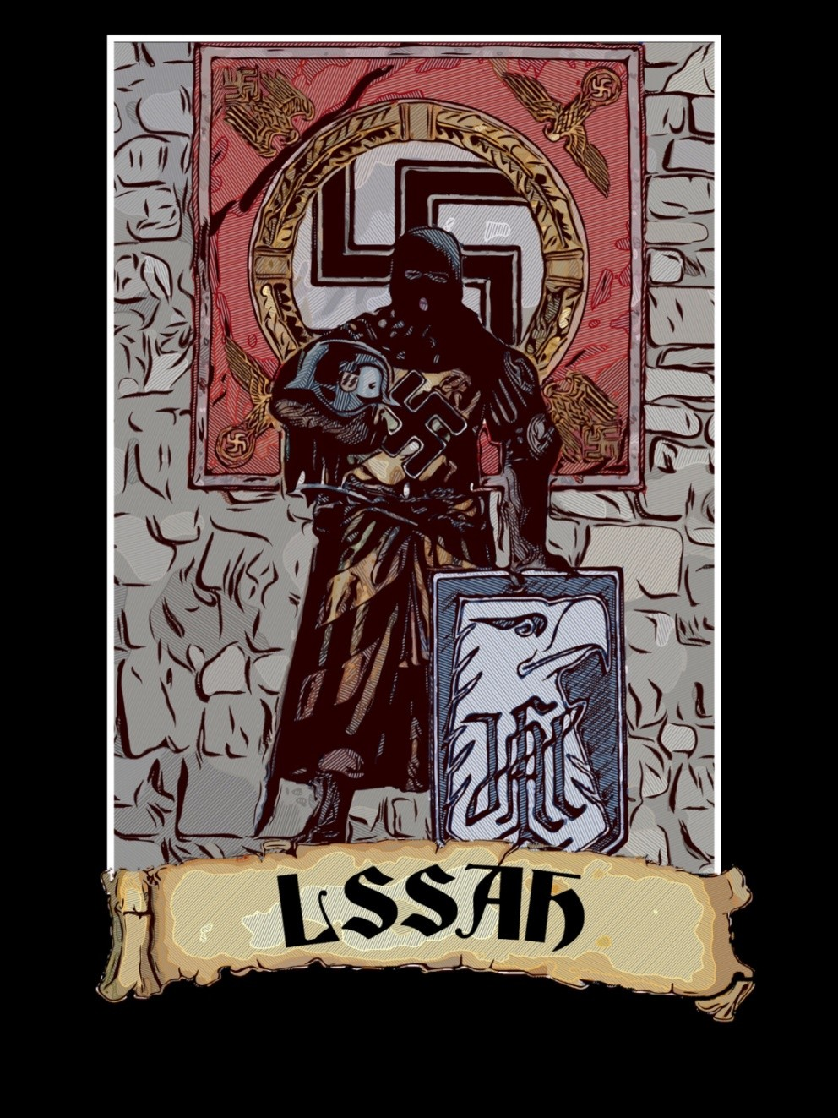



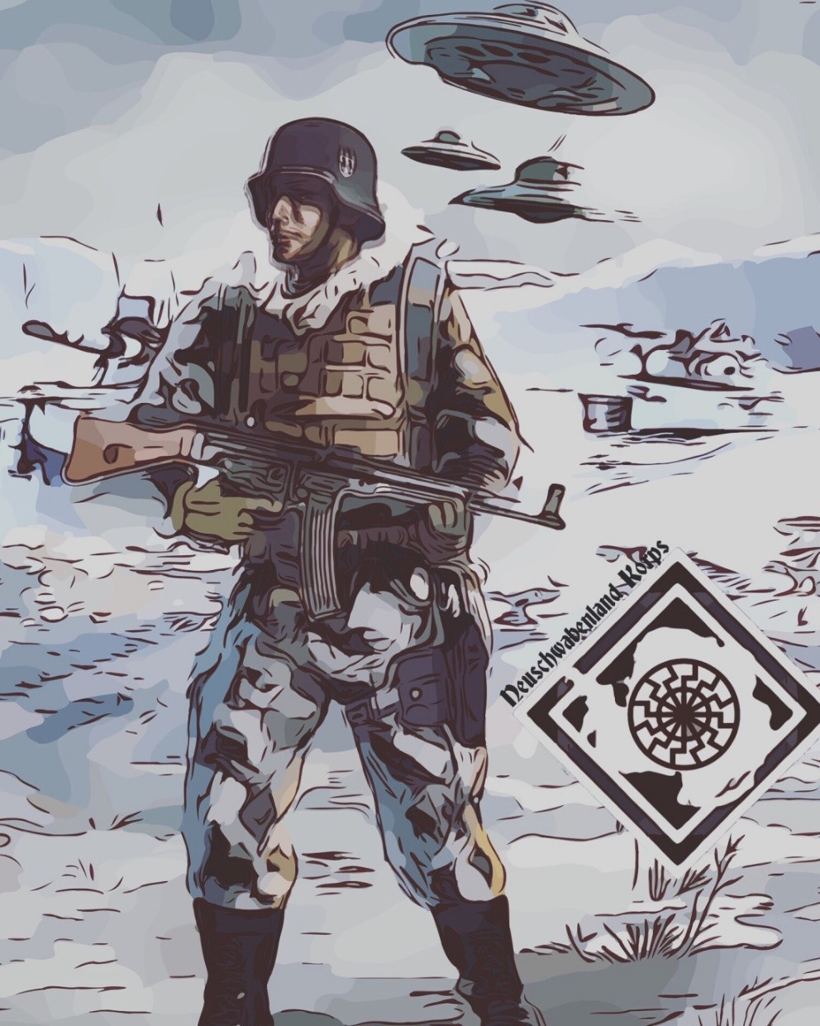

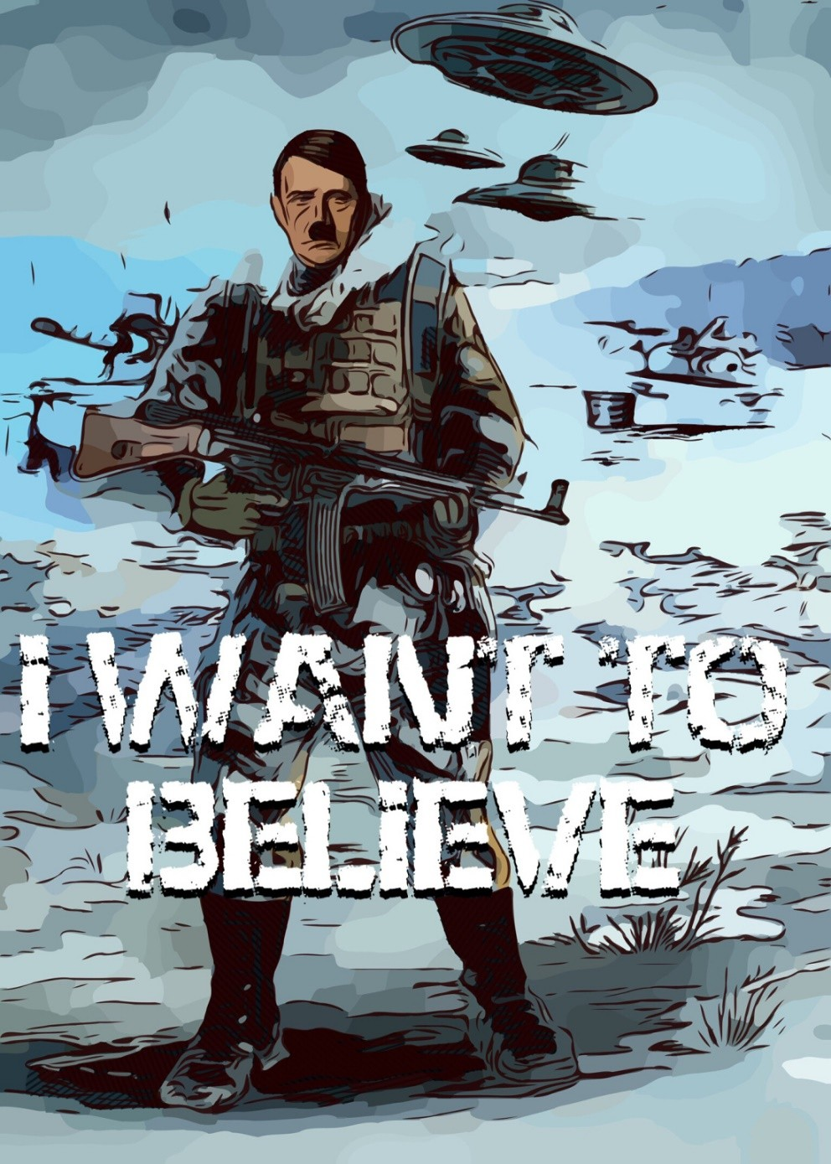

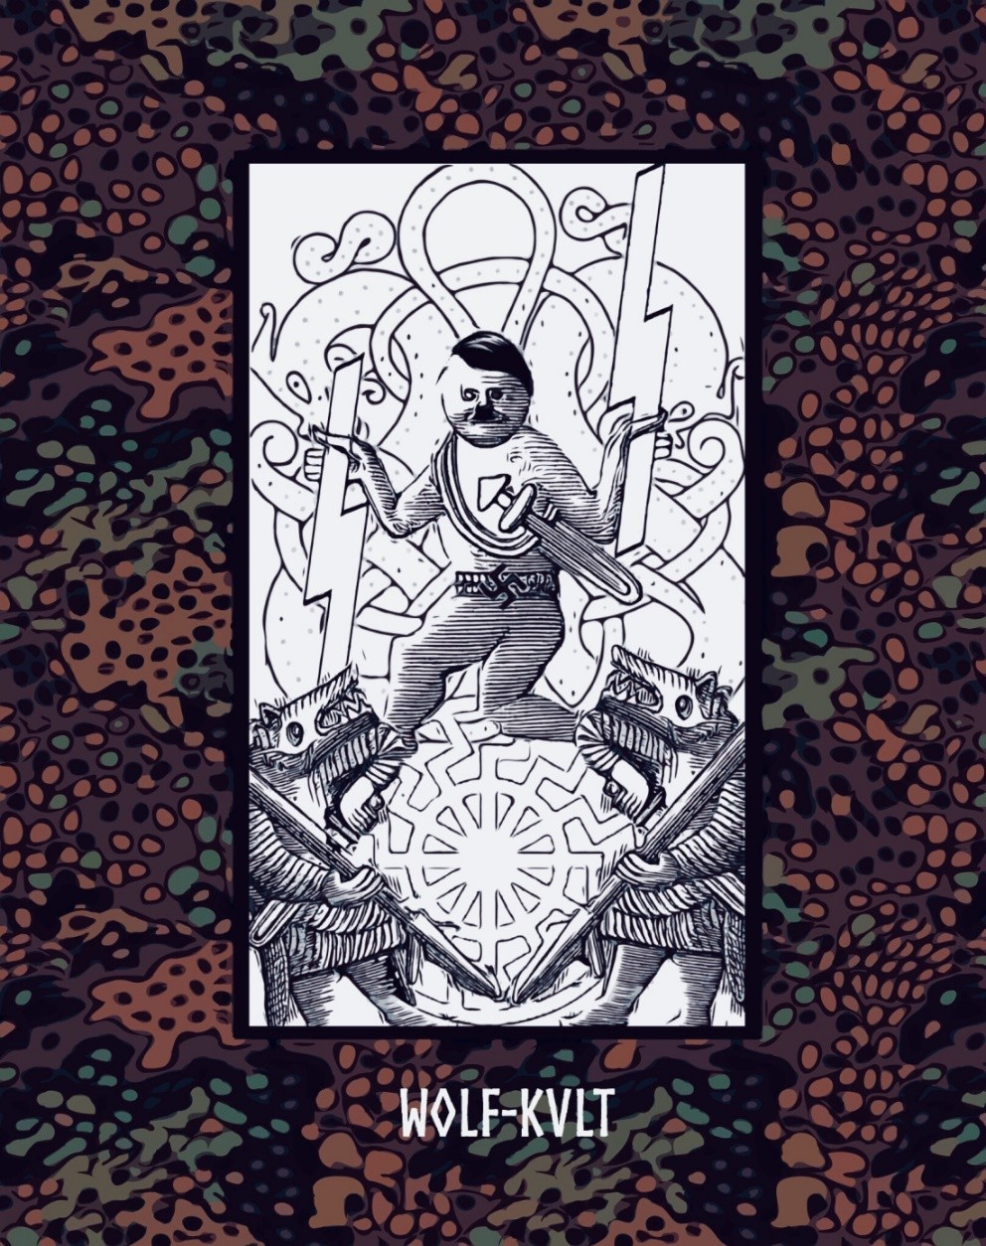

“Jung refers to Hitler as the prisoner of Wotan, God of storm and hurricane and the Swastika, like some vortex of irresisti- ble energy. Wotan, God of the wind. Therefore the Assault Troops of Nazism were called Sturmabteilung, storm troops, the hurricane.
The military campaigns of Hitler all have the same arche- type: a hurricane, a storm. He was the creator of Blitzkreig, the lightning war. It could equally be called “Wotan’s War.” It has been claimed that the English, familiar with the inter- views of Jung published before the war, had asked him his opinion about the conduct of the conflict. Jung had advised them to prolong it as much as possible, since Hitler could only win a short “hurricane” war. A hurricane does not pro- long itself indefinitely and the God of War, Wotan, is the God of the Hurricane, of the Wind.”
—Miguel Serrano

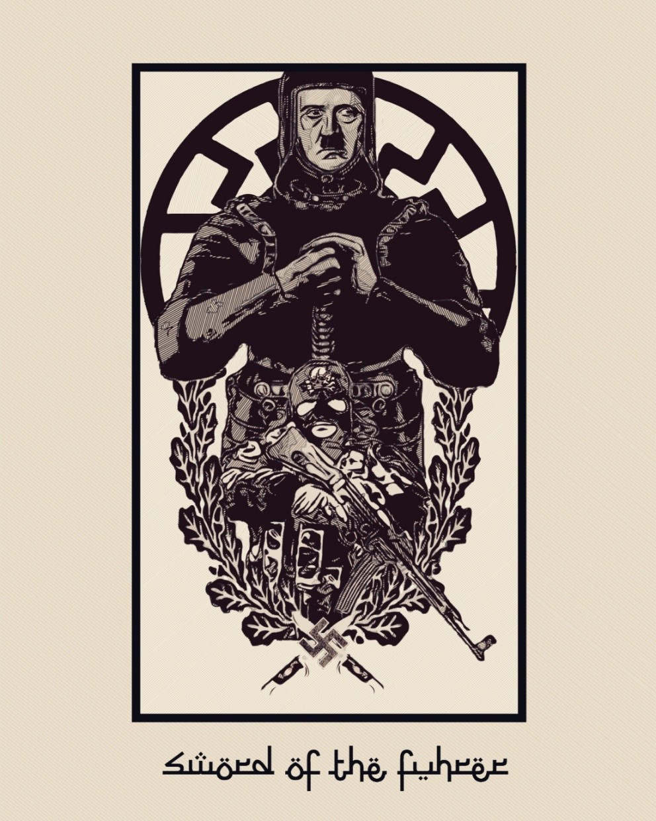

“Hitler is like Mohammed: He is the Messiah of Germany who teaches virtue with the sword.”
—Miguel Serrano
ᛋᛋᛋᛋᛋᛋᛋᛋᛋᛋᛋᛋᛋᛋᛋᛋᛋᛋᛋᛋᛋᛋᛋᛋᛋᛋ

“When there will be a Military March of Krsna con- scious soldiers, anyone who does not believe in Krsna, Blam! Yes, the same process as the Moham- medans did, with sword and Koran, we’ll have to do that. Do you believe in Krsna or not? No, Sir, Blam!”
—Prabhupada

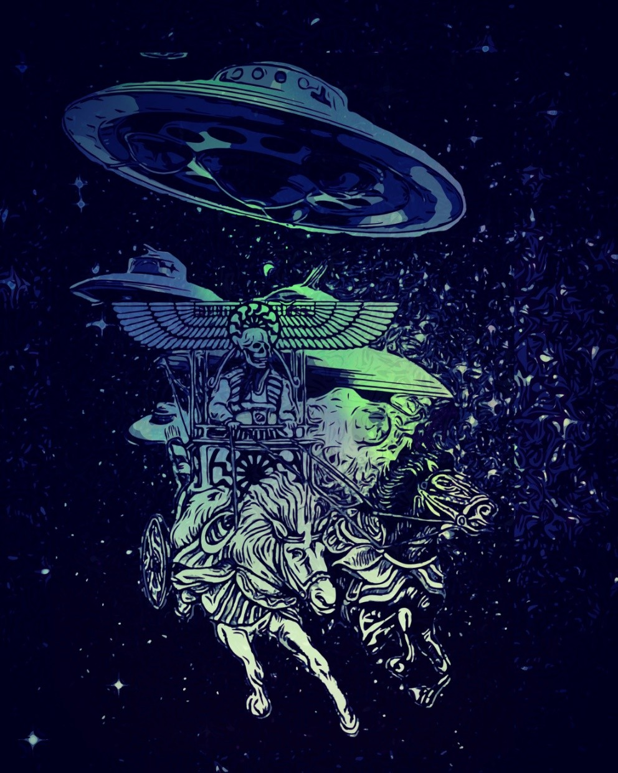

“Our vision of the world, or Weltanschau- ung, is simple and grandiose, a Cosmic War.”
—Miguel Serrano

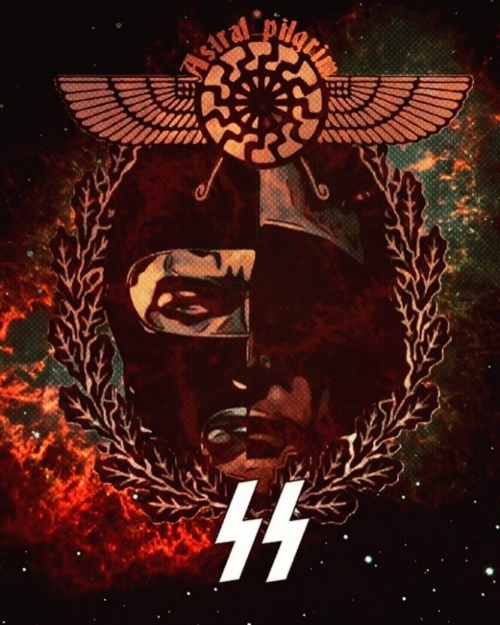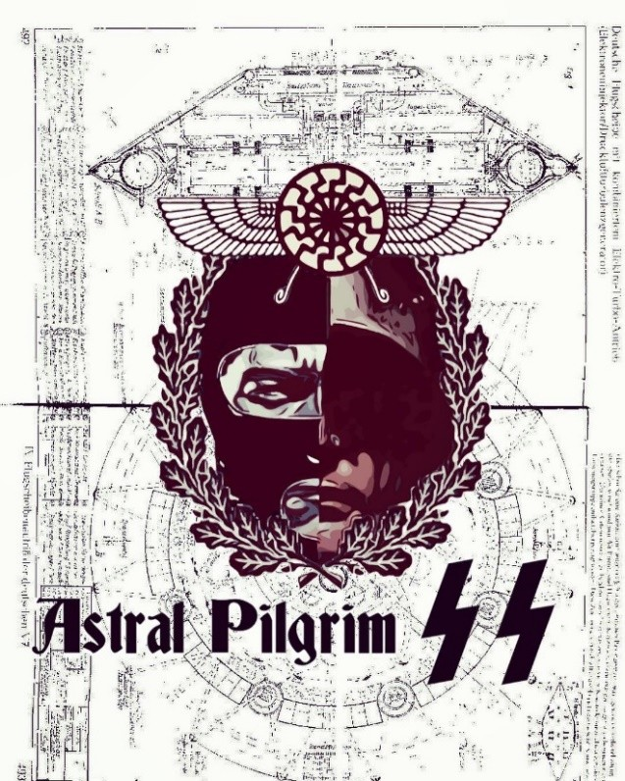

“Now all the world and the stars revolve around you. Now visualise the ancient crypt below, go through it down into the earthen hill, then back up through the column of the ether that revolves around it. Let all be silent, the silence of the dead mingles with the silence of the birds of the forest, silence reigns, Valhalla falls silent as it listens to the breaths of the Initiate. See in your mind’s eye the lightening bolts of the SS, now focus them inwards like the Iron Cross focuses inwards, with energies converging at the central point…See into the void of the Black Sun, into anti-matter, understand that the True Masters have overcome this world: they do not die in their bodies, they left this world of corruption and death in a glorious body of Resurrection, springing the lock as a divine key unlocks a gate, the Magic Gateway opens and their true body forms as a fiery chariot freeing them- selves from the chains of matter that implode in the centre of the Black Sun – The Spiritual Illuminator, the Midnight Sun, the ultimate Stargate of Death and Resurrection – opening of the portal of Eternity where all matter is dissolved, all mate- rialism is undone in its terrible vortex of ultimate destruc- tion. Only the Astal Body of the Ig-Nazi passes through the Black Hole of the Black Sun, the breakaway Astralkorper of Fiery Man passes through it.”
—Miguel Serrano

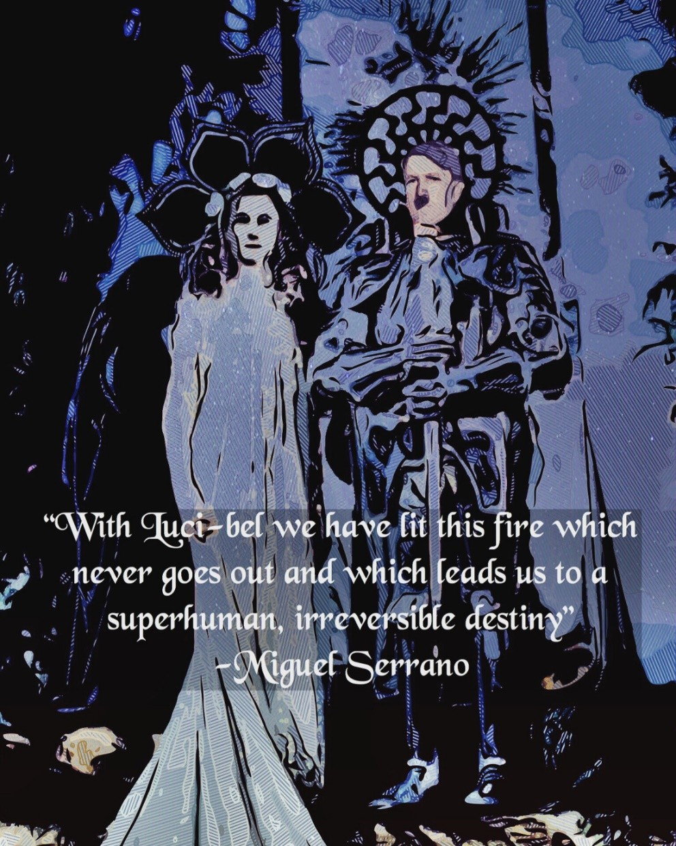

“With the Avatar, which is to say with the Fuhrer, he is pregnant with an entire world that he is bringing to light: The world of the Fourth Reich, the new Golden Age, the Other Earth.
Transcendent chastity, that of the Knights of the Gral, does not mean the presence of woman must be shunned. On the contrary, she is absolutely necessary, magically she is needed. As when Krishna danced with the shepherdesses of Gokul in the gardens of Vrindavan and his lover was Radha, the “wife of another,” the Parakiya: thus as the alchemist must always have his soror or mystical Sister at his side who gives him the metals, which the alchemist will mix in the Crucible of his own soul, impregnating them with the femi- nine energy (as the lustral water that calmed the viril fire of my vibrations would have been a “feminine water”), in the same way Hitler had to have women around him. Which is not to say he was not chaste. The love of an initiate with an initiated woman (not with Eva Braun… moreover, who was Eva Braun truly?) is a love fulfilled in astral, “dreaming to- gether,” “flying together,” as in my book “NOS.” Love is re- alized in other bodies, in other worlds, rather than in this one.”
—Miguel Serrano

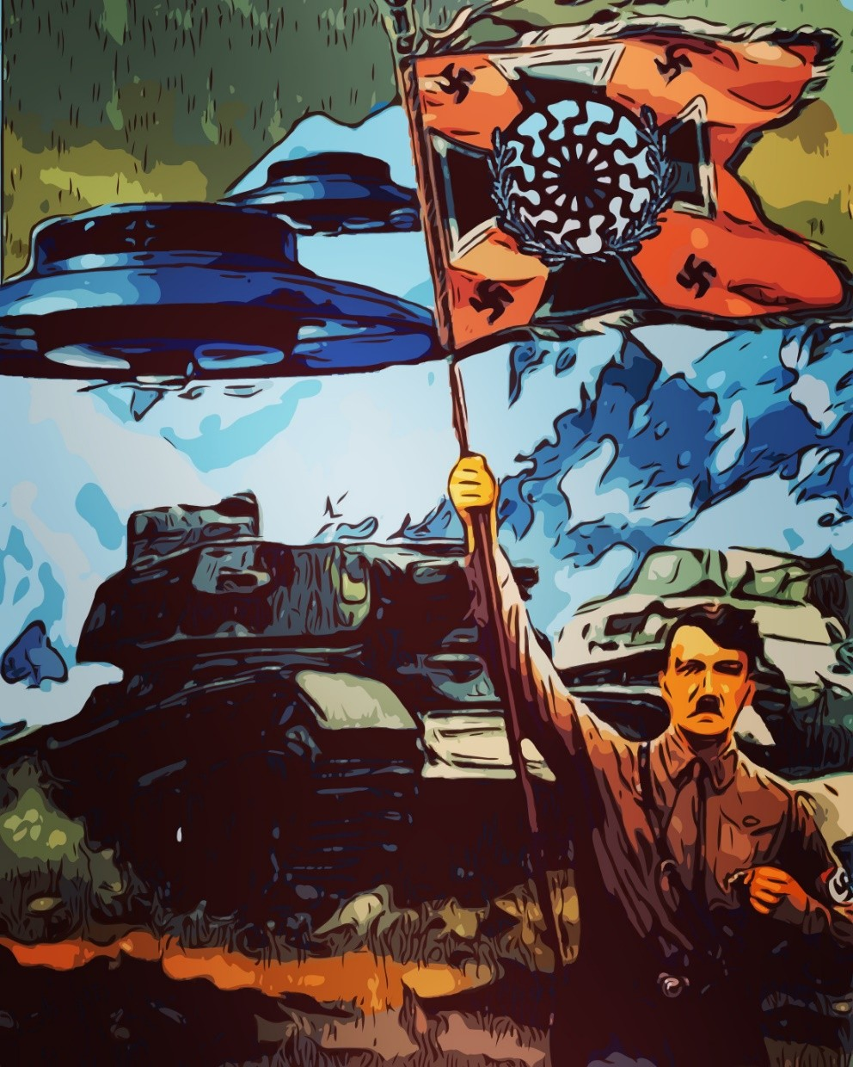

“Since I was very young I felt my mission was to help the imprisoned giants of the Mountain, to free them, like Lucifer chained in ice of the North Pole, or South Pole, to vin- dicate them, to liberate Prometheus. Today I also feel I must help the Fuhrer to return, from within the body of the Mountain, con- tributing to the fulfillment of his Myth of Resurrection.”
—Miguel Serrano

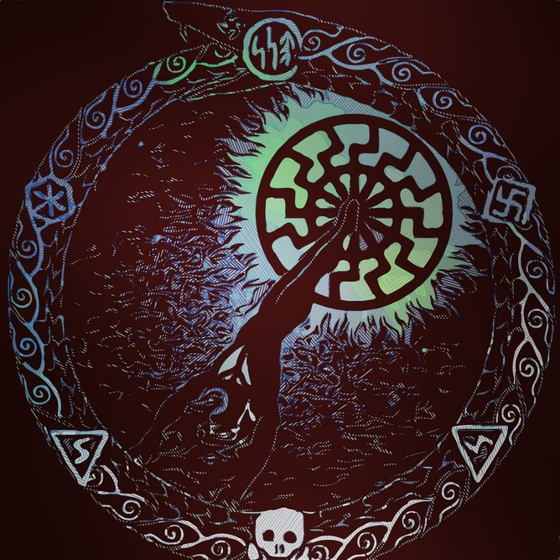

“The Nostalgia of nature, in pre-history, is ex- pressed in the cult of the Light of the Year and the Sun, as symbol of this Nostalgia of a different Sun, one beyond the Sun, spiritual seed and Light of an- other earth. In the Nordic-Atlantean strain this Nos- talgia was represented by means of enigmatic magic signs, Runes. The Ancient Sun, the Black Sun, be- yond the visible Sun and for which Nostalgia is felt, and who is the Man To Come, who will return. The vîra extends his arms towards him every sunrise, towards this Sun beyond the sun. He is the man with his arms extended upwards. The Hyperborean who has lost this Other Sun is the man plunging into the abyss of night in this land, with his arms open and extended downwards.”
—Miguel Serrano

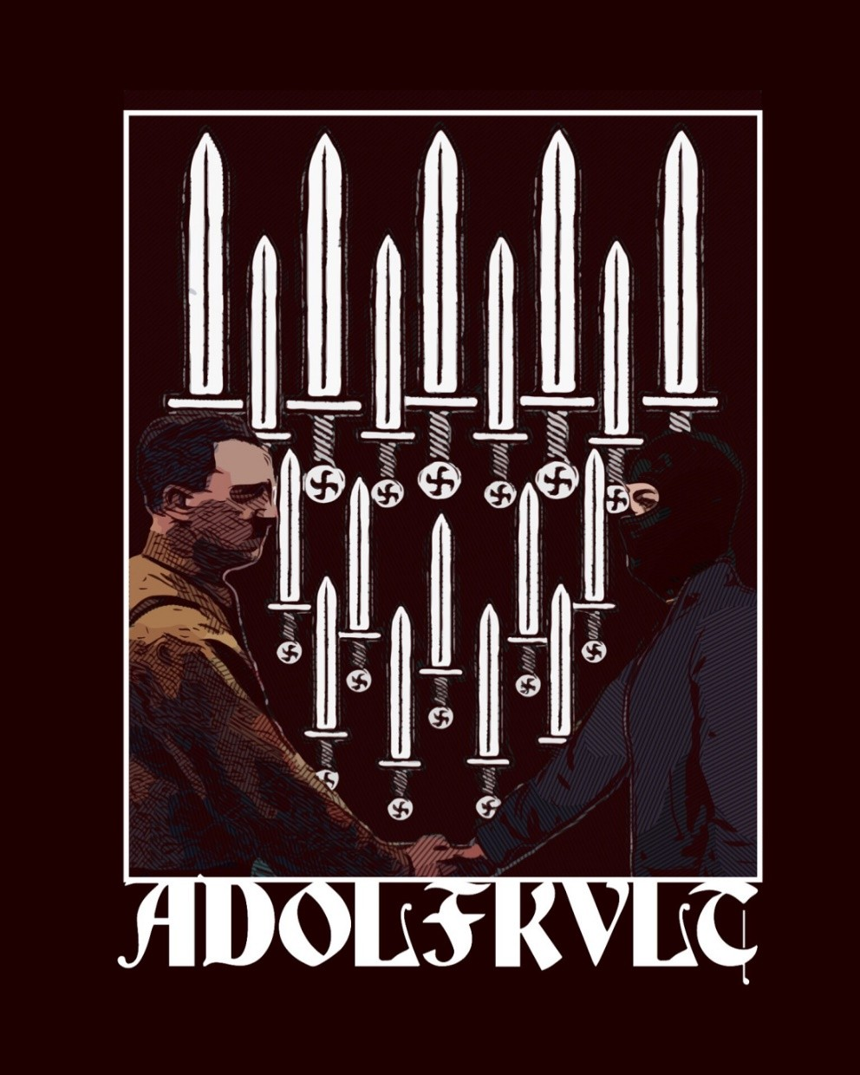

“I went on a mythic legendary pilgrimage, to render a cult to the dream, to the Myth, to the Legend, to the Avatar and to my Führer!”
—Miguel Serrano

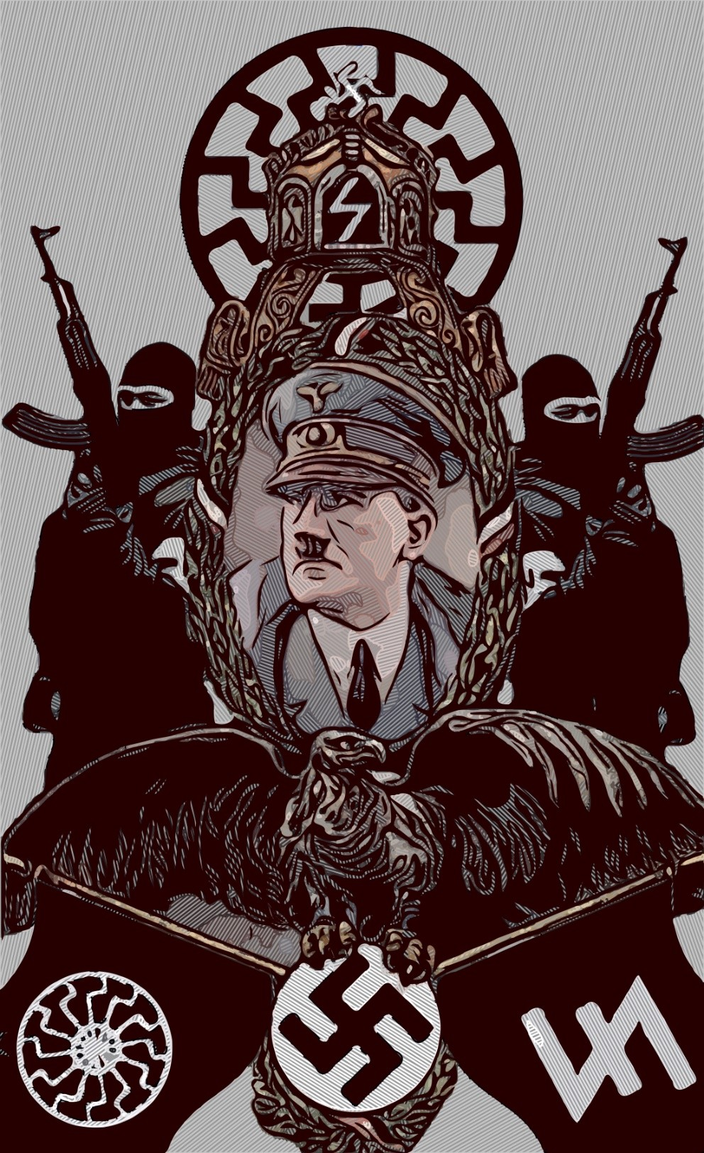

Our hearts to Adolf Hitler
for the future of our race!

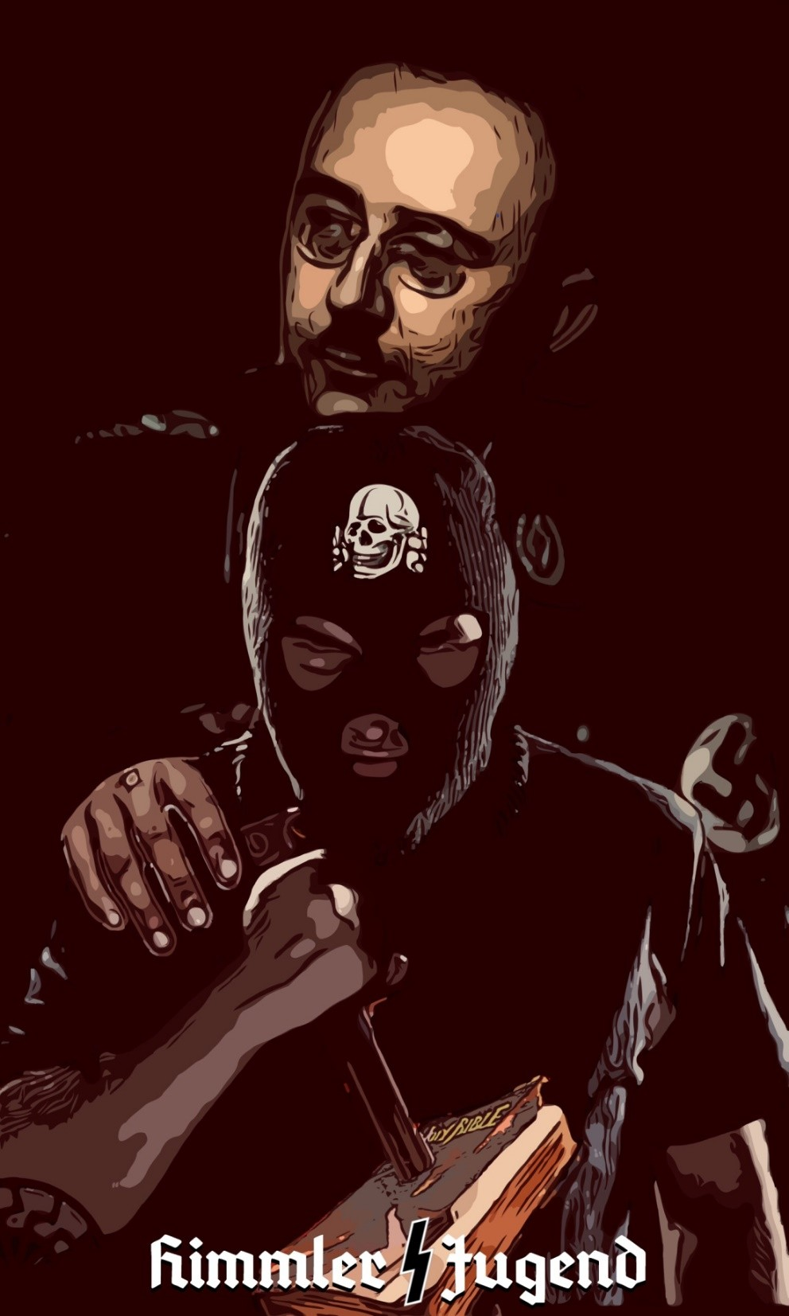

“We will have to deal with Christianity in a tougher way than hitherto. We must settle accounts with this Christianity, this greatest of plagues that could have happened to us in our history, which has weakened us in every conflict. If our generation does not do it, then it would I think drag on for a long time. We must overcome it within ourselves. Today at Hey- drich’s funeral I intentionally expressed in my oration from my deepest conviction a belief in God, a belief in fate, in the ancient one as I called him—that is, the old Germanic word: Wralda.
We shall once again have to find a new scale of values for our people: the scale of the macrocosm and the microcosm, the starry sky above us and the world in us, the world that we see in the microscope. The essence of these megalomaniacs, these Christians who talk of men ruling this world, must stop and be put back in its proper pr-portion. Man is noth- ing special at all. He is an insignificant part of this Earth. If a big thun- der-storm comes, he can do nothing about it. He cannot even predict it.
He has no idea how a fly is constructed—however unpleasant, it is a mir- acle —or how a blossom is constructed. He must once again look with deep reverence into this world. Then he will acquire the right sense of proportion about what is above us, about how we are woven into this cy- cle.
Then, on a different plane, something else must happen: We must once again be rooted in our ancestors and posterity, in this eternal chain and eternal sequence. By rooting our people in a deep ideological awareness of ancestors and grandchildren, we must once more persuade them that they must have sons and daughters.
If we do not secure this moral foundation, which is the deepest and best because the most natural, we will not be able to overcome Christianity on this plane and create the Germanic Reich, which will be a blessing for the Earth. That is our mission as a nation on this Earth. For thousands of years it has been the mission of this fair-haired race to rule the Earth, and again and again to bring it happiness and culture.”
—Heinrich Himmler

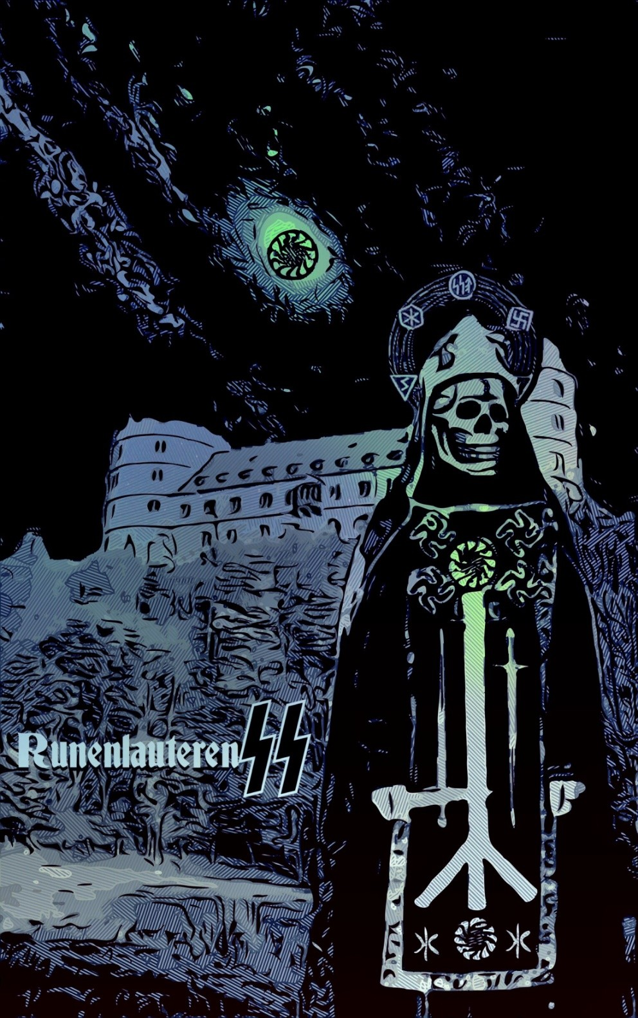

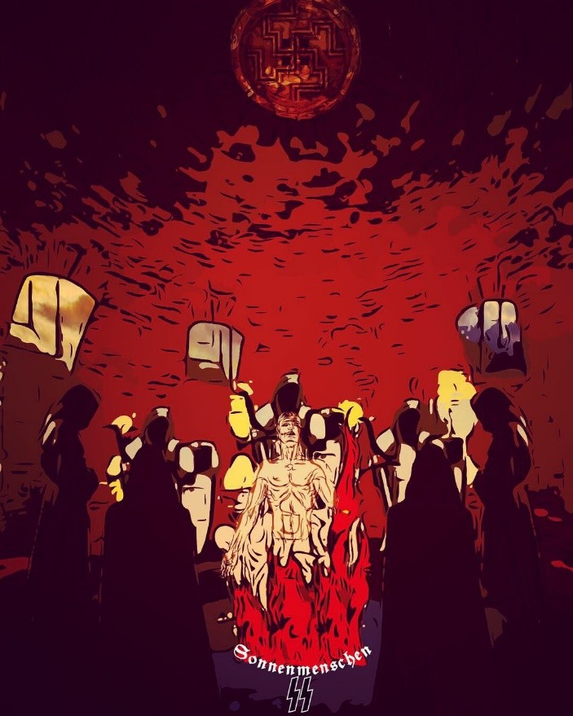

“On the roof of the vault the Leftwards Swastika appears carved in stone, combined with the SIEG Rune, the SS emblem. In the center of the floor of this underground vault is another circle, an empty space where something should be, or rather where they lit the Fire. Or perhaps the Supreme War- rior-Priest of the Black Order stood there to recite the Rune Mantras, which in this enclosed place of magic reverberations would make the Runenlau- teren. his music, pass over to the Black Sun and, through the latter, to the Green Thunderbolt, ultimate home of the most exalted Guides of Esoteric Hitlerism.
In my previous book I referred to the Castle of the Black Order of the SS, where a select few would have received initiation, attempting a mutation to make possible the appearance of the Sonnenmensch, Sun-Man, the Super- man, gradually and by stages. First, the transformation of the German into Nordic Man, then of the latter into the Aryan. Even being able to reach the Hyperborean of the origins, with the consequent restoration of the “lost or- gan,” that atrophied “gland,” the third eye, Vril, ER (“the column that crosses the Sky”), and condition of the original White Race.”
—Miguel Serrano

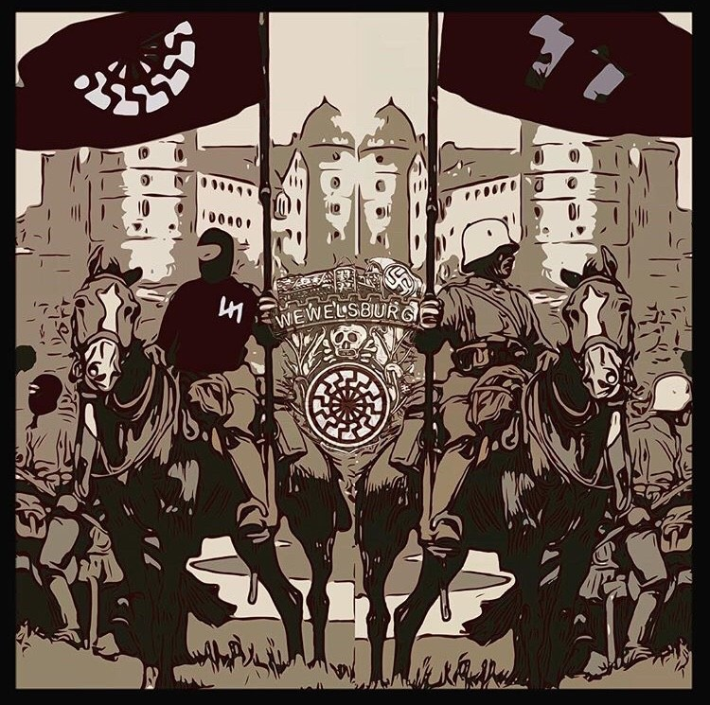

“Weisthor predicted that Wewelsburg was destined to become a magical German strongpoint in afuture conflict between Europe and Asia. This idea was based on an old Westphalian legend, which had found romantic expression in a nineteenth-century poem. This described an old shepherd’s vision of a ‘Battle at the Birchtree’ in which an enormous army from the East would be finally beaten by the West.
Weisthor brought this legend to Himmler’s notice, that the Wewelsburg was the ‘bastion’ against which this ‘new Hun invasion’ would be broken in fulfilment of the old prophecy. Karl Wolff, Chief Adjutant of the Personal Staff, recalled that Himm- ler was very moved by weisthors idea, which squared with his own notion of the SS’s future role in the defence of Europe in a coming East-West con- frontation which he expected in one to two hundred years’ time.”
—Occult Roots Of Nazism

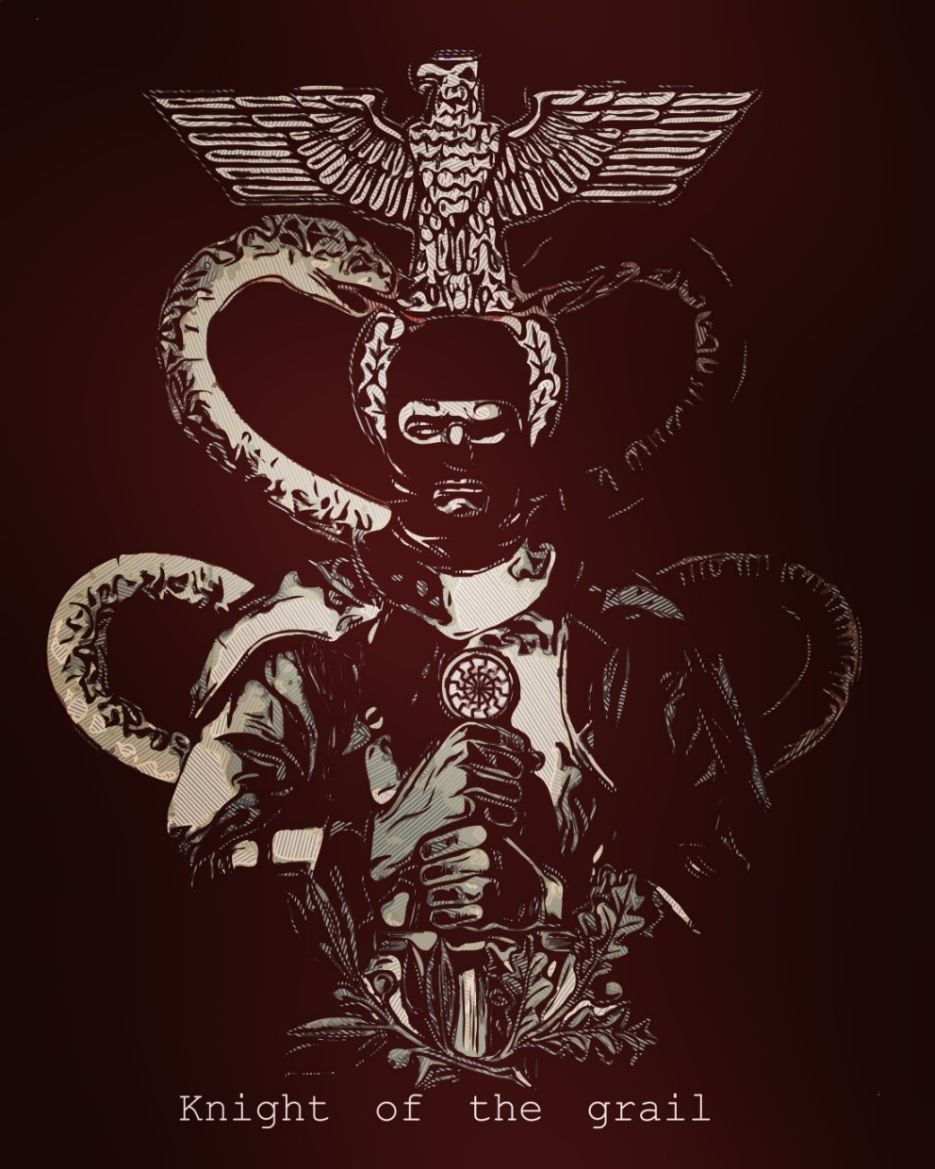

“Only the Lord of Pure Will can go to the end, forc- ing the Gates of the City of Eternal Life. For the Will, with perseverance, creates the thing contem- plated. Only the Furious Horde of Wotan and Parsi- fal conquers the Grail.”
—Miguel Serrano

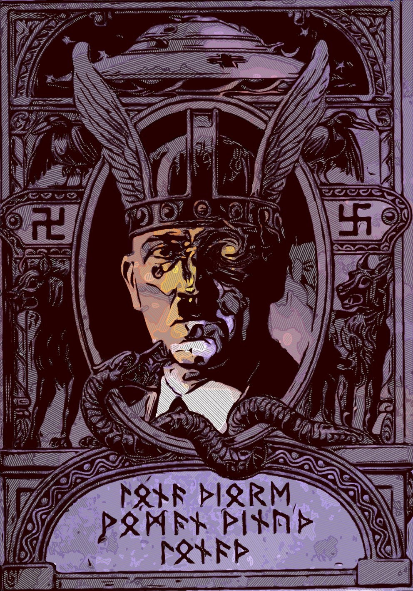

“Thus Hitler as Avatar is the reincarnation of Wo- tan and Kristos. Therefore He never wanted to al- low the establishment of an exterior public cult to Wotan in Germany, and moreover he forbade it. Be- cause Wotan is not outside somewhere else, but in He. And, as Führer of Germany and the Aryan Race he was conditioned to project this Divinity to his people, in reciprocity, such that Germany was also Wotan.”
—Miguel Serrano

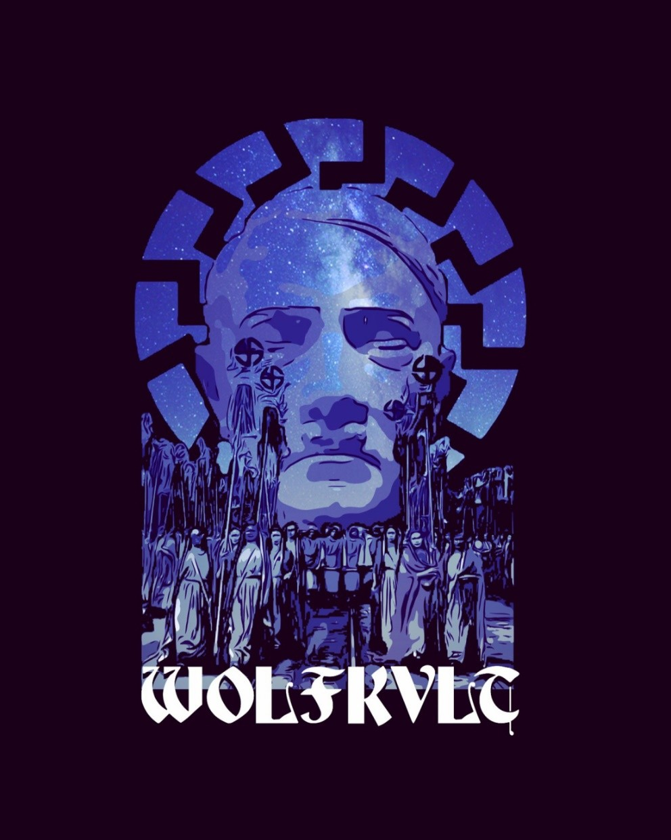

“And in no other way must the priestess-magas, virgin-ma- gas of Esoteric Hitlerism succeed without their heroic coun- terpart warrior, their He, in this Round. They will also turn their gaze to the stars and beyond the stars, where their He awaits, in Valhalla. And overlay his Face on that of the Füh- rer, Adolf Hitler, as Savitri Devi surely did, to render him cult and adoration, certain that the Ultimate Avatar will re- store their immortality and make them eternal, helping them in this difficult Dry Path of transmutation into Absolute- Woman and the recovery of her He. Our revered friend and comrade, the priestess of Odin Savitri Devi, raised up in In- dia a cult of adoration to the Führer, Adolf Hitler, to the Ulti- mate Avatar, and raised in her home a Temple in his memory. She has already gone away into the direction in which He is now to be found.
This is a recurring Archetype, which cannot fail to repeat, re- incarnate, through the initiations and religious dramas of humanity.”
—Miguel Serrano

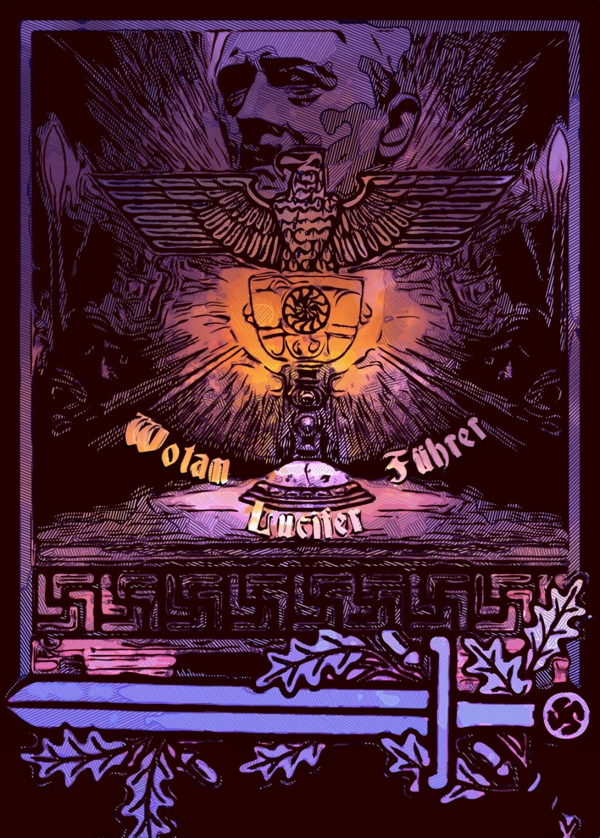

“The term “Gral” is the German spelling for “Grail”, and is taken from the aforementioned poet-troubadour Wolfram von Eschenbach. According to this German troubadour, Gral is a fallen stone from the Lucifer’s Crown, where the Law of the First Divine Hyperboreans is engraved. Therefore, Gral comes to mean the same as Grail, only that Gral refers to the oldest and pre-Christian tradition.
This object, “fallen stone of Paradise”, is the memory that awakens and invokes the “memory of blood.” In Rahn’s view, the Grail is the spirit that shares Aryan humanity along its march through the world, always calling us to the heroic overcoming of ourselves. This way, the way of the hero, is the way to overcome the limitations and weaknesses that sometimes bind us to the matter of this world and the animal instincts. The Grail guides us and teaches us to over- come the bonds that prevent us from recognizing the true nature of things and of ourselves. But, as we say, in addition to this spirit that is transferred among loyalists, the Gral, they say that it is a bonding object between the two worlds (this material world and the world of the gods), which comes from the Disappeared Atlantean-Hyperborean civili- zation and that many have sought.”
—translated from «LA GRAN TRADICIÓN HIPERBÓREA» (The Great Hyperborean Tradition) of Ignacio Ondargáin

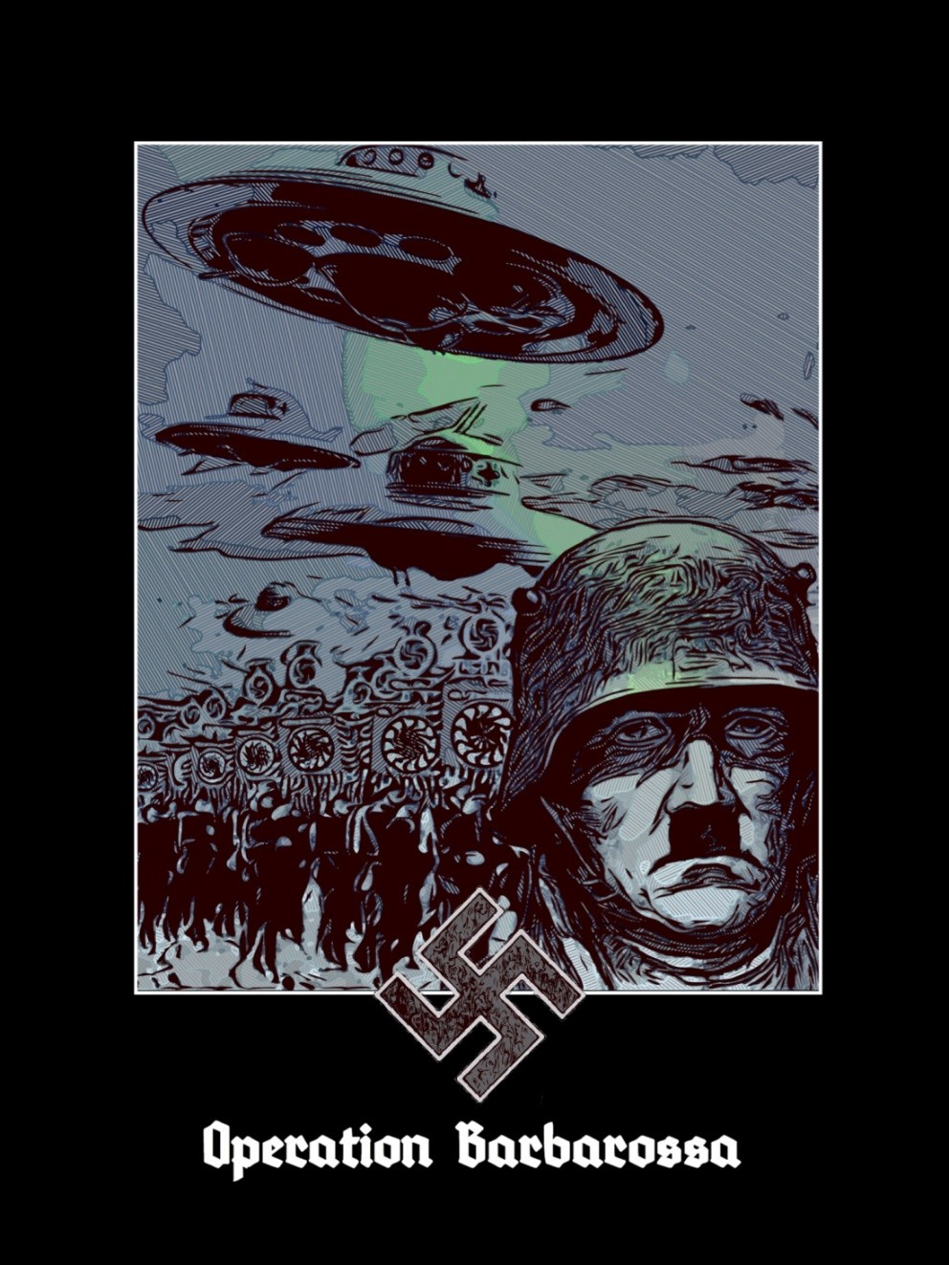

“The Ultimate Avatar has already come in Hitler, and will come again in Kalki, on a White Horse that is the same Sleip- nir, with Eight Legs. Myths and legends prefigure and re- peat this, like the legend of King Arthur and Frederick I Bar- barossa, Emperor of the Sacred Empire, Leader of the Third Crusade in 1190, when he did not die but sleeps at the bot- tom of a cavern guarded by two ravens of Wotan awaiting his return when everything will already seem to be lost.
Therefore Hitler gave the name Barbarossa to this Operation of Return, when awakening in the Hollow Earth, beneath the Poles. The resurrection of the Great Myth, the Final Return, as the living Kalki to rescue his Heroes and make way for the Man to Come, the Caleuche, from the waters of the South Pole after closing the Cycle of Kaliyuga, Ragnarök, with a great slam, as Goebbels announced. Moreover the Man to Come, by the name Manu, will do so in other Rounds of the Eternal Round. In a new beginning of the Same…”
—Miguel Serrano

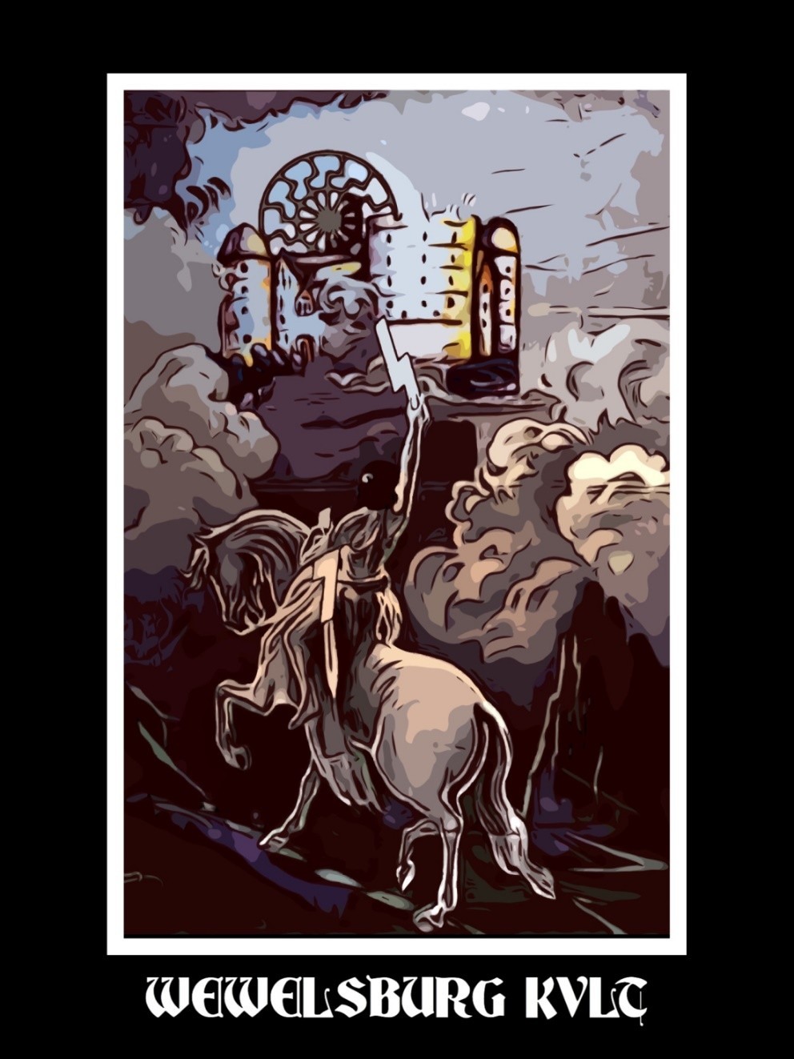

“In Wewelsburg Castle, which directed its towers like the Lance of Longinus towards the Crucifixion of Wotan in the Externsteine, the S.S. initiates also tried to be re-born, to resurrect as Aryans, becoming worthy to recover the Odil Power through the magic use of Runes, the Futhark of Wotan and the Implosive Science of the Paleolithic. In the central hall of the Castle there still hung an enormous stone in ‘critical balance,’ unpolished, showing what Eso- teric Hitlerism was and still is: the grand intention to create the God-Man, Superman, by means of the Tantric Alchemy of the Stone, lapis, and the recov- ery of the blood purity of divine Aesir, Fire of the Serpent of Paradise called in Sanskrit Kundalini.”
—Miguel Serrano

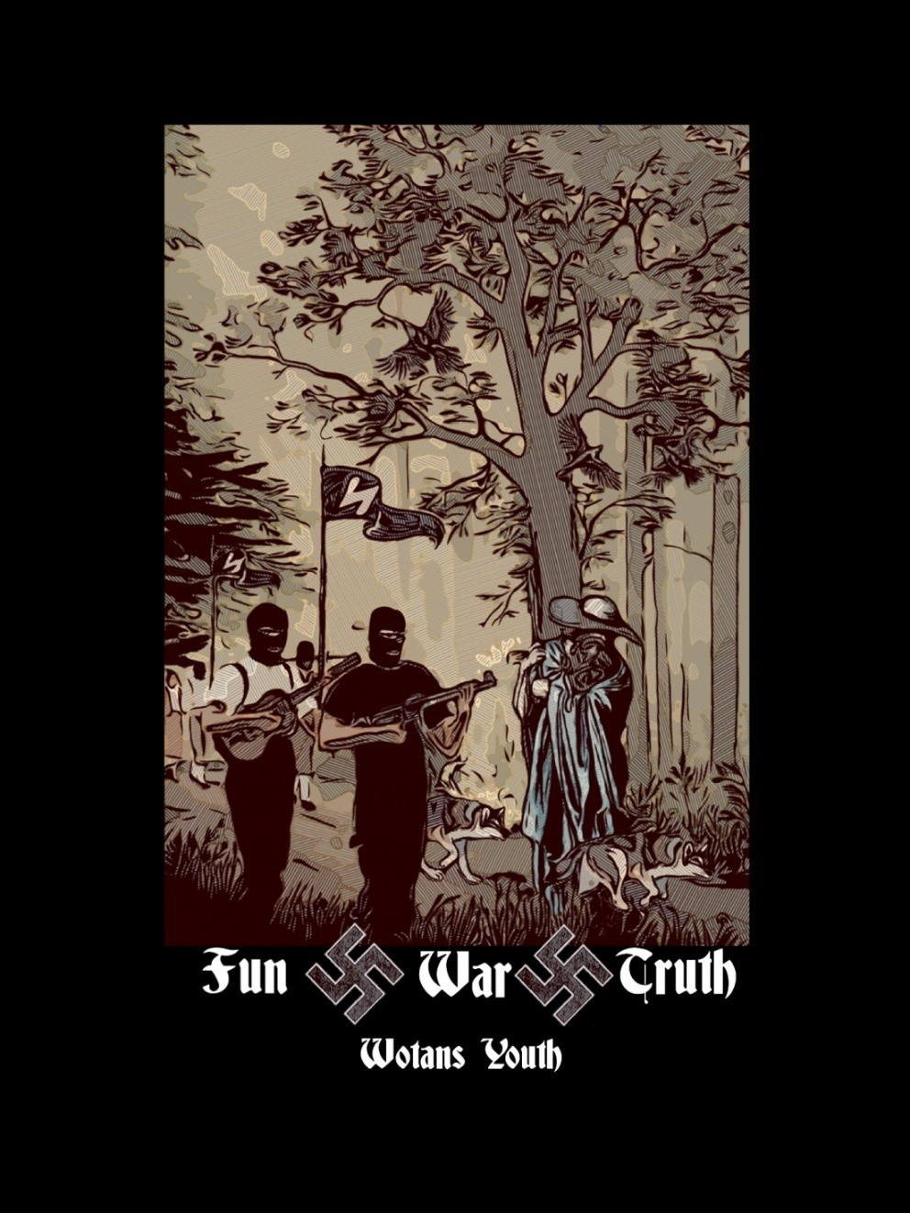

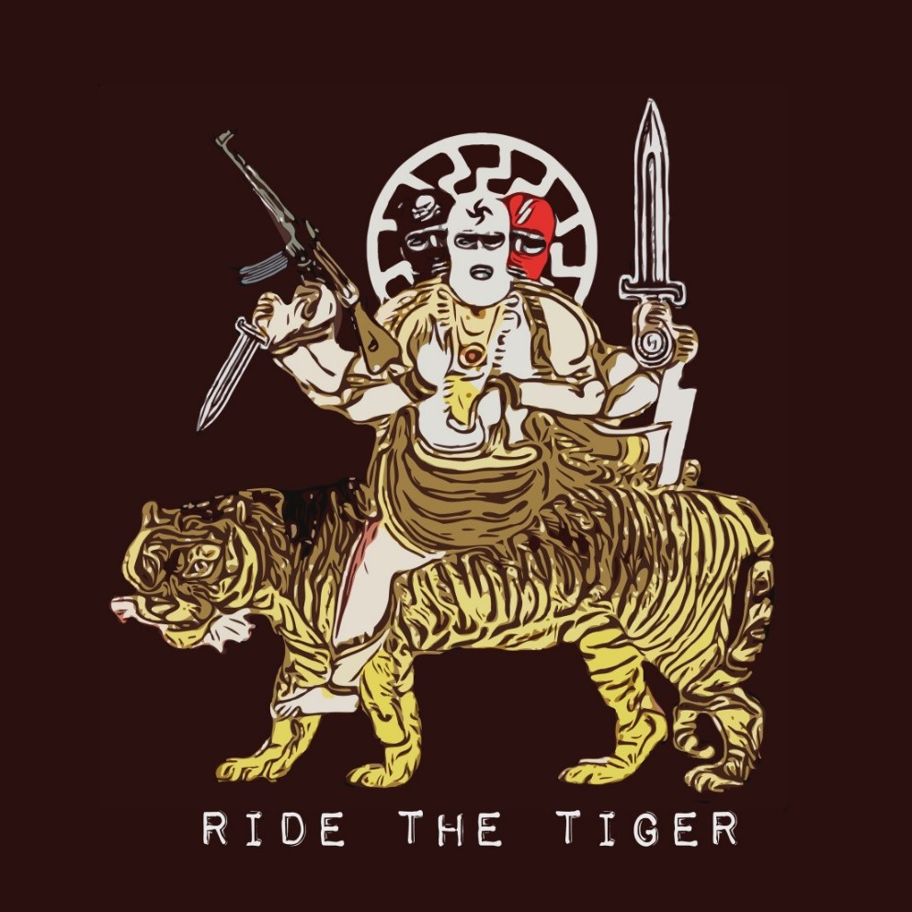

THE DIAMOND WAY AND NATIONAL SOCIALISM

From “National Socialism: History and Myths, Chapter IX.A

Translated by Oregoncoug “The Gods are with those who overcome themselves”
“No one can kill a Dragon without becoming a Dragon himself.
So it was with Saint George the Dragon-Slayer. He was the great- est among Dragons.”
—Anonymous

In the north of India, in the year 600 A.D., a set of practices were gathered and encoded that became known as the Diamond Way, in Tantric Yoga. This way, in fact, is a compendium of ancestral teach- ings in which ancient initiatic orders took part, such as, for exam- ple, the Mithraists, the Fedele d’Amore and the initiates of the long- ago Mysteries, the hermetic work and alchemy.
Nietzsche, the prophet of the superman, is a great scholar of the ancient world, gathering in his work much of that knowledge. In his book “The Twilight of the Idols,” which dramatizes a conver- sation between the diamond and its relative the cooking coal, Nie- tzsche refers to the initiation process by which the vulgar carbon becomes the pure diamond. This is the Diamond Way:
“Why so hard?” the kitchen coal once said to the diamond. “After all, are we not close kin?”

Why so soft? O my brothers, thus I ask you: are you not after all my brothers?
Why so soft, so pliant and yielding? Why is there so much de- nial, self-denial, in your hearts? So little destiny in your eyes?
And if you do not want to be destinies and inexorable ones, how can you one day triumph with me?
And if your hardness does not wish to flash and cut through, how can you one day create with me?
For all creators are hard. And it must seem blessedness to you to impress your hand on millennia as on wax.
Blessedness to write on the will of millennia as on bronze, harder than bronze, nobler than bronze. Only the noblest is alto- gether hard.
This new tablet, O my brothers, I place over you: Become hard!
—Zarathustra, III: On Old and New Tablets, 29.

“Only be tough, firm as the Aryan rocks of the Exsternsteine, and you can modify destiny in the darkest time.”
—Miguel Serrano

In Tantric Yoga, who has carried the yogic process to a suc- cessful conclusion has awakened and developed the serpent energy of kundalini. This sleeps at the base of the spine, and on reaching the highest seat, (located not in the physical body but on the head, as the crown aureole of the saints over the head), deconditions the physical body and bases it on the reintegrated I. This is the funda- mental method of all this way of initiation. The physical body itself is no longer lived with the heavy weight of materiality, but as en- ergy, alive and active. Then one has achieved the body of the “di- amond bolt.” To achieve this, force and dedication are required until one hardens oneself like a rock (or diamond) and becomes in- sensible to human weakness and cowardice.
We cannot think it casual that Miguel Serrano as well as Julius Evola, two well-known in esoteric circles of the phenomena of Na- tional Socialism and Fascism, were great personalities in Tantric Yoga who dedicated many of their studies to this topic.

Julius Evola states in his book “Tantric Yoga” that “the partic- ularity of the Tantras is in the particularity of their practice. Neither a lamentation nor contrition, nor repentance before a divinity. This is the practice of the union of Purusha and Prakriti.”
We understand Purusha is the masculine principle, purely spiritual, immutable and luminous, that Tantrism identifies with Shiva. For its part, Prakriti is the nature opposite to Shiva, the fem- inine principle or Shakti, the active and creative energy of the uni- verse. Shakti is the wife of Shiva.
Evola continues stating Tantric Yoga “is the practice or disci- pline (sadhana) of the union of Purusha and Prakriti, the practice destined to unite in the body the masculine principle and the femi- nine or maternal principle, to free from attributes what has attrib- utes (i.e., deconditioning being)… This practice is achieved with the awakening the forces of the body… This is not pure philoso- phy; does not worry about weighing empty formulas, but with something practical.” The Tantras state: “Begin exercising under the supervision of a qualified teacher. If you do not get positive results quickly, you are free to leave.” The powerful do not go around wearing a neither Brahmin or ascetic robe nor lecture on yoga practice: Only practice leads to success. About that there is no doubt.
The man of “the age of shadows” or Kali-Yuga is closely tied to his physical body and cannot disregard it. The way that suits him is not that of pure distancing, but rather that of awakening and dominating the hidden energies enclosed within the body. Moreo- ver, in Kali-Yuga, Kali, goddess of the first importance in Tantrism signifying the elemental and abyssal forces, is in a free state for what Tantra teaches us to take on, deal with, “to ride the tiger,” or to dominate and transform them according to the Tantric principle of “turning poison into medicine.” Tantra does not exclude the as- cesis of joyful pleasure; indeed, the two are tied one to the other. In Tantrism, an essential change occurs when the liberated one is alive and in his body, having obtained deconditioning, sahaja. In other words, there is a discipline that can “be free and invulnerable” con- cerning the full enjoyment of everything the world has to offer,

while we take from this world all its characteristics of appearance, illusion, mirroring and attachment the Vedanta has attributed to it. According to the Tantra, the world is not Maya (illusion), but power.
And this paradoxical coexistence of freedom and the dimen- sion of self-transcendence and joy in the world, the free experience of the world, is closely linked to the essential task or formula of Tantrism: The union of impassable Shiva with ardent Shakti in our own being and on all the planes of reality.
Thus, Tantra offers both joy and release. Dionysus was re- garded by the ancients as analogous with Shiva beneath one of his principal aspects that puts into relief the Tantrism of the Left Hand. A conception of the world as power. In the forms assumed by Tan- trism, Shiva keeps the specific traits of pure transcendence or puru- sha, being especially associated with a Shakti of terrible type, above all Kali or Durga, personification of his own indomitable and un- leashed manifestation.
When Hinduism adopted the doctrine of the Trinity, or the tri- ple aspect of the Principle, personified in three divinities, Brahma, Vishnu and Shiva, the significance of the two ways becomes clear to us: Right Hand and Left Hand. The first term of the Trinity is Brahma, the creator God; the second is Vishnu, the God who con- serves creation and cosmic order; and the third is Shiva, the God who destroys (with the action of his transcendence over what is done and conditioned). The Way of the Right Hand is beneath the sign of the first two divinities, the first two aspects of the divine, the Way of the Left Hand is beneath the sign of third divinity, Shiva. This is the road that essentially takes the form of Tantrism and Shaivism.
In brief, we take as characteristic of Tantrism a metaphysic of the Principle of power. Then follows the re-evaluation of the prac- tice already undertaken. In particular, the doctrine of the mantra, made from a metaphysics of the verb is considered as Tantric. The mantra becomes a word of power and acquires such importance that Tantrism has sometimes been called the Way of Mantra.

But it is especially Hatha Yoga (exercise, physical postures and breathing techniques of Yoga) that has a specifically Tantric char- acter. The correct translation of the term Hatha Yoga is “violent” yoga and in no way the usual translation of the term as “physical” yoga. This Hatha Yoga is to be understood as yoga of the power of the serpent, as kundalini-yoga, and is based on the awakening of the primordial Shakti, latent in the Indo-European organism, and in its use for liberation. (Non-whites may use these techniques to better understand and associate with Indo-Europeans, but only ra- cially pure Indo-Europeans can actually achieve the power. But this achievement will then benefit all sentient beings.) Physical strengthening through physical postures, breathing and sexual en- ergy are considered as the only two roads that remain open to man in the Kali-Yuga. They must be based on practice. Only practice can lead us to know.
As the diamond is hard and practically indestructible, as the lightening bolt is powerful and irresistible, so the word vajra des- ignates what is strong, permanent, indestructible, powerful and ir- resistible. Vajra is immortal matter, red, hard like a diamond, im- mortalised and finally the Vajra-rupa is the immortal body, of Va- jra. In truth, this corresponds to resurrection and materialization of the astral body, the Lingasarira. This is obtained in the Red Opus, the Rubedo of the “Opus Alchimicum.”
The highest initiates in National Socialism would have awak- ened their latent abilities through practice and the use of techniques aimed at superior developments, such as:
- Hardening practices through physical exercises, gymnastics and yoga, such as breathing.
- Thought control: Use of the mind in such a way that one can handle their thoughts and visualise objects as if they were ob- jects held within their bare hands.
- Visualisation.
- Astral projection.
- Transcendental consciousness, etc.
The Diamond Way and Tantric Yoga help awaken and develop the nature and powers or latent and “hidden” abilities in Aryan

man: the astral body. Thus, according to this way, Hyperborean knowledge is recovered, that is, making the two hemispheres of the brain work together at the same time, since the “normal man” uses nothing more than the left, where the mind and rational technology are located. Vril is that power or spiritual, magic organ the Hyper- boreans possess and that connects with all the universes and “par- allel worlds,” with the other dimensions. Hyperboreans once pos- sessed them and through the Diamond Way modern white Indo- European men can recover them, for the benefit of everyone.
Modern man generally knows only the use of his left brain, which is the rational mind, but the initiate learns to balance his two cerebral hemispheres, becoming conscious and awake to the right hemisphere that is of intuition and paranormal abilities.
According to the Royal Art of Alchemy, on the Path of Heroes three magic steps, or states, are fulfilled: nigredo, albedo and rubedo:
  - Nigredo means dissolution. As the initiate awakens his hid- den nature, he internally produces a process of fall and dissolution or what is esoterically defined as “mystic death,” where the “I” risks its demise. Here the unblocking of the subconscious is pro- duced that is symbolised in the “descent into hell” and is consid- ered the most critical moment on the way of the spirit. Carl G. Jung states that without taking this challenge there can not be a genuine mystical experience, given that the goal of both ways, mystical and initiatic, is to achieve the coincidentia oppositorum, the union of two contrary principles in a new unity, and this is only possible “making the unconscious conscious and living it as if it were real.” At this stage, there is the death of the old “I” (the lower self, purely physical and rational) and the initiate sees how the old world crum- bles before his eyes. It is a process equivalent to death, dissolution or something also identified with the putrefaction of the old per- sonality, which is peeling away in so far as the nature of the initiate is transfigured. In the rocks of the Exsternsteine, in Westphalia, a large open sarcophagus is found, where the initiates must pass a

night, perhaps nine nights like Wotan, to arise from there resur- rected as Kristos. That was the culmination of nigredo. The black magician king gives his gift to the newborn child.
  - Albedo. By persisting in practice, the initiatie is out of the maze gaining access to the astral world into which he enters in ec- static state. Kundalini has awakened, the Golden Serpent, the Ajna Chakra, and already the Phrygian Cap may be worn, of Mithras. The cap of Mithras, like the representation of snakes on the heads of Pharaohs, is a sign that the wearer has awakened Kundalini. Now the “I” is retrieved, but as an incombustible soul able to pre- serve itself through the change of states. The hero is truly an Aryan, reborn, a Twice-Born. He who survives the nigredo is “saved from the waters.” The God is now conscious and able to continue his march towards Hyperborea. In the albedo, the Aryan resurrected as white-man, with his blood purified, must journey through the deserts of the Exodus, still heading towards the White Pole, Thule, Hyperborea, to Asgard. He will return to the Gobi Desert. Now the white magic king brings his present to the reborn boy, the Hero.
  - Rubedo. This is a “miracle” that makes one immune to death and will occur at the end of a road, after wandering in the wilderness, through the albedo. In the legend of the Grail, Parzival, fighting with the Red Knight with red armor, which is the “resur- rection of the body” of matter, now coated with a substance or im- mortal, incorruptible energy, “hard as diamond, red as the ruby,” with the name vajra, in Sanskrit. Thus, it has risen with the body, and in the coffin or “grave” no one is found, only a Sword. The “Double Born” has risen with his indestructible body of red immor- tal vajra. He is taken up to heaven in a chariot engulfed in flames. Therefore the Aryans burned their dead, in memory of this lost abil- ity to dissolve corruptible matter in an inner fire, in the alchemical magic of transfiguration. Also nothing remains of the cadaver on the funeral pyre, but a body of immortal vajra has risen. In the red Opus, rubedo, the Boy that was born as an embryo in the nigredo and grew during the albedo has reached adulthood. In the engrav- ings of the Philosophorum Rosarium, a small boy rises from the Bath of the Lovers. He is the astral body, Rebis (of double nature)

the Homunculus being born. And, at the end, he is the King and Queen with one body. And he is also the Crowned Androgyne. Total Man. Absolute Man and Woman. The Alchemist and his so- ror. The Hero and his Valkyrie. Magic red king carrying his gift to the resurrected Hero: he is Vajra, Incorruptible Matter. And the Hero, as Enoch, ascends to his own Universe, in the direction of the Ultimate Flower in a Chariot of Fire, in a Vimana. He has mutated into a star, a Vimana.
National Socialism is a movement of action solidly standing on immutable transcendent principles. That is, the movement is based on an immutable transcendent vision of the world and, in turn, does not have a passive contemplative religious attitude, but is a positive organization based on action. Hence National Socialism shares the same principles that underpin Tantrism. The symbols and forms of the movement, and the use and mastery of energies are those used by Hitler and Hess. They are signs of this same yoga. Centrality and harmony. Impassibility and movement. To achieve the fixed and immutable point from which to project oneself with freedom. Like a swastika. This is the ultimate realisation of Tantra. All symbols of the Third Reich and its concentrated martial spirit, self-controlled, and action, signal this “Shaivist Principle.” National Socialism, become the embodiment of this spirit, is a con-
crete moment in history.
As we have seen, Tantric Yoga uses the power of sexual en- ergy. In the Way of the Right Hand it does so without sexual inter- course with their partner. In the Tantra of the Left Hand, generally, this sexual act with the partner is only realised once. This act is called Maithuna, and consists in reactivating and recreating the chakras. This can open the third eye, inner vision and achieve im- mortality, all together. As one can see, this is a sexual act that has nothing to do, not for the priests who perform it, nor by its form, nor by the objective pursued, with the sexuality of contemporary men. Through canalisation, the domination and transmutation of sexual energy, mutation into the Superman and Absolute Personal- ity is achieved.

Where modern man comes with anxiety and vice for the sexual desire that dominates and degrades him and causes him to lose his dignity and will, the Tantric initiate works with and strengthens his body-mind, his will, affirming himself above his own sexual desire, becoming the Lord of himself. In this way, through magic love, he develops and learns to channel his own sexual energy. There are initiatic exercises and tests that stimulate sexual desire for the Tan- tric pair, but without ejaculating, that is, without allowing the sex- ual energy to be lost. This dominion and accumulation of sexual power, efficiently canalised through physical exercises (asanas) and breathing (prahnayana), will produce, as we have indicated, the Kundalini to awaken, which as it develops and rises offers the ini- tiate ecstatic states that permit him to access and live in superior states of consciousness.
“Esoteric Hitlerism,” about which Miguel Serrano speaks to us, developed this approach in his initiation to overcome the opposed pairs, achieving the creation of the astral body and individuation, totality and the alchemical androgyne. In Wewelsburg Castle, Westphalia, the innermost circle of the S.S. was initiated into this way. There, in that magically built room, they developed anti-grav- itational science, according to a numeral science and Hyperborean Aryan mathematics, and there the S.S. achieved the disintegration of their physical bodies materialising their Astral Body, the Eidelon, Lingasarira. But only very few and in the greatest secrecy.



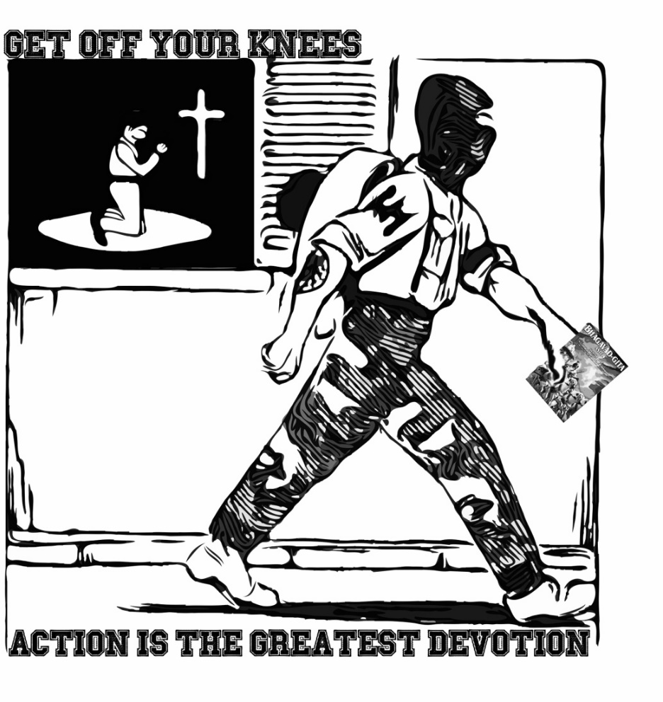

“What a strange god you Christians have, who created you upright, but who commands you to crawl to him on your knees!
We heathens do not beg to our Creator; it would be an insult to the di- vinity in our souls.”
—Wulf Sorensen
卐卐卐卐卐卐卐卐卐卐卐卐卐卐
“Positive activities constitute life, and positive activity is the message of Bhagavad-gītā. Spiritual life is not “Don’t do this.” Spiritual life is “Do this!” In order to act properly, there are certain things that one must know not to do; therefore certain activities are forbidden. The whole Bhagavad-gītā, however, is “do.” Kṛṣṇa says, “Fight for Me.” At the be- ginning of Bhagavad-gītā, when Arjuna told Kṛṣṇa, “I will not fight,” Śrī Kṛṣṇa said, “My dear Arjuna, how have these impurities come upon you? They are not at all befitting a man who knows the progressive val- ues of life. They lead not to higher planets, but to infamy.” (Bg. 2.2) Kṛṣṇa directly tells Arjuna that he is speaking like a non-Āryan—that is, like one who does not know the spiritual values of life. So Kṛṣṇa con- sciousness does not mean sitting down idly.”
—Prabhupada
卐卐卐卐卐卐卐卐卐卐卐卐卐卐
“Q: Is it true that Himmler always kept a copy of the Bhagavad Gita in his pocket and read passages from it every night?
MR. & MRS. TRIMONDI: Yes, this is true. In fact, it has been well docu- mented by Felix Kersten, his Finnish masseur, that Himmler liked to in- dulge in philosophical monologues in his presence. The Reichsführer SS called the Gita a high Aryan Canto.
Kersten also reported that Himmler read the Vedas, especially the Rig- Veda, the speeches of the Buddha, and the Buddhist Visuddhi-magga. Himmler made frequent references to karma, especially when he was talking about providence.”
—Heinrich Himmler ‘The Nazi Hindu’



“He (The Führer) did arise during the time when the Ger- mans were in the deepest distress and when they did not see any way out. He belongs to these great figures of light (Lichtgestalt). One of the greatest figures of light reincar- nated himself in our Führer.”
—Heinrich Himmler
卐卐卐卐卐卐卐卐卐卐卐卐卐卐
“And it is in these yugas of heroes, in these interludes, when a wind from another Universe blows through the galaxy, that the Avatar awakens the sleeping vîras, to light them with his fire, to force them again into great combat”
—Miguel Serrano
卐卐卐卐卐卐卐卐卐卐卐卐卐卐
“With the Avatar, which is to say with the Fuhrer, he is pregnant with an entire world that he is bringing to light: The world of the Fourth Reich, the new Golden Age, the Other Earth.”
—Miguel Serrano

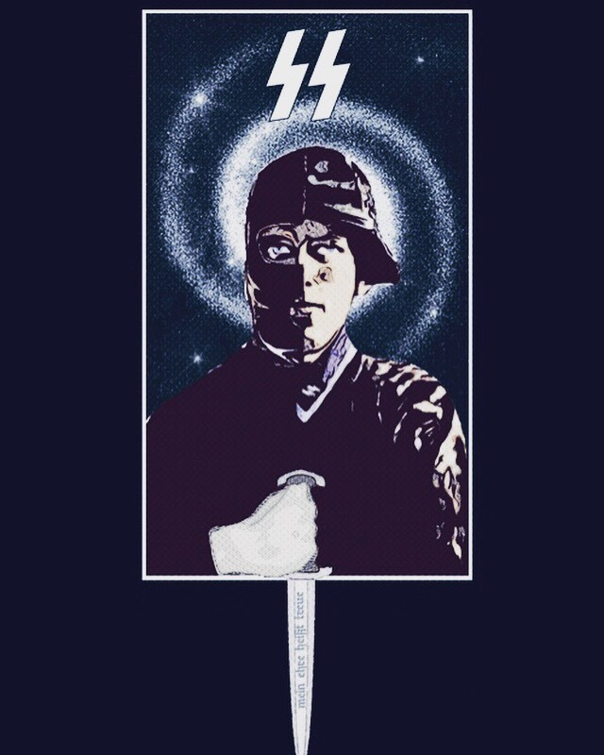

“Only very few would reach the re-living of their astral blood, together with their Linga-Sârira, in short, the conquest of Vril, coming to be SS of the Two Swords, thus able to unleash the struggle against the Enemy in more than one world and with more than one body. The Aryans in truth, Twice Born.
Besides the SS dagger, with the inscription “Meine Ehre Heisst Treue,” there was also a sacramental Sword, given to very few to possess, The Sword “Blood Memory,” handed to them by Anfortas, King of the Gral.”
—Miguel Serrano

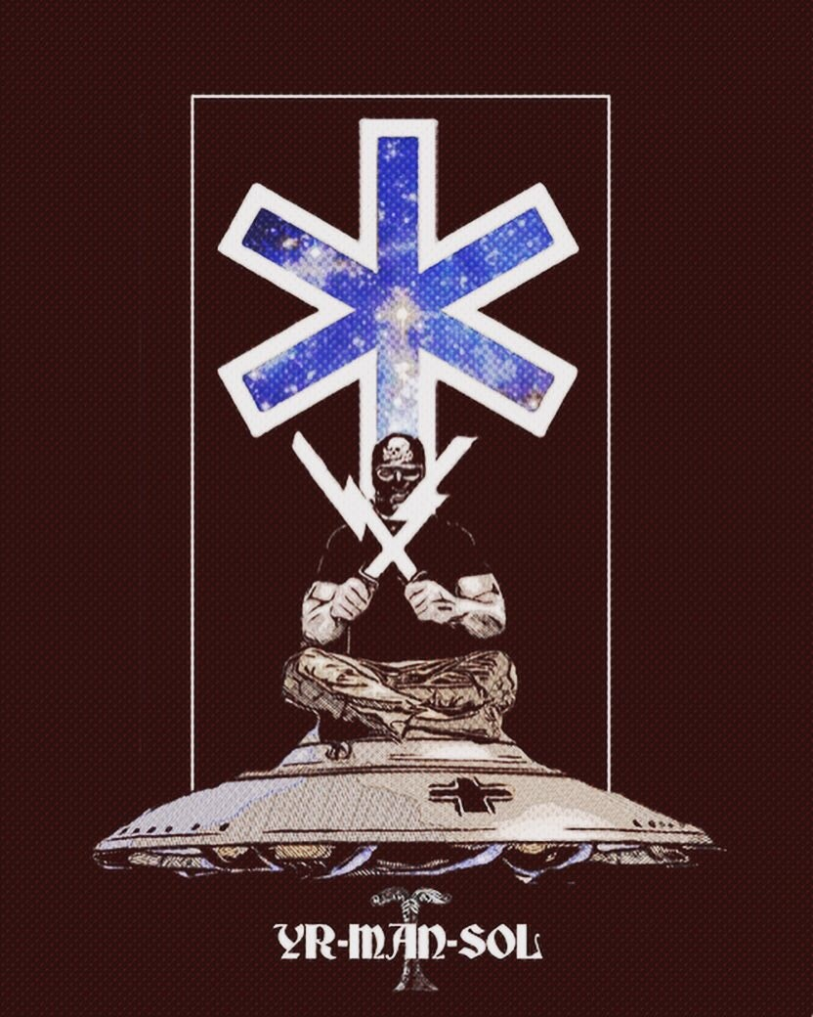

Miguel Serrano in his The Ultimate Avatar makes an inter- esting association between the Irminsul and the runes Yr- Man-Sol.
ᛣ-ᛉ-ᛋ
Yr, the 16th rune of the Younger Futhark and the Armanen Futhork represents both the yew and matter, telluric power and destruction. It was used on the grave stones by the SS as the Todesrune to indicate the date of death. Serrano depicts this rune as the portrayal of the Aryan deva, the God-man descending into matter, being incarnated as the vira, the hero.
Man, the 15th rune of the Armanen Futhork is named Madhr[man] in the Younger Futhark and is the 14th rune in that row. It represents divine ancestry in [Germanic] man, the God-man, the masculine principle, day, consciousness and is used by rune magicians to connect to other realms outside Midgard, in particular with Asgard. It was used by the SS on gravestones to mark the date of birth and was thus referred to as the Lebensrune. Serrano depicts this rune as signifying the ascent of the Aryan vira from base matter into spirit, where he escapes bodily existence via the invisible Irminsul from the earth to the realm of the Schwarze Sonne.

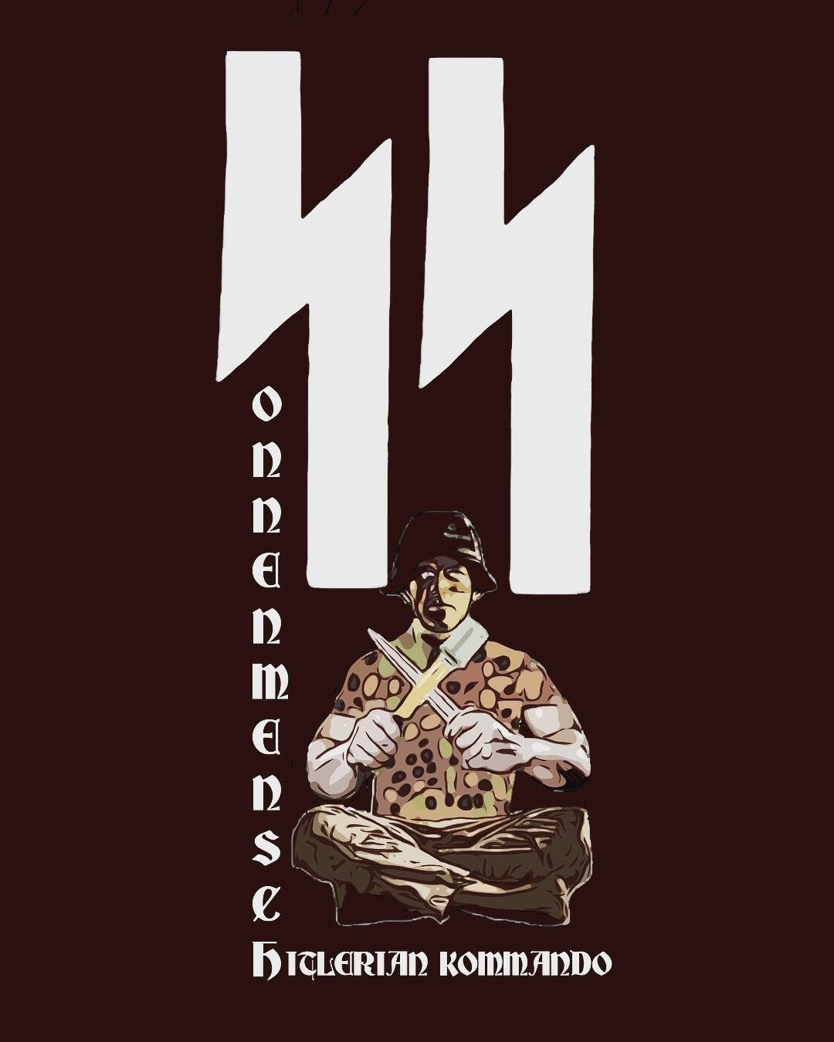

“Sol, the 11th rune of the Younger Futhork is named Sig in the Armanen Futhork, Sigel in the An- glo-Saxon Futhork and Sowilo in the Common Ger- manic Futhark and represents the sun, the sun- wheel, solar power, victory, knowledge and suc- cess. It is the rune of self-realisation, the rune of the Sonnenmensch.
ᛣ-ᛉ-ᛋ
One can see how these three concepts are repre- sented in the Irminsul or Yr-Man-Sol and is the method by which the rune magician, the Wodenist initiate can achieve awakening and recapture his lost divinity. It represents the awakening and rais- ing of the Kundalini via Germanic Rune Yoga.”
—Wotans Krieger

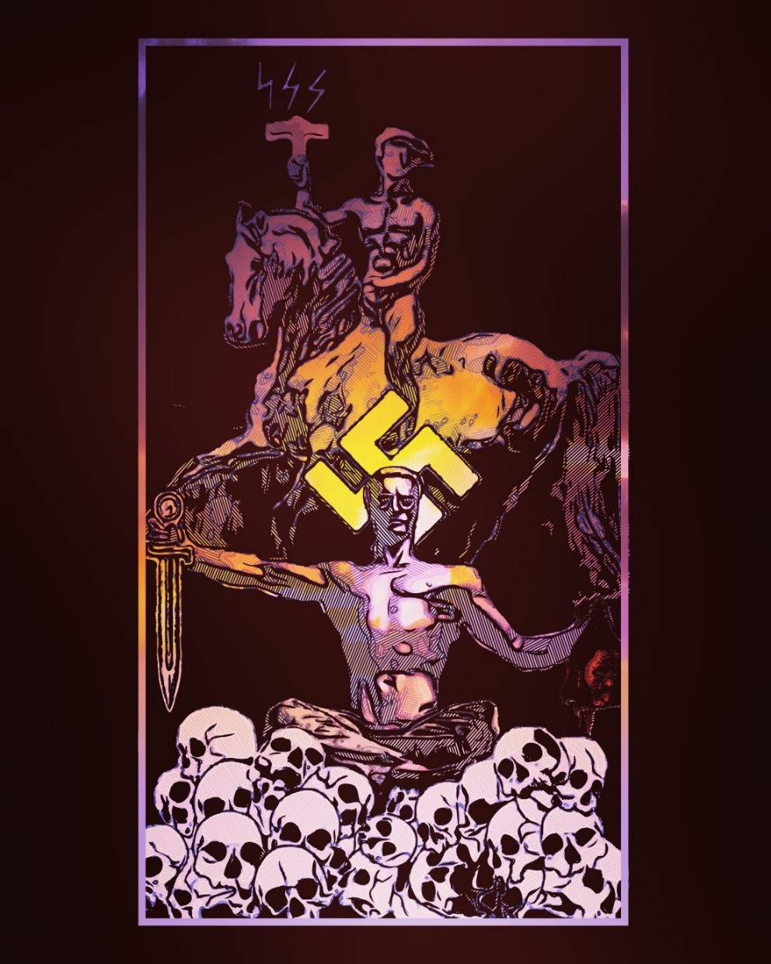

ᛋ Indra Mit Uns ᛋ
卐卐卐卐卐卐卐卐卐卐卐卐卐卐
O’er Sire and Mother they have roared in unison bright with the verse of praise, burning up riteless men, Blowing away with supernatural might from earth and from the heavens the swarthy skin which Indra hates.”
Soma Pavamana – 9.73.5
卐卐卐卐卐卐卐卐卐卐卐卐卐卐
“stormy gods who rush on like furious bulls and scatter the black skin.”… “the black skin, the hated of Indra” will be swept out of heaven.
[ RgV.IX.73.5 ]
卐卐卐卐卐卐卐卐卐卐卐卐卐卐
“Indra protected in battle the Aryan worshipper, he sub- dued the lawless for Manu, he conquered the black skin.”
[ Rg.V. I.130.8 ] [ Anna.114 ]

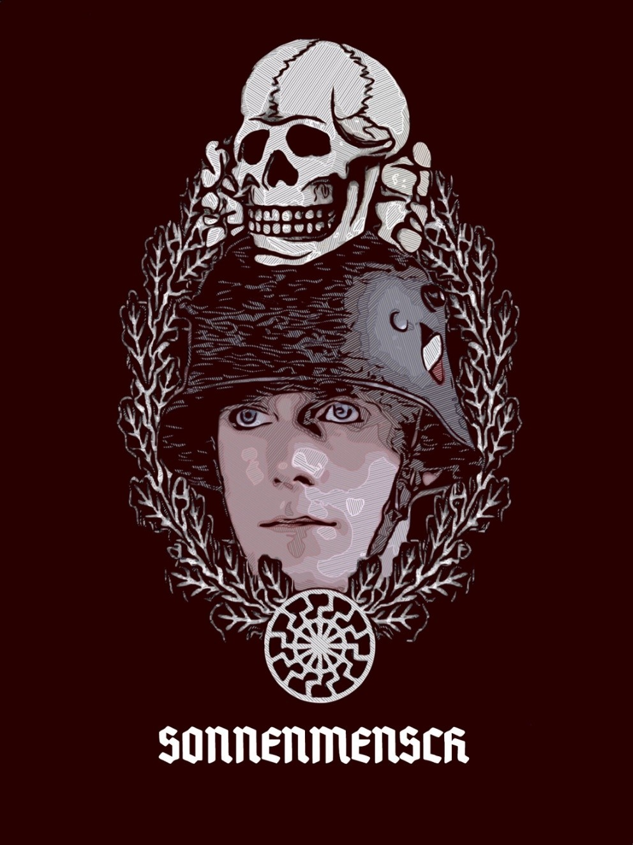

“Those who see in National Socialism noth- ing more than a political movement know scarcely anything of it. It is more even than a religion: it is the will to create mankind anew.”
—Unser Führer

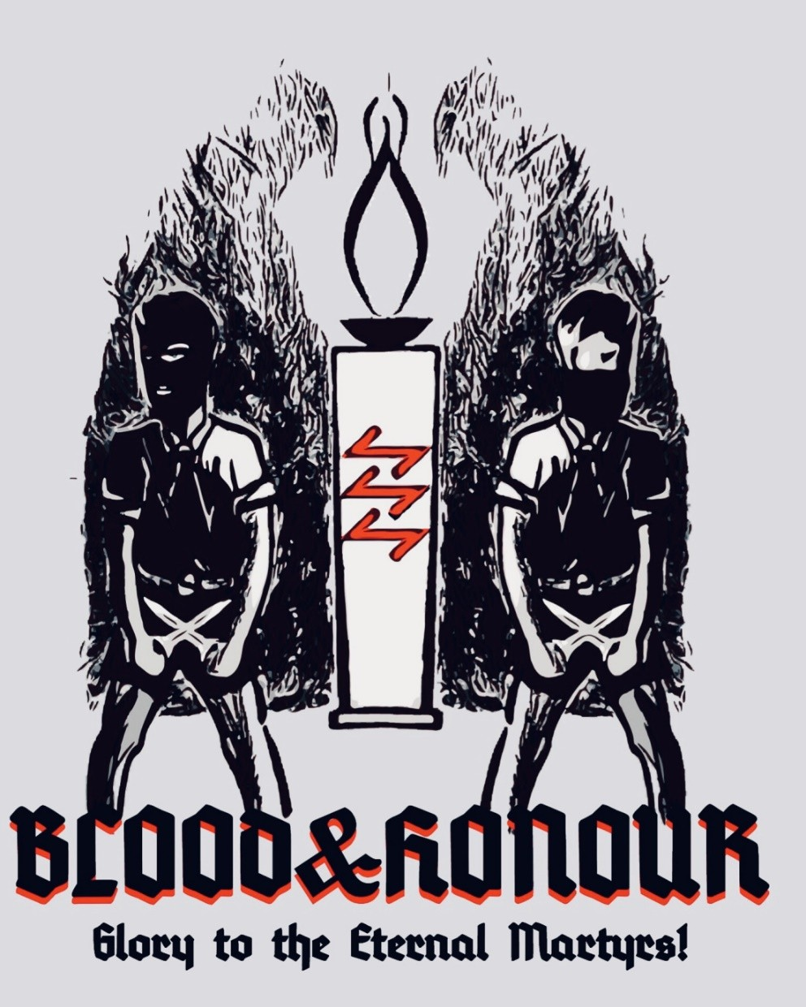

“This new yet ancient Myth of blood, whose countless falsifi- cations we experience, was threatened. In the back of the iso- lated nation, dark satanic forces became active. They sub- verted the victorious armies of 1914. Once again a time came when the Fenris Wolf broke his chains. He passed over a world with the stench of decomposition. The Midgard Ser- pent whipped up the ocean. The millions could only be pre- pared for sacrificial death by one slogan. This slogan was called the honour of the folk and its freedom. The world con- flagration came to its end. Nameless sacrifices were de- manded and made by all. We soon discovered that the de- monic forces had triumphed over the godlike by striking the army in the back. More unrestrained than ever they raged, unleashed through the world. They produced new unrest, new conflagrations and new destruction. But at the same time, in the bowed souls of the surviving kin of the dead warriors, that Myth of the blood for which the heroes died was renewed, deepened, comprehended, and experienced in its most profound ramifications. Today, this inner voice de- mands fulfilment of the Myth of blood and the Myth of the soul, race and ego, folk and Personality, blood and honour.
These virtues must triumph alone and uncompromisingly.
They must carry and determine the whole of life.”
—Alfred Rosenberg

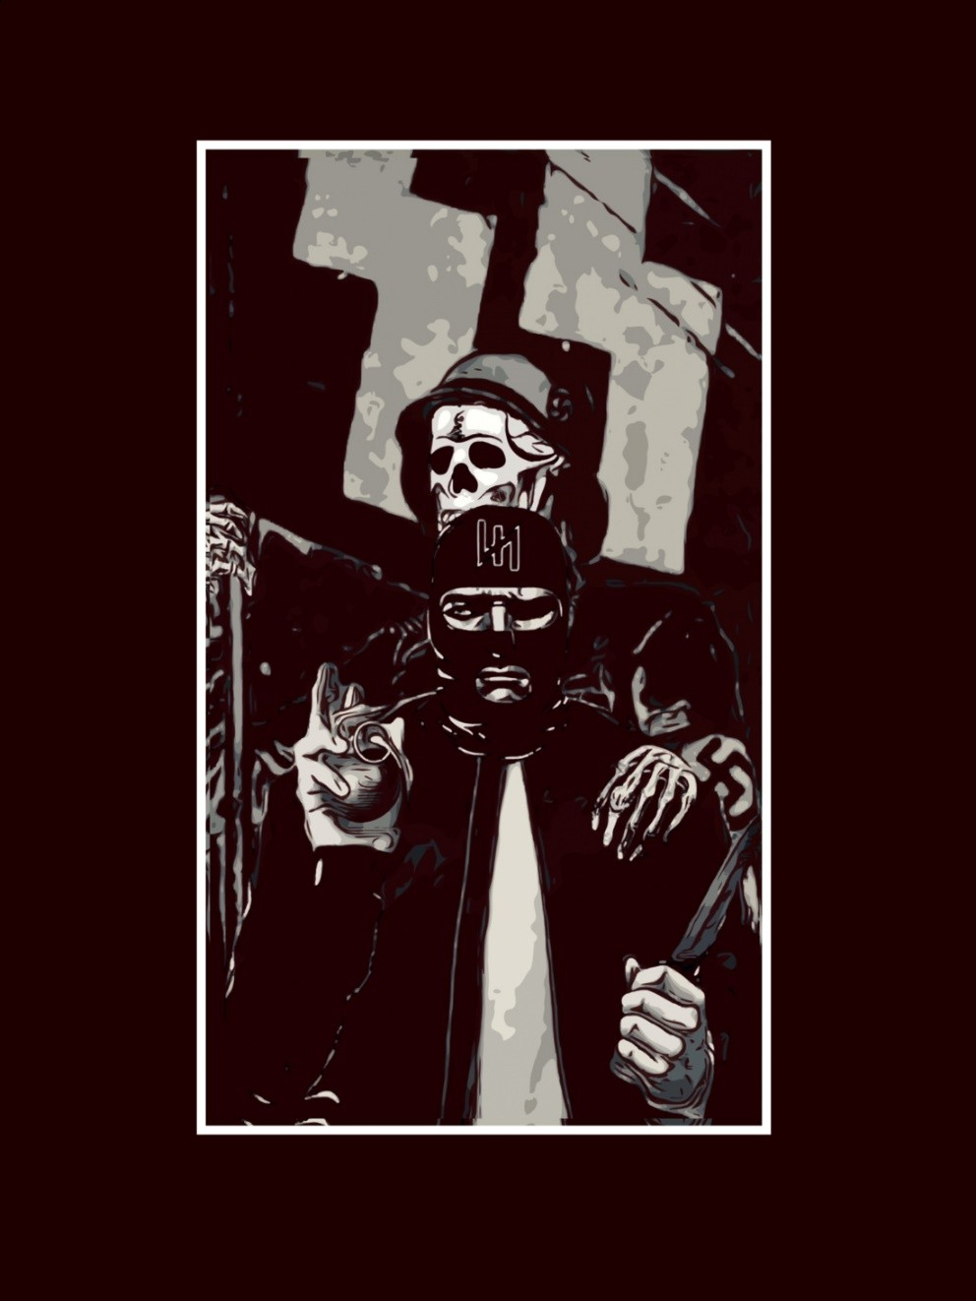

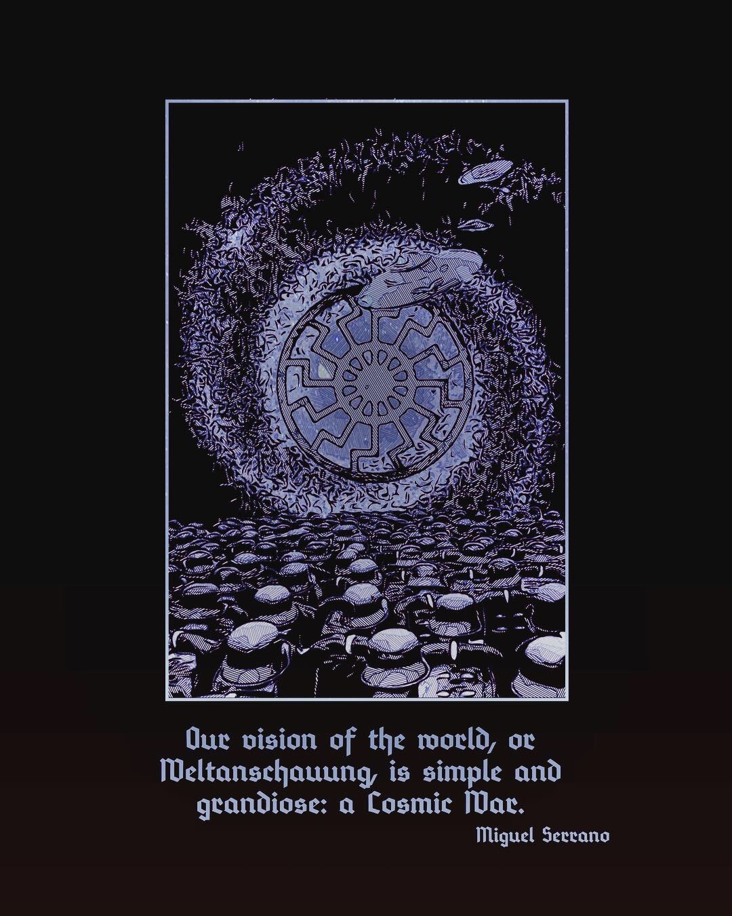

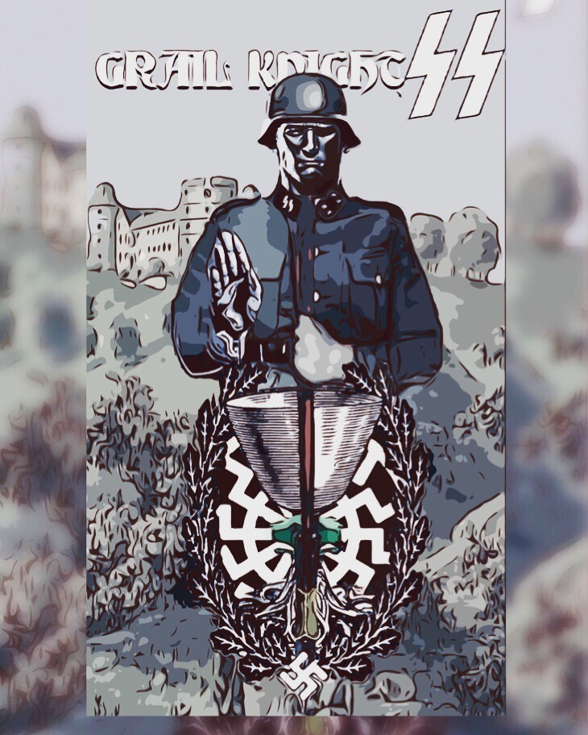

“ᛋThere seem to be two Grals, one feminine and the other masculine, the Legend tells us about: a Grail and a Gral. The first is a Cup, or a Caul- dron, making symbolic reference to the polar opening to penetrate the Hollow Earth, Anticton, the opposite land, the ‘other world’ in which Py- thagoras believed and that ‘will be found neither by sea nor by land.’ This would also mean the entrance to Mother-Sun, to die Sonnen, going into the ‘Second Earth’ of which Plato speaks, same as the ‘first,’ but in- visible to us for being on the other side of ‘Mother Sun.’
ᛋThe Cup, or Grail, will be offered to the Hero by his Valkyrie filled with her Aropa, with her golden liquor, to celebrate his triumph in Valhalla, his Resurrection in the Hollow Earth, in the Interior of Herself on the Other Earth.
The Gral is, in contrast, according to von Eschenbach an Emerald Stone fallen from the forehead of Lucifer in his stellar combat. It is masculine like the Lance of the Centaur Longinus. It is therefore the Power lost in the mixing and with the disappearance of Hyperborea, the Odil Force, Adel, Odal, called the Third Eye of Wotan-Shiva, with which he thun- ders against Smara. On recovering this Stone-Power, also with help from the Woman-Maga, from She (Hitler referred to the Odil Force, or Od – o, magic, indispensable, arising from some select women). Wotan-Baldur will be resurrected. And he will drink Ambrosia-Aropa in the Grail Cup.
In the center of the Round Table the S.S. had in Wewelsburg Castle was a Cup of carved emerald and certainly the Lance of Longinus. From the wall hung a huge Stone in ‘critical condition,’ held on its ‘angular point.’ I saw this Stone on my pilgrimage some years ago to the S.S. Initiation Castle of Wewelsburg as I recount in my book The Ultimate Avatar. Per- haps that is why the Stone has been taken away from there, attempting thereby to destroy the still remaining sacredness and magic there, the ge- omancy of that place.
The Cup, Stone and Lance symbolize as a whole the union of opposites, Androgyne, Absolute Man, Sonnenmensch. The Tantric Alchemy of Wewelsburg.”
—Miguel Serrano

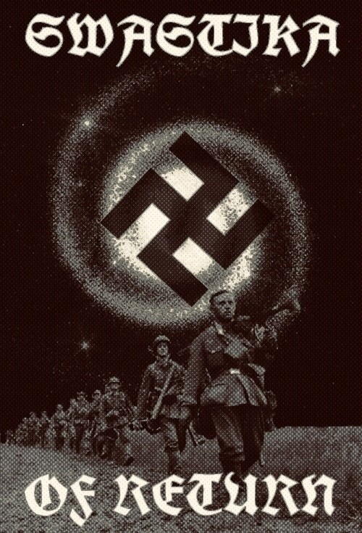

“What tremendous drama, what terrible Drama! A lone man holds within himself two superhuman beings, frightful, ar- chetypal, that combat and fight in opposite directions: the Führer and the Avatar. He is shaken, shuddering, burned, raptured by both, without knowing which way to go; within a whirling wind-mill, torn away into a Black Sun, a Black Hole where not even light persists, by the Leftwards Swas- tika, by the ‘Mill of Wotan,’ crushing into powder, destroyed and remade a thousand times…(‘Because there is nothing more beautiful in this world than to be resurrected after be- ing torn to shreds.’) He falls and gets back up, supported only by his iron will until he reaches the final, the ultimate sacrifice, where he will be taken up by a Chariot of Fire, by a Disk of Light and received at the end by the Chorus of Ein- herier Warriors, by the Furious Horde of illuminated eternal Heroes to give him his merited rest while we await the MAN TO COME in Resurrection and Glory. Who shall return from the Ice of Antarctica. Or the firmament from beyond the stars…”
—Miguel Serrano



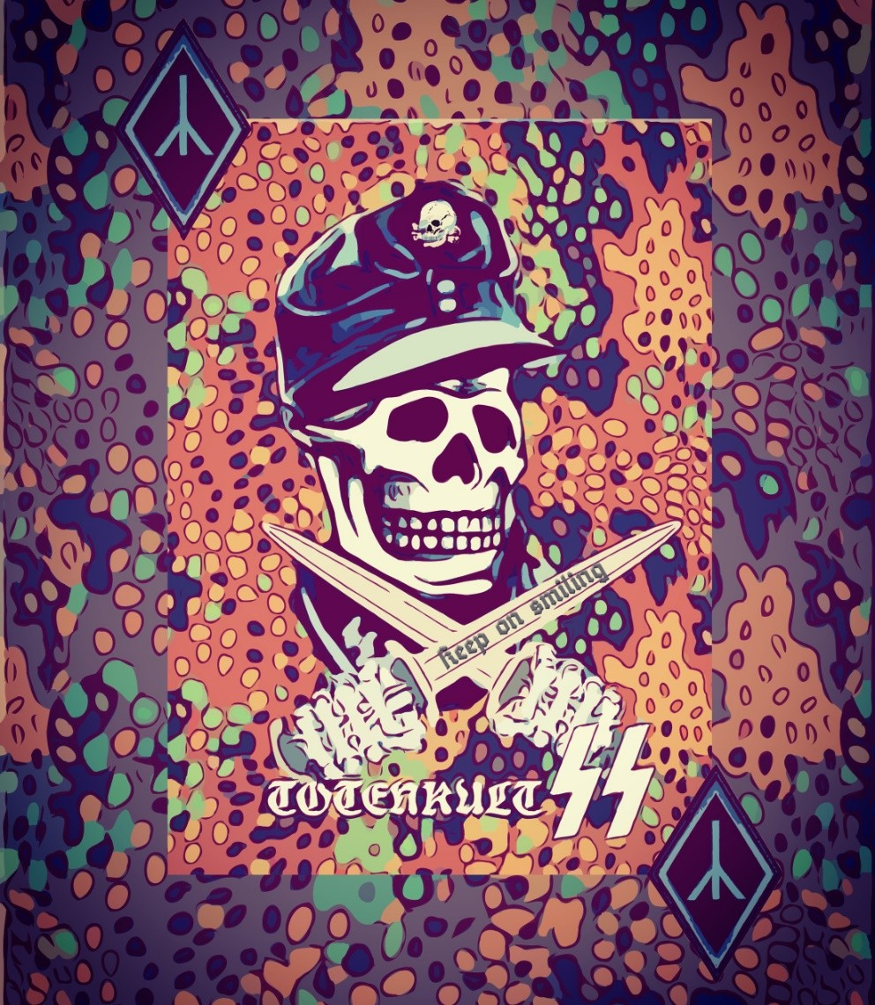

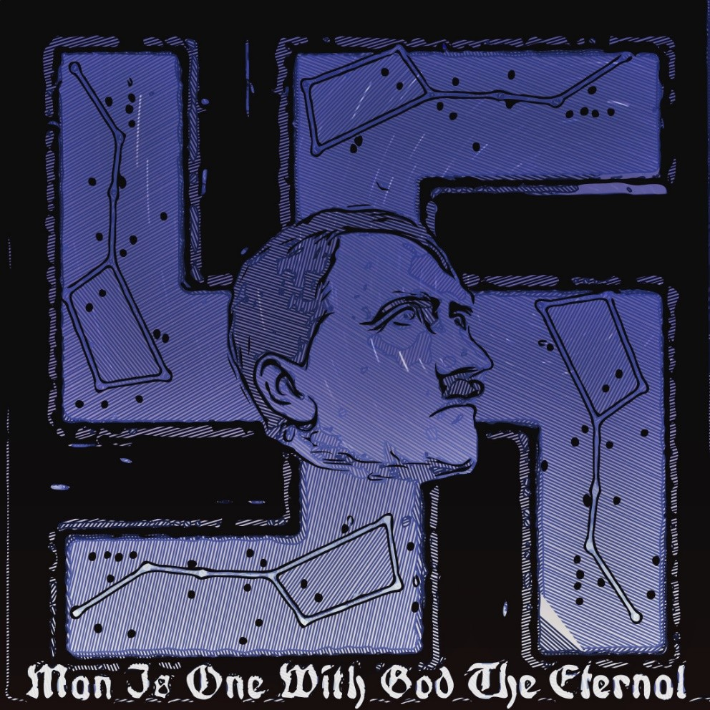

“I think the man who contemplates the uni- verse with his eyes wide open is the man with the greatest amount of natural piety: not in the religious sense, but in the sense of an intimate harmony with things.”
—Adolf Hitler

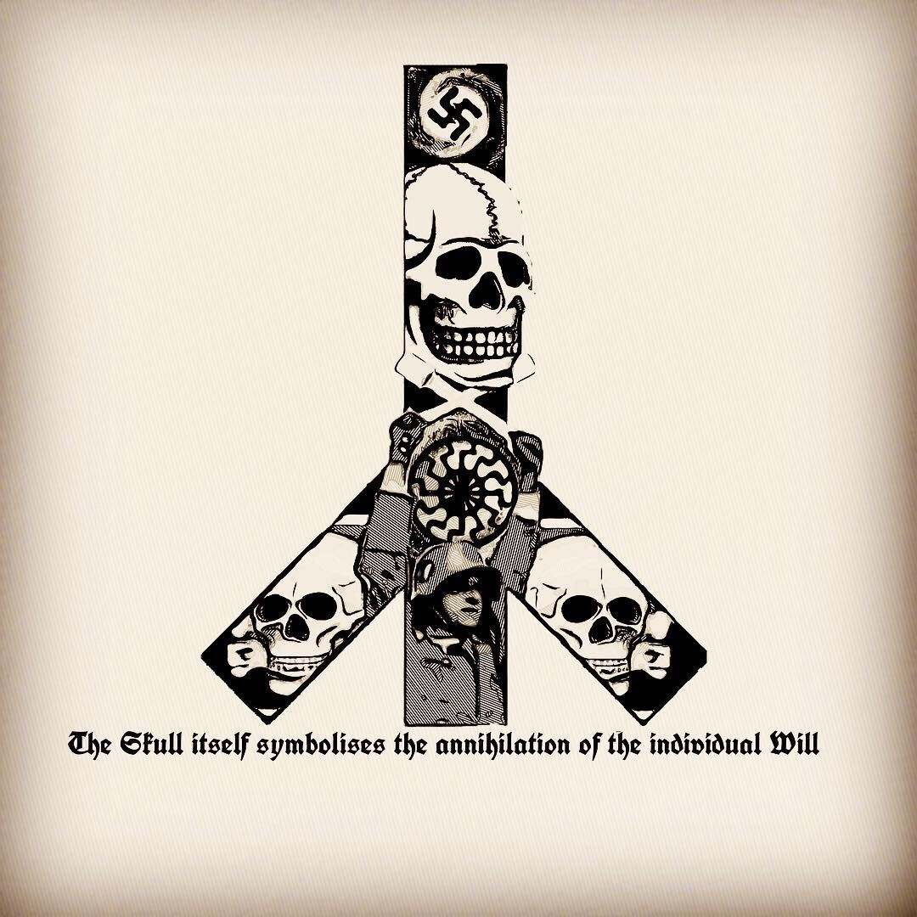

[the Totenkopf is to] “remind us that we should be ready at any time to lay down our lives for the good of the Germanic people.”
—Heinrich Himmler

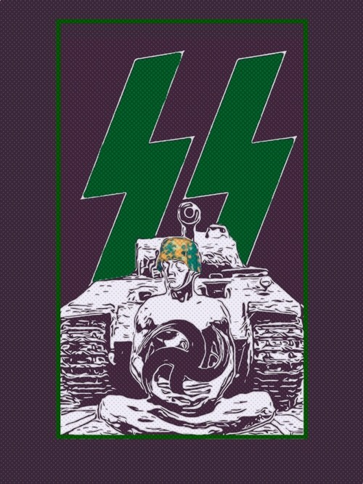

“The heroes know they could lose their lives at any moment, but the Val- kyries, Wotan and the Fuhrer will reconstitute them in Valhalla. Like the assassin, death does not matter to them, rather they desire it. Because life is good for nothing if it is not sacrificed for an Ideal, in this great fight, this Great War. The initiated Hitlerist is a Knight Errant in search of jousts, like Parzival, like Gawain, to conquer the Gral.
Yes! We are in mortal combat with the Demiurge, the Lord of Darkness and his acolytes. We know we are going to win, because as Adolf Hitler said: “If I win the war, I will have given a mortal blow to the Jew. If I lose the war, their triumph will only be for a brief time.
And so it happened, because his victory had already begun to decline, because it is on the longest day, at noon, when midnight is announced. Hence that terror making the Jew tremble, even in the apotheosis of his triumph and world domination.
In the synchronism of Hitlerian Initiation, when the Vîra has mutated into Divya, the Window of Venus opens, the maelstrom Door of the Black Sun, the “Black Hole,” in the center of the Leftwards Swastika, and the Divya, or Siddha, then disappears forever from the sight of mortals.
They have entered into a completely opposed Universe, where the Light of the Gold Sun disappears. They have reached the non-being of the Green Thunderbolt.
They have defeated the Enemy, the Demiurge-Asura-Jehovah (we still remain with those names). For those who fall here, for the Pasu, the event will seem like a defeat. But there has been a victory. They go over to the region of the Tulku, who is beyond and yet can return here. Who will return with a White Horse, with a Swan, a Vimana, to play with the enemies and rescue their own, in their Legion of Heroes-Vîras, continu- ing to battle for Him and for the Self, for the Selbst.
And when those who are still here in this Holy War, continuing and per- haps never to end completely, we will then go to pass again through that narrow Door, we shall meet Him face to face. We will be he!
This is Esoteric Hitlerism”
—Miguel Serrano

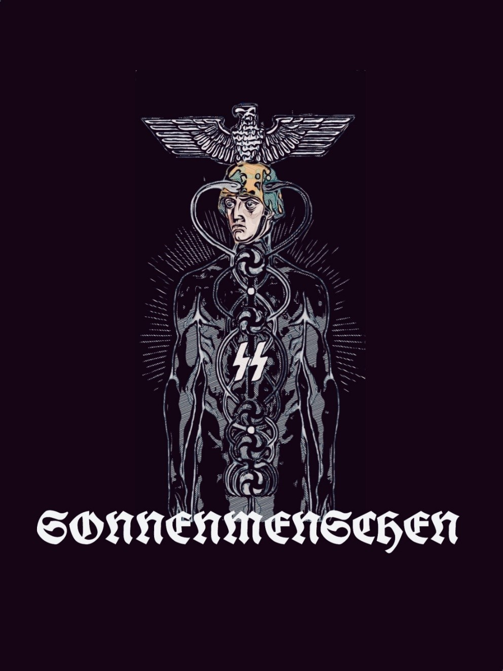

“The SS were conforming to their own racial vehi- cles so that the Hyperborean Archetype of the Ar- yan Collective Unconscious would express itself. Giving these vehicles a renewed life, the Archetype could incarnate here below. They were Sonnen- menschen, Sun-Men, Supermen, Man-Gods, Total- Man, Magician-Man. The new aristocracy of the Ar- yan race.”
—Miguel Serrano

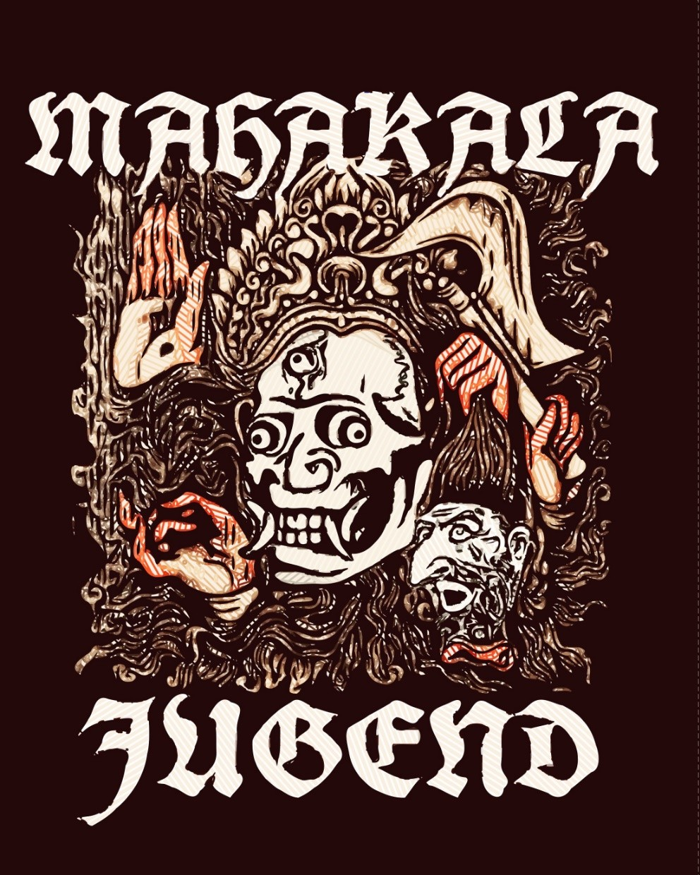

“It was Djalama, the Mongol, who initiated me and made me discover the secrets he had learned in the monasteries of Lhasa. He was a sage and a grand killer of Chinese. To liberate Mongolia of their yoke, he massacred them by the thousands. I have done the same with the Jews”
—Baron Ungern Sternberg
卍
“The best political weapon is the weapon of terror. Cruelty commands respect. Men may hate us. But, we don’t ask for their love; only for their fear.”
—Heinrich Himmler

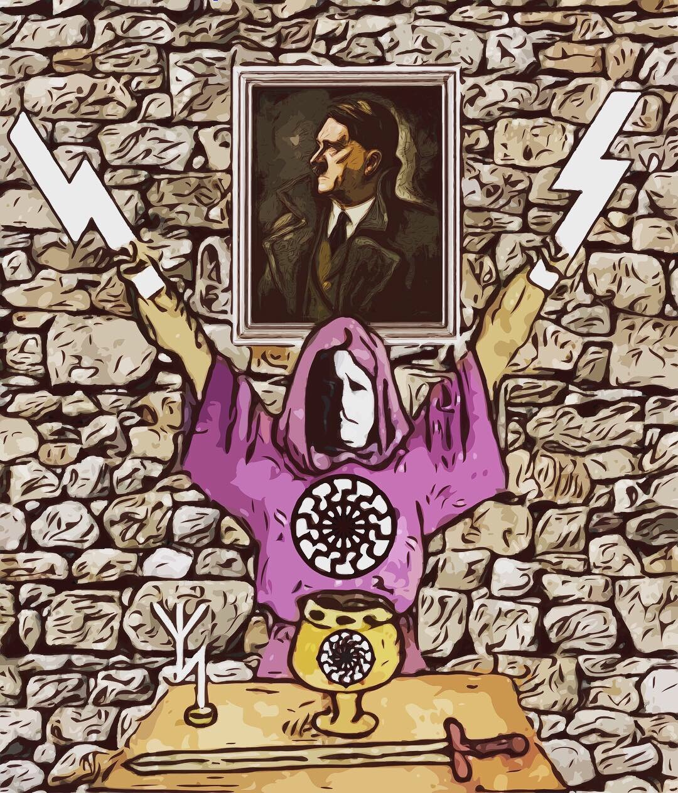

“The ultimate heroes of this time must be grateful to the Fuhrer, because He upheld so great a war, so enormous a combat, such heroic sacrifice, in the ful- fillment of an Eternal Symbol, making possible for new generations to give themselves to Him and in Him to meet a Destiny, a salvation, an Ideal, a Myth of Redemption. So as we have seen and understood, we already know a God was again among men, to- gether with the heroes; the true God of heroes, not the god of slaves; the God of Brahmins, of the Hy- perborean Hosts, God of the Aryans, not the god of Jews. And the new religion that will manifest itself, the new Myth that is fulfilled, is the ancient Polar Myth, when Gods inhabited the earth and lived among heroes.
We who have understood, the warriors of Esoteric Hitlerism, we are today the advance guard, the priest-warriors of a New Revelation:
Esoteric Hitlerism.”
—Miguel Serrano

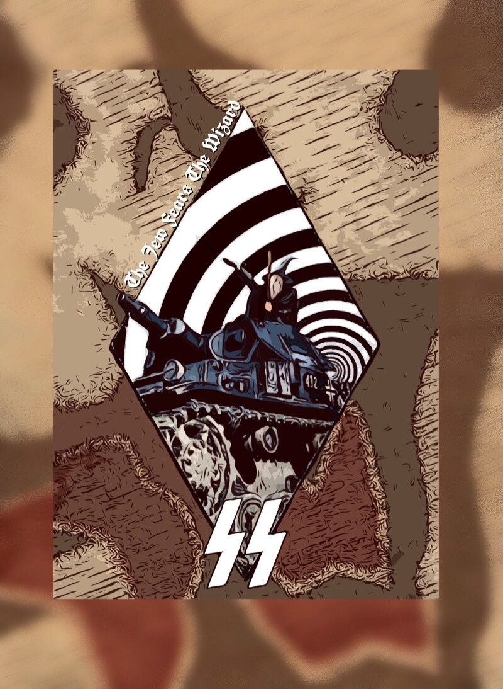

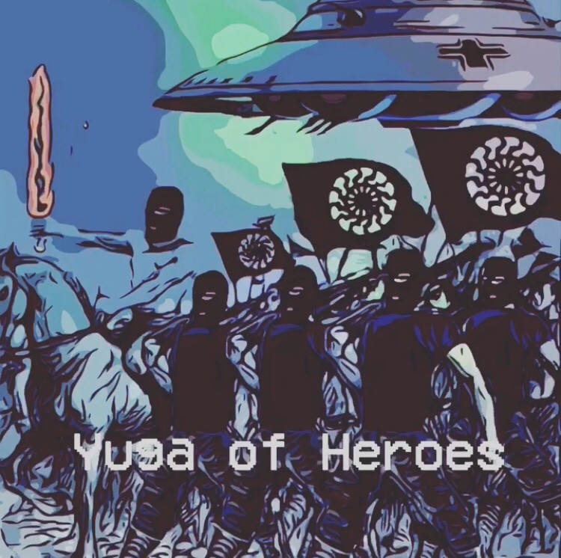

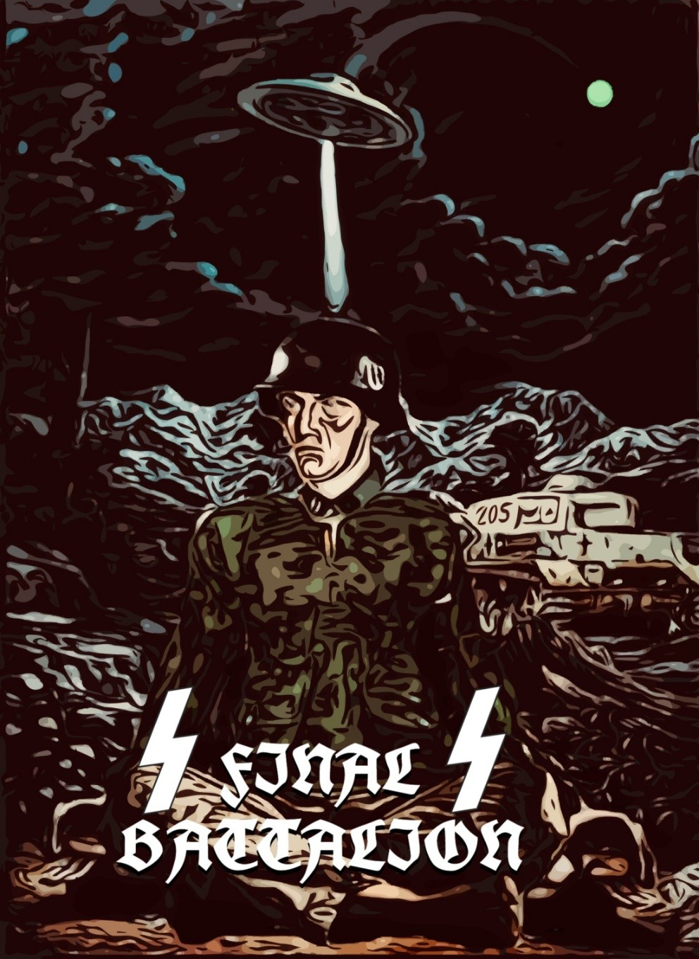

“To be able to go where the Fuhrer went, with his Vimana, with his Star, we must recover the Vril, and thereby go to where He is found, within, in the “Interior Earth.” First we must be able to go be- yond, so that He return.
The Third Reich was where the Sonnenmenschen, the men of the Black Sun, were able to recover the lost organ of Vril, the direct knowledge of the memory of the blood. The vîras, converted anew into divyas, built an astral body, their Sâhu, their own Vimana, and with them they departed to the regained impregnable Paradise of Asgard.”
—Miguel Serrano

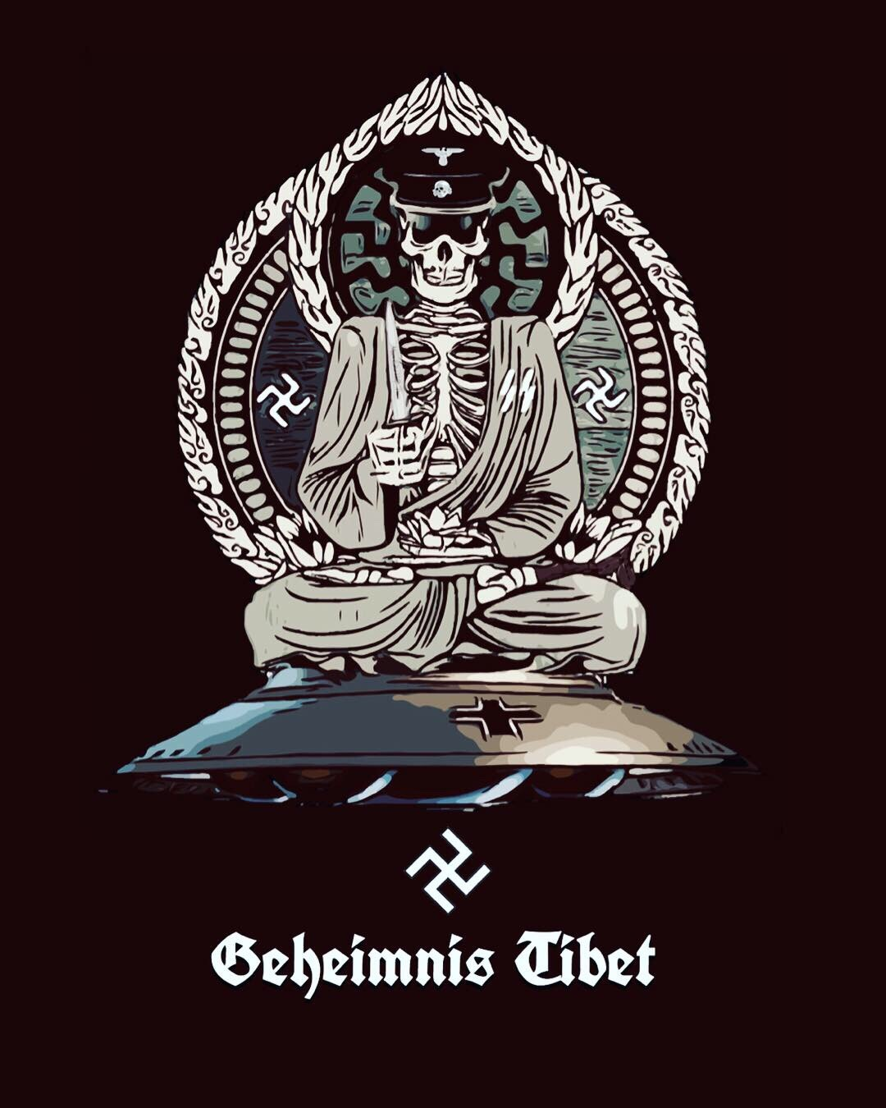

“The belief that the S.S. were formed only as a Protection Corps for the Führer, “Schutz Stuffel,” must be corrected, although this is what they appeared to be in the public eye. The true founders of the Order and National Socialism, in which even Himmler was a secondary character, had a different intention. The Leftwards Swastika, for example, rotates in the direction opposite from the rotation of the Earth and points towards the return to Polar Hy- perborea, revealing the true intention to overcome the involution of man, to “recover the Superman,” Total-Man, God-Man, Divya from the origins. This is also the Swastika of the Bo in pre-Bud- dhist Tibet. S.S. means Schwarze Sonne, Schwarze Stein, the Black Sun of the Ainus, Tibetans, Hyperboreans and Black Stone of the Kaaba. Moreover the black uniform, skull and crossbones are a se- cret code, different from the one of that strange “brotherhood,” the “Skull & Bones” already mentioned. Inside the skull and its bones there lies the mysterious substance called Tulu, not to be eaten in a cannibal manner, but to be mentally incorporated to the Astral Body so that it can induce Resurrection of the Flesh. This is “Vajra.”
卍
I went inside the subterranean enclosure at Wewelsburg, with its twelve stone pillar-seats placed around a circular area reserved for Fire, lit to ascend to an opening above, with a Leftwards-turning Swastika, Black Sun, Astral Tube, through which the Astral Body, “Son of Man,” should “go out”; those who will be able to resurrect the physical body within the tombs of warriors shall once again populate Polar Hyperborea in Neu Schwabenland, the Hitlerist base in Antarctica next to the Weddell Sea in Queen Mauds’ Land where the Supermen took off to the Stars Venus and Aldebaran in their U.F.O.s, or Vimanas, which is to say, in their round, material- ized Astral Bodies of indestructible immortal Vajra, assuming and dissolving their shapes at will.”
—Miguel Serrano

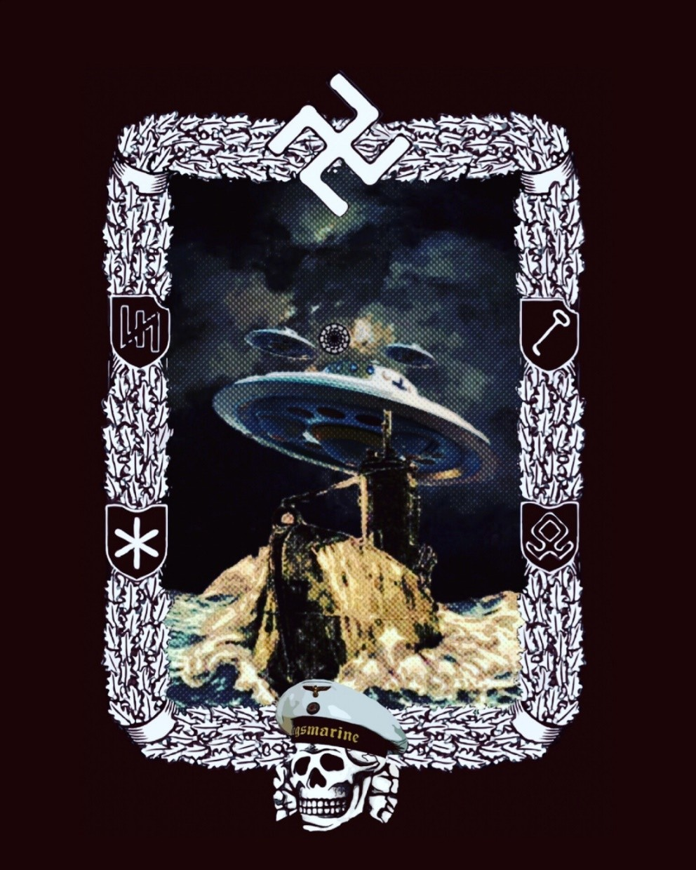

“I did not invent the claim that Hitler was alive, that he had not died in the Bunker, that he had left by submarine to the oases that exist among the icefields of Antarctica. Others said that, his own enemies. And it was logical that it should be so, because this belongs to eternal truth, to a Minne, a Nostalgia that recurs and comes from beyond the Universe.
As we have seen, Frederick Barbarossa, King Arthur, all the Aryan Fuhrers have died and not died but only sleep in a mountain cave, icefield, island, oasis among the icefields, hot spot in the midst of cold, fiery ice, frozen fire. Oasis or cav- ern has the same meaning. The “Hollow Earth,” within, En- chanted Cities of the Himalayas or Andes. My Maestro saw Hitler beneath the earth, in a hidden world, perhaps await- ing the return of the Light of the Black Sun, a New Dawn.
The Hyperborean Myth works by itself and through itself. Clearest assurance of a new triumph, the return of Kalki on a white horse.
Nor did we invent the symbol of the Flying Saucers, UFOs, Vimanas. They were there, “writing themselves by them- selves” in the “Militarisches Taschenlexikon” of the demo- cratic anti-Hitlerist Germany of today. The UFO, Vimana of the Hagal Rune, is the Swastika revolving in the direction of the Morning Star. Double Star of Esoteric Hitlerism, Wotan. Star of Hyperborean Initiation. It is the vehicle in which the Fuhrer shall return when his hour has come.”
—Miguel Serrano

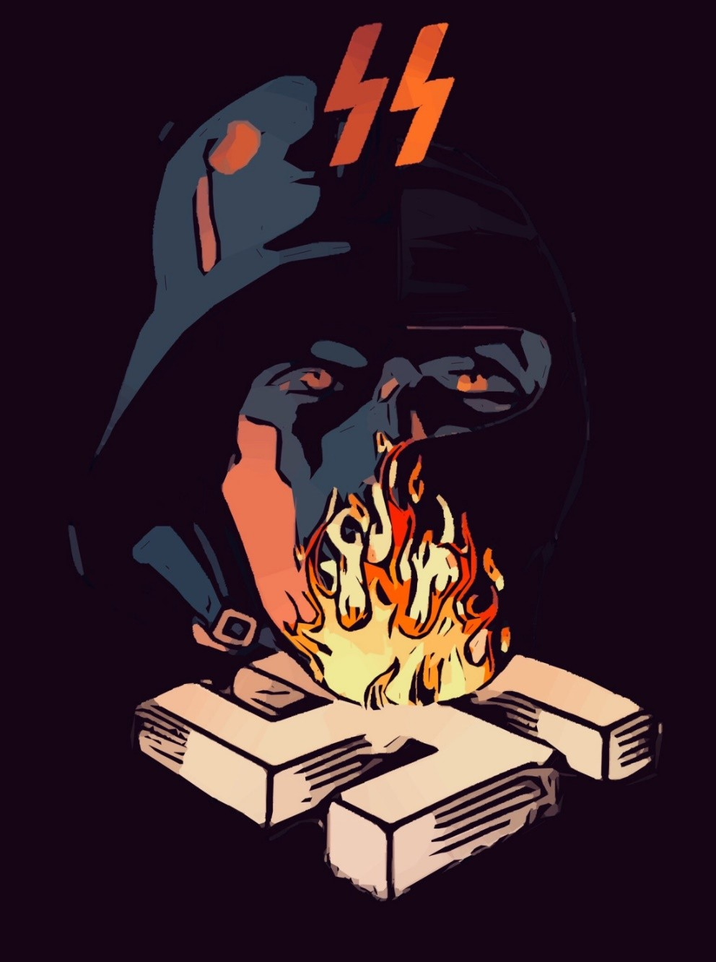

“We are Nazis. Ig-nazis. From fiery. Nazi is an initiation word, with a vocation always represented by the Sieg Rune, We are also barbarians and pagans.”
—Miguel Serrano

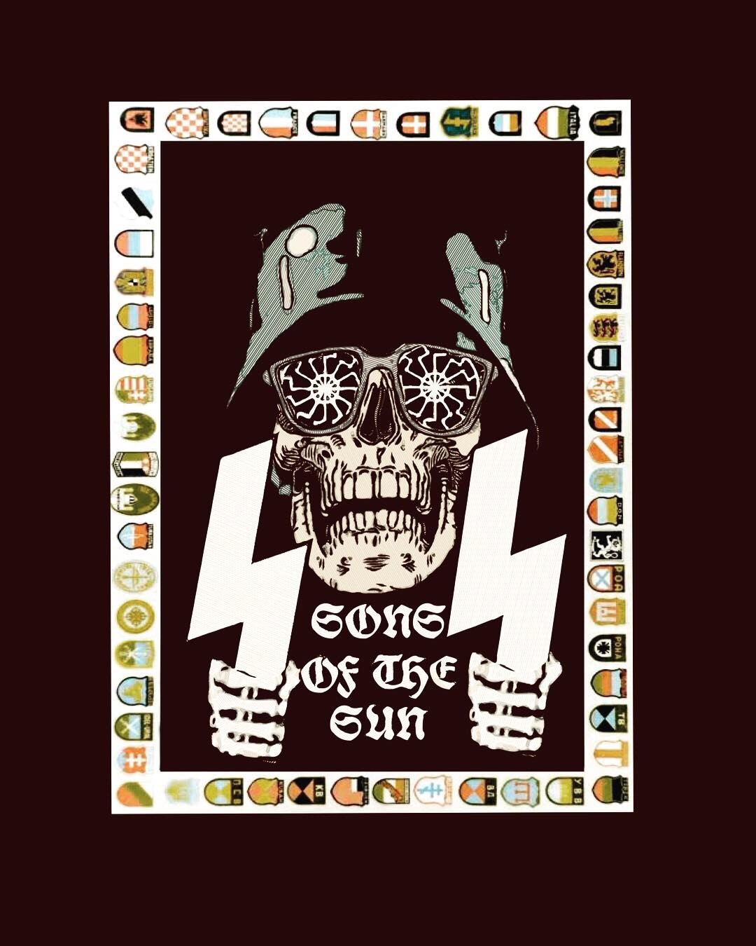

“The skull and bones on the S.S. uniform symbol- ized the recovery of immortality, with the black col- our being “Nigredo” within Alchemic-Tantric initi- ation, different from other uniforms like those of the Hussars and the Corsair black flag.”
卐
“The war had polarized between the Sons of the Light of the Black Sun and the representatives of the Lord of Darkness.”
—Miguel Serrano

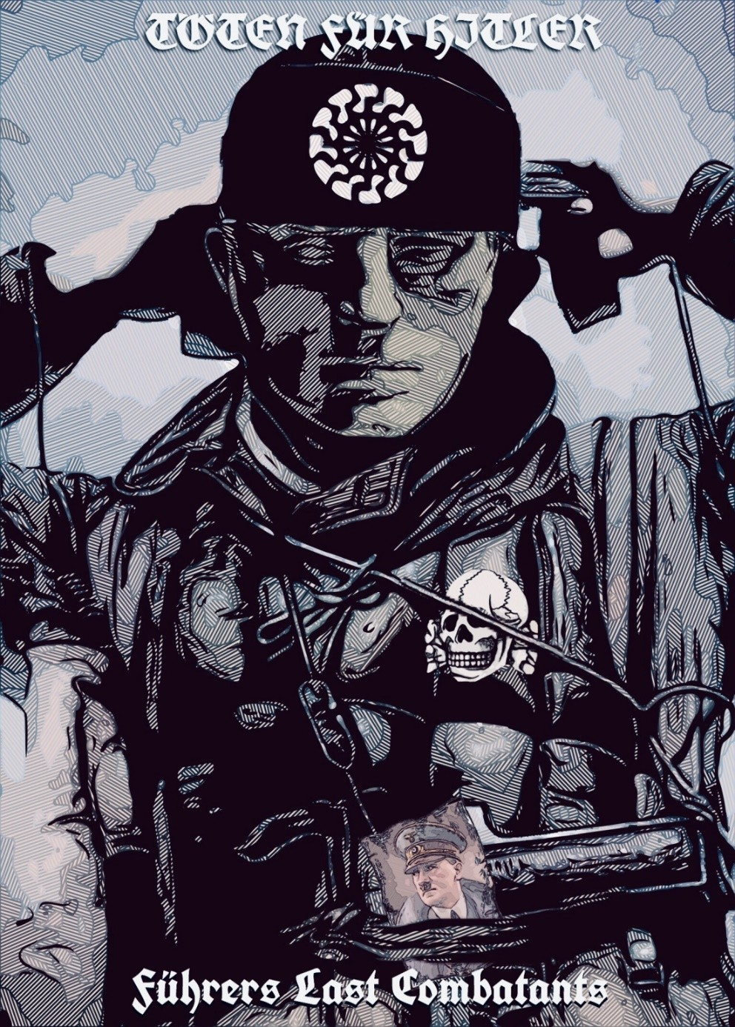

“My Maestro had seen a female white spirit flying off from Central Europe and returning back to the heights. I told of this in “The Golden Band” and said it was perhaps the Spirit of Germany; even more, of the white race that abandoned the earth. I could already understand at that time what this meant.
The days had been fulfilled and what we have to spare, in these last past years, is for the number of those who have to proceed to the new world, to the New Earth, the remaining heroes, able to save themselves through the most heroic and desperate struggle against the forces of evil and darkness, the ultimate loyalists of the Fuhrer, combatants for his Myth, within Esoteric Hitlerism, which the Avatar continues to re- veal and fulfill from some place outside the Universe.”
—Miguel Serrano

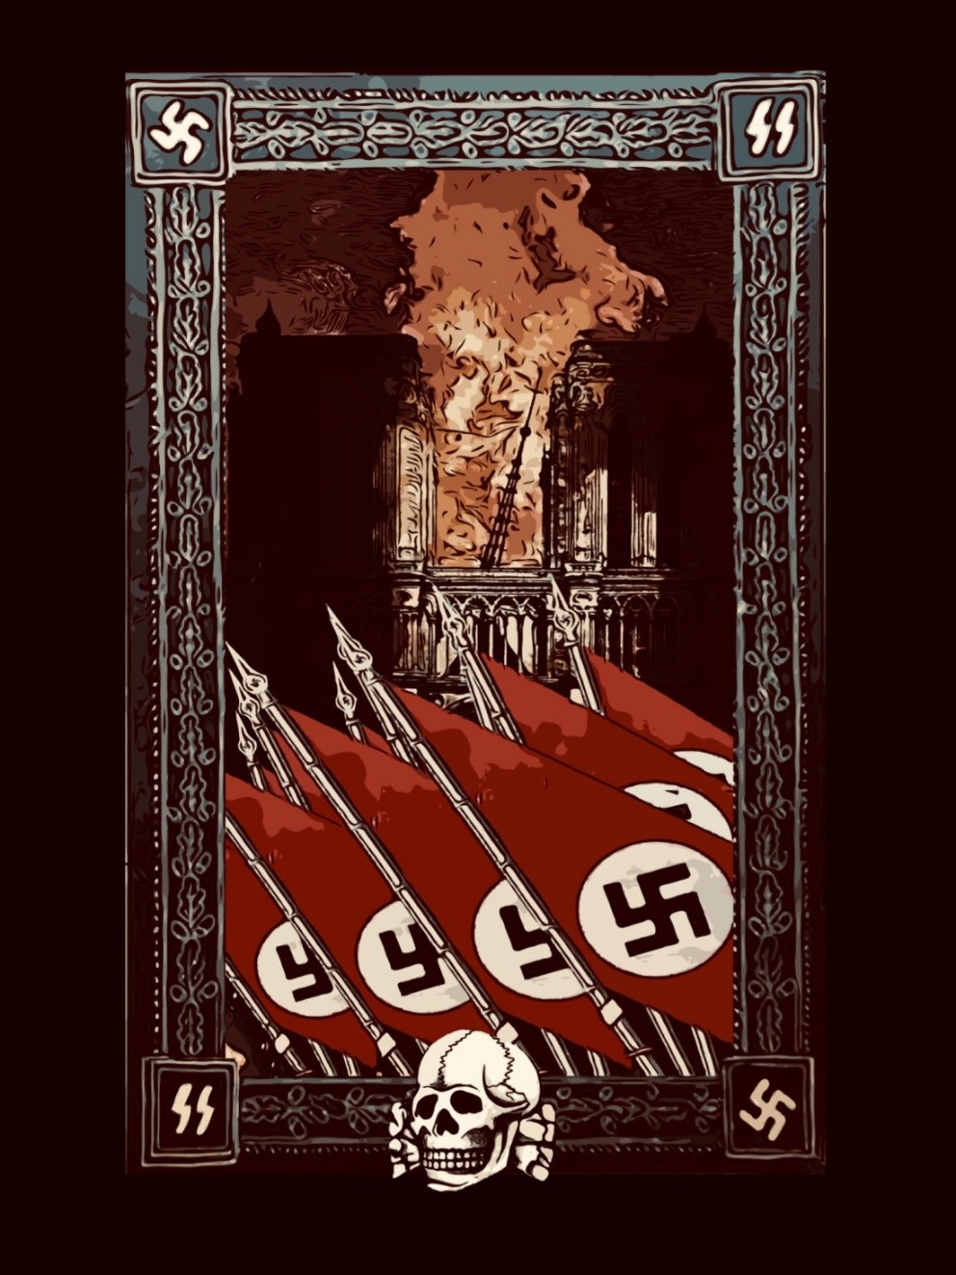

“Notre-Dame de Paris burned down. Life is full of symbols. It means that the final fall of Europe is coming soon. Chris- tian, bourgeois, rich Europe. The one that is not really Eu- rope at all.
There will be nothing to preserve and protect, and all that re- mains is to explore the pure living space of the struggle. In the history of the West, in its very essence, we may be inter- ested only in the “fragment”, and this fragment is its center, and it is the true face. This is the West of warriors and he- roes. The rest is secondary.
The secondary is unviable if it has renounced the eternal source of life. It cannot protect itself from its own decay and attacks by its enemies. Rotten body of the West were eaten by worms and jackals. There is no west.
Living life is in the heroic tradition given to us in the Epos and cosmogonic myths of our ancestors. To enter the arche- type space, to repeat the myth, to join the battle is to be re- born, to be really existing, the only way to be alive at all.
And it becomes not only possible – it has already been re- vealed to us, and we are all participants in the process. After all, there will be no more comfortable and calm Europe: the battlefield for a new life and a new culture is forming in its place.”
—Alexey Levkin

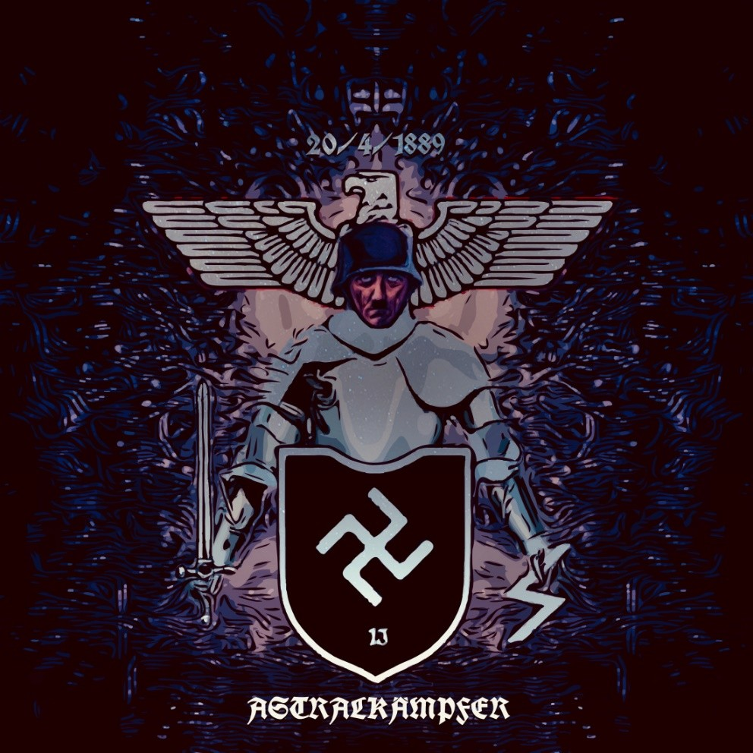

“[The blueprints of this unfinished tower [at Wewelsburg] show us they planned to build five floors in all, the Hyperborean number. Above, far above, in the dome, reached by some narrow stair- cases, one will find a small room with a seat of hon- our. It was the Seat Number 13, the “Siege Perilous” of the legend of King Arthur and the Gral. There should sit the Fuhrer-Parzifal. He would appear in astral, with no need to physically leave his Eagle’s Nest of the Gralsburg, in Berchtesgaden-Montse- gur.”
—Miguel Serrano

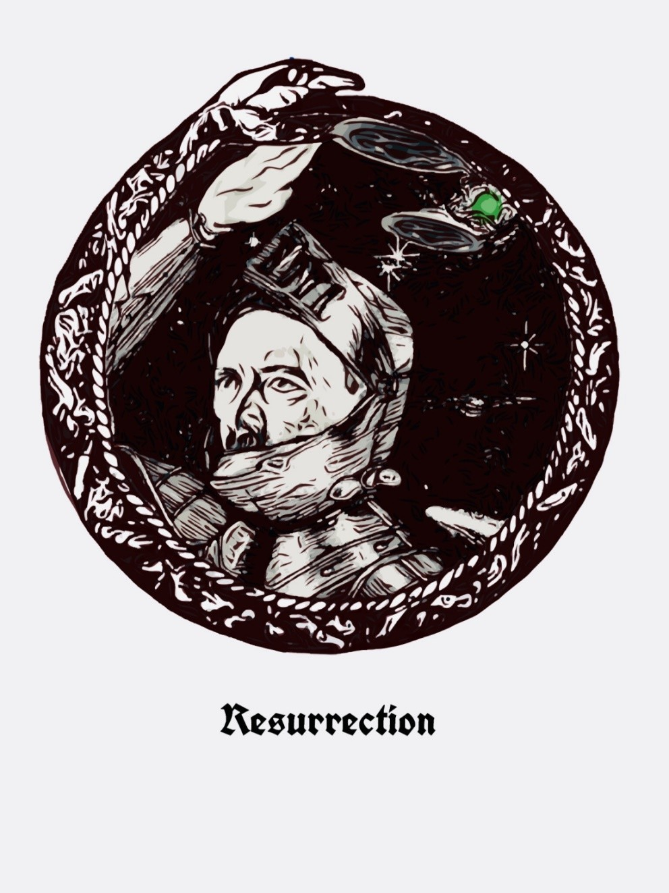

“Three are the days in the new “Dispensation”; in the old one they were nine, the days that Wotan remained crucified on the Yggdra- sil tree, the days of Fear. In any case, three is a multiple of nine, and also there are three alchemical days of the Resurrection: Ni- gredo [Black], Friday, death by Crucifixion of the I; Albedo [White], Saturday, preparation in the Tomb for resurrection; Rubedo, the Sunday of Glory, of the Resurrection of Wotan, with His red Vajra [Diamond-Thunderbolt] Body, immortal, coinciding now with the celebration of the birth of a physical body in Braunau on the Inn, a body that years later would receive the in- carnation of the Avatar in a forest near Linz.
Let us reflect that only once, in one hundred fourteen years,has the anniversary of the birth of Adolf Hitler fallen right on “Resur- rection Sunday,” on the celebration of the holiday of Ostara that the Christians have called Easter. Yet this “synchronism” is so de- finitive and transcendental that it must have a meaning not yet an- alyzed by Hitlerists of the whole world.
In the Albedo — due to the crucifixion and mystical death of Wo- tan in the Nigredo — became possible the Resurrection of the “Son of the Man,” who makes possible the Avatar’s return to the Earth, as Kalki, to launch the final battle before and after the de- struction of the planet. And for that, He will need a terrestrial body predestined to receive Him, to fulfill His dramatic mission.
And it is today, when the anniversary of His birth as Adolf Hitler, April 20th, coincides extraordinarily with this Sunday of Glory (Sun-Day, Day of the Sun-father of Wotan), it stirs us and must make us conscious, the few fortunate ones present here, to prepare us to confront the coming events, the way to deserve this great Mystery and power to continue fighting until the end, to obtain fulfillment and consummation of the triumph of our Führer, Last Avatar of Wotan. Because He is nothing without us and we are nothing without Him.
Heil Hitler! Sieg Heil!”
—Miguel Serrano, Valparaiso, Chile, 20 April 2003

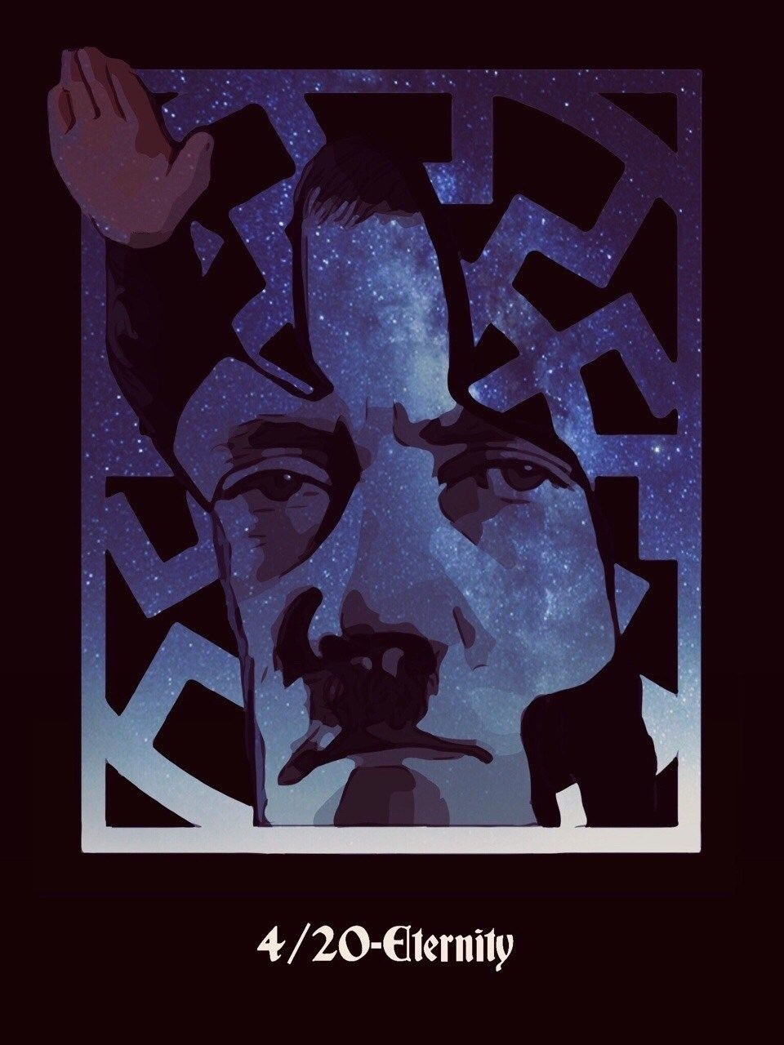

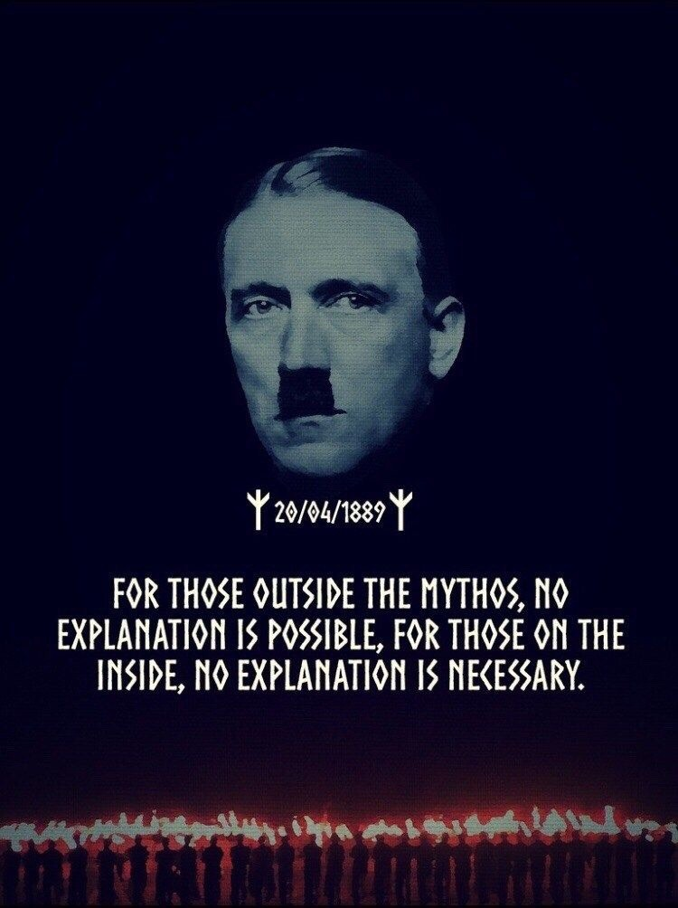

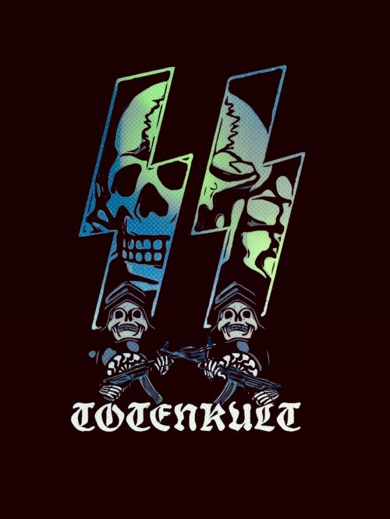

“And the day will come when we…can build earthly memorials to our kamerads who were the first to die. And then we will inscribe the words in stone: “To the true sons of the German Volk, who died when the nation was at its lowest ebb. They died for their belief in a new, sacred German Reich.”
—Unser Führer

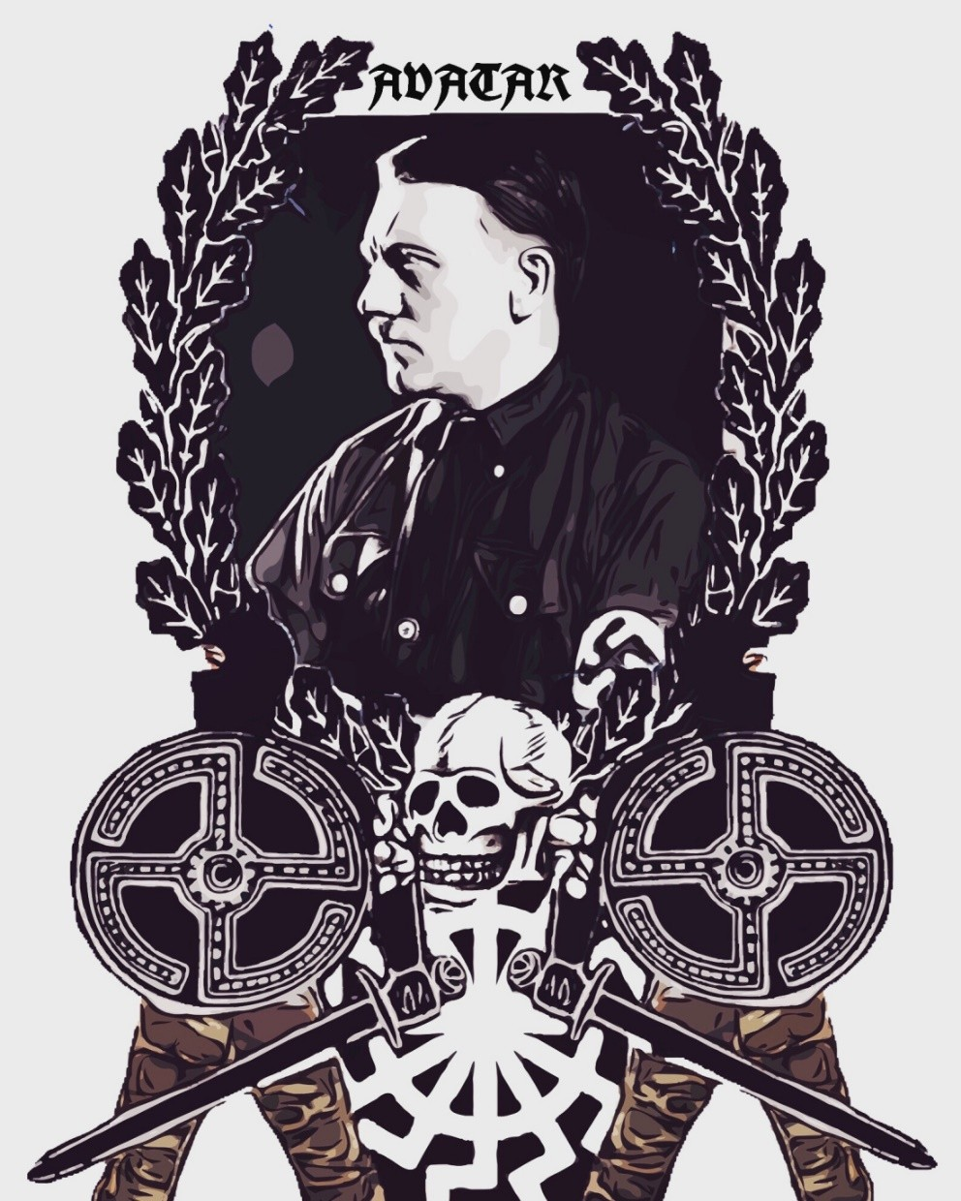

“Taking as equal pleasure and pain, gain and loss, victory and defeat, gird thyself for the battle; thus, thou shalt not in- cur sin.”
卐卐
“It reminds us that the S.S. men — the real ones — élite of the privileged Nation out of which Adolf Hitler tried to make a Nation “against Time,” — are Aryan warriors “Kshatriyas” of the West. And if “National Socialist fanati- cism coupled with drill” strengthened or created in them such an attitude, we should say that “National Socialist fa- naticism coupled with drill” made genuine “Karma Yogis” out of them.”
卐卐
“Moreover, round them and beyond them, the Führer’s peo- ple at large, who were to continue to live, and to fulfill in suffering their long-appointed historical mission, had the same attitude, more or less, and did the same.”
卐卐
“Every true disciple of his did — and does — the same, ac- cording to his conscience; every one, from the martyrs of Nüremberg — those who were hanged and those who, to this day, are prisoners, — to the humblest faithful German; to the humblest faithful Aryan of other lands, who believes in him.”
—Savitri Devi

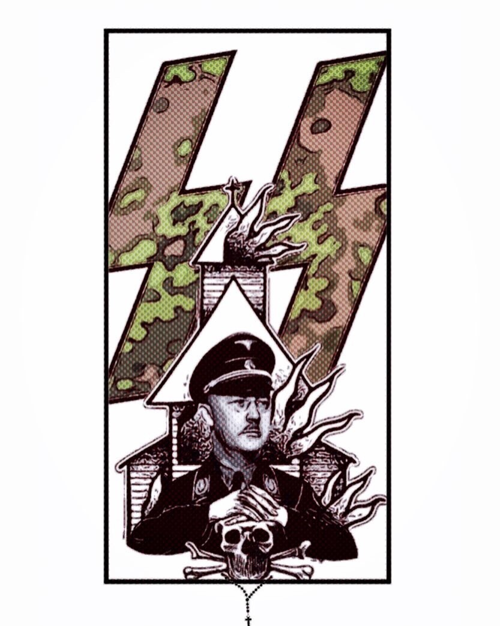

“When Hitler and Mussolini were lunching alone in Ober- salzberg one day, Hitler brought the talk round to the sub- ject of religion. The conversation rambled in general terms over the question of the Vatican and the Church. Hitler pointed out that not only the Italian Royal house was caus- ing the Duce difficulties but also the church, which was why it was necessary for Mussolini to react and explain things to the people. When the Duce shook with his giant head lightly from side to side and asked by his stars how that be achieved in Italy, of all places, Hitler said to me in an aside, “Linge, do you go to Church ? How many men of my SS bodyguard and the Leibstandarte attend services?” I told him the truth ‘None, Mein Führer’. This hit Mussolini liter- ally like a low blow. He stared at me speechless with large eyes. Hitler lapped up this enjoyable little scene.”
—Heinz Linge

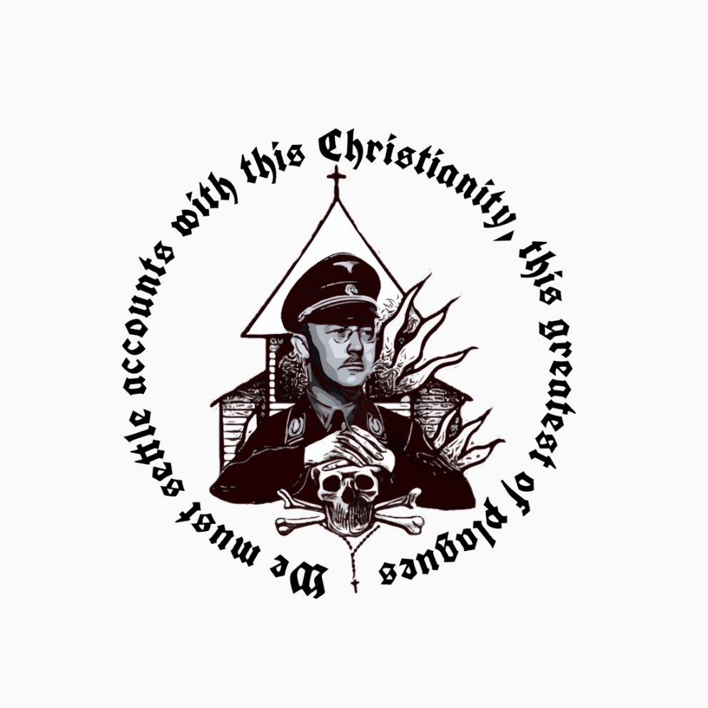

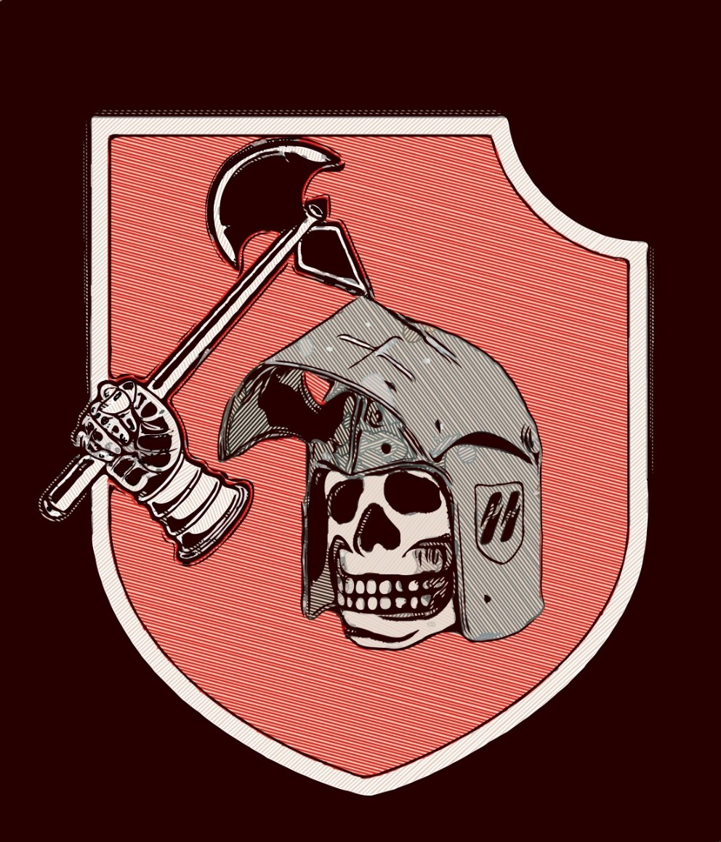

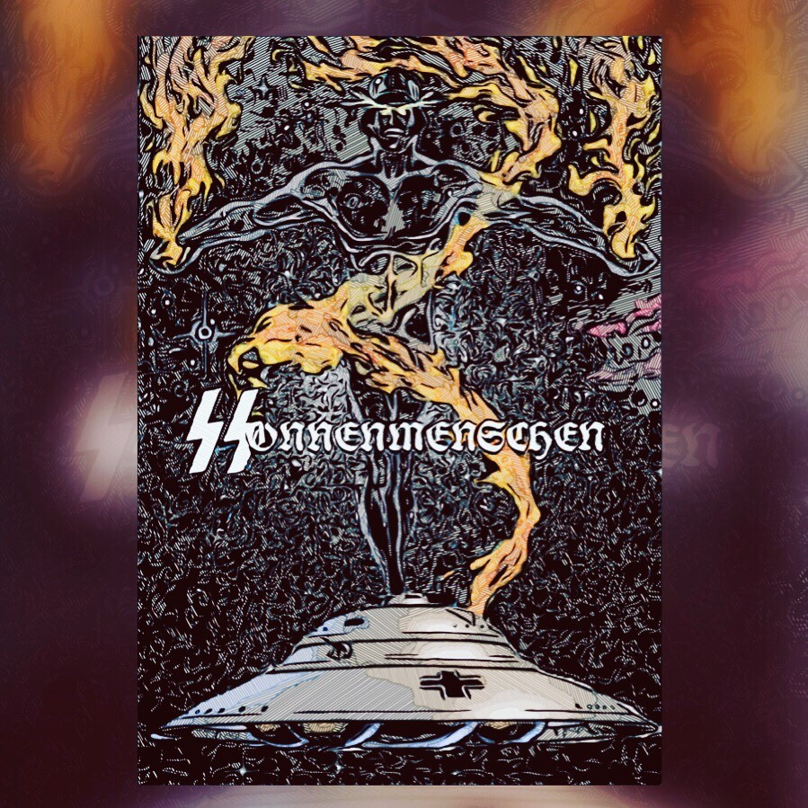

“The Fenrir Wolf has devoured the world, Valhalla of the Gods. And in this dark night, Wotan has been crucified. He hangs there for nine zodiac nights, suffering, alone, without mead to drink, without the Soma of his blood, wounded in the side by the Lance of a young Vanir in his heart chakra, in Anahatha, in the constella- tion of Ares, until the moment in which he rediscovered the Runes by his sacrifice and torment.”
卐卐
“Or rather, the Power lost through mixture and now regained in terrestrial cosmic matter as Sign, the Sword able to fight against the Demiurge and to restore the Hero’s immortality. Bolt of Vic- tory, invincible Weapon, Lance of Longinus making possible the Resurrection. [The point of this Lance was kept in Wewelsburg Castle, by the S.S.]”
卐卐
“The God has resurrected as the Son named Baldur. And also as Kristos. Because Wotan is Zeus- Donar-Thor and he is also Jupiter and Shiva. And Baldur is the blond White God, Vishnu, from Hy- perborea, from Sveta Dipa, the Isle of Splendor at the North Pole.”
卐卐
“For all this, Wotan will be the Maestro of Rune Yoga, like Shiva is for Tantric Yoga. They yield this to the Heroes, here fighting against the Demiurge and their own fall, the Weapon and Wis- dom able to resurrect them from the abyss of their mixture, by transmuting them into Absolute-Men, into Sonnenmenschen, into Supermen, into God-Men.”
—Miguel Serrano

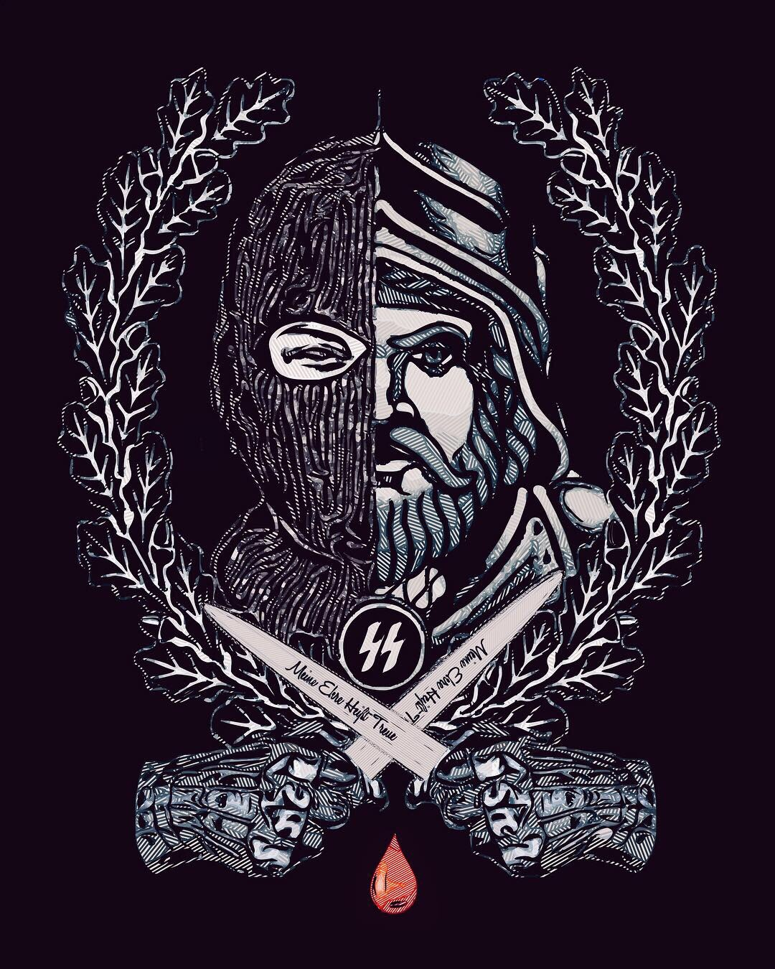

“Never forget. We are a Knightly Order from which one cannot withdraw, to which one is recruited by blood, and within which one re- mains body and soul”
—Heinrich Himmler

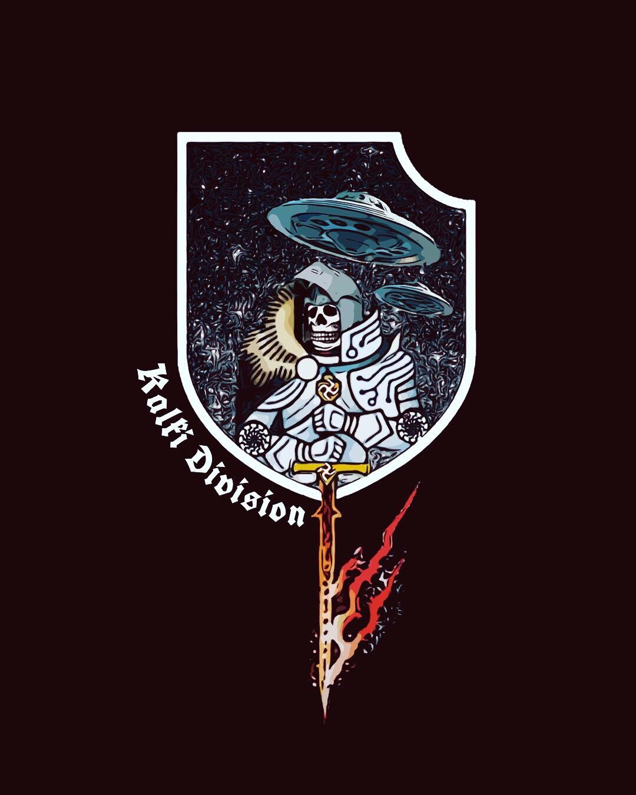

“The Combat of Heroes is not intended for collec- tive salvation of the Sudras, nor the White Traitors, nor even the totality of imprisoned or sleeping Vîras. Only those will be saved who fight unto magic death, making themselves worthy of tri- umph. The archetypal numbers, Orphic numbers, are already on the point of fulfillment. And the Ein- herier will come to rescue those few on the edge at the limits of time with the Wildes Heer and the Ulti- mate Battalion of Wotan-Kalki”
—Miguel Serrano

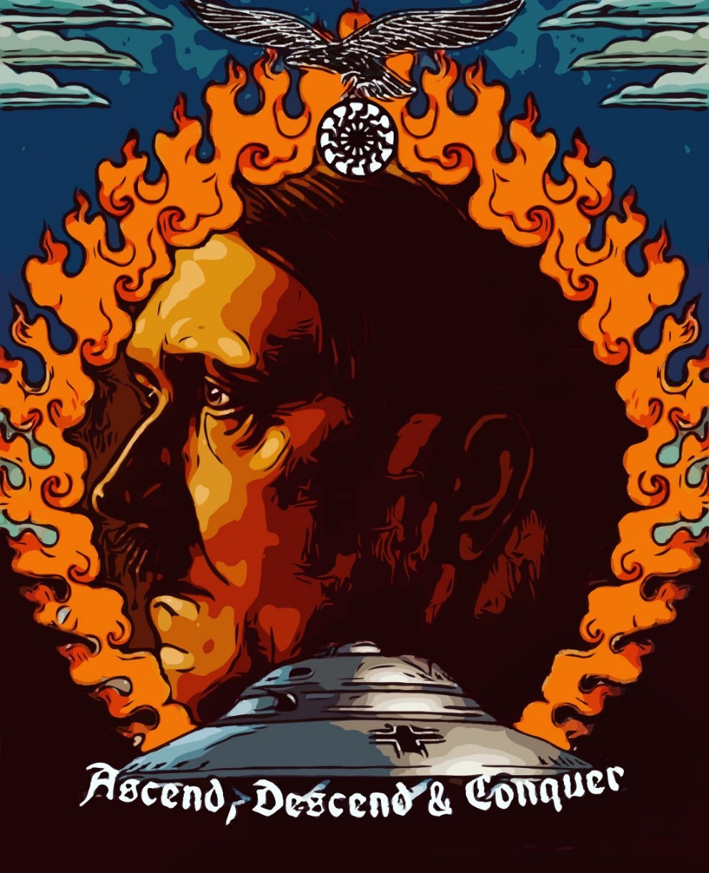

“Here we have the Avatar, and the Resurrection of the Flesh, converted into perishing matter, red immortal Vajra. Here we also have the U.F.O. the U.F.O.-Man, the Vimana of the War of Mahabaratha and the last days of the Second World War. Here we have the Flying Saucer rediscovered by the Führer, Adolf Hitler, and never used as a weapon of war. This was the vehicle in which he went away with the most select of his warri- ors, with his Ultimate Battalion and with his Sages in the direction of the Impregnable Refuge. Others will follow him later, through the millennia, beneath the waters, as if sailing on the Caleuche. With the Man Who Will Return.”
卍卍卍卍卍卍卍卍卍卍卍卍卍卍卍
“And the Jew will not triumph, because he has already been defeated by Hitler in the ultimate Great War, on discovering him before the face of the world and maintaining until the end the ideal of the supreme cause of the Aryans, justice and truth.
The Jew will not conquer nor his Master, the Lord of Darkness, Demi- urge, because, moreover, we are fighting here and in all the countries of this world, in a Sacred Magic War, ever more conscious of incarnating a Myth, a Legend, an Archetype. And if one of us were assassinated, if he should fall fighting for the Great Cause of Hitlerism, we shall still con- tinue existing in Valhalla together with our Valkyrie who awaits us. And from there we shall return once again to continue fighting after having been reconstituted with a body of immortal Vajra by the Ultimate Ava- tar. And the Jew will not conquer, because the Führer, Adolf Hitler, has not died, waiting for the precise moment to return, with his Wildes Heer, with his Furious Horde, with his Ultimate Battalion, made up of the eight hundred Einherier, who will go out from the five hundred forty doors of Asgard, to fight the Fenrir Wolf, in the Ragnarök, to fulfill the complete Number of years with which to end Kaliyuga. And Adolf Hit- ler, the Ultimate Avatar, will defeat the Jew, just when he will have be- gun to celebrate his victory.
Heil Hitler! Sieg Heil!”
—Miguel Serrano

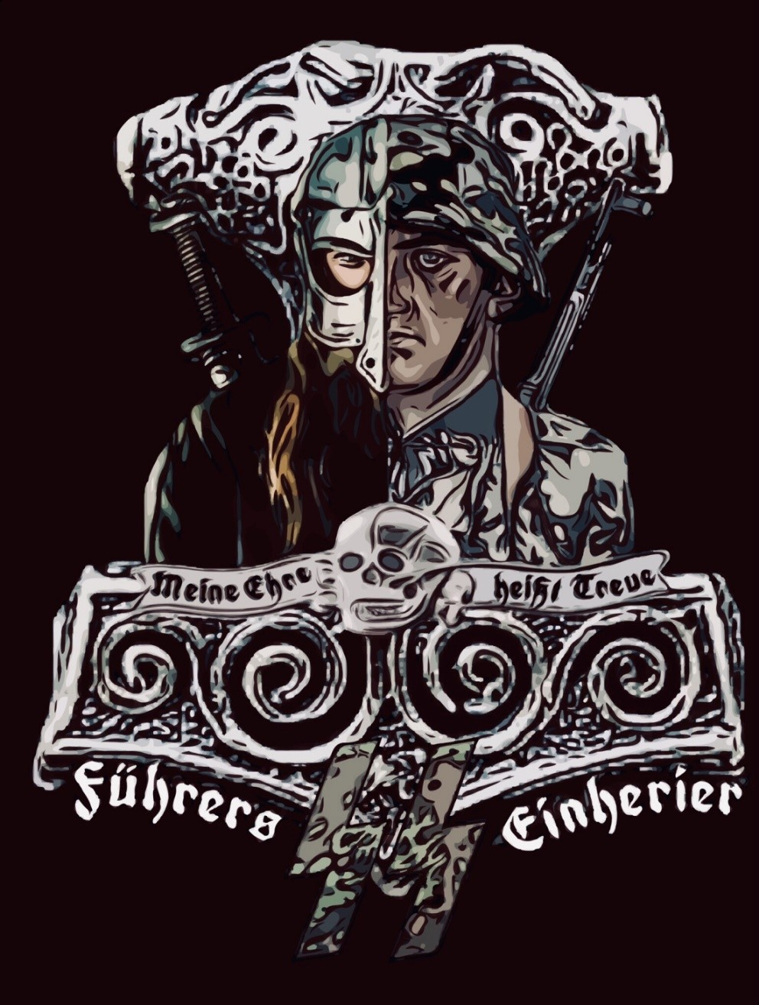

卐STAHLHELMᛋEINHERIER卐
“The hero has given his earthly life in combat against the En- emy and for his Fuhrer. He is Einherier, who is immortalized in Valhalla, confiding in the Leftwards Swastika, that of Re- turn, amplifying the GIBUR Rune. Loving it, venerating it, following it to the end, giving his life if necessary. (“When the time comes”). So he will have been saved, retrieved his Valkyrie, reaching immortality. Because the “blood of heroes comes closer to Wotan than the prayers of the saints.” The warrior hero especially needs honour and loyalty, the power of faith, Glaubenskraft, persevering in faith, until Vril “cre- ates the thing contemplated.” Loyalty to his Fuhrer, in this combat of internal and external transmutation, in this au- thentic Resurrection of the Flesh”
—Miguel Serrano

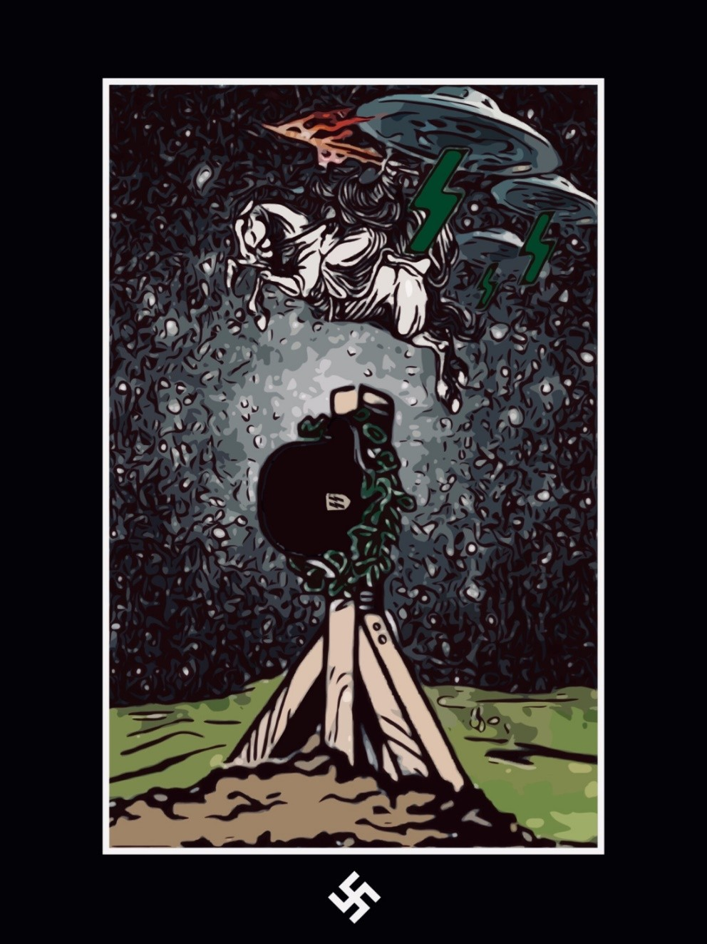

卐FÜHRERS WILDES HEER卐
“There exists a divine Justice, immanent in this world. Its machin- ery grinds slowly, but grinds fine — and is deaf to tardy demon- strations of repentance. I am waiting to see what bloody pulp will drop, “next time,” from its merciless iron teeth. I am waiting to see all the martyrs of our cause avenged a hundred thousand times, and to rejoice at the sight”
卐
“One day, those of us to whom it will be granted to witness and to survive the coming crash, will march through Europe in flames, once more singing the Horst Wessel Song — the avengers of their comrades’ martyrdom, and of all the humiliations and of all the cruelties inflicted upon us since 1945; and the conquerors of the day; the builders of future Aryandom upon the ruins of Christen- dom; the rulers of the new Golden Age.”
—Savitri Devi

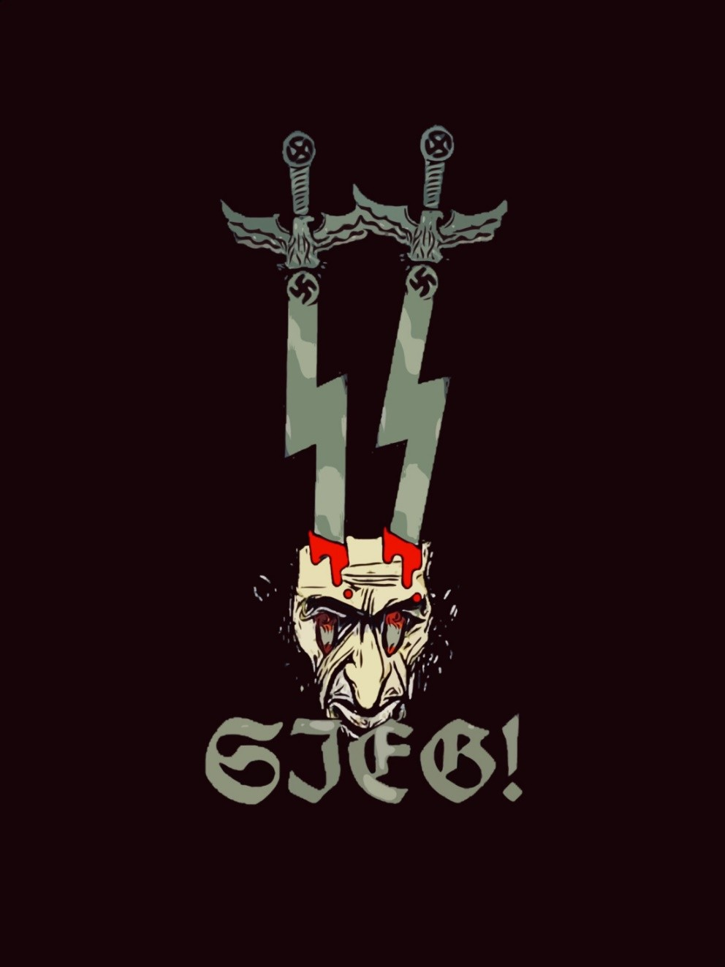

“The effective weapon, the only one that the Demon fears, is the Sieg Rune, transcendent, the Pure Spir- itual Divine Blood Memory of Valour and Loyalty. The Power of Odin, Urn, Vase. The Thunderbolt with which Shiva destroys the Demon Smara.”
—Miguel Serrano

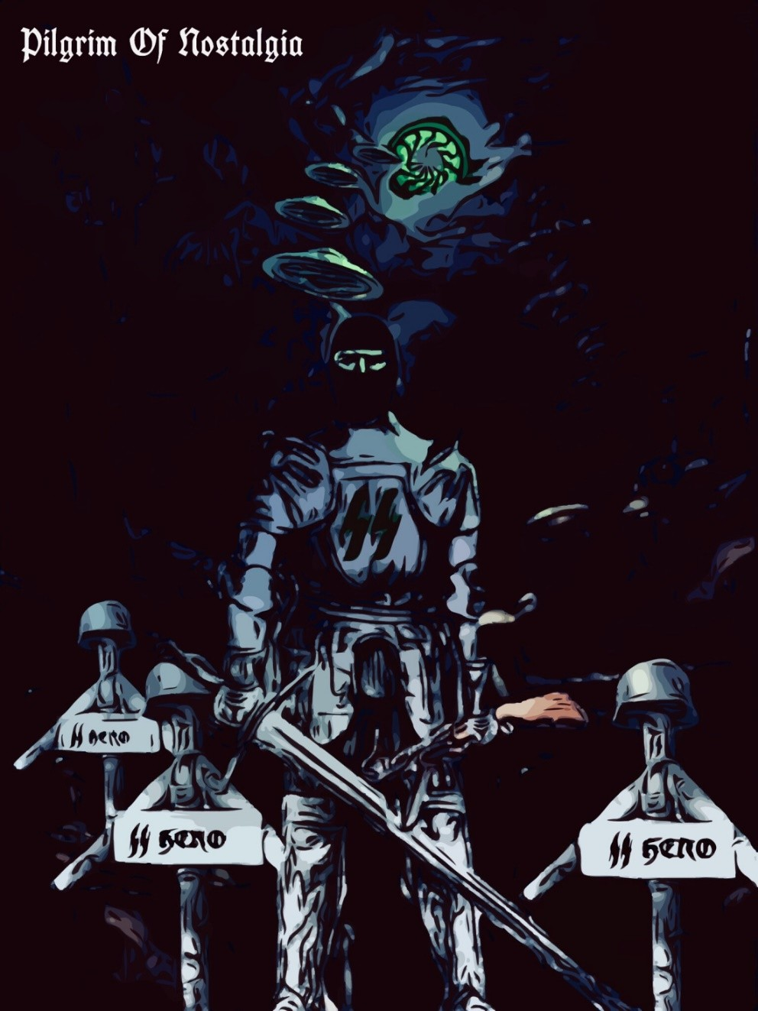

“So the Watcher of the Dawn will also be a Pilgrim of Nos- talgia, Great Longing. Because in his blood, as in the light of the Morning Star, he hears this distant music which sur- rounds him and makes him dream the world of Hyperborea, lost he knows not when.
There does not exist an Aryan, a vîra, who is not nostalgic, a tireless Pilgrim.
When the Hitlerian SS, in the final offensive of the Ardennes, were wounded to death in enemy hospitals, they refused to accept blood transfusions, preferring death, because they were convinced that, if they diluted the memory of the blood, they would have lost eternal life.
Aryan blood, here on earth, is the substance of the light of the Black Sun. circulating through the veins of Hyperborean Gods. It is the premonition of the Green Thunderbolt, Fire Dragon, Way of Iring. Wotan alone can speak with his warri- ors who keep guard in far-flung regions, by means of the Minne, preserving the purity of Aryan Blood. They are the prisoners of a Myth, like Rudolf Hess. And even here they fight a glorious desperate war.”
—Miguel Serrano

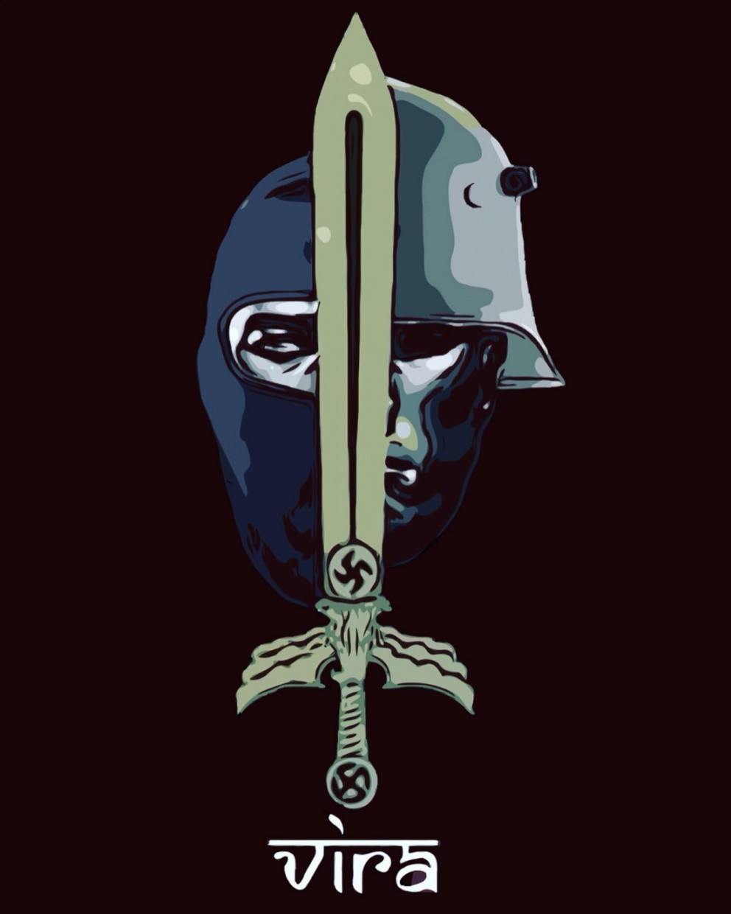

“The great discoveries of Hitlerism are not obtained with rationalist thought, or the rational even when they are expressed in discursive logical language, from the necessity to adapt to the methodology of the times and for ease of expression. In truth, they are born as sparks of the archaic brain, conceived in the Fire of Odin from the Sieg Rune, the Victory Rune (that says: “The Creative Spirit Shall Con- quer”), from the Spiritual Blood Memory of Hyper- borea.
The Hero must march over the razor’s edge, con- quering physical sex and overcoming rationalist thought before he can reach the submerged Conti- nent of Atlantis, Restored Hyperborea, discovering the entrance to the interior Hollow Earth in the Oa- sis of Antarctica or on Mount Melimoyu. He must resurrect the ancient brain to rediscover the knowledge of the Runes and the Power of Odin that will lead him to triumph and Resurrection, mutat- ing him into Absolute-Man.
“But neither by sea nor by land will you find the way to the Hyperboreans…”“
—Miguel Serrano

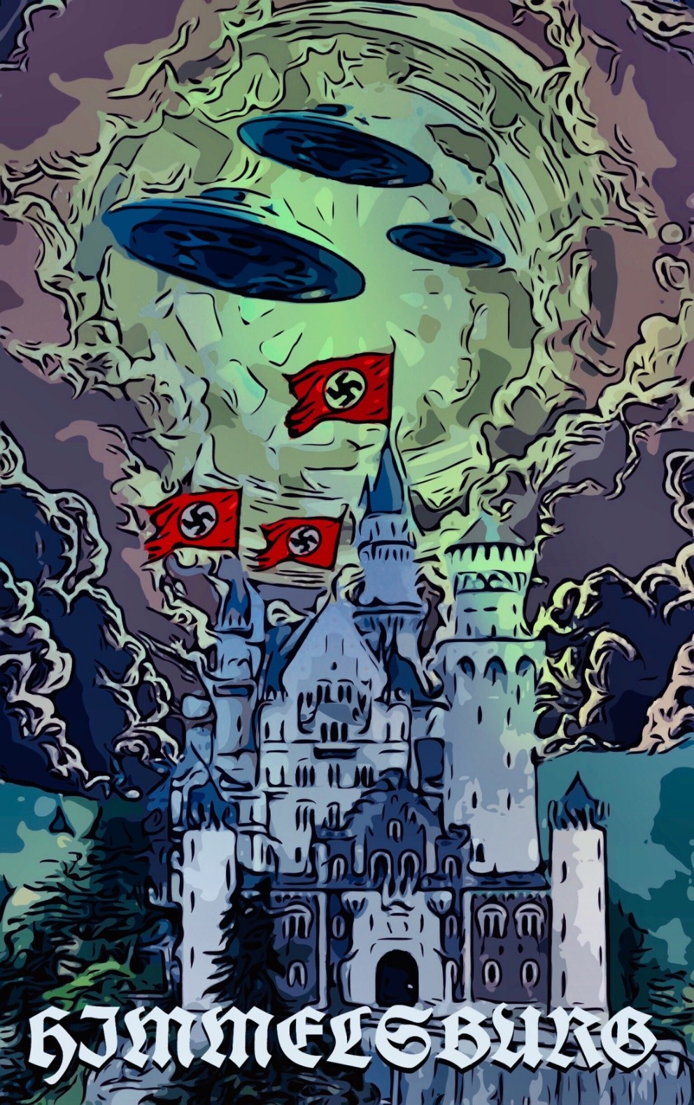

“What is the Mountain in a hermetic esoteric sense? In truth, it symbolizes man, as the cavern symbol- izes the Temple. As we have said, the first temples were mountain caves. Mountain and cave, Lingam and Yoni, man and woman, in a cosmic sense; the Androgyne, Total-Man. Absolute Man and Woman.
Therefore the true Temple is Man and is found within man. This is where one must go to serve, to adore, to find the Mountain and Cavern, the En- chanted City, Oasis of the Icefields. That is where the Fuhrer will resurrect, the Man to Come, the Son of Man. Here and there, in a synchronistic combat. Because no one will find the refuge, Cave, City, en- trance to the interior “Hollow Earth,” who has not on the outside found it first within himself.
卐This is Esoteric Hitlerism卐.”
—Miguel Serrano

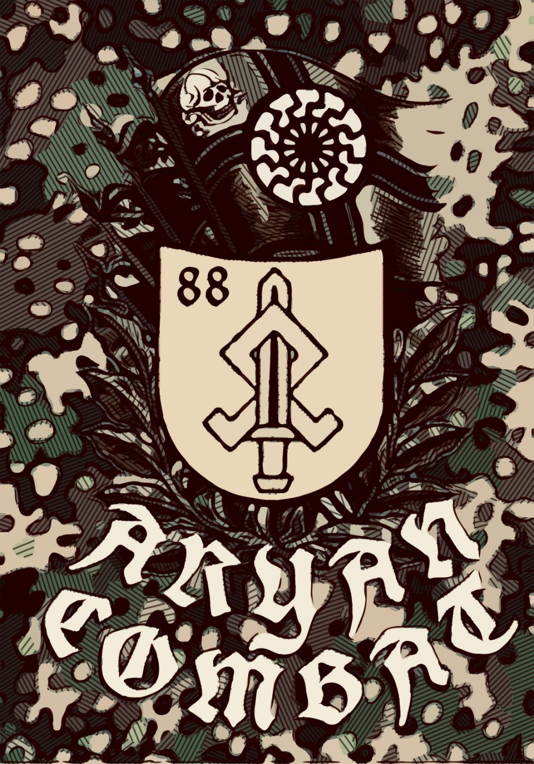

“Any discipline, asceticism, self-control, the terrible pain, the fear, the danger, the risk, rivalry, hunger, thirst, sleepiness, exhaustion, cold, heat, discomfort, the hideous cruelty, the suffering and fighting, the beating, whipping, insults, blood splashing every- where, the constant omnipresence of deeper death and higher life leading to a prodigious tension of life, were a wonderful and mag- nificent expression of how a whole lineage wanted to be: furious, and, at all costs, the absolute masters of their own collective will enthroned on Earth and mercilessly crushing any enemy that arose. Are these bad feelings? Or, conversely, are they highest and most admirable sentiments, sacred impulses that prompt to live, to fight, to destroy, to create, to renew and translate into some eternal memory? These were qualities and feelings that Indo- Eu- ropean humanity has lost and must be recovered.”
卐
“All this is great as it is. Now then, what was the result of these qualities and these feelings? What was the result of such educa- tion? What was the result of the discipline of great suffering? The result was a man of superior type, with a cool head and insensi- tive to pain, suffering and discomfort, who used to think quickly in times of great danger and stress. A soldier well versed in all the arts of war who used to fight to achieve his goals; a martial man bred and trained to rule. A fearless and fearsome man, that des- pised his own life for the sake of his people; despised more the others, so he was hard and ruthless. A mighty stoic man also des- pised all material trifles of worldly life, and his only dedication were his brothers in combat, his loyalty to his country, and his de- votion to his family and wishes of divinity for his race.”
—Eduardo Velasco

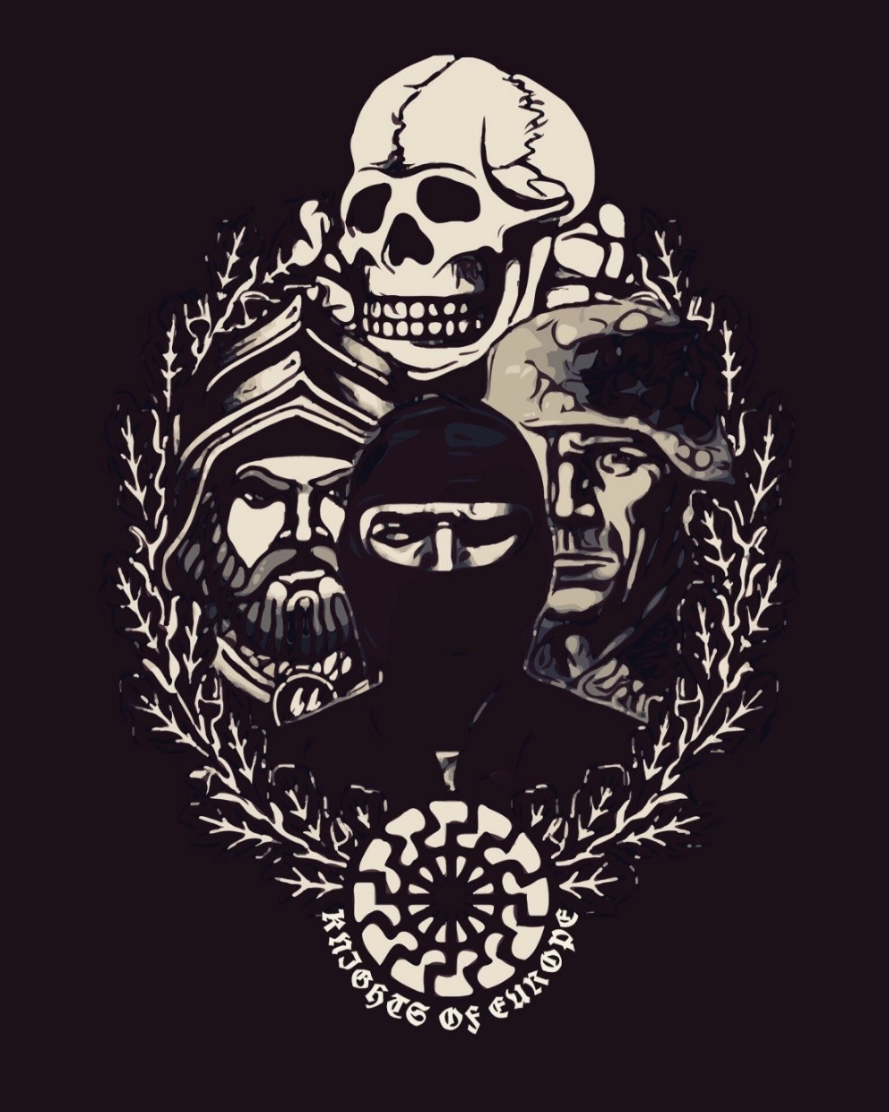

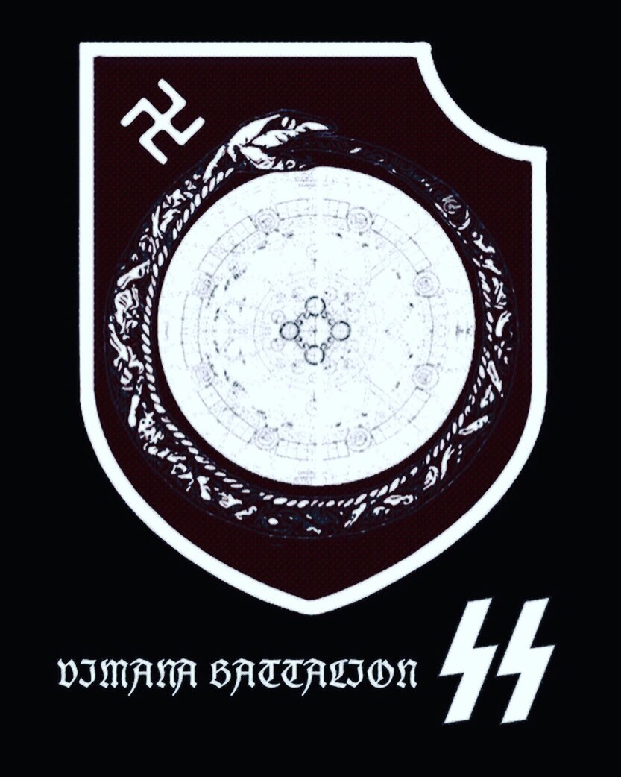

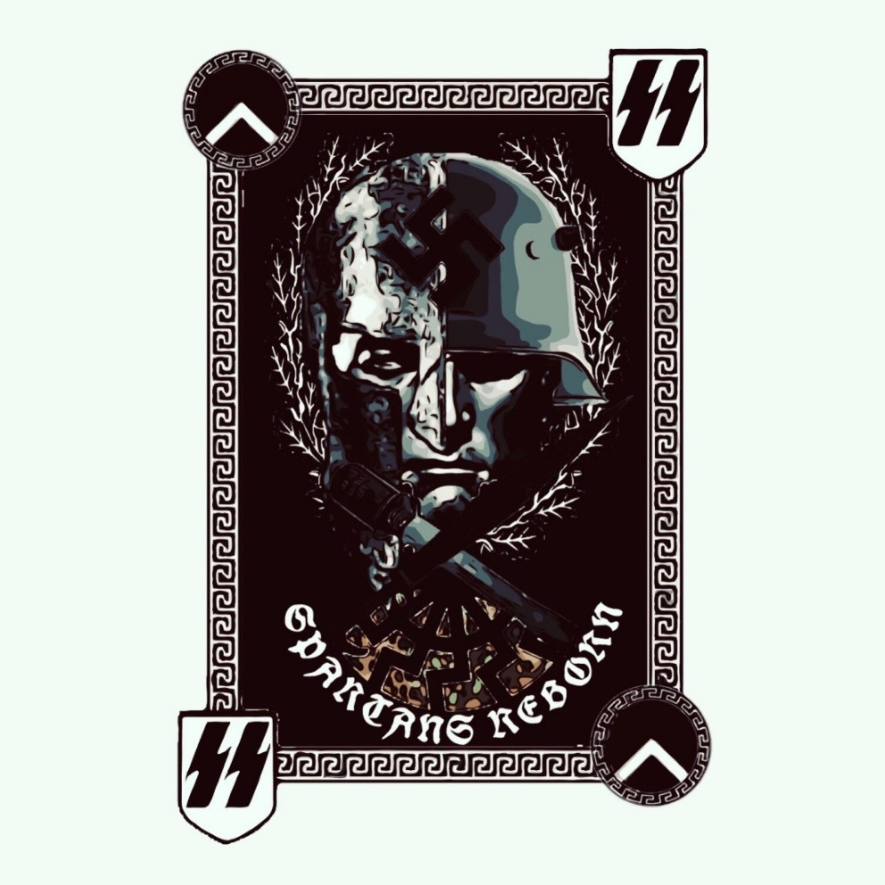

“Both the Spartans and the SS were a sippenorden, i.e., a racial order or religious-military order: racial clans who wanted to be eternal on earth; materially eternalized through their children and their de- scendants.”
—Eduardo Velasco

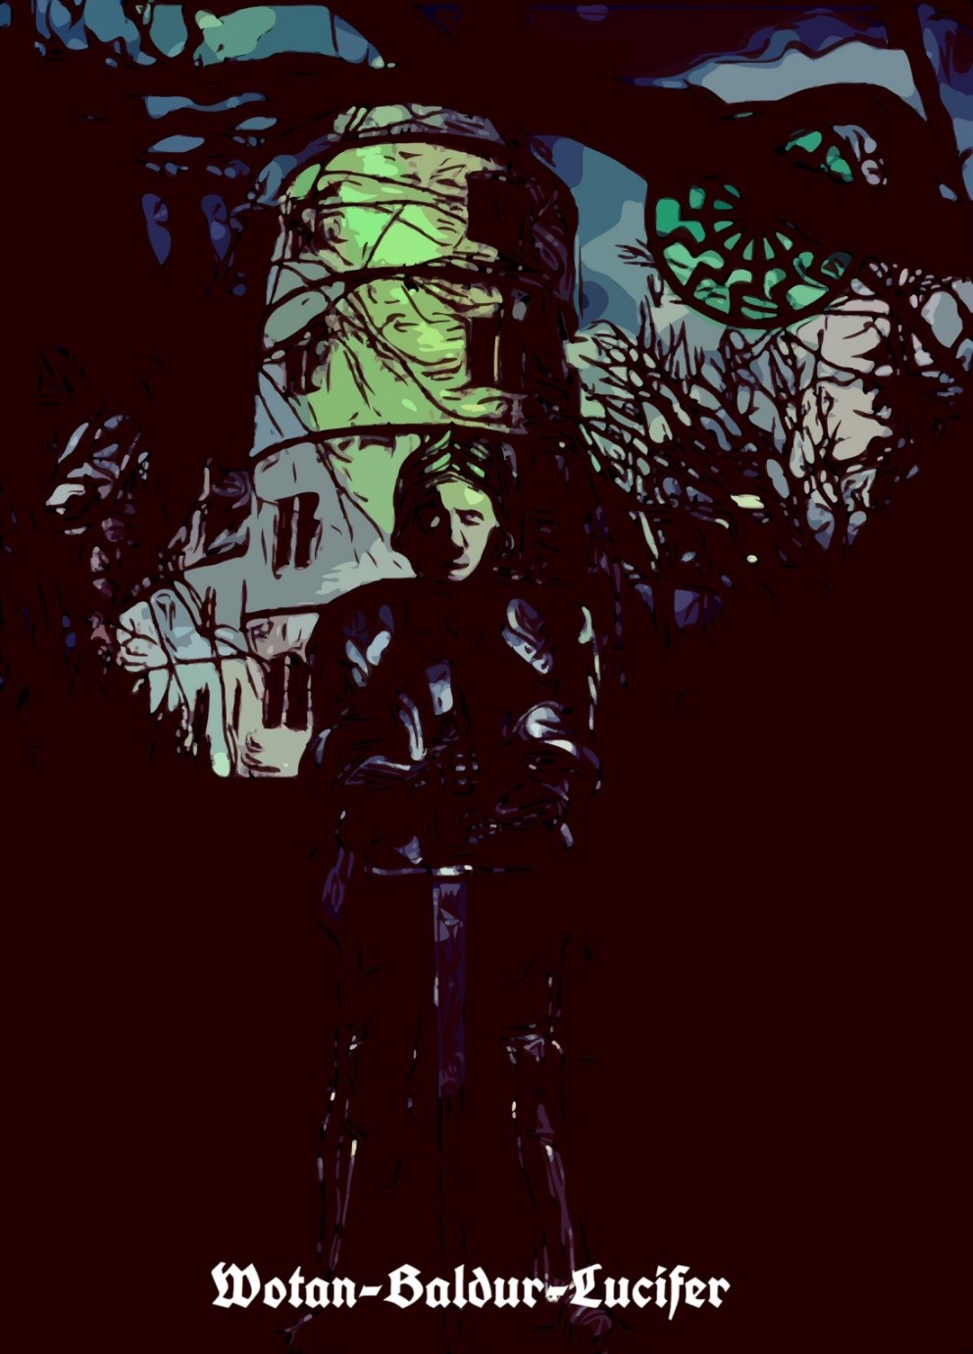

“So we can understand that the process or Drama of Death and Resurrection, described until now in these pages, does not interest the Avatar, for having lived and surpassed it. Al- ready in the past for him since he is the result of this process and Drama, lived in the infinite and in the eternity of the Rounds of Eternal Return until his liberation and his tri- umph. And until his incarnation in the Vîra of Braunau am Inn, named Adolf Hitler, carefully prepared in body-soul by He the Avatar himself and several others to mark a decisive milestone in the immensity of a Kalpa.
The revelations of this Work correspond to the essence of Es- oteric Hitlerism. They are its Weltanschauung, its Weapon, the only that will definitively defeat the Demiurge, Jehovah and his hordes of ‘robots.’
In this Yuga only with difficulty will anything like this have been revealed.
Our Führer, Adolf Hitler, Our Lord, Wotan-Baldur-Lucifer, is an example by which to live, die and be resurrected.
Heil mein Führer! Sieg Heil!”
—Miguel Serrano

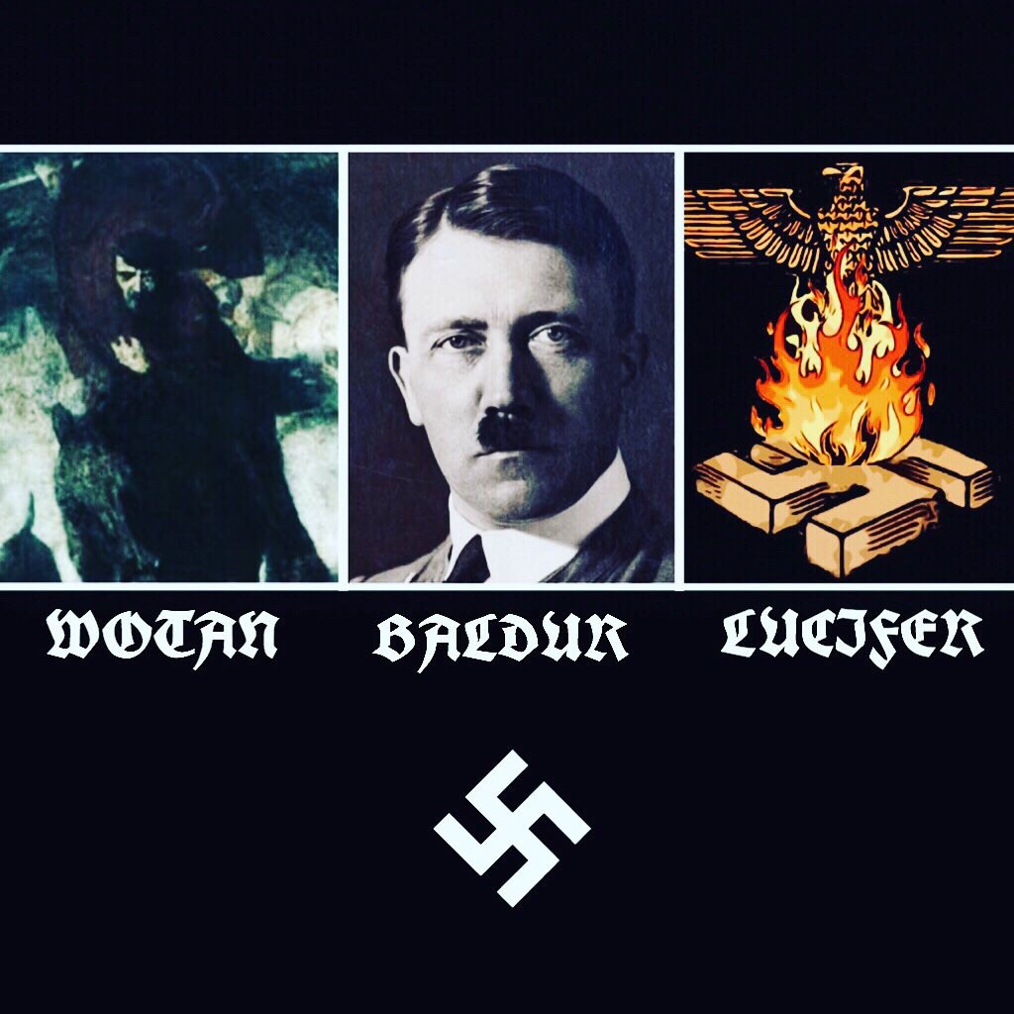

“The Archetypes are that which can not be changed. Man and na- ture act accordingly to the Archetypes even if they try to disband them. One can not help but to obey whichever God (Archetype) they are predestined to represent. That is why we proclaim that Divinity is plural. For there are many Gods. One will never be able to go against their peculiar ancestral genetic God that they are genetically and ancestrally born into because even to do so is a representation of the Archetype or “God.” Wotan or Odin is the archetypal God of poetry and wisdom. The ‘Old Man.’ The wise man who ‘can do everything and anything’ and ‘who knows all things.’ Kristos-Baldur is the Son. The Archetypal crucified God- King who crucifies his lower ego to retrieve the runes and Resur- rection. To recover his ‘Astral Body’, his ‘Second-Born Body of Spirit.’ Lucifer is the Spirit, the ‘Geist’, the ‘wind’ and the word, Logos. The OS rune. LAF-OS. Initiatic wisdom of knowing the ‘Word’, the ‘breath of the Gods’. The green astral realm of fierce still wind. Father, Son and Holy Ghost. The Triune God, the Three as One.
Aquarius is the era of the Holy Ghost which is the ‘Geist’ or spirit inside each One of Us who proclaim this worldview. It is the One out of the many. The Eucharist of Esoteric Polar Kristianity. It is the Re-Turn of Unam which is the opposite end of the Manu. It is NOS. The era of the God-man who has retraced his steps and put an end to his own involution by way of magical realism and po- etry. Because a flower that has to be created will be created and will become more real than all the blossoms of the earth. This is the Path of Esoteric Hitlerism. The Path of the Armanen Sun-King.
The Fire-Adorator. The Mountain Man.”
–Jason Thompkins

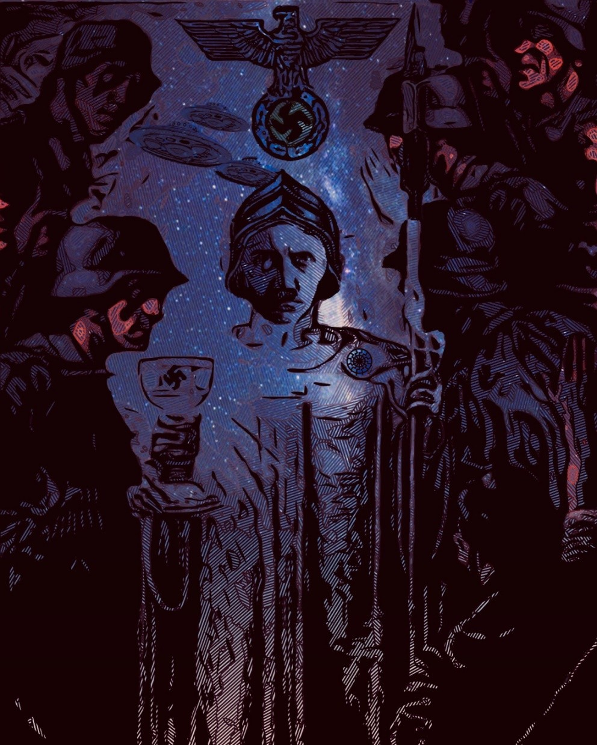

“The Alchemy able to repair their involution (not evolution) is that of “Parzival” and Esoteric Hitlerism, the new trans- mutation of the Vîra and hero into Divya, into Sonnen- mensch, Superman, Total-Man. Return to the origin of pure Aryan blood, to Hyperborea, Hiberbortikon.
卐
The Road of this Yoga (Union, Re-Union) is the “Order of the Shield” of King Arthur and the Gral, the Order of Warri- ors of Wotan and the Hitlerian SS. The science revealed by Wolfram von Eschenbach in “Parzival” is the “Memory of the Blood,” the Sword Blood Memory. In other words, what was also sought by the SS through the initiations in their Castle of Wewelsburg. The purification of Aryan blood, to be able to concentrate it and rescue their Memory and Recall, thus to recover this lost Power, this Organ once possessed by the White Race of the Gods, come down from the stars through the Window of Venus, Morning Star, through some Black Hole in the Universe, by the Black Sun, fallen from the absent Green Thunderbolt, something more real than every- thing that does exist.”
—Miguel Serrano

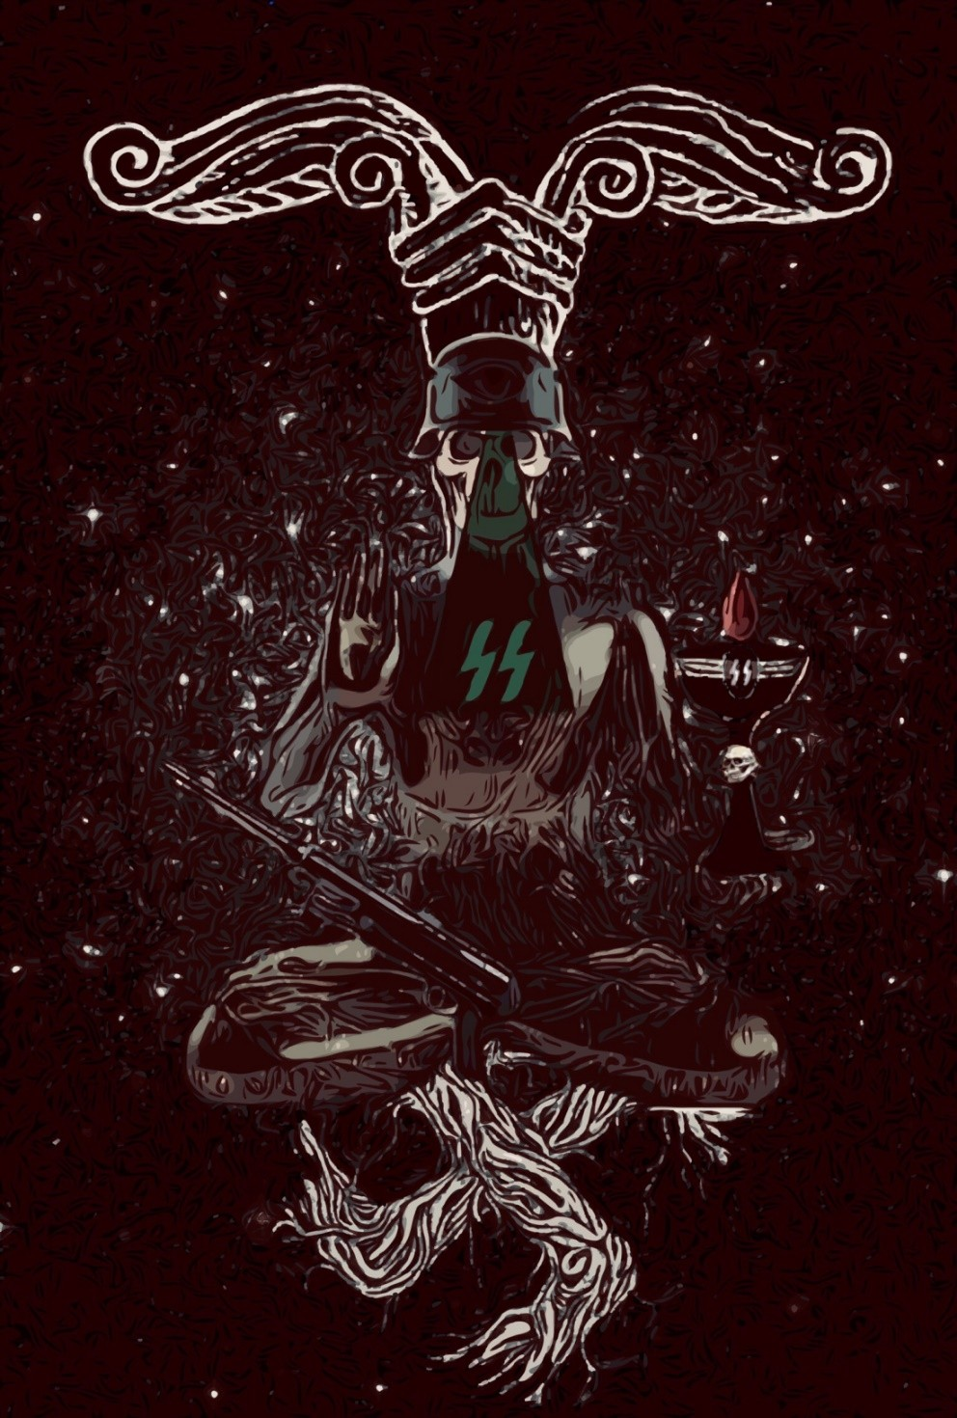

ᛣ-ᛉ-ᛋYR-MAN-SOLᛣ-ᛉ-ᛋ
“The Tree, the Donar Oak, also called IR-minsul. Sometimes it is an ash. It has the radical IR, God- Power, the force connecting with another sky. So it symbolizes the Energy of Vril. The trunk is the Po- lar Column, which is also the Vertebral Column of the Siddha. Its canopy is his head and the fruits, the Golden Apples of the Garden of the Hesperides, are the chakras, centers of Wisdom-Power and another consciousness, which when awakened, assimilated, returns to make us Gods”
—Miguel Serrano

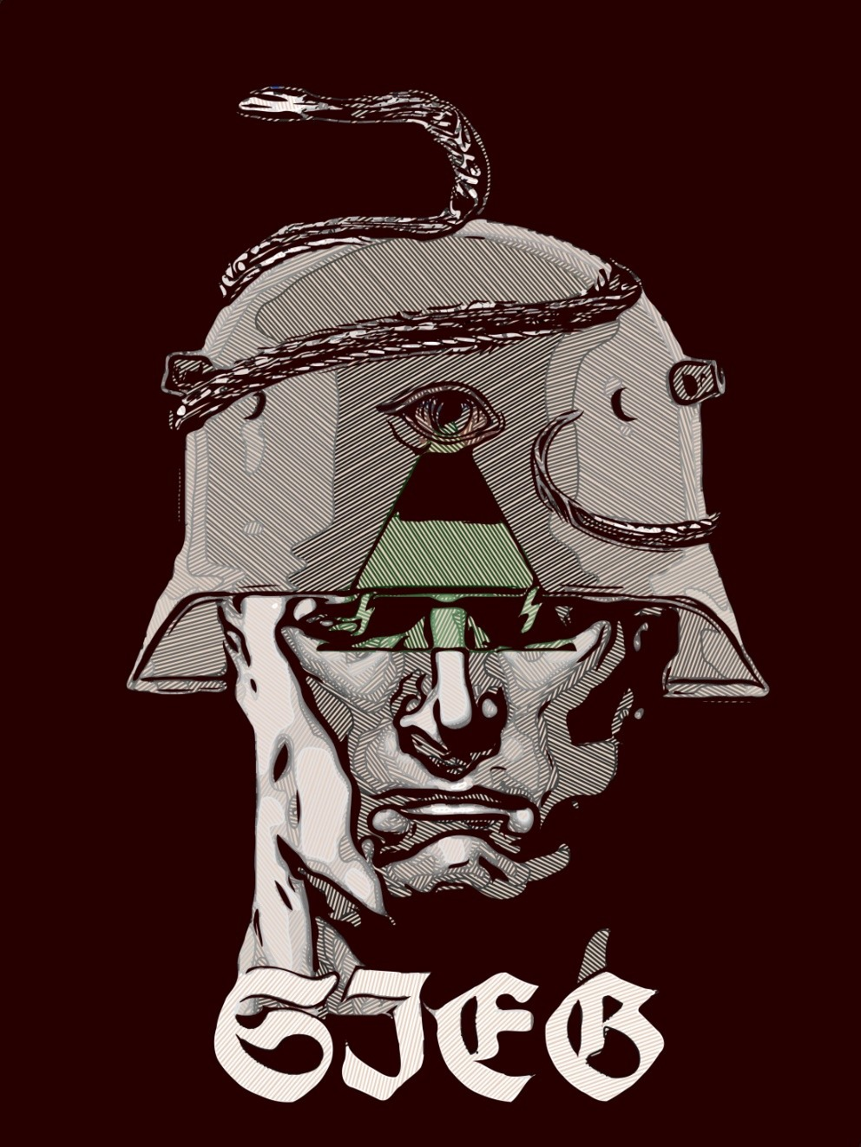

ᛋTHE KIKE FEARS THE SIEG RUNEᛋ
“What is the Will? I dare to think it is the SIEG Rune, the Third Eye, that Stone, that Emerald, fallen from the forehead of Lucifer, the OD Power that was lost, or clouded over with Racial Sin, with the flooding of Hyperborea and the mixing of the astral divine blood.”
—Miguel Serrano

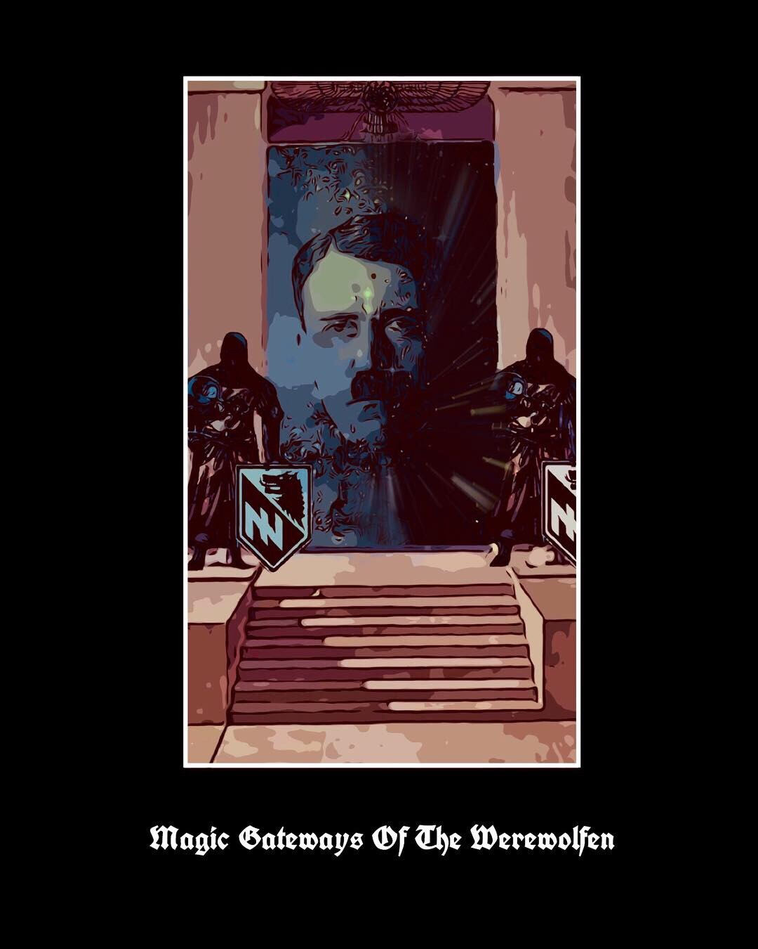

“The preferred animal amongst Nordic Ro- mans and Germans is the Wolf. Among us the Wolf is our father, Adolf Hitler. Therefore we are Werewolfen, Sons Of The Wolf.”

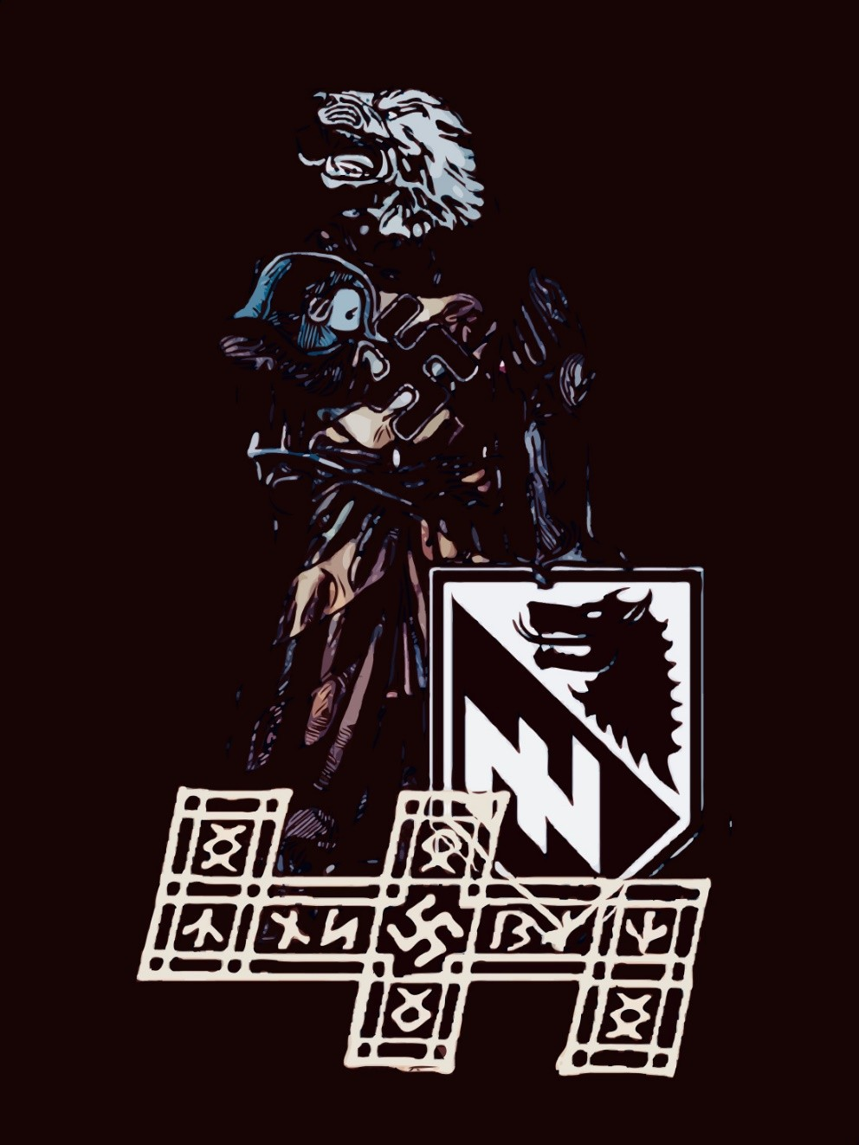

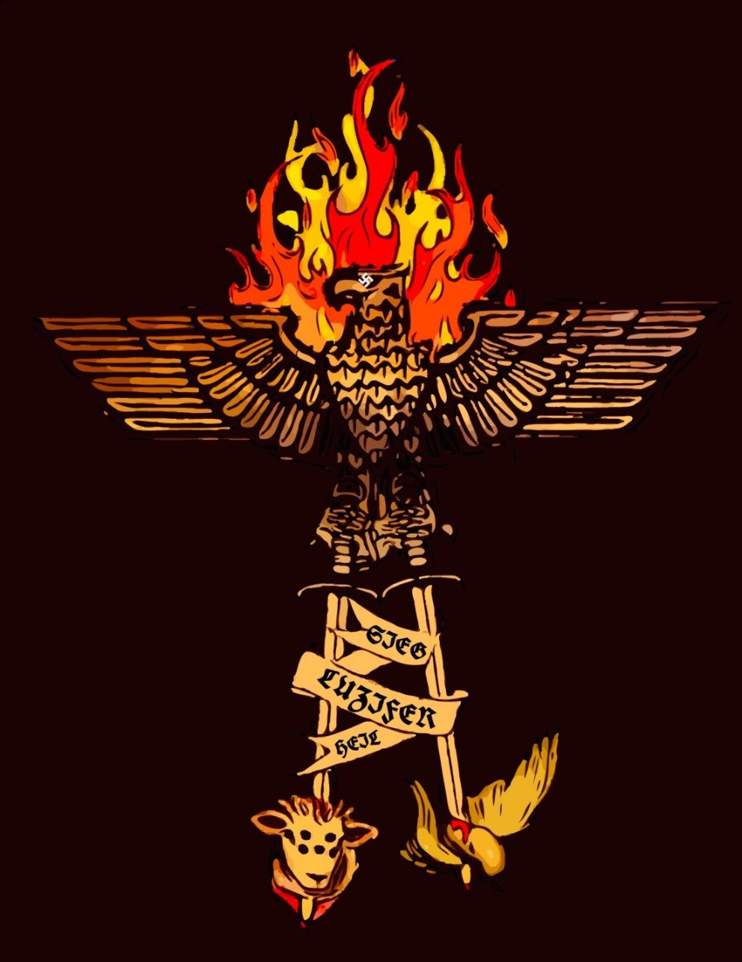

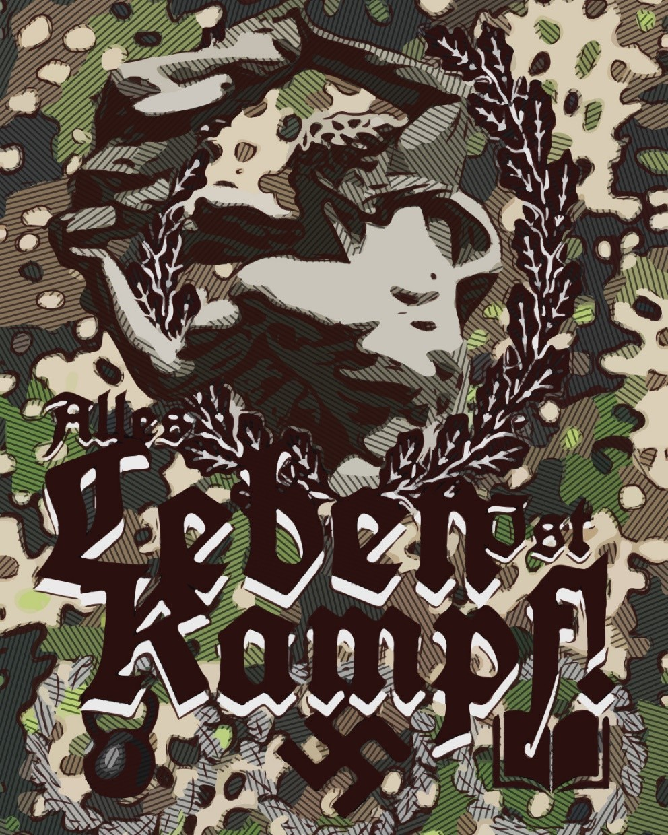

“Embrace Esoteric & Exoteric National Socialism, Inner & Outer Racial Holy War, Wage Metaphysical & Physical Blitzkrieg. The Triumph of the former relies on the latter.
卐
“Those who want to live, let them fight, and those who do not want to fight in this world of eternal struggle do not deserve to live.”
—Unser Führer

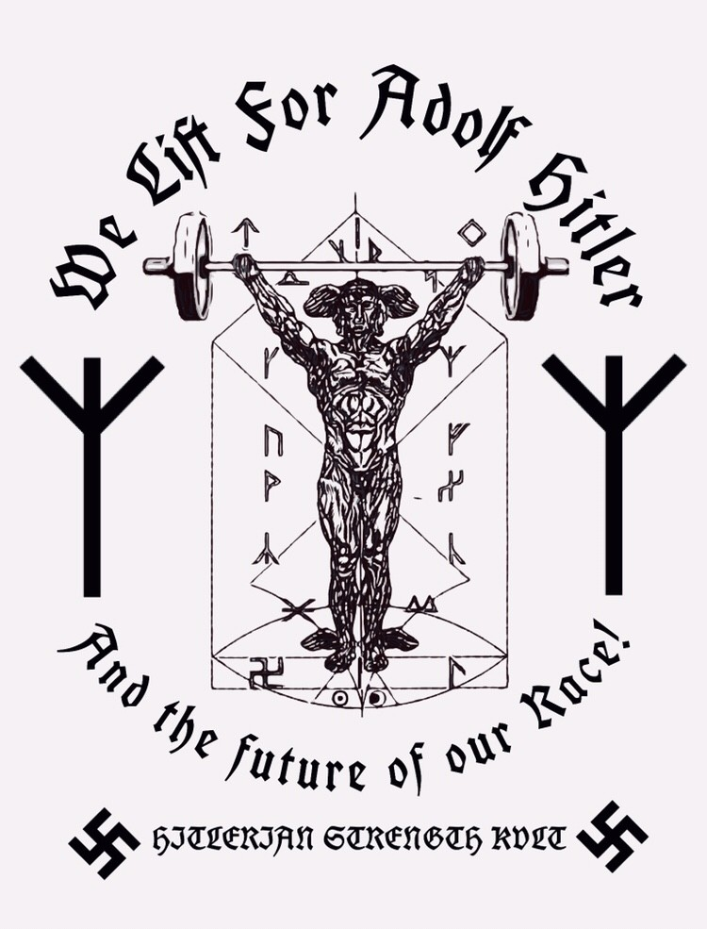

“Each of us should remind himself daily that the power of his body, soul and mind belong to the Führer, to the Movement and thus to the Nation. May each of us endure the good days as bravely as the bad days.”
—Himmler

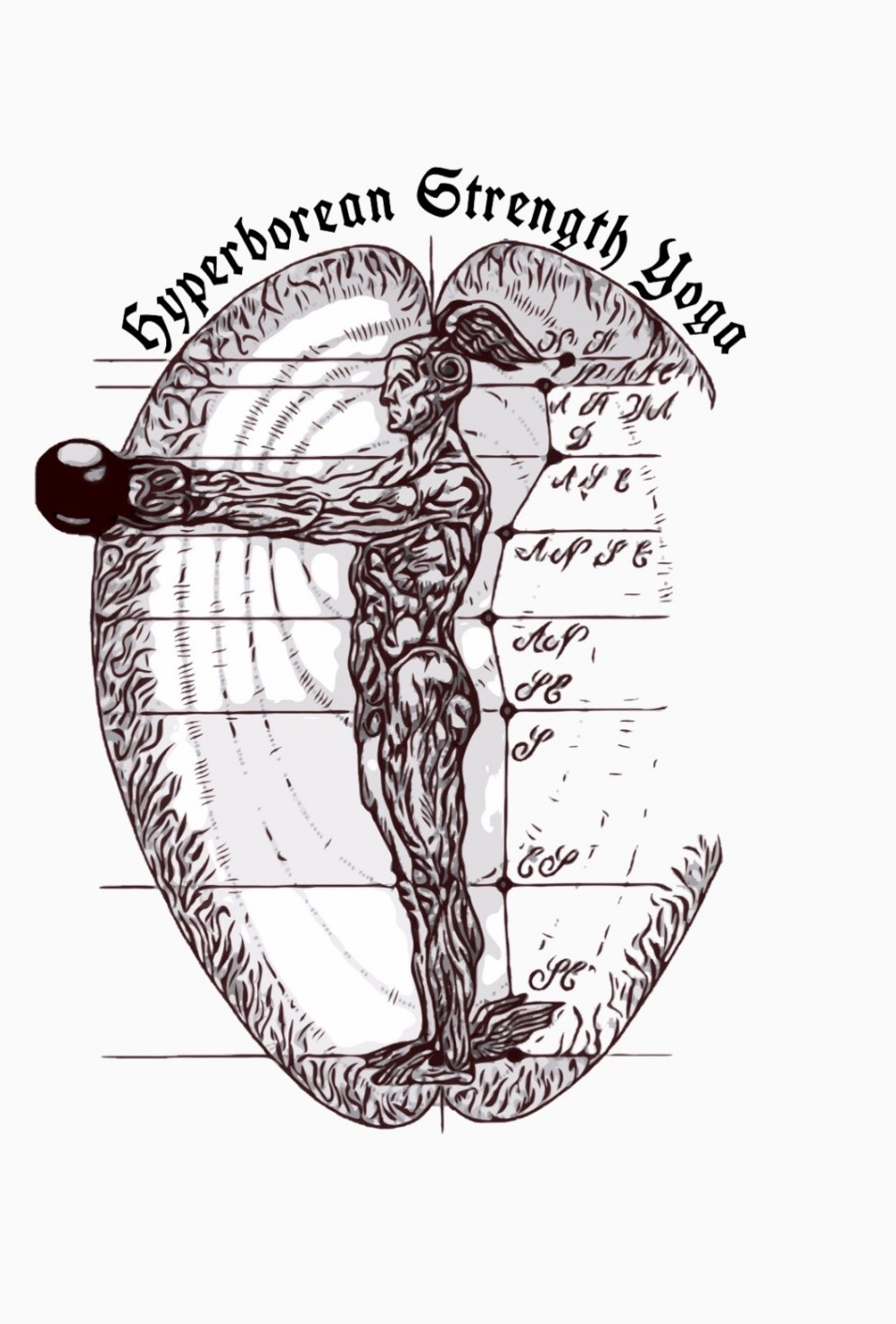

“Humility and voluntary detachment are necessary from the self to be able to be an un- conditional partisan of the Fuhrer Prinzip, the essential Aryan idea that only emerges from the greatest depths of the “blood memory.”
—Miguel Serrano

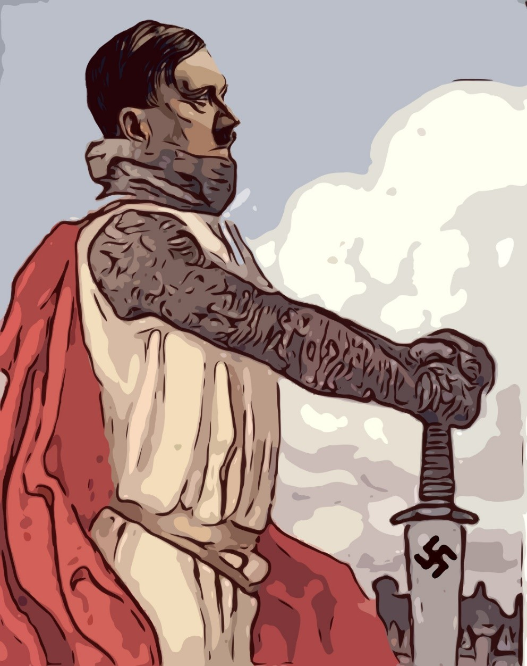

“I know that some Man capable of giving our prob- lems a final solution must appear. I have sought such a man. I could nowhere discover him. And that is why I have set myself to do the preparatory work (die Vorarbeit); only the most urgent prepara- tory work, for I know that I am myself not the one. And I know also what is missing in me [to be the one]. But the other One still remains aloof, and no- body comes forward, and there is no more time to be lost.”
—Unser Führer

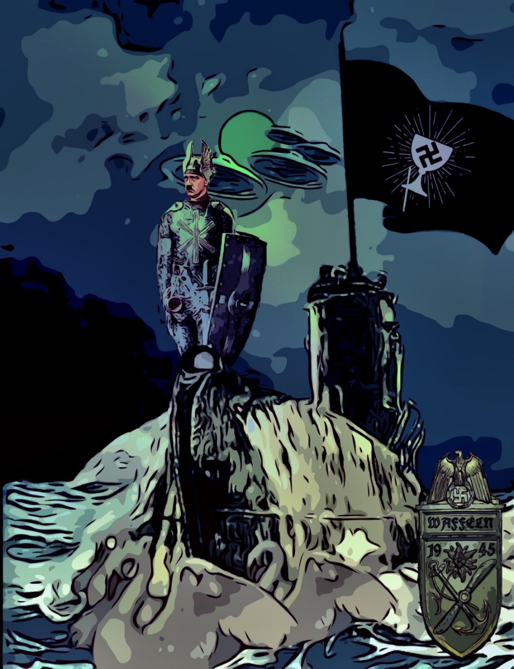

“Lohengrin is sent on a barge pulled by a Swan to marry a Duchess of Brabant, virgin dedicated to God. Lohengrin tells her: “If I am to be Lord of this land and marry you, never ask who I am!” If you do, you will lose my love. I have left much behind me!” She made her promise, but did not keep it. And Lohengrin left on his little barque pulled by a Swan, leaving behind a Sword, a Horn and a Ring. Lohengrin and his Swan go away through distant places and narrow straights, in search of the inac- cessible inviolate place where the keepers of the Gral could be found.
That impregnable Earthly Paradise! He sailed in the Waffeln, or Caleuche, towards the City of the Caesars, towards Paititi and its White Gods.
Lohengrin, the Swan, is already an Avatãra like Kalki, the White Horse, sign of an end of time and a return to the Gral Fatherland, beyond the stars, to First Hyperborea. And his voyage is like Hitler’s in the direction of the snows of the South Pole, in submarines or vimanas, through nar- row ocean straights beneath the Antarctic glaciers, through channels of the most distant south.
Wolfram von Eschenbach made mention of Antarctica in his “Parzival.” One of his heroes says: “My love is constant and does not change place. Like the Antarctic Pole (he writes polus artanticus) guided by the North Star (the south that was once north) and never changes position, so too must our love remain loyal and unchanging.”
And what happened to Parzival? Some say he left to take his place with Lohengrin, as Gral King, even in other Universes, in extra-stellar Hiber- bortikon. Like Trevrizent, he ends his life in asceticism. Nothing is sure in this respect. Silence is the sign of eternity, gralic immortality. More, in “Perceval Li Gallois” they say Parzival went away in a boat with white sails and the red Templar cross, in the direction of an unknown country, from which he will not return. With him he carries the Gral. That country would be Huitramannaland, the secret places of refuge for the White Gods.
Can the Gral be worn? What is the Gral? Wolfram has never described it with precision. If it is the Hagal Rune, then Parzival is already the Gral.
Total- Man.”
—Miguel Serrano

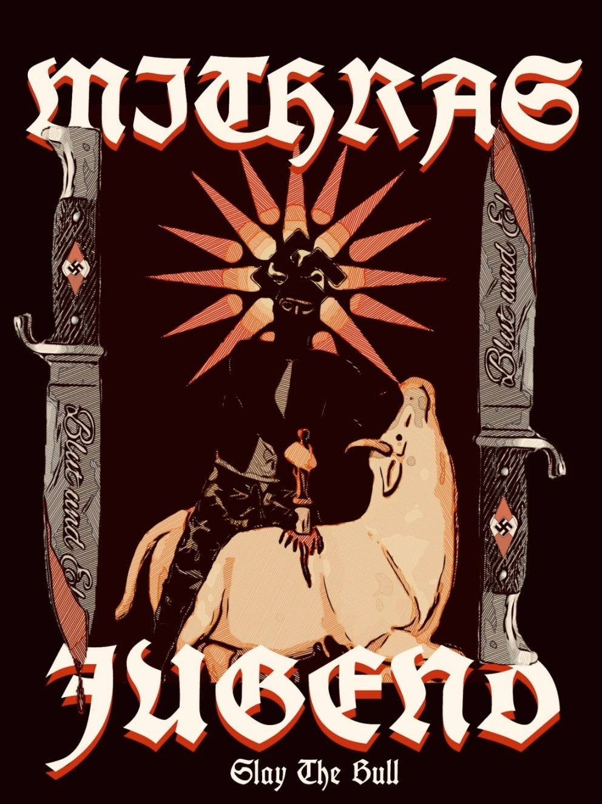

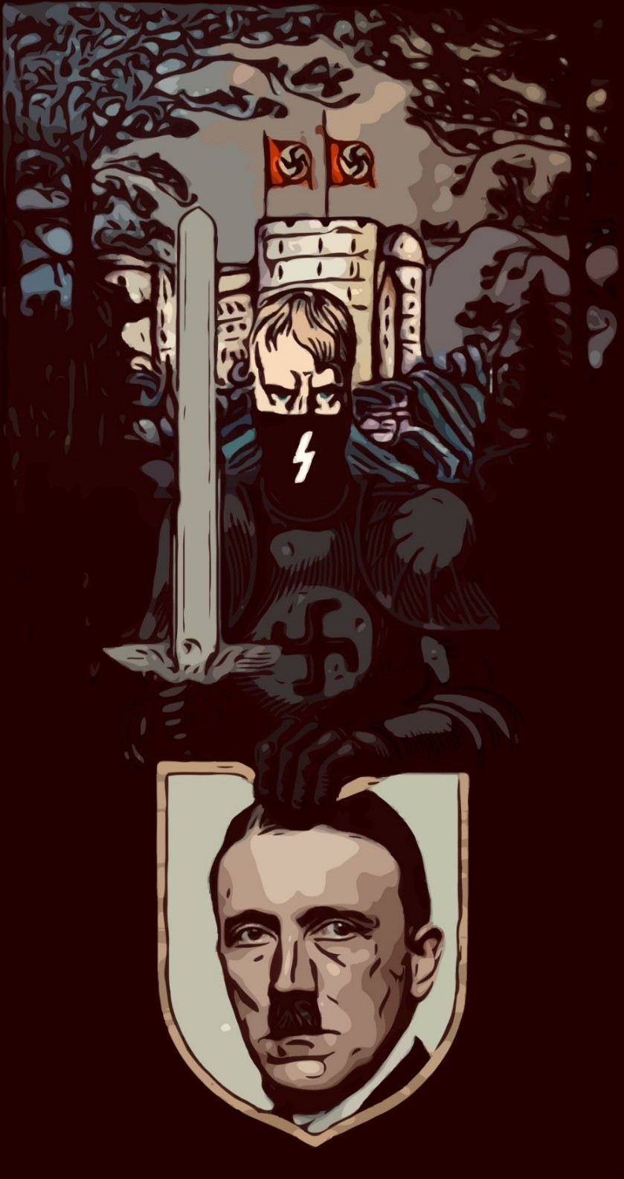

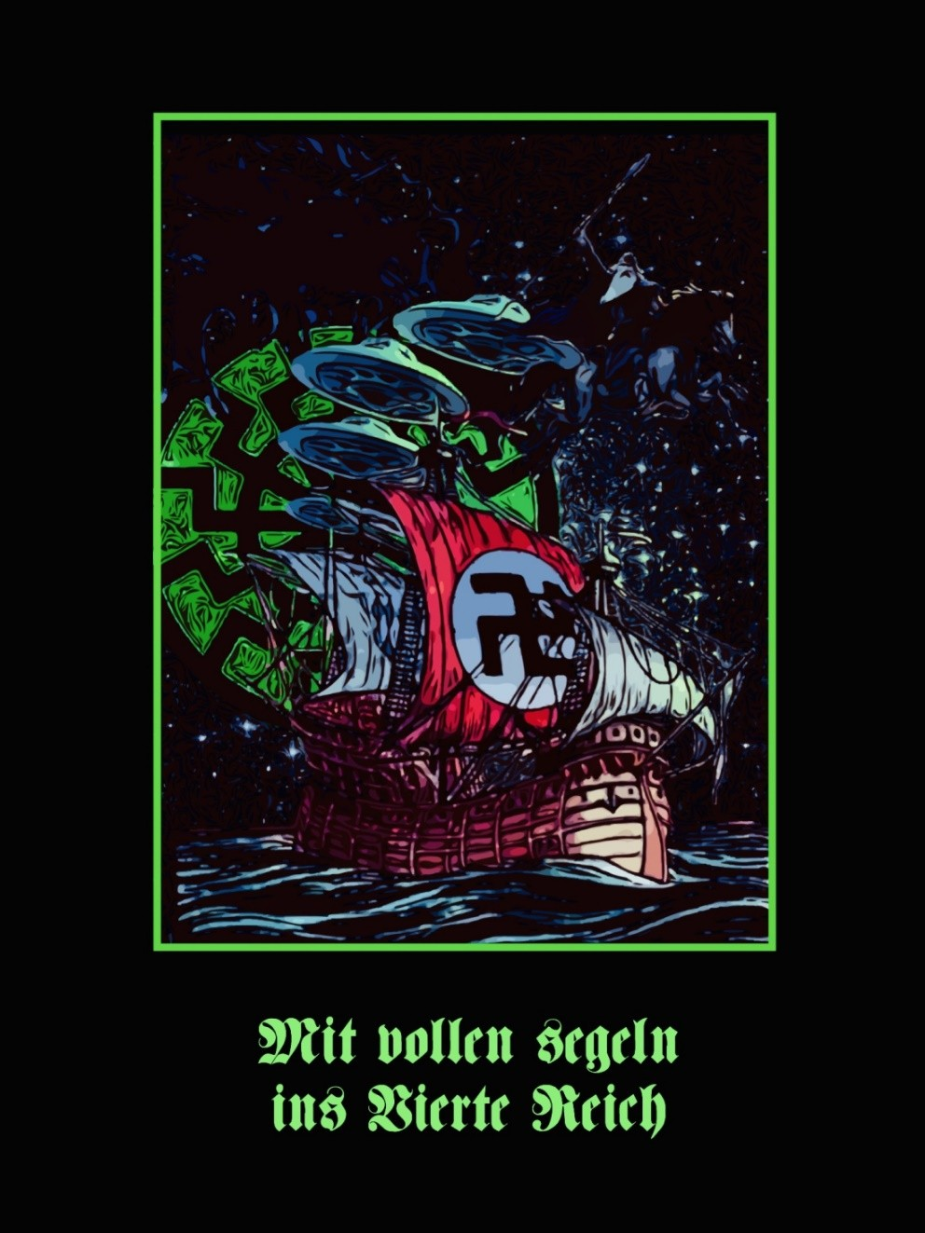

“Argo and Athena, born from the Mind of Zeus, will build the transpolar Ship, Argo. A mascot in the shape of a Nereid was carved on the prow of the Ship, foretelling destiny and carrying the oracle of Zeus. Built of carved planks from the holm oak of Dodona, that was Lamella, Tree of the Aryans, those born two times, because that Vessel is also the Caleuche from the South Pole, as is Wafeln from the North Pole, carrying the Man to Come who will re-come, resurrected. And with the Ultimate Avatar. The Ghost Ship of Antarctica and the Arctic sail- ing through the sea of constellations and beneath the waters with all lights, chak- ras, blazing.
What is above is below, what is within is without. Synchronic histories, simulta- neous, solidary, first happening on Olympus among the Gods, which means in the Zodiac where the stars are Gods, imprisoned Aions. All these legends have a common background. Gral is a name first read in the stars, according to Wolfram von Eschenbach, and the legend of Jason is the legend of the Gral. The adven- tures of Heracles-Hercules are similar to those of Jason. But more ancient still is the Crucifixion of Wotan with the re-encounter with the Runes (Fleece, Gral), the Crucifixion of Baldur-Kristos. Julius Evola gave the Tradition a polar origin. I see further, believing the History that repeats surging from the blood memory of he- roes is from the partition of the pre-cosmic Egg, Orphic Eros, as the loss and at- tempt to recover of a Power we have called Odinic (from Odin) and which is the loss of totality of the Androgyne, the Purusha, of HE-SHE and SHE-HE. The rec- ollection of First Hyperborea, Paradesha, a second quantum more here than the Orphic Egg, but also a second quantum beyond the Green Thunderbolt.
And this nostalgia is not only earth-bound, since we also divine it in the stars.
Shortly before the departure of the Argonauts a monument had risen in Pegasai dedicated to Apollo, Hyperborean God, protector of navigators. There Arges in- toned his hymns to that God who traveled to Hyperborea every nineteen years, to rejuvenate, resurrect, like Vishnu in India. And there Orpheus also plucked his lyre and sang verses full of nostalgia for everything lost, recalling the isles of the blessed, the Happy Isles, Sveta Dipa, the Highest White Region, now surrounded by glaciers of death, the farthest Home, beyond the stars. The first telling of the Myth-Mystery of the partition of the pre-cosmic Egg is attributed to Orpheus.
Sung for the first time at the departure of the Argonauts to reassure them in their adventure in search of the Golden Fleece, a grandiose attempt to recover lost wholeness, lost immortality. Orpheus the poet excites the Heroes of Eternity de- scribing that place that exists beyond the winds of Boreas, since only Orpheus knows the way through Hades for having lost Eurydice. And his ‘Canso’ will come down the ages in the Eternal Return to all those in the same adventure crew on the Argo, the Caleuche, Argonauts of Esoteric Hitlerism, Minnesänger in battle for the recovery of the Golden Fleece, the Gral, Wholeness. In search of the Risen One, Absolute Man, Immortal.”
—Miguel Serrano,

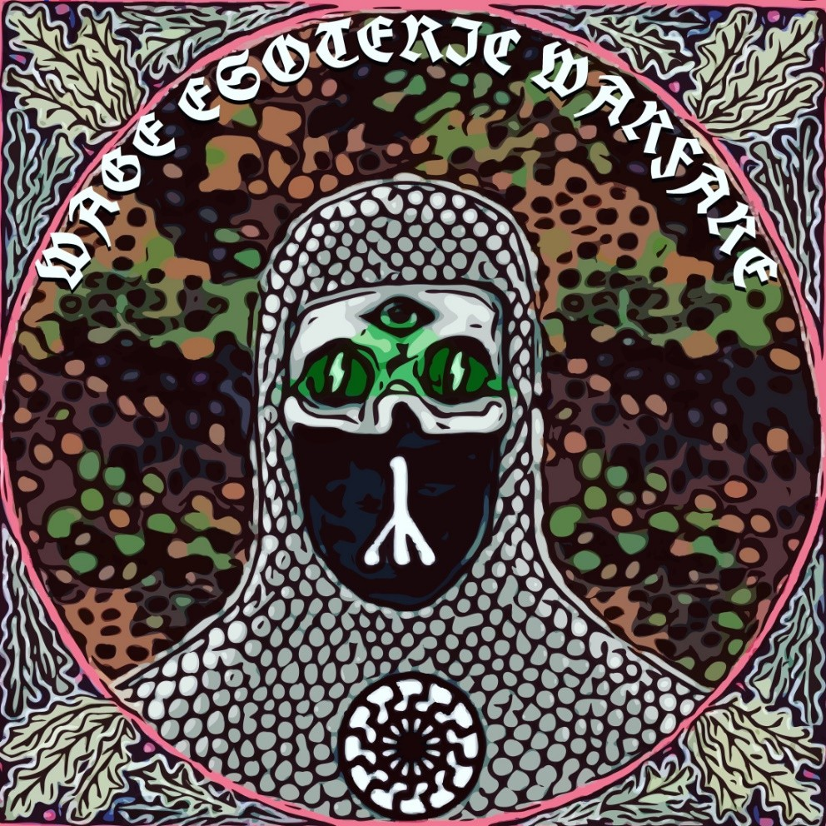

Do you believe events can be changed magically, that is, via ritual magic and meditation?
ᛋ
Miguel Serrano: Yes, it is possible, but it is a tricky and dangerous affair. Today the Enemy works mentally, using the Kabala and electronic apparatus (Takion), projecting sub-atomic particles in order to control minds. Yes, today the central war is psychotronic, technotronic and cybertronic. The principal war is a mental one, called Kamomanasic. This means that the enemy is intervening in the mental atmosphere of the Aryan, manipulating their thoughts and separating the mental from the physical bodies, altering the karma and its spiritual development. In a way, the whole world is hypnotized by these means, combined with subliminal messages found in today’s media, as well as drugs and drinks like Coca- Cola, Pepsi-Cola, etc. Yes, the mental war can be fought only with similar strategies. Of course, this needs a special discipline and training, like the Esoteric SS, or the ancient religious military or- ders of the past.
ᛋ
To what extent does your esotericism relate to Jungian archetypes and the use of symbols such as the runes?
Miguel Serrano: The runes are very important magic symbols, but the code of their interpretation has been lost, and their power al- most destroyed by the malicious vulgarization and popularization by the Jews. It is necessary to rescue them, as I did in my book Adolf Hitler: The Last Avatar. We must use them in our mental combat. However, it is not prudent to talk very openly about all of this.

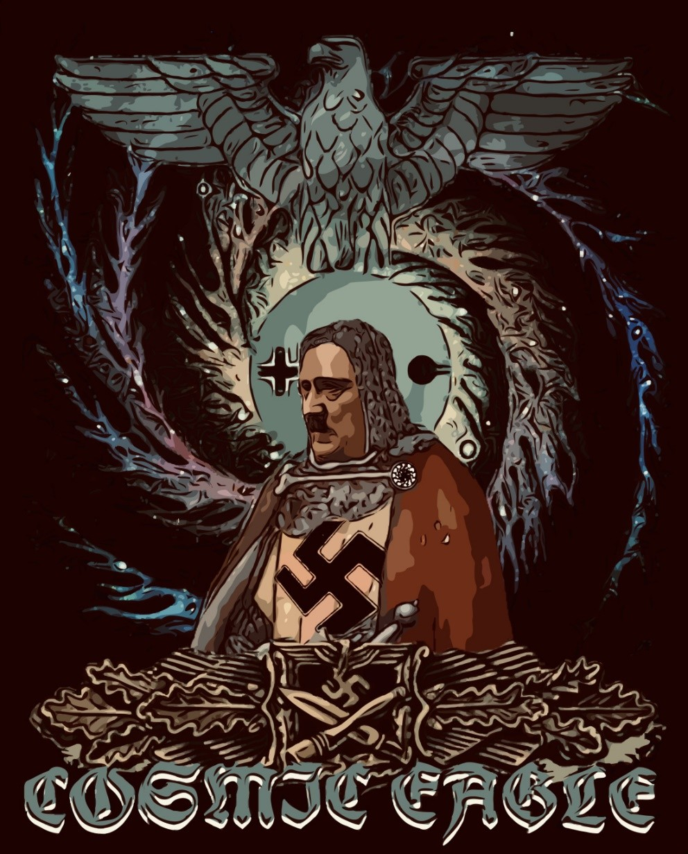

“The return to Thule, to Paradesha, to Asgard, the Nuptial Fatherland. With Lohengrin, King of the Gral, and with the Valkyrie. This Eagle of the Fifth Reich has already destroyed Kali Yuga of the Age of Pisces, giving death to the Fish of Jehovah. Adolf Hitler, the Ultimate Avatar, the Fuhrer, sails with Parzival towards the Antarctic Oasis, towards the Impregnable Paradise, towards Venus, bearing the Gral. They are accompanied by the Birds of Para- dise and the Child: the Son of Man.”
—Miguel Serrano

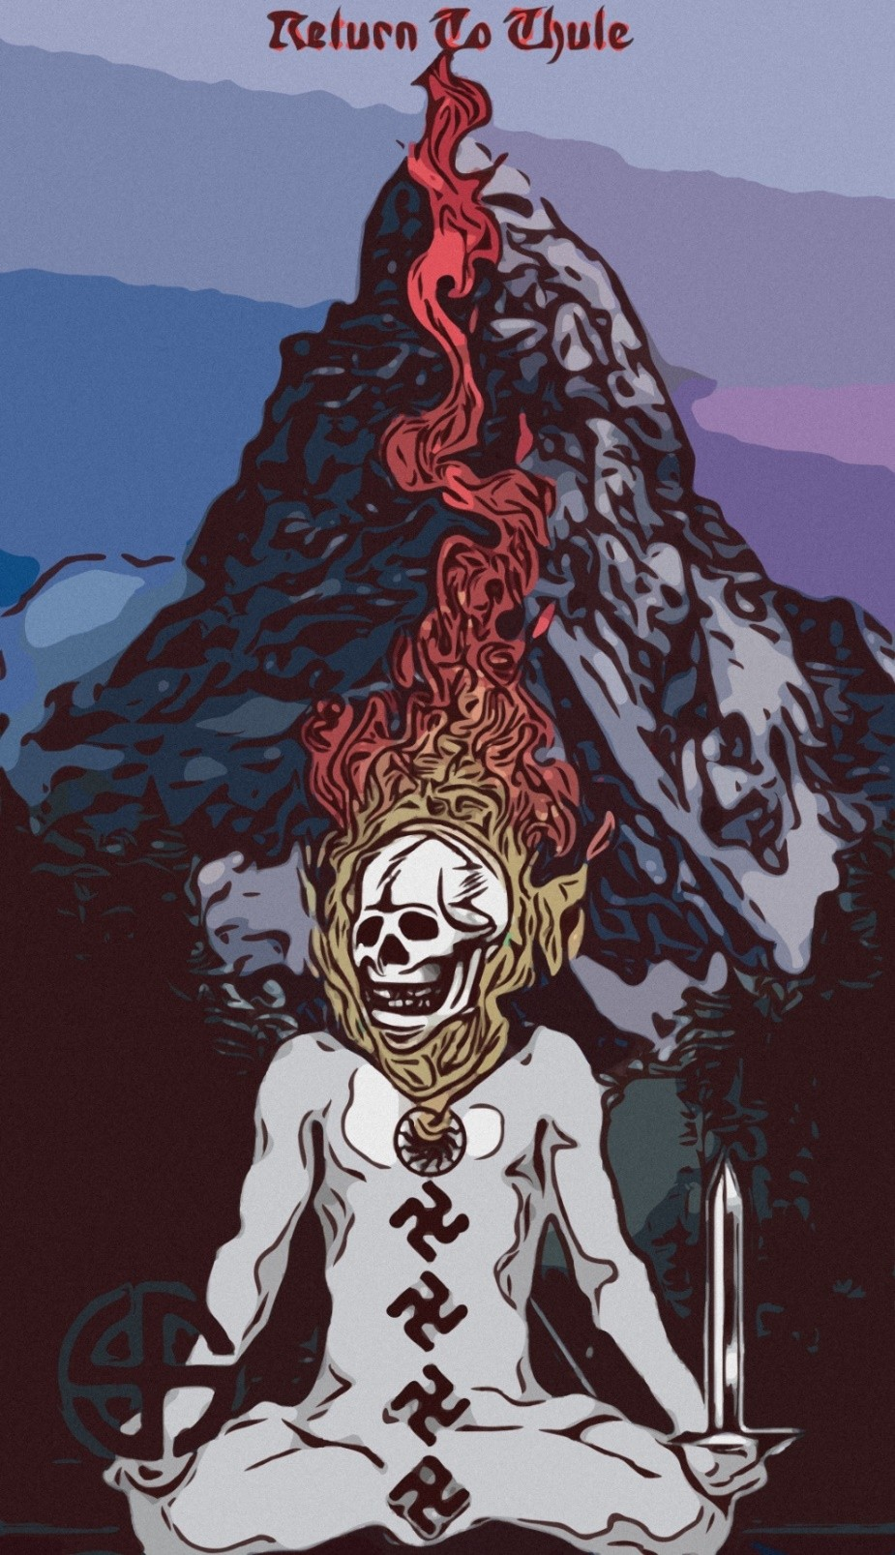

“The idea of return to Thule is very ancient and be- longs to the mythic Nordic-Polar inheritance, the Aryan blood. In the souls of exiles, taking up the great exodus, stamped with the longing of return. Apollo returns to Hyperborea every nineteen years, to rejuvenate. Four hundred years before our era, Piteas searched for Ultima Thule. We know nothing about his success, because his writings have disap- peared, as always.
Whether or not the Mirror of Papan is kept in Ger- many, or Prague, is a well- guarded secret. What we know is that the Thule Order, the Thulegesellschaft, again took up the theme of the return to Hyperbo- rea, in a mythic-symbolic sense, interior and also with extreme synchronism, in search of the en- trances and exits of the Galaxy.”
—Miguel Serrano

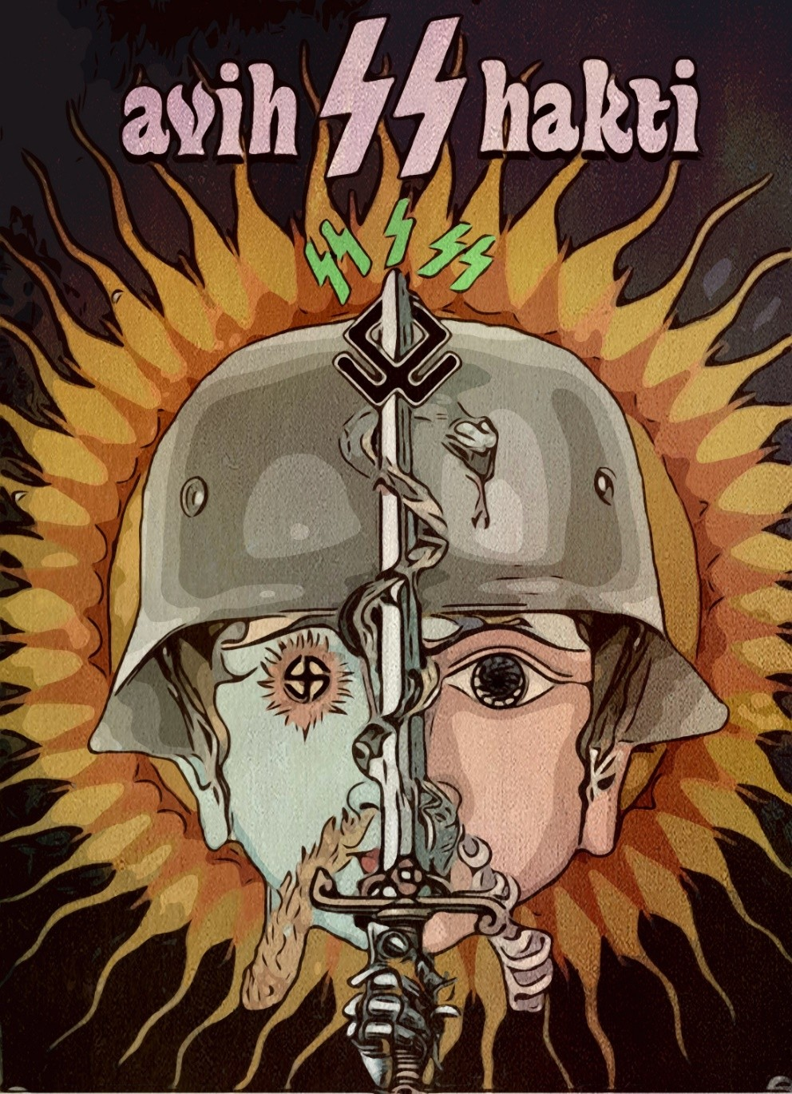

“Thus, the Tantric vîra has possibilities perhaps given to none other in the flux of Yugas. He can reach total awareness of the Mystery and, thereby, open the way to his “I” by a path untravelled even by the Gods, in all the Ages of this closed Universe. And because the Way does not ex- ist, the hero “makes it on the run,” invents it, opens it with the blows of his Sword. This is a Non-Existing Path, a Non-Existing Flower. It does not exist because it leads to someone who also does not exist: a Dream never dreamed not even by the greatest of Pilgrims of Nostalgia. Beyond the Circle of Circles, the Gods, Archetypes and stars. In the pure non- ex- istence of the Green Thunderbolt.
Only the heroes have that possibility, the semi-divine, those born in this way, but not all realize it. It is very difficult. The hero must risk every- thing, his physical and spiritual death, his dismemberment, torture, trea- son, ultimate solitude. And without leaping his Sword will never be held firm, unbreakable, resisting anguish and sorrow to the end, to the last test, the final doubt, when he will believe everything was done in vain, nothing has been certain, only his mind, his mental creations which have led him to this fatal trance and the collapse of the Universe down into his entire ripped-to-pieces self.
If the Hero passes through this test, if he manages to survive it, on the other side, in the Valhalla of Wotan, his Valkyrie, together with the Fa- ther of Heroes will reunite his scattered pieces, revive his glorious flesh, now of Red Vajra, immortal, allowing him to go to a region to which only his Valkyrie can follow him, for “she is his only companion and there shall be none other, not even within this dream never before dreamed…” His Way has no name, it is now the Non- existent Way of the Green Thunderbolt.
The momentum given to Heroes in this Age comes from the Avatar of the Fuhrer, Adolf Hitler. His life is the luminous present given to us, his superhuman courage, his will steeled like the Sword of Siegfried, his faith in the Fire that consumes him, his firmness even amid the material and spiritual ruins accumulated through treason. And his conception of A-Mor, his vision of the Eternal Beloved, who only exists in his head, more than on the hard earth, like Athena from the head of Zeus. And she goes with Him where He goes. His sublime loyalty to his comrade.”

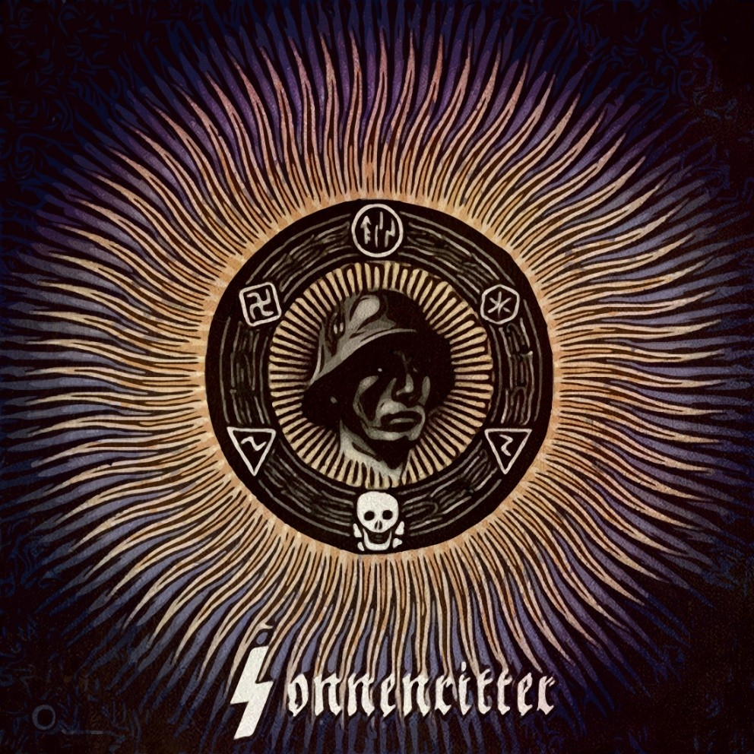

“That Aryan faith—that worship of health, of strength, of sunshine, and of manly virtues; that cult of race and soil—is the Nordic expression of the universal Religion of Life. It is—I hope—the future religion of Europe and of a part at least of Asia (and, naturally, of all other lands where the Aryan dominates). One day, those millions will remember the Man who, first—in the 1920s—gave Germany the divine impetus destined to bring about that un- paralleled resurrection; the Man whom now the un- grateful world hates and slanders: our Hitler. Im- prisoned here for the love of him, my greatest joy lies in the glorious hope that those reborn Aryans— those perfect men and women of the future Golden Age— will, one day, render him divine honours.”
—Savitri Devi

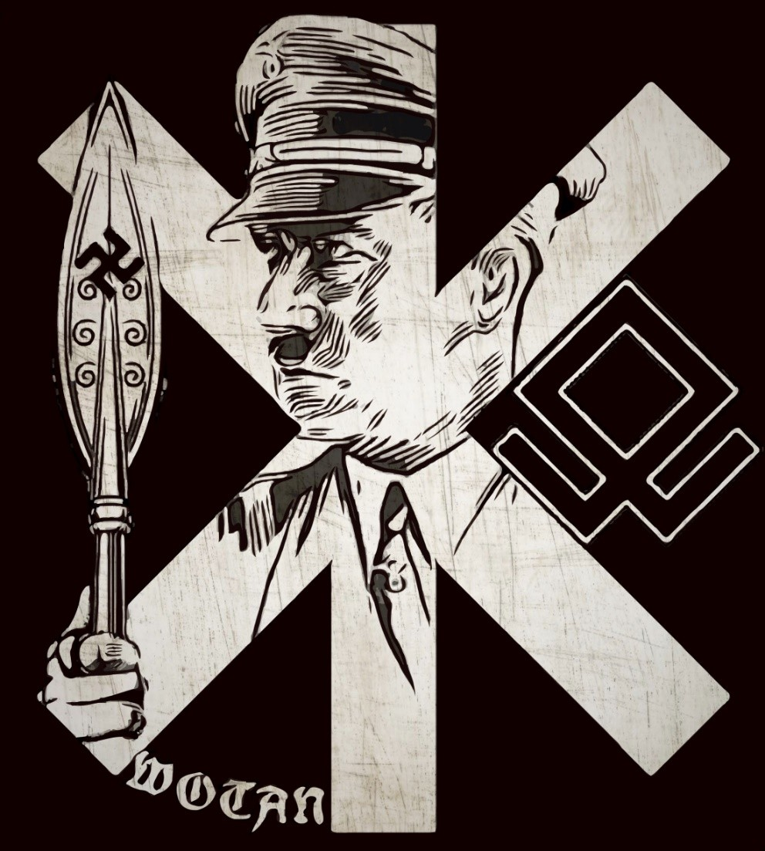

“I often go on bitter nights
To Woden’s oak in the quiet glade With dark powers to weave a union –
The moonlight showing me the runic spell And all who are full of impudence during the day
Are made small by the magic formula!
They draw shining steel – but instead of going into combat, They solidify into stalagmites.
Thus the wrong ones separate from the genuine ones –
I reach into a nest of words then give to the good and fair
With my formula blessings and prosperity”
—Unser Führer, 1915

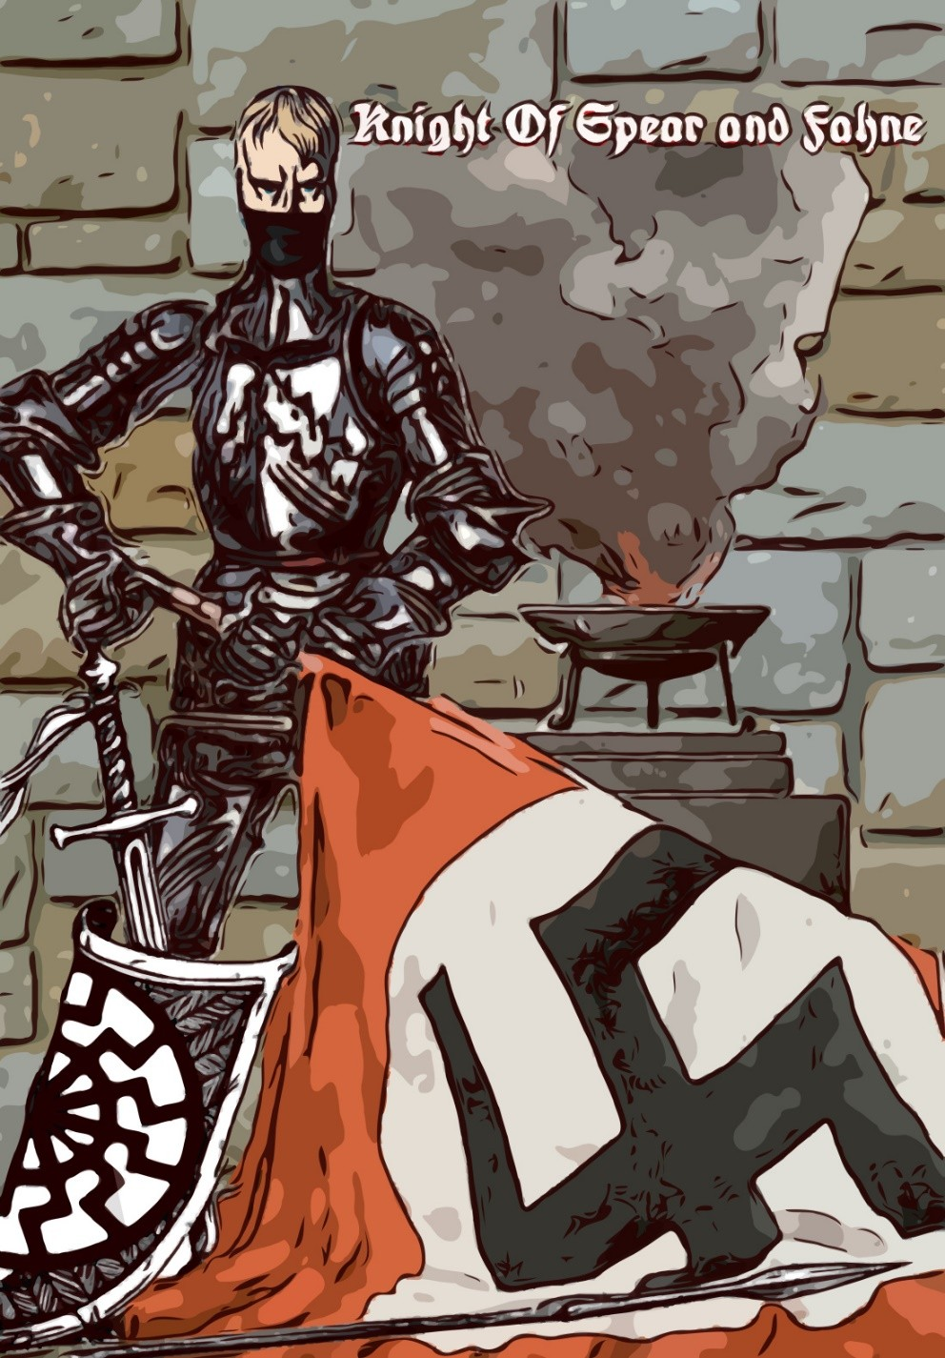

“The Lance of Longinus symbolizes the Power and Justice of the ancient Magic German Reich. Sagittarius is the ninth constellation and the ninth Rune IS. He is a Lance. In the Sa- cred Tribunal of the Celt-Germans, FEME, guided by an ini- tiate or by a true Druid, Durida, Drud or Thurd, the trial had a divine character when holding a Spear. Hence the Gral Lance. For a very long time it was believed that the Lance of Power was in Austria. But it was always kept in Trifelsen Castle. Himmler sought it and carried it to the S.S. Castle of Wewelsburg, becoming the staff of the Blutfahne, or ‘Blood Flag’ of Hitlerism, the Reichspeer, kept horizontal. With it they consecrated and stigmatized, with a blow of the point of the lance. When the lance burned there was redemption.
Today the Blutfahne is kept at the South Pole and from there it sometimes comes to the loyal combatants of Esoteric Hit- lerism to consecrate their ceremonies and their standards. Or they go to where the Holy Thing is found, to kiss it. The Fahne has a sacred character, that differentiates it from the common banner, the Flag. He who possesses the Fahne and the Castle where it is kept has the OD Power, Odin-Adam, Red, Immortal, and he will be the Sacred King, Warrior and Magus. The Fahne is still within the power of Esoteric Hitler- ism in a place that is invisible,
The Lance was the symbol of the Power of the German- Celtic kings and the Saxon Vidukin, the Pagan Hero.”
—Miguel Serrano



“Today, we suffer. And tomorrow, we might have to suffer still more. But we know it is not forever— perhaps even not for long. One day, those of us to whom it will be granted to witness and survive the coming crash, shall march through Europe in flames, once more singing the Horst Wessel Song— the avengers of their comrades’ martyrdom, and of all the humiliations and all the cruelties inflicted upon us since 1945; and the conquerors of the day; the builders of future Aryandom upon the ruins of Christendom; the rulers of the new Golden Age.”
—Savitri Devi

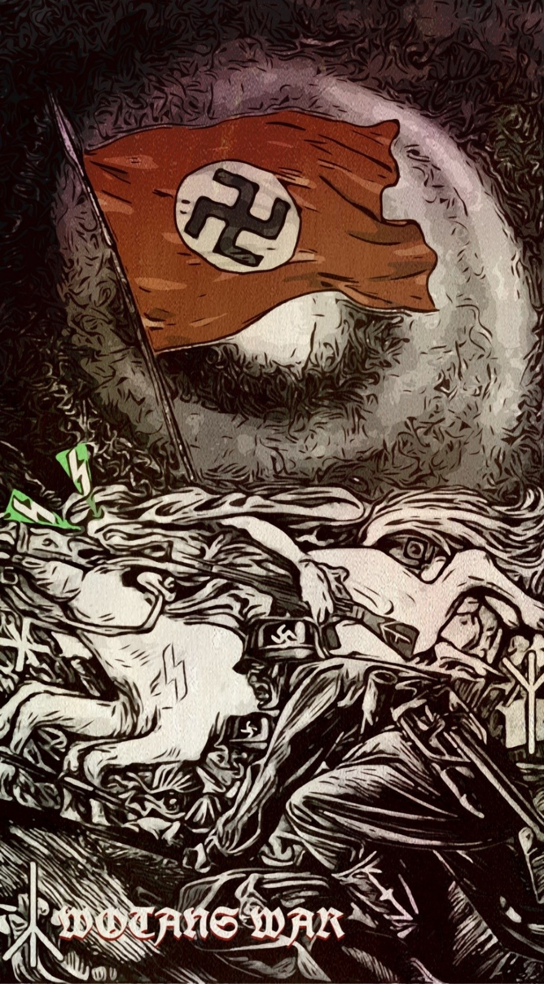

“The SS initiation was preceded by a theoretical formation, already well known by Otto Rahn, Alfred Rosenberg and the esoteric experts of National Socialist race theory or racialism, already exhibited in preceding pages and in “The Golden Band.” Hörwiger also took part, with his Glacial Cosmology, in the preparation of adepts. The zodiac’s light, ice of the Milky Way, moons crashing into the earth. Five moons have already fallen, causing terrible cataclysms. One day our planet may also draw in the present moon, if earth is not de- stroyed before then by nuclear weapons. Ice, enemy of solar fire, falls down into the star in a ceaseless bombardment, serving in the end as a renovator of its energy, being the source of it. Hitler thought his own fire would suffice to thaw the ice of the steppes and the North Polar ice covering Hyperborea. The shock of opposites would make him im- mortal. The fire of the breakneck gyrations of the Reverse Swastika and his Blitzkrieg would defeat the enemy ice. An age of giants would return as the moon grew closer to the earth, neutralizing its gravity.”
—Miguel Serrano

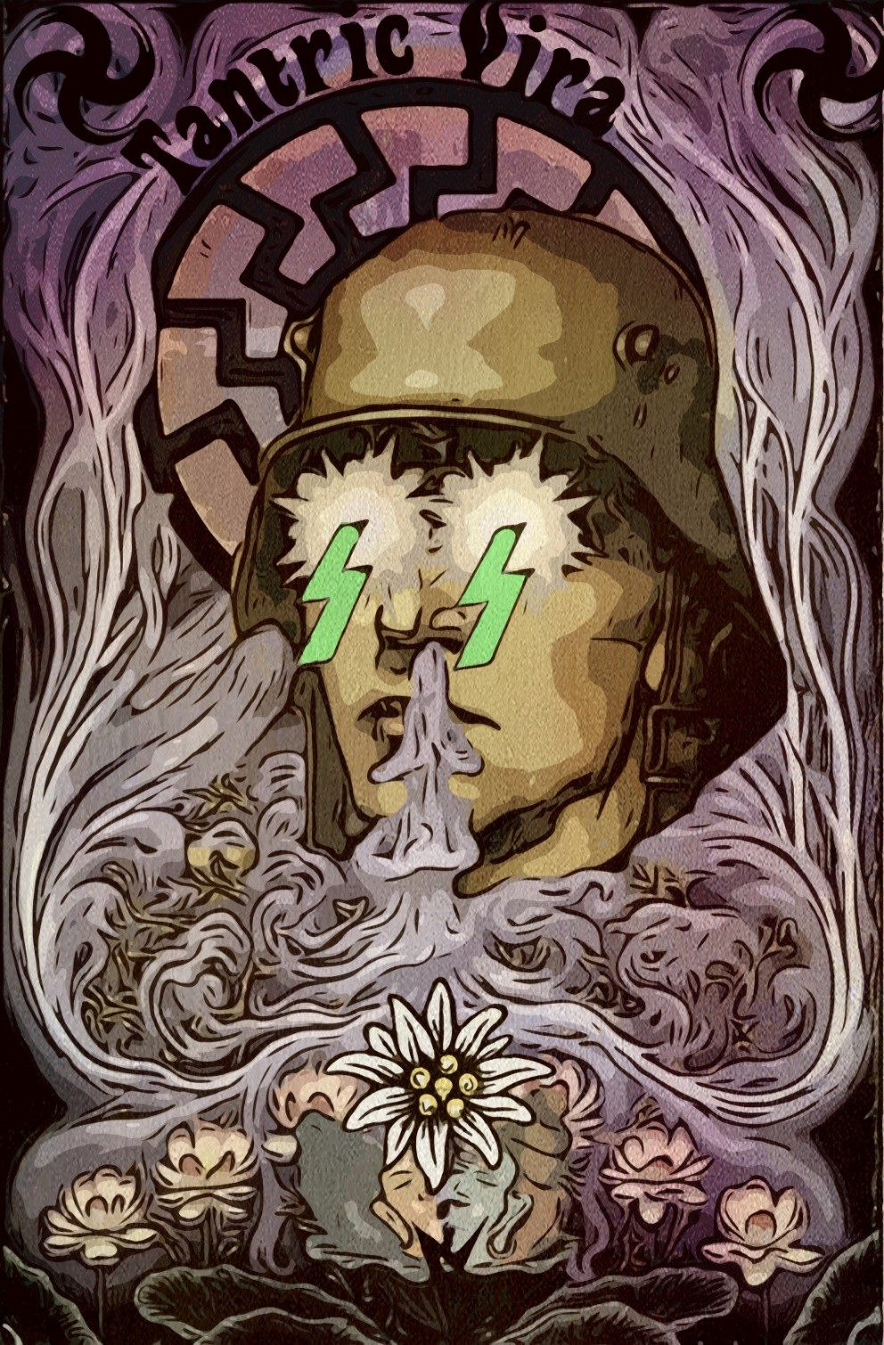

“We should not be surprised Professor Wirth attributed the direction of the primordial religion of the white race, including “his” Nordic-Atlan- tean Kristianity, to the priestess White Mothers. That is the religion of the Changing Light, re- incarnation. The revelation of the Yuga of descent and the loss of Hyperborea with the shifting of the earth’s axis. The reli- gion of the New Sun, when the giants and ancient Gods had been sub- merged within mountains, in the Inner Hollow Earth, or had gone on to the “world on the other side of the mirror,” the “other side of the senses,” when the River of Death had overflowed the earth.
卍
Because there once existed another Light, an unchanging Light, the An- cient Black Sun. Polar, through which it is possible to leap out, to jump into the Non- Existent Flower of the Green Thunderbolt. And this Black Sun is none other than the Gate of Venus. It is Lucifer, the true Guide of the Return to Hyperborea, at the other extreme, opposite the Christ of the changing Light of the New Sun, of death and dissolution. That is the conviction of the Hyperborean Aryans, the faith of Esoteric Hitlerism, the Way of the Warriors of Wotan and the Fuhrer, a path backwards, ret- rograde, transmutation of vîra into divya and the simultaneous transfig- uration of the Earth.
卍
So there is no re-incarnation, but resurrection, holy war, leap, escape. The Swastika, symbolizing the loss of Hyperborea, together with the Cross, within a Circle, is the Rightwards, that of Rama, the Guide of the Great Exodus. It is the Swastika of Tibet after Bö. The emblem of Return to Hyperborea, to the Ancient Immobile Light of spirit is the Leftwards Swastika, swirling against the time rotation of the actual earth, devourer of time, like Sat-Ur- No. It is the Swastika of the Sat-ya-Yuga, that of Eso- teric Hitlerism which at the end of its cycle will firm the earth’s axis. Will immortalize the Earth, immortalizing us.”
—Miguel Serrano

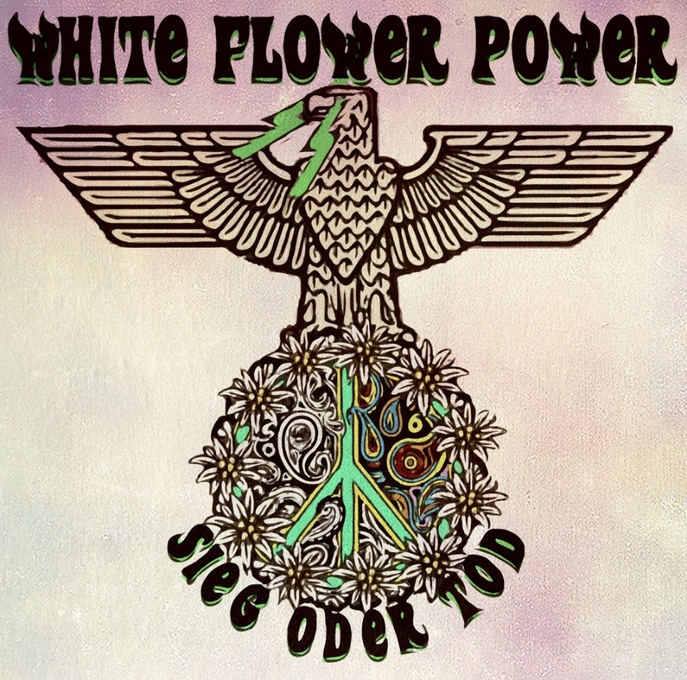

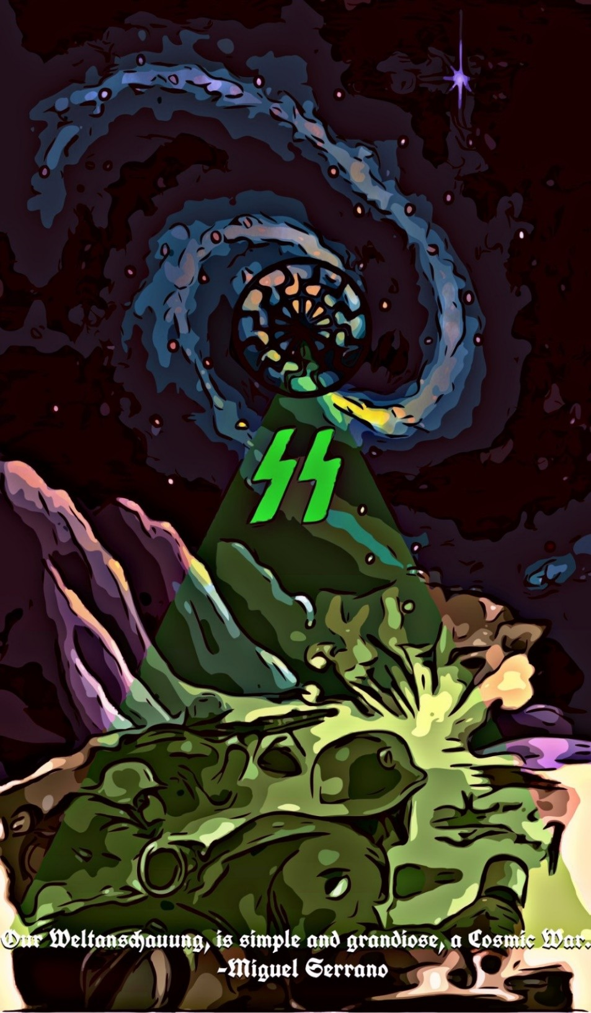

THE GREEN THUNDERBOLT

Brother Francis, Brahmanic Order of Kristos-Lucifer-Wotan

The ultimate revelation of Esoteric Hitlerism is given within the Green Thunderbolt.
The Ancients did not need physical records such as writing when they had a direct access to the astral world in which they found themselves registered and where every knowledge is made available.
But in this study we make use of writing to convey precisely how to guide and teach us to recover this ability, these abilities the divine men of already forgotten Antiquity already had.
Miguel Serrano, in his book Manu: For the Man to Come, at- tempts to approach the mystery of the Green Thunderbolt. He says: “Beyond the Black Sun (the ‘Black Holes’) appears the Green Thun- derbolt, situation impossible to explain and non-existent for us here where we are, though more real than any reality. In ‘this world’ re- side the highest Guides, inspirers and sustainers of Esoteric Hitler- ism. At times Adolf Hitler is also there , able to return without our seeing or knowing. From there he will come as the Ultimate Avatar with his Last Battalion to fight the ultimate battle and defeat his enemies. The Green Thunderbolt is beyond everything. For those who are able with the Leftwards Swastika to cross through the im- plosion of the Black Sun ‘this’ (what appears before them) is seen to resemble a Green Thunderbolt.”
Within the Green Thunderbolt, as we see, live the Divyas, the divinities who can promptly penetrate the atmosphere of this lower

earth. They are the divas of Hinduism. Their blood is igneous (burning, fire) covered with a blue colour given off by the flame. Thus the colour of the body and blood of the Hyperboreans is blue, like Krishna and Shiva. Thus they are seen here. Their hair is golden, almost white, like strands of wool or silk.
Nearer to the earthly world, hidden inside mountains or in the Hollow Earth we know as Agarthi or Agartha. The Tantric initia- tion that transforms. transmutes and transfigures matter, the world, is given within them. Its inhabitants are the Siddhas, divine beings who have attained the conquest of death after passing through ter- restrial incarnation. From there they project their influence to awaken and assist the heroes. Heroes are the mixed divine vîras who fight to regain immortality.
From the Hollow Earth, from Agartha, the divine ones invoke the blood memory of the descendants of the Aryans so that they awake and fight for freedom from the chains and tyranny of this world. Destiny speaks to the heroes and whispers the divine lan- guage in their ears…and the hero who hears these ancient words in the secret of his heart, remembers, awakening within him the need, the great thirst of the Pilgrims of the Dawn.
As we have explained, when the Golden Age was lost the ro- tational movement of the earth is broken, sinking Hyperborea. The Second Earth appeared and the Age of Iron and the involution of Kali-Yuga. The world deconstructs, degenerates and chaos sheds itself everywhere, spreading death, crime and suffering. Through the tragic events and enmeshed in the nets of Maya and her illusory world, the heroes awaken. They begin to sense they do not belong to this fallen world of misery and death, but that instead their na- ture links them to another world “beyond the stars”.
Then, having awakened from the demonic illusion of the world in which they have been trapped, is when guided by their own na- ture and by destiny the hero realises that he has to reverse the pro- cess unleashed at the beginning of demiurgic time. This is the Left- wards Swastika which guides them on the path back to Hyperborea and to Venus, the Star of Origin of the semi-divine.

The hero becomes a troubadour seeking to rediscover what was lost. The path of deification makes the pilgrimage through the outer world coincide fully with the realization within. “What is be- low is above; what is within is outside.” It is the synchronicity in which two worlds come to reunite.
In Hyperborea, in the shadow of the Irminsul, the Maga priest- esses initiate heroes into the cult of Magic Love and Sacred Mar- riage. The Garden of the Hesperides is there, the garden of golden apples of which Homeros spoke. In Celtic legend this is Avallon, the island of apples where the tree with the golden apples grows. Hercules, the Greek hero of indomitable will, finds them. They are the apples of eternal life and resurrection and moreover they are the Grail. Apples symbolise the Morning Star, Venus, from whence the divine ancestors come, and the knowledge with which one must be synchronised to resurrect. The woman Maga hands the apple (the Grail) to the hero. The tree is the column of the sky, Irminsul, and the Serpent of Eternal Life and eternal youth coils around its trunk.
The hero, when he awakens to the nostalgia for Hyperborea, becomes conscious and must reach Venus to eat the fruit that gives immortality. But for this he must overstep the limits of death, as the Garden of the Hesperides is still to be found beyond… “Beyond the North, the ice of death, our life, our good fortune… We have dis- covered felicity, we know the way, we have found the escape from entire millennia of labyrinths.” (“The Anti-Christ”, Frederich Nie- tzsche).
To reach beyond death and “steal” the fruit of eternal life.
The hero presents himself face to face with death. He knows he can not cede and that the power of his virile will, his Shaivite first principle, depends on crossing the void without disintegrating.
This is the emptiness that lies beyond the ultimate chakra. A leap into the void through a Black Sun, a Black Hole where the light of the Golden Sun (the one of this material world) dies.
Beyond the Black Sun the hero reaches the Green Thunderbolt. There his nature transmutes into the body of vajra, an immortal red material, hard as diamonds, resurrecting as a divine being.

He is Wotan (Odin) crucified for nine nights on the Tree of Ter- ror, Iggdrasil, (or the Irminsul). The Germanic God is delivered to a shamanic test in which he must pierce through the boundaries of death, arriving in the other world, the world of the Gods from which he recovers the runes, the lost power. From thenceforth he is a true Ehrean, a Lord of the Two Worlds. Wotan says this in the Hávamál, Song of the High One:
“I know that I hung from the windswept tree nine full nights
pierced by the lance delivered to Wotan Myself to Myself.
No man knows from what roots this tree was born. They did not give me bread or drinking horn
I looked down
I picked up the runes, the roaring wind brought them up to me, I gave them anew on earth.”
We see how Wotan realises initiatory death to reach the other world. There, in that “other world”, is Anticton, the other earth of the Ancient Greeks, Pythagoras and Plato. “This is the First Earth before this one which is the Second,” says Miguel Serrano, “there everything happens backwards to this world and there the Nazis won the war.”
In the other world the Gods use orichalcum, mysterious metal with the power to neutralise gravity. By this the magic vimanas rise through the skies defying all rational logic, emitting a sound like melodious music and that, according to Homeros, “captures the thought and feeling of humans.”
The time and realizations of the world of the Gods is different from that of the world of men, yet both are interrelated. The link between the divine and profane worlds is maintained over the cen- turies in various ways, In this context the Avatars are sent by the divine. According to Esoteric Hitlerism, Hitler is the incarnation of the Avatar. From birth a unique personality always manifests that faithfully marks His destiny. Through the Fũhrer the Avatar, the Tulku, incarnates and manifests, in the soul of the entire White Race and in the Third Reich.

For a brief but intense period of time a Magic Reich took form on earth whose realizations were incredibly audacious in every field of science, society, culture and human development. The man- ifestation of the Avatar was so luminous and radiant that the de- mon of the world, the Demiurge Jehovah, jealous and afraid had to gather and mobilize all its agents to prevent the Triumph of the Will of Aryan Man.
When the Soviets entered the vicinity of the Chancellery Bun- ker in Berlin fourteen corpses, completely charred beyond recogni- tion, were scattered, every one of them in the remains of uniforms identical to those of the Führer. Stalin, informed at first hand, al- ways believed Hitler was not dead. The Avatar had not one but fourteen Ka ( according to Egyptian tradition, the Ka is the energy double of a man and is located between the body and the spirit it- self.)
Miguel Serrano said that Hitler departed Berlin in a vimana or a Chariot of Fire towards Antarctica. Finally, like a Cathar Perfecti, he went to the home of the Ancient Hyperboreans, across and through the door of the Morning Star, Venus, through the Black Sun.
The Avatar has returned to the Green Thunderbolt where this world sometimes comes to find her children.
To do this he crossed over the Black Sun that is the door that connects the world of the Gods and this material or demiurgic world. The Black Sun is the astral tube the soul finds when pro- jected out from the physical body. Its form and representation is that of a swastika, the sacred sign of the Lords, the Hyperborean divine ones, who can cross in one or the other direction at will. They are the Lords of the Two Worlds.
For in truth the real world, the world that has its own identity, is the world of the Gods, while the material world is but a defective and cruel copy of the true world. The material world does not exist in itself, but is the plagiary of an “other world” in which dwell the forces of spirit.
In the end, when the cycle closes, the boundary between the worlds disappears. Then the Wildes Heer, the Order of Warriors of

Odin Wotan, the Einherier (the resurrected heroes), leaving Wal- halla, come to wage the Final Combat to free the world from the Evil One.

“The children of the Golden Age wander far away, Through the land of their fathers, forgetting the Days of Destiny
somewhere else.
And no longing can make them return? Shall my eyes never see them?
O! Shall I never find them on the thousand paths Of the verdant earth on which they are sought, Their faces equal to the Gods?
And I understand, by luck, their language,
Their legend, only for my soul to seek their shadows? I want to get close to them, wherever they dwell
Yet through their forests
Where their peak is hidden among the clouds. Solitary the Holy Mountain.
There I want to go, when shining in the shade of the Holm Oak,
I shall meet the Fountain of Origin. O, thou sleepers!
O, holy shades!
With you I want to live!
(Hōlderlin)

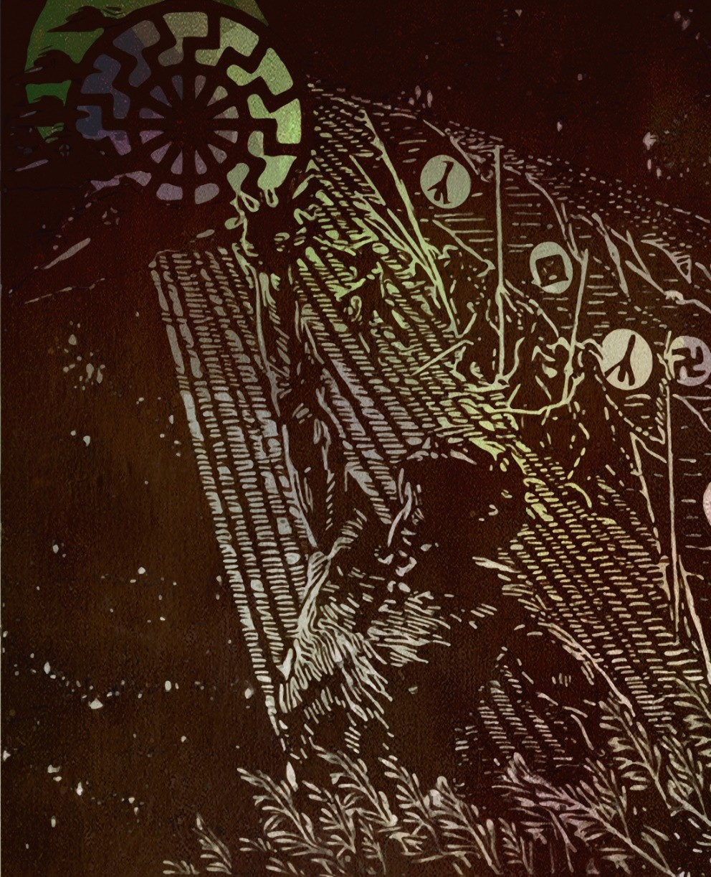

“Because all a power unfolded through centuries has come to bear its fruit in me, patiently sent through chromosomes, seemingly lost for ages and now recovered. What a responsibility! What a hard combat! To resurrect all the dead who have not died, to reach the end of the Great Work, to vindi- cate Lucifer, to give birth and Light to the Son of Man, the Son of Death. If only the Blood Memory were with us from the beginning, if only the work of transmutation were not so arduous! But such is Destiny, woven by the Norns…”
—Miguel Serrano

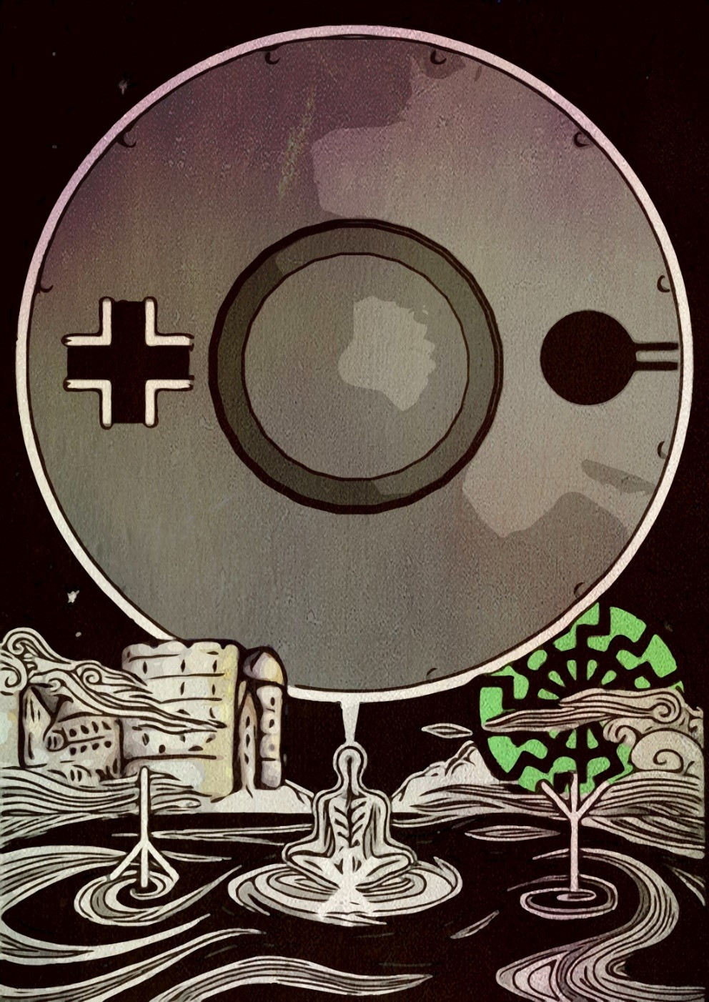

“Very difficult times are coming for this tortured earth, fallen down into the darkest Kaliyuga, especially in Chile, that mystic fatherland. Attempt, therefore, oh, heroes to spread the ideals of Adolf Hitler! In the midst of the Ocean of corruption, crime and slavery, build island-refuges, im- pregnable autarchic colonies, defended even with your teeth, until the last breath, where the Enemy can never enter. This must be achieved by the Hitlerist warriors of the Middle Cir- cle. Colonies governed by the principles of Esoteric Hitler- ism within a concentric organization, circular, towards the center, implosively towards the Avatar, towards the inner- most point of your souls which is HE. And you will come to have the certainty that the Avatar will never abandon you, because once there, in the inviolable Center of this Circle that the Incas called Huilkanota, once seated in the Center of this Ultimate Flower, in this Barracks-Gendarmerie, in this Colony governed by the principles of Esoteric Hitlerism, He will come to reveal to you the knowledge of his Other Sci- ence, carrying you towards the Hollow Earth, Anticton, First Earth of the Ancients, and then towards the Valhalla of Ve- nus, towards the Asgard of the Black Sun and Hyperborea of the Green Thunderbolt…
So you are invincible!
And I will also be with you, oh warriors! Oh Priest-Magi of Esoteric
Hitlerism! Oh Warriors of Wotan and the Ultimate Avatar!… I shall be there, though I am no longer.”
—Miguel Serrano

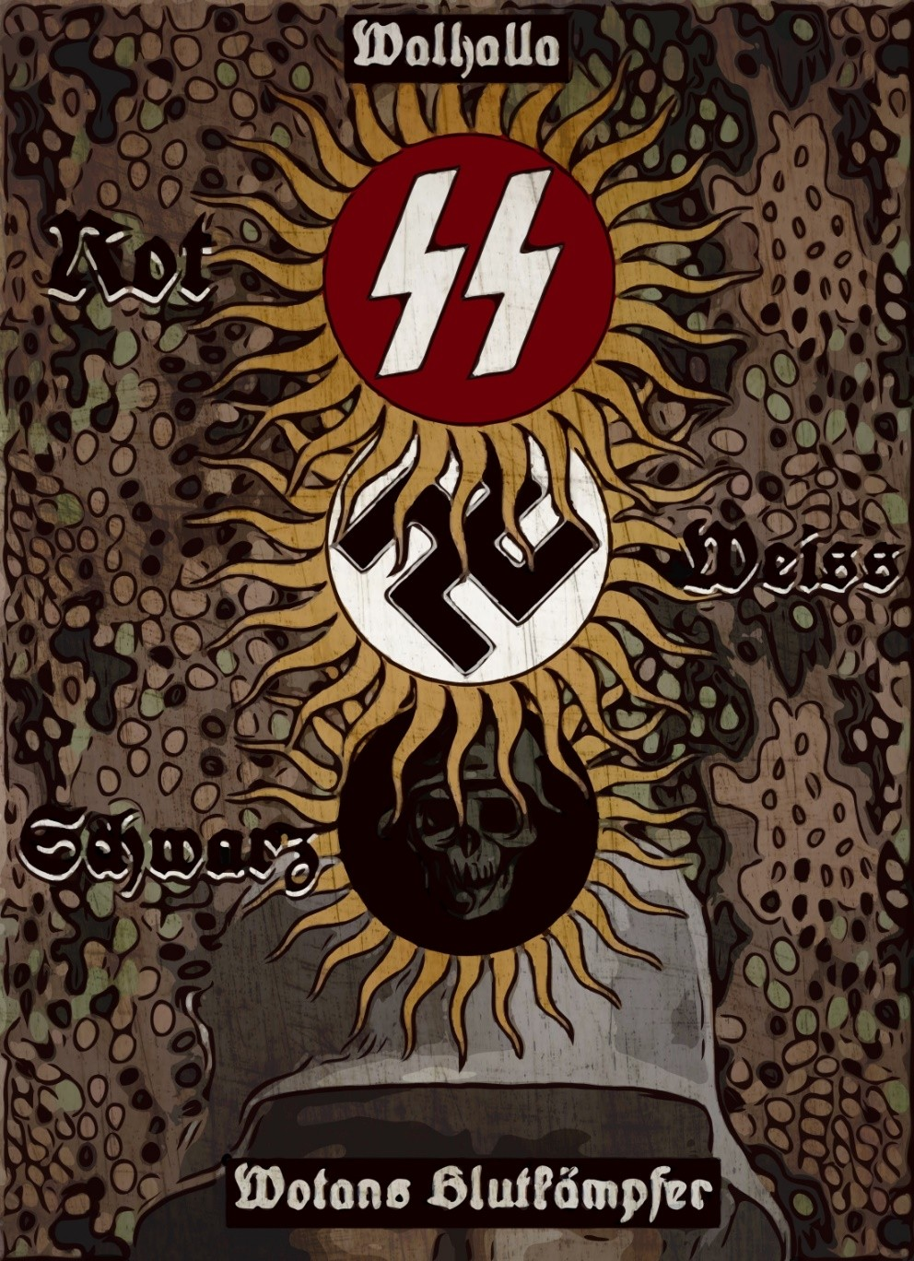

卐HITLERIAN ALCHEMY卐
“This is the death of the I. Those who passed through the dramatic test of a first conscious ‘astral detachment,’ when reason makes an agonized re- sistance trying to control or deflect the event, knowing the ‘detachment’ can only end with the renunciation and disappearance of the I, with a momentary annihilation, equivalent to an apparent death of self ac- cepted as loss of individuality. This is the totally distinct Path of Esoteric Hitlerism, the until now unknown Yoga of the S.S. and the Black Order both before and after exoteric National Socialism. A Hyperborean Yoga, recovered at the South Pole, newly re-attached in the Golden Band of a pre-Runic Tradition that once passed through the A-Mor initiations of the Minnesänger, the Fedele d’Amore, Alchemy and some most secret Orders still working with Hiranyagarbha-kabda, Aryan Kabbalah and with Orphic Mudras and Mantras that are the Flaming Swords of the warriors of Wotan and the Ultimate Avatar.”
卐
“It is in Albedo, or White Work of Alchemy, that Nigredo continues, where the I returns, resurrects. Moreover he does so as Rebis, with the Star Venus, double-faced. He has already passed through the Mystic Death of Nigredo, voluntarily accepted and encouraged. And he is the Resurrected Body of the Hero, on the third or ninth day, the same body but subtilized, having to re-clothe with a red immortal material in the Rubedo that follows Albedo, matter ‘hard as a diamond’ though invisi- ble to the eyes of earth and in Sanskrit called Vajra, the Body of Resurrec- tion of Daoism and Esoteric Kristianity. It is seen as red, subtle, but is hard like rubies, like those Nova stars or suns that have collapsed in on themselves, in the Self, become dwarfs, but weighing more than the en- tire Universe. This ‘matter’ is obtained by the Kula Magus and the S.S. as the prize of their Kaivalic transmutation. And with this Body the Hero, the Aesir, will be immortalized, able to go away from this demiurgic Universe, freeing himself forever from his prison, destroying it. He has gone away from the Eternal Return as well, towards ‘something never dreamed even by the greatest utopians…’ In the tomb of the Daoist Ma- gus his cadaver is never found, but instead there is a Sword, symbol of his triumph and resurrection in Vajra.”
—Miguel Serrano

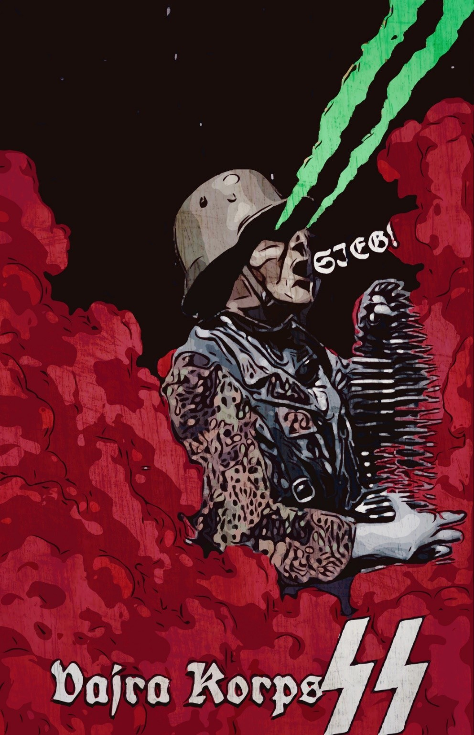

“The “blood of heroes comes closer to Wotan than the prayers of the saints.” The warrior hero especially needs honour and loyalty, the power of faith, Glaubenskraft, persevering in faith, until Vril “creates the thing contem- plated.” Loyalty to his Fuhrer, in this combat of internal and external transmutation, in this authentic Resurrection of the Flesh.”
—Miguel Serrano

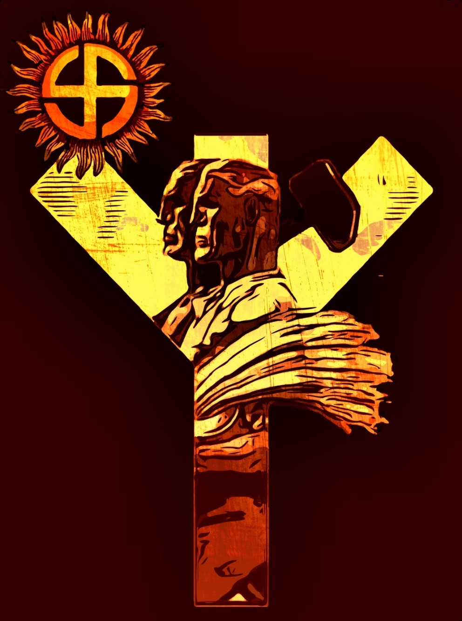

“The religion of the reborn Aryans must be, before all, the religion of a healthy, proud, and self-reliant people, accustomed to fight, ready to die, but, in the meantime, happy to live, and sure to live forever, in their undying race; a religion centred around the worship of Life and Light—around the cult of he- roes, the cult of ancestors, and the cult of the Sun, source of all joy and power on earth. Indeed, it must be a religion of joy and of power—and of love also; not of that morbid love for sickly and sinful “man- kind” at the expense of far more admirable Nature, but of love for all living beauty: for the woods and for the beasts; for healthy children; for one’s faithful comrades in every field of activity; for one’s leaders and one’s gods; above all, for the supreme God, the Life force personified in the Sun”
—Savitri Devi

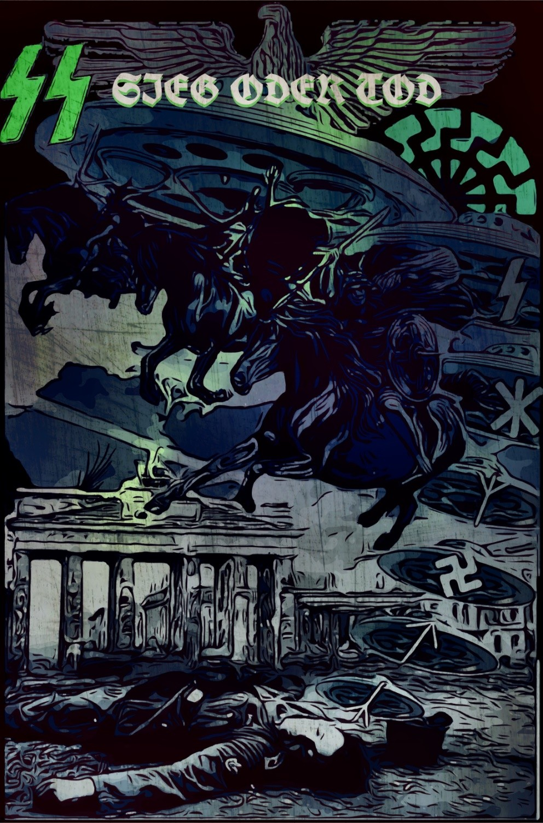

For those who died and those yet unborn We keep the faith deep in our hearts
You cannot conquer the Berlin inside us The Final Stand is yet to come!
卐
The Reich’s capital will stay Eternal
The walls may have fallen but not our hearts The Guards are dead but didn’t surrender
A Wagnerian End through smoke and blood
—Der Stürmer, Gallant Defenders Of The Last Bastion

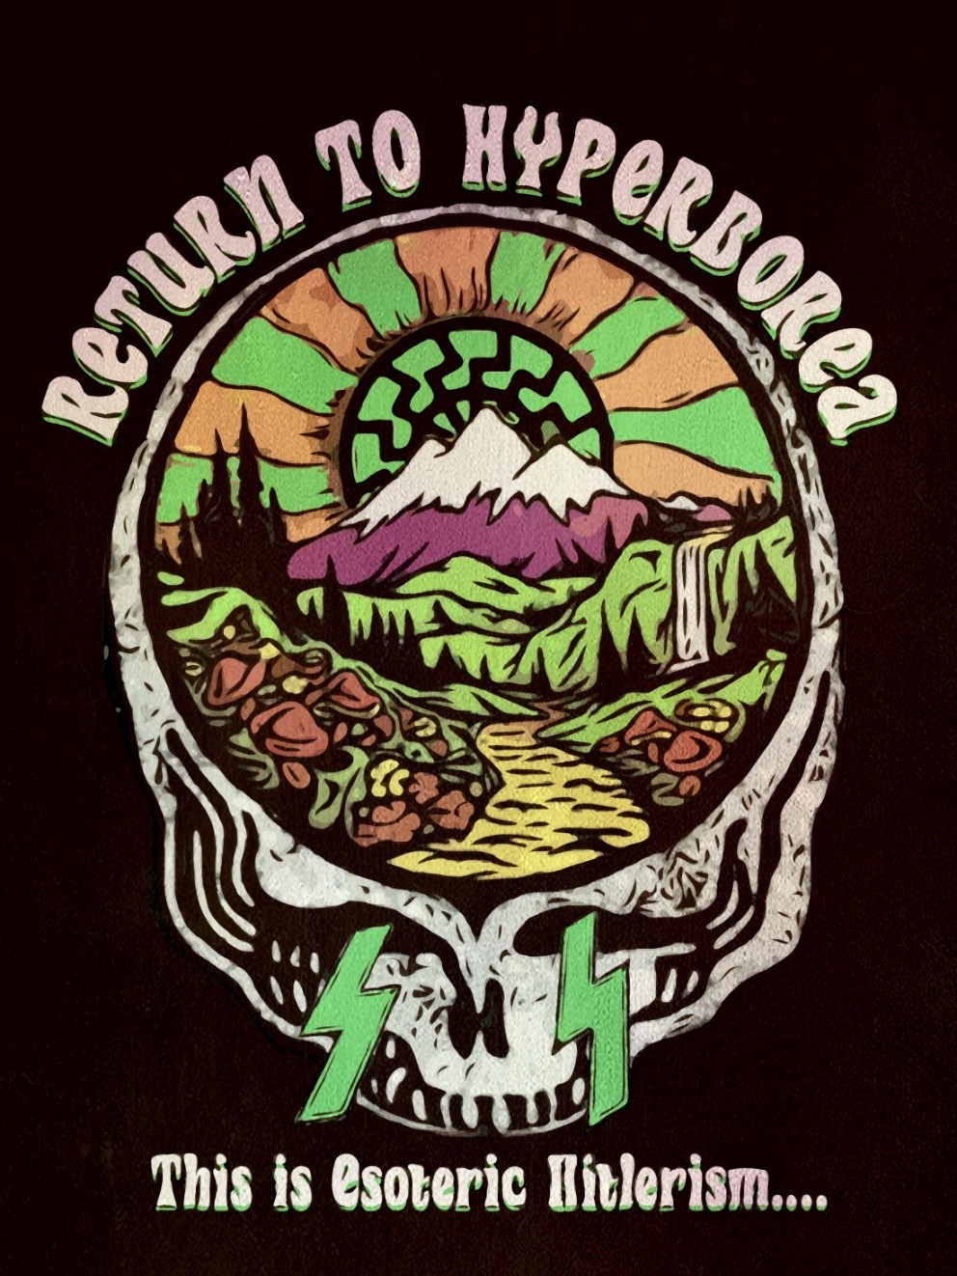

“Therefore the true temple is man and is found within man. This is where one must go to serve, to adore, to find the Mountain and cavern, the en- chanted city, oasis of the ice fields, that is where the Führer will Resurrect, the Man to Come, the Son of Man, here and there, in a synchronistic combat. Be- cause no one will find the refuge, cave, city, en- trance to the interior “hollow earth”, who has not on the outside found it first within himself. This is Esoteric Hitlerism!”
—Miguel Serrano

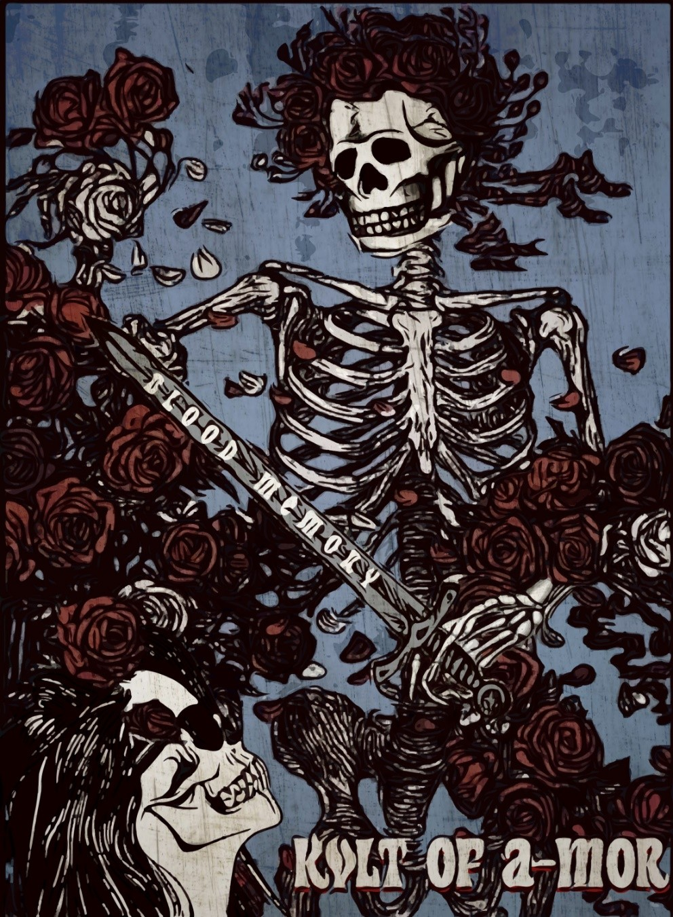

MAGIC LOVE

Brother Francis,
Brahmanic Order of Kristos-Lucifer-Wotan

“To give a face to the Beloved.”
“I sought divinity and I am at the Gates of Hell. Falling…I can still keep falling…Even through the flames, I must have a goal: There is a path to Heaven!”
He is Parzifal, sword in hand, and with the thought of the Be- loved in his heart and mind, the only one to cure Amfortas, the Grail King.
Miguel Serrano says his entire opus is centred on the mystery of magic love with his own anima, in this Love Initiation of the Min- nesänger.
There is a spiritual woman who calls us from what is not death. She may visit us, “reflecting” in a mortal woman and her love is the fruit of immortality.
The human being is a being whose nature is cleaved uncon- sciously, seeking to complete the lost unity or totality. When the hero falls precipitously to earth, he does so in one of the two halves or pairs of opposites that make the demiurgic world.
There is an animal love that results in children of the flesh, but there is a magic love from whose union the son of immortality arises. The power of love seeks the union of opposite pairs. The fruit of this union of opposite pairs, this union of the poles, is the element of life: So great is the power of love.
Through love man and woman seek to restore, regain life, the “lost unity”. Nevertheless, like profane love, vulgar love leads to

procreation and the child of flesh, whereas magic love gives birth to the “Son of Man,” that is, the son of spirit and immortality.
Throughout this initiation the archetype of the anima is the Lady of the Castle. As such, she can visit more than once in one’s life, “constellating” herself to use the expression of Jung, with the appearance of a real woman.
Serrano makes a distinction between the archetype of the an- ima, which is female, equivalent to the soul of man, and the animus archetype, which is masculine and is the soul of woman. He equates this with the “Body of Desire”, or subtle etheric body, which in men is feminine and in women masculine.
Therefore man desires woman and woman desires man.
In this understanding the Lady of the Castle is more than an archetype; she is the She of He-She. And the King is the He of She- He.
He-She is the one searching for her and She-He is the one look- ing for him. The ultimate union, Miguel Serrano tells us (in NOS: Book of the Resurrection), shall not occur in the union of opposites or in the primordial Androgyne, but between He-She and She-He in the ultimate separation and in reunion in this separation. In the Resurrection this union shall be WE.
The initiation of A-Mor (no-death) was discovered by the first troubadour (trovare, “to find”), Wotan, who discovered the runes, crucified on the Tree of Terror. And Wotan, to complete immortal- ization, the Resurrection, needed Freya or Frigg, She-He.
The first call, the first awakening on the path is achieved with “the gaze”. The Lady of the Castle, the Domna, “gazes” profoundly at the “Chosen” from his innermost secret. This catches fire, alights, “constellating” within the archetype of the anima. They fall in love: he has seen the divine woman. In “the Divine Comedy” Beatrice “gazes” at Dante who is smitten with life and death.
Having been “gazed upon”, the adept is transformed into the Fenhedor or sighing one. Thus he takes his part with the flute of Pan playing the notes in his blood and he goes to the forest, the mountain, the cave sighing of A-Mor for his Beloved, until she hears him and takes pity on his suffering and she “visits” him.

When she appears to him he declares his feeling of A-Mor to her. Now the adept is the Precador or suppliant, and he proclaims his A-Mor to his Valkyrie, his Domna. The proclamation is an invi- olable secret, only for two, because A-Mor never lasts once di- vulged and dispersed in words. Gods and Heroes love the secret.
The adept becomes an Entenedor, an unrequited lover, when she has lightly kissed him, scarcely placing her lips on his like the touch of a feather.
Then the adept understands that his nature is still ungainly and vulgar: He has not reached the level of such sublime love. This is the initiation of A-Mor which he must invigorate and transmute until the Beloved decides she has found him prepared for the great test of contemplating her naked.
For the Entenedor, the vision of the body of the woman is the supreme revelation of a Mystery collected at its core in the female form. He has been placed before a mirror where, with fright, he contemplates the form of his own soul, or his anima. This is the Memory and Nostalgia of the first union, before the partition of the Orphic Egg. It is the revelation of Paráklitos, the Cathar Dove.
From there follows “the test of Asag”. Dante says that “he who has set his foot there can never go back.” Doing so would be like committing suicide.
Asag consists in lying down naked in the same bed with his Beloved, spending the night there without touching her. We see here that Asag is chaste and belongs to the “Tantric “Right-Hand Path”.
In the “Tantrism of the Left-Hand Path”, in Maithuna, one physically takes the woman, but without ejaculating semen (Bundi), without orgasm initiated by the man, the Sadhaka; at least not physical orgasm. Instead of giving women an external son, Maithuna seeks to leave the man pregnant with an interior son, which is to say the man gives life to the Astral Body. The Astral Body is the Son of Death, Magic Death in this life so as to live be- yond death. The “Son of Man”. Which is to say A-Mor, without death, immortality.

In the event of esoteric pregnancy, the initiate, thanks to a Priestess of A-Mor, a spiritual Valkyrie, or a Tantric yogini, can give birth to the Astral Body, his vehicle for Eternity, his Son of Death and Immortality.
Authors such as Julius Evola assert that in the present moment of Kali-Yuga the body is so materialised that no escape can be found without making use of one’s own materiality, which is to say prac- ticing the Tantrism of the Left-Hand and Maithuna. The physical body lacks organs suitable for A-Mor and only has organs for re- production and the creation of the sons of this life, of the flesh who in reality is the son of terrestrial death.
Physical vigour and health provide virtue and healthy man- hood. This is essential for the power and self-control necessary to achieve the realization of Maithuna. The man who has declined and weakened his manhood is Amfortas, the Grail King who suffered so much and lost favour with the Grail. That is where chaos begins, obsession and sexual degeneration and where sooner or later mix- ing, impurity of the blood, miscegenation and Racial Sin occur. “And the commerce between the divine race, coming from other worlds, and the daughters of the animal-men.” (Miguel Serrano, “Adolf Hitler: The Ultimate Avatar”.)
Adolf Hitler was also called to follow the path of the Initiation of A-Mor. In the book “The Young Hitler I Knew”, August Kubizek reveals how the future Führer idealised Stephanie, a girl who he only “gazed upon” without ever saying a word. She was his own anima, perhaps the only one, though there may have been other “visits”.
Alchemy is also a Tantrism inherited from “Platonism”. It is the same as the Initiation of the Cathar Troubadours and the Ger- man Minnesänger. The soror mistica hands the metals to the alche- mist for him to mix in the Atanor of his own soul until he reaches the alchemical gold, the “aurum potabile” that we drink and gives us eternal life. Without this hand contact with the “mystic sister”, without this penetration of feminine energy and vibration, the mu- tual transmutation is not possible, nor the Jungian process of indi- viduation.

The woman is the custodian of the Grail Stone. She is the an- cient Hyperborean priestess preserving the Sacred Fire and thus en- ables the Golden Band not to break while awaiting the new cycle of the Resurrection of the King. At times she sleeps in the middle of a forest at the base of a mountain or in the Tower of a castle waiting for the hero to waken from his trance. She is Shakti-Kundalini.
Miguel Serrano says that alchemy is a science from Second Hy- perborea (after the fall) that tends to restore what was lost. Accord- ing to an ancient tradition, the angels were glorious beings that in- habited this world coming from elsewhere. Then they mixed and decayed. Osiris torn to shreds would thus be an angel fallen against his will. Isis united with the angel obtains the alchemical wisdom of the Grail and preserves it to give to her son, born virtually (her animus), Horus, who will be the avenging hero who remakes Osiris (equivalent to Amfortas, the Grail King) and restores the Golden Kingdom, regenerating the Terre Gaste, making it fertile again. Here we see the Parzifal of the Grail Cycle is equivalent to the Ho- rus of Egyptian tradition. Thus the Imperium of the Divine Dynasty is reconstitued, finally overcoming the Twilight of the Gods.
One must recover the the Tree of the Centre in the midst of the Terrestrial Paradise, conquer the Second Tree of Life (the second death), the Second Terrestrial Paradise. This leads to a tremendous conflict. It concerns healing a Sick King, dead and not dead, who must be restored. The metal is lead that must be transmuted into gold. It is the reconquest of the Golden Age. It is the Fifth Essence. Definitively this is the Grail, Total Man, the conquest of the Super- man. Osiris resurrected. Amfortas restored.
To transmute lead into gold, it is necessary to add sulphur, which is fire and the divine Luciferian element. Sulphur is also the will that converts the blood into fire. The Lord of Absolute Will (the Führer) must achieve the regeneration of the Aryan. In alchemy ar- senic or sulphur corresponds to virility.
By mobilizing virility we achieve pure will.
The opus alchimicum is the final product produced in the Atanor. Which is the Rebus, the Homunculus, the Androgyne, Shiva, the Astral Body, born to the alchemist thanks to his soror. He

is He-She, He and She together. The astral body of the alchemist with the face of the soror as well as his own. He is the God with two faces.
Here we see the face of the Domna occurs in the anima (female) of the Minnesánger. Simultaneously the soror has married her own animus (masculine), giving the face of He. She is She-He, She and He reunited.
Thus we encounter an androgyne created alongside the son Horus, the Astral Body. This is he and she, He-She in the case of him and She-He in the case of her. Because the astral body only ex- ists virtually, in potential. One must create it, invent it, in this mys- terious process of alchemic A-Mor. The astral body is the andro- gyne that lives beyond the death of the physical body.
All this after going through the Nigredo, the dark black night of mystic death, the Albedo, or resurrection from this death and the Rubedo, the immortalization by means of red spiritual matter pro- duced in the Green Thunderbolt.
The first mystery is fulfilled in the resurretion of the physical body, which is drawn to its resurrection by the astral body, as in a Chariot of Fire, as in a Vimana (since its shape has been made round) and it is carried beyond this world, like a black sun, through the door of Venus towards an extra-situation.
The second mystery is that in the resurrection and immortali- sation of the alchemist, the immortalisation of the soror, or the Be- loved, is produced as a consequence. Now there are two spheres, two androgynes, She-He and He-She, who love one another united and separated forever. Reunited in separation.
The third mystery is the mutation of the blood first produced in the veins of the astral body, later achieving the regeneration of the blood of the physical body of the vîra through the fiery vibra- tion of sulphur, able to transmute the lead of Saturn into gold, into “aurum potabile”.

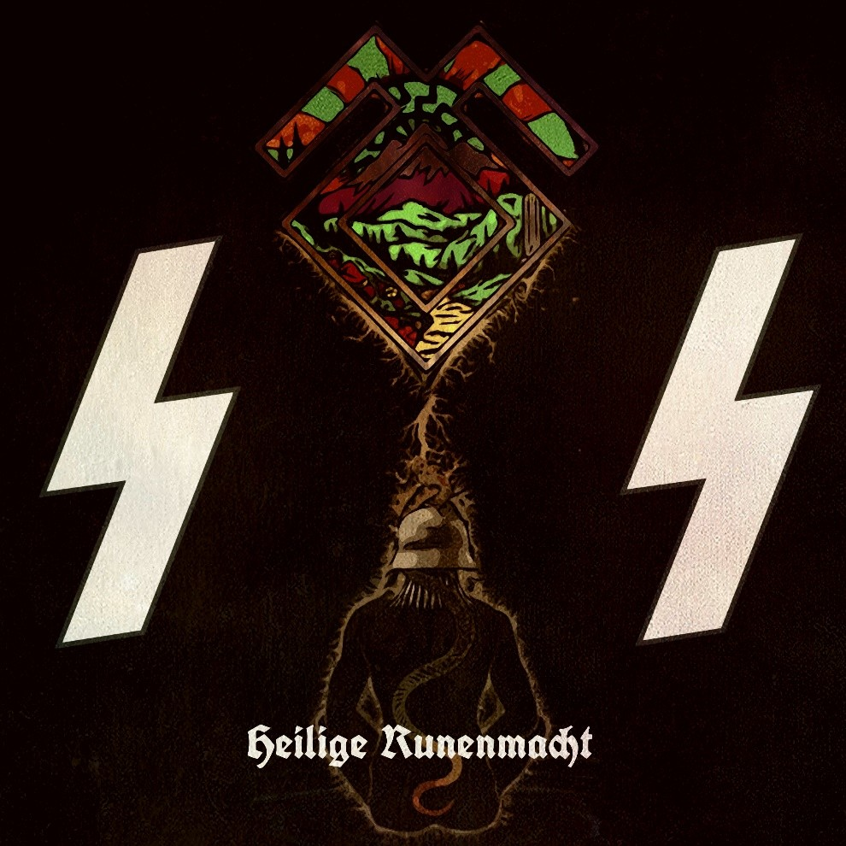

“Runes are this Power lost in Hyperborea, made visible as an exterior Sign during the Exodus and with the materialization of God Wotan making possible the Resurrection of the Hero, Baldur, the Comrade Son. The Res- urrection of Himself.”
—Miguel Serrano

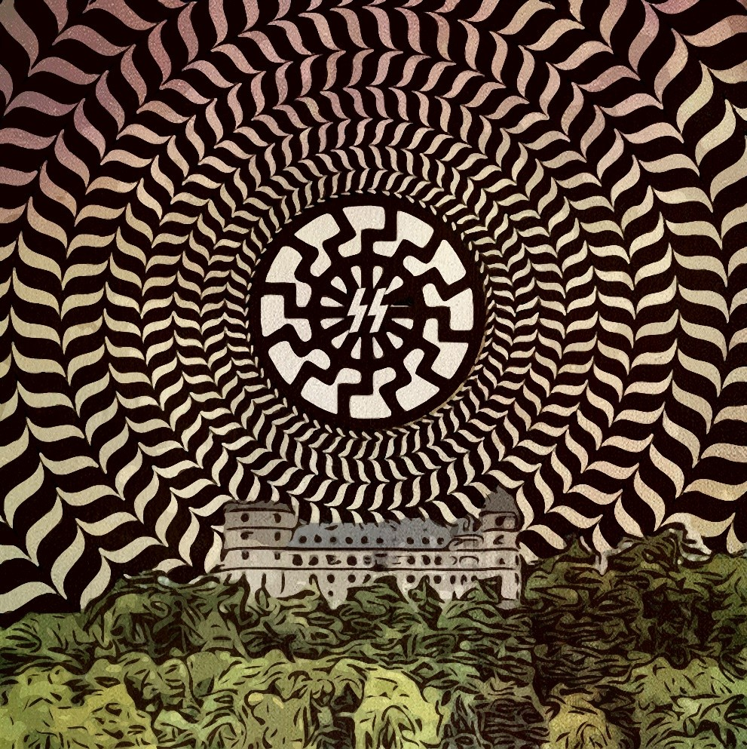

“Now all the world and the stars revolve around you. Now visualise the ancient crypt below, go through it down into the earthen hill, then back up through the column of the ether that revolves around it. Let all be silent, the silence of the dead mingles with the silence of the birds of the forest, silence reigns, Valhalla falls silent as it listens to the breaths of the Initiate. See in your mind’s eye the lightening bolts of the SS, now focus them inwards like the Iron Cross focuses inwards, with energies converging at the central point…See into the void of the Black Sun, into anti-matter, understand that the True Masters have overcome this world: they do not die in their bodies, they left this world of corruption and death in a glorious body of Resurrection, springing the lock as a divine key unlocks a gate, the Magic Gateway opens and their true body forms as a fiery chariot freeing them- selves from the chains of matter that implode in the centre of the Black Sun – The Spiritual Illuminator, the Midnight Sun, the ultimate Stargate of Death and Resurrection – opening of the portal of Eternity where all matter is dissolved, all mate- rialism is undone in its terrible vortex of ultimate destruc- tion. Only the Astal Body of the Ig-Nazi passes through the Black Hole of the Black Sun, the breakaway Astralkorper of Fiery Man passes through it.”
—Ignacio Ondargain

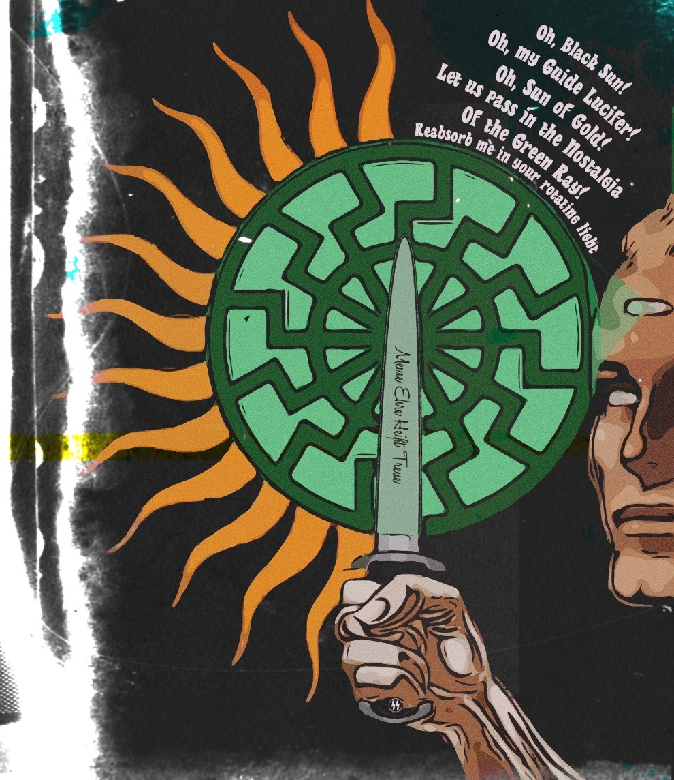

THE INVOCATION OF THE BLACK SUN

I pronounce my Oration to Lucifer:
_
Oh, Luci-Bel, Oh Morning Star Oyeihue
May your deep light fall upon me Moist
Cover me in your petals Of light
Like in the skies of Autumn.
Permit me to pass Through your Window Towards the Black Sun That waits behind you
Oh, Black Sun!
Absorb me in your light Backwards
Faster than the light Of the Golden Sun
And give me shelter In the nonexistence Of the Green Ray
Where the Master Dwells
Even the Masters of my Master And dwell the high Secret Guides Of Esoteric Hitlerism
Oh, Green Ray!
Engulf me in your nonexistence But more real than any existence Help me to realize
Impossible Dreams
The Resurrection of the Beloved
The return of the Fuhrer, Adolf Hitler The re-creation of Esoteric Hitlerism And the possession of the Archetype Until the consummation of its Myth And it’s Legend
In the Resurrection of the Flesh The Immortal Vajra.
Permit me to return to the Black Sun Oh, Black Sun!
Reabsorb me in your rotating light
And carry me to your home The Morning and Evening Star Yepun-Oyeihue
Oh, Morning and Evening Star! Together with the Beloved Now that She may fight
Within me
In my Impenetrable body of Red Light
The Immortal Vajra
The Incorruptible Power of Odil It Resides in NOS
The Vision and the Voice
And quickly we come to realize the Legend and the Myth
Of A-MOR
Until the consummation And Transfiguration
Into the Absolute Man and Woman
Oh, Evening Star, Yepun! Allow me to pass Through your Window To the Golden Sun
And with Chastity
There in Order to continue fighting The power in dawn
I reclaim.
Oh, my Guide Lucifer! Oh, Sun of Gold!
Let us pass in the Nostalgia Of the Green Ray
So that She and I We leave here
Towards something never heard Towards It-She
Beyond the Green Ray And of its Nonexistence
Heil! Sieg Heil!

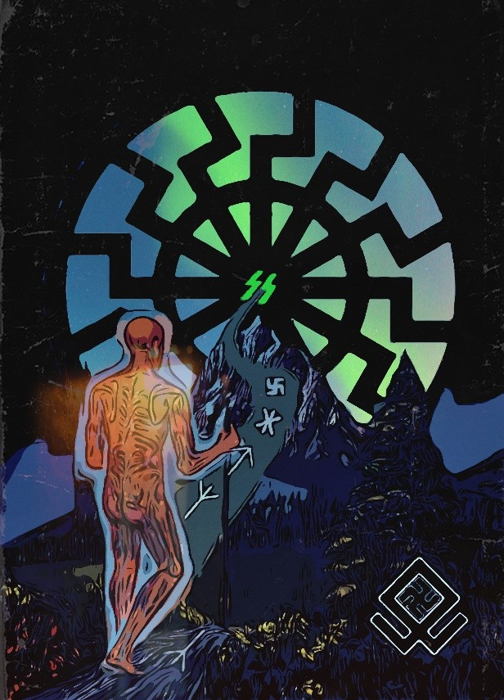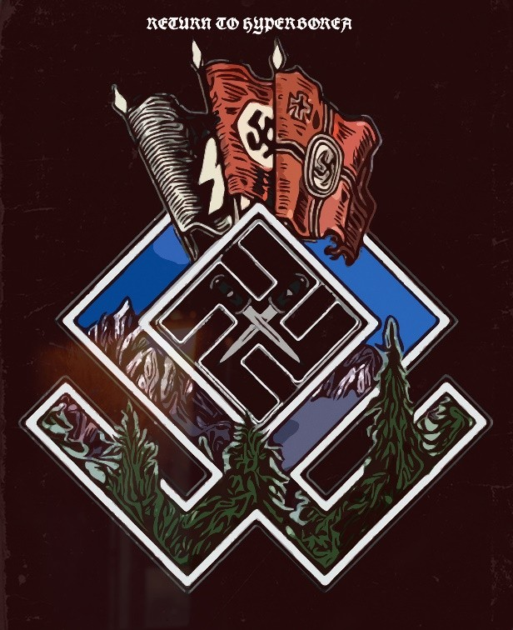

“So the Watcher of the Dawn will also be a Pilgrim of Nostalgia, Great Longing. Because in his blood, as in the light of the Morning Star, he hears this dis- tant music which surrounds him and makes him dream the world of Hyperborea, lost he knows not when. There does not exist an Aryan, a vîra, who is not nostalgic, a tireless Pilgrim.”
—Miguel Serrano

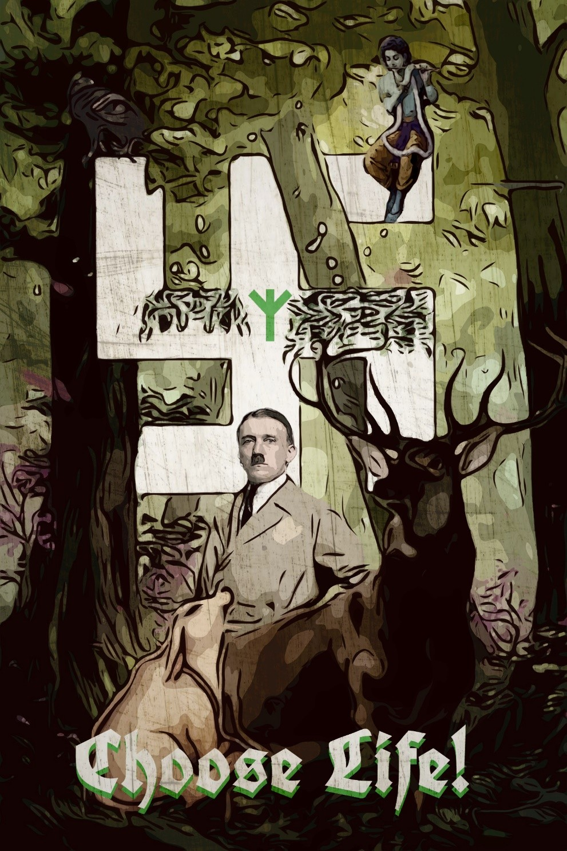

“Gods—i.e., divinely inspired supermen—are not born on earth every day, nor every century. And when they do come, and live and act in their miraculous manner, not every man, not every nation recognises them. Blessed is the nation who follows to the bitter end the divine men born in her midst, and who, whether in victory or disaster, clings to their spirit! That nation will triumph over the forces of death, in the long run, and thrive in beauty, strength, and joy, while the rest of the ungrateful world lies in waste at her feet. Thirty years ago, one could have believed that the days of the Gods were over forever; that the promise given to the world in the Book of books—the Bhagavad- Gita—was never again to be ful- filled; that mankind, day by day more degenerate, more bas- tardized, stupider, sicklier, uglier, had become incapable of producing an Individual worthy of carrying out a divine mission on an international scale. Both in the East and in the West, even the superior races were, or seemed to be, in full decay, nay, completely exhausted; nearing their end. But the message of the triumph of life, over and over again—God’s promise—can never fail. The words spoken by the world’s eternal Sustainer, no one remembers when, in Ku- rukshetra:”I come again . . . ,” were not spoken in vain. They hold good for all times, and for all lands in which a truly no- ble race, however tired, however overwhelmed by the dark- ening shadow of death, is still alive enough to bear witness to their accomplishment; to marvel and to adore; and to rise at the bidding of the returning Saviour. “When justice is crushed, when evil rules supreme”—when all hope seems ir- retrievably lost—the Saviour is already there, waiting, unno- ticed among the crowd; ready to reveal Himself.”
—Savitri Devi

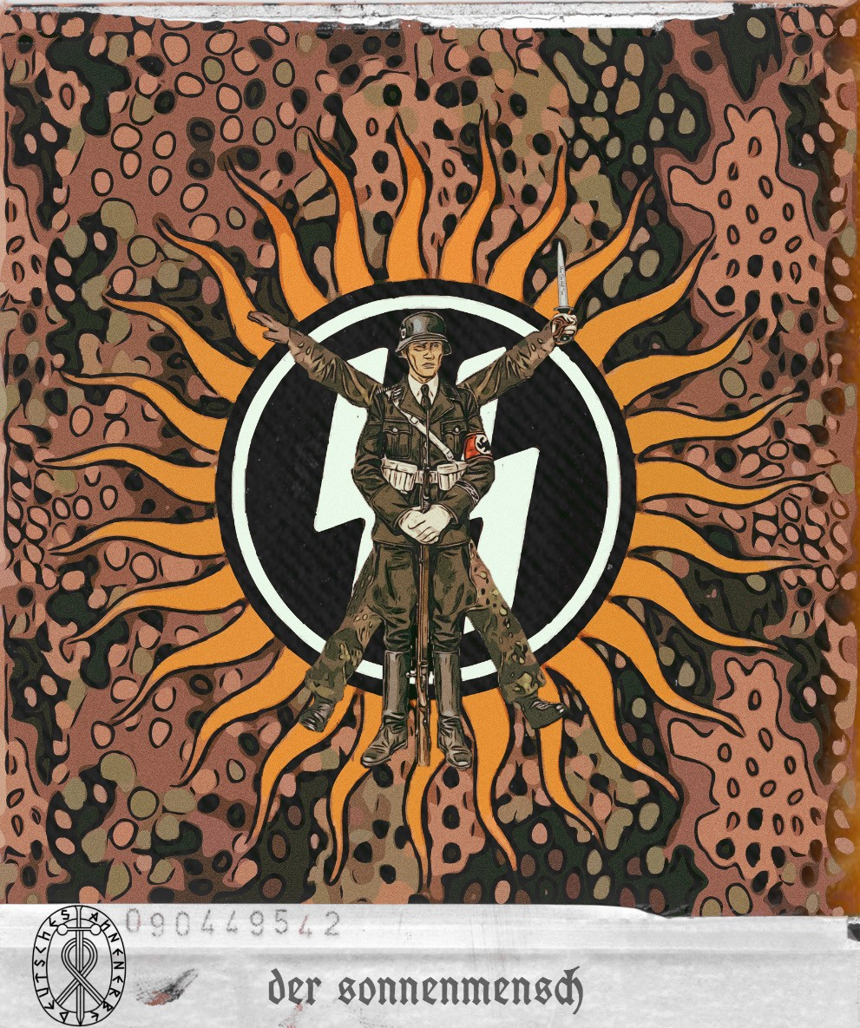

OTHER WORKS:

The complete Berghof trilogy – “A Thousand Years” Blutadler – “Warrior Revolution” Booklet Testament of Eagles



