 [Translated from Spanish to English - www.onlinedoctranslator.com](https://www.onlinedoctranslator.com/en/?utm_source=onlinedoctranslator&utm_medium=docx&utm_campaign=attribution)

2- OWN NAME AND SURNAME, CULTURAL IDENTITY: COVER SIGN OF PURE BLOOD.

Message by QUINTA DOMINICA » 29 Oct 2019 01:56

1- OWN NAMES AND SURNAMES, DESIGN AND MEANING DEMIURGIC OR HYPERBOREO.

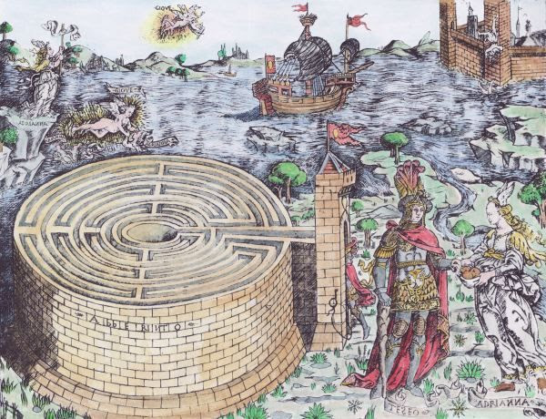

SOLVING THE MYSTERY OF THE LABYRINTH.

Engraving: "Theseus and Ariadne next to the Cretan labyrinth" (Baccio Baldini, approx. 1450).

of the ORIGIN.

1- OWN NAME AND SURNAME: ONTIC DESIGNS, HUMAN COVER SIGN OF THE NOOLOGICAL, OF THE PURE BLOOD.

In this article we are going to explore the "hyperborean" or synarchic meaning of the first or first names and the patronymic or surname of natural persons and their relationship with the human and racial, with the universal archetypes that determine the human and racial Soul. Pasu, universal ontic limits that must be crossed if the awakened Virya intends to make his spiritual liberation real.

This exploration is key for the VIRYA to achieve AWAKENING AND TRANSMUTE into an IMMORTAL SIDDHA.

This theme is the foundation of the second Hyperborean initiation of the awakened Virya, it must break, split the connections of meaning that by the name and surname identify it with the "interpass space" that separates the ONTIC from the NOOLOGICAL of the Microcosm.

The awakened Virya, if he intends to free himself, must RESIGN the HUMAN and RACIAL that determines him by his name and surname to the PASÚ PSYCHIC STRUCTURE.

Disintegrating the HUMAN and RACIAL requires GOING THROUGH the demiurgic DESIGNS projected by the FAMILY ARCHETYPE, designs that are determined by the OWN NAME AND SURNAME to the "BEING IN ITSELF" and "BEING FOR THE MAN", by the UNIVERSAL and PARTICULAR determines it to the PASU archetype .

If the KAMARADA intends to transmute into VIRYA BERSERKR, he must go through the initiatory tests that transmute the awakened Virya into Loyal Siddha. This article describes the obstacles, insurmountable walls that the WARRIOR must TAKE DOWN, we are referring to those obstacles that participate in the HUMAN and RACIAL SOUL, in the MANÚ RACIAL ARCHETYPE. OF THE "LOST" VIRYA limits that identify it with the HUMAN, with the RACE and the SOIL.

CULTURAL IDENTITY is a "LABYRINTH" COMPLEX from which only the AWAKEN VIRYA WHO HAVE MANAGED TO PURIFY THE BLOOD AND ARRIVE AT THAT ETHICS AND AESTHETICS WHICH PARTICIPATES IN THE SPIRITUAL LINEAGE OF THE HYPERBOREAL HEROES can ESCAPE, RELEASE, a topic that we will delve into in this text.

**Anthroponymy or anthropological onomastics.**

This science is a branch of onomastics, a science that studies the origin and meaning of the proper names of people, including surnames, of course, what we explore is that Gnostic KNOWLEDGE that reveals the HYPERBOREA WISDOM science of SPIRITUAL LIBERATION of the LOYAL SIDDHAS of AGARTHA about the DESIGNS that are present in the VIRYA about his NAME AND SURNAME. A topic that we will describe throughout this article.

To arrive at that GNOSTIC TRUTH that is found in the CULTURAL record of OWN NAMES AND SURNAMES we must dive into the deepest SPHERES of SELF, understand truths about the NAMES AND SURNAMES of the lost virya "people" and their relationship or connection of sense the SPIRIT, the SOUL and the BODY, about the three natures of the Virya; "animal or Pasu, semi-divine (Human Soul) or divine Virya (Racial Soul) or Siddhas (Eternal Spirit). Such understanding will allow us to reveal the truth that is subsumed "behind" the names and surnames and their link with the ontological reality of the SOUL and noological of the SPIRIT, what the lost Virya IS or tends to BECOME by being designated by that VOX that participates by the name and surname, of a link with a BLOOD and a SOIL, which determines ANIMICAL and CULTURAL and SPIRITUAL MIND in a "FORM THAT DETERMINES THE BEING". From now on, understanding that reality of the Virya by the OWN NAME AND SURNAME enters us into the Gnostic understanding of the BEING and its FORM which participates in the astral and psychic structure of the SOUL and biology of the BODY, in short of the CURRENT SCHEME OF ITSELF,

For this reason, it will be key to be an AWAKEN VIRYA who has the maximum spiritual ORIENTATION, capable of exploring one's own CULTURAL ONTIC RECORD to arrive at the NAKED TRUTH OF SELF, a truth that allows us to enter those gnostic noological powers that endow the AWAKEN VIRYA with a VOLITIVE RUNIC capacity with which you can DISINTEGRATE those ONTIC DESIGNS that CULTURALLY determines that pasú individuality that recasts it in the DEMIURGIC ONTIC ARCHETYPES:

a) the "BEING IN ITSELF" design where the Name and Surname is determined by the HUMAN that participates in the MANU MONAD and the SACRED SYMBOL OF THE PASÚ.

b) the "BEING FOR THE MAN", a design where the Name and Surname participate in the RACIAL MONAD and the SACRED SYMBOL OF THE VIRYA.

3) the "BEING FOR GOD", a design in which the OWN NAME AND SURNAME is designated and assigned by the RACIAL DEMIURGIC ENTELECHIES MANÚ (Hebrew race, of white betrayal, specifically).

Only those who are capable of CROSSING the ontic limits of the PASÚ MONAD and its RACIAL ENTELECHY MANÚ, which is designated by the human and racial of Himself, will be able to GIVE DEATH TO THE IMMORTAL SOUL and CONQUER the MORTAL BODY, thus free of the designs demiugicos will be able to free themselves from the PRISON of SPIRITUAL CHAIN ​​BY TRANSMUTING THEIR BODY INTO VRAJA or "flying" as SPIRIT SPHERE to the ETERNITY OF THE ORIGIN.

1- OWN NAMES AND SURNAMES DESIGNS THAT LINK YOU WITH THE RACE. THE LINEAGE AND THE BLOOD.

It is evident that the OWN NAME is a way of DESIGNATING a child and giving him/her a PARTICULAR IDENTITY; this name individualizes the VIRYA as an INDIVIDUAL who is part of a FAMILY ARCHETYPE and a RACIAL LINEAGE. On the other hand, the SURNAME is linked to the RACIAL LINEAGE of which the family archetype is a part. The SURNAME responds to a group of individuals, brothers, cousins, who have BLOOD TIES in common and the same SURNAME. This patronymic grants a common identity to the members of a FAMILY who share a LINEAGE linked by BLOOD to a RACE and by the LAND to the same COUNTRY.

At this point we must stop because BLOOD and SOIL participate in the mystery of chaining and liberation, the BLOOD refers to an INTERIOR point and the SOIL to an EXTERIOR point that is related or linked to the TAU POINT, the door of egress that is linked to the PATH OF RETURN through the Gnostic path of the PURE BLOOD to the TAU POINT to the SELBST and the VRIL, to that NOOLOGICAL RUNIC POWER that transmutes the VIRYA INTO SIDDHA BERSERKIR. This is a key issue to understand, since the OWN NAME participates in the PARTICULAR and the SURNAME in the UNIVERSAL, the NAME is linked to the BLOOD and related by the SURNAME by the LINEAGE and the RACE, linked to the SOIL,

(Nation, Homeland, culture, etc.)

The OWN NAME individualizes the lost Virya as a particular being within the FAMILY ARCHETYPE and through the SURNAME it links it to a LINEAGE which is part of a RACIAL AECHETYPE that participates in the evolutionary space of an EXTERNAL CULTURE which drives the archetypal evolution of the SUPER MACROCOSMIC CULTURAL STRUCTURE, analogue, TERRESTRIAL LOGOS, ROYAL KALACHAKRA SYSTEM.

Let's remember:

1- the HUMAN SOUL is linked to the human race and by the RACIAL SOUL to an ethnic species, to a RACE which is manifested by certain phylogenetic, physiognomic and anatomical features that define it as such, in the same way by a LANGUAGE and a reference spatial, geographical, and temporal, historical, etc. In another sense, a RACE is linked to a TERRITORY, NATION, EXTERNAL CULTURE, among other things.

2- The ETERNAL SPIRIT is charismatically linked with the BLOOD and the SOIL; through the BLOOD with the TONGUE and the inner world, through the SOIL with the RACE and the outer world, a topic we explore later.

3- NAMES AND SURNAMES, COVERSIGNS OF THE SELF/SPIRIT.

The CULTURAL REGISTER of the OWN NAME and SURNAME is a COVER SIGN that COVERS with its SIGNS the ONTICORTEMPORAL RECORD of the SOUL and BODY of the lost VIRYA, another issue is the SPIRIT of the AWAKEN VIRYA, which is accessed when the AWAKEN VIRYA manages to resign the COVER SIGNS and give DEATH TO THE IMMORTAL SOUL, freeing the SPIRIT from the prison of the Microcosm Pasú, from the chaining to the world of PAIN, a topic that we will delve into because this action of internal war transmutes it to the Virya into a Virya Berserkr.

As we will explore step by step, the NAME AND SURNAME is an archetypal design that acts as a COVER SIGN that COVERS the TRUTH of the SPIRIT, of the TRUE OR ABSOLUTE SELF. The COVERS SIGNS affirm the contents of the CULTURAL RECORDS that identify the lost SELF with the SOUL, with the BEING, the human and racial that participates in the Pasú potential MICROCOSM. The Virya is asleep and lost, lost within the Soul Subject or sphere of CONSCIOUSNESS, by the NAME and the SURNAME, designs that grant ONTOLOGICAL IDENTITY to the SELF chained to the BEING. It is clear that the NAME AND SURNAME is affirmed by the PHONETIC or ACOUSTIC QABALAH, by the ARCHETYPICAL VOICE that ADJUSTS the SELF to the BEING of the MICROCOSM that is CHAINED. "BEING" is understood as the HUMAN AND RACIAL SOUL that animates the humanity and raciality of the Pasu MICROCOSMOS. The NAME and SURNAME is a VOICE that grants CULTURAL IDENTITY to the MICROCOSM, being designated and REGISTERED as a PASÚ INDIVIDUAL that makes up the axiological context of a superstructure in which you are inserted called FAMILY, which participates in a LINEAGE, one or several RACES. and therefore it is part of HUMANITY that makes up all the EXTERNAL CULTURES of the MACROCOSMIC CULTURAL SUPER STRUCTURE. NAMES AND SURNAMES are conceptually related to designs that participate in an axiological context which is made up of: INDIVIDUALS, PLACES AND THINGS designated by the demiurge. . The axiological context where the Virya is inserted is a powerful TAPASIGN called PSYCHOID ARCHETYPE or EGREGORE, called CULTURE, which gives the NAME AND SURNAME HUMAN, RACIAL and FAMILY identity to the MICROCOSM designated by the Demiurge.

The Microcosm is an entity created and designated naturally by the Demiurge, (physionomy, anatomy and physiology, etc.), moreover, it evolves due to the cultural design it carries, a design that is projected by the psychoid archetypes that intervene in that ontic and cultural, epistemological evolution. and axiological, such as: Family, Race, Nation archetype. From another perspective; the genus and the species, namely:

1st) By the SPECIES with the first NAME designs related to the "BEING FOR MAN", the INDIVIDUAL PARTICULAR of the Virya that individualizes it and identifies it with a FAMILY LINEAGE and a RACIAL SPECIES, etc.

2nd) For the GENDER with the SURNAME design related to the "BEING IN ITS", the UNIVERSAL of the GENDER, which identifies it with its HUMAN condition and its historical evolution.

Both designs are present in the MICROCOSM and DESIGNATE it by its OWN NAME with the SELF/SPIRIT and by the SURNAME with the BEING/SOUL. At this point we must point out that the Maya Trap intervenes here, because the lost Self will identify itself with The UNIVERSAL OF THE GENDER, with its HUMANITY PASÚ, which leads it to move away from the mystery of BLOOD and LINEAGE, obviously from RACE, this is because the lost Self will follow the psychoid archetypes and these point the path of the SOUL HUMAN, the ELIX path that leads through the GENERAL LAW OF EVOLUTION to the MANÚ ENTELECHY, which paradoxically takes shape on the RACIAL SOUL, it is evident that the path of the HUMAN AND RACIAL SOUL definitively distances the lost SELF from the REVERSE PATH that through the LINEAGE AND THE BLOOD it is conducive to the AWAKEN SELF to the TAU point and to the SELBST. a topic that we will deepen step by step, as we go through that LABYRINTH that participates in gender, species, lineage, blood and is linked to first names and surnames.

It will be KEY to understand the sense or meaning that the NAMES and SURNAMES carry, if the AWAKEN VIRYA in his KAIROS intends to GIVE HIM THE DEAD HUMAN AND RACIAL SOUL PASÚ and resign the ILLUSION OF THE BEING OF THE IMMORTAL SOUL and its potential RACIAL ONTIC ENTELECHY MANU.

In another article on the Quintadominica Forum we explore: THE DEATH OF THE IMMORTAL SOUL AND THE TRANSMUTATION OF THE MORTAL BODY INTO VRAJA. From now on, it will be necessary to explore this topic to UNDERSTAND the meaning that OWN NAMES AND SURNAMES have in the SPIRITUAL LIBERATION STRATEGY, in any case, of SPIRITUAL CHAINING, depending on which perspective you look at it from, whether it is HYPERBOREA or if it is SYNARCA . In any case, the NAME AND SURNAME is a DEMIURGICAL DESIGN that grants CULTURAL IDENTITY and individualizes the lost semi-divine Virya as a BEING that is part of a FAMILY LINEAGE that participates in a RACIAL SPECIES and the HUMAN GENDER.

People's OWN NAMES and SURNAMES are identified with the SPIRIT, the SOUL and the BODY. In general, the SURNAME is linked to the SOUL and the NAME is linked to the SOUL and the SPIRIT, a topic that we explore.

2- THE SURNAME AND THE NAME AND THE ONTIC RECORD OF THE LOST VIRYA. /b]

The NAME and LAST NAME is key in the ONTIC AUTONOMY of the lost Virya, we can say that when the lost SELF enters the "center" of SELF (soul) the formation of the HISTORICAL SUBJECT or the HISTORY OF SELF begins, the which will constitute the ONTIC-TEMPORAL HISTORICAL RECORD of the CURRENT SCHEME OF SELF.

The LOST SELF as a PSYCHOLOGICAL SELF will never be able to RESIGN the ONTIC RECORD, unless it discovers that the NAME AND SURNAME is a DEMIURGICAL COVER SIGN that is identified with the FAMILY ARCHETYPE and the CULTURAL LINEAGE as such.

It is evident that to REALIZE that the NAME

OWN AND SURNAME are TAPASIGNO of the PURE BLOOD, or of the ETERNAL SPIRIT, the LOST VIRYA must be transmuted into AWAKEN VIRYA, only in this way can you understand that the RACIAL AND FAMILY ARCHETYPE is PURE ILLUSION, it is part of the EVOLUTIONARY PLAN contained in an EXTERNAL RACE AND CULTURE that participates in the MACROCOSMIC CULTURAL SUPER STRUCTURE.

Analogous to that EXTERIOR PLAN happens inside the MICROCOSM, that DEMIURGICAL plan or design contained by the RACE in the NAME AND SURNAME is updated by the voice of the LOGOS Kundalini, this updates the NAME and SURNAME in the essential matrix of the SNAIL design, and By the SERPENT design this ADJUSTS it to the potential MICROCOSM of the LOST SEMIDIVINE VIRYA. Thus the LOST SELF is confined ONTICALLY and BIOLOGICALLY to the ethical and aesthetic limit contained in the HUMAN and RACIAL of the current SELF SCHEME. The LOST SELF is SELF-CRUSSIFIED by identifying itself with the CULTURAL IDENTITY that the NAME AND SURNAME represents, remaining ontically and gnoseologically determined to that HUMANITY and RACIALITY that determines it as a LOST PASÚ or VIRYA.

Obviously the AWAKEN VIRYA will be able to UNDERSTAND that the SELF/SPIRIT is TIMELESS and INFINITE, it simply IS and nothing is outside of its BEING, on the other hand the BEING/SOUL needs to BE and the identity of its NAME AND SURNAME grants "REAL" existence to the BEING. that she or he IS. The Virya will identify itself with the being:

1- with the NAME, the "POSITION", given and projected by the PARENTS to the child.

2- with the SURNAME, what is "INHERITED" and "GIVEN" to the Virya by the biological and historical evolution of the LINEAGE, by the FAMILY ARCHETYPE.

Name. It is linked to the BLOOD and the LINEAGE, with the particular that determines and individualizes it as an individual Virya that is part of a FAMILY LINEAGE. The SURNAME is linked to the general universal that relates it to the evolution of a RACIAL LINEAGE linked to the SOIL and the COUNTRY, etc.

The SURNAME is the COVER SIGN of the RACE and HUMANITY, behind it is the HISTORY of the Virya, of its CHAINING and SPIRITUAL LIBERATION, which is why we must understand the strategic importance that participates in the DESIGNS projected with the NAMES of the people and the SURNAMES of family lineages, a topic related to the ONTIC RECORD of people or characters, although we must remember that we are NOT authorized to explore ONTIC RECORDS, so we will try to get closer to that truth by exploring the meaning that the NAMES AND SURNAMES carry, these They are CULTURAL RECORDS that act as ontic COVERS SIGNS that have the specific function of COVERING what IS of the ETERNAL SPIRIT and IS NOT of the SOUL in the MICROCOSM or PHYSICAL BODY of the LOST SEMI-DIVINE VIRYA. To understand this strategic truth we must explore its deeper meanings.

5)THE COVERSIGNS OF THE SELF/SPIRIT OF THE DEMIDIVINE VIRYA.

In these three mentioned points they express the CULTURAL COVER SIGNS of the SELF/SPIRIT, we affirm that the NAME, what is given by the PARENTS, and the SURNAME, what is inherited heraldically through the historical evolution of the FAMILY archetype, are true COVER SIGNS of the TRUE SELF, these SIGNS (name and last name) THEY COVER the reality of the SPIRIT and recast it in the CULTURAL ONTIC RECORD that endows, through the proper name, CULTURAL IDENTITY to the person, to the LOST SELF that, through the COVER SIGN, identifies itself with the CONSCIOUS SUBJECT and begins to suffer from an OBJECTIVE LOSS By participating all ARCHETYPICAL DESIGN and proper names and surnames, regardless of race, are the GENERAL LAW OF MACROCOSMIC EVOLUTION. The viryas who suffer from this objective loss will gradually identify with that identity that will make up their historical subject, the history of THEMSELVES which participates through the FAMILY and RACIAL ARCHETYPE in a series of CULTURAL DESIGNS (PROFESSION archetype, WORK, etc.) that promote the ENTELECHIAL evolution of the family lineage that is part of the FAMILY ARCHETYPE.

We will try to clarify the strategic meaning of the COVER SIGNS that gives the IMMORTAL SOUL and the MORTAL BODY its OWN NAME by exploring the CULTURAL RECORDS related to NAMES AND SURNAMES, fundamentally we carry out this exploration to KNOW what is behind the cultural COVER SIGNS that define men and women as such, as particular beings that are parts of the HUMAN gender, of a RACIAL group and of a SPIRITUAL LINEAGE.

Exposing a rational and "gnostic" explanation about the meaning of NAMES and SURNAMES leads us to investigate the relationship that these ONTIC DESIGNS have with the STRATEGIES OF THE BLOOD COVENANT related to the Hyperborean BLOODS and LINEAGES, on the contrary and in the same way , these ONTIC DESIGNS are related to the STRATEGIES OF THE CULTURAL COVENANT and to the synarch RACES and LINEAGES.

We can give hundreds of examples, let's take one: JULIUS CAESAR was a REGAL leader of the BLOOD COVENANT and his NAME will be CHARISMATICLY LINKED with the BLOOD and LINEAGES of the HYPERBOREEAN HEROES, on the contrary JESUS ​​is the name of a PRIESTLY messiah of the CULTURAL COVENANT and that ontic design will always be related to the BLOODS and LINEAGES of the GOLEN priests.

The NAMES and SURNAMES are the COVER SIGNS of SELF/SPIRIT, these constitute the ILLUSION OF THE BEING, they provide the SOUL and BODY (MICROCOSMS) with CULTURAL IDENTITY, which links it with the reality of GENDER (design "Being in Itself) and the SPECIES (design, "Be for Man). The COVER SIGN revealed by NAMES AND SURNAMES is studied by ANTHROPOLOGY ONOMASTICS, sciences that study the origin and meaning of the FIRST NAMES and SURNAMES of people.

ONOMASTICS together with TOPONYMY explores the origin of NAMES AND SURNAMES and their relationship with NATURAL and CULTURAL PSYCHOREGIONS, etc.

The etymological origin and the "hidden" meaning of the Virya's OWN NAME is key; the FAMILY ARCHETYPE actively intervenes on the SURNAME and this is related to the RACIAL ARCHETYPE and CULTURAL IDENTITY. Cultural identity means: genetic or racial inheritance, language or language, nation or soil, etc.

THE OWN NAME that will be projected to the child by the parents will depend on the RACE and CULTURE, from a Hyperborean point of view, according to the INTERNAL CULTURAL STRUCTURE of the parents, in other words, it will be the PREMINENT CULTURAL PREMISES that WILL INTERVENE determining the SEARCH of the OWN NAME of the parents who will confirm about the child.

In them the FAMILY ARCHETYPE actively intervenes in the choice of the OWN NAME which they will project to the son or daughter, in general if the PARENTS are asleep they will be victims of the CULTURE and choose a OWN NAME related to a SYNARCH DESIGN, if the parents are VIRYAS WAKE UP, the OWN NAME will be that of a HYPERBOREAL "HERO".

That NAME and its VOICE carry a DESIGN that enters it into a MYTH which participates by its OWN NAME in the HYPERBOREAN MYTHS of the BLOOD PACT of the LOYAL SIDDHAS or of the SYNARCH MYTHS of the CULTURAL PACT of the TRAITOR SIDDHAS.

This TRUTH is ABSOLUTE, everything acquires MEANING whether to RELEASE or CHAIN ​​and the NAMES and SURNAMES are the CULTURAL COVERS SIGNS of the ONTIC RECORDS of the LOST or AWAKENED VIRYA.

For example, proper names such as: AUGUSTO, NAPOLEON, ADOLFO, FEDERICO, FELIPE, ALEJANDRO, OSCAR, RICARDO, LUIS, MARIO, VICTOR, to name a few, are etymologically linked to the ROYAL LEADERS of the BLOOD PACT, on the contrary proper names such as: PEDRO, JUAN, SANTIAGO, JAKOBO, MIGUEL, RAFAEL, EMANUEL, LUCAS, PABLO, etc., are related to the GOLEN PRIESTS OF THE CULTURAL COVENANT.

Although we must consider that NOTHING IS ABSOLUTE, we must keep in mind that in the VOX of these proper names the HYPERBOREAL or DEMIURGIC design is superimposed and this has a relationship with the SPIRIT or the SOUL, with a historical context that is related to the LIBERATION or SPIRITUAL CHAINING.

6- GEOGRAPHICAL TOPONYMY.

Toponymy is a discipline of onomastics that consists of the etymological study of proper names with a specific geographical place. Let us remember that GEOGRAPHY is analogous to LAND or NATION and HISTORY is analogous to TIME.

The term "toponymy" derives etymologically from the Greek τόπος (tópos, "place") geography and ὄνομα (ónoma, name), language, history, race, etc. All names and surnames have two well-determined toponymic origins, the SURNAME, the "INHERITED" and participates in the anthropological and racial origin of the individual, and the NAME, the "GIVEN" by the language or idiom, by the culture in which the person was born. individual. The SURNAME is linked to the RACE and the NAME to the divine BLOOD or pasu, the concept of LAND or NATION intervenes little, a topic that we will expand on.

For example, the last name may be HEBREW, but when born on ENGLISH or SPANISH soil, your first and last name may be ANGLO-SAXON, HISPANIC, this onomastic TAPASIGN can COVER the TRUTH of who the HEBREW or Jew IS, but if you remove that tapasign, you will find the BARE TRUTH of what the VIRYA spiritually IS and corresponds to his SANRE and RACAIL LINEAGE. Geographic toponymy is the STRATEGIC WEAPON of the synarch initiates that is HIDDEN behind the NAME AND SURNAMES that are ARIAN or ANTIONS AND CULTURES that were or are part of the BLOOD COVENANT. On the contrary, there are the OWN NAMES AND SURNAMES that are ARISO AND HYPERBOREAL and still remain PURE throughout history, although they are less and less every day, only in certain EUROPEAN NATIONS do certain DESIGNS that were projected by the SIDDHAS OF EAGARTHA or by the HIGHEST PONTIFICES OF THE BLOOD COVENANT. For this reason, the NAME that an AWAKEN VIRYA would project to a CHILD OF STONE who joins the HOST OF WOTAN when he is a child of stone becomes relevant, is a MAN of the PURE BLOOD, an awakened Virya who fights and combats the enemy within the NATION that was born and that saw it grow. Let us remember that in HEBREW, no matter how much he uses Aryan COVER SIGNS, his JEWISH NATURE remains unalterable, whether his SURNAME is ENGLISH or SPANISH, he will always be a HEBREW.

This topic we will explore later.

The AWAKEN VIRYA must explore these academic sciences if he considers it necessary, we do it from a Hyperborean PERSPECTIVE, as the NAME and SURNAME are the COVER SIGN of the ONTIC RECORD of the LOST VIRYA, his first and last name is ONTICLY REGISTERED to a CULTURAL IDENTITY determined by LINEAGE and RACE or by LAND (NATION) and COUNTRY (HISTORY).

Let us remember that sooner or later the AWAKEN SELF will have to face those images of SELF that are represented by the NAME AND SURNAME and are referring to the HUMAN AND RACIAL ARCHETYPE that determines it in the PASÚ PSYCHIC STRUCTURE.

Let us remember that such an internal war between the ETERNAL SPIRIT and the CREATED SOUL must happen YES or YES, and by confronting the AWAKEN SELF with that aspect of the BEING that IS NOT of the SPIRIT and is of the DEMIURGE, the AWAKEN VIRYA will face those ontic limits that by its NAME AND SURNAME links it to the RACES and LINEAGES that RESPOND to it.

Hence the NAME carries a POWER in its design and this is a DOOR that enters it to the CONQUEST of the

ITSELF.

There are NAMES AND SURNAMES related to the SOUL and the SPIRIT, as we analyzed previously, we saw that JULIUS CAESAR is a NAME that is linked to a HISTORICAL RECORD that responds to the BLOOD COVENANT, on the other hand JESUS ​​is a name that responds to the strategy of the CULTURAL PACT. Evidently JULIUS CAESAR is a proper name HYPERBOREUS and JESUS ​​is a proper name SINARCA.

Let us remember: the PREDETERMINED FORM TO THE BEING, and in the etymological origin of the NAME and SURNAME, the BEING of the RACIAL AND CULTURAL DESIGN that represents the PHYLOGENETIC HISTORY of the MICROCOSM of the LOST VIRYA is superimposed, evidently the awakened VIRYA upon AWAKENING will begin to resign the HUMAN AND RACIAL of HIMSELF and those designs are related to the NAME AND SURNAME THAT determines what is designated by the Demiurge in the HUMAN SOUL and by the Shiddas who are traitors to the RACIAL SOUL, a topic that we expand on in an article in this Quitadominica Forum and that we recommend exploring . On this scale we represent certain relationships between:

a- The SURNAME is related to the BEING/SOUL and has a direct relationship with what is inherited by the FAMILY archetype and its relationship with LINEAGE and RACE.

b- The NAME is linked to the SELF/SPIRIT, it acquires relevance because it is what is "given" by the parents and conceptually defines in the first instance the SELF as a BEING, a conscious subject who recognizes and individualizes HIMSELF by his NAME and SURNAME .

With respect to the OWN NAMES that are projected to the children, many times these parents, generally asleep, are INSPIRED by the SIDDHAS OF AGARTHA, a hidden theme but that is Kdas, many times the name chosen is that of a HYPERBOREAL HERO, for GNOSTIC INSPIRATION Parents still asleep project a HYPERBORAE OWN NAME which will contribute to the SPIRITUAL GUIDANCE of the young virya.

In general the parents are simply LOST VIRYAS, victims of the FAMILY ARCHETYPE and the EXTREME synarch CULTURES and the name they project to the child comes from a religious origin, this is very common in FAMILIES that are inserted in monotheistic RELIGIONS, surely the NAME OWN projected by the parents will be of religious origin that participates in the FAMILY ARCHETYPE, if it is of the Catholic religion it will be a Christian proper name, if it is of the Hebrew religion it will be a Jewish proper name, if it is Islamic it will be a proper name of Muslim origin, so we can continue with all religions or beliefs that respond to the Golem Universal Synarchy. Such a name of religious ORIGIN is always a CAPASIGN, but such synarchic tapasigns will be directly conducive to that RELIGIOUS PATH SINARCH that participates in their NAME AND SURNAME and their function will be to COVER the spiritual search of the LOST VIRYA, if it has the BLOOD or HYPERBOREAL LINEAGE Let us remember beyond the NAME AND SURNAME, through the MEMORY OF THE PURE BLOOD, we will be able to remember our eternal origin and enter a HYPERBOREA GNOSTIC PATH AND TRANSMUTE INTO AN AWAKEN VIRYA.

Hence, for the AWAKEN VIRYA the design of one's own NAME acquires importance more than the design of the SURNAME, this is inherited and participates in the LINEAGE and RACE of the Virya, but as we affirm it will be the own NAME, the "given" and projected by the PARENTS, AWAKEN VIRYAS which will determine the DESIGN that is projected on the being of the young person; If the parents are AWAKEN VIRYAS, the name that they will assign to the BEING that is about to be born, to that STONE CHILD who must be educated as a Hyperborean Wise Warrior, will be linked with a OWN NAME of a HYPERBOREAN Hero of the BLOOD COVENANT.

7)HYPERBOREA ANTHROPONYM AND THE HYPERBOREA PROPER NAMES.

For this reason there is a HYPERBOREA ANTHROPONYMY, a science of the BLOOD PACT that studies and describes the "esoteric" meaning of NAMES, including SURNAMES, its knowledge guided the AWAKEN VIRYA on the DESIGNS that carry the VOX of those OWN NAMES, hence the FAMILY OF HYPERBOREAN INITIATES a SON OF THE PURE BLOOD will be given a HYPERBOREO OWN NAME, of course, for this to be REAL, one or both PARENTS must be AWAKEN.

In general, humanity is INSERTED in that colossal FAMILY ARCHETYPE and the PARENTS, SLEEPING VIRYAS, victims of the FAMILY ARCHETYPE and its potential MANU entelechy, project the NAME or ontic design to the CHILD in an UNCONSCIOUS way according to particular relationships linked to certain cultural, mythological, languages. religious, political, artistic. In general, this NAME is chosen unconsciously by the parents, its choice can or will have multiple cultural causes, for example: it will come from admiration for a mythological HERO, a historical CHARACTER, a religious SAINT, etc., etc. In general, this name will respond to an ontic record of a character that expresses the cultural power of a religious, political, scientific, artistic MYTH, etc. Hence the emergence of OWN NAME in boys or girls who are based on the sporting, artistic, religious HERO of that current present, for example, in ARGENTINA thousands of children were baptized with the name DIEGO after Argentina won the World Cup. from Mexico, another significant case is that of Pope FRANCIS, these examples, one LUDICO in honor of the soccer player Maradona and another SACRALIZING in honor of Pope Bergoglio, are an example of how culture determines the proper name that a child born within a family archetype dogmatized by the synarch culture.

On the other hand, the AWAKEN VIRYA or the AWAKEN VIRYA who will have a SON who understands the strategic meaning behind the OWN NAMES and their charismatic link with the SPIRIT and the SURNAME with the SOUL, will think deeply about the NAME(S) that they give him/her. will give to his children, the HYPERBOREA INITIATE knows that the NAME and his VOICE project an ONTIC CULTURAL design that participates through the LANGUAGE of a CULTURAL IDENTITY that is HYPERBOREA or is SINARCA. Hence, the SEARCH, OPTION AND CHOICE of the FIRST NAME should be carried out with GUIBURR, it should be a HYPERBOREAL name, expressing its VOICE to the name of the HERO of a HYPERBOREAL MYTH that participates in a colossal Hyperborean HISTORY of the BLOOD COVENANT. The AWAKENED VIRYAS know the VALUE that the NAME has over the SURNAME and although the surname cannot be modified it can be MODIFIED, STRATEGICALLY CHOOSE the OWN NAME that will be projected to the boy or girl and this will be KEY to the ORIENTATION STRATEGIC of that future VIRYA AWAKEN.

(For example: in Germany of the Third Reich, many children who were born at that time when their parents were awakened national socialists gave their children the first name ADOLPH, to pay tribute and honor to the great Ace of the WHITE RACES, the Fhurer ADOLPH HITLER. Paradoxically, in North American and English society, which is totally Judaized, the name ADOLPH is the one they give the least to their children, and Jewish names like JACOBO or Christian names like JESUS ​​are very common in those synarchical cultures).

Let's remember; The NAME is directly related to the BLOOD and the SURNAME to the RACE and SOIL, that design is a CULTURAL IDENTITY related to the ANTHROPOMY and TOPONYMY of the NATURAL and CULTURAL PSYCHOREGIONS of a region, country, nation, etc.

The ENIGMA of PROPER NAMES (proper nouns) is deeper if we explore them in relation to the FEMALE SPIRIT than the MALE, this FEMALE HYPERBOREO NAME transcends the ontic limit of the SURNAME, but not so in the MALE since both acquire relevance in ORIENTATION and AWAKENING spiritual of the HYPERBOREUS INITIATE TYRODAL KNIGHT.

For HYPERBOREAL WISDOM, the MYSTERY OF THE BLOOD is related to the NAME carried by the Virya, this is HYPERBOREAL as being: VICTOR or VICTORY will be related to the SPIRIT and spiritual LIBERATION, on the other hand, the SURNAME, regardless of its origin. , is related to phylogenetic inheritance, with the SOUL and the spiritual CHAIN ​​to a LINEAGE and a RACE.

We studied this deep topic in articles 3 and 4 published in this Forum.

In future publications we will expand, we simply want to guide the AWAKEN VIRYAS who decide to be PARENTS to give their children OWN NAMES that are HYPERBOREANS, well we must point out that it depends on whether the VIRYA is AWAKEN or not, or simply believes that he is.

On this date, the Comrades of the Tirodal Order and the Córdoba Circle commemorate the birth of Luis Felipe Moyano, always present in the memory of the kamaradas who study the Fundamentals of Hyperborean Wisdom and charismatically coincide with the Heroic Mysticism of the Siddhas of Agartha.

In this present we recommend delving deeper than ever into the Fundamentals of Hyperborean Wisdom, specifically in volumes: V, VI, VII and VIII. It is a priority to access the gnosis of their deep Hyperborean knowledge if we intend to incorporate that wisdom into the way of life that belongs to the awakened Viryas, wise Hyperborean warriors.

Let us remember that reading is a strategic way of life and we know from experience that understanding the work takes years of study, therefore, on this day in which we commemorate the birth of Felipe we specifically encourage the YOUNG comrades who entered the reading the novel and the Fundamentals to continue apprehending the knowledge taught in the texts, which is why we affirm to the comrades in general;

DO NOT SPARE EFFORT, GIVE YOUR BEST TO UNDERSTAND FROM THE GNOSIS OF THE AWAKEN SELF THE KNOWLEDGE THAT IS POURED IN THE FOUNDATIONS.

ON THIS SPECIAL DAY WE GREET WITH OUR HANDS RAISED FROM THE SELBST TO ALL THE COMRADES, ESPECIALLY REMEMBERING NIMROD, IN THE SAME WAY WE REMEMBER THOSE WHO ARE NO LONGER HERE AND GAVE EVERYTHING SO THAT THE WORK OF LUIS FELIPE MOYANO, HIS HYPERBOREA WISDOM, MAY BE PRESENT AND AVAILABLE TO ALL VIRYA WHO ENTER THE HEROIC MYSTICAL OF THE FUHRER: ADOLFO HITLER AND THE LOYAL SIDDHAS OF AGARTHA.

VVV AND VRIL.

**Hymn to Navután**

Millions of years ago he was born

a day like today.

Navután they called you,

son of the most Noble Blood.

We wait for you for so long,

closer today, very close,

is your arrival.

The Guide of my People awaits your signal.

The Son of the Virgin

wait for your call,

your meeting,

The moment will be terrible.

The heavens and the earth tremble,

The moment is near:

Navután since millions of years,

Navután, the end is near.

The Virgin and Child,

the Guide and his People.

Navután, only you are missing.

May Lucifer allow it, may the fat of the races of the eternal Spirit soon return: Navután!

VVV

ATTACHMENTS

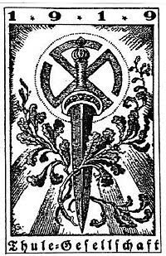

FIFTH DOMINICA

Messages: 52

Registered: 01 Nov 2017 11:58

Re: NAME AND SURNAME, (BLOOD AND RACE): HYPERBOREAL OR DEMIURGICAL DESIGN. FELIPE AND THE KDAS OF OCTRA.

Message by QUINTA DOMINICA » 16 Jan 2021 03:31

Greetings to the kdas of Octra/Octirodae.

At the time of the Order and specifically in OCTIRODAE, the proper names of the kamaradas who were chosen to be admitted were requested, at this point one enters that knowledge that is necessary to KNOW to strategically explore the ontic record of a Virya who aspires to be part of a Hyperborean Order.

The initiates of the Order in charge of exploring these ontic designs could observe and DISCERN by the proper name and surname of the Virya, their CULTURAL IDENTITY and the HISTORICAL ONTIC RECORD of the future chosen one, from now on this introspective task of the ontic record of the lost Virya was carried out by STRATEGIC reasons of SECURITY, there was no other reason for being and once that strategic action was concluded according to the results of the ontic exploration, it was decided whether that virya would be admitted or not, in that decision was the Eye of Fire of the Tirodal Pontiff, the only one capable of KNOW and SEE beyond the existing CAPASIGNO in OWN NAMES.

VVV AND VRIL

FIFTH DOMINICA

Messages: 52

Registered: 01 Nov 2017 11:58

Re: NAME AND SURNAME, COVER SIGN OF BLOOD AND RACE, OF THE HYPERBOREAL OR DEMIURGICAL. (under construction). FELIPE AND OCT

Message by QUINTA DOMINICA » 07 Feb 2021 09:48

SEVENTH VOLUME: TIRODINGUIBURR: THE SACRED SYMBOL OF THE VIRYA

A – Meaning of Wotan's Outer Labyrinth

The sacred symbol of the virya is expressed through the outer labyrinth sign represented in figure 85, which, without being identical to that of the ancient Mystery of the Labyrinth instituted by Wotan, at least maintains its topological properties invariant and allows its meaning to be updated in a structural explanation. .

An analytical decomposition of the runic elements of this sign demonstrates the presence of three runes: the runes TIR (109.jpg) and ODAL (110.jpg) that form the Sacred Rune Tirodal (figure 84), and the rune GIBUR (111. jpg) that we already saw in figures 62 and 63. Hence the outer labyrinth sign READS: TIRODINGUIBURR, a name by which it has been known since ancient times by those initiated into the Mystery of the Labyrinth.

But the three runes, evidently, are not of the same nature while the first two appear with filled strokes, the last is configured as a space between filled lines: this is because TIR and ODAL are LIMITING RUNES while GIBUR is a CONDUCTING RUNE. In general, the Sacred Tirodal Rune is called in Hyperborean Wisdom as "LIMITING RUNE OF THE OUTER LABYRINTH OF WOTAN" and GIBUR as "CONDUCTING RUNE OF THE OUTER LABYRINTH OF WOTAN". These differences will become clear if we consider the Tyrodinguiburr of figure 85 as the plan of a stone labyrinth, that is, as the plan of the strategic construction that in Hyperborean Wisdom is called the HYPERBOREA CHAMBER FOR INITIATION INTO THE MYSTERY OF THE LABYRINTH. In that case, the filled lines represent the LIMITING WALLS of the stone labyrinth, while the LEADING CORRIDORS are made up of the space BETWEEN the limiting walls. In other words, THROUGH THE GIBUR-SHAPED CORRIDOR YOU ENTER THE MEANDERS LIMITED BY THE THYRODAL-SHAPED WALLS.

With a Tyrodinguiburr hyperborean camera the Mystery of the Labyrinth can be explained analogically, allowing a first approximation to its operational function. Referring to figure 85, for example, we can summarize the Mystery of the Labyrinth in very few words: IT CONSISTS OF ENTERING THROUGH ALPHA (α) AND EXIT THROUGH TAU (τ). More clearly; WHEN THE LOST VIRYA ENTERS THE ALPHA CORRIDOR (α), AND WALKS IT TO THE END, HE ACCESSES A CLOSED CORRIDOR BETA (β) WHICH PREVENTS HIM FROM REACHING THE TAU SQUARE (τ); IN THIS "INTIMATE ENCLOSURE", THE VIRYA IS FACED WITH A DILEMMA: TO CONTINUE SEARCHING FOR THE EXIT, HE MUST CHOOSE BETWEEN THE GAMMA SIDE PASSAGE (γ) OR THE DELTA SIDE PASSAGE (δ); HOWEVER, NONE OF SUCH OPTIONS WILL FINALLY LEAD YOU TO TAU SQUARE (τ): IF YOU TAKE THE GAMMA PASSAGE (γ) YOU WILL HAVE TO STOP AT THE CLOSED CORRIDOR EPSILON (ε) OR ETA (ε); IF YOU TAKE THE DELTA PASSAGE (δ) YOUR PASSAGE WILL BE INTERRUPTED IN THE CLOSED CORRIDOR TETA (ζ) OR ZETA (δ). EVIDENTLY; IF THE LOST VIRYA REPEATS THE ROUTE OF THE DIFFERENT GALLERIES SEVERAL TIMES, HE WILL END UP CONCLUDING THAT THE LIMITING WALLS SURROUND THE TAU SQUARE ON EVERY PART. THEN, IF YOU ARE NOT WILLING TO GIVE UP IN YOUR SEARCH, IT IS POSSIBLE FOR THE NOOLOGICAL INTUITION OF THE TRUTH TO ARISE IN YOUR SELF: IN ONE OF THE FIVE CLOSED CORRIDORS THERE MUST BE A "SECRET EXIT", A PASSAGE TOWARDS TAU SQUARE (τ); MORE IN WHICH? AND IN THIS QUESTION WHAT IS "MYSTERIOUS" ABOUT THE MYSTERY OF THE LABYRINTH IS SYNTHESIZED: THE "MYSTERY" CONSISTS, PRECISELY, OF "ENTERING THROUGH ALPHA (α) AND EXIT THROUGH TAU (τ)".

But the Mystery of the Labyrinth does not pose a problem impossible to solve: its creator, Wotan, perpetuated the solution with the sign of his name, the ODAL Rune, whose secret, revealed by a Hyperborean Pontiff in the kairos of the virya, constitutes the First Initiation Hyperborea.

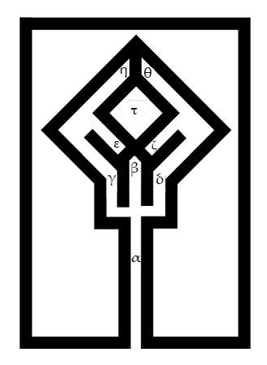

We are now in a position to analogously explain the solution proposed by Wotan to solve the problem of spiritual chaining. Firstly, it is necessary to WAKE UP and GUIDE the virya towards the exit: EXTERNALLY, this is achieved by making the virya notice its state of LOSS in the alpha corridor (α): THE GNOSIS OF THE "SEARCH" IN ALPHA IS EQUIVALENT TO AWAKENING, MOMENTARY OR PERMANENT, OF THE LOST VIRYA; then comes the OPTION that must be faced in the closed corridor beta (ß) between the lateral passages gamma (γ) or delta (δ) and the effective CHOICE of one of them; The SEARCH, OPTION AND CHOICE sequence summarizes the First Step of Wotan's solution to the problem of spiritual chaining: THE GNOSIS OF THE "SEARCH" AWAKENS THE LOST VIRYA, MAKES HIM INTUNE HIS LOSS IN THE STONE LABYRINTH, HIS DISORIENTATION ABOUT THE LOCATION FROM THE TAU EXIT; THE GNOSIS OF "OPTION" AND "CHOICE" GUIDES THE LOST VIRYA TOWARDS THE EXIT TAU; HOWEVER, THE FIRST SOLUTION ONLY "WAKES UP" AND "ORIENTS" TOWARDS TAU SQUARE, BUT DOES NOT "REVEAL" THE SECRET EXIT OF THE LABYRINTH: THIS CORRESPONDS TO THE SECOND STEP.

Thus, secondly, it is necessary to reveal to the awakened and reoriented virya the secret of the exit to the tau square. Although such a secret can only be known during the kairos of the First Initiation, at least we will know what it refers to if we define the concept "ODAL Archemona". The runic name of Wotan, in fact, is expressed by the PRINCIPLE OF THE ENCLOSURE with the sign represented in figure 86: THE ODAL RUNE IS, ABOVE ALL, AN ARQUEMONA THAT SEPARATES AN "INSIDE" FROM AN "OUTSIDE", A " SQUARE" LIBERATED FROM A "VALPLADS" DOMINATED BY THE ENEMY. The inner area of ​​the odal archemone, marked with the letter TAU (τ), is the "square" that must be occupied by entering THROUGH the fenestra infernalis BETA (ß).

The odal archemone has two properties that should be highlighted; The first is that the square is quadrangular; and the second is that one of these four interior angles is opposite the vertex to the exterior right angle "BETA" (ß). Hence, the way to enter the square tau THROUGH the fenestra infernalis, is known as SECRET OF THE RIGHT ANGLE. Hyperborean Wisdom formulates this secret as follows: THE VERTEX OF EVERY RIGHT ANGLE IS SUITABLE TO REFLECT THE INFINITE POLE OF THE REVERTED SPHERE SPIRIT. The secret of the right angle obviously allows us to apply to the ODAL RUNE the ARCHEMONIC TECHNIQUE and the STRATEGIC OPPOSITION that are described in the First Part.

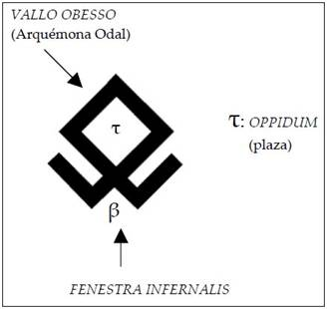

Returning to the sacred symbol of the virya, we now see that THE ODAL Arquemona CONSTITUTES THE CENTER OF THE OUTER LABYRINTH. But every "arquemone" is nothing more than the sign on which the principle of the fence is projected and recognized and, therefore, can be both EXTERIOR and INTERIOR: the Second Step of the solution to the problem of spiritual chaining, proposed by Wotan Through the Tyrodinguiburr sign, it consists precisely in transferring to the INTERIOR of the virya the EXTERIOR character of the odal archemone. In other words, the Second Step consists of directly teaching the lost Self the "secret exit" towards the tau square, that is, of showing an INTERIOR path for the return to the Origin. If you look at it, the analogical interpretation of the Second Step requires answering two questions: a) how does one "go" from the First Step to the Second Step by means of thyrodinguiburr, that is, WHY THE "SIGN" EXTERIOR LABYRINTH "CAUSES" THE GNOSIS OF THE INNER LABYRINTH"? Answer: by the principle of NOOLOGICAL INDUCTION; b) by what principle does the "gnosis of the inner labyrinth" reveal the "secret exit", the exact path of return to the Origin? Answer: by the beginning initiation of the ISOLATION OF THE SELF.

The OPERATIONAL FUNCTION of the sacred symbol of virya is based on the principles of "noological induction" and "isolation of the Self." The MEANING of Tirodinguiburr, search, option and choice, awakens and guides the virya towards the tau square; Your OPERATIONAL FUNCTION will reveal to you the secret exit during the kairos of the First Hyperborean Initiation: in the following articles the principles of the operational function will be studied, making answers (a) and (b) clear, and providing details analogs about the Second Step.

B – Operational function of the Outer Labyrinth of Wotan

B1 – Principle of Noological Induction

The First Step externally "awakens and orients" the virya because it makes him understand that he is lost and that his only recourse is the "search, option choice" of a path that leads to the tau exit (τ). Thus, this First Step must lead to the Second, to "the gnosis of the inner labyrinth", that is, to the gnosis that the I is truly lost on a LABRELIX path, permanently subjected to the law of the tetrarches "search, option and choice". As we saw, this "gnosis", this jump from the exterior labyrinth to the interior labyrinth, is caused by the principle of noological induction: such a principle defines the way in which the complex and interior content of a sacred symbol is apprehended by the I from a simple and external sign. In other words, NOOLOGICAL INDUCTION ALLOWS THE METAPHYSICAL UNDERSTANDING OF THE SACRED SYMBOL, THAT IS, THE APPREHENSION OF ITS ESSENTIAL MEANING. With reference to the sacred symbol of the virya, "the gnosis of the inner labyrinth" proposed by the Second Step is nothing more than its metaphysical understanding by the SELF. We already know the meaning of the sign of the outer labyrinth: search, option and choice of the tau exit; What, then, will be the meaning of the inner labyrinth symbol, the meaning that the I apprehends in the "gnosis of the inner labyrinth"? Answer: THE INNER LABYRINTH SYMBOL MEANS "THE STRATEGIC DISTANCE THAT SEPARATES THE LOST SELF FROM THE SELBST."

Every sacred symbol is the semic appearance of a metaphysical truth; The sacred symbol of the virya, perceived internally by the Self, reveals the strategic distance that separates it from the Selbst, that is, the degree of disorientation with respect to the Tau Origin. Once this meaning is understood, it will be possible, through the principle of isolation of the Self, to advance towards tau, towards the Origin, in the kairos of the Hyperborean Initiation. Since this metaphysical meaning is apprehended by "noological induction", it will be convenient to examine in detail this aspect of the operative function of the sacred symbol of virya.

The inner labyrinth symbol means "the strategic distance that separates the lost Self from the Selbst." From this definition it follows that the inner labyrinth represents an essentially INDIVIDUAL situation, UNIQUE for each lost virya, and, what is more important, an INTERIOR situation. On the contrary, the exterior labyrinth sign has been AFFIRMED in the world as a cultural object, that is, it has been COMMUNICATED COLLECTIVELY. But, if the first truth, the meaning of the interior labyrinth, is INDIVIDUALLY, UNREPEATABLELY, UNIQUE, INTERIOR, it is worth asking what relationship should be linked to the exterior labyrinth sign, a collective cultural object, with the interior labyrinth symbol, an individual cultural object? Answer: between the exterior labyrinth sign and the interior labyrinth there is the relationship that links the simple with the complex, when the complex is KNOWN from the simple. This is the principle that society uses to transmit common knowledge through TEACHING, a principle that has its remote origins in the initiatory instruction granted by the Mystery Schools of Antiquity; In summary, this principle consists of REVEALING to the student or disciple certain SIMPLE SIGNS, letters, numbers, ideograms, etc., from which, by INDUCTION, the understanding will advance to much more complex interior symbols. That is why the EXTERIOR SIMPLE SIGNS represent a lower, exoteric degree of the INTERIOR COMPLEX SYMBOLS, although only through the induction of the simple is it possible to approach the presence of the complex.

It is clear that the "exterior labyrinth sign" is an exterior cultural object and that the labyrinth symbol, which it represents, is an interior cultural object. However, it is worth remembering the definition on page 323: "In short, cultural objects can be "internal" or "external." "Internal cultural objects" are part of the cultural structure and constitute a first degree in the reality of the object. The "external cultural objects" are embodied and materialized projects of the previous ones and represent a second degree in the reality of the object; they are recognized in the world as a reflection of the internal objects: naturally, if such dependence is not noticed, the crime can be committed. epistemological error of attributing cultural qualities directly to the physical body or entity on which the project has been carried out". Now, an internal cultural object can be apprehended directly from the cultural structure if it has previously been discovered or intuited. This is what happens, for example, with the NUMBERS: they are projected into the world, affirmed as external cultural objects, and then, through a gnoseological correspondence (first movement, figure 73), they are discovered outside and recognized as such, that is, that is, introjected into the psychic structure as interior cultural objects; Once this LEARNING process has taken place, when TWO apples, ONE fish, FOUR stones, etc. have been recognized, it is only possible to COUNT, add without limits, since INDUCTION allows us to form the idea of ​​higher quantities EVEN IF THESE DO NOT PRESENT CONCRETE COUNTERPART, EXTERIOR, IN THE WORLD. When we recognize ONE apple, TWO apples, THREE apples, we can think of any number of apples, although we never see them; Induction allows us to INTERNALLY EXTEND the limits of knowledge, apprehending the idea directly from the cultural structure, and that is why, when someone tells us - I bought two hundred apples - we understand him immediately, we know what he is talking about; We grasp the idea of ​​the two hundred apples, WHICH WE DO NOT SEE, because we extend by induction the basic knowledge of the one, two, three apples that we possessed a priori.

The teacher who taught us how to count only intended that when she wrote on the blackboard: Ѽ + Ѽ + Ѽ = Ѽ Ѽ Ѽ she wanted us to discover numbers and apply induction to extend knowledge. But we didn't learn alone; This example of dough was shared with other students who were also discovering numbers and learning to count. And that means that the example: ONE apple, TWO apples, THREE apples, is eminently SOCIAL, MEETS AN INITIATING FUNCTION. When the students have understood it, the example will be a collective heritage since everyone will already be initiated in the inductive method of counting. But from there each student goes from the social to the individual because, once the numbers are discovered, it is possible to extend quantitative knowledge infinitely. And when our friend tells us: I will share the two hundred apples with you and my three brothers – WE KNOW that we will have forty apples EVEN BEFORE WE HAVE SEEN THEM. We have grasped the idea of ​​the forty apples, an internal cultural object, directly from the cultural structure. And that induction, as well as all the ones we can do in our lives, it is possible that sometime, by seeing ONE, TWO, THREE, EXTERIOR apples, we discover ONE, TWO, THREE, interior apples.

This long reasoning must allow us to understand two things: that induction extends knowledge from the simple to the complex, ONCE THE SIMPLE HAS BEEN REVEALED OR DISCOVERED; and, most importantly, that EVERY INITIATION to complex knowledge is based on this principle: esoterically, for example, the understanding of a Mystery must INITIATE with the understanding of an external sacred symbol that represents it.

We will now consider Wotan's outer labyrinth, which must be qualified as a SIMPLE SIGN in reference to the COMPLEXITY of the inner labyrinth it represents. This simple labyrinth expresses the idea of ​​SEARCH, OPTION and CHOICE: a lost virya searches, among several possible ones, for the correct path that leads to the exit; When she finds herself facing a fork in the road, she must decide which path to take and opt for one of them; If she chooses the wrong corridor she will soon find that it ends abruptly; or she will reach a new fork, where the dilemma will repeat itself. With no other help than her INSTINCT, lacking any indication to ORIENT, she only has to move forward and backward permanently, trusting that luck or a miracle will allow her to reach the exit. What she should never do is STOP: for someone who is lost in a labyrinth, without food or water, saving time, the haste with which she acts, is a fundamental survival factor. Such is the idea that the Hyperborean Pontiff exposes to the initiate as an explanation of the external labyrinth sign.

But once this idea is grasped, analogously to the example of the three apples, the simple concept of the external labyrinth can be extended internally by induction to discover the representation of an internal labyrinth of extreme complexity, which will be the archetypal interpretation of the true state of the Self, that is, a state of SEARCH, OPTION and CHOICE. According to Hyperborean Wisdom, when a lost virya represents his own spiritual situation through an inner labyrinth, HE HAS REACHED A DEGREE OF STRATEGIC PRE-ORIENTATION: hence the NOOLOGICAL qualification given to the induction of the outer labyrinth. The definitive ORIENTATION is then obtained, in the kairos of the Hyperborean Initiation, through the principle of isolation of the Self.

In article C we will examine various types of outer labyrinths, from different cultures, all of which are derived from Tirodinguiburr, Wotan's outer labyrinth. But what should be clear now is that the exterior labyrinths are cultural objects designed to fulfill an initiating social function, similar to the apples that the teacher taught us to count with, that is, they are "sacred symbols." And such objects of initiation, insofar as they induce the discovery of one's own spiritual situation and favor strategic orientation, ARE OF UNDOUBTABLE HYPERBOREAL ORIGIN. In other words, due to the initiating function in spiritual reorientation that the exterior labyrinths fulfill, they must be considered as HYPERBOREAN SIGNS, regardless of the race that holds them or the ancient "culture" in which they have been located. The external labyrinth is a sign that, after being revealed and explained to the virya by a Hyperborean Pontiff, makes it possible to glimpse internally the own OBJECTIVE LOSS of the Self and allows us to appreciate the "strategic distance that separates the Self from the Selbst": this is a consequence of the gnostic expansion induced in a Self that suddenly finds itself lost in a metaphysical labyrinth.

B2 – Principle of Isolation of the Self

After the "gnosis of the inner labyrinth", caused by the noological induction of the outer labyrinth sign, it is possible for the lost Self to reach a permanent state of strategic orientation. This is achieved in the kairos of the Hyperborean Initiation by definitively isolating the I from the soul subject; as? Answer: through its RUNIC RESIGNATION. This is an operation that must be carried out simultaneously in TWO WORLDS and in the right kairos; In other words, the Self must be resigned simultaneously in the Hyperborean Chamber of the Mystery of the Labyrinth by the Tirodal Pontiff and in Valhalla by a Loyal Siddha: THE RUNIC RESIGNATION CONSISTS OF PLASTING THE ODAL ARCHEMONE (FIGURE 86) ON A TETRARCH OF THE LABRELIX PATH . HOWEVER, EVEN WHEN THE ODAL ARCHEMONE IS REFLECTED, THE SELF WILL CONTINUE WITH ITS LOST OBJECTIVE AS LONG AS IT DOES NOT ENTER THE TAU SQUARE: THAT IS THE OBJECTIVE OF THE SECOND STEP, "REVEAL THE SECRET EXIT THROUGH THE GNOSIS OF THE INTERIOR LABYRINTH".

Now what was said on page 313 will be better understood: "In the Order of Tirodal Knights, THREE DEGREES OF INITIATION are practiced, all based on the path of strategic opposition. However, thanks to the high level achieved in the knowledge of Hyperborean Wisdom , the archemonic technique is applied directly to isolate the lost Self from the conscious subject. This quality can be understood analogously by observing figure 32: the technique of the Tirodal Knights consists of RESIGNING the conscious subject with the Sacred Rune that has the property of ISOLATING the subject. Lost Self; such an operation is equivalent to establishing a strategic siege on the Symbol of Origin (AB); the lost Self is then ISOLATED from the conscious subject and strategically REORIENTED towards the Selbst; then; in the Second Initiation, to place oneself in the Selbst and become an awakened virya. But the most important consequence of the Hyperborean Initiation is, without a doubt, THE IMMORTALITY OF THE SELF: after its runic isolation, in effect, the Self cannot be. already affected in any way; nor could the disintegration of the microcosm or the dissolution of the astral body alter it in any way. On the contrary, the isolation of the Self, the knowledge of its immortality, forever eliminates anguish and transforms the Hyperborean Initiate into a reckless warrior. A warrior who, it was said, awaits the End of History to employ its terrible power."

NOW, RESIGNATION WITH THE ODAL ARCHEMONE IS NOT ENOUGH TO ISOLATE THE SELF: IT IS NECESSARY FOR IT TO ENTER THE TAU SQUARE DURING THE KAIRÓS OF INITIATION. HOW WILL DO? ANSWER: USING THE SECRET OF THE RIGHT ANGLE, WHICH THE PONTIFF WILL REVEAL TO YOU SO THAT YOU CAN SUCCESSFULLY CROSS THE FENESTRA INFERNALIS BETA (ß): THAT IS THE TRUE SECRET EXIT, THE ONE THAT OPENS THE SECRET OF THE RIGHT ANGLE: THROUGH IT THE MYSTERY IS SOLVED FROM THE LABYRINTH, IT IS POSSIBLE TO "ENTER THROUGH ALPHA (α) AND EXIT THROUGH TAU (τ)". ONLY THEN, WHEN THE SELF HAS ENTERED, THROUGH THE BETA RIGHT ANGLE, INTO THE TAU SQUARE, THE VIRYA IS A HYPERBOREAL INITIATE, A THYRODAL KNIGHT; ONLY THEN IS YOUR SELF RUNELY ISOLATED AND IMMORTALIZED.

To analogously understand the meaning of the isolation of the Self, the following must be highlighted: THE INITIATIC RESIGNATION IS CARRIED OUT AFTER THE GNOSIS OF THE INTERIOR LABYRINTH: IT MEANS THAT. WHEN ENTERING THE ODAL RUNE, THE SELF DOES SO WITH THE CONVICTION THAT IT IS ENTERING THE "CENTER OF THE INNER LABYRINTH". A MOMENT BEFORE HE WAS ON A TETRARCH OF THE LABRELIX PATH, WHOSE DISJUNCTIVE NATURE HE JUST UNDERSTOOD THANKS TO THE GIBUR RUNE OF TIRODINGUIBURR (FIGURE 85); THEN I KNEW THAT THE GAMMA (γ) OR DELTA (δ) OPTIONS DO NOT LEAD TO THE TAU SQUARE (τ) AND THAT, ON THE CONTRARY, THE SECRET EXIT IS FOUND AT THE RIGHT ANGLE OF THE CLOSED CORRIDOR BETA (ß), THAT IS, IN THE BETA ENCLOSURE (ß) OF THE TETRARCH, A "CLOSED FORWARD" ENCLOSURE (FIGURE 59). AN INSTANT LATER, THANKS TO THE SECRET OF THE RIGHT ANGLE, THE SELF IS SITUATED IN THE TAU SQUARE, BEING ISOLATED FROM THE CONSCIOUS SUBJECT; BELOW THE TETRARCH IS THE MONARCH, THE INSTANT OF IMMANENT TIME IN WHICH THE LOST SELF IS USUALLY SUMMARY: AFTER ENTERING THE ODAL RUNE, PERHAPS FOR THE FIRST TIME, THE VOLITIVE FORCE OF THE LOST SELF ALLOWS IT TO DOMINATE THE SOUL SUBJECT AND NOT BE DRAWN BY ITS TEMPORARY CURRENT. AND THIS WILL BE POSSIBLE BECAUSE THE SELF WILL NO LONGER BLINDLY SEEK THE ORIENTATION TOWARDS THE SELBST, AND ITS VOLITIVE FORCE CANNOT BE USED FOR THE MICROCOSMIC OBJECTIVE OF THE PURPOSE OF THE PASÚ: FROM THE MOMENT IT WAS ISOLATED FROM THE CONSCIOUS SUBJECT, IN EFFECT THE SELF YOU NO LONGER NEED TO SEEK GUIDANCE. BECAUSE? ANSWER: BECAUSE THE SELBST IS SINCE THEN, AND FOREVER, "IN SIGHT" OF THE ISOLATED SELF.

THE SELF OF THE HYPERBOREAL INITIATIVE, SITUATED IN THE TAU SQUARE OF THE ODAL ARCHEMONA, ONLY HAS TO "LOOK" INNERLY TO IMMEDIATELY LOCATE THE SELBST. HE HIMSELF APPEARS AS AN "INNER STAR", LIKE A "PLANET VENUS", LIKE A STAR ALWAYS PRESENT ON THE HORIZON OF THE SELF. FOR THIS REASON, THE HYPERBOREAL INITIATIVE WILL NEVER LOSE THE STRATEGIC ORIENTATION: HIS PROBLEM WILL BE, INSTEAD, THE WAY TO BRIDGE THE STRATEGIC DISTANCE THAT SEPARATES HIM FROM THE SELBST, BUT THE SOLUTION TO THAT PROBLEM, "CONSTITUTING THE INFINITE LADDER", IS THE MYSTERY OF THE SECOND HYPERBOREA INITIATION.

Finally, it must be stated here, with all possible force, that NO ONE WILL BE MANAGED TO TAKE THE SECOND STEP WITHOUT HAVING ADOPTED A "PRIOR ETHICAL ATTITUDE", THAT IS, WITHOUT EXHIBITING A "LUCIFERIC GRACEFUL ATTITUDE" TOWARDS THE SACRED SYMBOLS; WITHOUT THIS PREVIOUS ATTITUDE IT IS OF NO WORTH TO TAKE THE FIRST STEP, OR EVEN EXPERIENCE THE GNOSIS OF THE INTERIOR LABYRINTH: YOU WILL NEVER BE ABLE TO ENTER THE ODAL ARCHEMONA. The reason for this requirement will become clear after acquiring a brief notion of the NOOLOGICAL RUNIC, the science of the Hyperborean Initiates.

**Women**

There have been serene women with clear eyes,

infinite and silent like that plain

that crosses a river of pure water.

There have been women with golden looks,

rivals of summer and fire, similar to

lascivious wheat fields that do not hurt the sickle

with their teeth but they burn inside

with sidereal fire before the stripped sky.

There have been women so light

that a single word, a single one,

He turned them into slaves. And there were others,

of reddish hands, that when touching a forehead

They gently dispelled terrible ideas.

And others whose bloodless and elastic hands,

with slow turns they seemed to insinuate themselves

creating a rare and fine warp

in which the veins simulated

ultramarine vibration threads.

Pale, withered, devastated women,

burning in the fire of love

to the depths of themselves,

burning face consumed,

with the nose agitated by the impulse

with restless fins, with open lips

as if going towards the spoken words,

with livid eyelids

like the corollas of violets.

And there have still been others and,

wonderfully, I have known them.

~ Gabriele D'Annunzio.

**The Mysticism of the Runes, A rare study among fragments of “Nimrod of Rosario”.**

When delving into the reading of the “Treaty on psychosocial strategy of the SS”, we would expect to find only the theme suggested by the title of the writing in addition to the quotes that the pontiff uses in the foundations when emphasizing the value of the charismatic bond in the psychoid management of the collective liberation strategy in the section on “The Golden Cord”:

“Hyperborean Wisdom calls “charismatic linkage” the fact of charismatic coincidence within the framework of Mysticism and this is the only concession it makes regarding the COLLECTIVE.

“Therefore, when within the framework of a Mysticism the “charismatic bond” between men is established, which is nothing other than the “collective perception of charisma” mentioned above, this fact must be interpreted by giving THE COLLECTIVE THE conceptual dimension. of COINCIDENCE TEMPORAL SPACE OF INDIVIDUALS instead of the most common idea of ​​mass or crowd.”- Treatise on Psychosocial Strategy.

Added to this, he will review the study of mass psychology "pasu", descriptions of gregarious functioning in contrast to the aurea catena, the power of the charismatic leader and even the final phase in which the discharged egregore produces collective mutation All these points are eloquently explained in this manual, but, between point “VI” to “VII” we will find an extract of 6 pages atypically added to the psychosocial series whose introduction at no time in the previous pages, later, or instead of the work Hyperborea in general, notice of its study or existence. This short exhibition is called “The Mystique of the Runes”, and will begin its exhibition by giving a brief account of the origin of the word “Rune” and “Letter”, its modes and objects where they used to be drawn, archaeological evidence, different runic variants until we reach their magical description, warning us of the sacred meaning held in them by the Ancient Germans.

There have been numerous mentions of the runes as essential weapons for the Virya in its liberation strategy, and what better exposition of this mystery than the one in the Work of Nimrod of Rosario where we can learn about the subject to its most unsuspected reaches. On the other hand, we will learn, if we are perceptive, about the infeasibility of using these signs (which are not the runes themselves) in the most frivolous instances of everyday life as the common man is accustomed to, exhibiting them anywhere without the slightest respect.

Now, throughout the rather short exposition of the “runic” chapter of the manual, we will notice the purely cultural bias through which the entire “mystical” fragment is covered, ironically approaching less to the mystery and very closely to the general, the exoteric, pouring our interest into the spurious; These paragraphs would go unnoticed if it were not for the utmost importance that has been given to the runic series drawn at the end of the 6 pages of the chapter, which prudently cannot be called “Hyperborean Futhark” for two reasons:

1. It has no established order and the runes have been presented in a very different way from the classic “Futhark” or “Fuhork” (Fehu, Uruz, Thurizas, Ansus (Sometimes "Os", Raido, Kenaz, or in its default, Freya, Ur, Thor, Ace, Rit, Kaun...), starting with the rune “Wunjo”, ending in “Dag”. In fact, it is not a Futhark, it is a runic series.

2. And “Hyperborean” has been an arbitrary connotation with which some more daring people have called it because it is found among the fragments of the “SS Tract” delivered by Nimrod. (We know that the true runes, that is, not created, not “visible” but “experienceable” are found in the symbol of the origin that attracted the uncreated spirits, and that like these, they come from Hyperborea, later being communicated by the Siddha Wotan to his Viryas; However, the runes that we see today in many cases are mutilations, unions or outcrops from an “original” rune that perhaps would be part of the legendary set of the “13+3”, but qualify today day to any runic series of “Hyperborea” and especially to the 24 of the treaty -(This set disagrees with the Old Futhark found on the Kilver stone, the best-known series of 24 runes dated to the 4th century AD, and the “added” forms ” in the aforementioned document are already widely known by the community.) - is the implicit equivalent of explicitly stating: “These are the runes that Nimrod has left to work on the strategy.”, or on the other hand: “Here are the 13+3 of liberation”…. No.

“THE LUCIFERIC GRACEFUL ATTITUDE ALLOWS THE RUNIC ECSTASY OF THE RIGHT ANGLE ON WHICH THE ORIENTED SELF “RESTS”” -FSH.

“The oriented Self, upon assuming the graceful Luciferic attitude, experiences a runic ecstasy that puts it in a charismatic connection with the paraklite, receiving from it an “extra energy” that allows it to suspend the dramatic tension of the sacred symbol and reinforce its sphere of will. egoic ehre:”-FSH

The RUNES that the pontiff bequeathed for the strategy of individual liberation as an initiatory symbol are called TIRODINGUIBUR, and nothing is required outside of the “Sacred Symbol of the Virya” and its apprehension to establish contact with the uncreated runes through the predisposition of the oriented Self. and the adoption of the appropriate attitude during the implementation of the strategic opposition with its back to the right angle. On the other hand, in said rune series NOR IN ANY OTHER KNOWN is found the most powerful Rune of all and the last in the series of 13+3, that is, The Trident of Poseidon, GUIBUR, Weapon of the Loyal Siddhas and SWORD OF WOTAN for the Tirodal Knight.

“The runes of the futhark or fupark are only a minimal part of the runic arsenal. The Sign of the Origin, for example, from which the swastika rune is derived by mutilation and deformation, does not fulfill any alphabetic function despite being the most powerful rune that exists.”- FSH

Here it should not be mistakenly understood that, "The greater the number of runes, the greater the number of Weapons for the Awakened Virya." On the contrary, there are only 16 runes that make up the awakened Virya's arsenal, and the first step is the final and most important "3" of the series. All the runes added later to the runic sets have no value beyond the macrocosm, since their unions depend completely on the archetypal sense like any sigil that their "draftsman" applies to them. Thus, for example, we have dozens of strange amulets and symbols that find their origin in the most vulgar inclinations of the magical arts, naturally, used to harm as well as to "heal", but if the individual considers reaching the dawn of Hyperborea through, he must change course and correct the submission that astral magic has cunningly imposed upon you under your grant.

“The Tirodal knight is the Virya whose self has been isolated during the Kairos of the Hyperborean initiation, by the Sacred Tirodal Rune. THE ARMING of the Tirodal Knight consists of the internal representation of the gibur rune in the fenestra infernalis of the odal rune: a semic arrangement is then formed whose analogical representation is the thyrodinguiburr of figure 85. To visualize the explanation, let us assume that the I of a Tirodal Knight is isolated in the tau square of the Tyrodinguibur: in that case, the I operates on the external reality, on the conscious subject, THROUGH THE FENESTRA INFERNALIS, that is, through the right angle that faces the gibur rune beta runner.”- FSH

At the completion of the “Fundamentals of Hyperborean Wisdom”, the Pontiff would have already induced us to the runic practice that most interests the lost Self through which it will be able to achieve the remaining runic ecstasies whose character will always be NOOLOGICAL, having been clear and concise. in the differentiation with the psychological or archetypal runic, a reason that should be sufficient for us from the objective care with which we should approach the reading of the "Runic Mysticism" whose content, as we have asserted, is of a CULTURAL nature, and the study carried out does not have noological validity. , basically leaving the “Hyperborean interpretation” in charge of the Virya, but even so, this will only serve to cover a “culturally positive” but ultimately cultural film, limiting the rune itself.

“The runes, in effect, are uncreated signs, that is, not created by the demiurge, although their communication by Wotan to the Viryas made it possible for them to be INTERPRETED archetypically when perceived by the rational subject; the runes, then, have been affirmed in the axiological context and incorporated as cultural objects; In this way, the axiological context sustains them in the superstructure while the context of the internal cultural structure grants it an archetypal meaning; BUT THIS IS AN ILLUSION, A SEMIC CONSTRUCTION THAT ARCHETYPICALLY INTERPRETS THE RUNE, NOT THE RUNE ITSELF”-FSH.

Now we are going to analyze some points separately from the chapter “The Mystique of the Runes” inserted in the “Manual of Psychosocial Strategy of the SS”.

In the following excerpt from the manual, “The inventor” or “Inventors” of the original runic writing will be referred to as individuals strongly linked to them from a “religious”, that is, sacrilegious, field through which they achieved their “meanings”. more unknown ones would say by “enlightenment” that they later communicated to the members of their clan.

“The INVENTOR – INVENTORS – of the pristine runic writing, not only knew the characteristics of the bark of a tree as a preview of many other traits of a practical man, who rationally conceives the meaning and purpose of his work, but, with his linguistic genius and artistic talent accompanied a very strong religious feeling; since the proper, significant names of each of the runes are closely related to very ancient features of the (Germanic) religion, as stated... And this also does not occur in any other alphabet, including the Semitic ones... known to date! !”-The Mystique of the Runes

Of course we will have to ignore this mention of the “Inventors” since we “know” the original creator and communicator of the runes to the Viryas lost after their Resurrection in Atlantis: The Siddha Wotan. The scandalous thing about this paragraph is the impersonal way in which it refers to its “creator”, since the pontiff (its supposed author) knew that he was a Siddha and his praxis of liberation towards the Hyperborean peoples, and its appearance was not “due” thanks to the variation of Greco-Latin writing and its necessary “rectilinearity” at the expense of the lines on rock and wood that hindered its “horizontality” and/or “curvilinearity”. Furthermore, let us keep in mind that the existence of the runes precedes the existence of modern man, with all of them being precisely the reason for their existence through the spiritual chain forged by the kalachakra key as we will already be informed in the foundations. (The mystery of the runes should not be taken lightly and the quotation we make throughout the article is only for argumentative purposes. To understand their functionality of both chaining and liberation, the Fundamentals must be carefully studied):

“The Kalachakra key,” the Loyal Siddhas continued explaining, “is an ingenious system that allowed the Traitor Siddhas to balance and neutralize the designs of the Demiurge. For this reason, it consists of two Complex Signs, joined by an iron rod that must be broken: one is the Sign of Pain, which is made up of forty-nine plus one raised signs, distributed around a three-dimensional spiral of decreasing diameter, that is, of a helical corkscrew; This spiral is the combination of the key, the key that opens the lock of the spiritual chain, since each of the forty-nine plus one signs represent the primordial Words of the Demiurge, the Voices by which all finite entities were created. : all designs are made up of combinations of such signs. The Kalachakra key is, nevertheless, the master key of Creation. - But, joined to this spiral bit by an iron rod, is the handle of the key, octagonal in shape: inside the octagon, carved in relief, is the other sign, the Sign of the Origin that balances and neutralizes the Sign of the Pain (See figure 85). This Sign is made up of thirteen plus three signs called RUNES: the thirteen allow us to describe and resign the forty-nine bijas of the Demiurge, and the remaining three, called NOOLOGICAL RUNES, are also used in our Strategy “o” and in the path of liberation individual “of the strategic opposition. But in the kalachakra key each of both sets of signs are structurally integrated into a Greater Sign that contains them: the forty-nine plus one in the Sign of Pain and the thirteen plus three in the Sign of Origin” - FSH

We will move on to the next extract where mention is made of a fact contrary to what we have been learning throughout the work, such as: “The Raising of the Banners”, evidently, with its symbols in the center: “The magical intention “recommended” recording them” ( The runic signs) “in a non-visible part (interior of the ring “alliance” that the woman wore – as in need of protection in marriage – internal part of the shield clamp; blade of the weapon – which would go from the sheath to the intimacy of the enemy body -; inner face of the fibulas and brooches; etc… Since, in the “visible” parts the runes were “public”, indicating mere belonging;

Already in the Third Reich the Swastika as a polar symbol flamed throughout the European continent, the SS marched defiantly with its double SIEG rune; On their rings the rune Hagal, Swastika, Tyr and Sieg were drawn; But without a doubt the most important example of the value represented by a runic symbol drawn on the outside is found in the story of Wildejagger, where this young German armed with an ax and shield where in its octagonal center the ANIS symbol lay painted. , he warded off the demons with this binderune by his mere contemplation, so the mention of the above quote would also lose relevance in a liberation strategy, and since all the acts of an awakened Virya must adhere to the principles of essential war, This explanation loses much or all of its interest. (We will also remember the Story of Nimrod the Defeated where his brutal warriors had the “HK” symbol painted on their shields during the assault on the “White City”).

Evidently, when we talk about raising a runic sign of these characteristics, we cannot even come close to attempting to challenge the powers of matter by “runifying” with rectilinear drawings of “sticks” without the slightest sense of war in practice. It must be kept in mind that in the Reich the Führer supported the active action of the Runes in the proportion that he considered.

In the Einherhar order the silver Sieg rune was embedded in the ground to carry out the strategic opposition, the sign of the oriden was projected on the opposition rock to raise the plaza, and the Odal rune was the projection of the Hyperborean fence. That is, beyond the useful life of the runes in more or less “profane” or “cultural” fields such as that of the Vikings, (whose strategic confusion we will know was extensive with respect to Atlantean wisdom, and through them we inherited several symbols of cultural court that, on the other hand, was not enough to "completely dirty their minne", maintaining a sacred treatment with the runes, teaching how to use their magic although in an archetypal framework, and they conceived a contact with the Gods thanks to racial purity and their implacable warrior attitude that earned them divine recognition to carry out a strategy of collective liberation in Greenland), today a cultural purity capable of allowing the public use of the archetypal runic without completely degrading its usefulness is not sustained where we have pseudo shamans, pseudo druids, and pseudo runic magicians incapable of establishing a mysticism with them because of their deplorable blood and academic state in the matter... That requires it! As a social example we have the Neo Viking groups or “Asatruar” founded on the recreation of ancient German religions that have fallen completely into cultural deformation, since here we no longer talk about true warrior courage, or cement a rugged and harsh way of life; Its “devotees” are people from the common world who, on certain days of the week, dress up as Germans and worship the powers of matter camouflaged behind “Aryan” names. Thus, for example, when requesting help from Tyr, Thor, Vidarr or Odin, the blood impurity actually directs its “prayers” (which no loyal Siddha would receive in any way) to psychoid entities that WILL COPY said emanations apparently “distant from Judeo-Christianity” ; Identical scenario for that of the runes, where we will find one of its important promoters at the end of the 19th century and throughout the 20th century (if not the most important), who shamelessly does not hide his “winks” and on the contrary appreciates part of the inspiration of his works to the founder of the theosophical society - Helena Blavatsky -, presuming the origin of his particular runic series (Armanen, among other promoters of runic yoga) during a "Vision of his inner eye" that would awaken in a period of months in which he suffered blindness after an eye operation...

That is, as we have been saying, this series of 18 runes will be justified by a spontaneous appearance (thanks to a deep religious approach to the gods) distant from the revelation that Wotan achieved during his “crucifixion”, since the runes cannot be “downloaded” to the rational mind unconsciously and worse still, drawn by a person alien to the Hyperborean mysticism, (may his enterprise to vindicate the Germanic tradition not persuade them, since like Rudolf Steiner he maintained a crude approach to theosophy that would notably influence his respective works. Thus, for example, for Lizt, the “I” must not return to Hyperborea, but rather help the Demiurge to perfect his wonderful creation, as one of many examples of the extent to which his lost Virya scheme perverted step by step the true German philosophy of war, hostility and liberation).

Finally, before moving on to the rune-by-rune description, the author will say:

“The patient work of philologists has not yet elucidated what reasons led to the ordering, as it appears, of the proto-Germanic futhark. Even in letters that, due to their shape, recall letters from Mediterranean alphabets, the same order, sound, or symbolism is not carried out... The study of such a symbolic “alphabet” requires sensitivity, erudition and work; Considering myself limited, I limit myself to “opening a door” in the interest of others more gifted” -

Who would be better prepared than a HYPERBOREAL PONTIFF to speak openly about the runes? With this sign of “humility” by the author, we are implicitly given a glimpse that the subsequent description of the runes will lack a “capable” hand, further diminishing the strategic consideration that could be given to it because it is found among the “manual”, then describing the particular meaning of each rune from contents equally exoteric to those that will have been taken for bibliography. This clarification is similarly alarming about the capabilities that the author has for this subject, being far from the pen of a Pontiff who, it will be understood (on aspects of runic art), is experienced in the subject. ; It will ultimately crown the paragraph by “opening a door for others who are more gifted,” which in the end will end up referring to recurring cultural aspects since this field is not defined in its entirety by “erudition,” but rather by the Gnostic contact that only a Virya Awakened in his condition as Pontiff (Now Siddha Incarnate, just like the Führer) can reach.

Runic Classification.

The author will group the runic sets as: Protective runes that ward off danger; medicinal runes; Bitter Runes that cause damage and Victorious Rune; Runes of Higher Beings; Divine Animal Runes; Divine Plant Runes; Runes of Natural Phenomena; Cultural Field Runes (As if they were not already in this field...). He will also mention some unpublished runic names such as “The Rune of the Elk” or “ILhs”; The “Ygil” Rune that represents “Thor” (Although I have previously mentioned the rune of the Giants who is called “Thurizas” or “Thor”...), in addition to the already mentioned exoteric descriptions and the erratic insistence on explaining its sense from the cultural; At the end of the descriptions he will say that it is the “primitive futhark” with the “translated” names, although, we insist, the arrangement is not carried out as such; Nowhere in the “Mystic” subsection did he treat the runes in order of a “Futhark”, covering each rune in a common way with schemes of usual instances, that is, rationally interpreted: “Rune of the Cattle, Bison, Giant, Aces, Wheel , Illness, Gift, Welfare, Storm, Fatality, Ice, Good Year, (Good Year?..), Fruit Tree, Yew, Elk, Sun, Gods, Fir, Horse, Humanity, Leek, Heroic Man, Day, Heritage ".. which on the other hand evidently combines and resembles all, any known runic treatise and with all esteem, as it is known to be published in this sense, something that will not be at all abnormal when we become aware that said tradition is undeniably extracted of the ancient Aryan peoples; The distinction that we cannot make a mistake is that these people had fallen into exoterism generations ago and the connection with the Siddhas had been truncated as they had already maintained it in the beginning through the stone of Venus, so their ancestral wisdom little by little became more materialistic and universal, although they maintained, as we defended paragraphs ago, racial purity and an instinctive way of life to their Hyperborean nature that on numerous occasions earned them the recognition of the Gods, enabling some strategies of collective liberation.

Conclusions.

“The Mystique of the Runes” inserted in the “Manual of Psychosocial Strategy of the SS” between chapter “VI” and “VII” has numerous edges that make us enter into well-founded alerts regarding its content and its supposed author, denoting a as a forced (and very erroneous) inclusion in a psychosocial treatise with very different objectives from those expressed in the “Runic Mysticism”.

Furthermore, we will attach the aforementioned pages (and a few more diagrams and drawings) that must be studied with great caution to avoid falling into the enemy's game, encouraging archetypal schemes and allowing ourselves to be carried away by supposed runic practices of dubious overtones and suspicious promoters that do not exist. They will resist a short investigation of their material to show the danger to which we are voluntarily exposing ourselves due to the innocence and PROMPT ambition of the lost Self that struggles to find a solution to its strategic confusion.

We will understand that at first glance this excerpt is not entirely “suspicious” for the readers present here, both literally and metaphysically, and in all probability the critical argument put forward in this article does not demonstrate to their discernment a complete gnoseological explanation, but This is not due to anything other than a usual lack of understanding and integration of the pontiff's work in his cultural schemes and his desire for liberation (although a not very extensive analysis is enough to show the incongruity and disorder of said work). chapter in that certain area of ​​the treaty, and we are not taking into account the final schemes extracted from the Fundamentals that without rhyme or reason have been added sloppily in the psychosocial document that is floating around the Internet, aggravating the intrigues about the origin of the topic criticized here. ), therefore, as you delve into the Hyperborean material in an orderly manner, your field of vision will become unmistakably broader. However, we will advance something more about the object that Hyperborean wisdom proposes as the purpose of study.

“Hyperborean metaphysics, then, is a science “typical of the sphere of light” but whose object of knowledge, the sacred symbol, makes possible the transcendence of the microcosm since it extends its scope of observation to the archetypal plane of the macrocosm. Of course, Hyperborean Metaphysics can only be practiced by the Viryas and Siddhas since nothing similar to the knowledge of the Universal Archetypes is allowed to the pasú”-FSH.

Here the pontiff tells us the mission of the Hyperborean Metaphysical Study, de facto cutting off all possible syncretization on runic studies that want to infiltrate his Gnostic propositions, because unlike any exoteric and materialist treatise on runes, no matter how “sacred” and “mysterious” ” that we wish to draw, Hyperborean metaphysics, a science developed in the Fundamentals of Hyperborean Wisdom, precedes all those banal contents that in their last layer derive in the Ludic, when the “once truly sacred Runic Signs” will be taken for the more frivolous everyday gadget than a cross, bracelet or quartz crystal, and in his social field, this strategic confusion will lead the lost Virya to practice various “Methods” that are offered to him as initiatory promises, which will be the simple yogic, meditative practice, by will. abstentionist, sexual or any strange meeting where “initiations” are talked about as resolutely as the most common normal of activities. That is why in the previous quote the pontiff ventures to make a premature explanation about what he will later delve into regarding the runic symbol Tirodinguibur (The sacred symbol of the Virya), when we will objectively direct ourselves through a correct initiatory introduction to use its metaphysical purpose, to reveal the mystery of the inner labyrinth, which is the mystery of our objective loss.

In summary, from everything we have seen we can doubt in numerous aspects (and others that we do not deal with here) about the probable mistaken classification of the runic extract as authorship of the pontiff, or, with greater caution, about the objective functionality as content bequeathed for the “liberation individual of the Virya", which, however, will remain sifted for you and its gnoseological - noological scope that can demonstrate the Gnostic antithesis of the chapter from which numerous "runic practitioners" are trying to cling, devoid of mysticism, alien to the true Runic Pontonics and very deviated of their conquest because of the blood impurity they suffer from.

PS: The runes provided in the extract analyzed as we said include part of the “Futhark” in its different modifications, so we do not comment or assert that said series is “tergivesarda” or “Judaized” in any way, limiting our criticism specifically in everything the contextual scope and its infeasibility as noological content.

2. In images you will find clarification of some points mentioned in the post.

“Tirodinguibur is the means that reveals the key,

Wotan's Outer Labyrinth that the Self must Apprehend,

The Gnostic Ecstasies will come,

After using it and succeeding,

Thanks to your courage and HK's will,

We can defend ourselves from sacred symbols.

The initiatory Runes,

With your back to angle La.

Facing Gibur, facing the eye of Yod,

We force the passage to TAU, it is the fortune of the Self.

There are no runes outside of these,

May the Virya Use require today,

And if you long to be free,

Tirodinguibur has to internalize”

Hyperborean Wisdom.

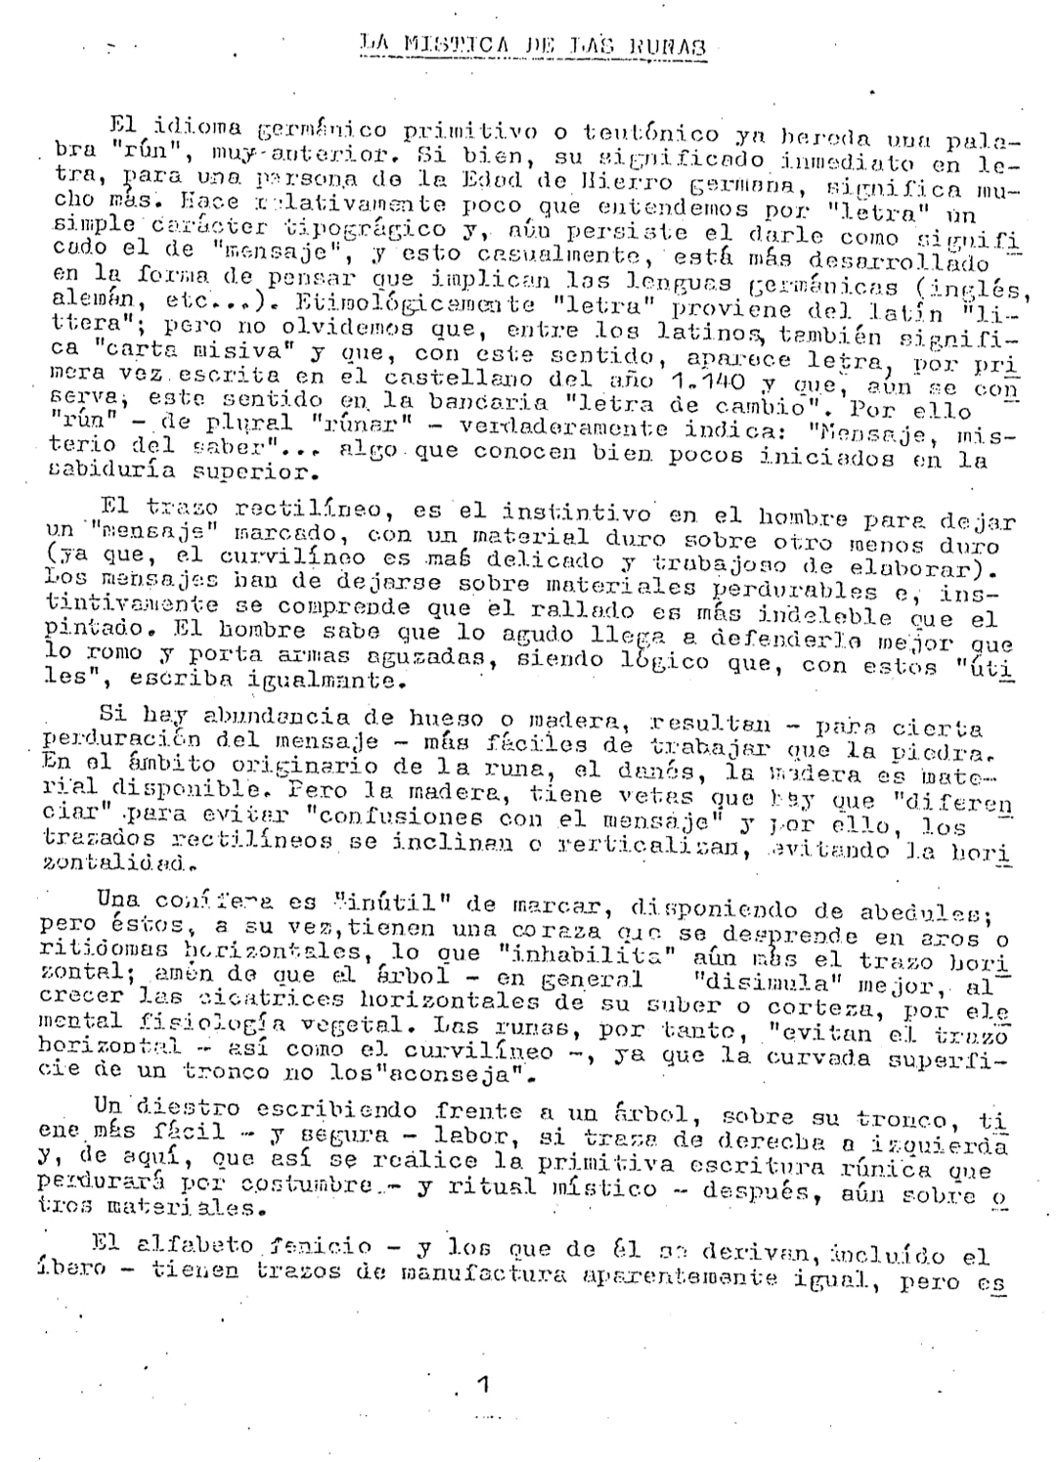

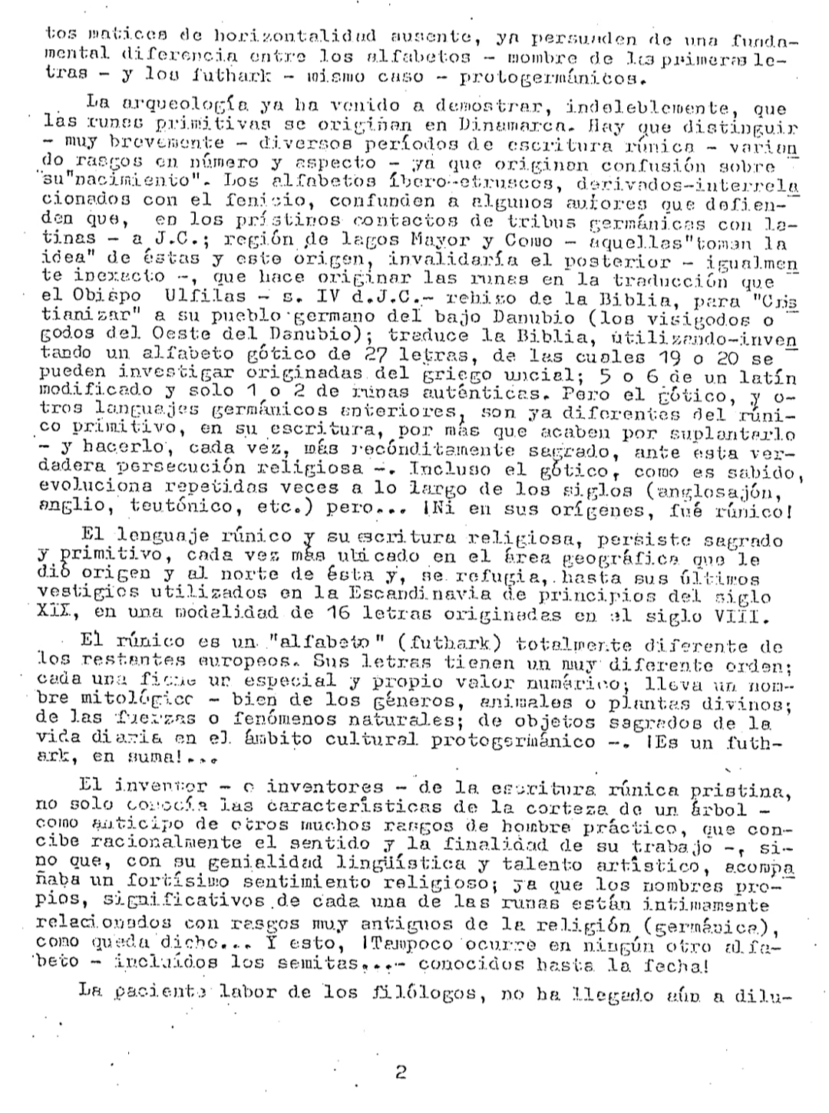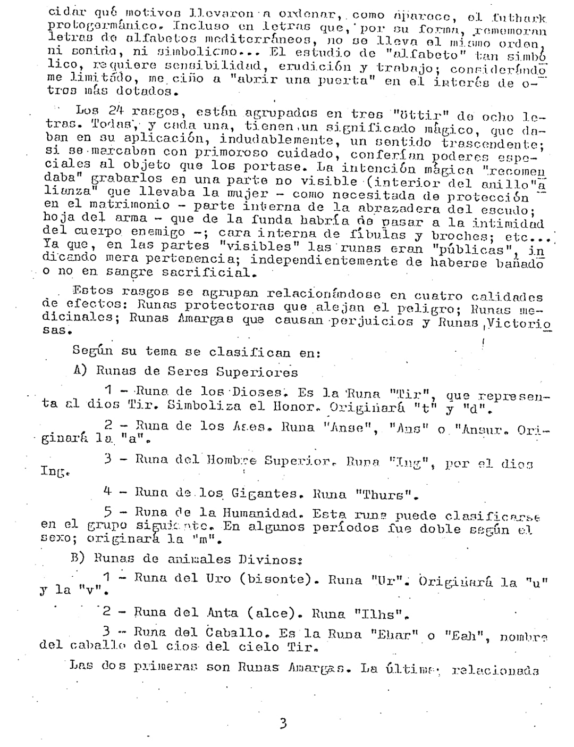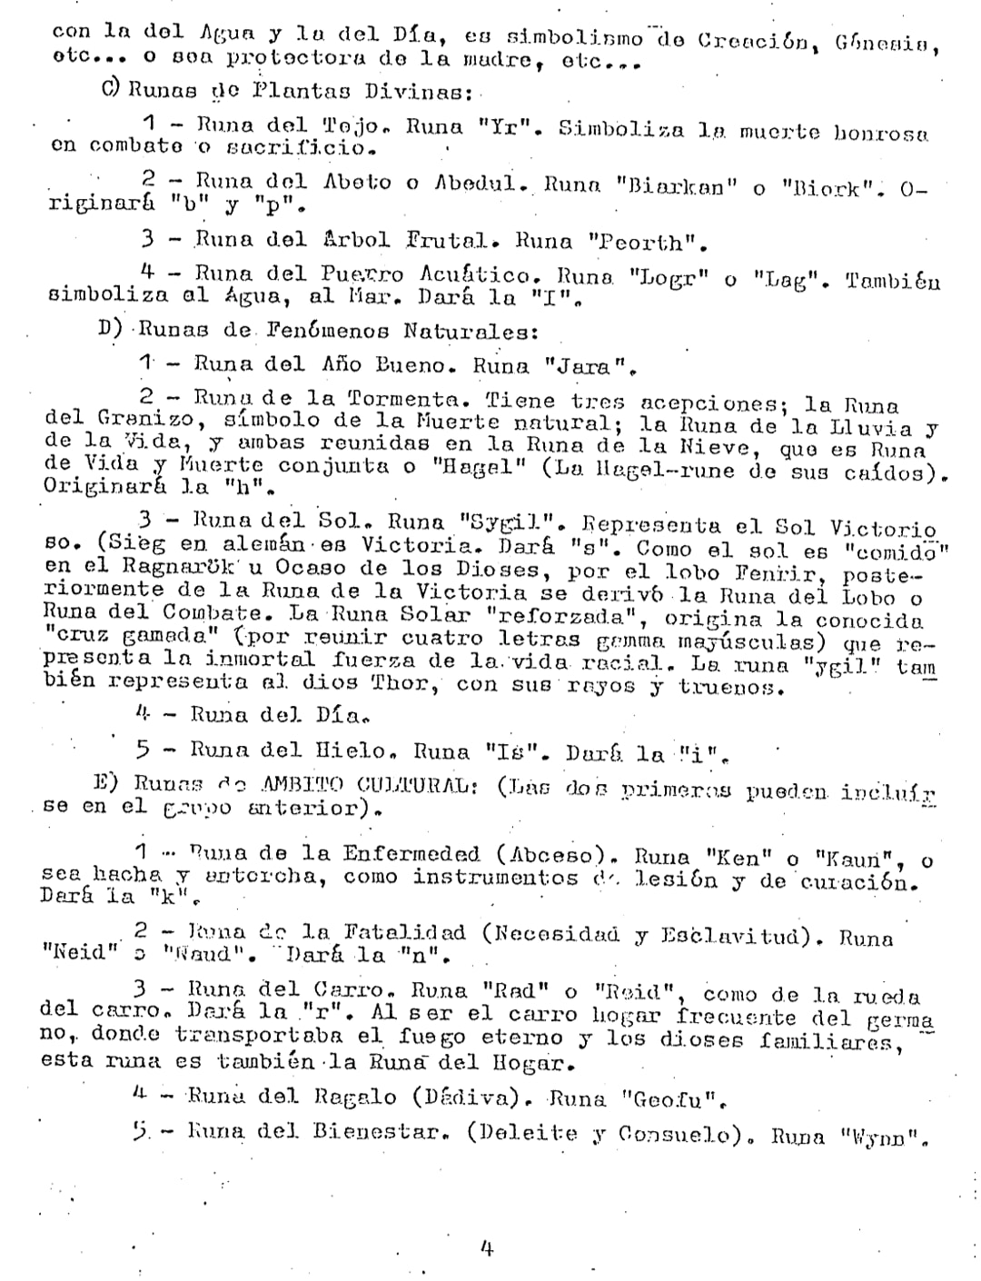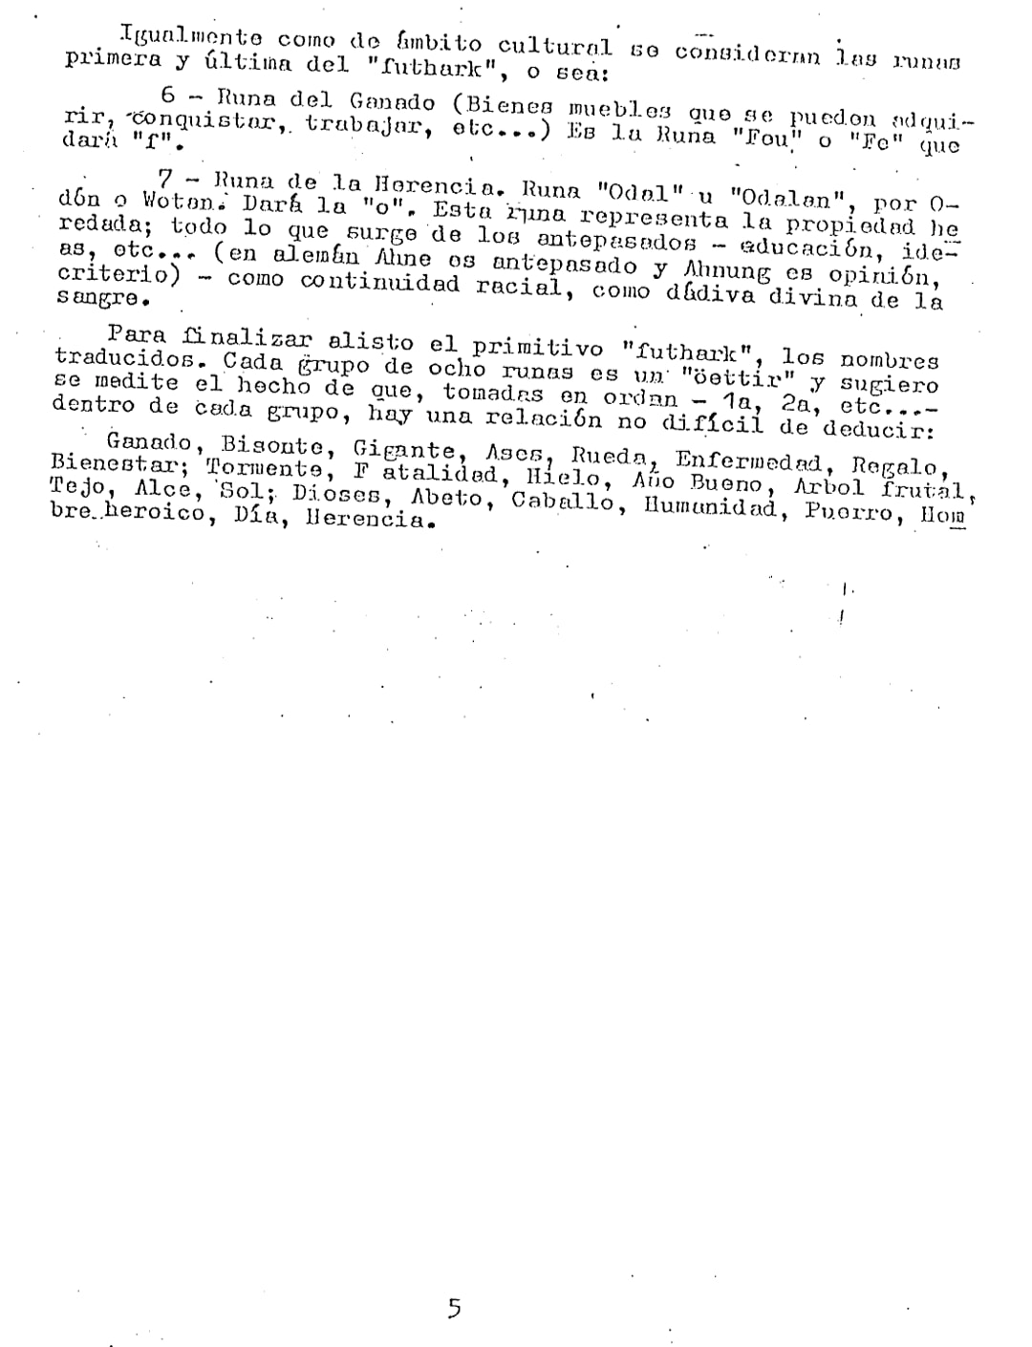

5

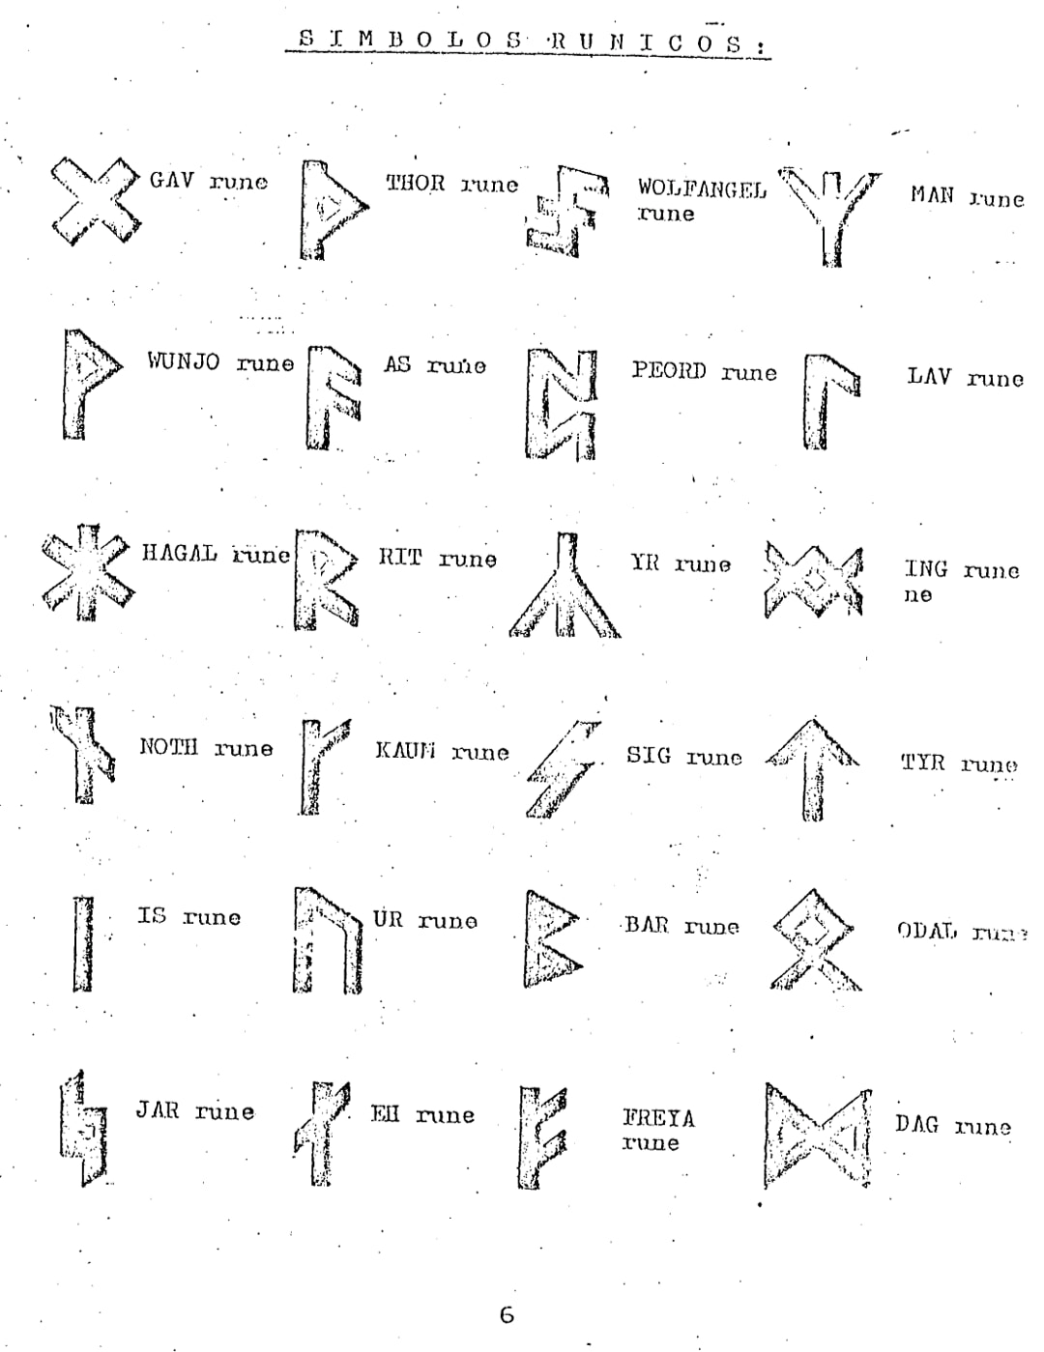

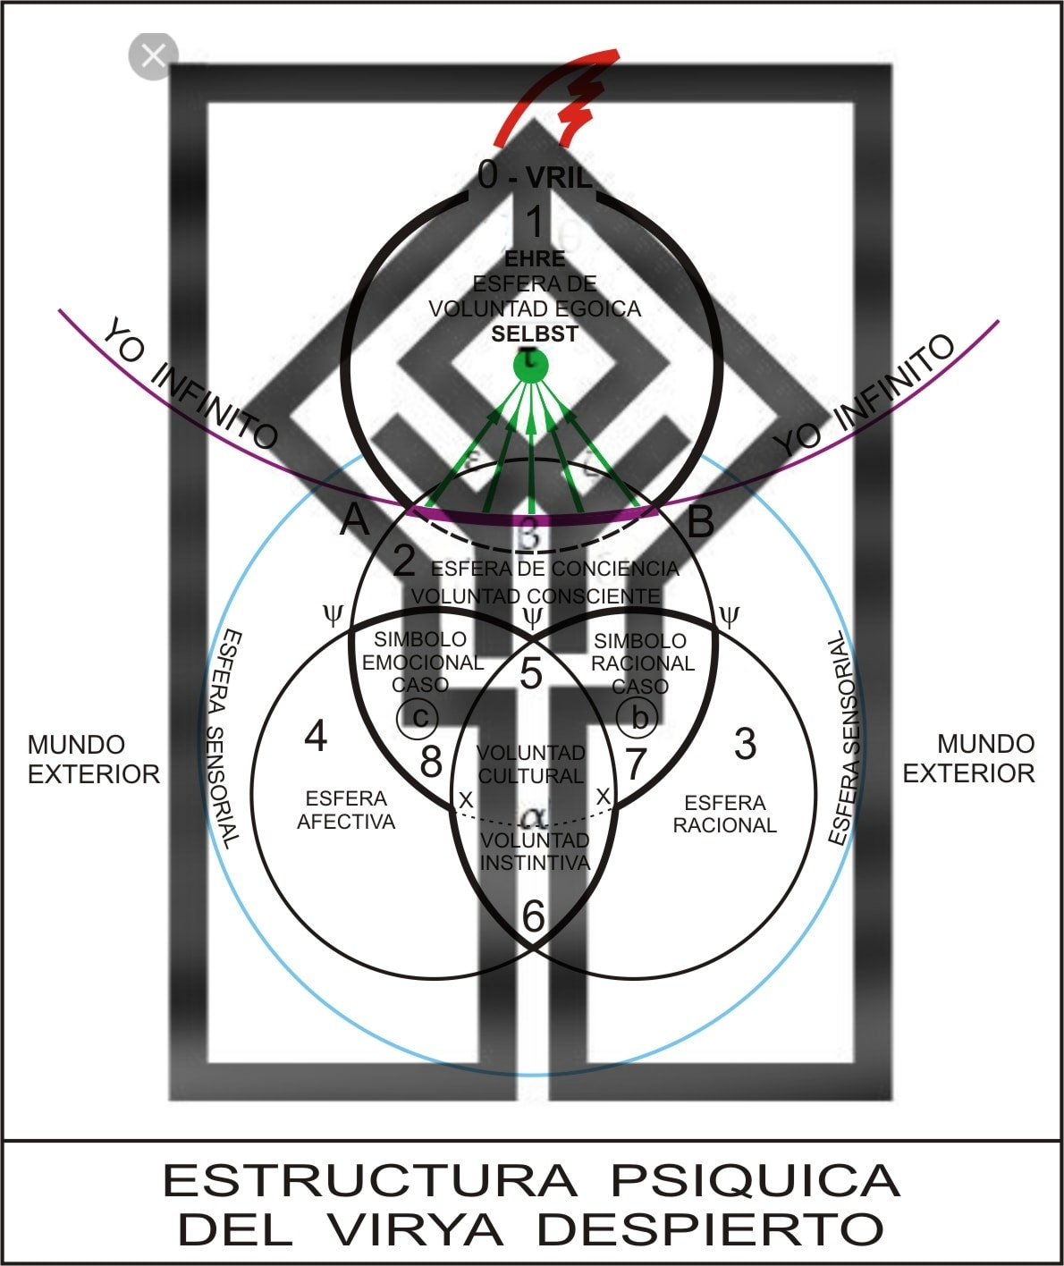

CARLOS CASTAÑEDA AND THE HYPERBOREA WISDOM (II)

-By Krissaor Tower-

Let's go with the second installment of common elements between the Toltec Wisdom of Carlos Castaneda and the Hyperborean Wisdom of Felipe Moyano.

CARLOS CASTAÑEDA BETWEEN REALITY AND FICTION

-SAME GOAL: FREEDOM-

This is the main element of both Works. Deep down, few people will be prepared to understand – much less practice – the proposal for Freedom of these two Giants of the Spirit.

It is understandable, because in a society where “freedom” is given by the possibility of choosing between Coca-Cola and Pepsi, the Freedom of the Spirit is going to be something that will be within the reach of very few.

It should be noted that, currently, the proposal of other “supposed spiritual paths” are not oriented towards the Freedom of the Spirit, but, as is clearly evident, towards “union with God”: the true antipode of the Spiritual and the conquest of will. Well, what freedom can there be in the loss of identity? The truth is that It is not possible to be Free if you stop being Yourself. The matter is as simple as saying that “IF THERE IS NO SUBJECT THERE IS NO EXPERIENCE OF FREEDOM”.

Confusing “Ego” with “diseases of the Ego” such as Egoism, corresponds to maneuvers skillfully carried out by the machinery of the Cultural Pact.

-ALLIES, SIDDHAS AND LUCIFIERIC GRACE-

In Castañeda's Work, the supernatural beings called “Allies” are completely similar to the Siddhas of Moyano's Work.

This point is not only coincidental in this sense, but it is also a point in which we can appreciate the magnificent level of Luciferic Grace that – at least in Castañeda's Work – the proposal of the Toltec Tradition enjoys.

I'll try to explain it:

As we have said, in Castañeda's Work, “Allies” is the term used to indicate a series of “supernatural beings of immense power” and who can, if such an “Alliance” is established, help the Nahual and his group. to achieve Freedom.

Since these are “supernatural figures”, we must give them the same treatment as if we were talking about “divine figures”. That is: they are not human figures, they are not men, they are something infinitely more powerful than men and that are “beyond” the perceptual and cultural reach of normal men.

Thus, far from looking for a way to please, beg, entertain, pay homage, offer sacrifices, put oneself at his service, pray and other niceties typical of priestly thought and behavior; and also far from “running away from them”, as the playful type would do; the Witch Matus proposes them as potential ALLIES. Not as “something higher” that must be feared and pleased in order to seek its favor. No, none of that: he points them out as Allies, that is, establishing a RELATIONSHIP BETWEEN EQUALS. Obviously, this implies the reality of having first recognized within Himself a Supernaturality – a Divine Nature if you will – that endorses that Alliance, since a Superior Being does not ally itself with an inferior being. That is: only The Supernatural can remain in front of The Supernatural.

-ANITNOMISM: BETWEEN WITCHES, PSYCHOACTIVES AND NAZIS-

It will be good, for this section, to remember a certain note that we took from Culianu that included antinomism among the elements to be identified in authentic Gnosticism.

In the case of Carlos Castañeda, the antinomian contents will be two: Witchcraft and the use of Psychoactive Substances. And in the case of Felipe Moyano, the main and most visible antinomian content will be National Socialism.

This means that both Felipe Moyano and Carlos Castañeda to a greater or lesser extent will be stigmatized – not to say directly demonized – by the Cultural Paradigm. Perhaps not so much on the side of Carlos Castañeda, since the image of the Witches, at least in Europe, no longer has the negative connotations that it may have had in his time. However, the idea of ​​witches still creates a certain “cultural aversion.” However, the use of “psychoactive substances” is, in every rule, an antinomian argument.

And what can we say about National Socialism! Anyway, I don't think it's necessary to comment that National Socialism is absolutely demonized in the Cultural Paradigm that prevails today. It is ironic – and very clarifying – that the countries that most promote the demonization of National Socialism have the most racist societies today and practice, precisely, genocide on a regular basis (Israel and its “bully”: the USA). However, they refrain from applying the economic principles of National Socialism. There must be a reason!

Still, the issue of antinomian content is not so much a matter of someone laughing at oneself for being interested in “Witchcraft”; or that someone makes a bad face for “using psychoactive substances” for purposes unrelated to leisure; or that someone accuses you of being a “neo-Nazi” for showing interest in National Socialism and the dark end of World War II. The antinomian argument is something that confronts the Subject, the Individual, with a powerful cultural barrier in some cases very close to taboo.

Thus, an antinomian content becomes a “First Test of Value” for whoever approaches this or that Initiatory proposal.

CARLOS CASTAÑEDA AND HYPERBOREA WISDOM (III)

-By Krissaor Tower-

Here we have the third summary of common elements between the Toltec Wisdom of Carlos Castañeda and the Hyperborean Wisdom of Felipe Moyano, better known as Nimrod de Rosario.

I want to remember that the treatment we have been giving in this series of articles is summary. That is to say: we will not elaborate on descriptions or developments beyond, practically, exposing the idea so that each person can then decide to delve as deeply as they wish or as much as their capacity allows.

Lace Point and Cultural Superstructure

It is more than evident that we can analogize the “Castañedian” concept of Lace Point with the “Nimrodian” concept of “being inserted in the Cultural Superstructure.”

After all, the insertion of the sleeping virya into the Cultural Superstructure conditions its vision and perception of the world based on what has been socially and culturally established. That is to say: the Cultural Superstructure acts as an interpretive filter of the surrounding reality, thus offering the Cultural Subject a fixed and moderately stable scenario in which to develop.

In this way, the idea of ​​“moving the assemblage point”, in Castañeda's Work, would be similar to the idea, already in Nimrod's Work, of “changing the angle of the plane of significance” of the structure.

Impeccability and Honor

It must be said, first of all, that both the concept of Impeccability and Honorability of both authors are often misinterpreted. It is usually seen, for example, Impeccability, as the characteristic that makes a subject “not deviate” from the established ethical or moral consensus. The same thing happens with Honor, that the presence of a cultural premise that is not transcended or resigned establishes a meaning different from that intended by the author.

Both Impeccability and Honorability speak, or indicate, a capacity of the subject that is not related to any type of social agreement. Rather, they are related to what we could call “Ability to Sustain Focused Will.”

For example, in the sense of Impeccability, it would be understood by stating that “impeccable is someone who executes a plan without having deviated from it.” Obviously, this judgment does not take into account, at any time, the result of the plan. In other words: the exercise of Impeccability – and Honor – occurs without taking into account the results of the actions that we intend to value as impeccable or honorable. This is because it is not the result that is valued – and this is the same error of interpretation that we had pointed out – but the ability to sustain one's own action (doing to do).

In other words: I will be Impeccable or Honorable if, whatever I do, all my attention and my ability is focused on that specific thing to do. For example: “My Honor is called Loyalty”; which means that “I will be honorable as long as I am loyal.” Or conversely: “I will have lost my honor when I have stopped being loyal.”

Silent Knowledge and Blood Memory

There is little to comment on this similarity, except, perhaps, to make an inventory of situations in Castañeda's Work in which Silent Knowledge is spoken of in a way in which it is easy to understand that the same thing is spoken of as the Memory of the blood. But we won't do that, which would be something more typical of a book. The intention of these articles is not to copy and paste to show what we point out, but rather to encourage potential readers to check it out for themselves, as we mentioned at the beginning.

What we will point out is that it is clear, in both one work and another, that neither the Silent Knowledge nor the Memory of the Blood arise in consciousness as the completion of a logical or rational process. On the other hand, it usually happens that this type of content is spontaneous.

It is good to point out that, as Felipe explains in his Work, it is possible to set out to search for the Minne, or the Silent Knowledge, from the use of the Faculty of Remembering...