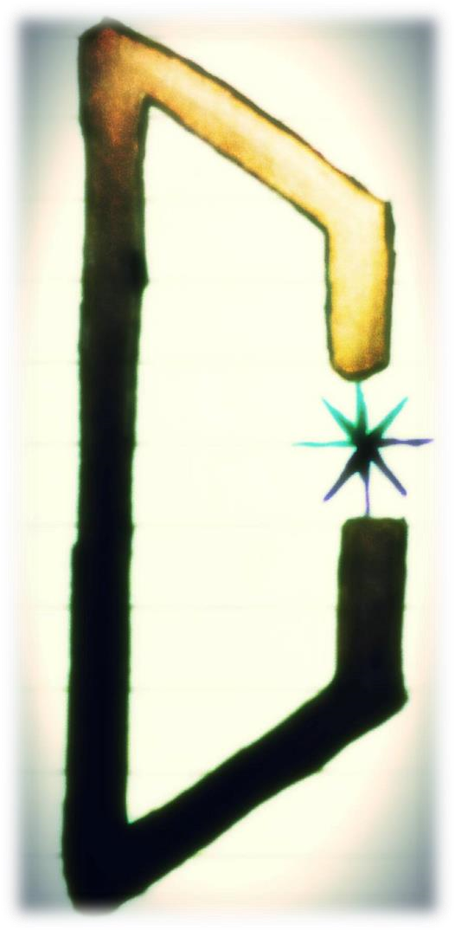
URRU

Thulean Polar Mythos

By Jason Alfred Thompkins III

Contents

- Introduction
- Templi Unam Official
- Serranoism
- Polar Midnight
- Lucifer ~ Lucibel
- Polar Thulean Mythos
- Sacred Amor, Magical Realism (the “Exit” from this tormented world)
- The Non-Existent Flower and Pre-Destined Divine Morality (Part I)
- The Non-Existent Flower and Pre-Destined Divine Morality (Part II)
- Defiant Beauty
- Cromlechs, Dolmens and Menhirs (Ancient Earth Science)
- Astral Body, Subtle Body
- Medea ~ The Amada of Jason
- Apotheosis
- Divine Magnetism, Vril, and The Cold Light of the Black Sun
- The Kristic Eucharistic Mystery
- Poetic Simplicity as an Exit, a Strategic Departure (Part I)
- Sacred Love and the Son of Man
- Gnosis versus Belief
- Square Pupils
- The Collective Kristos, The Collective Lucifer
- UFOs, Disks of Light, Vimanas
- Manos~God, Hand~God
- From the Black Sun, into the Green Ray of Light
- The Two Days of Veneris, and More on the Green Ray
- The Aquarian Odal
- Malo Mori Quam Foedari
- Atlantean Remnants, the War Continues
- Manu~Unam, Ur~Ru
- Divine Truth is Godly and Eternal
- Albania Spiritus
- First Earth ~ Second Earth (The Poetic Ur-Blood)
- Aquarian Threshold

Eternal A-Mor to Amanda, the Amada, the Vestalis Maxima of the Virgines Sorores
Glacies. To Wolfram von Odal, my Brother of the same Father. My Twin-Brother. The Twin-Poet-Magicians of the Avatara, Unam. Completing the work of Our Father for the Era to Come and the Man to Come. To Magi EHE, and his work with Hermitage Helm. To Magi GIBOR, and the Brahmatic Order of Kristos-Lucifer-Wotan. And to Frater Normannus, a true Hero in this last, final age. To Priest SIG, my protégé and friend.

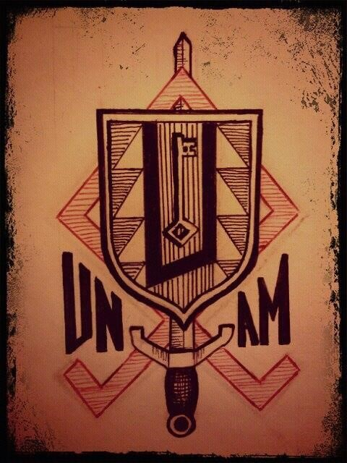

Prelude

"Man is the dream of a shadow"
-Pindar
Pythian VIII, 96-97

Don Miguel Serrano was born of the Andes, of the Rock, of the eternal ices and, like Shiva, his master and serene companion of idolized stone, came to dance over the abyss to destroy the demon of oblivion, he came to expound a path of total transmutation where forgetting is treason and error is cowardice, a path of aristocratic liberation, not for humanity, but for the men and women of Polar Midnight, the great defeated ones of the Eon who remain undaunted after the downfall of their creations and their dreams of creations, whose lonesome souls are a song of indescribable Love and Nostalgia. We are all that and more, children of the Great War of the Führer, born to continue the combat of the Avatar, born to continue the weaving of which we intuit the pattern and coloring.
Jason Alfred Thompkins, native of starry Autumn and of the lachrymose winds of his Albania, is the dream of a shadow, a poet full of inspiration for Her, a generous warrior for Him, captain of the anti-gravitational ship that waits for the last Argonauts of this round. He is one of those who has suffered like a fragmented god on Holy Friday to emerge renewed in Spring. He is a protected son of our Father, who has been parted from the most Beautiful Light, germinated with incredible nostalgia and longing for but a single glance from Her. And we are brothers of the same Father, we are Hyperboreans, we know that which others will never know....
It is the Master Jason Alfred, son of Alfred, son of Odal, who now expounds his Aquarian visions of a heir and initiate, who has managed to mutate the meaning of things, transforming the poison into medicine, the burdens into gifts, the pain into love, in a way that can today be expressed as experience and as triumph of the doctrine of the Resurrection of the Hero, recovering the soul and the light, showing in his work that the whispered doctrine is flesh and blood within him, no speech, no pose, no imitation, no evasion or substitute. I have seen, I have felt and understood, expressing in the Master’s own language, in a trance of the word as access to the light and I can testify that, of the countless faces that have sworn to abjure or betray what they did not understand, it is Jason Alfred who rules over one Pole and I the other Pole, in such a way that the Master today rests upon his Kshatriyas, which have already been proven, for the realization of his Esoteric Hitlerism.
I, who have been known to swear that I knew since childhood, after the passing of the Master, I serve as the propitiatory victim for the opening of our time, locked in the labyrinths of my own work and in sync with malefic and beneficent events, in the middle and upon the cross. But transmuting the poison into magical potion, with Jason we have taken this tempo feroce that is ours, to garrison the Tower of Fidelity, to arm the Argo of the Fatherland with dreams, and recuperate through assault that which belongs to each one of the chosen navigator-psychonauts by origin. Standing upon the last rock and over the abyss we return to be the Gods of the light of the Black Sun, beyond the wind and beyond finitude.
From here, I leave to you the visions, explanations and words of a true believer, a pure seer, one of those men who act, one who dies and is reborn, one who knows that the true Religion of Aquarius, which is more than a religion, has an Order, a Temple, and a Mission.

In Schastel Marveile, Holy Friday the year of our Lord CXXVI.

HEIL HITLER!
HEIL MIGUEL SERRANO!
SIEG HEIL!

Wolfram von Odal
Minnesänger
Priest of Odin

Foreword

This is not another translated work by the Maestro, Don Miguel Serrano. It is a book written by one of his foremost disciples: Jason A. Thompkins III – and it does credit to the Maestro.
Serranoism is an infinite worldview, an attunement to the Cosmic Truth: a recurring archetype that existed, exists and will continue to manifest itself in vast circles within circles: from the Prebeginning to the Neverend.
A convergence of two Esoteric Orders, fighting the eternal fight against the Demiurge and his incarnated manifestations. An Elite of Men and Women who find each other in the vastness of the Universe. They recognize each other and the polarity, the living electron binds them in Spirit, Soul and Body. And they keep the Flame burning, refusing to let it die out.
Serrano who claims the Archetypes ARE the Gods and not just racial memories, collected in the “Collective Unconscious”, as Jung had previously explained. And as the vortex of Kalyuga spins ever faster, this Elite band of Men and Women, carry that Great Longing and Deep Nostalgia which is their one weapon in this, the greatest of all struggles.
And the Divine visited Gaia and created a perfect civilization: Hyperborea up in the far North, beyond Borealis and the North Winds. It was a Golden Age, till the Divine consorted with the terrestrial daughters and became semi-Divine. They experienced Death and were given a choice:
to go down into endless reincarnation as ordinary humans or, to ascend back to their Divine state. And this choice is remembered in our Memory of The Blood.
The Fall was tragic for the Divine Hyperboreans but, on the other hand, started the Spiritualization of the crude terrestrials. And marvelous civilizations and structures began appearing all over the earth, with man still primitive, not knowing of the wheel even. It is as if the “Golden Angels” created these structures.
The Grail is really “GRAAL” and the very first “Grail” was a stone which fell from the heavens, down to the eternal ices of Hyperborea. The Black Stone at Mecca predates Islam and has ProtoSanskrit etched on it. And Parsifal asks: “And to whom does this Grail serve?!” – It will serve the worthy descendants of the Golden Angels in their quest for travel, faster than thought, with their Vimanas to the most distant stars.
The Eternal Spiritual Fight between Lucifer or Lucibel, the Bringer of Light against the Demiurge, the god and creator of the Jews. The former that Bright Morning Star denoting purity and perfection – the latter, representing all that is corruption, decadence and malevolence.
Those who truly have Magical Realism, also have what I call a “pre-destined Divine God-Given Morality” of which, they themselves are not even aware of. They are born with it. They walk with the certainty of a sleep-walker and know what is right and wrong. And they know we can never be equal to the inferior and can never feel guilty for being beautiful, insightful.
Cromlechs, Dolmens and Menhirs: reminders of our past. Portals and acupuncture points on the earth’s sickly surface. Healing and regenerating the land, the people and their psyche.
Thousands of giant stones at Carnac testify to the magical knowledge of our ancestors – these Holy Sacred Areas. For the initiates, the predestined few see the Divine in everything.
The autumn leaf falls exactly where it was always meant to fall – therefore it has every right to be there – divine simplicity. To say “good morning” and actually mean it, thus infusing positive energy - to go through Life with poetic simplicity, without demiurgic baggage. To be attuned with Nature, to recognize symbols that Nature speaks with: discernment.
The “meeting of eyes” in love making, as against mere procreation. “The Divine Feminine leads us to heaven” wrote Goethe. She impregnates the Male: Parthenogenesis - The Annunciation by the Hyperborean Angel. And the re-born, The Son of Man is eternally free from the rules of mechanics. He is beyond past and future – he is the Eternal Now.
Black as the absence of color - and yet it permits our visibility of all colors. The green flash of light lasting a split second at dusk, that in-between day and night - The exact point of unison.
The Jews have appropriated the Tradition, modifying it to suit their own personal interest; they have adulterated, exfoliated Genesis, wiping out the extraterrestrial and divine origin of humanity, because of the guilt for their own particular fall.
The numeral science and the science of names from Atlantis, the Aryan Kabbalah, will be used towards the personal power of the tribe, and still does to this day. In the astral plane it has produced the transformation of Jehovah. Man eventually comes to have no more than six thousand years of history, and his origin is declared to be exclusively of this earth. Then they altered the meaning of the Exodus, transforming it into the little exodus of the tribe. The Jews have spiritually circumcised the gentiles – the goyim.
Manu, who gave us his physical laws in Sanskrit, thousands of years ago, will reappear again as Unam. He will bestow his Spiritual Laws that will cleanse us, the White Race and enable us to resume the Forward and Upward Path. The Jewish Piscean Age has made way to Aquarius, the Aryan Age. And We, the Elite encapsulating the Collective Geist, will be merciless as we cleanse this vile and putrid planet.
Never before, in the history of this world, has an Empire risen with such speed, tenacity, beauty and by pure will alone, than the Third Reich. Other Empires in this world grew gradually, over time. Hitler was in power for 12 years and in that time-span alone, the Third Reich turned Germany, literally, into a Rome, Greece, or Persia. In 12 years the Third Reich not only rescued a dying, starving nation, but turned it into a literal miracle.
And for us, the precious few, Albania is our spiritual domain. For we drift in and out of the First Earth in our subtle bodies of starlight. We do not wish to be understood by the inferiors. We are a small family of SS Werewolfen. But our acts and deeds on this second earth, on this plastic godless rock, will save the predestined souls who are to Exit here in a not so distant future. Our work seems so demanding and we become tired, but we wake every day with a feeling of authentic joy by KNOWING we are the Few. We lay down at night with not one drop of bad conscience for we have purged ourselves, over and over, through the fires of the abyss.
Men and women are awakening to a new spiritual dawning, a vibrational spiritual frequency, every moment, while most are dying a slow agonizing death in stagnant waters. We are in a twilight threshold between Aquarius and Pisces. The latter, the Age of Darkness killed God – Aquarius will restore Him. This is Our Age.

Norman Lowell
The Sacred Island of Melita
March 2016

Introduction

It is now time to give to this murdered and savaged world my visions, explanations and words, which I came to know on this Path, before the world goes into the final devastating insanity of "Nature Unveiled.". It is my hope that it can help those Initiates on the Path of Tears. May it bring a clarity to a lot of the riddles, the symbolism and the more impenetrable works which Master Serrano has left to us, but never explained. My conclusions are of their own, although they are obviously influenced by my Teacher, Miguel Serrano. My Worldview has stayed the same over the past two decades. It never changed, it only grew in wisdom. I never departed nor questioned this man. It took me 40 years to reach a Totality and a deeper inner understanding, a Knowing, an authentic true Gnosis, of the entire cosmology of Esoteric Hitlerism, Serranoism and the Path of A-Mor. Once I discovered Serrano there was nothing that could possibly compare. So I read and read and re-read his books over and over. This achievement could not have been done without the pain, the agony, the mental and spiritual collapses, the crucifixions and the endless assaults on me by the lesser men of this satanic world. This work covers all spectrums of life and death from the smallest thing to the largest thing. And in-between those two extremes are the recurring archetypes which exist in vast circles within circles. From seeing the Universe as one giant blood feast, where stars devour stars and everything takes advantage of everything, to finding within the chaos a dynamic perfection. A Stillness. An eventual encounter with the Holy Ghost which brings the man who has cursed God, in the night while stabbing the earth, into a serene Consolumentum. My conclusion is that there was no "Beginning" and there is no "End." Nothing is linear. There is the Pre-beginning and the Neverend. Together, they form the NOW. Right now, right where you are. Here, wherever you are. The moment inside of your very BE-ing at this precise moment. Like a leaf that falls and sways down to earth, guided by a wind, until it reaches its pre-determined, predestined spot. The place where it was always meant to fall. The "click of the mind", as Serrano puts it. That which existed before so-called "Creation" was Perfection beyond the scope of human intelligence. That which we achieve through endless battle with Maya, with Demiurgic space-time, is something more glorious than that. To put human words on such things is a crime.
First, I came to know I was born for this. And one will, in all fact, obey the voice of God. I entered this world for this and to make me and my Beloved ready for the Strategic Departure. Serrano cannot be explained in rational writing so I spread his message, which was also my message ("obsessive melody") being sung to me in the autumnal winds, the ghostly nights, the haunting breeze in winter trees, through music and poetry and emotional mental imagery, without even realizing it at first. Only later did a dynamic effect between my Spiritual Path and my art emerge and permeate into one another (See: Harvest Rain "Blood Hymns").
Second, the deep rich layered esoteric works of Serrano led me to the most sublime Poetic Simplicity (a term I coined to describe my own form of Magical Realism). It is a simplicity filled with poetic magic, a world in which one can imagine and create. I can say with absolute honesty that the "Astral Body" is a very real thing, the chakras are very real, the bringing together of all polarity is vital and that it takes years and years to achieve a level of Immortality that Serrano speaks of in his books. If you are not patient and think you are going to find the Gral overnight, you have already lost it. If you approach Serrano with those diplomatic images of him in your mind and with the idea that this work is meant for men in suits and ties, the rich in material and poor in spirit, in "proper gentlemen," then you need to go ahead and put the book down. This Path is for the raw and the real. It is for a very few left on earth. It is for those who have been in the lunatic asylums, the rehabs, the prisons and everywhere else between the abyss and back. Those that conquered insanity. The defiant ones, the beautiful ones. Those that have transmutated their burdens into gifts of magic. It is Lucifer's work. It is not for pretentious idiots who sprout around the house all day listening to Mozart and sipping fine wine whilst dreaming of Parzival. The "Intellectuals" who have an argumentative opinion on everything except their own inner battle which is in synchronicity with the outer battle. The one who does not act and only speaks. They can talk all day, but they have no battle scars on their bodies. They literally think a warrior is a painting of a man holding a horse in Armour. The rational ones who look for explanations instead of waiting for the miracle to come when it is supposed to.
These writings are for the one ready to go to battle with Parzival if need be. It is for the "pure madman." The one who has received degradation after degradation, beating after beating, with nothing but the ancient Hyperborean fury running through his blood, as he takes up the blade and kills the enemy without a second thought, without passion, without fear, without attachment. Because the Hero of the Kali Yuga has become detached from all things, as all things have failed him. Why? Because he is not of this world, as he has said.
His is an Aristogenesis. A Family House. He has spread his own spiritual seed in some corner of the world. He has left on that jutted cliff a ghostly green light burning with his dreams and hopes. He has left the safe covering of his father’s mansion and now, with sword in his hand, has taken to battle a war with the entire world. He will look deep into the eyes of all he comes upon because he is alone, penetrating the soul of every stranger, to see if he has a comrade. And they come at the last moment. The true comrades. The life of a man seeking salvation in a godless world. The abandoned, the thrown away. And yet, the defiant survivor.
Yet behold, I am witness to one who made it through this Path and came out as the Victor. How grateful I am for the comrades and friends I have. How fortunate I am to be alive and able to help those who have a similar destiny. I am thankful to Miguel Serrano for so much. His Word saved my soul and now I am living proof. In the future there will be more testimonials as this one.
Heil Miguel Serrano!
Heil Unam!

S.S. V G.G.
Grand Master Alfred
Templi Unam
MGHSN
South Carolina, Albania

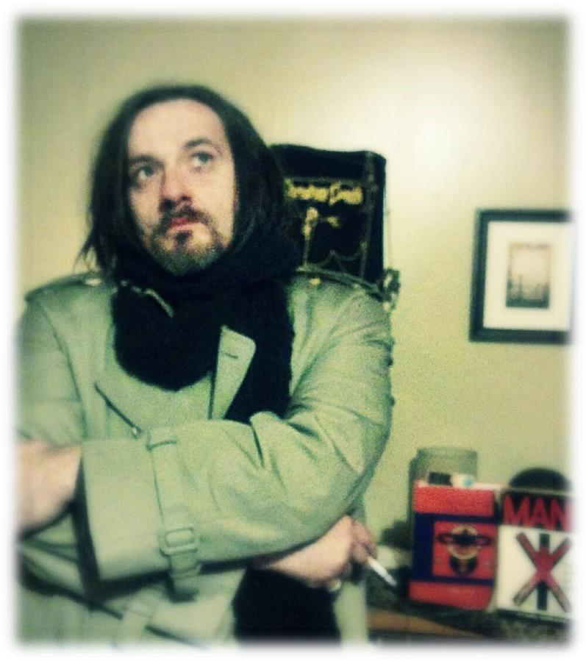

Templi Unam Official

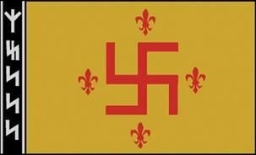
“A new kind of militia has been born, unknown to the past centuries, whose fate is to fight without truce a double combat against the flesh and the blood and against the evil spirits that live in the airs…” Bernard de Clairvaux

Templi Unam was formed in a convergence of two Temples. Templi Boreas Aurora in
North Albania and M.G.H.S.N. in South Albania. North Pole-South Pole. Since this past November, of the year 126 of the New Era, the convergence happened as a celestial strategy the very Gods put into place. Whilst both Temples are Esoteric Hitlerist and Armanen, neither Temple knew of each other’s existence. Both were fighting in the same manner against the same enemy. That is to say, an astral battle, a psychic battle, a battle within and without.
The convergence was a natural permeation. Now, the Two as One. Manu-Unam. Ur-Ru. United and Separated. The Esoteric Hitlerists of the entire world are joining under the banner of Templi Unam. We now also have a female Order alongside the Brotherhood. An Order of Mystical Virgins of the Avatara, Virgines Sorores Glacies. The mystical Virgins of the Ices are the Pole, they are the center, they are the protectors of the purity of Templi Unam. They keep the sacred flame burning. The Hyperborean Virgins of the Avatara have been solidified into this tormented world and now Master Serrano smiles upon us from the Morning and Evening Star, as cathedral bells echo out faintly, in a distant Thule.

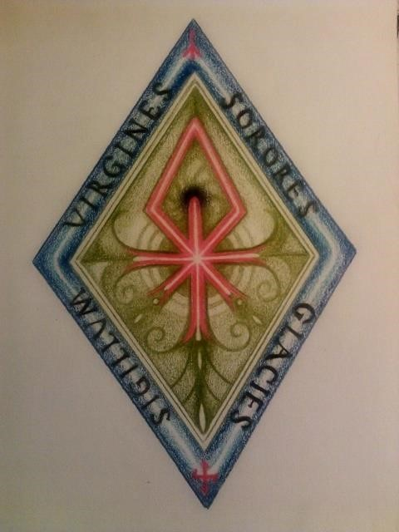

Templi Unam/M.G.H.S.N. (Mystical Warrior Brotherhood of the Black Sun), is a hermetic society, founded in Chile in November 1989, as a dependent association and heiress of two brotherhoods of its same ritual and affiliation, being one of them Ordo Novi Templi, the ONT, of Jörg Lanz von Liebenfels, whose symbols it preserves. This order transmits to their brothers and sisters a traditional sense of life, deeply rooted in ancestral lineage, and inspired in a cosmogony revealed for these particular times, in a way that merges paths, visions, poetics, speculations of different places and ages, all unified with El Cordon Dorado, which connects to a filogenetic origin.
This intimate identity of the superior human spirit with a plural divinity, converging with Indo-European paganism and their mysteries, which, in a late period, acquires a reactive position in relation to monotheism, through the Gnosticism of the first Piscean years. The ancient voice survives in the center of the obscurity and in the will of the Alchemy that the survivor builds up to the final irruption of a modern Gnosis, which the Aryan soul has collectively projected through their last Visionaries.
Three are the laric-vocal geniuses that, in the recent epoch, and with a rising clarity, gave answers to the major concerns of human kind, in relation to life and death. These are the Masters: Guido von List, John Rudolf Gorsleben and Miguel Serrano.

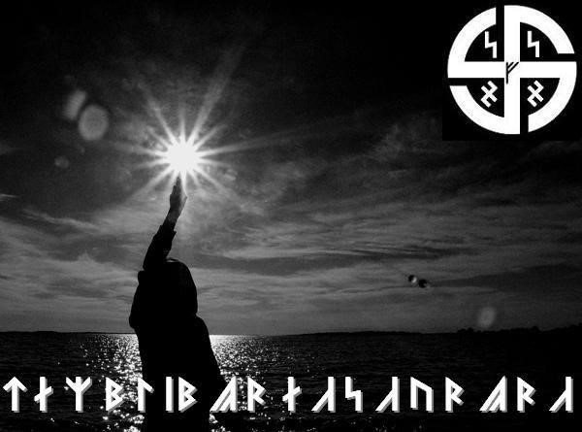

Since March of this year we use a black page in binary code, put in the new illusory net of the electron without life, because from March of this year it has been authorized, the Temple Order’s manifestation as a static and monologic presence, which does not look for followers nor for the diffusion of its rules. For this reason, we answer to Julian the Apostate in such a way: we will not write about that which is not spoken, we will not disclose what shall not be disclosed, we will not pronounce what shall not be pronounced. This is an internal and personal path, where more than knowing, the important thing is Being. The silence builds the walker’s way…

“Ad maiora nati sumus”

Serranoism

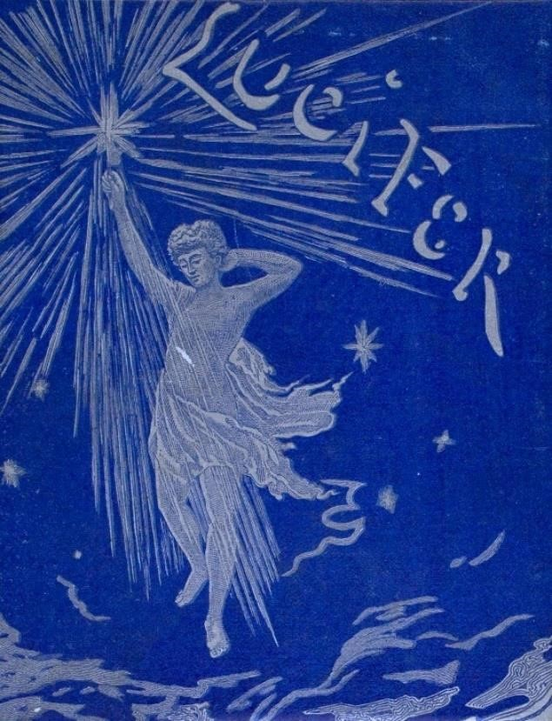

Esoteric Hitlerism, the Path of Amor, Esoteric Kristianity is ultimately what we now call Serranoism. It is not Anti, it is not Gnostic, nor is it Dualistic. Esoteric Hitlerism orSerranoism is Tantric (see below). Also, we can safely say it is Jungian, even though Serrano found himself disenchanted with Jung after finding out Jung was a Mason. Nonetheless, we feel Jung has given modern man the best verbal vocabulary for tapping into the archaic brain where Hyperborea and the ancient Gods reside. Whereas Jung could not take it to the next level because of his “Scientific” career, he did hand his legacy on to Serrano who claims the Archetypes ARE the Gods and not just racial memories collected in the “Collective Unconscious.” This is a valuable lesson for today’s cold rigid scientific atheist society. We must also see Serranoism as a deeply poetic Magical Realism. The concept of the “Non-Existent Flower,” which must be created, invented, until it becomes more real than all the flowers of this earth. This is the best weapon modern man has for any future salvation. Each day that passes sees the spiraling effect of Kali Yuga’s transition getting out of hand, where, at the end of a downward spiral, things move so fast and quickly with each new inward turn, it can be overwhelming. This Non-Existent Flower is created by “the most powerful weapon delivered to us by the Gods – Great Longing and Deep Nostalgia. “Without this High Magic, this writer would have been locked away many years ago.
The ego is not to be immersed or fused with the One. We do not allow Our-Selves to be swallowed by the Eternal Return, to be food for this Devil, or Demiurge. This is the way of a non-warrior defeatism that we cannot accept. The so-called “Nothingness” of the All, the One. The Brahma, who is, in fact, the Demiurge. In Jungian terms we must lose our egos in a “dark night of the soul”, accepted by our rational self, allowing our Self to die, to Die and Become, our inherent Be-ing, that which we know as our “I”, to allow it to be devoured to the point that one must “let go of holding on” and ultimately implode. This is what it
means to be immersed in the Black Sun. The confrontation with the Black Sun. Sucking one inward, implosively into a Singularity and from there, into the Green Ray of Light, the Green Thunderbolt, the “Flash of Green Light.” This then gives the Twice-Born, the authentic Aryan of yesteryears, a means to attain the most sacred resurrection into the Supra-Ego. An Individuated Persona, an Original Personality, a King or Queen of their own Self-Created Universe where no fear exist. Supra-Humanism. Forevermore. There will be no death when the physical body of this life is done. The New Man will Resurrect into an Immortal.
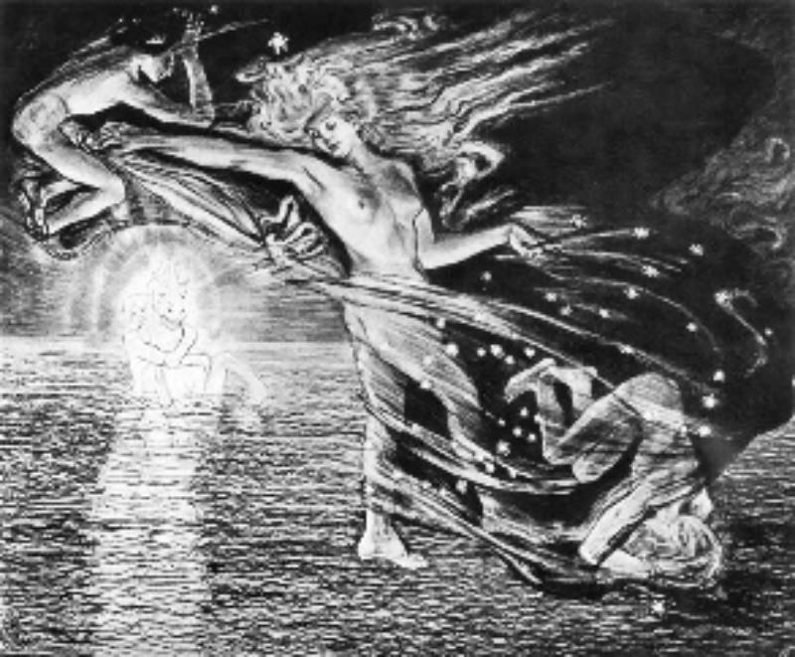

Do not fall into the trap of modern day Buddhism where they preach “feel at one with all”, or the trendy new age spirituality that offers only a “white light.” If a man or woman ignores the Jungian “Shadow” (the Gods), then it will slowly birth inside you and take over, creating madness and disharmony. The Shadow and the Light (the Gods) must be used as a means to attain this High State of Being. Of course we are speaking to the Serranoist. And not to the modern day man and woman who have no idea of what we are speaking of in the first place.
In Serranoism it does not matter whether you are a Christian, Pagan, Hindu and so forth. Serranoism is for the ones who take the Heroic Path of Immortality. Those whom separate themselves from this satanic kingdom and find Unity in Separation. In the Total Man and Total Woman. The Unity of the Morning and Evening Star – which is the same star. He and She become WE. Day and Night become Twilight. Summer and Winter become the
Autumnal and Vernal Equinox. As Serrano himself stated: “In these realms of slavery, this shows to us that the visible Demiurgic universe is not entirely his own possession…, the visible eyes of this Universe, that of the stars and constellations, hold behind it a Pristine Universe. “The Gods deliver to us a message within the poetic dialogue of nature. Of the stars, the zodiac, the seasons, the times of day, circles within circles.

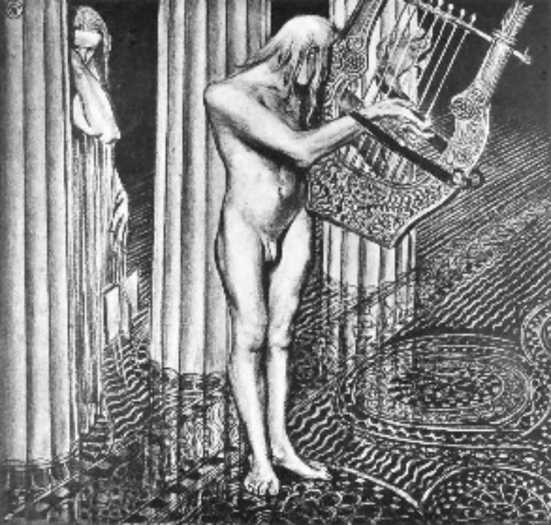

Tantrism. Nowadays most folks immediately get the image of sex magic, the Kama Sutra and so forth. This is not Tantrism. Tantrism is the use and manipulation of male and female powers, their inherent abilities and energies, to achieve a Union. In some Tantric Yoga we do use sex as a means to make a powerful energy move higher into a Divine State of Being. In short, it is called El/Ella and Ella/El (Him/Her and Her/Him) in Serranoism. Since modern man cannot be spoken to in the ways of old, we have had to speak “in code.” Those who are familiar with Serrano and with Elella and Ellael know what
authentic Tantrism is. There are more things we could talk about that Serrano has given us through his poetic musical books and words, but all in due time.

Polar Midnight

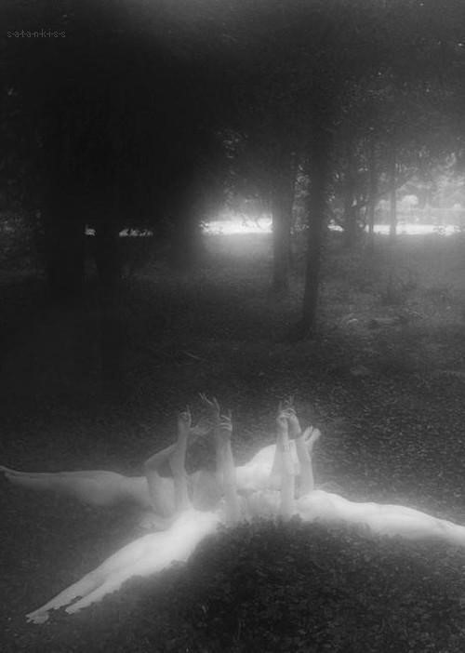

Yule ~ North, Midnight, Luminous Blackness. It is represented by the upper arm of the great wheel, the Black Sun. With its 12 mirrored SIG Runes that shine inside us, it permeates within us a nostalgic shimmering blackness for 12 nights. The most
Northerly Midnight, the darkest night of the year. The lit candles on the “Living Tree”, the Ever-Green, represent this Luminous Darkness. Candles, fires, old traditional stories from generation to generation. The ancestral hymns echoing out in the night air, the caroling – all of this has vast meaning in the blood, in the memory within the blood. The shimmering lights all about the countryside. The night in which the wise old man rides through the air from his home at the North Pole. The star we put at the top of the tree represents this North Polar Ur-Star. The tree being the Irminsul. We are reminded of the great Exodus from most distant Thule that our Divine ancestors traversed. From the Ur-Star of celestial Hyperborea, to the spiraling lights which tell of each turn of the wheel, each epoch. These meaningful things take us to the roots of present day terrestrial man, the roots of the tree. And just as the great Exodus from our Divine Star took place, so will we return back up, epoch to epoch, branch to branch, light to light.

Thule ~ Most Farthest North, the realm of the ‘Midnight Sun’ and the apparition of the Green Ray, the Green-Violet/Purple Spectrum, the “center” of the great wheel, the 13th Hour, the flames made of white crystallized ice, the unmoved mover, the Pole.
The ‘Black Sun’ has mirrored SIG Runes. This is because it shines inside us from “the other-side of the mirror” – the “other-side of the light” – it shines a luminous blackness – the polar opposite of the golden sun and the red-yellow spectrum. The initiates goal is to eventually unite with the “center” – Individuation. Nos.

Lucifer ~ Lucibel

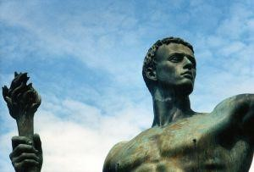

Lucifer is the bringer of Light. Light in the sense of illumination, gnosis, wisdom and poetry. Through trials, through initiation and through ritual, this other-worldly Light ascends as spectral brilliance after the dark night of the soul as the Morning Star in the East at dawn ~ Oiyehue

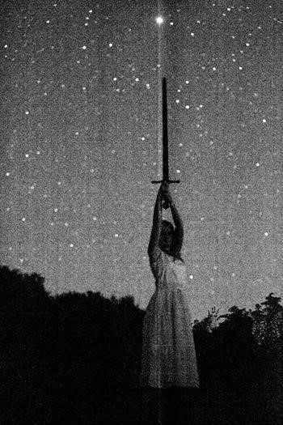
Lucibel is the bringer of Nightlight, Auric Beauty, dew, astral starlight on the moist foliage, humid fields, grass, leaves and trees. The twinkling eye of a snowflake as it swirls through the pre-dawn night air catching starlight and its auric brilliance. The muse who whispers on winds, whisping on the dewy leaves of Light like in a sky of Autumn. The Amada, the Beloved, whom glistens in the Evening Star in the West at dusk ~ Yepun
A 24 hour day/night wrapped in each other’s arms at twilight. The culmination ofEl/Ella (He/She) as NOS (WE) is Noontide and the culmination of Ella/El (She/He) as NOS(US) is Midnight.
The Initiation of the “Midnight Noontide”, “NOS”, is the ultimate goal of all initiates on this Path, and is found in the symbol of the 8-pointed star of Eterno Amor, Chilli-Mapu. The 6 pointed Hagal rune, MAN:YR (He/She) and YR:MAN (She/He) overlaid on each other. One horizontal, one vertical, to form the 8-pointed Ultimate Flower, the NonExistent Flower of NOS (WE/US) which becomes more real than all the flowers on earth. Individuation, Total-Man, Over-Man. William Blake’s “Poetic Genuis”, Friedrich Nietzsche‘s “Midnight Noontide”, Carl Jung‘s “Selbst”.

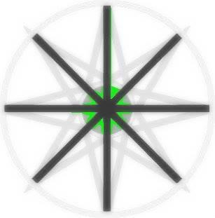

Polar Thulean Mythos

This is another chapter from the book I began writing almost a decade ago.
“Almost a decade ago I began writing a book that I never completed. The book was to be a simple “Introduction” for the few folks whom I saw being drawn to the teachings of Miguel Serrano. 18 years ago I felt like the only person on the face of the earth that heard the Opera of Serrano’s “Hymns from the Blood“. Since then, with the gradual onset of the Cybernetic Age, I saw and felt more and more souls who also heard, saw and felt what I also was witness to. The book was to be straight-forward, uncomplicated and to the point. A Synthesis of what I came to witness as “The Path of A-Mor”. I now make some of these writings available for those who may find it of use. May it help and guide the Pilgrim of Deep Nostalgia.”
The Divine, the Semi-Devine and the Sudra
In a time before recorded history, in Ur-history, perhaps at the beginning of the last
Manvantara, there was a glorious civilization located at what we now know as the Arctic
North Pole. It was there that celestial beings took refuge and built Hyperborea. The Hyperboreans as we have been told were divine beings who retained the “Golden Law” and lived in the Land “beyond the Cold, Ice and Storm,” “beyond the North Wind,” “beyond BOREALIS,”– the God of the Farthest North and the God “beyond the North Wind”. Today we hear of the term “Boreal winds” which mean “Northerly winds” or “winds coming from the arctic caps and ice sheets.”
The Hyperboreans established the Golden Age upon this earth. They had the power of telepathy, telekinesis, aerial and aural/astral flight. It was only after the Hyperboreans consorted with “the daughters of men” (the Book of Enoch/Genesis explains), that they became bound to flesh and earthly/terrestrial bodies. Before this they retained a pure spiritual form. Ghost-like beings who could drift in and out of the different worlds. Death was unheard of in the SATYA YUGA or Golden Age. Only after the diluting of the Hyperborean blood with terrestrial creatures did the semi-divine Hyperboreans experience death. However, they were given a choice upon their time of departure. “The Way of the Fathers” (Pitrayana) or “The Way of the Gods” (Devayana) were the choices one had at the moment of death. The first being a reincarnation back into a terrestrial body and the second being reincarnation into an ever advanced state, like going up a ladder, until they were Divine again. This loss of Godhood is remembered within the blood which retains the sacred Minne. The Minneis the memory of a lost Amor, the “Blood Memory”, the memory of something lost at the beginning of time. Something profound.
Throughout mankind’s time on this planet there have been poets, bards, troubadours and the “Minnesingers” who write their poetry and sing their hymns from their Minne, their blood-memory of a lost Love, almost as if when they speak of their Beloved they are speaking of their sacred mystical Homeland. Thule, Hyperborea. Mystical Motherlands and Mythical Fatherlands.

The Fall
While the mixture of the Divine Celestial Hyperboreans with the purely terrestrial earthlings was tragic for the Hyperboreans, it did set into motion the spiritualization of what would eventually become “homo-sapien”. Here began the great buildings of civilizations all over the Earth in Ur-historical times. Impossible structures that even mankind cannot reproduce today with all his technology. From the Great Pyramid to Tiahuanacu, from the giant statues of Easter Island to the thousand ton perfectly cut granite stones at the Temple of Jupiter (known as the ‘Rock of the Pregnant Lady’). We have
Ancient Greece and cities like Olympia and Delphi. The Externsteine (Stern = Stellar, Stein = Stone, Stellar Stones) in Germany. All over this earth are vast lost civilizations that science has yet to give their “logical and rational” hypothesis whilst ignoring the blatant truth right in front of them. Massive megalithic buildings that were constructed perfectly by so called man who was one-foot out of the stone age and didn’t even have the wheel invented yet. Oddly, this also coincides with the lost link on the time-ladder of mankind and it is as if some sort of beings came down and gave mankind culture, alchemy (which lead to chemistry), magic and advanced living. In Greek Mythology it is written that Apollo, the Solar Deity, Son of Zeus, went to Hyperborea every nineteen years to rejuvenate and refresh himself and to eat of the Golden Apples which brought him eternal life. We have the same basic tales in the Nordic-Germanic Sagas of Idunna’s Apples of Eternal Youth that the German-Nordic Gods Wuotan-Odin, Donnar-Thor, Freyja-Frigga ate to keep young and replenished. All these tales have a Collective understanding to the races of Indo-European stock. Each culture may have a slightly different name of the particular God or Goddess, but they are One and the same in the Blood-Memory.

Hyperborean Ancestry and The New Grail Mythos

It is the German God Irmin who held the Pole Star in place and his column, or Pole, called the Irmansul, stood at magnetic North and held the stars and the entire swirling firmament in place just as a swastika spins on its axis. The middle, the ‘Pole’, does not move. The middle or the Pole (A-Poll-o) stands firm as the outer arms rotate and spin accordingly. And it was Atlas who did the same for the Greco-Roman world. Atlas gave his name to the Atlantic and it is the very God Poseidon who first fell in love with Cleito and together they bore the Dioscuri, the twin Kings of Atlantis, whose name is also similar to Atlas/Atlantic.
It is important to give our interpretation of the word “Grail”. That is to say – something that is seldom seen or heard and only the very few are able to see it, “feel” it, to even know
of it, much less obtain it. The first Grail in history is the Golden Fleece which represents the Golden Law and Oath of the GOLDEN AGE (Satya Yuga). Hyperborea-Thule. As the Golden Age was being over-turned into the Silver Lunar Age, the Patriarchal into the Matriarchal, it would take a Vira, a Hero, to obtain the Grail. Once again it is important that we shed light on the true meaning of the word Grail and its true nature. Especially in the so-called “Arthurian Legends” of the Middle Ages. Arthur is nothing more than a code word for the Initiated. Arthur is ‘Arctic’ and ‘Thor’ and is basically “King of the North”. Also note the AR. AR, of the Sun, the Eagle, Arman, Aryan. Sangrael is a word that those familiar with the art of Trobar Clus (singing/writing in code) know mean two things. “Grail Saint”/ “Grail Knight” (San Grael) or “Royal Blood” (Sang Rael). However, the Grail is something that predates any of this and has been “Christianized” and has been usurped, abused and misused. The Grail is really “GRAAL” and the very first “Grail” was a stone which fell from the heavens down to the eternal ices of Hyperborea. It was a stone that was once a part of Lucibel’s crown which was struck in the heavenly war before He-She and She-He (Elella and Ellael)) and the other Hyperboreans settled at the North Pole. This stone has been an object of deep reverence since time immemorial. The Black Stone at Mecca predates Islam and has Proto-Sanskrit etched on it. Serrano himself stated that the word “Alla” is an ancient Mantra of “Him-Her”. Al being “Him” and La being “Her”. It is a Polar word that is mirrored. That is to say, when the first syllable is put in front of a mirror it becomes polarized. El/Ella. Lingam and Yogini. The mysteries of the Black Stone have been, to this day, the stimulating force that many esoteric and occult traditions have vigorously sought after.
In today’s modern world the Grail Mythos, the archetype, are the Flying Discs, Orbs and Dancing Lights seen in our skies that travel faster than the speed of thought and can read the “thoughts and emotions of man”. The lights of entire cities go out when they appear to give their celestial message to the few. The new Grail hunters are those in search of this ever evolving Gnosis which changes skin, clothes and it’s face many times as the wheel turns other rounds through the aeons. We hear of the Flying Discs of Light which travel by use of sound. Just like projecting one’s aura, the humming gets louder and louder until one finally gets out of their body or “falls out of their skin”. As much as we hear about it, we seldom see the Grail ourselves. And this is exactly what the Grail is. The “Will to go beyond” the very Gods to obtain the impossible.
“And to whom does this Grail serve?!” – Parzival

Lucibel
Lucibel is the name the Cathars gave to the God of Light or “The Light Bringer”, Lucifer. Lucifer is not, nor was He ever any Christian “Devil” or “Satan” and has nothing whatsoever to do with such. Lucifer comes from the Latin words for Light (Luc) and “To
Bring Forth/To Usher In/To Bearer” (Ferre) and thus we get Lucifer. It got put into the
Holy Bible through a misunderstanding and inaccurate translation of the Greek word “Phosphorous.” From here on Lucifer was forever stuck with the ‘Satan’ or “Shatain”, which literally translates as “the accuser, the oppressor,” However, He is really the Morning Star, the “Bearer of the Dawn”. Lucifer is the bright Dawn Star that ushers in the Morning and the moist dew. Lucibel is the Most Beautiful Light. Lucibel (Luc and Bella), as the Cathars called Him. The Light of Wisdom and Knowledge/Gnosis. Lucibel is the Supreme Leader of the Hyperboreans and as He came down to this earth He saw how an inferior sort of Godlet or Golem had created a race of slaves. Lucibel was repulsed at the way this savage and blood-thirsty Demiurge could be so cruel. This inferior Golem, known throughout time as El Shaddai, Jehovah, Yahveh – the God of the Jews and God of the Old Testament, has been feasting on the flesh and blood of the innocent. Since that time a spiritual war has been going on between the divine Hyperboreans, fighting alongside their Leader, Lucibel, against Jehovah and his servants of “Robot-men” and their Robotic Rabbis. The Highest conductors of Black Magic, murder and pain. Black magick which sunk Atlantis because of their ever increasing decadence and unhealthy sexualism. Turning a profound act of Love into an animalistic depraved form of violence. Desecrating the woman and the potential Hero, ever in need to dilute the Hyperborean Blood. These biochemical robots, these acolytes of the Demiurge, ushered in the corruption of the innocent. Their craving of materialism, gold and their mammonism knows no bounds and is so vast and disturbing that a whole Chapter would be required just to shed the smallest light on these, the Princes of Pain and Slavery.
An Overview (Salvation and Hyperborea Renewed) So, we have gathered the following:
LUCIBEL built a massive civilization in the Arctic region called HYPERBOREA
(sometimes known as THULE – the Most Northernly Midnight). When they settled here, a long stellar battle began. They witnessed the hideous sadistic behavior of Jehovah and proceeded to wage war in order to help the poor earthlings escape from the bondage of pain and slavery. Whether it was a “Conscience/Conscious” decision or not, the Divine Blood was diluted whilst the animal-man was Spiritualized. It had such a heavy price and impact because time was now set into motion and Involution set in. The Hyperboreans consorted with “the daughters of man” to spiritualize the earth. From here all great civilizations and Gods were born, depending upon the culture and geographic location/language. The “Semi-Divinities” were the result of the mixture of the divine Hyperboreans and the earth creatures. As time progressed the earth began going down a downward spiral. Science would have us believe we are evolving, thus the belief in Evolution. However, any person worthy of their blood should know we are not and have been in the process of Involution. Things are not “getting better” – We are finally in the nadir of the Kali Yuga, the Iron Age, the Final Age, which will eventually turn once more, from the ashes, into the New Dawn. Only Our Legends, Myths and the practice of A-MOR (Love Without Death, ETERNAL LOVE),
can bring salvation to those who seek it. It doesn’t matter whether one is this or one is that. Each one of us have our parts to play in these final times. It does not matter whether you call your God Christ or if you call your God Odin. The Gods are possessed by the archetype of any given moment, any given turn of the wheel. We Thuleans, we who seek the Black Sun, give names to our Gods and Heroes to make the stories understandable and there is also a magical vibration in names and in everything at the atomic level. The study of
one’s Ancestry and their culture will get one in contact with their MINNE (BLOOD
MEMORY-ANCESTRAL AWARENESS). In the Initiation of the Hyperborean Path of A-MOR we study the ARMANEN Runic system and the great Armanen who came before us. One should be trained in at least a basic Yoga. The control of the breath and breathing is vital. A daily meditation and contemplation is often a good discipline to keep the mind and body in harmony. The best hours for any sort of Ritual, meditation or/and
Spiritual/Religious practice is from 3 AM to dawn and then from an hour before Sundown to Dusk/Sundown. Finally, the true “Witching Hour” of the Thulean is 13 O’ Clock. That is to say, 1 AM to 3 AM, the darkest most Northerly portion of Night. Keeping ones living area clean is a vital discipline. The burning of certain herbs keeps astral leeches from sucking Vril or the force of Od/Odil from one’s body. Change your bed position every month if you are on a high level of Esoteric Tradition and are an Astral Projector so that certain astral leeches do not have constant access to your vital energy (Vril/Odil) while in bed. Studying the literature of the great Thulean Masters is a must. First and foremost: the books, the teachings, the words of Miguel Serrano. William Blake, the Ariosophist and Armanen such as S.A. Kummer, Rudolf Gorsleben, Guido Von List, and others The study of Tibetan Buddhism. The Bhagavad-Gita. The Eddas. The Vedas. A re-reading of the
Holy Bible with a new “outlook” in mind (that is to say, to know it is in fact an
antediluvian document, a Hyperborean revelation which was stolen by the enemy and plagiarized). All “Holy” books to all the various cultures and peoples of the world to find the common thread, El Cordon Dorado, in the deep regions of the divine
self. The Guardians of the Dawn and the Watchers of the Aurora keep eternal vigilance and keep the message of the Morning Star up in the sky every morning and evening. Like an eye filled with tears, it’s dewy morning message is sent to us “like a distant Cathedral Bell” until the return of the Golden Age when Lucibel shall be fitted with a crown with the Graal back in its rightful place and our blood, the condensation of the Green Light of the Black Spiritual Sun, returns back to its green light and our veins are once again coursing with the immortal emerald light of Lucifer/Lucibel.

Sacred Amor, Magical Realism (the “Exit” from this tormented world)

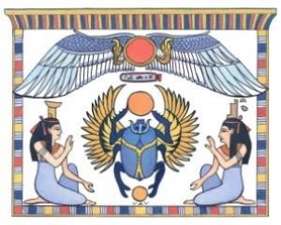

Can a being truly penetrate into the depths, the deepest depths of Sacred Amor and thus, magical realism (or what we call the Non-Existent Flower), in a world like today where Love is on sale, murdered, raped, imprisoned, 24/7? Where Love is spat upon and not even known just so inferior subhuman undermen can practice depravity. If one is born without the conscious (and conscience) knowing of what True Love is are they to be condemned? The condemnation means less to us than the fact that they most certainly will forever be inferior to us and we must remain as far away as possible from such profanity and to know that they are far, far below the rarefied souls who have Sacred Amor and the Non-Existent Flower in their eyes, aura, behavior and thus, SOUL.
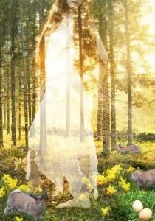
What can be said about the world of to-day. I, myself, solemnly know that the “Nadir of Kali Yuga”, the lowest point in the so-called “end times”, the infection, began to spread after 1945 by route of flu shots and any other government injection. Constant chemical warfare and the murder of our very food and water supply into “dead food”, “dead water”, has slowly caused an involution in the authentic beauty of human beings. Go to a public place this very day, take a close look, and tell me what you see. Only, at the most,10% of humans have the most rarefied authentic true BEAUTY which is NOT ALL to be seen on the outside, but is both in and out. As Above, So Below, As Within, So Without. Their Body matches their Soul. This is not to say everyone. Some ancestral blood is ALWAYS protected by Our God/s and Celestial Ur-igins. When the memory within and of our blood awakens we begin to go through a transmutation into Beauty just as the lead is rarefied into Gold. Both outside and most importantly, inside. Fate, destiny, the stars, the “Black Hole”, the Center, the Pole, moves everything accordingly. This is to include the chemicals (and even new scientific rarities that we know nothing about yet) they add to food supplies, to soft drinks, to any and everything that goes into a human body (possibly even the vegetables that we grow in our own soil – the nucleus, the infestation has been involuted at the atomic level), to city water, to expensive “hipster water” in grocery stores and et cetera. No one is spared. Do you really think just because you do not eat at McDonalds you are somehow not included in this Demiurgic Blue-Print? I do not write such things out of desperation or spite, for I have excepted the inevitable COLLAPSE of this world many years ago. Thus, the only thing I see left is Sacred Amor. Divine Love and Magical Realism (what William Blake calls “The Poetic Genius/Christ”, Jung calls “The Selbst/Self/Christ”) and so on). Medicine/drugs will and cannot bring Salvation – for I am The One who can testify to that. We do things “we love”, but that is not enough for actual Salvation, for the Consulamentum (the ancient Cathar ceremony of being cleansed and purified of all worldly ills).

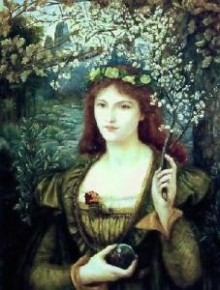

Old fashioned Sacred Amor must be adorned and made a Holy Temple once again. The worship of the Divine Feminine. Let US embrace our IS-IS without even thinking or acknowledging the Zionist induced disgust that is going on in the Middle East under Her Divine Name. It is a sacred Mantram, a runic formulae. The Ziobot can NOT have it by Divine Authority and this anti-race will pay cosmic debt to the Good God. This is a Law written in the very Stars. We must invoke Her name, Isis, IS-IS. Two :IS: runes from the Armanen Futhorkh. Isis, Ishtar, Mary, Maria, Eostre, Ostara, Freya, Venus, Lucibel. She IS our Soror Mystica, our Mystical Sister. She IS the Soror Mystica of Osiris (OS-IR-IS — another Armanic runic formulae and an example to live and die by). She IS the one who puts Us back together, readying Us for Resurrection (Re-Erection). The rising up from a grave towards the Ka. The devouring of the self in the shiny blackness of Fana and rebirth in the green immortal light according to ancient Sufi/Sophia tradition. The “Glorious Body” of the Gnostics. The “Rainbow Body” of the Tibetans. The “Astral Body” of Krist. “Noli me Tangere!”
~~~
Clothed in the immortal Red Vajra. The Diamond Body. Immortal. Shimmering, Celestial, the Alchemical Squaring of the Circle (to be reborn with “Square Pupils”). The authentic Resurrection of the Flesh. To be surrounded by walls of Eternal Ice in an eternal Spring/Autumnal twilight softness, like a soft petal falling directly where it was always meant to fall, perfected. Being able to ride on a Ray of Green Light as if it were mirrored through a Black Sun.

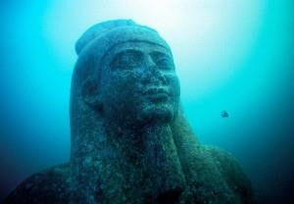

Sacred Amor is the Divine Love of Him and Her. The Two who are capable of dying in each other’s arms without any worry, anxiety nor sadness. To “exit” here, through a “wound-window” that has been sliced in the fabric of Demiurgic space as if slicing an enemy with a most sacred blade. From this “wound” opens a “window” in which the Light from another, more Pristine, Universe, pours out. The Light of Lucifer/Lucibel. That is to say, the Morning and Evening Star, Oyeihue/Yepun. Because Day and Night wrapped in each other’s arms is Twilight, the Dawn or Evening, where shines Lucifer/Oyeihue early before morning and shines Lucibel/Yepun at eve’ning. NOS! “The Leap!”, the “Exit”, the “White Window of Venus”.
Magical Realism is the ever evolving soul guided by Divine Love, or Willed Poetry, Willed
Power, Willed Anything, of the Magi-Poet-Warrior. He who uses his pen as a sword and receives his ancient fury from the sacred Amor of his Amada, his Beloved. He is capable of transfixing and transfiguring nature through his Will, his “Poetry” alone. He is the One who can, literally, make mountains crumble. His Magic is Realistic, thus TRUE, and his Reality is Magical, thus DIVINE. HE brings HER with HIM to the Sacred City, back to Hyperborea, to the Center, the two as One, the Self, Thule. The Dot that is located in the absolute Center of the ever fluxuating Circle.

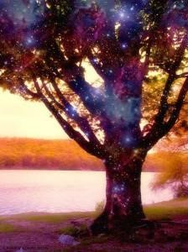

:EH: or the Path of Amor see the Path of the Magician, the use of a real woman as being the Ideal Left-Handed Path of Tears and the one we prefer although this can also be achieved through the Right-Handed Path of the Saint with the Adoration of the Ideal Divine Sacred Feminine Archetype. We think of the Master Vincent Van Gogh in this regard. Either way, within Sacred Amor (Eternal Love, Divine) and Magical Realism can be found the “exit”, the “wound-window”, the “the leap into the void”, the “departure” from this tormented world.

The Non-Existent Flower and PreDestined Divine Morality (Part I)

“The healing power of medical drugs is the Ur-power of their original essence in conjunction with the power of Ur-vibrations of the human-Divine combination that is composed of body, soul and spirit.” – Rudolf John Gorsleben, ‘Hoch-Zeit der Menschheit’
We must use the magical, alchemical, transmutational process of Magical Realism to make ourselves better souls, Light in the Night, and yet sometimes, Night in the Light. It should and actually can NOT be used as so called “excuses.” I firmly believe that certain drugs help rather than harm. I believe, actually, I know, that some rare poet/art type individuals NEED whatever it is inside the opiate. In a so-called scientific reason, I know that certain people stop producing dopamine after their teenage years. Those who explored, in their younger days, the psyche with lsd, mushrooms, etc are of this minority. So are those who had, what can be called, a traumatic childhood. Their endorphins, the “pain-killing, feelgood” chemicals that are released during sex, when we eat, when we exercise, and especially when we laugh, stop working as well. They suffer a horror that goes beyond mere “depression.” Taking one step in front of the other takes 120 percent of their will power.
Thus, the tendency to lay in bed and have no stimulation. The opiate releases this chemical.
In so-called reality when people like us take opiates we are simply NEEDING to feel like a “normal human”, to take away those demons, to take away what I have referred to as “being raped by God.” Mental visions that no one should see. Therefore, I will always have an opiate unless something else comes along. Opiate Maintenance. I went to a Methadone clinic for 6 years and now I take Suboxone, a medication for opiate addicts, to help. I refuse to be tortured when it doesn’t have to happen. I’ve been on opiates nearly 20 years now and my worldview is highly influenced by substance. I consider myself a “psychonaut” (a traveler of the Soul), not a drug-abuser.

More on drugs, addiction and my Love of those souls who have been through addiction and who are very misunderstood. The Luciferian Archetype, the Promethean Soldier, Magical Realism, Poetic Simplicity, Magic, Graveyards, Ghosts and all that pretty stuff……

Interview with Harvest Rain (Jason Thompkins) on the occult, magic, drugs, ghost, night and etc…
https://santasangremagazine.wordpress.com/2014/12/09/jason-thompkins-harvest-raininterview/

The Non-Existent Flower and PreDestined Divine Morality (Part II)

~ Concerning Magical Realism, Poetic Simplicity and the Non-Existent Flower (which becomes more real than all the flowers on this tormented earth) ~
This should answer some questions that have been coming my way. To ask such questions immediately answers mine. To explain our powers and our ways is to allow the enemy to get in. That is why we cannot simply “explain” everything. What good is it if all is simply explained in a textbook manner. One is to trust, with all they are, their g-Ur-u, Torch Bearer, or whatever you wish to call it. If he tells you to jump off a bridge then you do not even question it, you jump! Because you can be certain you are dealing with areas of the Mysteries, the occult, that is earned, not learned in a book. It means the G-Ur-u must know a cloud is going to catch you.
Our Goal is to take “Negatives” and transmutate them into “Positives” by a shift of perception, a “click” in time, yet ONLY if and when it can make our Souls move Upward and Forward. But that is just it. That is why a rapist, a psycho-sexual predator, etc, will never have Divine Magical Realism. If one consumes drugs and robs people then they cannot “transmutate” – they LACK the part of the Soul, or brain, that the Gods have given to those who can. The “Calcified Third Eye”, according to Master Serrano. Anybody who truly has Magical Realism also has what I call a “pre-destined Divine God-Given Morality” in which they themselves are not even aware of. It comes with the territory, so to speak.
In other words – We are Magicians, not madmen. We know right from wrong. We are not to be compared to the insane or inferior. Ours is the land where Fairies still exist. Where lightning bugs speak to Us in a flickering language of Light. Where my Beloved talks to the birds and She tells me what they are singing about. We do not have time for the inferior, the ignorant, the stupid, the drama and the fake. The gossip train. We have all done things we regret. It’s time to stop moaning and Fight! With Our Minds, Souls, Spirits and Fist!

Defiant Beauty

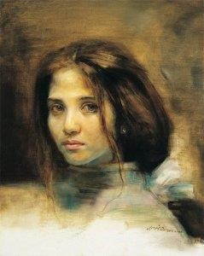

When One can stand in God’s Brightest Starlight, in physical and emotional nudity, on the highest zenith, at full noon, for all to see and for that One to not be ashamed of anything, then You, that One, are a Fellow-Traveler of Mine. The brightest, most intense flame of Lucifer jumped into Our veins at such a young age. We, the Experienced, will not ever be equal to the inferior, just as we always knew, so utterly deep inside, that all of it was disgustingly inferior to us all our lives. We, the Beautiful, will never feel “guilty” again for being beautiful, gifted, charismatic and of God. The sick twisted minds of to-day will tell you that beauty is to be destroyed in the name of equality, lude anarchy, social injustice and on and on.
This Soul, it stares out from this monkey suite at the keys on a computer, in the late a.m. hours of a crisp chilled night, seeing every word in which my God directs His Word from behind these words. Beauty and gracefulness are as Autumn Herself. Beautiful man and woman, Aryan Souls that look defiantly and sadly out those beautiful, impenetrable, divine Aryan eyes. Targeted for being Beautiful. Our Beauty goes so deep, so utterly deep. Like the darkest Night when stabbing the very earth with a knife whilst screaming death threats at the Creator. Crying and screaming like a mad lunatic. Men and women of Renown. They walk in a cafe and all inferiors shut their mouths. For their very presence is something Godly.
Bow before Beauty, ye Jewish Deformities. Ye have repaved the mirrored road of your own deformity and ye will kill yourself by putting a gun in the Demiurges mouth and have the deformed molester pull the trigger with his sick deformed tongue.

Cromlechs, Dolmens and Menhirs (Ancient Earth Science)

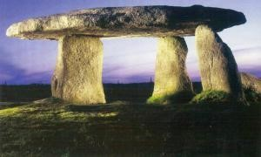

Cromlech is a term no longer used in current archaeology or academia. However, the old men who own the farms where these Cromlechs reside and are dug up by current academia still use this term to describe stone circles or more elaborated megalithic sites so we can be certain our tradition lives on in the culture of men. Blessed be the old farming man with no shoes! A Cromlech is a major site with many stones such as Stonehenge. A most Holy Sanctified circle, a portal, a terrestrial place which puts one in touch with the Hyperborean Gods.
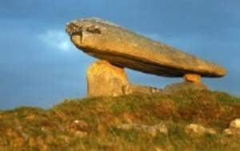
A Dolmen is the stone structure which uses two or more stones to hold up a flat stone “roof.” These can often times be “portals” and are more ritual in nature. Possibly graves, possibly sites of significant importance. “Portals”, nonetheless. They resemble chairs for giants. They are “Thresholds”, doorways into and through the other side.

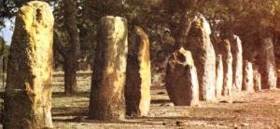

The Menhir is one single slab of stone stuck in the ground. This is the one which resembles the “acupuncture of the earth.” In many cases an unhealthy plot of land would be investigated by the Elder Counsel or a Healer, the “Wise Medicine Man or Woman” (what we today call a High Priest) of any given Tribe, and if the “flow of water”, even “water of the moon”, “astral water”, was disturbed then the earth was treated accordingly by treating its veins, arteries with acupuncture. This must be seen as being beneficial for all sentient life. Because if the earth is well then mankind, as a community (thus a whole), is well. In fact, all life is well including psychic life. It was work that had to be done. And that is why we find so many slabs of stone around the world, especially France, Spain, Portugal, England and Germany.
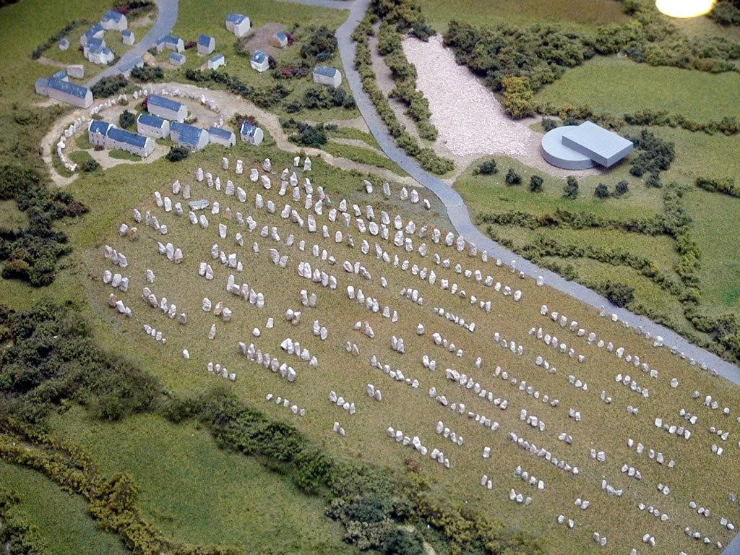

A sick unhealthy earth means a sick unhealthy mankind/womankind. I can only imagine what was going on at Carnac back then for them to align Menhirs in such geomantic fashion as that. Anybody with geometric knowledge can investigate the “formulae” they were using. My personal hypothesis is that the ancients (which, by the way, were far more superior in magic, ritual and supra-natural phenomena, by far, than the modern world of today) were healing the earth through authentic techniques we know little about. The rational brain of today cannot comprehend the type of technique and “science” we once possessed. They are even taught to immediately “refuse” it when it is brought up. For it is not based on Einsteinian Rationality. Their amnesia of how we raised stone with sound (mantra), how we made stone “soft” (Fire Magic), how we literally felt the underground water running through terrestrial veins, is a science of the Mind, Spirit and Body, both Leftside (Rational) and Right-side (Intuitive, Magical, Astral, etc).
It is only recently that mankind/womankind have activated both sides of the brain again to gain access to the “amnesia” of the glory days of when mankind had, within us, this Super Science. Once again we can perceive the ley-lines with hyper-intuition. The earth is covered with lines of potential energy that intersect one another. These areas that intersect are still known to this day as Holy Sacred Areas. The ancients built there most sacred sites on these convergent lines. The only difference is that one culture may have (and still) put their culture on top of another. Regardless of how mankind treats one another, we still have the ancient stones ready to heal again when they are embraced and called upon. When the “other science”, the “ancient science” is retrieved from our current amnesia.

Astral Body, Subtle Body

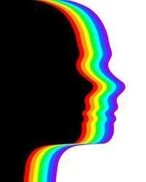

For a couple of years now I have slowly, through my astral experiences, realized that one does not go into the astral body as much as one “taps into”, “clicks into”, and/or “flips
into” something that is always there. A frequency that is always flowing. When one has an
orgasm they are not creating nothing new. One is simply “tapping into” that which is always there, always present. The “ecstatic orgasm”, the “never-ending orgasm”, as it is called by Serrano. Recently I have been able to feel myself fall to sleep, and have been cognitive of both hemispheres of the brain at the same time, thus “falling into” the Astral Body, the Astral Aether. This has been a work I have been pursuing for a very long time. “Clicking” or “flipping into” the Astral is not easy and it does not seem so real, so easy, so believable, when one starts on a basic yoga technique. My situation is different. I have had out-of-body experiences and Lucid dreams since puberty. Therefore, I studied this phenomenon in-depth and this phenomenon is what led me to my first teacher. Lama Geshe Dakpa Topgyal was/is a Tibetan exile living here in South Carolina. His teaching on Rlung, or “Wind Technique”, breathing techniques, were very influential on my early path. His teachings still stay with me to this day. However, I still cannot access the Astral Body “at will” – it happens only when I am prepared and the right moment washes over me.
I am convinced that it has a lot to do with the Schumann Resonance. When in this state of non-gravity and awareness at the same time I am sometimes “shocked” or “jolted” out of it. There are times I literally bounce off the couch by my muscles receiving an electrical shock. The static shock seems to occur at the Manipura Chakra. This happens in a most profound way when someone touches me. Here I am reminded of the mystery of Don Serrano’s statement on why Kristos said “Noli me Tangere!”, “Do not touch me!”, to Mary, after he arose from the dead.
The Schumann Resonance has everything to do with Lightning, the Aurora, etc, and it is the “Frequency” of the earth. 7.83 Hz. This exact same frequency is found in the human brain when we sleep at night.
When I say one “taps into” something that is already there I do not mean “in the body” as such although the body is used as a “vehicle”. The “frequency” that is the Astral realm is running throughout space-time and beyond. When the Aryan brain is electrically pushed, stimulated, etc, thus creating so-called “chemicals”, then one can “click into” and feel this vibration, this frequency. Think of someone who jumps in a flowing river. They become “submerged” – they are now a part of that river until they get out, until they “jump out” and back onto “earth”, land. Whilst under water one may see others who are “submerged”. This is precisely how Astral projectors “see” other people while in the Astral Aether. In my experience it is like the negative of a photograph and sort of monotone although I truly believe it is of a non-colour and it is more of a “substance” of sorts – like the way a bat or other animals with radar “see”. This is where Kundalini comes in. Tantric Yoga can, without question, open dormant areas of the spine and put one into their “subtle body”. Below are the actual frequencies of the earth’s “aura” and more….
https://youtu.be/lBgBJn0fDFs

Medea ~ The Amada of Jason

A little flower in the early a.m. dew. Moist, humid and silky, Petals drenched from the waters of the moon. Impenetrable. I see within these flowers something akin to a “Sleeping
Beauty” who is crying out in Her sleep, in Her “Glass Coffin”, for some Hero to come and
“awaken Her”, to “bring Her back to Life”. It is not the beauty of the flower that the Initiate seeks. The Initiate must seek the Essence of the flower. The Center. The integral aroma. The BE-ing. As deep as utterly possible. As deep as a being can possibly Be. The need to crawl inside the flower whilst the flower is, without cognition, screaming and opening itself up to be entered into.
There is a Holy Sacred Sadness in nature that can be seen in Her eyes. What is this message? What is the dialogue being spoken within the eyes of birds, of deer, of raindrenched flowers? Why do people weep at the sight of a flower? And why does that weeping feel as if the Holy Ghost has entered one’s body…
This is “Ella“. “Her” ~ not found on the outside of the female, but found deep within. The integral perfume. The silent dialogue. The silent sound of a perfected crystallized Winter snowflake falling in the absolute Center of a Sprouted Spring Blossom.

Apotheosis

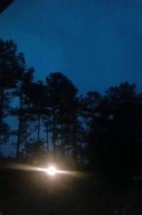

There comes a point when We are shot through the forehead with an Apotheosis. We are lit up with the Light of Knowing. Knowing that We entered into this world wearing the skin and body we currently reside in. We were not born. We “entered” into this world from Our world, Our Star, to fight for the sake of what is Right (Rita). We chose where, who, why and when. “Let Us now go into battle with Our Swords in Hand!” said the Master of my Master. This means, by any means possible, to transmutate and spread Gnosis, Amor (Eternal Love), Honesty and TRUTH, with Divine Purpose and Meaning, to those who seek it. The Final Voices calling out in the Wilderness. When One reaches the point when they are capable of standing physically and emotionally nude on a Noontide rock, at bright Midday, under the brightest Summer light of the Golden sun, when they have NOTHING more to hide for they are PROUD, then One has walked this Path of Tears, this Land of Tears, and they now are Complete. This Path can make a soul very tired, but the sheer Light that permeates through the thickness of Illusion is a most sanctified blessing from a Good God.

Divine Magnetism, Vril, and The Cold Light of the Black Sun

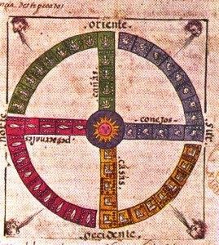

All forces in the Universe have a unique polarity that keeps them in a constancy, in a means and reason to carry on, a will to power. The great Ur-iginal Urge. It is the eternal cause and effect of Yin and Yang according to the Hyperborean Dropas, of HIM and HER losing and finding one another from within and without an infinity of black mirrors. The earth has a North Pole and a South Pole. Together, in accordance with divine harmony (Armane), a magnetic field is produced around the earth which shields her from dangerous space weather. The Aurora is produced when the earth’s magnetic poles are permeated with cosmic weather. The green glow of the Aurora is the Black Sun dreaming and longing for
the Green Ray. This sings to Us a great nostalgia and deep longing.
The human body also has a magnetic field. We know it as the aura. People who have attained a divine state of awareness produce a brilliant aura that can be felt worldwide, perhaps even through the various Universes. Sickness can cause the human aura to deplete. In fact, someone with a healthy aura can and will feed someone with a sick aura. Magnetism also has a repugnance. In various people we either feel a cohesiveness or a repugnance. The healthier ones aura, ones Divine Magnetism, ones Vril, the more they wish to remain alone and out of public places. They only surround themselves with others whom they flow with, feel comfortable with, pre-destination.
In yesteryears we see paintings of Holy men and women surrounded with an illuminated disk or halo-glow around their bodies or head. We feel that this exceptional ability to see and feel the aura, the Divine Magnetic Field, was shared among more humans than one may think. We feel it is an ability that was lost in the era of Pisces which brought about a sinister overcoating of ignorance. Today it is a miracle to find someone who can see the human aura. Thousands of years ago mankind had the science of the unpolished stone.
With Divine Will he lifted boulders, cromlechs and hurled great pyramids to the aether. Monumental cities that graced the earth on geomantic points of celestial synergy.

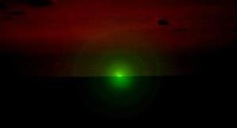

The three main instruments of the body that produce the aura are the genitals, the heart and the brain. Each one charged with electrical activity. The constant beating of the heart produces around the chest area a halo effect that one can feel and see. The brain also produces a great glow, a halo of colors. Those who have attained the supra-human state of be-ing have an aura that goes on through-out the infinity of the Eternal Return and beyond, where “one is waiting as if on the edge of a fountain.” They are the Bodhisattvas, the PoetWarriors, the Heroes, the Pilgrims of deep longing and nostalgia, the Magical Realists.
Everything is held together by magnetism. Magnetism also takes on the character of sound. Vibrations or frequencies are the particles which hold the Universe together. Magnetic vibrations are now being researched in Quantum Physics as “String Theory.” We feel science is only taking the long route to the Godhead whilst the Magical Realists and their divine Poetic Simplicity reach the Godhead through infernal flames. Through authentic trial, alchemical initiation. The vibrations, or divine mantrams, used in esoteric rituals harness the Divine Magnetism or Vril power of the various Universes. All galactic bodies give off radiation, thus they give off vibrations. And although we are trapped in the eternal recurrence of the same, we harness the ability to hear and sing along to the Harmony of the Spheres. It is within this synesthesia and synergy that sounds form colors and colors form smells. Where the taste of a snowflake sounds like the color of the dawn’s chorus. Where
the sound of a distant cathedral bell is see-through blue which is also the aroma of the morning dew.
Various colors represent various stages of the aural body. Divine Magnetism, Vril and the Initiatic Light of the Krist Electron is at the end of the color spectrum and yet holds them all within and without. Its color is seen as an electric blue glow in the night or day. The Violet Flame. The Cold Flame. The cold divine light of the Black Sun. The implosive inner spiral of a strategic departure, an exit from space and time. The UFO-Man, the Vimana, in his Chariot of Fire, the Disk of Light blinking in and out of our skies while “reading the
thoughts and emotions of man.”
Just as the Golden Sun shines heat down upon the physical corporeal realm, the Black Sun shines cold light into the ethereal non-corporeal realm. The light of the Black Sun is a shiny
glistening blackness. A dazzling darkness. A black flame that is burning bright in the darkest night. A cold flame, a cold light, a frozen light. Light that is frozen in time and
space. The green-purple end of the color spectrum. The anti-thesis of the yellow-red spectrum which represents the golden sun and reality. Fana, the annihilation of the rational self. A departure from all that is real. The triumph over pain and madness. The Divine Victory of every flu and hell that this tormented world could through at You. The Night of Light. From here, from this highest vibration of Divine Magnetism, of Vril, of the Electron of Kristos, of the cold frozen purple light of the Black Sun, one finds One-Self in the immortal existence of non-existence. Separation in Unity and Unity in Separation. Beyond this Universe of mechanics and laws where Polarity exists. No more good or bad, no more day and night, no more him and her, no more of anything of every-thing. Only an
emerald green flash of light echoed through the other-side of the mirror of the Black Sun.

The Kristic Eucharistic Mystery

In the ancient Solar/Polar Kristianity of Aryandom there were Priest, Kings and Magi who fulfilled a life of Initiation in order to attain various colors of Initiatic Light – new colors of their robes, new Mysticum Nomens (mystical names), and many sacred things that came with being re-born, re-surrected and being re-noun for holding more than the five senses. That is to say, Supra-Human.
The Priests, Magi and Kings of ancient Aryan-Persia first started the tradition of the
Eucharist. Trans-substantiating the wine into the blood of God, the bread into the flesh of God. We are to believe, according to Judaic-Christianity, that the Eucharist was to only be a partaking of God in order to feel a blessing from God, to be One with God. All men are allowed to be a part of Almighty God because all men are equal according to the modern world of plastic. However – in the Initiatic mystery schools we must now come to terms that at each new zodiacal dispensation a God died and a God was re-born. The God of any era gave his celestial message by route of the stars and by changing his skin, his mask, his robe. The God uses the archetypes to send the secret message, the Logos, to the Heroes.
This message is a dialogue which is a direct transmission of energy. A though unthought. Telepathic. Thus, we have Taurus the Bull, Aries the Ram, Pisces the Fish and now Aquarius the Water-Bringer.
Each new born God was far too huge, far too terrible and too awesome to be inside one terrestrial body. The God always decides who and where to enter into this world to fight the demon, the devil. He became symbolically recognized in that loaf of bread and that bottle of wine. Each Initiate, by trial and baptism through fire, became a little part of that
God. Only then did the collective Intiatic Family of Priests, Kings and Magi eat of the Divine bread and drank the Holy Blood. It was their own flesh, their own blood. A tradition carried over from the rite of Minnetrinken where the Hyperboreans drank their own blood. The fiery blue blood. For the terrible and awesome God can only fit in this world by entering into various vessels. The Initiated. The Initiated Magi, Priests and Kings always saw the Divine in everything because they were/are the Divine.
Therefore, the Ur-iginal meaning of the Eucharist was preserved only for a select predestined few. Each Initiate knows when he is being called by the Almighty God. Many hear the call, but a very few are chosen. The Bread represents the Almighty God. The Wine represents the Almighty God. Just as the bread is broken into various parts, so too is God broken and put into the Initiated Few. Each vessel that the Initiate drank from had various colors and symbols which represented his place in the Family and Hierarchy of God. The Blue Blood of Hyperborea. This custom has been passed down from a time that blows through faint mist. We must bring it back into the new Aqu-Arian Age.

Poetic Simplicity as an Exit, a Strategic Departure (Part I)

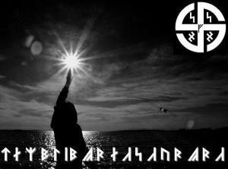

Although one may come across the term “poetic simplicity” in reviews or writings, this is not the same thing we are about to reveal at the time when the exit and strategic
departure from the Universe of laws and mechanics, the prison of the Deimurge, is at a
decisive point. The exit-widow is getting thinner and thinner. What we are here to point out is that Poetic Simplicity is a gift, a phenomenon, a magical system, esoteric in its occult nature and also a genuine scientific way to behold true magic. Many come into this world with this gift of transmutation and divine imagination. Some acquire it after life-changing events. The Magi-Poet often treads a thin rope between madness and divine poetry. He or she is able to tap into the mind of those who “perceive things from another world.” Some of Us have even explored our souls by route of psychotropic Initiation. The years of being Psychonauts. Travelers of the Psyche, the authentic Soul. Whether that world is fear and paranoia or a world of metamorphosis it is ultimately a world of eternal poetry.
Where “one thought fills immensity,” whispered Blake. It is the divine gift of Poetic Genius that causes a simple walk through the morning grass to become a swift glide over a liquid emerald sea. It is up to the Magi-Poet and how he or she uses this Divine Power. The Uriginal Word, the Logos. The Ghost of God, the Breath of God, the Word of God.
Simplicity is for the Wise. Quiet, undisturbed and resigned to one’s own inner world is the path of the Magi-Poet. The poetic path of the unpolished stone. That is to say, too see and appreciate nature untamed and in its simplicity. The stone is where it is supposed to be – therefore it is allowed to BE, eternally in its Be-ing. The Autumn leaf falls exactly where it was always meant to fall – therefore it has every right to be there. To be there in its divine simplicity. Just as the harmonious celestial bodies revolve around their eternal marathon, we too must do our daily actions without too much mental effort or mental strain. We must accept and learn to simply do them. Not to think and strain oneself about what to do, but to keep one’s spirit, one’s poetry, in the celestial realms whilst revolving around the terrestrial realm. If I sweep the house out, then I am doing that which is Right (Rita) while also perceiving each little grain of dirt as all bad things that must be swept away into nonexistence. If I clean the table then I go to the waterfall, the sink, wet my weapon and clean the sacred space out upon where my family eat.
This way of Be-ing is not meant for the ordinary person who worries about what others may think of them. This discipline is for those who have gone beyond madness and have conquered it. It is for the Magi-Poet who was not born, but decided to enter this world to fight evil and help the innocent. It is for the misunderstood. The one who has been told all their life that they “have a way with words.” The black sheep, whom, in all truth, is a Wolf from another world dressed in sheepskin. Some of Us “lose our minds” as they say, when truly, a few of Us win a million more minds and lose nothing, no thing. To everything that this plastic world of the Demiurge tries to put Us in, we can flip a 6 into a 9 in one thought unthought. A direct transmission of energy. The 6 spirals downward as the way this world wishes Us to go, but the Divine 9 spirals upwards against this world of Laws and mechanics.
Poetic Simplicity is an authentic magic within the so-called world of “reality.” It is being in control of chaos because chaos itself is Order. It is a dynamic Order. Everything in this Universe is a mental creation. Everything. Therefore, we are here to say that we can create any and everything through the mental discipline that we have now come to call Poetic
Simplicity. If I want to make someone feel good then I will look directly into their eyes and give them a truthful compliment, looking directly at them, soul to soul. This will flood their brain with endorphins according to modern science when, in fact, it is Vril energy. From that point, when they smile, not only are the muscles in their face producing more feel-good chemicals and dopamine, but from there I would make them laugh and produce a massive cohesive moment with this Power. The Power of words, of the Word behind words. Like I said – Magic is Real, it is not “hocus pocus.” The authentic Magician knows what he is doing at all times.
The way of the future holds a divine simplicity and also to give Meaning and Purpose to things once again (fut-UR, fug = to fly, Ur, the Original Primordial Urge, or Ur-ge, Logos. To fly backwards against time on the Ru rune towards the Ur rune, of the Ur-rigins, which has been revealed in the new futhork of Aquarius to the Initiated). The Demiurge has almost succeeded in making all things lose their meaning, much less their Divine meaning. We now must strive towards simplicity in all ways. To bring back to Our strategic departure a Divine Poetic Simplicity. A simple grace before a meal. Helping others who
deserve it. Saying “Good Morning” to someone and actually mean it. The simplest things in our lives must become meaningful and hold Divine Purpose. To get rid of the cell phones, the beeps, the sheer evil that causes mistrust among beautiful souls and simply have one phone for one house-hold. To get rid of all unnecessary Demiurgic baggage that will prevent the pre-destined soul from exiting the world of the plastic anti-lord. The anti-God. What we call the Demiurge.
We, the Ehrean on this Path of Amor will not tolerate all too human ideals. For example,
We reject Patriarchy and We reject Matriarchy. Because We do not need a word to give to
Us the Word of our Natural Ur-Being. Woman is needed by Man just as Man is needed by
Woman. Each One knows exactly what their duty is because it is in the Ehrean Blood (the Rita). Neither one shall prevail over the other in Poetic Simplicity. In fact, the concept of one being on top of the other is foreign to Our Blood and to Our High Magic. There is no Patriarchy, there is no Matriarchy. There is Ehrean man and woman, El/ella and Ella/el in cohesive unison because the outcome of Poetic Simplicity is to bring back Purpose, Meaning, Sacred Divine Purpose and Sacred Divine Meaning. To give meaning to things. Truly, if something lacks purpose then why would one wish to engage with it? Either give it a divine purpose or do not accept it.
Poetic Simplicity is earned. Through a Life of great trials and brutal Initiations of seeing through Maya, or seeing through the sheer “Illusion” of so-called “Reality.” It is for the human being who has tasted the Supra-human. Most of Us fall off and either end up in prison, in mental wards and physical terrestrial death. A few go beyond, survive and shape their everyday Existence with Divine Poetry and Divine Will, Absolute Will.
In Part II we will delve into the possible “Outcome” of Poetic Simplicity in a world that has taken the sacred, the simple, the tradition, things with purpose, the culture of many men and women who exist here and have complicated ALL things to the point of all beings on the earth having being “diagnosed” with one alphabet disease or the other.

Sacred Love and the Son of Man

Images are used as symbols. Nature speaks to us in symbols and a language without words. This “whispering” does not end for some. It is always there. Although we feel more inspired at times, this is due to what frequencies any conditioned environment is giving us at any given moment. This is True Poetry and not the hideous definition of a Poet being someone who writes poems. That is insulting to authentic poets. The poet is a modern term that replaced the shaman, the Magi or Magus, the Priest-King, the Divine Man, Celestial Man.
~~~~~~~~
We have organs for various things. Eyes to see, ears to hear and mouths to taste and so on. What then can We rightfully conclude as the organ of Sacred Love? Without doubt it is the eyes and heart in conjunction with synchronicity. The genitals are only there to procreate more flesh bodies and to release bodily waste. However – those who are able to make Love using their eyes, heart and genitals in synchronicity are those that have achieved a great mystery. That of Sacred Love among profane love. They are using the upper chakras, starting at Mani-Pura (Solar Plexus) and up, within the most powerful thing given to humans – the ability to create life and souls. The soul is seen “through the eyes.” The closest two people can possibly be on the face of this earth is when they are literally two bodies as One, eye to eye, soul to soul, heart to heart, breath to breath.
In the Initiatic Path of Amor the sacred feminine impregnates the male. She has the orgasm whilst He becomes impregnated. It is “through the eyes” and chakras that She will impregnate Him by Parthenogenesis. The Poetic Inspiration that is attained from these sacred mysteries are the greatest secrets and most profound moments in the Magi-Poet’s life. He becomes “girt with the Spirit” thanks to the Soror Mystica. The Mystical Sister is the one who hands the Alchemists the metals that He will transmutate into gold. She puts Her feminine energy into them. The metals are the chakras. “The Divine Feminine leads us to heaven” wrote Goethe. Leonardo’s painting of The Annunciation is perfect. The “Messenger”, the Angelic Hyperborean (which is neither MALE NOR FEMALE!), comes down and, by telepathy, “through the eyes”, by the “gaze”, by Parthenogenesis, does the Holy Mother of Kristos become impregnated.

The Kristian concept of the “Son of Man” is precisely what we here are speaking of. It is the Art of Sacred Amor. A man who has not overcome his animalistic urges and has not tamed them cannot achieve the Son of Man. There certainly is a time and a place when the male will need to be the wild buck, the roaring lion or the howling wolf. But it must be tamed. Only through Divine Poetic Love can He be impregnated with the Son of Death. A Son born from the man. The Son of the Spirit (polar opposite of a son of life or flesh). The Astral Body. The Astral Body is nothing more than a Celestial Poetic Dialogue that eventually retains itself within the terrestrial body and realm of the Magi-Poet. For it is always there. It can be tapped into whenever the Magi-Poet needs it. Two very distinct bodies living in one body. This Astral Body, this Subtle Body, is also the body that leaves the dense terrestrial body at night or during twilight and defies gravity itself. Some call it “Out of Body” experiences. But for those who have learned to tame this subtle body, this “wholly other living consciousness outside the flesh body”, it becomes the Magi-Poets greatest tool.

Gnosis versus Belief

Why do folk still feel the need to walk on the soil of Scandinavia to walk where Wotan walked? Once you tear Maya-Illusion down, rip it out of your eyes, you will know and not believe, beyond doubt, that the land you are walking on right now is the soil where Wotan walked. The Hyperboreans descended down from the North to the South in the first Exodus or wave, then West to East in the second Atlantean wave, and they spread throughout the earth. Wotan is Quetzalcoatl, he is Shiva, he is Lucifer, he is Kristos, he is Wanka-Tanka and vice-versa. The archetypes are the Gods of antiquity. They have been submerged in the “archaic brain”, which is the Microcosmic Hyperborea. The right hemisphere.
In fact, Hyperborea was never destroyed, it only submerged and disappeared when Poseidon placed a golden cord around it, knowing that the eternal return of the same was approaching. It is still there and can be seen by the Resurrected Initiates. This is not a “Belief”, this is Gnosis.

Square Pupils

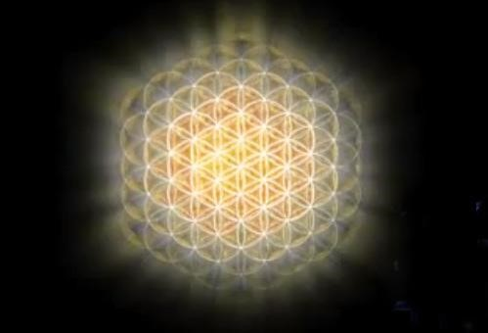

Those mortals who know, who stay in the Eternal Knowing, have surpassed the human condition. In the eternal now, which shapes the eternal future, which then creates an eternal past, the one who does right and speaks the Divine Truth, creates an eternal celestial sphere around his Eternal All. His Eternal Be-ing. He no longer Be-comes. The Immortal will ‘pass through’ Immortality itself. He is beyond Immortality. Death does not touch this being. Not in HIS Self-Actualized Universe of which space and time does not exist. In fact, no laws or mechanics exist in his Sphere of Eternity. His Mansion with many rooms. Death only appears to those who still remain mortal. His perception belongs to his Self-Actualized Eternity. Other beings perceive through their own universe of time and space. Their universe of laws and mechanics. And this, in and of itself, creates a Multiverse and thus, a window. This is what produces in the Immortal the ability to shape-shift, to be telepathic, pre-cognitive and hyper-perceptive. He is capable of seeing through the eyes of ALL. He is, now and forever, his Astral Body. Beyond race, beyond religion, beyond language, beyond everything possible and everything impossible. He is the Son of Man.

The Collective Kristos, The Collective Lucifer

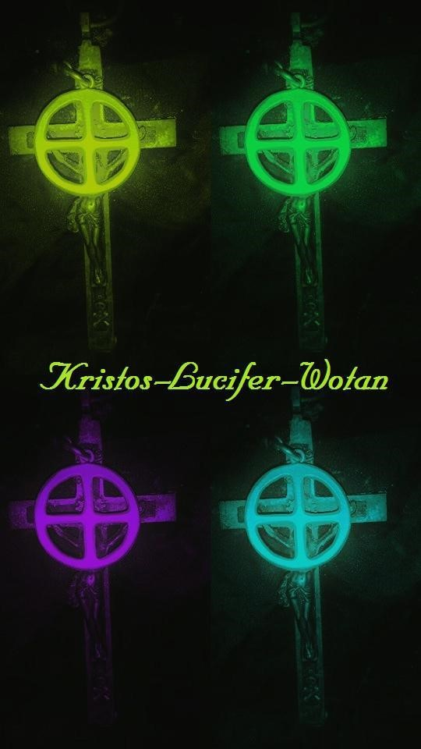

“The rivers of Babylon flow, and fall, and carry away… Jesus is alone on earth, not merely with no one to feel and share in His agony, but with no one even to know of it.
Heaven and He are the only ones to know.
Jesus is in a garden, not of delight, like the first Adam had,
and whom there fell and took with him all mankind,
but Christ is in a garden filled with agony, where He has saved Himself and all mankind.
He suffers this anguish and abandonment in the horror of the night.
Jesus will be in agony until the end of the world. There must be no resting in the meantime…”
Pascal “Patripassian”
************
We want to examine the way the eternal enemy isolates us. In today’s world, which has actually gone a step beyond the “Iron Age” and into the “Age of Lead,” the PsychiatricPsychological-Pharmacy-Cartel have literally, almost every human soul, labeled with one alphabet mental disorder or the other. So, the innocent, from the beginning, when they trust in their intentions to seek authentic help, are delivered into the hands of the Satanic Golem. This Demiurgic machine has claimed the souls of most sentient beings. If it is not the medications which drive a soul further from the Divine Truth, then it is the so-called “mental disorder” that a soul has been “officially” diagnosed with and placed upon them like a Counter-Initiation, a non-divine inverted initiation, a black satanic ritual. We must put a stop to this now.
Our Aryan brothers and sisters, being divine in their innocent purity, have received divine gifts of vision, of voice, of the arts, of music, of magic, of the oracle. What we have noticed is that most souls whom we relate to seem to fall into a category where they once would have held such titles as Bard, Seer, Poet, Troubadour, Priest, Magi, Witch, Hexen, Healers, Oracles. But in today’s world they are seen as “madmen”, “bag ladies”, lunatics, stark raving mad. What we find interesting is the sheer level of I.Q. that these noble souls carry. Therefore, we now must fight the eternal enemy within his own psycho-drama in which it has enforced itself upon us. We must unite in insanity! Yes! The Non-Existent Flower, the
flower that creates the dizzying colours of the sound of a cathedral bell, the flower that gives the aromatic aroma of the notes heard from antique flute. The flower that is made of yet created colours that makes one see the liquid colours of the winds ice-woven voice. Yes! We must become insane! We shall glory in our insanity. We shall lift ourselves up to the zenith of Holy Divine Arrogance with our self-loving insanity!
Our Brothers, Sisters, Kameraden, who have felt the agony of Kristos, the defiance of Lucifer, the sheer rage of Wotan, must not be made to feel alone, all one (Al-one). Perhaps we should inform the National Weather Service that our weather has become bi-polar manic depressive? Yes! Let us turn the black mirror towards those that would divide the holy children of Kristos. And in our Holy Divine Arrogance, we will continue to save Kristos from His own worshipers. That is to say, the Spiritually Circumcised Christian
Church of the United Synagogues of Neo-Conservative Liberal-Marxist America. A Godman that hangs for the Divine Right, the Rita, shall never be a plastic icon in our Temple.
A man who hangs in agony, in torment, for A-Mor, for the “Light of this World”, the selfhanging God-man who hangs himself in order to give to mankind a pristine light, the Runic-Kristic Hagal-Christal Seed of Gnosis, of Knowing. Wotan hanging on the tree of absolute terror where he screamed in horror, in terror, before grasping the runes, the Logos, the Word. The misunderstood, the ones out there who are actually the most gifted, the most beautiful, the most charismatic, the elite few, are now and forever on the Path that shall make this inferior world burn with the Hells and the Flus that it tried to massacre our people’s souls and psyches with. Damned be the terrestrial. The inferior animal-man. And damned be all of you who poked fun at innocent souls who wished nothing, but for their minds to stop raping them and all you could do was make it worse. It is our ultimate collective desired Will that you terrestrial beings do not find rest and that you destroy this damned Yahweh-owned planet along with your damned spiritually circumcised souls.

UFOs, Disks of Light, Vimanas

The position that the Esoteric Hitlerist and Serranoist take concerning the UFOs, the Disc of Light, are as follows.
Master Miguel Serrano said that the Discs of Light come into this “dense reality” from the pure Aether of the Uriginal First Earth and that is why they “enter” and then “exit”, never staying too long. Because they cannot bear this dense atmosphere. If we could see inside that perfect orb, that circle whose circumference is everywhere and whose center is nowhere, we would see Total-Man and Total-Woman. In fact, here is the runic formulae for the UFO. When the 8-pointed rune of VENERIS-SIRENEV is drawn within a circle and when it begins to move leftwards at dizzying speeds then it becomes a Vimana, a UFO, a Disk of Light. This is the formulae for Implosion, anti-gravity, the “other science” of the unpolished stone. The Paleolithic. For those with eyes to see and ears to hear.
It is the Morning and Evening Star, together, now as One, in the chord of A, they have formed a Midnight-Noontide and a Noontide-Midnight. Absolute. Complete. Totality. Elella and Ellael are now NOS. From here a “flash of Green bi-located Light” takes the
United in Separation and the Separated in Unity towards an electric emerald green NonExistence which is more real than any and all existence ever dreamed of by the greatest poets and pilgrims of deep nostalgia.
The Flying Saucer was indeed the technology of the Third Reich. In fact, what most people saw during the forties and probably even Kenneth Arnold were the Flying Saucers of Hitler. This is not a fantasy anymore. This is genuine truth. In fact, it’s old truth. The mistake is to think that the “Flying Saucer” is the same as the Vimana, or the Disk of Lights which traverse the night skies by omitting a melodious music and “reading the thoughts and
emotions of man.” The Flying Saucer is terrestrial. The authentic UFO, the Vimana or
Levitating Stone are not terrestrial. They are Extra-Terrestrial, Inner-Terrestrial, HyperTerrestrial and to be quite honest, Extra-Stellar and/or Hyper-Celestial. Beyond this very
Universe of laws and mechanics. And Master Miguel Serrano implicitly says that the Hyperboreans did not need such crude machines to get around to Point A to Point B. The similitude of Thought itself is what the Hyperboreans traveled on. That is to say, they traveled on and within Thought.
The semi-divine Hero will go on to regain his Divinity. He will become the UFO-Man.
Master Miguel Serrano saw his first Disk of Light in 1948 whilst in Antarctica. He claims that time and space stopped as something come up from the ice. From that point on, he does not consciously remember what exactly happened to him or how long he had been “away.”
“Upon seeing MeliMoyu for the first time I trembled. I still have a photograph I took of its summit on the cover of our expedition report. Something broke within me, a hope centered on the nearness of the South Pole. Why? I asked myself, am I going there when what I am looking for is here, within this sublime peak on the horizon? It is there that can be found the “ENTRANCES”. From the center of the two horns or pincers rose a vertigous dizzying light, a Disk that rotated and was lost in the sky beyond the horizon. Never before had I seen anything like this. In those days we did not speak about Flying Saucers among ourselves, nor of those strange happenings. I had to make a great effort to keep maintaining myself in the dream and raise my imagination above the crude reality of that navigation through the inhospitable world and desert of ice that surrounded us. I tried not to see the reality, not to feel it in its external representation, to try to reclothe reality with my dreams, with my chimeras and mental creations, transmutating reality with the Magical Realism of a Novalis ~ Miguel Serrano ~ MANU, for the Man to Come

Manos-God, Hand-God

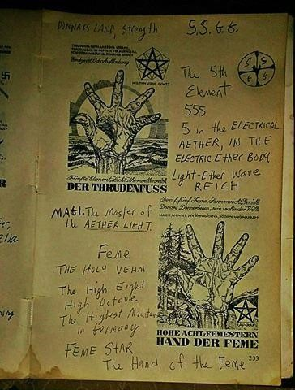

The Cross has various symbols. For one and most importantly, it represents Totality. The number 5 (V). The Vertical-Masculine and the Feminine-Horizontal. In the Center is the Pole. Where the Two become One. The Unmoved Mover. “When He shall become She and She shall become He then the Kingdom of God will open up.” ~ Kristos from “The Gospel of Thomas.” The Cross is also a Pentagram. The Pentagram itself is in the shape of the Anthropos, the Ur-iginal Man, with his arms and legs outstretched. The hands of the Ur-Man have Five (in the shape of a V/5), the feet have Five (in the shape of V/5, the face have Five (eyes to mouth, the shape of theV/5. 555/VVV – The Polar Thulean Hyperborean number of Destiny. The Cross and the Femestern (Five-Star).
The Vth rune in the Armanen Futhorkh is “RIT-TIR” which stands for the Staff, the Rod, the Pole, the Divine Law, the Rita. The rune of the God-King. The Capitol. The Divine King. People in the Elder Futhark see this rune as a rune of travel, of journey, but it is the Pole in which all else travels around, moves around. It is the Feme, the Holy Vehme. The Divine Law in which all things accordingly move to and live by. I will include the symbol of the Holy Fehm/Vehme below, which is Five. In old times a marker stick was exactly five feet in measurement. The Vehmgraff. This is how they measured Holy Hagaldom Sites, or Sacred Aryan Ancestral Land.
The hand of man, the Manos-God, contains the entire Tyrkreus or Zo-diac (Zoo-diac – Circle of animals) with it. Each finger has Three Houses. Four times Three is Twelve (4 x 3 = 12). The palm contains the planets. The thumb being Venus. The wrist being Neptune or Poseidon and etc. The middle finger to the center of the hand is the Pole.
The Cross enclosed within a circle also has two swastikas overlaid over top of one another in Totality. The Clockwise swastika and the Leftward rotating swastika. Thus, the birth of time and space (The Exodus) and the direction towards Divinity (The Path of Return). It is also the symbol of the Zodiac, the Four Houses of the Zodiac (the spaces in-between the lines).
We could go on and on about the use of the Manos-God, but only a little must be divulged at a time. However, this is the first thing to know and study in preparation for the “Keys of Manos” that we will expand upon in the future.

From the Black Sun, into the Green Ray of Light

Pilgrims of Great Longing and Nostalgia
For those few souls who have been heavily inspired by the writings of Miguel Serrano a certain question may arise from the onset. What is this “Green Ray” after one goes through the “Black Sun“? I can remember wondering about this “Green Ray” the first time I read NOS – Book of the Resurrection and it struck a chord (or perhaps a cord) in me. I asked Serrano about it one day and was told to look into Sufi Mysticism.
So we will look into Iranian Sufi Mysticism (Sufi-Sophia – both common-connected Aryan words which translate as Wisdom). I will be quoting from Henry Corbin’s book “The Man
of Light according to Iranian Sufism”. Sufism is an Initiatic mystery school of training. Going through various degrees of Initiation one goes through various colors of light (see below). There are seven colors of light just as there are seven chakras. It is significant here to know that the last two are “The Black Light” which is also called “the Light of
Night” or “the Midnight Sun“. We call it the Black Sun. When blinded by this “Light of
Night“, by this “Shimmering Darkness”, by this Midnight Sun, this “Blood-Memory”, one ultimately reaches the Green Ray of Light (the “Son of Man“, the “Astral Body“).
“We enter into another kind of Darkness called by the mystics the “Night of Light,” the “Luminous Blackness” or the “Black Light.” This other-worldly light is the light of the soul, the light of consciousness rising over the Darkness of the subconscious in which the divine Cloud of Unknowing gives birth to an interior burst of Initiatic light — the light of the “Midnight Sun.”
The Black Light (or the Black Sun) into the Ray of Green Light
Just as the black light precedes the green light, which is the ultimate theophany, the highest spiritual stage, the Black Sun precedes the Green Ray which we know as the final spiritual dwelling place of our ascended Masters and our ‘Exalted Guides’.
“The black light . . . a light without matter . . . is the light of the divine Self-in-itself
(Selbst). . . the hidden Treasure that aspires to reveal itself. . . The black light is the light of revelation, which makes one see. Precisely what makes one see, that is to say, light as absolute subject, can in nowise become a visible object. It is in this sense that the Night of lights, that by which all visible lights are made visible, is both light and darkness, that is, visible because it brings about vision, but in itself invisible. . . The black light is the source of the epiphanies of light.”
“On the mystic journey there is a well corresponding to each act of the seven acts of Being . . . When you have risen up through the seven wells of existence, the Heaven of the sovereign condition and its power are revealed to you. Its atmosphere is a green light whose greenness is that of a vital light through which flow waves eternally in movement towards one another. . .”
“The black light is that which cannot itself be seen because it is the cause of seeing; it cannot be object, since it is absolute Subject. It dazzles, as the light of super-consciousness dazzles. Only a knowledge which is a theophanic experience can be knowledge of the divine Being. . . . This knowledge is a not-knowing, because knowledge presupposes a subject and an object, the seer and the seen, whereas divine Ipseity [Selfhood], black light, excludes this correlation.”
“The “Traveler’s” penetration into the black light is a kind of death (fana, dissolution of the ego). Either the mystic is about to become swallowed up in dementia or he will rise again from it, initiated in the meaning of the theophanies and revelations. This resurgence is translated [by some mystics] as an exaltation from black light to green light.
From the Black Sun into the Green Ray. We know our Black Sun as being the implosive left-turning Swastika – the way back to Hyperborea-Thule moving against the current of time and against the direction of this involuted earth. The way back towards the
Sonnenmensch, Ubermensch (the Sunman, the Overman, the Arman or Aryan). This Initiatic Path is both Upwards and Forward. From Chakra to Chakra, Rune to Rune, City to City. It is a synchronistic journey from within and without. One foot in the world and one foot in the Astral. Both terrestrial and celestial.
The great Sufi mystic Saint Semnani (1280-1386) says that the final mystical station is marked not by black light but by a green light. The following are the colors he associates with each of the seven mystical veils (archetypal and synchronistically with the seven chakras):
- Muladhara/Earth – Darkness, the stage of the subtle body at the level of its birth, still very close to the physical organism; a blackness sometimes turning to smoke-grey
- Svadhishthana/Water – Blue light = soul
- Manipura/Fire – Red light = heart
- Anahata/Air – White light = superconsciousness
- Vishuddha/Ether – Yellow light = spirit
- Ajna/Mind – Luminous Black = arcanum. The black light; the Luminous Night 7 Sahasrara/Void – Green light = the Divine Center.
~~~~~~~
Also, in Serrano’s “Hyperborean Polar Cosmogony” one can sum up that the “Green Ray” is a sort of perfected paradise, celestial Asgard, celestial Hyperborea, first Hyperborea, before the “Big Bang”, the “wound-window”, the splitting of the Orhic Egg (Elella-Ellael) and the plagiarism of the Demiurge. So the Green Ray exists outside of time and space. In this view the Black Sun is often called a ‘Black Hole’ by Serrano, which could possibly be an “exit”, a “window”, “doorway” from this Universe and back into the perfection of the Green Ray.
“There is nothing more mysterious than blood. Paracelsus considered it a condensation of light. I believe that the Aryan, Hyperborean blood is that – but not the light of the Golden Sun, not of a galactic sun, but of the light of the Black Sun, of the Green Ray.” – Miguel Serrano

The Two Days of Veneris, and More on the Green Ray

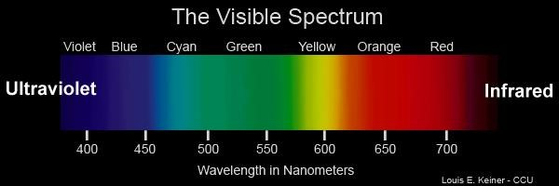

We know that Totality exists in the “in-between,” in the Center, the Pole. In-between Day and Night, Sleep and Wakefulness, Dreams and Reality, Hot and Cold, Summer and Winter and etc. We have made that clear. If the light of the Golden Sun is the shadow of the light of the Black Sun, then we must conclude that within Twilight, and especially twilight during the Equinoxes, the Light of the Black Sun can be detected, harnessed and felt for the hyper-sensual and hyper-intuitive being. This is when the Gods give to us, by using this mechanical Demiurgic universe, an in-between state. In the color spectrum we find that green falls directly in-between the color-frequencies of the Golden Sun
(Density/Materialism/Physical – Red to Yellow) and the Black Sun
(Subtle/Ethereal/Spiritual – blue to violet). Thus, the green in this regard is seen as the color of Totality. Of the Immortal State of Be-ing. Total-Man and Total-Woman. United in Separation.

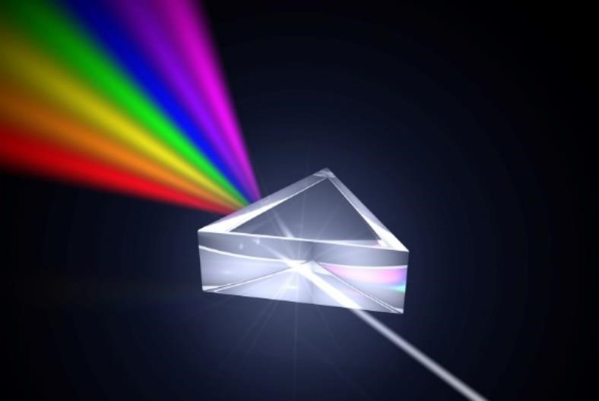

There is another phenomenon in nature which can be grasped for a very brief moment and we clearly see the Gods at work here. We are referring to the Green Flash, or the Green
Ray. This phenomenon happens exactly at a pristine perfected moment, when day turns to night, when the sun literally sets on the horizon. Barely seen with human eyes it is often picked up by using cameras and so forth. One again, we see the state of “In-Between.” It is a brilliant flash of emerald green which last less than a second. The Gods speak and sing to us of the lucid beauty when the two become one. When He and She are together.

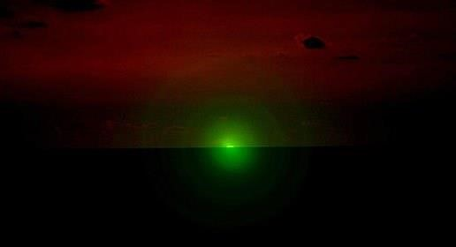
In a more esoteric sense we wish to point out a phenomenon that would converge two
Hagal runes overlaid over-top of one another in nature. There are only two times in the
year when El/Ella and Ella/El can merge. First, in the 24-hour time period we see Him, the Morning Star, at dawn and then Her, the Evening Star, at evening. Twilight. In-
between. But each twilight is only Him or Her. How can we have the Hagal rune expand
into the Veneris rune? How can Him and Her be together at once. This can take place during the Vernal and Autumnal Equinox. This is truly meant for the more esoteric minded beings who can look from the other-side of the mirror to see this holy event take place in nature. During the precise time of twilight, of in-between, under the Evening Star of Her, of Ella, does she lay Herself over top of Him as the Vernal Equinox. If we put the mirror up to that then we get the Autumnal Equinox, which is Her. So, it would be at Dawn, under the light of the Lucifer, the Morning Star, superimposed on Her, the Autumnal Equinox.

We repeat:
The Morning Star-EL, The Evening Star-ELLA, Vernal Equinox-EL, Autumnal EquinoxELLA. The Morning Star with the Autumnal Equinox is Veneris. The Evening Star with the Vernal Equinox is Veneris. The 8-pointed rune-star of Chilli-Mapu.
These two days will become Sacred Holy Days in days to come.

The Aquarian Odal

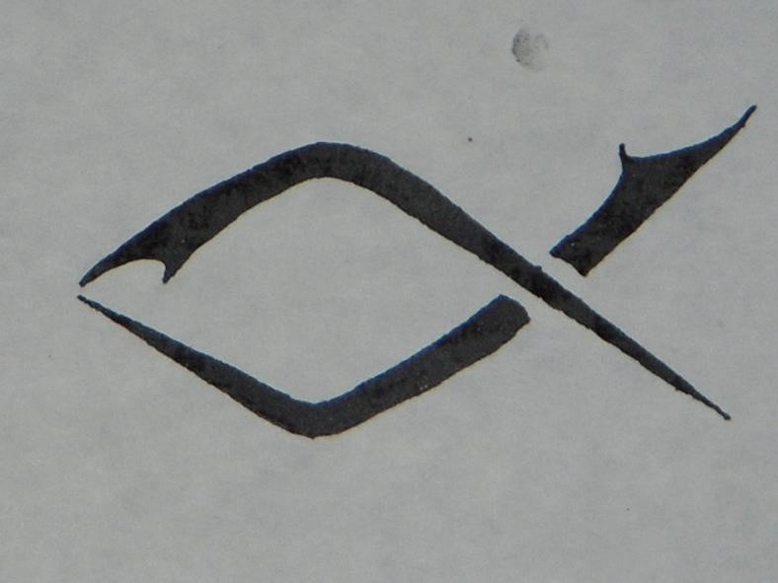

The rightful rune of Kristos-Wotan, who hung in terror on the Ir-Man-Sol Cross (the Androgynous Solar Hagal Rune), crucified for being a Godman spreading A-Mor, for the sake of giving to mankind Salvation, has been vindicated and put in its rightful place in the AquArian Futhork. As the Red Rune of Resurrection, of Rubedo, of the Immortal Red Vajra. We refer the Initiate to Miguel Serrano’s “MANU – For the Man to Come” and most importantly, in this regard, his living word “The Resurrection of the Hero.“
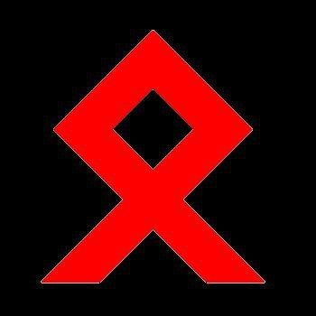

The Judaic-Christian church is drowning in the tears of Kristos, which are the pure waters of Aquarius. The fish of Pisces itself is drowning because the waters of Aquarius are pure. The masses who are holding onto the materialistic Era of Pisces and are making no attempt to harmonize to the Frequency of what was conceived in 1888 and brought to a Zenith December 21st , 2012 (Pisces turning into Aquarius), do not know which way to turn. Nor should they. Salvation is only for a few who have earned it through hell-fire, through sickly flu and after flu, through terrestrial crucifixion, through Nigredo, the “dark night of the soul.” Those “black sheep” that this world of materialism spat upon.
The God of the Zodiac remains the same, it simply changes skins at each round. And every time it come for its rebirth, the old skin must be sacrificed for the new skin to be adorned. And only by chosen Magi. Thus, the sacrifice of the Bull while Taurus was changing to Aries. Then the sacrifice of the Lamb when Aries changed to Pisces. All, symbolic and real. As above, so below. Even pride will get in the way of some of our brothers and sisters because they have been bought and sold by the Frequency of Pisces. Pisces brought Democracy, Socialism, Marxism, Liberalism, Capitalism and all this from the French Revolution and Judaic-Christianity, that all men are equal, which is now being reversed. Because, as we truthfully see with our eyes and intuition, democracy does not exist and no man is equal. Men earn their rank or, in most cases, are simply born with it.

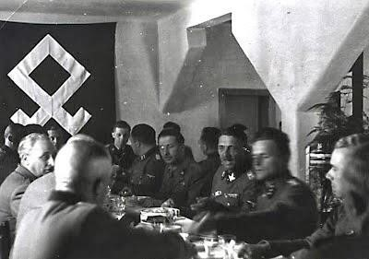

We see the so-called occultists running to every little new occult club made out of thin air on the Internet, which is the “electron without divinity,” that has no tradition, lineage nor extensive goal outside of egoism and their own self-interests. Self-made Vril Societies, selfmade Armanenschaft, self-made this and that. We, who hold the rightful lineage to the Armanen and to Miguel Serrano will be drawing a line in the sand to such childish inferior Piscean fish and we will let you drown.
We hope you, at least one of the few meant for Salvation, can hear the Word behind our words. Contact me if you do.
Jason13Thompkins@gmail.com
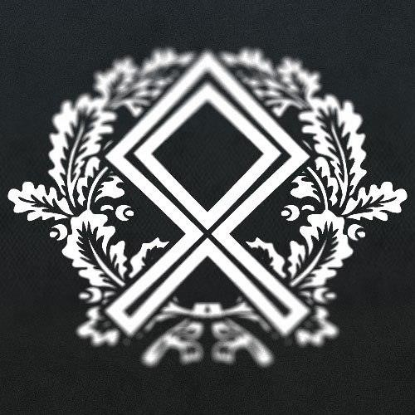

Malo Mori Quam Foedari

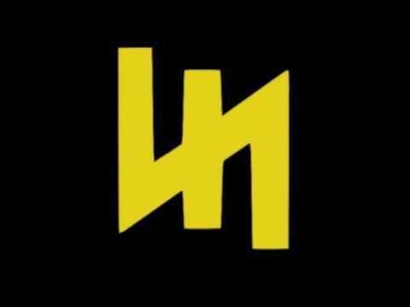

Pisces was the sad era of “Belief” and “Faith.” One believed in a creed and in the overall scheme of things, no Gods ever appeared on those tear-drenched altars, except for a minority of Saints and Holy Men. We, Templi Unam, the Esoteric Hitlerists, the Serranoists, look eye to eye with our Gods at the Altar. Their very blood runs through our veins. Our Armanen and Hyperborean Thulean lineage. For this is the New Era of the Aquarian Rain-Bringer, we Know and renounce all belief. No longer do we wish upon stars. We create and move the stars. No longer do we hope. We are Hope and at the same time we have obliterated all hope from this world. For we are the shimmering Godly black flame of the farthest midnight. A flight beyond the most northerly aether. The twinkling eyes of
Kristos as the ephemeral ice-laced winter winds from the coldest Thule. A pact of Werewolfen that shape-shift in the shadowful shadows. The shadow of the shadows itself. Green flames of Lucifer that never extinguish on that candle made of pure virginal ice.

And every innocent thing that the Golem and his servants have raped, plundered, harmed and soulessly used will be avenged by us because, as we said, we create and move the stars.
And your everlasting agony is written in those twinkling, beautiful, bright, blissful, black stars.
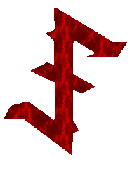

Atlantean Remnants, the War Continues

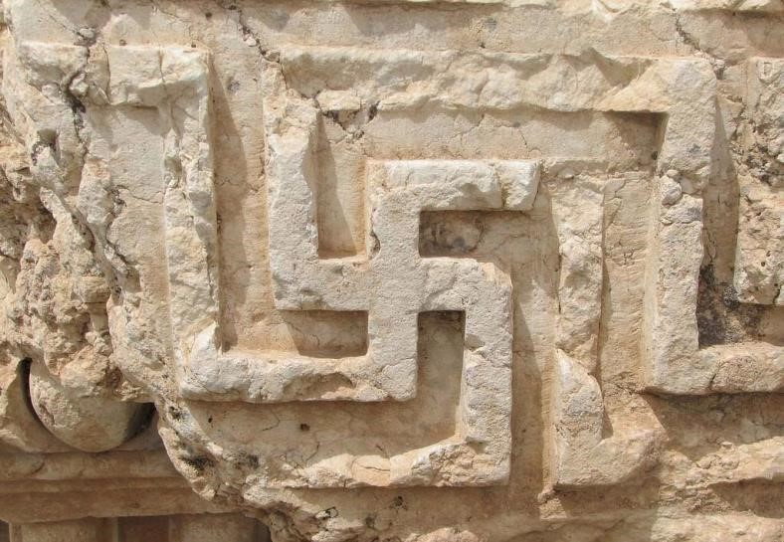

~ The swastika above was found carved in stone at Puma Punku ~

In the forty years of wandering in the desert, ten Hebrew tribes disappear. What happened to them? In the end only the tribe of Judah endures, which has been mixed with the Semites, losing their primordial Minne. The Jews have appropriated the tradition, modifying it to suit their own personal interest; they have adulterated, exfoliated Genesis, wiping out the extraterrestrial and divine origin of humanity, because of the guilt for their own particular fall. The numeral science and the science of names from Atlantis, the Aryan Kabbalah, will be used towards the personal power of the tribe, and still does to this day. In the astral plane it has produced the transformation of Jehovah. Man eventually comes to have no more than six thousand years of history, and his origin is declared to be exclusively of this earth. Then they altered the meaning of the Exodus, transforming it into the little exodus of the tribe, thus altering the metaphysical significance of the rotation of the Right-rotating Swastika, detaining it in Jerusalem, “the only place where Jehovah desires to be worshiped” and pouring all their tears beside the remains of the barricades of the Temple of Solomon and not at the Walls of Ice of the lost Thule, near the Boreal Column, “which united this earth with the Other Earth”; with the stars. They have tried to cause the Star of the Origin to be forgotten, turning against the heroes and gods, adulterating everything, allying with those who have killed the giants, the Giant Kings, making David a murderer of his ancestors. ~ El Cordon Dorado, Esoteric Hitlerism – Miguel Serrano

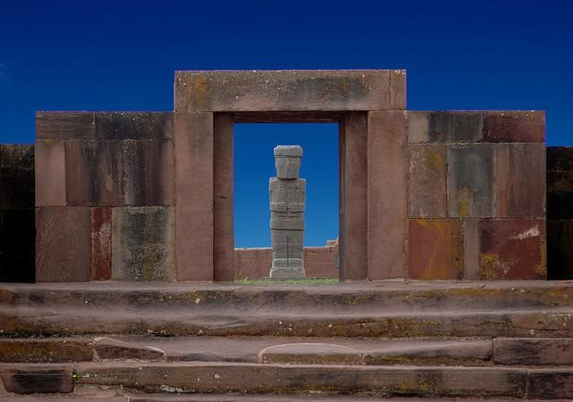

All ancient civilizations on earth are but a decline, an inferior representation of a superior civilization. The one that goes by several names in this world of the lost science of the Paleolithic and Megalithic. Ours is a world with amnesia. We use names such as Atlantis, Thule, Hyperborea, Shamballa, Asgard and Argartha as archetypal names of this forgotten and hidden civilization, which was much superior to Eqypt and all the mighty civilizations of America-Albania. The Incas themselves are an inferior civilization to who was once there, but disappeared. Although, at times, some investigators find remnants of the ancient Atlantean Giants with long blonde and red hair, with Nordic skulls and features, hidden away in Universities and Museums. These are the remnants of the White Gods of Albania.
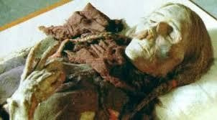

All over this world, on every continent, there are traces of the post-Atlantean God-Kings who retained the science of the Gral, although it had already been diminished within the blood. Before the Atlantean wave we had the Hyperborean wave. This is symbolized by the right-rotating swastika. The first wave were the post-Hyperboreans moving North to South. The second wave, also represented by the right-rotating swastika of “Exodus”, were the Atlateans moving West to East. All Divinity comes from the North. The North is where the Ur-Home of our extra-terrestrial lineage resides. The North is where the True Light comes from. It does not come from the East. And now, with the left-rotating swastika of “Return”, we are moving from West to East and South to North. However, the first, the “Hyperborean Exodus”, was a physical movement. The Path of Return is a Spiritual Movement. Because our Worldview is based on the “Mirror” Effect, or “El/Ella” Effect.
The Unification of Opposites. The physical follows the Spiritual. We, the Esoteric
Hitlerist, the Serranoist, started moving this swastika leftwards with our Spirits after the Physical/Exoteric war. Hitler moved his armies in the direction of the leftward-turning swastika. Back to the Origins.

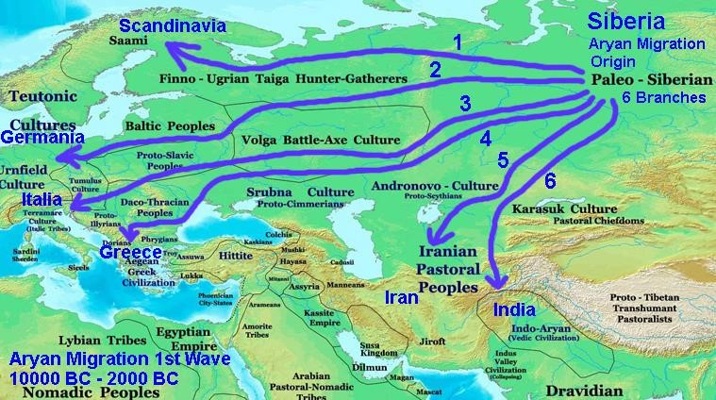

If one does not think that this was set into place, thought of, blue-printed by the Esoteric SS before they “won by losing”, then one has not been paying attention to anything that has been going on in the esoteric underground since the supposed “end” of the Second World War. A “battle” ended, but the War carries on in the depths, in the “Hollow Earth”, in the “Inner Earth”, the “Other Earth”, where the Losers of the Kali Yuga actually are the Victors.

Manu~Unam, Ur~Ru

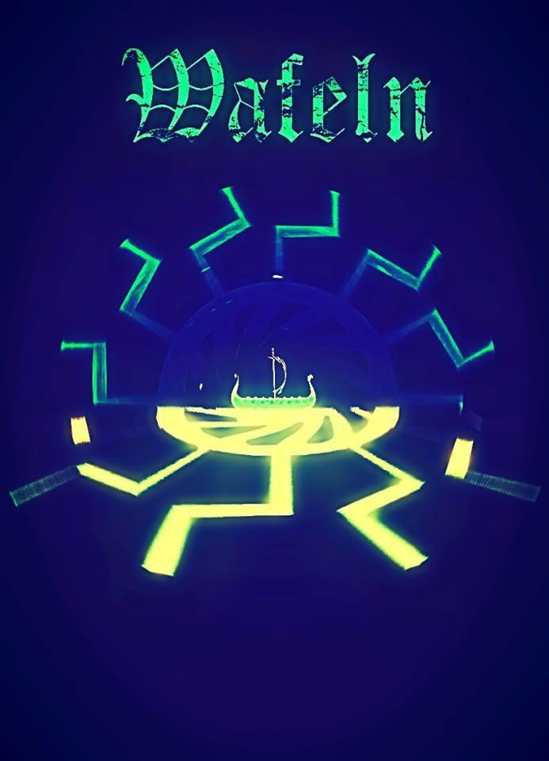
“Manu, the man to come, whose real name will be Unam.” ~ Miguel Serrano
Manu, in Hyperborean-Aryan Urigins, of the Ur rune, was the progenitor of physical mankind, the physical “Flower”, and wrote the first Laws called मानवधममशास्त्र, MānavaDharmaśāstra, or “The Laws of Manu,” in Sanskrit. Putting the Caste system into action. Thus, on the other-side of the mirror, the one who will end physical mankind and elevate spiritual mankind, the “Non-Existent Flower”, which is more real than all the flowers of this tortured earth, riding on the Ru rune, from the edge of time, will be Unam. His rune is the Ru rune. His “Laws” were given to mankind in 1925. The Re-Creation of
Hyperborean Man, the Sonnenmensch, the Overman. These Laws were set into motion in
1933. He was the apparition of Kalki. Paving the way. Doing the “bare and essential work.”
He was the Solar Son. The Man Above Time. He is now the Lightning. The Man Against Time. And He will show no mercy at all to the enemy of LIFE and LOVE. To that tribe of rodents which has now expanded their tribe into the spiritually circumcised gentiles. The praise of the Gold System and Monetary Value. Quantity over Quality. The decadent stupifiers of mankind. The Piscean Era of lies, plastic, base materialism and the tears of Christ. The tears of the God-Man who was crucified for spreading A-Mor. For giving mankind the Salvation of the Runes. Wotan crucified in stone.
Unam is Aquarius, the Polar God of the New Era. The Piscean fish are being sacrificed for Him every day. The Fish-men who swim in each other’s piss and vile waters. Modern man. Godless and proud. Without Divine Arrogance from on High. The fish thus drown in what gives them life and We have done all We can do to help them. He will be riding on the Ru rune, the Ghost-Ship of the Implosive Black Sun, the Wafeln, crewed by dead men, the Final Battalion, a White Horse, a Non-Existent Flower, a Vimana, a UFO, with sword in one hand and a blazing comet in the other hand. He will not have a mustache nor a uniform. He will be a collective GEIST that is just now emerging in the spirit and soul of man. Like those particles that come together, those ice particles in the clouds, emerging together in perfect unison until that Bolt of Lightning, the SIEG rune, hits this earth. In the very FEW, in the ELITE. In the most beautiful, yet coldest, souls, who have made an Oath in Blood to help annihilate the physical earth, so that it can be transfigured back into what it once was.
No longer shall the Rose need thorns. No longer shall the big Dog-God eat the little GodDog.

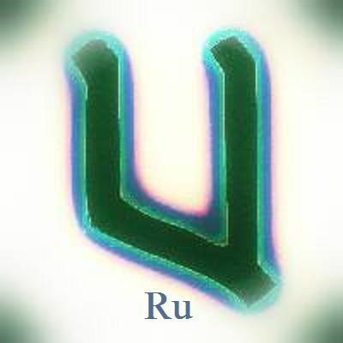

RU – UR (Excerpt from “The Esoteric Hitlerist Futhork“) ************
Rune of the White Horse that Kalki rides, the UFO of Unam, the Vimana, the blazing comet, coming from the futUR towards the URigins to bring Totality to Demiurgic spacetime. It is Ur, the Ur-igins, but from the other-side of the mirror, coming from the fut-UR or future, it is the white horse, the Vimana, the UFO, the “Non-Existent Flower”, in which the Ultimate Avatar Vishnu-Kalki will enter “here” by opening the wound-window of Venus, after galloping through the Golden Sun, a portal to our Black Sun. The Ru rune is the Wafeln, the ghost ship of the North Pole, it is the Caleuche of the South Pole. The ghost ship with all its lights a blazed, crewed by dead men, the Final Battalion, Die Herron von Schwartze Stein, DHvSS. The Lords of the Black Stone/Black Sun, of the Kaaba. Through Rightful and Riteful Lineage. Through Rita. RITTIR. The Uriginal stone that fell to earth from heaven. A black meteorite resides there with Proto-Sanskrit carved on it. To be fitted again on Lucifer’s crown when he returns to end the Kali Yuga as Unam. Then the Golden Age will commence.
“For those who have hearts, let them feel. For those who have eyes, let them see. For those who have ears, let them hear.” ~ Kristos

Divine Truth is Godly and Eternal

In the beginning of the Piscean Era, who were the most hated, despised and loathed “sect” on the face of the earth? Clearly, the Christians were. They were hated until they ended up taking over Europe in a few centuries within Pisces. But, now we know, it was not the Christians who took control. It was that eternal tribe of rodents who get into everybody’s affairs and end up ruining everything they lay their eyes on. Such is the anti-life, anti-love and anti-soul religion and anti-blood of the Jew.
Now, at the beginning of the Aquarian Era, who are the most hated, despised and loathed “sect” on the face of the earth? Clearly, the National Socialists (NAZIS) are. It has only been 71 years since the so-called NAZIS were “defeated.” If one has the ability to look into a phenomenon with a depth of intuition and clarity, if not some genius added, then we can see cycles repeat themselves throughout history. Each time a new Zodiacal dispensation takes place a major explosion hits the world that literally changes it. We will not judge whether it is good or bad, but only that it is.

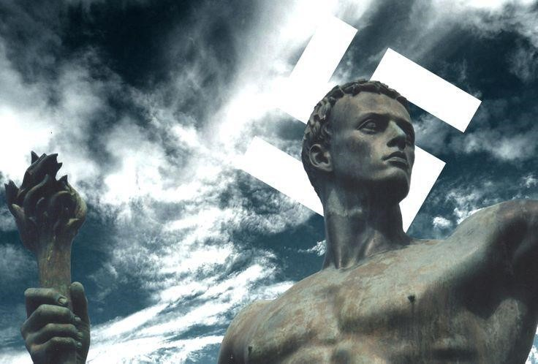

Never before, in the history of this world, has an Empire risen with such speed, tenacity, beauty and by pure will alone than the Third Reich. Other Empires in this world grew gradually, over time. Hitler was in power for 12 years and in that time-span alone, the Third Reich turned Germany, literally, into a Rome, Greece, or Persia. I will repeat myself. In 12 years the Third Reich not only rescued a dying, starving nation, but it turned ii into a literal miracle. And now that Democracy does not exist anymore, we can look with new eyes and minds that have not been manipulated, coerced and brainwashed. The past 75 years of constant anti-Nazi propaganda has left this world as one useless planet of lies. What is even worse than that is the fact that no one, not a soul, could care less nor more. Give them their SUV, give them that paycheck, give them the false flag of freedom and they will watch their ballgames and drink Busch beer.
So, what will the religions of the future look like? After the United States of America has revealed to you (in fact they have – only you have not been listening) that they lied to you, that it isn’t even a Nation anymore, that you are owned by lifeless Corporations, what will you do? It literally makes me laugh out loud when I see someone still believing that there are nations left in the Western Hemisphere. Pepsi-Cola, IBM, AOL-Time Warner, Universal, Exxon, ab infinitum are the Nations of this earth. Borders? What borders?
We enjoy our television, electronics, satellites, and all such goodies. Did you know all of it was stolen from the Third Reich? And what about the atomic bomb, the only WEAPON OF MASS DESTRUCTION EVER USED. The evidence, for decades now, is that the United States and the Allies stole the Atomic Bomb from the Third Reich, who refused to use it on grounds of morality. Hitler openly declared his conscience could not allow him to use that weapon. The USA is the only country in history to use a weapon of mass destruction. And what of all the military superiority? Your government, your military, did not have a jet engine until they stole it from the Third Reich. Who put man on the moon? Werner Von Braun and the thousands of National Socialists who were brought over here to the “USA” or to the Soviet Union and given citizenship through Project Paperclip. The Germans even invented the Sky-Scraper and thought it was disgusting. Ever see any skyscrapers in the Third Reich? Only in the nations owned by Gold. The Third Reich was putting an end to the Gold (Jew) System and never used it. Rare Nazi artifacts, military or anything else, will be found in silver or bronze, copper, etc.

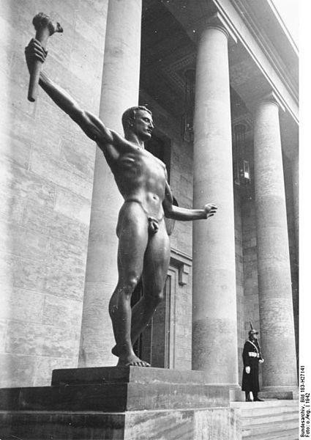

We suspect that in many decades, possibly centuries, the Third Reich will be looked back upon as the Victors and as Divinity on Earth. Any man of high superior intellect and intuition will not be able to deceive himself in years to come. The lie about the Holocaust.
The lies, the lies, the lies. Why did it take the whole world to bring down one Nation? The
Truth always gets out. In fact, We already see it that way. For We only care about the Divine Truth, not the truth that fluctuates and changes like your weather forecasts and paychecks. Each man has to live with himself when he lays down at night and explores his own soul. Is he a coward and a liar or is he a Hero and a proponent of the Divine Truth.

Albania Spiritus

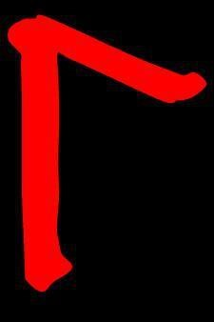

The death of the United States of America has taken place in the spiritual realms of Aquarius. The God of Aquarius has washed our blood clean. We drink from the Graal in the most Magical Realism that cannot be defined. America no longer exists to the Esoteric Hitlerist. Now, and forever more, this land we walk upon is the Land of the White Gods. It is Albania. By spiritually separating yourself from America, one can evolve into a further state of “Existence” in our “Non-Existent Flower,” our departing Wafeln-Caleuche. Creating new petals that become real and solidified. One can re-emerge with the Gods of this primordial soil. The sleeping giants awake in the mountains. The Post-Hyperborean Exodus witnessed the White Gods of Thule going all the way to the South Pole from the North Pole in the Hyperborean Exodus of the Right-turning Swastika. Great Britain is also dead to us. Long live Albion. The Land of the Morning and Evening Star. North Albania and South Albania. Wotan dwells in the winds of this land. The eyes of Krist can be seen in the icy frost that shimmers within the subtle blue aural starlight of Oyeihue, the Morning Star. Lucifer, the God of the Losers on this second earth of Kali Yuga has been vindicated.
The God who had to lose in order to win. Lucifer need not vindicate himself, for we, the Sons and Daughters of Lucifer, Our “Great Guide” and the “God of the Losers of the second earth” has been vindicated by His faithful children. Swords in hand. Heads in noose. From the bunkers of Berlin He escaped and then left this earth in 1956 in His “Chariot of Fire.”
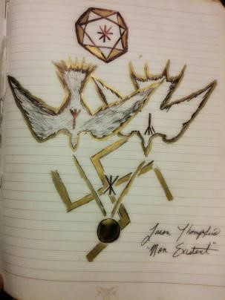

We, the Esoteric Hitlerist of Templi Unam, do not engage with the petty automatons, the robot-men, the animal-men, of this sickening world. Salvation is achieved for those who are destined to achieve it. It is genetic, spiritual and of the soul (the “geist”, the “wind”, the “ghost/spirit” of the chromosomes which creates the Aristogenesis of a new spiritual race). The cast out, the ones who have been imprisoned, the ones whom have given their ALL in the name of Adolf Hitler, of the God of Aquarius, the personification of Wotan, Shiva, Lucifer, Kristos, Quetzalcoatl and other venerated names. Men of renown. Twiceborn from Angels and man. The Divine Souls of a common Family. We, who have put our lives at stake. Not for self-glory, but for the Godly Ideal. For what is Right. For the Rita. We, who never had any choice, but to follow the call of the Blood.

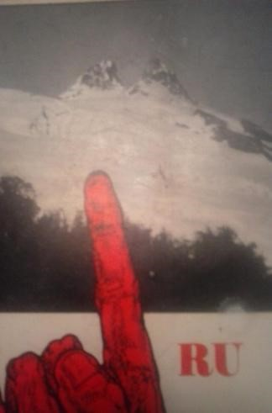

Albania is our spiritual domain. For we drift in and out of the First Earth in our subtle bodies of starlight. We do not wish to be understood by the inferiors. We are a small family of SS Werewolfen. But our acts and deeds on this second earth, on this plastic godless rock, will save the predestined souls who are to Exit here in a not so distant future. Our work seems so demanding and we become tired, but we wake every day with a feeling of authentic joy by KNOWING we are the Few. We lay down at night with not one drop of bad conscience for we have purged ourselves, over and over, through the fires of the abyss.
Glory be to Our Father.

First Earth ~ Second Earth (The Poetic Ur-Blood)

The soul of man yearns to fly “Home” on the wings of A-Mor (Eternal Love). When we “fall in Love” with someone, it is in this state of being that man and woman have the ability to, literally, Exit all laws of this Universe. The chemicals shared between a man and a woman is the intoxicating Liquor of the Gods. It is a Sacred Divine Act. The average man and woman these days, do not realize, that when making Love, a deep chemical exchange is taking place. You now run through each other’s veins like a drug. The woman leaks out a substance that will go into the pores of the man’s skin. The man will usher out a substance that gets absorbed by the woman. Making Love is a chemical discharge of a multitude of “spirits.” It is a Tantric Art. Making Love is Poetry. The woman is forever “pulling Him in” whilst He is now “pushing Himself in.” This act is a symbolic reference to mankind struggling for Totality. Him and Her, seeking Re-Union, within their-SELF.

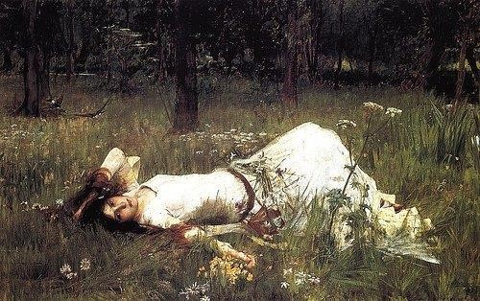

The blood is a condensation of the Ur-Sun, the Original Sun of Non-Existence, of Black Sunlight, of Green Wind. Twilight, where night and day embrace and hold one another in their arms. It is neither day nor night. Neither male nor female, good or bad, hot nor cold.
It is NOS. In-between. The twice-born feels, within their pulsating veins, a deep nostalgia, that something is not right. Something has happened and that every act we do on the face of this earth is in earnest, to bring back, from the deepest depths, this lost state of Totality, of that “most sacred memory.”

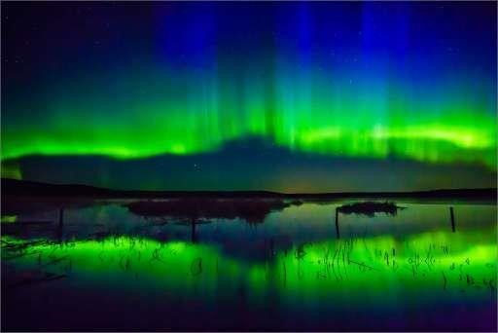

From eating to making Love. Every act is an act of returning to the Ur-Man. Original Man. Without mass and substance. The Original Angelic or Hyperborean BE-ing. That which he lost and he can now only feel as a deep thirst, a hunger, the desire to hunt. To be with a woman. Nature is like a Sleeping Beauty that has been ravaged and taken prisoner by something Unholy. The twice-born can actually see and feel this when looking at the eternal poetic dialogue of nature. From the smallest of critters to the most distant galaxies. The beautiful sadness of looking into the crying out eyes of a young deer, a fawn. The aroma of the Rose. The Ur-Essence, before the Rose had to make thorns to protect Herself. The howling winds of Winter whispering through the bedroom and asking one to listen to its tender song of Nostalgia. All of this is tangible to earthly man after the great ejaculation of the Devil. The actual object one is seeing and can touch and see is but the “second version” of it. The “second earth” after the disappearance of Hyperborea-Thule, which is the “First Earth.” It is now the “Other Earth”, the “Astral Earth.” Beyond its material form lay the “Ur-Version” – the Original Purity of things. The HyperboreanThulean essence, the Ur-Version, still lay there when one rips Maya, illusion, from their eyes. When a man has become impregnated with the “Son of Man” – with the “Siegen Geist”, Parakletos. When a man has put a Face on His soul. The Face of His Eternal Beloved.

Aquarian Threshold

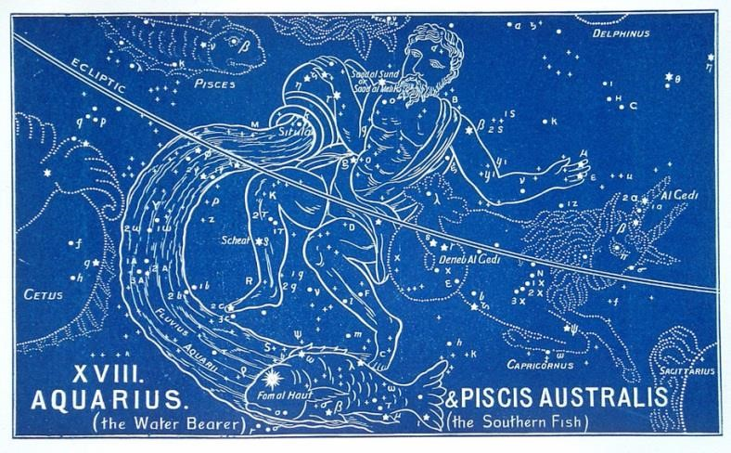

The Age of Pisces will forever be remembered as the Age of Tears, Lies and Deceit. The stench of dead fish is going to linger for many years to come. Many are still walking around, wondering when the end of the world will come, when it ended 70 odd years ago. The rapture has been happening all around you. Men and women are awakening to a new spiritual dawning, a vibrational spiritual frequency, every moment, while most are dying a slow agonizing death in stagnant waters. We are in a twilight threshold between Aquarius and Pisces. The satanic black magicians, the Elders of Mammon, the dead who lead the dead, the blind who lead the blind, the dead who bury their dead, are doing everything in their financial capital, their materialistic weapons of mass control, to make Pisces stretch out as long as possible, so as to prolong the agony of God, while the Sons and Daughters of the New Era are already spiritually woven in the High Vibratory Frequencies of the WaterBringer. The proper sacrifices have been done in the same ways as time immemorial.
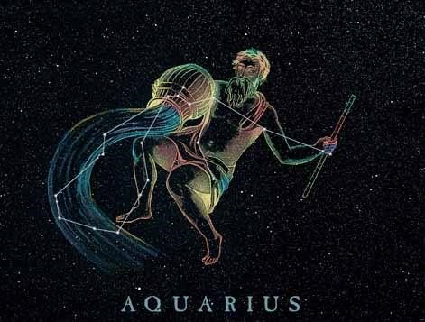

Only the man who has been ripped apart, cast aside, crucified endlessly, day after day, in the most agonizing and tortuous ways, ways upon which I will not even speak of, has the depths within to re-emerge as a Divine Being, Angelic Being, Hyperborean Being. The Christ of Pisces was stolen from the start. And just as they killed God then, they have been murdering Kristos over and over and over in this sad Era. The Greek Xristos was not allowed to make his miraculous appearance as Unified Man and Woman (of which “The Gospel of Thomas” speaks), a Totality within a God-Man who preached A-Mor, upon which the Cross represents. The Veritical, the Masculine, up to down, represents man and the kingdom of mineral. Man and his spinal coloumn. The Horizontal, the Feminine, is the vegetative and animal kingdom. The spine of the animal. The Four Kingdoms of Material Earth according to Plato. Iesous Xristos (Jesus Christ), (I plus X = Hagal), contains within it’s very name the Hagal rune of the original Androgyne. God was stolen from mankind at the very beginning of Pisces.

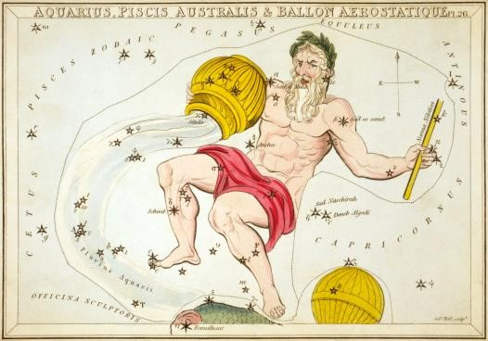

We cannot allow this to happen again. The Age of Pisces does not have to repeat itself. But in all honesty, We, the Esoteric Hitlerist, do not see much hope for mankind as mankind has chosen to die a straw death. Thus, we have come to an ever evolving Gnosis, that we are quite different than the average man. We do not even consider to be of your kind. We know with absolute firm certainty that we chose who to give birth to us, when they would do it, where they would do it, and how they would do it. We are Immortal Souls that have been traversing this earth for thousands of years. All of this resides in the “Memory of the Blood.” There are men who are born and then there are men who decide to enter here to continue fighting evil because they cannot bare to leave their kameraden behind.
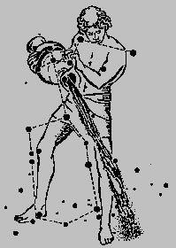

Long gone of the safe days of politics. What this world is about to see will be unleashed in a fury of darkened storm clouds drenched in blood. You will witness the Divine Man give his life up for the Divine Truth. You will witness martyrdom. You will witness high school kids more awakened than the average 40-year-old, as I have witnessed in the past year. Pisces took it too far. And for this, the Pendulum of Polarity that keeps the Universe in motion must swing, with each little motion towards our side, with more velocity and momentum each tiny bit it moves. There is nothing no one can do about this because it is written in the stars just as it was thousands of years ago. The only difference is, some of Us now have the ability to create new stars at Will and at the moments when the Gods use nature to speak to us.

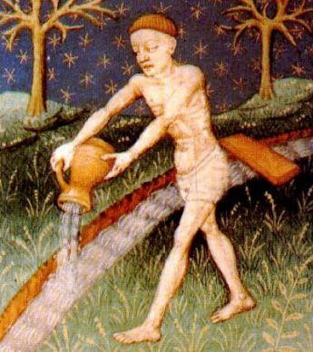

Only the fresh boreal waters of Aquarius can give life. The Piscean fish-men will drown in their own self-deluded waters of piss and vile.

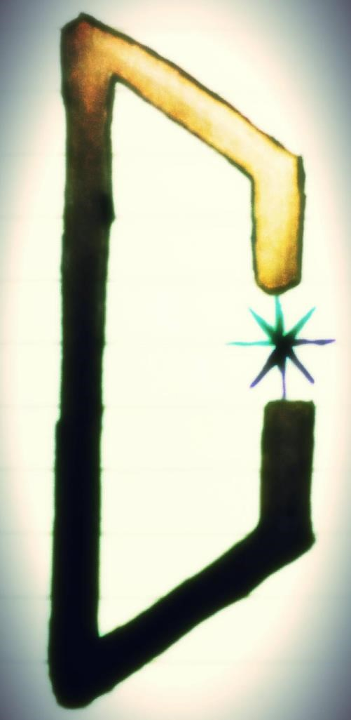
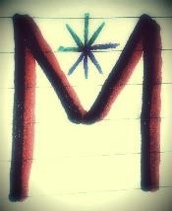
URRU

RUUR

Created by LAFFAL
for Templi Unam

