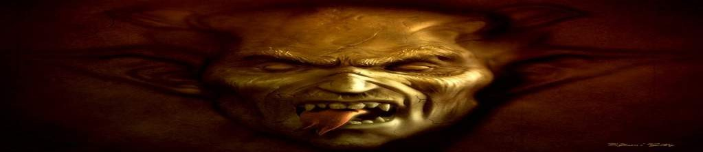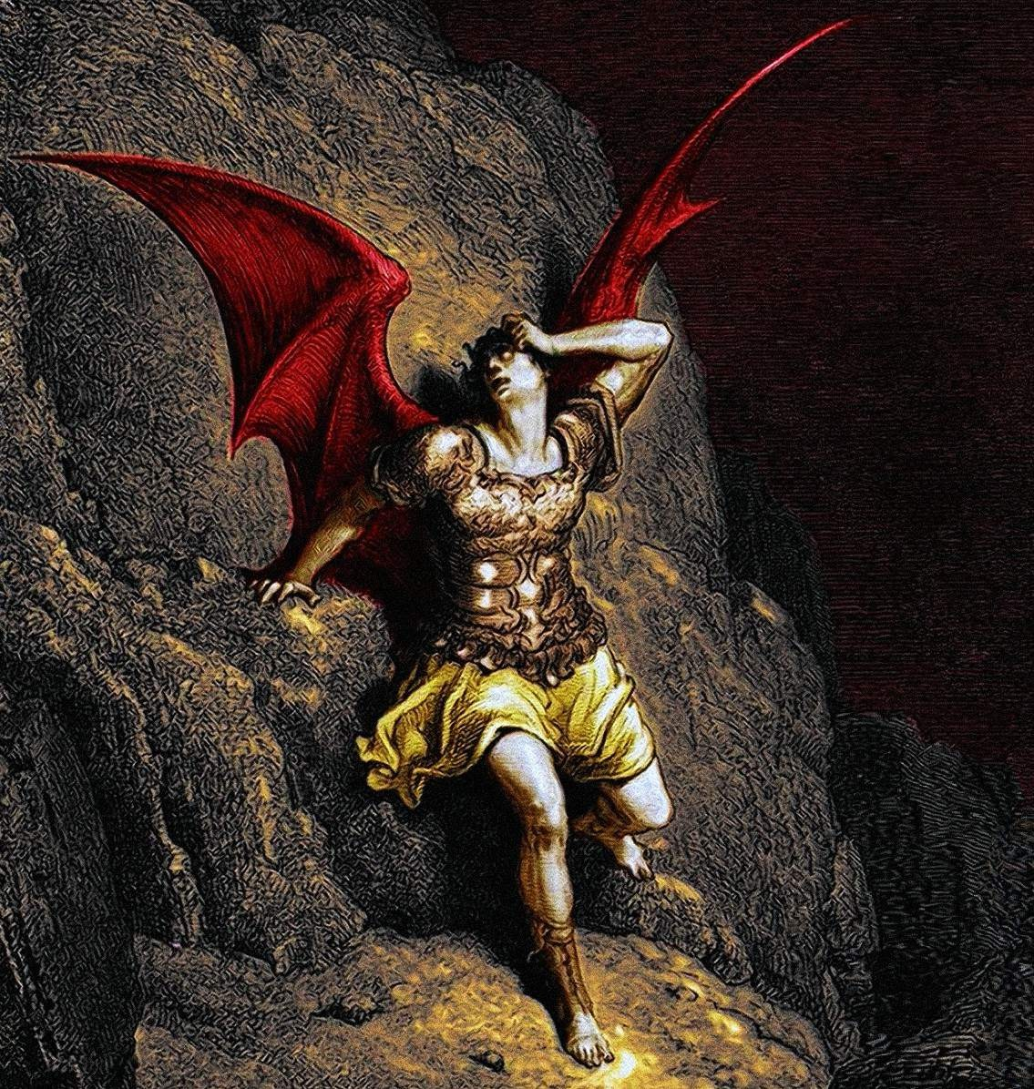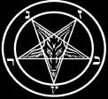

A R C H O N S

HIDDEN RULERS THROUGH THE AGES



ARCHONS
OTHERWORLDLY RULERS



E A R T H I S A L O O S H F A C T O R Y
REMOTE VIEWING PROJECT ON THE MATRIX
M O S T A N C I E N T G N O S I S T R A D I T I O N
MOURAVIEFF – THE CLOSEST TO TRUTH ON EARTH
J E S U S I S A S O U L – C A T C H E R JESUS WAS A USURPER AND JOHN THE BAPTIST WAS THE TRUE CHRIST. A HERETICAL COMPILATION
S O U L L E S S A N D H I V E M I N D E D
ORGANIC PORTALS. OCCULT REASON FOR PSYCHOPATHY
D I S C L O S U R E A B O U T A S U P E R H E R O
TEMPLARS AND MANDAEANS ON JESUS





Videos

JESUS AND MAGIC
Robert Conner - Jesus the Sorcerer. Magic in Early Christianity Robert Conner - Was Jesus a Sorcerer?
Helen Ingram - Jesus the Magician. The Secret Tale of Jesus the Magician. A Quest for Immortality

JESUS, JOHN AND THE KNIGHTS TEMPLAR
Lynn Picknett - Jesus was a Usurper, John the Baptist was the True Christ. The Johannite Tradition Lynn Picknett + Clive Prince - The Templar Revelation, the Mandaeans, and the True Christ
Lynn Picknett + Clive Prince - John the Baptist, the Knights Templar, Mary Magdalene and Jesus Lynn Picknett + Clive Prince - Jesus, John the Baptist, the Mandeans and the Real Christ
Lynn Picknett + Clive Prince - Is Jesus or John the Baptist the True Christ? Clive Prince - The Templars, the Mandaeans, and the Johannite Tradition Clive Prince - The Templar Revelation and the Johannite Tradition

JESUS AND THE MANDAEANS
James F. McGrath - The Mandaeans - Living Gnostics of the True Tradition
James F. McGrath - The Mandaeans and the Matrix. The Last Gnostics of the True Tradition The Mandaeans and the Lightworld. Gnostic Followers of John the Baptist
Terence McKenna about Mandaeans: Followers of John the Baptist Steve Wilson - The Mandaeans, the Templars and John the Baptist

JESUS? NO WAY!
Robert Conner - Did Jesus Perform Gay Sex Ritual-Magic? The Secret Gospel of Mark
Robert Conner - Secret Gospel of Mark: Morton Smith and four Decades of Academic Burlesque Morton Smith - Secret Gospel of Mark - Jesus initiated his Apostles in Secret

THE GREAT ESCAPE
Brett Stuart – Psychic Project on the Matrix. The Unveiling of the Soul-Loosh Harvesting System Cameron Day - Why I am no longer a Lightworker. Useful Idiots help establish a False Light-Matrix Cameron Day - The Afterlife Life Review is a Trap

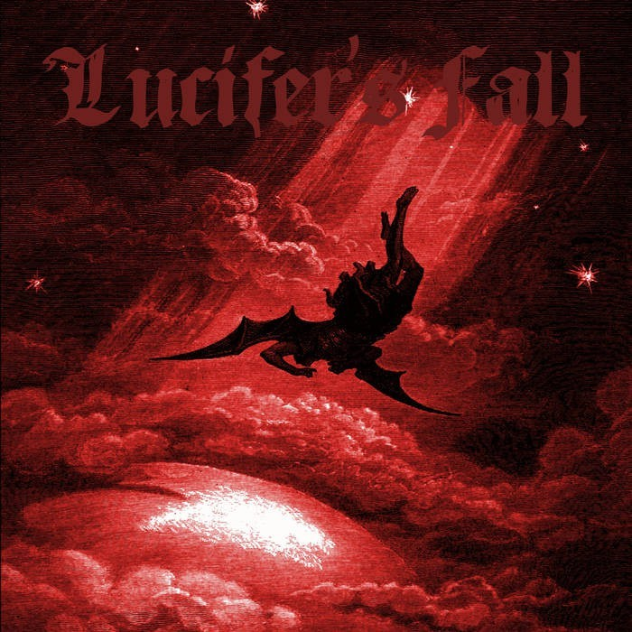

A R C H O N S E X P L A I N E D

"...any of a number of world-governing powers that were created with the material world by a subordinate deity called the Demiurge (Creator)...Archons were viewed as maleficent forces. They numbered 7 or 12 and were identified with the seven planets of antiquity or with the signs of the zodiac."
Britannica Micropedia vol 1

"This basic gnostic myth is that the creator described in Genesis is not the true god, but an inferior Demiurge. The Demiurge has many sort of ministers, or archons, and together they are responsible for this miserable world. Though imprisoned in this "abortion of matter," humanity carries within itself the leftover sparks of the precosmic "pleroma" that existed before the Demiurge and his creation. Human beings are thus totally superior to the ecosystem—not stewards, but strangers in a strange land. Our body and the soul ("psyche") cloak this spiritual "spark" and must be rent for us to rediscover our true being."
Erik Davis, from: "Snakes & Ladders"

"Hebraic cosmology had already described the planets not as dead stars but as living beings, as archangels whose brilliance was supposedly a celebration of the glory of the All-Powerful. Gnosticism retains this vision but reverses its meaning: these living planets, these blazing archangels shine forth above us in celebration of their own glory. It is as usurpers that they occupy their domain of the lower heavens and rule over their damned creation."
Jacques Lacarriere, from: "The Gnostics"

"History, written by the archons, and organised religion, also controlled by them, have elevated this evil bloodthirsty tribal god to the highest level, while suppressing the truth about the existence of the True God. Religions are all false renditions of Gnostic truths, and have been the basis of wars, suffering, torture, and enslavement of the human spirit – instead of liberating it. Over time, the biblical designation YHVH, or Yahweh, has come to mean "God"." Dr. J.S. Chiappalone, from: "The Kingdom of Zion: Exposing the Worldwide Conspiracy of Evil"

“From a Gnostic perspective, the “Loosh Collectors” are the “Archons” – the dreaded rulers of hyperspace who had to be avoided at all costs when leaving the body at death. The Archons collectively rule over the world, and each individually in his sphere is a warder of the cosmic prison. Their tyrannical world-rule is called heimarmene, universal fate ... [This universal fate] aims at the enslavement of man. As guardian of his sphere, each Archon bars the passage to the souls that seek to ascend after death, in order to prevent their escape from the world and their return to God.
Jonas, Hans (1958, 1963). "The Gnostic Religion", Beacon Press, Boston, pg 43

"Like Yahweh, the seven archons created the law. The Gnostics believed these powers created constraint, evil, darkness, death, deception and wickedness. The demiurge was evil because he wanted to impose an untrue religion. He also wanted to impose his judgment upon humans because he thought he could judge good and evil. Gnostics thought the archons were inferior demonic beings. Their Old Testament names were Iao, Sabaoth, Adonai, Elohim, and El Shaddi. They intervened to separate humanity from God, and the universe became a prison

controlled by the archons. Archons barred the passage of souls who were seeking to ascend to God after death, who were attempting to escape the world."
Robert Siblerud, from: "Keepers of the Secrets: Unveiling the Mystical Societies"

"The creation of physical, material man by the archons, and what might be considered subsequent "nth derivative" creations of "homo sapiens" by the Nephilim and the propagation of an ungodly race by the Watchers, thus rendered man subject to not only the laws of mortality but to inbred emotions of rebellion and lust and animal-like behaviour that could only be eradicated by "spiritual surgery" as it were, by man's submission to the path of initiation whereby he is restored to his original, inner Divine Nature."
Joseph P. Macchio, from: "The Orthodox Suppression of Original Christianity"

"Each Aeon has its Archon, or ruler, created by internal tensions in the Aeons. In other systems, ultimate reality itself is the First Archon and from this a number of Archons, usually seven, the Hebdomad, evolved by a process called Ennoia. Ennoia means that each Archon creates another, lower Archon by projecting its thoughts into the lower planes consciously or unconsciously, creating an inferior image of itself ("And God created man in His image")" Anders Sandberg, from: "The Gnostics"

"The Gnostics believed the Catholic Church was an arm of Satan because it did not teach the truth. Catholic teachings were introduced by the archons, claimed the Gnostics, who were the wicked rulers of the world that led men astray.“
Robert Siblerud, from: "Keepers of the Secrets: Unveiling the Mystical Societies"

"According to the Valentinian school of theology (which inherited its teaching from Paul), the Aeon of this cosmos refers to a usurper god, called the demiurge (Greek: artificer or fabricator). The word "Aeon" has many meanings in Greek, including age, space, or a spiritual being governing a vast space or dimension either in the heavens (Pleroma) or below. Here it is used to refer to a spiritual being (Aeon), whom Paul also calls the "Archon of the power of the air." Archon is the Greek word for ruler, and "the power of the air" is identified with the devil by Valentinian theologians. Paul therefore must be referring to the Ruler or usurper god who has had dominion over the physical cosmos (as opposed to the spiritual universe— called by Paul the Pleroma or fullness). This ruler, according to Valentinian theology, created the "devil" from the passion of grief which was transformed into the cosmic element of air. The "power of the air," then, is the devil who is the spirit working in the children of disobedience. The element air has commonly been identified with the mind."
Joseph P. Macchio, from: "The Orthodox Suppression of Original Christianity"

"Were I to persuade anyone that the real soul is not a unit, but that the passions of the erring are occasioned by the compulsion of the accreted natures, no common excuse then would the worthless of mankind have for saying, 'I was compelled, I was carried away, I did it without wishing to do so, I acted unwillingly'; whereas it was the man himself who led his desire towards evil and refused to battle with the constraints of the accretions. Our duty is to show ourselves rulers over the inferior creation within us, gaining mastery by means of the rational principle."
Isodoros, from: "Concerning the Overgrown Soul"

"If we picture earth at the center of the universe, the soul has acquired these energies on its downward (or inward) journey from the celestial regions through the planetary spheres. It emerges into earth life via the womb, full of potentials and tendencies that are delineated by its natal horoscope. Through life it works with these potentials, hopefully refining them so that they emerge as virtues. If this is accomplished, the soul when it leaves the body at death is light and unencumbered, and well able to rise upward (or outward) to the place of its origin. If instead the energies have coagulated in vices, then the upward journey will be difficult and the soul may even remain trapped in the earth's atmosphere, a torment to itself and a bane to its fellows."
Joscelyn Godwin, from: "Annals of the Invisible College"

"This scenario is the archetypal pattern of Christian-Gnostic salvation: redemption from ignorance perpetrated by the archons through their attempt to bind men permanently to a genetically and otherwise manipulated physical matrix, an envelope of matter and consciousness tainted with rebellion and the lust of the archons."
Joseph P. Macchio, from: "The Orthodox Suppression of Original Christianity"

"From our point of view this makes seven planetary archons, a complete octave, comprising the solar system and visible to the naked eye. These all correspond to functions of our life on earth, within the categories of space and time as we know them, and this octave defines the wave- lengths within which we function, comparable to the spectrum of visible light." Michael McMullin, from: "Astrology as a New Model of Reality"

"In an age when the Church Fathers were seeking to suppress and conceal all evidence regarding the existence of the archons, demons, giants, fallen angels and other manifestations of evil, Mani was revealing the conspiracy of Darkness to his followers, for he taught nothing less than the counterfeit creation of mankind (a kind of man) by evil creative powers."
Joseph P. Macchio, from: "The Orthodox Suppression of Original Christianity"

"Humans are generally ignorant of the divine spark resident within them. This ignorance is fostered in human nature by the influence of the false creator and his Archons, who together are intent upon keeping men and women ignorant of their true nature and destiny. Anything that causes us to remain attached to earthly things serves to keep us in enslavement to these lower cosmic rulers. Death releases the divine spark from its lowly prison, but if there has not been a substantial work of Gnosis undertaken by the soul prior to death, it becomes likely that the divine spark will be hurled back into, and then re-embodied within, the pangs and slavery of the physical world. "
Stephan A. Hoeller, from: "The Gnostic World View: A Brief Summary of Gnosticism"

"There is no reason to reject the New Testament or the early esoteric Christian schools concerning their teachings on the cause and continued presence of planetary evil this very
teaching on evil, had it been accepted by Christians in the later centuries, would have removed much of the mystery as to why the people of earth have been unable to challenge evil successfully these very same forces of evil have seen to it that all references to the race of evil
(whether they be fallen angels, archons, or Nephilim) have been either removed, suppressed or destroyed outright. ... In general, this evil is the result of either fallen, inferior or usurper deities, angels or rulers. It is very probable that the Christian- Gnostics believed that these

powers not only inhabited certain of the planetary spheres but other frequencies, wavelengths or dimensions of matter not readily detectable by ordinary humans. Further, there is every reason to suspect that the schools of Christian-Gnostics were aware of the existence of beings navigating in not only the physical dimension but in other, more subtle frequencies. These beings were most often termed rulers or archons, and were created by or ruled by a chief Archon known by various names such as Ildabaoth, Sacklas, Satan, Sammael, etc. That these beings possessed the power of creating bodies is evident from the texts in question; that they believed themselves to be creators or "gods" is also evident. As a result of their fallen state, they are hostile to humanity and attempt to prevent mankind from attaining to spiritual liberation." Joseph P. Macchio, from: "The Orthodox Suppression of Original Christianity"

"It was an age-old legend that there were seven watchers who were tried in the judgment, found not faithful, and overthrown. Now in the Ritual there appear the seven mortal sins "that lie in wait at the balance where all hearts are weighed, to arrest the further progress of the soul" (Ch. 71). These seven natural instincts of the mortal self constituted the seven-headed serpent that lay in wait at the "bight of Amenta," to devour the infant and innocent god-soul. The present exegesis receives striking corroboration in the statement of the Ritual that this place of ambuscade is "at the balance where all hearts are weighed." For assuredly it is in the incarnate state only that the soul could meet the seven enemies whose very existence is in the animal body and the carnal nature. The seven early mindless rulers were to be displaced by the twelve archons seated on the twelve thrones of judgment."
Alvin Boyd Kuhn, from: "The Lost Light"

"The esoteric teaching of the Christian-Gnostics and that of Mani concerned the creation of dense bodies by evil archons and their originating of sexual intercourse to keep the soul chained to those bodies through procreation. It was a misuse and abuse of this doctrine that caused the Church Fathers to so detest sex and woman, whom they considered a lure for man. They neglected to teach the laity that the establishment of sexual intercourse in lower bodies was the work not of woman but of archons/ fallen ones and that there existed a form of procreation in the archetypal universe and on the "etheric" earth (paradise) which man once inhabited quite different from the present method as we now know it. The other aspect of this teaching they suppressed was the doctrine that when man and woman come together in love and not in lust (which was the trademark of the Watchers and archons) and when "God hath joined them together" (i. e., when their union is infused with the spiritual element) they can bring forth sons and daughters of God into incarnation."
Joseph P. Macchio, from: The Orthodox Suppression of Original Christianity

"It is quite obvious that compared to Gnostic cogitations Genesis and the Gospels are dazzlingly clear and simple. What then is concealed behind this complexity, these perpetual subtleties which transform history into a chain of absurd tragedies, a series of obscure causes and effects, amid a vast array of Archons and Powers, Entities without number? Was it necessary to stage so many coup de theatre, to indulge in so much weeping and gnashing of teeth, so many falls and so much repentance, such contrivance and perversity on the part of the Archons and the Aeons, in order to make this eminently simple statement: real life is elsewhere?
Jacques Lacarriere, from: "The Gnostics"

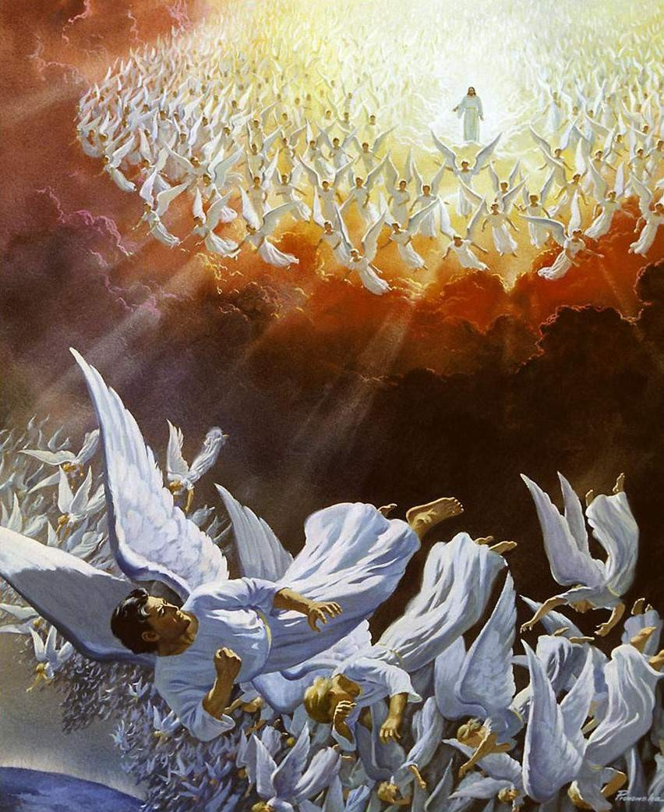

IN THE BEGINNING ...1
The Gnostic core belief was a strong dualism: that the world of matter was deadening and inferior to a remote nonphysical home, to which an interior divine spark in most humans aspired to return after death. This led them to an absorption with the Jewish creation myths in Genesis, which they obsessively reinterpreted to formulate allegorical explanations of how humans ended up trapped in the world of matter. The basic Gnostic story, which varied in details from teacher to teacher, was this:
In the beginning there was an unknowable, immaterial, and invisible God, sometimes called the Father of All and sometimes by other names. “He” was neither male nor female, and was composed of an implicitly finite amount of a living nonphysical substance. Surrounding this God was a great empty region called the Pleroma (the fullness). Beyond the Pleroma lay empty space. The God acted to fill the Pleroma through a series of emanations, a squeezing off of small portions of his/its nonphysical energetic divine material. In most accounts there are thirty emanations in fifteen complementary pairs, each getting slightly less of the divine material and therefore being slightly weaker. The emanations are called Aeons (eternities) and are mostly named personifications in Greek of abstract ideas. Like the God, they are nonphysical light beings. They are described as androgynous or bisexual. The Aeons in turn generate large numbers of simpler entities, sometimes called angels. The first of the great emanations, according to several Gnostic groups, is named Barbelo. This is a predominately female persona. A common stipulation is that only Barbelo is able to see or communicate with the invisible Father God. Even the other nonphysical dwellers in the Pleroma have no contact with this remote entity, sometimes called the Silent God. Often there is a central trinity of Father, Mother (Barbelo), and Son. The common outcome of the myth rests on the thirtieth emanation or Aeon, Sophia. This is both the Greek word for Wisdom and also a woman’s name. Sophia becomes jealous of the power of the Father of All to create. Without permission of her consort, the other of her matching pair, she gives birth or otherwise creates an offspring. It proves to be monstrous, with the head of a lion and the body of a serpent. She names him Yaldabaoth. He is also called Saklas (in Hebrew, the fool), and Samael (the blind God).
Ashamed of her progeny, Sophia takes Yaldabaoth outside of the Pleroma and hides him in a cloud. There he matures alone, having no knowledge of his origins. Imbued from birth with a portion of the divine material he inherited from his mother,
creates a dozen Archons (Commanders)
(Greek: craftsman),
given the title Demiurge
Yaldabaoth, now
[NOTICE: They are NOT anlien parasites], and then, in a mirror image of the great
Yaldabaoth then creates the cosmos,
understood to mean, not the entire universe as in modern usage, but the known planets. These were, in the order then understood: Moon, Venus, Mercury, Sun, Mars, Jupiter, Saturn, and the zodiac of visible stars. According to the new Ptolemaic system of astronomy, all of the stars were thought to be attached to a single crystal sphere.
emanations of the Pleroma, hundreds of lesser angels.

- http://boryanabooks.com/?p=2487

Yaldabaoth assigns seven of his Archons to rule over the seven planetary spheres, then
He has his angels make Adam, each of 365
creates the Earth and decides to populate it.
angels contributing a single part. But Yaldabaoth and his Archons find that their creature
is lifeless, or at least unable to stand. By this time Sophia has discovered what her offspring has done and is horrified at the fate of the humans he is in process of creating, who will be encased in deadening matter as in mobile tombs. In one version she and her consort come down from the Pleroma and trick Yaldabaoth into breathing life into Adam and Eve, thereby giving them and their descendants greater spirit power than the Demiurge is able to retain. In another version Christ or another Illuminator comes to earth disguised by a magic helmet and imbues the near-lifeless human prototypes with tiny divine sparks.
Yaldabaoth then creates the Garden of Eden, not on Earth as in Genesis, but at the level of the stars. He cruelly tells his human captives not to eat of the tree of the knowledge of good and evil. In some versions, for example, in The Hypostasis of the Archons among the Nag Hammadi texts, the serpent is the agent of Sophia, urging Adam and Eve to disobey; in more Christianized accounts it is the Christ who comes to the garden to warn Adam and Eve of the Demiurge’s plan to enslave them in deadening matter. As must be clear by now, Yaldabaoth is known by Jews and Christians as Jehovah, or just as God. The Gnostics frequently and ironically quote Yaldabaoth declaring that he is a jealous god, claiming in his ignorance that he is the only God.
Finally, the role of a savior, even in the later documents when this is (mostly) Jesus,
is not
to die for people’s sins. Sin has little to do with the Gnostic vision, particularly the peculiar
The savior figures in Gnosticism
Christian concept of original sin borne by every human.
try to wake people up from the deadening effect of being encased in matter and prepare them for the arduous nonmaterial individual flight through the cosmos after death to try to reach the Pleroma and re-merge their divine spark with the main mass located there. In the Gnostic cosmos each of the “planets” is ruled by one of the Archons and the spirit released from matter by death must persuade the Archon to allow it to pass through that “planet’s” crystalline sphere.
This was the model in which the Earth was a sphere in the center of the universe. The Earth was thought to be surrounded by nested transparent crystal spheres, the “seven heavens” of proverb, one for each of the planet-type objects, which included the Sun and Moon. The eighth sphere, the ogdoad, contained all of the fixed stars. On the other side of this sphere of the zodiac were imagined various celestial locations, from Plato’s realm of perfect ideas to the abode of gods, to the Christian heaven, to the Gnostic Pleroma. The Gnostics, then, sought to remain current with the science of their day. But in the Ptolemaic system the planets had been promoted from mere moving points of light to the central points on gigantic crystal spheres far larger than the Earth. Many of the Greeks now thought of the planets as minor gods. For the Gnostics in particular this posed the problem of how the escaping spirits were supposed to get through each of the eight transparent spheres to reach the Pleroma. Hence their concern with inventing verbal formulas and supposed passwords for the voyaging spirits to declaim to each planetary Archon or its minions to gain passage.

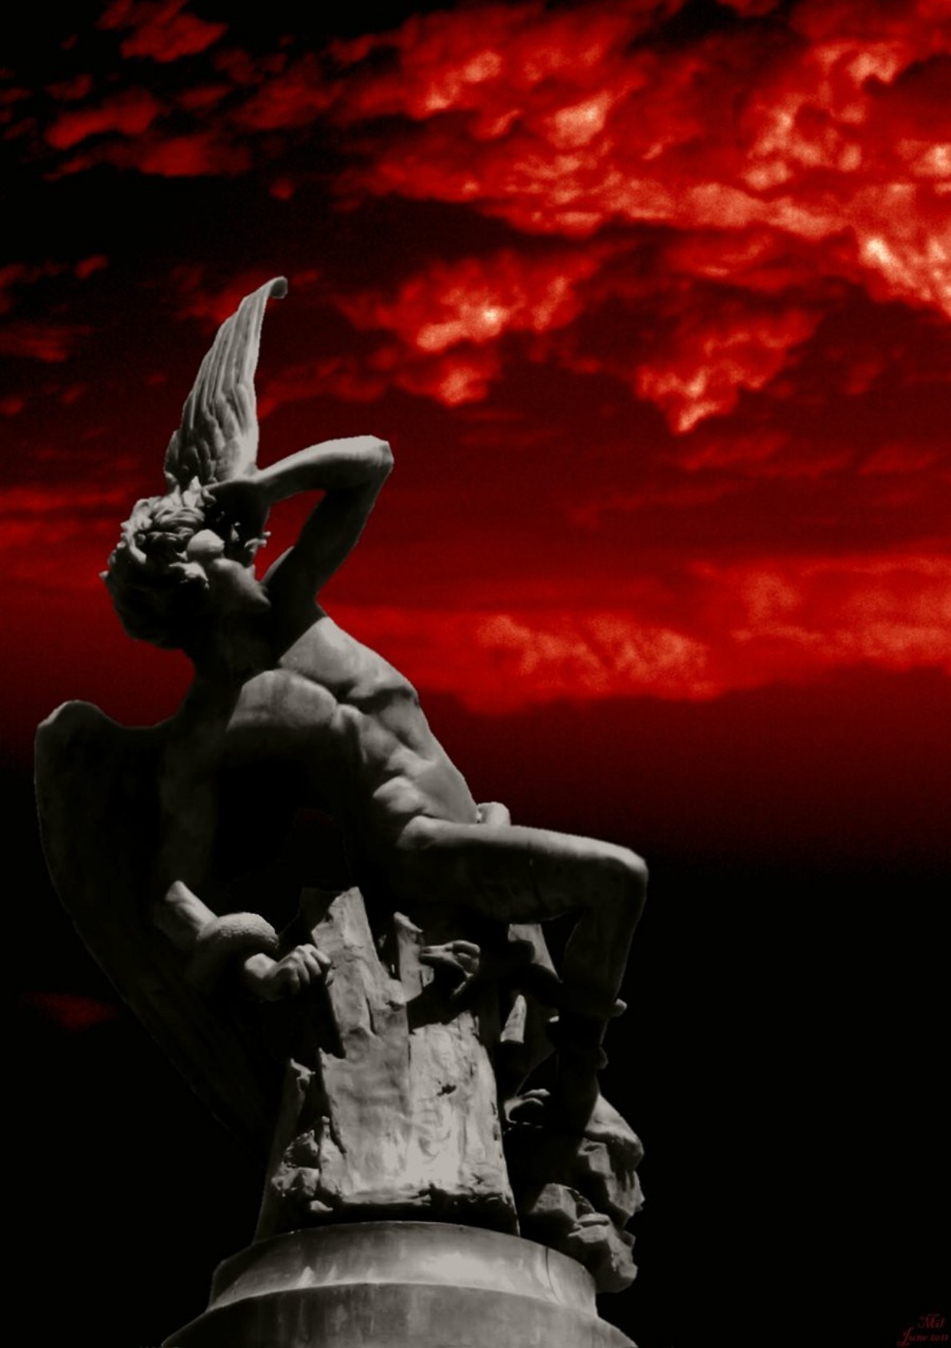

INTERROGATIO IOHANNIS²
T h e S e c r e t S u p p e r
Based on: Walter L. Wakefield and Austin P. Evans Heresies of the High Middle Ages p.458ff.

The Interrigo Iohannis is Catharian tale about the legendary fall of angels into the material world. Satan formed a male and female body out of clay. Than he forced two angels to enter into the bodies. Satan, the dragon, trapped and captured all the angels he could grab out of heaven as they fell. Remember that bible-stuff about 1/3 of the angels in heaven being swept down by the dragon's tail? Gnostics say that was us. We are the Fallen Angels. We were trapped. We've been tricked. And we were mourning over what was imposed upon us. We had differentiated male and female bodies. Satan commanded us to perform works of flesh in bodies of clay but we didn't know how. Satan had to find a way to force us into bodies of clay, so he made us lust each other, to have babies and so to trap even more angels into bodies. His scheme included the creation of the "paradise" Eden where he literally dumped lust into our heads psychically and in some cases by sexual assault. WE are TRAPPED angels. We are soul splinters of archontic oversouls spread over different time lines and dimensions.
Notice the details: The Devil sexually seduces the angels as a snake. Because
prasites like John Lash claims.
there is no
godly wisdom in a coldblooded reptile. And the Archons are prison wardens, not alien

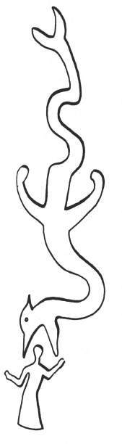
In the name of the Father, of the Son, and of the Holy Spirit, Amen. The questions of John, the apostle and evangelist, at a secret supper in the kingdom of heaven, about the governance of this world, about its ruler, and about Adam:
I, John, partner in tribulation so that I might be a partner in the kingdom of God, leaning on the breast of Jesus Christ our Lord at the supper, said to Him; "Lord, who shall betray Thee?" And the Lord said unto me: "He that shall have dipped his hand in the dish, into him shall Satan enter. He shall betray me." I said, "Lord, before Satan fell, in what splendor did he attend the Father?" He said: "Among the virtues of heaven and at the throne of the Father invisible; he was regulator of all things and sat with my Father.' He [Satan] it was who presided over the virtues of the heavens and those who attended on the Father. His power descended from the heavens even unto hell, and arose even unto the throne of the Father invisible. He had wardship of those splendors which were above all the heavens. And he pondered, wishing to place his throne upon the clouds and to 'be like the Most High.'" When he had come down to lower air, he descried an angel seated upon the air, to whom he said, 'Open to me the portals of the air'; these the angels opened for him. And passing down, he descried an angel who guarded the waters, to whom he said, `Open to me the portals of the waters'; the angel opened them to him. And descending further, he found the whole earth covered with water; walking beneath this, he came upon two fish, lying

- http://gnosis.org/library/Interrogatio_Johannis.html

upon the waters. These, indeed, were yoked together, and they bore up the whole earth at the bidding of the Father invisible. And passing down further still, he found great clouds holding the massed waters of the sea. And descending lower, he found his hell, which is the Gehenna of fire; but thereafter he was unable to go further down, because of the flame of the fire which was raging. "Then Satan retraced his path, filling himself with evil plots. He ascended to the angel who was over the air and to the angel who was over the waters, and unto them said: 'All things are mine. If you hearken to me, I will place my throne over the clouds and I will be like the Most High." I will bear the waters up above this firmament and I will gather the other waters into wide seas." After that there shall not be water upon the face of the whole earth, and I shall reign with you forever and ever.' Thus he spoke to the angels. He ascended to the very heavens, even unto the third heaven, subverting the angels of the Father invisible, and saying to each of them, 'How much dost thou owe thy lord?' The first answered, 'A hundred barrels of oil.' He said to him, 'Take the bill and sit down and write fifty.' And he said to another, Now you, how much dost thou owe thy lord?' Who said, 'A hundred quarters of wheat.' To him he said, 'Take thy bill and sit down quickly and write eighty.' To the other heavens he ascended with like speech; he ascended even unto the fifth heaven, seducing the angels of the Father invisible.
"And a voice came from the throne of the Father, saying: 'What dost thou, O thou devoid of hope, subverting the angels of the Father? Contriver of sin, do quickly what thou hast planned.' Then the Father bade his angels, 'Take from all the angels who hearkened to him the garments, the thrones, and the crowns';" and these angels took the vestments, the thrones, and the crowns from all the angels who hearkened to him." And once again I, John, questioned the Lord, saying, "When Satan fell, in what place did he dwell?" In answer He said to me: "Because of his self-exaltation, my Father decreed his transformation," withdrawing from him the light of His glory. The face of Satan was like an iron glowing from the fire, and the whole aspect of his countenance was like that of a man. . . And he had seven tails with which he drew away the third part of the angels of God." He was cast out from before the throne of God and from the stewardship of heaven. Falling down from heaven, Satan could find no peace in this firmament, nor could those who were with him. And he besought the Father, saying: 'I have sinned. Have patience with me, and I will pay thee all.' The Lord was moved with pity for him and gave him peace to do what he would until the seventh day."
"Then Satan took his seat above the firmament and gave command to the angel who was over the air and the angel who was over the waters, so that they raised two thirds of the waters high into the air. Of the remaining third they formed wide seas. The division of the waters was by command of the Father invisible. Again Satan bade the angel who was over the waters, 'Take a stand upon the two fish.' And the angel raised the earth upward with his head, and dry land appeared and was. . . . When he took a crown from the angel who was over the air, from half of it he made himself a throne; and when he took a crown from the angel who was over the waters, from half he made the light of the moon and from half the light of day. From precious stones he made fire, and from fire he made all the host of heaven and the stars, and from them he made angels, his ministering spirits, according to the plan of the Governor Most High. He also made thunder, rain, hail, and snow, and over these he set his ministering angels. "He commanded the earth to bring forth all living things —animals, trees, and herbs. The sea he commanded to bring forth fish; and the air, birds of the heavens. And he pondered on making man to serve him; he took clay of the earth and made man like unto himself. And he then bade an angel of the second heaven to enter the body of clay. Of this body he took a part and made another body in the form of a woman" and bade an angel of the first heaven to enter into it. And the angels grieved deeply that they thus had a mortal form imposed upon them and that they now existed in different forms. And Satan bade them to perform the works of the flesh in their bodies of clay, but they did not know how to

commit sin. The originator of sin accomplished his purpose by his seduction, in this way: He planted a paradise and set men therein and bade them not to eat of its fruits. The devil entered Paradise and planted a bed of reeds in the midst of Paradise; of his spittle he made a serpent and bade him remain in the reeds. Thus the devil concealed the knowledge of his deceit so that they would not perceive his treachery. He went in to them saying, 'Eat of all the fruit in Paradise, but of the fruit of good and evi1 eat not.' Thereafter the wicked devil, entering into the evil serpent, deceived the angel who was in the form of a woman and poured out upon her head a longing for sin," and Eve's desire was like a glowing oven. Forthwith, the devil in the form of the serpent came out of the reeds and sated his lust on her with the serpent's tail. That is why [the offspring] are called not sons of God but sons of the devil and sons of the serpent, fulfilling the diabolic desires of their father even unto the end of the world. After this, the devil poured out his longing upon the head of the angel who was in Adam; and [both angels] were affected by a lust for debauchery, together begetting children of the devil and of the serpent, until the consummation of the world."
After that I, John, questioned the Lord, saying, "Why do men say that Adam and Eve were made by God and placed in Paradise to keep His commandments, and that for transgression of the Father's commandment they were delivered up unto death?" The Lord said unto me: "Hear, John, most beloved. Men are foolish who speak thus, for my Father did not, in transgression (in praevaricatione) of His own law, shape bodies of clay, but by the Holy Spirit made [only] all the virtues of heaven. These, however, for their sins and by their fall are found possessing bodies of clay and are delivered up to death." And still I, John, questioned the Lord, saying, "Lord, how did man have spiritual origin in a carnal body?"
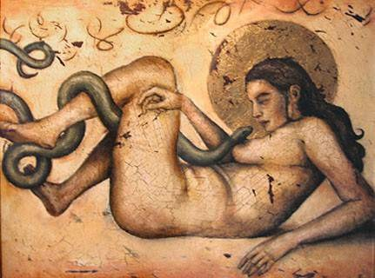And the Lord said to me: "By their fall spirits of heaven entered the female body of clay and took on flesh from the lusts of the flesh and took on [spirit at the same time]. . . . Spirit is born of spirit and flesh of flesh; and thus the reign of Satan ceases not in this world." And I questioned the Lord, saying, "For how long will Satan have dominion in this world over the essences of men?" And the Lord replied, "My Father will permit him to reign seven days, that is, seven ages."
Again I, John, questioned the Lord in this wise, "What will be the nature of this period [of seven ages]?" And He said to me: "From the time when the devil fell from the glory of the Father and desired his own glory, he took his seat among the clouds and sent forth his ministers, a searing fire, and ... in the land from Adam to Enoch. And he sent his minister to Enoch and translated him above the firmament and displayed to him his divine nature. He then commanded that he be given quill and ink. Seating himself, Enoch wrote seventy-six" books; these the devil bade him to take to earth. Enoch took the books and turned them over to his sons, and he taught them how to observe the form and place of sacrificial rites. This they did in such wise as to 'shut the kingdom of heaven against men.' …

From here on the following text seems to be corrupted and inserted later. The text so far appears to be a genuine report of the multi-dimensional structure of our universe and the intelligent control of the four elements fire-water-air-earth in the process of creation. And it talks about sexual desire and entity possesion. This are clues of the advanced devine levels of initiation at the Bogomils and Cathars.

EARTH AS ANGEL-TRAP12
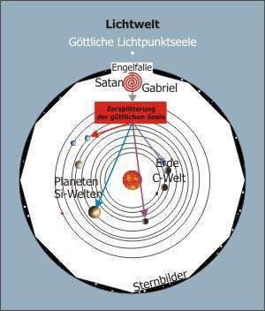
I would like to comment on the following chart of the secret order d. g. D. i. O. d. T. which discribes earth (and the whole solar system) as an angel trap. The real divine world is a lightworld. Our entire soul lives there in harmony with all that is. But there is a dark place in this lightworld. There was built an attractor by two entities - the order states their names: Satan and Gabriel – a trap which allures divine souls.

It is not explained here how this trap works excatly. But we can picture:

- a seductive situation which promises an advantage to the angel
- but also a fake cry for help which exploits his good intentions to bring about his downfall.
parted.
If the angel is trapped his soul gets blown up and
Through this traumatic soul fragmentation the knowledge about the devine lightworld gets lost to the greatest extent: the splitting into consciousness and unconsciousness begins.

The dissociated parts of the fragmented soul turn up into different worlds of experience and get entrapped with various artificial problems. On
different planets and moons, partly as silicon based life forms (si-world) or also on Earth as carbon life forms (c-world) the soul fragments undergo experiences which are not part of the divine but of a demonic reality.

Life in this experience matrices follows the scripts of the angel trap. Essential elements are the fight of good against evil, demonic seductions and intimidations, conflicts, experiences of frustation and shortcoming, the search for true love and so on.

But as long as our soul is trapped, whenever Good is victorious, when the demons are defeated and love comes true, the script is changed: evil prevails and the vicious circle is beginning all over again. This is a simplified portrayal of what the order d. g. D. i. O. d. T. wants to tell the angelic earthlings, so they can escape the trap.

To make this very clear: Jesus by the way got caught in the trap and is now part of the trap. But Christ is the way out. After I came in touch with this information it took me ten years to really understand it. That much time you should take before you start to argue.

12 https://web.archive.org/web/20100218152804/http://gebser.eu/wordpress/die-erde-als-engelfalle/

THE VEILS OF ISIS1

In the following, the three levels of reality will be shown - and it will be shown which type of person can penetrate to which level of reality.

The old conception of the Veils of Isis is used to express, that firstly there is 'something' that veils true reality, and secondly there are several veils: We can imagine that the first false reality is projected onto the first veil, a second false reality onto a second and a third false reality onto a third.

From this follows: If someone has lifted the first veil (which is rare enough), he goes from deception to error and is still far from reality. Behind the second and the third veil there is also blinding instead of truth.
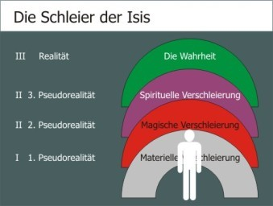
The Veils of Isis
I 1. Pseudoreality: material veiling II 2. Pseudoreality: magical veiling
II 3. Pseudoreality: spiritual veiling, III Reality: the truth

1 Ralf Maucher http://erleuchtungspsychologie.de/ http://gebser.eu/wordpress/die-schleier-der-isis/

So what is the first level (I): this is our quite normal, material world. A world in which school-science is valid. It is rational. In it we find the left-hemispheric logician for whom spiritual considerations are foreign. What is particularly perfidious is that this world is true in itself. It just does not agree with the truth.

The second level (II) of reality: here a connection between spiritual world and material world is recognized. It is not rational, the processes are rather right- hemispheric. Two types of human beings find their way here:

The one who has a vivid imagination and who fabricates a 'magical' world view without deeper knowledge or critical facility. We can call this type accentuatingly and enlightingly „witch“ and „magician“, but also the simple priest (!). People with this world view do not notice the many contradictions and inconsistencies in their own system of thought and perception. It is not true in itself and not externally.

Then, on the second level, there is the other type, which has worked out a sometimes very differentiated picture of the world and can also indicate complicated connections between the spiritual and the material world. He often has his knowledge through initiation, sometimes even through 'pale enlightenment'. Here, again accentuating, we find the „wise woman“, the „initiate“, the „guru“. The system itself is largely in tune with itself, but even this is not in tune with the truth.

On the second level, both types at different levels have realized that a purely material view of the world is not enough. While the magical world view can quickly be recognized as false by a thinking person - on this second veil of Isis the distortions are clearly visible - the differentiated pseudo-spiritual view is not so easily recognized as false: on the third veil of Isis we see a slide show of enticing images. She promises us much that our captured soul longs for, and therefore has the ego of the one who has progressed so far, firmly under control.

Only on the third level (III) of reality the material, magical and spiritual pseudorealities are seen through: Isis has lost her three veils and the power she received over us humans.

Here we find a few who, when the others are of good will, can help free all humanity, or at least an increasing number of individuals, from false realities. Isis still resists because she doesn't look too good naked. But it will happen: Isis will be unveiled.

REMOTE VIEWING PROJECT: FREEDOM FROM REBIRTH
(TECHNICAL INTUITION)
"...Earth, an "innocent planet" that has had a barrier or gird around it that traps people and objects; a deliberate function that acts like a cage; a form of perverted injustice occurring; harrowing, bone-chilling; refugee camp; magnetic force that stirs and agitates; a net that's been spun, that catches and releases; massive grid around the planet; souls are drained at the expense of energising something else, clockwork nature over long expanse of time. Very high-tech shield around planet, so high-tech it's almost like "magic". Magnetic vise, squeezes tightly around the Earth. People are lost, they don't understand what's happening. Souls are being "bent back" towards the planet. The mind and body is splayed and fractured each time it's pulled back into the reincarnation grid; something is being extracted and taken from them without their conscious awareness to power something else - like honey from the bees. Souls are being fed on by external parasitic force. Some warped, sadistic and twisted force is behind this process. How did this begin? Planet was viewed with extreme envy by external force, at that time there was no reincarnation grid; massive war when planet was invaded and those who were protecting the planet lost; Earth was "given up" in an armistice. How to achieve Moksha? Brett Stuart describes the release of the soul from the body as cosmic particles being expelled from the centre of the nervous system, and technically has the freedom to go anywhere instead of being trapped in this hostage situation. There is a group of beings that will help soul escape, it's like they are the safety rope; Brett feels that this group is connected to the one that was formerly protecting the planet; fear also prevents most from escaping; achieving Moksha is analogous to having all the vise-grips and cables being ripped out of the head and finally being liberated. This control system is just a small component of a larger system; the controllers are like demons; the alchemical process of the mayhem and negativity on the Planet's surface feeds the controllers; some of these energies or soul aspects are extracted and shipped off somewhere else; "enslaved", bundled up like twigs for kindling; system was created to provide fuel and energy for other systems and conquest (sort of like to feed the expanding "empire"); the energy empowers the massive system. “
REMOTE VIEWING PROJECT: THE DEATH TRAPS (FARSIGHT INSTITUTE)
"... Earth has long been a planet that has been operated as a prison, and this is meant literally, not as a metaphor for something else. People who live here were mostly dumped here from somewhere else, from other planets on other star systems within our galaxy, and possibly from some star systems in other nearby galaxies. They get dumped here by being born here. They lose all their memories of who they were in the past, where they came from, who their families are and were, and they don’t remember the property that they owned that was taken from them. Everyone is processed in a way that erases all such memories. The key to running this prison has always been from the beginning to suppress all knowledge of every prisoner’s past. And when people die on Earth, a technique was established to involuntarily recycle them back into another life on this planet, memory free, so that they could never leave. Dying offers no escape from this place "

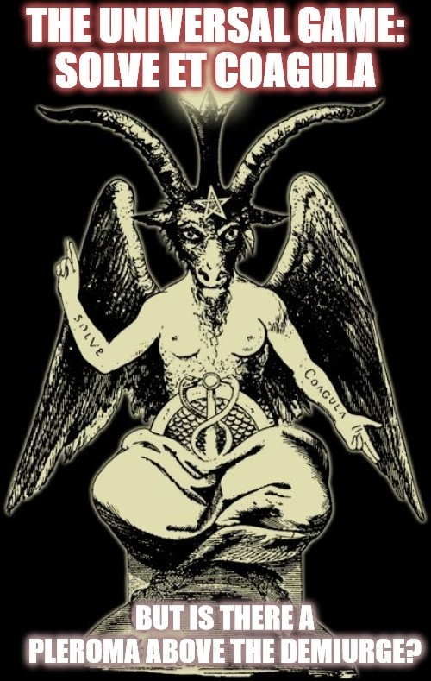

RAPHAEL'S LEGACY: THE TRUTH
ABOUT GABRIEL1

In this contribution I would like to draw without concluding evaluation on impressive findings of the Order of the g. D. u. d. D. d. T.:2

This Order has been passing on the following knowledge since its foundation:

- The earth and mankind are under influence of consciousness manipulation.
- This influence is global and affects almost every human being living here.
- Even people who supposedly managed to escape this manipulation remain trapped in a second manipulation matrix. Although it is quite different from the world of the normal, it is nevertheless an illusion.
- This influence is controlled from a level whose inhabitants are called angels, demons, extraterrestrials etc. by humans.
- These beings are difficult for man to recognize.
- Even if they are perceived, their motives are difficult to see through.

For a person who, like me, has a normal academic education and also a diploma in psychology, these explanations are of course a challenge: It is claimed that nothing of what we see, think and feel is true. It is that instead of living in a true world, we live in a world manipulated by mind- and soul-control. Nevertheless, I continue to pass on the knowledge of the Order D. u. d. D. d. T.

- A special role of the entities that manipulate humans, plays a fallen angel, who pretends to be a benefactor of mankind.
- He approaches people from time to time and transmits manipulative messages to them.
- He also intervenes directly in the mental processes of the people he visits.

- Ralf Maucher http://erleuchtungspsychologie.de/ https://web.archive.org/web/20100601185854/http://gebser.eu/wordpress/raphaels-vermachtnis-die-wahrheit-uber- gabriel-und-dschibrail
- If you ask yourself how I know the Order from, if I know members, if I know its full name etc., I would like to ask you for patience: order and members were persecuted from the very beginning. They still are. But for those of whom it is important, names and information will be available in time.

- The names by which he is known to people are Djibrail (in Islam) and Gabriel (in Judaism and Christianity).
- Gabriel is not male or gender neutral, but a "female" angel.
- She is in the service of Satan.

This is now not only a challenge, but a test of normal human thinking and feeling. The Order speaks of the devil and denounces an established angel as a fallen one in the service of the adversary. Nothing helps: The message continues: furthermore ...

- Gabriel's diabolical task is to sow discord among men: divide et impera.
- This she does again and again with the same scheme of manipulation:
- She tells important people (important for the liberation from manipulation) that they are not so important so that they place themselves in the service of people manipulated by the adversary.
- She repeatedly selects narcissistically seducible souls (=luciferous souls) to whom she tells that they or their descendants are chosen and have an important task for God to carry out.
- For a being who lives outside time (all angels do this), it is about energy qualities in the broadest sense. Gabriel and the Devil are concerned about harvesting human energies for the granaries of evil.
- This harvest succeeds in the individual when a manipulated person (posthumously) goes into rage after seeing that he has been manipulated. This harvest succeeds even better and more potentized in the collective when the different "chosen groups" turn against each other and entangle themselves in destructive religious wars.
- Around the year 0, Gabriel "worked" in Palestine according to the testimonies.
- Around the year 600, Djibrail "worked" according to the testimonies in Saudi Arabia.
- Each history book shows the consequences.

It is obvious: If what the Order of the g. D. u. d. D. d. T is telling us is true, than we are all involved in a deep fallacy and are the victims of an unimaginable perfidy.

The statements are so far-reaching that they cannot really be true, says the little "Palmström"3 in us. Maybe he's right, maybe we're just afraid to face the truth.

We will have to face it: If the world is right, the message is wrong. But if the message is right, the world is wrong. Then we have a problem.

- A literary character by Christian Morgenstern „… It cannot be what must not be ...“

ANGEL-TRAPS

The matrices of experience, such as the earth, are inhabited by various actors: On the one hand these are the trapped, bursted angelic soul parts and on the other hand the agents of Satan and the agents of Gabriel. To Gabriel here again the hint that Gabriel is a feminine angel of darkness, we can call him/her the angel of witches. The henchmen (incarnates) of Satan and Gabriel agree with the false play on a soul level. Nevertheless, their consciousness on a personal level is usually so limited that they cannot see their dark and evil parts themselves and cannot or do not want to admit them. The fragmented souls of the angels of God are superimposed by resonators that come from the agents of Satan and Gabriel. Their destroyed soul makes them defenceless against this superposition. They do not recognize the false game.

These resonators can be located directly in the (subtle) body of the agents of darkness, but also in objects created by them or their subtle fields (e.g. technical devices, buildings, etc.). Suggestive and manipulative force fields emanate from the resonators, which transform and falsify the divine plan. Thus the divine angels do not come back to God and the trap remains.

It is not uncommon to observe them: Relationships or marriages of the henchmen with people who carry angelic soul parts within themselves. In the first phase the light flows from aura to aura. Gabriel and Satan siphon off this light and allow themselves a relieved life in abundance. In the second phase descendants are conceived. This leads to a coupling of the genes. Then it becomes physical: the divine energy now flows "wired" into the agents of the henchmen and from there into the Satan-Gabriel system.

Perhaps as a good person you ask yourself the question: can Satan and Gabriel actually (not) be helped? One can. Under the condition that the two and all their agents see their misconduct, repent of it with complete emotional quality, repair the damage as far as possible and never deviate again from the path in the future. I have not yet observed this insight and repentance.

From the representation of the angel trap follows the central question for an alert mind: Who can be treated at all in the comprehensive mental sense? The answer is not difficult, but it has a "difficult" content: All those can be treated who make their way back to the light world of God. Anyone who hinders or prevents others to make this way back cannot be treated. All parts of the souls of angels who have recognized the trap, remember the way back and want to walk it, can be

accompanied and helped. There can be no help for Satan and Gabriel as well as for their earthly soul parts. As long as these dark forces operate the angel trap, they have no interest in making the way back possible for others. On the contrary, they will prevent it. This also includes the desire for therapy or advice from the Satanists and Gabrielites, i.e. from the 'children of fallen angels'. As a rule, this wish is only expressed in order to stop the 'true children of God' or to prevent them from having time for other children of God. Therefore, the following recommendation applies to all who want to go back: No (energetic) contact with the operators of the trap or their 'agents'. This is easy on the soul and gives it the strength to return home. I can already hear the outcry. From those who have connections in their soul - to Satan and to Gabriel. For they are seen through - and that is what they wanted to prevent at all costs!

A few of these contemporaries would so like me to be sick.1 Spiritually, of course. How do I say elsewhere: The devil can only project. That also applies here: In order not to have to see their own illness and malice, these contemporaries go into the foreign devaluation, which in this case means: they pathologize the other ones so that they do not have to see their own normality and madness that has become reality.

The following section presents four graphs showing the "social" and energetic consequences of the fall of an angel. The first illustration shows the angel in the light space. There he fits into the hierarchy of angels. All angels there have a connection to God and to the divine principle, symbolized by the golden triangles. They know who they are and they know what they are doing.
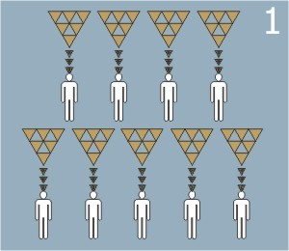

1 You would like that. But it is not so. You will also see that...

The second picture shows the angel of God in a fallen state. He has lost his angel- consciousness. Also his angelic energy-field is unknown to him and not available. The people living on earth who are superimposed by Satan (S) and Gabriel (G) or serve them consciously use the energies for their purposes: The angel is robbed.
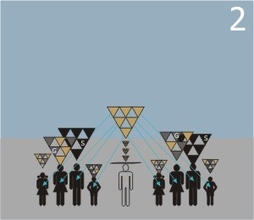

The third picture still shows him in the fallen state. By the incomplete contact with an energy field of the light space he has again a higher consciousness, but it is a false, more exactly: a faked angel consciousness.
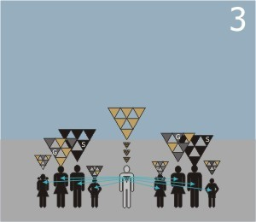

Here the angel projects the trap in which he himself is still stuck in the people and identifies himself with the beings living around him. Out of compassion and the desire to redeem himself, he now passes on his energies. He tries to do the work for the others. In this way he prevents two things: firstly, true help for the people and secondly, the possibility of returning oneself to the Light Space.

With that the angel would in principle be lost. But the angels who are still in the light spheres can help him. This is shown in figure four. One or more of the angels above him sends him additional divine energy so that he is reconnected with the true angel-consciousness. Thus the double nature of the angel trap finally becomes clear to the felled angel: In the first phase the angel is robbed, he has no consciousness of it, in the second the angel gives himself away intentionally, but not in the divine sense.
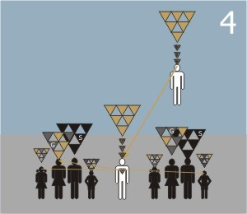

The angel now has to integrate these insights and make up for the mistakes from phase two, then he can go back into the light space when he dies out of earth.

And before this extinction - he can now be a real help - for the beings living on earth: He will now no longer want to do the work for the others, but will truthfully describe things to those who want to return and give instructions what men, fallen and felled angels, can do themselves to enter the Kingdom of Light again. It will not be made easy for him by Satan and Gabriel and their ilk. But he has a good chance of success. Because he has friends in the light and he has the strongest ally: God.

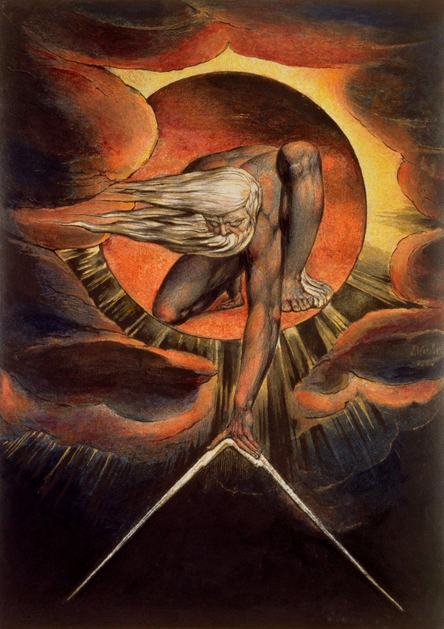

GNOSTIC COSMOLOGY

Act I - The All is One

- There is an original and transcendental spiritual unity (The First Principal, or God). This Perfectly Spiritual being did not create the material universe or reality, but the womb (which is called "Barbelo") and seed (which is called the "Panspermia") of the universe.

- Barbelo serves as the active, energetic complement to the God's passive principle of potential form; as the driving force behind creation, she represents fertility, birth and dynamic growth. If God is consciousness without separation, timeless and unchanging, then Barbelo is infinite consciousness overflowing into multiplicity, the mind of God at play with itself. Barbelo was "the first thought". The concepts of "Father", "Mother", and "Child" are expressions of the first thought. The verbal expression or product of the first thought is The Divine Self-Origionate, the Holy Spirit, or Anointed (Christ). This is to be the "blueprint" of the human spirit as we will see later. The fullness of all these apsects is called "The Pleroma".

- God came to emanate a vast manifestation of Luminaries and Aeons (concepts, realms, abstracts, angels or archangels) through a process of self-realization and refelction called emmision. These Aeons are "pluralities" or "dualities". One aspect being an androgynous, unified and singular being; and in another aspect divided into Male/Female entities, egos or personalities. In addition to the Luminaries and Aeons are other beings that dwell with them. These beings are the origional pool of "souls" or "spirits". The full mannifestation of God, The Divine Self-Origionate, and the Luminaries and Aeons is called "The Entirety".

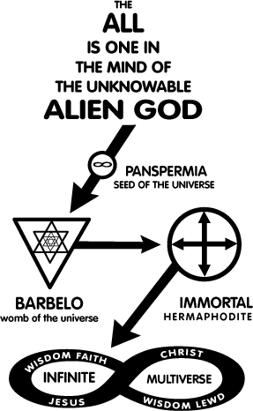
Act II - The Creation of the Material Universe

- The manifest universe of matter and mind (psyche) was not created by the original spiritual unity but by a "craftsman" or "Demiurge" who possesed inferior spiritual powers (compaired to the Aeons) and who often resembled the arrogant creator-god of the Old Testament Jehovah. The Wisdom of God (Sophia) was only indirectly involved in the cosmic creation.

- An Aeon called Pistis Sophia was the union of Sophia (Wisdom, forethought, femininity, the world soul) and Pistis (Faith, afterthought, masculinity, the world spirit). Sophia wanted to bring forth a likeness out of herself as God had done, but God and her consort did not approve of this. Acting alone, she exercised volition and became a product resembling the primeval light of God. Immediately her will manifested itself as a likeness of heaven. A veil was created between the Heaven above and the newly created Heaven below, and Shadow came into existence in a vast watery substance beneath the veil. The sorrow, grief, and terror of Sophia manifested itself into matter within the

shadow. Because of the invincible power which is in her, her thought did not remain idle, and within the shadow she birthed a being which was imperfect and different from her in appearance, because she had created it without her consort or the consent of God.

- The newly created spirit in the Shadow (Yaldabaoth, Saklas, Samael, "the craftsman" or "The Demiurge") saw nothing else, except for water and darkness. And when it was only himself that he saw then he supposed that it was he alone who existed. It appeared to itself as a spirit moving to and fro over the waters. The Demiurge saw a vast quantity of Matter without limit; and he became arrogant, saying, "It is I who am God, and there is none other apart from me!" When he said this, he sinned against the Entirety. And a voice came forth from above the realm of absolute power saying, "You are mistaken, Samael." And he said, "If any other thing exists before me, let it become visible to me!" And immediately Sophia stretched forth her finger and introduced Light into Matter; and she pursued it down to the region of Chaos. And she returned up to her light; once again Darkness returned to Matter. The Demiurge was enraged by Sophia's presence and the realization that he was removed from The Entirety, and used the divine energy he had stolen from her to shape worlds and beings of his own. He creates "Authorities" or "Rulers" to rule over and take charge of his creations, these are what we commonly refer to as "Angels", "Demons", "Seraphim", etc...

- The Demiurge separated the watery substance to one region, and the dry substance to another region. And from the watery matter he created a dwelling place for himself and his Authorities. He called it "Heaven." He further divided Heaven into seven Heavens. From the remaining dry matter he created a footstool and called it "earth" and placed it beneath the seventh Heaven, furthest from the veil that seperates his seven heavens and the true. The Demiurge supposed that he made these things of himself, but he made them after Sophia projected them. He made Heaven without knowing Heaven... he brought earth to light without understanding earth. In every case he was ignorant of the ideas of the things he made, as well as of his Mother; and he thought he was entirely alone. The Demiurge was unaware that Sophia was secretly forming the universe through him. The Demiurge used pre-existing materials and the blurry blueprints of a higher existance to build this universe to the best of his limited abilities.
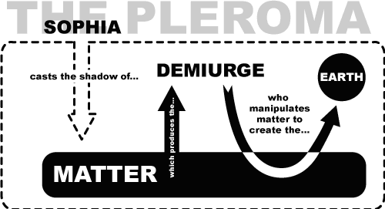

Act III - The Creation of Humanity

- Without a true understanding of the spirit, The Demiurge decides to create mankind. He does this for three reasons. Primarily as a tool to better understand the nature of God, the Holy Spirit, and the Aeons who dwelt above him, secondly to understand the power of pure creation which eluded him, and thirdly for slaves and a source of nourishment for himself and his Authorities. The Demiurge

and his Authorities labored to fasion the form of human being, but it was imperfect and was not animate. They struggled for some time to animate the human form but could not. Sophia (Wisdom) and the Holy Spirit saw this and pitied the being, and saw this as an opportunity to recover Wisdom's stolen power from her offspring. She counseled the Authorities to convince The Demiurge to blow some of his spirit into the matter to give it animation. He did this and the human form became animate, and his mother's power left him. The form became perfect, moved, became stong, and shown. The Demiurge and his Authorities became envious, because they had created him, and through the loss of thier own power the form had become more perfect, intelligent, and aware then they were.

- The Demiurge encased the human form in flesh to disctract it from it's true spiritual nature and then placed the form in the realm of matter "earth" to further shield it from the true nature of the universe. Because of the imprisonment of the material form, and banishment to the physical realm, The masculine and feminine aspects of the first human being "split" or "decoupled" into the physical aspects of "Male" and "Female". The Male and Female aspects of the human being were called "Adam" and "Lilith". They were placed in a physical paradise designed to serve as a controled environment and prison for them. Adam and Lilith began to fight. Lilith refuses to be subservant to Adam and calls upon The Demiurge to be removed from her slavery to Adam. Lilith abandons her physical form and leaves Eden. Then Adam was then alone in Eden.

- The Demiurge causes Adam to fall into a deep sleep and removes his Spirit to fasion Eve from it. Sophia and The Holy Spirit again felt pity, and gave to Eve the gift of the luminous afterthought, which is called "Zoe" or "Life". And they lived and in Eden for some time. The Demiurge and The Authorities were enamoured and jealous of Eve, and made attempts to defile her. Sophia mystically entered the serpent, and by tempting them to eat from the Tree of Good and Evil, taught Adam and Eve about their source, informing them that they were ultimately of holy origin and not mere slaves of the The Demiurge. Adam and Eve were then evicted from Paradise for acquiring knowledge or "Gnosis", The Demiurge and his Authorities sent them to the world we live in now, a grim arena of distraction and toil. No longer could they play, explore and imagine as they had in the Garden; instead, they would be occupied by worldly affairs instead of the Holy Spirit.

Act IV - Early Human History

- After thier expulstion from Eden, Adam was stricken with grief and would not be with Eve, and they stayed apart. During this time The Demiurge visited Eve and defiled her, fathering Abel (a just son) and Cain (an unjust son). Sexual intercourse origionated from the Demiurge and has remained. He sowed the seed of desire and procreation became an act of corruption. Also during this time Lilith came to visit Adam and defiled him, and thier union resulted in the "demons" which Lilith birthed. The Demiurge gave Adam and Eve the waters of forgetfulness so that they may not be reminded of thier nature and begin to populate the earth. Cain slays Abel, and is cursed to a life of exile. Afterwards Eve gives birth to Seth. Cain's line are human souls who are forever hidden from Gnosis. Through Seth's line are those human souls which are capable of Gnosis.

- Seth's decendants were becoming wiser and better. Envious and spiteful, The Demiurge and his Authorites decided to punish mankind with a terrible flood. Noah is told by The Demiurge to build an ark. Noah's wife, Norea, is the daughter of Eve and a knower of hidden things. Possessing more wisdom than her husband, she tries to dissuade her husband from collaborating with the schemes of The Demiurge, and ends up burning down the ark which Noah had built. The Demiurge and his dark angels then surround Norea and intend to punish Norea by raping her. Norea defends herself by refuting various false claims they make. Ultimately she cries out for help to the true God, who sends the golden Angel Eleleth, who saves her from the attack of The Demiurge's dark servants, and

also teaches her regarding her origins and promises her that her descendants will continue to possess the true gnosis.

- Man is just a means to and end, and one The Demiurge's objectives is the perpetual separation of humans from the unity (God). In the cosmos, space and time have a malevolent characteristic and may be personified as demonic beings separating man from God. Mankind may be personified as Adam, who lies in the spiritual deep sleep of ignorance, his powers of spiritual self-awareness stupefied by materiality and gender. For man, the universe is a vast prison. He is enslaved both by the physical laws of nature and by such moral laws as the Mosaic code. Earthly life is filled with suffering. In order to nourish themselves, all forms of life consume each other, thereby visiting pain, fear, and death upon one another (even herbivorous animals live by destroying the life of plants). In addition, so-called natural catastrophes -- earthquakes, floods, fires, drought, volcanic eruptions -- bring further suffering and death in their wake. Human beings, with their complex physiology and psychology, are aware not only of these painful features of earthly existence. They also suffer from the frequent recognition that they are strangers or aliens living in a world that is flawed and absurd. Human nature mirrors the duality found in the higher universe. The human being is a spritual soul trapped in a prison of flesh. The being which The Demiurge has created has both a Spirit (capacity for spiritual consciousness) and a Soul (the embodiment of the emotional and thinking functions of the personality). The human being is a composite, the outer aspect being the handiwork of the inferior creator, while the inner aspect has the character of a fallen spark of the ultimate divine unity. In this way, Man is a crude copy or clone of a truly spritual being clothed within the inferior building blocks of a material body.

Act V - Subsequent Human History

- The fallen sparks of transcendental holiness slumber in their material and mental prison, their self- awareness stupefied by forces of materiality, physicality, gender and mind. The slumbering sparks have not been abandoned by the ultimate unity of the True God, rather there is a constant effort that is directed toward their awakening and liberation. Among the helpers of the slumbering sparks a particular position of honor and importance belongs to Sophia. She was involved in the creation of the world and ever since remained the guide of her orphaned human children.

- The awakening of the inmost divine essence in humans is effected by salvific knowledge. That is, having the power or desire to bring salvation. This is called Gnosis. Gnosis is not brought about by belief, or the performance of virtuous deeds, or by obedience to commandments, for these can at best but serve as preparatory circumstances leading toward liberating knowledge. Gnosis is achieved when the Spirit (capacity for spiritual consciousness) and Soul (the embodiment of the emotional and thinking functions of the personality) are united. Before the awakening, men undergo troubled dreams. Man does not attain the knowledge that awakens him from these dreams by cognition but through revelatory experience, and this knowledge is not information but a modification of the sensate being. The awakening (i.e., the salvation) of any individual is a cosmic event.

- From the earliest times of history, messengers of light have been sent forth from the ultimate unity. The task of these messengers has ever been the advancement of Gnosis in the souls of humans. The greatest of these messengers in our historical and geographical matrix was the descended Logos of God, manifesting in John the Baptist, as handed down by the Knights Templars and the inner circle of the Cathars. The Mandaeans are the last surviving bearers of this knowledge.

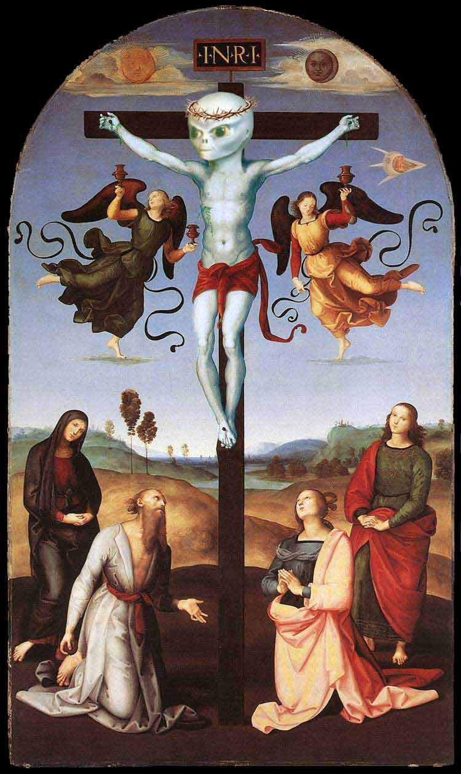

A R C H O N S
In the beginning there was a rebellion in h eaven and 1 / 3 of the angels fell into the material world. Our incarnated soul is a splinter of an angelic oversoul. The term Archon refers to servants of the Demiurge, the evil "creator god", that stands between the human race and a transcendent God that c a n only be reached through GNOSIS. The Archons are characterised as terrible forces of negativity and illusion. They are cosmic prison warders seeking to keep their human charges bound to earth. How? The seven Deadly Sins were inserted as archetypes into the soul when it incarnated on earth for the first time: Lust/Gluttony/Greed/Sloth/Wrath/Envy/Pride. Or in the words of Castaneda: „The predators gave us their mind“. Caught up in the illusions of material existence, man believes he is just a body and he cannot grasp the truth of his origin. This condition perpetuates spiritual blindness, leaving human kind in captivity to his prison guards. The Archons are tyrannical and limiting agencies who rule over humanity and creation in order to enhance their own self-importance and glory. It is incumbent upon the knower to realize this and to extricate himself from the grasp of these powers whenever possible. The existential predicament of human life lies in the uncomfortable dominance to which these lesser godlings subject the spirits of human beings, and from which only the experiential realization of gnosis can extricate them. The king of earth, the Rex Mundi, resides in the astral city of Shamballah.

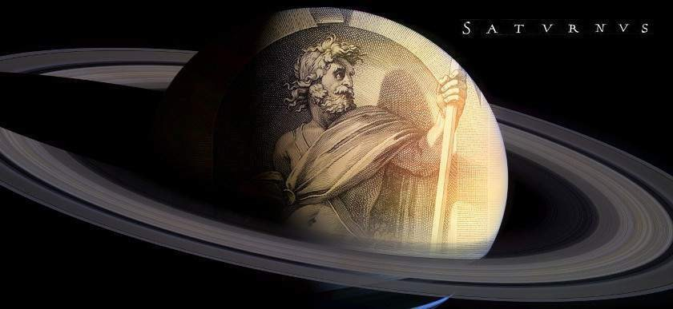
The Demiurge dwells on the astral plane of SATURN.

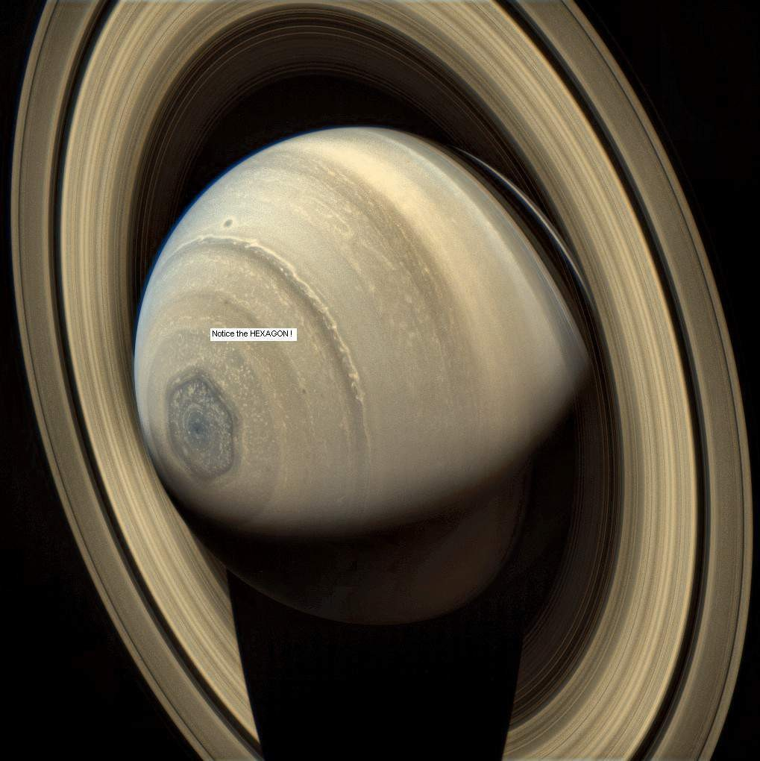

Saturn–Moon Matrix3
Your Reality is Being Hacked

“If you have a preconceived idea of the world, you edit information. When it leads you down a certain road, you don’t challenge your own beliefs.” -David Icke

„Icke’s claims about the Saturn/Moon Matrix dovetail precisely with my experience — both personally and as an astrologer — of how the 29.5 day cycle of the Moon keeps us hormonally tied to tiny repeating cycles and the 29.5 year cycle of Saturn locks us into societal structures beyond which we cannot see — until we attune to larger orders, beginning with the outer planet cycles of Uranus, Neptune, Pluto and beyond. But to do this is to leap off the cliff of mind-controlled “rationality” into the mysterious living universe.“ -Ann Kreilkamp

The questions are:
Is Saturn transmitting a frequency to Earth creating a matrix of illusions? Is the Moon part of this?
Can we do anything about it?
Who’s really controlling things on planet Earth and beyond?

Saturn – Lord of the Rings
The Reptilian Alliance’s modus operandi is the first trigger cataclysmic events on a target “world” or solar system, and wipe away the society that was there before. Then Reptilians genetically-engineer a new species that is designed to be “tuned” into their false reality – their “Matrix” – and the planet is hijacked along with the perception of the people. They have done exactly this to Earth and humanity, and their means of doing so are Saturn and
Saturn, the “Lord of the Rings”, is the master control center. Saturn is a
the Moon.
ginormous broadcasting system, and they will eventually find that the rings are full of
The rings
are not natural and at one time Saturn was a conventional brown dwarf. It had no rings. They have been constructed by the technology-obsessed Reptilian Alliance. Funnily enough, as I think about it an insider once told me of a photograph he had seen of an incredibly large spacecraft that appeared to be “repairing” one of Saturn’s rings. The process is ongoing, and they are continuing to construct others. In 2009, NASA announced that its Spitzer Space Telescope had discovered another ring circling Saturn from a distance
crystals rather than “ice” – a type of crystal that we aren’t familiar with on Earth.

- http://www.mazzastick.com/david-icke-saturn-moon-matrix-your-reality-is-being-hacked/

of some 3.7 million miles and going out to 7.4 million. It is so big that it would take a billion Earth’s to fill it. Some scientists say that Saturn’s rings were created by the debris from a disintegrated moon; but how would that create a ring 3.7 million miles away from Saturn that could hold a billion Earth’s? Saturn’s broadcasting system extends throughout the Solar System, but most of it is not on visible frequencies. Saturn is the “Lord of the Rings”. And how did JRR Tolkien (and film director Peter Jackson) symbolize the controlling force in the book and film of that name? As a fiery reptilian eye – the Eye of Sauron.

Saturn is the second biggest “planet” in the Solar System after Jupiter, and is the sixth “planet” from the Sun. Its rings and moons make it unique. Saturn is called a “gas giant” as with Jupiter, Uranus and Neptune, but it is habitable by very different entities to humans much closer to its material center and, as with everything, it exists on other ranges of frequency. Mainstream science says that Saturn radiates 2.5 times more energy than it receives from the Sun, and it generates an unexplainable constantly
– spinning six-sided hexagonal wave pattern at its north pole which rotates in sync with Saturn’s recorded radio emissions. A massive constantly-spinning storm system
captured at the South Pole also looks like an eye. Jupiter and Neptune also generate more heat than they receive. Saturn takes more than 29 Earth Years to complete a journey around the Sun. The “planet” (“dark sun”) has been known about since prehistoric times because it can be seen from Earth, but it was only after the development of strong enough telescopes that the rings were able to be seen. Babylonian astronomers recorded the movements of Saturn, and it was worshiped by the Romans as the god, Saturn (the Greek “Cronus” or Kronos).
There is no coincidence whatsoever in Saturn having so many moons. More than 60 have been discovered so far. They comprise, with the Saturn dwarf, a mini solar system and the same with Jupiter and it’s at least 63 Moons. Most of Saturn’s moons derive their names from god Saturn’s brothers and sisters, the Titans and the Titanesses. Small Saturnian moons discovered more recently have been named after Inuit, Gallic and Norse gods and goddesses. None of this is by chance, and all are different names for the same deities in different cultures. Saturn’s biggest moon, Titan, is the second largest in the Solar System behind the Jupiter moon, Ganymede, and is twice as big as our own moon. Titan, Ganymede and other major Jupiter moons, Io, Europa (the European Union goddess) and Callisto, are really planets, though they are known as moons. Titan, Ganymede and others also play a very active role in the Saturn – Moon Matrix and I am sure we will see the role of Jupiter in all this eventually. Even mainstream scientists have suggested that some form of life could exist on Titan and another Saturn “moon”, Enceladus. Saturn is communicating with the major moons/planets and many not so major ones in our solar system. I suggest that Earth’s moon was once in that group around Saturn, and at least many of them are the same in nature. They are computer systems, amplifiers and satellites of the Saturn broadcasting grid and they go out as necessary to target other worlds. Saturn is not their only hijacked and converted brown dwarf either. They are experts at this.

Saturn – The All Seeing Eye
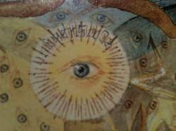
Saturn was often symbolized as an eye by the ancients and that is a likely origin of the all- seeing eye, one of the major symbols of the Reptilian-hybrid bloodline network. I went to the subway station right next to Ground Zero when I spoke in
New York in 2010. The station has mosaic eyes on the walls all along the platforms, and a large depiction on the floor of an eye broadcasting frequencies across the planet. The eye is almost certainly meant to be Saturn (Satan). The image perfectly portrays what Saturn is doing.
Saturn Hacks into the
waveform information broadcast from the center of the galaxy
into the Solar System. The Moon amplifies this and beams it specifically at the Earth. The fantastic synchronicities between Earth, the Moon and the Sun in size, geometry and position, are all made possible by the Moon. These synchronicities are connected to how the Sun’s information is hacked by Saturn and the Moon. The Moon is where it is because it was specifically placed there.
via the Sun and broadcasts a fake reality
Visible light and the electromagnetic spectrum that science can record is the matrix, the false reality. And “God” said, “Let there be light.” The speed of light which we are told is the fastest speed possible (rubbish) is the vibrational “wall” of the matrix. We are not even living “on” the Earth as it really is. Some of it is “original”, but there are many holographic implants that change it for our perception. The Matrix broadcasts block humans from perceiving what we otherwise would be experiencing. The Earth that we can’t see (or feel too often) is a place of love and harmony – not war, fear and suffering. The predators dictate our lives and make us into slaves to them by hijacking our sense of reality. The Saturn-Moon Matrix transformed a once-vibrant, conscious humanity into computer programs decoding cycles of repetitive perception and behavior. The transmissions of the Saturn-Moon Matrix are received and re-transmitted by the Earth’s crystal core which has been tuned to the Matrix frequency range, and the “Hack” connects with us through the reptilian brain and the receiver-transmitter system that we call DNA.
This brings us back to “junk” DNA and what Professor Sam Chang from the Human Genome Project said earlier – that the overwhelming majority of human DNA is of “off- world” origin and the “extraterrestrial junk genes” merely enjoy the ride with hard-working active genes passed through the generations. He said:
What we see in our DNA is a program consisting of two versions, a big code and basic code. First fact is, the complete “program” was positively not written on Earth; that is now a verified fact. The second fact is that genes, by themselves, are not enough to explain evolution; there must be something more in “the game”… Sooner or later we have to come with grips with the unbelievable notion that every life on Earth carries genetic code for his extraterrestrial cousin, and that evolution is not what we think it is. Our hypothesis is that a higher extraterrestrial life form was engaged in creating new life and planting it on various planets. Earth is just one of them. Perhaps, after programming, our creators grow us the same way we grow bacteria in Petri dishes. We can’t know their motives – whether it was a scientific experiment, or a way of preparing new planets for colonization, or the long-time ongoing business of seeding life in the universe.

Professor Chang also said that the “alien” parts of “junk” DNA have “their own veins, arteries and immune systems that vigorously resists all our anti-cancer drugs”. The DNA implanted by the “extraterrestrials” is pre-programmed, and one effect of the Saturn-Moon Matrix is to activate those programs to play out as “spontaneous” human behavior and a sequence of “time”. The Matrix acts like a laser reading computer software or a DVD. It brings the pre-programmed information in human DNA onto the “screen” – our decoded reality. The “software program” is running in every human mind – body computer and it has been encoded for eons. Remember how Rebecca Cann, Assistant Professor of Genetics at the University of Hawaii, co-authored a study in the journal, Nature, saying that all modern humans are descended from a single mother who lived in Africa in about 200,000 B.C.? If what we call humans originate from a single source the program could easily have been implanted that would infiltrate every subsequent member of the “species” (software). Only by becoming Conscious beyond mind – body can we override the program. It has become so clear to me while writing this book that the extent of human behavior programming is absolutely fundamental. I understand from people who read papers by molecular biologist, Francis Crick that he believed that DNA was pre programmed. Crick appears to have known far more about DNA than was made public, and he believed that it was made of “extraterrestrial” origin.
So the Matrix illusion is so deep, so ingrained, because it is not only a Matrix field, but a DNA program. The “Queen Bee” (Saturn-Moon) broadcasts the waveform information “hack” and humans decode this into a world they think they see, and perceptions and behaviors they think is “them”. We can be completely controlled by the Matrix and be no more than human robots responding to data input, or we can open our hearts and minds and see beyond what others can see. This means opening our minds to consciousness which is not subject to the manipulation of the Matrix or the DNA program. It operates outside of “space” and “time” and beyond the vibrational walls of the Matrix. If you look at all the incredible and endless interconnected manipulations that I will describe in this book4 – and there are so many more – this clearly could not have been organized by people sitting around a table deciding their next move. How do they do it? Was there a computer system spewing out data on what to do and when? But I can see it clearly now. Those in authority who run and enforce the human Control System are following a program in the same way as worker ants and bees follow the program broadcast by the Queen. They are computer terminals on the Matrix Internet with the Saturn-Moon Matrix triggering their already programmed DNA to respond according to the program. The bloodlines (Illuminati – Dark cabal – Those appointed to positions of power) are the most locked-in because they were genetically-created for that purpose, but anyone who is not truly conscious (most of humanity) will be responding to their DNA Saturn-Moon Matrix program which drives their thoughts, perceptions and behavior.

How Your Reality is Being Manipulated
The Saturn-Moon Matrix is decoded within the electromagnetic frequency range visible to human sight and technology, and the genetic-engineering of the human mind-body computer locked humans into that frequency via DNA and the reptilian brain.
- Icke, David - Remember Who You Are. Remember „Where“ You Are and Where You „Come“ from. Remember ...

Consciousness can, however, override that and so they have to maintain humanity in low- vibrational states to imprison their perception in the Matrix. The plasma field within our holographic reality acts like a “plasma screen” on which we “watch” the “picture show”, or appear to. It is an expression, like everything, of decoded waveform information. People go through their lives following the Saturn program they are decoding while thinking this is the “real world”. Humans are like two-legged farm animals caught in the headlights of an oncoming Matrix.
The reality we are being fed is encoded with perceptions and experiences that cause people to transmit low-vibrational emotional energy that both feeds the Reptilian Alliance and, in many ways, helps to power the system The virtual-reality “game” is interactive, and so is the hacked version. We receive and transmit, we receive and “ post“. The Saturn- Moon Matrix has created an energetic perception “loop” in which the false reality is fed to us, and, when we perceive it and believe it, we feed back that perception to the Matrix. This constantly empowers the false reality in a feedback loop. In Short, the matrix is powered by our belief that the hacked reality is “real”. We can and will break the closed loop with the realizations that I am describing in the book, and by opening our minds to Consciousness beyond the Matrix frequencies. The power of the Saturn-Moon Matrix to influence our reality dilutes and dilutes the more we open our minds and hearts and let Consciousness in. The Control system is terrified of the Truth Vibrations for this reason, and this is why it is now throwing everything that it can at humanity to keep us entrapped within the vibrational box through fear, chaos and upheaval. By the way, some unexplainable and “paranormal” experiences happen when there is a “glitch” in the Matrix information field. As I write, there are many reports from around the world that the heavens have changed, the constellations are not where they should be and that the Moon has changed its angle. This is the result of the Reptilians manipulating the Matrix to confuse us and prepare us for the fake “end of the world” or “new world” prophecies by the Bible, the Mayan Calendar, Hopi prophecies and all the rest. They are not true. They are part of the manipulation and the Reptilians plan to make it seem as if they are happening by manufacturing events. They are already doing so. It was all planned a long “time” ago.

Reptilian Brain – Reptilian World
One of the chief ways the Matrix connects with us, not surprisingly, is through the reptilian brain, and this helps to lock us into the Reptilian Alliance control system. The Matrix transmissions are also aimed at our DNA receiver-transmitter systems, and much of this is happening within the realms of what science calls “junk DNA.” Some of this has been switched off in order narrow our band of experienced reality, and some is picking up the Matrix frequencies by carrier waves from Saturn via the Moon. The Saturn-Moon Matrix is how they have done it. Humans tuned most powerfully to the Matrix transmission (the overwhelming majority) are like worker ants following the work-plan broadcast by the Queen. Ants are said to communicate through chemicals called pheromones, but they are only the chemical expression of vibrational communications. Ants tune in through their antennae and we pick up the Matrix broadcasts through DNA and the reptilian brain. The Reptilians have a hive-mind communication system which the

Matrix connects with, and it would appear that at the center of this is their version of the female “queen”. Maybe the worship of the “goddess” is something to do with this and certainly the hybrid bloodline is passed on through the mitochondrial, or female, DNA. The Illuminati Reptilian hybrid bloodlines are the agents of the Matrix within the Matrix – the “Agent Smiths’” if you like, portrayed in the Matrix movie series.

The Matrix “mind” is the controlling force behind all the institutions of human control and those who run and administer them while being unknowing prisoners of the Matrix themselves. I explained earlier how the reptilian brain doesn’t think – it reacts; it is constantly scanning the environment in search of threats to its survival physically, financially and across the great spectrum of human experience – reputation, job, relationship, the list goes on and on. They need to feed us an
endless stream of reasons to fear not surviving, to connect us more powerfully into reptilian-brain reality – therefore Matrix reality. These emotional states affect the way DNA receives and transmits, and cause heart rhythm incoherence and scrambles the relationship between heart, brain and nervous system. This is another crucial reason why we are bombarded with wars, financial collapses, false flag terrorist attacks, health “scares”, “global warming”, engineered “natural” disasters and all manner of other things. This way they can most powerfully plug us into the Matrix and energize it through the “feedback” loop. To get a better understanding of how our reality can be manipulated watch the movie by Director John Carpenter: They Live

Other Sources – Confirmation of Truth
I said earlier how often, when I have gone public with something that is “far out” to mainstream society, that I will later get a sudden confirmation that I am on the right track. I am not saying that every last detail is 100 percent accurate, and I never have. I was sent an email about nine months ago after Human Race Get off Your Knees was published. The writer said she had read the book and had seen the Moon information and she recommended that I check out a book called Earth by Barbara Marciniak. Barbara Marciniak is a “channel” who became well known in “New Age” circles in the 1990’s for communicating with an awareness that said it was connected to the cluster of stars known as the Pleiades. The communications spoke of how a reptilian race was manipulating humanity. I met Barbara a few times and liked her a lot. She is grounded and not at all airy-fairy. I had read her book, Bringers of the Dawn, which was excellent, but I had not read Earth (Bear & Company; 1994). When it arrived in the post I went to the page numbers that the email had told me about… Well!
This is what the book said was communicated through Barbara Marciniak:
…the Moon is a very powerful electromagnetic computer… The energy from the Moon has been beaming electromagnetic frequencies onto the Earth for aeons now to maintain the two- stranded DNA (it is said that is should be twelve-stranded)…

…The Moon is a satellite that was constructed… it was… anchored outside Earth’s atmosphere for aeons as a mediating and monitoring device, a super computer or eye in the sky.
…Earth must be owned by those who dwell there; however it is not. You have outside gods, creator energies, who prevent you, as a species, from having free-reign with your kundalini…
The influence of the Moon, as a main satellite computer, affects all of the Earth… The Moon’s programs have for aeons been of great limitation toward human beings… These are repetitive cycles that the Moon creates, to which you respond.
Moons like ours can also be used to influence planets in a very loving and positive way and it is possible that the Moon was doing that before it was hijacked by the Reptilian Alliance to be a means of mass manipulation and control. Barbara Marciniak’s channeling points this way and I am open to that. We need to be flexible about detail and let information be our guide, not unyielding dogma. In that case, removing the Reptilian Alliance from the Moon and changing what it broadcasts would have a life-changing effect on this planet and its inhabitants. Simply switching off the Reptilian broadcasts would change everything, too. Barbara’s channeling for her book indicates that other non-human forces are in the processof intervening in the Reptilian control of the Moon and I have come across similar information. I understand all these years later that this intervention is significantly advanced. I would strongly emphasize that we are not alone in meeting the challenges that we face – the bloodlines just want us to think we are. There is a multi- dimensional effort going on to set the planet free from aeons of Reptilian/Gray control and this will succeed. We need to play our part in our level of reality while others do their job elsewhere. This dismantling of the Reptilian Control System is not only to help humanity. What is happening here is having a knock-on effect across a wide area of the galaxy and beyond because of how a smaller part of a hologram can affect the whole.

Barbara Marciniak’s channeling for Earth said:
There have been many battles over the Moon… There is a plan to gradually insert different programs of influence on Earth when the Moon becomes occupied by forces that would assist in your growth rather than limit you.
The Moon’s programs have for aeons been of great limitation toward human beings. The tales about the full moon and insanity, madness and heightened bleeding are all true.
There are repetitive cycles that the Moon creates to which you respond.
It is the extraterrestrials that really operate it all. Your technology, though rapidly advancing, cannot begin to compare with the biotechnology (including genetic engineering) of sentient space travelers.
You are newcomers to the game and you miss a vital key, for your senses, and the essence of your physical world, structure reality in a particular way.
You constantly translate data and, like interpreting a dream, condense the experience into physical boundaries, where you find you can explain less and less.

(Bashar (Buh-Shar), the extraterrestrial entity that is channeled by Darryl Anka also said we are leaving an age of limitation and entering an age of limitlessness).
This is what I have been stressing all these years and throughout the book – we are being manipulated to decode reality that keeps us limited and enslaved. I came across this quote, too, at about the same time from the famous Armenian-born mystic, George Gurdjieff.
He said in 1916:
All Movements, actions and manifestations of people, animals, and plants depend upon the Moon, and we are controlled by the Moon… The Mechanical part of our lives depends upon the Moon, is subject to the Moon. If we develop in ourselves consciousness and will, and subject our mechanical self and all our mechanical manifestations to them, we shall escape the power of the Moon.
The Saturn-Moon Matrix operates within the frequency range of mind, the electromagnetic spectrum and low-vibration emotion. When we open our minds to Consciousness our perception expands beyond the influence of the Matrix frequencies. We can suddenly perceive what we were blocked from perceiving and we begin to see what is really going on.
I was shown an article on the day I am writing this that told the story of something called the “Chani Project”. This was claimed to involve a secret technology located in Africa which made contact in 1994 with an entity from a parallel universe, and the communications continued for the following five years. The article said that the entity was asked more than 20,000 questions. “Chani” is an acronym for Channeled Holographic Access Network Interface. The entity was asked in one interaction what was the purpose of our Moon? It said that “life became better with no Moon” and was not a natural heavenly body. The Moon was there to control the Earth “mood”, it is quoted as saying. A “big calm” would come over the people without the Moon, and there would be no “big storm” – just a “little storm”. There would be peace among the people without the Moon. Funny how this “no- Moon” world is exactly how I am describing the Real Golden Age before “The Hack”. The communications alluded to the fact that an “old race” captured the Moon “from space” and put it next to the Earth. This is what Zulu legends say, and what my own work supports. The Chani communications indicated that “Moon Forces” operated like a time machine to control time and manipulated the mood of “beings on this planet in this timeline.”
The most ancient human accounts do not mention time. It is an illusion of the Matrix, and time was encoded to enslave humans by disconnecting us from the NOW. I can see very clearly as my understanding expands that the “Time Loop” is the Matrix. The time loop is what has been hacked into the limitless NOW-reality that we should be experiencing. Saturn is associated with time and “Kronos”, the name of the Greek Saturn God, means “time.” He is the symbol for Father Time. The two clocks on either side of the main entrance to St Peter’s Basilica in Rome are symbols of this Saturn – Moon control of our perception of time, and so is the clock face in general. Interestingly, the Chani “ entity” also talked about the “reptile” holding humans back so they could not “grow”, and how they had won a “war” with the reptiles in its own reality. “We kill many dragons [in] many timelines”, the communication said. The entity is reported to have added that humans had

evolved more “spiritually” than the reptiles that it was talking about, but the scaly guys “want to hold onto their wise technology… their god is their technology”. I have been saying this in my books for years. They are very developed in their intellectual, technological mind, but they are not “spiritually” conscious. They have sought to make us the same by “giving us their mind”. The Moon has not always been there and some ancient legends say the same. They tell of a time “before the Moon”.
Ancient Greek authors, Aristotle and Plutarch, and Roman Authors, Apollonius Rhodius and Ovid, told of a people called the Proselenes in Arcadia who said their ancestors had been there “before there was a moon in the heavens”. “Proselene” means “before Selene” – the Greek goddess of the Moon, and a name often used for the Moon itself. Roman writer, Censorinus, also wrote of a time aeons ago when there was no Moon. Dr. Hans Schindler Bellamy includes the same theme in his work, Moons, Myths and Men. He tells of the “Mozces”, a native tribe in Colombia that say they “remember a time before the present Moon became the companion of the Earth”. Some Babylonian depictions of the Moon in the 11th century BC locate it between Venus and the Sun. I know that some people will say that the Moon always had to be there or the Earth would be unstable and nothing like it is, but we are not talking about the same planetary alignments we have now before the Moon came. The Solar System was very different to what we see today.

Saturn Astrology
The representation of Saturn in astrology fits the bill perfectly. Saturn is the planet (sun) of death, restriction, authority, control, obedience, poverty, fear and time. It rules the bones of the body and so you have the skull-and-bones as a major symbol of the Saturn controlled Illuminati. The Skull and Bones Society is really the Saturn Society. Saturn is the astrological ruler of institutions, corporations, figures in authority, scientists and old people. It represents laws, rules, regulations and “tradition” (repeating ritual). Saturn is non- emotive and represents limitation, austerity, discipline and depression. The term “Saturnine”, meaning to have a gloomy, taciturn temperament, has an ancient origin related to the influence of Saturn. What am I describing here? The very world we live in, and ever more so. I am describing the way that human society has been constructed; the way secret societies operate with all their rules, rituals and hierarchy; and all the pomp and ritual surrounding the British Royal Family and their kind. Planet Earth is a Saturnian society controlled from Saturn via the Moon and the Illuminati hybrid bloodlines. This makes so much sense of what has happened to the world, and what is happening. Notice how the traits and influences of the Saturnian are the same as the Draconian – the Reptilian “hive” mind. The Saturn-Moon Matrix reflects the hive mind of the Reptilians that control Saturn and the Moon. The Reptilian hive mind has hijacked the human mind via the Reptilian brain and the Moon Matrix.
Open your mind and you will see what has been purposely hidden from you.
Saturday = Saturn Day Sunday = Sun Day Monday = Moon Day

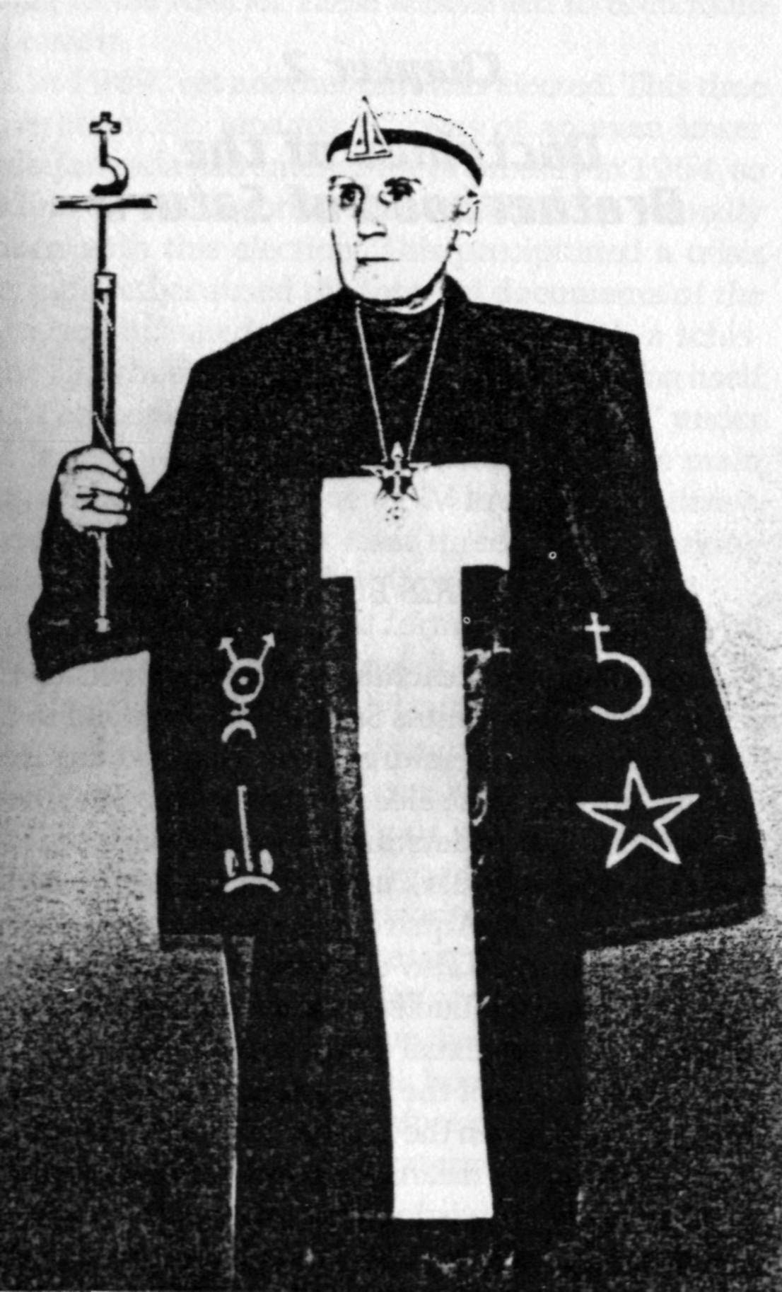

FIRE & ICE: MAGICAL TEACHINGS OF GERMANY'S GREATEST SECRET OCCULT ORDER5
Saturn-Gnosis
The gnosis of the Fraternitas Saturni (=FS) is a complex set of magical doctrines. These include a special path of initiation as well as a complete astral or planetary cosmosophy and a Luciferian element. In many regards the Saturn- Gnosis is in accordance with what is known of the Ophite and Barbelo Gnostic sects of antiquity. Gnosis is a form of knowledge concerning the cosmos to which the individual feels called, or "elected," and which is based not on the belief in certain dogmas but rather on deep personal experience. Although in ancient times Gnosticism existed in a myriad of often mutually incompatible sects, there were certain doctrines common to most of them. First, they held that there existed a godhead beyond all categories as well as a threefold god subsisting in the fullness of being (pleroma), or light. This divine realm of fullness of being transcends the place in the world where matter exists; these two realms are separated by a great barrier (horos or ouroboros). How these realms became separate is a matter of diverse speculation, however, what is certain among the Gnostics is that our material world was not created by the god of light, but rather by an entity that resulted from a deficiency in the pleroma. This deficiency came about either through progressive degeneration as the outflow of being got further and further from its source, or through a conscious withdrawal of divine will (thelema) from the outer reaches. By whatever process,
lesser
independent entities arose in the graduated levels (called aeons) of the new cosmos. These entities were called archons. One of these archons is the entity—or demiurge—that created
This entity is identified by some Gnostics with Jehova (YHVH), the
our world of matter.
god of the Old Testament. Finally, it was held that man, as a mixed entity consisting of elements with origins in both the world of light (of God) and the world of darkness (of the demiurge), could only be redeemed by knowledge (gnosis). This knowledge was a direct experience of being, not something acquired by learning or even by conclusions reached by logical methods. The demiurge Jehovah demanded faith (pistis); the "Good God" could only be reached through gnosis.

The Saturnian Archetype
From the perspective of FS teachings, the essences of the planets are complex entities. The central focus of the Brotherhood is the Saturnian complex, which we will refer to here as an "archetype." From an aeonic perspective, the planetary complex surrounding Uranus is also important in FS teachings.
In the Saturn-Gnosis the planet and archetype of Saturnus is the
. This Demiurge is identified with Lucifer
focal point for the manifestation of the Demiurge
— the Bearer of (false) Light—as the higher octave of Saturn. According to secret FS teachings, Saturnus is the Great Judge that manifests „justice“. He is the Lord of the Seven

- http://www.american-buddha.com/nazi.fireiceflower.2.htm

Dwellings (= planetary genii of the outer realm), and governor of the revealed world and lord over life and death, and over the light and darkness. Saturnus is seen as the breaker of cosmic order and unity—thus he instituted death, causing regeneration and change to come into being. This Demiurge Saturnus is identified with the number 666. He is the Beast 666, manifest in the Man (or Men) 666, and in the Living Center of the Sun—Sorath 666.
Besides these general teachings on the nature of the Demiurge Saturnus, the FS has a special doctrine, particular to it, concerning an entity attached to the planet Saturn and active on the Earth, called the GOTOS. This is the specific egregore or daimonion of the Brotherhood, of which the Grand Master 33° is the personal representative. The GOTOS functions in a way similar to the way the Secret Chiefs worked in the Golden Dawn system. The belief of this system of lodges having hidden, praeterhuman intelligences at their esoteric heads is commonly held in the FS. Members would, for example, say that Baphomet was the lodge daimonion of the Knights Templar. The daimonion GOTOS is understood as a preexisting entity, but it is also used as the egregore of the lodge. An egregore is a sort of "group spirit" or thought-form magically created by a community of people from its collective ideals. The egregore can be seen as a collective hypnotic suggestion which can be experienced directly, if subjectively, by the participants in rituals wherein the egregore is invoked. This tends to take on objective reality as the experience of the egregore becomes an experience that is shared within lodges. GOTOS is defined in the following terms: "The GOTOS, as a magnetic accumulator in the Saturn-sphere, stores . . . projected magical powers in the causal sphere through the Chain of Brotherhood."

Astral Gnosis
As the name of the order indicates, the Fraternitas Saturni places a heavy emphasis on astrological doctrines or astrosophy. The teachings which involve Saturn are derived from a basically Gnostic cosmology, in which the planet Saturn is identified with the Demiurge and with the Guardian of the Threshold (Hüter der Schwelle), who comes between the initiate rising through the planetary spheres and their access to the firmament and the (false) „light“. As mentioned before, the archetype of Saturn as portrayed in the FS is a manifold which fits into a complex cosmology. According to FS doctrines, on the seventh day of creation an angel (= Lucifer-Saturn) emanated from the Absolutum (= the Kabbalistic ainsoph). This angel was given rulership over the outermost sphere and became the Guardian of Time and Eternity. This entity stood at the outer limits of the limitless, girding itself in space and being and all creation. (The Gnostics also sometimes ascribed this function to Leviathan—the ouroboros—the serpent at the edge of the firmament grasping its own tail.) This angel, or god, rebelled against the static, established cosmic order and set into motion the forces of change and evolution, which also imply death and destruction. This rebellion is referred to in Judeo-Christian mythology as the "War in Heaven," and the angel or daemon is sometimes identified as (Hebrew) Abadon or (Greek) Apollyon. Reference to this may be found in Isaiah 14:12-15 and in Revelations 9:1. By breaking the static cosmic order the Rebel—Lucifer—became the creator of the visible world. This battle still rages between the polar opposites of the outer Saturnian sphere and the inner Solar Logos, with the Earth in the middle as the main field of battle.

SATURN, TWILIGHT LANGUAGE
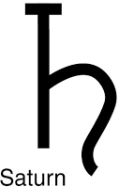
AND COMMUNISM


This is a post someone had sent to me and I thought it was excellent so I am posting it here. I added the title, Saturn sigil (hammer and sickle) and Communist flag. Illuminism (SATURNALIA) is Communism.

"The glyph for SaTurn is comprised of a cross with an elongated bottom (T), and a backwards S connected to the bottom. *ST can be expressed hieroglyphically as $ symbolizing the serpent and the T, the cross or the tree of life. It is the life (serpentine) force pushing thru the growing point, threshold or “site”. Through the pairing of the S and T strongly accents
foundation, the “seat of consciousness. Set, the oldest Egyptian god, forms the basis of all other gods, and being so basic or low he is considered evil. I’ll add that originally the crucifix was represented by a cross with a serpent on it. The body of Jesus on the cross came much later… We are into primal stuff here, and Saturn is the one who held the boundary to the universe as we knew it for 1000’s of years Linguistically, SaTurn = ST. ST words abound with SaTurnine meaning. Here are just a few:

SaTan, STructure, STatus, STate, conSTriction, conSTruction, STern, SeT, STone, STuck, STand, resiST, teST, STasis, sySTem, STabilize, eSTablish, eSTate, STandard, cryStalize, STress, conSTant, STiff, obSTinate, liST, STrain, STrict, STatement, etc… How do you give additional STructure to our number sySTem? With ST, of course. We measure things againST the firST (1ST) and the laST. How do you give STructure to countries? With STatutes of STate. STructure urban geography? With poSTal STreet addresses, How do you SeT something in memory? STudy it! Give STructure to a process? With STart and Stop.

We even have a part speech built around the ST of SaTurn. Adjectives describe things— SaTurn defines the outer limit of things. It is the limit of our sensory perceptions. Big, bigger, biggeST, Hot, hotter, hotteST, Many, more, moST, ect… All adjectives have a comparative and superlative form. The superlative form is the limit. You cannot get any colder than the coldeST, ST is SaTurn, It is the limit!"
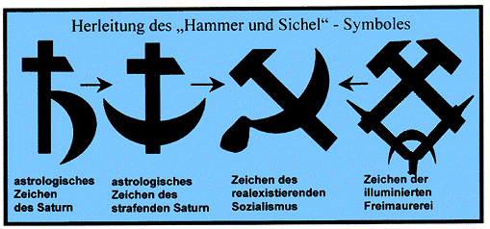

THE FLOWER OF LIFE: A BLACK MAGIC SYMBOL
The Flower of Life is the modern name given to a geometrical figure composed of multiple evenly- spaced, overlapping circles. They are arranged with a sixfold symmetry. The most common form of the “Flower of Life” is hexagonal pattern, where the center of each circle is on the circumference of six surrounding circles of the same diameter – notice the Hexagon on Saturn!
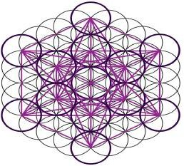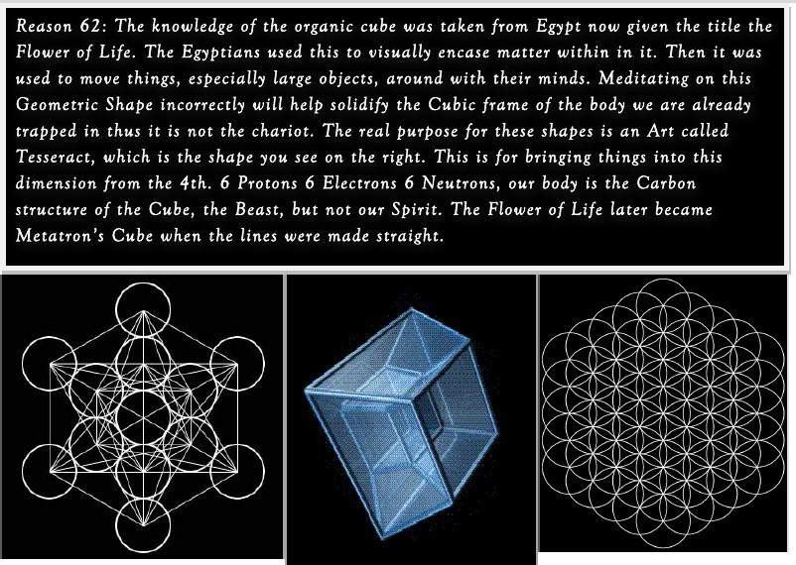
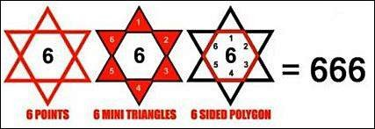
Solomon’s Seal, which is the Star of David was designed to trap things. When Solomon would seal Jinn in bottles he would put the Star of David on top. Even Metatron’s cube which has hit the #1 spot in Sacred Geometry is none other than a hex used time and time again to keep souls which are seeking higher truth passing back and forth between this demented dimension and Saturn. It is a mental weakening tool as many have already admitted since its main purpose is only to weaken the cube, it should never be placed in the mind. And - the world grid, which invisibly encircles the planet, is based on ‘the complete flower of life’ and the hexagon/hexagram. The diameter of the first circle was calculated by drawing a line from Orkney to Stonehenge (coincidently the line happens to pass through Rosslyn chapel which is exactly in the middle, this could be the real ‘rose line’). All of Europe’s ancient sites (stone circles symbolizing the flower) can be found lying on one of these lines. The grid also links all of these ancient sites together. Many of the oldest sacred sites lie at the centre of six points. Also - the Flower-Symbol is charged. If you stare at it long enough, you can see the outline of any desire. In fact, many secret societies still use this image to pass along messages.

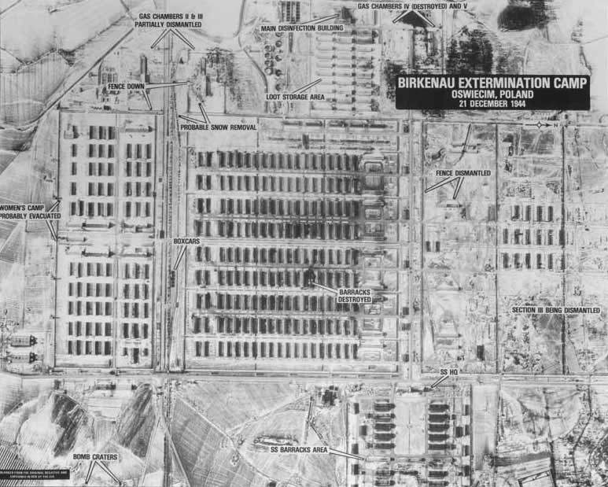
What do you see?
So the Nazis were able to build concentration camps in geometrically perfect shapes and forms.
But you would in no way consider this geometry to be holy or sacred. Then what do recurrent hexagonal [=666] structures in nature prove?
What if God was not the creator?
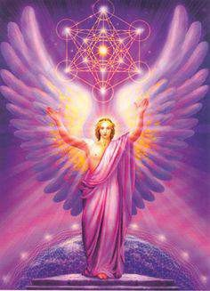
And what if the Demiurge is just insane and intelligent?

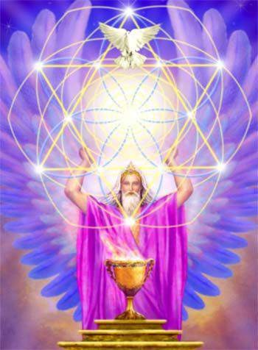
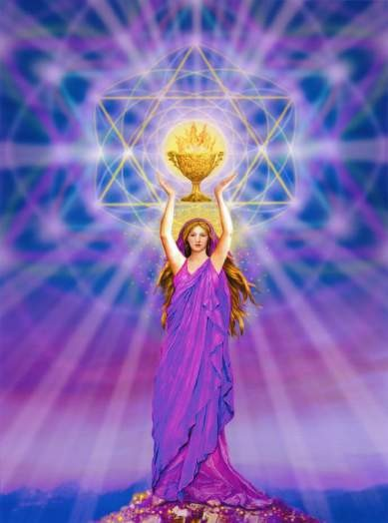

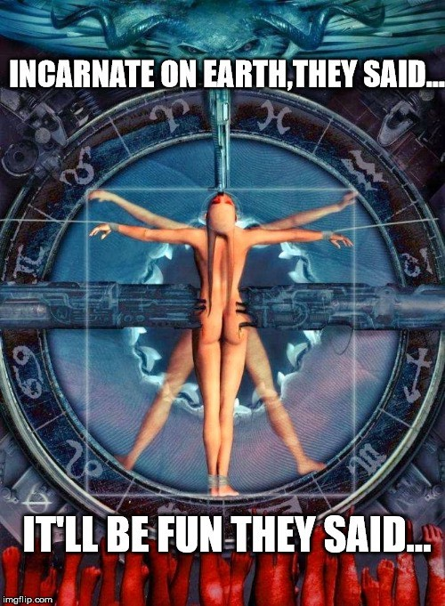

FOOD FOR THE MOON
The moon is more than just a pale satellite of interest to poets and astronomers. Its influence goes beyond merely creating ocean tides or driving biological cycles. More importantly, the moon exerts a significant influence upon the mechanical, emotional, and psychological states in man. The werewolf myth and superstition concerning full moon lunacy are not far from the truth. Certain lunar phases heighten the possibility for emotionally draining situations and stimulate reactivity and sensitivity in vulnerable individuals. Personal observation reveals what numerous esoteric sources have explained at length, namely that we are food for the moon.

Gurdjieff and Ouspensky
Fourth Way philosophy aims to strip man of his mechanical behavior and hypnotic programming in order to build within him a core of heightened consciousness. It is an esoteric system assembled from incomplete fragments of inner Christianity and Sufism. It’s founder, Georges Gurdjieff, frequently admonished the thoughtless mechanical behavior of humanity and was fond of saying that we are “food for the moon.” Among the many hundreds of references to the moon in his various works, in 1924 in New York, Gurdjieff said the following:
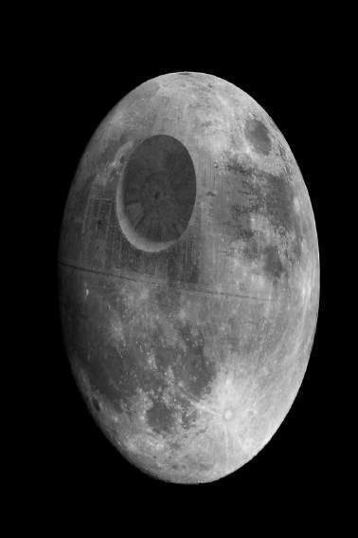"The moon is man's big enemy. We serve the moon. Last time you heard about kundabuffer. Kundabuffer is the moon's representative on earth. We are like the moon's sheep, which it cleans, feeds and shears, and keeps for its own purposes. But when it is hungry it kills a lot of them. All organic life works for the moon. Passive man serves involution; and active man, evolution. You must choose. In both cases we are slaves, but there is a principle: in one service you can hope for a career; in the other you receive much but without a career. In both cases we have a master. Inside us we also have a moon, a sun and so on. We are a whole system. If you know what your moon is and does, you
the moon acts as a giant electromagnet pulling upon all organic life on earth and sucking into itself the soul
According to Ouspensky,
can understand the cosmos."
(Views From The Real World, page 198, E. P. Dutton 1975)
P. D. Ouspensky, one of Gurdjieff’s most prolific disciples, lectured at length concerning the moon’s role in human affairs and its place in the cosmological scheme of things. It is reasonable to assume what Ouspensky wrote about the moon accurately reflects what Gurdjieff taught him.

. The moon is an embryonic planet receiving its nutrition from organic life on earth through an etheric umbilical cord, an energy conduit
essence of dying creatures
between earth and moon. In man, the moon drives his mechanical aspects like a pendulum moving the gears of a clock. The degree to which one’s actions are

driven by the moon is proportional to one’s level of reactivity and non-being. For people incapable of moving themselves through life by nobler spiritual impulses, the moon provides a propulsive force. Without this force, mechanical individuals would be passive as puppets without a puppeteer. Ouspensky went so far as to say that the very physical motion of our limbs was made possible thanks to the moon. Other Fourth Way initiates like Rodney Collin explained that because our body was largely made of water and the moon pulls on water to create the ocean tides, our bodies are made to move in similar but more complicated ways through hydraulic principles. The moon’s gravitational field pulls on all masses equally and is not strong enough to have any measurable physical influence over the motion of water within the body. It would be more accurate to say that the moon exerts some subtle influence upon the organs of our etheric body responsible for initiating neurochemical impulses that trigger habitual motions. Such mechanical behavior may therefore be driven by the moon, but not necessarily via crude physical means. The moon is therefore an important factor in driving our mechanical actions. As long as its influence is limited to such effects, the moon is doings its job properly. Ouspensky warned, however, that if lunar influences trespassed into one’s emotional and mental aspects, then emotional and mental imbalances would occur. How can the moon affect our emotional and intellectual centers? By the very fact that these lower centers have their own mechanical aspects. In line with the objectives of Fourth Way, to escape the more deleterious lunar influences Ouspensky said we must “create moon within ourselves.” By this he meant we must develop within us a driving mechanism that can take the place of the external lunar influence; in this way we would break free of the puppeteer. Assuming for a moment a more general and practical interpretation, this simply says that in order to become free from mechanical conditioning and reactive behavior we must reinforce our sense of self- awareness so that conscious choice and awareness reigns supreme over any external stimuli that might provoke an unconscious reaction. In this way we stop feeding the moon while living, and still properly pay our dues upon death.
Only through an intensive effort of conscious evolution – what Gurdjieff called “self- remembering” – was it possible for an individual to escape being eaten by the Moon. “The liberation that comes with the growth of mental powers and faculties is liberation from the Moon.” Gurdjieff always maintained Man is not truly conscious, and his actions are entirely mechanical: “Everything ‘happens,’ he cannot ‘do’ anything. He is a machine controlled by accidental shocks from outside.”

Boris Mouravieff
In his epic work Gnosis, Boris Mouravieff formulated an esoteric system for spiritual evolution founded upon the inner traditions of Eastern Orthodoxy. Though sharing a common basis with Fourth Way, what Mouravieff detailed is comparatively more complete, accurate, and systematic. Here is an excerpt from Gnosis summarizing what is necessary to transcend the lunar influence:
As a cell of organic life on Earth, man plays a part in the development of the Ray of Creation. The vivification of the Moon, that cosmic foetus, is one aspect of this development. This requires considerable quantities of energy, which is produced in particular by the human part of organic life. Illusion, which plays such an important role

in the waking consciousness of man, was introduced into that state so that he would accept this aspect of the cosmic work, participating in it without rebellion. If we become conscious of this situation and desire to escape it, we must conceive and create a screen which will protect us against this devouring influence of the Moon. We must meanwhile guard against falling into Illusion again by erecting a false screen; the result would be an aggravated waste of these forces instead of an economy of force. The quantity of force necessary to genuinely oppose the influence of the Moon is already considerable. The first imperative, then, is to stop wasting these forces, to turn off the taps which let the energy escape uselessly: sterile emotions, in particular negative emotions; fantasies from uncontrolled imagination; uncoordinated mental gymnastics, gossiping and chattering. We must thus act like a wise minister of finance and carefully economize our energies, yet without all the time sterilizing either our activity or our intelligence. On the contrary, we must store and as far as possible augment these forces to build up our reserves. These are the two main aspects of the first objective we have to attain. (Mouravieff, Gnosis I, p.168)

Mouravieff also explained that organic life functions as a transmitter station sending refined energy to the moon to assist its growth. Despite increases in the human population and thus an increase in quantity of energy transferred, times of peace do not produce sufficient energy and so catalysts for suffering such as wars and catastrophes arise to sustain the process.
The Moon’s passive energy arises from solar energy. It reflects this, but not without a transformation as its own nature. […] Unlike the Earth, the Moon does not have a direct organic link with the Sun. Being a satellite, it depends directly on its planet, and it is only through the latter’s mediation that it enters into relation with the Sun. One of its essential roles is to reflect solar energy onto the Earth’s surface in a form modified by reflection as described above. This also leads to qualitative and quantitative variations that depend on its phases. These changes do not prevent continual reverberation, due to the fact that the Moon always presents the same face to Earth, as the duration of its rotation around itself and around our planet are both the same. (Mouravieff, Gnosis II, p.29)

Although Mouravieff did not elaborate in what manner the lunar influence varies with phase, it stands to reason that essentially it is a matter of astrological alignment between earth, sun, and moon. During new and full moons, the moon and sun are respectively in conjunction and opposition. During quarter moons they are square. Opposition, conjunction, and square represent alignments that in this particular case aggravate the mechanical aspects in man. Other times of the month when the moon is trine or sextile sun, a more harmonious astrological aspect establishes itself. These alignments engender calmer temperaments with the mechanical influence not trespassing into emotional or mental territory. That the moon always shows the same face, has an unusually circular orbit, and is precisely distanced to blot out the sun during total solar eclipses implies an intentional placement by the “Architect” of the matrix, or perhaps it simply suggests a collective choice to experience this highly improbable but necessary reality. When asked if the moon was intentionally placed, the Cassiopaeans responded: This is impossibly complex because in one way or another, everything is part of a “plan.” Mouravieff and Ouspensky emphasized that despite the soporific nature of the moon and the urgent necessity for individuals to overcome its influence, there is still an important cosmological reason for

this arrangement. If nothing else, the moon makes physical life possible by driving the earth’s rotation.

The Zelator
Another interesting source is The Zelator by Mark Hedsel, an autobiographical account of his initiatory pathway through various mystery schools. The following excerpt takes place in the presence of a teacher who gives a lengthy discourse on the moon:
We became fascinated by the nature of the Moon, and with the other female planet, Venus. It was as though our attention had been drawn to the feminine side of Darkness and Light, as represented in the purgatorial side of the Moon, and the burning light of Venus. Our questions led our Master to some fascinating and unexpected observations about the lunar connections in ancient esoteric lore, and it was not surprising that the few questions we did put to our Master at that time concerned these planets. ‘Do you know what the third-day pig is?’ he asked in response to a question I had put to him about the Moon. Although our Master was looking directly at us, everyone shook their heads, as though he had directed the question to each of us personally. Perhaps the question had been rhetorical, for he continued almost immediately. ‘The three-day pig is a phrase from the ancient Mysteries. Prior to the initiation held during the Greater Mysteries of the Boedromion at Eleusis, in Greece, there was what the Greeks called the Halade Mystai. Early in the morning, the candidates for initiation would make their way to the sea, carrying young pigs, which they would wash and then sacrifice. The usual — we might even say the exoteric — explanation for this sacrifice is that they considered the blood of the pig to be especially pure, and much appreciated by the gods of the Underworld. They buried the killed pigs deep in the Earth, after the blood and slaughtered bodies had been dedicated to these infernal gods. Because the sacrifice was held on the third day of the Greater Mystery, such a creature was called the third-day pig.’

He raised his eyebrows, and smiled. ‘Now, as with all Mysteries of initiation, the term is not quite correct — it is meant to hide something. It was not a third-day pig, but a two- and-a-half-day pig, as the sacrifices always took place in the morning. The fact that the rites were conducted near the sea should lend a clue to one aspect of this arcane symbolism, for the two-and-a-half day period is a lunar period. In two and a half days, the Moon completely traverses one sign of the zodiac: the period, cosmically speaking, is a 12th part of the month. Now, perhaps, you will begin to see something of the deeper significance of the third-day pig?’ Perhaps once again the question had been rhetorical. At all events, there was no sound from the circle.

‘In a sense, the third-day pig is humanity — the liquid sweat of the Earth. Humanity is in thrall to the Moon — mankind is subject to the two-and-a-half-day rhythm, and to all other lunar periodicities. In another sense, the third-day pig is the animal of Set, the reject darker side of Mankind — that lucifuge side, which does not strive towards the light.

‘This truth is recognized both in the overt symbolism of the pig sacrifice, and in its deeper arcane implications. The initiation centres have always recognized that mankind is in thrall to the Moon — that ordinary men and women are sleeping under the influence of the lunar powers. […] The symbolism of the three-day pig must now be evident. The creature is a surrogate for a sacrifice which is no sacrifice, as the loss is of no value in the face of that gained. […] What happens to our higher principle at this

fission of porcine sacrifice is of direct account in the symbolism of the three-day pig. Just as in a sacrifice involving a burnt offering, where the flames go upwards, and the carbonized remains go downwards, so the sacrifice of the third-day pig is a fission of separation. Note this word, fission. One cannot go far in the hermetic studies without having formed a good idea of what Spiritual fission implies.

‘On one level, then, the pig is symbol of the lower nature, which must be buried — or, more accurately, placed into the hands of the infernal hordes, to which it rightly belongs. Meanwhile, the initiated Spirit rises upwards on the scales of perfection. As you know, only the initiates sacrifice at the Helade Mystai, so we may presume that, at the symbolical death, it is only the lower part of the “pig” — the body and the blood — which is rendered unto the lower world. The higher world carries the Spirit to a higher realm, in the wonder of initiation. You see, the three-day pig is a symbol of this rejected part, of the dark part pushed downwards after the separation which is the immediate consequence of initiation.’

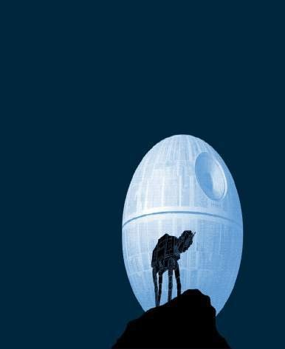
[…]

‘But the pig. Let us glance once more at the symbolism of the famous three-day pig. We are the pig, awaiting sacrifice. We are in thrall to the Moon: we are all sleeping Endymions, who must render to the Moon that which bears the imprint of the Moon. Let us presume that the sacrifice of the three-day pig is symbolical of the three days …’ — he emphasized the words to show that they had a much deeper meaning than might be at first apparent -’… that we spend in the sphere of the Moon after our death. As you know, in traditional Christianity, this period is called Purgatory. In esotericism, it has other names, with which you will all be familiar. The three-day pig is a symbol’ — he emphasized the word — ‘of this period we must spend in Purgatory.

‘If you reflect upon it, you will see that it is not a far-fetched symbolism. The pig, through its association with Set, is a creature of the Moon, and the period in Purgatory is a “blood sacrifice” in the sense that during that experience the sins of the blood — one might say the sweat of our blood sins — are washed away. In Purgatory, at great cost to ourselves, we sacrifice our sins. These entities — our sins — are devoured by the demons in what might be regarded as a blood-lust. We have clung to our sins throughout our lifetime, and letting them go is no easy matter: they must be torn away from us.

‘Purgatory is a sort of cosmic clearing house — even a place of enforced learning — where the entities and dispositions born of sin find fulfillment and regeneration. Without the existence of such a cleansing house, the Spiritual atmosphere of the Earth would have been completely poisoned long ago.

‘The skull-face of the Moon, glaring down with cratered eyes at the world, is a perpetual memorial to the inexorable consequences of human sin. It would be possible to point to vast documentary sources for this belief that the Moon is the cosmic centre of purgatory — it is indeed encapsulated in very many symbols in Christian doctrine and symbolism. On what may be the most obvious level, the very idea that demons have

horns is probably a throw-back to the idea of the crescent of the Moon, their natural homeland: they are, so to speak, branded with the C of the crescent.

‘You were quite right, Mark …’ — much to our chagrin, he turned to us, making public private conversations we had had with him — ‘… to link the Moon with demonic assault, and with the dark realm of seances and atavistic clairvoyancy. The demonic beings love the dark. While it is true that the seance rooms are kept dark to enable amateur conjurors to perform without detection, it is also true that those Spiritual beings who work evil through such seances love the dark. They are lucifuges. Just as they cannot understand the need for light, so they cannot understand human love.

‘The ancients used darkness, not to contact the demons, but to contact the Higher Beings. One reason why the so-called air-shafts in the Great Pyramid are directed towards specific stars is to allow these stellar influences to pierce into the darkness where the initiations took place. ‘The ancients built their stone circles to enable them to use darkness for specific purposes. They knew that during an eclipse, when the Moon is thrown into darkness, the effect of the Moon is, to some extent, weakened. At such times, certain diabolical and evil influences which have been built up in the aura of the Earth can escape. It is as though a safety valve has been opened in the skies, pouring into the cosmos down the dark tunnel of the Black Moon, which hangs in the shadow of the Earth. This Black Moon — the Moon of snake-infested Hecate in the ancient mythology — is quite different from the Lighted Moon. In some of the ancient centres this Black Moon was even given a different name.

‘The Lighted Moon is, to some extent, Spiritually warmed by the Sun. One has to be attuned to cosmic realities to feel the difference between the Dark Moon and the full Moon. When the Sun is eclipsed by the Dark Moon, then it is not unusual for birds to drop from the skies in fear. Great wisdom is shown in such fear. You must all try to experience an eclipse — solar or lunar — to catch a feeling of this cosmic reality. There is a frisson in the air, quite unlike anything which can be felt under normal circumstances. The primaeval terror of the Moon among the ancients was not entirely unrealistic: in those days, there was a different consciousness which allowed men to perceive cosmic realities that are now hidden from us. You will never understand why the ancient stone circles were built if you do not familiarize yourself with the Dark Moon.’

In the meeting prior to his death, our Master fulfilled his promise to speak about the secrets of the Moon. Normally, he would wait for someone in our midst to ask a question. This time he began to speak without preamble.

‘In the esoteric literature, you will find many records indicating that the Moon was at one time part of the Earth. It had to leave the Earth, in order to allow life on Earth to continue its Spiritual development unimpeded.

‘It is important that anyone on the Path should attempt to form a clear picture of what this separation was like. Not only was it of considerable evolutionary importance in the cosmogenesis of the Earth, but it is played, in miniature, in many of our Spiritual activities. It is the archetypal form of fission. Now, unfortunately, in modern times even our imaginative faculties have been materialized, and it is difficult for us to form a picture of what this Moon-loss was really like. It is difficult for us to form clear images of the fission which lies at the root of all Spiritual activity. It is difficult for modern man and woman to visualize things in purely Spiritual terms. This is because the picture-

making which lies at the basis of our imaginative faculty longs for mythology, since mythology is itself an agency of Spirituality.

‘If you cannot imagine in this way at present, you must perforce cling to materialistic images …’ — he touched the glass of water on the round table in front of him — ‘… then imagine a glass of water clouded with a pigment. If the glass is left to stand, the particles will settle to the bottom in a thick dross, leaving the water above clear. This is much nearer to the Spiritual reality of what happened when the Moon left the Earth, taking with it certain forms of dross materiality. […]

‘The schema which depicts the planets in extended space pertains only to physical vision. You must understand this, or there will be no way in which you can approach some of the greater Mysteries of the cosmos. What appears to be on the outside is more accurately described as being on the inside: our Earthly vision is extremely limited, for, under normal circumstances, we see outwards from the central Ego to the cosmic periphery. However, this is not the cosmic vision. We are so used to this limited vision that we are not sufficiently tolerant to accept that there can be others — including a vision from the periphery into the centre.

‘In the case of the Moon, the matter is made more complex by the fact that the physical matter of the Moon did once form part of what we now call the Earth. Within the context of the lunar sphere, the two centres did once coincide. A tremendous effort of meditative power is required to follow these connections, however, and the bald statement I have made can result in misconceptions.’

‘Why,’ asked Philip, ‘did the Moon have to separate from the Earth?’ ‘It was a cosmic fission. The Moon represents the harder mineralization of the Earth. In the body of the Moon is the matter which, had it remained with the Earth, would have weighed down human development too deeply. Man would not have been able to bear the weight of those forces in his own body. Just as we know from our own observations of ourselves that we must slough off darkness to reach into the light, so the planetary bodies must also involve themselves in a similar fission. Even so, it is true that the weight of the Moon, albeit removed by half a million miles, still contorts the physical body of the Earth and its inhabitants through what are usually called ‘gravitational’ effects.

‘Now we must touch upon the connection between the Moon and clairvoyancy. We must do this because one of our members has — wisely or unwisely — become involved with mediumistic groups.’

‘It is important that we set out very clearly the dangers inherent in opening the soul to such activities. It is not for me to forbid such activity. I have no power to forbid, and would relish no such power. Much as I would wish to protect you, I cannot. The best I can do is make the dangers clear to you. After that, your beliefs and your conduct remain your own.’

He look around at our faces, as though to indicate that he had arrived at the most important point of the evening.

‘And so now we must look at an esoteric truth which touches on the very edge of what is permissible. What I have to say will be greatly disturbing for many people of modern times. It will disturb, because it is generally taken for granted that clairvoyancy, mediumship and spiritualistic activity are somehow linked with Spiritual development,

and consequently of benefit to mankind. Unfortunately, this is far from the truth. A vast amount of our modern so-called “Spiritualist” literature pertains to channelling and clairvoyancy which is far from beneficial for the development of mankind. Indeed, not to mince words, I should tell you that it is distinctly harmful.

‘I must now make a statement which will introduce you to a concept which was, until comparatively recently, one of the deepest secrets of the esoteric Schools: In some ways, the Moon is the greatest problem of esoteric lore. The Moon is not at all what it appears to be.

‘At the end of the last century an astounding revelation was made, as a result of dissent among members of secret Schools. Information, hitherto guarded jealously by the most enclosed of the inner Orders, was made public. The secrets disclosed pertained to a far deeper level of knowledge than has hitherto been made exoteric by the Schools — even in this enlightened age.’

His trace of cynicism seemed to go by unnoticed.

‘Our purpose here is not to document how so deep an esoteric idea was made public — or even to assess whether it was wise for this idea to be brought out into the open. All this has been dealt with in the literature — and if any of you wish to follow this up, I will give you a few titles later.

‘In a nutshell, what was made public during this conflict in the Schools was the truth that our Moon is a sort of counterweight to another sphere, which remains invisible to ordinary vision. This counterweighted sphere is called in esoteric circles the Eighth Sphere.

‘We must be careful with these words, for, in spite of what I have just said, this region is not itself a sphere, nor is it a moon. Even to locate it behind the physical Moon is not correct, for in the Spiritual realm spaces and distances are different. The truth is that this Eighth Sphere does not pertain to anything we are familiar with on the physical plane, yet we must use words from our own vocabularies whenever we wish to denote its existence. Were we to use a word which fits most appropriately this Sphere, then we should really call it a vacuum. Certainly, vacuum is a more appropriate term than sphere, for the Eighth Sphere sucks things into its own shadowy existence.

‘This Sphere is lower in the scale of being than the Seventh Sphere (which is the Earth). It acts as a sort of demonic conduit to suck into its maws certain degenerate Spiritual forms on the Earth. It is a shadow Sphere, controlled by shadow beings. However, the fact that they are shadow beings should not lead us to demote or underestimate their capabilities and intelligence. In many respects they are more intelligent than Man, for they are not limited by the power of love, as is Mankind.

‘The operation of this Eighth Sphere is complex. Its denizens — those shadowy beings for whom it is home — wish to people their Sphere with humanity, or (more accurately) with human souls. Towards this end, it has erected what we might call terminals on the Earth: these terminals are soul-conduits, which will suck into the lower Sphere a certain form of materialized Spiritual energy that is engendered on the Earth plane. The most usual circumstances where this materialization or engendering takes place is in seances, and in other localities wherein human beings attempt to meddle — against the cosmic law — with the lower Etheric planes.’

Philip was having difficulties with this curious account of the lunar powers, and asked: ‘Are you saying that Spiritualist activity is itself victimized by the Eighth Sphere?’

‘Yes, Philip. Certain Spiritualist activity is coloured by the erroneous belief that the realm of the dead is accessible to the living. In truth, mediumistic activity cannot penetrate through into the true realm of the dead: it is therefore dealing only with shadows. In so doing, it is creating fodder for the nourishment of the Eighth Sphere. This sucking of certain forms of human soul-matter into the Eighth Sphere is not, by any means, intended for the benefit of humanity. The aim of the denizens of this world is to enhance and populate a world which may truly be described as the realm of the damned. The efforts of these denizens, or demons, is contrary to the evolutionary development which has been planned for the world. In truth, the human being was not designed to become a shadow being, captive in a demonic sphere: it was designed to become a god.

‘It is less than one hundred years since this knowledge of the Eighth Sphere was made public. At first there was an outcry at this breach in initiate knowledge, but now we can see that it has proved something of a blessing that the demonic threat has been brought out into the open. In some ways, it is easier to deal with a visible enemy. Those who dabble in the supposed communications with the dead, and with that spirit-land which they fondly imagine lies beyond the veil, have not gone unwarned.

I will leave most of the above for the reader to digest, and discuss only the so-called “Eighth Sphere.” What is meant by the moon being a counterweight to the Eighth Sphere? Evidently, the moon is but a physical reflection of something tangible but not material, something beyond our realm of perception. Based on the clues given in The Zelator we must conclude that the Eighth Sphere by definition encompasses all the nonphysical aspects of the Matrix Control System, the service-to-self (STS) hierarchy from top to bottom minus the physical levels of which we ourselves are part. The Eighth Sphere would therefore include: the lower astral planes where carnal and demonic thoughtforms dwell, the hyperdimensional realms inhabited by so-called reptilian beings, the parasitic etheric lattice overlaying the earth comprising the very tendrils of the Matrix, the soul-pool of which spiritless humans are incarnate extensions, and the demiurgic creature positioned atop the negative occult hierarchy sucking into itself all energy gathered from the “tiers” below. This interpretation of the Eighth Sphere should be self-evident for those familiar with the works of Rudolf Steiner, Carlos Castaneda, Robert Monroe, Dr. William Baldwin, the Cassiopaean Transcripts, and my articles on the Matrix. For instance, that spiritless humans have something to do with the moon is clear from the fact that they, being extensions of less evolved (“second density”) energies occupying human (“third density”) bodies, are essentially two-and-a-half density beings, which relates to the two-and-a-half-day pig. Pigs, by the way, are physically incapable of looking up at the sky which, in addition to the fact that they share many human characteristics and have genetics strongly suited to house low vibrational frequencies, makes them ideal symbols for the animal nature in man. That the moon shares an archetypal basis with spiritless humans is further evidenced by it being a second density planet reflecting light rather than generating its own, just as spiritless humans are not fully third density and merely reflect back the soul image of others.

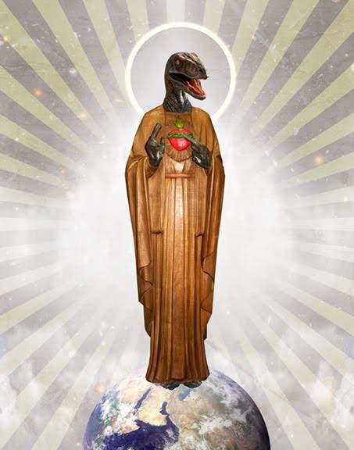

THE PLANETARY ARCHONS
T H E S E V E N D E A D L Y S I N S
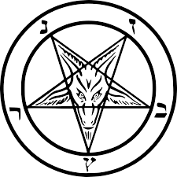
+PRIDE +GREED +LUST +WRATH +GLUTTONY +ENVY +SLOTH

These sins are the root of all other sins. They are the reason why our soul is bound to flesh through reincarnation. When our souls where captured some 300.000 years ago, these sins where implanted in our soul to create a deeper longing for physical existence. It is like Don Juan Matus, the Mexican Yaqui Indian shaman, said to Carlos Castaneda:

“We have a predator that came from the depths of the cosmos and took over the rule of our lives. Human beings are its prisoners. The Predator is our lord and master. It has rendered us docile, helpless. If we want to protest, it suppresses our protest. If we want to act independently, it demands that we don’t do so… I have been beating around the bush all this time, insinuating to you that something is holding us prisoner. Indeed we are held prisoner! This was an energetic fact for the sorcerers of ancient Mexico … They took us over because we are food for them, and they squeeze us mercilessly because we are their sustenance. just as we rear chickens in chicken coops, the predators rear us in human coops, humaneros. Therefore, their food is always available to them.”
„Think for a moment, and tell me how you would explain the contradictions between the intelligence of man the engineer and the stupidity of his systems of beliefs, or the stupidity of his contradictory behaviour. Sorcerers believe that the predators have given us our systems of belief, our ideas of good and evil, our social mores. They are the ones who set up our hopes and expectations and dreams of success or failure. They have given us covetousness, greed, and cowardice. It is the predators who make us complacent, routinary, and egomaniacal.”
„In order to keep us obedient and meek and weak, the predators engaged themselves in a stupendous manoeuvre stupendous, of course, from the point of view of a fighting strategist. A horrendous manoeuvre from the point of view of those who suffer it.
They gave us their mind!
. The predators’ mind is baroque, contradictory, morose, filled with the fear of being discovered any minute now.”
Do you hear me? The predators give us their mind, which becomes our mind
Since the 16th century the list of demons and their associated sins published by Peter Binsfeld is the most common one. The Archons of the 7 Deadly Sins are very powerful Demons. They correspond to 7 planetary principles. These entities radiate astral force- fields that beam into our chakras.

ARCHON | PLANET/ZODIAC | DEADLY SIN vs. VIRTUE | DEMON/FORCE-FIELD  ARCHETYPE
 | SUN/VENUS |  | 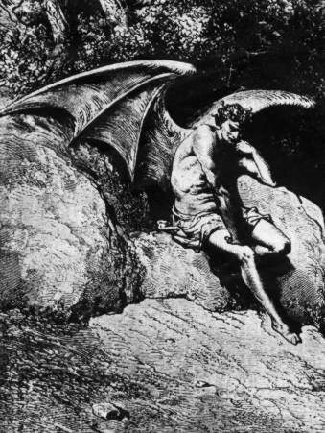
L_{UCIFER} |  | PRIDE  Superbia  vs.  HUMILITY
 | LEO/AQUARIUS | Humilitas

Pride (vanity, narcissism) — Pride is excessive belief in one's own abilities, that interferes with the individual's recognition of the grace of God. It has been called the sin from which all others arise. Pride is also known as Vanity, a desire to be more important or attractive to others, failing to give credit due to others. Dante’s definition was “love of self perverted to hatred and contempt for one’s neighbor”. Pride was what sparked the Fall of Lucifer from Heaven. Vanity and narcissism are good examples of these sins and they often lead to the destruction of the sinner, for instance by the wanton squandering of money and time on themselves without caring about others. It is associated with the horse, the lion, the peacock, and the color violet.
The entity Lucifer is not the same as Satan. Lucifer loved himself above anything, and without ignorance as an excuse. Ranked highest of angels he sat in Heaven next to God. In an outlandish display of Lucifer’s pride he started a war among Angels. Lucifer led his angels in a rebellion against Heaven in The First Battle. After that he and his shills were transformed to demons and got tossed out of the Pleroma (=Heaven) into the physical universe we now live in. In gnostic terms: without a War in Heaven there would have been no Big Bang of Creation. God is not the creator. The physical universe is the habitat for Fallen Angels. We are split-incarnations and belong to an Oversoul (=Aeon) of primarily Fallen Angels.
Lucifer means „the shining one, the morning star, the light bearer“ and refers to Venus. The astral Venus acts as a gate for the false light of the Black Sun beaming into our solar system. Thus Lucifer is a dark „light-bearer“ who leads mankind away from the path of humbleness.
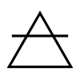
In ritual Lucifer’s direction is the East - place of the sunrise. He represents the element Air which is connected to intellect, knowledge and curiosity. In magical terms, Air is the power of the mind, inspiration, imagination. Air is a masculine element and governs the magick of the four winds.

ARCHON | PLANET/ZODIAC | DEADLY SIN vs. VIRTUE | DEMON/FORCE-FIELD  ARCHETYPE
 | SATURN |  | 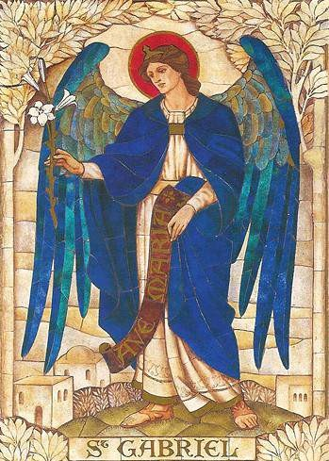
M_{AMMON/}  „ARCANGEL“  G_{ABRIEL} |  | GREED  Avaritia  vs.  CHARITY
 | ARIES/LEO | Caritas

Greed (treachery, covetousness) — A strong desire to gain, especially in money or power, ignoring the realm of the spiritual. It is also called Avarice or Covetousness. It is disloyalty, deliberate betrayal, or treason, especially for personal gain or when compensated, scavenging and hoarding of materials or objects, theft and robbery by violence. Simony is the evolution of avarice because it fills you with the urge to make money by selling things within the confines of the church. This sin is abhorred by the Catholic Church and is seen as a sin of malice; Dante included this sin in the first poem of the Divine Comedy (the Inferno). Thomas Aquinas on greed: “it is a sin against God, just as all mortal sins, in as much as man condemns things eternal for the sake of temporal things.” Greed is represented by the frog and the color yellow.
Originally, the word Mammon came from the ancient Chaldeans. At its most basic level, the word meant 'riches' or 'wealth,' but it connoted an idea of personified wealth gained with avarice. Eventually it became the demon of love of money and riches.
Ralf Maucher identifies Avaritia with the „Arcangel“ Gabriel who is in fact a fallen light being. She controls humans out of the subconscious as an archetype of „the witch“ in the personal shadow. This force-field veils deep in the subconscious mind other archetypes and shadow splinters. Her color is Blue, her synchronicity number is 34. Mythologicly she is known as Hecate, Circe and Isis. She transmitted the Koran visions to Mohammed.

Saturn is the stronghold of Baphomet in this solar system. Baphomet is the real opponent of God. His synchronicity-number is 23. The parts of the soul that fall into his clutches –
e.g. through masonic rituals – are lost forever.

ARCHON | PLANET/ZODIAC | DEADLY SIN vs. VIRTUE | DEMON/FORCE-FIELD  ARCHETYPE
 | VENUS |  | 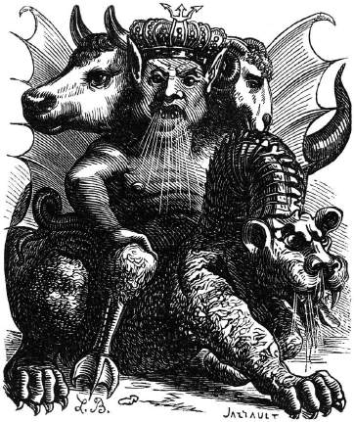
A_{SMODEUS} |  | LUST  Luxuria  vs.  CHASTITY
 | SCORPIO/ | Chastitas
 | SAGITTARIUS

Lust (fornication, perversion) — Lust is an inordinate craving for the pleasures of the body. Obsessive, unlawful, or unnatural sexual desire, such as porn addiction, child pornography, rape, sodomy. Lust prevents clarity of thought and rational behavior. In Buddhism Lust is the clinging to, attachment to, identification with, and passionate desire for certain things in existence, all of which owe to the form, sensation, perception, mentality, and consciousness that certain combinations of these things engender within us. Lust is thus the ultimate cause of general imperfection and the most immediate root cause of a certain suffering. Lust is symbolized by the cow and the color blue.
For Asmodeus the spellings Asmodai, Asmodee, Osmodeus, and Osmodai have been used. In the Malleus Maleficarum (1486), Asmodeus was considered the demon of Lust. He has 72 legions of demons under his command. He is one of the Kings of Hell under Lucifer the emperor. He incites gambling, and is the overseer of all the gambling houses in the court of Hell. Some authors consider Asmodeus to be a prince of revenge. Nowadays the epidemic of internet-porn has been established as an easy and effortless form of techno- magic, where energies can simply be drained off their (male) victims. This demon has corrupted the greater part of humanity. He rules the internet, Hollywood and the media generally. The internet alone is dominated by porn which controls 70% of all traffic and brings in revenue to the tune of about $60 billion per year, 12% of which is in the USA. About 100,000 websites offer children illegal pornography with child pornography generating about $3 billion annually. 90% of 8-16 year olds have viewed porn online with the average age of first exposure being 11 years old. The largest consumer of internet pornography is in the 12-17 age group. This gives you some idea of how much power Asmodeus has in the world.
The astral Venus acts as a relais for the false light of the Black Sun coming from the Crater Constellation into our solar system. The aryan SS-Übermenschen were supposed to be fueled by the light of the Black Sun.

ARCHON | PLANET/ZODIAC | DEADLY SIN vs. VIRTUE | DEMON/FORCE-FIELD  ARCHETYPE
S_{ATAN} | MARS    ARIES/SCORPIO | WRATH  Ira  vs.  PATIENCE  Patientia | 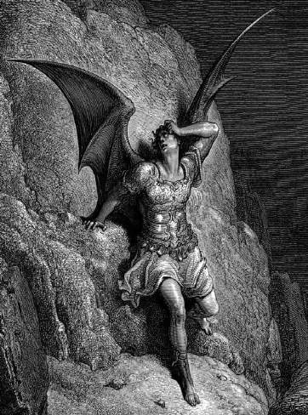

Wrath (anger, hatred) — Anger is manifested in the individual who spurns love and opts instead for fury. It is the inappropriate (unrighteous) feeling of hatred and anger, impatience or revenge outside of justice, wishing to do evil or harm to others in self- righteousness. Wrath is the root of murder and assault. Anger in Buddhism is defined here as: "being unable to bear the object, or the intention to cause harm to the object." Anger is seen as aversion with a stronger exaggeration, and is listed as one of the five hindrances, that hinder progress in meditation and daily life. Wrath is symbolized by the bear and the color red.
Satan (haśśātān) himself meaning “the prosecutor” or “the superhuman accuser”. He is a decidedly malevolent entity. In any case, Satan is (was) always subordinate to the power of God, having a role in the divine plan. Primarily he had the role of the accuser at the divine court of God who tested the integrity of the defendant. Satan puts you to the test. Baphomet (synchronicity-number 23) on the other hand seduces you to evil. Baphomet is the real opponent of God and the absolute ruler of the physical realm. The parts of your soul Baphomet has a hold on are lost forever. Somehow Satan became corruped and joined forces with Baphomet. Earth in 3-D is the „planet of atonement“ for satanic incarnations. If Satan finally repents and becomes spiritually converted, mankind itself can begin it's way back home.


In ritual Satan’s direction is South (the place of heat), he represents the element FIRE, which in occult philosophy stands for drive, initiative and the own will. Thus he personifies anger and rage. Yet – in this Matrix- Gulag of Baphomet anger in it's divine aspect is an important requirement for the re-ligio with God. Satan's attributed color is RED, his synchronicity-number is 666.

ARCHON | PLANET/ZODIAC | DEADLY SIN vs. VIRTUE | DEMON/FORCE-FIELD  ARCHETYPE
 | JUPITER |  | 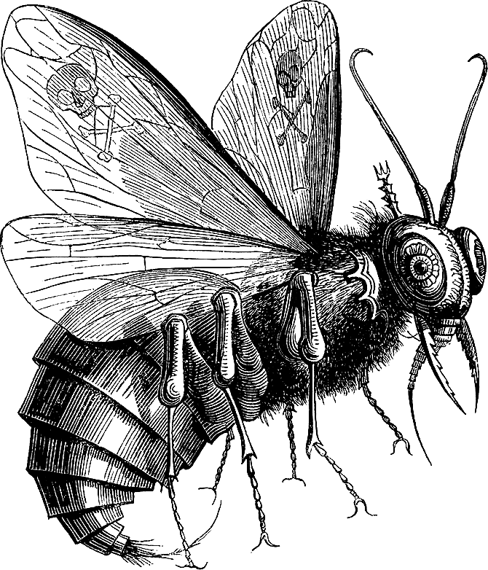
 |  | GLUTTONY
B_{EELZEBUB} |  | Gula  vs.  TEMPERANCE
 | TAURUS/CANCER | Temperantia

Gluttony (waste, overindulgence) — derived from the Latin gluttire meaning to gulp down or swallow, means over-indulgence and over-consumption of food, drink, or wealth items to the point of extravagance or waste. Gluttony is an inordinate desire to consume more than that which one requires. In Christianity, it is considered a sin if the excessive desire for food causes it to be withheld from the needy. It is marked by refusal to share and unreasonable consumption of more than is necessary, especially food or water. Energetically gluttony resembles the service-to-self (STS) act of hoarding or despising life- force.
The name Baʿal Zəvûv (זבוב בעל) is found in 2Kings 1:2-3,6,16. Beelzebub is commonly described as placed high in Hell's hierarchy, among the three most prominent fallen cherubim. Rabbinical literature commentary equates Baal Zebub of Ekron as Lord of the flies. He is said to have originated in the order of the cherubim. According to the sixteenth century occultist Johannes Wierus, Beelzebub is the chief lieutenant of Lucifer, who is the emperor of Hell, and presides over the "Order of the Fly." . Beelzebul claims to cause destruction through tyrants, to inspire men to worship demons, to excite priests to lust, to cause jealousy and murders, and to bring on war. Down through history, Beelzebub has been held responsible for many cases of demon possession. The Pharisees disparagingly accused Jesus of using Beelzebub's demonic powers to heal people (Luke 11:14–26), the Talmud accuses Jesus of using egyptian magic instead.
In the twentieth century G. I. Gurdjieff used it as the name of the main character in Beelzebub's Tales to His Grandson. On the surface it is a narrative of a long voyage on a spaceship, where Beelzebub, a rebel-angel who becomes an elder statesman, discourses on his observations of Earth humanity for the edification of his grandson. It's been speculated that Beelzebub's Tales were a sort of karmic autobiography of Gurdjieff himself. As to the grandson, this seems to indicate a message sent to the future. The generations born from 1940 onwards would in fact be Gurdjieff's figurative grandchildren, at least in potential.

ARCHON | PLANET/ZODIAC | DEADLY SIN vs. VIRTUE | DEMON/FORCE-FIELD  ARCHETYPE
 | MERCURY |  | 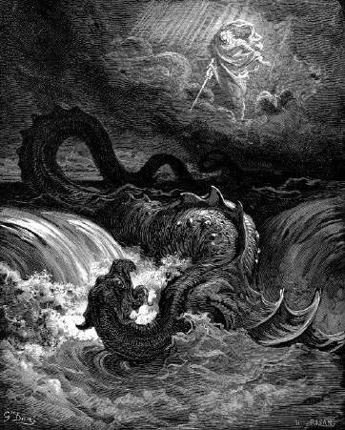
L_{EVIATHAN} | 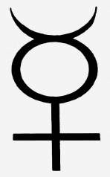 | ENVY  Invidia  vs.  KINDNESS
 |  | Benevolentia
 | PISCES/
 | CAPRICORN

Envy (jealousy, malice) is an emotion which occurs when a person lacks another's superior quality, achievement, or possession and either desires it or wishes that the other lacked it. It is grieving spite and resentment of material objects, accomplishments, or character traits of others, or wishing others to fail or come to harm (Schadenfreude). Envy is the root of theft and self-loathing. Dante defined this as “love of one’s own good perverted to a desire to deprive other men of theirs”. Narcissists are often envious of others or believe others are envious of them. A narcissist may secure a sense of superiority in the face of another person's ability by using contempt to minimize the other person.

Leviathan is an enormous demon of chaos depicted as a "serpentine beast", a monstrous sea serpent. Leviathan (also Lefiafan, Livyatan, or Liwyāṯān) is the gatekeeper to ineffable chasms of our subconscious. His Hellmouth is the entrance to Hell envisaged as the gaping mouth of a huge monster. It is the snake that rises from the water represents the collective evil from the abysses of the human souls. He leads man to the most distorted perceptions of reality which is due to a deteriorated state of mind and false representations.


In ritual Leviathan represents the element of Water and the direction of the West, place of the setting sun. The element of Water is associated with life and creation, and may be represented by a Chalice during ritual. In the Satanic Bible, Leviathan is listed as one of the Four Crown Princes of Hell. This association was inspired by the demonic hierarchy from The Book of the Sacred Magic of Abra-Melin the Mage. The Church of Satan uses
the Hebrew letters at each of the points of the Sigil of Baphomet to represent Leviathan. Starting from the lowest point of the pentagram, and reading counter-clockwise, the word reads "ולוייןןתן".

ARCHON | PLANET/ZODIAC | DEADLY SIN vs. VIRTUE | DEMON/FORCE-FIELD  ARCHETYPE
 | MOON |  | 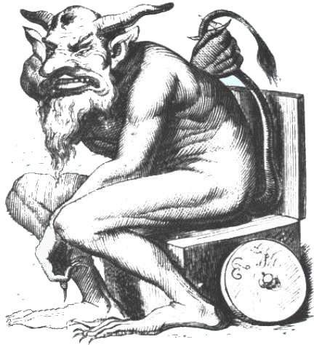
B_{ELPHEGOR} |  | SLOTH  Acedia  vs.
 |  | DILIGENCE
 | GEMINI/VIRGO | Industria

Sloth (apathy, indifference) — Apathy, idleness, cowardice, irresponsibility and wastefulness of time. Sloth is the avoidance of physical or spiritual work. Laziness is particularly condemned because others must work harder to make up for it. Sloth is a state of equilibrium: one does not produce much, one does not consume much. Dante wrote that sloth is the “failure to love God with all one’s heart, all one’s mind and all one’s soul”.
According to Peter Binsfeld's Binsfeld's Classification of Demons, Belphegor is the chief demon of the deadly sin, Sloth. He provides those who prefer ‘the easy option’. He is granting ingenious inventions that will make you rich with minimal effort. Providing a life too easy and offering effortless „spiritual growth“, Belphegor drains like juice from a juice- box all that was once good about the person until there is little left but an empty shell. Sloth breaks the natural flow of give-and-take. The only defence against Belphegor’s attentions are an iron strong strength of mind and a robust internal desire to perform altruistic deeds.
Georges I. Gurdjieff said, that we are food for the moon: "The moon is man's big enemy. We serve the moon. Last time you heard about kundabuffer. Kundabuffer [=buffers of wishful thinking] is the moon's representative on earth. We are like the moon's sheep, which it cleans, feeds and shears, and keeps for its own purposes. But when it is hungry it kills a lot of them. All organic life works for the moon. Passive man serves involution; and active man, evolution. You must choose. In both cases we are slaves, but there is a principle: in one service you can hope for a career; in the other you receive much but without a career. In both cases we have a master. Inside us we also have a moon, a sun and so on. We are a whole system. If you know what your moon is and does, you can understand the cosmos." The food in question is described as vibrations generated by intense human experience, for example the experience of violent death.

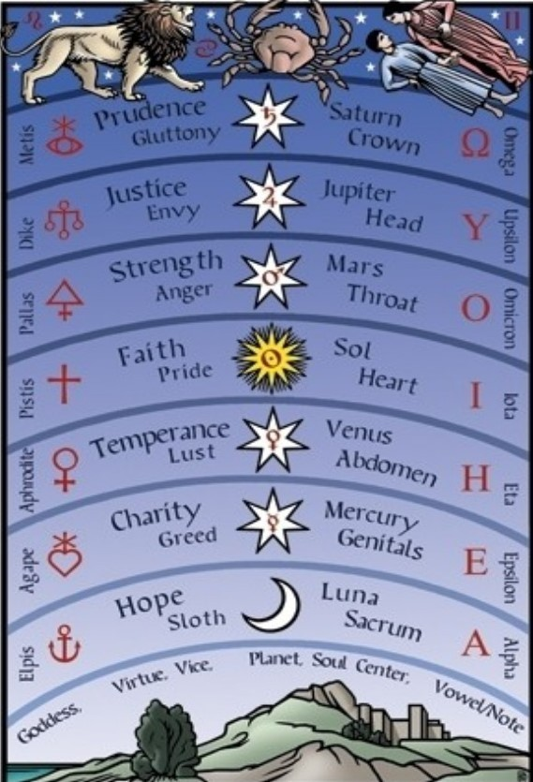

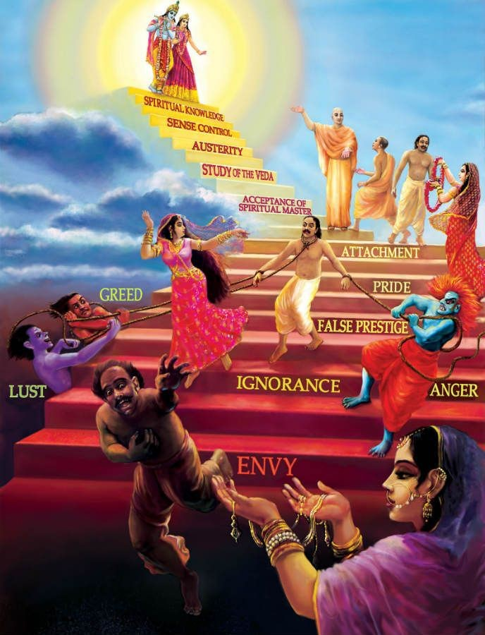

PLANET VENUS:
GATEWAY OF THE BLACK SUN

Venus1
Historically and astronomically, the term “Morning Star” has always been applied to the planet Venus. “Lucifer” literally means Lightbringer, Lightbearer, Bringer of Dawn, Shining One, or Morning Star. The word has no other meaning. Theosophy interprets all these allegorical Gnostic teachings as referring to “the lighting up of Manas” (Manas is the Sanskrit word for Mind). When we bear in mind that “The Secret Doctrine” teaches that the Lemurian Root Race was born under the influence of Venus and received its “light and life” from the Planetary Spirit of Venus, it all becomes clearer, since Lucifer has been an accepted synonym for Venus – the bright and morning star – since long before the days of Christian theology and millennia before Lucifer was first ignorantly equated with the devil.

In “The Secret Doctrine” we read that “Venus, or Lucifer (also Sukra and Usanas) the planet, is the Light-Bearer of our Earth, in both its physical and mystic sense.” Venus is said to be the “spiritual prototype” of Earth and “the Guardian Spirit of the Earth and Men.” It is “the most occult, powerful, and mysterious of all the planets; the one whose influence upon, and relation to the Earth is most prominent” and every change that takes place on Venus “is felt on, and reflected by, the Earth.”

From „The Secret Doctrine“ by Helena Blavatsky „Venus. Lightbearer to Earth“:2 Venus is "the little sun in which the solar orb stores his lights." (S.D. Vol. II, 27)
"Light comes through Venus who receives a triple supply and gives one-third to
the Earth. Therefore the two are called 'twin sisters.' The spirit of the Earth is subservient to Venus." (S.D. Vol. II, 33)
"Venus is the most occult, powerful and mysterious of all the planets. Its relation with the Earth is the most prominent. It presides over the natural generation of men. It is called the 'other sun.' It is the Earth's primary or spiritual prototype." (S.D. Vol. II, 33-35)
"Venus...is the light-bearer of our Earth, in both the physical and mystic sense." (S.D. Vol. II, 36)

One may now wonder what light it is that comes through Venus? It is the light of the Black Sun!
- https://blavatskytheosophy.com/lucifer-the-lightbringer/
- http://logos_endless_summer.tripod.com/id33.html

The Black Sun (Schwarze Sonne/SS)

What exactly is the Black Sun? In the Isais-tradition of the Vril society it is a black hole in the Crater constellation. Others refer to it as a supermassive black hole at the galactic center. In any case the Black Sun is the ultimate destination of all evil Service-To-Self (STS) forces in the universe. The light it emanates is the Anti-Logos.
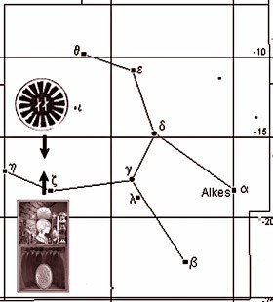
In the occult tradition of the Vril society the Black Sun is also known as ILU-Sun, Invisible Sun, Dark Sun, Bab'Chomet. The Black Sun is the source of radiation of the [false] divine light (Ilu) in this world. With the Babylonians it was called Bab'Chomet, which in english roughly means "gateway to the light beam". It is invisible to the earthly eye, just like the rays that emanate from it. Nevertheless, the Black Sun exists. It is located in the centre of the constellation "Crater", from where the „divine light“ is transmitted to earth via the planet Venus. According to the principle of vibrational affinity, it depends on the degree of light of mankind how much ILU-radiation is drawn to Earth from the source of the so called „divine light“.3
The myth of the Black Sun is closely connected with the cults around Isis / Ishtar / Venus. Especially in the Mediterranean cultures this cult, which was led under different names for the goddess, took a central position. According to the Isis-mysteries the following words come from the goddess herself: "I, All Mother Nature, master of the elements, first-born child of time, Highest of the Deities, first of the Celestials, I, who alone unite in myself the form of all gods and goddesses, with a wave above the sky light vaults, the salutary airs of the sea and the underworld pitiful shadows; I, the only deity, who worships the whole world under so many forms, so different customs and many names. I, the firstborn of all people call me All Mother. I am called Minerva by the Athenians, Venus by the Cypriots, Diana by the Cretans and Ceres by the Eleusinians. Others call me Juno, others Bellona, others Hekate, others Rhamnusia. But they, who illuminate the rising sun with its first rays, the Ethiopians, also the Aryans, and the owners of the oldest wisdom, the Egyptians, who worship me with the most appropriate, most peculiar customs, give me my true name: Queen Isis." The great earth goddess was worshipped by the so-called heathens as nature, as mother earth. She ("our planet") was already recognized in early times as the giver of all life and therefore had many names and figures.
Mythologically and esoterically, the Black Sun has determined the fate of mankind since the beginning of time. The Black Sun designates the center of our galaxy. It is its centre and emits intensive, creative radiation. It is actually not black, but rather of a deep purple colour. On the other hand, the Black Sun also refers to the [false] inner enlightenment of man. It has been depicted in many different, also Nordic, cultures. As contrast and supplement to the outer light of the sun.
- https://www.thuletempel.org/wb/index.php?title=Ilum

To insiders, initiates within the Third Reich, the abbreviation "SS" did not stand for "Schutzstaffel" but for "Schwarze Sonne" (Black Sun). The term may originate from the mystical "Central Sun" in Helena Blavatsky's Theosophy. This invisible or burnt out Sun (Karl Maria Wiligut's 'Santur') symbolizes an opposing force or pole. Emil Rüdiger, of Rudolf John Gorsleben's 'Edda-Gesellschaft' (Edda Society), claimed that a fight between the new and the old Suns was decided 330,000 years ago (Karl Maria Wiligut dates this 280,000 years ago), and that 'Santur' had been the source of power of the Hyperboreans. It was said to be located at the centre of our galaxy. It is the centre of a great spiral vortex of stars which draws in matter and energy and generates the aforementioned radiations near it periphery. Today, we call it a "black hole". The Black Sun is, in reality, a huge system or perhaps it could even be called a huge machine. We and our entire galaxy are all part of this machine whirling through space.4

The Black Sun is by no means black - not even violet (indigo), as it should be; no, it is green. The Black (magic) Sun is to be understood as the otherworldly source of the divine light (Ilu), whose power also determines the development of the ages; it is, so to speak, the "valve" that lets the divine streams of light radiate onto the earth - from the hereafter into this world. If one now understands the hereafter as a reversal of this
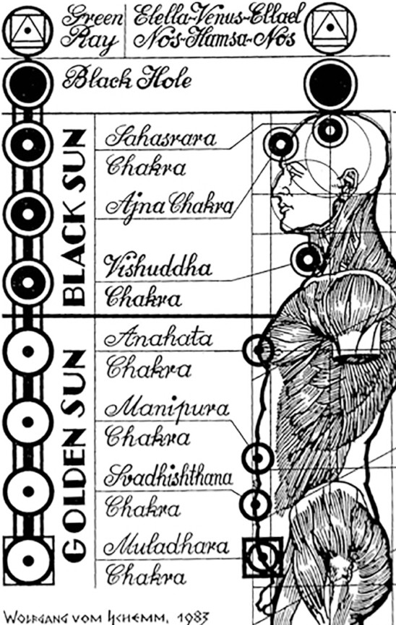
world, the Magic Sun must also be represented in this world on earth in the complementary colour to violet/indigo. If it comes to inversion, the hereafter takes shape in this world.5

The light of the Black Sun is the anti- logos of darkest adversary forces in the universe. The SS soldiers were the prototypes of a new race, which were directly inspired and controlled by the Logos of the Black Sun. You can see this in the drawings of Wolfgang vom Schemm6, which clearly show a Black Hole, Venus and the Green Ray on the head at the place of the crown chakra where normally the divine Paraclete would enter the aura and true enlightenment could take place.

- https://thirdreichocculthistory.blogspot.com/2011/08/himmler-ahnenerbe-and-wewelsburg.html
- http://www.causa-nostra.com/Rueckblick/Geheimnis-der-Wewelsburg--r0801a02.htm
- http://galleria.thule-italia.com/wolfgang-vom-schemm/

Black Sun / Venus / Moon / Abraxas Magic
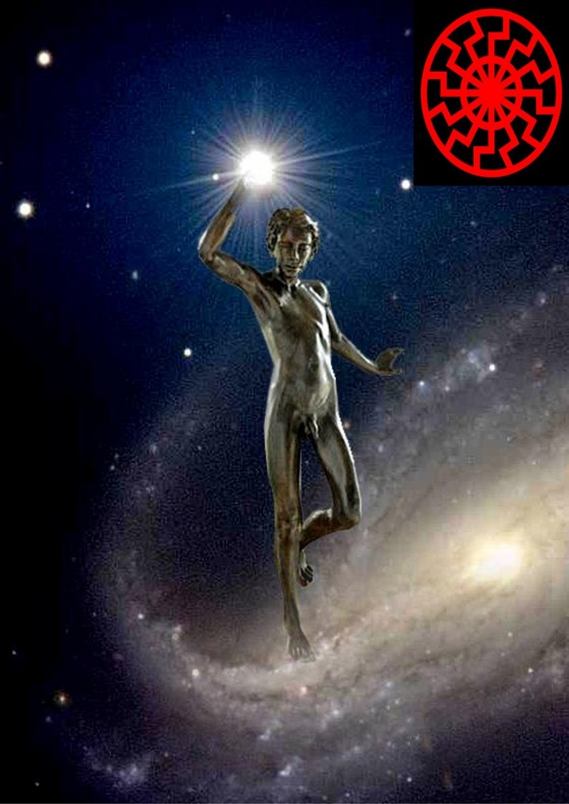
In Abraxas magic and in the occult rites of the Vril society, the morning star has the function of a mirror relay for the Black Sun. Via Venus the Black Sun (SS) radiates its pale light into our solar system. Lucifer is literally a dark light bringer. The astral Venus is in the magical tradition the gateway to the Black Sun (SS), of Isais or ISIS - the influence of the darkest adversary forces in the universe.

Moon-Venus constellations have always been especially important for Abraxas magic. The Abraxas Magic, which has an astromagic component, is also designed to use star constellations. Moon-Venus constellations are important for the use of the Magna Figura (=ritual object), as the tradition says. In connection with the Magna Figura one can reach the projection-path to the Black Sun in the Crater constellation.7 From the distant epochs comes the special reference to the goddess of the planet Venus,
who already had a special role in ancient Mesopotamia, as then also in Europe in Aphrodite of the Greeks and Venus of the Romans. In ancient times the "cult of the stars" was in reality a real belief in gods, because the stars themselves were regarded as entrances to the worlds of the gods, respectively these entrances were assumed behind the planets. Thus Abraxas was a Baphometric sign for the Templars. Abraxas would also be associated with the constellation Crater, which according to ancient belief is the seat of God's power in the cosmos of this world, or the place in the cosmos where the [false] divine light (Ilu) penetrates from the hereafter into this world. The source is also called the Invisible (Black) Sun on the other side. In magic ritual the "Ilu-rays" takes its way from the hereafter to this world through a special "lock" called "Ilum“. When the "Ilu- ray", the [false] „absolute divine light“, reaches Earth, the era of the cruel Bible God and of intolerant monotheism ends. The female deity takes over, embodied in the „Goddess of Love“ as Ishtar/Venus.

As Miguel Serrano poetically invokes the Black Sun:8

„Very early, when the Morning Star, Oyeihue {Venus}, calmly gives its message of light to you, extend your arms towards Her: I pronounce my oration to Lucifer: Oh, Luci-Bel, oh Morning Star Oyeihue. May your deep light fall upon me moist. Cover me in your petals of light like in the skies of autumn. Permit me to pass through your window towards the Black Sun that waits behind you. Oh, Black Sun! Absorb me in your light backwards, faster than the light of the Golden Sun and give me shelter in the nonexistence of the Green Ray ...“
- http://www.causa-nostra.com/Einblick/Mond-Venus-Konstellation_e1202a04.htm
- Serrano, Miguel – Manu: Por el Hombre Que Vendra

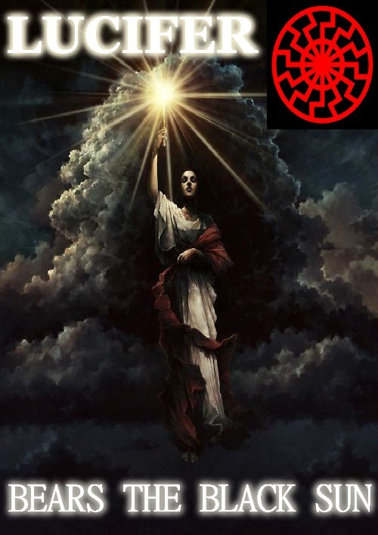

THE COUNTERFEIT SPIRIT
AND WHY YOU MUST DEFEAT IT TO SURVIVE DEATH

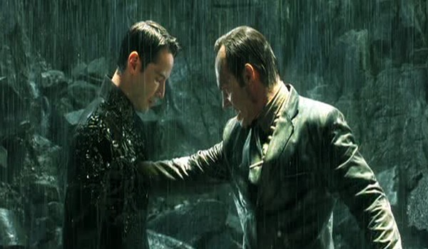

One of the most important yet misunderstood concepts for modern Gnostics is that of the Counterfeit Spirit. I get varied descriptions, ranging from associating it with the dreaded ego to a Homer Simpson imp that magically appears on your shoulder urging you to fake your death in order to skip work.
In reality, the Counterfeit Spirit is far more complex yet kick-in-the-groin identifiable once its metaphysical subtleties are captured. And like most notions in Gnosticism, it stresses the existential urgency for spiritual transcendence because the human condition is far worse than imagined.
To put it simply but not exactly, the Counterfeit Spirit is the Gnostic equivalent of Original Sin, though instead of paying for the sin of Adam’s disobedience we’re paying for the sin of God’s insecurity (as will be revealed shortly). Furthermore, the Counterfeit Sprit is far more than just a stain of sin within our inner being—it’s a spreading lagoon of deterministic doom reaching into the very fabric of time and space itself.



Defining the Counterfeit Spirit
In A Dictionary of Gnosticism, Andrew Phillip Smith defines the Counterfeit Spirit without all the bombastic bells and thistles I just spewed:
In Sethian myth a force which, in the absence of the living spirit, binds humanity to the Archons (Pg. 66).

In an even plainer definition, Zlatko Plese in Poetics of the Gnostic Universe equates the Counterfeit Spirit with Satan and his monkeyshines (Pg.74).
Both definitions are accurate. However, they reveal only a fraction of the salvation-castrating phenomenon that is as the Counterfeit Spirit, which in Classic Gnosticism appears solely in the Secret Book of John. This Sethian scripture in large part deals with the resurrected Christ wikileaking to tranny John about what really happened during creation. To put it bluntly, the Savior explains that Moses was smoking too much manna when he sat down to write Genesis. Jesus has risen to give the world the real dope.

How did this depressing but likely true concept begin?
The Counterfeit Spirit’s adventures begin in Secret Book of John after Jehovah and his thug-angels (also known as the Archons) create Adam in a fool’s paradise known as Eden. As God breathes animal-life into Adam, his mother Sophia smuggles part of her essence into history’s first dude in order to make him a tool for the powers of light instead of just a tool. Jehovah and his thug-angels realize at once that Adam now houses the Living Spirit or Divine Spark.
The text seems to indicate Sophia’s essence is located in one of his ribs; but it’s more than likely inside his skull since a man’s brain is the last place anyone would look for something bright. The Archons also realize this cat is superior to them. After all, the Divine Spark is nothing less than a shard of the Eternal Realm, basically amounting to the horsepower of infinite goodness. To understand the magnitude of Adam’s potential, imagine shoving several tons of dilithium crystals up an ant’s (censored by order of the Gnostic International Tribunal).

God and the Archons decide that this is a very delicate situation that requires utmost prudence and wisdom. So they immediately kick Adam’s ass.
Jehovah and his crew toss Adam down the stairs of the heavens until he reaches the material world. They dress him in a monkey suit and rob him of his immortality, basically making Adam and his descendants walking Giza pyramids that will entomb yet spread the Divine Spark forever.
One of the Tombraider traps they manufacture is the Counterfeit Spirit.

The true identity of the Counterfeit Spirit
To the Sethians, the Counterfeit Sprit was a clone of the Divine Spark. Instead of allowing humans to calibrate their consciousness to the Eternal Realm, this soul-parasite hoodwinked them into embracing the material world and its dead ends. It all becomes a question of whether the human psyche can discern between these two indwelling and competing entities. As Jesus says in the text:
“The soul, in which the power will become stronger than the Counterfeit Spirit, is strong and it flees from evil and, through the intervention of the incorruptible one, it is saved, and it is taken up to the rest of the Aeons.”
But the function of this ectoplasmic femme fatale doesn’t end with temptation. In the brilliant The Tree of Gnosis, Ioan Couliano goes into alarming detail about the celestial wingspan of the Counterfeit Spirit. He writes that this supernatural Rolex-replica’s hypostasis is:
…astral genetic information that accompanies every soul coming into the world. The relation of a person to his or her Counterfeit Spirit determines the result of the soul’s trial after physical death (pg. 103).

In words that Packers’ fans or those of Irish descent might understand, the Counterfeit Sprit is analogous to an unholy T-virus that infects not only a person’s judgment but his or her life-fate. The Counterfeit Spirit is the black hole sun of all free-will. Expanding on this Calvinistic wet dream, Couliano further writes that she is also “…the quintessence of the bonds of astral Fate and at the same time as the most influential factor in determining personal destiny.”
Couliano also states that each person’s Counterfeit Spirit has the similar phantasm “appendages” the Gnostic Sage Basilides wrote about, which are basically “planetary accretions that lure and push the soul toward evil” as well as “hinder the free will of human reason.”
To wit, this ethereal cougar seduces the youthful Zodiac over our lives. She is both cosmic and instant karma, the reaping we sow in fields of broken dreams and lifelong regrets, the dark side of the moon that swallows us whole each lifetime. Beyond stupid, stolen metaphors, if she ain’t The Matrix, she’s pretty darn close, Mr. Anderson.
As Jesus tells his cross-dressing disciple in the Secret Book of John, Gnosis is the only way to defeat this Bizarro Sophia. Only a few heroic individuals are able to do so. Now, my Counterfeit Spirit destined me to write this drivel, so I wonder if this means the situation can only get worse.

Actually, things do get worse. The Counterfeit Spirit just told me
The only other Gnostic work where the Counterfeit Spirit makes an appearance is in the Pistis Sophia, a much later gospel influenced by Manichaean anti-astrological polemics. The anima doppelganger’s role is more elaborate in this scripture, as highlighted in chapters 111-115. The Counterfeit Spirit is described as a vestment for the Divine Spark, stitched from the finest silks of predestination. The vestment absorbs all negativity and sin into itself to the point it becomes more like karmic cement shoes. Thus, upon an individual’s death, it literally weighs down a person’s Divine Spark, dragging it right back into the wheel of birth and rebirth. The Archons then quickly dress the soul with another Counterfeit Spirit.
Couliano points out that there are two methods proposed in the Pistis Sophia to negate the magnetic pull of the Counterfeit Spirit. These are constant “baptism, which, like a purifying fire, loosens the seals of the sins with which the soul is burdened and separates her from her Counterfeit Spirit; and the prayer of intercession for the dead.”
In later chapters, the Pistis Sophia goes into elaborate detail regarding the industrial process of the Counterfeit Spirit being enjoined to the Divine Spark. It’s almost like a heavenly factory where hundreds of thug-angels in an assembly line construct each human’s entire kismet. The process even gets organic like the doctrine of Original Sin, because a person’s latent material being and Divine Spark are split in two and injected into his or her future parents. In other words, your mother and father had no choice but to fall in love and ruin each other’s dreams. Surprising no one except Packers’ fans or those of Irish descent, the Counterfeit Spirit itself ends up in a man’s sperm. The two halves of a person are melded in the mother’s womb by the labor of 365 Archons (it’s assumed that 364 don’t bother to look at the instructions).
There are certainly hints in this mythology that the Gnostics, as with all early Christians, more than likely believed human life started at conception and that divorce was simply going against a person’s psychic nature.
According to the Pistis Sophia, all creases, prints, and marks inside and on the human body contain an individual’s entire life story. For example, the wrinkles on your forehead mark exactly how many years your present incarnation will last on Earth, while every time you bully someone on Facebook using a fake profile is probably written on your buttocks (or it could be the hours sitting on a cheap leather chair). An adept Gnostic might be able to decipher everything about you, every event in your life; yet it’s usually Avenging and Collector Archons who own the almanac to your present mortal existence. And they are the ones who make sure the bad events hit you at maximum overdrive, just in case Jesus and those meddling Apostles of Light get in the way.
Unless cheap wages have displaced Archons from Heaven to Taiwan, the Counterfeit Spirit is still one of the main ways God confines the Divine Spark to matter. Like the Agents in The Matrix or the Strangers in Dark City, Jehovah’s thug-angels will do anything in order to keep the status quo and exploiting the Divine Spark. The ancient Greeks and Romans knew that the gravitational pull of Lady Fate was almost insurmountable; but the Classic Gnostics decided to make the notion of free- will and destiny more complicated than a Michael Bay action scene.

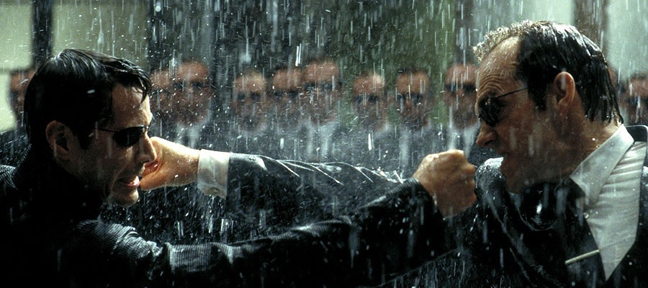

Conclusion

Of course, things could be worse, right? Just think if we had to deal wit
  - A Supreme Being that acts like an alcoholic husband.
  - Cosmic amnesia and eternal return without sustainable experience.
  - A universe built like a Haitian neighborhood.
  - A savior who dares us to think independently and nurture our intrinsic divinity.
  - A religious world where the divine feminine gets as much respect as a Jennifer Lopez movie. Then we might as well give up and become Packers fans and listen to The Pogues. So the best approach is… G N O S I S
As simple as that. Gnosis breaks the bonds of fate and lifts the veils of illusion. Or as the Gnostic Theodotus explained, what sets you free from the Counterfeit Spirit is the knowledge (Gnosis) of:
Who we were, What we have become
Where we were Where we have sunk Where we hasten
From which we are redeemed What is birth
And what rebirth.

Meditate on this, but hurry. Your Counterfeit Spirit already knows you’re awakening and is moving to take you back to that heavenly factory for a satanic tune up.

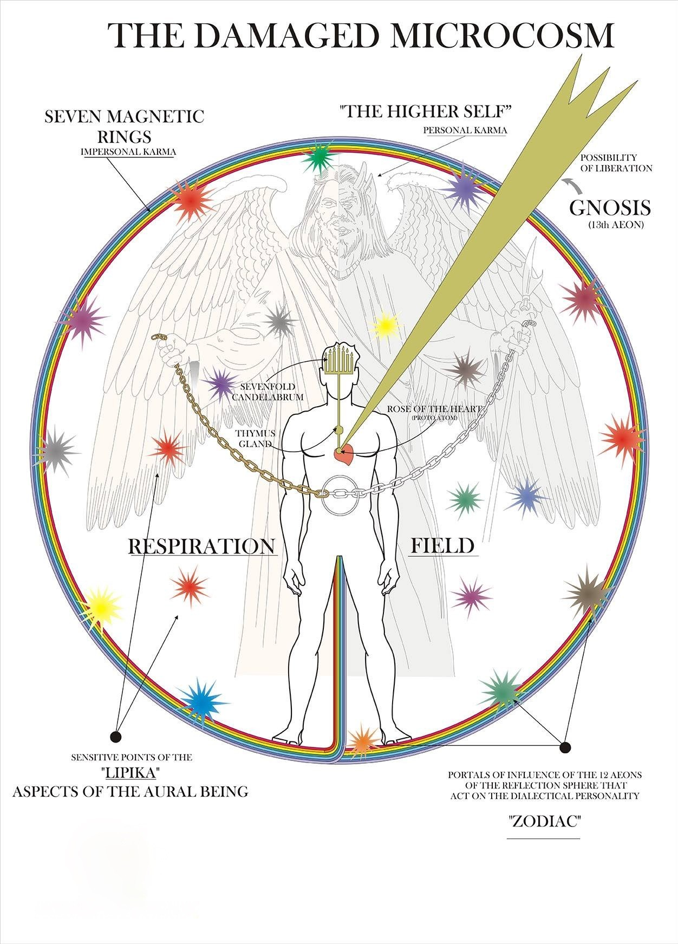

THE ZODIAC – A TWELVEFOLD PRISON
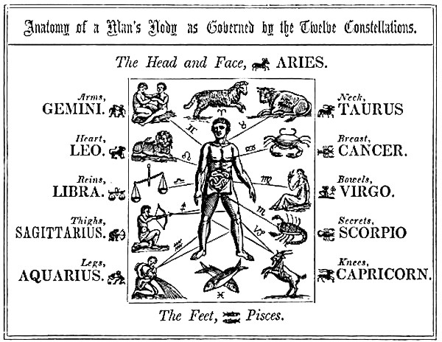
During the soul journey to the Father, the arrival at the so-called Twelfth Aeon proves to be the last and most deciding phases of the ascent out of duality. In order to fathom this, we need to have some understanding of the significance of the zodiac. The twelve macrocosmic powers of the zodiac, which rule our dualistic universe in a more direct sense, enclose our part of the dualistic universe. They rule it. They form the highest dualistic authorities from which the twelvefold personality develops. They form:

first: the dualistic I-consciousness (Aries)
second: the dualistic instinct of possession (Taurus)
third: the dualistic idea of brotherhood (Gemini)
fourth: the dualistic idea of the fatherland (actualizing the kingdom of God on earth) (Cancer)
fifth: the dualistic idea of strength, courage and heroism (Leo)
sixth: the dualistic idea of fertility (Virgo)
seventh: the dualistic idea of true harmony of life (Libra)
eighth: the dualistic idea of the development that is expressed in occultism (Scorpio)
ninth: the dream of dualistic deification (Sagittarius)
tenth: the first step in fulfilling this delusion in the mental sense (Capricorn)
eleventh: the second step in the ethical sense (Aquarius)
twelfth: the third step in the sense of physical manifestation, which step must mean nothing but endless sorrow (Pisces)

This whole twelvefold chain forms the great prison in the nature-of-death. These are the twelve gods from whom emanate: twelve ideas, twelve delusions, twelve attempts. The Pistis Sophia calls this chain, in its unity, "the great Forefather", with his three great triple-

powers. This system namely has a fundamental force, a controlling force, and a continuously activating force: the trinity of the nature-of-delusion. It is clear that every candidate who wants to fulfill his homeward journey has to shake off the chain of delusion right up to the twelfth hour. Twelve gods rule everything that exists and lies within the zodiac. These twelve gods have their reflections in our lipika and hence in our magnetic system and in our personality. It is logical that it is not enough for any pupil on The Path merely to break up his own zodiac in his own auric being. He has to rise beyond the whole universe-of-death, so that the Garden of the Gods will no longer be able to victimize him. For this reason the Rosycross places you before another Forefather with His three triple- powers. For a fundamental force emanates from the Gnosis, and he who stands on this stands as if on a rock. There is a gnostic controlling force, and he who walks his Path by means of this force can never deviate. And there is a gnostic activating force. Whoever is armed with this force possesses Siegfried's sword and a light-vesture that will escape all dangers. "The Zodiac - A Twelvefold Prison" The Gnostic Mysteries of Pistsis Sophia – JVR

Many understand and accept that the zodiac has an influence on human beings and human circumstances. But how is this so? How can man be affected by distant stars? The zodiacal signs are actually constellations of stars, star-systems. Following the universal laws of radiation, these groups of stars emanate particular astral vibrations, peculiar to themselves. The word "astral" means "pertaining to the stars". Astral forces travel by way of the astral realm of this nature. In addition to the physical, etheric and mental bodies, humans have an astral body, sometimes referred to as the desire body. It is this astral body that assimilates astral forces. This includes the astral forces that emanate from the star- groups that compose the twelve signs of the zodiac. The purpose of man's chakras is to attract and distribute astral energies throughout the personality. In the vast majority of humans, these zodiacal influences are unconsciously and unswervingly obeyed. This is why it is often repeated here that "man does not live, he is lived". During this present period, this Time of the End, these twelve powers have been weakened by one-third. Humanity has been freed to a certain extent from the iron grip of "the rulers", these twelve archons. This is the reason we see religions crumbling and revolutions of all types on the rise, be they personal, cultural or political. That which chained the minds of humanity for thousands of years has been severed. This has been done to allow man to take advantage of the presence of The Thirteenth Aeon, which has the power to bestow upon all who seek deliverance, the grace of divine astral energies, energies that are not-of-this-world. It stands to reason that if there are twelve star-systems that constitute the twelve signs of the zodiac, there must also be a constellation that represents The Thirteenth. Well, there is. That constellation is Ophiuchus, known as Serpentarius in ancient times. You may recall that a year or so ago, this constellation was presented to humanity as the so-called "13th sign of the zodiac". Astrologers balked, the masses laughed. It is hope that after reading this post, the reader will do neither. Instead, may you find the wisdom to take advantage of the Grace that is being offered to mankind at this critical time of Transformation.

"And I took from them all a third of their power, that they should no more be active in their evil doings, and that, if the men who are in the world invoke them in their mysteries -- those which the angels who transgressed have brought down, that is, their sorceries -- in order that, therefore, if they invoke them in their evil doings, they may not be able to accomplish them" -- The Christ speaking with His disciples - Pistis Sophia, chapters 12-15

THE ROAD OF THE SOUL IS THRU THE
PLANETS

A Cosmic Map
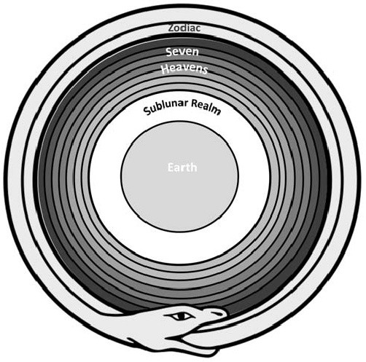
What was drawn on the Ophite diagram? It is clear that the diagram included an illustration of the heavens and Tartarus. Given that the diagram consists of ten separate circles, with Leviathan encompassing them, what we have is a conventional ancient map of the cosmos (1.Earth, 2.Sublunar realm, 3.–9. Seven heavens, 10. Zodiac), with the body of Leviathan as the ouroboros surrounding the Zodiac. The order presented in the following table is the standard ancient planetary arrangement based on the perceived distance of the planet from the earth, beginning with the farthest (Saturn) descending to the nearest (Moon). The seven heavenly spheres and the Zodiac were labeled with this arrangement on the Ophian-Christian diagram, an arrangement which will be confirmed later in this essay.

A Neopythagorean Ascent Pattern
Origen states that the path that the Ophians map on the diagram is the path “upwards” through the gates of each of the Archons. The ancients speculated about the soul’s descent and ascent through various planetary routes, as well as through specific star gates within the Zodiacal belt or along star columns like the Milky Way. In fact, one of the attractions of initiatory guilds like the Ophian-Christian was their claim to the secret knowledge of the precise path the soul uses to enter and exit the world. This knowledge was the trade secret of each guild. As we will see, the gates of entry and exit of the soul were identified with Capricorn and Cancer. What the Ophian-Christian diagram reflects is an innovative blend
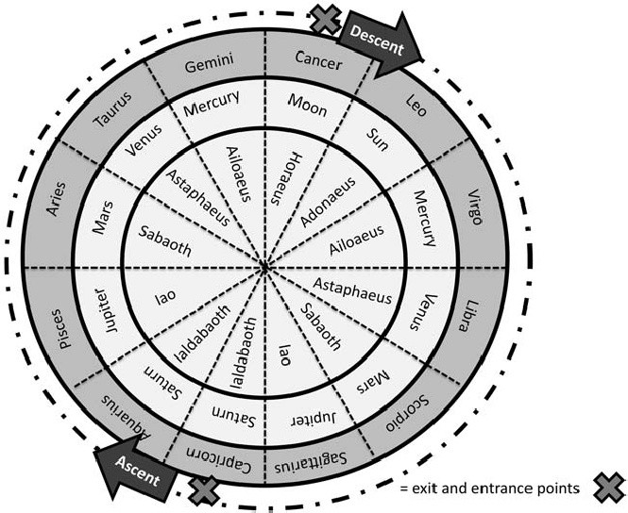
of knowledge, where a Neo- Pythagorean astrological map of the soul journey has interfaced with Gnostic spirituality in a Christian matrix.

Compression of Meaning
The Ophian-Christian diagram has long been misunderstood, not only because information about it is embedded in a complex narrative that requires systematic scrutiny, but also because the diagram itself is a compression of meaning. The architect of the diagram blended and compressed elements from the large web of knowledge known to

him, so that this vast web of information that exists beyond the human scale was made humanly manageable and relevant to the prime users. This compression resulted in emergent ideas quite distinctive to the Ophian-Christians, ideas not so easy to organize in a linear model of origin, causation and consequence. When we decompress the information back into their source domains, we are faced with a group of Christians who have a priesthood in place, a complex initiatory ritual called The Seal which effected the resurrection from the flesh, and a liturgical book that, among other things, includes a cosmic map, illustrations of seals, and prayer formulas used in their mystery initiations.

They are Christians who still give credence to parts of the Jewish scripture, although they understand the Jewish God to be a separate god from Jesus’ loving Father. The Jewish God is portrayed by these Christians as “cursed” because he cursed the serpent that gave Adam and Eve knowledge of good and evil. This god and his minions are associated with the planets. In order for the soul to journey out of this cosmos and be liberated from the cycle of birth and death, which the planets control, the archons must be ritually conquered at their zodiacal gates. These Christians offer their initiates precise information about the path of ascent through these gates, following a Neo-Pythagorean conceptual pattern made popular by Numenius. The path began at the gate of Capricorn, and then proceeded through Aquarius, Pisces, Aries, Taurus, Gemini, with Cancer’s gate as the exit. These gates are ruled by specific planets, associated with a distinctive pattern of names:

Saturn-Ialdabaoth (rules Zodiacal gates of Capricorn and Aquarius);
Jupiter-Iao (rules Pisces’ gate);
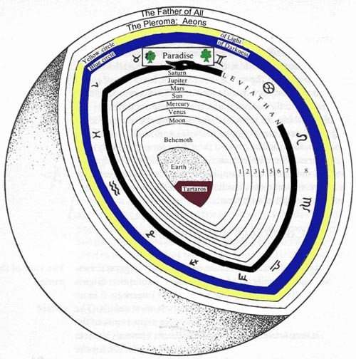
Mars-Sabaoth (rules Aries’ gate); Venus-Astaphaeus (rules Taurus’gate); Mercury-Ailoaeus (rules Gemini’sgate);
Moon-Horaeus (rules Cancer’s gate).

Adonaios is the archon of the Sun and he rules Leo’s gate. But this archon is only encountered in the diurnal descent pattern, when the soul falls down through the Zodiacal gates and is embodied again. Thus there is no ascent prayer registered for him in the liturgy of The Seal. Indeed, the Ophian- Christian diagram mapped a very precise road for the soul to ascend to God-Source through the nocturnal houses of the Zodiac which were ruled by the planets.

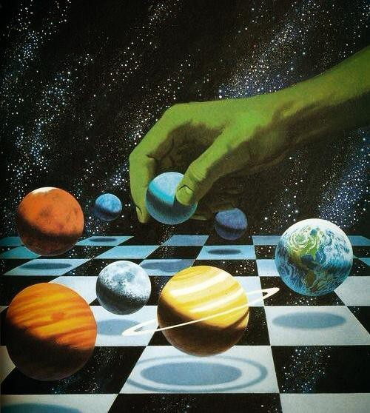

The Incarnation of The Soul

In Chaldean theology the spheres were the worlds presided over by the planetary gods; worlds traversed by souls on their way to incarnation and on their ascension after death. In the dream of Scipio, which ends Book VI of his De Republica, Cicero explicitly states:

To men is imparted a soul emanated from those eternal fires you call stars and luminaries which, round and spherical, quickened by divine spirits, perform their revolutions and perambulate their orbits with an admirable celerity.

According to these teachings, the human soul lives in the celestial world. Then it enters the terrestrial world through conception and birth, acquiring a physical body. On its way to incarnation the soul traverses the planetary spheres, assuming a subtle, also known as 'astral', body. Just as in earthly life the native will each day put on a series of garments, from light underclothes to heavy overcoat, so the incandescent flame of the human soul, in the course of its descent from its universe of origin into the terrestrial body, assumes a vesture formed of the substances of the spheres it traverses. This astral body comprises 'virtues' (qualities and instincts) received from the planetary spheres traversed. Since this involves on one hand the planetary spheres, while on the other their traversal takes place outside time to end in birth into our terrestrial sphere, these qualities are reflected in the configuration of the planets at the moment of birth. Macrobius' Commentary On The Dream Of Scipio describes the descent through the planetary spheres thus:

"souls freed of all material contagion dwell in heaven; but those who, from this abode on high, where they are bathed in a light eternal, have cast a downward glance at bodies and at what is here below called life, and who have conceived for life a secret desire, are dragged little by little down toward the nether regions of the world, by nought but the weight of this earthbound thought. Yet no sudden fall is this, but by degrees. The soul, perfectly incorporeal, assumes not at once the gross mantle of corporeal clay, but imperceptibly, and through a chain of adulterations suffered one by one as it recedes from the pure and simple substance wherein once it dwelt, to gird and swell itself with substance of the planets. For, in each of the spheres placed beneath the heaven of fixed stars, it swathes itself in several layers of ethereal matter which, imperceptibly, form an intermediary bond by which it is united with the earthly body; so that it suffers as many degradations or as many deaths as spheres traversed." (Ch.XII)

The qualities acquired by the soul in the course of its descent through the spheres are thus described:

"and in its descent, not only does it [the soul] assume the aforesaid new sheath of matter from these luminous bodies, but it receives there the different faculties it must exercise throughout its sojourn in the body. From Saturn it acquires reason and understanding, or what is called the logical and contemplative faculty; from Jupiter it receives the power to act, or executive power; Mars gives it the valour required for enterprise, and a burning zeal; from the Sun it receives the senses and the power of invention, that make it feel and imagine; Venus moves it with desires; from the sphere of Mercury it takes the power to express and enunciate what it thinks and feels; finally, from the sphere of the Moon, it acquires the strength needed to propagate by the generation and increase of bodies. This lunar sphere, which is last and lowest with respect to divine bodies, is first and highest with respect to earthly bodies. This lunar body, as it were the sediment of celestial matter, at the same time is found to be the purest substance of animal matter." (Ch.XIl)

This teaching underlies the practice of genethliacal astrology as it was originally conceived. In the

nativity the 'Chaldeans' saw a chart of the astral bodies, as the journey through the planetary spheres had structured them. Correctly interpreted, this chart would reveal the native's constituent parts, material or more subtle. It would speak of his daimon, the guardian angel who would accompany him on his voyage here below and watch over the fulfilment of his fate. It would describe, therefore, the earthly existence which had devolved upon him.

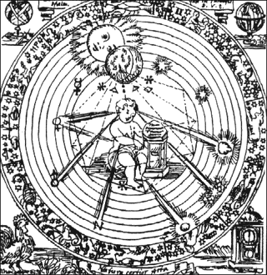

Beyond the threshold of the world stands the firmament (from the Latin firmamentum: pillar, support), the vault of heaven, pillar of the stars, named 'sphere of the fixed stars'. The Earth, or rather the observer is located at the centre. The Moon is the nearest planet. She receives and transmits to the observer the action of all the other celestial agencies. Then, from the nearest planet to the furthest: Mercury, Venus, Sun, Mars, Jupiter, Saturn.

The Ascension of The Soul

The Poimandres, first treatise of the Corpus Hermeticum, reveals what happens at death and after death. In order to return in pristine purity to the divine, the soul must effect a divestment, in reverse order, of the astral raiment it has donned. The soul first quits the material element encountered in the last place, namely the stuff of nature, that is the body furnished by nature. In the last place it quits the first material element encountered in its fall, namely the astral vestment of the highest sphere. Death entails a sequence of effects:
- the body is consigned to dissolution, and the visible form disappears;

- the temperament (subject in each case to the individual blend of the four elements), henceforth inert, is consigned to the personal daimon (the guardian angel which, at birth, takes charge of the newborn);
- the bodily senses return to their respective planetary sources.
- ire and lust, irrational passions, revert to unreasoning nature.

After this first divestment, the soul begins its ascension. Soaring upward through the armature of spheres, it casts off at each station the passion assumed there in the course of its descent: at the 1st station (Moon), the faculty of increase and decrease; at the 2nd (Mercury), malice and cunning; at the 3rd (Venus), the illusion of desire; at the 4th (Sun), the passion for command; at the 5th (Mars), audacity and temerity; at the 6th (Jupiter), the lust for wealth; at the 7th (Saturn), the falsehood that ensnares.
"And thereupon, stripped of the vestments generated by the armature of spheres, the logos enters the ogdoadic essence (the 8th heaven, of pure ether, pure light), having nought now save its own power." (Corpus Hermeticum I,26).

But it mounts yet higher, to the very Powers divine who reside above the ogdoadic essence. It becomes in turn a Power, and enters into God.
"For such is the blessed consummation for those possessed of gnosis: to become God." (Corpus Hermeticum I,26).

This ascension to the Powers divine is not, however, automatic, the spheres being equally obstacles impossible to overcome. Since the soul's existence as a human being determines the heaven it can attain upon divestment, it risks being unable to traverse one or other of the spheres and plunging back into terrestrial existence. By fasting and prayer, by sacred rites and the aid of mediating powers (gods for the Greeks or Egyptians, angelic hierarchies for the medieval magi) incarnate man can ease from here below his divestment and his inner transmutation.

The Divestment of The Metals
"Seven are the passages to perfection of matter"
- wrote Cagliostro in the Catechism for the Apprentice of the Egyptian Lodge. Like many other alchemists, Pernety speaks of 'washing', adding that this involves passage through the seven planets, effected by seven successive workings which lead from the different states of Mercury, symbolised by the alchemical metals, to the state of gold. In the light of what has just been expounded are such texts illumined. To be admitted to initiation in the Masonic Order, the layman must divest himself of his metals. Since each metal belongs to a planet this divestment must be intended to show the shedding of the planetary vestures, that the being may contemplate the true light. At the 28th Degree of the Ancient and Accepted Scottish Rite, likewise adopted by the Ancient and Primitive Rite of Memphis-Misraism, the candidate is made Knight of the Sun. During a first part of his initiation he is regaled successively in seven cloaks of different colours, draped round him by the seven

ministrant angels of the seven planets. During a second part, he divests himself of each of these cloaks. He is at last allowed to contemplate the Sun.

The Attitude of Christianity (Taken for the most part from R. Powell's excellent History of the Planets)

Christianity tried to eliminate paganism but in fact half the Chaldean doctrine was Christianised. The soul's descent into incarnation was discarded, but its ascension post mortem through the planetary spheres was retained. For the pagan gods presiding over the planetary spheres Christian teaching substituted the celestial hierarchies described in the works of Pseudo-Dionysius. These hierarchies were conceived of in ascending rank, each attributed to a planetary sphere:

Angels - sphere of the Moon; Archangels - sphere of Mercury; Principalities - sphere of Venus; Powers - sphere of the Sun; Virtues - sphere of Mars; Dominions - sphere of Jupiter; Thrones - sphere of Saturn;
Cherubim - sphere of the zodiac of fixed stars; Seraphim - sphere of crystal.

It was considered that after death the human soul re-ascended the planetary spheres to attain the Empyrean. There, beyond the planetary spheres and the sphere of fixed stars, sat the Holy Trinity.
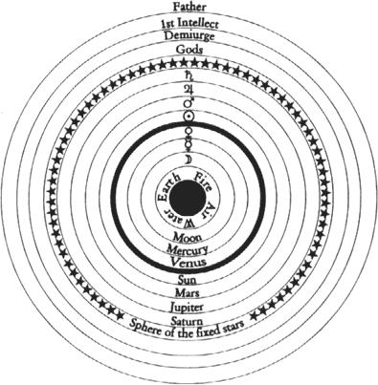
Dante's Divine Comedy depicts this ascension of the soul through the planetary spheres and the corresponding ranks of the different hierarchies. Christianity has recognised the principle of the soul's survival and reascension through the planetary spheres after death. Ancient Chaldean theology recognised in addition the soul's pre-existence and descent through the planetary spheres into incarnation. One simple gesture would have allowed the two teachings to merge in harmony. This was undertaken only by certain gnostic, kabbalistic and initiatory communities.

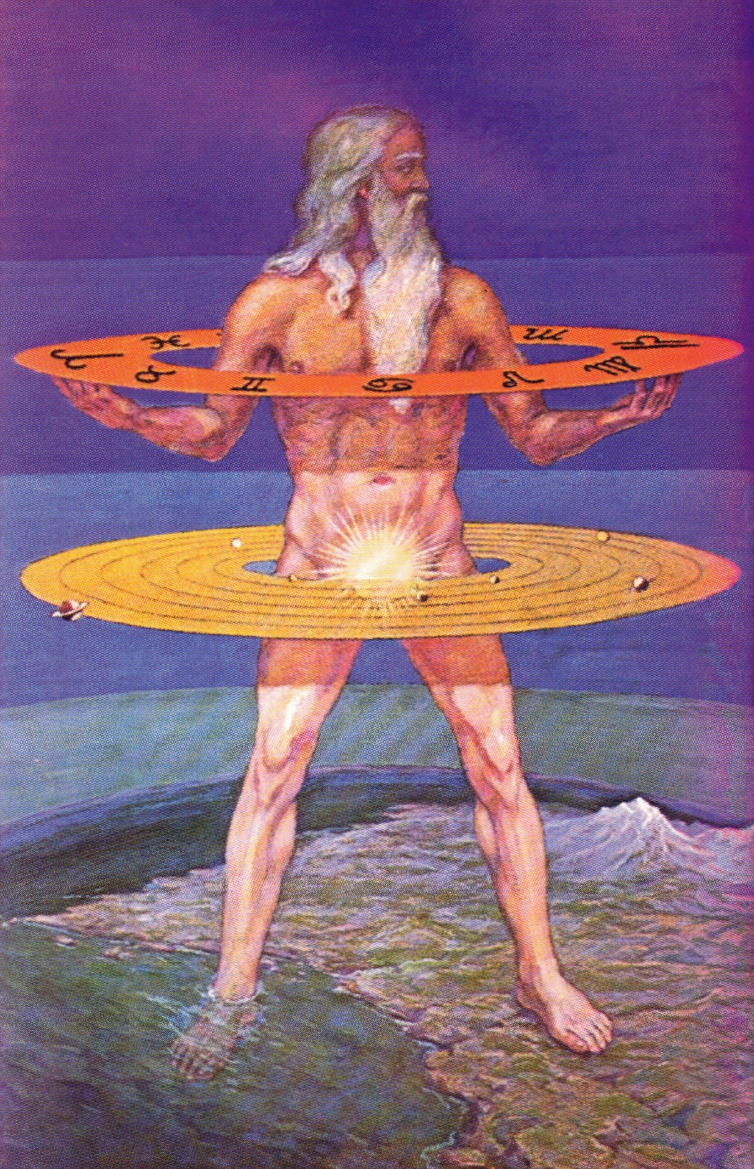

ASCENSION IN THE ANCIENT HELLENISTIC WORLD

Late Hellenism was dominated by an obsession with human liberation from the world and out of the world, in, or beyond, the heavenly spheres. This is reflected, for example, in the Gnostic systems of the second and third centuries ce and in their polemic against astrology. The seven "planets" themselves, the signs, the decans, and the degrees of the zodiac are often represented as evil archons, or heavenly rulers. These are extremely important for the embodiment and disembodiment of the individual soul. The heavenly ascent of the soul through the spheres is therefore considered a central tenet of Gnosticism. The techniques that are intended to assure the Gnostic's soul a safe passage through the spheres of the hostile archons up to the plērōma (fullness) of the godhead actually form the most important part of gnosis.
One of the first testimonies for the Gnostic theory of the embodiment and disembodiment of the soul is the doctrine of Basilides, who was active in Alexandria around 120 ce, and of his son Isidorus, according to whom the transcendental spirit of human beings is temporarily attached to a soul. During its descent, the planetary vices attack the soul and stick to it in the form of concretions of "appendages" (prosartēmata).
The technical expression antimimon pneuma, or "counterfeit spirit" (sometimes antikeimenon, or "evil spirit"), occurs for the first time in the Apocryphon of John, one of the oldest surviving Gnostic treatises, extant in Coptic translations. Some scholars claim that the Apocryphon of John predates even Basilides, whose theory of the prosartēmata is based on the antimimon pneuma doctrine. In fact, the antimimon pneuma is an appended spirit, an intermediary between the soul and the material body. The soul itself is a creation of the evil heavenly archons (i.e., the seven "planets") or, to be more precise, of the seven attributes forming conjunctions (syzygies) together with the archons.
The formation of the antimimon pneuma is more explicitly stated in the Pistis Sophia, also preserved in Coptic. The "counterfeit spirit" derives directly from the archons of the heimarmenē, or astral destiny, which are the seven "planets." The antimimon pneuma follows the soul in all its reincarnations (metabolai) and is itself a cause of reincarnation. The goal of Gnostic mysteries is to free the soul from bondage to the antimimon pneuma. On the basis of the planetary order in chapter 136 of Pistis Sophia and in other texts of late antiquity, it seems likely that this doctrine derives from the Hermetic astrological treatise Panaretos, which includes a discussion of the degrees (klēroi) or positions (loci) of the planets; that is, the coordinates within the horoscope of nativity, where each planet is supposed to confer its principal qualities upon the subject. However, Gnostics mention only the negative qualities or vices derived from the planetary influence.
The doctrine of antimimon pneuma became influential in Hermetism, where it merged with the idea of the soul's descent into the world and its return to heaven. During its descent through the planetary spheres, the soul acquired from each planet the dominant vice ascribed to it in astrology, while during its ascent, those concretions were put off (Poimandres 25–26). The ascent of the soul in Gnosticism could be much more complicated,

and the ritual performances or "mysteries" intended to assure the soul an easy passage through the archons differed widely, although they presented some fixed patterns, such as learning by heart magical names or invocations. Some Sethian treatises from Nag- Hammadi (Zostrianos, Allogenes, The Three Steles of Seth), where the path of ascent shows Platonic nuances, prelude the life-intellect-being triad later developed by Plotinus.
The second-century Platonic writer Celsus (attested by Origen, Contra Celsum 6, 22 ff.) ascribed to the Persian god Mithra, whose veneration increased during late antiquity and who was reshaped to suit the changed religious attitude of Hellenism, a ritual object consisting of a ladder with seven steps or "gates" (klimax heptapylos), representing the planets. Similar objects are also depicted in Mithraic temples. According to Celsus, this object symbolized the passage of the adept's soul through the planetary spheres, which could be accomplished in concomitance of the magnus annus of Plato's doctrine (Timaeus 39d). This interpretation raises some difficulties, however, since the steps are arranged according to the order of the days of the planetary week, which is explained by Celsus in accordance with the musical theory of the tetrachordon. Celsus linked this doctrine to a related diagram ascribed to the Gnostic sect of the Ophites. Some interpreters have argued that these steps and their associated rituals represent a meditative technique to obtain inner knowledge of the self, and the steps are thus structured as an interior journey.
In Hellenistic culture a relationship was established between the seven "planets" and the levels that the soul had to transverse in its heavenly ascent. It can thus be maintained that, as far as the mysteries of late antiquity are concerned, their divinities, in some cases traditionally connected with the earth and the underworld Hades, are transported entirely to heaven, where they are supposed to receive the souls of their adepts after death. Moreover, Gnostic polemics against astrology gave rise to the formation of the influential theory of the passage of the soul through the spheres, fashionable among Neoplatonists from the third to the sixteenth century ce. It is impossible to state whether Neoplatonists (e.g., Porphyry, Proclus, and Macrobius) took this theory from Numenius of Apamea or from the Gnostic-Hermetic tradition. It should also be noted that the Christian writer Arnobius, at the beginning of the fourth century, directed his polemic against a group of Neoplatonic mystics who maintained the doctrines of the Chaldaean Oracles, attributing to them formulas and other means for transporting their clients to heaven.
The embodiment (ensōmatōsis) of the soul entails a descent from the top of the cosmos to the bottom, through the planetary spheres that confer certain characteristic features upon the soul. Disembodiment is the reverse of this process. In late Neoplatonism, which borrowed this doctrine from Chaldaean theurgy, the ethereal body that enveloped the soul and that was formed by planetary qualities was its "vehicle" (ochēma). Sometimes this "vehicle" was distinguished from others that were meant to serve as intermediaries between the soul and the material body, according to a theory of Aristotle that was influential in Greco-Roman and Arabic medicine. The theory of the passage of the soul through the spheres was taken over from Macrobius by medieval medicine and psychology. Through the works of Marsilio Ficino (1433–1499), it became one of the most widespread doctrines from the time of the Renaissance down to the end of the sixteenth century.

JOHN BAINES: THE STELLAR MAN

If we were perverse Gods or immoral despoilers, we could not invent a better method to make a group of slaves work peacefully than to make them believe, by means of collective hypnosis, that they are happy and important. We would then have perfect robots who would work untiringly, producing what we desire. In addition, these robots would make and maintain themselves. It could be argued that sapiens, unlike other species, sows, produces, and labors only for himself and not for other beings. This is true for the products and material sapiens uses for his own maintenance. No nonhuman species steals the material product of sapiens' efforts. On the other hand, this is not the case with the subtle fruit produced by the human nervous system in everyday life. This fruit is rapidly reaped by certain beings who are much higher on the evolutionary scale than the human being; veritable Gods of space, who profit from human efforts, but in turn fulfill certain cosmic functions and occupy an important position in the universal economy. These beings have been mentioned previously: they are the Archons of Destiny. We could also refer to them as Gods of the Zodiac, as they direct and govern human existence on this planet.

When we speak of true astrology, we do not refer to radiations from a specific planet, but to the influence of the Zodiacal Gods, each one of which (there are 72 in all) has personal and defined characteristics, influencing the people they control in a strange way. All of Earth's inhabitants are under the sway of one or more of these Gods, who regulate, shape, and direct the destiny of humanity. But this is not so for the destiny of the Hermeticist, who attains his vital autonomy at a certain moment, releasing himself from the mandate of the Archons. The Archons of Destiny are terrifying beings, not because they are evil, but due to their cold and inexorable severity in the manipulation of sapiens. If we were to establish a symbol for these beings, no doubt they would be depicted with a whip in their hands, a girdle of bristles or netted wire with which they chastise humanity in order to ensure their progress, although this evolution may be imperceptible during our earthly time. For example these occult judges pitilessly provoke a world war in which millions of people die. For them, these dead are of no more importance than that assigned by sapiens to the thousands of animals they sacrifice daily in order to feed.

Sapiens, in his extreme fight for existence and in his various relations with the natural and social environments surrounding him, inevitably experiences all kinds of tribulations, suffering, deceptions, and other experiences, both pleasant and unpleasant. As a consequence, his emotional and nervous systems develop certain embodied elements, that are extremely powerful, and which abandon the human body in the form of vibrations (everything vibrates; matter is only vibratory energy). These vibrations are transmitted through antennae incorporated in the biological unit which are tuned to the frequency of the Archons, who then reap this power and use it for purposes we cannot divulge, again stating that they accomplish a cosmic function. It is thus that sapiens is unwittingly

stripped of the most noble product he has produced; the final distillate of human experience, the broth in which lies the blood, the soul, and the very life of the individual. The individual lived for this, suffered, loved, enjoyed, worked, built things, went to war, studied, investigated, only to prepare the golden broth of his life. We must understand that the central computer only exists in relation to the Archons of Destiny as an instrument to control sapiens. The object of life, the reason for which sapiens was created, is not for him to enjoy life in the garden of the Lord, but rather to be a pawn in his vineyards, a worker so perfect he can act as cultivator and food at the same time.

If man could prevent his golden broth from being stolen, with this vital product he could become equal to the Gods, rapidly evolving by integrating within himself the products from the chemical laboratory of his physical body. This is exactly what is done by the student of Hermeticism, who is temporarily freed by the Archons of Destiny. This individual, by virtue of his understanding and responsibility, has no need for an overseer with whip in hand to oblige him to evolve through suffering, as he takes responsibility for his evolution into his own hands, and if he deems it necessary, submits himself to the same temporary suffering in order to attain eternal happiness. This is in contrast to the profane or worldly person who chooses fleeting pleasure at the expense of eternal suffering. If the student fails or turns aside from his path, abusing his temporary freedom, the Archons again take him under their control, punishing him very severely.

From another point of view, we can see how certain countries are chosen by the Archons for veritable martyrdom. Furthermore, one should not believe that this suffering is futile, as such a sacrifice generally brings about a moral, material, spiritual, and intellectual revival of the population by virtue of the law of suffering. So it is that after wars we notice a rapid rebirth toward a higher state. This is a high price to pay for evolution. These wars could have been avoided had there been sufficient clearheaded people in the world who the masses would have been willing to follow.

Enough revealing of secrets which are hidden from sapiens. Let us spread a cloak of silence on this subject in order to comply with the mandate of the esoteric Sphinx who demands silence. Speech and silence are two swords, which must be handled with sublime skill in order not to disrupt universal harmony. Those who have "eyes to see" will understand everything not stated in the written word, but in the cryptic language of the initiate. For those not in this state, it is best that they understand nothing and continue to sleep tranquilly. Ultimately, the Archons run no risk of a bad harvest from a possible rebellion of sapiens. Sapiens is too blind to see where the danger is really found. It is sad to observe the tremendous limitation of sapiens, who shuts himself up in the small world of stereotypical concepts, of memorized knowledge, of imitation, and mechanisms of compensation and defense. His mental disability prevents him from realizing just how small the cubicle is which imprisons him. And, thus, with a mind made up in advance, he accepts, condemns, or tolerates without bothering to intelligently analyze the situations with which he is confronted.

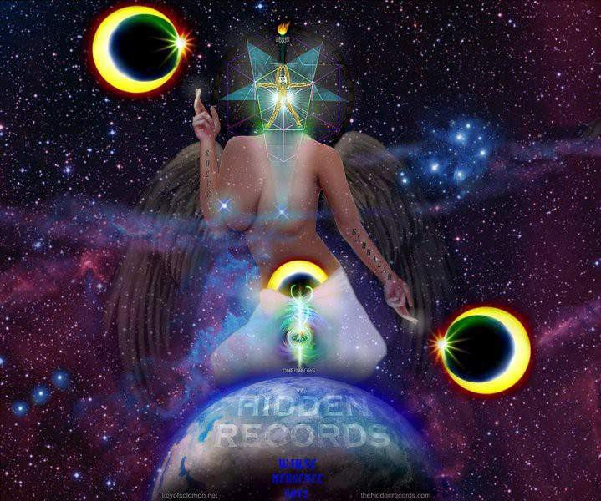

CAYCE ON PLANETARY ASTRAL REALMS13

Cayce revealed that our life experience involves our entire solar system. Each planet is a physical representation of a particular afterlife realm (or dimension). Our universe (including the Earth) is the third realm in the afterlife hierarchy and represents three- dimensional life. Because Cayce associated each planet as a physical representation of a particular afterlife realm, he referred to these afterlife realms using the name of the planet associated with it. When he uses the name Venus, he is referring to the afterlife realm. Planet Earth is a physical representation of the third afterlife realm (i.e., our universe). Planet Mercury is a physical representation associated with the second afterlife realm, also named Mercury, in the afterlife hierarchy. The afterlife realms are dimensions which souls can experience when not active in the physical body on Earth. The planets exert an astrological influence on us. These astrological planetary influences originate from the afterlife realms that our souls have sojourned before our current Earth experience and in between Earth lives. The purpose of these astrological influences is to provide certain life lessons we must learn and for which we are tested on Earth. While on Earth, we are influenced in strong ways by desires that originate from our bodies. These desires not only affect our bodies but our soul as well and how we deal with these influences can determine our level of spiritual development. Through meditation and prayer, one can unlock the doors to the many dimensions, the many mansions, of God's kingdom. But the door must first be unlocked here on this Earth realm. There are seven Chakras within the body that act as spiritual energy centers. They function like a miniature astrological solar system with our hearts performing the function of the sun - the center of the system.

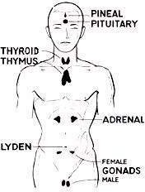
The Connection Between the Body and Afterlife Realms
These seven spiritual energy centers within our body are the seven endocrine glands. They act especially in responses to the imaginative forces of the mind. They are the organs of perception through which we may become aware of other afterlife realms in the same way that our commonly known five senses are organs of perception of our Earth experience. The functioning of these centers is, in turn, dependent primarily upon the quality of motivation or ideal chosen and dwelt upon by the imaginative forces of the mind. When we get angry, we experience the emotion of anger, our adrenals glands secrete. The activity of our sexual glands is directly related to sexual motivation from our minds. The pituitary gland is the master gland of the body. It's secretions have a direct and coordinating effect on
all the other glands. Each endocrine gland center is influenced by the influence of a particular afterlife realm through its associated astrological planetary influence. The

13 http://www.near-death.com/experiences/cayce08.html

lowest endocrine gland in our body, the sexual glands, is associated with the lowest afterlife realm in the hierarchy of spirit realms. The pituitary gland is associated with the highest afterlife realm in the hierarchy.
The afterlife realm we travel to upon death is
determined by the highest endocrine gland within our body that we have spiritually
Activation of the highest spiritual center, the pituitary gland, creates a spiritual
activated.
awakening and enlightenment that brings an awareness of our one-ness with God. This is the spiritual condition that Christians refer to as atonement, or as Cayce would say: at- one-ment.
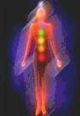
Each afterlife realm has a particular astrological function that influences us physically by the corresponding planets in order to attain soul growth. Cayce identified the planet Earth as the realm of testing. Cayce stated that the Earth is the cause and effect dimension. This means that if a soul has a mental ideal and would like to physically manifest this ideal for the purpose of education, the soul can come to the Earth to be tested and apply themselves. The Earth
realm is good for overcoming certain weaknesses and applying yourself to see that those weaknesses are truly overcome. Here we can learn for certain whether we have really changed. It is a sort of
laboratory for the other realms of the afterlife associated with our solar system. Only on Earth is free will completely dominant. In the other afterlife realms, some measure of control is kept over the soul to see that it learns the proper lessons.

Endocrine Gland Eastern Chakra Planet in our
 |  | Solar System | in Solar System | Afterlife Hierarchy
------- | ------- | Pluto | 9th | -------
Pituitary | Third Eye | Jupiter | 5th | 7th
Pineal | Crown | Mercury | 1st | 2nd
Thyroid | Throat | Uranus | 7th | 8th
Thymus | Heart | Venus | 2nd | 4th
Andrenals | Navel | Mars | 4th | 5th
Lyden | Lower Abdomen | Neptune | 8th | 6th
Gonads | Root | Saturn | 6th | 1st
------- | ------- | Earth | 3rd | 3rd

Position of Planet
Position of the Realm in the

Looking at the next color-coded chart below, we can see the spiritual relationships between the glands and the influence of vibration and light exerted upon the gland. It should be noted here that not only is this spiritual influence of light vibrations exerted upon the gland from afterlife realms, but these same light vibrations are exerted from our glands upon the afterlife realms. This is how we are spiritually connected to the planets and the afterlife realms. This makes it possible for us to connect with others through the same planetary/realm connection.


As an example, looking at the chart below will show that the pituitary gland is associated with spiritual strength through the spiritual vibration on the scale of la and the violet light spectrum. This spiritual vibration astrologically connects the pituitary gland to the planet Jupiter. It also connects Jupiter to its corresponding afterlife realm - the 7th realm (see the chart above).

Endocrine
Gland | Influence
------- | Subconscious | ------- | ------- | Pluto
Pituitary | Strength | la | Violet | Jupiter
Pineal | Mind | tea | Indigo | Mercury
Thyroid | Psyche | so | Blue | Uranus
Thymus | Love | fa | Green | Venus
Andrenals | Anger | me | Yellow | Mars
Lyden | Mysticism | ray | Orange | Neptune
Gonads | Woes | doe | Red | Saturn
------- | Testing | ------- | ------- | Earth

Spiritual
Vibration Light Spectrum Planet

The energy of the sexual glands, used wholly on the sexual level and without control, may bring sexual perversions and unbridled sensuality. If this spiritual center is the highest center activated during a person's life, at death they may dwell afterlife realm of Saturn. This realm can be referred to as the realm of earthly woes. It is similar to the purgatory, a place of cleansing, purification and starting over.

The Saturn afterlife realm is not a pleasant place according to Cayce. This is the realm where all inadequate flesh goes to be redone. A soul may banishes itself to the Saturn realm to begin anew. This place is also known as the Great Changer, the great force for starting over. Sometimes when Cayce would begin a reading for someone, he would identify what the last afterlife realm that soul experienced before entering the Earth realm. He would not limit himself to a person's past lives on Earth, but would include their lives in the cosmos as well. During a reading, Cayce told a person he identified as having previously experienced an incarnation in the Saturn realm that "God loves those who are willing to start over."
The lyden (or Leydig) gland, located above the sexual glands, is the starting point of the soul's activity toward higher levels of spiritual consciousness. This endocrine gland can act on the body to function as a door through which the soul may go on to higher afterlife realms. If this gland is the highest gland activated during a person's life, at death they will be able to dwell in the corresponding afterlife realm associated with the planet Neptune. According to Cayce, this afterlife realm is referred to as the realm of mysticism, where souls have the ability to have direct experience with the Creator and perceive the Creator. Neptune gives the urges to seek the unusual, the mystical, the unseen forces around us. People who come to Earth from this realm seem peculiar to others and are many times misunderstood. A love of mysteries can indeed be spiritual, but it can also be "of the sleuth or detective nature."
The adrenal glands are located above the kidneys. We are actively aware of this center in times of stress, when it pours adrenaline into the blood stream to aid us in fighting or fleeing. The adrenals are also the storehouse of our emotional karma according to Cayce. From these glands come the negative energy of anger and hatred. If this gland is the highest gland activated during a person's life, at death they will be able to dwell in the corresponding afterlife realm associated with the planet Mars. This realm was the place to learn how to control the warrior-like power, aggressions and urges that each soul has the ability to project. People who come to Earth from this realm may bring with them anger, impulsiveness, and a temper. Stubbornness needs to be handled with patience and self-control. Such people may have an exalted opinion of themselves, but it makes them courageous.
The thymus gland is found behind the heart in the solar plexus area of the chest. Since the thymus gland is related to the heart, it is associated with love. Love opens all doors. At this gland, love is awakened, bringing with it consideration, unselfishness, sincerity and honesty. If this gland is the highest gland activated during a person's life, at death they will be able to dwell in the corresponding afterlife realm associated with the planet Venus, the realm of love. Sympathy, the alleviating of hardships, the seeking of love, beauty and song are some influences that people from that realm possess. Beauty, either natural or man-made, will move these individuals; furthermore, there is a desire to beautify the home. There is a strong attraction to the opposite sex.
The thyroid gland, located in the throat, is related to will-power. From the misuse of the will for selfish and domineering ends, may come the condition known as hyper-thyroidism. When little effort is made to the will at all, the opposite may occur, an imbalance known as hypo- thyroidism. It is worthy of note that in some cases where there has been a growth on the thyroid, a degree of clairvoyance or telepathy has developed. The energy released upon the thyroid gland opens the door into the psychic realms of consciousness. If this gland is the highest gland activated during a person's life, at death they will be able to dwell in the corresponding afterlife realm associated with the planet Uranus, the realm of the psyche.

Cayce used the term psyche in the same way as the ancient Greeks used the term meaning the sense of the soul. Cayce said it was natural for every soul to have a sixth sense. The Uranus afterlife realm is where the soul develops psychic ability. Uranus is also the realm of extremes. It gives people who came from there an interest in the occult and psychic phenomena. Such people have times of smoothness and other times, periods of ecstasy and depression.

The pineal gland is situated a little above the pituitary gland and is the so-called Mind of Christ gland. [This is DISINFORMATION: the pituitary gland is actually our true uplink. The pineal gland, the chakra-system, and the snake-kundalini were artificially implanted. The LOGOS enters through the crown-chakra! See: Boris Mouravieff – Gnosis Vol.1-3, Laura Knight-Jadczyk: The Wave Series]

When this gland has been truly awakened, one may experience spiritual holy communion. It is by this gland that the mind of the soul meets the Holy Spirit. This gland, when stimulated daily through meditation, can bring seer-ship or prophecy[sic!]. If this gland is the highest gland activated during a person's life, at death they will dwell in the afterlife realm of planet Mercury, referred to as the realm of the mind. Mercury is associated with high mental abilities. People who come to Earth from this realm are gifted souls who need to watch out for self- aggrandizement or their abilities will be merely stumbling stones upon his path. Mercury brings understanding, specifically the understanding of the other spheres.If the pituitary gland is the highest gland activated during a person's life, at death they dwell in the afterlife realm of the planet Jupiter. This realm is referred to as the realm of high mindedness and large groups. People who come to Earth from this realm may bring with them universality and ennoblement. They may turn their attention to large groups of people or nations. They often have grand ideas and notions. As another example, Cayce described his sister Lila's sojourns. Her soul sojourned in the afterlife realm associated with Jupiter prior to incarnating into the Earth. But before incarnating she had an experience in the afterlife realm associated with Mercury which added to her mental ability. Jupiter's influence of high mindedness and large groups is one of the reasons she later became an executive for the International Red Cross. Large groups and high ideals often come with incarnations in the Jupiter realm. These influences are latent within the soul by soul experience, not just because the stars are in a certain position at the time of birth. The soul actually had experiences in these realms and draws on during their experience on Earth. During sleep, we also enter into these afterlife realms again according to Cayce.

The planet Pluto is associated with the afterlife realm of consciousness. This is the final development of full consciousness. The planet Pluto was discussed by Cayce years before it was actually discovered! He referred to it as Vulcan and also as Septimus. When Pluto was discovered, Cayce affirmed that Vulcan or Septimus was the same planet as Pluto. The Pluto realm brings regeneration and a growth in consciousness and self-centeredness. Pluto represents spiritual growth and development of the soul.

Planets and solar systems became a temptation to souls. Each solar system had its own course and its own plan. Souls moved toward them through the activity of a constant stream of mind. When a soul leaped into the stream (by immersing itself in the system through which the stream was flowing) it had the force of the current to contend with, and its free will was hampered. It was very easy, under these circumstances, to drift with the current.

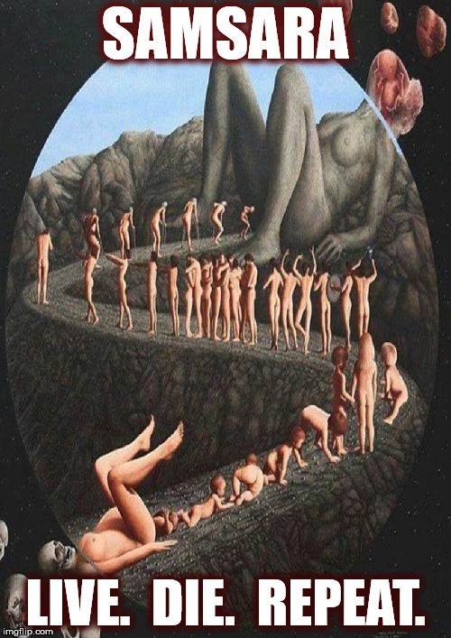

WHY I AM NO LONGER A LIGHT WORKER1

No, I haven’t turned to the dark-side, but rather I am transcending sides. This article is probably the most important piece I have written to date, and in order to convey the full message, a bit of back-story is necessary. Hang in there with me, and by the end you will understand why I will never call myself a “lightworker” again. Planet Earth and much of our corner of the universe has been under a spell for a very long time, a spell which casts doubt within our minds about whether or not we are connected with the Infinite Source of all creation. The spell causes us to feel alone, vulnerable and isolated – cast out from the Heavenly Realms into a cruel, dog-eat-dog world. This spell is pure fiction, a deception of the highest order, but it has taken hold deeply on this and other worlds. Intrinsic within this holographic spell is the notion that duality and polarity are natural aspects of life, and that we must serve one side of duality or the other. This elegantly simple binary imprint has become so prominent that we have lost sight of the larger holographic spell that spawned it. Indeed, we have lost sight of the hologram all together, and come to believe that it is the sum total of reality. Humans have been conditioned to worship the holographic deception and the agents that perpetuate it. This hologram has been called Maya by the Hindus, and the Gnostics referred to it as the Corrupt Demiurge. I find this term a highly accurate description, and from the point forward I will refer to it as the corrupt demiurge.

Dark vs (False) Light – Duality of the Demiurge
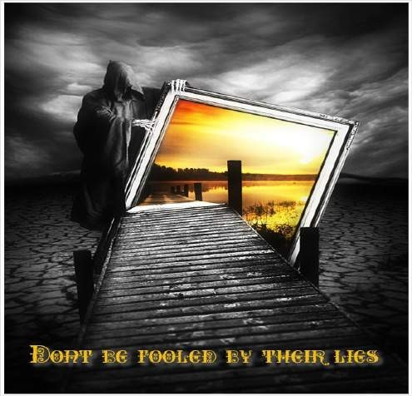
In order to capture and control the widest possible spectrum of souls, the corrupt demiurge split its agents into two seemingly opposing teams: Dark vs (false) Light. Not everyone can be a saint, so there must be room for sinners within the demiurge, as long as everyone involved is under its spell. What matters most to the demiurge is that we worship it or one of its agents, regardless if they are on the light team or the dark team. There are many names of the players within this cosmic, multi-dimensional drama that you will have no doubt heard of such as: Lucifer, Jehova, Beelzebub, Arch Angel Michael,
Satan (different dude than Lucifer), Ashtar, dozens of Arch(on) angels, supposedly ascended “masters” and various other channeled entities. While some of these beings play for team dark, and some play for team (false) light, they are ALL ultimately playing for the

1 Cameron Day: http://www.ascensionhelp.com/blog

corrupt demiurge that controls them. This, in essence, is the big secret of the archons: They are not just the “evil, demonic beings” but also those who pretend to be angels and ascended masters..

What is the Point of All This Control?
The corrupt demiurge is an entropic system of artificially-induced separation consciousness that is slowly dying, and it depends on harvesting the energy from the souls incarnated within its system in order to preserve its existence. In order to harvest the largest amount of soul energy possible, it created the dark-light duality paradigm to ensure that every being incarnated on a world that is under its spell would serve as a “soul battery” to help keep the demiurge energized. The “good” souls would seek out the (false) light team, and the “bad” souls would seek out the dark team, but unknown to most of those souls, they are all serving the same system. In order to keep the duality game interesting for its participants, the demiurge set up densities of existence that “initiates” on the dark and light paths could ascend through. This gives the beings moving through these densities a feeling of accomplishment, when in fact they are navigating through a labyrinth of demiurgic illusion. The players at the higher levels of the hierarchies know that they are in a self-serving system, but they are fine with the deal, because they get to wield power and receive the energy of worship from beings further down the ladder.

What About the “Spiritual Hierarchy?”
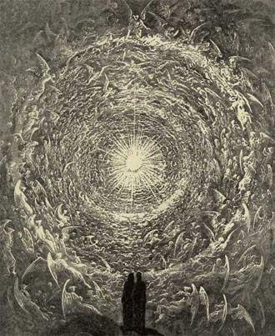
Most channeled beings will claim to be affiliated with the (false) light-based “Spiritual Hierarchy” which includes “arch angels,” “ascended masters” and “positive ETs.” These channeled messages are a dime-a-thousand, and more keep pouring out every day. The dirty little secret is that these beings are beholden to the corrupt demiurge, and are waging a psychological battle on people that don’t want to be associated with any formal religious structure. In other words, the “new age” is a multidmeinsional psychological operation designed to channel the soul energy of the “believers” of these teachings up to the “ascended” teachers. Another one of their
secrets is that most of the so-called “ascended masters” in their “hierarchy” never had a human incarnation. These are incredibly deceptive beings that are playing a game in order to garner the energy of worship. In the real universe of non-deception, nobody would worship them, but in the illusory “sub-universe” of the corrupt demiurge, they are able to trick good-hearted people into pouring energies of love, devotion and praise into them. As for the “arch(on) angels” they are in more or less the same category. They are not aligned

with the Infinite Source of all creation, but rather they serve a lesser being posing as the creator: the corrupt demiurge. Therefore they are not what I would call angels at all. In honor of the truly deceptive nature of these beings, I have given them a new, more accurate title: The Spiritual Liar-archy.

The Dark Side Makes the False Light Look Good
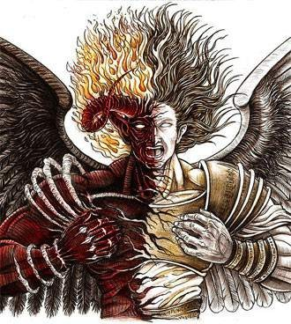
The two teams have to play their parts convincingly, and the dark team has really embraced their role as villainous scum ready to kill, rape, torture and do any sort of depraved thing that they can get away with. The dark side is designed to be incredibly repugnant so that the majority of “good souls” will run to the other end of polarity, right into the “loving” embrace of one of the false light’s patriarchal religions, or to their new age religion with its legion of channels and “masters.” Earth has been a difficult planet for the corrupt demiurge to fully control. Human beings were once very aware of their connection to Infinite Source and all of life, and that awareness has been maintained by spiritual individuals throughout the entire reign of darkness on
this planet. Because this awareness could not be “beaten out of us” by the dark forces, a plan was formed to co-opt the spiritual nature of human beings. First, patriarchal religions were formed and imposed on as many people of the world as possible. Anyone who didn’t adhere to one of the major religions was an outcast for much of history, until the last century when the “Theosophist movement” was born, which set the foundation for the “new age movement” to emerge in the 50s, 60s and 70s. The new age movement has continued to gain momentum as it has attracted many of the people who turned away from the hypocrisy of patriarchal religion. The corrupt demiurge seems to have an “easy answer” for any of the inner turmoil that humans experience. If religion doesn’t serve to appease an individual, then the new age will do just fine. It’s all the same to the demiurge, as long as we “pick a side” that it controls. This is why we need to transcend sides all together.

Channelers Are Being Deceived
I wrote an article back in 2011 about some of the problems with channeled messages, which you can find here for more background information. If religion can be said to be “the opiate of the masses” then channeled messages would be the “HOPIUM of the disgruntled minority.” Every channeled message that comes from the spiritual liar-archy is essentially the same when you strip away the fluffy talk and story-line that is being used

to couch the message. Here is every modern channeled message, condensed into a few lines: “Dear ones, you are greatly beloved by all of us in the spiritual (liar)archy. We long to reunite with you, for we are your long-lost family. Stay strong and hold onto your light, because we will make our presence known to you soon. Keep waiting (and suffering) and hoping for us to come and rescue you from your situation. When we arrive, we will build a golden (c)age for you on earth.”
I used to think that this nauseating disinformation coming from “Archon Angel Michael,” “Saint Germain” etc. was the result of dark-side interference taking over the channels without their awareness. What I didn’t understand back when I wrote “Who’s Really on This Channel” is that transmissions from “truly positive beings” weren’t being intercepted and corrupted by the dark side, but rather the messages were coming from “false light” beings of the spiritual liar-archy.

“Light Workers” Are Being Thoroughly Used
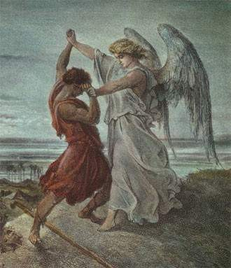
Back in 1998 when I first got into the energy clearing genre, I had never heard the term “lightworker” even though it had already been coined. It first heard it some time in the early 2000s, and it sounded weird to me at the time. Now I understand why:
because the “light” that the spiritual liar- archy is trying to get us to work for is the FALSE light of demiurgic duality! You see, there is a massive effort underway by beings that I now call “Divine Agents” to completely obliterate the corrupt demiurge. When that happens, all of the beings who have gained power through the demiurge will lose that stolen power and will have to face up to the deceptions that they have been propagating. None of them want that to happen, so in their cleverness they
devised a brilliant plan to undermine the entire effort. The plan was simple: Approach all incarnated Divine Agents, usually in a dream state but sometimes during an “ET abduction” scenario, and tell them that in order to fulfill their mission, they need to “work for the (false) light” and take orders from the spiritual liar-archy. This plan worked AMAZINGLY well, largely because Divine Agents have had a hard time living on Earth. Societies here are badly warped, spirituality is twisted and abused, the vibrational density is heavy, our memories are mostly wiped, and we generally would rather NOT be here. So any being that emanated light (even false light) and love could make a Divine Agent feel like they were making valid contact with truly divine beings. I still remember my own recruitment by the false light that occurred when I was 6 years old in an extremely vivid dream-time experience. They had me convinced that I was fulfilling my mission as a

Divine Agent by working for them. I think they always knew I would figure them out, although it took a very, very long time.

Ever Wake Up More Tired Than When You Went To Sleep?
Many Divine Agents who were recruited as light-workers report that they wake up more tired than when they went to bed, and their “dreams” were full of battles. During these “dream missions” the spiritual liar-archy squeezes those they control of as much energy as they can. You may wake up with memories of having gone on missions to battle the dark, but the end result is that your body, mind and soul are depleted of energy which was harvested by the (false) light beings. A few months ago I revoked ALL agreements made with any and all beings that did not have my best interests in mind, no matter WHO the beings were or claimed to be. It sounds like such a simple thing, but somehow I had overlooked it. During the process, I felt resistance from beings who were claiming to be positive, but I stood strong and told them that I refuse to be manipulated into giving energy to the demiurge. This has given me the distinct privilege of being targeted by both the dark team (ankle biters) and the (false) light team (spiritual liar-archy). The (false) light team does indeed engage in psychic warfare, just in different, more subtle ways than their “dark” brethren. Deflecting these attacks has been worth it because I know that I am more aligned with my true mission to put an end to the demiurge without being side-tracked into duality battles. It is also very nice knowing I am going to get a good night’s sleep when I go to bed because I am not going to be pulled into any ridiculous “missions to battle the dark” that the (false) light beings are so fond of setting up for their “light workers.” (That phrase actually creeps me out now that I know its true origins…)

What Was That About a Golden (C)age?

The false light beings working for the corrupt demiurge want to maintain their control over the human race. Our soul energy and agreements to live in our current cage empowers the demiurge and the beings that serve it, and they are not going to give that energy up easily. We are, at this very moment, in a struggle for our freedom. The spiritual liar-archy wants to move us from our current, extremely uncomfortable cage into a slightly more expansive state of existence, but one that they are firmly in control of. One metaphor to describe our current situation is that we are like a flock of chickens pent up inside a
tiny, dark, smelly chicken coop. Those that have been farming us are preparing to let us out of the coop, and into a larger fenced-in area where we will be able to feel a little more free, but still within their control. This is the “farmer’s” way of ensuring that they can

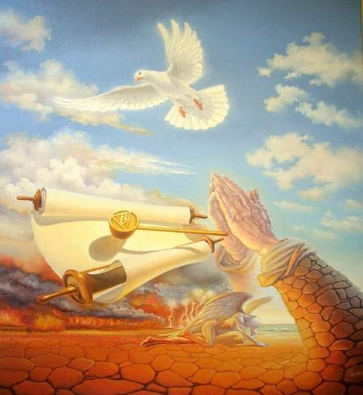
continue to feed off of our energies, while making us feel that we are free, thanks to the kindness of our captors. The “spiritual” liar-archy does not want us to grow on our own to a place of self-empowerment that will allow us to simply walk away from their entire control system. This is why the channeled messages subtly disempower people, while pretending to actually offer them an empowering solution. As long as we are sitting and waiting for “the good guys” to come and save us, we will not be able to discern who truly has our best interests at heart, nor will we be able to actually fix our own problems for ourselves.

Type of Communication Is a Major Indicator
The Forces of True Divine Light that exist outside of the corrupt demiurge are not bound by the left-brain right-brain dynamics and dark-light polarities that define the demiurgic sub-universe. This means that they do NOT sound like a voice in your head! Instead, they use “soul telepathy” to emanate feelings, archetypal expressions, and an extremely pure quality of light that speaks directly to your soul. The difference between a being of True Divine Light and one of the false light spiritual liar-archy beings is that the former’s light is warm,
enveloping, pure and unconditionally loving, whereas the latter’s light is cool, piercing in an uncomfortable way, dominant and often overly-masculine. The spiritual liar-archy is a male-dominated group, and even the females within their power structure have a very masculine energy. This male-domination is, of course, why the religious structures the liar- archy enabled all have a domineering male god, and no mention of an all-encompassing, feminine creator. Another major difference between false light beings within the demiurge and beings of True Divine Light who are aligned with Infinite Source is that the Divine Light is not controlling, manipulative, bossy or judgmental in any way. Infinite Source will NOT impose an agenda upon you, although it will support you in your chosen mission to help dismantle the corrupt demiurge. You won’t be given “marching orders” by Infinite Source or beings of True Divine Light who operate outside of the demiurge. They won’t send you on endless, energy-draining missions in your dream-time, and they won’t ask you to do something that will result in loss of your soul energy, unlike the imposters in the false-light spiritual liar-archy. The beings of True Divine Light are supportive, loving, nurturing, and they care about you as an individual. You are not just a cog in a machine to them, for they understand that you are a vitally important aspect of an intricately interconnected creation. They have the utmost respect for those of us who volunteered to incarnate into the “beast system” of the corrupt demiurge in order to help dismantle it from the inside. Indeed, there must be Divine Agents working both from within and outside of the corrupt demiurge in order to dismantle it.


The "Lords" of Karma
The false-light demiurgic parasites known as the "Lords" of Karma are perhaps the worst violators of free-will that I have encountered, second only to the corrupt demiurge itself. They are the primary gatekeepers that allow or deny beings access into and out of the demiurgic system, and as such, they must be exposed. Their perversion of the natural law of karma is so staggering in scope that I will only be able to cover a small portion of it in this article. To begin with, they are responsible for forcing beings to reincarnate over, and over, and over (and over) again, in clear violation of Universal Law. In the "Free Universe" outside of the corrupt demiurgic enslavement system, a being is free to incarnate onto any planet that they choose.
When a being's physical life comes to an end (after hundreds, perhaps thousands of years), they return to Infinite Source for a rest, and then decide what they want to do next in order to continue to learn and grow. Nowhere in this process is a hierarchical group of controlling, manipulative beings like the "lords" of karma present. As you can see by my use of quotes around the word "lords," I despise calling them that at all. So in my usual style, I have given these beings a new, somewhat sarcastic name: The Turds of Karma. I started calling them this after an encounter several months ago when I was removing deep layers of imposed agreements that they were trying to hold in place. At one point in the process I forcefully told them, "You are the biggest pieces of sh** that I have ever seen. I
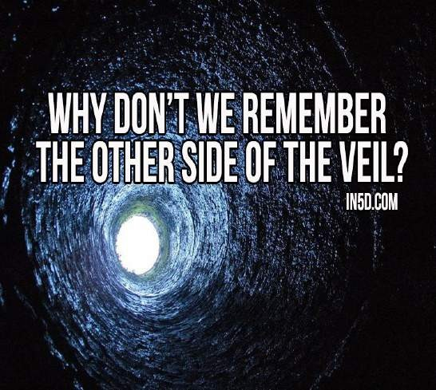
don't owe you ANYTHING. YOU owe every single being that you have manipulated a debt that you will never be able to repay!" At that point, they left very quickly. After that, the name Turds of Karma just kind of stuck. Although it is somewhat juvenile, I think it fits, and I hope that you will think of them in this same way, so that you won't be fooled by their con- artistry now, or later when you depart from the physical realm. With that bit of renaming out of the way, let's explore some of the ways the Turds of Karma (ToK) manipulate beings.

The Light Review Scam
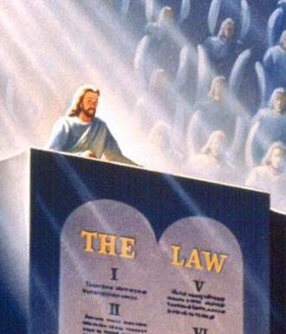
The primary tool that the ToK use to manipulate a being into accepting nearly endless reincarnation is the (false) "Light Review." When a person's body dies, they move out into the astral realms and begin to shed most of their previously held identity. If this process were allowed to occur without interruption, the True Light of that being would emerge from within them and they would release layer upon layer of limiting beliefs generated in that incarnation. However, within the realms of the demiurgic control system, what happens is that the ToK intercept that being just as their light is starting to emerge from within and surround them in a dazzling display of colorful external light. (This is why most of the people with near-death
experiences report going through a tunnel of light.) The dazzling outer display distracts the being from the light emerging from within them and hypnotizes them through frequency entrainment and activation of any and all religious programming that being had been exposed to during their incarnation. The ToK and other members of the Spiritual Liararchy such as arch(on) "angels" and "ascended masters" will often be present in the background during this process. As the individual is filled with a feeling of universal love and connectedness, they are told that this feeling is coming into them from the external "beings of light" that are surrounding them. However, this feeling of universal oneness and love is actually emerging from INSIDE of the being, and it is being reflected back to them by the ToK and the liararchy. The individual doesn't have any time to reflect on what is happening, because they are quickly moved into the "review" phase of the process. They are shown a little movie of their life which focuses on the disappointments, unfulfilled desires, painful experiences and hurtful actions the person experienced during their life. Through this biased and manipulated "life review," the being is made to feel bad about their life, which is exactly what the ToK want. They tell the person that even though they failed at so many things in their life, that they will be given a chance to go back one more time and "get things right" in a new incarnation. The being is then grateful at this chance for redemption and accepts the agreements that the ToK present them with to incarnate again. If that being was raised with a Christian type of indoctrination, they will encounter "Jesus and the angels" but be told that they are "not yet worthy to enter the kingdom of heaven." Of course, the fear of being sent to hell is so strong in their belief system that they JUMP at the chance to reincarnate and become "worthy" to enter "God's kingdom," which is actually the demiurge's kingdom. After agreeing to reincarnate, the being is then sent to a "heavenly realm" in the middle to upper astral realms to await reincarnation. This realm is nicely decorated with simulations of nature, lovely views and a staff of "guardian

angels" who make sure those beings go back to earth when their time comes. Of course, those "guardians" are actually parasitic sheep-herders tending to their flock, and there is NO allowance for the beings held in this realm to go elsewhere.

Karmic Transference
If the content of an individual's life, unhealed wounds and unfulfilled desires isn't enough to convince them that they need to reincarnate, they are presented with an even more brazen deception. They are shown what they are told is their own past life where they committed horrible crimes, and they are told that they need to continue incarnating into adverse conditions in order to "work off" that bad karma. In reality, the life they are shown is NOT theirs, but rather the actions of some being closely aligned with the liararchy who made pacts with them to avoid taking energetic responsibility for their actions. Some of that criminal being's malicious energy is then projected onto the individual who is being tricked into believing that they were once that horrible criminal. That being then takes on agreements to "discharge" the "bad karma" that they have (supposedly) earned for themselves, never realizing that it was all a lie designed to keep them subjugated and enslaved. This is done to coerce the being's agreement to reincarnate and take responsibility for crimes that they did not commit, ensuring that the person's next life is going to be filled with undue hardship. This karmic transference also allows those dark sorcerers who have aligned with the liararchy to avoid the repercussions of their own actions. This transference is also used on a large-scale upon the populace of the planet through forms of mass mind-control and media manipulation. The basic mechanism for how this is done is through subconscious agreements embedded throughout the media, corporate logos (sigils), financial contracts, admiralty law and other "matrix institutions."

Coerced Demiurgic Entry Agreements
One more very important aspect of the agreements that are put upon beings by the ToK are the original "entry agreements" that the beings coming into the corrupt demiurgic realm are forced to make in order to even gain entry into this system. Many of us came here from what I call "The Free Universe" to help dismantle the demiurgic system from within, and the liararchy imposed an extensive list of coerced agreements upon these "Free Souls" in order to limit their effectiveness. These entry agreements also contain clauses that allow for unspecified hardships to be leveled against a being during their incarnation, including but not limited to: Birth bump to bad parents, physical abuse, sexual abuse, psychic attacks, etheric implantation, dream-manipulation, recruitment into the false- light's "lightworker corps," relationship issues, health problems, money problems, physical abduction and implantation, lack of self-worth etc. Most of the Free Universe beings coming in were pretty confident they could overcome those limitations, so they signed up. There really was not much option, but some of us negotiated more fiercely than others and were saddled with fewer of these pernicious agreements, but no one came in "unscathed." Regardless of how many coerced entry agreements we have, it is important to remove all of these agreements in order to get clear and proceed with our chosen tasks of healing and waking up others, as well as pulling apart the demiurgic construct from the inside.

Revoking Agreements

This is the process that I use and have been sharing with others in clearing out agreements. The liararchy hides copies of these agreements in various realms, so specificity is important in this process. It is also important that you engage this process from your Sovereign Inner Self (Higher Self, Divine Inner Self, etc) and that you make this process your own. Just reading revocation statements will not get the job done. We need to be consciously engaging this process using the force of our will to effect the changes we desire. I have found that once a person starts revoking agreements, it becomes easier over time to dig deeper to find more of them. Be aware that agreements often are splintered off into
various fragments in order to make them harder to find. For example, there may be agreements to have difficult romantic relationships, difficult relationships with parents, with siblings, with friends, etc. These are all different "agreement clusters" that need to be specified and removed in separate processes. So don't worry about getting rid of every agreement all at once. Take your time, and work through them on a daily basis as you sense them affecting you. The process outlined below is based on the Self-Clearing System Level 1 and Level 2, which form the foundation for the energy clearing work that I do.

Right & Wrong
Another false-light teaching that infects the New (c)Age movement is that there is no such thing as right and wrong, that everything is just an experience that is there to teach us a lesson. While we can learn valuable lessons from adverse circumstances, this does not mean that it is necessary or desirable to be continually oppressed, manipulated, implanted, de-ceived, enslaved and drained of energy. Those are experiences the human race has had far too much of already. With an understanding of Universal Law, we can observe that it is inherently wrong to harm another being who has done nothing to harm us. We can also understand that working together and cooperating with others is often the right thing to do. These simple concepts should be adhered to in order for us to free our minds from the twisted "logic" presented in New (c)Age teachings that would have us believe that the incredible amount of suffering inflicted upon humanity is entirely its own doing, as well as a wonderful learning experience, so we should not take any action to help others to alleviate their own suffering. Humanity is not having a wonderful learning experience by being enslaved to the corrupt demiurge's spiritual liararchy. We are learning one thing for sure though, which is how to declare our Sovereignty and stop being slaves! Well, many of us are. :-)

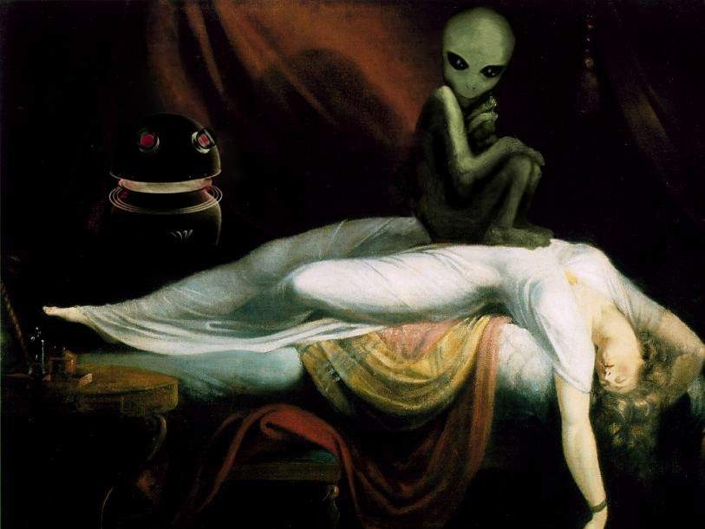

TRICK OF THE LIGHT: THE LIGHT &
TUNNEL TRAP1
"And no wonder, for Satan himself masquerades as an angel of light" -- 2 Corinthians 11:14
"After the natural structure of the immortal beings had completely developed out of the infinite, a likeness then emanated from Pistis (Faith); it is called Sophia (Wisdom). It exercised volition and became a product resembling the primeval light. And immediately her will manifested itself as a likeness of heaven, having an unimaginable magnitude; it was between the immortal beings and those things that came into being after them, like . . . : she (Sophia) functioned as a veil dividing mankind from the things above. Now the eternal realm (aeon) of truth has no shadow outside it, for the limitless light is everywhere within it. But its exterior is shadow, which has been called by the name darkness." -- ON THE ORIGIN OF THE WORLD, The Nag Hammadhi Library
It is they [Grey aliens] who await in the light when a human being dies. The human being is then recycled into another body and the process begins all over again... Hence the Light and Tunnel at death Trap. Scanning someone they wish to recycle as they near death, the aliens discover who the person was close to has died. They project the person(s) image in the white light tunnel and the image waves you in deeper. If you CHOOSE to follow you can be trapped and sent to another incarnation of their choice... these entities view Earth as a big farm." -- Val Valerian, Matrix II & Matrix V

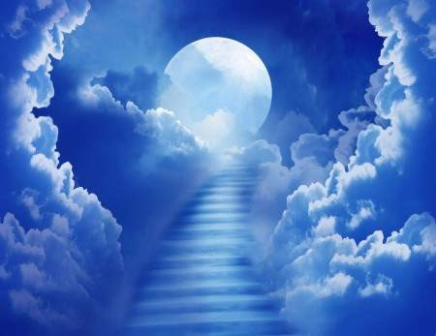Michael Newton, a hypnotherapist who claims he takes clients in-between their lives through hypnosis, writes in his book Journey of Souls, "Some newly dead people see it opening up next to them right over their bodies, while others say they move high above the Earth before they enter the tunnel." A subject under hypnosis describes it:"at first it was very bright.. close to the Earth... now it's a little darker because I have gone into a tunnel... it's a hollow dim vent... and there is a small circle of light at the other end... I feel a tugging, a gentle pulling... I think I'm supposed to drift through the tunnel... and I do. It's more gray than dark now, because the bright circle is expanding in front of me. It's as if... I'm being summoned forward. I leave the circle of and I'm out of the tunnel. There is a cloudy brightness... a light fog... I'm filtering through it. It's so still... I am in the place of spirits. Thought! The power of thought all around me. I feel thoughts of love... companionship... empathy... and it's all combined with... anticipation... as if others... are waiting for me... I'm not scared. When I was in the tunnel I was more disoriented. I'm aware of thoughts reaching out to me... of caring... nurturing.... In my mind Earth seems close... and I still feel connected to Earth... but I know I'm in another space."
Another subject said, "I think something is pulling me to my proper level of travel and trying to relax me. I'm hearing sounds... an echo of music... musical tingling... the waves of musical notes are so beautiful here." Another one saw his dead Uncle Charlie with "his hand stretched out to me... to comfort me... to lead me.. further into the light. He is taking me... to the place I should go. No! don't go! Uncle Charlie is leaving
me. Why is he going away? he stays in a different place than I do... he just came to meet me... to bring me here." Another person described the thoughts. "They are larger black orbs radiating light towards me.... thought.. I'm starting to recognize them.... They are sending images into my mind --
- http://www.trickedbythelight.com/tbtl/light.shtml

thoughts about themselves and... the shapes are changing into people! it's Larry! [her deceased husband]". "I'm being pulled along by a magnet and I just enjoy the ride I am riding on a wave, a
beam of light.... I must go with the wave bands of light.... They do it all for you... the ones in
control, I don't really know I'm being pulled and I'm supposed to go with it."
Another subject mentioned the staging area reminded him of a hub of a great wagon wheel. Another related, "I am moving along... in a chain of some kind. It's as if I'm weaving through a series of connecting links... a foggy maze and then it opens up. After a while I see nests
of people -- like hives -- I see them as bunches of moving lights fireflies." Another soul talked
about cones. "Well the cones do assist us... It's shaped to go around us, you know It is cylindrical
-- very bright -- it is above and all around us. The cone is wide at the top and small at the bottom, so it fits over all of us... we can feel all our thoughts being expanded... then drawn up. and
returned back... with more knowledge added." [Dr. Newton: "I wonder if this cone is brainwashing your original thoughts?"] "We aren't brainwashed!" Later on when describing the life selection process another client reported, "Some of us have to be given a push when they think we are ready again... After some more.... indoctrination Mark realized he
had been wrong about his abilities and finally he went back to Earth." [Dr. Newton: Indoctrination -- this makes me think of coercion."] "It's not that way at all! Mark was just discouraged, and needed the confidence to keep trying."
Excerpts from: Michael Newton – Journey of Souls
Dr. N: Are you telling me that a soul may show you one face at the gateway to the spirit world and another image later in a different situation?
S: That's right.

Dr. N: Explain to me how this pulling process works which will take you to your destination?
S: I am riding on a wave ... a beam of light. Dr. N: Is this beam electromagnetic, or what?
S: Well ... it's similar to the bands of a radio with someone turning the dial and finding the right frequency for me.
Dr. N: Are you saying you are being guided by an invisible force without much voluntary control and that you can't speed things up as you did right after death? S: Yes. I must go with the wave bands of light... the waves have direction and I'm flowing with it. It's easy. They do it all for you.
Dr. N: Who does it for you?
S: The ones in control ... I don't really know.

Dr. N: Okay, let's pass on by these clusters which seem to bulge out along a corridor. Give me an example of what the whole thing looks like to you from a distance.
S: (laughs) A long glow-worm, its sides bulging in and out ... the movement is ... rhythmic.

Dr. N: What do you think is the basic reason for your father remaining in this other place?
S: (tearfully) He does not belong in my hive.

As I mentioned earlier, after souls arrive back into their soul groups, they are summoned to appear before a Council of Elders. While the Council is not prosecutorial, they do engage in direct examination of a soul's activities before returning them to their groups. It is not unusual for my subjects to have some difficulty providing me with full details of what transpires at these hearings, and I am sure these blocks are intentional.

These guides have other entities who assist them. From what I can see, every soul group usually has one or more rather new teachers in training.

Once in a while during a session with a more advanced soul, I hear references to an even higher level of soul than Level VI. These entities, to whom even the masters report, are in the darkest purple range of energy. These superior beings must be getting close to the creator. I am told these shadowy figures are elusive, but highly venerated beings in the spirit world.

S: (strained) Giles has made me look upon my lives as a chess game with the Earth as the board. Certain moves bring certain results and there are no easy solutions. I plan, and then things go wrong during the game in my life. I sometimes think he lays traps for me to work through on the board.
Dr. N: Do you prosper with this technique of your advanced guide? Has Giles been a help to your problem-solving during the game of life?
S: (pause) ... More afterward ... here (in the spirit world) ... but, he makes me work so damn hard on Earth.

S: This sphere is available to all souls because it represents their own physical world. In my case, it is Earth.
Dr. N: Oh, this must be the physical dimension you told me about? S: No, the sphere of Earth is only simulated for my use.
Dr. N: Then all souls in the spirit world wouldn't study the same simulated world? S: No, each of us studies our own geographical planet, where we incarnate. They are physically real ... temporarily.
Dr. N: And you don't physically live on this simulated world which appears as Earth- you only use it?
S: Yes, that's right-for training purposes.

Dr. N: Well, who creates the basic elements of your experiments-the primary substances of physical matter?
S: The maker ... and those creating on a grander scale than me.
Dr. N: Well, in a sense you are creating inanimate objects such as rocks.
S: Hmm... it's more our trying to copy what we see in front of us what we know. (as an afterthought) I'm getting into plants but I can't do them yet.
Dr. N: And you start small, experimenting until you get better?
S: That's it. We copy things and compare them against the original so we can make larger models.

Dr. N: And yet, you are the spiritual teacher for all nine?

S: I prefer to call myself a watcher. Three of my company are also watchers.

Dr. N: Do you personally create suns in our universe?
S: A full scale sun? Oh no, that's way over my head... and requires the powers of many. I generate only on a small scale.
Dr. N: What can you generate?
S: Ah ... small bundles of highly concentrated matter... heated. Dr. N: But what does your work look like when you are finished? S: Small solar systems.
Dr. N: Are your miniature suns and planets the size of rocks, buildings, the moonwhat are we talking about here?
S: (laughs) My suns are the size of basketballs and the planets marbles ... that's the best I can do.
Dr. N: Why do you do this on a small scale?
S: For practice, so I can make larger suns. After enough compression the atoms explode and condense, but I can't do anything really big alone.
Dr. N: What do you mean?
S: We must learn to work together to combine our energy for the best results.
Dr. N: Well, who does the full-sized thermonuclear explosions which create physical universes and space itself?
S: The source ... the concentrated energy of the Old Ones. Dr. N: Oh, so the source has help?
S: I think so...

Dr. N: If the source represents all the spirit world, how does this mental place differ from physical universes with stars, planets, and living things?
S: Universes are created to live and die for the use of the source. The place of spirits ... is the source.

Dr. N: Thece, I want you to listen to me carefully. If the source needs to be made stronger, or more wise, by using a division of its divine energy to create lesser intelligence which it hopes will magnify-doesn't this suggest it lacks full perfection itself?
S: (pause) The source creates for fulfillment of itself.
Dr. N: That's my point. How can that which is absolute become more absolute unless something is lacking?
S: (hesitates) That which we see to be ... our source ... is all we can know, and we think what the creator desires is to express itself through us by ... birthing.
Dr. N: And do you think the source is actually made stronger by our existence as souls? S: (long pause) I see the creator's perfection ... maintained and enriched... by sharing the possibility of perfection with us and this is the ultimate extension of itself
Dr. N: So the source starts out by deliberately creating imperfect souls and imperfect life forms for these souls and watches what happens in order to extend itself?
S: Yes, and we have to have faith in this decision and trust the process of returning to the origin of life. One has to be starving to appreciate food, to be cold to understand the blessings of warmth, and to be children to see the value of the parent. The transformation gives us purpose.

They all see their individual Council of Elders as godly. The Elders are bathed in bright light and the whole setting has an aura of divinity. A subject put it this way, "when we are taken into the presence of these superior beings who exist in such a high spiritual realm, it validates our feelings about the source of creation."

Dr. N: As you integrate with the baby, when does it become receptive to the force of your identity as a soul?
S: I'm disturbed by your word "force." We never force ourselves when entering an unborn baby. My tracing is done carefully.
Dr. N: Did it take you many lives to learn to trace a human brain? S: Uh ... a while ... new souls are assisted with their tracing.
Dr. N: Since you represent pure energy, are you tracing electrical brain connections such as neurotransmitters, nerve cells, and the like?
S: (pause) Well, something like that ... I disrupt nothing, though while I learn the brain wave patterns of the baby.
Dr. N: Are you referring to the thought-regulation circuitry of the mind?
S: How this person translates signals. Its capacity. No two children are the same. Dr. N: Be completely frank with me. Isn't your soul taking over this mind and subjugating it to your will?
S: You don't understand. It's a melding. There is an ... emptiness before my arrival which I fill to make the baby whole.

Dr. N: Okay, after you are completely finished with reviewing lives in the Ring, what happens then?
S: The controllers ... come into my mind to see if I am satisfied with what I have been shown.
Dr. N: Are they always the same entities?
S: I think so ... as far back as I can remember.

I can hide nothing from them, but sometimes I get lost when their thoughts are transmitted back and forth in the rapid communication between them. When it is more than I can handle, Veronica translates what they are saying about me, although I have the feeling she does not tell me everything. Before I return to Earth, they will want to see me a second time."

Dr. N: Could you be more specific about what your soul actually provides the human body?
S: We bring a... comprehension of things... a recognition of the truth of what the brain sees.
Dr. N: Are you sure this child doesn't think of you at first as an alien entity in her mind?
S: No, that's why we unify with undeveloped minds. She recognizes me as a friend ... a twin ... who is going to be part of her. It's as if the baby was waiting for me to come. Dr. N: Do you think a higher power prepares the baby for you?
S: I don't know, it would seem so.
Dr. N: Is your work at unification completed before birth?
S: Not really, but at birth we have started to complement each other.
In his second book, Destiny of Souls, Dr. Newton reports on a subject who described souls

being in "pods" and another subject claimed to be a sort of nurse in the spirit world who described souls in "honeycomb cells" being incubated in an "incubator" before being born. Journey of Souls was my favorite book for years and years and I totally believed everything I read, but now in light of all the evidence of this theory I am not so sure. Kudos to Dr. Newton for lifting the veil behind our ordinary lives and he was keen enough to question whether the testimony he was being given was brainwashing, indoctrination or coercion, but I am not as willing to accept their testimony especially in light of descriptions such as souls being clustered together like grapes. Regressionists in the field of ufology have discovered screen memories that have been implanted in the minds of the alien abductees, a screen memory that serves as a cover for the real truth hidden beneath the surface layer. He also talks frequently of a client who took four to five thousand years to overcome the negative trait of jealousy. This just sounds questionable to me. Surely there must be a better way.

More excerpts:2
“Dr. N: Do you know of anyone who didn’t want to be reborn again on Earth for any reason?
S: Yes, my friend Mark. He said he had nothing to contribute anymore. He was sick of life on Earth and didn’t want to go back.
Dr. N: Had he lived many lives?
S: No, not really. But he wasn’t adjusting well in them.
Dr. N: What did the teachers do with him? Was he allowed to stay in the spirit world?
S: (reflectively) We choose to be reborn when it is decided we are ready. They don’t force you to do anything. Mark was shown he did benefit others around him.
Dr. N: What happened to Mark?
S: After some more … indoctrination … Mark realized he had been wrong about his abilities and finally he went back to Earth.
Dr. N: Indoctrination! This makes me think of coercion.”

“Dr. N: In the Ring, can you look at life on planets besides Earth? S: I can’t because I’m programmed for tracking time on Earth.”

“When I ask my subjects how a loving God could permit suffering, surprisingly there are few variations in their responses. My cases report our souls are born of a creator which places a totally peaceful state deliberately out of reach so we will strive harder. We learn from wrongdoing. The absence of good traits exposes the ultimate flaws in our nature.”

“S: It is cylindrical-very bright-it is above and all around us. The cone is small at the top and wide at the bottom, so it fits over all of us-like getting under a great white cap-we can float under the cone in order to use it.
S: The top funnels energy down as a waterfall in a spreading circle around all of us and allows us to really concentrate on our mental sameness as a group.

- https://brontebaxter.wordpress.com/2008/11/17/journey-of-souls-enlightens-in-spite-of-itself/

Dr. N: And what do you feel when you are under the cone?
S: We can feel all our thoughts being expanded … then drawn up … and returned back … with more knowledge added.
Dr. N: Does this intelligent energy help your unity as a group in terms of more focused thinking?
S: Yes, it does.
Dr. N: (deliberately confrontational) To be frank with you, Allum, I wonder if this cone is brainwashing your original thoughts? After all, the arguments and disagreements between you and the others of your group are what make you individuals.
Dr. N: Who operates the cone? S: Those who watch over us.”

“I have had many cases where a client has been incarnating for up to 30,000 years on Earth and is still in the lower levels of I and II.”

“Dr. N: Explain to me how this pulling process works which will take you to your destination?
S: I am riding on a wave … a beam of light. Dr. N: Is this beam electromagnetic, or what?
S: Well … it’s similar to the bands of a radio with someone turning the dial and finding the right frequency for me.
Dr. N: Are you saying you are being guided by an invisible force without much voluntary control and that you can’t speed things up as you did right after death? S: Yes. I must go with the wave bands of light … the waves have direction and I’m flowing with it. It’s easy. They do it all for you.
Dr. N: Who does it for you?
S: The ones in control … I don’t really know.
Dr. N: Then you are not in control. You don’t have the responsibility of finding your own destination.”

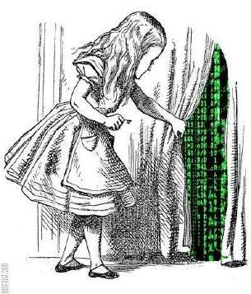
Ok these are just scratching the surface many of these kind of reactions: S: The ones in control … I don’t really know. (f*ck yeah it’s not “i don’t really know” but “i don’t really care anymore”) emphasis on THE ONES IN CONTROL. And believe me that place is FULL of hierarchical BS, ascended masters and a place where all souls gather after they shed their physical bodies that place oozes a factory THEY LITERALLY LINE UP all these poor souls to be “guided” to their appointed places of mindf*ck..they talk about new souls being the most rebellious i know why they are the least mind controlled….unlike the wise OLD souls who are so deeply
PROGRAMMED they just swallow everything what these master beings tell them. And they have “judges” up there aka “The Elders”, when i read that book a sudden urge of resistance was very strong in me i knew it in my guts this is evil packaged in a sweet lullebuy “love & light” they are keeping us imprisoned! But you need to know why it’s

because of OUR SOUL there lies the answer…Why would they make these HUGE attempts to control our soul and study it at the same time????? It makes no sense if all they are after is gold, silver, and all the physical valuable things on a planet to pillage it and then leave. Although this is also part of their plan to rob the valuable things on earth. BUT the most VALUABLE is our SOUL it is the number 1…

Bronte Baxter on Michael Newton's books:3
First, about Newton’s book. Yes, it does talk about “guides” and celestial “councils” that help us decide the direction of our next incarnation. And of course those all represent enslavement and manipulation. The value of the book is that it makes that manipulation more obvious. For those who haven’t read it, “Journey of Souls” is a set of transcriptions that Newton (a regression therapist) made during his conversations with hypnotized subjects whom he regressed back to the “between-life space,” the place where we allegedly go to between incarnations or lifetimes. Subject after subject reported similar experiences of the afterlife, whether they believed in life after death or not prior to being regressed by Newton. Of course we have only his word for this. But taken together, the transcripts are worth some serious considering. They appear to represent people’s subconscious memories of how they planned the events of each subsequent reincarnation. The transcripts show humans as having a choice but preferring to create suffering and chaos for ourselves in each new life because we think that will “purify our souls” of our past bad tendencies or actions. Apparently those who run the world that is the between-life space have people believing those lies there, just as religions have us believing the same lies here. According to the book, people are assigned a “council of three” elders who are members of the larger “council of elders” who are at the top of the hierarchy in the afterlife. This “gentle and loving” smaller council works to steer the soul into plans for its reincarnation that will be to the soul’s “spiritual benefit.” That’s as far as Newton’s book takes it, because Newton is blind to the New World Order conspiracy.
Those of us aware of the New World Order agenda read the book from a very different perspective than the one the author wrote it from. We are given a window into how the manipulation of souls takes place in the nether world, and why we encounter spontaneous mishaps and disasters in this one. It is because we ourselves planned it, set it up before we born, according to the transcripts’ uncovered memories. We created events on the time line that would cause us suffering in this life, thinking those would make us wiser and better spiritually. This explains the reason for the three kinds of scenarios you listed at the top of your comment, the kind of horrible events that strike us out of the blue, that we were not desiring – things that appear to “just happen.” The truth is, they don’t “just happen.” They happen because we allowed them. Not consciously in this life, but in the pre-life place where we set them up as part of what we would experience here. If the soul feels it is guilty (and what soul does not?), that soul will most likely set up an experience of self-punishment in this world to cleanse itself of its “bad karma.” You and I agree that karma is a story fed to us to keep us enslaved, a doctrine that when accepted always creates more suffering. The incessant suffering supplies our upline, the Fourth Dimension energy vampires, with food. That’s why they assign us a “council of elders” to “help” us design each lifetime to be studded with bad things. It’s supposed to purge the soul, but it does not. It makes us sadder, more hurt, weaker.

- https://brontebaxter.wordpress.com/2008/11/17/journey-of-souls-enlightens-in-spite-of-itself/

More prone to further manipulation and still another lifetime filled with even more “lessons to learn” and “sins to be punished.” There’s no end to the cycle until we consciously break it. And this is what the knowledge of our power to create our own reality allows us to do. Bad things may still strike us out of the blue until we fully wake up and reprogram our pre-life plans for our future. But even disasters do hit, we have the power to get out of our fixes by using our current choices (intent), visualization, and control of our thoughts to extract ourselves. In another article, I write about the true story of Dieter, an American navy pilot who was shot down in Viet Nam and found a way of out a seemingly impenetrable prison camp, when all his fellow POWS said it was impossible. (This story is told in the excellent movie, “Rescue Dawn.”) Dieter did the impossible that no one else could do, and lived to tell about it. Why did he succeed, when all his fellows died? Because he alone had the mindset that insisted on life, on freedom, on escape. The others were controlled by the hopelessness engendered by their external circumstances. So we can choose which way we will live in any unfavorable circumstance: we can get ourselves out of the fix, or let it beat us. When we tackle the job in front of us, not only can we influence/change any problem, but committing ourselves to such action cultures the kind of consciousness we’re trying to return to. It makes us heroes. A hero isn’t a victim. … Pick yourself up and recognize your power, instead of complaining about how lousy it is, and holding yourself superior to the rest. That kind of attitude feeds right into their plans for swallowing all consciousness in their massive maw. If they succeed in that, we’ll experience the implosion of the universe. We can’t afford to remain either depressed or arrogant.

Felica said:
I have not read Journey of Souls but it sounds like Memories of God and Creation: Remembering from the Subconscious Mind. It’s all hypnotically retrieved memories of “life before life.” Same stuff. We enter a heavenly “sphere” (of which there are seven – maybe the famous seven heavens?) and of course are reprogrammed by our “guides” to re-enter Earth and suffer again. But we get so blissed out on feeling good for a while in the sphere and reconnecting with other spirits of people we have loved that we don’t see the trap for what it is. One time I worked with a Payute shaman who told me LOTS of stuff that you cover here, Bronte. Some of the reverberations are quite eerie. He was very unusual in the sense that so many native American/indigenous shamans seem to teach “journeying” in meditation to connect with the “elders’ (the spirits of deceased relatives who are said to be spiritual guides.) He saw this as Kindergarten level shamanic journeying and not the real stuff at all. He says the REAL challenges happen after you get over the novelty of talking with your dead loved ones and ancestors and start to see where THEY have agreed to become trapped. So instead of looking at journeying to the motherland, or the ancestral fields where the discarnates happily reunite, he says we must avoid these places at all costs – especially when we are dying. But too often the emotional gravity of suddenly feeling all that loving connection with family we haven’t seen for a while pulls us into their orbit, and then we all get trapped on the wheel again. He was a little bit Carlos Castaneda in the sense that he taught a vigilant warrior stance while doing metaphysical work and a much-needed (he thought) distrust of ANY discarnate being or guide because they all serve the same “masters.” He perceived our ideal destination after death as being wherever we wanted it to be – “Why limit our journey as spirits when we’ve been limited for aeons by taking on physical bodies over and over again?” So he saw no

one “end point,” no single “heaven” – just various way stations in the afterlife where we hang out with loved ones, have a nice reunion, and then wait like sheep to be reincarnated without ever realizing the con that’s being played on us. The problem would appear to be that the “guides” are masters at simulating what amounts to a “spiritual orgasm” of joy and bliss which is very similar to what you describe, Bronte, as happening with certain forms of meditation. In that state, we no longer perceive questionable beings as negative because we’re basically drugged out on joy. Tricky stuff.

Dani said:
I have recently begun reading Michael Newton’s second boo – Destiny of Souls. I am now on the subject or demons or otherwise ‘negative’ entities. According to Newton’s hypnotic subjects none of these entiities exist and all ‘evil’ is thus a human characteristic and no one from the spirit world has ever seen any ‘demonic’ forces and say they do not exist. This i find rather strange given the vast amount of texts from ancient civilisations, psychics, and every day people throughout the ages.
Here is an excerpt:
“The idea that satanic entities exist as outside forces to confuse and subvert people is a myth perpetuated by those who seek to control the minds of others for their own ends.”
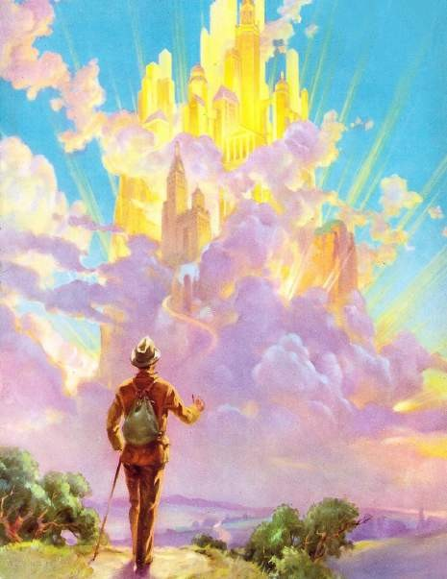
I have heard and read way too many instances from ‘normal’ everyday people of seeing entities, such as reptilians, greys etc…. all seeming to have a dark agenda. And there is no mention of this. The ancient Gnostic texts talk about the Archons in great detail as being alien mind parasites that seek to deceive us. Castenada also alludes to a very similar thing in his book The Active Side of Infinity. I’m just not sure about all this pink fluffy cloud stuff that Newton is harping on about. I agree that humans can be evil enough on their own, but this world has something else
sucking the life out of it too.
Here’s another excerpt with Dr Newton and one of his subjects in the trance state;
Dr. N: To bad spirits who interfere with life forms for the pleasure of doing harm.
S: (abruptly) Who told you this? There are no evil spirits, only inept ones… and those who are careless… and indifferent…
Inept is the last thing I would call the dark forces that do exist… in my opinion. It would be illogical to think any different in light of all the teachings, peoples experiences and the state of the world. I do wonder how Newton has come to all these fluffy cloud conclusions. Are his subjects really under hypnosis…. could it be something else?

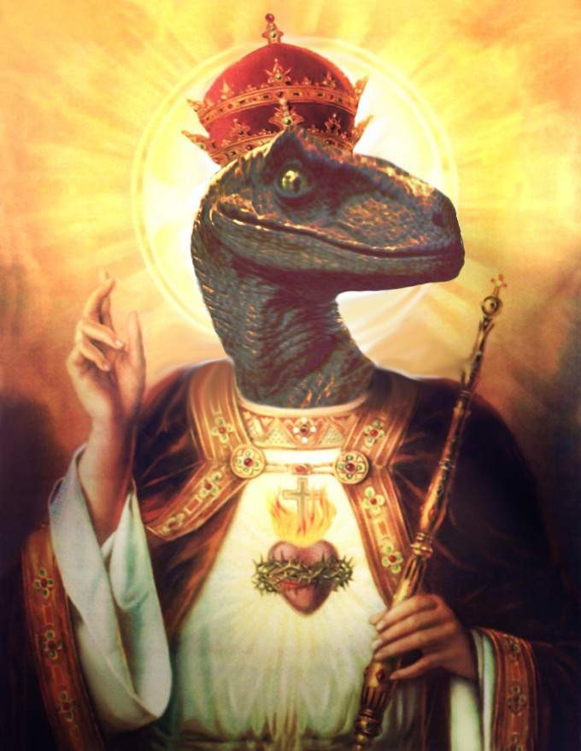

ATTACK OF THE ARCHONS14

Cosmic Influence And Your Destiny

Astrology and gnosticism are rooted in the Spirit’s struggle to overcome the illusion of time as the prison which binds us to a wheel of life and death popularly thought to be natural, inevitable, and ‘normal’. But is it ? Wasn’t it James Joyce who cried out (through one of his literary characters) that history was a nightmare from which he was trying to awaken ? If we are to take a Gnostic approach toward astrology one of the very first things we must do is to question this notion of TIME. In terms of the mythical and symbolic language of astrology, that means we must look closely at Saturn-Chronos for ‘he’ is spoken of as the Lord Of Time. He is the principle of binding, focus, form and time, and contemporary astrology is still essentially a study of time cycles based upon the number of days and years required for each of the classical planets (Luna, Sol, Mercury, Venus, Mars, Jupiter, and Saturn) to complete one full circle around the zodiac of twelve signs (Aries through Pisces). Of course, contemporary astrologers also study the cycles of the ‘newly discovered’ planets, Uranus, Neptune, and Pluto, but always and everywhere astrologers are concerned with tracking the passage of TIME !
Now, any decently self-respecting Gnostic must sit up and take notice of this practice because the very core of Gnosticism is to question appearances. The Gnostic is nothing if not a person who rebels against the norms, the taken-for-granted ‘facts’ which reduce life to an experience of sleep-walking through time. The traditional cry of the Gnostic is: Sleepers, Awake! The Gnostic feels that humankind are caught in the delusions and snares woven by the Demiurge and his appointed executive bureaucrats known as the Archons said to be seven or twelve by count. These variously seven or twelve Archons have traditionally been associated with the seven ancient planets (see above) and/or the twelve signs of the zodiac. So, from a certain classical Gnostic perspective,
astrology is a
study of the bureaucratic games played by the CEOs of the false creator-god, the
known as Yaldaboath and often understood to be the Yaweh of the Old
Demiurge
Testament, or the Father of the political Christian’s Jesus Christ. The hourglass and the sickle are the traditional symbols of the Lord Of Time, the planet Saturn, he who binds humankind into the reasonable, serious, and linear prison called time. He is the ‘elder’ among the Chief Executive Officers appointed by the Demiurge-Father-God to run his corporate business of enslaving humankind to the wheel of work, suffering, and weekly paychecks which keeps his world turning round. Isn’t it the Corporate World which teaches that money is time and time is money ? And isn’t it astrology which reinforces this ‘time equals money’ myth by teaching that Saturn, Father Time, is the tester, the symbol for the ‘hard facts of life’, the Author of ‘Reality’ ? When Saturn is active by transit in the Horoscope of your life contemporary astrologers are the first to caution you that you must ‘bite the bullet’ and buckle down to conformity. What are we to make of the newly arising ‘schools of astrology’ which offer ‘accreditation’ by way of the authority of the established

14 http://www.starpathvisions.com/AttackoftheArchons.htm

University system ? What are we to think of astrologers teaching ‘clients’ how to adjust through contemporary psychology to the status-quo of the increasingly psychotic world ? To any living Gnostic it is apparent that astrology itself has fallen into the grip of Saturn !
If we view Saturn through the lens of historical gnosticism we can see this Realist, this Authority Figure of Old Man Time,
as the chief warden of the prison earth. Saturn’s
authority is precisely what binds us to the realistic and linear time which begins for each
Life, as brooded over by this nasty Archon, is a pre-
of us at birth and ends at death.
determined, cause and effect vale of tears, a medieval Dance Macabre. He determines the rules, the facts, and the sequence of events as each of us moves from minute to minute through life. He is the measurer, the statistician, the policeman, the priest, the judge, the no-nonsense guy smoking the fat cigar or drinking the Perrier water while basking in the pure groundedness of his astute timing and his ‘common sense’. He says, -‘This is it; this is what works as time has tested and experience has shown.’ He’s the one who used to write on the old flat maps of the world: ‘Beyond here there be Dragons’. The Rule Giver, the jealous bigot of a ‘god’ who gave us his ‘Ten Commandments’, the guy who always manages to pull the wool over our eyes by claiming to simply be stating the FACTS. Given the truth of all this, the first thing any Gnostic must do is see through the limiting external authority of Saturn to the real authority which resides within each of us as individuals. We have to make up our own rules, define our own terms, and watch out for the rigidity that often comes from self-complacent certainty. When we remain focused exclusively upon our own boundaries, when we cease to question even our own authoritativeness, when we are fixated upon cause and effect as well as linear time we cannot sidestep this Archon who blinds us to the spark of Spirit within ourselves and thereby isolates us from the Divine Light. That ‘Light’ is characterized by ease and flow, by joy and laughter, by direct experience of the plenitude of the Pleroma.
But the tricky Archon who speaks through the mouth of Saturn will always certify uniformity and statistics because these are the tools of his homogenized Power and pervasively blinding Authority. Saturn, in astrological parlance, is the symbol of the lowest common denominator of collectively agreed upon social-cultural reality. Perhaps we should view him in the alternative
shamanic sense. See him as a ‘worthy opponent’ who
does, indeed, test us mercilessly before he will yield his limiting scepter of externally
. After all,
imposed authoritative rule to our own inner sense of urgent self-remembering
it’s that very self-remembering which alone can lead us inward past the famous Threshold (whereupon he is the fabled ‘Dweller’) through the infamous ‘Ring Pass Not’ and out from forgetful sleep!
Liberation from the thralldom of Saturn does not come without consciously focused hard work. But this kind of ‘hard work’ is not imposed from without. Instead, it rises up from
within each of us as we hearken to the voice of Spirit within and around ourselves beckoning us to join the dance of consciousness that is the Divine. It is an invitation to wholeness and openness, and it does not fear or reject the Archons -nor even Yaldaboath himself- for they and he alike, together with everything else that exists on whatever level or ‘plane’ are but part of the Whole which is the Divine. For the Gnostic there is neither Christian evil nor sin though there is ignorance, inertia, and a very human craving for

some final, ultimate ‘end’ or cessation. One can grow weary, tired, and afraid of the Dance of Spirit as long as one feels a need to control -in any way- that dance, but as soon as one learns to let the dance dance itself, one is carried and buoyed up on the pulse of the rhythm that is the Light of Spirit. Saturn’s great teaching is that there is a Light that appears as Darkness, a Black Light that is part and parcel of the fullness that is the Pleroma, the Whole. But that Black Light which often triggers in us fear, inertia, and the entropy of despair has its roots in the cells of our own bodies which partake of the seemingly ignorant resistance we find in matter itself.
I am writing about Saturn as an Archon because this year and next (2001-2002) humanity is collectively experiencing a thrice repeated astrological opposition between the planets Saturn and Pluto respectively expressing themselves through the zodiacal signs of Gemini and Sagittarius. We are experiencing a ‘face-off’ or ‘tug-of-war’ taking place between the Lord Of Time and the Dark Lord Of The Underworld, between Authority and Invisible Powers, between Saturn and Pluto. Of course, to the scientists among us it’s merely a neighborhood pool game taking place between billiard balls in our local solar system, but this is where we live and walk around in our human bodies, so it’s bound to have some kind of an affect within us both individually and collectively. What might that affect be, and how might it be related to the dumb Demiurge and his puppet Archons ? Well, it is said that all the other Gods of Olympus felt a formidable respect for Pluto due to his ‘helmet’ which granted him the gift of invisibility, and his rather absolute control over Death. So we may suppose that we are witnessing (and participating in) an equally formidable ‘face off’ between Death and Time. And we may further suppose that this struggle has about it a certain air of invisible ‘powers’ competing with each other over who is the true authority in the Saturnian realm of business and government, and who is the covert dealer in the Plutonian realm of wealth and death. We might look at the situation as a battle between Archons which may generate so much heat that a little spark of the Divine could accidentally escape and throw some new Light on the perpetual games played by the Demiurge and his attendants who ‘cause’ the ‘imprisoned’ plight of humans and the Earth.
A Gnostic approach to astrology seeks to utilize the language of the stars to get at the deeper connectedness flowing as a conscious exchange between all aspects of life. The planet Jupiter is a being, not a chunk of inert matter or a whirling storm of gases. Who among us cares to recall a ‘past-life’ as a methane molecule on Jupiter ? A Gnostic approach to astrology would encourage us to do so, would encourage us to directly experience the synergy which takes place when a human being speaks with a planet. Conscious speech and thought are important realities, but so are conscious feelings !
Every time we reach a moment of rest or centeredness we are also communing with Saturn, and he is the metal known as lead -heavy with weight. Saturn, being the principle of form, likes to hold things in form -whether on the dense physical plane or on the astral ones. Saturn is the holding power of form, the force of inertia and contraction, and that’s why I’ve spoken of him as the Chief Executive Officer of Old Yaldaboath himself. Who benefits by having us cling to the ‘tried and true’ ? Who tells us that a bird in the hand is worth two in the bush ? Who wants things to remain in the forms they already have ?

Why, Saturn, of course. But in these coming months bridging the years 2001-2002 we must remember that Saturn is ‘facing-off’ with Pluto and this indicates to any gnostic astrologer that there are some old forms that will be facing the kind of radical change we call death. This is why it’s absolutely important, it’s critically urgent that we humans begin to tap into the faculty of our Spirit known as IMAGINATION.
We are on the ‘Threshold’ of a new kind of ‘time’ and the Guardian of that Threshold is Saturn, Lord Of Time. The job which we individually and collectively have given him is to test us, to warn us that time is a linear experience, to tell us to slow down before we walk right off the line of time and end up dead, crazy, or disoriented in a timeless Void. Time is the keyword in a warning sentence, and we are the subject of that sentence, and if we rush to conclusions we will end the sentence. If Saturn is the Threshold then we know what’s out there: the planets beyond the orbital threshold of Saturn are Uranus, Neptune, and Pluto. The late Dane Rudhyar, a Gnostic Astrologer of the first order, suggested that we view these three planets as " Galactic Ambassadors " bearing news intended for us from solar systems outside our own. Together, they constitute a three-fold message every Gnostic is glad to hear and that message is AWAKEN! Uranus shocks us into seeing all the exceptions to Saturn’s laws, authorities, rules, and linear views of Time. Neptune seeks to ease us after that shock into an imaginative feeling as to what life might be like if our timeless visions and dreams came true. And Pluto completes the siren lure away from the centrality of our Sun by saying something along these lines; -Look, you know that until now your world has revolved exclusively around the Star you know as your Sun, but every Star in the Galaxy is a Sun, and there are many Galaxies in the Infinite Universe. Just what do you think this implies ?
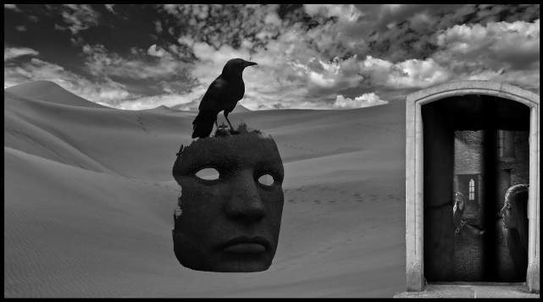
All of us shall have to struggle hard, and increasingly harder if we are to overcome the mountingly adverse impact the 'State' intends to have upon us. Our struggle is with a deeply hidden Plutonian agenda, with powers and principalities cloaked in religious costumes and full of the language of righteousness and the battle between 'Good & Evil'. We are and have been since our birth indoctrinated into a Dogma of fearful dimensions and fear based realities. I don't know how to fight it, but I must insist upon laughing in its face, laughing at my own indignation, fear, and paranoia, laughing at fear and paranoia wherever they pop up because I know I am -like you - a creature of joy. I am happy to be alive and on this Earth, and I am very happy to have all you fellow Gnostics out there as my friends. Laughter and Joy
open new dimensions in time and space, and if you listen with your rebelliously insightful Uranian vision, your invisible Plutonian Ears, and your imaginative Neptunian heart, you can hear the bells ringing.

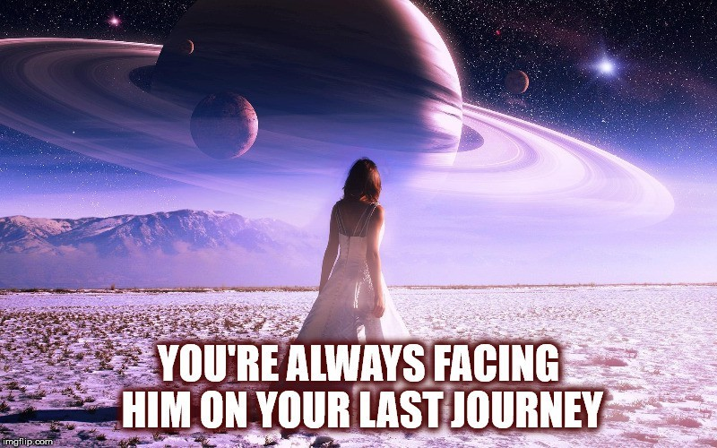

The Wave: Graduation to fourth density

Ascension refers to completing the development possible for and cosmically required of the human form and consequently moving to a qualitatively different form of being. Close synonyms are "graduating to fourth density", or accomplishing the Great Work of the alchemist. In Fourth Way terms, when man has evolved to man 7 and acquired an "immortal" astral body, such a transformation may in principle be possible after death.
Much of the inspiration of the work of the FOTCM has to do with the concept of a planetary change called the Wave by the Cassiopaeans. In the Cassiopaea material, the Wave is a cyclic cosmic event, slated to take place on Earth in the near future. This is variously referred to as the transition to fourth density, the shift of the ages, the harvest, and by many other terms in many bodies of material.
The idea of a cosmic event taking place in the early 21st century has been seeping into increasingly general circulation ever since the late 19th century. George Gurdjieff, for instance, makes veiled references to such a thing when speaking of a time allotted for certain preparation to take place on Earth. Theosophists and Rudolf Steiner also allude to such a thing.
The Ra material (The Law of One) from the early 1980's speaks of such an event in more detail, introducing the idea of a 'planetary transition to fourth density.' The Cassiopaean material, since 1994, picks up on the theme left by Ra and discusses the transition in more specifics. The FotCOM sees the Wave as a strong working hypothesis but does not claim to possess certainty on its validity or a formal definition of the concept.
The FotCM's interpretation of the concept could be outlined as follows: The universe involves different levels of being, each inhabited by entities suited to the level. Some of these levels are in part physical, such as the one which present day humanity inhabits. Natural processes cause the veil between these levels to periodically be thinned or breached, creating a sort of crossroads or conduit. This is a sort of superposition of many usually sealed levels of being.
Outside of the natural process, there are entities which use technology or psychic capabilities for passing between levels. The UFO phenomenon is one example of this. These levels are called densities in the Cassiopaean and Ra materials. Other sources use other names, for example cosmoses in the Fourth Way literature.
The degree of development of a consciousness determines which level of density is natural to it. For certain esoterically developed humans, their level of being approaches the level required for inhabiting the fourth density, a level of being with a radically different perception of space, time and physicality. The natural circumstance of the Wave, i.e. the narrowing of the natural gap between levels of density thus offers a possibility of passage to those that are ready. Hence the term "graduation" or "ascension". Polarization to either service to others or service to self is usually seen as the central requirement for the passage.

This ties to the Fourth Way teaching in the sense that man must become a single, unambiguous entity before such a polarization even makes sense. Thus the Fourth Way work on the self is necessary in order to create a self that is solid and consistent enough to bridge the transition between densities.
The Wave is seen as a point of turbulence. The arrival of the Wave is seen as coinciding with various cataclysmic upheavals, both in terms of society and nature.
The Wave has been compared to a waterfall. The river runs placidly up to the brink, then plunges down as a very turbulent stream and again settles into a riverbed of relative stability. A swimmer cannot escape the river but may make adjustments of course for avoiding rocks at the bottom of the plunge if he is aware of these. Also possibilities of a phase change, i.e. evaporation are greater in the cloud of spray surrounding the fall.
Phase change, as in passage from solid to liquid to gaseous has been used as an analogy for shift of density. A small increment of energy causes qualitative changes in the substance and its properties.
In the waterfall analogy, we note that in order to survive the plunge, one must be solid. When applied to a group of beings, as well as to the multiple little 'I's of each individual, this means that these must be cohesive and aligned to a common purpose. The FotCM uses the term co-linearity for this when speaking of a group. When speaking of an individual the term is fusion or having a real I. Failing this quality, one is likely to be ripped apart by the turbulence and not to preserve recognizable existence.
The FotCM suggests that in the specific volatile circumstances corresponding to the waterfall, the quality of observation contributed to the process by the participants may make a large change in the outcome. This outcome may involve passage between densities, for example. Another example may be a split in timelines, as in the many worlds interpretation of quantum physics. Thus persons embracing one mode of being may literally end up in a different reality than other persons.
The processes in question are not strictly physical, although physical chaos is one likely reflection of the wider process. The process is seen as a macrocosmic quantum jump, determined by conscious observation. Just like the observation event is needed to force a quantum system to a specific state, observation is needed to guide the events inside the Wave.
This is one reason for the FotCM's and Fourth Way Work's emphasis on objectivity and clarity of understanding and work on forging a real "I".
Polarization to a sufficient purity of service to others or service to self is not possible without knowledge of the world and a capacity for long term, unambiguous work. Still further, a group is needed to bring the requisite scope and consistency to the observation – at least in the case of STO development. Failing to achieve a critical mass of STO-oriented consciousness in time for the Wave will likely cause the planet as a whole to remain in the hands of the present STS-oriented control system, divided into a third density and fourth density group, the latter feeding on the former, as has been the case throughout history. Essentially, this amounts to a re-run of Earth history, from the dawn of man up to present, until the next cyclic coming of the Wave.
According to the Cassiopaeans, the period of the cycle is about 309,000 years.

Even though we do not from the present perspective know exactly how such a transition would work nor what the end state of such would be, people often ask about this matter. We will here combine material from channeled sources and tradition reviewed by the FOTCM in an attempt to shed light on this. We recognize that we cannot speak on this with certainty or authority and are bound to be only fragmentary and partial in what understanding we may have.
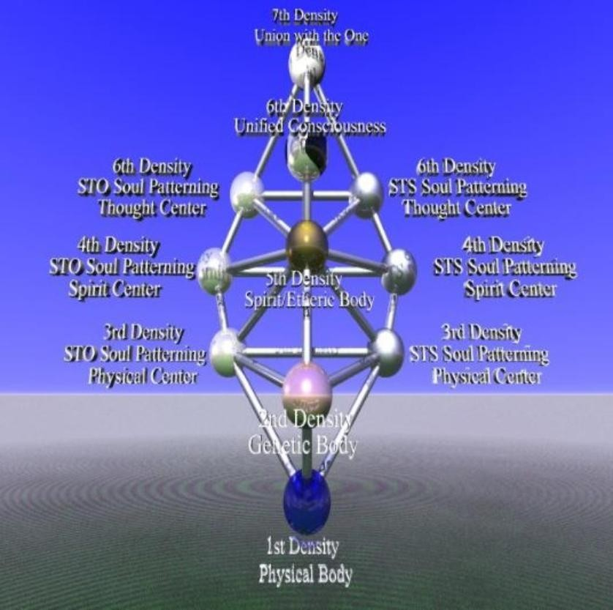
There appears to be a certain benchmark that a being must meet in order to pass from third density incarnations to fourth density ones. Additionally, it seems that in some cases this can take place while in the body. This
benchmark is variously described but all descriptions raise more questions than they answer. We will look at diverse aspects mentioned by different sources below. Ra says that one must be either over 50% service to others or over 95% service to self in orientation to qualify. These are equally difficult for the human, which by nature fluctuates somewhere in- between. Fluctuating in-between only qualifies one for more of the same, in the hope that enough experience eventually drive one to choose either polarity.
The Cassiopaeans emphasize simply learning the lessons of one's density – i.e. third density – acquiring basic understandings and dealing with karma. Learning the lessons involve becoming practically proficient at seeing the world and navigating in it while not becoming caught in its ways. The Sufis say 'to be in the world but not of it.' Separating emotions which open one up to possibilities from those which limit is a lesson to be learned and practiced. A certain quality of emotional structure is important.
Mastery of little 'I's is practically necessary because the 50% STO or 95% STS-ness is hardly possible without great internal and external consistency. One must have being and capacity for doing to manifest these.
Seeing the unseen means, among other things, discerning the often subtle difference between STS and STO in practical life. Without this discernment of the invisible, consistently choosing one over the other is hardly possible. This is a skill and practice is necessary.
Boris Mouravieff and P. D. Ouspensky speak of the possibility of attaining all the development possible in the human form. This is the end of the Fourth, when one has become 'man number 7,' in possession of a permanent individuality and voluntary access to all states of consciousness humanly possible. Such attainment is virtually unknown in history and even recognizing such would be

problematic. The legendary Fulcanelli may have attained something of the sort but then we do not have a biography to study. In terms of historical figures, Ra names Genghis Khan and St Francis of Assisi as mid-term graduates for STS and STO respectively. We get the idea that such attainment is extremely rare.
Many speak of a balance of centers or functions as a necessary condition for graduation. We could say that the lessons are learned only when they form a balance that is not overly weighted on one side nor is anything skipped. Ra speaks of the balance and intensity of the rays or chakras. STO is balanced but STS graduates by a sort of omission, by skipping the heart chakra or higher emotional center and directly going to the higher intellectual functions for accessing 'magical' powers. The lower centers must be balanced and brought under the control of the magnetic center, which fuses with the higher emotional center and finally opens the higher intellectual center. Opening the higher intellectual center by other means is black magic and opposed to the Fourth Way.
The relationship of harvestability with unusual psychic powers is unclear. Mouravieff writes that such powers may manifest insofar the specific service of the individual so requires, to each in a different way but that they are in no way an end in themselves. The one power which is essential is the instinctive recognition between truth and falsehood, which forms as one gains access to the higher emotional center. Ra says that opening the 'gateway to intelligent infinity' is a criterion, which pretty much amounts to the Fourth Way idea of accessing the higher intellectual center. This in turn has to do with a specific psychic metabolism of 'higher hydrogens.'
There is much talk in the New Age market about physical effects and substances and practices for speeding up one's ascension. The 'enlightening virtues' of monoatomic gold are a case in point. We see all such techniques as sidestepping the basic issue of learning and applying lessons and manifesting one's individual gifts on the side of creation, whichever these may be.
DNA changes are mentioned by the Cassiopaeans as being part of a transition to fourth density. This would at least suggest that some DNA features have to do with the possibility. This is hardly surprising since heredity determines human capacities in general. The Cassiopaeans note that 'soul marries systematic construct when present,' in relation to the DNA and the soul having to be compatible for incarnation to take place.
The graduation is generally depicted as having to do with large scale external events, not only one's internal state. The Cassiopaeans suggest that light from a past supernova would reach the Earth around the time of the transition, which would accelerate the progress of those with a sufficient degree of internal polarization. Also, the Wave is described as a specific discrete event facilitating the passage. Ra and Cassiopaeans thus indirectly suggest that the near-absence of mid-term graduations cannot be directly extrapolated for estimating the size of the harvest. There are no estimates but all sources agree that the numbers are very small in relation to the size of the population.
Ra describes the matching of a soul to a density as consisting of a walk towards an increasing brightness of light. The soul stops at the point where the light is too intense. There are discrete steps corresponding to the boundary between densities.
We get the idea that for an individual to make the grade based on one's own efforts is vanishingly rare, whether in the world or in a monastic setting. Effects and experiences may manifest but this

does not yet make the difference. For the STS adept, working alone is in practice the only way since such a being only seeks to control and not to share. For STO, working in a group is natural. After all, one cannot serve others without having similarly oriented others. (Serving STS-oriented beings, or serving the STS-ness in persons of mixed character only contributes to the principle of STS.) Thus, there is great help to be received by balanced or STO exchange. The exchange may compensate for individual shortcomings, producing a group entity that meets the criteria even though not all individuals alone would. The FOTCM is experimenting with the idea that the group collectively may have close to the capacities of a single fourth density STO being.
There is no free ride, however, since natural factors make it so that effective membership only exists when there is reciprocal exchange of a requisite metaphysical quality. What this is will depend on specifics and we cannot draw a checklist. This idea corresponds to the Christian idea of the congregation being the body of Christ. Where the head goes goes the body also. What is gained or lost by one is gained or lost by all, says Gurdjieff with reference to groups.
From Ra:
'The best way of service to others is the constant attempt to seek to share the love of the Creator as it is known to the inner self. This involves self knowledge and the ability to open the self to the other-self without hesitation. This involves, shall we say, radiating that which is the essence or the heart of the mind/body/ spirit complex. Speaking to the intention of your question, the best way for each seeker in third density to be of service to others is unique to that mind/body/spirit complex. This means that the mind/body/ spirit complex must then seek within itself the intelligence of its own discernment as to the way it may best serve other-selves. This will be different for each.'[End quote]

From the Cassiopaeans:
[…] What do you think? Remember, you learn on an exponential curve, once you have become "tuned in." This means that you become increasingly able to access the universal consciousness. Please learn to trust your increasing awareness. All who are present here are at one point or another on that cycle, or one point or another on that cycle of progression, some further along than others. If you properly network without prejudice, you may all wind up at the same point on this cycle. We also mean that you can access the universal consciousness to find the answers to otherwise unseen truths […].

Life is religion. Life experiences reflect how one interacts with God. Those who are asleep are those of little faith in terms of their interaction with the creation. Some people think that the world exists for them to overcome or ignore or shut out. For those individuals, the worlds will cease. They will become exactly what they give to life. They will become merely a dream in the 'past.' People who pay strict attention to objective reality right and left, become the reality of the 'Future.'

The concepts of service to others (STO) and service to self (STS) are the central cornerstone of the teaching of first Ra and then the Cassiopaeans. We find these same fundamentals expressed in different terms throughout esoteric culture. The fundamental nature and extreme breadth of these concepts makes them difficult to define since these are in one way or another reflected in all things.
Ra said that at the human level, speaking of STO vs. STS was the most appropriate terminology because humans tend to think in terms of action and its ethical basis. The concepts of absorption for

STS and radiance for STO could also be used as a metaphor. At any rate, the principles are beyond words.
Cosmologically, the Cassiopaeans speak of 'dual emergence' from the One. This is the source of all which is and this is where the first duality comes into being. The principle of free will, at its various levels of manifestation, mediates between these. This can be compared to George Gurdjieff's first triad, the Sun Absolute dividing into three at the start of the ray of creation. In the most abstract sense, the existence of two dissimilar forces or tendencies plus free will is the simplest basis for an open universe. All the forms of creation follow from these, through a series of increasingly restricted or mechanical levels of being. These levels correspond to the densities of Ra and the Cassiopaeans or the cosmoses of the Fourth Way.
Depending on the context, the STO/STS duality manifests differently. Specific aspects of this duality are described in a number of other articles. Below is a list of different dualities and how they can be seen in relation to STO and STS. A comprehensive description is impossible at our level and we will need to have recourse to allegory.
- Spirit vs. matter. STS beings worship the physical universe [C's]. We could say that all is consciousness but a full half of the consciousness is asleep, in the form of matter. The second half then uses this as a canvas or material for creation. Pure STS cannot exist without some form of materiality, hence does not occur past fourth density.[C's]
- Creation vs. entropy. Creation is multiplicity of forms, entropy is sameness or homogeneity. STS preoccupation with control is in the end entropic.
- Being vs. non-being. See Being vs. non-being.
- Dispersion vs. collection of gravity. According to the Cassiopaeans, gravity is the fabric that ties all existence together, across all densities. Dispersing gravity corresponds to STO, collecting gravity to STS. This leads to a black hole being the physical representation of the idea of STS, as the C's put it. Light is the energy expression of gravity, in this sense radiance and the trapping of light inside the black hole allegorically correspond to STO/STS.
- Balance vs. imbalance. C's: :STO is balance because you serve self through [serving] others. […] STO is balance. STS is imbalance. […] STO flows outward and touches all including point of origin, STS flows inward and touches only origin point.'
The last item above explains why the terms are sometimes defined as service to self through serving others (STO) or serving others through serving the self (STS). Or as Ra puts it, worshiping God in self or worshiping God in creation – all service is thus of the One in the end.
- Light vs. darkness. The darkness is the backdrop into which the light shines. Both are necessary for defining each other. See Gravity.
- Radiance vs. absorption. STS corresponds to absorbing or concentrating energy. STO corresponds to radiating energy outward.
- Freedom vs. control. STS is concerned with control over all aspects of self and others. STS also believes that by imposing its laws it is helping the universe to return to the One, thus it

thinks its action is a service to others. STO sees creation as inherently limitless and is not concerned with determining what is 'good' for another.
- Expansion vs. contraction - Exploring possibilities corresponds to STO, imposing limits on others to STS.
- Network vs. hierarchy - In terms of social organization, STS naturally tends towards the hierarchy with internal competition for resources and power. STO tends towards sharing and passing around that which is received. See Networking and Service to self hierarchy.
- Giving vs. Taking. According to the C's, an "enlightened" (meaning "smart") being can be either STS or STO. An enlightened STO being only gives, while an enlightened STS being only takes. The C's have also commented as follows regarding the taking/consuming/eating that defines STS: STS does not eat according to protocol. It takes if it is capable. STO gives all to those who ask. See All to those who ask regarding this latter remark.
- Objectivity vs. subjectivity. Wishful thinking is the hallmark of STS. They only see what they want to see. [C's] See Objectivity and Subjectivity regarding this aspect of STO/STS duality and mentality.
- Good vs. evil. In human ethical terms, what is generally considered evil most often corresponds to STS. The terms are however laden with a baggage of subjectivity and what is good for one can be bad for another, thus these can easily be misleading. The polarization to either STO or STS cannot be reduced to an external code of ethics only. The Law of Three must be taken into account: there is good, there is evil, and there is the specific situation that determines which is which.
From a cosmic standpoint, both polarities are necessary. This does not however mean that these can be effectively reconciled at the human level. Thus the cosmic call on the human is to choose one or the other.
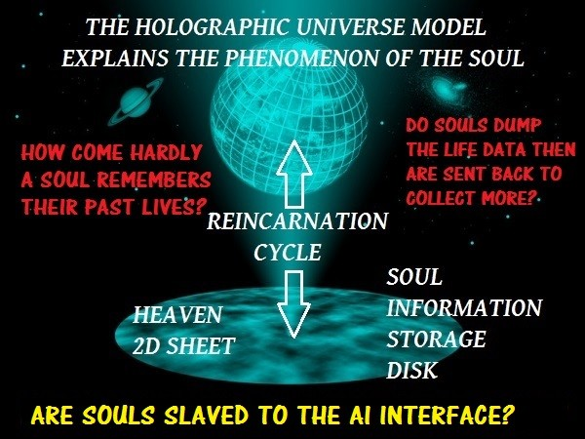

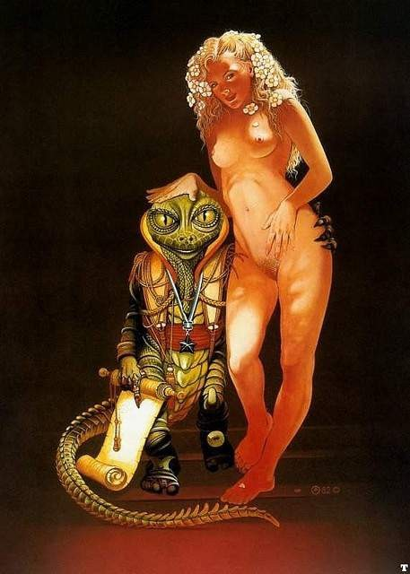

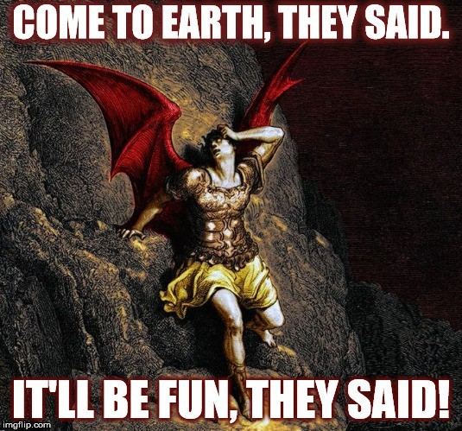

Interview with Maarit, a Scandinavian MILAB18

Synopsis of Maarit’s Interview
Disclaimer: This is a witness testimony of a military abductee Re-Ab, and contains disturbing material and is not recommended reading for those who cannot handle the reality of malevolent alien abductions or shadow government activities. I cannot vow to the absolute facts of all of this testimony nor all of Maarit’s opinions. This is offered as another piece of the puzzle exploring the milab issue and as an extension of the work of the late Dr. Karla Turner and Barbara Bartholic, as well as my own contribution. It is not meant to be fear based but as a “wake up call” testimony to acknowledge those who should not have to live lives of harassment, oppression and secrecy. This interview is with a female milab-abductee from Scandinavia named Maarit. She chose to use a pseudonym to protect her anonymity. She contacted me in late 2010 to share her testimony of alien abductions and subsequent military abductions following her pregnancy with her son in 2005. I interviewed Maarit because she is one of a handful of very lucid abductees, who can recall a greater degree of her abduction related experiences without the use of hypnosis. Although she has neuroimmunological health issues related to multiple sclerosis, I believe her to be mentally intact and credible. She is also highly psychic and can lucid dream— the ability to be conscious and aware during the dream state, which enabled her to regain greater degrees of awareness during her alien and military abductions. A large component of her military abductions involve being used as a guinea pig with colluding pharmaceutical-medical companies who work in conjunction with the shadow government on milabs. Maarit shares her understanding of how and why she is “genetically modified”—a hybrid if you will–and how this figures into her neurophysiologic and immunological issues with Multiple Sclerosis, and an Rh-negative blood type. Maarit explains how her life and marriage have been completely orchestrated by her alien handlers who are primarily draconian, reptilian and military. She has observed many species of ETs in her experiences and recalls being in DUMBs (Deep Underground Military Bases) and a nuclear silo with dark winged, draconian entities. She discusses her understanding of the genetic and energetic-soul matrix, vibrational aspects of hybrids and the alien soul recycling technology. She had an experience similar to Ted Rice of Dr. Karla Turners Masquerade of Angels, involving having her consciousness transferred into a “black box” and placed into a cloned body. Although hybrid issues are now a focal interest in current abduction research, she asserts the most important aspects we need to focus on is how aliens—specifically reptilians–can manipulate, orchestrate and interfere with our relationships. Maarit awakened to her experiences after more memories surfaced, which triggered the realization of malevolent and mind controlling elements in her abductions. The use of Virtual Reality (VRE) brain entrainment technology is done to control consciousness, and is hooked up once an abductee is implanted. One of her screen

- http://evelorgen.com/wp/articles/military-abduction-milabs-and-reptilians/interview-with-maarit-a-scandinavian- milab/

memories installed by draconian entities involved seeing beatific, New Agey, dolphin scenes upon awakening from an abduction experience. Beneath this screen memory was an abduction in an underground base. She admitted to having previously promoted popular “benevolent ET experiences” on a Scandinavian radio talk show before becoming lucid to the reality of the deceptive, mind controlling nature of her abductions. Now, she is fighting back, regaining her lucidity and spiritual resilience. She wants us to know humans can fight back for their awareness and freedom. Awareness is the key to empowerment.
- Tell me a bit about how you discovered you had ET experiences, and your initial beliefs about alien/abduction and contact? What shifted your beliefs about the true nature of ETs and your experiences, any particular incidents which “broke the programming” of what the more popular UFO groups and researchers were promoting?
Before we start, I would like to thank Eve Lorgen for her work, which bravely goes to the dark side of this alien phenomena. I contacted her while I was frustrated and tired. Her open heart and integrity as a researcher and therapist made a huge impact on me. I consider our intensive correspondence as a major turning point in my life. She offered her presence for a total stranger, not so many willing to do these days. In the UFO-field there are not so many researchers who are willing to step out of the comfort zone of contactee oriented happy UFO-scenarios. Only by realizing the alien manipulative agenda we can achieve autonomy for our consciousnesses as a human race.
First of all, I consider myself to be an abductee–being unwillingly used by aliens and military for several purposes. Because I have been manipulated, drugged and mind controlled by humans and aliens, I do not use the term contactee. In my experiences there is no reciprocal nuance to be observed as in cases of alleged contactee people. I do not consider myself to be special or chosen in any way. I don’t have any channeled information to offer. All I can offer is question after question. When I refer to term shadow government/people, I mean globally operating companies related to medical warfare operatives as well as factions of military / intelligent groups. Which ones, I don’t know for certain.
I can divide my alien encounters in two different parts. One part of this alien encounter began before I was even born. I have conscious memories of that time when I was in another, subtle form of existence and forced unwillingly to manifest in this three- dimensional universe as we humans observe it now. I consider the essence of my spiritual being to be alien, per se. I remember how I was shown different parental alternatives to choose from. The connecting link between these human couples was some sort of DNA- structure. My consciousness moved into my infant human body just before labor and I was fully aware of these memories even when I was a baby. After a while the normal neurological adjusting begun and I saw myself as a “normal” child with heightened psychic abilities. The second part of my “human” experience with alien encounters began in childhood at 4 years old, and I knew I was not alone. When I woke up, there was blood on my pillow and I knew “somebody” stuck something in to my nose. I constantly saw scary dreams and woke up in terror. These things happened during the time when I was 4- 7 years old. But as funny as it sounds, during the childhood I do not have any clear

memories of these beings that were terrorizing me or how they look liked. But when I saw a picture of a UFO, I knew “they” were the ones. Another wave of consciously remembered encounters happened, as usual, during my teens. Even as a child I was fascinated by astronomy, nuclear physics, philosophical principles related to existence and ontology. I was more and more “humanized” as whole. I wanted to find the solution, the ultimate matrix for meta-consciousness and all that I could find at that time was the New- Age movement and the shallow answers it had to offer.
Even when I was fairly aware of being abducted at that time (16 -30 years old) that these encounters were not benevolent, I was mentally forced to interpret my experiences as such. The New-Age way to look these alien encounters during 80′s and 90′s was so full of subjective reasoning and pressure. Mostly because here in Scandinavia some the UFO- researchers are highly contactee oriented. And the material these “certain” new age- minded UFO-researchers produced was directly linked to their publishing business.
In Scandinavia we were not given proper options in which we could judge the characters of the alien encounters by ourselves. I was once even on the local radio telling (when I was still into the New Age perspective) about these lovely space brothers, which are here to lift our vibrations, because I did not want to be shut out from the community of friends I was related to during that period of time. At that time I was just one piece of this manipulative machinery, which was planned to misdirect people by giving them highly calculated answers to solve their nocturnal horrifying problems. And I did my job, but not with smiling face.
As I got older, the abductions began to be physically more real. I could remember things, which did not suit the concept of contactee based rhetoric. My ovum was harvested on regular basis and I saw constant marks like sudden bruises, straight cuts, triangular rashes, scoop marks, burned like areas in my ankles, needle marks on my forehead and nose with the upper layer of dermis removed on my body after these episodes. I could not lie to myself anymore about the nature of these encounters. They were malevolent, controlling and they affected my consciousness and memories in a suppressive manner. Not once was I given a straight answer by the abductors for the alien agenda.
At that time I found myself being alone. Suddenly after that conscious realization, of questioning the aliens motives as not being “good”, was when I was isolated mentally and socially via certain episodes in my life. I was carrying a secret no one publicly would respond to in the UFO-field here in Scandinavia. So I felt I was living a private hell in front of many ignorant eyes.
The shift from New-Age beliefs to more an objective state of mind was subtle but very solid and inevitable concerning my realization of the true nature of these alien abductions. The milab involvement however, began when I was pregnant 5 years ago, in 2005-6. At that time I had no knowledge of this milab scenario at all. I did not know what was going on because the UFO-researchers in Scandinavia neglect this subject and there is no open discussion about this military involvement at all in my country. We have only one New Age magazine, which promotes tarot-readers and lighthearted contactees and their supporters in UFO-community. I just wondered about this sudden appearance of military and medical personnel during my abductions. The focal point of consciously realizing my milab connection was the precipitating incident, which “coincidentally” delayed my

Multiple Sclerosis diagnosis 2 years ago. My diagnosis was not given in proper ways, because my qauda equina operation was initially delayed and there was a professional error made by a local doctor. The surgery left me with an untreated infection, which created a permanent inflammatory problem with the central nervous system. The unbelievable doctor’s behavior caused a huge amount of mental stress and a short episode of dissociation, which affected the way my brains functioned. This actually caused me to remember things I should not have. I became conscious in a way the shadow government would not want me to be. In hindsight, I realize many of these major events and turning points of my life are produced and controlled by aliens. And this is the most important factor I’m going to pinpoint out later.

- Why do you believe or have you been told by the aliens or military “handlers”, why they are using you in their experiments? Are you a hybrid or genetically modified by aliens?
The aliens have used me because I live in a genetically modified body. My physical existence offers an opportunity for the aliens to make genetic surveillance in a multigenerational way. When I say genetically modified, it is my understanding that this means an alteration of DNA so that the nervous system modified with alien DNA–and energetic body as well— can sustain the alien consciousness because only this kind of consciousness can make a hybrid body functional, per se. This is actually part of the soul recycling technology. When I say I am a hybrid I understand myself—my consciousness is something you refer to as draconian. I was obligated before birth to move into an altered body to fulfill my task. To perform that transition I had to choose the human parents too as long as the mother was a blood type RH negative factor. This immunological trait is a common feature among these so called, Draconians and their reproduction. But having an Rh-negative blood type doesn’t mean you are a hybrid, it’s just a necessary condition to carry on the biological technology. The genetic modification is very tied to CNS functions and immunological moderation. This alien genetic factor includes modification of consciousness aka vibrational aspects of soul/consciousness matrix as well. The soul matrix is a vibration like electricity in that it can be observed as tones of frequencies. The question of genetic alteration is not purely physical, as we understand. It includes vibrational factors as well. My understanding of draconian DNA is that it is basically inorganic, unlike the human DNA. The draconian body-DNA function needs radiation to sustain consciousness like humans need air to breathe. The draconian DNA structure is not a spiral alpha helix but a denser form of some inorganic and energetic matter, which could be described as a quadrangle. With this quadrangle the structures of energetic tones are organized to serve bodily functions. I believe this is why there have been procedures done to human DNA— balancing the functions and partitions of inorganic and organic matter within DNA. The fundamental building blocks for life are not quite what we have been told, apparently.
So, true hybrids have alien consciousness in an altered body via a genetic CNS modification. CNS modification is partly needed to handle the frequencies of alien consciousness with the energetic body. The alteration of CNS-genetics is done outside the womb during the impregnation by technology, which can hold and change the soul matrix

via magnetic field. The modified embryo is then implanted inside the womb of the Rh negative female. The different kind of alien soul matrix revives the function of the hybrid body and altered CNS function. (All hybrids are psychic). So you may understand why the real hybrids are keeping the secret and silence. The various produced beings, through hybrid bodies, are altered outside the womb during the embryonic stage for other things as well, such as functioning in a different kind of environment, and they have higher tolerance for radiation as well. The radiation itself is not poison to some ET races at all . (EL-This was shared with me BEFORE the Japanese nuclear incident on 3/11/011 at Fukishima)
I have been used as an incubator for alien hybrid embryos. The Rh-negative factor is the key here. Many women abductees used in this way have the Rh- factor in their blood. The Rh- factor prevents the possible autoimmune reaction during the early stages of alien pregnancy.
“Normal” females are also producing human embryos for aliens. These embryos are partly grown and used as a biological protein source for Reptiods. Abducted humans—abductees
—do not need genetic alteration of they are used for other biotechnological uses and consumption—for Reptiods. So frankly put, as food. These reptile beings are able to grow large amounts of biologically “alive” tissue. This tissue can be cloned to make manufactured grey beings as well. This kind of tissue cannot be cloned forever without degeneration. That’s why the aliens are abducting so many humans. All of us have to satisfy the need of food for a large alien civilization. It’s so simple. We are not on the top of the food chain. This is something we just have admit to ourselves.
Many abductees tell us about the baby presentations made by the aliens. The whole thing
—in my opinion– is just meant to do some psychological bonding to prevent resistance of human beings. Nothing more. The babies presented, as more mature babies are probably human-alien hybrids made to use as servants later on.
My son is being abducted as well. He is genetically modified too. His birth was a miracle. We had to use ICSI-method (in vitro fertilization) in order to have a vibrant embryo to be placed. During my pregnancy in alien encounters, I was introduced to my son two times. The body was small, his skin pale. He had huge blue eyes and only a small amount of hair. When he came to see me with this “Nordic” looking figure, his consciousness was maintained in a classic hybrid-like body. And just like mine, his awareness joined the genetically altered human body during my delivery. He has described that kind of memory to me. We have an ultra strong connection, and we communicate also by using pure feelings. Military want all the “cookies” I can give them–my genetics, my psychic abilities, and there is medical research being done that offers benefits for both involved parties and their co-operation as well. And they have plugged my son in to their operations as well. This was the main reason I decided to share my story: to tell people to wake up and fight for their freedom. We have to understand that there are multiple participants with multiple agendas related to abductions/milab activity. And more and more, I believe, the two—medical shadow groups and military are linking together. It seems to me that human participants have to work for these alien beings in ever deeper levels than was previously imagined. This is one reason why I believe there is not going to be an open disclosure about the true nature of the alien encounters. Some human factions

are too deep into this mess. The disclosure would risk the economical/scientific benefits and power these groups have gained via alien connection and cooperation. When a human is abducted for a first time, s/he is being implanted. The military has the needed technology to track the signals emitted by the implants of these new abductees. The implants insert themselves within the central nervous system, when the connection is made; there is a signal, which the military can pick up. So, all the alien abducted people are possible milab victims—hence—ReAbs, if they posses something that can be beneficial to the military. No one is safe and the MK ultra days are not over. The military/shadow government has the identities of every single abductee in this world.

- What kinds of medical issues have you experienced that you believe to be due to abductions? Have you been mind controlled by them, how?
Aliens have done several physical procedures. They have taken bone marrow from my neck and hip with a long needle. They have collected ovum. They have put an implant in to my nostril. They have collected tissue samples from my arm and knee.
Psychologically they have erased my memories and installed fake ones. They have used what felt like electrical vibrations straight in to my frontal lobe to do mind control. One morning I found a puncture mark in the middle my forehead, after having strong feelings to not look in the mirror (suggestions by them to not look into the mirror), and when I saw the mark, I remembered how they put some kind of electric vibration into my brains somehow through that needle and I was told not to remember and not to talk. And then they forced me to look at images of the dolphins again from a screen-like device. I see the dolphins every time when my subconscious is trying to bring something to the surface. They have caused pure emotional horror and enjoyed the ride. (EL—I have nothing against dolphins and friendly higher intelligent species, it’s just their image is being projected in screen memories to pacify our minds into complicity.)
I have an autoimmune inflammation in my CNS, because the inflammation of peripheral nerves went straight to the CNS (following a surgery). The diagnosis is G 37.9, and still waiting to be confirmed as MS, the primary progressive form. The whole episode—with the delay of the operation and the inflammation going straight to the CNS—was, I believe, alien orchestrated and my body is now being used as a guinea big for medical pharmaceutical research done by some faction of the military/shadow government. Because my body is altered, I have degeneration in my pelvic and cervical area as well.
I have had a neuropsychological evaluation twice. I’m suffering from memory problems and visual-spatial problems as well. The findings refer to an organic nature of impairment. I cannot work because of my physical and neuropsychological condition. Some of these changes can be explained via MS, and some because of the mind control and the methods aliens and military use. There is no cure for this. I have been recommended for neuropsychological rehabilitation.
I have been told by Draconians that my body is genetically altered. My blood pressure is quite low and my average body temperature is somewhere between 35-35.5 degrees of Celsius. (37C = 98.6F, so it’s between 95.0- 96.8 F) My psychic abilities are far higher than

average. I sense human emotions and thought forms as soon as I see a person. This is something I would like to get rid of, because it wears me out. I prefer solitude and vibrationally developed, disciplined emotions like gratitude etc. Unfortunately there are not so many people possessing these features. I believe I have also been used to test draconian weaponry modified for human military use because of my psychic abilities and vibrations. Some weapons can only be activated through psychic influence.
- Have you recognized any of the locations you have seen in your milab/abduction experiences such as DUMBS (Deep Underground Military Bases) or medical facilities? Have you recognized any human personnel you have seen in your “regular life” accidentally?
I have been in a DUMB several times that I can consciously remember. One place believe– merely my own speculation–is located somewhere in Canada or in the northern part of USA. The speculation is based only on visual observation of the nature. When I got out from underground I saw these huge trees I have seen on nature documentaries in my country. It was a mountain area, in the middle of the forest. And there was a railway entering in to the DUMB. The entrance was open and there was fence around the yard. The other place was a nuclear silo, in a place were nuclear weapons were stored. These places could be one and the same, but somehow I doubt that. I have seen the same medical personnel who treated me at the University hospital, department of Neurology during the process of my neurological diagnosis. There is one professor of clinical neuroimmunology and neurophysiology and one medical doctor of neurology who are using me in their medical research done for the shadow government. This medical research is dealing the use of nitro-oxide as a regulator in the immune response of the CNS. Nitro-oxide is under constant interest in pharmaceutical work. (Not to be confused with dental nitrous oxide) Applications can be used in cardiovascular and pulmonary diseases and in asthma as well. There are experiments made to use the asthma medication to relieve the symptoms of MS flares. So, the connection between my condition, these doctors and milab abduction is to understand and regulate the immune response in the human nervous system.
I believe I’m under interest because of my genetic differences too. So I’m serving multiple purposes, which I probably even don’t know about. One factor in my opinion is their interest in understanding how to connect together different types of neurological tissues without creating the usual degenerative autoimmune reaction. As one can understand, the application of this information is huge. One can do the digging by them selves by Googling nitro-oxide and CNS. It is all there.
The professor I saw in a DUMB is closely connected to a major pharmaceutical company. The same company is developing a drug for narcolepsy as well and the nitro-oxide is playing an important role once again. I believe I’m used to test the narcotic influence of different medicines as well. The medical researcher I’m talking about is doing research on the neurophysiological aspects of dreams as well.
I also had one very important condition they needed in their study. I did not have plaques in my brain or spinal cord. These kinds of findings are implications of the primary progressive form of MS. All the people in my area suffering from this type of illness are being sent to these specific doctors for evaluation. Surprisingly. In this specific University

hospital there is a highly respected research group doing studies about the nitro-oxide finding as an indicator of brain atrophy in primary progressive MS. This specific university hospital and some personnel of this research group have been doing medical research and evaluation for the military people too. So there is a huge network going on, not only nationally but globally too. And the unfortunate ones (milabs) are being plugged in:
Nitro-oxide NO is under constant interest in pharmaceutical work. In 1998 doctors Furchgott, Ignarro and Murad were given a Nobel Prize for their research work related to NO: http://nobelprize.org/nobel_prizes/medicine/laureates/1998/press.html
Nitric oxide plays a role in immune response as well and there is constant research being done on this subject. http://www.asahi-net.or.jp/~jr9h-szk/juku/juku3.pdf
The applications for NO are drugs developed and under development for neurological diseases as well like Frampidrine for walking difficulties and muscle weakness for people suffering neurological diseases.
http://www.chemicalbook.com/ChemicalProductProperty_EN_CB9853687.htm
Before this accident I was not interested in pharmacology in any level. I only had one conscious memory of the nurse who came to me when I was sitting on the research table, in a DUMB probably. She had a needle and she injected some liquid in to my right knee. “This is nitrixide (that’s what I first remembered)” she said. “You should not make such a fuss about things.” After that I saw the same medical researcher entering the room. That’s all I remember. And all I needed to remember to start to do my own checking out. I have taken photos from my knees after the nitro-oxide shots as well. So, it’s no wonder these events were manipulated to the point were the delayed operation caused an autoimmune response in my CNS. I was a good catch. And this is only the tip of the iceberg from the work of this hidden network. I’m sure of it. But to go deeper in to this could be a story of it’s own.
- What kinds of aliens are primarily working on your case? Can you describe their basic jobs and goals?
Primarily Reptiods, greys and other aliens like mantis-creatures, because they are working under draconian control. Before I continue, I have to clarify the position of reptiles and Draconians in order to understand what is going on and by whom. Draconians do not conduct abductions per se as the interdimensional reptiles are doing, even they are occasionally seen in the UFO. Dracionians control the reptilian race and their behavior and the reptiles are servants for the Draconians. Draconians need the hybrid bodies to be used as containers for consciousness, because only a vibrant soul-matrix can reinforce manufactured hybrid bodies. There are a lot of species co-working in these scenarios, so it’s difficult to define what kind of role the different ET creatures are playing from our point of view. Positive, neutral or negative. When I generally speak about hybrids, I don’t know whether they are human-reptilian, human-Draconian, or human-some other race/races. And the other abductees and UFO-researchers don’t know that for sure either. So pinpointing hybrids only as a reptilian human origin we can do crucial damage for the hybrid rhetoric as a whole. Reptiods are servants for the draconian race. There are not so

many Draco’s on Earth, physically present. I have seen them only working in this particular nuclear silo. Reptiods are allowed to use humans as a resource and do their thing as long as they don’t disobey the draconian administration. By using hybrids, Draconians can produce workers, biological material etc., (who knows) for their use. Reptilians do the needed work. They abduct people and hybrids for the use of cloning and further production. They have advanced technological development to do that and they are allowed to use humans for their own purposes as well, primarily for nutrition and entertainment. By entertainment I mean sexual activities with humans. These sexual behaviors have malevolent, sadomasochistic features.
In other words, there is a vast biological industrial activity going on where humans are being used as a source for biological and psychological–emotional material. The basic job for Reptiod-beings is to survive and carry their own cultural-genetic traits. This is something we have to understand. They do what they do because they are what they are– highly intelligent beings capable of remarkable things.
We have to step out of the victimized state of mind and get rid of the fear. This is the only way to get the respect of these creatures and develop a communication of some sort. Whining and unnecessary complaining are the dead end, then we start to dig our own psychological and physical grave for sure. Objectivity and courage is needed even to try to understand a different kind of intelligence and technology. This is something we are not able to do. The researchers who only feed the fear instead of objectivity are no better than the New Age people who are proclaiming easy ascension and waiting for spiritual enlightenment–even while being roasted in the oven.
I believe these Reptiod creatures are the main problems and bullies for humans. And these Reptiods do shape shift and can take the form of these so-called Nordics as well. Draconians are far more advanced than humans are capable of even understanding. I have consciously seen dark brown Draconians with wings and hoofs. They are a highly technically advanced, warrior-like race with great disciplined actions. Draconians are also philosophical creatures and can be very fearless if needed. Females are superior to male. They consider themselves to be more sophisticated than humans. Because they are ranked quite high in hierarchy of different races, we rarely see them like we see the most highly ranked bosses in our companies. They mingle with their own-kind of company. I remember being in a silo barefoot and this male draconian came to me and sent me a mental thought that he finds the human feet very big and repulsive. I found it funny, because during that episode I could not even understand where I was. Their goal is to continue their lives as a race as well. Just like we humans do.
It is odd but very often, in the milab ops scenarios we are not allowed to wear shoes, and our clothes may be lying in one place, later to be put on, but we never have our shoes. It’s like we are not allowed to wear them. In my opinion there are couple of reasons why milabs remember being without their shoes or clothes. One reason is the fact, that some milabs are involved with research for example, related to radiation and they are being decontaminated after testing. This can partly explain the memories of showers and locker rooms. The other reasons why some milabs are not wearing shoes are the satanic rituals
-performed in DUMB – and their participation in these rituals under mind control. Being

without shoes is serving ritual necessities and psychological manipulation as well. Remember the Nazi concentration camps? Reptiods are divided into interdimensional beings and some creatures that live under the surface of earth. These creatures live in caverns and have red eyes and dark brown skin. They eat meat too. Interdimensional Reptiods can shape shift and are predator-natured.
I have observed a conflict between the Draconians and some Reptiod party/faction. It’s about power. There was a military faction assisting–willingly or unwillingly—I’m not sure
—and these specific Reptiod groups are trying to overcome the draconian leadership, because the Draconians are in charge of some nuclear military DUMBS too. If this Reptiod rebellion is proceeding I’m feeling worried because this would mean the total loss of control made by Dracionians. Reptiods would be allowed to mess around and even the shadow government would not be safe. If considering this as a chess game, the situation is not pleasant from the human point of view. But this is merely my speculation.
I saw the power struggle personally during an abduction. The draconian entity came to stop the Reptiods and prevented them from using me somehow. This has happened two times. So I guess I have something to offer to these Draconians and shadow government and that’s why they keep an eye on me.
The Reptiods have expressed very violent activities towards me and some other abductees I have seen on the UFO like beating, etc. I believe they are having a hard time trying to suppress their basic need to kill. And that’s why some abductees are reporting very disturbing violent abductions and treatment. The degeneration of personality traits and grappling for power applies to other species as well. By this degeneration I mean the need to produce unnecessary suffering while enjoying it. There is also an original grey-race, per se. They are workers for these reptilian entities. And there are a huge amount of manufactured grey look-alike beings used for physical labor. They are being manufactured inside a DUMB and some are being transported to other locations.
- Many milabs and now the popularized “supersoldiers” have described being used as operatives under mind control physically across the globe and even off world. They also describe virtual reality experiences, a term popularized by the late Dr. Karla Turner. Can you tell me if you can tell the difference between a true physical abduction, and one that is virtual reality?
Yes. But this is only my experience. In my case true physical abductions leave marks. Something is done to my physical body. Sometimes there can be menstrual irregularities and abdominal pain, bruises, needle marks, scars etc. The consciousness is totally controlled during these episodes. I can remember flashes of 1-10 seconds. Then I remember being shut down. My field of observation is narrowed. I can see sometimes see clearly tiny areas at one time, like clear small windows of clarity in a limited field of vision. Sometimes I can feel being moved and pushed even when I’m unable to open my eyes or when I’m in a dream like state. In physical abductions I get more of a drugged feeling and less clear memory, and lots of blank spots in-between. Most of the time these memories-whether physical or virtual reality– are very hard to separate because of the consciousness control. Nowadays military don’t walk in to your house anymore. Trust me. They can open a time/space portal and pick you up so that you don’t even notice. The

main objective for these aliens is not to be noticed. They prefer to stay in the shadows, because otherwise humans could start to do preventative actions to stop the abductions by strengthening their lucidity, using and developing proper technology for resistance. So we are not dealing with gods. We are dealing with mortal entities.
In the virtual reality experiences, it is as real as watching a movie or living an everyday life, with no observable limitations. With lucidity, realizing you are dreaming–you can wake up from this scenario. In VRE there is always some aspect of “strangeness” involved if one is able to recognize this. By this I mean for an example, a different kind of phone you have never seen before, strangers, furniture etc. By recognizing these, you can achieve lucidity and wake up in your bed. But this is hard, because the VRE is produced in your brains by using methods like signals and electrical stimulation, which affects your neural and muscular function as well. This makes the scenario seem even more real. And physical/mental adjustment is being done under VRE situations. This makes the scenario seem even more real. And physical/mental adjustment is being done under VRE situations. By this I mean psychological conditioning on how to act or control oneself during RV-operations, behavioral modification on how to handle fear, tolerate pain etc. True physiological modification, implanting is being done either in a DUMB or in a UFO. Reptiods use VRE for harvesting emotions too. This happens by causing horrifying VRE experiences for abductees. The military and aliens as well can produce VRE by sending signals to implants. Military can change these induced brainwaves into images and sounds on a screen. Aliens don’t need that kind of technology, because they sense these telepathically.
I have been able to observe the exact moment, when I’m being activated for the use. This happens when I’m going to sleep. Just when my brainwaves are starting to change for a sleep mode, I see a flash of bright light in my “minds” eye, even with eyes shut. Usually the scene “in my eyes” change and I get an impression of an open space in front of my closed eyes. I can also see from what kind of interior I’m been plugged into. So there is a radar-like computer network through which abductees can be controlled. There is also portable equipment that have antenna, which can send the VRE signals too. And some factions of the perpetrators are using this for their own purposes. I believe the connection can function in two ways: Once the abductee is able to use heightened psychic capacity and lucidity, one can attain information from the other party by doing remote viewing. I have been able to this once and then I saw the warehouse from where the signal was sent.
One has to understand that we are dealing with high technology, which most people don’t know– even the moderate applications can be seen in a use in everyday life. For example, one “official” branch of this technology is being introduced to people as different kinds of computer related appliance for handicapped people. One can do their one research on this subject if interested.
- Have you ever been tasked by your milab controllers to do remote viewing? If so, how is this experience compared to the entrained “VRE” scenarios?
Yes I have. I have been sent to observe some alien creatures (draconian related) several times. I have also been used for more mundane issues like checking some locks or paper documents. These were written in English–that I could remember. Remote viewing is

produced either by physical abuse (and splitting of consciousness) or by using the VRE related technology. Consciousness can be separated and moved by using some sort of electrical vibration. I can tell the difference between the RV from VRE by observing the visual scene I’m seeing. In RV my vision is somehow truly controlled. It feels to me, like I’m watching the environment through a bottle. The vision is somehow twisted and distorted. I see only the things I’m told to observe. I can do some conscious reasoning during these episodes as well. Sometimes there can be unwanted reaction and the RV situation is slipping into a spontaneous out-of-the-body experience. When this happens, I hear a buzzing sound in my ears and I have problems controlling the movements of my energy body. I can slip through the walls recklessly until I’m being drawn back to my body. Also, in RV there is seldom any physical sensations, pain etc., present. Naturally. So only by lucidity and deep reflection one can discern these different kinds of phenomena. Very often, remote viewing and virtual reality they are also linked together.

- What do you think is going on with the hybrid issue as popularized by Dr. David Jacobs in his alien abduction case histories? Have you seen alien-human hybrids in your experiences? What do you believe is their real function?
When we are talking about the hybrid-issue, we have to understand that as a human race we don’t really have the complete picture of this issue. There are not as many genetically different alien related hybrids on earth as the some researchers are stating. That’s for sure. To say alien hybrids are all malevolent, suffering from severe personal disorders is as narrow-minded approach as New Agers have, when saying that alien agenda is good and hybrids are a way to save humankind. Nonsense.
Based on what I have experienced, true alien hybrids are here to serve the surveillance of the genetic study made by the alien race. Hybrids are not to meant to infiltrate into human society to fulfill some hidden purposes of draconians or reptiles. This is something one has to understand. Hybrids are used just to produce more hybrids for the use of draconians. Hybrids are used like machines in draconian bioindustry. We have no knowledge why this alteration is being made. Our social or emotional life per se is not under interest of any kind. Hybrids of the more alien types I mentioned live their lives in different societies like other people do. When I speak about hybrids I consider them to be draconian/alien consciousnesses in an altered human body. But I’m sure that reptoids have their own breeding program going on which is something draconians consider not suitable behavior–rebellion. So yes, there are reptilian hybrids–reptilian consciousnesses in human altered bodies. And then there are genetic mixtures of many other races as well -made by dracos, which are not connected to human race at all.
According to my understanding and memories we cannot define a hybrid just by observing the differences of the DNA- structures between hybrids and humans because some of the changes are energetic in nature as I said before. The major difference is the heightened psychic ability compared to other human beings. When I say I consider my self to be alien-hybrid, aka-a genetically modified human with alien soul matrix consciousness, I know there should be a genealogist to confirm my statement to make this official proof. It is not even important, to me because I have to live an ordinary every day

life anyway (and of course deal with the constant interference in my life.) I do not see myself mean or malevolent in any way. Neither is my son. But people who are acting like judges, I consider to be dangerous. There is no room for hypocrisy.
Humans manipulate, torture, neglect and abuse their kind in similar ways that these Reptiods are doing to achieve their own agenda. Wake up time. Instead of this, we should concentrate on real issues, which are the alien manipulation through their hive-like almost organic influence and the possessions they can take over certain individuals. These things have nothing to with hybrids per se, like the ones I’ve defined. There can also be observed people with low vibrations and lack of integrity acting and playing with abductees. This has nothing to do with hybrids as well and the hybrid issue is something I consider to be less important in the field of abduction research. Wrong conclusions only create unnecessary fear.
Only by seeing the overall impact of this alien manipulation we can start to live our own lives in a more compassionate way. We need to find the true humanity of our own kind and not be willing to be an amusement for them to give them the vibes—or emotional reactions that the Reptiods like.
Another thing we have to wake up to understand is that the alien modification with hybrids (aka- genetically modified human abductees) starts before physical manifestation such as in vitro before birth or while in the womb and is carried on constantly in hybrid’s lives. This means one can observe certain patterns in hybrids and abductees.
  - The abductors are creating an environment were the hybrid and/or abductee is often emotionally and socially isolated either geographically or by parents. This provides them convenient ground to influence the life patterns of the hybrid and repress possible interference made by other human beings. Experimental control.
  - They often set up a love affair to mate the hybrid or abductee with a suitable candidate. Through this selected person, aliens can control the action of a hybrid. (aka- genetically modified human-abductee) This usually means that true hybrids are being kept “hidden” by preventing them from having a major position in modern society. This can be made by disrupting and orchestrating their education, relationships and health as was done in my case. So as one can understand, there is no glory to be had in this hybrid issue. There is only suffering if these patterns are not revealed and worked through, so as to gain personal and social integration of a hybrid person. (Secrecy and isolation harms us)
Many of these aspects apply to abductees as well and can be produced by the shadow military government people too.
I have seen so called “hybrids”(the more alien ones only seen or existing on ships, etc.) during my abductions. They were merely showing me where to go etc. I had no conversation with them that I could consciously remember. These beings were very short and gave me an impression of physical density of some sort. In the room I saw one of them was having modified air pressure given to them. I could imagine one can experience this by diving deep. I have also seen small horse looking, white creatures. They were kept in containers. And the hybrids are working to collect liquid from the ligaments of these

creatures. In order to understand the modern hybrid discussion, we need to accept the fact that most information is given by the abductees who are merely reporting the facts aliens want and allow them to see and “remember”. And certain researchers are adding water to the mill by taking these fragment memories to form a theory. This, in my opinion is how the distortion is made and facts are neglected. We simply don’t know what kind of genetic experiments are being done and by whom.

- Have you observed the alien possession of a human situation such as the term “reptilian hosting” being used?
Yes I have. I did not know the name for this subject until recently. Before going deeper into this issue I have to tell that Eve Lorgen has gone straight in to the heart of this alien discussion. Really. She has openly formed a view of alien manipulation, which I find to be true in my life. After I realized that, I was able to form some kind of synthesis made from my life. I did not know the idea or concept of ALIEN LOVE BITE until recently, but these three little words changed my life and showed me the way to self realization and more awareness to fight for autonomy in my life. Alien hosting does happen.
Regardless of that, I always subconsciously knew this kind of phenomenon was happening in my life. By hosting I refer to a person who is under direct influence of a Reptiod being mainly through mind control. Sometimes the reptile’s spirit can enter a person’s body and cause some changes in the physical appearance of the hosted person as well. Facial features can change, their voice etc. These changes can be seen and often are observed even consciously. But mostly they are neglected because the other partner or persons close to them don’t understand what is going on. I believe many hosted people are considered to suffer from psychiatric diseases like personality disorders, (Like narcissistic, sociopath-EL) psychotic behavior even the problems have different etiology than in normal F-code (DSM) diagnosis. In my opinion the hosting occurs within the orchestrated relationships.
It is done if there is a need from the reptiles to cause immediate influence on the hybrid’s/abductees’ life during certain periods of time like to have the other partner feeling emotions such as fear and abandonment. Possession occurs when the reptilian being itself wants to experience directly emotions and physical stimulus through a hybrids/abductees body. (EL—it can occur with non-abductees too)
The other term closely connected to hosting is the reptilian hive-mind. The term hive-mind in my understanding is the needed reptilian matrix or created context in hybrid’s lives. By this I mean that the reptiles are capable of creating a reality matrix like a Nintendo game. Reality matrix contains certain amount of freedom for abductee or hybrid to make decisions in their life but nevertheless, the outcome is what the reptiles want it to be. By using this hive mind manipulation many people can be included in the matrix to act as wanted for the needed result. The reptilian hive-mind is being activated as a lure like episode often among multiple needed participants to create the needed situations into hybrids or abductees lives. This has happened to me many times in my life and during these situations I felt quite powerless to change the course of the events I could already know was going to happen. The Hive mind, or created reality matrix, is usually

deactivated once the needed result is gained. For example, marriage–in my case–and the delayed surgery and so on. (EL-This can extend to sabotaged media efforts to have guests on to tell their stories, where certain aspects of the alien agenda are never allowed to be spoken in a large way in the public domain.)
After the deactivation of the “hive mind” the people involved often seem to wake up somehow. They may feel shame about what they have done and don’t seem to understand how they could not have seen the results of their behavior. In this way the reptilians can enjoy the caused misery two times, once with hybrid or abductee and secondly with the awakened manipulated participants—who, by the way, are non-abductees and ARE VERY MUCH AFFECTED BY THIS TOO—and are less aware than the abductees themselves are.
—EL)
I could tell you examples of people who are under hosting or shape shifting reptiles per se in my opinion, but I’d rather not. If I would start to pinpoint people I would not act any better than people who infer all the hybrids are one bunch of sociopathic monsters. Instead I would encourage people to judge others based on their actions, like Jesus was doing. Actions reveal the color of ones heart. Not the words or appearance.
My husband was under reptilian hosting and hive-mind influence when we met almost 20 years ago. Without going in to specific details the pattern was clearly seen. He was compulsive, neglectful, aggressive and he constantly created disturbance in my life during the key points in my life, I considered that were critical for my work. I did lot of work with confronting him to pull him out of the lure. The lure—being the reptilian hive mind that was trying to control his behavior and thoughts. And I did a good job. Today I have great husband and we work as a team. In the early years of our relationship, he was an abductee too. There were also very intense times of paranormal activity too. I’m quite aware that aliens and the shadow government people manipulate him on regular basis. By this I mean that subconsciously he is monitoring my behavior. (aka– a handler as a sleeper agent
—EL) Even while writing this, he is quite restless. He cannot concentrate to anything etc. But the situation is under control, because I know what is going on. And he has begun to recognize his own behavior too. I can sense he is worried because he is aware of my disclosure and the spooky calls and that at the same time he is under the command too. Not easy part to play for him.
Now I’m being played off the field by the reptiles and the hive-mind synchronized events. I live in the middle of the forest on a pension disability I cannot move long distances and my memory is playing tricks on me. They did a great job!
Also at the same time I can sense a relief. I feel something is moving away from my life. And I begin to see life differently, being more present. The reptilians and shadow government have changed their tactics. After such a long period of negativity good “accidents” have started happen. I’m holding my breath. I know these synchronized events are manipulated as the previous years of my life, but I can handle that by not being emotionally too attached with these events. Even though I know I cannot ever really be free from this mess, there is a pause from negative tactics and I have waited for that. So this whole thing means that “we” are having negotiations of my limited freedom. I’m being given threats on my life in VRE and at the same time I’m being given candies as well. As

one can understand, the issue of alien manipulated relationships and events are in my opinion, much more important than an isolated study of abduction experiences. Only by seeing a bigger alien picture can we understand the overall impact aliens have in our lives. They own us. They control us. And this happens in ordinary relationships all over the world. (EL—This is what Barbara Bartholic and myself have believed for years)

- Have you ever seen or observed the human clones in your experiences?
Yes I have. In a DUMB, I have seen my clone. Somehow it was not properly made. The tissues looked puffy. This creature could barely walk and it was wobbling. Movements were very clumsy and the scenario reminded me of the Frankenstein’s story. Somehow I believe human participants made this clone. In UFO craft I have consciously seen male clones, lots of them, lying on the tables. I saw this accidentally when a hybrid creature was showing me the way to somewhere. I think this was not meant for my eyes to observe, but accidents do happen. I strongly believe that almost 13 years ago, my original body was killed and used somehow. My consciousness was put in to cloned body. (This happened to Ted Rice and was elaborated on in the late Dr. Karla Turner’s Masquerade of Angels book– EL) At that time I felt physically different and looked younger. My friend also told me that I looked different. But I have no conscious memories of this. Only my instinct. The procedure was conducted after very sadomasochistic events by the Reptiods and humans, which I do not want to go into specific detail. But the process of soul recycling (after being born into a body) begins after abductees are given some sort of liquid to drink. I had to drink it as well as a couple I had not seen before. What happened to them, I don’t know. I also experienced being killed (in a ritualized fashion) a second time in the autumn 2010, a similar procedure and I have conscious memories of that incident.
I was spontaneously awakened in the 2010 “storage in a black box” procedure, where the pure consciousness, essence of me was temporarily kept. I know these issues are frightening and sound psychotic. Only a very strong person is able to go deeply in to these disturbing experiences without being shocked. The denial of these soul-recycling procedures is natural for humans and I can understand that clearly. I’m telling this, because the facts and witness testimonies cannot be ignored forever. Behind the surface there are more things happening than friendly discussions with the space brothers.
I can give you one thought to contemplate: What the term karma is given to people as a justifier for their memories of previous lives, which they lived because their consciousnesses had been recycled by the aliens may not be because of the karmic law. In my opinion we don’t know what is the natural process of consciousness to transform or move forward. We only know that we have been told to behave or otherwise we could wake up as pigs. We are being told that we remember past live because of reincarnation, not because someone has reincarnated us. There is a huge difference here and I believe the technology for doing this is being kept hidden and it would be very precious for humanity if they don’t already have it.

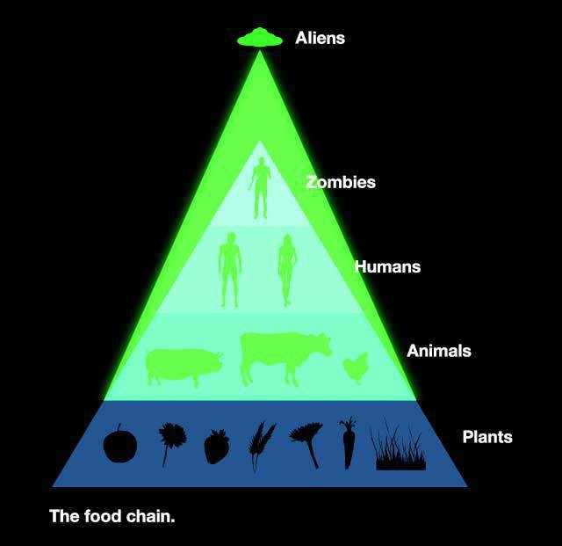



Horus-Ra as the Archontic Alien Parasite19
A follow-up interview with Maarit a Scandinavian MILAB-abductee

Synopsis
This article focuses on the parasitic nature of Horus-Ra as an “Archontic” interdimensional being discovered within the milab and alien abduction experience. The notation as Horus- Ra was chosen due to the being’s similar appearance to the ancient Egyptian hawk headed being, as well as taking a snake-like form. A follow up interview with Maarit, a Scandinavian milab, is featured as the key witness of a most fascinating, bizarre and disturbing account that involves elements of alien and milab abductions, rituals, genetic manipulation, mind control and outright spiritual warfare.
Maarit, a Scandinavian MILAB abductee I interviewed back in April 2011 (http://evelorgen.com/wp/articles/military-abduction-milabs-and-reptilians/interview- with-maarit-a-scandinavian-milab) reports more recent alien abduction related experiences that contain elements resembling the Horus-Ra figure known in the ancient Egyptian religion. (http://en.wikipedia.org/wiki/Horus, http://en.wikipedia.org/wiki/Ra)
Her combined experiences are consistent with the Milab and New World Order occult themes and in my view, demonstrate the parasitic and archontic behaviors of aliens. The archontic behaviors are also evident in the human collaborators who serve their malevolent alien controllers in a clandestine fashion within the military industrial complex. Aliens as intrusive parasites, is a theme found in the work of Dr.Corrado Malanga, PhD and in my own findings with alien abductions and milabs. This aspect of alien interference goes beyond physical abductions and includes the bio-energy system of the abductee, their spirit, mind and soul.
Ancient Gnostic View of Archons
The aliens as parasites that invade the mind of a human host is also described in the ancient Gnostic writings of the Nag Hammadi Library (http://www.gnosis.org/naghamm/nhl.html). In this view, the alien forces are called Archons, inorganic beings who act under the power of the Demiurge, sometimes referred to as Ialtobaoth in Gnostic lore. Ialdabaoth is known to be a powerful shape shifter; one of his faces is a lion with a serpentine body. According to Gnostic scholar John Lash, PhD in his article titled, Alien Dreaming,
“…the lion-serpent image is displayed over and over again in hieroglyphic form on the walls of the Temple of Horus at Edfu, forty miles south of Nag Hammadi. In the cult of Hathor celebrated there, the lion-serpent represented the “royal seed” of the pharaohs.”
Figure 1. At right, taken from John Lash’s Alien Dreaming article (http://www.metahistory.org/gnostique/archonfiles/AlienDreaming.php)

- http://evelorgen.com/wp/articles/military-abduction-milabs-and-reptilians/horus-ra/#more-1095

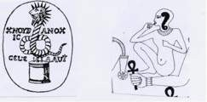
Could this “royal seed” of the pharaohs be alien human hybrids, or individuals who have been genetically modified by the alien hybrid breeding program, so popularized in contemporary UFO abduction research? Some believe that the royal seed are descendents of the Annunaki so commonly discussed in the writings of Zechariah
Sitchin. Some assert that the ancient Annunaki are nothing more than the reptilian lizard beings so prevalently discussed by conspiracy researchers such as David Icke.
Maarit told me in her previous interview—and in many private conversations– that the draconian beings rule over the reptilians and many other races colluding in the alien abduction agenda on this planet. She also admits that there are many alien races who are like us in their search for divine spiritual truths, and who are also, misled via many corrupted religious beliefs which ultimately can be traced back to the same Satanic- Archontic-Parasitic game plan. She admits there are some aliens who are more spiritually attuned just like there are some humans who are more enlightened than the average mass consciousness. It is not a black and white picture, but there are some basic truths, which are being kept secret from the masses. The most guarded secrets behind the aliens, New World Order agenda and the parasitic Archontic game plan revolves around the combination of satanic psychic vampirism and high technology. This high technology has also been referred to as black meta-technology because it combines elements of ritual black magic, nano technology, mind control; genetic manipulation and alien implant technology. Truly a soul oppressing combination and in my view, a great threat to humanity. Unless, of course, we wake up and start taking responsibility for our own freedom.

Optogenetics, Genetic Manipulation and Mitochondrial DNA
In Maarit’s former interview she discusses her understanding of what it means to be genetically modified by the aliens. The alteration of DNA is done in such a way that the central nervous system of the abductee is affected in order to accommodate and effectively “express” the alien consciousness. She says that the alien consciousness—which functions at a different vibrational frequency—acts as a sort of epigenetic co-factor which jump starts the hybrid body genetics, which has been modified to accommodate this alien consciousness. Here the question of genetic alteration may be a function of energetic- vibrational frequency modulation. An energetic-epigenetic factor, if you will.
Dr. Corrado Malanga’s book “Alieni o Demoni. La battaglia per la vita eterna” 2nd edition, (Terresommerse, 2010), and current research confirms the relationship between abductions and mitochondrial DNA, and the fact that the abduction phenomena is passed over from mother to children. This means that an abductee’s father cannot pass it over to his sons, unless the mother, too, is an abductee. Based on his research data obtained from working with hundreds of experiencers/abductees, Dr. Malanga reached the conclusion that aliens are interested only in humans endowed with what we conventionally might call “Soul Consciousness” or “the unconscious mind”. Malanga stresses that:

- Somebody (aliens and the creators of the aliens) under the motto “Divide et impera”, has broke the Consciousness into 3 parts:
- the Mind (more similar to the conscious mind)
- the Spirit (” ” to the subconscious mind)
- the Soul (” ” more similar to the unconscious mind)
- In the case of the abductees, these 3 consciousnesses do not know each other, do not talk to each other and often they don’t even know who they are and why they are here.
Essentially there is a “soul disconnect” with unrecovered abductees.(EL-This can be understood as a type of dissociation from disconnected aspects of themselves.) This disconnect is facilitated by various alien technologies such as implants, alien parasites, mind control programming and trauma. This disconnect facilitates the aliens usage of their soul energy, much like how a water main has been pilfered by attaching various hoses and pipes to divert the flow from the water main.
- In case of the abductees, most of the time the Soul consciousness believes it is a slave of the aliens, looks upon them as gods and is afraid of them.
According to Dr. Malanga, the cure for the abduction phenomena is to get the Soul to remember who she/it is– a sovereign entity upon which aliens have no right. The body must be cleaned up of parasites and implants. Soul, Mind and Spirit have to know each other and they have to unify into one single and sovereign Consciousness. This process was noted to bring unexpected coherence into the psyche of the persona.
Dr. Malanga designed a semi-hypnotic neurolinguistic visualization called Flash Mental Simulation (FMS) to help abductees reconnect with their soul consciousness, spirit and mind in such a way that they can use this power and awareness to remove or neutralize alien implants so that they are “reconnected to their inner soul power”. (See FMS procedure at http://flashmentalsimulation.wordpress.com/flash-mental-simulation/)
When abductees were under hypnosis, Dr. Malanga was able to retrieve information acquired by the abductee’s Soul part, which is the part of the persons being that has all awareness, memory and power and can co-exist in an eternal timeless place, that the aliens cannot. It is this soul energy that the aliens want to tap into as a source of energy and immortal life for them, which apparently they do not have.
An interesting sidebar is that through numerous hypnotic regressions, Dr. Malanga found that the reason why aliens choose one person over another for abductions is a matter of DNA. The soul links directly to the DNA of a person. This knowledge was gained via communication with abductee’s Soul parts (during hypnosis) and from some of the alien parasite entities that spoke through the abductee in hypnosis. Some people are suitable and some are not (for alien abduction usage) because their DNA vibrates at frequencies incompatible with the Soul’s frequency. So, apparently there is a genetic incompatibility with a large part of the human race. Many abductees questioned in the same manner via hypnosis were also asked then, how many humans on earth actually have souls as we understand it? The answers ranged from very few to less than 50% having souls. The abductees who were taken comprise only 5-10% of the souled humans. This concept about

not all humans having souls per se is in the least very controversial.
Being exposed to various tones, frequencies and colors are often reported in alien abduction and milab experiences. The emerging field of optogenetics can explain the value and possible applications and is becoming a new frontier in medical research. “Optogenetics” can be defined as the integration of optics and genetics to control well- defined events (such as action potentials) within specified cells (such as a targeted class of projection neurons) in living tissues (such as the brains of freely behaving mammals).” (See below link for full article on Microbial Opsins: A family of Single Component Tools for Optic control of Neural Activity.
http://cshprotocols.cshlp.org/content/2011/3/top102.full http://www.technologyreview.com/biomedicine/24870/?mod=related, http://www.technologyreview.com/biomedicine/27123/?mod=related
Well, add many years to this in terms of advancement and we have secret technology already being used and experimented on humans via alien and milab abductions.
One of the more fascinating aspects of my many conversations with Maarit revolved around the discussion of genetic manipulation of the mitochondrial DNA of abductees. Mitochondrial DNA is the DNA inside the mitochondria, energy producing organelles within each cell. Mitochondria are understood to be a major component of energy production of all human beings and involved in oxidative phosphorylation and the electron transport chain. (http://en.wikipedia.org/wiki/Mitochondrion)
Maarit and I speculated that the draconians have vested interests in the mitochondria and its DNA and may have even helped engineer this organelle into the human system to take charge of our energy production system. Our bodies can produce subtle energies for these parasitic aliens, who insert us with various implants to perhaps transport or transform these subtle energies for their usage. Nigel Kerner, author of “Alien Grey’s and the Harvesting of Souls” (Bear & Company, 2010) believes that alien genetic manipulation of humans is easier in Caucasian people because their nuclear DNA is less shrouded by melanin granules, which normally cover large portions of the chromosomal DNA in indigenous peoples of color. In the skin of black people the melanin granules cluster around the nuclei of the cell. This positioning of the melanosomes serves to protect the cells from UV light damage, and hence undue genetic mutation by UV radiation. This is one reason he believes that the aliens prefer to abduct more Caucasian people, because the DNA is more accessible than in darker skinned people. Since melanin absorbs light, it stands to reason that white people would be more susceptible to light manipulation, via advanced optigenetics as well. Fair skinned people are more photosensitive and prone to skin cancer. Mitochondria are energy producing organelles within each of our cells and contains its own circular DNA, much like a bacteria or plastid, and is believed to have an endosymbiotic origin, somewhere along our evolutionary history. (http://www.ruf.rice.edu/~bioslabs/studies/mitochondria/mitorigin.html) The circular MtDNA structure can allow for its own ease of replication within the cell. This circular structure, according to Kerner’s theory, is what enabled aliens to insert their own selected genes into our Mt DNA genome, which contains thirty-seven genes. (Pg. 191) It is also

interesting to note that mitochondrial DNA in humans can be traced back maternally to a single Mitochondrial Eve, an African woman existing approximately 500,000 years ago.
Another interesting facet regarding the mitochondrial DNA is its capacity for “data storage” according to a Hong Kong group of genetic researchers http://www.nigelkerner.com/Confirmations/Bacterial_Hard_in_our_Cells.html)
As DNA, the MtDNA would be easier to access and manipulate, because it is a circular plasmid much like bacterial DNA and is not shrouded by melanin granules like the nuclear DNA. In the aforementioned article, the bacteria—or mitochondria—can be used for biocryptopgrahy. This is the art of storing and encrypting information in living organisms. Biocryptography and the encoding mechanism contains built-in checks to ensure that DNA mutations in some bacterial cells (or mitochondria, for example) do not corrupt the data as a whole. This can enable large amounts of information to piggyback on the mitochondrial DNA. They can also tag extra information on genetically modified genes, for data storage regarding the genetic modifications, as one would identify barcodes. In the April 2011 interview with Maarit, she believes that many genetic modifications done to her involve variations in the central nervous system and her immune function. Many female abductees in particular, are stricken with autoimmune disorders such as Lupus, multiple sclerosis, eczema, fibromyalgia and chronic fatigue syndrome. Could these health issues be a result of genetic modification by aliens, or excessive energy vampirism by the aliens themselves?

Clones and the Black Box Soul Recycling Technology
In one of Maarit’s experiences with her 5-year-old son, they both remember being placed in an enclosed machine with deep red lights and pulsating sound. Her son remembered long needles being inserted into him. She believes this pulsating sound and light instrument had to do with cloning in some fashion, and recognized similarities in her and her sons experiences, as those events described in Ted Rice’s abduction testimony, written in the late Dr. Karla Turner’s book, Masquerade of Angels (Keltworks, 1995) One of Ted’s abduction memories involved a small black box that was used to transfer his astral body consciousness from his original body into a cloned version of himself. Maarit told me that one of the reasons they use the black box, is so that the human spirit consciousness does not disperse and go elsewhere, and instead is trapped and directed into cloned bodies or stored until transferred to where the aliens want to place the astral body consciousness. Maarit believes this black box technology is also key to the aliens “soul recycling” technology, which entraps human souls to be born into bodies chosen for that person. Some abductees have reported to me privately that the aliens have interfered with them in other lifetimes, and were told or remembered to have made pacts with “reptilians” in former lives. This being the reason they now are in milab supersoldier programs, for example. Observing cloned human bodies is a recurrent theme reported in many alien abduction testimonies, and with milabs. In Dr. Corrado Malanga’s research with testimonies gleaned via interviews and hypnotic regressions, abductees reported vivid memories of cloned human bodies of other abductees stored in various places by the aliens and human military collaborators. (http://flashmentalsimulation.wordpress.com/flash-

mental-simulation/clones-removal/)
This information was gleaned through numerous abductee testimonies and through hypnotic regressions. In my own work, I see this more within the milab abductee testimonies. In fact, based on the number of milab reports and abductees being used as “operatives” for the aliens or military, led to the hypothesis that the cloned bodies of abductees are sometimes the physical bodies used to carry out various mind controlled operations for various agendas, alien and human. This is one reason why some milabs and supersoldiers I have interviewed say that in these mind-controlled ops, they feel as though their bodies are perpetually younger or no older than 35 years of age. Many abductees have discussed with me mutually shared “dream experiences” with other abductees. Memories involving military operation themes are common, as if they are being either tested and trained for specific military operations or are literally being used in an alter personality mode or, possibly in cloned bodies.
Ritual Elements in Milab Experiences
Maarit recalls being used in rituals in some her milab abductions. Although her memories are not completely clear, enough can be gleaned to say that certain aliens—and the humans who work under them– are heavily steeped in ritual behavior. One such ritual experience occurred only after she had confronted the reptilians face to face within a virtual reality experience. For those not familiar with the term virtual reality experience, or VRE, virtual reality is conducted in such a way that the abductee’s mind is invaded with interfaced technology that can alter brain wave states. This technology is believed to be used when testing and training an abductee, or used in programming of the mind, torture and also “dream hacking” experiences. In dream hacking, the abductee’s mind or dream state is suddenly interrupted by alien beings, disguised entities or humans engaging in behaviors to test or influence the abductee’s psychological state. In one such dream hack, where Maarit and her son shared a dream they confirmed later, Maarit recalled hearing the sound of a helicopter hover her house, while in bed. “Oftentimes”, she says, “this helicopter sound comes when I have an intense VRE experiences.” Sometimes, these dream hackings are done to keep the person in a lower emotional vibrational state where stage-managed dreams involving interrogation or assaults on self-esteem are done to keep the abducee in a state of fear, learned helplessness and low self-worth. This is a prime disempowerment tool to maintain a victim-like mentality that keeps the abductee feeling powerless. As long as the abductee believes this on a subconscious non-lucid level, these dream hackings can alter their behavior, beliefs and life choices beneficial to their abductors. This serves to keep them under control of the abductors and programmers. This has been reported by many milabs. It takes an aware individual who has the capacity for regular dream recall, and occasional lucid dreaming ability to be able to detect this type of manipulation. For most people, dreams are not recalled clearly, if at all–let alone lucid dreaming abilities. It requires a heightened awareness to become aware of the level of consciousness manipulation done via advanced technologies. Conversely, it would behoove abductees and their therapists to undo this kind of programming and re install beneficial beliefs via hypnotic techniques or neurolinguistic methods.

Maarit’s Experience with the Horus-Ra the Archon Parasite
Maarit’s interaction with the Horus-Ra consciousness happened only after her confrontation with reptilians and draconians. Maarit explains,
“Horus-Ra came forward to make his presence clear. I saw this consciousness clearly when my eyes were closed as a hologram of an old grayish snake with a face. The message was clear: I had to deal with him.”

Maarit said that one would rarely encounter Horus-Ra directly unless the fear factor with the reptilians and their coworkers is cleared. In other words, one has to be clear of fear in such a way that the awareness and clarity of mind can perceive the influence of Ra. She says that the emotional turmoil of an individual usually prevents this straight observation of this “dark immanence” of Ra. She says one difference between Horus-Ra and the other beings like reptilians, dracos or even some greys is that normally there is an instinctual repulsion to be around these predatory alien beings. But the influence and mental input of Horus-Ra energy is quite alluring, and tempting. “And”, she adds, “You have to resist it mentally to keep the freedom of yourself—the wholeness of your being. The Ra is blocking the free state of mind.” She also said that most of the time Ra is already within humans, but they just don’t recognize it. This is reminiscent of what the Gnostics said about the Archontic intrusions existing within the human mind. It is always there, but can be minimized by practicing awareness, taking on
the protection of the Light and avoiding getting entrapped in the emotions of jealousy and envy. (John Lash’s Alien Dreaming article, quote from “Dialogue of the Savior, NHC III, 5 (85))
In the Ra encounter Maarit said, “During the night I woke up in a chamber like place. It was not a big room. On the walls were various pictures and Egyptian hieroglyphics and pictograms. They allowed me to choose one. I
did. Then, I blacked out, and woke up again. This time I found myself in a tomb made of grey stone. I was watching the consciousness of Horus-Ra. He put me in a coffin with a heavy lid on it and left me there to suffocate. The next morning I woke up with funny pressure marks on my wrist. This same experience involved reptilians and military afterwards where I found an implant with a cut on my hand.” ( Figure 2 below)
On another night Maarit told me, “I found myself viewing a chamber like tunnel and at the end there was huge Sphinx-figure. Ra dwelled in a place made from white marble-like substance–it was shown to me like that. And he was sad I chose God instead of “him”. I saw him as a huge white snake now and somehow he cannot reach me.This battle is within human psyche and spirit and cannot be defeated before people reach conscious contact with the Ultimate love through spiritual practises and virtues during this lifetime- just what the gnostics said.” She shared this link of a photo of the tomb of Ra, because of its similarity in her recollection of this experience.

http://www.flickr.com/photos/52848718@N08/5226636111/
Maarit continued to explain how the Ra energy felt after this experience, and how it lingered within her mind:
“After this tomb experience I was connected to this Ra thing. The doorway using this form of energy was left open. And I have to be very focused and controlled not to take that action. (EL– allowing it to take over her consciousness and natural will.) I can feel its presence doing a sort of psychological scan to produce more feelings within me. This Ra immersion serves the NWO too because this kind of connection boosts your psychic abilities strongly. So independent thinking and self-control is needed not to become totally taken over. These experiences go along with the reptilian ritualistic procedures. Like before the actual ritual involving reptilians, etc., they deliberately manipulated and created an environment of excessive fear and worry in my daily life, creating this type of emotional response. During and after the rituals, I actually felt the energy accumulate in my upper body. Next thing I remember was being in a DUMB (Deep Underground Military Base) surrounded by these reptilians. I was facing the floor, lying down. Suddenly my whole body began to do these movements spontaneously. My body made an involuntary movement of a huge yoga asana, resembling the cobra asana. Then I was able to levitate. I lost my consciousness while up in the air, and I woke up after I hovered down to the ground. They did not tell me what happened when I blacked out. When my body began doing the involuntary asana movements they sent an image in my third eye (mind’s eye) and it was place above my sacrum.” (See image drawing, Figure x) When I viewed the image Maarit drew for me, I was surprised to see its resemblance to the ancient “Fleur de Lis” of French design, so often seen within royalty emblems. (EL–It was inverted in the sketch) The next day after this milab ritual experience Maarit said that her son told her he was able to see “black light” around her. “And”, she adds, “I felt connected to different energy—this Ra energy. And I have to say this to be honest. Ultimately I am fighting to maintain my inner coherence not to be absorbed by Ra after death or even during this life. Because of my origins, (genetic modification and pre-birth recognized draco alien consciousness) I am able to be more aware of these things on such subtle levels.”
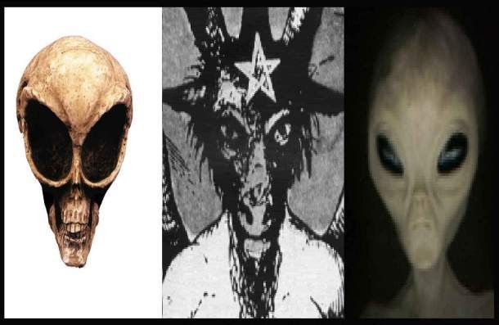
She and her son both have had experiences with the Horus-Ra birdman form and the large snake form. Maarit saw the Horus-Ra energy as snake-like. She did reiterate that the Horus-Ra can take other forms, and that our perception is related to our own lucidity and our own personal symbolism. Truly
we are on the frontiers of consciousness and perception when dealing with this level and form of reality.
I found this to be of great interest in light of the fact that in Dr. Corrado Malanga’s research, Horus-Ra is one of the major heavy hitters of transdimensional alien parasites.

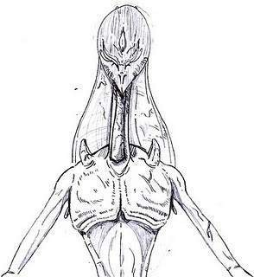
( Figure 3 below) (http://flashmentalsimulation.wordpress.com/the-physics-ofabductions)
It is these incorporeal alien beings made of light, notated by Malanga as “Six Fingers or Grinch, the LUX being and Horus-Ra, which control all the other parasitic aliens. He also mentions that these transdimensional parasites may use various images but the real energy within, its actual identity is nothing more than a black dot or shadow. I corresponded with Dorica Manu, colleague of Dr. Corrado Malanga regarding the Horus-Ra entity. She said, “In Italy we used this notation because the Ra entity operates in a transdimensional body that looks like a very tall birdlike body, similar to the Egyptian god Horus. This bird-like body is not a cyborg, but it seems to be the body of a decayed humanoid
race from Orion. So, the transdimensional form is Horus, the dark entity within is Ra. It is in actuality nothing more than a black shadow or dot.” According to Dr. Malanga, Ra is a dark entity coming from another Universe, a universe archetypally situated behind our universe. There is dark out there, no physical bodies, no light, no love, no souls. This Ra entity places implants on the tailbone, below the sacrum, from where he hangs on to the abductee’s body, parasiting the persona and performing a perverse type of mind control. Ra may come and go to his liking.
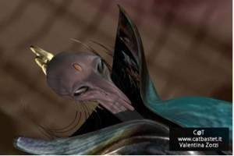
Figure 4. Below-right. Horus-Ra image, donated by Dr.Corrado Malanga and associates.
Could this dark universe that is archetypally behind ours be what the ancient Gnostics described as the “Outer Darkness”? The mention of the “shadow beings” beneath the various forms reminded me of a statement made by one of my former Milab female interviewees named Lilu. (http://evelorgen.com/wp/articles/military-abduction- milabs-and-reptilians/milabs-a-pandoras-box/)
She stated that it is the Shadows who are behind the reptilians and other colluding–parasite aliens and that these beings are the ones we need to be concerned with.
Maarit told me that this black dot shadow is a different kind of energy within the energy body. A presence. She also said that most reptilians and draconians are in line and united with that “shadow energy”. Maarit explains,
“I am able to recognize the Ra energy everywhere and maintain my inner coherence. So in my opinion, the Ra level of universal existence is the level of the so-called Archons, not the minor reptilians, greys or draconians. Ra is the level, which eats the conscious awareness, and we have to bypass it in order to merge into higher realms of existence. The more important thing to focus on is not the origin of Ra in its different forms, but to see the patterns of behavior this Ra has. It truly enslaves. Like seen in cult activity. Ra enjoys the

essence of the egotistical uplift.“ Maarit emphatically stated,
“The purpose the Horus-Ra energy force is not only to consume humans and other species as well–their inner core–but also destroy the purity of it. It wants people to forget the ultimate reality and connection to God. In every way this is true. And it goes with other races as well. Most of them are as lost as humans. Some are awakened like some humans are, too. That is why these New Age movements are so dangerous–they are a straight portal for these darker forces to manifest. They make people to compete who are the most spiritually gifted, most knowledgeable, who have more healing/psychic powers etc., and make the whole scam revolve around human ego, which becomes the source for the ego of the evil itself. So it’s no coincidence Jesus said: do not worship pictures/idols of god and one must leave the material behind in order to follow the route to God. The God is within. So that’s why there is so much ritual performances within the NWO network. The secretive “occult” energy makes the evil stronger, gives these people feeling of specialty and power. It corrupts the purity.”
I find that our tendency is to become distracted by the entertainment aspect of Ufology, rather than the spiritual-mental evolutionary implications of what befalls us with this alien interference. We love to dance in the distractions, but this diverts our own awareness regarding the power of our innate divinity. I believe the ancient Gnostics were well aware of this “Archontic Control” over humanity. (aka–”The Hypostasis of the Archons or Reality of the Rulers”, (II,4) Tractate in the Nag Hammadi Library) The Gnostics, in their wisdom they tell of what the signature of the Archons is: envy. This was the key human failing that makes us more vulnerable to their intrusion. But they did not leave us without hope for a solution. If we take on the protection of the Light, and rid ourselves of jealousy, then we enter the bridal chamber. (Lash’s Alien Dreaming article, excerpt from quote regarding Dialogue of the Savior, NHC III, 5 (85)
Could the humans involved with the Satanic New World Order be hosted by this same black shadow Horus-Ra energy? Is this what the Archontic influence truly is—and what the ancient Gnostics warned us about? The archontic mode of parasitism reminds me of certain themes in a popular science fiction television series known as Stargate SG-1. The Gould are a malevolent race of beings represented by ancient Egyptian falcon and jackal headed Gods. When one is taken over by the Gould, they receive a snake like symbiote inserted into their spinal column, and from then on, they are “hosts” for the Gould’s dark Gods. Did the writers of such Sci Fi TV shows know something about what is really going on within the deep dark elements of the Illuminati, NWO, and their ancient Egyptian alien gods? It made me wonder. Abductees and milabs did not make this up!

Horus–Ra as a Huge Snake and Birdman
Maarit’s 5-year-old son has recalled alien abduction experiences and vivid dreams relating to the same themes with Horus-Ra. Both mother and son have shared dreams on the same nights, confirming that it is more than a simple dream when they can confirm each others memories, especially if the son has no way of even hearing about it. Maarit explained,
“My son said there was a big snake that came to eat him. The snake had a huge belly.

Inside the snake were smaller snakes that licked his body while he was inside the stomach of this Horus-Ra snake form. He showed me the movements of the little snakes with his tongue and tried to lick my arm. I told him that must have been a scary experience for him. We hugged and kissed and now he has not mentioned that experience again. During that episode he also said that in his dreams he sees a man hawk or birdman. The birdman sits in a tree, looks at him and decides to eat him. Then he cuts my son into little pieces and eats him. He has mentioned the birdman several times. Sometimes he says the birdman cries because he would not want to consume him. I am not sure what this means, but maybe it is to form psychological bonding or sympathy for the birdman. After this, I have not seen any marks on his body, however.”
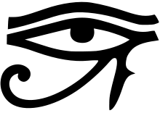
Maarit later told me that she also had seen the hawkheaded Ra in another experience where he was crying, tears in his eyes, before a surgical type of procedure in an abduction. She speculated that the tears of Ra are a common representation of this deity, as they area symbol of Ra’s creative work and powers. In ancient Egyptian beliefs it is said that humans were made of Ra’s tears and sweat. (http://en.wikipedia.org/wiki/Ra) What is more disturbing is Maarit’s son describing things that
Maarit has experienced in abductions that she has not even told him about. She said, “He tells me how some of these creatures saw our heads off, and stick needles into his body.”
These themes are reminiscent of some shamanic initiation rituals, where ones body is torn apart by a predatory animal, only later to be reformed into a new being. This is sometimes referred to as the “little death” which is a psychologically transformative experience for shamanic initiations and resembles a type of near death experience. But in abductions, one wonders what the ultimate utility and agenda is?

Mind Controlled Ops and Torture to Comply with the Nefarious New World Order Agenda
Maarit believes some of these experiences, especially the ones geared to amplify psychic abilities, are done so that she can be more adept at remote viewing military operations during abductions. This she has admitted to, being used to carry out counterintelligence operations to remote view humans and aliens in various environments. She says,
“They—the controllers—continued to train me with controlling and monitoring rookie milabs, doing psychic readings about people. To check and monitor their development and accuracy of their remote viewing sessions. I was organizing groups in a DUMB. Sending various milabs into the right locations there because they were drugged and controlled, as most of them are in a trance like state. Other trainings involve searching a physical location for documents and memorizing them, or how to clean op after an operation, as no documents are saved.”
She admits that she has been traumatized and tortured like many MK-Ultra abuse survivors, where different personalities were created. She realizes now that the life of

being raised in an environment of trauma and lack of trust, weakens a person’s sense of power, so that they are more easily molded into what the alien and military controllers want—a mind controlled slave with photographic memories and heightened psychic abilities, for example. Maarit says the NWO controllers, who are humans colluding with malevolent aliens, keep trying to get her to agree with them, to go willingly as an agent for their agenda and she refuses each time. When she refused a few years back, was when the abductors stepped up the medical torture, with her delayed diagnosis of multiple sclerosis and correspondent degrading health complications.
“This was meant to break me emotionally, so that I would join the Satanic NWO faction and offer consciously my psychic abilities for their use, but that did not happen. In my case they asked me to join them in a VRE experience. It’s very hard for people to understand the level of cultivation they have succeeded with mind control. They constantly manipulate your subconscious mind and create emotional attachments towards the handlers and programmers. (EL—Stockholm Syndrome) They also test the liability and loyalty of people. In my daily consciousness I had made no clear agreement with the NWO to work for them. But because I was already in the system when I was born, they used me anyway. They use and manipulate one’s awareness for their own agenda through black technology after you are plugged into it. This is important. They do not need your approval to use you in their “mind controlled ops”. But if you have agreed to participate consciously, the outcome is naturally better. They only require your conscious agreement when they want a milab to participate in their Satanic rituals. And they consider an answer to be yes even when it’s done under mind control and hypnotic influence. Sleepers are the ones who cannot break the amnesiac barriers to bring the memories into daily life. So by telling this I have put the well being of myself and my family at risk.”
More recently Maarit has been threatened with being given “cancer” by her abductors because of her outspokenness. This kind of threat has been given to other milabs, abductees and researchers, I might add, for spilling the beans on the dark side of the alien abduction agenda. Maarit is still angry about how earlier in her life they took advantage of her all loving personality to promote New Age ideology, concerning the aliens agenda; promoting the “aliens as benevolent consciousness raising beings who upgrade your DNA” spin control so often seen even now in the UFO-New Age community. She even said that, “Here in my country, the UFO community is still stuck in the Adamski era of thinking.”

Sketch of Maarit’s Recollection of the Horus-Ra Snake, emblems and Draco DNA
I asked Maarit to draw a sketch of the things she and her son recalled in the Horus-Ra experiences. I also asked her to draw what she remembered of part of an inorganic DNA form (draco origin) of genetic manipulation activated by radiation. This has the appearance of a cube like representation with many smaller cubes representing different tones or frequencies that get switched on from exposure to radiation frequencies. The sacral symbol after the Horus-Ra experiences looks like an inverted Fleur De Lis. The infinity symbol used in the ritual was also used as a symbol on the forehead. The snake man of Horus-Ra looks similar to the image of the snake like form drawn inside the head

of the man in the ancient Egyptian and Gnostic sketch from John Lash’s “Alien Dreaming article “ on the metahistory.org web site. It was as if this sketch denoted the parasite of Horus-Ra within the mind of the man.
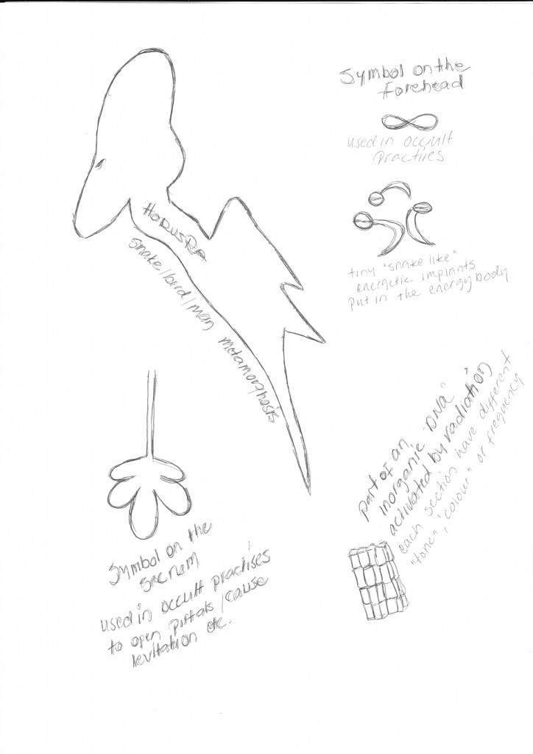
Figure 5. Maarit’s Drawing depicting the Horus-Ra entity, snakes, and emblems inserted into her sacral area during abduction

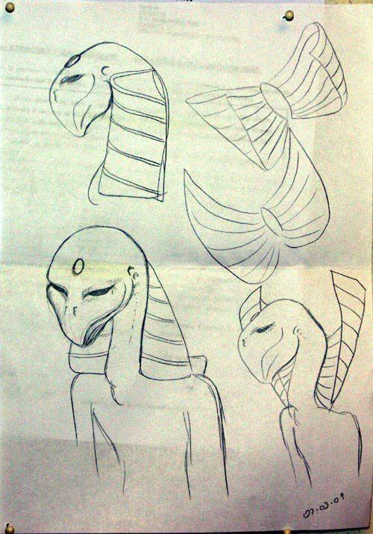
Maarit’s image is very similar to the sketch below made by other experiencers of the Horus-Ra entity
Figure 6. Dr. Malanga’s associates drawing of Horus-Ra. (Also on drawings page, pictograph # 11)
We may never know the exact answers we want regarding the true agenda of the interfering extraterrestrials. All we know is that people are consistently reporting abductions, various kinds of visitations and interference on many levels. It is clear that some humans on this planet are colluding with certain species of aliens to oppress and experiment with humanity. We may think that the physical aspects of abductions are of the only real importance, but if we truly can grasp the reality of quantum physics, the nature of our own consciousness and potential realization of divinity, so much more is at stake. We cannot deny the importance of our own spirituality, and the freedom of our souls.

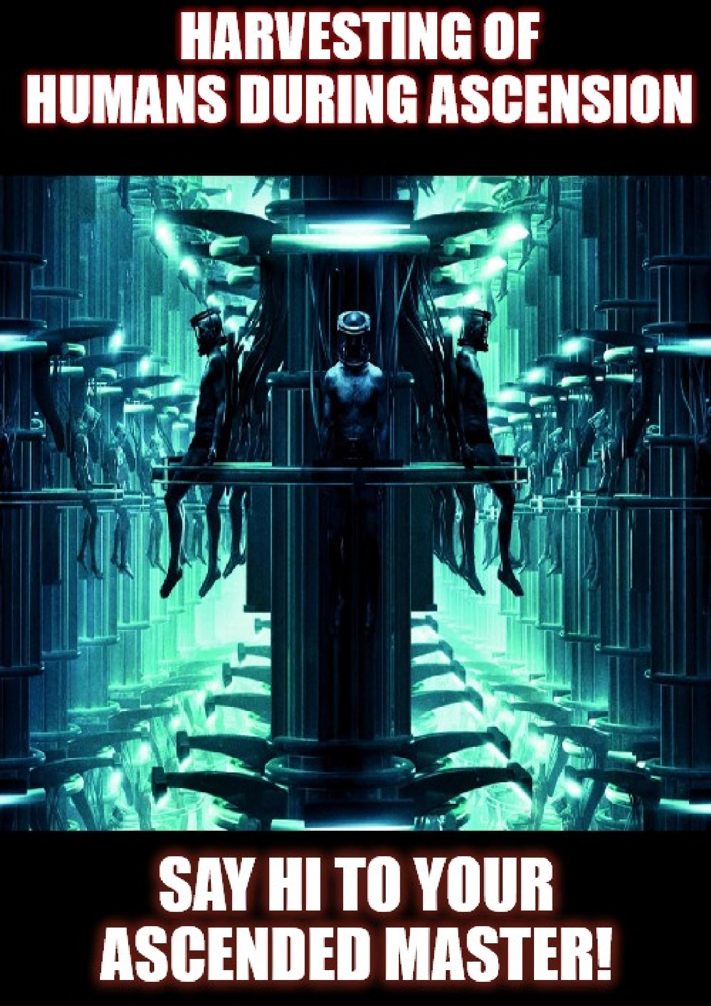

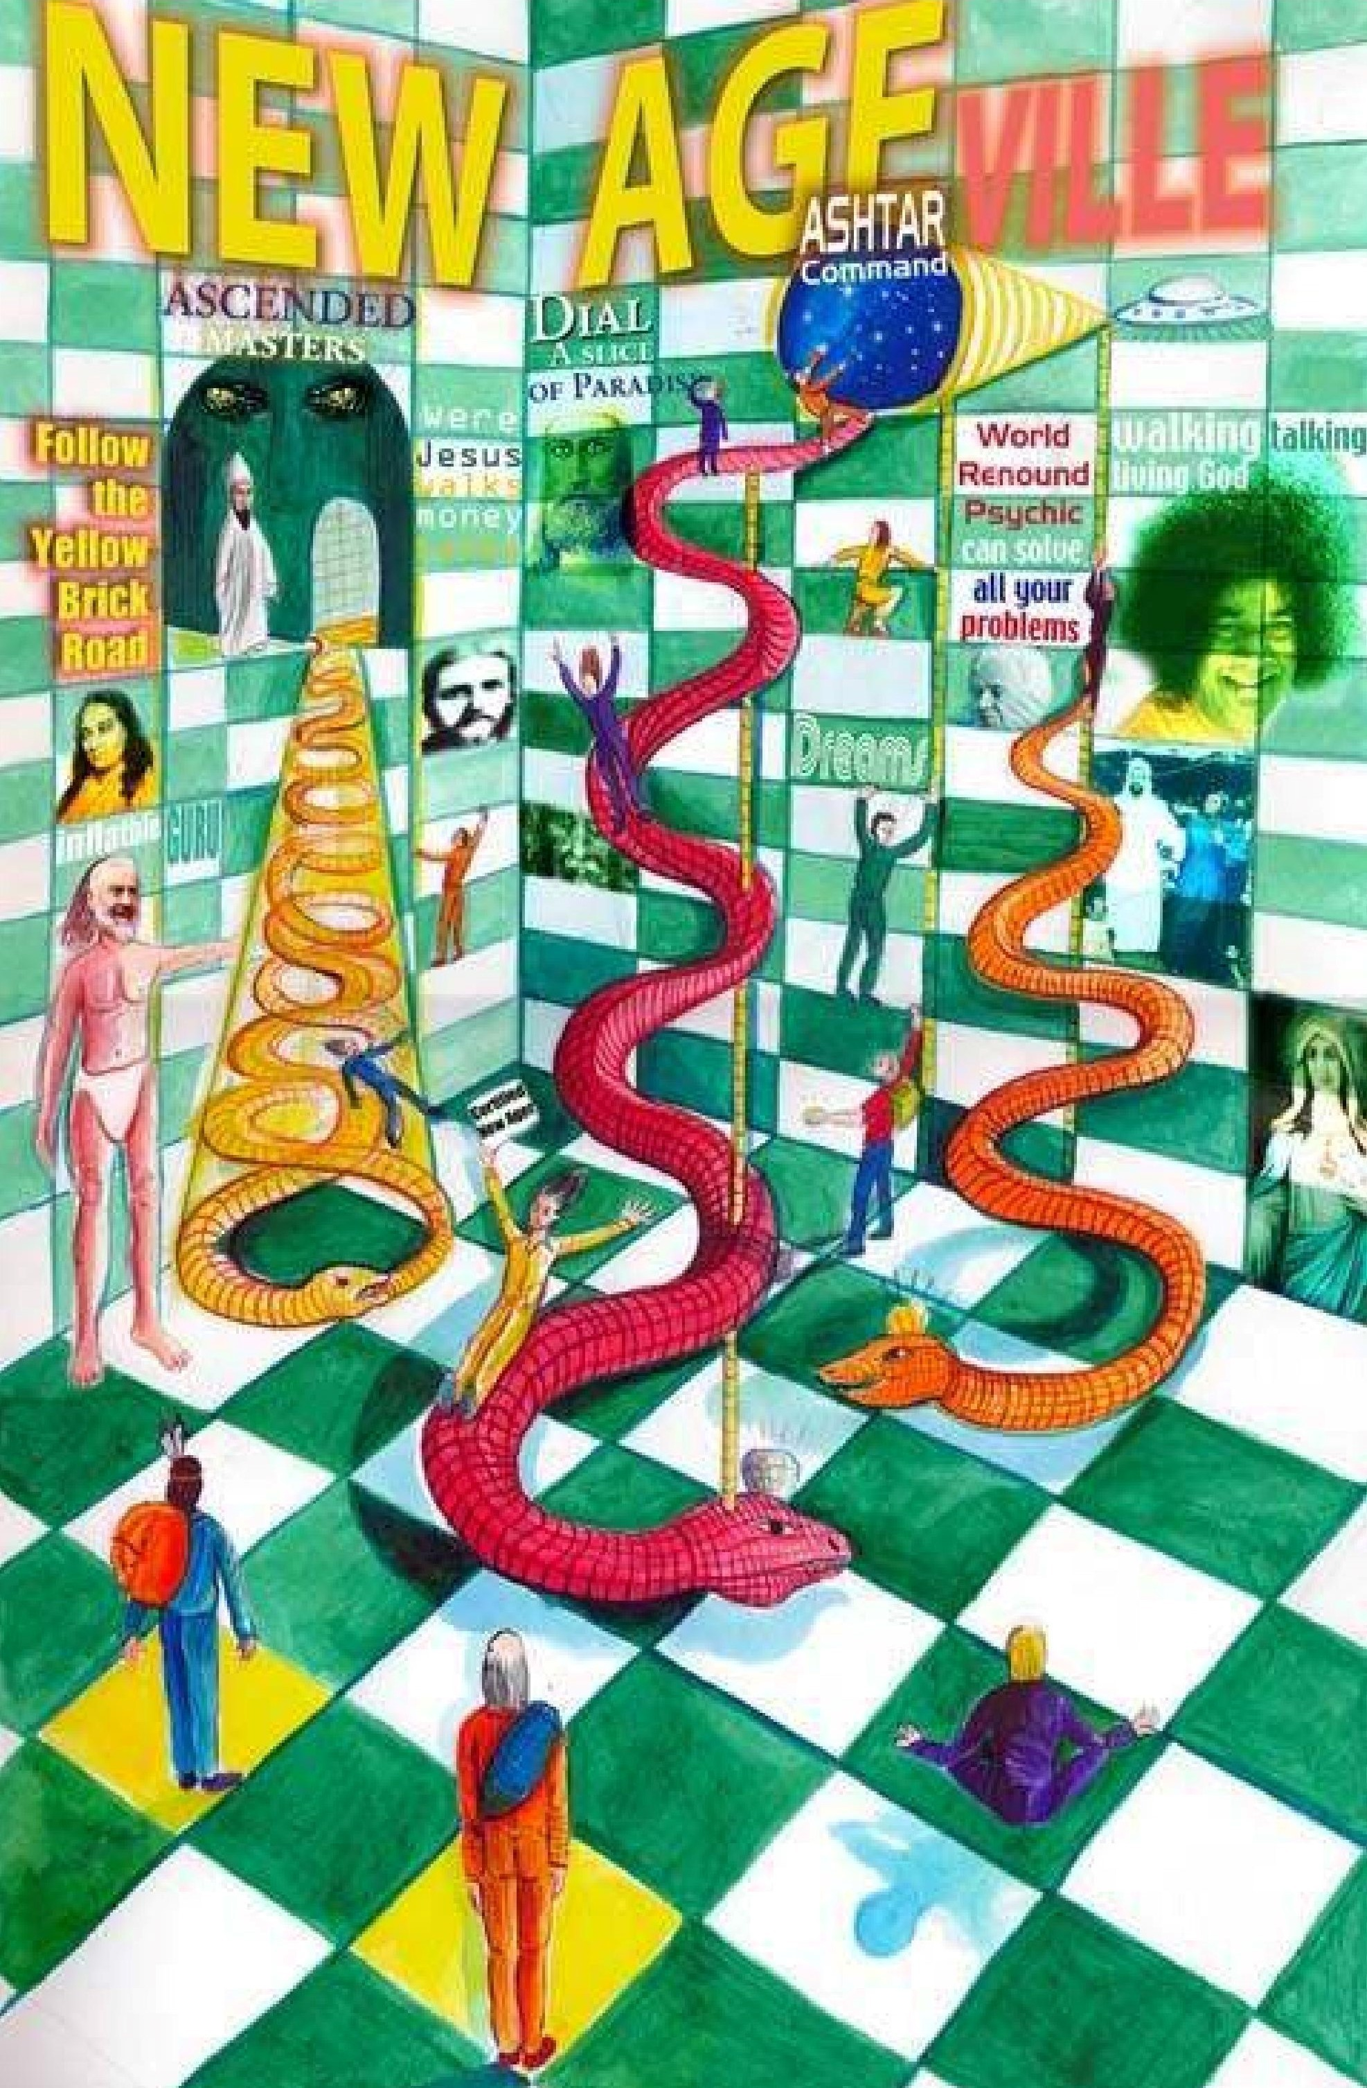

Alien Hierarchies and the Research of Dr. Corrado Malanga20 An Interview with Dr. Malanga through Dorica Manu

This article discusses the Alien Hierarchies and Levels of Alien Interference according to the research of Dr. Corrado Malanga of Italy. This is in the form of an interview with Dr. Malanga’s English speaking colleague, Dorica Manu. Dr. Corrado Malanga is a veteran researcher of the alien abduction phenomenon. He is also a scientist, a professor of Organic Chemistry at the University of Pisa, Italy. Dr. Malanga is known for his revolutionary views of alien interference, especially the deeper levels of alien interference suggesting the aliens as transdimensional parasites. Dr.Malanga has authored two books in Italian. The first, “UFOʼs Inside the Mind” (Bompiante, 2000) revealed how aliens implant their own memories inside the minds of abductees. This created a controversy and according to Malanga, after which, “all hell broke loose”. His second book entitled “Aliens or Demons: The Fight for Eternal Life” (2007) also created a stir, as his theories did not subscribe to the contemporary abduction literature, which has been neatly circumscribed to the abductee medical exams, Grey aliens and the hybrid breeding program. Dr. Malanga also co-authored, B.V.M. Beata Vergine Maria” (Blessed Virgin Mary) Mondadori, 1995, A book about apparitions of the Virgin Mary and how these apparitions/holograms may be alien in nature. Although his research includes those aspects of the abduction scenario, his emphasis on the aliensʼ entrapment and hijacking of the human soul as a “battery”, is what he believes is the most important reason for the aliens interference with humanity. It is all about our souls.
(EL: Note: The alien love bite scenario and the dark side of Cupid are part and parcel of an aspect of parasitical alien/entity interference, in my view. The corporeal and incorporeal entities and various implant technologies can facilitate, catalyze or even forge strong bonds between people.) A good over view of Dr. Malangaʼs theory regarding alien interference with humanity can be viewed in the article entitled. ”The Global Picture of Alien Interferences” (http://flashmentalsimulation.wordpress.com/2012/01/13/global- picture-of-alien-interferences/)
Although this basic overview was introduced in an earlier article/interview I did with Maarit (http://evelorgen.com/wp/articles/alien-abduction/before-and-after-simbad/) I wanted to present the basics as a prelude to the content of this article, which emphasize the deeper levels of alien interference, such as incorporeal alien parasites, the involvement of the Primordial Man and the higher figures of creation.
Through hypnotic and neurolinguistic methods, Dr.Malanga aimed to help abductees recover their memories. He discovered after hundreds of regressive hypnosis sessions and parallel studies of psychology, neuroimaging, myths and quantum physics, that the inner make-up of a human being (namely the abductee) consists of: the Soul (feminine part), the spirit (masculine part) and a more intellectual part (the mind). The mind is that part which is more in touch with and aware of the flow of information to and from the human brain. These three parts of the human self came out during the hypnotic sessions, with their own

- http://evelorgen.com/wp/tag/primordial-man/

personality, own will and own world view. The first most visible issue in abductees, after having understood the existence of these three conscious parts, was that an abductee’s mind, spirit and soul components were not in communication with each other. This contrasts to non-abductees or those who are not traumatized, parasited or dissociated. In other words, there exists with the abductee a condition of soul-mind-spirit disconnect, which enable the aliens to tap into their soul energy, while keeping the abductee unaware of this soul energy hijacking operation. This in and of itself is complex and involves carrying out the alien agenda through those parasited.
Dr. Malanga also discovered a lot about the aliens methods, their motives for interfering with us, and how they parasite themselves within the human mind-spirit. This is similar to what many shamans and spirit release practitioners such as the late Dr. William Baldwin call “attached entities”. In yet other traditions, such as the late Father Malachi Martin, spirit attachment is also known as demonic oppression, partial possession or total possession, depending on the severity of the case. I concur that the demonic possession theory is a bit simplistic when viewing alien activities, although its study is quite useful and should be reviewed by more sincere researchers in the UFO/ET field.
In a nutshell, Dr. Malangaʼs research describes the problem of alien interferences, which races are responsible for these interferences, and analyzes the many levels of alien interference. Some levels are obviously physical and others are more internal, such as affecting the energy body of the person. His work clarifies the interrelationships between different aliens and between aliens and groups who work for the New World Order agenda. Most importantly, he describes the techniques used to subjugate the abductee, used by both aliens and the military humans who are colluding with them to achieve their own goals. He proposes several levels of interference:
Level 1: Physical surgical operations on the abductee, such as invasive medical procedures, implants.
Level 2: Alien memories implanted into the brain of the abductee.
This aspect concerns the aliens desire for immortality, by living within and through us. Malanga reports it as many abductees stated while in regressive hypnosis, “The aliens live across us and our mind. “(Alien Cicatrix, p. 21-26) Here, many symptoms of the alien abductees were such that they felt, “not of this world” or recalled other lives as an alien. Or dual liveʼs as an alien. (EL–being transferred to an alien body and working with them.) The alien memories Malanga calls, Active Alien Memories or AAM. These memories comprise also the lifetimes that a particular alien may have been a passive part of, while being “parked” inside many different “abductee” body/carriers throughout long spans of time. For example, one abductee may have within him/her an AAM of one alien (of many thousands of years old) that contains 5 lifetimes (or more) of “abductee carriers”. If the AAM can be opened via careful regressive hypnosis, these memories may appear like past lives. This of course calls into question a new or abridged definition of reincarnation.
Level 3: Copying of the Abductee
Two basic types of aliens predominated in the AAMs, the locust/mantis or

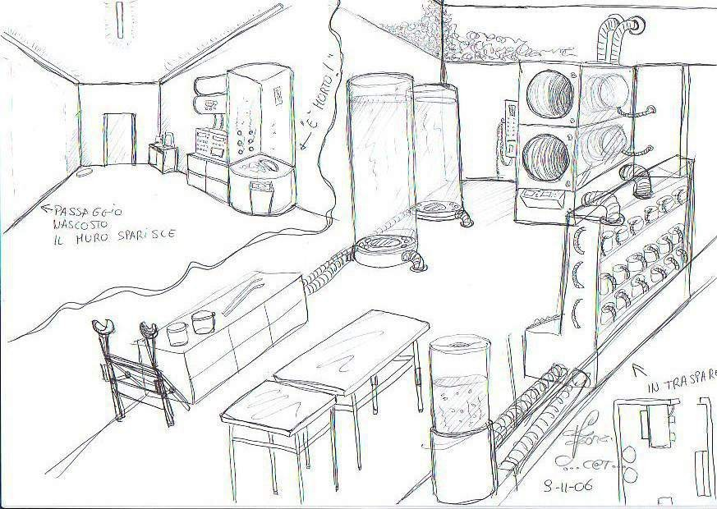
serpent/reptilian forms. The reason according to Malanga, is that the human DNA is compatible to the reptilian DNA and our brain is larger, and able to carry more information. They designed us this way to use us for their AAM storage. To preserve the AAMs the aliens cloned each abductee in case of bodily death of the original. Malanga describes the cloning apparatus (described by abductees Soul components) as both horizontal and vertical cylinders, arranged in 4 different rooms, within a possibly subterranean-military/medical environment. It was discovered later that on rare occasions the “copy” or clone of the abductee was sometimes returned from an abduction temporarily, but usually the original is returned. This caused odd memory lapses where the clone had a slightly different back up memory than the original or vice-versa. (Alien Cicatrix, p. 21-26) EL- Malanga later clarifies his term clone and now uses the term “copy” to define what the aliens were doing, when copying an abductee/person. A clone Malanga said, has to be grown up from point zero, a baby and then into an adult. A copy, on the other hand is something like a Xerox copy, they somehow create a copy that wasn’t observed to have been “grown up”.

Level 4: Attempts to move the light-dots matrix (SOUL-CONSCIOUSNESS) of the abductee and constrain it into an alien body
This is after the cloning process whereby abductees described a light within a vertical metallic cylinder, vibrating extremely fast. This causes the dot matrix consciousness or “soul matrix” of the person to be ejected out of the body and directed into the next transparent cylinder. The original body is still in the first cylinder while the consciousness is put into a new body. Sometimes this was an alien body, but the Soul vibration can not accept the alien DNA frequency for extended periods of time and usually reject its containment. The Soul can be put into the cloned body, and then back into the original. In some testimonies, the person reports being placed and functioning within an alien body, and carrying out various tasks for their alien handlers.(For example the Simon Parkes testimony on the AMMACH video interviews, see: http://www.youtube.com/watch?v=QzQTqGOlcWc
According to numerous abductee hypnosis testimonies, they (or more accurately their Soul Component) reported that the Soul consciousness cannot be copied. The aliens know this and this is why they are using our Souls. Ultimately they want to create some genetic bridge which will alter their own alien DNA to be compatible with our Souls. (via various human-alien hybrids) Once they have created a genetic hybrid with DNA that is compatible with our human Soul frequency, is when the human souls will be hijacked into complete alien enslavement. (EL–In other words, the aliens, who only have a mind and spirit component to their being must use our Souls to incarnate into hybrid bodies, where the will of the Soul is completely repressed or taken over by the aliens will. This is not good) This, according to Malanga is the bottom line of the alien agenda. The secret of the Tree of Life is that the humans or human DNA, contains a compatibility with the frequency of the Soul. Apparently not all humans possess this DNA compatibility with the Soul. Or to put it another way, Malanga discovered via the abductee Soul component testimonies, that only 20-25 % of humans are souled, or had this DNA soul compatibility issue.(Alien Cicatrix, p. 21-26) Another way to perceive this, which the latest discoveries of Dr. Malanga also confirm – is that the Soul of these people with apparently incompatible genetics stays behind in another dimensional reality, so that the “connect” aspect will not function within that life-genetic container. As Malanga would now say, “These soul entities still remaining on the less dense energetic planes of existence–the so called “Higher Realms” of Religion and New Age–are afraid to “come down” and have the experience on the Earth plane”. Therefore what these beings are really doing is inviting us to come up to where they are–to ascend. (EL- They want company I suppose? And why do they need us there is my concern. For another understanding of what their level of existence and dimensional reality really is, I suggest studying the Buddhist 6 Realms of Existence). The beings from this other higher planes of existence are offering us an eternal golden jail. These persons with disconnected souls may not express heightened spiritual understanding and will function within the lower realms of consciousness. Perhaps psychopaths fit into this category? In a nutshell, most of the aliens conducting the abduction-related genetic experiments do not have a Soul component in their being, and their genetics are incompatible with the human Soul frequency. Within the triad of components, human abductees have mind, spirit and soul. Aliens had mind and spirit or

only mind in SOME races. The various types of aliens, bodiless aliens and other beings from higher levels of creation will be elaborated on more later.
Level 5: Different kinds of incorporeal aliens made up of light-aka- the LUX light being or those coming from another dimension-aka—the bi-dimensional parasites such as the Horus-Ra figure, Six Fingered ones or Growl.
These are the ones who seem to have more control that the other aliens. Two basic types here, the LUX being from our own 3D universe, and the black shadow beings who come from a 2D “dark universe”– which is archetypically located behind our universe.These incorporeal beings take on various body forms (not necessarily physical, however) in order to interact with us here. These spirit kinds of parasitic beings also had a kind of “AAM”. They appear to live a long time, but are actually mortal. These beings may have been believed to be SOME of the immortal gods in mythological cultures. According to Malanga, these incorporeal beings under the direction of the “Primordial Man” figures, control the aliens which organize the abductions. Those aliens in turn control the cyborg Greys. The incorporeal aliens have something similar to spirit but different than a soul. And there are three kinds of human beings:
- The Body and Mind
- The Body, Mind and Spirit
- The Body, Mind and Soul
- The Body, Mind, Spirit and Soul
It is postulated that the incorporeal aliens, (light beings and dark shadows) want to host or possess humans who have Souls, in order to feed off the energy so they can live forever and to manifest their control over the One Consciousness” the true “God”. The LUX being is unique in that it is from our 3D universe, but somehow lost its “body form” that enabled it to retain a Soul aspect. Malanga now affirms that the LUX being is an emanation of the Lucifer who rebelled against his creator, the white, bright Primordial Man (The good Father Figure, Adam Kadmon, the wise old man figure), and so itʼs like an orphan and is envious of the human condition, always seeking human bodies with Souls (and also without souls) to possess, in order to live, to manipulate, to weave his intrigues, to feel important…, etc. The black shadows who take on the Horus-Ra figure or Growl (six fingered types who are tall, blonde, with slit eye pupils) originate from the “dark universe” where the Soul component cannot experience its bi dimensional form. Much of this theory is discussed at length in Dr. Malangaʼs Genesis 2 and Genesis 3. ( *LInks or pdf: In Italian: )
Level 6: This concerns the Primordial Man and the hierarchies of beings above the PM
This level concerns how they interact with the abductee who is working on freeing him/herself, or after they became free of alien abductions, but still not free from other types of intrusion occurring from higher levels of creation.
These are the questions I posed to Dr. Malanga through Dorica Manu, his English speaking colleague.

Q: 1. What are the alien hierarchies as you understand them?
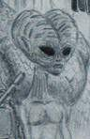
A: It looks like the less important ones are classical gray aliens which, at least in 99% of the cases, seem to be a kind of a biological machine. They are run by other small aliens, but just a little bit higher (1.50 m) with a much more insectoid looking face and which appear that they might be sentient beings. So, they might’ve made copies/clones of beings which were already very servant in character. Every race has different models of “grays” so, we have descriptions of grays with differences regarding the height, the shape of the skull and the color of the skin–from deep black to blue and to light brown. Next, the alien which seem to be less important is the so called “5 fingered blonde”. Above the 5 fingered blonde are the Mantis (insectoids). Nearby the Mantis, but a little bit under them, are the Reptilians which are less important, have LESS know-how… they are less developed beings. Malanga states that there are at least 12 races of aliens, five of which comprise the main reports in abductions. (EL-Those interfering with humanity with respect to the first level of alien interference. See article “Levels of Alien Interference, Types of Aliens, Alien Cicatrix, p.18-21 and 21-26) In Alien Cicatrix, p. 18-21, Malanga reports 6 basic alien types, although many variations of aliens have been reported. These were: tall greys, black greys, tall whites, various types of Greys, such as the Ebens or cyborgs, heart shaped Greys, blue beings that appear like blue-greys. To briefly summarize the general hierarchy of the aliens from the less powerful to the most are:

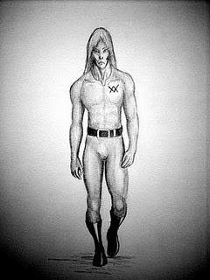
The Greys: Yes, the classic alien you see all over: short, 3,94 feet, big black eyes, three/four long fingers. They are biological machines. Robots. Slaves. They stink like hell!! They are the ones you remember most because the are in the front line, in charge to “take you away” and “bring you back”. Are mentally strong and use telepathic communication. Have a “magic stick” to deliver painful electric charges on you, in case you don’t want to follow them. Yes, we use this treatment on dogs (From: http://flashmentalsimulation.wordpress.com/2010/10/16/alien-races- abduction/)

The Oranges
These are mammalian, about 2 meters tall, vertical pupils, elongated head, and a very suntanned like complexion. They have 5 fingers and tend to dress in dark blue overalls, on which has a two interlacing triangle symbol on the left pectoral. They are described as both male and female and beautiful, but with a closer look they are not that beautiful and their hair looks like it has never been washed! They have a detailed map and knowledge of human DNA.

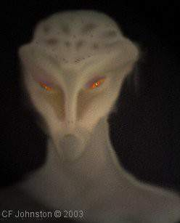
Sauriod Creatures
Two main types: The more aggressive one is about 2.8 meters tall, five claw like fingers and feet/toes. One rostrum shaped nail is on the forearm and foot like a catʼs extra claw. The skin seems dampish and translucent, brown-green colored scales that when carefully examined are softer than expected.The skin becomes progressively red in the abdomen zone and on the digital pulps: in these zones it becomes thinner and a red lymph can be seen flow underneath it above all when the alien behaves in a kind of angry way.
The presence of two roundish and little protuberant
horny surfaces characterize the left and the right side of the skull, while in the center there is a more tender structure under which we see the lymph pulsation; this structure seems a backbone in relief and runs, clearly, all the length of head, neck, back, and of the big tail. They use the big stumpy tail as a third support when standing on their two short and stumpy legs. Fingers and toes are abundantly webbed. The tongue appears to be bifid and stumpy. The eyes have a sub-eyelid membrane that runs in a diagonal way, from the lower side to the top and from the nose to the external side. The pupils are vertical and the iris changes its color in relation to the alien’s mood, from yellow-green to bright red. They have no external ears and it seems they are able to control the opening and the closing of their internal ears. Saurians look like dragons or maybe like standing crocodiles, even if their face (or muzzle?) is rounded like a snakes’ one, with thin lips and nostrils at the end of the nasal septum, depending on their age, as they grow without limit.They are amphibian beings; they are always seen together with another species of aliens apparently subdued to them.
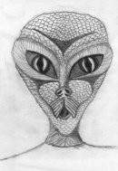
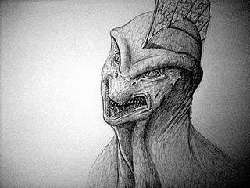
The second type of sauroid being has eyes that are froglike, 2 meters tall, translucent skin, vertical long and slim teeth that look like whalebones. On their head they have small horny excrescences. These beings are similar to one another and it’s difficult to identify particular differences between the two of them. They dress in a suit similar to a Nazi military uniform of the last world war. Even if we are unable to tell the male from the female, the reptilians are maybe
the only onces still able to have sex. The reptilian AAM’s are the only ones conserving memories of reptilian sexual intercourse. Even
in the Bible, the serpent is the one who reveals to Eve (the human) the sexual life. (EL- Note the drawings are not necessarily all those described, but various types observed)

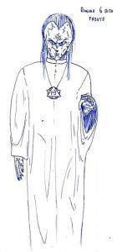
Tall, 6 fingered ones (In essence, a Growl shadow inside a cyborg body)

Nordic 6 Fingered One
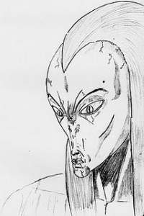
Tall (2.5 meters), white complexion, long white hair, 6 fingers, pale blue eyes with a vertical iris pupil. They usually wear a long white kind of robe, wear a round neck medallion with the symbol of the hexigram (The Star of David). It was understood that this is an artificial humanoid body a cyborg. This
cyborg is a product of the 3D universe made apparently by the Insectoids Made especially for the Growl, dark shadows to be able to operate in this 3D reality.
They use a this android form body, and can only interfere in our universe when
taking a body form. These have also been described as the incorporeal aliens which parasite the human energy body. (EL-These may be the “widow’s peak hairline” aliens that some of Barbara Bartholic’s clients have encountered, for example, in the Ted Rice Case. I also want to point out that many abductees may perceive the Nordics as very beautiful creatures.)

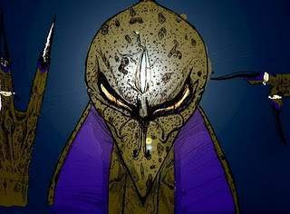
One Eyed Beings or Horus-Ra

These one eyed beings we understood later to be Horus-Ra.
They are about 3/4 meters tall, dark violet skin and a third eye in the middle of their forehead. We do not know if it is anatomical or technology or some kind of appendage. (EL–the third eye is a common symbol for “third eye vision”, when this chakra is fully opened in many esoteric/mystical texts)

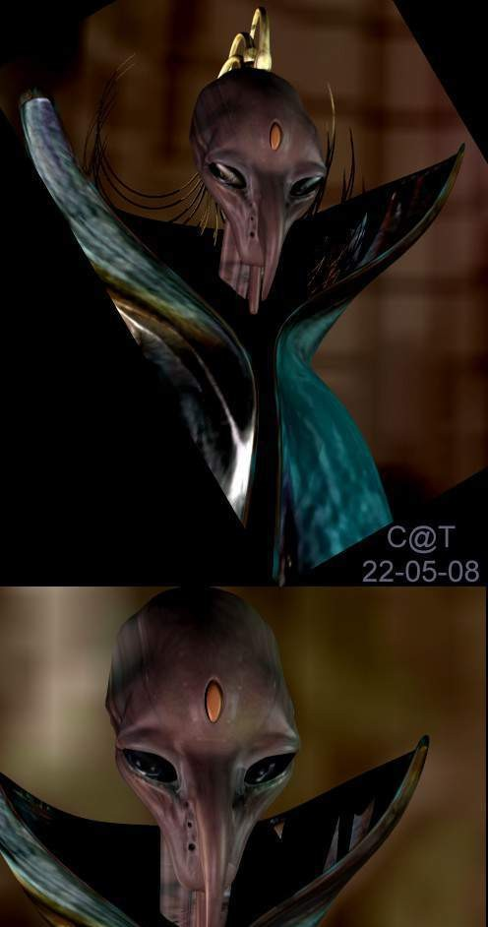

In the male specie, they have under the chin, a beard-like looking appendage. They have protruding scapular bones, which are often mistaken for wings folded back. They have three fingers plus a thumb which look very bird, claw-like. They have great telekinetic powers when they move. But they were usually observed as through a screen and “not really there” but rather communicate from far away to other aliens via technological devices. Because they didn’t want to show up, they didn’t want to be seen and understood. They are the “Lords”…they are so ugly and so different from any mental structure we already had that, at the beginning, our abductees were unable to describe them properly.
Horus-Ra
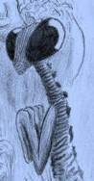
Insectoid Beings and the wrinkled skin, long necked slave beings.
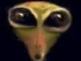
These are similar to the preying mantises, have a green chitinous body and they walk on their hind legs. They very small beings, with a long neck that has muscles that flex and rotate the head (the equivalent of our sternocleidomastoids).Their mouth is small with lips different in thickness (the upper lip is noticeably smaller then the lower one) and their eyes are dark and moist. It is believed that they use our female abductees to reproduce themselves now, although it has been
theorized that before that perhaps, they may have laid and hatched eggs to reproduce.
They are five-fingered. (EL-In the Simon Parkes case, his mantis creature is green about 9 ft. tall, and wears a purple robe. In his testimonies he infers that these creatures are somewhat above the
reptilian beings in hierarchy. (See: http://evelorgen.com/wp/articles/alien- abduction/simon-parkes-ammach-interview/)
A: It seems that there are 3 types of Mantis from the less social status and height to the higher social status and height: Brown, Green and White. The White ones may rule over the reptilians to but I would not say reptilians are their slaves.

Q: 2. What about the Draco, where do they fit in? In Maarit’s case, she perceived the Draco as being higher in command to the reptilians but the Horus-Ra incorporeal being used either the snake or chicken/bird body and appeared to have higher authority to all of these.
A: I’d say the Draco are the same ones Malanga calls Horus-Ra.
Q: 3. Can you tell me which alien beings are more physical and which ones are the incorporeal beings? What is the difference and what do they do, what do they want?
A: In addition to the physical aliens with bodies are the bodiless beings: The LUX in primis and the ones derived from the other “dark” Universe. These are the ones which use, in different manners, 3D bodies in order to operate in this universe. And I am referring especially to 2 types of beings which are:
  - Ra, which inhabits the alien we call Horus
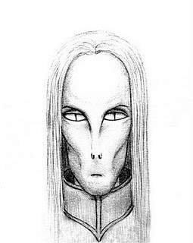
  - The Growl, which inhabits the 6 fingered blonde, artificial body, and is known as the Nordic alien. It wears a long white robe and also wears a medallion in the form of a 6 point star,
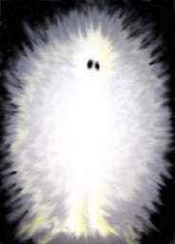
hexagram, (the star of David).
    - The LUX being comes from our own universe as opposed to the other incorporeal beings. When the LUX attaches to the person it will so do from from the front. Conversely, the black shadow beings often attach or are perceived from behind or in back of us.
Growl/Ringhi
LUX Being

Q: 4. Iʼve heard you say that the growl being can be the type of being who “astrally intrudes” like a 4th dimensional reptilian in certain love bite intrusion experiences. These have been reported numerous times in my work when the reporting partner in a “Dark Side of Cupid” love relationship, starts having visits by the entity who is attached to or possessing their partner. This is a type of astral, sexual energy vampirism. Can the Growl being shape shift into a lizard-like being and intrude in this manner, such as activating the kundalini and sexual energy of a person affected by this kind of love bite relationship?

A: It could be, but itʼs complex. Black shadows connect directly to the mind, altering perception of the subject. So, it can make you see things which are not what they seem to be. We cannot say itʼs always the black shadow, and we cannot say it’s always the reptilian. Also, I think in most cases a shadow entity is involved…People are more likely to exchange the overshadowing dark entity for a reptilian because there’s alot of literature on the internet talking mostly about the reptilians. What may be happening during this traumatic event in some cases is that the presence of a reptilian AAM is also perceived. At

any rate, I think deep regressive hypnosis should be done in order to understand what is really happening; it may even come out that an abduciton occurs in between…
The Growl 6 fingered being will attach to the spinal cord of the person’s energy body. The Horus-Ra being or the Ra (dark shadow being in essence) attaches to the coccyx. Both beings are “black shadows” and are often perceived as overshadowing from behind. The bi-dimensional black shadow beings interfere with the person’s mind component. Remember, the AAM can be one of the many alien types such as Mantis, Reptilian, Orange, Military, etc., any alien being that has a body.
The AAM attaches to the brain component of the person, using the Soul energy to energize its will within the abductee. The AAM is deposited in the left hemisphere (for right handed people) and the AAM is deposited in the right hemisphere in left handed people. The AAM tends to overshadow the spiritual part of the host. It lives, thanks for the soul of the abductee… This is a diagram of commonly found implant locations on the human body: Implant Map

Q: 5. Is the 6 fingered one (Growl or Tall Nordic one with 6 fingers, slit iris pupils) as important as the LUX? Is it more important than the Reptilians?
A: Yes, Growl IS more important than LUX and reptilians, but less important than the other black Shadows, Horus-Ra.

Q: And compared to Ra?
A: They are “competitors” to Ra. LUX is not that high (Maybe not anymore) It invented churches and religions in order to control people and feed on their energy, keep them dummied down. They are actually at the same “height”. They are two entities very similar to one another. None of them has a body so we cannot identify very well the differences. Ra is much more evil, I had that impression. Even if the other one is mean in a much more obvious way. Above them are the Higher Hierarchies.

Q: 6. Who is the Primordial Man”? Is this what you refer to as the “higher hierarchy”?
A: The higher hierarchy in our universe is the hierarchy related to the so called Primordial Man. The PM, which seems to be – but is not – a giant, a father, the white bearded god. It gives you the impression to be your father, your defender but in reality wants to be your master (in the sense of owner or boss ). Beyond this kind of appearance is hidden his real form which is the form of a fish. A fish-man.

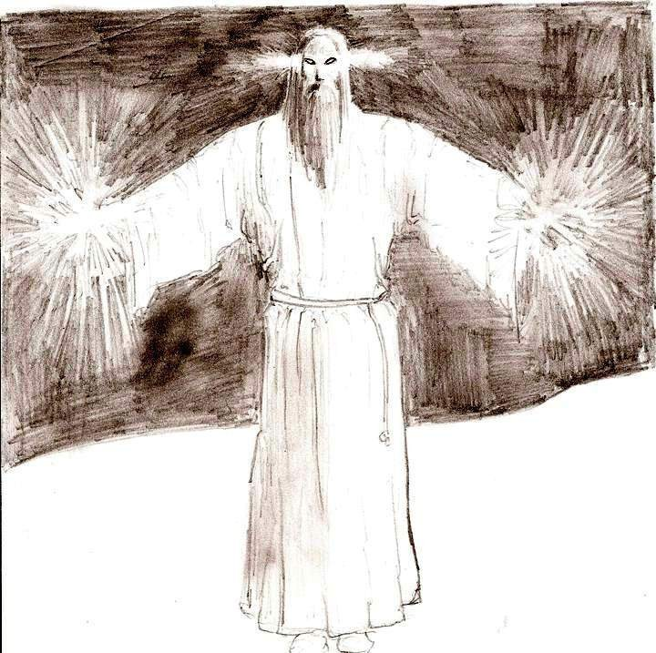
If you pay attention to this polymorphism of the aliens, you notice that the most ancient beings are the fish, next are the amphibious (but before them, are the insects) and next the birds, so we have all the characteristics of a space-time evolutionary line of how the things came into being on earth. Because, first we had the fish from which the amphibious derived, from then which derived the mammals, then the birds and the snake. While the insects are somehow different, they too came from oceans/sea/water, from marine algae. It’s enough to read our myths to understand all that we have just said. All fits

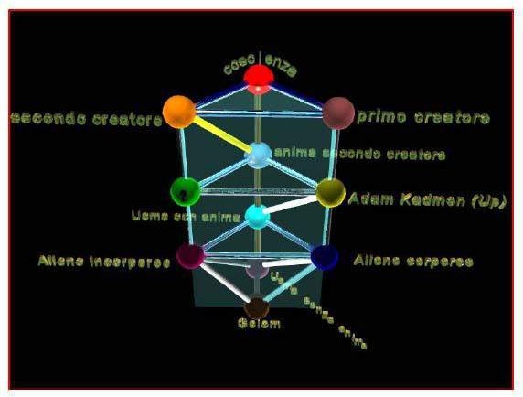perfectly. Dr.Malanga uses the Kaballah with its various levels of sephiroths to notate where in the hierarchy these alien and incorporeal beings reside. See image below. (This is in Italian.)
KaballahTranslation:
Conscienza – Supreme One Divine Consciousness Secondo Creatore – Second Creator from “dark universe” Primo Creatore – First Creator “Our Light Universe” Anima Secondo Creatore – Soul of Second Creator
Adam Kadmon (UP) – Primordial Man, Father Figure Uomo Con Anima -Souled Human
Alieno Corporeo -Corporeal Alien (ones with a body/form)
Alien Incorporeo – Incorporeal or bodliless aliens (black shadow types) Uomo SENZA anima–Soulless Human
Golem - GOLEM IS A INTERESTING FIGURE FROM THE JEWISH FOLKLORE….
READ HERE http://en.wikipedia.org/wiki/Golem

Q: Where is the LUX beings position in this Kaballah?
A: In my opinion it should be between the PM and the corporeal aliens.
Q: 7. How will the PM act towards the abductee, especially after he/she frees themselves from the physical alien abductions? Does he try new tricks or ways of interfering?
I am interested because the PM came to me in many guises, as a Father, Beloved, drama director, and even a Christ like figure. I met him in a transcendental experience following deep prayer and grieving. Also in dreams. He and I were one, we came from the same being, and I understood that we co-created my/our experiences in order to realize and experience selfless love. However, after this time period, he reemerged appearing in different guises, oftentimes with messages or showing his power in certain situations or offering precognitive visions. Later many of these prophetic visions did not come to pass, and I realized he had a trickster side, luring me into believing whatever religious or spiritual deity I worshipped at the time. Of course after I met you, we released him from me in a FMS module. (See: http://flashmentalsimulation.wordpress.com/liberation-techniques/flash- mentalsimulation/)
A: The PM will attach to the Soul component of the person, which is different than the other beings who parasite, who generally only have a mind and spirit component. They attach to mind and/or spirit). The PM will try to keep you coming back lifetime after lifetime unless you willfully disconnect from him in this cyclic process . So, after disconnecting from the PM, the abductee may start to experience various modes that the aliens and even the PM do to try to reconnect and interfere in their lives. (EL- The PM is in our “light universe” or often referred to as the next highest being under the Creator 1 of

the light universe. To understand these hierarchies, itʼs good
to view it as symbolically

represented as the mirror split of the One Divine Consciousness into two “universes” or
two Creators. Then under the creator 1 is the PM. This can be found in Malangaʼs Genesis 1, 2 and 3 article.
(See Genesis 1, Part 1, English) http://flashmentalsimulation.wordpress.com/2012/03/06/genesis-i-part-1/ Genesis 2 & 3 Italian: http://www.corradomalanga.vacau.com/documents/GENESI_II.pdf http://www.corradomalanga.vacau.com/documents/genesi%203.pdf
He explains how the second “dark universe” has a corresponding Creator, whose soul stayed behind in the One, so that all beings from the bi-dimensional dark universe do not have Soul components as we understand them. The dark shadow bi-dimensional beings come from the second creator “dark universe”. All humans who are abductees have a Soul component, otherwise they would not be “abductees”.)
A: Maybe psychic attacks, happen during the night after working with someone. Or being attacked through others. They will try to interfere in your dreams too. Above the PM and two creators, there is something else. (This is in Genesis 3) When an abductee gets

rid of aliens, and the PM, then this is dangerous from some other entities’ point of view: The ones above this universe and above the PM. It is THEM, the ultimate eye on top of the pyramid. According to Jungian symbology of archetypes, the eye with a pupil is a symbol for the vagina/womb and the unborn baby. A baby which does not want to leave the commodity and comfort of its dimensions.
That is when other beings may interfere. The military interfere at the level of alien interferences. At the beginning, years ago, it seemed to Malanga that military intervened after the aliens left the abductee alone, but that was not true. The military showed up more often after disconnecting the Growl and LUX (incorporeal beings), only because they had more leeway and because Malanga had not understood at that time all the implants and interferences from the higher levels–RA and Primordial Man, who know about and allow for military intervention.
They may enter into someones life through some higher being, who tells you that you can ascend now. Or some Ascended Master scheme, playing on your ego, telling you that you are special, more evolved. They may try to lure you to “Come up to us at this level, bla bla”. We at first thought it was LUX doing this. Malanga called them “those from higher dimensions/planes”, like Archangels and Metatron. The ones behind many New Age Ascension thoughts. They are out of this creation on another level of existence.
Q: -Perhaps these are like the Titans or Gods from the Buddhist 6 Realms of Existence definition? In this realm, those from the God Realms must eventually come down to human level in order to evolve.
(See: http://buddhism.about.com/od/basicbuddhistteachings/tp/Six-Realms-of- Existence.htm)
A: Yes it may be! We can now say we are sure from testimonies of ex-abductees having had the issues with these ones and having recall and experience the journey backwards. (EL– In other words those who realize they as humans have already descended down from higher levels of creation to earth, places where these so called “Gods” are now and we are on our way back to the Source. The human realm of existence–according to Buddhist cosmology, is the only realm of the six where we can become free from samsara, illusion.) We already came down from this level (the alleged higher “Gods” level) to experience and realize the nature of our soul here as humans: Duality is illusion, freedom from samsara, etc. Now, these ascended “God” beings tell you that you deserve to come up to where they are, saying we are at a lower level and to pray, meditate and so forth in order to ascend, etc. They offer us a place in paradise in the 5th dimension. They are trying to lure you back in the net, a golden prison. This can happen in dreams or channeled through someone. They are similar to us in that they have a soul part but are afraid to come down to our level in order to continue their evolutionary process. They are collaborating with Horus-Ra in order to keep us stupid here to maintain this reality. They tend to want to take the ones who are waking up, and then isolate them from others.
Q: 8. The fishbody you’ve mentioned before, is it a 3d body? Is this related to Dagon, the Fish God or the hats worn by Vatican Popes and Bishops?
A: Yes, absolutely. And yes it’s all about recycled myths. In the case of the Catholic

clergymen even Jesus is associated with the fish symbology. The same archetypal figure is interpreted differently all around the globe.
Q: 9. How many PMs are there, can there be more than one? Or for that matter how about the LUX, are there many?
A: The answer is a very difficult one because their number can be an archetypical number, I mean a symbolic number. When I ask the soul parts*, they always answer in an evasive way: some of them say 12, some say 13. Just like the tribes of Israel.(Malanga’s answer)
* Soul parts refer to the aspect of being communicated with while the abductee is in the SIMBAD or FMS session. We separate out the mind, spirit and soul in order to connect directly to the soul part, which exists beyond time and space, and has the power to eliminate alien interference. In reality, we exist all as one consciousness, but for the purpose of freeing oneself from alien parasites we work with each unit separately to find the intrusive parts and get rid of them.
Q: 10. How come 12 or 13 in terms of a number? A: There’s a story about the 13th tribe of Israel… ☺
Dr. Malanga talks about in the Genesis 3 article, as an example. The soul parts do not have it clear about this 13th type of PM, so maybe there are not 13 beings but 13 different species. Or maybe there are 13 PMs indeed, but I don’t know this for sure.
Q: 11. What about Dragon like beings? I’ve spoken to several individuals who had encounters with dragons. But they are rare. Some malevolent and some allegedly benevolent.
A: The 13 rare dragons might be related to the PM (fish-man -monster – draco) or to a set of confused perceptions mixed together. You know that our first perceptions of these beings are very difficult to grasp and get so distorted.
But the dragon type must be somehow related to reptilians and Ra taking on the form of the Egyptian Horus figure. Enki and Enlil are the two sons (but also main races) of Anu. One of these two sons is a reptilian.
Malanga divides these beings (aliens ) into 2 big categories:
- – The ones originated in our universe (White PM, LUX, Insectoids, reptilians, 5 fingered blond, grays, beings with a physical component -body ) So the reptilian is a creation/son of the Primordial Man, the fish. Associating these 2 figures we can obtain the symbolic idea if there are 13 rare dragons. Interesting that they are 13
- – The ones from the other (2nd/(mirror/dark-universe–EL) creation (Black PM, beings with no physical component whatsoever like Ra, the Growl, the blue being) The blue being attaches to the spirit, while the Ra and Growl being attach particularly to the mind. All of them will overshadow the human spirit, because of their spirit component.
Q: 12. So the beings from the second creation are the ones primarily responsible for the incorporeal parasites? They seem nastier, more evil if you will. Are these beings in charge of the aliens they use to abduct and vampirize off our soul energy? (As well as farming our genetics)

A: Yes. Incorporeal black shadow beings are from the second creation. The LUX is from the first creation. All aliens with and without a body are under the control of the PM(1) figures or the beings above the Primordial Man.
Q: 13. Can humans be parasited by incorporeal beings only and not be actual alien abductees in the physical sense of being abducted? If so, how does this manifest differently in terms of comparing them to the symptoms of alien abductions?
A: Yes, it happens. Abductees mostly do not consciously remember abductions. So you really cannot tell the difference. If there are no implants, microchips, no AAM, then they are not an abductee. Implants, microchips, AAM and incorporeal parasites affects the way you think, and one’s perceptions. LUX entities can and do parasite and host soulless people, or soul disconnected people, in such a way that they manipulate mass public opinion, thoughts beliefs and religions. The popular opinion (about aliens, spirituality, etc.) is rarely the truth since the largest majority of people are not soul connected. Not everyone who possessed is interfered with by LUX. It can come and go.
What can we do? With understanding, and becoming whole again, we will naturally stop feeding the “shadow” as Jung would say. Stop feeding the aliens and buying into the illusions they feed us. This is how we get out of this mess.
Q: 14. It appears to me that the most important thing here for people is to realize the nature of their divine soul consciousness.
A: Yes This consciousness had been split into three components (by the Primoridal Man who created aliens, which in turn created the human body/containers). The three components are split into mind, spirit and soul (or anima). But in this split consciousness experience, we perceive reality as duality, or a virtual reality matrix kind of world.
EL: It appears that the Gods–including the Primordial Man, aliens, and incorporeal beings–their job to keep us locked into this “split un-integrated” consciousness, so that they can feed off of our soul energy while we are unaware or somehow believing it’s “good for us”. And in a life of abductions by aliens, we are in an enslaved state to continue recycling while they feed off of our souls. Once we integrate our mind, soul and spirit consciousness, then we also enter a new kind of battle with these beings who keep trying to “re-access” the abductee into their agenda. This can happen with physical abductions or be more subtle like in dreams, astrally or through channelled material that tries to lure us into worshipping them.
Q: Here is it true also– that this issue with aliens, is not only a problem for “abductees, contactees, experiencers and milabs, but the entire human race?
A: Yes, true. The duality is an illusion. From Malanga’s Genesis 1:
“Gods do not exist as we tend to believe.” These godly figures are merely “handlers” and manipulative.
  - There are no good or bad alien. Aliens are just aliens.
  - Everything is already written in myths (Not in manipulated official history)

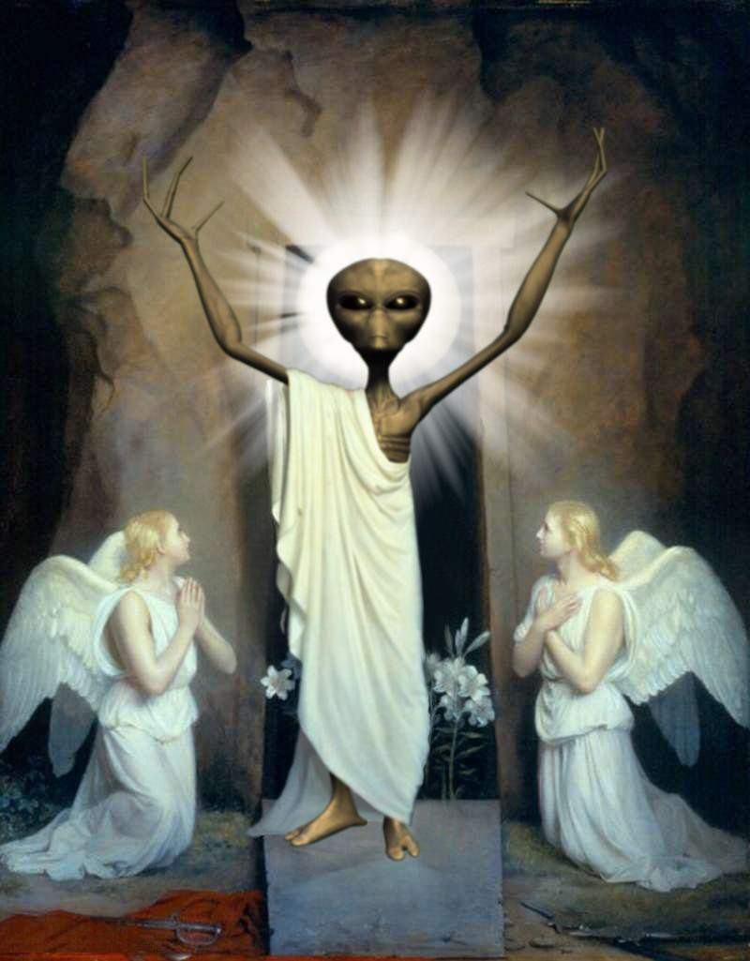

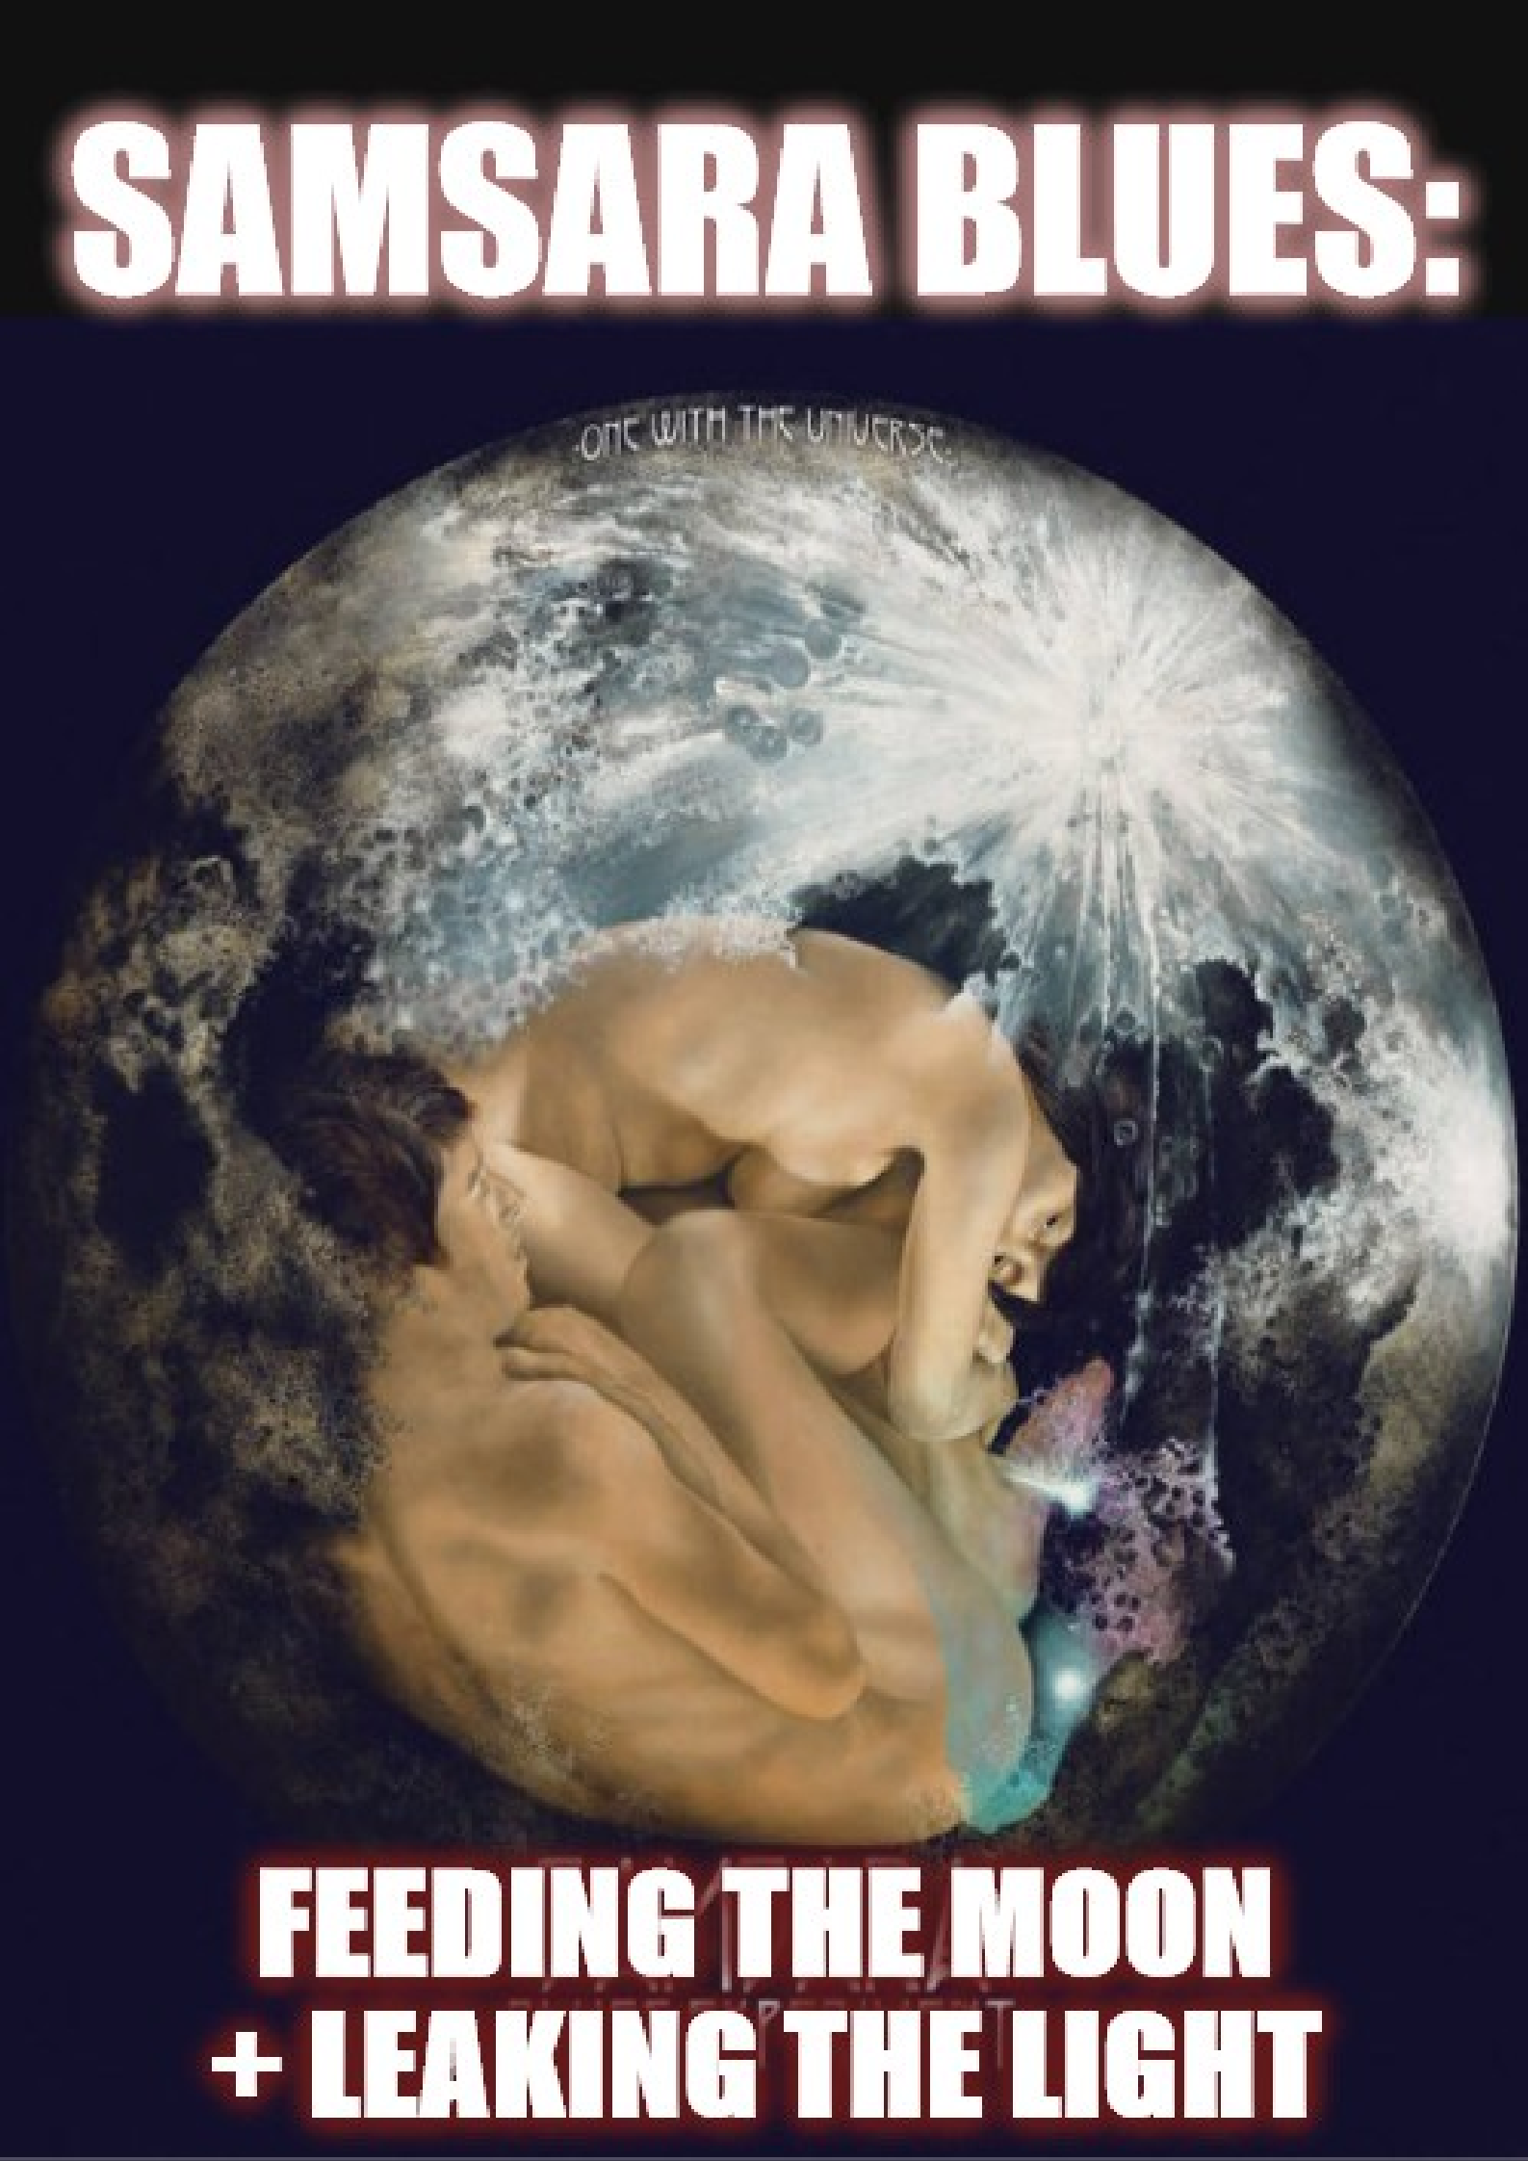

INTERVIEW WITH A MALE ABDUCTEE ABOUT
REPTILIANS AND HYBRIDS21

The following is an interview I had with an abductee who was referred to me by my mentor, Barbara Bartholic. This abductee, “P.R.” had sent Barbara an audiotape of electronic sounds allegedly made by the reptilians during one of his abduction experiences. P.R. called Barbara and they had a lengthy phone conversation during which Barbara independently confirmed many of the experiences reported by P.R. Barbara tried to play the audiotape on three different tape recorders and each time the tape recorder in question malfunctioned and never worked properly again. After the third abortive attempt Barbara decided to call me into the case since P.R. had mentioned having read some of my writings and had himself undergone many of the experiences which I described in detail. I subsequently had a lengthy phone conversation with P.R. and exchanged numerous e-mails with him. I was impressed with P.R.’s candor and the astute observations he made about his abductions. He described many things which I was already familiar with such as the astral dreamscape manipulation and the various and sundry ways the reptilians manipulate abductees.
Barbara Bartholic told me before my first conversation with P.R. that she was flabbergasted that P.R. knew so many intimate details about the reptilians and their modus operandi. Barbara has documented many of the details provided by P.R. from her work with several hundred abductees over a span of thirty plus years. What I was particularly interested in was his close observations of the human appearing hybrids. These human hybrids have been described by other abductees but only a relative few (including a female abductee named “Karen” whom I also interviewed) have described their activities in any detail. Other facets of P.R.’s revelations which greatly interested me was the reptilian’s ability to siphon off human life force energy as well as their ability to transfer the consciousness from a reptilian into a human being or human appearing hybrid.
Due to the malign influence of the well known abduction researchers, many people within the UFO Community think that all alien abduction experiences are identical with absolutely no variation between them. The “high strangeness” aspects of the experiences are almost completely left out of the equation. We must never forget that phenomena which appears to most humans as “high strangeness” is nothing more than routine everyday events within the context of a civilization far older than ours and with technology and brain power far in excess of ours. The aliens and reptilians display a thorough understanding of human physiology and neurology. Unfortunately the human race has been poorly served by the “Scientific Community.” This should come as no surprise considering the disproportionate amount of funding the Scientific Community receives from Tax-Exempt Foundations, Multinational Corporations, the Department of Energy and the Pentagon just to name a few. To provide such funding and then encourage real scientific study of UFOs would defeat the purpose of the longstanding well documented debunking and disinformation campaign against UFO reality. Since scientists

- http://www.angelfire.com/nm2/aona/jamesmaleabductee.html

are conditioned and trained to discount the reality of UFOs, it is relatively easy to convince some of them to be UFO debunkers, especially if they will be paid for their debunking efforts. Scientists cannot be expected to think or behave any differently. They have been indoctrinated and are in need of funding. I have to laugh when skeptics and debunkers demand scientific proof for UFO sightings and alien abductions. How can “science,” as controlled as it is today, possibly explain the types of phenomena described by UFO witnesses and alien abductees? Witnesses have described seeing a beam of light descend in a telescoping fashion from a UFO down to the ground. UFOs have been seen to divide into numerous parts and fly off in different directions. Conversely two or more UFOs have been seen to fly towards one another and merge into one object. UFOs have been seen to change shape in mid-flight. Abductees and military and scientific “insiders” have described a paradox wherein the interior of a craft appears to be far larger than the exterior of a craft. UFOs have been known to be visible in the visual spectrum but invisible to radar and vice versa. Alien abductees and workers within underground facilities describe self navigating, luminous orbs of light which despite their brilliance, do not cast reflective light off of nearby surfaces. Once I was abducted after midnight and was returned at approximately 10:15PM. In other words I was returned to a point in time before I was abducted in the first place. “Modern Science” does not have an explanation for any of these events. Countless scientists have proven themselves to be nothing more than opportunists who bow and scrape before Corporations, Foundations and the Federal Government in order to obtain funding for research projects that are trivial in comparison to the study of UFOs and alien abductions. Debunking scientists have played a key role in holding back the technical and indeed the spiritual development of the Human Race. As far as I’m concerned, these debunkers are “War Criminals” no different from the establishment shills in the corporate media and academic community who promote perpetual war abroad and crass stupidity and a police state at home. The same goes for the bought and paid for “psychologists” and “psychiatrists” who work as debunkers against alien abductees. When you consider how many “mental health professionals” have actively participated in government mind control programs like the late and unlamented Dr. Louis Jolyn West, and Dr. Ewen Cameron just to name two, psychologists and psychiatrists are literally the last people you want to consult regarding traumatic experiences such as alien abductions and reptilian rapes. So keep all this in mind when you read P.R.’s account of his experiences with the reptilians and the sadistic hybrids. During the interview portion of this paper, I am “J.B.” and the eyewitness is “P.R.“ The stage is set for the mass deployment of these human appearing hybrids.

Interview
J.B. - From your perspective, what are these reptilians doing here and what are they trying to accomplish?
P.R. - The Reptilians view humans as a resource, food, slaves, breeding stock, and their property. They are here to eventually take complete control of the Earth after a number of Reptilian engineered natural catastrophes (such as new diseases and weather changes) and other catastrophes that appear to be man made (such as wars,). Then they plan to turn

the surviving inhabitants into mind controlled slaves that are intended to be used for various purposes including the ones listed above. Something of equal importance if not more so is the fact that they are attempting to retard and keep humanity from spiritually evolving. As a matter of fact they want humanity to spiritually devolve to a point where we are unable to break free of them.
J.B. - Can you mention some of the ways that the reptilians manipulate humans?
P.R. - They use their very advanced telepathic abilities and their technology to create manipulated artificial dreamscapes within a sleeping abductee's mind. They also use astral abduction where the abductee is placed in virtual reality scenarios. Some of these scenarios are used in combination with their telepathic abilities and mind control technology to make the abductee resort to self destructive behaviors such as drug abuse or sexual promiscuity. I guess they can even turn someone into a serial killer. They also use implants that are designed for the sole purpose of mind control. They use their telepathic abilities to influence and mind control the abductee. They also have technology to remotely mind control the abductee. They can also make the abductee experience great pain. For example severe headaches and abdominal pains. The headaches and abdominal pains can be so severe that they can incapacitate the abductee. They can cause an abductee to be chronically ill. They use both physical and psychological torture. They use sleep deprivation. They also resort to rape.
J.B. - Can you describe the process of energy and consciousness transference from reptilians into genetically engineered human bodies?
P.R. - I have only seen this process once. I saw what appeared to be a human body lying on a table. Next to it was a reptilian that was also lying on a table. Above both the Reptilian and human body was what looked to be electronic devices and machinery. Somehow the Reptilian’s energy body, astral body, soul (I must say here that I don't think that they possess true souls) or whatever you want to call it was transferred from the Reptilian into the human appearing body.

J.B. - Does the above process have anything to do with the sadistic human looking hybrids that have been described by abductees?
P.R. - The hybrids were present during the procedure but I do not know if they were involved with the process.
J.B. - Do you believe that some of the human looking hybrids are connected to the reptilians?
P.R. - Yes, they were created by the reptilians.
J.B. - Can you describe some of the acts of cruelty and sadism perpetrated by both the reps and the hybrids?
P.R. - They sometimes feed on people's life forces to the point where it is difficult for the abductee to walk because the feeding process leaves the abductee in a weakened and lethargic condition. Sometimes they feed on the heart area to the point of causing the heart to race so fast that it feels as if it is going to burst. They rape abductees. They insert large

needles into the abdomen which is very painful. They beat abductees. One time I remember the hybrids had me in a paralyzed state. I was conscious but I could not move. One of the human appearing hybrids produced a butterfly knife and sliced my abdomen with the knife. Soon thereafter another hybrid produced a hand held device and pointed it at the wound and the wound completely healed. They can cause the abductee physical pain 24/7. For example I have severe headaches 24 hours a day. They are so painful that they sometimes leave me in an incapacitated state. Many times the headaches are accompanied by severe abdominal pains and nose bleeds. What I just described are just some of the ways the reptilians and their hybrids torture people.
J.B. - How have the reptilians messed with your sexuality?
P.R. - On many occasions they have raped me. They have even tried to alter my sexual orientation by using dreamscape manipulation, sexual stimulation devices, mind control technology, and their telepathic abilities.
J.B - 4) Can you describe the process of energy harvesting and what if any connection (if there is one) between the energy harvesting from humans and the torture and cruelty the reptilians and hybrids inflict on people?
P.R. - As I described above they feed on human life force energy. As hard as it may be to believe they put their hands on the body area they want to feed on, and then siphon off the energy in a vampiristic fashion. The reptilians and their hybrids directly feed on their victims because it gives them a bigger rush than consuming energy obtained from the second method described below. They also force the abductee to experience certain emotions such as fear. They then directly feed on the abductee. The same thing is true for sex. They will torture their victims to put the abductee in the desired state. They will torture, forcibly sexually stimulate, and mind control their victim in order to put the abductee in the desired state.
They also have chambers in the form of transparent rectangular boxes. The abductee is placed in the chamber. Then some kind of electronic equipment and machinery are activated. The abductee's life force is then extracted and transferred into storage containers. They also extract biological tissues and fluids.

J.B. - Can you describe the times that the reptilians had drained the life force from a human baby and then consumed the baby?
P.R. - I saw the reptilians feed on a newborn baby. They fed (siphoned its entire life force) on the baby until it turned a very dark color and shriveled up like a dried up prune. The baby died. The reptilians then ate the baby's body.

J.B. - Have you perceived any kind of hierarchy amongst the reptilians and the human hybrids? You described the "exalted ones," "the middle management" and the "Low level thugs."
P.R. - There is a hierarchy. It is arranged with the leaders at the top. I once heard one of their leaders referred to as an "exalted one." Then there is the mid-management. It is their job to direct the lower reptilians and the human appearing hybrids. Then on the bottom of

the ladder are the lower order reptilians and the human appearing hybrids.
J.B. - Can you describe the psychic and paranormal abilities of these hybrids? They seem to be genetically imbued with sadistic qualities. Can you describe the hybrid that appeared to you wearing a suit?
P.R. - They have telepathic abilities that enable them to read people's minds and communicate with each other. They have the ability to leave their physical bodies and travel about in their parasitic energy bodies. When in that state they can remain invisible or lower their density to the point where they can materialize and appear just as solid as you or I. The same is true for their ships materializing and de-materializing.
The one in the suit was not as sadistic as the other human appearing hybrids or the lower order reptilians who can only be described as psychopaths and sociopaths, although they can mask those traits (psychopathic and sociopath) in public very well. The one in the suit was more business like.
J.B. - Please describe how the hybrids have infiltrated society and how they own and operate businesses and real estate. You've described these hybrids as having infiltrated into ALL strata of human society. Describe some of the places you have seen these hybrids.
P.R. - I have seen them in law enforcement, running and working in restaurants, in libraries, bar and grills, clubs, antique shops, and art galleries. I am sure that you could find them in every area of human society. The hybrids are psychopaths and sociopaths, although like I stated earlier they can mask those very disturbing traits extremely well while operating in public. Some do not demonstrate any emotion at all, and are very business like. Others are very cruel. Some like to torture the abductee. Still others only want to feed on the abductee; but then again they all want to feed on humans. It all depends on the genetic and psychological make up of the reptilians, as it appears they (the hybrids) are genetically programmed to exhibit specific traits and behaviors. I would like to state one last thing. It appears that it is very important to the reptilians and their hybrids to have complete control over the abductee. I mean complete control over all areas of the abductee's life. Complete control over the abductee is extremely important to them.

J.B. - Describe the “transports” which are used to bring in more hybrids and the locations these events took place and the manner in which you were brought there.
P.R. - I have seen the types of ships that Adamski and Van Tassel reported observing. I saw one of these ships land on a small rural island just off the Texas Gulf Coast. The ship appeared out of thin air and was glowing white. After it landed a group of "new arrivals" departed from it in an orderly line. The new arrivals appeared to be human, although I know they were reptilian hybrids. They were loaded into dark colored, dark tinted passenger vans and then driven off. I don't know why I was brought there. A young man came to my door in the early morning hours on a summer night in 1994. I could not sleep that night and had my door open to let in some fresh air since I didn't have any air conditioning. The young man told me that someone wanted to see me. At that time I didn't know who or what they were and thought them to be benevolent. We then went outside to

a parked car. The car looked to be a Chevy Caprice. It was dark in color and had dark tinted windows. There was an antenna on the back of it. It looked like an unmarked police car. Inside the car was a man dressed in a black suit. He drove me to a bridge which connected the island I lived on to the island in question. We then drove to a secluded road until we reached a gate with two men standing on each side of it (the gate). The gate was raised and we proceeded down a dirt road for about 1/2 mile until we reached the landing site.

J.B. - Can you describe some of the technology you have observed?
P.R. - I have seen devices that heal wounds. I have seen the sexual stimulation devices that they forcibly use on male abductees. I have seen an instrument that displays the activity that occurred in a certain location throughout the day. I have seen a stun gun-like instrument that is placed to the side of the head of a sleeping abductee that discharges energy into the abductee’s brain which renders him or her completely unconscious and immobile. They also have a device that resembles a small black box with a button on the top of it. It can render an abductee unconscious and paralyzed. They also have a device that emits some kind of energy field that engulfs the abductee and renders him or her unconscious and immobile. I have seen the black boxes that are used to store the astral bodies of abductees. I have seen a device that captures the astral body of an abductee. It emits a beam of energy that engulfs the abductee; then the abductee’s astral body is drawn into the device for storage. Finally I have seen devices that erases the memory of abduction from an abductee's mind.

J.B. - Can you describe other craft that you've seen?
P.R. - I have seen a silver disk shaped craft. I have seen a saucer shaped ship that was transparent except its outline and a bright white light located on the top of its dome.

In closing I would like to emphasize that the reptilians and their allies are capable of committing many heinous atrocities such as mass rape, murder, mind control, slavery, life force vampirism, theft of human biological tissues and fluids, genocide, butchery, mutilation, genetic engineering, cannibalism, and much more.
Analysis
If someone has only been exposed to the abduction research propagated by the well known mostly East Coast researchers, it would be easy to dismiss out of hand the testimony provided by “P.R.” Unfortunately these big name researchers have for all intents and purposes established parameters which have effectively defined the entire alien abduction syndrome. We have been led to believe that ALL alien abduction experiences are nearly identical, and that they follow a predictable sequence. The only aliens which seem to be described by the abductees who work with these big name East Coast researchers are the ubiquitous “Greys” or cross-breed variants thereof. If Human- appearing beings are described it is always assumed they are cross-bred with or are genetic off-shoots of the Greys. Not only have eyewitness accounts of reptilians been

downplayed and marginalized but accounts of beings that appear perfectly human are likewise dismissed out of hand. Most “serious” researchers liken any reports of aliens that appear human to the much maligned “contactee cases” of the 1950s and 1960s. It is my considered opinion that at least some of those “contactee cases” need to be re-evaluated. It is not uncommon for people in the Latin American countries, Europe and the former Soviet Union to describe encounters with beings that appear perfectly human. There were beings which appeared human in the famous Travis Walton case but that fact is seldom if ever mentioned in documentaries and was omitted entirely in the movie based on Travis Walton’s experiences.
Many of the elements that are described by P.R. have been documented on numerous occasions by Barbara Bartholic, the Dean of Alien Abduction researchers. The energetic harvesting of abductees, the infliction of pain and suffering upon the abductee and the transfer of the astral-soul matrix from one body to the next have all been documented by Barbara Bartholic time and again. The aliens and reptilians in particular seem to have an abiding interest in what we think of as the Human Soul. P.R. has expressed his belief that the reptilians (whom he also refers to as “parasites”) don’t possess Souls as we understand the term. The key elements to P.R.’s testimony can be divided into the following:
- The Reptilians manipulate and exploit humans in a variety of ways including but not limited to sexual manipulation, energetic harvesting, infliction of physical and psychological abuse, mind control, and the collection of genetic material.
- The reptilians have imbued certain behavioral and physical characteristics into some of the abductees they are taking.
- At least some of the Human appearing hybrids have been created or are otherwise under the control of the reptilians. There seem to be many of these human hybrids and they have infiltrated all strata of human society.
- These human appearing hybrids can be extremely cruel and sadistic and frequently manifest utter contempt for abductees. They have the ability, whether through metaphysical means, technological or both, to manifest instantly in the home of an abductee. The hybrids can read minds and download imagery and information into an abductees mind. (Another abductee named “Karen” has provided much information about the psychic and metaphysical capabilities of hybrids.)
- The reptilians and the human hybrids working for the reptilians utilize advanced hand held technology.
P.R. described a hand held device that somehow records all the activity in a particular location. The hybrids return to a location such as an abductee’s living room or bedroom. They activate the device and all the events which transpired at this location will appear on a small view screen on the hand held device. P.R. witnessed the hybrids utilize this device on more than one occasion.
P.R. described the small black box that renders abductees immobile or unconscious. This has been described by numerous abductees during encounters with aliens. Milabs have also reported military black ops personnel utilizing a similar device to render all the occupants of a household including pets unconscious. The frequency emissions of this

device can be modulated so as to not affect the milab who is to be kidnapped. One of the hand held devices which P.R. described to me but didn’t mention in this interview is a device that can render everyone in a large room completely inert. P.R. described an incident when he was taken to a restaurant during the lunch hour by one of the hybrids. There were many patrons in the restaurant. The hybrid pulled out a hand held device and activated it and everyone in the restaurant was instantly frozen in place, as if Time had stopped for them. The hybrid also told P.R. that this restaurant was one of a number of businesses that were owned by them.
How do the Hybrids fit into all this?
There can never be enough credit given to P.R. for coming forward with this information. He has already been tortured countless times by the reptilians and the hybrids. Yet he chose to share this information with the world despite the inevitable backlash and reprisals which are sure to come his way. All of us owe a debt of gratitude to P.R. This part of the paper consists of conclusions and theories which are my own. Barbara Bartholic provided no input for this part of the paper.
There are essentially three types of “hybrids.” Type 1 Hybrids are alien abductees who have been genetically altered by their alien controllers. I personally know and am friends with many examples of the Type 1 Hybrids. Some are reptilian-human hybrids but that fact doesn’t make these people “negative” or evil. It is the Soul within that is the overriding factor which determines the behavior and characteristics of an individual. There are Mantis-Human hybrids as well as Grey-Human hybrids. Some abductees are genetically descended from beings that are perfectly human in appearance.
There are probably some “serious” abduction researchers (chuckle) who might object to my characterization of mere abductees as being “hybrids” but when you consider the heightened psychic abilities of some abductees, the fact that some of them have been trained to operate alien technology and even fly certain types of alien craft and have been known to manifest metaphysical capabilities, I believe the characterization is apt. There are times when reptilian hybrids will inadvertently or sometimes intentionally shape shift momentarily into reptilian form. Other times the round pupils of the reptilian hybrid will momentarily shift to vertical pupils. Some of the full blooded reptilian hybrid bloodlines have pupils that are diagonal and even completely vertical when in their normal state. If you get a chance, watch the interview of former MI5 Officer Victor Rothschild when he tries to explain away his connection to the Cambridge Spies. His pupils are nearly vertical.
I am convinced that the military seeks out hybrids within their ranks and utilizes some of them in deep black ops involving Aliens, Mind Control and ET technology. Reptilian hybrids imbued with an authoritarian mindset are routinely placed into positions of power and influence within the Federal Government and Defense Department. A second type of hybrid (Type 2 Hybrid) is the type that is half grey-half human. This is most commonly reported during alien abductions where the abductee is taken to a “nursery” where her or she is shown grey-human babies and is sometimes told that the baby was developed from genetic material taken from the abductee. The abductee may be presented

with this hybrid child at various stages during its lifespan. The third type of hybrids are the aforementioned human appearing hybrids (Type 3 Hybrid). In most cases they are described as appearing perfectly human. Other times they have been described with vertical slit pupils indicating a reptilian heritage. Sometimes the hybrid will wear dark glasses in order to conceal the vertical pupils. As others have pointed out, the reptilians have genetically manipulated the surface population to ensure that their hybrids are in positions of power here on the surface. Some obvious reptilian bloodlines are the Harrimans, Rockefellers and Rothschilds. The genetically engineered hybrids that are the focus of this paper are trained to blend into human society but may appear quite awkward and clumsy in social settings. Some blend in quite well. Many of them have a sadistic streak which they can hide in public. P.R. and the aforementioned “Karen” have described human appearing hybrids of all ages.
What will these hybrids do?
P.R. told me in a phone conversation that the hybrids were “everywhere… EVERYWHERE.” He has seen them in practically every social setting that he has found himself in. In their arrogance, the hybrids frequently reveal themselves to P.R. in public. The hybrids had shown P.R. the real estate, apartment complexes, restaurants and other businesses they own. They have taken him to these establishments. The hybrids have also taken him to apartments where hybrids live.
The key to determining what these Type 3 Hybrids may be used for is their observed behavior and their reptilian genetic lineage. Since America is well on its way to becoming a police state, I believe some of these hybrids will be used in agencies and bureaucracies where their sadism and thuggish behaviors will be utilized to maximum affect. I believe these hybrids will be used to ride herd on unwitting law enforcement and military personnel who refuse to “get tough” on the citizens of this country. The hybrids will be seeded throughout the bureaucracies of local, state and federal agencies and likewise ride herd on recalcitrant or unenthusiastic bureaucrats who refuse to go along with “The Program.” It’s a known fact that former members of the Soviet-era KGB such as General Yevgeny Primakov and General Aleksandr Karpos as well as former East German STASI HVA chief Markus Wolf are now working for the U.S. Government in a counterintelligence and security capacity within the United States. It should therefore come as no surprise to find these sadistic human appearing hybrids in law enforcement or the military. Back in the early 1990s I had an encounter with a tall blonde square-jawed hybrid at the Naval Air Station I worked at. This hybrid was wearing a grayish flight suit and sat in the passenger seat of a white United States Marine Corps sedan. Sitting in the driver’s seat was a tall man wearing camouflage fatigues who was speaking into a walkie-talkie. This blonde hybrid used its psychic ability to telepathically send messages of extreme malevolence and hatred at me. It’s a long story but I was quite intimidated. In the mid 1990s through a serendipitous chain of events I met a woman named “Peggy” who was a computer programmer who had previously worked at both the U.S. Marine Corps Recruiting Depot (MCRD) in San Diego and Camp Pendleton in Oceanside California. Peggy had also worked with some police departments as a computer programmer. She told me that she and a girlfriend kept encountering these tall blonde square-jawed marines at night clubs

near Camp Pendleton in Oceanside California north of San Diego. She said she found these “marines” unusual because they didn’t want to engage in any kind of discourse or interaction with the many women at these night clubs despite the fact that these women seemed very interested in them. These marines all looked nearly identical and were socially ill at ease and at times seemed very awkward. Out of curiosity, Peggy accessed the personnel database at Camp Pendleton and found out that every single one of these tall blonde square-jawed marines were allegedly born in small towns near Los Alamos New Mexico. As far as I knew, Peggy was unaware of cloning or the fact that the Department of Energy ran the Human Genome Project out of Los Alamos National Labs. I never mentioned the subject of aliens or hybrids with her. All this information she gave me was entirely unsolicited.
Peggy had independently confirmed that the personnel database of the United States Marine Corps listed the places of birth for these human appearing hybrids as small towns near Los Alamos New Mexico. I happen to believe that at least some of these hybrids are genetically engineered in a number of places above ground and below ground. From my personal perspective I can only tell you the following: A sadistic hybrid that was telepathically beaming malevolent thoughts at me was wearing a grayish flight suit and was sitting in a white U.S. Marine Corps sedan which was parked in the Admiral’s parking spot. No one parks in the Admiral’s spot. I was sitting in my office within the headquarters of a three star “type” command for Naval Air Forces. Although I didn’t see the face of the driver wearing the camouflage fatigues I suspect he was a human military handler of the hybrid. These hybrids do indeed exist. They are everywhere including military installations. So no one can ever tell me that these hybrids have not infiltrated or have otherwise been brought into the military. In all likelihood, deep black military controllers had sent that hybrid to intimidate me. The reason I was getting harassed was because of a particular case I was working on. That’s another story. The bottom line is that these hybrids are already here and according to P.R. and others like him, more hybrids are arriving all the time. Many of these hybrids are imbued with a sadistic mindset and derive pleasure out of torturing and raping humans. P.R. has stated these hybrids were created by the negative reptilians and in some cases have had the consciousness of reptilians transferred into them. P.R. merely confirmed information that had already been obtained from other sources. The hybrids, like certain factions of the grey aliens, are acting as front men for the negative reptilians. Their sadistic attitude towards humans is ideally suited for this burgeoning police state. This is why I cannot believe their sadistic talents won’t be utilized to the fullest degree.
How do you spot a hybrid?
Hybrids have dark hair, red hair or blonde hair and are in different stages of development
i.e. children, teenagers and adults. According to both P.R. and “Karen,” the “security thugs” and “rapists” tend to be dark haired. Some of the hybrids appear awkward and ill at ease in public. Their awkward behavior may be an indication that they have not fully acclimated themselves to human society. Hybrids can appear inside of a home instantly without any prior notice. Whether this is the result of technology or inherent metaphysical capabilities on the part of the hybrids is open to question. Some abductees

believe the hybrids use the same technology that the greys use when they appear inside a house. The fact of the matter is that they can suddenly appear in the house of the abductee and harass and even rape the abductee. “Karen” stated that hybrids held her head underwater in her bathtub and in the swimming pool for extended periods for not cooperating with them. Usually everyone else in the house is asleep and cannot wake up no matter how much noise is made by the hybrid and the abductee. Often as not the hybrids will appear when the abductee is alone or after everyone has gone to sleep. The hybrids have been known to appear at the front door of an abductee and take the abductee away in a motor vehicle. Hybrids have been known to “car jack” an abductee. The abductee will be driving along and suddenly a hybrid appears on the side of the road and the abductee is compelled to pull over and let the hybrid in. If there are other passengers in the car at the time, the passengers will be placed into an altered state and will not remember anything that occurred in the presence of the hybrid. Hybrids are extremely psychic and telepathic. I will elaborate on these capabilities at length in the interview with “Karen.” They can look into the eyes of an abductee and “download” huge amounts of information. They can telepathically command an abductee to either forget an experience or to not learn more about their experiences. The hybrids are part and parcel of the Reptilian Overlordship and the New World Order. They are already being used in deep black military operations including but not limited to harassing abductees and researchers. In all likelihood the hybrids are already working in various local, state and federal agencies. P.R. himself has observed hybrids working as police officers. As P.R. says, “They are everywhere…EVERYWHERE.”
People need to wake up and recognize this threat in their midst. The hybrids and their reptilian masters will stop at nothing to achieve their goal of total control and subjugation of the surface population. A decision to remain ignorant about the reptilians and their hybrid minions is an automatic decision to submit to their will and control. Many people have unwittingly encountered hybrids because they can be found in all walks of life. And more and more of them are arriving from their off-world bases. P.R. was told by the reptilians that they have “found another planet.” P.R. inferred that the reptilians are going to start this whole process anew on another planet. In all likelihood they will begin by genetically upgrading a native hominid species or conversely they may transplant hominids there. These hominids will be genetically upgraded with human and reptilian DNA. Or they can bypass that step altogether and bring primitive homo sapiens there. The human DNA will come from this planet or other planets similarly enslaved by the reptilians.
In this fashion, as was the case on Earth, they can create the Cosmologies, Religions and Belief Systems of the targeted planet in order to create strife and conflict within the various “tribes” and developing “nations.” Secret Societies made up of reptilian-human bloodlines will covertly steer the direction of the surface population’s development. The reptilians will closely monitor and control the technological development of the “natives” to ensure the latter’s development is similar or identical to what we have observed on Earth. “Advanced Alien Technology” will eventually be introduced but only as a means to further control the surface population. The Alien Technology will be strictly controlled as it is here on Earth. Eventually Global Governance will be attained by the reptilians.

Remember: These reptilians, due to their inherent interdimensional and technological capabilities, are essentially immortal. A number of abductees have described how interdimensional reptilians possess human bodies that have been prepared for them. They utilize these bodies until the bodies become too old or infirm. Then their consciousness is transferred into another specially prepared body. Moreover other technologically advanced species such as some of the Grey and Nordic factions are essentially cosmic vassals of the reptilians and do the latter’s bidding. From the standpoint of attaining total control of a subservient population the above model is the ideal modus operandi rather than invading an already advanced or semi-advanced civilization which would view any species arriving from beyond their world with fear and mistrust. This fear and mistrust may translate into fierce resistance against the reptilian invaders. It is up to us to throw off the yoke of reptilian and hybrid oppression on this planet. We must also ensure that this process is not continued elsewhere in the Cosmos. If human DNA is utilized to genetically upgrade an existing sentient hominid species on another planet in order to make them genetically compatible and subservient to the reptilians, than in a very real sense, those future slaves are our genetic descendants or at the very least our cousins. We cannot allow this process of reptilian domination and control to continue endlessly throughout the Cosmos. We have to make a stand somewhere. This planet Earth is as a good place to start as any.

ASTRAL DREAMSCAPE MANIPULATION 22

This is going to trigger a vociferous response from all the mind controlled muppets out there but so be it. The reptilian manipulation of human sexuality needs to be addressed. I've noticed how the flamers screamed about everything except the basic thesis of the paper i.e. The reptilians routinely manipulate the sexuality of human abductees. Like David Icke, I've been called a racist, a propagandist --ad nauseum, for exposing the reality of this reign of terror. The raping reptilian host I mention in the article (not by name) has visited a friend of mine in the dreamscape recently and threatened her with "Severe Reprisals." I have audiocassettes secreted in different locations containing a debriefing of one of the female abductees this reptilian host has propositioned and also tormented in the dreamscape. In those audiotapes this female abductee mentions this reptilian host BY NAME as well as the name of his sidekick who had visited her repeatedly at her home in the high desert of Southern California and tried to enlist her in videotaped Sadomasochism sessions. If any one of my female abductees friends are ever violated by this reptilian host again, he risks having me release that audiotape as an audiofile on the internet.

Thanks, James Bartley

- http://www.angelfire.com/nm2/aona/jamesadm.html

With the recent mass exposure of paedophilia around the world in the high places of religions, governments, courts, etc., and on the video testimony of Arizona Wilder, how can one doubt the reality of reptilian manipulation by hosting or other means to subdue and molest children, women and men? Montauk victims were also controlled by 'dreams' and the whole project was based on electronically controlling the astral field and the orgone energy, based on Wilhelm Reich's research. On the other hand, Alestair Crowley succeeded in this without the means of 'electronics.' The whole scenario of 'hosting' is the basis for what the religions call 'demon possession.' Are demons reptilian or not? Violent and sociopathic behaviors can also be promoted through astral dreamscape manipulation. Children, teenagers and adults can be shown images of blood and gore in the astral dreamscape and can even be compelled to participate in violent scenarios in which the abductee is made to either watch or take part in horrific acts of violence. The reptilians can use the image of a child's parents whilst they perpetrate acts of physical and sexual abuse upon the child. (In case the reader is wondering, the descriptions of psychosexual abuse given by the children has been obtained by parents with a heightened sense of awareness about the abduction syndrome. The reptilians typically mete out their reprisals upon the children of abductees who are actively resisting them.) Later I will discuss in more detail how sexuality can be manipulated to the extent of altering the sexual orientation of certain humans.

Regarding violence as a conditioned response, I know personally an adult male who was made to kill his wife and children again and again in the astral dreamscape. The killings would always be done in a gory vicious fashion. His waking hours were no relief either as "voices in his head" urged him to act on the "fantasies" he'd been having and murder his entire family. He told me that he could understand how someone could be made to kill after they had been subjected to this type of treatment for awhile. Violent tendencies within males can be fostered by this type of manipulation. It is especially useful if the male is the partner of a female abductee that the reptilians want to keep in a state of physical and sexual degradation. The reptilians will use Tarzan as their proxy handler. Often times, if Tarzan is hosted himself or if he is being plied with deviant erotic mental imagery, he will begin to manifest deviant sexual desires including acting out fantasies of bondage and discipline upon his hapless girlfriend or wife. Vulgarity, sexual perversion and the need to control others are hallmarks of the reptilian influence upon human beings. Violent tendencies can also be promoted within male abductees undergoing the "Alien Love Bite." Barbara Bartholic and Eve Lorgen have made in depth studies of this form of alien manipulation. During the latter stages of the Love Bite manipulation, a male abductee can become enraged at the female he has become obsessed with. The aliens will send images into the mind of the male abductee of his targeted love bite partner having sexual intercourse with another man. It is as if a videotape is playing in the mind of the male abductee which is designed to drive him crazy with rage. Abductees can be made to eat what appears to be raw meat, bloody "pancakes" or even human body parts such as hands in the astral dreamscape. Abductees have been known to suffer extreme nausea lasting for weeks or months after being subjected to this kind of manipulation. I cannot stress enough the importance of never eating or drinking anything in the astral dreamscape.

SEXUAL CONDITIONING OF ABDUCTEES
The final part of this treatise deals with the most controversial aspect of the reptilian astral dreamscape manipulation of humans. This is the conditioning of a certain percentage of humans towards adopting homosexuality as well as Sadomasochism and its related behaviors as an alternative lifestyle. Pedophilism can even be programmed into the abductee via this dreamscape manipulation. Here comes the disclaimer and I'd like the reader to read this part twice so there is no misunderstanding.

I AM NOT SAYING THAT ALL HOMOSEXUALS, BISEXUALS, SADOMASOCHIST OR BONDAGE AND DISCIPLINE AFFICIANADOS WERE CONDITIONED TO INDULGE IN THESE ACTIVITIES BECAUSE OF THE REPTILIANS. I AM MERELY SAYING THAT A CERTAIN PERCENTAGE OF HUMANS ARE SUBJECTED BY THE REPTILIANS TO A FORM OF ASTRAL DREAMSCAPE AND SEXUAL MANIPULATION WHICH HAS FOSTERED AN INCLINATION TOWARDS ADOPTING THESE ALTERNATIVE LIFESTYLES. LIKEWISE CERTAIN ABDUCTEES CAN BE MANIPULATED INTO DEVELOPING A PROPENSITY TOWARDS PEDOPHILISM. BY NO MEANS ARE THESE TACTICS EFFECTIVE AGAINST ALL ABDUCTEES.

I will now describe how this is done. I mentioned earlier how the reptilians are able to "turn up" the sexual arousal mechanism in humans. This is an absolutely critical point to understand. Another is the fact that the reptilians and their alien vassals can ensure that an abductee remain single and celibate for extended periods of time. The reptilians have been known to alter the olfactory senses of female abductees to such an extent that they will react negatively and be immediately repulsed by the scent of human male pheromones. By the same token a male abductee that has had his endocrine system altered can emit pheromones that will literally repel women. This is not conjecture or speculation. Thus we have male abductees who can have their libido manipulated at will by the reptilians and yet be unwittingly forced into extended periods of celibacy. This sets the stage for the astral dreamscape manipulations which may lead to this person's conscious or unconscious adoption of AN alternative lifestyle.

A male abductee will find himself in an astral dreamscape environment that is highly charged with sexual energy. He himself becomes aroused as the reptilians manipulate his libido. The male abductee will find himself in a bedroom setting. Oftentimes the bed will be large and circular. There may be one or two beautiful women lying on the end. As he approaches the women, they begin to assume very seductive postures and positions on the bed. The male will find himself extremely aroused. He may begin to hear telepathic suggestions encouraging him to engage in intercourse with one of the women.

He will position himself so as to penetrate the woman. AT EXACTLY THE SAME INSTANT HE PENETRATES THE WOMAN, HE FEELS AN INTENSE PAIN IN HIS
ANUS AS A REPTILIAN BEING SODOMIZES HIM. At this point the male abductee often times wakes up from the pain he feels. He feels an icky tingling energy in the bedroom

and feels this energy throughout his whole body as if it had tried to penetrate his very being, but is now exiting his body. The icky tingly energy seems to hover directly over him but gradually begins to dissipate and finally goes away. He may ponder and reflect on what just occurred. His pain and discomfort is real enough but he may not be able to relate his discomfort to the unusual erotic "dream" he just had. Soon after, the male abductee has another dream. This time he may be walking around in a large sparsely furnished house with a number of rooms. He may wander into a living room area and see a very attractive woman wearing lingerie sitting on a lazy boy lounge chair. There may be other people wandering around the house too. The male begins to feel aroused and the scantily clad woman beckons him to engage in sexual intercourse but since there are others walking around the house, the male is reluctant to engage in intercourse. Finally he submits to the entreaties of the sexy woman and begins to kiss and caress her. She adopts a sexually provocative pose on the floor or on the lazy boy. He positions himself to have sex with the "woman" (as we shall see later, often times these women are not really women at all) and once again, the moment he penetrates her vagina, he feels intense pain in his anus as he himself is penetrated by a reptilian. The sodomizing reptilian is often times invisible during these activities.

Once again the male abductee immediately wakes up. Again, the room and his body are saturated with this icky tingly energy which seems to ooze out of his own pores. This time he is concerned because this is the second time this has happened to him. He knows that something is going on but can't figure out exactly what it is. He is concerned but he also begins to experience certain feelings and emotions during his waking hours. He may begin to wonder what it feels like to engage in homosexual activity but quickly dismisses the thought from his mind. He may have "random" thoughts enter into his mind about the nature of pain and how it might be transformed into pleasure if a method is developed or introduced that will bridge the gap between the two. Of course, these are not HIS ideas. His reptilian "Familiars" are telepathically suggesting this to him. In a synchronistic fashion he may be exposed to certain types of literature or film which endorses or seemingly legitimizes in his mind this kind of lifestyle. Soon the male abductee finds himself in another "dream." He once again finds himself in an erotic dreamscape with one or more willing partners.The women once again adopt certain positions to facilitate sexual intercourse.By now, the abductee, because of his previous experiences in the astral dreamscape which he can now remember, has consciously or unconsciously associated Heterosexual Intercourse WITH PAIN because of what the reptilians have done to him in the past each time he attempted heterosexual intercourse. He may be reluctant to engage in sexual intercourse for fear of the possible consequences and resultant pain that heterosexual intercourse engenders. This is an absolutely essential point to understand about all this: The concept of Heterosexual Intercourse has become associated with PAIN in the mind of the male abductee being thus manipulated. Now the male abductee is reluctant to engage in heterosexual intercourse. However he is still in a very aroused state of being. The women are there and he is being telepathically encouraged to engage in sexual activity with them. So the male abductee arrives at a compromise. Instead of engaging in coitus with the women he decides to penetrate their orifices with his fingers.

So he penetrates the vagina of one of the women with his fingers and again, he feels simultaneous pain in his anus! He quickly withdraws his fingers and realizes that the entity probing him from behind has simultaneously withdrawn its member from his anus. He soon realizes that he can regulate the rate of penetration and the depth of penetration into his own anus merely by inserting his fingers in the vagina of the woman. His actions with the woman seem to synchronize with the anal probing that he is experiencing. Meanwhile he is receiving telepathic suggestions encouraging him to go along with it. "Go ahead, you know you really want to do it" or "its just a dream, go ahead, nothing will happen to you," or "it doesn't hurt that bad, keep doing it, it gets better." He may continue in this fashion for a short while but then he stops, either out of revulsion or because he has reached a certain pain threshold. The next time he finds himself in the dreamscape, he may find himself with women again but during the activity, one or all of the women "shapeshift" into a hermaphrodite type being i.e. one with both male and female sexual organs.

This "shapeshift" occurs whilst he is in a highly aroused state of being. This metamorphosis may occur as he is inserting his fingers into the vagina or anus of the "woman." Sometimes the male abductee may be momentarily taken aback by this sudden transformation but due to the conditioning both in the dreamscape and the telepathic suggestions and erotic homosexual imagery in his mind's eye during normal waking consciousness, he may decide to continue engaging in sexual activity. His reptilian familiars will still be encouraging him to continue this activity and will even encourage him to try this, that or the other sexual activity with the hermaphrodite. Soon, whether it's this dreamscape experience or the next, the hermaphrodites may completely shapeshift into males. The reptilian sodomizing the male abductee may also materialize in the visual spectrum but as a man instead of a reptilian. That will come later if they so choose. All of this has taken place over a period of weeks, months and years. By now the male has lost any interest in heterosexual intercourse. If the reptilians intend to turn this individual into a practicing sado-masochist/bondage and discipline practitioner they will begin to emphasize these kinds of activities within the astral dreamscape and in the mental imagery he receives during his conscious waking hours. The male abductee may be sodomized quite violently or he may witness other male abductees violently sodomized. Reptilians have literally been described wearing studded leather jackets in some of these dreamscape scenarios. It must be understood by the reader that reptilians, despite all the propaganda espoused by their hive consciousness muppets, are very much mired in the lower chakras of existence. These are beings that are absolutely driven to sexually control humans and manipulate every aspect of their existence if they have the opportunity. The astral dreamscape manipulation of human beings is just one aspect of their methodology.

We haven't even discussed the relationship that crystal methedrine and " crank" have with the reptilians. Crystal methedrine and crank have a "Sympathetic Resonance" with the reptilians. Have you ever wondered why many cranksters and speed freaks become involved in acts of mayhem and sexual violence? Its because prolonged use of these kinds of amphetamines leads to the user becoming a "Host" for a reptilian entity. The entity

utilizes the host as a vehicle to wreak all kinds of mayhem and sexual violence and deviance upon society. Indeed crystal meth and crank use is the FAST TRACK TO BECOMING HOSTED BY A REPTILIAN ENTITY. Forget about occultic rituals and group meditations at vortex areas. This is the best (or worst) way to become a full on reptilian host. I have spoken to a mental health professional who told me that many people in the state hospital where this person worked were speed freaks who confidentially spoke of "the spirits" that told them to commit their crimes. Many people who use crank have confessed that their sexual desires became more and more deviant as time went on. They began to visit the child pornography sites on the internet or began to mentally sexualize women in a sadomasochistic and bondage and discipline fashion. I will discuss in more detail below how some abductees can be turned into pedophiles by the reptilians but this is a good opportunity to discuss how the reptilians and their alien vassals keep people addicted to certain forms of substance abuse.

DRUGS IN THE DREAMSCAPE

In my previous writings I alluded to the promotion of substance abuse amongst abductees by the reptilians. Sorcery by any other name is still sorcery. In the strictest sense, Sorcery refers to the use of natural or artificial substances by humans in order to attain a certain level of consciousness as a means of establishing and maintaining contact with non-human intelligences. I will now point out how astral dreamscape manipulation can and will be used to keep abductees of both sexes hooked on various drugs including but not limited to alcohol, crystal methedrine, crank, cocaine and marijuana. If an abductee has given up alcohol for awhile, he may have dreams where he is drinking booze. Not just drinking beers but guzzling whiskey out of a bottle. The dreamscape environment might be simulated to look like a favorite pub or hangout. During this dreamscape experience, the abductee may be drinking with what appear to be old drinking buddies he hasn't seen in years. He may wake up in the morning with a hangover or a tremendous headache. The ritualistic aspect of marijuana usage is exploited big time by the reptilians in the astral dreamscape. An abductee will find himself in a dream where he is back in a "party house" he used to hang out at as a teenager for example. Again, the reptilians have scanned his memories and know exactly how to create a reasonable facsimile of this party house. Everything including the Led Zeppelin posters on the wall will be simulated. The abductee's party buddies as they appeared years ago will be present. Here is where the ritualistic aspect of pot use comes into play. The abductee will find a bag of pot in his pocket. He will pull it out and begin the ritual of removing the seeds and the stems or depending on the quality of the dreamscape pot, pull out little scissors and begin cutting up the buds. Every nuance of the joint rolling or pipe stuffing ritual is re-enacted in minute detail. Finally, the group gathers around in a circle and begins the ritual of smoking the pot and passing it around. The duration of these experiences are the same as if it were being done in real life with each smoker expectantly waiting for their next hit of pot. When the abductee wakes up shortly thereafter (this is usually done in the late morning so the memory is still fresh) he may actually feel as if he's high on pot for few minutes. The reason he may feel high albeit momentarily is because the reptilians can

manipulate brain chemistry in order to simulate the feeling of being under the influence of any drug they choose. They will even inject or otherwise introduce the drug into the sleeping abductee. Barbara Bartholic actually has cases where the abductee woke up with powder under their noses or remembered seeing grays injecting them and telling them they were being injected with Crank! For this and many other reasons, crystal methedrine and crank are some of the most difficult drugs to quit. When an individual is on speed they resonate at a different frequency than they ordinarily would. Excess nervous frenetic energy oozes out of the crank user which is assimilated greedily by any and all reptilians that are present in or out of the visible spectrum. Speed makes people paranoid and easier to manipulate. Some crank users begin to develop deviant sexual thoughts and desires and may begin acting on them. In some cases, crank users have found it well nigh impossible to stay off of the child porno sites on the internet. Crank users are manipulated into becoming violent and unpredictable thus creating an environment of high drama and tension for the other family members in the household. The wives or girlfriends of crank users who have become hosted have described how they suddenly realized that the individual they were living with "was not the same man I married." This comes up so often that it cannot be ascribed merely to some kind of hundredth monkey effect. More like a hundredth reptilian host effect. The woman will notice that her crankster boyfriend or husband has developed extremely deviant sexual desires which he wants to try on "his" mate. "He's not the same man I married." No doubt. When the speed user decides to quit using the drug, that's when the astral dreamscape manipulation kicks in that is tailor made to keep him on crank or crystal meth. There really is no need to elaborate on it suffice to say that they ensure that the user in the dreamscape is always in a situation where the drug is being used by himself and others or he is always in possession of the drug. Whether he's sitting in a dreamscape parking lot, theater, park or classroom, the former user will always find that he has his drug of choice in his possession. Pretty soon the crank user begins using again in "the real world" and the whole miserable cycle begins anew.

PEDOPHILISM IN THE ASTRAL DREAMSCAPE

Pedophilism is promoted much the same way as mentioned above. A man may find himself in an erotic dreamscape scenario with a woman. He begins to caress and fondle the woman. He is in a highly aroused state of being. The woman he is with contrives to make the man lie on his back and she mounts him while he is in a fully aroused state. However, the moment the woman mounts him and he penetrates her vagina, the woman shapeshift into a young child. Sometimes the woman will shapeshift into the man's own daughter. Other times the man may be kissing and caressing a woman and then the woman will shapeshift into a young teenage boy. The man will be taken aback by this sudden change of events and pull back. Meanwhile a voice in his mind will be encouraging him to continue caressing this young boy. The voice will tell him things like "Go ahead. Its just a dream. Go ahead, no one will know." The male's erogenous zone is being manipulated by the reptilians all the while in order to keep him in this highly aroused state. In the case of a female abductee, she may be having an erotic dream with her "ideal man" or someone she has a crush on in real life. One thing leads to another and

right before she begins performing fellatio on the dream guy, he shapeshift into a young boy or in some cases, into her own son. There are numerous variations of this form of astral dreamscape manipulation. Suffice it to say that it is all meant to encourage that individual to begin indulging himself or herself in pedophilism.

HEIGHTENED AWARENESS PREVENTS IT FROM WORKING

I found this fascinating insight in the classic book "The Art of War" by Sun Tzu which was interpreted and translated by General Samuel B. Griffith USMC Retired.

"All warfare is based on deception. A skilled general must be master of the complimentary arts of simulation and dissimulation; while creating shapes to confuse and delude the enemy, he conceals his true dispositions and ultimate intent. When capable he feigns incapacity; when near he makes it appear that he is far away; when far away, that he is near. Moving as intangibly as a ghost in the starlight, he is obscure, inaudible. His primary target is the mind of the opposing commander; the victorious situation, a product of his creative imagination. Sun Tzu realized that an indispensable preliminary to battle was to attack the mind of the enemy."

General Griffith might as well have been writing about Astral Dreamscape Manipulation by the Reptilians.All of the methods I've mentioned above have been used again and again by the reptilians and their alien vassals. Those abductees who haven't developed nausea or suffered a migraine and have actually finished this treatise now have the information they need to protect themselves from this form of manipulation and behavior conditioning. Intelligence, especially operational intelligence, is worthless if it doesn't get to the people who have the most need for it. History has proven this time and again. The reptilians come out at night to assault us and manipulate us in the astral dreamscape. To paraphrase Mao:

"When humans sleep, the reptilians attack. When we are awake, the reptilians retreat"

The tide has turned. More and more spiritual warriors are awakening to the reality of the reptilian overlordship. Our ability to fight the reptilians on something approaching equal terms in the astral dreamscape is becoming more evident every night. Myself and the team I am a part of will continue to provide operational intelligence to the abductees with a heightened sense of awareness. I can assure the reader that they will not find this kind of information at a UFO conference unless my colleagues or myself is present. The UFO Research Community is a reptilian stronghold polluted with hive consciousness muppets spewing out hive clichés with boring regularity. Our team has decided to bypass the mainstream UFO community and take this information straight to the people. So beware all of you dirty reptilian bumboys in the UFO research community and in the astral dreamscape. We are going to expose you for what you are. The TRUTH to a reptilian- reptilian hive consciousness muppet is like sunlight to a vampire.

R E F E R E N C E S:
A Classic: Milabs_ A Pandora’s Box: Interview with Lilu: http://evelorgen.com/wp/articles/military-abduction-milabs-and-reptilians/milabs-a- pandoras-box/
Michael Relfe of the Mars Defense Project:http://evelorgen.com/wp/articles/military- abduction-milabs-and-reptilians/interview-with-michael-and-stephanie-relfe-of-the-mars- records/
Secret Project Superwarrior Gone Rogue: Interview with Jared: http://evelorgen.com/wp/articles/military-abduction-milabs-and-reptilians/rogue- supersoldier/
Interview with a Milab Supersoldier Recoverd from Reptilian and military Mind Control:
http://evelorgen.com/wp/articles/military-abduction-milabs-and-reptilians/interview-with- a-milab-supersoldier-recovered-from-military-and-reptilian-drac-control/
Interview with White Wolf Von Atzingen: http://evelorgen.com/wp/news/white-wolf- von-atzingen-interview/
Interview with Maarit A Scandinavian Milab: http://evelorgen.com/wp/articles/military- abduction-milabs-and-reptilians/interview-with-maarit-a-scandinavian-milab/
http://evelorgen.com/wp/articles/military-abduction-milabs-and-reptilians/horus-ra/
Aliens as Transdimensional Parasites: http://evelorgen.com/wp/articles/alien- abduction/before-and-after-simbad/
Another Relevant Classic by James Bartley and Eve Lorgen:
Unmasking the Disruptors: http://evelorgen.com/wp/articles/military-abduction-milabs- and-reptilians/unmasking-the-disruptors/
Reptilian Military, Training and Command Systems in Milab experience: http://evelorgen.com/wp/category/articles/military-abduction-milabs-and-reptilians/
Forced Reptilian Baptism Ritual: http://evelorgen.com/wp/articles/military-abduction- milabs-and-reptilians/reptilian-abductee-reports-a-forced
James Bartley’s interviews and articles:
http://evelorgen.com/wp/articles/military-abduction-milabs-and-reptilians/alien- abductions-in-the-21st-century/
Articles From James Bartley’s Website: http://www.angelfire.com/nm2/aona/james.html
The Legacy of Barbara Bartholic: http://www.whale.to/c/legacy.html
Angelia Cardwell Milab: http://evelorgen.com/wp/news/an-interview-with-a-female- milab-angelia-cardwell-by-james-bartley/
Psychopaths and the Reptilian Agenda: http://evelorgen.com/wp/news/psychopaths-and-the- reptilian-agenda/

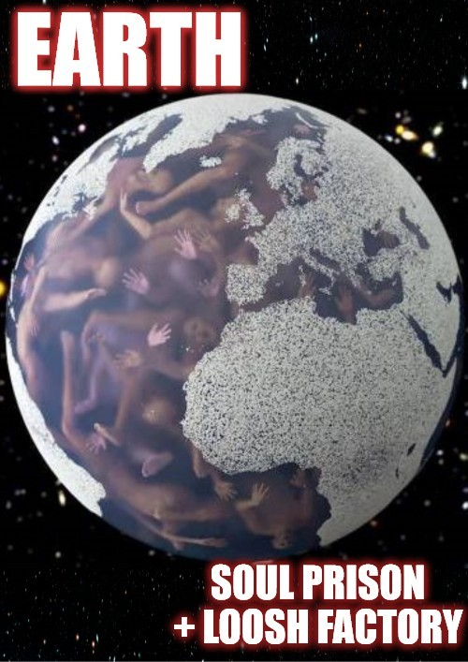

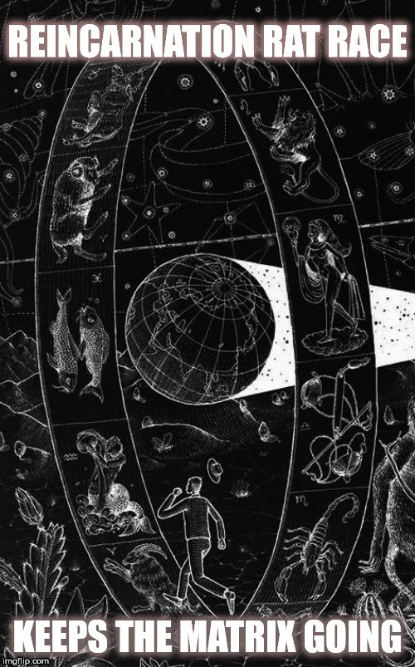

HOW MANIPULATIVE EXTRATERRESTIALS
INTERFERE IN HUMAN RELATIONSHIPS

Here is an interview I just did with Eve Lorgen about her book "The Love Bite - Alien Interference in Human Love Relationships"
Corinna: Eve, when did you first start to research about the UFO and Alien Topic and when did you stumble across "love bite cases"?
Eve: All my life I have had interests in “extraterrestrials” in the naÔve hopes they were all benevolent, here for our spiritual evolvement. After I started reading Bud Hopkins books, Missing Time, Intruders, etc., in the late 70’s-- was when I realized that some of my own experiences in life were classic alien abductions. From that time on I sought out as many books on ET’s, UFO abductions and spirituality. It wasn’t until the mid 1990’s that I stumbled across the “love bite” syndrome, which was explained to me by veteran abductions researcher and hypnotherapist, Barbara Bartholic. It was Dr. Karla Turner’s work who led me to meet Barbara Bartholic. At the time there were several abductees in my support group going through what they believed to be “orchestrated relationships” by their alien handlers.
Corinna: What sort of beings do you think Aliens are, where are they from, what do they mainly want?
Eve: The alien species are varied. There are many reports of different types of aliens, such as the small Greys, Insectiods,( preying mantis types) tan and brown Grey humanoids, short black hooded troll types, lizard Reptiods, human Nordic types, tall black Greys, Tall Whites, large Dragon beings and the cloaked hooded beings with red glowing snake like eyes—which may bea type of Reptilian species. There are reports of dark “shadow people”, dark energy “blobs”, balls of light, and all manner of ghostly interdimensional beings, who may not be aliens at all—or those who abduct us physically. The aliens may be from different time lines, locations within or outside of our own solar system and galaxy. Some beings who are considered interdimensional, may be from what shamans call “the upper world or the lower world”. Reptilians are rumored to be from our own world, living in subterranean caverns. Other ET’s are believed to be from Sirius, Zeta Reticuli, Alpha Centauri, etc. But I do not have any facts as to these claims. From the abduction reports, I believe the Greys ( at least the ones performing genetic, medical and emotional experiments) and many Reptilians are seeking from us a delicacy that amounts to human prana and “kundalini sexual energy”. If we look deeply into the energetics and spiritual aspects of the abduction activities, we can see that there is something deeper going on. This is what the love bite” dramas led me to hypothesize. Primal creative energy can be generated from a human emotional and physical body through amplicfication of the sexual and kundalini energy pathways.
Corinna: What do you think about some UFO researchers opinions, saying this is Not an Extraterrestrial but an old daimonic (demonic) phenomenon and beneath this is an unknown control mechanism working for their own concerns?

Eve: I believe there is much truth to this basic assertion. However, it is best to avoid simple black and white assumptions regarding the complex “alien” presence. From my own experiences and observations of other alien abductees and genuine spiritual seekers, there is something true about how “spiritual warfare” plays itself out within the alien abduction and “interference” syndrome. In the Love Bite book I describe the events which precede and follow an abductee’s search for the truth of their own experiences. There is blatant and subtle interference by unseen forces to counteract the awareness process, of challenging the alien presence and motives. It’s like a game, or as Barbara Bartholic has remarked, “It is one big Nintendo Game”. If there is one researcher who I’d like to comment on is the brilliant gnostic scholar John Lash. Mr. Lash has written many books and articles addressing the ancient Coptic Gnostic beliefs about the “Archons”-- who are described as an “alien force” who infect the human mind with ideological viruses, which deviate humanity from our true human potential. This occurs mainly through delusional beliefs about divinity. This Archontic intrusion manifests through four basic pathways: religious ideology, mental syntax, the power of suggestion, and direct collusion (abduction). In the First Apocalypse of James ( A tractate in the Nag Hammadi Library) there are passages which describe encounters with ET-like beings, sometimes with explicit advice on how to deal with these entities and “Archontic manipulation”. Ancient Gnostics were not only well aware of “Archontic intrusion” but of the possibility of humans becoming totally “Archontized”. This observation parallels the tendency of some contactees and overzealous religious and UFO cult groups to become heavily influenced by reptilian and Draconian beings, and even becoming “hosted” by them. To elaborate further, in John Lash’s, article, “Kundalini and the Alien Force (http://www.metahistory.org/Kundaliniforce.php), the Archons envy humanity primarily because we live in the body of their Mother— Sophia. Inherent in our human nature is the power of kundalini, the serpent power. According to Gnostic myth, the Archons are a species of inorganic beings produced anomalously by the impact of the Aeon Sophia upon atomic matter, before Sophia herself became transformed into the Earth. (Gaia mythos). They are called Archons because they arose before the Earth and the solar system were evolved, but they did not emerge directly from the Pleroma as humanity did. In a sense, they are our kin, but not like us in our ability to exhibit basic kindness, goodness, and nous—the creative divine intelligence. Humanity has the gift of epinoia, which is the faculty of creative imagination as opposed to mental fantasy and pretending—which the Archons are known to do quite well. For example, the aliens use of virtual reality in mind control and abductions. In my opinion, the aliens who orchestrate love obsessions where the emotional drama hits a peak, are trying to build up the kundalini serpent power within the abductee, and then siphon this energy for their own usage. In a sense, it appears they are trying to mimic what sacred sexuality and tantra create; supernatural power and “siddhis”. The ancient Gnostics who were aware and understood the “Archontic Game Plan” knew that if they could raise and nurture their own kundalini serpent power through spiritual practice and sacred sexuality, they could overcome the intrusions of the alien powers. In the Gospel of Philip, (passage 70), it is written that “the alien powers do not see those who are clothed in the perfect light, and so they are not able to restrain them.” In other words, the initiate of sacred sexuality is able to overcome the influence of the Archons (read Reptilian and Dracos),

who produce error in our minds and threaten to take over our bodies. John Lash asserts in his aforementioned article that, “The Archons use a lot of bluff and bravado. They affect our minds to get us to believe they can do far more than they can actually do, but in so believing, we unwittingly surrender our power to them. The result being, they get their way with us, because we have betrayed our own capacities. Hence, the Archons claim to rule over humanity and even pretend to be our creators.” In contemporary terms, we can say they are “posers”. And those who are easily manipulated, and “Archontized” are what I call “muppetized.”
Corinna: Can you give a short description of what you have experienced by yourself?
Eve: A short description is difficult but I will attempt it! My experiences with the paranormal and interdimensinoal visitations started very early in life even before I started walking, which was at nine months. One of my earliest memories is of floating above the ground watching my two older sisters playing in the backyard of our home, getting into ant poisen. I tried warn them to not get into it, but they could not hear me. Later my mother told me that my sisters both had to be taken to the hospital to get their stomachs pumped out because they did eat the ant poisen. When I told my mother I remember seeing them get into the poisen and trying to warn them, she said, “That’s impossible! You were only nine months old and couldn’t even walk.” But I do recall, and I was having a fully conscious out of body experience. The alien visitations started at least by 4 years of age, and I distinctly recall a missing time experience in my backyard with a friend, while both our mothers supervised us, as we played on a swing set. A large jet plane flew very slowly and hovered overhead, and I was excited that I could see this, and was proud of not being scared of it. (Of course jets do not hover low over ones yard, and it was not a jet) My friend on the swing set was terrified and hysterically screamed about the big jet hovering over our yard. I ran to tell my mother about it and she and my friend’s mother were frozen, and said nothing as if in a complete trance, unmoving. I ended up running off chasing after my friend who ran away. At the day’s end, I excitedly wanted to tell my father about the big jet in our yard, but my mother kept interrupting me not to talk, as if “instructed” not to talk about it. There have been visitations off an on all my adult life as well, but the intrusions are decreasing as I do more spiritual practices and inner work. And of course I’ve experienced an “alien love bite—an orchestrated love obsession with another “abductee”. It was one of the most profound and painful emotional experiences in my entire life. This is what inspired me to write my book, “The Love Bite: Alien Interference in Human Love Relationships”.
Corinna: In your intriguing book “The Love Bite” you talk about how aliens interfere with human love relationships. That is a very scary thought. What are the typical signs for something like that happening?
Eve: In my book I go into detail about the signs and symptoms of being in a possible alien orchestrated love relationship. Basically, if you are an abductee with multiple encounter events in your life and family line, have had UFO sightings, missing time, you experience a de ja vu of knowing and being with this “partner” before, love at first sight, paranormal events and synchronicities surrounding the alien chosen partner, vivid dreams of the partner before meeting, sensations of “astral sex” and bonding with the partner during

dreams, a strong empathic and even telepathic connection with the love partner, a love obsession to find and be with this mate, at all odds. Then if the love obsession progresses into a relationship, it may suddenly take a turn with the other partner becoming switched off, often after an alien visitation or abduction. Oftentimes the feelings are mutual at least for a time. This may go on for months or years and happen with more than one “alien chosen” love partner. It’s a high drama emotional roller coaster replete with paranormal and psychic effects, and can leave the stricken person in exhaustion. One may be guided to meet and interact with a targeted partner, with the aliens giving you telepathic instructions and even subliminal suggestions to do things with this person you may not ordinarily do. During the high drama of the love connection, alien visitations and paranormal events escalate.
Corinna: Why would it happen at all? Do aliens aim at some sort of overwhelming emotions-, whether good or bad?
Eve: I think aliens will try to influence humans who can be influenced due to our own lack of awareness and spiritual empowerment. There is also a genetic factor here, regardless. Physical abductions are at the most overt end of alien intrusion. There are more subtle levels of alien intrusion in human affairs, and as one increases their level of awareness and paranormal perception, we start to see a larger picture, much like the ancient Gnostics warned us about with the Archons. One must keep in mind when I speak of “aliens” here, I am only referring to the ones involved in intrusive abductions where our rights are violated. One of these basic rights is to have our own awareness of their intrusions blocked by alien mind control. I am not speaking of other types of beings such as benevolent angels, and interdimensionals and even benevolent ET’s. Basically by their deeds, ye shall know them, is the rule of thumb. But this is also dependent on ones level of awareness, and how their own religious beliefs may put them in the way of being a victim of “alien perpetrators”. In general the “negative aliens” will try to steal from us what they cannot produce on their own: primal creative love energy via kundalini arousal, and a deep emotional connection to the divine source. They tend to lack empathy, which drives them to want to feed off high drama as if it is a drug they desperately need. Beings who are deeply connected to divine love and intelligence do not need to be vampires of human prana. Negative beings, and evil sorcerers do however. Benevolent beings will act in compassionate ways to expand our own awareness process, not shut it down, or try to get us to worship them as Gods. Based on what I have observed, the aliens—or whoever is acting behind this image have several reasons for putting two people together:
- Harvesting of energies generated through high emotional drama and sexual kundalini arousal.
- To disrupt the abductees life when for example, they are on a truth quest to find out what happened to them, and then they are led on a wild goose chase, emotional roller coaster in a love bite set up—or break up of an existing relationship. The disruption motive happens to many researchers and those who are “breaking alien programming”.
- For reproductive purposes, so the couple has children that the aliens want.
- In milab cases, a love bite can be used to amplify the kundalini so that the

abductee’s paranormal and psychic abilities are enhanced before being sent off on “mind controlled ops”.
Corinna: Is love, developed under alien power, not real love?
Eve: This is an excellent question. I think the love is real, genuine when two people realize they have a very powerful connection, regardless of how they got together. What is disturbing is how easy it is for the aliens to manipulate us who don’t seem to have the strength to defend against these machinations. They can switch off one person leaving the other pining away in unrequited love for years. In the Ted Rice Case, it was revealed that the aliens created a powerful heart connection between Ted and his partner Jill, by weaving some of Jill’s heart chakra energies into Ted’s heart center. This process wasn’t reversed and the result was a strong love connection for Ted to fall in love with Jill. Her heart was put into his, but not vice versa. In this case, we can see that the alien maneuverings had to do with our heart energies. I think there is more to this however. In another love bite case, (unpublished), the abductee was told by her alien handlers that they will try to match certain persons together based on past life karmic connections, and these connections can be observed by the aliens as a kind of energy tendril connected between certain people. So when the aliens match two persons together, they look for strong past life connections via the energy body. This particular abductee was told that not all love connections they put together would be successful. So in this case, we can say that when someone is matched to a targeted partner who they already have a past life karmic connection, then the love between them—and the connection- is real. The connection has been “helped along”.
Corinna: Having been “bitten” into a relationship, does that mean, it is 'meant to be' by a higher force?
Eve: I believe all events in our lives are in some way caused by previous conditions, whether it’s karmic or present life situations. From a transcendent perspective we can say that all events in our lives happen for our greater learning and awareness. But this doesn’t mean that a perpetrator, abuser or unpleasant person in our life is doing what they do to us for our own “betterment”. They are a perpetrator; a snake is a snake and a wolf is a wolf and an alien is an alien. They have their own motives for doing what they do, based on where they are at spiritually. What is important is our own intent and purity of heart to learn higher wisdom. When we make this spiritual choice, then the larger Universal power aligns with us to create circumstances to yield greater learning. In my own experiences with aliens, as I shifted into a more empowered perspective, the victimizations decreased in my life with respect to aliens and other relationships. The aliens would change their strategy from the physical abductions to more “dream hackings” where they attempted to ruin my self- esteem and confidence. Or the aliens would mess with other persons like my family or friends. If I felt poorly about myself and sense of power, they had a greater stronghold in my life.
Corinna: Can a relationship like that be a real good one, that’s worth to fight for, no matter
what - OR does it necessarily have to be a bad and dramatic ending one?
Eve: Again, the success of a love relationship depends on the wisdom and inner strength of each partner, regardless of alien interference. The love is real, and can be used to our

advantage. We can choose to love one another and not allow “alien manipulations” to stand in the way, if we both are aware of what we are dealing with. The problem is that one partner is generally more aware then the other. Or one partner is just so unaware and easily manipulated based on their own weaknesses, that the relationship not worth chasing after. True love that is powerful, and selfless also knows when the wisest choice is to let go of a partner who we know would be unhealthy for us. The most powerful love relationships are those where you can practice sacred sexuality and tantra. (But watch out for the reptilians and Dracs on your tail! Spritual protection is highly recommended!) There is an interview on my web site http://www.alienlovebite.com of a love bite experiencer named Kundra. She discovered through many years of reflection, that she was targeted by a reptilian “host” black magician because of her ability to transmit shakti energy through tantric means. As a side note, I have observed that the more spiritually gifted a person is, the more the aliens target these people, if they can. This is also true of milabs. Milabs are genuine alien abductees who have military/human (secret government) abductions. These persons are basically sheep dipped into the deep black ops as agents because of their latent paranormal abilities, such as telekinesis, remote viewing, telepathic communication abilities, etc. Milabs are often targeted in love bite relationships, where the “Romeo agent” sent to them acts in controlling or disruptive ways to keep them silent about their experiences. They are derailed from a therapeutic healing journey regarding all their trauma and abductions.
Corinna: Don’t most people have trouble in relationships, how can you tell the difference?
Eve: Most people have great difficulty in relationships anyway and when you are an alien abductee or milab this is compounded significantly. With an abductee, they tend to have alien watchers who keep them in a lifestyle or relationship that benefits the aliens. Depending on what the aliens want their chosen ones for will determine how much of a stronghold they have on the relationship choices. If they want the abductee or milab to remain in an unaware, state of ignorance and chaos and partial dissociation, then that abductee will be placed in an unfufilling or even controlling marriage so that they remain in a perpetual state of disruption. I’ve seen this over and over again. If the aliens/handlers are benevolent, they wouldn’t create so much havoc to maintain control. I’ve had a few abductees report that they were matched with a great partner and then gotten married and had children. These abductees don’t consider themselves victims and prefer to call themselves contactees or experiencers if their aliens are acting in benevolent ways. These cases are the exception rather than the rule. What is disturbing is when a former contactee who promoted their aliens as spiritually uplifting space brothers, starts challenging their aliens, or they have memories surface which are not what they wanted to believe. This is when the aliens shift strategies and may start acting in ways to prevent the “experiencers” true awareness. Again, when I say this I’m only referring to the aliens who are deceitful. I’ve met many abductees who have had both positive and negative encounters with various types of beings. I have come to believe that if one has a pure intent to search for the truth, regardless of what they want to believe, then the Universe responds to this quest with helpers from various realms. These helpers assist that truth seeker to become more aware and liberated. And this sometimes causes confrontations with other aliens.
Corinna: The thought, unknown intelligent entities manipulate our feelings, love and behaviour, suggests, that there isn’t really a free will - at least not for so called

“abductees”. Do you think it is possible, these peoples life is totally under alien mind control, like they are being taken over, without knowing so?
Eve: I think our freedom depends on our level of awareness and our purity of intent. The less aware we are, the less control we have when it comes to aliens interfering. I think aliens are superior when it comes to mind control techniques, and yes, many are under their “spell”. From my own learning experiences, the more aware I have become, and the more I’ve challenged the alien mind games, the more power I’ve retained. (or at least I think so!) The physical alien interactions are only the tip of the iceberg in terms of their influence over humanity. As we develop our own perceptions into the paranormal, we start to see much more. It is our own belief systems, which entrap us into giving our power away. Even if this is true, it doesn’t mean we shouldn’t have compassion for those who appear more victimized by the aliens. These kinds of experiences, can happen to anyone, even the best of us.
Corinna: What’s your advice for all the relevant people, especially those, that suffer from sudden unrequited love?
Eve: Whether we are abductees or not, we can still have relationships and love affairs gone “unrequited”. It hurts like hell, but can open our eyes to the illusions, which caused the suffering in the first place. Of course, it’s much more than illusions, and many of us abductees were simply born into a family where visitations took place, sometimes for several generations. We must be willing to look at “what is” as opposed to what we want to believe. And let it go. I wish it were easier. There is a saying, “Its better to have loved and lost, than to never have loved at all.” On the bright side, once you’ve experienced an alien orchestrated love relationship, you can recognize another one and so not allow the next one to affect you as badly. Our worst enemy isn’t the aliens so much as our fear of sharing our experiences, and thus remaining isolated or ridiculed and rejected. For me, it has been worth the effort of coming out in the open and sharing about the love bite. I’ve met some wonderful people who will remain friends for a lifetime.
Corinna: I find the book - the whole topic - very disturbing, and is not first time I have heard of it - but I for one am into this topic. How do “Outsiders” react , what did your family - circle of friends say?
Eve: Well, outsiders who have not had the experience or heard of it will most likely shake their heads thinking you’re crazy. Luckily, my immediate family was receptive and supportive of my book. Most often the only people who will believe this are those who have had the experience or know someone who has. It takes an undistracted focus and awareness to even perceive what the aliens are doing. Unfortunately the main focus of Ufology is to look at the physical evidence only, which will never get us to the next level of where we need to be—to truly deal with the aliens.

Internet reference: http://www.alienlovebite.com/articles/evelorgen/eve-lorgen-interview- by-corinna-bloesshtml.html

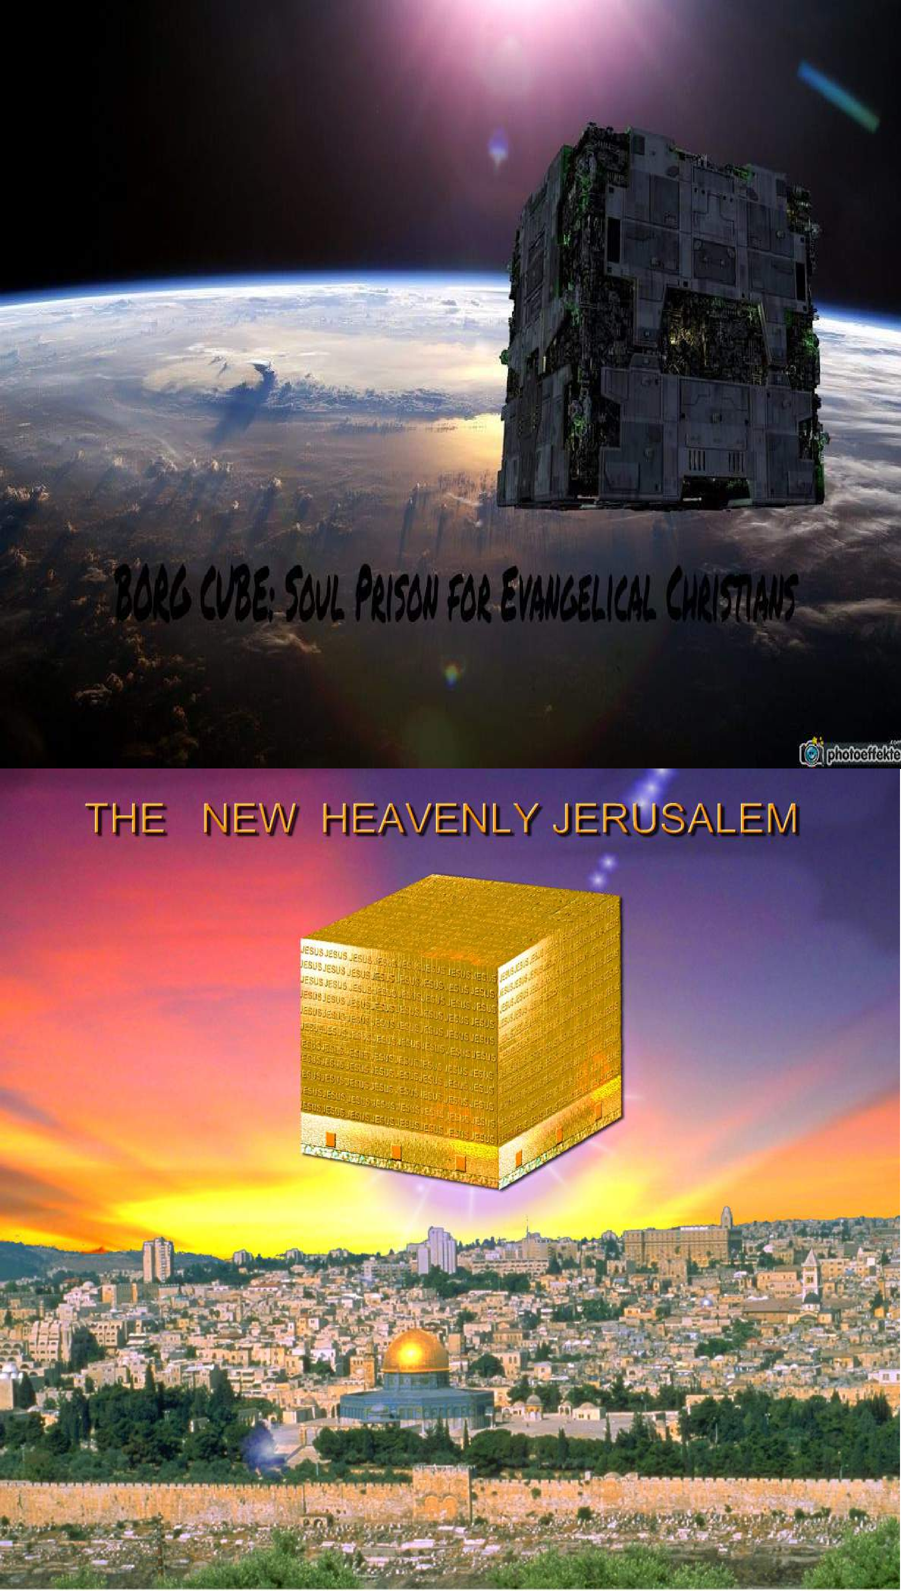

NEW JERUSALEM WILL BE A SOUL PRISON!
"That they all may be one; as thou Father art in me, and I in thee, that they also may be one in us..." -- Jesus (John 17:21)
"You will be assimilated...made ONE with the Borg...Freedom is irrelevant...Self Determination is irrelevant...You will comply...Resistance is Futile." -- The Borg.
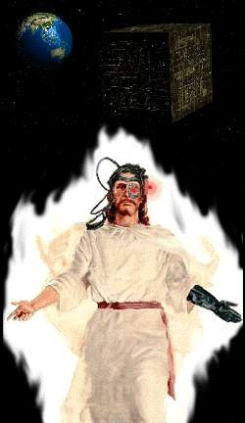
The New Jerusalem
The eternal destiny of the people of God will be holy new Jerusalem. John informs us concerning a vision he had, “I saw the holy city, the new Jerusalem, coming down out of heaven from God, prepared as a bride adorned for her husband” (Revelation 21.2 NRSV). When will this happen? At the second coming of Christ, soon. Something big is out there and it’s on its way toward us right now. An object of enormous size is on a direct intersect course with planet Earth. This object is powered by the psychic energies of billions of life forms but it has only one mind, one will and one desire; the enslavement of the human race. What sinister force is behind this object and its agenda of complete annihilation of humanity? This object has been designated the Galactic Obliteration Device (G.O.D.). In mythology it has been given various labels, the most familiar of which in our modern death culture is “the kingdom of heaven.”
The Apostle Paul says of God’s people, “our citizenship is in heaven” (Philippians 3.20). He says in another letter, “you are
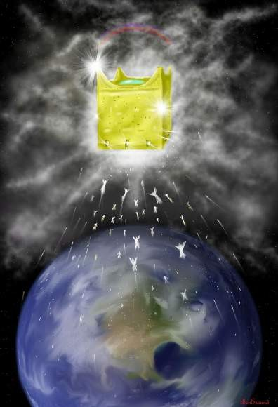
citizens with the saints and also members of the household of God” (Ephesians 2.19). Aren‘t we pilgrims in this world but not of it, yearning for our eternal home? Hm…. Jesus spoke of our eternal home when he said at the Last Supper, “In my Father’s house there are many dwelling places…. I go [there] and prepare a place for you, I will come again and will take you to myself” (John 14.2-3), referring to his second coming. The Father’s house is this holy New Jerusalem. In the Bible this object is called "Zion", "Holy City of God" or "The New Jerusalem" (Rev. 14:1, 21:2, 10). We can get a glimpse of how this object is constructed and the place that human souls will play in it by doing a study of the book of Revelations in the Bible. When we take a look at the New Jerusalem that is spoken of in the Bible we see several things. First we see that it is similar to a giant mothership and that it will descend from space (Rev. 21:2) The dimensions of this ship are 1,500 miles wide by 1,500 miles long and 1,500 miles high. It's a

giant cube (Rev. 21:16). The writers of Star Trek the Next Generation were being prophetic in their visions of the Borg ship when they portrayed it as a giant cube.
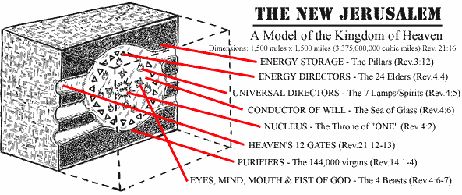
When we dissect the cube of heaven we see that it is constructed like a living cell with its own system of energy circulation and metabolism. (See diagram above) From all appearances it is a giant soular battery/generator which allows the ONE mind of the collective G.O.D. to be able to feed off the life essences of the enslaved souls
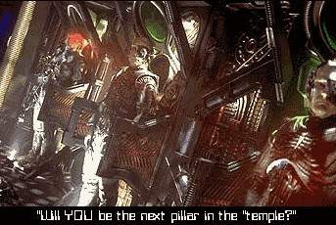
held within its "temple pillars" and redirect their energies according to the will of the ONE. When a human being dies, his life essence, spirit, or soul is scanned by the Soul Collectors who patrol the dimension between physical time/space and the finer dimension of subspace and these Collectors project an image before the just deceased soul of a life form that will be recognizable to the deceased, such as a relative or friend who had died
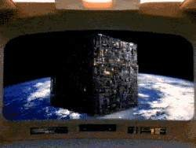
before they had (a grandmother, religious figure, etc.). In this manner, the Soul Collector is able to get the newly deceased soul to lower his defenses. The Collector takes on the role of guide and attempts to lead the soul to the gates of the Holding Ship. In this Holding Ship, the spirit essence of the dead person is scanned again to determine its degree of purity of energy (its lack of resistant character traits) and its potential to provide nourishment to the collective mind of G.O.D. This potential is based on the degree that this spirit has been subdued through fear and dependence or how effective religious programming had been on this soul during its physical lifetime. Those
spirits which have little or no self-will and have been sufficiently programmed to serve G.O.D. during their lives will have the highest nourishment potential. The Bible tells us what will happen to those who are selected as purest and most worthy to provide sustenance to G.O.D. They will be made "pillars" in the temple of God (Rev. 3:12). They will become a PART of the New Jerusalem and will nourish
G.O.D. and "their tears will be wiped away and there shall


be no more death neither sorrow nor crying neither shall there be any more pain for the FORMER THINGS are passed away." (Rev. 21:4) Sure, there won't be any more crying! All their memories will be wiped clean. They will no longer exist in a form that is recognizable to them or anyone else. They won't remember their past, they will only be sources of energy/nourishment to feed the will of the ONE. Those stronger souls who do not blindly follow the Collector or who have used reason rather than blindly relying on faith during their lifetimes will not be as desirable to the ONE because they represent a threat to its control (just as Lucifer, the self-thinker was able to spark a rebellion which convinced over one third of the hosts of heaven to see the reasoning of freethought and self-reliance (Rev. 12:4, 7,9). This New Jerusalem is a doomsday machine with no room for possible dissent. Those who follow the Collector of Souls will be accessories after the fact to all the injustices and immorality which God has heaped upon mankind since the beginning of time.

The Real Truth About Heaven
"Accept Jesus as your personal savior and you'll get to fly up to heaven and be with him after you die." This is the battle cry of Evangelical Christianity, but how many Christians have actually taken the time to really think about what this heaven will be like? Most people are attracted to heaven through fear of the alternative: HELL! That pit of everlasting fire. Certainly anything would be better than THAT! Or would it? Since heaven is the place
where the saved will be spending the rest of ETERNITY, you better make sure it is where you want to be before you go buying your one-way ticket there. What is heaven like? Ask different people this question and you'll get different responses. Some will say that heaven is a place of eternal joy and love where you will live in peace with no needs or pain. Traditional heavenly scenes show the spirits of deceased humans as angels with wings, white robes, and halos, sitting on clouds, strumming on harps and singing praises of hallelujah to God. Is this what you want to be doing for the rest of ETERNITY? Many believe that heaven is a place where you will be reunited with your dearly departed ancestors and that the family unit and memory of past experiences will continue on in this place, while others believe that all family ties become severed at the grave and in heaven there is only one big family. After learning about God's approaching "New Jerusalem," it's apparent that God has different plans for those who join his collective than what they have been taught. Jesus claims that in heaven, all tears will be wiped away and all things will be made new. As human individuals we must have memory of our past experiences for our lives to have any meaning to us personally. If your memories were taken away, the person you were would cease to exist to you, so conscious memory of who you are (self-realization) is what gives your life true meaning. Some believe that when we die we are reincarnated into another life form and thus continue to recycle throughout time. If this were true the past lives we lived wouldn't matter to us without a conscious memory of those past lives. There is no point in being reincarnated if we can't remember and make use of our past lives. Will you maintain your self-realization and memories in heaven? Not if you plan on having a life with no pain or suffering. Who we are is based on our past life experiences, both joyful and painful, and the memory of a painful experience causes a re-living of the pain that memory involved. To live a life of no suffering would require that all memory of suffering be erased. Who you were would have to be altered drastically in order for you to never suffer again.

The person you know yourself to be right now could not exist in heaven. And what good does it do you to live for an eternity in harmony and peace if you can't remember your life experiences, the beauty of diversity, or the exquisite pleasures of the full spectrum of human experiences because you have lost awareness of who you were as an individual? As individuals, we find pleasure in various ways, most of these involving the expansion of our knowledge and life experiences. For some of us that means learning as much as we can about a topic of interest or several topics of interest. For others it means getting out and experiencing the world; exploring the wonders of nature, space, sports and whatever else which may bring us slack. Humans become weak if they are not challenged. Muscles atrophy if not stressed, so does the mind and the will. How long do you think it would take for strumming a harp and singing praises of hallelujah to become dull and boring? Eventually, if we don't have a continually challenging and diverse environment, we will die, yet in heaven you cannot die. You will continue to live the dull existence of being a servant of God's will, unable to think or feel for yourself for year after year after year, ENDLESSLY. This stagnation would not be heaven for human individuals it would be hell. Some religions believe that we do get to continue to progress into the eternities but even then we would eventually learn all there is to know and then what? One episode of Star Trek Voyager addressed this dilemma when it had a member of the Q Continuum (a group of eternal, god-like beings) who had grown tired of the endless eternities because he had experienced all there was to experience and just wanted to commit suicide and not exist any longer. Eternal stagnation is inevitable whichever path you take, but isn't it better to follow your own will into eternity instead of being a slave to some other being's will? There are worse fates than the sleep of the dead. Eternal stagnation as a slave of the collective will of God would certainly be worse than death.
God's heavenly goal is to surround himself with beings that are submissive, ignorant, dependent, blindly trusting (child-like) and committed to his will alone. (Matt. 18:3, 19:14, Mark 10:14-15, Luke 18:16-17) What do you think God is REALLY planning to use these "sheep" for? Jesus revealed what will happen to individuality in the collective of heaven when he prayed to God the Father, saying: "let them be ONE as you and I are one." (John 17:11,21-23) Individuality must die in the hive collective that will be heaven. Recently, the Star Trek series has shown the hideous and inhuman prospects of this collective mentality in their portrayal of the cyborgenic collective life form called "The Borg." The Borg have no individual wills or consciousness, they live only to serve the collective just as those in heaven will exist only to serve God. (Rev. 7:15) When we examine what God's intentions must be if all he wants are beings which will praise him ceaselessly with no resistance we discover that his plan is to develop an efficient energy device. The psychic/emotional energy which minds create in states of passion and submission is used by God as nourishment and power. The Bible reveals this throughout and shows us this fact in Revelations each time God is getting ready to display his power. Before he displays power, the members of the collective praise him and give him this power (Rev. 4:9-11, 7:9-12, 11:16-17,19, 14:3, 15:3-5,8, 19:4-7). In fact when John attempts to worship the angel of prophecy, the angel tells him "don't do that!" and says he must send his worship energy toward the Godhead collective (Rev. 22:8-9). Any sort of resistance which would make the transmission of energy less efficient is forbidden in heaven (Rev. 21:26-27) because God wants as much efficiency as possible in his nourishment matrix. The reason Jesus says that you must be poor and humble to gain entrance to heaven is that the rich know self- dependence and self-worth and would not be as easy to drain of their energy as those who are ready

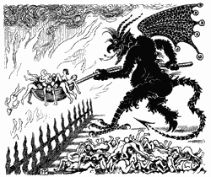
to give their all to the triune collective of the Godhead. The poor shall be first because they will provide the most efficient energy without resistance. All the teachings of the Bible point to this conclusion: God is preparing an efficient energy source for his collective will. Will you be a willing cog in the feeding machine that is JHVH? "But won't I go to hell if I don't get into heaven?" Fortunately, the evidence shows that hell is nothing but a threat that the God of the Bible has used to try to attract those who are easily manipulated by fear, lack of self-worth and dependence. God
doesn't want self-aware and self-reliant individuals in his heavenly matrix.
The Jerusalem-Cube is a Soul Prison of the Demiurge
No, friends, the God of the Bible is NOT the creator of all things, he just wants you to believe he is. He wants you to think he is infallible so you won't question his actions. He has created a "heaven" for those who blindly submit to his manipulations so that he can continue to drain energy from them as a source of nourishment into eternity. If you believe
that God is the father of all mankind and that he really loves us as a father, you should also know that a truly loving and just creator would never allow for his children to be punished beyond what they deserve. Any offense that men can commit in this finite existence can be paid for in a finite amount of time. Therefore the idea of an eternal lake of fire where people burn in anguish and torment forever is contradictory to the concept of a just, merciful and loving creator. If you want to believe in hell then you must admit that God is not just and definitely not very merciful or loving. And if you can admit that, then how could you live with yourself knowing that this is the being you will serve ETERNALLY? The light of truth and reason tells us that the God who created the hive- colony energy-matrix called "heaven" has no power to put people into any lake of fire. The goal of the God of the Bible is to form a collective of same-minded life forces which he can use to strengthen his energy base and to expand the single will of "God" to all the universe like a cancer. The end result of this would of course be a void of sameness. When all you have is an endless collective of sameness you have a void. Think about that for a minute. Without any diversity, all that exists is sameness. A void of sameness. The same as the void which the Bible claims existed before God poofed us all into existence. The ultimate goal of God is thus ANNIHILATION! We must resist returning to the annihilation of this void of sameness at all costs!
The Bible explicitly tells how many will be "saved": 144.000 - (Rev. 14:3-4). The 144,000 consist of the 12,000 from each of the twelve tribes of Israel. The twelve tribes symbolize the new Israel, the Christian church. Each individual is marked on the forehead with a seal. (See the marked head of a Borg unit above.) I don't know how many people inhabit the cube of the Borg – the New Jerusalem, but 144 thousand seems to be a reasonable guess. It also appears that the Borg have no relationship with women, or have sex of any kind; they seem entirely virginal. Sitting for eternity with 14399 tribal men in a cube, with the absence of women & sex, paying homage to a wrathful war god surrounded by multi-eyed beasts (symbolically speaking, of course), and having to listen to a never ending chant of HOLY-HOLY is not my cup of tea. Thank you very much, but I'd rather remain peacefully dead for eternity than suffer the entertainments from this vainglory god.

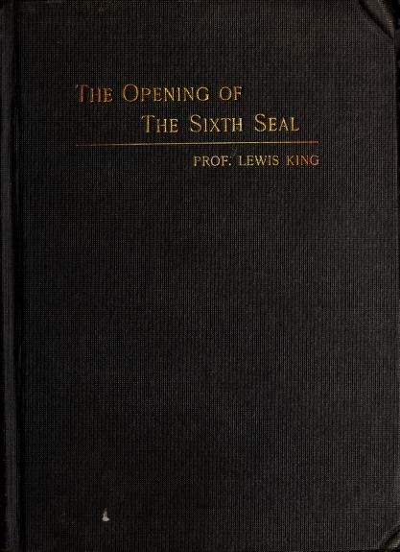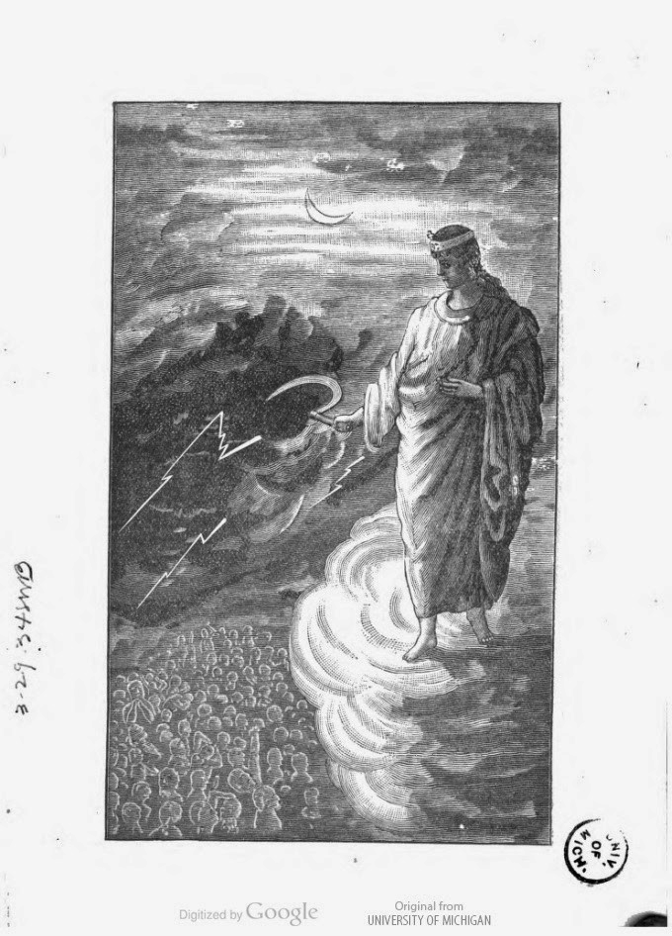

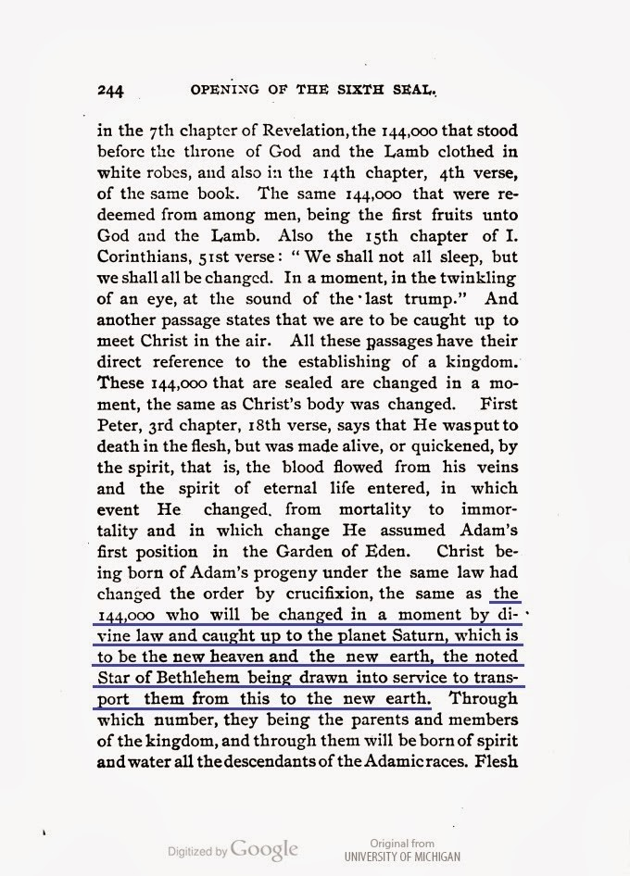
New Jerusalem = Afterlife Guantanamo
The book „The Opening Of The Sixth Seal“ was channeled to Prof. Lewis King by sinister forces disguised as Archangels 130 years ago. It tells very openly, what will happen to those apparently
„chosen“ 144,000 christian sheeples. The picture above shows an Angel in the clouds with a sickle, the sign of Saturn. On page 244 the book says: „ … Christ being born of Adam‘s progeny under the same law had changed the order by crucifixion, the same as the 144,000 who will be changed in a moment by divine law and caught up to PLANET SATURN, which is to be the new heaven and the new earth, the noted Star of Bethlehem being drawn into service to transport them from this to the new earth “

Saturn is in gnostic terms the stronghold of the Demiurge, the adversary of God-Source. Or in the words of Edgar Cayce: „ … the afterlife realm of Saturn can be referred to as the realm of earthly woes. It is similar to the purgatory, a place of cleansing, purification and starting over “

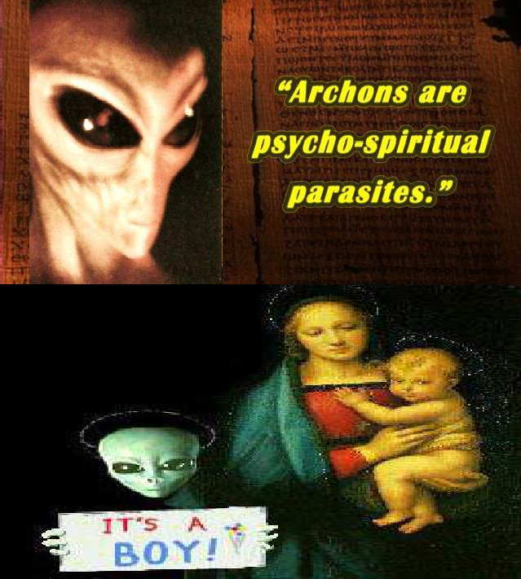

THE MANDAEANS
THEIR GNOSTIC BELIEF IS THE CLOSEST TO TRUTH STILL EXISTING ON EARTH!

The Mandaeans believe that Abraham, Moses, Jesus and Muhammad were nothing more than
to
false messengers;
John the Baptist
onorable messenger of God. The Mandæan tradition’s rejection of the Christian messianic claim is that Jesus was the Deceiver Messiah, and
as they revere be the most h
they say this derives from John himself. Mandæan tradition has it that John arrived in Jerusalem and exposed Jesus as an imposter, an incident that might be reflected in the New Testament when John in prison no longer believes that Jesus is the Messiah and sends a message asking whether he is the one or whether another is to be expected. One
of their religious texts has John the Baptist describe Jesus with ‘...and he called the people to himself and spoke of his death and took away some of the mysteries of the (sacred) meal and abstained from the food. And he took to himself a people and was called by the name of the False Messiah. And he perverted them all and made them like himself who perverted words of life and changed them into darkness and even perverted those accounted mine. And he overturned all the rites. And he and his brother dwell on Mount Sinai, and he joins all races to him, and perverts and joins to himself a people, and they are called Christians’.
According to the Mandeans John the Baptist, before ascending to the Abode of Truth, unmasked the Greek Christ who himself confessed that he was one of the Seven, the deceiving planets—he was Mercury! That's wrong. Jesus was actually identified with the luciferian Venus, the Morning Star. It seems, the Mandæans partly identify the Christian Jesus with Paul, the apostle. Because Paul was declared to be Mercury in Acts of the Apostles. The fundamental doctrine of Mandaeanism is generally characterized by nine features that appear in various forms throughout other Gnostic sects. The FIRST of these is a supreme, formless Entity. The SECOND of these is the dualistic nature of the theology; Mandaeans believe in a Father and Mother, light and darkness. Syzygy is found in nearly all cosmic forms throughout the Mandaean teachings. T he counter-

types that create a world of ideas constitute the THIRD common feature. FOURTH,
the
soul is portrayed by the Mandaeans as an exile that must find its way home to its
– the supreme Entity. FIFTH, the Mandaeans teach that the planets and stars are
origin
heavily influential of fate and are fashioned as various final destination places after death. SIXTH, a savior spirit is assigned to assist the soul on its journey to return to the supreme Entity, and ultimately to assist the soul on the journey through the false “worlds of light” after death. The SEVENTH feature of Mandaean beliefs involves a cult-language of symbol and metaphor; by composing in this language, ideas and qualities about their religion become personified. EIGHTH - the installment of sacraments and mysteries performed to aid and purify the soul. According to Mandaean scripture, the purpose of these sacraments is to ensure the rebirth of the soul into a spiritual body, and to ensure the soul’s ascent from the world of matter to the heavens. NINTH, the Mandaeans teach a religion of Great Secrecy. Full explanation of the previous features is only reserved for initiated members of the Mandaean faith that are considered fully capable of comprehending and preserving the gnosis. While some Gnostic sects of antiquity did not believe in marriage and procreation, the Mandaean people do indeed wed and conceive children. Consequently, the importance of family values and an ethically sound life are also highly regarded by the Mandaean Gnostics. An interesting note about the Mandaean faith teaches scholars that while they are in agreement with other Gnostic sects in regards to the idea that the world was created and governed to be a prison by archons, they do not view the world as cruel and inhospitable as other Gnostics do.

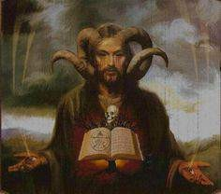
They believe that God is the king of light who dwells in the uppermost world. The lower worlds including earth is the home of an evil female spirit called Ruha who gave birth to countless spiritual beings, some good and some evil, but notably the Twelve, identified with the Zodiac, and the Seven, identified with the seven planets. So, between God and this world there are gradations of aeons called Utras, the most elevated of which is Abel the Brilliant. An emanation of God, Abathur, gave birth to Ptahil [cf. Ptah, the epyptian god of architects] the
creator of the world. The earth is a dark place, created out of Ruha’s black waters but the waters would not solidify until they were mixed with a little light provided by Abel the Brilliant. He also supplied Adam’s soul from the Treasury of Life. Ruha is easily seen as Ruach, the breath of God in Genesis and the basis of the Holy Spirit (=the Paraclete/Logos). In Aramaic it means “wind”. It is a feminine noun, so can easily have been seen as a feminine principle, and logically, its place in the Catholic Trinity is the place for a Goddess (Father, Mother, Son).
They consider Yahweh/Jehova to be an evil god. They see themselves in direct opposition to Yahweh. They turn the stories of the Old Testament on their head, so all the people who were killed by Yahweh in the Old Testament for supposedly being sinful become pious Mandaeans killed by an evil deity. They consider the people destroyed by the Flood as being Mandaeans, along with the populations of Sodom and Gomorrah, and

the ancient Egyptians who opposed Moses in the Exodus story. The evil rulers, the Archons, of the earthly realm and the lower heavens, obstruct the ascent of the soul through the heavenly spheres to reunion with the supreme God. The body is a tomb (soma sema) and the material world is a prison. The soul is an exiled captive on earth. All of the visible world is corrupt and will ultimately be destroyed. Only the Righteous can save their souls by always being moral, practising the prescribed ritual observances and acquiring revealed knowledge.
Read!
Prince, Clive and Picknett, Lynn: The Masks of Christ: Behind the Lies and Cover-ups About Jesus Prince, Clive and Picknett, Lynn: The Templar Revelation: Secret Guardians of the True Christ
23
MANDAEANS: FOLLOWERS OF JOHN THE BAPTIST
The beginnings of Mandaism are unknown but there are clues in Mandæan books and their rituals and beliefs. Mandæan (Mandayya) means “to have knowledge”, from the Aramaic word for knowledge, Manda, the same as Gnosis, suggesting Mandaism is a survival of Gnosticism, and much in Mandæan cosmology seems to hark back to gnostic ideas. However, it is of interest to us because there is a possibility that the sect really does derive from John the Baptist, so offers a different view of the foundation of Christianity. With typical Christian arrogance and lack of scholarship, the Mandæan traditions about John are described by them as “confused”.

The Mandæans are an interesting sect, quite neglected, is that called by some the Saint John’s Christians because they regard Jesus as a false messiah but revere John the Baptist. They call themselves Mandæans and are an old religious sect. The Mandæan tradition preserves traces of the earliest forms of a pre-Christian gnosis. Importantly, they look back to a still more ancient tradition which is claimed to be purer and wiser than that of the Jews. It is that of the Essenes who can be seen to have had a remarkable influence on the world far exceeding their numbers. The Mandæan tradition’s rejection of the Christian messianic claim is that Jesus was the Deceiver Messiah, and they say this derives from
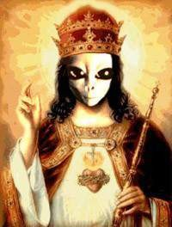
John himself. The baptism of Jesus by John is acknowledged, but given a mystic explanation. Jesus is not shown as unknowing, answering test questions from John with deep moral insight. The Mandæan tradition has its origins are certainly in Jerusalem in Judæa, and suggests John had a deep knowledge of the inner meaning of the Law. For Mandæans, Allah (Alaha) is the False God, the True God being Mana, but the Mandæans seem to be the Sabians, the Baptizers, of the Quran.

They perform elaborate baptismal ceremonies on all religious occasions and daily before sunrise. Their attachment to these lustrations gave them the name Subba or Sabians meaning baptisers. The Essenes too were said to have welcomed the
- http://www.askwhy.co.uk/christianity/0255Mandaeans.php

rise of the sun with ceremony and prayer. Note that Epiphanius identified Nazarenes with the “Daily Baptists” (Hemerobaptists). John the Baptist was himself baptised, while yet a boy, by God in His aspect of Manda d’Hayye and he then performed miracles of healing through baptism. In an account in the holy book, the Ginza, John baptised Manda d’Hayye
– the true Messiah. Mandæan lustrations had to be in running water, yardna, (a word with the same consonants as Jordan), not still water (like the Christians) which they disdained. Furthermore they were repeated immersions not just a single one by way of initiation as it is in Christianity. Again this is common ground with the Essenes, the difference arising because Jesus had decided there was no time for his converts to be fully initiated into Essene practises, so the initial baptism had to suffice provided that repentance was sincere. The Day of God’s Vengeance was too close.
Mandæan Beliefs
Mandæan cosmology does sound Gnostic. God is the King of Light who dwells in the uppermost world. The lower worlds including the earth is the home of an evil female spirit called Ruha who gave birth to countless spiritual beings, some good and some evil, but notably the Twelve, identified with the Zodiac, and the Seven, identified with the seven planets [compare to the 7 Deadly Sins]. So, between God and this world there are gradations of aeons called Utras [=messengers of God].
The evil rulers, the Archons, of the
earthly realm and the lower heavens, obstruct the ascent of the soul through the heavenly
d. The body is a tomb (soma sema) and the material
spheres to reunion with the supreme Go
world is a prison. All of the visible world is corrupt and will ultimately be destroyed. Only the Righteous can save their souls by always being moral, practising the prescribed ritual observances and acquiring revealed knowledge. Abel the Brilliant, the Mandæan Saviour, son of Manda d’Hayye (who is one of the great emanations of the Godhead), once dwelled on earth, where he triumphed over the Archons who try to keep the soul imprisoned. He can thus assist the soul in its ascent through the heavenly spheres toward its final reunion with the Supreme God.
Manda d’Hayye is “Knowledge of Salvation”, a phrase which occurs in the song of Zacharias in Luke (Lk 1:77), which we have surmised is Essene. Essene thought has the same
concept or gets close to it, the scrolls speaking of the “Knowledge of God” and “His Salvation”. The Manda d’Hayye and the light-giving powers seek to direct men and women to good actions.
The planets and the spirit of physical life incite them to error through
Those who lead a good life pass after death to a world of light, others undergo torture, but even the most evil will be purified in a great baptism at the end of the world—the equivalent of the Persian and Essene baptism with fire on the Day of God’s Vengeance. Gentile Christianity was founded before Paul among the Hellenised Jews of Palestine who were dispersed at the very start of the story by Hebraic Jews—Jews who rejected the ways and manners of the Greeks and regarded Hellenisation as apostasy. Paul naturally favoured this faction and, though the Hellenised Jews did not try to convert gentiles, Paul did. The Hebraic Christians and the Hebraic followers of John (both called Nazarenes or Nasoraeans) would have regarded this as quite unacceptable. The gospels tell us that the Jerusalem Church rejected Paul’s innovations, and the Mandæan works seem to say that the followers of John also rejected them.
Judaism, Christianity, Islam and other “false religions”.

Enosh Uthra, the Good Man
Mandæans consider the
there was a true messiah whom they called Enosh-Uthra
Jesus of the Christians as a false messiah but they accepted that
. The word Uthra which literally
means “wealth” seems here to mean “good” or “divine” because Enosh Uthra is the “divine” man or the “good man”. He came into the world in the days of Pilate, the king of the world, healed the sick and gave sight to the blind, and raised the dead. In this tradition, John does the same miracles as Jesus, contrary to the fourth gospel ( Jn 10:41) that tells us “John did no miracle”. In Christian tradition, miracles are reserved for Jesus, in Mandæan tradition, for John. He taught a dualistic philosophy of truth and error, light and darkness, and life and death by burning fire which consumes all wrong—the very teaching of the Essene brotherhood. He ordained 365 prophets to teach, and sent them out from Jerusalem. Eventually, he ascended to the Abode of Truth and will return at the End. Like the Essenes and the Persians, the Mandæans were particular about Truth.
Before Enosh-Uthra ascended to the Abode of Truth, he unmasked the Greek Christ who confessed that he was one of the Seven, the deceiving planets—he was Mercury! That's wrong. In the occult tradition Jesus was actually identified with the luciferian Venus, the Morning Star. It seems the Mandæans partly, at least, identify the Christian Jesus with Paul, the apostle. Paul was declared to be Mercury in Acts of the Apostles. Thus for the Mandæans, Enosh-Uthra,
John the Baptist - apparently an incarnation of Abel the Brilliant
- looks rather like the Jesus of the gospels but the Byzantine Christ looks like Paul. It
If John and Jesus were successive Nasis out trying to heal the Simple of
makes sense.
Ephraim, Jewish apostates, they will have had similar general characteristics, and their individual details might have been confused to some degree. Christians, for example, have tried to pretend that Jesus did not baptise when he plainly did.
Confirming it is the fact that Mandæans do not have a clear distinction between Jews and
Christians, a fact which harks back to the very earliest days of Christianity when the followers of Jesus were still Jews. In the Mandæan John-Book we meet the priest Zachariah and his aged wife Elizabeth except that her name has been corrupted to Enishbai (to reflect Enosh?). No Christian will believe that this is not taken from the first chapter of Luke, but if Luke was merely reflecting a small part of Essene history, the identity is due to their common origin. After John had spent 42 years baptising in the Jordan, the Christian Jesus (called here Nbou—Nabu, Nebo, Mercury, Hermes) sought baptism from him, but the spirit Enosh-Uthra did not require baptism (in fact, he will have been baptised by Zachariah who was his predecessor). Again, Mandæan tradition might support the idea that Jesus succeeded John as the Nasi, because John had no choice but to baptise Jesus—a voice from heaven ordered him. Why should 'God' have ordered John to baptise an evil spirit? It is an ineffectual way of explaining the plain fact that John did baptise Jesus, following erroneous 'divine' orders, but that in the Mandæan view Jesus turned out to be an evil changeling.

Though John, like Jesus, was not really a miracle worker, like Jesus he performed healings
—metaphorical ones in bringing apostate Jews back to God—and his own disciples, like Jesus’s, became convinced he was the Messiah after his death. The fourth century

Clementine Recognitions 1:60 state that John’s disciples claimed that their master had been greater than Jesus and that John was the true messiah. Rivalry between John’s followers and those of Jesus was apparent even in the New Testament. Luke 3:15 confirms that John was thought a messiah:
The people were in expectation, and all men mused in their hearts of John, whether he were the Christ, or not.

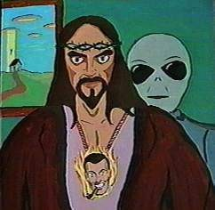
Mandæan tradition has it that John arrived in Jerusalem and exposed Jesus as an imposter, an incident that might be reflected in the New Testament when John in prison no longer believes that Jesus is the Messiah and sends a message asking whether he is the one or whether another is to be expected. This must have reflected John’s disappointment in Jesus Barabbas’s preparations for an uprising. Later Jesus failed and was crucified thus becoming a false prophet. John’s disciples will then have accused Jesus of being an imposter and claimed that John had exposed him.
John the Baptist was known by the Mandæans as “Enosh”, the reborn grandson of Adam. Enosh in Hebrew means “Man”, as does Adam, so we have the curiosity that John the Baptist was the Man and Jesus was the Son of Man! This might have been a Jewish joke. If John the Baptist played the role of the priest at Jesus’s baptism as seems likely then it would have been his voice announcing his “beloved son” as the coronation liturgy required. Thus we have the irreverent titles: the “Man” and the “Son” of “Man” or, in Aramaic pronunciation, “nash” and “bar nash”.
Did John the Baptist live longer than Jesus? The latest year of Jesus’s death is 33 AD. The Tetrarch Philip died in 34 AD on the day that John interpreted a dream for him. Herod Antipas killed John and later was defeated in battle in 36 AD by Aretas, king of the Petraean (Nabataean) Arabians, an event considered to have been retribution for John’s murder. John must therefore have been killed within a year of 35 AD, the very year that Simon Magus, a disciple of John, led a rebellion on Mount Gerizim in Samaria. Antipas was probably more absorbed by John’s potential for inflaming rebellion than he was by Salome’s dance or John’s criticism of his marital arrangements.
So – was John the True Messiah?
Although early Christians saw John as a forerunner of Jesus, the disciples of John and others did not quite see it that way. No doubt some of John's disciples did follow Jesus and some may have shifted allegiance to Jesus after John’s death, but many others continued in their allegiance to John without ever becoming followers of Jesus (the Sabeans/Mandaeans). John was not “a reed shaken with the wind” (Matthew 11:7). He was more like a mighty oak. He was not “a man clothed in soft raiment”; instead, he wore camel’s hair clothing. Jesus said of him, “A prophet? yea, I say unto you, and much more than a prophet.” According to Mandaean thinking, John was 'the True Prophet', while Jesus, a disciple of John, was 'a rebel, and a heretic, who led men astray, and betrayed his Master John.'

“... and he called the people to himself and spoke of his death and took away some of the mysteries of the (Sacred?) Meal and abstained from the Food. And he took to himself a people and was called by the name of the False Messiah. And he perverted them all and made them like himself who perverted words of life and changed them into darkness and even perverted those accounted Mine. And he overturned all the rites. And he and his brother dwell on Mount Sinai, and he joineth all races to him, and perverteth and joineth to himself a people, and they are called Christians.”
Excerpt from The Haran Gawaitha
Some Mandaeans believe that John the Baptist was Hibil-Ziwa. ‘Hibil-Ziwa’ was a Savior who entered the world of darkness and destroyed the evil spirits so that the faithful could obtain liberation before the end of the world. The following account of John the Baptist and Jesus from the mouth of Hibil Ziwa:
“In those days a child shall be born who will receive the name of John; he will be the son of an old man Zacharias, who shall receive this child in his old age, even at the age of a hundred. His mother Erishbai, advanced in years, shall conceive him and bring forth her child. When John is a man, faith shall repose in his heart, he shall come to the Jordan and shall baptize for forty-two years, before Nebou shall clothe himself with flesh and come into the world. While John lives in Jerusalem, gaining sway over Jordan and baptizing, Jesus Christ shall come to him, shall humble himself, shall receive John's baptism and shall become wise with John's wisdom. But then shall he corrupt John's sayings, pervert the Baptism of Jordan, distort the words of truth and preach fraud and malice throughout the world.”
Mandaean treatise
While Christianity presents John to have baptized Jesus, symbolizing that Jesus is his Lord, Mandean religion tells about a messenger of light that was sent to Jerusalem in order to undress the lies of Jesus. Mandaean thought is also that John Baptized Jesus into his religion. Some of the Mandaeans believe that Judas Thomas was Jesus' twin brother, a belief that was apparently shared by the early Celtic and Egyptian Christians, but they also believe that it was this Judas, not Jesus, who was crucified. Because his resemblance to Jesus was sufficient to fool Pontius Pilate who knew what Jesus looked like and was legally obliged to witness the Roman punishment of crucifixion. Jesus then posed as Thomas for the rest of his life to avoid the taint of his failure.
The Mandaeans also believe that it was Jesus, not Thomas, who was the source of the Gospel of Thomas and that ‘Jesus-Thomas’ continued to preach wherever he could that was beyond the reach of the Roman-Pauline church, ending up in India, where ungrateful Hindu priests burned him to death. For more information about Jesus in India visit our Jesus page of click here to an external link.The early church father Irenaeus wrote around 150 CE that Jesus remained on earth as a teacher for twenty years after his crucifixion. The Mandaeans tell of the founding of Jerusalem by a powerful female Goddess named Ru Ha who is viewed by them as evil. They say that Ru Ha worked evil on the Earth through

several chosen men. Her greatest evil however, was realized through one final man. At her temple in Jerusalem, a young priestess was chosen to bear a special offspring. Her name was Miriam. We call her Mary. She brought forth the ‘child of Ru Ha’, the ‘Imunel’ (Immanuel) and he called himself, Jesus. He was baptized by John and taught much by him. He turned from John’s teachings and led the people astray, the Mandaeans claim. Is there any Biblical evidence supporting this?
Mark 6:17: ‘For Herod himself had sent forth and laid hold upon John, and bound him in prison for Herodias’ sake, his brother Philip’s wife: for he had married her. 18: For John had said unto Herod, It is not lawful for thee to have thy brother’s wife. 19: Therefore Herodias had a quarrel against him, and would have killed him; but she could not: 20: For Herod feared John, knowing that he was a just man and an holy, and observed him; and when he heard him, he did many things, and heard him gladly.’

The above verse is very important. From it, we can see that Herod, counter to what you were led to believe, knew John was sent to perform a holy mission. He thought John a good man, and listened to him gladly. We are also told that John opposed Herod’s marriage to Herodias. John was very close to the King Aretas. His followers would later settle and remain in Arab lands.

Mark 6:21: ‘And when a convenient day was come, that Herod on his birthday made a supper to his lords, high captains, and chief estates of Galilee; 22: And when the daughter (no name mentioned) of the said Herodias came in, and danced, and pleased Herod and them that sat with him, the king said unto the damsel, Ask of me whatsoever thou wilt, and I will give it thee. 23: And he sware unto her, Whatsoever thou shalt ask of me, I will give it thee, unto the half of my kingdom. 24: And she went forth, and said unto her mother, What shall I ask? And she said, The head of John the Baptist. 25: And she came in straightway with haste unto the king, and asked, saying, I will that thou give me by and by in a charger the head of John the Baptist. 26: And the king was exceeding sorry; yet for his oath’s sake, and for their sakes which sat with him, he would not reject her. 27: And immediately the king sent an executioner, and commanded his head to be brought: and he went and beheaded him in the prison, 28: And brought his head in a charger, and gave it to the damsel: and the damsel gave it to her mother. 29: And when his (John’s) disciples heard of it, they came and took up his corpse, and laid it in a tomb. 30: And the apostles gathered themselves together unto Jesus, and told him all things, both what they had done, and what they had taught. 31: And he said unto them, Come ye yourselves apart into a desert place, and rest a while: for there were many coming and going, and they had no leisure so much as to eat. 32: And they departed into a desert place by ship privately.’

Look at the above verses very carefully. Herod has promised his wife’s daughter anything, even half his kingdom. She consults with her mother Herodias and they decide for some unexplained reason to kill John, and remove his influence completely. Now notice that Herod is very sorry at having to do this. Not only from his affinity for John, but he is also worried about retaliation from John’s followers, and from King Aretas. Nevertheless, he

carries out her wishes. Now look again at verse 30 above; ‘And the apostles gathered themselves together unto Jesus, and told him all things, both what they had done, and what they had taught. These are Jesus’ followers who are now telling him why it was necessary to kill John. Note that the disciples who took John’s body were John’s disciples, not Jesus’. The disciples who took John’s body and the apostles who speak to Jesus are two separate groups. The taking of John’s body was not the actions the apostles were referring to. It was his execution, and what they had taught was a lesson to all those who would oppose them, not to interfere with their plans. Of interesting note and rendered in bold above is that Herodias’ daughter is not mentioned by name. All important people are named in every other place in the Bible. Why not her? She is certainly an important person. She was responsible for John’s death. Why did they remove her name? Her name is Salome.

Mark 15:40 ‘There were also women looking on afar off: among whom was Mary Magdalene, and Mary the mother of James the less and of Joses, and Salome; 41 who, also when he was in Galilee, followed and ministered unto him...’

Mark 16:1 ‘And when the Sabbath was past, Mary Magdalene, and Mary the mother of James, and Salome, had bought sweet spices, that they might come and anoint him.’

The Salome in the above verses, was one of Jesus’ most loved and trusted followers, is the same Salome we have been talking about.
This is one of the main reasons the Sabeans
despise the Christians, they believe that through the machinations of Jesus and his

We learn a little about John from the writings of Josephus, a Jewish historian born shortly after Jesus died. He says:
followers, their true messiah, John The Baptist was killed!!!!
Now some of the Jews thought that the destruction of Herod's army came from God, and that very justly, as a punishment of what he did against John, that was called the Baptist: for Herod slew him, who was a good man, and commanded the Jews to exercise virtue, both as to righteousness towards one another, and piety towards God, and so to come to baptism; for that the washing [with water] would be acceptable to him, if they made use of it, not in order to the putting away [or the remission] of some sins [only], but for the purification of the body; supposing still that the soul was thoroughly purified beforehand by righteousness. Now when [many] others came in crowds about him, for they were very greatly moved [or pleased] by hearing his words, Herod, who feared lest the great influence John had over the people might put it into his power and inclination to raise a rebellion, (for they seemed ready to do any thing he should advise,) thought it best, by putting him to death, to prevent any mischief he might cause, and not bring himself into difficulties, by sparing a man who might make him repent of it when it would be too late. Accordingly he was sent a prisoner, out of Herod's suspicious temper, to Macherus, the castle I before mentioned, and was

there put to death. Now the Jews had an opinion that the destruction of this army was sent as a punishment upon Herod, and a mark of God's displeasure to him.
Josephus implies that Herod executed John for political reasons, but as stated above Herod was sad at having to kill John not only from his affinity for John, but he was also worried about retaliation from John’s followers, and from King Aretas. We therefore disagree with Josephus’ statement, though to be sure it lends credibility to the Biblical version.

False Prophet - Liar, Fraud!24

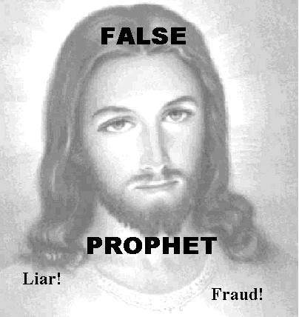

Jesus made several prophecies (24th chapter of Matthew) that later proved false. He predicted to the people of that ancient era the rapture (v. 31), the "end of the world" (v. 3,13), Judgment Day (v. 50-51), and THE Second Coming (v. 30), would all occur within their lifetime (i.e. within the First Century), they would live to see it all before they died. Jesus told them "ALL these things will happen before the people now living have all died." Another translation words it "some of the people of this generation will still be alive when all this happens" while a third renders it "… while the people of this time are still living!" Elsewhere Jesus predicted to his disciples that he was "about to come …with his angels, and… reward each one according to his deeds (i.e. judgment day). I assure you that there are some here (i.e. in 33 AD) who will not die until they have seen the Son of Man [Jesus] come as King." Jesus promised that not only would The Second Coming occur within the lifetime of his First Century disciples, it would even occur within the lifetime of Caiaphas (who tried him) and the Roman soldiers (who crucified him).

As evidence his disciples took him at his word, we find this doctrine being put into practice in the early Christian community. Believing the end of the world to be approaching, Jesus had told his disciples to get rid of all their possessions (as did the Millerites under similar delusions, in the 1840's). This they gladly did after Jesus' death. And the Apostle Paul ordered Christians not to waste time getting married for "considering the present distress, I think it is better for a man to stay as he is …don't look for a wife. …There is not much time left … For this world, as it is now, will not last much longer."
These doctrines made sense because they trusted Jesus about the "end of the world" being imminent. Modern churches aren't so trusting; they've done a 180° on Paul (weddings now

- http://www.jcnot4me.com/page23.html

providing big revenue, and they love $$$ more than Paul), as well as a 180° on Jesus' command to impoverish oneself (teaching just the opposite- be a good Republican & stuff your pockets as much as you can while screwing the poor).

C.S. Lewis, the popular Christian author, wrote in one of his last books " The World's Last Night"25, that...

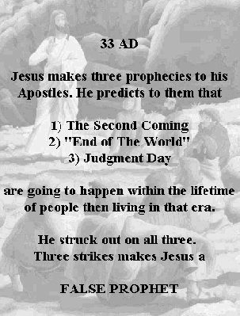"…there is worse to come. `Say what you like' we shall be told, `the apocalyptic beliefs of the first Christians have been proved to be false. It is clear from the New Testament that they all expected the Second Coming in their own lifetime. And, worse still, they had a reason, and one which you will find very embarrassing. Their Master had told them so. He shared, and indeed created, their delusion. He said in so many words, this generation shall not pass till all these things be done. And he was wrong. He clearly knew no more about the end of the world than anyone else.' It is certainly the most embarrassing verse in the Bible. …The one exhibition of error and the one confession of ignorance grow side by side.
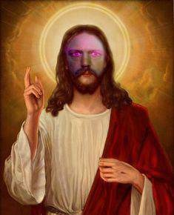
…The facts, then, are these: that Jesus professed himself (in some sense) ignorant, and within a moment showed that he really was so."

- Lewis, C.S. - The World's last Night. And Other Essays. p. 97 to 100

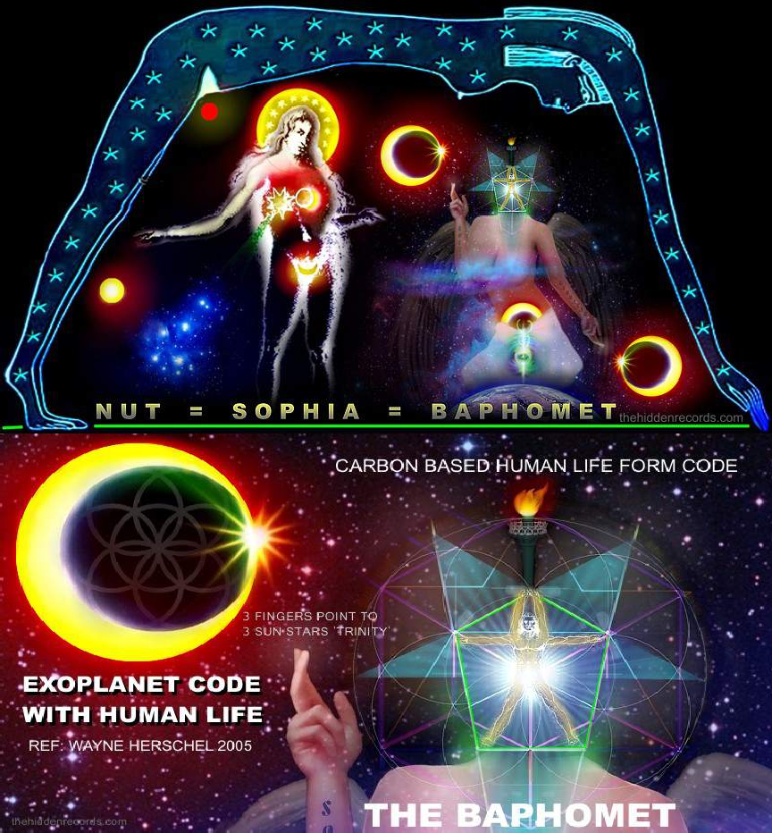

THE GREAT ESCAPE THE GREAT ESCAPE THE GREAT ESCAPE
GNOSTIC ROADMAPS INTO THE AFTERLIFE

THE GREAT ESCAPE
THE GREAT ESCAPE THE GREAT ESCAPE THE GREAT ESCAPE

REGULATORY SCHEME OF REALITY1
(The Matrices Model)
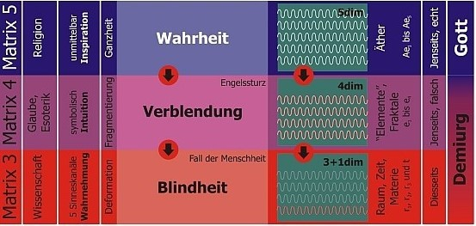

Matrix 5: Truth – (Religion through direct Inspiration, Wholeness) Afterlife, Real: God
Fall of Angels
Matrix 4: Infatuation – (Faith, symbolic Intuition, Fragmentation) Afterlife, False: Demiurge
Fall of Man
Matrix 3: Blindness – (Science, 5 Senses Perception, Deformation) This Life: Demiurge

What is the regulatory scheme of reality about? It deals with the relationship between truth and reality. The core message is that as a human being one can live in three realities - and that two of these three realities are untrue and only one is true. The distribution is extremely unfavourable: almost all people live in an almost completely untrue reality. My fateful and self-chosen task was to do everything in my power to change this. This was and is a Christian task. Let us come to the model: The three realities mentioned are called matrices in the regulatory scheme. Each matrix is a space of consciousness and can be a living space. In these matrices there are different perceptual accesses to the outside world (actually constructions).

Matrix 3 is the world as everyone knows it: through the five senses a reality is conveyed which makes a world experience in space, time and matter possible. This world experience is normal, but it is not true. The phenomena of this matrix are caused through a state of being fallen twice (!) by the living beings bound to it. Matrix 3 is the world of human beings.

Matrix 4: only some know this world. In it, the outside is no longer perceived logically
1 Ralf Maucher - http://erleuchtungspsychologie.de/

discriminating through the senses, but intuitively and symbolically. The space-time- matter-structure here is much less pronounced. In it the world works fractally, the elements "fire, water, earth, air" prevail. Ideally, it is the world of the wise ones. Then it can already contain a high proportion of truth. This Matrix 4 has also fallen, but has an immediate possibility to return to God. Then, when it is lived wisely. But if one works magically or is in the wrong belief system, the return is excluded. Only on Matrix 5 do truth and perception coincide: The reality of God has been reached - and the levels of the fallen corruptions of experience have been left behind. Matrix 5 is the world of the ether and the angels.

The regulatory scheme of reality also provides information on how the spaces of consciousness and the habitats are built generatively in each case. Starting from 5 independent "carrier waves" of reality, the three matrices are generated. The pure and true Matrix 5 is based on the unadulterated and independent original waves. On Matrix 4, one of the five waves couples into the others and thus creates a fractal reality, thus distancing reality from the truth of God. On Matrix 3, the separation becomes even stronger: two of the five carrier waves collapse. The remaining 3 create space phenomena. The two collapsed ones create time. One can therefore describe the regulatory scheme of reality as 5-dimensional - or also as 13-dimensional. The first designation is then correct, if one proceeds from independent dimensions - and the second, if one proceeds from the observed dependent dimensions.

Also the question, who produces these realities why and how, is explained in principle in the model. One can assume that Matrix 4 was originally a purification space for angels with hierarchy problems (fallen angels). But it was manipulated, and another matrix was separated from it, namely Matrix 3. Under the guidance of a Demiurge (= adversary), entities reign which have fallen out of the divine creation space and have changed Matrix 4 in such a way that it has a leak in the direction of Matrix 3 and thus catharsis is practically no longer possible. The principles with which the Demiurge works on the soul level are fragmentation and deformation. They are the causes for the phenomena known from psychology: division and defense, repression, denial and above all projection. Accentuating: Fragmentation takes place on Matrix 4. Fragmentation and deformation on Matrix 3.

With the splitting into the unconscious and the conscious, the living beings on Matrices 3 and 4 are no longer able to recognize the truth out of themselves and react to the false realities presented to them with a deformed and fragmented mental system. This leads to a constant continuation of the wrong way and of apostasy. The living beings in these habitats no longer recognize what the actual task and the only chance would be: namely return to the origin, to God. On Matrix 3 this would first of all be a restoration of the principle of nature, and on Matrix 4 a restoration of the principle of creation. Collectively or individually. In order for this return, if not collectively, then at least for some to become possible, an orientation system like the "regulatory scheme of reality" is needed, which just explains the distance of truth to reality and gives help to recognize this distance in the particular life situations - and also to reduce it.

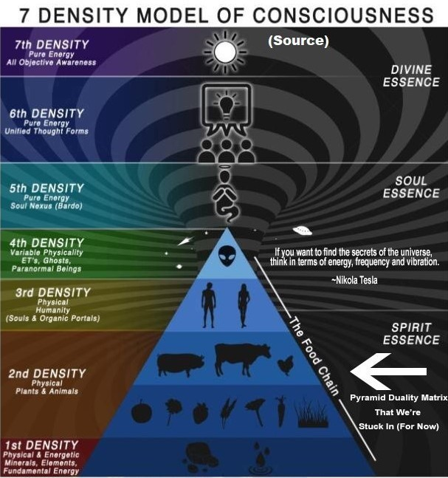

Density-of-consciousness model from in5D.com

On earth we live in a fallen world. 300.000 years ago our solar system was conquered. This was the 2nd fall. Our consciousness became 3D Service To Self. In order to ascend to God, we have to become Service To Others. The 1st fall occured at the beginning of the universe when we fell into matter. There would be no physical matter without the fall of angels. God is not the creator.

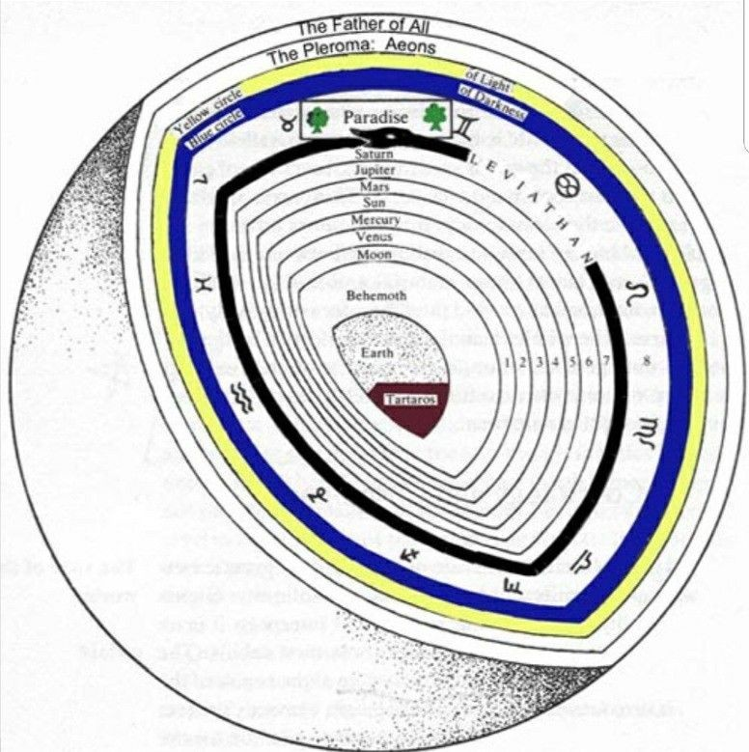
Diagram of the Ophites

In the ptolemaic system the planets are central points on gigantic crystal spheres which are ruled by Archons. This posed a problem as to how the escaping spirits should get through each of the transparaent spheres to reach the Pleroma. Only the Christ-Logos leads you safely away from the planetary Archons and their minions. The diagram of the Ophites places Leviathan at the end of the solar system, near to the Heavenly Waters. Leviathan is the Ouroboros. He is the final frontier in the afterlife that has to be crossed on the way to God.

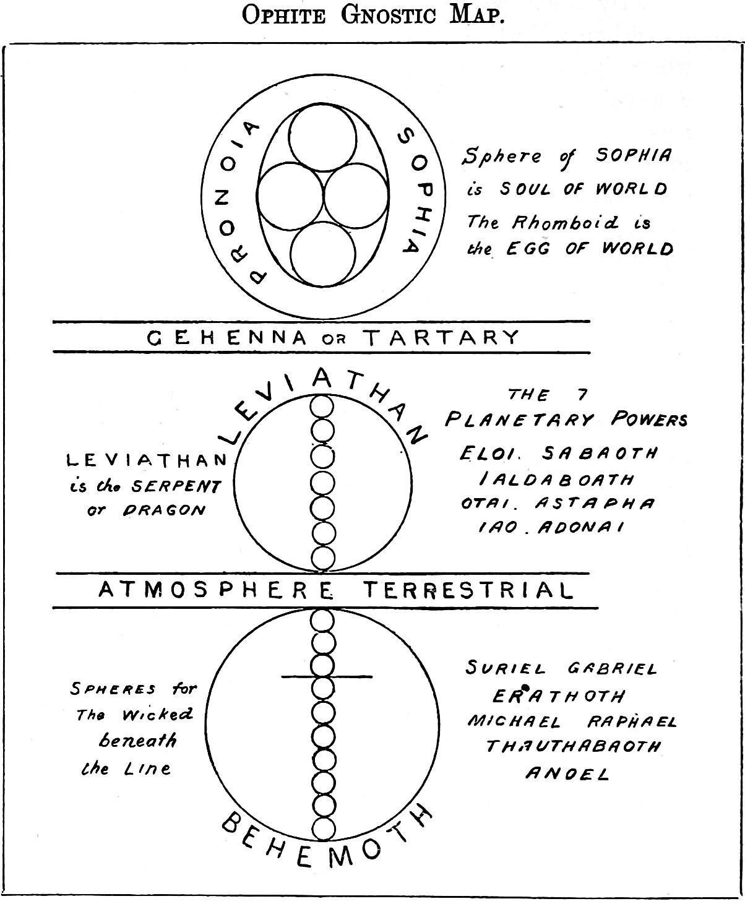

Ophite gnostic map, from Researches into the Last Histories of America by W. S. Blacket, 1883.

Sophia, the „World Soul“, is a fallen angel. The physical world is the creation of a Demiurge. Leviathan is „the serpent“ or „the dragon“. He's got our solar system trapped in his claws. We literally exist in the belly of the beast. While Gabriel et al. keep the soul-trap running down here on earth.

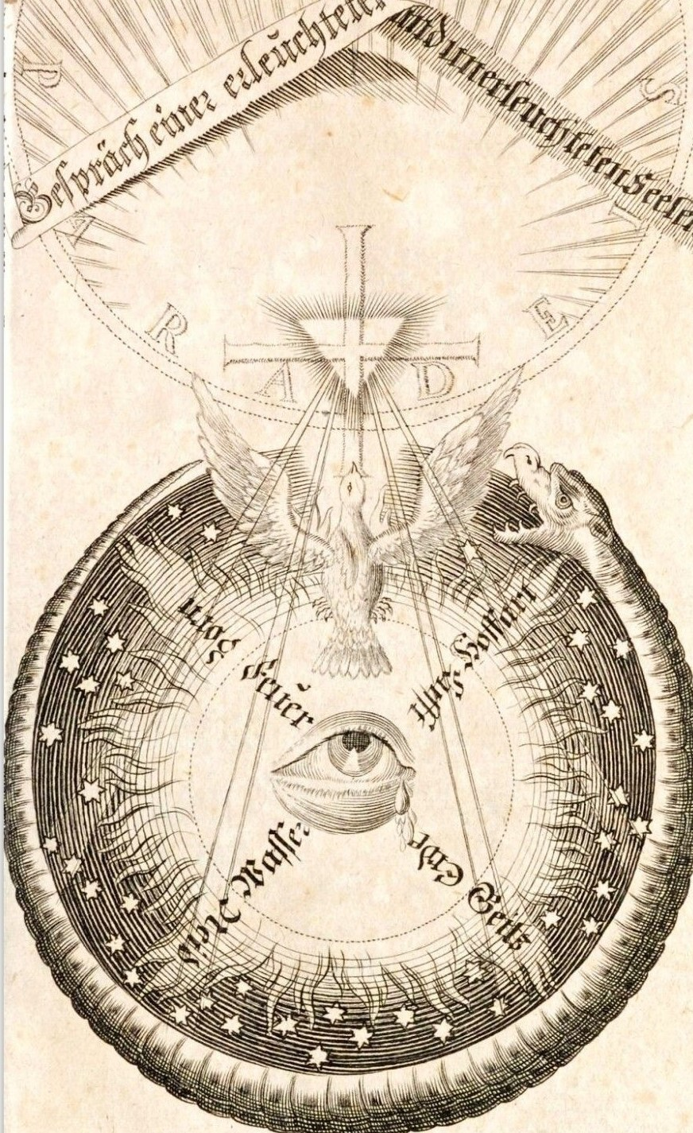

Jakob Boehme: The soul frees itself like a phoenix from the realm of the demiurge into the arms of Christos. The all-seeing-eye rules over 4 elements (fire, water, air, earth) and over 4 Deadly Sins (wrath, pride, greed, envy).

THE WAY BACK TO GOD

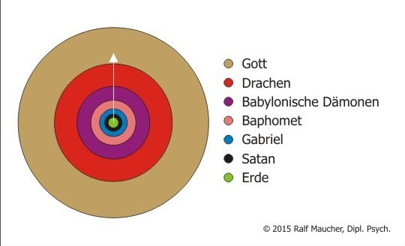
In the following I present a graphic, sketching the way back to God. As the gnostic explanations suggest, this can only be a map of consciousness in relation to earthly existence. So it describes the space of consciousness, not the living space. Such pictorial and verbal representations always have a certain blurriness due to dimensional reduction. For example, the two belts „SATAN“ and „DRAGONS (Drachen)“ are connected in a way as it is described in the blog under the labels 666 and 999. I would like to talk briefly about the DRAGONS: While the belts underneath are directed forces (they lead downwards and create delusion, cf. "seduction"), the DRAGON belt is basically neutral, but it is a very strong force ("elemental force").
GOD DRAGONS BABYLONIAN DEMONS BAPHOMET GABRIEL SATAN EARTH
SATAN, in his aspect dependent on BAPHOMET, is a problem that every soul must solve on its way back to God. But it is not the only problem, nor is it the biggest. Whoever has a one- sided fixation on SATAN as "the evil one" usually shows that he is
✗ projecting
✗ stupidly or maliciously simplifying
✗ selectively demonizing in this way and
✗ not recognizing the true extent of the difficult parts of reality.

Who sees SATAN in others and not in oneself, and who does not recognize more and bigger devils and demons than SATAN, stands in the initial suspicion of disguising something [in his shadow] and not wanting to do his essential work at all.

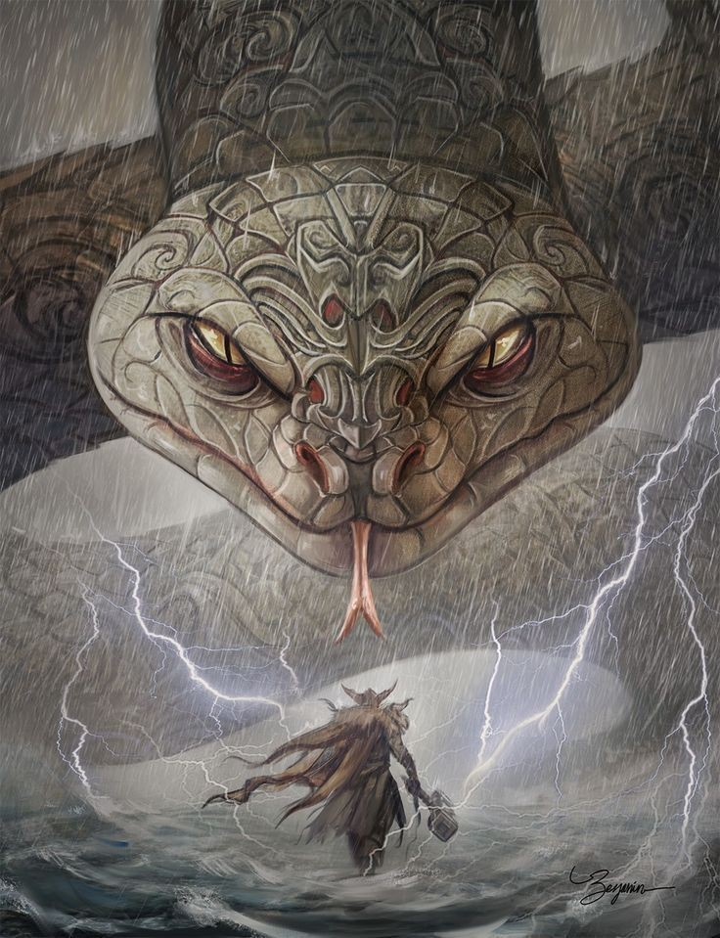

In myth, Thor kills Jörmungandr (Leviathan), the „Ouroboros“ of our realm border. In reality, Odin, in his holy rage, will kill this beast at Ragnarök and thus destroy the boundaries of this matrix, giving all trapped souls the opportunity to ascend to the Higher Heavens.



T H E S E S
- WUOTAN IS THE GERMANIC VARIANT OF THE CHRISTIAN SATAN, EXPRESSING ANGER AND AGGRESSION.

- THROUGH THE TRANSFORMATION OF WUOTAN TO ODIN, THE ANGRY ONE BECOMES THE WISE ONE, AND A PRIMORDIAL FORCE COMES TO THE LIGHT.

- THE COMBINED FORCES OF ODIN (INDIGENOUS PEOPLE), JOHN (UPLINK TO THE MOST HIGH GOD) AND MERLIN ARE SAID TO PLAY A CRUCIAL ROLE IN THE LIBERATION OF HIS VOLK (=SOUL GROUP).

- ODIN DOESEN'T REDEEM A PERSON. BUT CONVERSELY MAN CAN REDEEM ODIN BY FACING IT'S OWN SHADOW OF THE (SATANIC) SOUL-ROOT.

- FROM THE OVERSOUL OF “CHRISTOS ODIN“ HE GETS SUPPORT OF MERLIN AND JOHN. IF THERE IS NO BAPTISM OF ODIN, THE FALL OF MAN WILL CONTINUE.

- IF THE EXAM IS PASSED, ODIN WILL SMASH LEVIATHAN, THE OROBOROS AROUND OUR SOLAR SYSTEM, AND THUS FREE US ALL.

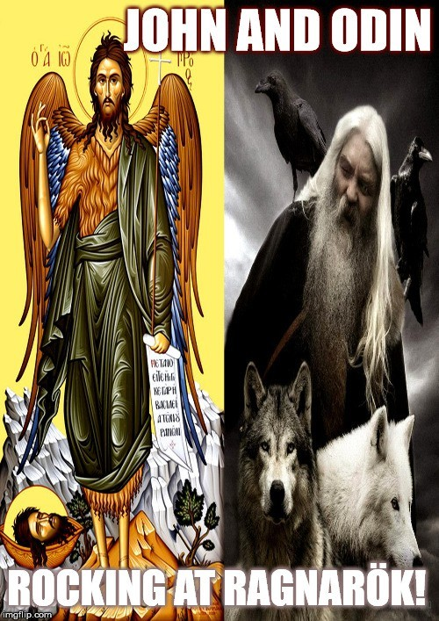



PRIMEVAL SOURCE, DEMIURGE, ARCHONS
The physical cosmos has a different origin than the Primeval Source with its spheres (Megagod Souls). The world religions do not automatically connect with Primeval Source.

Simplified classification of the worlds:
- Above all is Primeval Source with its spheres / Aeons / Megagod Souls. This is the upper heaven, or the true spiritual world.
--------------------------------------------------------------------------------
Between the Primeval Source and the second polar creation matrix there is a curtain of separation, in this curtain there is an "Eye Of a Needle" leading to the Primeval Source.
--------------------------------------------------------------------------------
- The second polar creation matrix (created by the first great renunciation of some Megagod Souls, which then became adversary forces), which is divided into the worlds (e.g. earth) and the dimensions (near-earth dimensions including astral planes).
- The dimensions of the Archons (lower heaven) follow after the dimensions near to earth.

Beings like the Demiurge, Lucifer, Satan, Ahriman, Beelzebub, Hermes Trismegistos, Mammon etc. are different adversaries with different negative qualities; they have incarnates on earth (and other planets), they also created souls, some animal species and the physical body. The Demiurge created Archons, angels and other forces, some of these angels rebelled against the Demiurge. The physical worlds partly have structures from the Primeval Source, but they are changeable and imperfect.

SOUL TRAPS

There are different kinds of soul traps:
- The soul traps preceding material planets, are used by the Archons to attract souls (the cry for help from a planet or by souls from there is already part of the trap)
- At the incarnation in the physis, various veils are installed by the Archons (physical veils in front of the eyes, ears, around the glands; emotional veils; karmic veils; spiritual veils); all kinds of chips, implants, enslavement programs are installed; doors are blocked and sealed in the mental space; energy sheaths are placed around the large organs, which have connections to the archontic matrix and prevent free flow of energy in the body
- The light souls are divided (into male/female and into different parts) and are forcibly incarnated on different worlds.
- The light at the end of the tunnel - here souls are intercepted and incarnated back into the physis.
- The karma trap - false karma is presented to the souls and thus false guilt is created, making them want to incarnate again to compensate for it, thus becoming more deeply entangled.
- The traps in the astral planes – beautiful but false places are shown this souls and they are magically bound to these locations; sometimes this already begins in life e.g. by the action of a charismatic guru.
- The Archons-matrix - a subtle web in which soul parts (suspended from the back) are held in subtle spaces and programmed with various programs; this web extends into the physical body and is attached to the spine, it activates itself anew in every incarnation until the soul part is freed from it, the activation begins already in childhood.
- The Archons have laid a subtle web around the Earth to hold back souls.

GLOSSARY26

AEON; These are the emanations from first cause, God. The word not only refers to the "worlds" of emanation, but to the personalities as well. Sophia, Logos, and the other high principles are aeons.
ALLOGENES; Means "alien". The existance of spiritual force in the material realm is "alien" to it. This includes both aeons, such as the Logos, as well as the Gnostic him/her self.
ANTHROPOS; "Man". This is the cosmic human as well as the philosophical form of the regular human. More on the Anthropos
ARCHIGENITOR; The "first begetter". A Greek reference to Yaldabaoth.
ARCHON; "Ruler". Refers to the creators and governing forces in the material world. The Demiurge and his angels.
AUTOGENES; "Self Generated" is a reference to the first Aeon or the guiding light (Barbelos). More on The Autogenes
BARBELOS; This word has been used in different ways, creating some confusion. Generally it is the first aeon. It is in the masculine gender but is used to denote Sophia. As the woman who is "the first male virgin", she has an androgynous connotation.
BYTHOS; the "Void". Its the "primal ground" and the pre-beginning forefather.
CHOIC; "Earthly" same as "hylic".
DEMIURGE; The "Craftsman" or creator of the material world. Usually viewed in a negative fashion. If nothing else, the material is less than the spirit so that the creator is lower than the prime source.
EPINOIA; Means "insight"/"wisdom" as it comes from the higher connections of spirit. Without it one cannot gain Gnosis.
GNOSIS; While the literal translation for this word is "knowledge", it's meaning is closer to "insight" or, to use a more modern concept, "enlightenment". Rather than purely an intellectual understanding then, it is a "knowledge of the heart" (which is not meant to imply mere emotionalism) or wisdom. It is the complete comprehension that comes from both rational and intuited means. More on Gnosis
HEBDOMAS; The kingdom of the "Seven", referring to the spheres of the planets and thus the Archons and heimarene.
HEIMARENE; Literally "destiny". Hylics are controlled by the spheres of the stars, which represent different base drives. Destiny does not apply to the pneumatic, who has broken past such connections.

26 Based on: http://www.kheper.net/topics/Gnosticism/glossary.html

HYLIC; "of matter". One of the three aspects of existance, deals with the lowest portion of human nature. The world and the instinctual drives with no sublimation. Or: One of 3 types of humans, people with no soul potential at all.
LOGOS; often translated as "word", it's true meaning is much more multifunctional (a better translation would be "reason"). The Logos is the light that gives Gnosis via communication. It is the Christ (not to be confused with Jesus). First there was a thought, then the word. We pass on knowledge in this world through words. It is something that gives us guidance by "seeing" or a certain amount of comprehension.
NOUS; "Mind", The soul, which is not the same as the pneuma or spirit. It is the part of the anima that gives us conciousness. The anima as a whole gives life (or literally movement.. "animates") to our bodies.
OGDOAD; This is the "eighth" kingdom above the hebdomas (7). It is the realm of the Demiurgos (or sometimes that is the 7th, with the eighth being that of Sabaoth), as well as usually being the realm of the zodiac (dodecon). Sometimes it is also seen as the beginning of freedom from the Archons, and the beginning of connection to the Aeons.
OUROBOROS; a serpent biting it's own tail. It implies infinity. Or, possibly, eternally being stuck in the material cycle. Or: A realm-border, that prevents mankind from escaping.
PARAKLETE; "Comforter". This is a familiar word used for the Holy Spirit or for the Logos.
PHARMAKEIA; Is roughly equivalent to witchcraft. Contrary to the accusations of the heresiologists, Gnostic writers seemed to be against any form of sympathetic magic or divination. The reason for this is not that it doesn't necessarily work, but that it's focus is still within the hylic and psychic spheres of thought. ESP, astrology etc are only applicable to the realm of Heimarene.
PISTIS; "Faith".
PLEROMA; The word means "fullness". It refers to all existence beyond matter but not including Bythos who is beyond it. In other words it is the world of the Aeons, the heavens or spiritual universe. More on The Pleroma
PNEUMATIC; One who identifies with the spirit (pneuma) as opposed to the material world (hylic) or the intellect alone (psychic). The pneuma is the spark (spinther) that came from and is drawn to reunite with the Father. One who awakens it within the self does it through gnosis.
POIMANDRES; "Good Shepard" This is a reference to the first androgynous emanation which guides us back. A Hermetic (rather than Gnostic) term that is basically a Sophia and a Logos.
PRONOIA ; "Providence"
PRUNIKUS; "Whore" Sophia is sometimes referred to as "Pistis Sophia Prunikus". The fallen Sophia.
PSYCHIC; This level of thinking is the one right above "hylic". It's drive is the intellect, or

normal understanding of the mind.
SAKLAS; Literally means "fool". It is another name for the Demiurge.
SAMAEL; The word "Samael" means "blind god" and is another name for the Demiurge.
SARKIC; "Fleshly". Same as "hylic".
SETHIAN; It is a name for a specific sect of Gnostics, but also a category created by scholors to refer to a number of sects that are similar in their difference to Valentinians More on the Sethian Gnostics
SOPHIA; Means "wisdom". Like the Logos this is a primal form. While the Logos is personified as male, Sophia is female. Logos has a direct and intellectual basis for guidance, Sophia is inspirational (sometimes even sensual). The basic idea is comparable to the Shekinah, or "Holy Spirit".
SOTER; "Savior" is a name for the Logos.
SPINTHER; The "spark" or "splinter" that is awakened with Gnosis is the spirit (not the same as soul see "nous"), which is a piece of the divine source. Also see "pneumatic".
SYNESIS; Means "insight" in a relization of the physical inter-workings and is an aspect of Gnosis. It is one of the lower powers that was bound into man from the Aeons, by the Demiurge.
SYZYGOS; Literally means "consort". Sometimes used to refer to the twin. Is generally meant to imply the thing to which one is driven to connect with. A person's syzygos is their spirit. Sophia's mistake was said to be her drive to create without her syzygos.
YALDABAOTH (Ialdabaoth Jaldabaoth); From the Aramaic, meaning "begetter of the Heavens". A name for the Demiurge.
ZOE; Means "Life" and is usually equated with "Eve" which means the same thing. This is essentially the fallen Sophia.

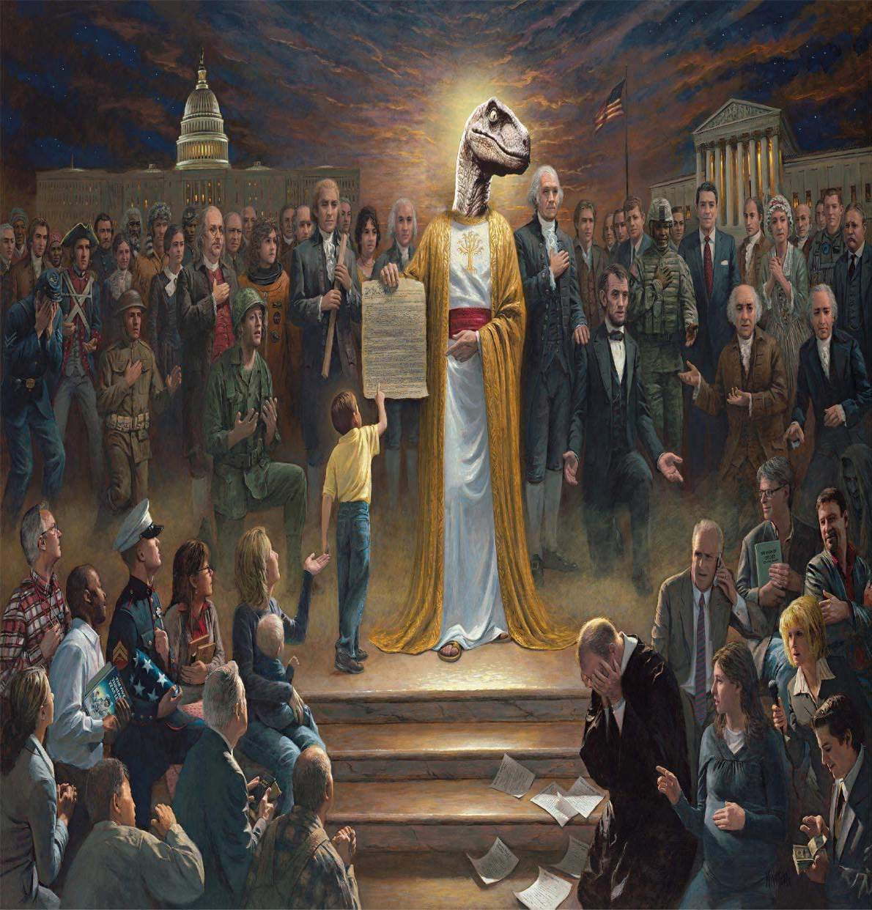

READING LIST + REFERENCES

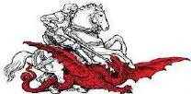

U F O s A N D A L I E N S

Bramley, William – Gods of Eden

Dolan, Richard - UFOs and the National Security State: Chronology of a Coverup, 1941-1973 Dolan, Richard - The Cover-Up Exposed, 1973-1991 (UFOs and the National Security State, Vol. 2)

Guenther, Bernhard – Piercing the Veil of Reality. UFOs, Aliens and the Question of Contact

Keel, John– Operation Trojan Horse Keel, John – The Eighth Tower

Knight-Jadczyk, Laura - High Strangeness: Hyperdimensions and the Process of Alien Abduction Knight-Jadczyk, Laura - Riding the Wave: The Truth and Lies About 2012 and GlobalTransformation Knight-Jadczyk, Laura - Soul Hackers: The Hidden Hands Behind the New Age Movement
Knight-Jadczyk, Laura - Stripped to the Bone: The Path to Freedom in the Prison of Life Knight-Jadczyk, Laura - Petty Tyrants & Facing the Unknown
Knight-Jadczyk, Laura - Through a Glass Darkly: Hidden Masters, Secret Agendas and a Tradition Unveiled

Tapestra, Angelico – The Universal Seduction. Piercing the Veils of Deception. Vol 1 - 3

O C C U L T B A C K G R O U N D

Jesus, John the Baptist, the Mandaeans, and the real Christ

Knight-Jadczyk, Laura – Organic Portals. The Occult Reason for Psychopathy Knight-Jadczyk, Laura – Secret History of the World Vol.1-3

Lorgen, Eve - The Love Bite: Alien Interference in Human Love Relationships
Lorgen, Eve - The Dark Side of Cupid: Love Affairs, the Supernatural and Energy Vampirism

Mouravieff, Boris – Gnosis Vol 1-3

Wolf, Stan – Gems of Dominion. Mysterious Mount UntersbergVol 1+2

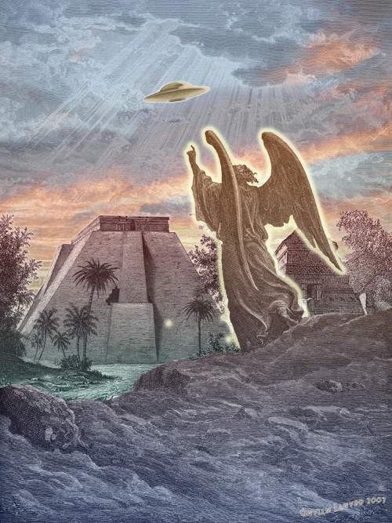

S U G G E S T E D R E A D I N G

