MUDRA VIGYAN: The science of finger postures | Version française (doc format)
Guhyam brahma tadidam braveemi.
Nahi maanushaa shreshthataram hi kin chit.
(No visible or invisible power can compare with the enormous inherent power possessed by man)
What are Mudras? How do we define them?
Where and how Mudras originated
Mudras in Therapy
A Scientific look
YOGA TATVA mudra vigyan
Most commonly known mudras and how they affect the body

What are Mudras? How do we define them?
As per Eastern philosophies and culture and Yogic practices, 'Mudras' are systematic hand gestures. Literally, Mudra in Sanskrit means a posture/seal.
More deeply, "closed electrical circuits" of the subtle channels in physical and etheric bodies are also known as 'Mudras'.
Some Western writers have defined 'Mudra' as mystic hand gestures used to focus subtle energy, transmit teachings through symbols and confer psychic protection.
Chogyam Trungpa says Mudra is "a symbol in the wider sense of gesture or action………Also it is a symbol expressed with the hands to state for oneself and others the quality of different moments of meditation……."
Leaving aside the complex definitions offered by various people and sects, we will summarise to say that:
Mudras are a non-verbal mode of communication and self expression consisting of hand gestures and finger postures. They retain the efficacy of the spoken word. It is an external expression of inner resolve, suggesting that such non verbal communications are more powerful than the spoken word.
In Yoga mudras denote the finger and hand gestures and movements used in the performance of dances, rituals and rites and while engaging in spiritual exercises such as meditation. Mudras symbolically express inner feelings and inner psychological states. They also generate various qualities such as fearlessness, power, charity and peace in the practitioner and to on-lookers.
The Gherand Sanhita and the Vajrayana Tantra advise that the Mudras are capable of bestowing great powers and psychic abilities called "Siddhies" on their practitioners, hence, their knowledge should not be conveyed to those steeped in sin, to those that are not true to their word, to the skeptics and non believers, to heretics and insincere persons and those who do not observe the precepts.
Mudras have therefore always been considered an esoteric science and even as of date there are thousands of Mudras that are not available to the uninitiated (like in the Chen Yen Buddhism or True Buddha Schools). However, besides the mudras providing spiritual gains, there are mudras which are likewise of tremendous value in therapy. Constant researches by the dedicated have brought a large number of these to the fore although we still seem to be scratching the surface only of this sea of knowledge.
Where and how Mudras originated
No one knows for sure where and how mudras originated. They have been in use for millenniums. They have not ben known to adhere to any barriers . They have been found in all continents, practiced by people of all religions and those professing none. They are as natural to the body as the daily needs of the body. All that was required was to recognize them, identify them and scientifically understand and use them.
- In the Orient these can be observed in the rituals and rites of the rich cultural traditions of Hinduism and Buddhism in India, Tibet, China, Japan Indonesia etc. The paintings in the caves of Ajanta and sculptures in the Ellora caves, dating back to 2nd. and 1st. centuries BC show innumerable mudras.
Hinduism shows the earliest recorded knowledge and analysis of Mudras. The earliest documentations are found in Mantra Shastra (the book of incantations), Upasana Shastra (the book of worship and prayers) and the Nritya Shastra (the book of classical dances). The following verse from Srimad Bhagwad Gita mentions that Lord Krishna was in the posture of Gyan Mudra when he bestowed the knowledge of Gita to Arjuna.
Prapannapaarijaataaya totravetre paanaye,
gyaan mudraaya Krishnaaya geetaamritaa duhe namah
- In Jainism, Swami Mahavir Jain and in Sikkhism, Guru Nanak Devji are always shown in Gyan or Dhyan Mudra.
- In the Occident, cheironomy is the science of hand gestures (mudras). In Christian art Jesus, John the Baptist and Virgin Mary are shown in various Mudras. Reference may be had from the book "The sign Language of the Mysteries" by J.S.M.Ward. Even today, the sign used by the priests of Catholic Churches while blessing the devotees, is what is shown elsewhere in this article as "Mahagyan Mudra"
- Egyptian hieroglyphics are a virtual treasure house of mudras. The postures of their kings and queens even as mummies show them holding mudras.
- The Babylonian sun God Damuzi depicts Mudras while descending into the underworld.
- In Islam, the mystical Whirling Dervishes used Hand signs or Mudras for various rites and rituals.
- Roman art is replete with mudras.
Man only has that supreme power in his soul, that when scientifically endowed with Yoga, can help him achieve all the three sublime powers - the physical, mental and spiritual. All that is needed is the guidance and the rules of Dhyana (meditation) and Practice (sadhana)
There are various supreme sciences for the investigations on and into the human mind and body. Some of these are:
Mudra Vigyan | The science of finger postures
Kayakalpa Vigyan | The science of rejuvenation
Brahma Vidya | Divine knowledge - theosophy
Pranvinimaya Vidya | The science of curing the sick and the defective
Surya Vigyan | The science of solar energy
Punarjanma Vigyan | The science of reincarnation
Deerghayu Vidya | The science of longevity
Swar Vigyan | The science of sounds
Rasayan Vigyan | The science of Alchemy
Mantra Vigyan | The science of spiritual incantation
Samyad Preshan Vidya | The science of Telepathy etc.
There are many many more covering all aspects of science known to man today and those that modern science still has to discover again.
YOG TATVA MUDRA VIGYAN or in short, the more commonly known MUDRA VIGYAN is an entirely distinct and independent branch of yoga. This is the science of finger postures, based on Yoga of elements that go to create the human body. The science that can help raise the human being to achieve almost divine powers and keep the body perfectly fit.
Mudras in Therapy
We have mentioned earlier that The World Health Organisation defines good health as:
" A STATE OF COMPLETE PHYSICAL, MENTAL AND SOCIAL WELL BEING, NOT MERELY THE ABSENCE OF DISEASE OR INFIRMITY."
On this site, we shall be dealing with only those Mudras that have a salutary effect on the mind and the body to help maintain them at peak efficiency and /or help to cure them should they get stricken by any ailment or disease.
Like any Yoga, Mudras must be practiced sincerely and after gaining full knowledge of them. With few exceptions, a practice of these, with partial knowledge can, at the least, result in no gains and if practiced wrongly also produce undesireable effects.
Like any Yoga, Mudras should be learned from a Guru. After understanding the basic principles, the practitioners can generally do most of the Mudras by themselves.
Like any Yoga, Mudras are natures way of healing, as intended by nature and therefore, the mandates of nature are to be followed. These are no instant pills, which do give temporary relief but harm in the long run. While some Mudras do give instant relief, for permanent and long term gains they should be done with sincerity and belief.
Remember, the gains from all Yogic procedures are permanent and achieved without interfering with the natural working of the body mind or spirit.
A scientific look
Any living body is made of 5 distinct elements :
FIRE | WIND | ETHER | EARTH | WATER
These are not as per science's definition of elements but refer to the five building blocks that go into the formation of any living body. Several ancient health systems are based on the concept of the balance of the five elements. Indian Medical science according to Ayurved and metaphysics affirm that distortion or impairment of the 5 elements create outer disturbance and inner sickness in the body.
The 5 fingers of the hands represent these 5 elements :
The Thumb | symbolises the Fire
The Forefinger | symbolises the Wind
The Middle finger | symbolises the Ether
The Ring finger | symbolises the Earth
The Little or small finger | symbolises the Water

The finger tips of every living being have many concentrated nerve root endings which are free energy discharge points. Science also confirms that around every tip there is a concentration of free electrons. By touching together of the tips of the fingers or the finger tips to other parts of the palms this free energy (Prana) is redirected back into the body along specified channels, back up to the brain. The redirected energy traveling through the nerves stimulates the various chakras. Keeping the hands on the knees stimulates the Gupta Nari and makes the energy start from the Mooladhara Chakra.
Thus, the tension applied to the nerve/s and/or the neural or psycho-neural circuits formed by the mudras help in balancing the five basic elements (or building blocks). This balancing of the tension, and redirection of the internal energy effects the changes in veins, tendons, glands and sensory organs, to bring the body back to a healthy state.
Keeping specified nerves stretched for specified periods tones up of the nervous system. The fingers of each hand are held folded in certain specific postures and this provides the required tension on the nerves.
The fingers of each and every individual in the world are different in their shapes and sizes. These are determined and provided by nature as a tool to bring the nerves into prime condition when affected adversely.
Thus, they provide a different 'end tension' on the nerves when different individuals fold their fingers or the same individual folds the fingers by different methods in different Mudras. This is exactly the tension required by that individual for that particular application. Nature has already bestowed us with the tools to be used to keep us healthy.
Compare this with Acupressure where the nerves are influenced by the application of pressure on certain points or Acupuncture, where slight electrical impulses are conveyed through needles inserted in the body. The advantage in Mudras is that the pressure to be applied on the nerves is automatic and controlled by the shape and size of the fingers and not by external agencies.
Because the Mudras work on the nerves, they are a NEURAL SCIENCE
Mudra Vigyan is also a science based on the principles of the Indian Medical Science (Ayurveda) which lays down three factors primarily responsible for the body's ills, Vata (wind), Pitta (bile) and Kapha (Phlegm).
10 types of Vayus (Winds) circulate through the nerves of the human body and can be controlled with MUDRAS.
MUKHYA VAYUS (Main Winds)
Pran Vayu | Mouth; central nose; central nabhi; heart
Apan Vayu | Rectum; regenerative organs; knees; loins Stomach; waist; navel and calves
Vyan Vayu | Eyes; ears; shoulders; ankles; throat
Udan Vayu | Hands and feet
Saman Vayu | assists other Vayus
UPVAYUS (Secondary winds)
Nag Vayu, Kurm Vayu, Kriker Vayu, Krikal or Devadutta Vayu, Dhananjaya Vayu and these winds circulate in places like the skin and bones etc.
The rules to keep these Vayus in good order are called PANCHMUKHI PRANOPASANA or the five faceted worship of the life forces and use the Mudras to achieve their ends.
YOGA TATVA mudra vigyan (Yoga related to the elements)
- Tatva Yog Mudra vigyan is an independent yoga, built upon the knowledge of the five fingers of the human hand.
- Detailed descriptions are available in Mantra Shastra (Books of incantation), Upasana Shastra (Books on meditation), Nritya Shastra (Books on the art of Dances) and the books on the art of sculpture.
- Mudra is a very exact and scientific yogic function by which one can develop or even change, one's internal and external dispositions viz. mental (anger, emotional disturbance, intelligence etc.), spiritual (concentration, meditation) or physical (in various diseases, illnesses).
- Mudras can bring miraculous mental, spiritual and physical changes and improvements in our body. They help in quickly balancing the elements of the body.
- Mudras effect changes in veins, tendons, glands and sense organs.
- Mudras need no prior preparation. They can be done (mostly but with exceptions) at any time, anywhere and under virtually any circumstances.
- They are like literal remote control switches bringing quick and effective changes.
- They help bring about permanent changes.
- A constant practice of Mudras can stop or slow down the destructive changes in the human body. It can help develop a virtuous, socially amiable, non-violent, pious and courteous disposition.
- Some of the Mudras can balance the elements of the body within 45 minutes; some react within a few seconds on the human body.
- The ancients believed there were 24 diagnostic elements, the Gayatri mantra has 24 words, the Jains have 24 Tirthankaras, and Sanatan Dharma has 24 avatars. The 24 words of the Gayatri Mantra have a special relationship with 24 mudras known as GAYATRI MUDRAS. They have different names and formations. The importance of Mudras is also clear from the grim qualifier to these:
Etaa Mudraa na jaanaati, Gaayatri nishphalaa bhaveta
To him who does not know Mudras, Gayatri becomes ineffectual.
- Mudras awaken the cosmic energy and help unite the atma (soul) with the Paramatama (the cosmic soul).
Most commonly known mudras and how they affect the body
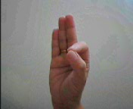
Gyan Mudra: In this position the fingers are held with the tip of the index finger touching the tip of the thumb and the remaining three fingers nearly straight--kind of like an "OK" sign, except the palms of each hand are pointed up or front.
This mudra is good for: stresses and strains, insomnia, emotional instability, indecisiveness, excessive anger, idleness, laziness, indolence, and is a great help in increasing memory and I.Q. It can help cure sleeplessness and get one off sleeping pills where these are being taken.
There are a number of variations of this mudra for higher and higher degrees of attainment e.g. Purna Gyan Mudra, Vairagya Mudra, Abhay Mudra, Varad Mudra, Dhyan Mudra, Mahagyan Mudra. As one keeps attaining higher and higher levels of the mind, the mudra's change.

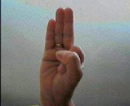
Vayu Mudra: This finger position is unbeatable in quickly and effectively removing the accumulated wind in the stomach. Depending on one's physiology, it may take anywhere from 1 minute to 15 minutes or so to effectively expel all accumulated wind in the stomach without the use of anti-flatulants. Mudra should be stopped when the trouble abates.
It helps in alleviating all wind based aches and pains. Considering that almost 80 % of the body's aches and pains are due to wind, the practice of this Mudra is a must, before taking recourse to any other treatment. It is very effective in Parkinson's disease (an ailment of the nerves where the patients body, head and limbs shake uncontrollably).

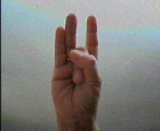
Shunya Mudra: This helps those with impaired hearing. If there is no physical defect, the mudra, if practiced regularly, can restore the hearing power. Remarkably, it helps in getting rid of earaches within minutes. It takes no mare than 2 to 3 minutes to get rid of most earaches.
It helps in relieving the nausea and vomiting sensations felt while driving on winding hilly curves or while taking off or landing in aircrafts. It helps in many problems of vertigo.
The mudra should not be continued after the problem has been removed.

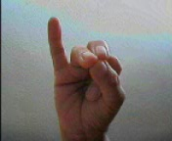
Apan-Vayu Mudra: This finger position works like an injection in cases of a heart attack. Regular practice is an insurance in preventing heart attacks, tacho-cardia, palpitations, depressions, sinking feeling of the heart. Also known as the Mritsanjivani Mudra for arresting heart attack.

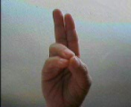
Pran Mudra: This finger position is an all time useful Mudra and can be done for any length of time, any time, any place and will only help in adding to the benefits. This is the mudra which, along with the Apan Mudra, precedes any efforts at higher meditation by the Yogis and saints. The mudra helps to increase the Pran Shakti or the "Life force". It increases one's self confidence. It helps the body in increasing it's vitality and sustenance when deprived of food and water.
It helps in improving weak eyesight and quiescence (motionlessness) of the eyes.
It supports any other treatment where the patient is short on confidence.

Here are some more mudras which are useful in therapy. As mentioned earlier there can be no end to the gains that may be had from Mudras. While for most Mudras there are no restrictions of posture and time, others should not be performed without full knowledge. In some cases, practice for longer periods or while in a different posture or at the wrong time could even prove harmful.
Aatmanjali Mudra: Helps in centering the consciousness of the mind

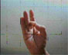
Aakash Mudra: Helps to remove weakness of bones, hearing deficiency.
Caution: This Mudra should not be done while walking

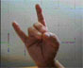
Apan Mudra: Helps in purification of the body, urinary problems, easy secretion of excreta, regulating menstruation and painless discharge, easy child delivery, Piles, Diabetes and kidney disorders.
Caution: This Mudra should not be done by pregnant ladies before completing 8 months. After that a 10 minutes practice 3 to 4 times a day will ensure normal delivery

Girivar Mudra: urinary problems, purification of body

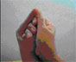
Shankh Mudra: Tone therapy, speech defects, Indigestion, loss of appetite

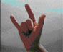
Meao Mudra: Excellent in bringing the Blood Pressure to normal from either high or low

Vyana Mudra: To be alternated with Meao Mudra for High B. P. only.

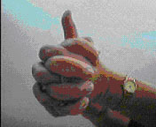Ling Mudra: Generates heat in the body. It destroys phlegm and helps in problems of colds, catarrh and coughs. It is excellent when the body is cold due to shortage of cover in inimical weather. This mudra must be performed under supervision or with full knowledge.

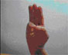
Varun Mudra: A miracle mudra for Skin problems, wrinkling, loss of glow, dehydration, excessive body heat, blood disorders

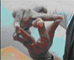
Surabhi Mudra or the Dhenu Mudra: Is a very effective and powerful Mudra. By itself this Mudra helps a sadhak (an aspirant practitioner) to break any barriers which he may face when on the thresh hold of samadhi (the ultimate meditation).
In this Mudra the ethereal elements combine such as to magnify and multiply their powers and produce powerful results on the body. Vayu (Wind; symbolised by the first finger) meets Aakash (Ether; symbolised by the middle finger), to stabilise the chakra (the circle) of the universe. Again Prithvi (Earth; symbolised by the ring finger) meets Jal (Water; symbolised by the small finger), to produce the generative power of the universe.
With constant practice, this mudra helps to stabilise and bring in resonance the Nabhi Chakra or the circle of the navel, so essential for the ultimate elevation of the human mind and body. The mudra has 4 variations, each of which gives different results.

Vayu-Surabhi Mudra A variation of the basic Surabh Mudra, it helps to eliminate all ailments resulting from the increase of wind in the system

Shunya Surabhi Mudra By increasing the ethereal vacuity it helps the sadhak to increase the hearing power manifold.

Prithvi Surabhi Mudra Helps to cure all ailments of the stomach generated due to defects in the digestive system. Specially effective for people with chronic digestive ailments.

Jal Surabhi Mudra This mudra helps to cure and eliminate diseases related to bile. It helps in curing diseases related to urine and assists easy passage.

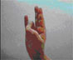
Prithvi Mudra: Increases solidity in the body. Removes weakness, lack of body solidity. Helps gain for underweights. chronic fatigue and weakness

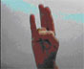
Surya Mudra: It helps to reduce the accumulated fat in the body and unwanted cholesterol. in accumulated fat in body, reduction in cholesterol.

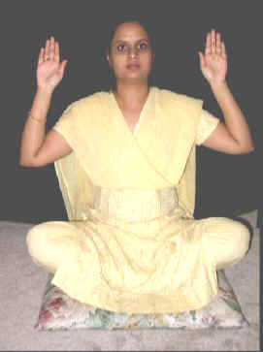Singhakranta Mudra Helps to regain the lost halo due to abuse of the body.

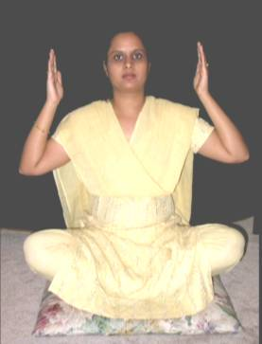Mahakranta Mudra Helps to regain the lost halo due to abuse of the body.

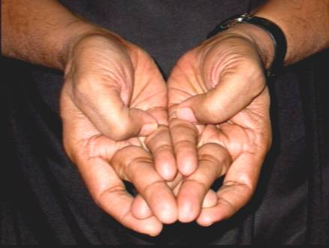Yoni Mudra Helps to overcome loss of virility, loss of Satwik Gunas ( pure qualities)

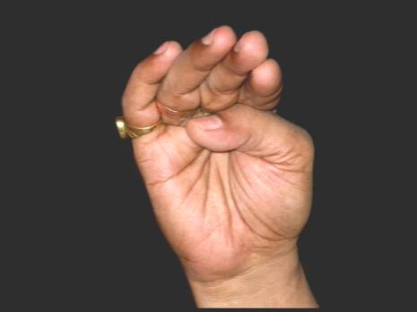Kamajayi Mudra Helps to gain control over unsuppressed passion and sexual urges etc.
In short, Mudras can be our best friends to help us maintain good health and when needed, to help overcome many ailments and diseases effectively and without harm to the body. Wouldn't it be logical, therefore,
first give the body a chance to heal itself before giving it invasive medicines and drugs, which must and will have some side effects.

