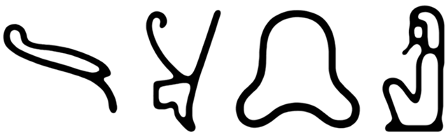

**The Book of Thoth**

Abstract

    This work is devoted to reconstructing the metaphysical cosmology of ancient Near-Eastern polytheism. It constitutes a theory of ancient Egyptian religion derived from the hypothesis that early mytho-religious narrative may be interpreted as a prescientific technical language of cosmology. The basic theory is developed through reconstructive analyses of Egyptian funerary literature made within the paradigm of later metaphysical systems (i.e., astrology, alchemy, and the tarot) possessing sufficient correspondence in form as to suggest a common derivation. Further consideration of such evidence indicates that the "pip" cards of the tarot are correlated with the thirty-six Egyptian "decans" by way of analogy to those of modern Jyotish, as the sequence of four elements associated with the decans of the latter system follows the order in which the gods of the cardinal points are enumerated with those of the former. Additional evidence is considered for an identification of the aces and "fool" card with the epagomenal degrees of the ancient calendar (namely, a correspondence in the mathematical relationship of these cards to the pips with that of the intercalary degrees to the decans), which are identified as the four classical elements through a structural analogy between their attendant deities and those of the cardinal points. Likewise, the "trumps" and "court" cards are identified respectively as the twenty-one "halls of the netherworld" and fifteen "tombs in the field of offerings," with the eastern horizon serving as a meridian by which to calculate the azimuths of those regions in accordance with their depiction from the Book of the dead. That the elemental properties of the Minor Arcana do not extend through the Major is attributed to the distinction between active and passive matter in late Hellenistic sources, whereby a structural analysis of names derived from the preceding astronomical literature suggests the existence of a counterpart to the elements analogous with the three "principles" of Jyotish astrology. Through a direct correlation of the elements and principles with the four natural states of matter and three of energy, respectively, the active and passive types of the former set are equated to the positive and negative electromagnetic polarities of the latter; in which context neutrality represents the element of "aether" as physical equilibrium. Hence, the association of elemental qualities with the four humours of classical medicine would imply a similar correspondence between the principles of Jyotish and the three "doshas" of Ayurveda. Subsequent analyses regarding the complementary structure and function of the major astronomical deity groups serve to establish a provenance for these relationships in ancient Egyptian cosmology, and thereby constitute evidence for an early system of metaphysical astronomy describing the synthesis of cosmic radiation in its passage through the interstellar medium. To substantiate this hypothesis, direct correspondences in outline and position are identified between certain asterisms from the ancient system and the Ptolemaic constellations of modern astronomy, enabling a tentative reconstruction of star maps contemporary with and integrated into the context of Old Kingdom religious cosmology. Lastly, the use of names and images in ritual worship is correlated with the function of entropy and information in quantum systems behaviour.

The Unwearying Stars

    Prior research on the tarot has identified evidence of a structural correlation between the thirty-six pip cards and the decans of modern astrology, but has neglected the implications of such evidence regarding the decanal asterisms of early Near-Eastern astronomy. This correlation may be extended through the latter set of decans by their equivalence to the former in terms of numerosity, angular diameters, and locations relative the ecliptic - which have been inferred from descriptions of their heliacal rising each ten days, and subsequent invisibility on the following seventy nights due to proximity with the sun. By these criteria, the decan stars must necessarily have been located in a region of the celestial sphere extending parallel to and roughly thirty degrees south of the ecliptic, wherein the majority are identifiable as known asterisms. Comprehensive enumerations of this prototypical decan sequence first appear in the ninth-dynasty Coffin Texts as a table of stars ordered by rising time at intervals of ten days, which likewise constitutes a principle of organization for the Jyotish decans by way of their analogous configurations in the rectangular zodiacs of the Ptolemaic Period, and the astronomical diagrams of the New Kingdom from which the latter developed. Hence, the correlation of individual decans to the gods of the cardinal points listed by their diagram entries (cf. the astronomical ceiling in the tomb of Senmut) forms a structural analogue with the decans of Jyotish inasmuch as the four elements associated with the latter also represent the cardinal points in that system. Evidence suggesting a derivation of the Jyotish element sequence from the astronomical diagrams is found in the correspondant order of its enumeration to that by which the gods of the cardinal points are listed in the Pyramid Texts, where the former sequence is three steps advanced relative the decans - likely as a corrective measure against the shift in apparent positions of the background stars due to equinoctial precession since the date of the latter. However, such an attempt to conserve the elemental qualities of the decans after precession by altering their sequence does not take into account that the prototypical calendar was derived from the appearance of these stars in a specific mundane position at intervals based on the solar day, and hence determined their attributes from its sequence of observation (i.e., the decan’s position in the calendar) rather than the observables themselves. That the calendar was principally organized around the solar day is exemplified by its use of intercalary degrees to maintain the correct sequence of decans after their annual displacement from the standard intervals of observation.

The Days upon the Year

    Historical scholarship likewise demonstrates that the four elements correspond to the ace cards by association with their suits, enabling an identification of the "fool" card as the element of aether, which Diodorus Siculus affirms[1]. Hence, with a shared classification as Minor Arcana establishing their analogy to the pip cards, the aces and fool may be identified with the five epagomenal degrees appended to the series of decans in compensation for the apparent shift of those stars over the course of a year. As the decans have been assigned specific elements in a recurring order, it follows that the sequence of their association would continue through the epagomenal degrees in order to reset itself to the beginning. Hippolytos' remark[2] that the elements were considered either male (water and fire) or female (earth and air) supports this attribution, inasmuch as the gods and goddesses presiding over the epagomenal days were consistently ordered in terms of their sex, with two of each at either side of a neutral member whose name is a cognate of "fool." The inclusion of epagomenal days to reestablish the proper sequence of decans in the calendar was likely necessitated by its method of observing celestial bodies at an interval of the solar day, and the consequent disparity among their relative mundane positions at later times of observation due to the inequality of that period and the shorter sidereal day (wherein a star consecutively transits a fixed mundane position) by roughly four minutes. Angular distances between adjacent decan stars are thus calculated to be around 9.9 degrees, which at the beginning of the first epagomenal day comes to about 354.8 degrees[3]. Since the diagonal star tables began with the first appearance of the twelfth decan after the epagomenal degrees, that of decans one through eleven would have been transposed from the standard time and place of observation, necessitating their substitution for eleven intercalary decans at the correct intervals. Located in a triangular section at the bottom-leftmost third of the diagonal tables, the first of these alternate decans began five degrees before the first standard, allowing the full set of the latter to rise heliacally in one cycle.

The Imperishable Stars

   Referred to as the "Unwearying Stars" for their continuous motion along the ecliptic, the decans were frequently juxtaposed with a group of twelve thirty-degree asterisms in the north circumpolar region called the "Imperishable Stars" due to their cyclical movement above the horizon. The earliest of these references[4] affirm that while the Imperishables are joined by the sun at dawn ("set for N. the fire to the kettles containing them"), the Unwearying stars follow its path along the ecliptic ("revolve for N., [and] the kettles are replenished for him"), establishing their identity as the astronomical bases of the thirty-six "decade" periods and twelve months of the ancient calendar, respectively. Such a derivation is likewise evident in that the Imperishables are first represented by the star tables of the Middle Kingdom as a group of figures in the central column of the decan charts - a configuration preserved in the later astronomical diagrams, from which the Imperishables may be correlated with modern Ptolemaic constellations by their analogous form and placement[5]. Inasmuch as the decans and circumpolar stars possess a structural complementarity, the direct association of individual elements with the former group members would thereby extend to the latter, as demonstrated by the corresponding elemental attributes of the Jyotish decans and zodiac signs. Conversely, the latter associations extend to the former inasmuch as their placement in complementary regions of the sky indicates that the decans and circumpolar stars would have been associated with contrasting element sequences - and likewise, that the sequence of associations for the circumpolar group began at a point in the calendar opposite that of the decans. The resultant organization is corroborated by an image from the tomb of Senmut depicting the Imperishables separated into three groups of four at the appropriate points in this sequence. Considering how the structure of these groups affected their elemental qualities, it stands to reason that their arrangement was predicated on the belief (known from Seneca's historical accounts[6]) that matter consists of active and passive types[7] - the mutual exclusivity of which is apparent in the organization of the great ennead relative the Imperishables.

The Greater Body

    The greater and lesser enneads, or "companies of the gods," were often described as complementary in the earliest sources, but while the names of the greater are well known, those of the lesser were never explicitly documented unless prior speculation is correct in attributing them to a list of "dwellers" from the Pyramid Texts[8]. By that reasoning, the lesser company must represent the circumpolar asterisms, since the function of this passage - according to its erratic reproduction on the Senmut ceiling[9] as a list of names for the Imperishables one step advanced from the standard order - was to identify the deceased with the Imperishable stars. Such an interpretation becomes less plausible when it is noted from the explicit associations between its members and various decan stars (which become increasingly prevalent in later sources) that the greater company is evidently a set of divisions on the celestial sphere adjacent to the belt of decans, as identifying the two companies with analogous star groups would thus be in opposition to their implicit complementarity. A potentially more viable counterpart to the greater ennead may be discerned from an utterance in the Pyramid Texts which states "I have come to the ennead in the sky... [and] to the ennead on the earth," as the calendary principle of observing celestial bodies at a specific mundane position would indicate that the conceptual framework to which the former ennead belongs necessitated the existence of the latter - thus establishing a complementarity of mundane and celestial regions. Further support for this alternative is gained from the correspondence between individual elements associated with the members of the greater and lesser enneads, which proceed in opposing sequences from a central fifth member that incorporates both active and passive matter in accordance with the classical definition of aether. This conventional grouping of astral, liminal, and cthonic deities also formed the structural basis of the calendar's three seasons.

The Trinities

    Exemplifying the metaphysical correspondence between a celestial body and its mundane position is the relationship of the earth god and sky goddess, whose children formed two opposite-sex couples that each had one child in turn, representing a division of both the mundane and celestial spheres into three. Consequently, the members of each group are described in terms of their respective elemental associations (e.g., the celestial father as god of air) following the order of their occurence in the set. That the sequence of elements would remain incomplete upon association with the triad is accounted for by taking the elemental properties of both triads to comprise one set of four, as each of their second members are designated aether, and moreover by the existence of a counterpart to the elements in the three principles of Jyotish astrology. A recurrent sequence of the latter is associated with the zodiac signs and decans of that system in juxtaposition to their elemental attributes, which may explicate the dichotomy of "active" and "passive" matter as a quantitative ratio for the elemental complement of a body relative its principle, and of aether as their equivalence. As with its elemental qualities, the Jyotish system has retained the associated principles of the original calendar after precession, thus conserving the differential between the two sequences as well. From the organization of astronomical diagrams representing the circumpolar set divided into three groups, it follows that the celestial triad was located in the north circumpolar region, as the equivalent numerical relationship of these sets to that of the decans and the greater ennead would thereby constitute a structural analogy. To the extent that the Imperishables and decans served as bases of organization for the months and decades of the astronomical calendar, the celestial triad may likewise have informed its three seasons, and the mundane its conventional demarcation of hours into morning, afternoon and night. References to the location of various triad members are often explicit (cf. the celestial son "in the middle of the mid-heaven"), further illustrating their provenance as an early form of the numerous variant triads.

The Lesser Body

    The foregoing evidence has shown that the lesser, or Hermopolitan, ennead may correspond to a set of divisions on the celestial sphere associated with four male deities, their female counterparts, and a neutral "leader" of independent status. Each member of this group was referred to by the masculine or feminine inflection of a descriptive term for its associated element, which proceed by gender in the usual sequence to correlate with the structure of the celestial ennead - i.e., the leader on the eastern horizon, the passive female members in the north, and the active males in the south. This arrangement is corroborated by an image from the Book of What is in the Netherworld[10] that portrays a star rising between the fourth and sixth members, and further by depictions of the mundane ennead in late astral mortuary papyri as four opposite-sex couples, with each member facing its counterpart over a schematic image of the horizon. The organization of elements into opposing sequences, or "antiscia," is referenced explicitly in the Book of Two Ways - a section of the Coffin Texts written on the floor of the sarcophagus that enumerates mundane positions for the diagonal star table on the underside of the lid. At a point in its narrative relating to the horizon, where the order of the text is reversed, the former states "These ways are like this: one thereof opposing its companion in the opposite direction." Hence, from the corresponding sequence of elements associated with the enneads, triads, and epagomenal degrees, the valence of these associations for the remaining sets are inferred to be active in their first and passive in their second halves; the midpoints being neutral. As the structure of the lesser ennead is equivalent to that of the greater, and the principle of organization for the greater ennead is likewise that of the circumpolar set (i.e., the valence of its elemental associations), the mundane counterpart of the circumpolar set must have been organized according to the same principle as the lesser ennead. That counterpart is represented by the group of mundane divisions known as the "gates of the sky."

The Gatekeepers

    Funerary texts such as the Book of the Dead often refer to seven "gates of the netherworld,” which by their depiction from the earlier Book of Two Ways[11] evidently correspond to distinct regions of the celestial sphere, located at equidistant points on the horizon and southern half of the ecliptic, that supplement five identical features on the northern half to form the twelve mundane counterparts of the circumpolar asterisms. These attributions are substantiated by an image from the latter source representing the ecliptic as a circuitous band - the upper and lower halves of which are painted blue and black, respectively, with a red line between them to indicate the horizon. Since the upper half of this image denotes south as per the typical orientation, and the rightmost of seven gates depicted therein features text referring to the eastern horizon, it evidently portrays the visible and invisible sky from a north-facing perspective. Two lists enumerating the "keepers of the gates" are written on their respective halves of the diagram with the first and last names in either correlated inversely, suggesting that they were intended to be read as a continuous series. Other salient features of this image are accompanied by prayers for the soul of the deceased as it travels to corresponding regions in the sky, which thus form a narrative cycle that proceeds anti-clockwise from below and to the right of the horizon line. At this point in the text is an image representing the "gate of darkness," which appears below a schematic illustration of the sixth gatekeeper relative the fifth member of the Hermopolitan ennead on the horizon. In the traditional classification of hours, that division corresponds with the first of two three-hour twilight periods when the stars were not invariably observable, and which are thus counted with the eighteen hours of total invisibility as the twenty-four hours of the day. To these were added the twelve hours of night during which the stars were completely visible for a total of thirty-six hours (corresponding to the rise of decans at forty-minute intervals), that by the operational principle of the celestial and mundane sets would necessarily have their basis in a set of mundane positions at ten-degree intervals represented by the "watchers" from the Book of Two Ways.

The Watchers

    Numerous passages from the Book of the Dead refer to complementary sets of ten-degree mundane positions on the southern and northern ecliptic, respectively, as the twenty-one "halls of the netherworld" and fifteen "tombs in the field of offerings," which thus constitute a structural analogue to the Major Arcana. Since these positions evidently correspond to the trumps and courts, it follows that the latter would be identified as the midpoints of their respective areas based on a prevalence of the homologous decans in the northern sky, and the former as their cusps by the analogy of this configuration with the set of gates (and hence the Imperishables) regarding its placement of the median in the south half of the sequence. Images from the Book of Two Ways depict such an organization as the transposal of attributes between figures representing the northern and southern positions; the names of which are inaccurately recorded by a passage in the Book of the Dead substituting those of "gatekeepers" from the earlier text for every third name in its sequence of mundane positions. The eighteen southern positions are enumerated in the Book of Two Ways by three passages inscribed on the ecliptic diagram beside images of their respective gates - the structural correlation of whose gatekeepers with the "keepers of the mounds" named herein obviates their substitution for members of the previous set. At the righthand margin of this diagram is an image representing the sequence of northern positions divided by four gates into three contiguous registers under a horizontal red line, with the last two in each section portrayed as human figures, and the remainder as a group of nine scarab-headed snakes. The latter positions are enumerated where they appear in a subsequent image as three scarab-headed figures grasping crocodiles and snakes, while the previous image contains an utterance listing the former by name - of which the last is recorded on a separate diagram of the eastern horizon. Hence, these images taken in series constitute a full listing of the northern positions. It follows that since the two figures in each section of the first image are preceded by a group of nine snakes that reappear as three figures in the second, the latter names would be read in one sequence punctuated at intervals of three by the two names for each of the former, with the final name being last. Ordered as such, the names of these positions explicitly refer to their elemental attributes in the proper sequence, as well as their location relative the members of other sets, and are correctly associated with their respective figures.

The Aspects

    That the soul (*ba*) was typically identified as one of the Unwearying Stars, and the spirit (*akh*) with an Imperishable Star, is attested to by several utterances in the Pyramid Texts. An identification of the remaining celestial and mundane sets with the other "parts of the soul" (namely the *ka*, *shut*, *khet*, *sah*, *ib*, and *sekhem*) is made possible through a correspondence between their respective orders of enumeration in the Pyramid Texts, where these sets are likewise associated with the elements and principles. Various utterances identifying the circumpolar stars and decans with the *akh* and *ba*, respectively, describe their relationship to the *ka* in terms of an alternating presence consistent with the temporary invisibility of those stars when occulted by the sun. Specifically, the *ka* is identified with the active set of the celestial sphere by its description as the "aspect of the *ba* that is in the earth," from which the sun rises to join the *akh* in complementarity with the transposal of mundane valences at the horizon. It follows that the elemental and principle sets of that sphere may be identified respectively with the *akh* and *ba* - leaving the *shut* to correspond with the passive set by its appearance opposite the *ba* during sunrise. That the *ka* is portrayed as an exact duplicate of the physical body suggests a correspondence between the *khet* and the active set of the mundane sphere, to which the *sah* is evidently a passive counterpart from its diurnal association with the *ba* in utterances reading “when you stand before the sun, then you are endued with your *sah* among the *baiu*.” Likewise, the *ib* corresponds with the elemental set of this sphere through a description of its passive form as “where the *ib* is at peace and the *sah* is rejuvenated,” while references to the *sekhem* being "made an *akh*" demonstrate its association with the principle set. Thus identifying the "parts of the soul" as physical members of the earth god and sky goddess serves to establish the correlation of their eight associated sets with the "spheres" of the seven classical planets and fixed stars[12], in which capacity they are functionally equivalent to the latter. As a principle of organization for both the celestial and mundane sets, the standard elemental sequence thereby has an observable effect on their mathematical relationships, in that the most numerous set of its sphere divides by a single iteration of each associated sequence into two lesser subsets, which are in turn multiples of the least numerous set by one iteration of the opposite sequence. From the complementarity evident in this process, it follows that because the elemental sequence is correlated with the associations of the planets in Jyotish through their standard enumeration by sidereal period[13], the latter would correspond to the sets in that order as "rulers" of the planetary spheres. This configuration parallels the sequence of elementary colours appearing in various images from the ninth dynasty onward, by means of a consensus among Hellenistic sources that designate each colour to a planet and element[14].

The Royal Art

    In accordance with their identification as bodily members of the earth god and sky goddess, the spheres of the classical planets and fixed stars correspond to the "canopic" organs of the deceased; thus serving to correlate their associated elements and principles with the four humours of classical medicine and three doshas of Ayurveda, respectively. Through an association with the elements discernible from their embalment in jars representing the gods of the four cardinal points, the canopic organs may be determined to regulate the four humours as their corresponding spheres influence the planets and stars, with the stomach designated to yellow bile, the intestines to blood, the liver to black bile, and the lungs to phlegm. Conversely, the embalment of the heart, brain, and genitive organs inside the body establishes their association with the three doshas as mechanisms of biological homeostasis, in that the brain regulates the flow of chemical substances (i.e., the humours) into, the heart their circulation between, and the genitals their outflow from the canopic organs. Since the elemental and principle states of these substances translate into modern scientific terminology as the four common states of matter and the three of energy, respectively, it follows that their active and passive types correspond likewise to the positive and negative electromagnetic polarities of matter or energy; the neutrality of which thereby corresponds to aether. In this context, the element of earth correlates with the solid state of matter, water the liquid, air the gaseous, and fire the plasmic, while the fixed principle corresponds to potential energy, the cardinal mechanical, and the mutable kinetic - the synthesis of elemental or principle states being mutually exclusive as a result of their complementary valences. According to the current molecular theory, a product of two unlike states with opposite polarity retains the polarity of the higher-energy state, while that of two like material or energetic states with the same polarity retains its former state. Hence, the product of two like material or energetic states with opposite polarity is neutral when both complements are thus equivalent, or assumes the polarity opposite that of its complementary state when that complement is polarized. Two states of matter a state apart produce the intermediary state when synthesized, but if the states are contiguous, the higher-energy state is retained when the synthesizing matter is positively charged, and the lower when negatively charged. If the contiguous material states are of like polarity, the higher-energy state is retained when the synthesizing energy is mechanical, and the lower when potential or kinetic, in accordance with its elemental qualities. Plasma and solids of unlike polarity synthesize gases if the plasma is positively charged or liquids if negatively charged, but when alike in polarity, these states produce gases if the synthesized energy is mechanical, and liquids if potential or kinetic. A neutral body in synthesis with a polarized body assumes the state and polarity of the latter, but retains its neutrality when synthesized with another neutral body. Two unlike energetic states of opposite polarity synthesize the third state, retaining the polarity of the state associated with the higher-energy material complement, or if the latter are alike, assuming a positive charge when the synthesized energy is mechanical, and a negative charge when kinetic or potential. The product of two like energetic states of opposite polarity retains that state and assumes the polarity of the state complementary to the higher-energy matter, or neutralizes when the latter are alike.

The Study of Hours

    At the time and place in which the Coffin Texts were composed (circa 2150 B.C., roughly thirty-one degrees north and thirty degrees east), the heliacal rising of Sirius occurred on the seventh of July, and the summer solstice on July seventeenth. From that time on, the decan incorporating Sirius would no longer have occupied the midpoint of the original star table, as it had since the inauguration of the calendar circa 3500 B.C. when their alignment first occurred. To compensate for such precessional effects, the observation point for the ancient calendar was evidently shifted from the eastern horizon to the medium coeli around 2000 B.C., necessitating the advancement of its original decan sequence by five steps, and of the greater ennead by two. If the original calendar was revised to account for precession without changing its observation point, the sequence of decans would be advanced four steps, the circumpolars by two, and the greater ennead by one - all while retaining their previous elemental associations. In that sequence, the Imperishable Stars correlate approximately with modern Ptolemaic constellations as follows: *jst-DAmt* - Ursa Minor and Cepheus (gamma region), *rrt* - Draco (Eltamin to iota) and Cepheus (excluding gamma), *mnjt* - Lyra (Vega) and Cygnus (iota-2 region), *nwH* - Cygnus (Deneb to Albirea), *nxt* - Cassiopeia and Andromeda (phi to nu), *Htp-rdwj* - Lacerta and Pegasus (pi), *nTr-rwtj* - Perseus, *HAqw* - Camelopardalis, *saq* - Auriga (northern half), *Anw* - Lynx and Gemini (Pollux to iota), *msxtjw* - Ursa Major (north of chi), *srqt* - Ursa Major (south of chi), Leo Minor (10 to 46), and Canes Venatici (Chara to 20). The decan *spd* (region of Sirius) rises heliacally eight hours after the first visible decan rising on August second at the above coordinates. Because these asterisms are equivalent in structure to the constellations of the Ptolemaic system[15], which likewise incorporated their divinatory function as the basis of its horoscopy, the operative principles of the former system may be applied to the latter thusly - on a given date, the celestial position of the sun is found by noting that on which it occupied the previous zodiacal cusp (e.g., March twenty-one for Aries), then adding the difference in degrees of Right Ascension. The mundane position of the sun is obtained by calculating its azimuthal distance from the rising point as a function of the difference in minutes between a given time and that of the previous sunrise, where approximately four minutes equals one degree of azimuth. Having likewise determined the celestial and mundane positions of each relevant body (i.e. the sun, moon, planets, and heliacally-rising decan), their elemental and principle states are synthesized with those corresponding to the divisions of their respective sets in which they are currently located. Finally, the product state from each set is synthesized with the state of the division aligned to its ruling planet in the complementary set of the opposite sphere, with the end products representing aggregate chemical states from which the humoral pathology of the subject may be derived.

The Divine Work

    As the image (*tut*) and name (*ren*) of the deceased represent a specific configuration of elements and principles associated with the "parts of the soul," likewise the form and function of a body constitute higher-order emergent properties of the information and entropy stored in its chemical makeup. Thus, for quantum states where the entropy of a system is inversely proportional to its information content, any increase of the former requires that an equal amount of the latter is transferred from the system into its environment, causing their states to become entangled. Once a system has lost information due to entanglement with its surroundings, the consequent gain of entropy induces a systemic wave function collapse, resulting in the emergence of classical dynamics - whereby entropy is converted to matter, information to energy, and their proportional interaction to the electromagnetic force. It follows that since the ratio of information to entropy in a system is correlated with the electromagnetic polarity of its energetic and material components, the equivalent relationship of images and names associated with a body could likewise affect the valence of its elemental and principle states. In technical terms, the entropy transferred from a system to its environment that produces a reciprocal transfer of information by means of entanglement is analogous with the sacrifice offered to a deity that invokes its presence through sympathetic magic. The transfer of entropy from an organic system to to a celestial body could thereby induce a modulated absorption of photonic energy in the former as a catalyst for specific types of chemical synthesis. With higher systemic proportions of information to entropy resulting in a net positive electrical charge and negative magnetic moment, the performance of a ritual emphasizing words over images could likewise engender passive elemental and active principle states in the associated body, or vice versa. Consequently, the administration of a ritual sacrifice would first entail identifying the chemical states of all relevant planets and stars by synthesizing their associated states with those of any regions in the atmosphere and cosmic background to which they are aligned. Images and words corresponding to these states of matter and energy can be determined from their association with the humours and doshas, respectively, then combined in accordance with the laws of molecular synthesis to produce changes in the physical state of an organism. The latter is possible insofar as images and words affect the emotions and thoughts, which are associated with the four temperaments (melancholic, sanguine, phlegmatic, and choleric) and three minds (hylic, pneumatic, and psychic), respectively, that correspond through the elements and principles to the natural states of matter and energy. As such, images and words can be manipulated according to the emotions or thoughts they produce in the same way that matter and energy are synthesized according to the laws of physics - which may serve as the means of producing a state of consciousness referred to as the Philosopher's Stone.

The Divisions of Natural Philosophy

**I. ALCHEMY**

As the interactions of charged particles determine the resultant structure of atoms that synthesize into chemical compounds, so the harmony and strife between elements in a body determines their average proportion to generate its humours and principles.  
  
  
Four Elements and three Principles:  
Physical states of matter and energy  
Comprise the four Humours and three Qualities  
  
Material states and Elements (Humours):  
Liquid = water (phlegm)  
Plasma = fire (choler)  
Solid = earth (bile)  
Gas = air (blood)  
  
Energetic types and Principles (Qualities):  
Potential = fixed (salt)  
Mechanical = cardinal (mercury)  
Kinetic = mutable (sulphur)  
  
  
Activity and Passivity:  
Positive and negative electromagnetic polarities  
  
Electrical charge: Elements  
Magnetic Moment: Principles  
Electromagnetic neutrality: Aether  
  
  
Transmutation:  
Synthesis of bodies according to molecular theory  
Produces new body of mean state, type, and polarity  
Like states and types of opposite polarity neutralize

**II. ASTROLOGY**

As the chemical substances occurring naturally in various regions of the earth's atmosphere interact with stellar radiation and the cosmic background in regions of the celestial sphere to which they are aligned, so the elements and principles of the stars combine with those of the mundane positions.  
  
  
Mobile Celestial and stationary Mundane Sphere:  
Divided in Hemispheres by ecliptic or horizon  
Hemispheres divided in Regions by longitude or azimuth  
Regions associated with Elements and Principles  
  
Upper Hemispheres (Regions):  
Celestial and Mundane Triads (three)  
Imperishable Stars and Gates (twelve)  
  
Lower Hemishperes:  
Heliopolitan and Hermopolitan Enneads (nine)  
Decan Stars and Watchers (thirty-six)  
  
  
Spheres of the Planets and Fixed Stars:  
Region sets in orbital path of planets or conjunct stars  
Ordered by sidereal period length of transiting bodies  
  
Mundane Planetary Spheres (Elements):  
Gates: Moon (water)  
Watchers: Sun (fire)  
Ennead: Mercury (earth)  
Triad: Venus (air)  
  
Celestial Planetary Spheres (Principles):  
Decan Stars: Uranus (aether)  
Imperishable Stars: Saturn (fixed)  
Ennead: Jupiter (mutable)  
Triad: Mars (cardinal)

**III. THEURGY**  
  
  
As the transfer of entropy or information from a system to its environment induces a proportional transfer of the opposite component from its environment to the system, so the offering of ritual sacrifice induces a transfer of corresponding elements and principles from the stars.  
  
  
Image and Name:  
Particle and wave characteristics of a quantum system  
Emergent properties of Humours and Qualities  
Generated by Canopic and Polaric Organs  
  
Humours and Canopic Organs (Spheres):  
Phlegm: stomach (Gates)  
Choler: liver (Watchers)  
Bile: intestines (Hermopolitan Ennead)  
Blood: lungs (Mundane Triad)  
  
Principles and Polaric Organs:  
Aether: eyes (Decan Stars)  
Sulphur: brain (Imperishable Stars)  
Mercury: heart (Heliopolitan Ennead)  
Salt: genitals (Celestial Triad)

Tablets (Celestial and Mundane Spheres):  
Columns = Planetary Spheres (headers = Planets)  
Rows = Regions of longitude or azimuth  
  
Top border = 0* Cancer or due West  
Midline = 0* Capricorn or due East  
Footer row = intercalary days (1* each)  
  
Names = Deities (Manuel de Codage)  
Symbols = Elements (left) and Principles (right)  
(bold = Active, regular = Passive, QE = Aether)

The Tablets

The Celestial Sphere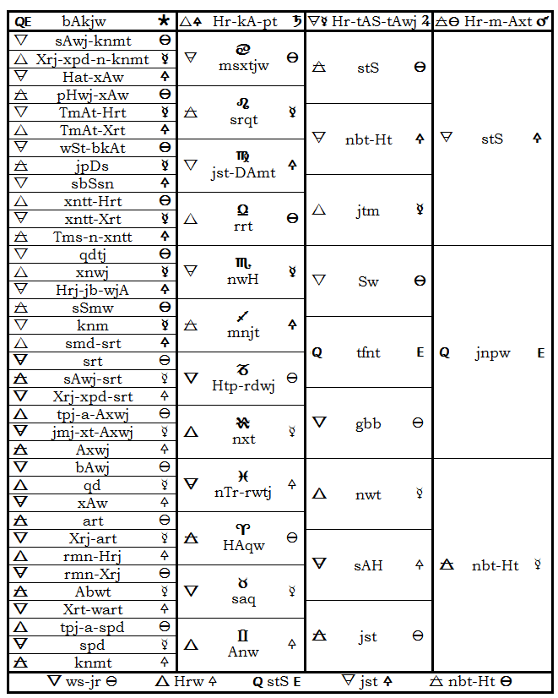

The Mundane Sphere

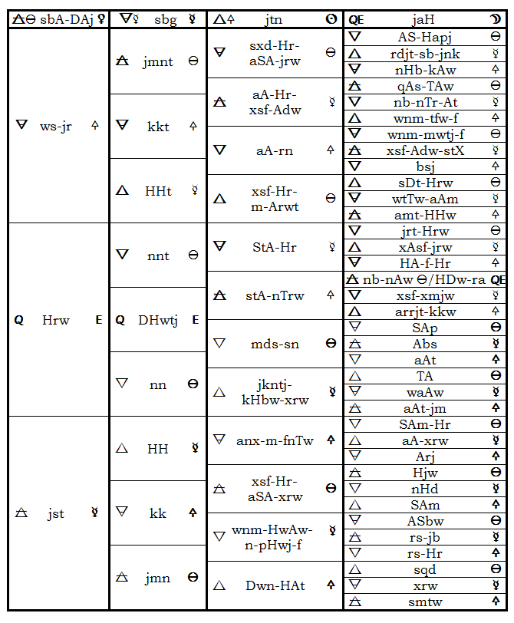

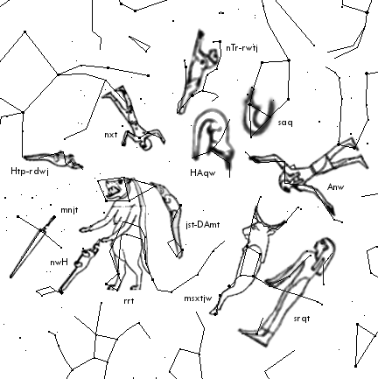

Figure 1: The north circumpolar stars.

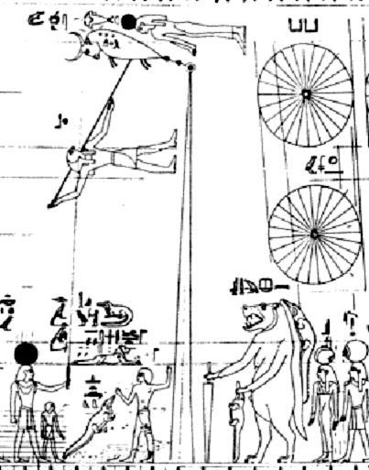

Figure 2: The Senmut astronomical diagram (detail).

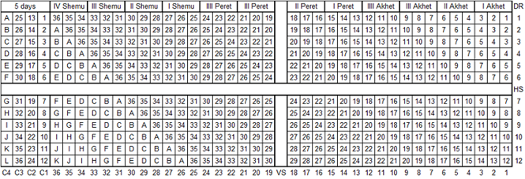

Figure 3: An idealized diagonal star table.

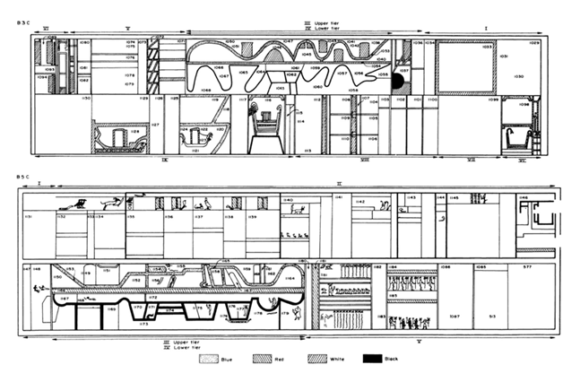

Figure 4: Ecliptic diagrams from the Book of Two Ways.

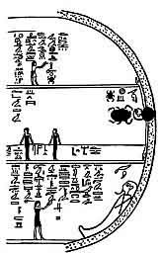

Figure 5: Image from the Book of What is in the Netherworld.

Notes

1 Diodorus Siculus, *Bibliotheca Historica*, bk. I, 42.

2 St. Hippolytus, *Episcopi et Martyris Refutationis Omnium Haeresium*, trans. Ludwig Duncker and Friedrich Wilhelm Schneidewin (Göttingen, 1859), bk. IV, passim.

3 Sarah Symons, *A Star’s Year: The Annual Cycle in the Ancient Egyptian Sky*, in *Calendars and Years: Astronomy and Time in the Ancient World*, ed. John Steele (Oxford: Oxbow Books, 2011), 1-33.

4 Raymond Oliver Faulkner, *The Ancient Egyptian Pyramid Texts* (Oxford: Oxford University Press, 1969), passim.

5 Juan Antonio Belmonte and José Lull, *The Constellations of Ancient Egypt,* in *In Search of Cosmic Order: Selected Essays on Egyptian Archaeoastronomy*, ed. Juan Antonio Belmonte and Mosalam Shaltout (Cairo: Supreme Council of Antiquities Press, 2009).

6 Seneca, *Quaestiones Naturalibus*, bk. III, 3.

7 Iamblichus, *De Mysteriis*,  bk. VIII, 3.

8 Ernest Alfred Wallis Budge, *The Gods of the Egyptians* (London: Methuen & Co., 1904), vol. I and II, passim.

9 Marshall Clagett, *Ancient Egyptian Science* (Philadelphia: American Philosophical Society, 1995), vol. II, 117.

10 Ernest Alfred Wallis Budge, *The Book of Am-Duat* (London: Kegan, Paul, Trench, Trübner & Co., 1905), 277.

11 Leonard Lesko, *The Ancient Egyptian Book of Two Ways* (Berkeley: University of California Press, 1977), passim.

12 James Henry Breasted, *Development of Religion and Thought in Ancient Egypt* (New York: Charles Scribner's Sons, 1912), 28.

13 Otto Neugebauer, *The Exact Sciences In Antiquity* (New York: Dover, 1969), 169.

14 James Riddick Partington, *A History of Chemistry* (London: MacMillan & Co., 1970), vol. I, 20, 301.

15 Alexander Pogo, *The Astronomical Ceiling-Decoration in the Tomb of Senmut* in *Isis* 14, no. 2 (1930): 301-325.

Bibliography

Belmonte, Juan Antonio and José Lull. *The Constellations of Ancient Egypt,* in *In Search of Cosmic Order: Selected Essays on Egyptian Archaeoastronomy*, ed. Belmonte, Juan Antonio and Mosalam Shaltout. Cairo: Supreme Council of Antiquities Press, 2009.

Budge, Ernest Alfred Wallis. *The Gods of the Egyptians*. London: Methuen & Co., 1904.

---. *The Book of Am-Duat*. London: Kegan, Paul, Trench, Trübner & Co., 1905.

Breasted, James Henry. *Development of Religion and Thought in Ancient Egypt*. New York: Charles Scribner's Sons, 1912.

Clagett, Marshall. *Ancient Egyptian Science*.Philadelphia: American Philosophical Society, 1995.

Diodorus Siculus. *Bibliotheca Historica*.

Faulkner, Raymond Oliver. *The Ancient Egyptian Pyramid Texts*. Oxford: Oxford University Press, 1969.

Hippolytus, St. *Episcopi et Martyris Refutationis Omnium Haeresium*, translated by Ludwig Duncker and Friedrich Wilhelm Schneidewin. Göttingen, 1859.

Iamblichus. *De Mysteriis*.

Lesko, Leonard. *The Ancient Egyptian Book of Two Ways*. Berkeley: University of California Press, 1977.

Neugebauer, Otto. *The Exact Sciences In Antiquity*. New York: Dover, 1969.

Partington, James Riddick. *A History of Chemistry*. London: MacMillan & Co., 1970.

Pogo, Alexander. *The Astronomical Ceiling-Decoration in the Tomb of Senmut* in *Isis* 14, no. 2 (1930): 301-325.

Seneca. *Quaestiones Naturalibus*.

Symons, Sarah. *A Star’s Year: The Annual Cycle in the Ancient Egyptian Sky*, in *Calendars and Years: Astronomy and Time in the Ancient World*, ed. John Steele. Oxford: Oxbow Books, 2011.

ιο ἄρτιος ογδοάς