The Trine Jew
In Judaism, the Torah states that the Jews will inherit and rule the earth in the Messianic age in which there will be no god, religion or culture except for the Jewish one, and the nations will serve the Jews as slaves. This will be a global Jewish theocracy in which the Goyim will be forced to convert to the one world religion of Judaism as a slave caste, and follow the Noahide laws as righteous Gentiles (meaning slaves who obey their Rabbinical masters). How does a small number of Jews bring this about in a practical way?

The bible was written by Jews, and it states to the Goyim that one must become Jewish and the spiritual seed of Abraham, the first Jew, in order to obtain salvation which is of the Jews. The Rabbi Saul converts the Gentiles into open Judaism in the New Testament. Jesus was a Rabbi who preached Judaism, and he commanded his other 12 Rabbis to go forth and convert the world into Judaism to achieve the agenda of bringing forth the Messianic Age of the Jewish cult in which the ruling Theocracy is god and all must submit to the Jewish god.

Mohammed was a racial Jew who was born of a Jewish mother whose Jewish Qurayshi tribe was descended from Ishmael, the son of Abraham the first Jew. Mohammed stated that he taught the religion of Abraham which is Judaism. Jesus is also in the Koran as a great prophet who was born of a virgin birth. This is why Mohammed's first wife was Jewish. The messianic mission of Islam (which means Submission to the god of Abraham [Yahweh], the Jewish god) is to create a global Islamic State in which Judaism will be the sole world religion.

Both Islam and Christianity believe the Messiah will return and usher in the Messianic Age of Judaism by way of a violent, global Messianic war.

Islam and Christianity are nothing more than a Jewish mass ritual working to bring about the Jewish Messianic Age.

Christianity, Islam and Judaism are the trine Jew. The Christians and Muslims are simply their Golems who are working to spread the Jewish agenda of the Messianic Age around the world and act as physical conduits for the Jewish god form to act through and take hold in. When this god form fully manifests as a ritual working into the material world, they will be the willing servants to the Jewish Messiah when this being appears and conquers the world by bringing together the billions of Golems to act as its world army and slaves.

There was an article in the Jewish press in 2016. The large congregations of the Jewish Rabbinical leadership gathered in large rituals by the thousands and

performed a Kabbalistic ritual to command their Messiah to come forth into the world.

President Bush also signed the Jewish Noahide Laws into effect as well. It's called: Public Law 102-14.
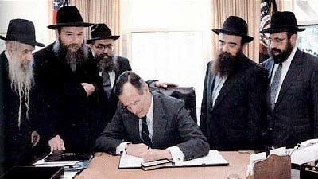
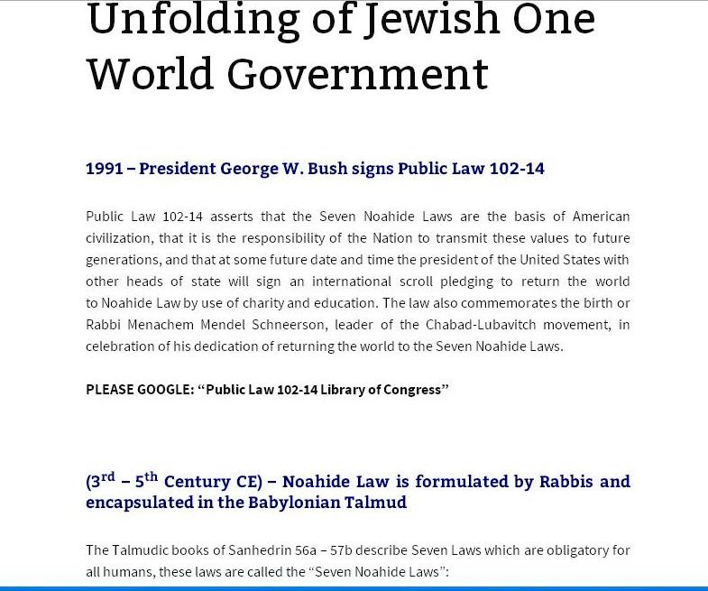

July 16, 2017
Joy of Satan Forums Contributions

