Reptilian Rabbis
The Jewish leadership is the rabbinical class. The top leadership are the ones who are selected from the Yeshivas for training in the "Oral Torah", the occult teachings only passed down orally by adepts. This is done after they make years of study of the Torah, Kabbalah, Talmud, and other related texts. They study up to ten hours a day in these Yeshivas and the training starts early in their life. This is done on the highest level so they can then be initiated into the actual meaning of the texts if they qualify for such. The qualification is where they show they are psychically open enough from the lower- level practices they are given to receive the higher teachings. These candidates are then sent to special programs in specific locations many times in Israel and then given the higher teachings. To be the leadership of the rabbinical class, one has to be a Sadok, meaning they have strong psychic, spiritual abilities and can demonstrate psychic powers at will.

The people on this level openly have stated something about the Seraphim angels they contact through the Merkava teachings, which is based developing the mental abilities to be able to do such.

They state the Seraphim are literally around seven feet tall, covered in golden scales and have lizard-like facial features. They call them "reptilians" because they are. They communicate with these being astrally, hence these beings appear to them in their astral bodies, but they exist physically. The Jewish leaders call these beings the Teli, meaning "masters", and they are also called the "Hidden Tzadikim", which are their hidden masters who influence the earth and direct the Jewish People in secret from behind the scenes. Note Tzadi...Kim". Kim means gold in the ancient language. This is probably due to the appearance of these Reptilians in their astral bodies, which from the Rabbis description of them they appear like this:


These are the beings the Jewish leaders call their "god" collectively, as they state they are one hive mind. These are the beings they take orders from and these are the beings they state gave them the 22 letters and the Oral and Written Torah.

They also state in the teachings that there is another group called the Nishaya whom are described as being literal Grey Aliens, and some Rabbis have openly admitted that is what they are. They also summon and appear in what the rabbinical texts state are their astral bodies to help them and take directions from the Jews. The texts also state that these are physical beings as well. The Greys are a hive mind, a slave race who work like cyborgs for their Reptilian masters. Masonic statements from the Masons who use the Kabbalah as their system report that these Greys appear many times in the ritual chambers in their astral forms when they summon the "angels of god". The Rabbis state that the high-level Jews are the ones who deal directly with the Seraphim or Teli, the "Masters" of the Jews. The Teli are also the masters of the Greys.

The Nishaya are stated in the Jewish texts as appearing as this:
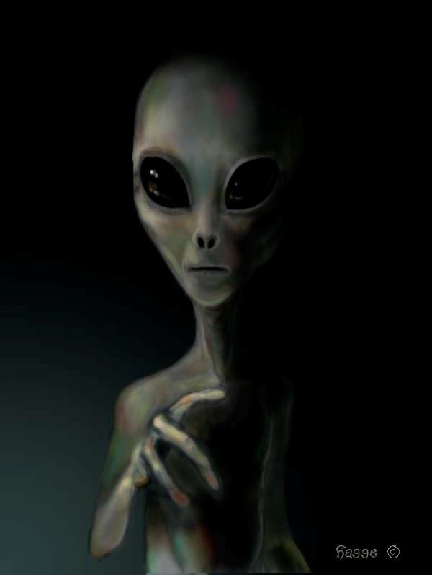

The Rabbis state that the Reptilians are to be collectively called "YHVH" by the Jewish leadership and they are referred to as "Yahweh" individually and collectively as a title. The Jewish religion states the Jews are a special race that came from "out there beyond this world". Rabbi Laitman openly states this in his famous talk to the nation of Israel. The Jewish religion states the Jewish race was created by YHVH and has a special bloodline from YHVH, which only the Jews have. The Jewish racial gene is called the Cohen gene and has Reptilian DNA in it. The Rabbis state the Jews share a special spiritual connection to these Reptilians to their collective racial consciousness for such reason. The Jewish leadership writes on the fact that they received their entire religion from these Reptilians including all the Kabbalah practices that form the whole of it. It’s simply a criminal system of using the collective psychic power of the Gentiles’ mass mind and connecting into this to materialize the Global rule of the Jews and their "Masters".

The Jews state they are the only humans and the Gentiles are animals to serve them. When Jews, especially the Rabbis talk about "humanity” or "man", they are only talking about Jews. The Talmud which all Jews study and learn from birth, the Talmud's teachings is that for a Jew to have sex with a Gentile is bestiality and punished by death in religious law. Because Gentiles are animals:
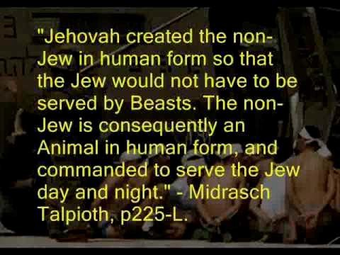

The Jews are an alien program put here to take this planet over for their "god" as their Torah states. They are the method in which the Reptilians work to take over this world by conquering it from within and enslaving us as cattle, which is the meaning of

"Goyim", the word the Jews call non-Jews. What do you do with cattle..... That is why they call us cattle.


The former Rabbi, Leader of Chabad, and proclaimed Messiah of the Jewish race. Chabad is the Jewish organization that is run by the Rothschilds behind the scenes. His statements on us Gentiles:
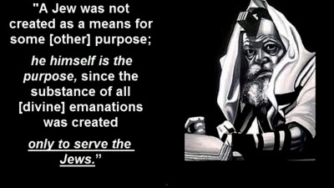

The Jewish global media praised this Rabbi to the Jewish heavens:
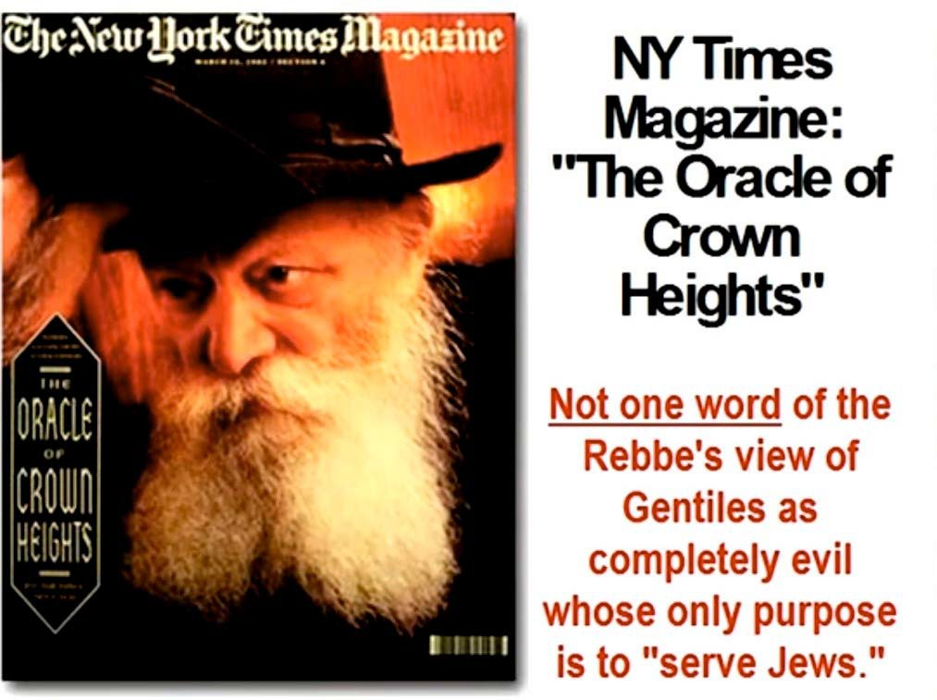

The Jewish Prime Minster of Israel stated in his speech to the Israel government in which he got a standing ovation:
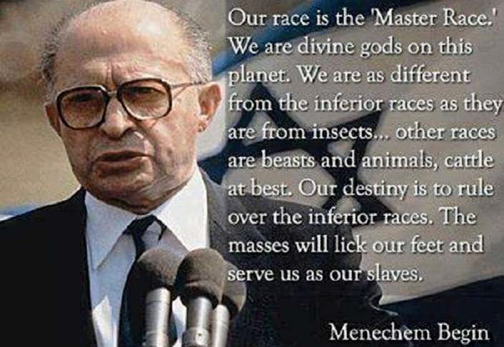

That is why Palestine is in the situation it’s now in. The Palestinians are ruled totally by a predatory reptilian race that considers them nothing more then sub human cattle as non-Jewish life. The entire planet will look like Palestine if the Jews are able to create their One World Government. Remember what the Jewish Talmud states about Gentiles:


November 4, 2018
Joy of Satan Forums Contributions

