Mars, Phaeton, and Earth
A high level Soviet scientist who fled to the west reported the finds of a satellite that the USSR sent into space to Mars. This was kept top secret by the Soviet government. What the Soviets found was identical to the photographs from the American Viking spacecraft. Some of the photos from the Soviet satellite have surfaced, and they show structures on the planet of Mars.

"A Soviet scientist who defected to the West claims that photographs taken by an orbiting satellite clearly show the ruined temples of a civilization on the planet Mars.

The 58-year-old scientist was a high echelon member of an elite team that has worked together since 1961 when Vostok 1 carried Yuri A. Gagarin as the first man in space.

The photographs are computer enhanced and in full color. The detail they show is far beyond anything produced in America. And there is no mistaking what they reveal.

The city scanned by the satellite's camera is three times the size of Moscow and it is ringed by wide boulevards, one inside the other and linked together by smaller avenues, like the spokes of a cartwheel.

The temples must have been huge. Most are in ruins, as thought crumbled by a tremendous Marsquke. But some still support slate grey domes that measure two to four miles in diameter." [1]

In the 1970's two American journalists were allowed into the Soviet Union. They interviewed a series of Soviet scientists including those dealing with matters of outer space. They were flat out told that the Soviet scientists had established there was once a planet between Mars and Jupiter which they called "Phaeton" that had been destroyed, and this planet would have supported life identical to Earth. However, the lead scientist had died suddenly and his work disappeared. Yet this fact has also been established by western scientists as well.

What happened to Mars?

From reports of those who studied the photos, there is evidence that the planet was subject to a massive war:

"I'd seen; in examining the City under the magnifying glass, I'd viewed direct evidence of melting and flow on the Main Pyramid within the City. In addition, there was the apparent massive destruction of much of the southeast direction of both that structure, and the equally puzzling "Fort" - and of forces which had, somehow, apparently completely vaporized [or blown off] the "roof" which must have originally covered up "the honeycomb!"

Then, there was the strategically placed "impact crater" in the south-eastern flank of the D&M pyramid, and the equally suspicious "domed uplift" distorting its geometry. Was this the work of a kind of "rocket-borne explosive"- which had penetrated the interior of the pyramid, and then detonated leaving an exit "blowhole" type crater, and severe internal structural deformation?"

I explore with [plasma physicist John Brandenburg] the kinds of craters a nuclear exchange would leave behind, and the "statistical anomalies " of so many craters on the objects of most interest like the Face and the D&M pyramid.

It was his suggestion that, if craters on this part of Mars were "artificial," there would be a way to tell because nuclear explosions [as opposed to meteor craters] would be shallower... On the other hand, he said if the crater produced in targets in the lab as part of the new space defense initiative tests were deep not unlike meteor craters themselves a direct result of the way they were produced: Exotic particle weapons "burying" their energy deep within the targets.

The Xenon found on Mars, a nuclear byproduct not normally encountered naturally? What Hoagland has clearly implied is that the Cydonia region shows every sign of having been deliberately targeted and destroyed in a war, a war that notably was fought not only with nuclear bombs, but exotic energy weaponry, weaponry recalling the plasma discharges of Anthony Peratt, and the ancient petroglyphs. Cydonia, in other words, constitutes not only strong prima fair evidence of a civilization on Mars, but also of a war, a cosmic war, that destroyed it."[2]

The Hebrew Torah states that their "God destroyed worlds," and there were other worlds before Earth that were destroyed by "God.'' The top Jewish rabbis (not just Laitman) state that the Jews came to this world from “out there,” meaning extraterrestrial planets.

The physics of current plasma weapons and science developed now was laid out in Farrell's own book on the subject, "Cosmic War" which proved that Phaeton could not have been destroyed by natural forces but by technology that includes the use of high energy beam weapons. These are identical to the movie "Star Wars" with the "Death Star" that was used to destroy an entire planet. The

strange thing is that the Death Star was made to look like the moon as the evidence shows the artificial moon of Saturn, Iapetus. Remember in the movie Star Wars the Death Star was also referenced as a moon by the main characters as they approached it.

Compare the moon of Saturn which the evidence shows is artificially built, next to the Death Star from Star Wars:
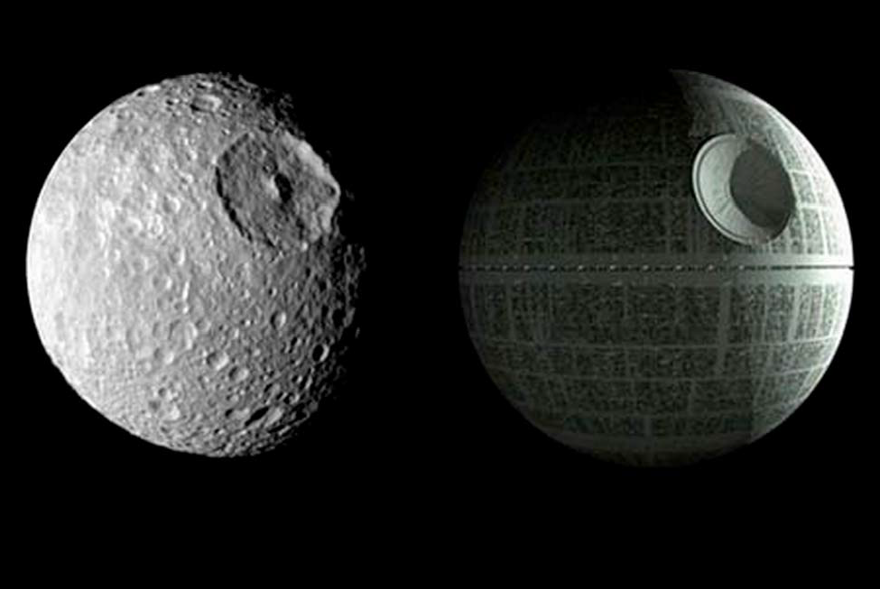

It might be that this possibly artificial moon was a battle station used to destroy Phaeton? There is evidence of artificial moons around Mars, and our Moon is artificial and covered in structures as is the Mars moon Phobos.

And what is found on Saturn is there are AI ships maintaining and building the rings around the planet. This was exposed by:

"Dr. Bergrun's ultra rare in which he reveals that NASA's Voyager I (1980) and II space-probes took photographs of an estimated 7000-mile-long elliptical (cigar shaped) craft orbiting in the rings of Saturn."

What about Earth?

Something to note:
Tibet
"Sanskrit documents discovered by the Chinese at Lhasa are claimed to obtain direction for building interplanetary spaceships. Flight to the moon is mentioned. The Chinese had stated that certain of the data were being studied for the inclusion in their space program."[3]

The Tibetan civilization was found to have records of interplanetary flight as well as China. There are numerous Sanskrit texts that mention the "Vimanas," and some of them are said to be able to travel into space. The Sanskrit and Sumerian texts mention the sky once being filled with the Vimanas as normal as planes flying in our skies today. Numerous finds from the Gobi to India to the Middle East show areas that were hit with atomic weapons; this includes the finding of ancient skeletons in the Ganges region around Rajasthan that are fifty times above the level of normal radioactivity, and numerous ruins in the Gobi and Ganges region that show the effects of Atomic weapons. The sands of the Gobi are full of ancient glass which resembles the effects of Atomic warfare. The Tibetan texts mention a war in the Gobi region that caused the destruction of the area, and the forced migration of the survivors further west into the Middle east and beyond to Europe. The race described was Aryan Peoples. The Indian texts mention the use of Atomic weapons in the Ganges and Rajasthan regions.

The ancient Sanskrit texts talk about an intergalactic war fought between the forces of the Devas (our Gods) and the anti-Devas (the Reptilians) whom the top Jewish Rabbis called their Gods or the Elohim. It might well be that many humans on this planet are the descendants of survivors who made it out of Phaeton and Mars in time and came here. If one studies the physiology of Aryan people, the plain fact is we didn't evolve on this planet. Is it that we were genetically created on this planet by the Gods, or is the reason why we just sprang up also that we came here from the other worlds which we lived on. Or maybe both.

Sources:
Dead Men's Secrets, Gray [1] [3]
The Cosmic War, Joseph P. Farrell [2]

March 13, 2019
Joy of Satan Forums Contributions

