Ley Lines, Earth's Alien History and Jews
by HoodedCobra666 » Wed Jan 31, 2018 2:32 am
When the Gods were leading the planet, they went and instated the temples with the friends humans on the Ley Lines of the planet. They calculated these sites with means such as extremely advanced technology, which is spiritual and material. Part of this is how they taught people about astrology, measured the stars, heavens, and generated natural calendars and taught the first humans many other things.

In the Golden Age, it appears very obviously that these beings were in many places where there are Ley Lines. One Ley Line is Machu Pichu, another one in the Giza Pyramids, others pass from the middle of mountain Olympus, while others extend in the Middle East, down to Mount Kailash in India. All these temples were linked and the Gods were teaching humans to maintain the active energy grid that constantly kept the planet not only very safe from outside danger, but prosperous as well.
This time was also called the "Eternal Summer" as the earth was producing plentifully, all the time, and animals were also existing in plenty.

It appears that the fact the enemy overthrown this grid, also affected the weather in the last 10,000 years or so. But this is only a minor speculation. Generally what is obvious is that the so called "CIVILIZATIONS" of the enemy, are a pollution, so much materially, as physically. While Gentiles possessed power in their civilization, there were never environmental disasters, even after the Golden age. The Jews have been ruling the planet for around a few centuries and the planet is at serious and deadly risk, because of the technology and type of 'evolution' the enemy seeks about to create.

While for the weather one may not say for sure. What's for sure is that it destroyed the vibrations of the planet all together. Part of why the world was way better on these times was because of upholding an external system with this knowledge. Which is done basically through people who are ascended and do this actively.

The Golden Age is said as the age when no human being hungered, and the earth was everywhere fertile, and people hardly had to labour to achieve anything because the level of existence was very high. Even labour felt relaxing as a result of a very high level of existence overall. The astral and the physical worlds were also very close as well, which ensured quicker manifestation of goals and in general, the definition of 'paradise' as people can imagine it. Free energy that is wireless seems to also have been the norm, in methods not even imagined by science today. How this was maintained was through spiritual work, and this is a very advanced approach on matters. Reality is based on vibrational fields, not merely machines and so forth.

This approach to life has been 'lost'. Well, for the 99.99% of humanity, that is. Because the rest of the 00,01% know how to use these energies and they do, at least in part. The enemy does not possess the actual knowledge to run a planet spiritually like the Gods did, but they have a different evolutionary method that destroys, pollutes, and enslaves species, which unfortunately seems to have also worked for these parasites for a while. This is the enemy and their lackeys, who are

abusing a fake system set in place of the above system for personal gain, spiritually, what we call the "Jewtrix". This is done in allegiance to the enemy who is monitoring this farm they are trying to create of planet earth.

The farm is operated with the psychic level, down to the material, where is the societies as we see today - racemixing, decay, pollution, and the few civilizations that are escaping a bit and become better, are pulled in the cesspool violently and forced to comply with the 'general rules'. For this to happen, there has to happen drastic degeneration of the species of the planet. Some races fell quickly others persisted for thousands of years, but as you can see now, disaster came for everybody sooner or later.

The late Egyptian texts from like 2500-3000 years ago, mention of this massive degeneration taking place like a plague that was spreading in many places both of Egypt and other places in the world. Others just said the Kali Yuga or the age of darkness was arriving, but this has nothing to do with the astrological age. The Gods created themselves this grid system to protect us exactly from situations like that. Everything would have been just fine if this system was still up.

For people who live in places with temples, the Ley Lines still pass from these temples. In many cases, Pagan sites and Pagan temples were destroyed by the Christians and were replaced. One major replacement is the Kaaba. The Kaaba was a Pagan monument that had 360 statues around it (the 360 faces of the Zodiac), divided in 12 (the 12 houses) and so forth. It was a monument created specifically to project specific energies. Even the Cube is a stolen shape by the Pagans.

Other types of architectures were used, such as the Pyramid, known well in Egypt. The upper dome of the Greek style temples was a triangle to show the Pyramid as well. This was because the issue was channelling spiritual energy. In the Pan-Satanic religions, people went on the common holidays all over the world, chanted and did their rituals to keep the energy grid going. Then the war happened and many of these sites were abandoned, and the grid started dropping.

The enemy over centuries and slowly, went at these places, and corrupted them. This is easy, as this involves firstly the corrupt of the individuals who go there (Reptilian/Jewish offspring is using these places now like the Saudi Family in the Kaaba), but also corrupting the place itself. The Kaaba is filled now with Quaranic verses to bless the Jews and tie into this vortex. This is one part of it, as the three main hoax religions are linked through the Torah, the Bible, the Quaran and the Jewish Race as a whole.

Rabbi Laitman says that the Jews came from another planetary system. He says they are coming from another universe, to conquer the people on this planet. As another most reputable and higher ranking Rabbi named Ariel Tzadok said in Ancient Aliens (S07E01), the angels of the bible are reptilian alien species. And as it's well known from the Torah, these aliens created 'mankind', which the Jews use as a code to mention themselves, only around 6000 years ago. Only them are 'human', the rest of people are living garbage.

From what is mentioned also in the bible, the patriarchs of the Jews basically came to be from taking Humanoid DNA and doing experiments to create something that looks human materially, but has Reptilian genetics, or what the Jews call in their internal Kabbalah the spirit of Elohim. As such

Rabbi Laitman says as well the Jews are the infiltrator race, and they look like the nation in which they are, but they are Jewish. Modern science came to prove this fact that Jewishness is a factor that deals with few genes, which manifest as a big, rat like, or in some cases Reptilian, strain in the rest of the blueprint. Elohim is also the codeword for 'those that came' and created the Jewish race.
Therefore Biblical 'human history' only reflects the Jewish history basically.

The Torah is the series of battles they went in to destroy each centre of civilization that existed on the planet and ruin it, finally subverting it to "God".

Part of which is how the Jews arose out of nowhere on the planet, were created and grown by ETs, got their memory wiped out, and were sent to infiltrate civilization to overthrow it completely. For this reason, while all people on earth also had a land, the Jews never had a land or continent for themselves.

They just appeared in the middle east and started claiming and shouting about their bargain with ETs, that if they subvert the planet, the land of Palestine would be given to them. After exterminating all the enemy tribes in the region. This would be the bargain to enslave the planet, destroy all humans who are opposition to their alien flick, and impose a massive slave-order. When this was manifested, this would be the Jewish 'messianic era' for the enemy. This is very well known by Rabbis and they keep people motivated for this work to manifest.

As it's known from UFOlogists and other people, alien races who are scaly and look like reptiles (The Reptilians) and others like the Greys are those who many people call as "Angels" are only half-terms. As stated above Rabbi Tzadok in ‘Ancient Aliens’ threw the lid off of it completely, these are just alien species like Greys who assist the Jews. Psychic people like Crowley have seen these Greys face to face.

As it's also very well known, the Abrahamic religions are creations of the Jews. Which essentially just program people who are "Pagan" (i.e, from our Satanic/Pagan Gods) to become slowly an emulation of a slave of the Jews. This is the purpose of the enemy religions. Tying the cattle on the grid, to pull the matrix vortex so that in the end they get sucked in and die while also delivering the planet to the enemy. The enemy being parasitic is extremely dependent on the mind-energy of the people and in programming them to achieve the enemy's goals. So as you can see the less religious people are, the more the enemy panics and forces this to happen.

While the enemy keeps copying our work and goes after us to try to maintain this whole magickal operation, there are two fundamental things that will allow us to win. One is that they do not have the in-depth knowledge on how to maintain this grid of their crap, and the second reason is that they are not really powerful to rule this world. They are standing on things achieved with people who have had power. This is what makes them dangerous. However even these problems can be solved.

If it were not for these constructs and that knowledge they stole, they would be destroyed in a decade, all together. However their material establishment is their major saver. However the weakness of the enemy is that they rely on a deliberate program which they are running on the world, that is their Torah and their filthy crap. These are the key to tip the whole game over. For this reason we are doing the RTRs. The huge waves they are using, one puts cyanide in them (RTRs)

and they have no choice but to drink this in order to maintain their rule on the world. But this very process is what will destroy them in the long-term.

If they were to stop, they would fall. So it's a matter of fighting and time on our behalf. As we go, the enemy is also getting destroyed on the higher level, giving us a footing to finish this thing all- together. For this reason we also have to keep going as there is no time to waste, and no time for worry or useless doubt. We have to fight and remove the enemy from their position, and then, the world will be free.

-High Priest Hooded Cobra 666 www.joyofsatan.com
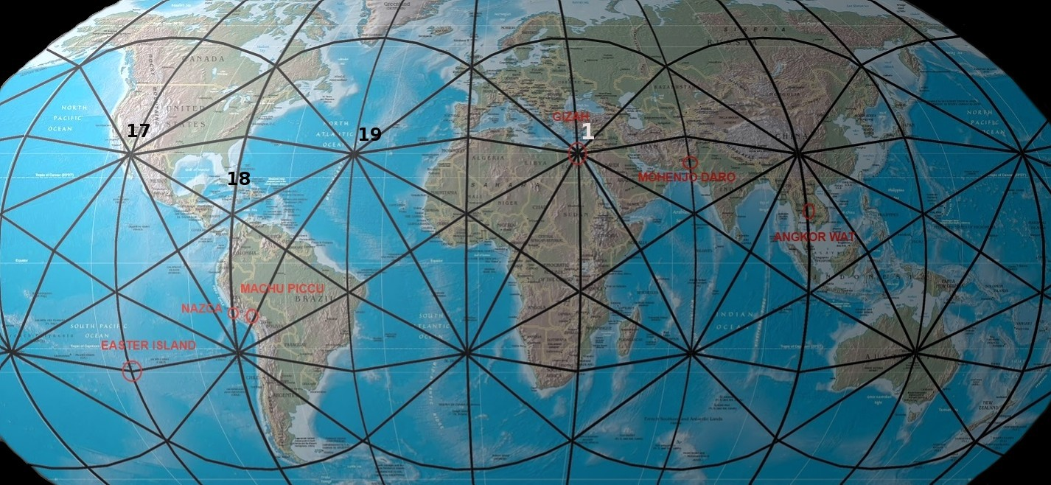

AscendingSun wrote: “I would like to point out, after looking at ley line maps, one of Satan's sigils is based off Earth's ley lines.”

