Greys’ Involvement in Ancient America
Look who appears all over these ancient Mayan temple artifacts. From the Aztec codex Chimalpopoca:
“The Toltecs were engaged in battle at a place called Netalpan. And when
they had taken captives, human sacrifice also got started as Toltecs sacrificed their prisoners. Among them and in their midst the evil YAotl followed along. Right on the spot he kept inciting them to make human sacrifices. And then, too, he started and began the practice of flaying humans...Then he made one of the Toltecs named Ziuhcozcatl wear the skin and he was the first to wear a Toltec skin. Indeed, every kind of human sacrifice that there used to be got stared then.
For it is told and related that during the and under his authority, the first Quetzalcoatl, whose name was Ce Acatl, absolutely refused to perform human sacrifice. It was precisely when Huemas was ruler that all those things that used to be done got stared. Huemas sacrificed a human streamer, thus making payment.”

In the Codex, the original civilization given by the Gods, which is described as blond-haired and blue-eyed, ordered them to never commit human or animal sacrifice. In the Codex, the Quetzalcoatl here is a title not of the Nordic God [Satan] but of the Priest King of the time, who kept the law given. We see in the Codex that later rulers started to make deals with these other beings, described as being evil. In return for power and earthly favors, they offered blood sacrifices. The name of this being is YAh-olt, Jau of Yau, Yao, is also a spelling of Yahweh who is also called Yah by the Jews. Yahweh is a collection of enemy aliens. Yahweh orders human sacrifice and animal sacrifice in the Torah.

You can see the arrival of the Greys and Reptilians at later date in the South American histories:
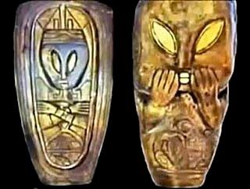

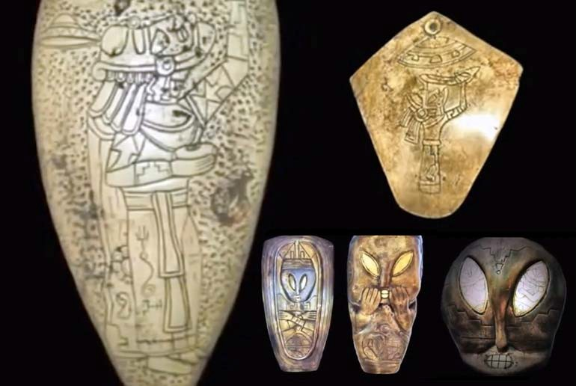
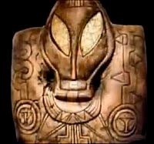
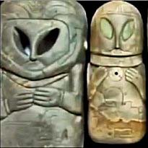
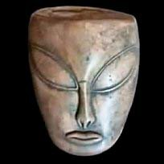
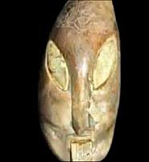

September 9, 2016
Joy of Satan Forums Contributions

