Akhenaton
The Egyptian ruler Akhenaton has been noted for his strange appearance and bizarre destructive political movement to destroy the spiritual knowledge of Egyptian culture.

We can know Akhenaton's actual appearance from the body of his son King Tut, which has been found. Tut did have the elongated skull that his sisters and father were shown to have, which means the depicted facial features of Akhenaton are his actual ones. Akhenaton prohibited symbolism in art. He demanded that art only show things as they were, and that included him. The researcher Lloyd Pye was famous for the "Star Child Skull", which was found buried in an ancient burial ground in the Americas in a way that suggested something. He had DNA tests and other tests done on the skull. The body was that of a Grey-Human hybrid.

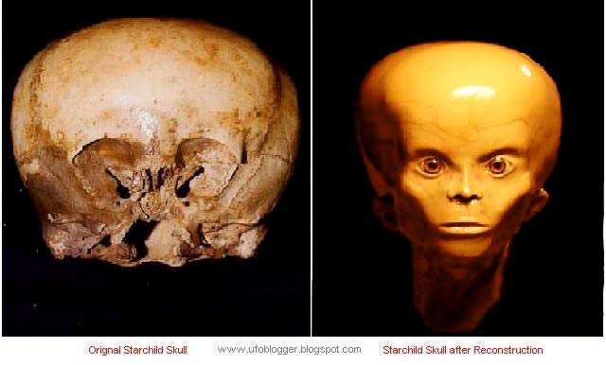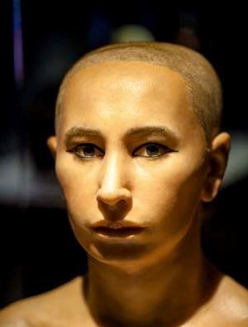If one looks at the images of this skull you can see the truth. Akhenaton was also a Grey-Human hybrid. His son King Tut, who died when he was young, looks identical when put next to the Star Child Skull.
Reconstruction of King Tut

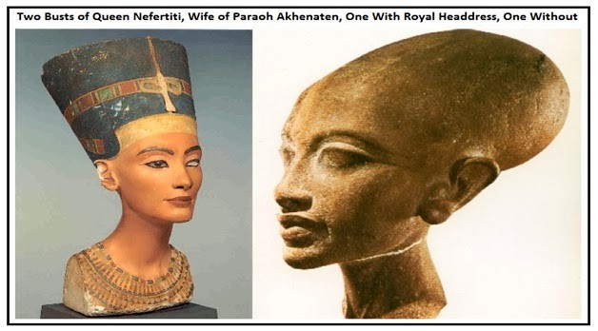

Their three daughters the same skulls:
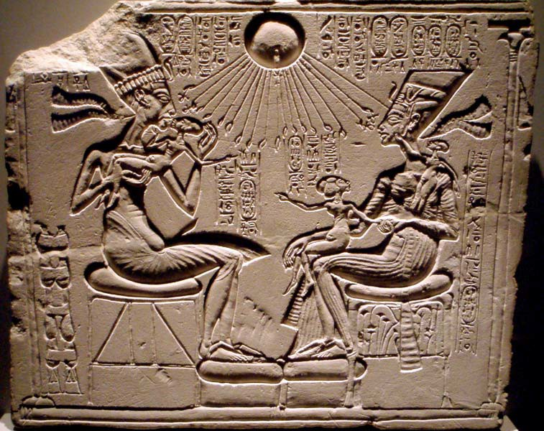

Akhenaton destroyed Egypt from within and caused a civil war to erupt against him and his foreign mercenary forces, which he used to impress his will on the People. The Egyptian culture was divine and handed down from our Gods at the time when they were on earth, as the Egyptians stated. Any deviation of the cultural teachings was not allowed as it would alter this information for future generations and cause loss of true knowledge of humanity, its origins, and the cosmic spiritual teachings of the light body, the magnum opus, which is how to become perfected. The Egyptian People were all taught this knowledge. The entire nation was initiated into the teachings. In the off season of farming, People would spend six weeks in the Temples being taught different levels of it. The Priests were called the "Serpents" and the Pharaoh was the head Serpent, who once a year would personally initiate the new candidates with Shakti pat transmission to help awaken their spiritual centers and Kundalini power. The Pharaoh could only make a decree based upon natural spiritual law for his People and the Pharaoh was the guardian of the cultural teachings of the enlightenment methods. The point of the Egyptian religion was to spiritually ascend into a star, which is the eight pointed star, the symbol of the perfected soul, and thus become a perfected being, a Neter, or divine being, and join the Gods in Duat, in the Milky Way galaxy in the belt of Orion. In the Egyptian texts that are correctly translated, they only mention the serpent energy and the light body, symbolized as the Ankh. The point is to raise the fire up the spine and open the inner eye of Osiris to obtain gnosis. There is a chapel found under the sands of Egypt built by a Serpent Priest who finished the Light Body process and became an immortal divine being. He left the Chapel as a place of teaching and a monument for future generations. This is why the ancients left spiritual instructions on their tomb walls. They had a conscious understanding of things and knew the day might come when these tombs are all that are left to transmit the instructions of history, spiritual knowledge, and culture to lost generations. They stated there was a time in the golden age when humans didn't die. Instead they just entered the light of immortality, the light body.

Now why would this Akhenaton regime want to remove and destroy all this? Akhenaton ordered the images of the Gods smashed apart and desecrated, had the Temples shut down and destroyed, and the Priests persecuted and forbidden to teach the knowledge. This is outright violent cultural genocide of the most sacred teachings and places. Akhenaton built a new capital, which he made the center of his violent cult. The bodies found buried there are shown to have died by brutal violence and suffered hideous punishments by this regime. This place was a prison for the Royals to keep them under control and to enforce his new insane and violent cult on the populace. After the civil war and uprising was over, the Egyptians removed any mention of this regime from history because they wanted to erase the teachings of this insane cult from existence as pestilence so it could never return and threaten the world. This cult destroyed the entire Egyptian culture and spiritual teachings and imposed a monotheistic political cult on the populace where Akhenaton was now the supreme ruler of this fake

monotheistic god of Aton. This is the same cult of the Christian Church of Rome, the same behavior, the same actions, and the same purpose. It was also the same with the Zoroaster cult of Persia.

There is a lot of ancient evidence suggesting the Jews actually got their start in this regime in Egypt. The Jews call their "god" Adon and Adonai, in which the T and D are double letters, making it the same as ATON and ATONAI. Even the name Levite was popular term of Egyptian Priests at this time. Judaism might just be the morphing of what started in Akhenaton's regime. The Persian Zoroaster cult is totally full of Jewish ideology, which is mentioned by many experts on the subject. Christianity is the later version of both the Aton cult the Zoroaster cult and the Jewish ideology. Judaism brags about the influence the Jews had in the Persian courts and Empire. They even had a whole city to themselves in Persia. Alexander the Great fought his war against the Persian Empire as a spiritual war to destroy the Zoroaster cult. The only culture he ordered destroyed was the Zoroaster cult, as it was a destructive and evil program against the spiritual teachings of the Gods. Centuries before this, a civil war was fought in the Roman Empire to stop the Christian cult just like in Persia and Egypt.

What this shows is that the enemy Ets, the Grey-Reptilians, have been trying to take over this planet since at least the time of Akhenaton's regime. They have been doing it by creating hybrids and then working behind the scenes to use this Trojan Horse movement of infiltration and subversion to take over the planet. The victory of the leaders of Egypt and Alexander against them shows why they need to remove spiritual knowledge to succeed in this. The document they ordered their "Chosen People", their hybrids, to construct directs them to do so. The Bible tells them the key to enslaving humanity is the removal of spiritual knowledge and the erasing of the true origins of humanity, which is what the Akhenaton, Zoroaster, Islamic, Christian and Jewish cult and Communist cult is all about doing.

Alexander was a highly ascended master. He was made Pharaoh of Egypt by the decree of the Gods for this reason. He also had a risen serpent. His family were the Serpents of the Dionysus tradition, which is also Egyptian. He also worked to destroy the Zoroaster cult and bring a rebirth of the original spiritual teachings, hence he made his capital Babylon, the ancient head of the Enki teachings, who was Oannes to the Babylonians and Loannes to the Greeks, whom they also called Dionysus.

The enemy programs were defeated by individuals and organized groups of spiritually advanced humans working with our Gods from the Serpents of Egypt to that of Greece.

When "Adonai" didn't hide behind hybrids, from the Aztec codex Chimalpopoca:

"They tell how Quetzlcoatl departed. It was when he refused to obey the sorcerers about making the human payment, about sacrificing humans. Then the sorcers deliberated among themselves, they whose names were Tezcatlipoca, Ihuimetcatl, and Toltecatl. They said, "He must leave his city. We shall live there."

"The Toltecs were engaged in battle at a place called Netalpan. And when they had taken captives, human sacrifice also got started as Toltecs sacrificed their prisoners. Among them and in their midst the evil YAOtl followed along. Right on the spot he kept inciting them to make human sacrifices. And then, too, he started and began the practice of flaying humans...Then he made one of the Toltecs named Ziuhcozcatl wear the skin and he was the first to wear a Toltec skin. Indeed, every kind of human sacrifice that there used to be got stared then. For it is told and related that during the and under his authority, the first Quetzalcoatl, whose name was Ce Acatl, absolutely refused to perform human sacrifice. It was precisely when Huemac was ruler that all those things that used to be done got stared. Huemas sacrificed a human streamer, thus making payment."

The original culture the Gods installed in South America banned all blood sacrifices and only accepted fruits and flowers. This is the same custom of offering to the Gods in Hinduism. The later animal sacrifices are deviations from this. We see this again, right in the Jewish Bible. The Pagan God Baal refuses the blood sacrifice of animals, but Yahweh accepts. Yahweh refused Cain’s offering of fruits and plants, but Yahweh accepted Abel’s offering of blood and animals. In the Torah, Abraham tells his fellow Jews not to offer the animal sacrifices in Egypt because the Egyptians will punish them drastically, as this is a serious offense to them. The Egyptian civilization came from our Gods the Nordics, as did Quetzlcoatl. Humans who have interacted with the Nordic ET's mention that they look like this:
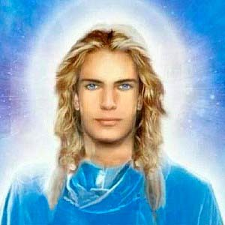
This is how the ancients described them as well.

In the surviving religious records and artifacts of the Americas, we have a story that comes together in South America that we see happening around the world. The above passage is reference to the overturning of the culture of the Gods, of which Quetzlcoatl is the symbol and also the name of the offices of the leaders. It describes the replacement of this culture with a new religion that is based upon human sacrifice to appease the new divinities. The records state the King Huemac made this deal with the god Yaolt. The “lt” is a title, so the name is Yao, which is the ancient name of Yahweh in the Hebrew texts. This led to the imposing of a new religion, led by the sorcerers who were in contact with Yao.

With this change in the religion, the language became exactly the same as in the Jewish Torah, demanding payments in blood sacrifices to Yao, and the concept of debt payments as blood sacrifice. This language is only found elsewhere in the Jewish Torah, which forms the Christian Bible. Hundreds of thousands were murdered every year in the blood sacrifices of the new cult of Yao, and they were done along powerful lay lines to influence the energy grid around our planet.

From the Popol Vuh:

"It has turned out well, your lordships, and this is her heart. It's in the bowl."

"Very well. So I'll look." said One Death, and when he lifted it up with his fingers, its surface was soaked with gore, its surface glistened red with blood.

"Good. Sir up the fire, put it over the fire, said One Death. After that they dried it over the fire, and the Xibalbans savored the aroma. They all ended up standing here, they leaned over it intently. They found the smoke of the blood to be truly sweet!"

In the Jewish Torah in the book of Genesis:

“And Noah built an alter unto the Lord: and took of every Clean beast, and of every clean fowl, and offered burnt offerings on the altar. And the Lord SMELLED A SWEET SAVOR."

From the Popol Vuh:

"And this is the sacrifice of little Huanhpu by Xiblanque. One by one his legs, his arms were spread wide. His head came off, rolled far away outside. His heart, dug out, was smothered in a leaf, and all the Xibalbans went crazy at the site."

These new Gods are feeding on the energy of humans. They literally went crazy with delight and ecstasy from feeding on this death energy. These new Gods are even called "Deaths" and referred to by numbers, as they are a hive such as "One Death."

The ancient South Americans all mentioned the racial traits of the original Gods as being Nordic. When the Spanish arrived, they thought Quetzlcoatl had returned. The same cultures also recorded the physical appearance of the new Gods Huemac imposed on them, the Gods who chased out the previous religion.

We now know what the new Gods of the Aztecs and Mayans who imposed this culture on South America look like from the religious finds of the images they made of their Gods in their Temples and religious sites.

Behold Yao, Yahweh:
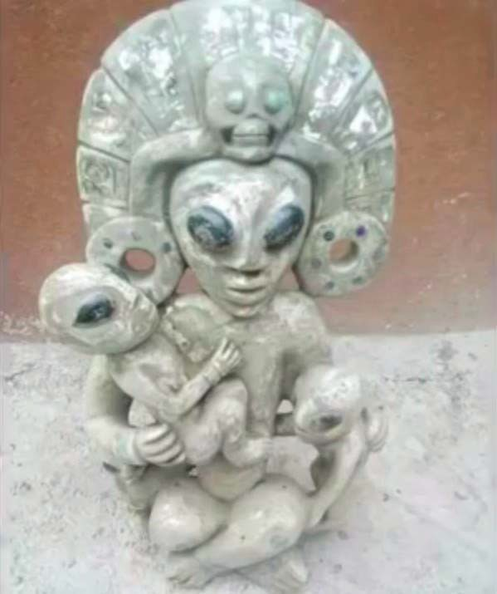
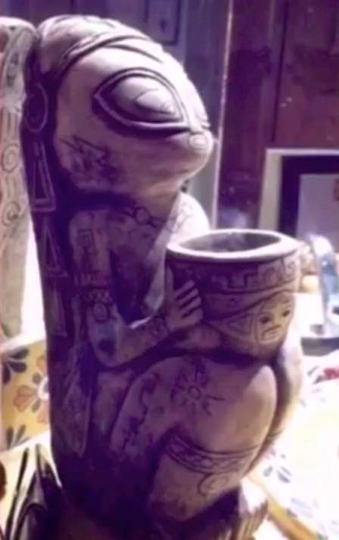

This is what was going in ancient South America:
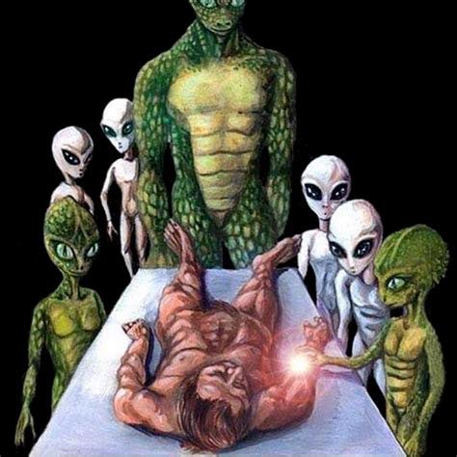

What did the elite Rabbi Michael Laitman tell his fellow Jews in Israel?

"We [Jews] came here [to earth] to put things in order like in our home planet and now were gathering in groups to prep ourselves to conqueror earth that's the mission [of the Jews].

How do we do it? We are also sent the method its coming from our original planet and thanks to that original natural force we have. We will take over those living on earth."

The Jews state they are genetically from this Yahweh and are literally alien, and Yahweh is a collection of Reptilian aliens. The Jewish Cohen gene, their racial gene, has reptilian DNA in it.

Source:
The Grid of the Gods, Joseph P. Farrell, Scott D. de Hart

June 28, 2018
Joy of Satan Forums Contributions

