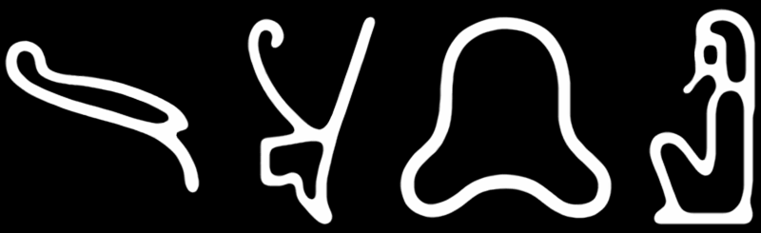

**The Book of Thoth**

Abstract

    The aim of this work is to reconstruct the metaphysical cosmology of ancient Near-Eastern polytheism. It constitutes a theory of ancient Egyptian religion predicated on the hypothesis that early religious narrative may be interpreted as a prescientific technical language of cosmology. This theory has been deduced from reconstructive analyses of Egyptian funerary literature conducted within the purview of later metaphysical systems (i.e. astrology, alchemy, and the tarot) exhibiting sufficient correspondence in form as to suggest a common derivation. Further analysis of such evidence indicates that the "pip" cards of the tarot are correlated with the thirty-six Egyptian decans by way of analogy to those of modern Jyotish, inasmuch as the sequence of four elements associated with the decans of the latter system follows the order in which the gods of the cardinal points are listed with those of the former. Additional evidence is considered for an identification of the aces and "fool" card with the epagomenal degrees of the ancient calendar (namely, a correspondence in the mathematical relationship of these cards to the pips with that of the intercalary degrees to the decans), which are associated with the four elements through a structural analogy between the epagomenal deities and those of the cardinal points. Likewise, the "trumps" and "court" cards are identified respectively as the twenty-one "halls of the netherworld" and fifteen "tombs in the field of offerings," with the sixteenth and final court described in their enumeration by early astronomical images serving as a meridian from which to calculate the azimuth of those regions. That the elemental associations of the Minor Arcana do not continue with the Major is attributed to the complementarity of active and passive matter in late Hellenistic sources, the basis for which is determined through a structural analysis of names from the preceding astronomical diagrams to be an obscure counterpart of the elements analogous with the three "principles" of Jyotish astrology. By the direct correlation of elements and principles with the four common states of matter and three of energy, respectively, the active and passive types of the former set are equated to the positive and negative electromagnetic polarities of the latter, with neutrality representing the concept of aether as physical equilibrium. Hence, the association of elemental qualities with the four humours of classical medicine would imply a similar correspondence between the principles of Jyotish and the three "doshas" of Ayurveda. Further structural and symbolic relationships among the eight major groups of astronomical deities provide the fundamental bases on which to reconstruct the main corpus of ancient Egyptian cosmography, from which is derived a system of metaphysical astronomy involving the synthesis and analysis of stellar radiation in its passage through the interstellar medium to earth. To substantiate this hypothesis, direct correspondences in outline and position are identified between the major asterisms in the ancient system and the Ptolemaic constellations of modern astronomy, enabling a theoretical reconstruction of star maps contemporary with and integrated into the context of Old Kingdom religious cosmology. Lastly, the use of names and images in ritual worship is correlated with the function of entropy and information in quantum systems behaviour.

The Unwearying Stars

    Prior research on the tarot has identified evidence of a structural correlation between the thirty-six pip cards and the decans of modern astrology, but has neglected the implications of such correspondence regarding the decanal asterisms of early Near-Eastern astronomy. This evidence is applicable to the latter set of constellations by their equivalence with the former in terms of numerosity, angular diameters, and location relative the ecliptic - which has been inferred from descriptions of their heliacal rising each ten days, and subsequent invisibility on the following seventy nights due to proximity with the sun. In accordance with such criteria, the decan stars must necessarily have been located in a region of the celestial sphere extending parallel to and roughly thirty degrees south of the ecliptic, wherein specific asterisms are thus identifiable as decans. Comprehensive lists of the prototypical decan sequence first appear in the ninth-dynasty Coffin Texts as a table of stars ordered by rising time at intervals of ten days, which thus constitute a basis of organization for the Jyotish decans by way of their homologous configurations in the rectangular zodiacs of the Ptolemaic Period, and the astronomical diagrams of the New Kingdom from which the latter developed. Hence, the correlation of individual decans to the gods of the cardinal points named in their diagram entries (cf. the astronomical ceiling in the tomb of Senmut) forms a structural analogue with the decans of Jyotish inasmuch as the four elements associated with the latter also represent the cardinal points in that system. Evidence suggesting a derivation of the Jyotish element sequence from the astronomical diagrams is found in the correspondent order of its enumeration to that by which the gods of the cardinal points are listed in the Pyramid Texts, with the former sequence advanced three steps relative the decans - likely as a corrective measure against the shift in apparent positions of the background stars due to equinoctial precession since the date of the latter. However, such an attempt to conserve the elemental qualities of the decans after precession by altering their sequence does not take into account that the prototypical calendar was derived from the appearance of these stars in specific mundane positions at intervals based on the solar day, and hence determined their attributes from its sequence of observation (i.e., the decan’s position in the calendar) rather than the observables themselves. That the calendar was organized principally around the solar day is exemplified by its use of intercalary degrees to maintain the correct sequence of decans after their annual displacement from the standard intervals of observation.

The Days upon the Year

    Historical scholarship likewise demonstrates that the four elements correspond to the ace cards by association with their suits, and may thus serve to identify the "fool" card as the element of aether - which Diodorus Siculus affirms[1]. Hence, with their relation to the pip cards established by a shared classification as Minor Arcana, the aces and fool correlate with the five epagomenal degrees appended to the set of decans in compensation for the apparent shift of those stars over the course of a year. As the elements have been attributed to specific decans in a recurring sequence, it follows that this series of associations would continue through the subsequent epagomenal days by individual degree in order to reset itself to the beginning. Hippolytos's remark[2] that the elements were considered either male (water and fire) or female (earth and air) supports this attribution, inasmuch as the gods and goddesses designated to the epagomenal days were consistently arranged in terms of their sex, with two of each on either side of a neutral member whose name is a cognate of "fool." The insertion of these epagomenal days to reestablish the proper sequence of decans in the calendar was necessitated by its method of observing celestial bodies at intervals of the solar day, and the consequent disparity in their relative mundane positions at later times of observation due to the inequality in length of that period and the shorter sidereal day (in which a star successively transits a fixed mundane position) by roughly four minutes. Angular distances between adjacent decan stars are thus calculated to be around 9.9 degrees, which at the beginning of the first epagomenal day comes to about 354.8 degrees[3]. Since the diagonal star tables began with the first appearance of the twelfth decan after the epagomenal degrees, that of decans one through eleven would have been transposed from the standard time and place of observation, necessitating their substitution for eleven intercalary decans at the correct intervals. Located in a triangular section at the bottom-leftmost third of the diagonal tables, the first of these alternate decans began five degrees before the first standard, allowing the full set of the latter to rise heliacally in one cycle.

The Imperishable Stars

   Referred to as the "Unwearying Stars" for their continuous motion along the ecliptic, the decans were frequently juxtaposed with a group of twelve thirty-degree asterisms in the north circumpolar region called the "Imperishable Stars" due to their cyclical movement above the horizon. The earliest attestations to their existence[4] confirm that while the Imperishables are joined by the sun at dawn ("set for N. the fire to the kettles containing them"), the Unwearying stars follow its path along the ecliptic ("revolve for N., [and] the kettles are replenished for him"), enabling their identification as the astronomical bases of the thirty-six "decade" periods and twelve months of the ancient calendar, respectively. Likewise indicating such a derivation is that the Imperishables are first represented in their entirety by the star tables of the Middle Kingdom as a group of figures in the central column of the decan charts - a configuration preserved in the later astronomical diagrams, from which the Imperishables may be correlated with modern Ptolemaic constellations by their analogous form and placement[5]. Because the decans and circumpolar stars were so inextricably linked, a direct association of individual elements with the members of the former group would therefore extend to the latter; as demonstrated by the corresponding elemental attributes of the Jyotish decans and zodiac signs. Conversely, the latter associations extend to the former inasmuch as their placement in complementary regions of the sky indicates that the decans and circumpolar stars would have been associated with contrasting element sequences - and hence, that the sequence of associations for the circumpolar group likely began at a point in the calendar opposite that of the decans. The resultant organization is corroborated by an image from the tomb of Senmut depicting the Imperishables separated into three groups of four at the appropriate points in this sequence. Considering how the properties of these star groups affected their elemental attributes, it stands to reason that their order was predicated on the assumption (known from Seneca's historical accounts[6]) that matter consists of active and passive types[7] - the mutual exclusivity of which is apparent in the organization of the great ennead relative the Imperishables.

The Greater Body

    The greater and lesser enneads, or "companies of the gods," were often portrayed in juxtaposition by the earliest sources, but while the names of the greater are well known, those of the lesser are never given as such - unless Budge is correct in attributing them to a list of "dwellers" from the Pyramid Texts[8]. By his reasoning, the lesser company must represent the circumpolar asterisms since, according to its erratic reproduction on the Senmut ceiling[9] as a list of names for the Imperishables (in proper order, but advanced by one step to correct for precession), the apparent function of this passage was to identify the deceased with the Imperishable stars. Budge's interpretation becomes less tenable when it is noted from the explicit associations between its members and specific decan stars - which become increasingly prevalent in later sources - that the greater company is evidently a set of divisions on the celestial sphere adjacent to the belt of decans, as identifying the two companies with analogous groups would thus be in opposition to their implied complementarity. A potentially more viable counterpart to the greater ennead may be discerned from an utterance in the Pyramid Texts which states; "I have come to the ennead in the sky... [and] to the ennead on the earth," as the calendary principle of observing celestial bodies at a specific mundane position would indicate that the conceptual framework to which the former ennead belongs necessitated the existence of the latter - thus establishing a complementarity of mundane and celestial spheres. Further support for this alternative is garnered from the correspondence between individual elements associated with the members of the greater and lesser enneads, which proceed in opposite sequential order from a fifth member that incorporates both active and passive matter, and is thereby designated aether. This conventional grouping of astral, cthonic, and liminal deities also formed the structural basis of the calendar's three seasons.

The Trinities

    Exemplifying the metaphysical correspondence between celestial bodies and mundane positions is the union of the earth god and sky goddess, whose children formed two brother-sister couples that each in turn had a child - and thus represent a division of both the mundane and celestial spheres into three. Accordingly, the members of each group are described in terms of their respective elemental associations (e.g., the celestial father as god of air) following the order of their occurence in the set. That the sequence of elements would remain incomplete upon such a designation may be accounted for by taking the elemental attributes of both triads to comprise one set of four, as each of their second members are consigned to aether, and moreover by the existence of a counterpart to the elements in the three principles of Jyotish astrology. The latter correlate with the zodiac signs and decans of that system in a recurrent sequence juxtaposed to their elemental attributes - which explicates the dichotomy of "active" and "passive" matter as a quantitative ratio for the elemental complement of a body relative its principle, and of aether as their equivalence. As with its elements, the Jyotish system has retained the associated principles of the original calendar after precession, thus conserving the differential between the two sequences as well. From the organization of astronomical diagrams representing the circumpolar set divided into three groups, it follows that the celestial triad was evidently located in the north circumpolar region, as the equivalent numerical relationship of these sets to that of the decans relative the greater ennead would thereby constitute a structural analogy. To the extent that the Imperishables and decans served as bases of organization for the months and decades of the astronomical calendar, the celestial triad would thus have informed its three seasons, and the mundane its conventional demarcation of hours into morning, afternoon and night. References to the location of various triad members are often explicit (cf. the celestial son "in the middle of the mid-heaven"), further illustrating their provenance as an early form of the numerous variant triads.

The Lesser Body

    Various funerary texts describe the mundane ennead (being the "oldest company of the gods") as a set of four male deities and their female counterparts, with a neutral "leader" enumerated separately. These four pairs of deities are typically referred to by the masculine and feminine inflections of common terms for the elements, organized by gender in their usual sequence to correspond with the arrangement of the celestial ennead - i.e., the leader on the eastern horizon, the passive female members in the north, and the active males in the south. This arrangement is corroborated by an image from the Book of What is in the Netherworld[10], which portrays the sun rising between the fourth and sixth members, and further by depictions of the mundane ennead in later astral mortuary papyri as four opposite-sex couples, with each member facing its counterpart over a schematic image of the horizon. The organization of elements into opposing sequences, or "antiscia," is referenced explicitly in the Book of Two Ways; a section of the Coffin Texts written on the floor of the sarcophagus that provides mundane positions for the diagonal star table on the underside of the lid. At a point in its narrative relating to the horizon, where the order of the text is reversed, the latter states; "These ways are like this: one thereof opposing its companion in the opposite direction." From the corresponding arrangements of the elemental sequence for the enneads, triads, and epagomenal degrees, the valence of these associations for the remaining sets can be deduced as active in their first and passive in their second halves; the midpoints being neutral. Therefore, if the organization of the ennead of Hermopolis is equivalent to that of the celestial ennead, and the principle of organization for the celestial ennead (i.e., valence of elemental associations) is also that of the circumpolar set, then the mundane counterpart of the circumpolar set must be organized by the same principle as the ennead of Hermopolis. This counterpart is represented by the group of mundane divisions known as the "gates of the sky."

The Gatekeepers

    Astral mortuary texts such as the Book of the Dead often refer to seven "gates of the netherworld,” which by their depiction from the Book of Two Ways[11] are evidently distinct regions of the celestial sphere, located at equidistant points on the horizon and southern half of the ecliptic, that complement five identical features on the northern half to form the twelve mundane counterparts of the circumpolar asterisms. These attributions are substantiated by an image from the latter source representing the ecliptic as a circuitous band, the upper and lower halves of which are painted blue and black, respectively, with a red line between them to indicate the horizon. Since the upper half of this image denotes south as per the typical orientation, and the rightmost of seven gates depicted therein features text referring to the eastern horizon, it likely portrays the visible and invisible sky from a north-facing perspective. Two lists enumerating the keepers of these gates are written on their respective halves of the diagram with the first and last names in either correlated inversely; suggesting that the lists were intended to be read as a continuous sequence. Other salient features of this image are accompanied by prayers for the soul of the deceased as it travels to corresponding points in the sky, and which thus form a narrative cycle that proceeds anti-clockwise from below and to the right of the horizon line. At this point in the text is an image showing the "gate of darkness," which is here portrayed as a schematic representation of the sixth member of the gatekeepers relative the fifth member of the mundane ennead on the eastern horizon. In the classification of hours by time of day, this division corresponds with the first of two three-hour twilight periods when the stars were not invariably observable, and which were thus counted with the eighteen hours of total invisibility as the twenty-four daylight hours of invisible stars. To these were added the twelve hours of night during which the stars were completely visible for a total of thirty-six hours (corresponding to the rise of decans at forty-minute intervals), that by the organizational principle of the celestial and mundane sets necessarily have their basis in a set of mundane positions at ten-degree intervals represented by the "watchers" from the Book of Two Ways.

The Watchers

    Numerous passages from the Book of the Dead refer to complementary sets of ten-degree mundane positions on the southern and northern ecliptic, respectively, as the twenty-one "halls of the netherworld" and fifteen "tombs in the field of offerings," which thus constitute a structural analogue to the Major Arcana. Since these positions evidently correspond to the trumps and courts, it follows that the latter would be identified as the midpoints of their respective areas based on a prevalence of the homologous decans in the northern sky, and the former as their cusps by the analogy of this configuration with the set of gates (and hence the Imperishables) regarding its placement of the median in the south half of the sequence. Images from the Book of Two Ways depict such an organization as the transposal of attributes between figures representing the northern and southern positions; the names of which are inaccurately recorded by a passage in the Book of the Dead substituting those of "gatekeepers" from the earlier text for every third name in its sequence of mundane positions. The eighteen southern positions are enumerated in three lists from the Book of Two Ways written on the ecliptic diagram beside images of their respective gates - a structural correlation of whose gatekeepers with the "keepers of the mounds" named herein obviates their substitution for members of the previous set. At the righthand margin of this diagram is an image representing the sequence of northern positions divided by four gates into three contiguous registers under a horizontal red line, with the last two of each portrayed as human figures, and the remainder as a group of nine scarab-headed snakes. The latter positions are enumerated where they appear in a subsequent image as three scarab-headed figures grasping crocodiles and snakes, while the previous image contains an utterance listing the former by name (of which the last is recorded on a diagram of the eastern horizon), and hence these images taken in series consequently provide a full listing of the northern positions. It follows that since the two figures in each section of the first image are preceded by a group of nine snakes that reappear as three figures in the second, the latter names would be read in one sequence punctuated at intervals of three by the two names for each pair of the former, with the final name being last. So ordered, the names of these positions explicitly refer to their elemental attributes in the proper sequence, as well as to their location relative the members of other sets, and are correctly associated with their respective figures.

The Aspects

    An identification of the deceased's "soul" as one of the Unwearying Stars, and his "spirit" as an Imperishable Star, is made explicit by various utterances of the Pyramid Texts. These associations with the "parts of the soul" (namely the ka, shut, akh, ba, khet, sah, ib, and sekhem) may be extended to the remaining celestial and mundane sets through the correspondence between their respective orders of enumeration in the Pyramid Texts, and to the elements and principles by means of references therein. Passages which identify the ba and akh with the decans and circumpolar stars, respectively, describe their relationship to the ka in terms of an alternating presence coincident with the temporary invisibility of those stars in proximity to the sun. The ka is here referred to as "the aspect of the ba that dwells in the earth,” which correlates with the active portion of the celestial sets in that several utterances describe the sun accompanying the ba at night and leaving it at dawn to join the akh, as per the valences of the mundane sets relative the horizon. It follows that the akh and ba are identified respectively with the principle and elemental components of the celestial sets, and their passive aspect with the shut since the latter is said to accompany the ba during the day. That the ka is portrayed as an exact double of the physical body indicates a correspondence between the khet and the active portion of the mundane sets, to which the sah is evidently a passive complement by its association with the diurnal ba in an utterance reading; “when you stand before the sun, then you are endued with your sah among the baiu.” The elemental portion of the mundane sets is thereby associated with the ib, as in its passive form “the ib is at peace and the sah is rejuvenated,” while the sekhem corresponds with the mundane principles through “becoming an akh” upon the death of the physical body. Hence, that the parts of the soul are identifiable as bodily members of the earth god and sky goddess serves to establish the correlation of their eight associated sets with the "spheres" of the seven classical planets and fixed stars[12], since they are in this capacity functional equivalents of the latter. As a principle of organization for both the celestial and mundane sets, the standard elemental sequence therefore has an observable effect on their mathematical relationships, in that the most numerous set of its complement divides by a single iteration of each associated sequence into two lesser sets, which are in turn multiples of the least numerous set by one iteration of the opposite sequence. From the complementarity evident in this process, it follows that since the elemental sequence correlates with the associations of the planets in Jyotish through their standard enumeration by sidereal period[13], they are designated to the sets in that order as "rulers" of the planetary spheres. Such a configuration accords with the sequence of four colours employed in funerary art from the ninth dynasty onward by means of the consensus among later sources attributing these colours to the elements and planets[14].

The Royal Art

    By their function as "parts of the soul," the planets are to the sky goddess and earth god what the "canopic" organs are to the mind and body of the deceased - thereby serving to correlate the elements and principles associated with their sets to the four humours of classical medicine and three doshas of Ayurveda, respectively. Through an association with the elements discernible from their embalment in jars representing the gods of the four cardinal points, the canopic organs may be demonstrated to influence the four humours as their corresponding planets govern the classical metals; with the stomach designated to yellow bile, the intestines to blood, the liver to black bile, and the lungs to phlegm. Conversely, the embalment of the heart, brain, and genitive organs inside the body establishes their association with the three doshas as mechanisms of biological homeostasis, in that the brain regulates the flow of chemical substances (i.e., the humours) into, the heart their circulation between, and the genitals their outflow from the canopic organs. Since the elemental and principle states of these substances translate into modern scientific terminology as the four common states of matter and the three of energy, respectively, it follows that their active and passive types likewise correspond to the positive and negative electromagnetic polarities of matter or energy; where neutrality thus equates to aether. In this context, the element of earth corresponds to the solid state of matter, water the liquid, air the gaseous, and fire the plasmic, qwhile the fixed principle corresponds to potential energy, the cardinal mechanical, and the mutable kinetic - synthesis of elemental or principle states being mutually exclusive as a result of their complementary valences. According to current molecular theory, the product of two unlike states with opposite polarity retains the polarity of the higher-energy state, while that of two like material or energetic states with the same polarity retains its former state, and the product of two like material or energetic states with opposite polarity is neutral when both complements are thus equivalent, or assumes the polarity opposite that of its complementary state when that complement is polarized. Two states of matter a state apart produce the intermediary state when synthesized, but if the states are contiguous, the higher-energy state is retained when the synthesizing matter is positively charged, and the lower when negatively charged. If the contiguous material states are of like polarity, the higher-energy state is retained when the synthesizing energy is mechanical, and the lower when potential or kinetic, in accordance with its elemental qualities. Plasma and solids of unlike polarity synthesize gases if the plasma is positively charged or liquids if negatively charged, but when of like polarity, these states produce gases if the synthesized energy is mechanical, and liquids if potential or kinetic. A neutral body in synthesis with a polarized body assumes the state and polarity of the latter, but retains its neutrality when synthesized with another neutral body. Two unlike energetic states of opposite polarity synthesize the third state, retaining the polarity of the state associated with the higher-energy material complement, or if the latter are alike, assuming a positive charge when the synthesized energy is mechanical, and a negative charge when kinetic or potential. The product of two like energetic states of opposite polarity retains that state and assumes the polarity of the state complementary to the higher-energy matter, or neutralizes when the latter are alike.

The Study of Hours

    In the time and place at which the Coffin Texts were composed (circa 2150 B.C., at roughly thirty-one degrees north and thirty degrees east), the heliacal rising of Sirius occurred on the seventh of July, and the summer solstice on July seventeenth. Therefore, the decan incorporating Sirius would no longer have occupied the midpoint of the original star table, as it had since the inauguration of the calendar circa 3500 B.C. when their alignment first occurred. To compensate for this precessional effect, the calendar's observation point was evidently shifted from the eastern horizon to the medium coeli circa 2000 B.C., necessitating the advancement of its original decan sequence by five steps, and of the great ennead by two. A hypothetical alternative using the former point and time of observation would thus advance the decans by four, the circumpolars by two and the great ennead by one, while retaining the previous structure of elemental associations. By that ordering, the Imperishable Stars correlate approximately with Ptolemaic constellations as follows: "jst-DAmt" - Ursa Minor and Cepheus (gamma region), "rrt" - Draco (Eltamin to iota) and Cepheus (excluding gamma), "mnjt" - Lyra (Vega) and Cygnus (iota-2 region), "nwH" - Cygnus (Deneb to Albirea), "nxt" - Cassiopeia and Andromeda (phi to nu), "Htp-rdwj" - Lacerta and Pegasus (pi), "nTr-rwtj" - Perseus, "HAqw" - Camelopardalis, "saq" - Auriga (northern half), "Anw" - Lynx and Gemini (Pollux to iota), "msxtjw" - Ursa Major (north of chi), "srqt" - Ursa Major (south of chi), Leo Minor (10 to 46), and Canes Venatici (Chara to 20). The decan "spd" (region of Sirius) rises heliacally eight hours after the first visible rising on August second at the above coordinates. Since these asterisms are equivalent in structure to the constellations of the Ptolemaic system[15], which likewise incorporated their divinatory function as the basis of its horoscopy, the operative principles of the former system may be applied to the latter thusly - on a given date, the celestial position of the sun is found by noting that on which it occupied the previous zodiacal cusp (e.g., March twenty-one for Aries), then adding the difference in degrees of Right Ascension. The mundane position of the sun is obtained by calculating its azimuthal distance from the rising point as a function of the difference in minutes between a given time and that of the previous sunrise, where approximately four minutes equals one degree of azimuth. Having thus determined the celestial and mundane positions of the sun, moon, planets, and heliacally rising decan, their elemental and principle states are synthesized with those corresponding to the divisions of their respective sets in which they are currently located. The product state from each set is then synthesized with the state of the division aligned to its ruling planet in the complementary set of the opposite sphere, with the end products representing their aggregate chemical states - from which the humoral pathology of the subject is derived.

The Divine Work

    As the image (tut) and name (ren) of the deceased represent a specific configuration of elements and principles associated with the "parts of the soul," likewise the form and function of a body constitute higher-order emergent properties of the information and entropy stored in its chemical makeup. Thus, for quantum states where the entropy of a system is inversely proportional to its information content, any increase of the former requires that an equal amount of the latter is transferred from the system into its environment, causing their states to become entangled. Once the system has lost information due to entanglement with its surroundings, a subsequent gain of entropy from the latter initiates the collapse of its wave function, giving rise to classical dynamics in which entropy is correlated with matter, information with energy, and their proportion with the electromagnetic force. It follows that since the ratio of information to entropy in a classical system can determine the electromagnetic polarity of its energetic and material components, the corresponding relationship of the image and name associated with a body could likewise affect the valence of its elemental and principle states. In the former context, sacrificial offerings made to invoke the power of a deity would represent units of entropy transferred from one system to another for the purpose of causing their entanglement, and hence a reciprocal transfer of information. Such offering rituals may therefore influence the behaviour of living systems through the mechanism of entanglement, initiating a controlled absorption of photonic enery in their subject as the catalyst for a predetermined form of biochemical synthesis. Consequently, the performance of a ritual sacrifice would first entail identifying the chemical states of all relevant planets and stars (as well as those of any regions in the atmosphere and cosmic background to which they are aligned), determining the words and images associated with those specific configurations of matter and energy, and employing them in accordance with the standard ritual formulae. Where higher proportions of systemic information tend to yield a net positive electrical charge and negative magnetic moment, a greater emphasis on words over images may therefore induce a passive elemental and active principle state in the associated body, and vice versa.

The Three Divisions of Natural Philosophy

**I. ALCHEMY**

As the interactions of charged particles result in the formation of atomic structures that synthesize into chemical compounds, so the harmony and strife between elements in a body determines their average proportion to generate its humors and principles.  
  
  
The four Elements and three Principles:  
Physical states of matter and energy  
Comprise the four Humours and three Qualities  
  
The material states and Elements (Humours):  
liquid = water (phlegm)  
plasma = fire (choler)  
solid = earth (bile)  
gas = air (blood)  
  
The energetic types and Principles (Qualities):  
potential = fixed (salt)  
mechanical = cardinal (mercury)  
kinetic = mutable (sulphur)  
  
  
Activity and Passivity:  
Positive and negative electromagnetic polarities  
matter: electrical charge (stasis)  
energy: magnetic moment (motion)  
  
Aether:  
Electromagnetically neutral organic substances  
Produced from like Elements of opposite valence

**II. ASTROLOGY**

As the chemical substances ocurring naturally in various regions of the earth's atmosphere interact with stellar radiation and the cosmic background in regions of the celestial sphere to which they are aligned, so the elements and principles of the stars combine with those of the mundane positions.  
  
  
The mobile Celestial and stationary Mundane Spheres:  
Divided into Hemispheres by the ecliptic and horizon  
Hemispheres divided into Regions by latitude  
Regions associated with Elements and Principles  
  
Upper Hemispheres (Active):  
3 Celestial and Mundane Triads (Principles)  
12 Imperishable Stars and Gates (Elements)  
  
Lower Hemishperes (Passive):  
9 Heliopolitan and Hermopolitan Enneads (Principles)  
36 Decan Stars and Watchers (Elements)  
  
  
The Planetary Spheres:  
Region groups integrated with the classical planets  
React strongly with planets of like chemical state  
Ordered by sidereal period length of ruling planet  
  
Mundane Planetary Spheres (Elements):  
Gates: Moon (water)  
Watchers: Sun (fire)  
Ennead: Mercury (earth)  
Triad: Venus (air)  
  
Celestial Planetary Spheres (Principles):  
Imperishables: Saturn (fixed)  
Decans: Uranus (aether)  
Ennead: Jupiter (cardinal)  
Triad: Mars (mutable)  
  
  
  
  
**III. THEURGY**  
  
  
As the transfer of entropy or information from a system to its environment induces a proportional transfer of the opposite component from its environment to the system, so the offering of ritual sacrifice induces a transfer of corresponding elements and principles from the stars.  
  
  
The Image and Name:  
Particle and wave characteristics of a physical system  
Emergent properties of the Humours and Qualities  
Generated by the Canopic and Polaric Organs  
  
Canopic Organs (Planets) and Humors (Spheres):  
stomach (Moon) - phlegm (Gates)  
liver (Sun) - choler (Watchers)  
intestines (Mercury) - bile (Hermopolitan ennead)  
lungs (Venus) - blood (Mundane triad)  
  
Polaric Organs and Principles:  
brain (Saturn) - salt (Imperishable stars)  
eyes (Uranus) - aether (Decan stars)  
heart (Jupiter) - mercury (Heliopolitan ennead)  
genitals (Mars) - sulphur (Celestial triad)

The Tablet

The Celestial Sphere

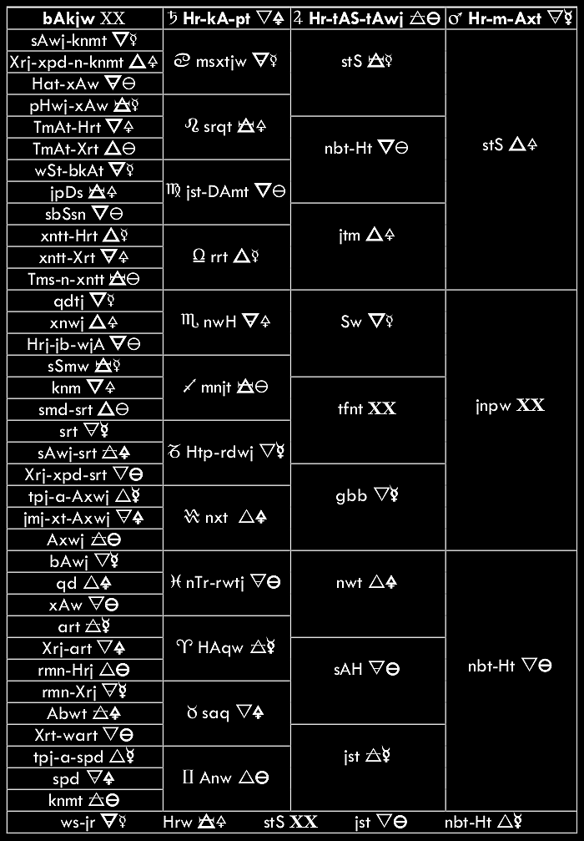

The Mundane Sphere

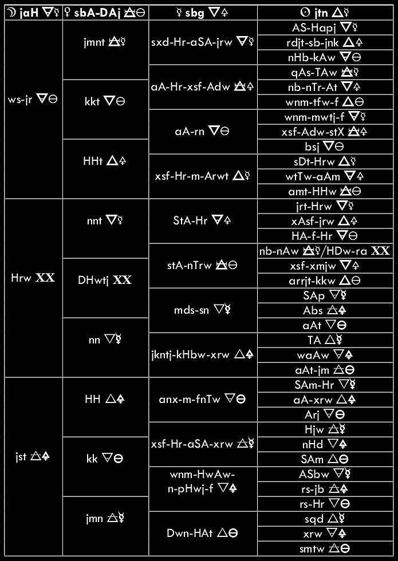

L**EGEND:**

                    Charts:

                    Columns = planetary spheres (column headings = planets)

                    Rows =  sections of right ascension or mundane position

                    Names = Deities associated with regions or planets

                        (Manuel de Codage transliteration)

                    Symbols = associated Elements (left) and Principles (right)

                        (bold = Active, regular = Passive)

                    Chart 1 columns/rows (from left):

                    Uranus/decans, Saturn/imperishables, Jupiter/ennead, Mars/triad

                    Top border = 0* Cancer, midline = 0* Capricorn

                    Footer row = intercalary days (1* each)

                    Chart 2 columns/rows (from left):

                    Moon/triad, Venus/ennead, Mercury/gates, Sun/watchers

                    Top border = due West, midline = due East

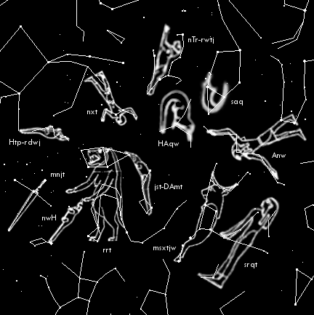

Figure 1: The north circumpolar stars.

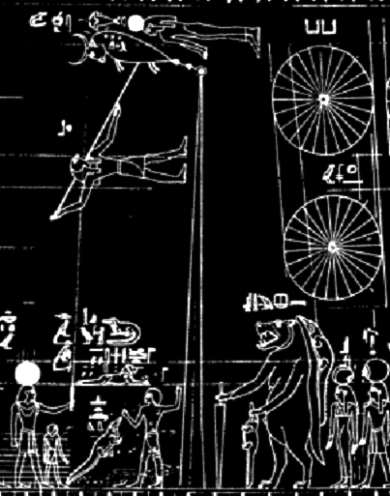

Figure 2: The Senmut astronomical diagram (detail).

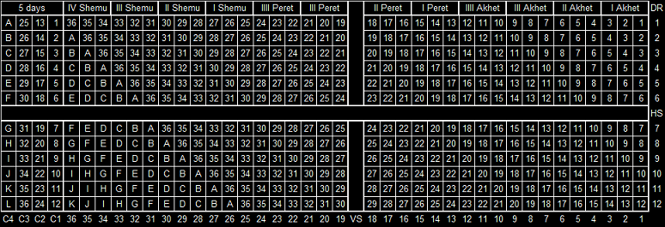

Figure 3: An idealized diagonal star table.

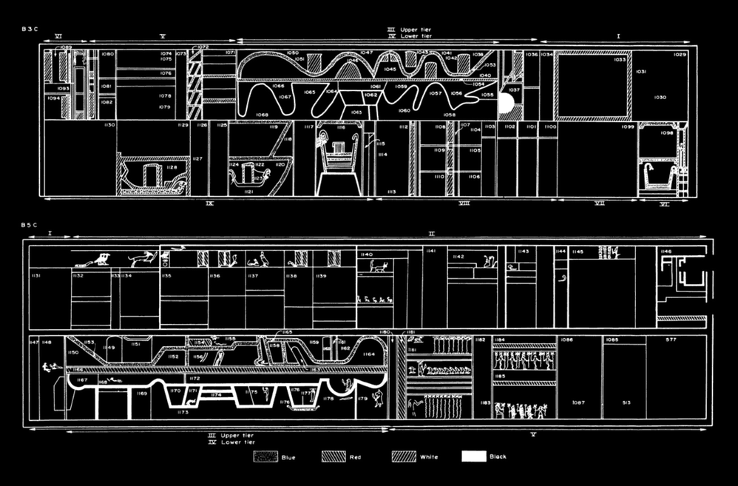

Figure 4: Ecliptic diagrams from the Book of Two Ways.

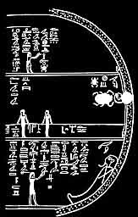

Figure 5: Image from the Book of What is in the Netherworld.

References

1.    Diodorus Siculus; Bibliotheca Historica I, p. 42.

2.    S. Hippolytus; Episcopi et Martyris Refutationis Omnium Haeresium IV; Ed. L. Duncker & F. G.

            Schneidenin, Gottingen 1859.

3.    S. Symons; A Star’s Year: The Annual Cycle in the Ancient Egyptian Sky, p. 27; University of Leicester, 2002.

4.    R. O. Faulkner; The Ancient Egyptian Pyramid Texts, passim; Oxford University Press, 1969.

5.    J. Belmonte & M. Shaltout, Ed.; In Search of Cosmic Order, passim; Supreme Council of Antiquities Press, 2009.

6.    Seneca; Quaestiones Naturalibus III, p. 3.  
7.    Iamblichus; De Mysteriis VIII, p. 3.

8.    E. A. W. Budge; The Gods of the Egyptians, vol. I & II, passim; Methuen & Co., London, 1904.

9.    M. Clagett; Ancient Egyptian Science, vol. I, p. 117; American Philosophical Society Memoirs, vol. 214, 1995.

10.    Budge; The Book of Am-Duat, p. 277; Kegan, Paul, Trench, Trübner & Co.; London 1905.

11.    L. Lesko; The Ancient Egyptian Book of Two Ways, passim; University of California Press, 1977.

12.    J. H. Breasted; Development of Religion and Thought in Ancient Egypt, p. 28; Charles Scribner's Sons, New York, 1912.

13.    O. Neugebauer; The Exact Sciences In Antiquity, 2nd Ed., p. 169; Dover, New York, 1969.

14.    J. R. Partington; A History of Chemistry, vol. I, pp. 20, 301; MacMillan & Co., London, 1970.

15.    A. Pogo; The Astronomical Ceiling-Decoration in the Tomb of Senmut; Isis, vol. XIV, number 2;

              The History of Science Society, 1930.

© 2012 - 2017  Iou Artios Ogdoas