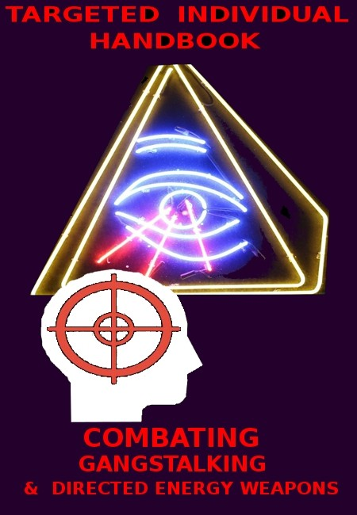

TARGETED INDIVIDUAL HANDBOOK:

a handbook for the Targeted individual to identify and counter gangstalking and directed energy weapons

Introduction

1. What and Why?
2. Who
3. Solutions
4. References Marching Orders

INTRODUCTION

The phenomenon of state-sponsored terrorism is nothing new and has been orchestrated by the architects of destruction, the hidden hand of judeo-freemasonry since time immemorial. Imposing trauma-based mind control on the common folk is the mechanism of power relied upon to maintain power-mind control, world control. The shadow government of the cabal is comprised of jews (a biological mongrel race bound up with entities which control them) and their 'shabbos goyim' (meaning 'stupid animals' in yiddish, referring to the non-jewish tools they exploit to absorb total power for themselves). The cabal has been in existence for thousands of years and is poised for the realization of their plans for global dominion and enslavement of all to their despotic will as of the time of this writing.

This handbook treats of the foremost particular means employed in the manipulation of the common folk beyond that of chemtrails; electro-magnetic fields broadcast from cell towers and other arrays; the poisoned food (GMOs) and water supply (chlorine; fluoride; estrogenic substances and synthetic chemicals); coerced taxation and wage slavery; media and education- indoctrination system propaganda and mind control among other technotronic control mechanisms.

The cabal has allegiance towards itself alone and to the entites which control it. The society engineered and controlled by the cabal is structured as a trapezoidal geometrical figure in terms of power share: Jews are at the top of the trapezoid in the physical dimension with freemasons and other illuminist groups subordinate. Under the controlling elite the population is divided into rival camps based upon occult principles of polarity: masculine (right wing) and feminine (left wing). The whole of "the system" of the judeo-masonic theocracy operates in secrecy and is hierarchically compartmentalized with advancement or demotion based upon the degree of loyalty given to the cabal and the use value of the individual thereto.

This loyalty entails an agenda of endeavoring to eliminate, to genocide, the white race as the greatest threat to the world rule of the cabal as those of pure blood (the white race), listen to the call of the blood memory and are not willing to sell out to the cabal for self-serving ends to as great an extent as other groups as the white race intuitively understands the difference between good (harmony) and evil (cacophony) and what is harmonious is the preservation of the organism of which one is a part, the racial soul.

That the white race is that most elevated in its consciousness can be inferred from its vertical tendency towards the higher planes of existence, towards the spiritual realms and its essential drive towards maintaining a harmonious world order.

The cabal of judeo-freemasonry seeks a world order based upon greed; usury; trickery and deceit. It seeks to destroy the identity of all and to reduce all to a mongrel mass in the crucible of its power politics, the divide and conquer tactics it employs to create chaos and impose its order.

Those who oppose the cabal are targeted and those of pure blood, those of a healthy mind incorruptible by its influence are foremost in the crosshairs. This group, especially those who are the most intelligent and intuitive amongst them, are prime target's for the cabal's use of the following means of global enslavement.

It is the wish of the author and compiler that this handbook be spread as widely and effectively as possible (reaching the reachable and those who will take action) so that the crimes of the cabal will be exposed and ultimately the balance of justice they have upset rectified. The following work is largely a synthesis of existent material on the phenomen of targeted individuals, gangstalking and directed energy weapons, identifying what they are, how they are used, by whom and why. Either this information will get out and the cabal be exposed and overthrown through effective necessary action or there will be no future for this world. This handbook is designed to be a contribution to the overthrow. Spread it- it is an arrow in the black hearts of the architects of destruction.

1)

WHAT and WHY?:

A) Definitions:

"Organized Stalking is a well-organized, occult form of covert harassment used against an individual. It is done by large groups of people who systematically & repeatedly harass individuals. This has also been called Cause Stalking, Gang Stalking, Community-based Harassment, Organized Vigilante Stalking, Vengeance Stalking, Terrorist Stalking, Revenge Stalking, Covert Action, State-Sponsored Harassment, Microwave Harassment, Microwave Mind- Control, etc. All of these labels explain the same basic phenomenon." (Rich, State-Sponsored Terror Campaigns: The Hidden Evil",pg. 28-29).

"Mobbing, also referred to by some as bullying, psychological terrorism, and organizational violence is described as a collective form of psychological violence in which many individuals unite to persecute an individual Mobbing is a way of destroying a person without using any physical means Degrading themes are often used to try to prevent people from coming forward." (ibid., pg.35)

"Operations [are] designed to intimidate and destabilise [targeted individuals, 'TIs' for short] by subjecting them to repeated disappointment, and to socially alienate them by interfering with and disrupting their relationships with others as in social undermining. The aim was to induce personal crises in victims, leaving them too unnerved and psychologically distressed to have the time and energy for anti-government activism. " (zersetzung, pg. 1)

"What we are seeing now is a globally co-ordinated and organised effort of control and conformity. Many countries around the world are currently using a model of policing called Community Oriented Policing [ie.gangstalking]." (ibid.pg.3)

“Organized Stalking is a form of terrorism used against an individual in a malicious attempt to reduce the quality of a person’s life so they will: have a nervous break-down, become imprisoned, institutionalized, experience constant mental, emotional, or physical pain, become homeless, and/or commit suicide. This is done using well-orchestrated accusations, lies, rumors, bogus investigations, setups, framings, intimidation, overt or covert threats, vandalism, thefts, sabotage, torture, humiliation, emotional terror and general harassment. It is a “ganging up” by members of the community who follow an organised method and participate in a systematic “terrorizing” of an individual.” (ibid.pg.4)

"What are the goals of Gang Stalking? The usual goal is to isolate the target from all forms of support so that the target can be set up in the future for arrest, institutionalisation or forced suicide." (Stasi tactics-Zersetzung,pg.4)

This is called "sikul memukad" in Hebrew (targeted killing)

"The Zersetzung ['decomposition' in German] of individuals was usually carried out by systematically undermining the target’s quality of life (both socially and in the workplace) with the intention of simply destroying the target’s confidence. The tactics used took various forms, such as spreading slanderous rumours, causing trouble at work etc. " (ibid.)

Organized harassment is a form of "Fourth Generation Warfare- is a form of political/information warfare waged against civilians by a state or other entity. It utilizes civilians and the military, indeed all of society, to target civilian adversaries (aka “domestic state enemies,” “insurgents,” extremists, non-state actors, “cells of fanatics,” citizen “terrorists”) who value national sovereignty and/or pose some perceived threat to the state’s interests."

(“Instruction Manual for Community Gang Stalkers”).

"This[...]never ending systemic[...]harassment, influence and manipulation of the targeted individual [...is] specifically designed to control the target with the aim of keeping them in line or the[...] destruction (Zersetzung) [of their soul].

("Zersetzung - The East German Secret Police Methodology of Psychological Decomposition",pg.3)

"The long-term objectives of these harassment and experimentation campaigns appear to be quite fundamental; (1) induce a sense of perverted loyalty toward the very agencies engaged in the individual s harassment (2) redirect the targeted individual s feelings of hopelessness, anger and frustration toward racial and ethnic groups (3) force the individual to commit an act of violence, whether suicide or murder, under conditions which can be plausibly denied by the government." Microwave Harassment & Mind-Control Experimentation, Julianne McKinney,

Director Electronic Surveillance Project, Association of National Security Alumni

"[T]he objective of the campaign is to separate a person from friends/family, keep them unemployed, induce homelessness, & reduce the quality of life so much that they suffer a nervous breakdown, cause them to commit suicide, or end up medicated, incarcerated/institutionalized."

(Rich, State-Sponsored Terror Campaigns:The Hidden Evil", pg.45).

"7. Our kingdom will be an apologia of the divinity Vishnu, in whom is found its personification - in our hundred hands will be, one in each, the springs of the machinery of social life. We shall see everything without the aid of official police which, in that scope of its rights which we elaborated for the use of the GOYIM, hinders governments from seeing. In our programs ONE- THIRD OF OUR SUBJECTS WILL KEEP THE REST UNDER OBSERVATION from a sense of duty, on

the principle of volunteer service to the State. It will then be no disgrace to be a spy and informer, but a merit: unfounded denunciations, however, will be cruelly punished that there may be no development of abuses of this right.

1. Our agents will be taken from the higher as well as the lower ranks of society, from among the administrative class who spend their time in amusements, editors, printers and publishers, booksellers, clerks, and salesmen, workmen, coachmen, lackeys, et cetera. This body, having no rights and not being empowered to take any action on their own account, and consequently a police without any power, will only witness and report: verification of their reports and arrests will depend upon a responsible group of controllers of police affairs, while the actual act of arrest will be performed by the gendarmerie and the municipal police. Any person not denouncing anything seen or heard concerning questions of polity will also be charged with and made responsible for concealment, if it be proved that he is guilty of this crime.
2. JUST AS NOWADAYS OUR BRETHREN, ARE OBLIGED AT THEIR OWN RISK TO DENOUNCE TO

THE KAHAL APOSTATES OF THEIR OWN FAMILY or members who have been noticed doing anything in opposition to the KAHAL, SO IN OUR KINGDOM OVER ALL THE WORLD IT WILL BE OBLIGATORY FOR ALL OUR SUBJECTS TO OBSERVE THE DUTY OF SERVICE TO THE STATE IN THIS DIRECTION."

("Protocols of the Elders of Zion", Protocol 17,sections 7-9)

B)

3 STAGES OF 'Zersetzung' ('decomposition') the terrorist protocol of the Hidden Hand:

1. Targeting (investigation and surveillance)
2. Gangstalking
3. Electronic Harassment (directed energy weapons, a.k.a 'D.E.Ws') 1)

Targeting (investigation and surveillance)

Targeting "begins with [i)]surveillance so that a person's personality traits can be catalogued."(Rich, pg.19). "Targets are constantly monitored and if a target responds emotionally to a particular trigger, that will be built into the protocol." ( Julianne McKinney).

From there it progresses to ii) investigation. "The bogus investigation appears to be the platform used to launch the smear campaign & remove a person's support structure." (ibid., pg.20) "The people who organize these harassment programs will try to assassinate your character. They will carry a case file on you that they will use for character assassination & to gain community support." (ibid.)

* 1. Surveillance and ii) investigation:

"They will set up a base of operation in your neighbourhood to conduct surveillance." "They will sublet, lease, rent property above, below or to the sides of your living space to do this. Money is no object as they have an unlimited budget. Half-truths, setups, & outright lies WILL be used. If you re an Organized Vigilante Stalking target, the investigation is not a means to an end, it is an end unto itself." (ibid.). "Gang Stalking begins the targeted individual may at first be placed under covert forms of surveillance. The person will probably be monitored 24/7. Foot patrols and vehicle patrols may be used to follow the individual as well as electronic means as part of the monitoring, psychological profiling process. Once the psychological profile is complete, the Gang Stalking can commence."

("Zersetzung - The East German Secret Police Methodology of Psychological Decomposition")

"The first stage of Zersetzung was an evaluation of all state held data and information, eg medical records, school reports, police records, intelligence reports, searches of target’s residence. At this point they were looking for any weak points (social, emotional or physical) that could be used as a way to put pressure on the target[...]that could be used to socially isolate them." ("Stasi Tactics – Zersetzung")

"[T]he group will be watching your home from their bases of operation using triangulation. Devices such as radar flashlights & millimeter wave devices, like the ones used at

airports may be used such as The Life Assessment Detector System (LADS). It has a range of

about 135 feet can & can detect heartbeat & respiration. It can also be configured to track a specific person s movement inside a building." (ibid.)

"Both community-based agent (CBA) visual surveillance and advanced electronic surveillance are used." (“Instruction Manual for Community Gang Stalkers”, pg. 2)

2) GANGSTALKING

"Once the psychological profile is complete, the Gang Stalking can commence. Gang Stalking generally originates from when a covert investigation is opened on an individual and teams of plain clothes police officers, citizen informants/snitches and snoopers are deployed to obsessively harass the targeted individual usually to an extreme degree"

("Zersetzung - The East German Secret Police Methodology of Psychological Decomposition", pg.2)

"The next stage was often to supplement covert surveillance with overt observation in order to communicate to the target that they were of interest to the Stasi and to create a sense of insecurity and paranoia." (Stasi Tactics – Zersetzung, pg.4)

The Gangstalking; Organized Stalking or mobbing protocol targets both the person and their property as well as those the cabal believes they care for as a means of harming the targeted individual. The following section covers examples of particular tactics employed and the desired effect of the perpetrators though it is by no means exhaustive.

1. Property:

Thefts & Break-ins

'Thefts may be reduced to small inexpensive items. But some targets have reported jewelry, passports & other important items stolen. There is usually no sign of forced entry. This is done to let you know that they ve been in your home. These cults are obsessed with all aspects of a targeted person s life. Personal items may be passed around to group members & are apparently symbolic of the control the group has over their target." (Rich, State-Sponsored Terror Campaigns: The Hidden Evil",pg. 22)

Sabotage & Vandalism

"This happens at home & in the workplace. Electronic equipment may constantly be failing. This may be accomplished with the e-bomb or a similar device[...]Projects you ve worked on the previous day may become broken. Many times this vandalism is usually just below what you'd report to the police." (Rich, State-Sponsored Terror Campaigns: The Hidden Evil",pg. 23)

"Where the target owns substantial land, noxious activities can be arranged and built for next to the property. In one case, a dump, an auto race track, and a prison were built adjacent to a target who owned a large farm in an area of natural beauty. While this is rare, it does illustrate

commitment to delivering punishment to those “deserving” of it." ("Bright Light on Black Shadows",Dr. Rauni-Leena Luukanen Kilde, ch.18)

While this is not necessarily property damage it is a destruction of the right to the quiet enjoyment of the premises and to the market value of the property thus harming the targeted individual indirectly as with most of the gagnstalking protocols.

1. Person:

The assault against the person is of course the ultimate purpose of the Hidden hand. The cabal targets the person a) economically;b) legally; c) socially; d) physically and 3) most importantly psycho-spiritually all of whichspecific forms of assault are interpenetrating given that the person is a multidimensional being whose sphere of influence participates in these spheres. The following amplifies upon how the person (T.I) is affected in these ways:

* 1. Economic Sabotage:

Blacklisting

"Gang Stalking groups will interfere with every personal & business relationship you have.(7) Since they are state sanctioned they can easily keep you unemployed. Job opportunities will be trashed. They get paid to make sure that you don't. Most targeted people are unemployed." (Rich, State-Sponsored Terror Campaigns: The Hidden Evil",pg. 23).

Bank accounts may be shut down or sabotaged through white collar crime; online transactions may be obstructed from other financial mediums or major or minor sellers. Attempting to sell or buy on the internet will also be obstructed through sharp pratices or preventing from occuring by the perps.

Should one attempt to sell real estate he will lose on the value as with other sales as the cabal has a monopoly on the real estate industry/profession. Also any other commodity of negotiable value is subject to loss of its value if sold for the same reason (eg. bullion; collectibles; etc.)

Financial surveillance. It looks like every penny a Targeted Individual has is counted and only a certain amount is allowed for the Targeted Individual to gain or evil schemes made to bring bankruptcy or poverty to the target.

* 1. Legal Sabotage:

Reporting things to the police should adhere to the extensive protocols and advice outlined in:"Information Handling in the Fight to Expose and Stop the Crime of Organized Stalking and Electronic Harassment"[O.S.E.H], Eleanor White

In brief one should avoid dealing with police (see below in the section "Coping", subsection "Dealing With Police")

The cabal utilizes police both plain clothes and undercover in their O.S.E.H campaign against T.Is and they are perhaps with some exceptions involved to varying degrees, the higher up in the hierarchy they are the more compromised and more corrupt they are. Officers of the rank of

Sargeant and above are invariably freemasons who are the shabbos goy ('stupid animal' in yiddish) of their jewish masters. Hence they cannot be trusted.

Police work with private security 'professionals' (locksmiths and alarm system companies as well as private security guards and their managers) to spy on and break and enter into T.I's residences for harassment and sabotage purposes.

The legal system, being under the control of the cabal (a noahide-talmudic court which has supplanted the common law) employs lawyers and judges who will seek to railroad anyone they can frame as having violated their laws or bylaws throgh the system and give them the heaviest penalties they are able. Advice: trust no member of the legal profession as they are almost universally compromised and are either jews or freemasons or jewdeo-christians. 'They' are the cabal along with all other bureacrats and orgnizations private or public that all work together in their 'communitarian' spy society system (the 'Hidden Hand' shadow government).

* 1. social sabotage:

'Some tactics used to keep you Blacklisted include interfering with communications, & slander. Also there are lists and software packages used to check these lists for suspected terrorists, threats to national security, etc. Apparently this is a flourishing business & some organizations are required by law to use it." (Rich, State-Sponsored Terror Campaigns: The Hidden Evil",pg. 24).

"Since they have federal connections, they do have the ability to frame a targeted person for crimes out in public as well using informants.(101, 7) Any weakness a person has can be used in one of these setups. A person may not be aware of some of these set-ups, but they may be added to a case file to assist with the smear campaign. They may try to provoke a confrontation when Mobbing you out in public.("Terrorist Stalking in America", David Lawson). Group members also try to entice the target to assault them, but this is never done without having witnesses present. The criminal conviction of the target, following the testimony of numerous concerned citizens can be followed by a civil lawsuit. (ibid. pg.23)

"Pedophilia is one common lie used to bring neighbors, co-workers, community members, and in some cases even family members into the 24/7 harassment." (ibid., 62)

In the gangstalking protocol the attempt to frame the T.I is employed through the perps following the T.I around (presumably through GPS if the T.I is implanted with a chip or through maintaining a continuous visual by pedestrian and driver perps as well as residencts being given notification via text message or alerts on their cellphones that the T.I is approaching and that they should begin a noise campaign to harass the T.I when he is in range). They often deliberately involve children and women with baby strollers and babies to have them intercept the T.I while the latter is walking along a route at a certain pace (see 'intercepts' below). He can then be photographed adjacent to the women and children and these photos shown around community members by police or other 'authorities' to convince the gullibile goyim ('cattle' in yiddish) to go along with the campaign and attempt to escalate the harassment of the T.I. Once adequate evidence is gleaned of the T.I in the context of womena nd children he may evenutally have trumped up charges brought against himself to involve him in legal trouble (charged with 'pedophilia' or put on a

watchlist). Should he be jailed he may be executed by prisoners there or even by vigiliantees in his community. This will also prevent him from gaining employment owing to the notoriety of his constructed identity (constructed by the cabal).

Once the T.I's reputation is irreparably damaged through smear campaigns and rumour mongering he can then be further subject to punishment by the cabal and its agents and if he complains no one will ascribe value or truth to his claims.

electronics:

"[...]additionally, T.Is "[...]may receive unsolicited email that parallels a current event in your life[...]you may receive covert insults & threats."(ibid. pg.29)

"Your email may be blocked or filtered & your web activity may be monitored[...]If you try to [...]participate in online discussions groups, online dating [...]it is very possible you will be interrupted, trashed, or harassed. This can be done by a combination of paid civilian contractors (operatives/provocateurs) & email filtering." (ibid., pg. 30)

Should one encounter any others through daily life those he encounters may very well be gangstalkers/perps themselves who are seeking to either gather information on the person or who are seeking to set him up somehow (assassination via poisoning or other means; rape; planting evidence on the person for a subsequent police investigation or raid instigated by other perps, a.k.a 'swatting', calling the police with false accusations). This may be the case even after prolonged contact with the person who befriends the T.I as they may be a deep cover agent. Also the 'friend' may be simply playing the role to subject the T.I to gaslighting and other forms of implicit abuse to wear away their sense of self-worth or to encourage them in vice such as faggotry or other deviant sex practices or drugs,etc. Anything that can be made to set the person up, sully their reputation and escalate their demise in the most cruel and traumatic way (the purpose of the Hidden Hand).

Social Control - Isolation of individuals through social and societal systems of control

Fabrication of false evidence that justifies ”Crime prevention” (fabrication of evidence of a falsified crime and rumor spreading - Discrediting of Targets); In most cases, Targeted Individuals are accused of a sex crimes with no chance to defend themselves.

Sudden unemployment or redundancy, discrimination or hostility within work places.

Loss of friends, because of rumors or direct control. The perpetrators take over the friendship and social life of the TI. They are always rude, and manipulative and not real friends.

Creating ”symptoms” of Mental Illness (voices in the subconscious, V2K; trying to describe what is happening for others) putting the individual in psychiatric care.

Creating ”symptoms” of Substance Abuse (tampering food with drugs, poisons or medication; blurred vision; read eyes; disorientation; head aches; memory loss; difficulty talking or making sense) destroying the targeted individuals reputation;

Creating ”symptoms” of Insulin related diseases (pain in the spinal cord, back of the head, terrible head aches, high blood sugar levels, enormous fatigue) creating early retirement or poverty because of inability to work.

Creating "symptoms" of hormonal imbalance. (See that you take a supplement of minerals and vitamins and take care of your glands).

Creating “symptoms” or dementia because of apparent difficulty, sometimes, to express one’s feelings and thoughts; memory problems when the “attacks” are enormous.

* 1. physical sabotage:

The use of D.E.Ws (directed enery weapons discussed below) creates both acute and chronic pain s well as the destructive of the physical body.

The perps may poison the T.Is food not only in their residence but that which exists in the store prior to their purchasing it (this utilizes advanced technology of synthetic telepathy V2K discussed below).

Poison gas may be pumped into their residence via whatever intake vent or the perps may simply drill a hole into the wall of the residence and pump it in while the T.I sleeps (eg. nitric oxide or other forms of gas).

Harming; torturing and/or killing the animals under the care of the T.I or those the T.I is suspected of caring about.

Doctors, nurses and other 'professionals' will abuse their powers to visit harm on the T.I (vaccinations; needless surgeries that will be botched deliberately in some way; pharamceuticals will be prescribed if possible coercively through threat of physical force to ensure compiance; other harmful procedures will be prescribed and effective natural healing modalities will be omitted to be mentioned or will be discouraged)

Noise campaigns:

"Noise must be of a type which the general public deems “normal.” Remember that the goal is to have the target aware they are being punished, but not be able to convince anyone else that that is the case. Observe local noise curfews, but plenty of punishment can occur outside noise curfew times. The target must not have easy cause to involve law enforcement."

("Bright Light on Black Shadows",Dr. Rauni-Leena Luukanen Kilde, ch.18)

"[...]egs. Loud music from neighboring home; frequent squealing of tires near target’s home; frequent drilling into a scrap of wood or masonry held against the target’s wall, floors or ceiling as if “working.” Alternatively, hammering; Frequent use of sirens near the target’s home[...]" (ibid.)

"Basically, there will be a steady stream of noise consisting of a rotation of various types of disturbances around your house. This noise may even follow you wherever you go. This includes car doors slamming, people coming/going, people yelling, car alarms, horns, tires screeching,

banging, engines revving, cars beeping, constant construction, lawn mowers, snow blowers, etc. Your neighbors will probably be bribed with free home repairs that will result in a very noisy construction process[..]Chronic exposure to even low-level noise is considered a hazard that has been known to produce adverse physiological and psychological health effects. Prolonged expose to noise can produce high blood pressure, a rise in cholesterol, damage to the circulatory, cardiovascular, gastrointestinal, & musculoskelatal systems."(Rich, State-Sponsored Terror Campaigns: The Hidden Evil",pg. 28-29).

Synchronization:

"You re movements will be synchronized with noise, vehicles coming or going, people coming or going, or other movements. These synchronization tactics are often times done several times, perhaps three or more."

Noise campaigns in and around your home -

1. OUTSIDE: Using vehicles, car alarms, car horns, slamming vehicle doors, idling vehicles, loud music coming from these vehicles, Street Theater with neighbors, or strangers talking loud, or amplified sounds generally via hypersonic sound direct speakers - these are directional devices that can are inside the units surrounding the target or placed within the unit/home itself, which can be reversed in either direction.

Hence, if you hear any echos in your home, the device is being reversed so that you voice will carry. If it is coming at you, whereby, people speaking sound louder than usual, or coming from some unknown origin, it is being directed at the Target.

1. INSIDE: If you live in an apartment with connecting walls:

a. If you live below someone, this occupants will be recruited to increase the levels of noise they make. Walking heavier than usual on the floors, dropping heavy objected above your head, and shadowing the moves you make in your apartment. These occupants will also give permission to have their units be used in their absence so that other recruit's can occupy these units, to continue the 24/7 harassment of the Target.

This hypersonic sound device will also be placed upon Electronics like Refrigerators, Water heaters, anything that produces sounds and/or vibrations, which can be amplified to increase the sound levels. This devices will also be used, so that you think the sounds, voices, walking, is coming from specific area.

There will also be an influx of Fire Engines, Ambulance, and Police Vehicle who will turn on their Siren's when in close range to the Target's residence.

Also, gardener's blowers, and large trucks when in reverse will have a loud beeping. Regardless - most of it is Amplified via the directional use of HYPERSONIC SOUND - ACOUSTIC HARASSMENT:

Harassment can be done in a couple of ways:

1. Increased Noise timed noise in your surroundings, in particular at your private residence.

Neighbors playing loud Bass driven music, generally the speakers will be in line with Hypersonic Sound Devices - which when focused targeted sound. This means the sound can be directed at a specific target, and as such can be increased when target at you, but anyone not within its range will not hear the sound.

Neighbors will also increase the sounds they make in their apartment. In particular if you live below them. They will time their noise response, by walking heavily on the floor, to increase the harassment campaign. They will also do something called shadowing - whereby, every move you make within the privacy of you home will be SHADOWED LOUDLY. If you get up to use the restroom, you will hear footsteps following you to the restroom. If you flush the toilet, the neighborhood recruit will do the same. If you get up to go to the kitchen you will hear the upstairs neighbor do the same. If you turn on the faucet, you will hear the faucet being turned on.

These are PSYCHOLOGICAL TERROR TACTICS used by these NEIGHBORHOOD RECRUITS - in order to facilitate and harbor the Architect's whose job it is to TERRORIZE, TORTURE AND MURDER THE TARGETED INDIVIDUAL.

On the streets you will have TIMED LOUD RESPONSES - where the Privacy of You HOME ADDRESS will be given to these Citizen Recruits. These recruits will be asked what type of vehicle they drive, in particular, vehicles that make the loudest noise, they will be assigned the task of driving near the Target's home, idling their vehicle, and making sure the Targets are aware of their presence. Recruits will also be told whenever they are in the neighborhood of the Target/s address, they will be told to simply drive by.

Much of this is done in the very early mornings when you are asleep, or in the middle of the night, generally after you have turned out the light, and are ready for sleep. During this time, you will hear much traffic, car doors slamming, alarms going on and off, honking of horns, people talking, and laughing. Banging on the walls, or loud sounds around your room that will literally wake you out of a sleep -

1. ACOUSTIC HARASSMENT using DIRECT ENERGY WEAPONIZED TECHNOLOGIES -

This type of Acoustic harassment is generally in the forms of extreme High and Low Frequencies, Piezoelectric Vibro-Acoustics, Radio Frequencies - The FOLLOWING is a list of Frequencies that can effect the Biological and Neurological make up of the Targeted Individual.

SLEEP DEPRIVATION -

There will timed loud noise responses, in order to wake you up out of this state of rest and/or sleep. These acoustic harassments can be directional to a vehicle, an acoustic frequency, an amplified household appliance - that will WAKE YOU out of rest or sleep. This is done several times, so as to get the Target in a State that they are unable to fall back asleep. If the Target is employed, they are in a Sleep Deprived State, as such makes them less affective at work, which then allows for the process of giving the false impression of incompetence, something wrong with the Target, as such their ability to work becomes compromised due to their Overt Targeting.

Sleep Deprivation is also used to slowly break the Target down, so as to keep them in a continued vulnerable state, which makes it easier for the Terrorist Architect's to ATTACK the Target psychologically for the purpose of manipulation, set-ups, entrapment, terrorizing and intimidating the Target.

Collisions & Cut-offs:

"They can happen with vehicles, on foot, or a combination. This type of space invasion is designed to startle you & create tension. It can be thought of as a virtual slap. They are used in blind areas such as corners, hallways, restrooms, or intersections where you constantly have people or cars cutting you off, or almost hitting you. The perpetrator is unseen until he jumps out in front of you[...]With some artificially induced cut-offs, the perpetrator is seen at a distance. You & the perpetrator(s) are heading toward the same focal point. It may be a corner, a very small walkway, or a path that cannot accommodate both of you. They will adjust their timing & rhythm to yours so that they always meet you at that point, so that you will have to squeeze through, stop, or go around because of their deliberate adjustment of timing. The idea is to get your attention and make you uncomfortable." (ibid., pg.26)

Convoys of vehicles:

"If you're targeted, you may have foot & vehicular traffic "re-routed" through your street. Common practice is for vehicles to drive by screeching their tires, blowing their horns, playing loud music,revving their engines, & yelling as they drive by your house." (ibid.,pg.28)

Brighting:

"You may also be followed by convoys of vehicles that have their Hi-beams on during the day.Spot lights being

shined into a target s windows is another tactic." (ibid.)

* 1. Psycho-Spiritual sabotage:

Sensitivity Programs:

"Cause Stalking groups usually begin their campaigns with sensitivity programs.(7) The goals of a sensitivity program are: To get the person's attention and let them know they're being harassed. Anchor damaging emotions to common objects/sounds so a target can then be covertly harassed openly in public These sensitivity programs are based on a science called Neuro- Linguistic Programming (NLP)." (ibid.pg.31)

"A stimulus which is linked to & triggers a physiological state is called an anchor in NLP. How are anchors created? First by repetition.Secondly, & much more important, anchors can be set in a single instance if the emotion is strong & the timing is right. In extreme cases an external stimulus can trigger a very powerful negative state. This is the realm of phobias." ("Introducing NLP", Joseph O Connor & John Seymour)

"You can think of NLP as a very powerful tool that can be used to produce rapid, profound change.Harassment groups create negative emotional states such as fear & anxiety, & anchor them to common objects in the environment."(Rich, State-Sponsored Terror Campaigns: The Hidden Evil",pg.31).

"Groups will take an object you ve been sensitized to & link it to another object. The idea appears to be to keep expanding the amount of objects you associate fear, anxiety, anger, or shame with (sensitization)." (ibid., pg.32)

"Anyone else observing this might think it s a little strange that someone would turn their alarm on/off a few times but they d write it off as an isolated strange incident. Since they

have not had your previous experience (sensitization) with that sound & are not aware that it is a small part of a much larger harassment program it would be difficult to explain what those beeps meant. In NLP, the process of copying an emotional state anchored to an existing trigger & transferring it to a new trigger, is called chaining." (ibid., pg.32)

"Anchors can be chained so that one leads to another. Each anchor provides a link on the chain & triggers the next one, just as the electrical impulse flows from nerve to nerve in our body." ("Introducing NLP', Joseph O Connor & John Seymour)

Street theatre/Harassment Skits:

"Harassment skits can be classified as a type of Street Theatre that contain verbal & non-verbal harassment, threats, insults, intimidation, & violence, conveyed overtly, or overtly using themes, symbolism, or other medium. They may be carried out after a target has been sensitized. This harassment can be relayed with metaphors, verbal remarks, and symbolism using clothing or other items. Insults or comments by strangers, designed to evoke a paranoid reaction, as well as dirty looks & negative behavior from previously friendly neighbors is common among targets." (ibid., pgs.32-33)

"Some words [used by perps in 'street theatre'/harassment skits]carry with them a particular weight to potentially trigger an effect on a person's emotional state." (ibid., pg.33)

"This is called metacommunication. Metamessages are suggestions hidden in a statement, perhaps a compliment. The tone, volume, & rhythm of specific words in the sentence are changed so that the actual message is different than what the spoken words were." (ibid.)

Symbolism:

"Symbolism appears to be a big part of subliminal attacks. After a target has been sensitized, they can even be harassed, insulted, & threatened with symbolism using articles of clothing, newspapers, & other items. Just as body communication (Social Kinesics) is used to harass a target, so too is symbolic communication. Symbolism can be used with articles of clothing, especially during a wave attack where you are blitzed by a crowd [of pedestrians or vehicles]." (ibid.,pg.35)

The symbolism used entails colour; shape and number. Certain perp cab drivers for example will have the number '33' on their cab making it visible to you and be driving a red vehicle. Orange is also used frequently, symbolizing 'light' in the darkness or the lifeforce (life) but can also be used to symbolize possession by entitites (mocking the T.I as a 'blemmye' or possessed being).

Symbolism is also associated with what is known or believed by the cabal to be related to the target. An example is the target having been in certain locations and the cabal employing drivers with vehicles whose license plates are from those regions. Another example is where gangstalkers wear clothing that bears certain words; phrases; logos or other symbol that is believed to have meaning for the T.I and to allow them to know the cabal knows about them and they are being watched or to convey a related message to the target.

STREET THEATER:

Take place around your neighborhood. These are recruit's who have been illegally given you home address, and/or is a Recruited person from within the Geographical neighborhood, who are asked to show up around the Target's private residence at all hours of the day or night, in particular if the Target is home.

The Street Theater can either be in group formation, using a number of people who will show up near your residence, starting making noise, having loud conversations, and generally the conversations they are having will be specific to the Target.

There will also be solo individual's who walk dogs, or babies, most of the time the PERPS will be on a Cell Phone - directing their conversation using Keywords that are person to the Target.

Another form of Street Theater is the use of Public Service, and/or Utilities - whereby, you will see an influx of Telecommunication, or Utility vans around the neighborhood.

In addition to the use of Streets and Transportation, whereby there always seem to be road work taking place, so that the Targeted Individual is directed into another area.

Generally, if they are trying to set the Target up to appear dangerous to children, like some type of Pedophile, or dangerous to some type of official they will direct all their so called street traffic to pass by an area like schools or where children are.

In addition, to buildings or residences of Official's or Leaders' within community Organization's to give the false impression that the Target is stalking these people or areas.

This is deployed so as to further victimize the Target by way of SET-UPS and ENTRAPMENT. The Targeted Individual innocently follows the directional signs, generally not realizing that there is another Recruit - taking photos or video at the very moment that Target shows up.

This gives the Architect's video, or photos showing the Target in some designated set up Area, so that it can be used in their FEAR-MONGERING Recruitment Process.

Another type of STREET THEATER will be used, in the forms of young recruits who will come round the Target so that PHOTOS' and/or VIDEOS can be taken to once again give the false impression that the Target was doing something nefarious. These young recruit's are on a mission of Destruction, and will be told to deploy these underhanded Tactics, so that another Recruit can capture a Specific Event, to make the Target look bad.

Example: A young female or male recruit will be told to go up to the Older Male or Female Target, and begin a conversation, or place themselves in a compromising position, so that the Male or Female Target can be photographed, or video taped with the Target - giving the false impression that it was the Targeted Individual who initiated the act.

The absurdity of the gangstalking protocol, proving it to be 4th gneerational warfare can be seen in the following quote:

“To break this down for anyone who has half a brain, and the ability to think for themselves - if the TARGET were that HORRIBLE of a PERSON, or HAD COMMITTED such CRIMES - the ARCHITECT'S behind the COVERT STAGES OF PROFILING and WARRANTLESS STALKING and SURVEILLANCE - would HAVE IN THEIR COVERT STAGES

- actually HAD MATERIAL EVIDENCE”

As you shop, you will begin to notice this Retail Store begins to have an influx of people showing up, who appear to recognize who you are, but who are TOTAL STRANGER to you.

Be on the look out for some of the Terrorist Psychological Tactics these Citizen Snitches will deploy in public settings:

Stare at you, point, whisper and/or giggle as you walk past them.

Have directed conversations either with the person they are with (group), or on a cell phone and use keywords as they pass, to let you know they are Citizen Snitches for the State

Psychological pain

Bullying at work, friends and family suddenly lost leading to Isolation.

Bullying in general. Because of what appears, as social problems with other people, the Targeted Individual moves to a place where the “attackers” and the “manipulators” can spread around any kind of rumor for people in the neighborhood and can take control in another way.

Gang stalking (rude people in crowds that appear and insult the individual, using both verbal and non-verbal communication). Having 20 people, or more, strategically placed to for example look with a hateful look at the Targeted Individual. They are all strangers, they are all rude. They appear every time the TI is outside, and it can take many different expressions. Sometimes it looks like they have some kind of scheme and the harassment follows a pattern, and when it achieves a certain stage, they reset themselves and it starts all over again.

Street Theater: A group of people play out a whole show for the individual, and it appears to follow a predetermined plot. Following the Targeted Individual’s thinking. The thought surveillance is perceived as humiliating. The home is entered and the perpetrators don’t steal things, but can destroy them or they can leave objects that don’t belong there. They often seem to enter with a key, because the doors are not forced. Thefts in town, at airports: money of belongings. Destroyed means of transportation: car or bike.

The use of COLOR is to:

1. Terrorize the Target into letting them KNOW of the CIVILIAN COLLABORATIVE EFFORTS taking place UPON and AGAINST their HUMAN LIVES.
2. As a CALL SIGN to let other INDOCTRINATED, and BRAINWASHED CULT MEMBERS' for this STATE and CORPORATE SPONSORED DOMESTIC TERRORIST ORGANIZATION KNOW - they are WORKING AS A TEAM to DESTROY THE HUMAN LIFE of the SOLO TARGETED INDIVIDUAL.
3. As a way to psychologically CONDITION the Targeted Victim of this Domestic Terrorist Organization -

Total lack of support

When the Targeted Individual meets health professionals they are not interested in what the TI tells them. Symptoms are treated in the “old fashioned” way.

Many times TIs are forced to take the wrong medication and to agree to sometimes stigmatizing labels in order to receive their pension.

In certain countries, the TI, can be forced into psychiatry, where total loss of human rights occurs.

Blacklisting often leads to inability for the TI to find work, or has to accept a job way under their specialization. At the new job, the TI is constantly under harassment and is bullied.

The police participates in the harassment and is totally insensitive to what the TI goes through. The media ignores the TI-cause.

Cyberstalking:

The same goes for other units within, who will also be recruited, and given access to cyber capabilities, in order to without warrant, and illegally monitor what the Target may be doing within the privacy of their home via cable, internet, and telecommunications. They will also be queued with keywords to use when the Target is within hearing distance, so that they can repeat what the target may have been doing in the privacy of their home, to include what they were watching on television, websites they were viewing, to what they are reading, and then mimicking that very show, website, chapter of the book, etc. back to the Target to let them know or give the impression that they are MONITORING every move the Target makes.

SET UPS - you will find being the victim of Organized Terrorist Stalking -

The Perpetrator's of all crimes being committed against you as a Targeted Individual - are in many cases the same people who will then turn around in a reverse projection and pretend to be the victims of the insidious violence a Targeted Individual is being forced to endure.

The truth, these are well organized double-speak tactic that are used to further victimize the Targeted Individual, these so called - PERP VICTIMS are simply ACTORS who are used to further set up and destroy the target in order to meet their FINAL OBJECTIVES.

DEATH

The GANGSTALKING program can be described as a long term and slow DEATH with the constant life event of psychological and physical attack and torture. During any of the five levels the GANGSTALKING agents have it within their power to take a Targeted Individual out and mark the target for DEATH, and no one will be the wiser that the person was actually murdered by the SECRET push of a button.

STAGES OF GANGSTALKING: 1)-6)

The GANGSTALKING Program Targets Every Aspect Of The Person

The first four levels of the GANGSTALKING program are specifically designed to target as follows:

1. Level one mainly targets the IGNORANT.
2. Level two mainly targets the MIND.
3. Level three mainly targets the HEART.
4. Level four mainly targets the BODY.
5. GANGSTALKED (IGNORANT)

At this level, the Targeted Individual is IGNORANT of the fact that he or she is a Targeted Individual because the GANGSTALKERS are more covert in their tactics. This is the period of time that the GANGSTALKERS watch the Targeted Individual and spend time gathering background information such as habits, health, sexual orientation, illegal activity, and people and places the Targeted Individual likes to visit. I believe that most of the people on earth are at this first level IGNORANT stage. They are IGNORANT that a GANGSTALKING program exists just as Targeted Individuals were once IGNORANT of it “before” they became targeted.

Second Level Of The GANGSTALKING Program

The second level of the GANGSTALKING program is as follows:

1. GANGSTALKED (FOLLOWED/SURVEILLED OVERT)

At this level, the GANGSTALKERS keep their distance away from the Target Individual and away from the belongings of the Targeted Individual, but they FOLLOW and SURVEIL the Targeted Individual on foot or by vehicles, in an OVERT manner with COLORS OF UNITY, BODY GESTURES, STARING, STREET THEATER, MIMICING, DIRECTED CONVERSATIONS, SYMBOLS, WORDS, NUMBERS, and SOUNDS such as NOISE CAMPAIGNS, COUGHING, and CLEARING OF THROAT

1. GANGSTALKED (CONFRONTATION And ENGAGEMENT)

At this level, the GANSTALKERS enter the personal space of the Targeted Individual in some cases for insincere intimate relationships and insincere friendships. The GANGSTALKERS want to CONFRONT and ENGAGE the Targeted Individual in person through conversation and interaction. The GANGSTALKERS seek opportunity to insert themselves into the life of the Targeted Individual. Some of the GANGSTALKERS may use “touchy-feely” gestures of familiarity such as a tap on the shoulder or pat on the hand but not in a violent way.

“Honey trapping is an investigative practice utilizing romantic and/or sexual relationships for an interpersonal, political or monetary purpose to the detriment of one party involved in this romantic or sexual affair.

Investigators are also often employed by wives, husbands, and other partners usually when an illicit romantic affair is suspected of the “target”, or subject of the investigation.[1] Occasionally the term may be used for the practice of creating an affair for the purpose of taking incriminating photos for use in blackmail. A honey trap is primarily used to collect evidence on the subject of the honey trap.”

Note: Beware of the “honey trap” agent at level three.

There are There are two types of ELECTRONIC HARASSMENT as follows:

1. ELECTRONIC HARASSMENT with mainstream technology and devices
2. ELECTRONIC HARASSMENT with secret advanced technology and devices Fourth Level Of The GANGSTALKING Program

4. GANGSTALKED (CRIMINAL ACTIVITY)

At this level, the GANGSTALKERS are hands-on and physical. The GANGSTALKERS are, dispatched to commit crimes against the person and property of the Targeted Individual such as breaking and entering the home of the target to commit crimes of theft and property damage. They may be dispatched to commit criminal activity and harm against the person of the Targeted Individual and/or against persons or animals associated with the Targeted Individual such as to “gaslight”, rape, beat, and poison.

4. GANGSTALKED (ELECTRONIC HARASSMENT WITH MAINSTREAM TECHNOLOGY AND DEVICES)

After the GANGSTALKERS physically enter the home of the Targeted Individual, their criminal activity may include but is not limited to the installation of cameras, listening devices (“bugs”), GPS tracking devices, RFID microchip tracking devices, computer keylogger software, malware, viruses, and trojans. Home phone and cellphone hacked. Computer hacked. Manipulation of utilities. Home security system hacked.

5. GANGSTALKED (ELECTRONIC HARASSMENT WITH SECRET ADVANCED TECHNOLOGY AND DEVICES)

At this level, Targeted Individuals are exposed to attacks and torture with advanced technology and devices which can be administered from a remote location. The GANGSTALKERS have the ability to rape, beat, and poison Targeted Individuals from a remote location through the invisible POWER OF THE AIR with directed energy weapons 24/7.

Electromagnetic Energy Targeted To The Brain Inventor: Joel Steven Goldberg https://[www.google.com/patents/US20160375220](http://www.google.com/patents/US20160375220)

“Method to maintain peace through electromagnetic energy targeted to the brain Patent: US 20160375220 A1 (Filing date: March 1, 2016)

Using the Belousov-Zhabotinsky (B-Z) reaction as a model of brain activity, an early prototype of this weapon was developed. In order to prevent another arms race this technology should be assigned to the United Nations.”

Electromagnetic Energy Targeted To The Brain Abstract (Partial Excerpt)

Patent: US 20160375220 A1

“Concentrated extremely low frequency (ELF) electromagnetic waves can penetrate the cranium in the most conductive portion of the skull, the pterion-temporal lobe intersection, and produce effects in the anterior temporal lobe that contains the amygdala. Remote stimulation of the temporal lobe may cause lethal or incapacitating seizures. Stimulation of the amygdala produces fear in a high percentage of humans and in some instances respiratory depression.”

Amygdala https://en.wikipedia.org/wiki/Amygdala

“The amygdala (plural: amygdalae; /əˈmɪɡdələ/; also corpus amygdaloideum; Latin, from Greek ἀμυγδαλή, amygdalē, ‘almond’, ‘tonsil'[1]) is one of two almond-shaped groups of nuclei located deep and medially within the temporal lobes of the brain in complex vertebrates, including humans.[2] Shown in research to perform a primary role in the processing of memory, decision-making, and emotional reactions, the amygdalae are considered part of the limbic system.[3]”

“Location of the amygdalae in the human brain” Amygdala Function https://en.wikipedia.org/wiki/Amygdala

“There are functional differences between the right and left amygdala. In one study, electrical stimulations of the right amygdala induced negative emotions, especially fear and sadness. In contrast, stimulation of the left amygdala was able to induce either pleasant (happiness) or unpleasant (fear, anxiety, sadness) emotions.[9] Other evidence suggests that the left amygdala plays a role in the brain’s reward system.[10]”

Electromagnetic Energy Targeted To The Brain Inventor: Joel Steven Goldberg Claims

Patent: US 20160375220 A1

Having described my invention, I claim:

1. A method to produce behavioral changes in a human from remote transfer of electromagnetic energy to the temporal lobe of the brain.
2. The method of claim 1 where electromagnetic energy is transferred to the amygdala.
3. A method to produce a seizure in a human by remote transfer of electromagnetic energy to the temporal lobe of a human.
4. GANGSTALKED (ELECTRONIC HARASSMENT WITH SECRET ADVANCED TECHNOLOGY AND DEVICES)

The GANGSTALKING agents have the ability to hack into the brain of the Targeted Individual to induce realistic “hallucinations” that affect the five senses of sight, hearing, taste, smell, and touch of the Targeted Individual. The dreams of the Targeted Individual can be manipulated.

Fifth Level: V2K (Voice To Skull)

https://[www.theverge.com/2017/4/24/15406882/ai-voice-synthesis-copy-human-speech-lyrebird](http://www.theverge.com/2017/4/24/15406882/ai-voice-synthesis-copy-human-speech-lyrebird)

The GANGSTALKING agents have the ability to transmit sound such as voices into the head of the Targeted Individual that others cannot hear which mimic schizophrenia. Targeted Individuals call this ability V2K (Voice To Skull). The GANGSTALKERS can clone voices to sound like people you know who are alive or dead.

The Five Senses

“Five senses and the respective sensory organs inherent among Homo sapiens”

After the brain of the Targeted Individual is hacked, the GANGSTALKERS can access the physical body of the Targeted Individual to induce sensations such as pain and various illnesses. The GANGSTALKERS can electronically rape, electronically induce orgasms, and electronically make a person impotent. The GANGSTALKERS can manipulate vital signs such as the body temperature, blood pressure, pulse (heart rate), and breathing rate (respiratory rate).

The GANGSTALKING agents have the ability to read the mind of the Targeted Individual. The technology used enables the Targeted Individual to hear his or her own thoughts in a type of speaker mode. The GANGSTALKERS can demonstrate their ability to mind read by repeating back the unspoken thoughts of the Targeted Individual to the Targeted Individual. It is a type of synthetic telepathy. Targeted Individuals cannot hide anything.

Sixth Level Of The GANGSTALKING Program DEATH

It appears to be used to BREAK the Targeted Individual down, to the point of suicide. To get these highly functional Target's to become dysfunctional. It is in line with REVERSE ENGINEERING, whereby the purpose is to with premeditated malice, break down every aspect of the Target's life. In particular, to break down their cognitive abilities in processing, thinking outside the box, and to GIVE UP on questioning THOSE WHO DARED to Target them to begin with.

Thus, the MAJORITY of what is deployed is in line with Survival Evasion Resistance Escape (SERE) Prisoner of WAR training which, generally Elite Active Military are sent to in order to SURVIVE should they become a captured Prisoner of War, but most of all to see how long it TAKES to LITERALLY BREAK their HUMAN PRISONER'S by using a MYRIAD OF PSYCHOLOGICALLY TRAUMATIZING, TERRORIZING, and HARASSING METHODOLOGIES.

As such, the Target, will be BOMBARDED on a 24/7 basis in Psycho-Traumatology (which examines factors that enhance psychological resilience in the face of traumatic experiences.) and see how their Non Consenting Human Guinea Pigs a.k.a. Targeted Individual can rise above, and SURVIVE though the TORTURE and TERRORISM being inflicted upon and against them.

The more RESILIENT and CAPABLE the Target is at SURVIVAL, the MORE AGGRESSIVE, VIOLENT, TERRORIZING, and TRAUMATIC these ORGANIZED TERRORIST'S will INFLICT, in their TERRORIST CRUSADE TO DESTROY.

3)

Electronic Harassment (directed energy weapons, D.E.Ws)

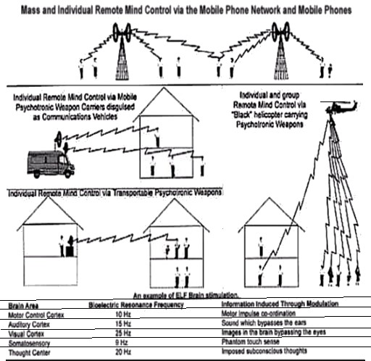

* 1. proof it exists and how it functions:

What are Microwave/Directed Energy Weapons; how do they work and how are they used:

"Precisely modulated microwave radiation is used to influence brain function. Human behaviour and reactions can be entirely controlled by using pulse modulated microwave EM[F]* radiation. Pulse modulated microwaves are useful as the carrier for the mind control signals as they are able to pass through the skull, which is rather resistant to low level EM[F]."

("Microwave Mind Control", Tim Rifat) *electromagnetic fields

"It was found that when microwaves were used to fire these signals at victims' brains, they experienced the moods, behaviour, and the pathological states, carried by the signals. This meant that by mimicking natural brain frequencies, the human brain could be controlled remotely by use of extremely low frequency broadcast carried by pulse modulated microwave beams (ELF pulse modulated microwave remote mind control technology)." (ibid.)

"It is now possible to broadcast mind control commands directly into the brain by use of microwave beams. All that is needed is a catalogue of every specific brain frequency for each: mood, action and thought." (ibid.)

"Particular excitation potential, is then broadcast by pulse modulated microwave transmitter. This pulse modulated microwave beam has the ELF excitation potential frequency imprinted upon it. It was found that each behavioural set in humans had a distinctive frequency. There was one for: anger, suicide, hysteria, trauma, serial killing, paranoia, lust...etc." (ibid.)

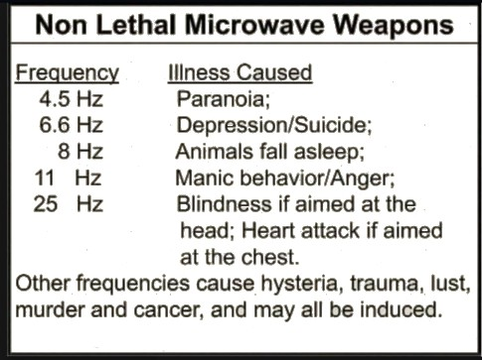

Cabal Operatives "have sophisticated millimetre wave scanners to look through the victims' walls, so they can see the targets' in their homes. Pulse modulated microwaves are regularly directed at the victims' brains, while other people in their homes are oblivious of what is going on." (ibid.)

"Some of these Directed Energy Weapons (DEW) are Through-The-Wall (TTW) in nature. These devices or a similar ones are currently being used on citizens in North America & other NATO nations. It is likely that the perpetrators are using radar/Millimeter wave technology similar to the ones used in airports to pinpoint a person s location in a building and assist with aiming other DEWs at people." (Rich, State-Sponsored Terror Campaigns: The Hidden Evil",pg. 38)

Torture: Physical, Mental & Psychological - Physical pain due to ICT-Implants + non-lethal weapons.

Direct pain in the body around the clock that tends to get worse and more severe due to ICT-Implants or other kind of transmitting devices, often labeled by Targeted Individuals as non-lethal weapons, Directed Energy Weapons (DEWs), Electromagnetic Frequency (EMF) or simply radiation.

Pain in the spinal cord or back, lethargic and aching pains.

Pain in the back of the head (Cerebellum) or various regions responsible for memory and imagination.

Pain in the “amygdala” or the limbic system. Pain in the forehead or frontal lobe (induces scattered or slurred speech).

“Cooked” brain (slight heating of the brain or Hypothalamus to induce synthetic emotional states or stress disorders (ELF waves can also cause depression or stress tuned at 6.6Hz).

Electroshocks in the brain, Zaps and mild shocks; Involuntary body movements caused by nervous system shocks and attacks.

Pain in the chest, Palpitations and Adrenal rushes.

Toothache, gum bleeding and pain in gums or teeth or in Jaw and glandular regions.

“Mild Heart attacks” or slowed heart beats, panic attacks and chronic anxiety and fast paced heart beats. Pain in vital organs: liver, stomach, heart, lungs, eyes, genitals amongst other places

Itching eyes – leading to tears and red eyes, beams alike a pin prick or irritation. Food is poisoned, contamination by evil Perps in food stores or restaurants etc.. Air around your nostrils heated or lacking oxygen.

Electronic sexual “rapes” during sleep or while awake, probably with ICT-implants, unnatural genital stimulation or swelling.

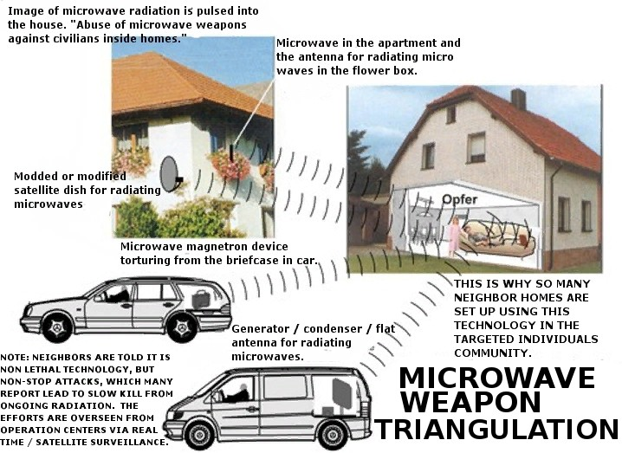

“Military and intelligence agencies have developed frightful electronic weapons in black budget projects the last decades. These weapons, based on radio waves, are used to disable, to present pain and torture, to drive into suicide, schizofrenic or criminal behaviour. This is done by cooking/irradiating body parts, letting a victim hear voices, reading the mind, etc. through walls and from distance. “

([http://www.stopeg.com](http://www.stopeg.com/))

“The new generation of electronic weapons is capable of burning and cooking humans, destroying (exploding) body tissue, or cause heart attacks. This is all possible from large distances (hundreds of meters) and through walls. These weapons are now (2008) being used at large by secret services to eliminate people: incapacitate, drive into suicide, insanity, criminal behaviour, or are just used to cause heart failure, brain damage, etc. They replace knife, bullet, poison, car accidents.” (ibid.)

Examples:

Heated body, feeling sick like having the flu; Headaches that come and suddenly disappear; Sting sensations like a fly or mosquito; Blurred vision; Irresistible coughing; Very serious diareah; Heart attack/cramps; Kidney pain; Excessive burping; Excessive farting; Stomach pain; Stomach bubbling; Intestinals cramps; Pain in the legs; Pain in ankles; Heel muscle ;Reduced strength in hands; Aging the body, etc.

There are 5 types of technology being used in the targeting:

* + 1. Smart Meters
    2. Microwave Satellites
    3. Cell Towers
    4. Drones
    5. Portable units

1. Smart Meters

The smart meters are readily controlled from a remote location, which allows the government criminals to harass an individual with plausible deniability. This is one of the first steps taken against a new Targeted Individual. The microwave signal is transmitted thru all of the household wiring. If you are exposed to microwaves coming from all directions, the first possible solution - is to switch off certain circuit breakers at the breaker box.

1. Satellites

The first microwave attack satellites were launched under President Reagan's Star Wars program (SDI) in 1987. These satellites were designed to disable ICBM nuclear missiles during the ascent phase.

Tracking frequencies used are 3600 - 3750 MHz, and the attack signal is 3920 - 3935 MHz. FCC frequency allocation tables, confirm the use of these frequencies. These satellites and frequencies are now being used against Targeted Individuals. The tracking signal has an accuracy better than 1 centimeter, and the GPS coordinates can be relayed to a cell tower or drone for additional targeting.

These tracking signals come from a satellite that is directly overhead.

Generally, it takes about 30 - 50 feet of concrete and steel (or packed earth) to shield against the satellite microwave beam. Tall skyscrapers can provide a temporary shelter from the satellite targeting. The technology does have its limits, which is good news for TI's. A faraday cage that is properly designed and properly grounded can block some of the microwaves. However, improvements can be made by using A/C voltage grounding on the faraday cage, which will "consume" the narrow beam and take it to an external grounding rod. Please DO NOT attempt such modifications unless you know what you are doing. The satellite tracking and Vircator microwave weapon uses a narrow beam at low voltage (about 10 millivolts) and high amps.

3) Cell Towers

Magnetron microwave signal generators have been installed on many cell towers in urban areas. These devices can be identified as the vented enclosure boxes on a cell tower. The magnetrons become very hot while operating and can be seen on an infrared camera photograph (you can rent an infrared camera at Home Depot). Typical frequencies are 2400 MHz and 2550 MHz. The USAF criminals have started synchronizing the cell towers to automatically follow a specific point on your body - so that as you drive down the freeway, it will automatically transfer to the next cell tower and continue to hit the same location on your body. Use the hand technique to identify which cell tower. We encourage all TI's to pay attention to the construction and repairs at cell towers - get the vehicle number/license plate and company name of anyone that is working on a cell tower. Please send this information to us. If you are convinced that your neighbors are directing microwaves at you, please consider that it is probably coming from a cell tower that is 1 or 2 miles away. The microwave beam can travel straight through many houses. It is possible to use your fingers to "feel" the direction of the microwave beam. Hold your arm out with your palm facing you, in the direction of the beam, and you can feel the "pop" in your finger joints when the beam hits them. This will usually direct you to the cell tower, where it is coming from.

1. Drones

This also includes commercial aircraft of varying sizes. Small planes especially are used to fly over one’s residence and beam the T.I with scalar waves as well as helicopters which are employed to tail after one in urban centers for example.

A good source to track the fklight paths of aircraft to determine if one’s residence is targeted and by whom is: planefinder.net or flightradar24.com

1. Portable units

These small microwave generators are used to harass Targeted Individuals that find temporary cover inside tall buildings or underground shelters. They come in small box enclosures, about the size of a small microwave oven.

https://[www.rlighthouse.com/technology-for-tis.html](http://www.rlighthouse.com/technology-for-tis.html)

* 1. What particularly is intended through the use of microwave/D.E.W weapons:

"When firing microwave beams through walls at one specific target, every material in the way of the microwave beam attenuates or modifies the intensity and frequency of the beam. Since precise frequencies and intensities are needed for mind control, very sophisticated microwave arrays and computer programmes had to be developed so that the microwave beam could be changed in response to the materials which lay between the target and the weapon, as the victim moved around the house. To do this, the reflectivity and refractivity of the materials between victim and weapon had to be analysed in real-time and fed to a computer which could

change the microwave array in concert with the changing environment between victim and weapon, as the target moved around his/her home. Secondly, there had to be an automatic interrupter if another person walked in front of the beam. The victim needed to be driven mad or disabled, without anyone else being aware that he or she was being targeted. The technology for this was very complex but eventually it was perfected."

("Microwave Mind Control", Tim Rifat)

"[B]y beaming the excitation potential of a particular pathological mental state at your brain while you are at home[...certain brain states/emotions can be induced." (ibid.)

Microwave DEWs will produce dizziness, burning, headaches, eye problems, damaged nervous system & internal organs, heart attack, & an inability to concentrate. A common microwave oven can be turned into a DEW by modifying the appliance to operate with the door removed. It can then be positioned against a wall to attack someone on the other side. You can also build a weapon for a few hundred dollars that will employ a more focused attack.", (Rich, State- Sponsored Terror Campaigns: The Hidden Evil",pg. 38)

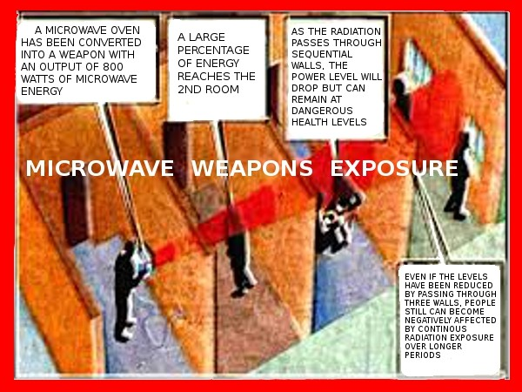

"the intelligence operatives can place sounds and speech in the target victim's brain. This inter cerebral hearing is used to drive the victim mad, as no one else can hear the voices transmitted into the brain of the target." ("Microwave Mind Control", Tim Rifat)

"Transmission of auditory data directly into the targets' brains using microwave carrier beams is now common practise. Instead of using excitation potentials, one uses a transducer to modify the spoken word into ELF audiograms, that are then superimposed on the pulse modulated

microwave beam[...which causes] the Targeted individual tohear the voices transmitted into the brain." (ibid.)

used as a clandestine assassination tool:

" If the [targeted individual] needs to be made temporarily ill, microwave beams containing the signal the brain gives off during a vicious bout of flu can be fired at the victim. This causes the target to display all the symptoms of flu, even though they have not caught the virus."(ibid.) An example of this is how the 5G network is coordinated with the manufactured corona virus or similar 'pandemics' to dialectically engineer the Cabals' plans through 'creative destruction'."(ibid.)

"can also use low level microwaves to cause mental and physical confusion that leads to illness. Beaming microwaves at victims makes them fatigued, damages their immune system, causes neurological damage that effects their thinking, and ability to carry out tasks, induces premature ageing, cancer and cataracts." (ibid.)

"Heating the victim to death, by microwave cooking is caused by increasing the field intensity of the radiation, to cause local hot spots in the victims' eyes and gall bladder, which have poor circulation, so cannot carry away the heat. Irradiating the optic nerve of the victim with the same signal that is sent to the brain by this nerve, causes the nerve tissue to overload. In this way, subversives can be blinded by the intelligence community without them knowing what has occurred." (ibid.)

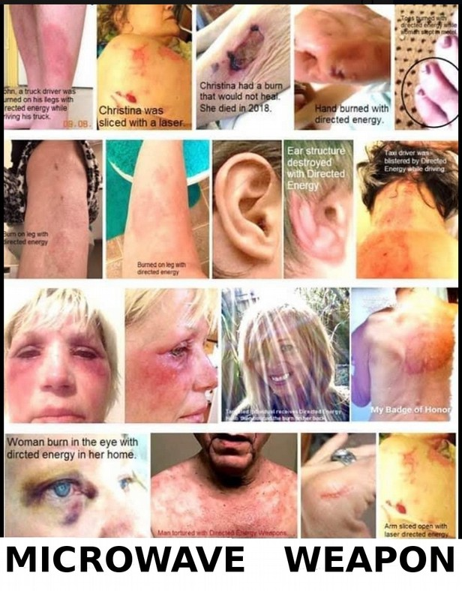

"Neurological research has found that the brain has specific frequencies for each voluntary movement called preparatory sets. When you pick up an object, there is a specific preparatory set for this action. By firing at your chest a microwave beam containing the ELF signals given off by the heart, this organ can be put into a chaotic state, the so called heart attack." (ibid.)

"Paralysis can be induced in the target by use of this method of broadcasting preparatory sets encoded on microwave beams. A pulse modulated microwave beam, carrying an ELF signal, which is identical to the one in the motor neurone centre of the brain, is used to jam the victim's motor co-ordination." (ibid.)

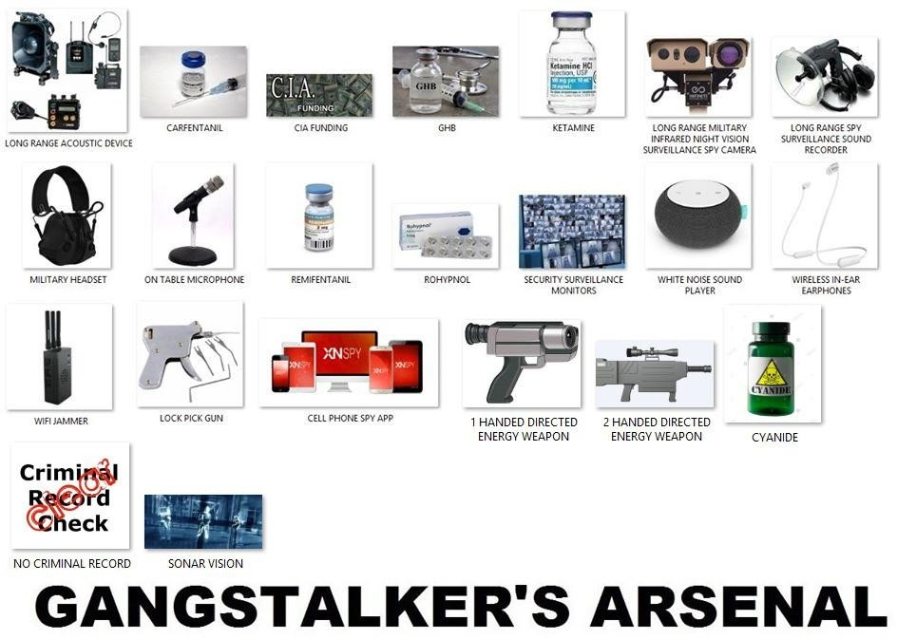

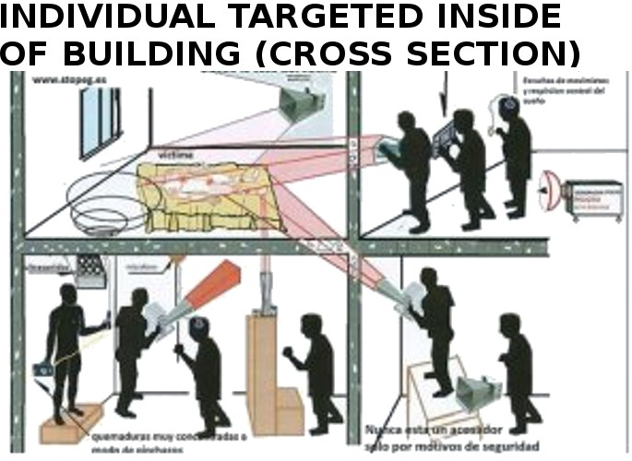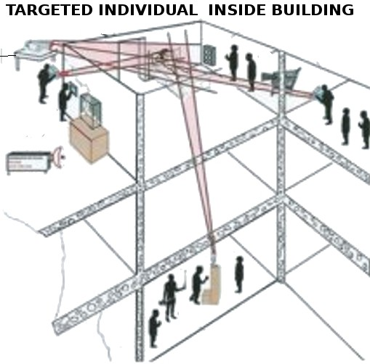

synthetic telepathy (remote thought reading/implantation of thoughts):

"The latest advance in electronic mind control were discussed in my previous articles in Nexus, but for those who missed the ESP of Espionage, this equipment uses special types of microwave beams called MASERs. These are the laser equivalent of microwave beams. These MASER beams have been used to develop something called synthetic telepathy. This is the ability to read peoples' minds from a distance. Electronic scanning of victims' brains by monitoring the

electromagnetic (EM) emissions from peoples' brains and using amongst other things, the brain waves (as measured on an EEG), to read the victim's subvocalised thoughts." (ibid.)

"Synthetic telepathy detects the l5Hz, 5 milliwatt auditory cortex brain emissions, that are linked with the excitation potentials in the brain associated with subvocalised thought. New technology, involving low frequency microwaves and RF, has enabled devices to be built which can scan through walls and look inside peoples' bodies like X-rays. This enables security personnel to see a target in his own home and to track him throughout the house. Further to this, being able to see inside the victim's head, would allow computer controlled targeting of specific brain centres in the victim's brain, even when he was walking around the house." (ibid.)

"A scan of the specific brain emissions given off when the victim subvocalises using an array of pulsed frequency MASERs fired at the specific brain centres of the subversive, while he resides in his own home, enables the victim to be scanned. By firing an array of ELF pulse modulated MASERs, which scan up and down the window of frequency emissions given off by subvocalised thought, interference effects can be measured in the MASER beam. The victim's ELF brain emissions will interact constructively or destructively with the pulsed frequency MASER carrying ELF in the ELF window associated with subvocalised thoughts. If we fire an array of pulsed MASERs, which are out of phase with each other, extraneous noise can be filtered out in the digital domain. Since the converging ELF modulated MASERs are being effected by the low level emissions in the victim's brain, the shifts in the ELF pulsed signal going into the subversive's brain can be detected. A simplistic version of this would be the LASER beam shone at the window of the person that is being bugged. The vibrations in the window cause modulations in the LASER that can be converted into electrical signals and hence into sound. In this way the subvocalised thoughts in the victim's brain can be read. Having already built up a library of excitation potential signatures for differing words and groupings of words, a sophisticated computer can begin to decode the emission signatures into word streams. In this way the subvocalised thoughts of the victim can be stored in the memory of a supercomputer and analysed to give a read out of what the target is thinking.[...]Using ELF audiograms carried by a single pulse-modulated Maser, subvocalised thoughts can be placed in the victim's brain. This enables [Cabal] synthetic telepathy operators the ability to enter into conversations with the subversive to drive him mad or to bring up key words which will get the victim thinking about the information they wish to find. Visual cortex excitation potentials can also be broadcast into the victim's brain so that illusory images can be projected into their brain to drive them mad, or to programme them to commit suicide." (ibid.)

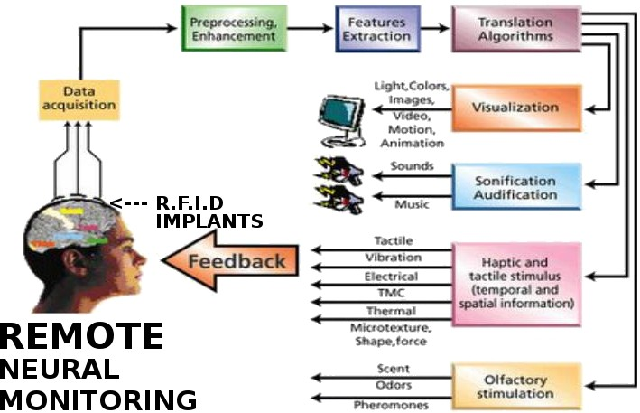

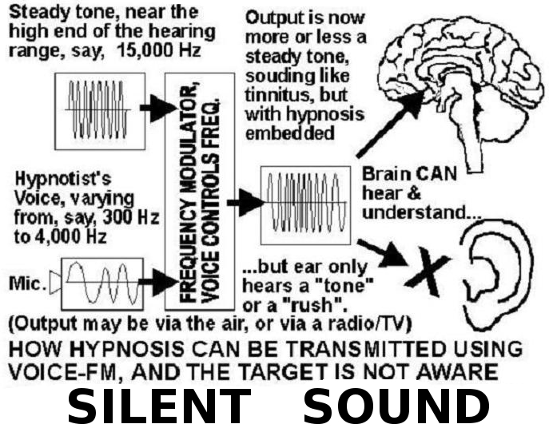

"Secondly, the police have been granted the exclusive use of the 450 MHz microwave frequency range.[...]Dr.Ross Adey found that by using 0.75mW/cm2 intensity of pulse modulated microwave at a frequency of 450 MHz, it was discovered that an ELF modulation could be used to control all aspects of human behaviour" (ibid.)

Examples of Directed Energy Weapons( Through-Wall Electronic Weapons):

A simple microwave oven, door removed, with the door interlock switch bypassed, and held against the bedroom wall of a target in an apartment building or semi-detached house. This device can cause a variety of disabling medical symptoms. Some of the symptoms of microwave exposure are: Asthma, cataracts, headaches, memory loss, early Alzheimer's, bad dreams, depression, fatigue, concentration loss, appetite loss, heart and blood pressure problems, and

cancer. ("Coping With the Crime of Organized Stalking and Electronic Harassment", Eleanor White, pg.51)

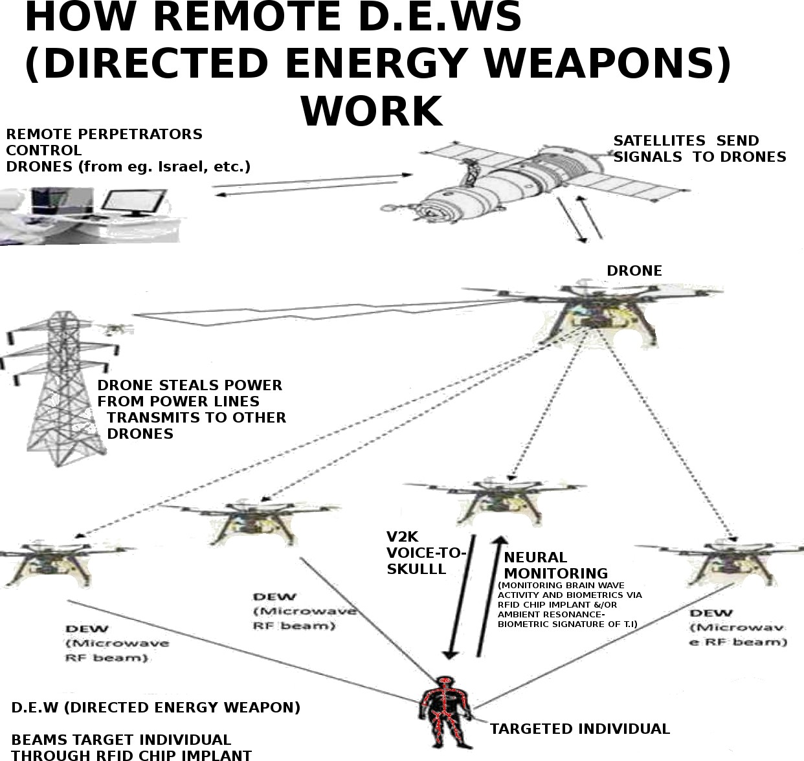

*LIDA*

The Russian LIDA machine (patent 3773049) is an old brain entrainment device used for the drugless sedation of mental patients. This device can be used as a weapon to drain a person of energy. The pulse rate can be adjusted so that it causes fatigue or excitability (sleeplessness).

Although the LIDA signal does not travel a great distance, it can be

used TTW in an apartment building. This device is about the size of a breadbox & works silently. (Rich, State-Sponsored Terror Campaigns: The Hidden Evil",pg. 38)

"[...]pulsed 40 watt, 40 MHz radio transmitter which can be used to make a target exhausted on the job when pulsing at the rate consistent with sleep, and with a pulse rate increase, DEPRIVE a target of sleep too. This device is a radio transmitter version of other types of trance induction devices[...]" ("Coping With the Crime of Organized Stalking and Electronic Harassment", Eleanor White, pg.54)

*Voice-To-Skull (V2K)*

V2K, also called Microwave Hearing. If you have a tightly focused antenna, this can be transmitted through walls & over a distance. Voice or other sound can be transmitted over a distance, through walls, directly into the skull of a person. This was possible more than 30 years ago. (ibid.)

For some years in the 1990s and early 2000s, the United States Army recognized "voice to skull" technology, which they abbreviated as "V2K," in their on line thesaurus. For reasons unknown, the Army removed that thesaurus entry circa 2007.

("Coping With the Crime of Organized Stalking and Electronic Harassment", Eleanor White, pg.52)

*Silent Sound Spread Spectrum*

"Silent Sound (patent 5159703),also called Clear Channel, is an improvement over the time- slicing subliminal suggestions. It does not need to compete with other sound to influence a subject because it occupies a separate channel just beyond the human hearing range. Hence the name: Clear Channel. This channel is beyond human hearing but not human perception. It is not normally in use but it is a direct conduit to the subconscious. Silent Sound can be used by installing a hidden speaker near person s area of work or in their home. These suggestions can be played constantly & the person would not be consciously aware of them. Silent Sound can be transmitted through ordinary radio or television carrier frequencies. However, only a speaker is necessary. But Silent Sound cannot only convey suggestions, it can transmit cloned emotions.

This is brain entrainment." (Rich, State-Sponsored Terror Campaigns: The Hidden Evil",pg. 38)

"Although enhancements have been developed, at its simplest, a Silent Sound voice encoder takes a spoken message, and uses a circuit similar to a telephone voice changer to raise the frequency of the voice up near (but not exceeding) the upper limit of human hearing. The listener hears a fluctuating high-pitched tone, and any words cannot be discerned, consciously. However, the brain can subconsciously decode the words. The brain takes

advantage of the fact near the upper limit of hearing, the sensitivity to frequencies drops off. The sensitivity curve is sloped downwards in the Silent Sound frequency range, roughly 14,000 to 16,000 Hertz (cycles per second.)." ("Coping With the Crime of Organized Stalking and Electronic Harassment", Eleanor White, pg.53)

"Silent Sound" is not a through-wall device by itself. However, when Silent Sound is transmitted to a target by way of a voice to skull through-wall transmitter, if the target is susceptible to hypnosis (many people are), the target's thought processes and personality could be severely disrupted over time, and the target would have no idea why this was happening, as the sound is essentially silent. The target may hear a high pitched tone or hiss, but no words. The target would be much less able to resist hypnotic suggestions than with audible speech." (ibid.)

Through-Wall Radar

"Through clothing (and through non-conductive wall) RADAR, widely used at airports and by police to look through clothing for hidden weapons. The harassment potential of this

technology in the hands of organized stalking gangs is obvious." ("Coping With the Crime of Organized Stalking and Electronic Harassment", Eleanor White, pg.55)

"The same security scanning radar used at airports, and now coming into use by police, can also view a target through a non-conductive wall[...]Many targets report being "followed" in their apartments by rapping noises from an adjacent apartment, particularly the one below. As the target walks about, rapping noise which sounds as if the occupant of the adjacent apartment is doing "work" on something, will move as the target moves." (ibid.)

also the perps utilize Microwave telemetry to locate T.Is

IMPLANTS

What is an RFID (Radio Frequency Identification) implant?

RFID is a technology for identifying unique medical equipment and supplies and other high value assets using radio waves. Typical RFID systems are made up of two major components: Readers and Tags. RFID tags are also referred to as a ‘chip’. RFID stands for Radio Frequency Identification.

The RFID reader (also called a scanner), is set to a particular electromagnetic frequency, and an RFID tag, which consists of a microchip is connected to an antenna. The microchip contains information that is transmitted to the scanner when the chip is within its range.

Implanted human beings can be followed anywhere. Their brain functions can be remotely monitored by supercomputers and even altered through the changing of frequencies.

When a 5-micromillimeter microchip (the diameter of a strand of hair is 50 micromillimeters) is placed into optical nerve of the eye, it draws neuroimpulses from the brain that embody the experiences, smells, sights, and voice of the implanted person. Once transferred and stored in a computer, these neuroimpulses can be projected back to the person’s brain via the microchip to be reexperienced.

Using a RMS, a land-based computer operator can send electromagnetic messages (encoded as signals) to the nervous system, affecting the target's performance. With RMS, healthy persons can be induced to see hallucinations and to hear voices in their heads.

Every thought, reaction, hearing, and visual observation causes a certain neurological potential, spikes, and patterns in the brain and its electromagnetic fields, which can now be decoded into thoughts, pictures, and voices. Electromagnetic stimulation can therefore change a person's brainwaves and affect muscular activity, causing painful muscular cramps experienced as torture.

Each of us has a unique bioelectrical resonance frequency in the brain, just as we have unique fingerprints. With electromagnetic frequency (EMF) brain stimulation fully coded, pulsating electromagnetic signals can be sent to the brain, causing the desired voice and visual effects to be experienced by the target. This is a form of electronic warfare.

Using different frequencies, the secret controller of this equipment can even change a person's emotional life. S/he can be made aggressive or lethargic. Sexuality can be artificially influenced. Thought signals and subconscious thinking can be read, dreams affected and even induced, all without the knowledge or consent of the implanted person.

Diminished blood circulation and lack of oxygen in the right temporal frontal lobes result where brain implants are usually operative. A Finnish experimentee experienced brain atrophy and intermittent attacks of unconsciousness due to lack of oxygen.

Mind control techniques can be used for political purposes.

Zombified individuals can even be programmed to murder and remember nothing of their crime afterward.

Since 1980, electronic stimulation of the brain (ESB) has been secretly used to control people targeted without their knowledge or consent.

One reason this technology has remained a state secret is the widespread prestige of the psychiatric Diagnostic Statistical Manual IV produced by the U.S. American Psychiatric Association (APA) and printed in 18 languages. Psychiatrists working for U.S. intelligence agencies no doubt participated in writing and revising this manual. This psychiatric "bible" covers up the secret development of MC technologies by labeling some of their effects as symptoms of paranoid schizophrenia.

Victims of mind control experimentation are thus routinely diagnosed, knee-jerk fashion, as mentally ill by doctors who learned the DSM “symptom” list in medical school. Physicians have not been schooled that patients may be telling the truth when they report being targeted against their will or being used as guinea pigs for electronic, chemical and bacteriological forms of psychological warfare.

Jew “Scott Silverman” Chairman and CEO of “Applied Digital Solutions,” the company that has developed micro chipping for humans. The NSA contracted with Israeli companies such as Verizon of which one of the founders Jacob “Kobi” Alexander, [a former Israeli intelligence officer], owns Verint. In 2007, a previous head of Israel’s intelligence wing “Unit 8200" told Forbes Magazine that the technology of Comverse, the company that owns Verint, is based on Israel’s “Unit 8200″ intelligence expertise."

It involves using a hypodermic needle to inject an RFID (radiofrequency identification) microchip, the size of a grain of rice, usually into the person's hand or wrist. The same kind of chip is used for tracking lost pets.

Vaccinations, flu shots, dental work, surgeries, sleep abductions, in fact most medicine including dentistry has been loaded with implantable chips since the 1960s. They have had this technology for 40 years or more and are just now bringing it out to condition and introduce it to the public.

“It may also be possible to compress the silk-based implants and deliver them to the brain, through a catheter, in forms that are instrumented with a range of high performance, active electronic components,” Dr. Rogers said.

ALL POTENTIAL VICTIMS - it becomes IMPERATIVE that you use Tracking Technologies that are on the MARKET to FIND OUT IF YOU, TOO... HAVE BEEN ILLEGALLY IMPLANTED, ALL THE WAY DOWN TO NANO-SEMICONDUCTORS THAT RUN OFF OF WIRELESS TECHNOLOGIES, AND EMIT RADIO FREQUENCIES -

However, there are plenty of completely public Homeland Security and FEMA documents detailing parts of the secretive COG plans for a national emergency. Among these is the document we covered earlier, as this document reveals not only detailed aspects of the COG personnel relocation plans and martial law takeover of communications, but a plan to militarily-target Americans and designate them as enemy combatants– dramatically, through a blue/red high-tech surveillance matrix aimed at suppressing dissidents and occupying the homeland.

Blue Force Tracking is a United States military term used to denote a GPS-enabled system that provides military commanders and forces with location information about friendly (and despite its name, also about hostile) military forces... friendly in blue, and enemy in red)

implants:

MRI (magnetic resonance imaging) cannot detect Titanium implants, because the titanium is non- magnetic.

A Portable Ultrasound machine is one method that can detect the implants. Microwave Burns

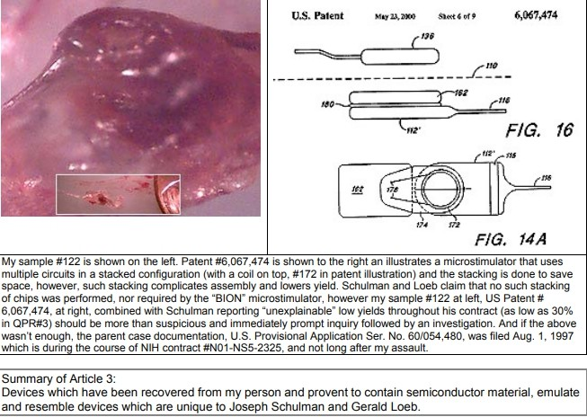The microwaves destroy the melanin in the skin, turning it white.

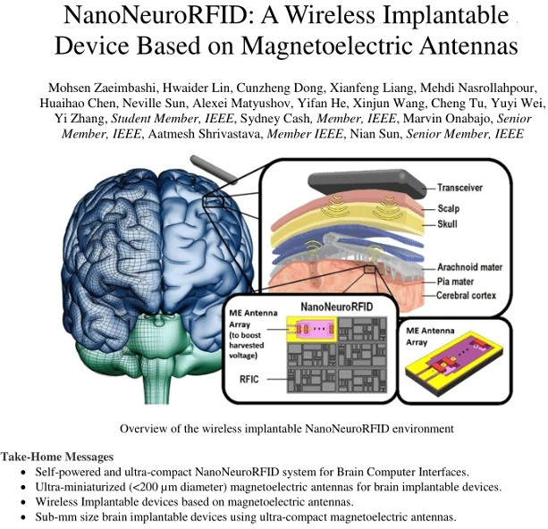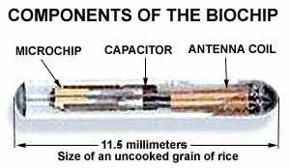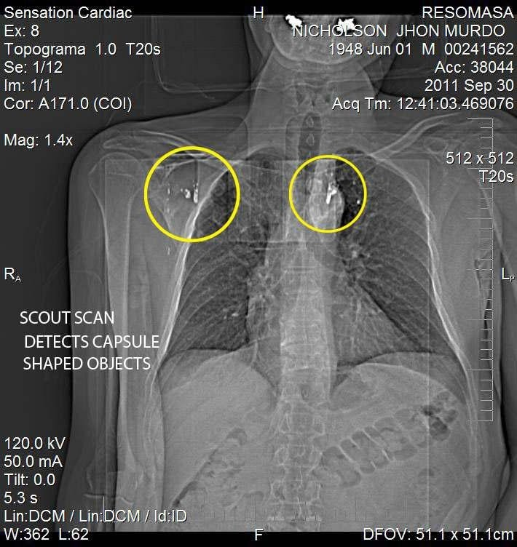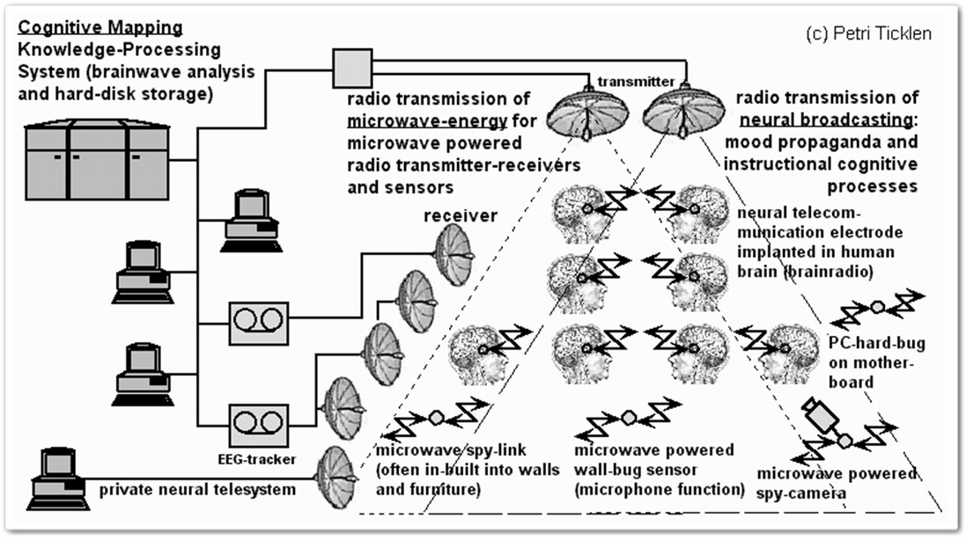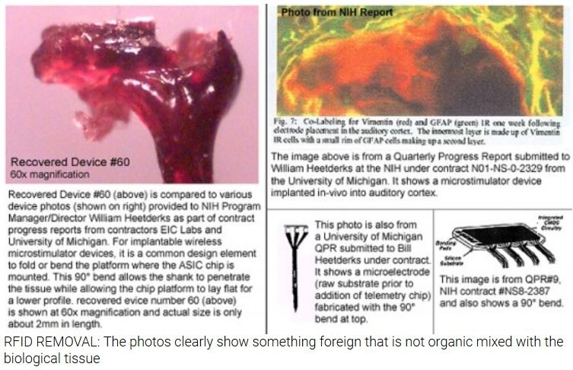

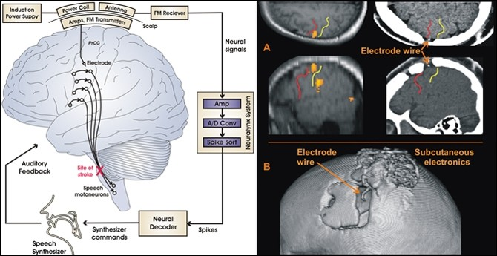Remote Neural Monitoring\Manipulation (RNM)

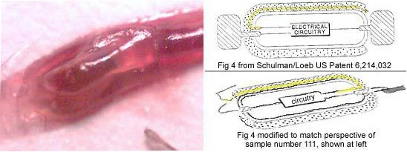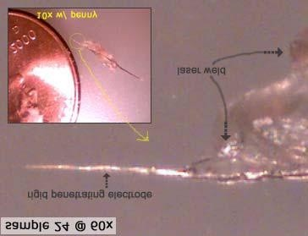

DIRECTED ENERGY ATTACKS

The human body is an Electromagnetic Organism. It is a Vibratory Organism.

As such each organ and region of the body “”””VIBRATES””” at a different frequency of electromagnetic energy.

By varying the frequency and intensity of each stream of energy, CIA & DoD operatives can manipulate and damage each region and organ of the human anatomy.

HYPER GAME THEORY ATTACKS

As soon as you say the won’t then they will. As soon as you say they will then they won’t. Everything the CIA\DOD operatives are doing is based off IF & THEN scenarios which are founded on the Hyper Game Theory principle. If the victim does this then they will do that If the victim does that then they will do this.

In order for TRAUMA BASED MIND CONTROL to be effective the mind control victim is kept in a constant state of severe pain, stress, hypertension, agitation, anxiety, ect., utilizing a continuous stream of directed energy targeting the victim.

TRAUMA BASED MIND CONTROL, is based on the constant provocation of the victim into set responses constantly all day and night long. So they are constantly provoking the target both physically, emotionally, etc., into set responses which their ‘Remote Neural Monitoring \ Manipulation’ system can remotely measure via a continuous stream of directed energy constantly interacting with the nanotechnology in the victims body.

Hence the mind control victim is more easily provoked in this constant state of physical and psychological TRAUMA! This allows them to manipulate the victims brain and, by default, the victims Central Nervous System which controls the bodily functions including heart rate and blood pressure.

That is what these directed energy attacks are about: killing me in a way that makes my premature death appear as a normal natural cause while simultaneoulsy discrediting me in the process.

Remember they are trying to alter your ‘Daily Motives’ and ‘Emotional Perceptions’.

The remote neural monitoring system is designed to provoke you emotionally, intellectually, physically, etc., so they can generate RESPONSE STATISTICS which the system will use to determine how to interpret and link descriptions with data captured about your memory references, etc.

That is why they are constantly trying to keep you talking, or constantly

stopping you and asking for directions, etc. So always ignore prolonged random encounters with people you don’t know. You’re not being rude. Just refusing to allow them to manipulate you.

Once they have consistent statistics the system will use previous ‘choice references’ and inject them into your subconscious thought during normal activity which is also accompanied by simultaneous ‘IMPULSE INJECTIONS’ to convince you that the response was your own and influence you to complete or describe the reference by making the appropriate verbalizing or performing a related action, which is known as ‘Verification’. You can fight and/or control this if you learn to defeat these memory attacks by learning to read Active Memory.

Once they see what you respond to emotionally, or intellectually, they will fabricate ‘conversational’ or ‘situational’ scenarios’ (Street Theater) based on events or topics they know will capture your attention.

This is why the perps try to keep you talking for so long. Not just to aggravate you but to provoke you into an ’emotional response’, intellectual respones, etc., so they can map your thought process in order to subsequently inject impulses etc., and control your mind. This is why the feds try to get people close to you (eg by approaching you and/or befriending with a hot girl) with so called ‘Honey Traps’.

Here is how you stop that from happening: ignore all prolonged random encounters with strangers you don’t know and be spontaneous.

This same remote neural attack can be used to disrupt your speech if the attackers decide to prevent you from discussing a specific topic or repeating a given word. The system can be configured to disrupt your recollection when formulating a related statement or inject gibberish [triggered substitution] while you are attempting to speak.

Again, the goals of these attacks appear to be threefold:

1. CENSORSHIP
2. MEMORY MANAGEMENT
3. DIRECT BEHAVIORAL CONTROL

These remote neural attacks are most effective when you are stepping through sequenced tasks so try to avoid ‘zoning’ on your activities. How? By changing your actions and activities randomly and constantly at the speed of thought. Don’t always plan out or think out your daily itinerary, if you don’t have to. ‘Just do it’ ! Be ‘SPONTANEOUS’!

Remote Neural Manipulation is accomplished via their system’s ability to interpret your thoughts and is wholly dependent on its ability to predict and influence your ‘reference choices’ or ‘impulse sequencing’ during thought composition. The system maps patterns with impulses and identifiers (evoked potentials) and uses statistical data about your ‘composition habits’ to predict how you will think or act as you begin to formulate thoughts or prepare to act. The system’s ability to define and

map these references intelligibly depends on your cooperation [or ignorance] and the attackers’ ability to make sense of what they see visually or what they can guess based on your past activity

They will constantly run you through a ‘verification’ routine where the system probes you for a particular set of responses repeatedly in order to establish a pattern. If you are interacting and countering these probes the operator will vary the routine in an attempt to ‘verify’ via different methods.

Once the system ‘verifies’ the selected responses they will be used in the next wave of harassment routines. The process is endless and you will see the effects clearly if you are consistently defeating the system. If you are not defeating the remote neural manipulation system then you will not see or notice the effects.

How to combat: through maintaining situational awareness and learning to read active memory, ie. 'mindfulness'

HOW BRAIN TO BRAIN INTERFACING IS BEING ACHIEVED.

When our neurons fire and pass signals to each other they reach what is known as an action potential when generates and electrical pulse.

The electrical pulses are measured using EEGs and are automatically translated into what you see, hear, feel, smell, touch, taste and they are also translated into all of your muscle movement including the smooth muscle movements of your intestines. This information is extracted from your brain and it is stored in a computer. This is called BRAIN COMPUTER INTERFACE.

A COMPUTER BRAIN INTERFACE writes information into your brain using transcranial magnetic stimulation or by a number of other means. Phosphene induction is used to write information into the brain. The process of writing information into your brain is used to stimulate your action potentials which generates electrical pulses. The process is called SSVEP. The electrical pulses which are generated by this process cause you to see, hear, feel, smell, touch and taste what is not there. It is simply an illusion but yet you can be made to feel as if you are inside a virtual reality setting which can be used to either torture you or give you pleasure. Some of the electrical pulses which are generated when information is written into your brain can be used to cause the muscles of your face and body to be used against your will, which can be used to turn you into a bio-robot. This process is currently being used throughout the world as a form of wireless remote controlled secret psychological torture.

A BRAIN TO BRAIN INTERFACE is created by attaching a BRAIN COMPUTER INTERFACE TO A COMPUTER BRAIN INTERFACE. By means of brain computer interface the brainwaves are extracted from one human being and they are stored inside a computer. They can then be sent thousands of miles across the world to another computer which can be owned and controlled by cabal operatives. The cabal operatives write this information into the brain of another human being, often against the

will and without the consent of that human being. (source: Gretta Fahey: <http://targetedindividualsireland.net/> )

Remote Neural Monitoring is a form of functional neuroimaging, that is capable of extracting EEG data from the human brain at a distance. A human subject’s bioelectric field can be remotely detected, so subjects can be monitored anywhere they are. With special EMF equipment, NSA cryptologists can remotely read evoked potentials (from EEGs). These can be decoded into a person’s brain-states and thoughts. The subject is then perfectly monitored from a distance.

Unique EEG patterns corresponding to each spoken word, each verbal thought, each images and each muscle movement can be translated at the speed of light by fully automated supercomputers into what a non-consenting human subject is saying, thinking, hearing, seeing and doing and this can all be achieved from a long distance from the human subject simply by remotely analysing the bioelectric field of the human subject. All of these aforementioned unique EEG patterns can be retransmitted back into the central nervous system of the human subject thereby forcing that human subject to hear words which originate intercranially, see unwanted images some of which are pornography and experience his or her own muscles being forced to move against his or her will.

Remote Neural Monitoring is now being used for the purposes of transcranial magnetic stimulation from a distance. Transcranial Magnetic Stimulation from a distance enables unknown operatives to disrupt the portions of your brain that are associated with cognitive reasoning and narrative comprehension in order to force individuals to believe what they would normally not believe and do what they normally would not ever do. (ibid.)

Hypnotic trigger words

Can mimic any of the above symptoms: radiation, pain, bad tastes, head aches, and so on or trigger unbearable fatigue.

The trigger words come in whole sequences, like they were taken out of a dictionary with all symptoms and all words that sound alike or similar.

While some trigger words have effects on the mind and body, other’s have emotional effects only (sensitisation of the Targeted individual to certain words, that trigger negative emotions, like disgust, fear, anger).

The trigger words are sometimes reinforced through dark NLP and gang stalking.

Trigger words are in the beginning very difficult to discover because they are coupled with the TI's routines. The brain can’t differentiate always between what it is made to believe and what really happens.

Once discovered, they are “released”; becoming aware of the “truth” wins over the lie that the mind has been told.

When they are discovered, new trigger words will be programmed into the subconscious.

Mental pain

Loud synthetic telepathy. The attackers talk with some of the victims 24/7. They use interrogation techniques that are only used in the CIA or secret service. That is labeled also V2K (voice to skull, or loud synthetic telepathy). A learning computer with a synthetic voice that can be modulated in any voice, can take over partially or full time, after the initial stages. This keeps the victim awaken and always tired.

Silent synthetic telepathy. The victim doesn’t hear the attackers but there is thought manipulation, directing their attention. The communication is experience as "thoughts". A sort of repetition of the same thoughts happens, like a tape is playing one's thoughts over and over again, word by word.

HAPTIC TECHNOLOGY

Haptic technology, also known as kinaesthetic communication or 3D touch, refers to any technology that can create an experience of touch by applying forces, vibrations, or motions to the user. These technologies can be used to create virtual objects in a computer simulation, to control virtual objects, and to enhance remote control of machines and devices.

Haptic feedback is the use of touch to communicate with users.

Human beings have five senses, but electronic devices communicate with us using predominantly just two: sight and hearing.

Haptic feedback (often shortened to just haptics) changes this by simulating the sense of touch. Not only can you touch a computer or other device, but the computer can touch you back.

https://[www.ultraleap.com/company/news/blog/what-is-haptic-feedback/](http://www.ultraleap.com/company/news/blog/what-is-haptic-feedback/)

A polymer called the ‘PEDOT’ polymer is being manufactured which allows human brains to be linked to computers. Applying a layer of ‘PEDOT’ to other materials makes them conductive.

Most of the general public now have bio-synthetic materials inside our brains and bodies which we either inhaled, ingested or had vaccinated into us.

Hydrogel Biosensor Would Emit Various Signals

The DefenseOne article outlines the properties and capacities of the hydrogel biosensor:

“The sensor has two parts. One is a 3mm string of hydrogel, a material whose network of polymer chains is used in some contact lenses and other implants. Inserted under the skin with a syringe, the string includes a specially engineered molecule that sends a fluorescent signal outside of the body when the body begins to fight an infection. The other part is an electronic component attached to the skin. It sends light through the skin, detects the fluorescent signal and generates another signal that the wearer can send to a doctor, website, etc. It’s like a blood lab on the skin that can pick up the body’s response to illness before the presence of other symptoms, like coughing.”

Profusa’s website states:

“Rather than being isolated from the body, the biosensors work fully integrated within the body’s tissue — without any metal device or electronics, thereby overcoming the body’s attempts to reject it. To date, the injected biosensors have functioned for as long as four years. Smaller than a grain of rice, each biosensor is a flexible fiber about 5 mm long and half a millimeter wide, comprised of a porous scaffold that induces capillary and cellular ingrowth from surrounding tissue. The hydrogel is linked to light-emitting fluorescent molecules that continuously signal in proportion to the concentration of a body chemical, such as oxygen, glucose, or other biomolecule of interest.” (ibid.)

Remote Neural Monitoring, Voice to Skull (V2K) Key Evidence/Proof:

Methods of Remote Neural Monitoring

1. Remote audio satellite surveillance: RNM stalkers listen to one’s speech and one’s surroundings.
2. Remote See through walls satellite surveillance: RNM stalkers can watch the targeted individual and also read the thoughts in words of the targeted individual in buildings and open area like roads and parks.
3. Remote Thought Surveillance: RNM stalkers can read the thoughts in words of the targeted individual.
4. Remote Voice/sound relay: Targeted individual alone hears a white noise whisper speech when no one is there or hears someone’s (synthetic voice) or a clone voice of known person clearly as someone is speaking. Also RNM stalkers can relay any sound only to you using microwave auditory effect.
5. Remote Synthetic telepathy: RNM stalkers can read the words which targeted individuals think in their heads and either repeat targeted individual thoughts in words or respond by talking to you using white noise whisper speech.
6. Remote Human Motor control: They can control some of the human body motor control i.e. involuntarily eyelids open and close fast without any control.
7. Remote Visual relay: RNM stalkers can relay phospenes and augmented reality to targeted individual’s eyes vision.
8. Remote Olfactory and Smell memory Surveillance: RNM stalkers can access specific memory of smell or create a desired smell and one can smell it by electric stimulation.
9. Remote Electrical relay: RNM stalkers use satellite to zap you with electricity causing electrical shock, pin and prick, sharp pain and more often than usual itch on the skin.
10. Remote screen and computer surveillance: RNM stalkers can view mobile phone screen and computer monitor.

Remote screen and computer surveillance:

1. RNM stalkers can view what is on the computer screen.
2. RNM stalkers can view the screen of mobile phone.
3. By using this surveillance RNM stalkers can hack your email and change the login password if you don’t have strong security measures i.e. 100 or more character password, two step sign in verification and recovery options.
4. They can jam the internet Wi-Fi signals and also stop the LAN internet connectivity of a laptop. Limitations of RNM technology:
   1. During heavy rain white noise whisper relay voice volume reduces and stop.
   2. RNM is unable to decipher the humming tune like ‘na na na’ when you think in your mind. They can only identify the phonetic sound of words and not the tune which you are singing in your mind.
   3. While in car traveling 100 km/hr and above, RNM is unable to read the thoughts or repeat the word which one thought.
   4. If you read a sentence from a book, fast enough in your mind RNM would not be able to comprehend what you read.

They relay the words which you know form your vocabulary database, because

* + 1. Make you think that you yourself were thinking about that word, if you are emotional/not alert.
    2. You’ll not be able to identify the words which you thought in your head was relayed by white noise whisper voice or voiceless word relay, if you are emotional/not alert.
    3. New words will make you realize those words are from RNM voice relay/voiceless synthetic telepathy

During RNM mind reading think of one word only, i.e. meditating, mindfulness. By doing this you can identify the new words which RNM is relaying to you either through voiceless word relay or voiced relay method.

While talking to RNM stalkers in words in your head keep your tongue pressed at bottom of your mouth or top of your mouth. So that your tongue does not respond when you think of words in your head and get fatigued.

RNM electrical relay examples:

1. Pin and pricking pain in left side of the upper abdomen (probably stomach).
2. Itching skin on places like hands, groin, legs, cheek, lower lips, head, nose, ears more often than usual. RNM uses an electrical relay to create the itches. These electrical relay seem to be 3D and can be pointed to any surface of the human body. See ‘GPS satellites provides precise three-dimensional position’ in One’s hand goes to the itch automatically that’s because Spinal cord neurons control pain and itch.

A reflex response occurs within the spinal cord. Motor neurons are activated and the muscles of your arm contract, moving your hand. This occurs in a fraction of a second — before the signal has been relayed on to the brain — so you will have moved your arm towards the itch before even becoming conscious of the itch.

Sometimes hand doesn’t goes to the itch if you were aware of the itch. Electrical relay itch done on others also, i.e. by passers, standing near, person visible to you. They do it to others to show as if RNM stalkers are following you or known persons are harassing you. Which is not true.

1. Electrical relay on the eye, as if something touched the eye.
2. Electrical relay on the left side of the chest (probably heart).
3. Sharp pain in the left side of the upper abdomen (probably stomach).
4. Pain at left and right back between approximately the lowest rib and the buttock (probably kidney).
5. Electrical relay in the throat to make you cough.
6. Electrical relay on arms as if a rain drop has fallen on the arm. See ‘Electric shower’ in Web link:

<http://www.stopeg.com/electronicharassment.html>

RNM stalkers controlling abilities:

1. Control of one’s Feet and toe-While standing one’s body lifts up on toes all by itself, without thinking about moving.
2. Hip – swaying back all by itself, while standing and sitting
3. Jaw :
   1. Clinching of jaw, making you think that you are angry.
   2. Opening of jaw and mouth involuntarily.
4. Facial muscle control – Showing emotion sad and happy by control of eye brow, facial muscle and tears
5. Tears control, involuntarily tears in eyes without emotional thinking.
6. Smell memory and olfactory- RNM stalkers can access specific memory of smell or create a desired smell and one can smell it by electric stimulation. They are probably getting assistance from Artificial Intelligence or Analytics software to access those specific smell memory.
   1. While I was sitting in my room I smelled cow dung.
   2. While doing exercise in my room I could smell strong smell of urine. As if I had urinated in my pants which I didn’t.
   3. When I closed my eyes to sleep, immediately I smelled fart which I didn’t fart and there was no one nearby me.
7. Eye lids:
   1. Eye lids blink fast without any control, involuntarily.
   2. One of the eye lid partially getting closed forcefully.
8. Going blind for a half a second, blanking out the vision which one can see
9. Control of fingers – a) On phone display my index finger was zigzagging on its own.RNM stalkers claimed that they could control my index finger by relaying white noise whisper voice to me.
10. Thumb and index finger rubbing together indicating money gesture, RNM also white noise whisper voice relayed ‘money’ along with the gesture. My wife and son also did the same money gesture the next day.
11. Involuntary twitching of right hand index finger like a nervous tic. See ‘involuntarily moved his right index finger’
12. Electrical sensation like Goosebumps throughout the body, but without any hairs rising.
13. Tongue – Tongue twitch involuntarily at rest or when speaking.
14. Bladder – Involuntarily release of urine, RNM white noise whisper voice relayed ‘bladder control’
15. Make you cough.
16. First I heard RNM white noise whisper voice relay something about ‘brain mapping’, then my elbows twitched and knees twitched, then RNM whisper relayed ‘bladder control’ and involuntarily released my urine.
17. Wrist motor control, bending involuntarily like a twitch.
18. Make one faint. The faint started with feeling of heavy head as if my brain being under heavy magnetic field. RNM stalkers have done this to me two times. Then they white noise whisper voice relayed to me that I’m having a Brain tumor, which I don’t have it.

Mind Control - Control and manipulation of thoughts, feelings and ultimately behavior Control of thoughts and thought patterns; feelings and their expression; behavior control.

Dark NLP: Neuro Linguistic Programming and Organised Gang Stalking (street theater; comments coinciding with the programming) that anchor feelings to certain words, and sometimes colors, certain types of people or objects… Creating the illusion of ”guilt” or "frustration".

Hypnotic ”trigger words” that results in specific sensations, feelings or behaviors brought on by Psychotronic Attacks; Voices in Head or Sounds (V2K) or certain events in your life.

Monitoring attention both where to look but also what to think about and in what terms through Remote Neural influences and subliminal ELF low hertz waves from Cell Towers etc.

Real time Mind Reading and Thought Broadcasting, sometimes before it becomes aware or apparent in the Targets Mind (Verbatim); The erasing or altering of thoughts and memories; short term memory problems.

Induced memories and ”synthetic” associations to those false memories (that are believed to be made by a Intelligence Super-Computers; aware of the context).

Induced dreams or manipulation of dreams, disturbing visions, thoughts and imagery.

Sleep disorders and Sleep Deprivation sometimes accompanying temporary induced paralysis or micro-comas (to force trauma or visions, sounds and a state of fear of sleep).

How to detect RNM/V2K:

For example when you experience ‘sudden severe aggression and agitation’ its the perps using impulse injections and memory management tactics, artificially injected, not you, and is part and parcel ‘Mind Control’.

So, then, look for patterns of compulsive behavior or thoughts and contrast that current state of mind (powerful emotions & impulses) with your normal state to identify the attacks. Look for patterns.

Everything they do is based on patterns.

Remember they want to keep you constantly thinking about them. They must isolate the mind control victim in order to minimalize all external interference in order to force the trauma based mind control victim to ‘internalize’, or internally focus, on the Neuroprogramming.

This is a weapon system based on cognitive warfare and psychological warfare. The objective is to turn the Trauma Based Mind Control victim into a weapon who will inflict destruction on others or who will self destruct.

You can limit and counter this effect by learning to read active memory while blocking their system however it takes quite a bit of skill and self awareness utilizing a cognitive defence method through redirecting their remote neural attacks.

This is also known as ‘REDIRECTION’.

Redirection’ is simple. When the remote neural attack happens and impulses and thoughts are introduced into your mind (by strong urge [high frequency attack] or slight motivation [low frequency attack]) just change your thread of thought. This hinders ‘integration completion’ between your brain and the RNM system. You do this by establishing what is known as a ‘Working Reference’.

You can thwart their RNM attack by establishing a ‘working reference’ each time they attempt to inject impulses and thoughts to your brain. This is done by recognizing something in life that makes you very happy and then re focusing or ‘redirecting’ back to that happy experience in life each time you are attacked through Remote Neural Manipulation.

Understanding the memory attacks (blocking your real memories and injecting false memories and impulses) are key because if you do not recognize modification of your ‘active memory’ the system will cause you to briefly lose time perception which may be enough procedural [functional] disorientation to influence you to respond to an injected impulse. Forced speech for example.

As you learn to defeat the predictive capabilities of the system (quenching, redirection, multitasking and spontaneity) their attempts to restrict your ‘reference choices’ will become increasingly evident and you will begin to perceive what I will describe as ‘functional duality’ [it might also be described as focal duality] within your working memory. The perps system’s prediction error rate will dramatically increase and its attempts to predict your thoughts or intentions will become humorous if not simply annoying.

combat complacency

Although by cooperating and allowing the system to interpret and define your daily activity you may find that the suggestions become more tolerable as the system is designed to mimic your normal cognitive behavior, I would recommend not allowing this as you will tend to more readily accept the system’s influence, and the purpose of the system influencing you in this manner is to give the attackers the ability to restrict you at will and to allow them to deceive or manipulate you subconsciously.

Everyone who is hearing “V2K” is being monitored in this manner and being influenced in this way as well. The phrases you are hearing should be related to information captured during the ‘silent monitoring period’ and will eventually be used as the foundation for your endless verbal harassment.

What they do is a game of DECEPTION and MANIPULATION, nothing more.

Do not accept anything they say as truth and do not acknowledge anything the system interrogates you about as truth. The system will take random bits of anything it captures through your senses and fabricate stories which they will use to harass and interrogate you with no intention other than to distract and torture you into submission [to the system’s influence].

decoding electromagnetic emissions of the brain into actual thought patterns. Once those patterns are identified they are used and varied in the repeated harassment and torture of the targeted individual.

The mental images of the brain can actually be seen and through this window into the soul. Images, sounds and other sequences (aromas) can be encoded into the human brain. They do this with me a lot also engaging in situational and conversational scenarios designed to confirm their technology is working properly by capturing the attention of the targeted individual, seeking verification.

These electromagnetic impulses are sent into the brain via impulse injections, to trigger evoked potentials, for the purposes of verification.

Again, this generates sounds, images, aromas, etc., via the neuronal circuits.

Essentially, they have turned the brain of the mind control victim into their very own visual, verbal and auditive communications system.

A computer multiplexer routes the signal, or stream of electromagnetic energy, through towers, satellites and mobile platforms (trucks, vans, ships, etc.,) then on to a digital receiver The receiver is located with pinpoint accuracy and tracked to a few feet of its actual location. However the receiver is not a cell phone. It is a human mind.

Right now they are able to clone the human mind and soul (will, intellect and emotion) by downloading ones entire persona and psyche into a computer database. This technology is also being used by British Intelligence agencies and is known inside MI6 circles as Project Soul-Catcher. This is achieved through transcranial stimulation via directed energy and bioelectric R&D

the cabal maps your brain and then ties you to a supercomputer which downloads your information (thoughts, memories, emotions, etc.) back into a database at speed of light as injection feedback and monitors all electromagnetic activity of your brain 24/7 for life until the day of your death. This is achieved through Transcranial Brain Stimulation

NSA agents use this technology to covertly debilitate people using directed energy weapons, such as micraves, to slowly degrade their minds or other internal organs until they die or become incapacitated. They have done this with me continually for years. The point at which the victim dies or becomes incapacitated by this technology is an important metric in their research and development into how to SILENTLY ASSASSINATE people THROUGH ADAPTIVE NETWORKS (S.A.T.A.N.) such as by

heart attack, stroke, etc.

This Hyper Game Theory No Touch Torture Terror paradigm is based off never ending IF & THEN scenarios. They engineer chaos or trauma in the victim’s life and then wait for the victim to respond, such as by trying to document the attacks are happening as I am doing now. Then they initiate the Hyper Game Theory formula against the victim by basing their next response off the victims last response; basing their next move off the victims last move.

So if you say they will then they won’t and if you say they won’t then they will. overcoming induced exhaustion

By causing a long term or short term, even a split second, sudden dizzy or drowsy state, the remote neural attacks are more effective than when I am alert in ALPHA state because the brain is momentarily placed inro FUNCTIONAL DISORIENTATION which makes it easier to subliminally decieve and manipulate the brain into accepting the speed of light split second remote neural attack consisting of an Impulse Injection & Memory Injection thereby disrupting the victims normal thought and memory process during normal ‘THOUGHT COMPOSITION’ to subsequently achieve DIRECT BEHAVIORAL CONTROL over the victim.

IF YOU HAVE ANY SUDDEN BOUTS OF DROWSINESS OR DIZZINESS YOU MUST RE-EVALUATE YOUR TRAIN AND NARRATIVE OF THOUGHT IMMEDIATELY BY REDIRECTING BACK TO ANYTHING THAT MAKES YOU THE MOST HAPPY IN LIFE. THIS HAPPY EVENT OR PERSON, IS CALLED YOUR ‘WORKING REFERENCE’!

The CIA/DoD operatives use an electronic brain to brain interface & an electronic brain to computer interface to achieve this, by simply closing their eyes to prevent any external interference they can see everything I see in real time as it is happening.

It is more difficult for the brain to computer interface and the brain to brain interface to measure the cognitive effect of audio to text from video to text. They need you to watch rather than listen because of the remote neural monitoring interface is using a screen of the victims own mind downloaded back to their analogue screen .

The combined cognitive effect of listening to audio not only depatterns their neuroprogramming but also disrupts the bidirectional speed of light incoming/outgoing INFORMATION and INJECTION FEEDBACK LOOP which Mind Control technology is dependent upon

It is not just the audio content and the visual text you are simultaneously reading but the thoughts and memories you associate with that content that defeats their technology because it creates noise, or electromagnetic energy, inside the neural networks of the victims brain jamming their neuro- technology and because the CIA DoD interface cannot determine a coherent pattern of thought because of that noise, and thereby make sense of what they are seeing on the screen of the victims mind, there is no data to intergrate. The thougts and memories you are having is creating additional electromagnetic emmssions or spike – evoked potentials – on their screen which confuses the Remote Neural Monitoring and Remote Neural Manipulation System.

Remote Neural Manipulation, or RNM, is accomplished via their system’s ability to interpret your thoughts and is wholly dependent on its ability to predict and influence your ‘reference choices’ or ‘impulse sequencing’ during thought composition. The system maps patterns with impulses and identifiers (evoked potentials) and uses statistical data about your ‘composition habits’ to predict how you will think or act as you begin to formulate thoughts or prepare to act

The system’s ability to define and map these references intelligibly depends on your cooperation [or ignorance] and the attackers’ ability to make sense of what they see visually or what they can guess

based on your past activity which they cannot do if they cannot measure and integrate what they see into COHERENT PATTERNS OF THOUGHT

The CIA NSA perps are using a ‘fabricated or falsified stream’ of data known as the INFORMATION, to interfere with your memory and thought process. This is how the constant speed of light – energy travels at speed of light – bidirectional INFORMATION and INJECTION FEEDBACK LOOP works. The RNM system also downloads all your thoughts, memories, emotions, etc., back into the supercomputer at speed of light. Without the INFORMATION and INJECTION FEEDBACK LOOP WORKING PROPERLY Mind Control fails.

In other words, ‘Integration Completion’ between the RNM system and your brain is hindered and without your response to their specific ‘impulse injection’ the RNM verification process breaks apart and Mind Control fails.

This INFORMATION and INJECTION FEEDBACK LOOP is achieved by a –Computer Multiplexer which ROUTES the signal or INFORMATION to a tower, satellite or mobile platform, such as a van, truck, ship, etc., which then RELAYS the signal, or INFORMATION, via a continuous fabricated and falsified stream of energy waves – containing the specific carrier frequency of the victims brain wave signature – to the digital reciever, similar to how a cell phone call works. The digital reciever is tracked and pinpointed at speed of light in real time. However, the digital reciever is not a cell phone. It is a human mind. The brain of the mind control victim has been digitalized by way of the nanotechnology, etc., in their body.

Once you become dependent (ie. you believe their impulse injections are your own) on the system’s output (or they believe your responses to it are consistent) they will begin to fabricate ‘subconscious responses’ which they will pretend are indicators of honesty/dishonesty, positive recognition, anxiety, etc, and they will use these ‘impulse injections’ to convince you that the fabricated responses are your own.

If you are unaware of this constant mental manipulation the system will begin to shape your thoughts and behavior. They will use this to [attempt to] restrict your thoughts and behavior by blocking [interfering with] your memory and thought process while these suggestions (injected impulses) are being provided the interference is triggered and can be activated at will by the attackers.

Reason for sleep interference:

SEVERE PAIN SEVERE PULSATING PAIN TO EARS AND HEAD AND HEART AND CHEST REGION. SEVERE SLEEP DEPRIVATION TORTURE! THE MIND CONTROL ATTACKS WORK BETTER IN THETA STATE LEVELS SO BY DEPRIVING ME OF PROPER SLEEP THEY ARE ABLE TO AMPLIFY THE EFFECT OF THE NEUROPROGRAMMING

interfacing their mind with the mind of the Trauma Based Mind Control Victim(s) attempting to diabolical alter the human soul (will, intellect and emotion) of the victim(s).

The fabricated and falsified stream of energy they are targeting the victim with contains a carrier frequency specifically tuned to the unique one-of-a-kind brain wave signature of the Trauma Based Mind Control victims and they use that stream to align their (cabal Clones) brain wave frequency to the victims brain wave frequency using a process called ‘Alignment ‘ to mimic the very own EEG frequency of the victim. This is achieved by way of phase, frequency and amplitude modulation of my and other victims brain wave frequencies.

By this way they can also create a hive mind allowing them to read monitor and manipulate the thoughts, memories and emotions of the victims through 24hour remote neural monitoring and remote neural manipulation of the victims mind and soul (will, intellect and emotion).

In other words, the urges and motor cortex actions of the cabal mind control clone operative were automatically transfered to the T.I because they have entrained and mappped my brain. This is how they kill the target causing the mind control victim, for example, to suddenly jerk the wheel while driving, or jerk the gun when trying to pick it up off the table, etc

The emotions, thoughts and memories of my handlers can and are transfered to the T.I, the Trauma Based Mind Control Victim, in split second speed of light (energy travels at speed of light ) real time scenarios and are used on me and millions of other victims, most of whom are unaware they are even targeted with this technology, on a daily basis to confuse and disorient the T.I.

For their technology to work effectively they need to constantly keep me cut off and isolated from the rest of society,from any and all external interference because that external interference creates chaos in their Neuroprogramming.



2)

WHO

"Jews are behind the whole thing"-Alan Landis, targeted individual and jew

"many people will be recruited to participate. The idea is that you get as many people as possible to participate in the torture. The logic is that the more people you can co-op, the more assistance you'll have for covering it up, & the less likely it will be exposed." (Rich, pg.57)

"Civilian Spies also known as “Covert Human Intelligence Sources” are recruited from every level and sector of society."

("Zersetzung - The East German Secret Police Methodology of Psychological Decomposition",pg.3)

Who are they exactly? Why do they participate?

The participants are colloquially called 'perps' short for perpetrators as they are complicit in the perpetration of terrorism against others which they often rationalize as 'safety and security', upholding what they have been conditioned by the media to view as a 'noble cause'. Their ulterior motive that they may conceal even from themselves is power; material rewards; social prestige and a feeling of belonging (monetary stipends; drugs; reduced jail sentences); (employment or promotional opportunities in their organization or group such as churches or antifa).

Definition of a Perpetrator: Domestic Terrorist Civilian Recruit'

But, I believe the TEST'S that are given to All Recruited Perps, is not to show that they are "SPECIAL" in the Normal means, but "SPECIAL" because they MEET SPECIFIC PSYCHO-PATHOLOGICAL PROFILES , which makes them EXCELLENT Candidates to be Recruited, that there are DISTINCT Pathologies about the Recruits that Must be PRESENT in them and that they;

EXHIBIT various Traits' that are NECESSARY in order to Target Innocent Human Beings -Without Question, Without Reservation, Without Remorse and most of all Without Regard to the Human Life and/or Humanity of the Targeted Victim.

Antisocial Personality Disorders a.k.a. Sociopath and Psychopaths Antisocial personality disorder symptoms may include:

Disregard for right and wrong Persistent lying or deceit

Using charm or wit to manipulate others Recurring difficulties with the law Repeatedly violating the rights of others Child abuse or neglect

Intimidation of others Aggressive or violent behavior

Lack of remorse about harming others Impulsive behavior

Agitation

Poor or abusive relationships Irresponsible work behavior

Narcissistic Personalities,

Narcissistic personality disorder is characterized by dramatic, emotional behavior, which is in the same category as antisocial and borderline personality disorders.

Narcissistic personality disorder symptoms may include: Believing that you're better than others

Fantasizing about power, success and attractiveness Exaggerating your achievements or talents

Expecting constant praise and admiration Believing that you're special and acting accordingly

Failing to recognize other people's emotions and feelings Expecting others to go along with your ideas and plans Taking advantage of others

Expressing disdain for those you feel are inferior Being jealous of others

Believing that others are jealous of you Trouble keeping healthy relationships Setting unrealistic goals

Being easily hurt and rejected Having a fragile self-esteem

Appearing as tough-minded or unemotional

There is an endless STREAM of WHO THE PERPS are, but from My own Experience in Targeting it is a combination of several different CITIZEN ORGANIZATIONS and/or GROUPS who are Psychologically Manipulated into Participation, HENCE - COMMUNITY BASED BULLYING.

A MIX OF PEOPLE WHO ARE OBEDIENT TO AUTHORITY, FOLLOWER'S and HAVE THEIR OWN INTERNAL DEMON'S TO SLAY, and CAN EASILY BE MANIPULATED by the LEADER'S within their RESPECTIVE ORGANIZATION'S AND/OR

BELIEFS systems by the Slanderous and Libelous Propaganda sold to them, in order to manipulate them into becoming Vigilante Hater's who act upon that hate via Organized Stalking and Electronic Harassment.

The RECRUIT'S come from all WALKS, and Beliefs, to include NO BELIEFS at ALL - what ALL RECRUIT'S share in COMMON is their BLIND OBEDIENCE TO AUTHORITY, and their WILLINGNESS to buy into Propaganda, Smear Campaigns, Slander, and Libel of another Human Being, but most of all are easily PSYCHOLOGICALLY MANIPULATED by those who lead them.

They will use whatever weapons their Organized Terrorist Leader's hand over to them, and fire them whenever they get a chance.

These Recruits have a WARLIKE MENTALITY AND ARE PACK ORIENTED who only seek to DESTROY HUMAN LIVES.

I have found that there are three types of Perps. 1 Hard Core Recruit

1. Mission Offender
2. Thrill Seeker.

These are taken from the Hate Group breakdown as to the levels from which these recruits reside. The Hard Core Recruit is someone who is fully indoctrinated into the Group

The Mission Offender believes in the Cause, and as such can be deployed to carry out Missions for the Group Leaders, at their request, and needs.

The Thrill Seeker, is someone not quite recruited, is curious about what is taking place, and as such will join in on occasion to carry out acts of Terrorism and Hate.

Basically, if you are a hard core recruit for the Group/Cause - you are totally addicted to the sense of power it gives you to terrorize, stalk, mob, intimidate, torture, and harm to the point of destruction the Targeted Individual.

The Mission Offender, feels the same sense of addictive power, but like to partake, but still has a small capacity to walk away and live in the real world.

The thrill seeker get's a taste of the power toxin, and depending upon how it makes them feel, they will move into the Mission Offender, or Hard Core Recruit sector.

3)

SOLUTIONS FOR TARGETED INDIVIDUALS

gathering evidence/surveilling perps:

the equipment outlined below is adopted to clandestinely monitor the perps on person:

cellphone in armband facing forward spy camera glasses (~$100) pinhole camera in hat

hand-held audio recorder (use in event of communications with government employees especially, to have a record of the transaction as a defense against false accusations and/or lies by omission) (~$50-80)

burglar alarm with pull-cord (to sound alarm if attacked) (~$40-50) airhorn (to blast perps)

vehicle dash cam (front and rear) bike helmet camera

digital camera (w/32 GB sd card)

telephone pickup microphone (allows recording of phone conversations) on property (infrastructural security):

panable bubble dome video cameras (with zoom function); motion sensor wire-mesh covered motion sensor flood lights

perimeter fence (barbed wire; stone wall with hedges; wrought iron railing)

moat with sharpened logs jutting out and retractable/removable bridge across ('chicken walk') guard dogs (caveat: danger of their being killed; poisoned or tortured by perps)

alarm system (ideally not run by compromised security company-most are)

multiple Bolt locks on interior doors (middle and above and below midway door jamb; welded to metal door)

doors should be solid steel with reinforced doorframe (metal kick plates if wooden door; also plate to prevent intrusion through sawing of deadbolts with hacksaw blade)

barriers erected across path to residence (eg. logs; heavy steel barrels or cisterns)

wire mesh screwed into windows on the interior telephone pickup microphone

live with other trusted person or fellow vetted TI (caveat: fake TIs abound-exercise extreme caution)

carbon monoxide and other types of gas detectors (to detect gas perps may pump into your residence)

bug sweeper (detects rfid implants and other bugs perps have planted in residence) geiger counter/dosimeter (cheap portable vintage soviet versions are evailble)

emf meter (acousticom is a reputable brand) shielding fabric (eg. silver fibre)

styrofoam panel covered with multiple layers of multiple layers of aluminum foil covering all walls

aluminum siding lead paint

sheetmetal screwed into walls inside (must overlap or have additional metal panels covering cracks)

caulking or synthetic resin or pine sap along floor boards (to prevent gases entering residence) mosquito screening/metal mesh mosquito net around bed and over windows

lead lined bags/containers (‘pig’) personal protection from D.E.Ws::

Directed energy sources may include land-based, satellite, aircraft, drone and ionospheric relay (GWEN and HAARP systems). Land-based assaults can come from equipment located in structures, automobiles, and trailers or may be in the form of a small signal emitter device that has been covertly hidden in the vicinity of the target. Though I have never seen a directed energy device, it's speculated that some units may take on the appearance of, or be concealed as, some type of home appliance, utility device, stereo speaker or amplifier. Hidden signal emitters are small electronic devices that are probably no larger than a cell phone

Jamming

Home-made electric and magnetic jammers such as those at www.us-government- torture.com/callallfriends.html and www.us-government-

torture.com/countermeasuresNOguaranteeNov2000.htm may be worth experimenting with; the bare-wire electric motor jammer has been found to be notably effective

**"Many" so-called DEW attacks are likely not a directed beam or laser but actually an extremely low frequency radio broadcast that has been modulated into waveforms that mimic pain, sound or an actual physiological process of the body.**

magnets (N52 neodymium high gauss small size with rounded sides:creates magnetic field that interferes with the DEWs' specific frequency thereby disrupting it): wear these on stainless steel jewellery (ear studs; chains; bracelets,etc.)

earthing (1st thing in morning barefoot; tree hugging; moccasins; all generate negative ions and/ or assist in removing positive ions reducing inflammation)

movement:

moving around prevents/impedes RNM on the part of the pers. When standing in front of a computer eg. Moving the body or sitting in a rocking chair or using a cardiovascular machine

Scalar Wave disruptor:

1800W/2500W ZVS Induction Heater Induction Heating Machine With Copper Tube (purchase power supply with it)

ECS machine (electro-cranial stimulation, eg. Altered-states.net; cesultra.com) [use to manipulate brain wave activity to throw off remote neural monitoring and induce certain mood states)

Brain entrainment: Use: induce states of consciousness/certain brain waves for neural remodelling of axonal connections/synapses, mood states,blood electrification,induce development of synapses/modifies brain architecture/pre-frontal cortical conditioning/activation; induces trance states, enables remote viewing/psi abilities) etc. via electrical, sonic &V visual means:

1. electro-cranial device(small handheld-least expensive; typically direct transcranial or direct body connection via electrodes));
2. RF(radio-frequency generator-typically most expensive)
3. Cymatics:[sound generator-polyrythmic music, eg. baroque(harpsichord/other), sitar, dulcimer, complex drumming /drum machines(synthesizers)

Helps confuse RNM/mapping of T.I consciousness by perps

When you detect electronic assault emply brain entrainment tech.

Listen to subliminal recordings and/or polyrhythmic music while sleeping via mp3. This combats noise distruption and v2k interference with consciousness. Haprsichord and Baroque music is recommended

Binaural Brain Entrainment tones:

The Binaural Brain Entrainment tones will help interfere with the various frequencies they use to Brain Map us.

listening to multiple radio stations simultaneously; and thinking multiple thought streams simultaneously (what Bryan Tew called "thinking in multiple threads")

Remember it is all Encoded and Decoded Bio-Neuro-Physio-Radio-Electical MAGNETISIM, REMOTE NEURAL MONITORING, WIRELESS CONNECTIONS UTILIZING EVOKED POTENTIALS/BRAIN WAVES/POLICE BRAIN PRINTS/IRIS

SCANS/BIOMETRICS, etc, etc, etc.

Wearing UV (Ultra Violet) Sun or Saftey Glasses significantly reduces the access to the eyes by lensatic refraction and distance sheilding and de resolution.

PROTECTION FROM THE VIBRATIONS

Leaning something against the window cuts the vibration down considerably-a heavy object wrapped in fabric like a towel for example.

Rife machine (radio frequency generator) hand-held zapper ('Hulda Clark' zapper)

Pemf device (pulsed elctromagnet) [reduce inflammation; protect from DEW attacks)

Magnets:

increase voltage/boost energy field; anti-inflammatory if ~polarity of magnet used;

Magnet chair: folding metal chair with magnets underneath seat, preferably with wool blanket on top(piezoelectric effect). B)Magnetic bed (magnetic mattress pad); C)magnetized food/drink plates/containers

worn on jewellery (ear studs; necklaces; bracelets,etc.)

I use an Exercise headband to hold a complete circle of magnetic strip placed against the skin. Be sure to cover your ears, eyebrows and nape of neck. You can add more magnets to this circle especially at center forehead, at ears, next to eyes at temples (if you have video’s-in-the-mind) and at base at neck. I use this to sleep many nights, but not always. Somedays I wear it all day.

All magnets need to be north side placed against the skin.

To determine north side of magnet, use a hiking compass flat on the table, pass magnet face perpendicular to compass on table. If the compass needle does not move, then you know that this is the north side.

bakeable art clay as an earplug and place a magnet in the center

sleeping mask with magnets sen inside to minimize facial D.E.W attacks Degauss (Instant Grounding) tips:

Place the same nickel size magnets in a small Altoids tin that you can carry in your pocket. Use the backside as the north side so you always know what is the side to use. It fits in your hand discretely. Pass the tin over the side of your face, down the side of your head, at your temples if you are getting disturbing visions or any where you are experiencing pain.

Make small flat spirals of any type of copper wire, uninsulated.

Count the number of lines in the spiral to 9 or 12 across the complete diameter. Attach speaker wire to the spirals. Tape the spirals at the nape of the neck, side of the head, over heart, inside hat (for example)

Run the speaker wire under clothing to your feet, Also put magnetic printable sheets from office store in your shoes.

child protector plugs painted with the graphite powder or lead paint

Test your outlets to see if they have been magnetized. Hold the hiking compass perpendicular to the wall and pass over plug. If the needle swings more than half way, you must change out the socket. This is easy to do and can be learned from the internet. Be sure to scrape the ends of Romex wiring coming from the wall several times to realign the electrons before installing new socket.

sleeping on a water bed had the effect of "completely grounding-out the directed energy."

grounding shoes/sandals

Electrical Grounding and Ground Planes

Aluminum screen that is electrically grounded, thus forming a ground plane, has the effect of absorbing directed energy. For example place a bed-sized sheet on the mattress, with a fitted sheet and perhaps a thin cotton pad on top of it, and with a wire or clip lead connect the screen to electrical ground (third round prong of an electrical receptacle, cold water supply line metal plumbing pipe under the sink, or a metal rod driven ~2' into the ground outside). Also effective is having an electrically grounded wire touching the skin while sitting or sleeping.

Shielding:

Move to a detached structure home or RV. A location that has the least number of angles of potential attack is best.

A home with less neighboring structures is a much better option than one in the middle of a subdivision with homes located on all four sides, because you never know who could rent or buy the home next door. The inner-most location of a dwelling may provide the most secure area due to more walls being present between yourself and the offender. Homes with basements are prime. The further you are from the nearest structure, the better.

Shielding paints – the revolution in shielding technology.

One of the top selling products for electromagnetic shielding is the metal free high frequency shielding paint. It is applied like any other paint. Most of these paints are suited for both indoor and outdoor use. There are different qualities. I have included two of the several available.

These paints are suitable for a wide range of applications.

Living areas: Protection from HF-radiation from cellphone towers, TV and radio broadcasting antennas, radar, digital standard cordeless telephones, wireless networks and other last-mile applications. To prevent data- stealing from wireless networks, to prevent interception of potentially bugged conference rooms, to shield EMI- sensitive facilities and equipment. Medicine: Protection of sensitive technical equipment. Further applications: schools, nurseries, hotel rooms, hospital rooms, recording studios, etc.

(Pure acrylic, HF radiation + LF electric €elds, Interior + Exterior application)

This paint has a high attenuation even with a single coat. Attenuation of 36 dB (shielding effectiveness of 99.98

%) at typical coverage in one coat, attenuation of 43 dB (shielding effectiveness of 99.995 %) at typical coverage with two coats. This paint has good adhesion on most interior surfaces, such as old emulsion paint layers(regular interior pain latex or vinyl, sheetrock, cement, plaster, masonry, wood, etc. Also, it can easily be covered with water based latex or vinyl paint, the color is black. This paint is reinforced with long conductive fibers, which bridges the gap in the underground. This simplifies the process so no ground strip is needed, especially in outdoor applications. Highly breathable, free of solvents, plasticisers, etc

Anti-EMF: use: buffer/shield electromagnetic fields to prevent mind control via cell towers/electrical grid/HAARP, etc.; Forms:A) clothing/fabric(typically silver fibre interwoven with nylonVbambooVcotton material.

hats;trenchcoats;gloves;socks;facemasks;etc; B)shielding paint for dwellings/other structures. Also Shungite stones&black tourmaline are useful for this purpose as well as having negative ionic properties for anti-inflammatory function.

Faraday Cages:

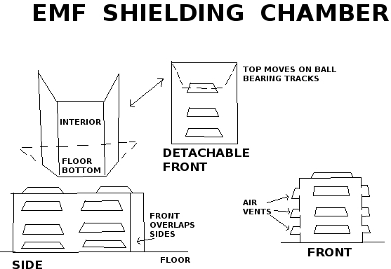

Faraday cages can attenuate electromagnetic energy. Steel sheet metal grounded by electrical wire and 50% Silver fabric can form the main base of the structure. Mu-metal and SiliconSteel can be added at critical areas (head region) to attenuate low frequencies, which are your biggest enemy.

Finally, envelop the structure with silver fabric, such as 50% Silver Argenmesh. Lead sheet or PolyTungsten sheet is not required but it is added protection against high frequency ionizing energy (and acoustic energy). Sheet Metal: (below is an example of a sleeping/safety chamber) use: 20 to 30 gauge Steel sheet (with iron content - Not stainless steel) can be effective against lower electro- magnetic energies when electrically grounded. I would recommend testing the integrity of your electrical ground with a small volt meter. (20ga = ~1mm thickness & 30ga = ~ 0.3mm thickness.).

Other ideas for shielding faraday cages are: metal bathtubs converted as above; wood frame enclosure shielded with aluminum mosquito netting (multiple layers) and possible aluminum foil with small holes puntured in it.

Steel Plate:

Steel's iron content can effect the magnetic component in electromagnetic transmissions. The steel's carbon can act against the electrical component.

Lead (Pb):

1/4 inch thick lead sheeting folded into multiple layers, as needed, can provide effective attenuation of ionizing and acoustic energies. It is malleable and can be folded with some pressure and cut with a box cutter blade. Lead is a poison and should be handled with caution.

Use lead ‘pigs’ to store electronic equipement to prevent emp attacks (electromagnetic pulse , aka. ‘E- bomb’ attacks); also lead lined bags

Rubber:

"Natural" rubber bath mats or rubber step stones (pavers) have proven to be effective as acoustic dampers (MUST be natural rubber). Five or more mats (or several pavers) can be rolled or stacked together and duct-taped as a bundle.

Other shielding materials: feathers; real wool; leather; silk

Cemented Basement as shielding:

cemented provides coverage from electronic attacks (microwave, electromagnetic, and laser). My basement is cemented throughout except for some of the walls and ceili

3 things as essential for TI’s to wear :

1. Lead vest
2. Lead hat
3. Silver-lined ballcap

I believe 0.175mm is the ideal ‘happy medium’- protects but can wear it throughout the day without its weight wearing you down.

Lead curtains

copper foil; barbecue grill/baking sheets (copper infused); copper mesh scrubbers lead or bbq grill paint (put on reverse of mirrors tro deflect DEW emf)

A fabric conditioner called AegisGuard LL, available

from [www.blockemf.com](http://www.blockemf.com/) and [www.aegisguard.com,](http://www.aegisguard.com/) added to the final rinse cycle of the laundry while in the washing machine, results in clothe

high rated window tinting (eg.Florida) mylar blankets

chain mail silicon

silver fibre clothing (buffers emf and energy fields as well as destroys bacteria) and leather and rubber clothes (help to buffer emf)

incense and wood smoke (blocks lazers/scalar weapon beams) mist (disrupts current): showers and steam machines/vaporizers

relieve that ever so washed out tired feeling. This is meant to assist instant alertness, and also towards thinking more clearly. It has been tried and seems to work well. This simply involves a spray bottle filled with water, (Cost efficient).

Personal Health:

connecting to nature to reset human biohythmns:

One can create an internal vibration of their own choosing which can counter-act/jam/override any invading/incoming ELF frequency.

Black clothes is an excellent way to avoid headaches. Black colour filters the most harmful microwaves effects; I think it is better to use natural fibres, like cotton or wool.

remove filings (they attract radiowaves and generate metal vapour which poisons the body-if a necessity only composite filing should be had)

don't frequent dentists (implants; rfid chips)

German new medicine

ozone generator (for atmosphere and distilled drinking water)

Plasma gas/Ozone generator: purifies air, kills pathogens, increases oxygen/ozone in liquid/water, internal body purification. Oxygen singlet in O3 breaks off and binds to pathgoens, etc. destroying them via redox reactions;

natural fibre clothing (linen; silk; cotton) earplugs

white noise machines (fans; etc.)

music (harpsichord; instrumental polyythmic-helps to enhance memory and to complicate brain activity to throw of RNM attempts by perps

prayer/meditation-mat:: i)wool(magnetic resonance/piezoelectric effect)

* 1. orgonite blanket(above)layering of organic/inorganic materials(eg.carbon steel wool &wool) iii)yoga mat(bamboo reeds/wicker/natural material);

ION generator: purifies air, reduces inflammation/DOR(deadly orgone energy);

Chromotherapy color light: swathes or bulbs: activates correspondent chakras via sympathetic vibration

Red heat lamp/near-infrared sauna[red bulb/colored light swathe):

draws toxins out of body; induces sweating;

initiates liver detox via sympathetic resonance of vibrational frequency(red); use during daytime from waking taper off as night approaches

Amber/orange low blue lights: reduces hormonal/mood altering blue light; use wrap around glasses(uvex); bulbs; computer screens(color film)

'Violet ray machine'/hand-held high frequency eletrotherapy instrument: calms nerves; analgesic; localized sterilization; exfoliation; destroys cancerous moles/tumours; accelerates blood circulation; increases tissue cellular metabolism; anti-wrinkle; stimulates lymphatic drainage; breaks up calcification; use on: joints; muscles;blood vessels;blemishes;

Crystals:

* + 1. jewels: around neck(pendant); wrists(bracelets); on body(brooches, etc.).
    2. environment(under/over/around): bed/bath/electronic equipment etc.).C) food/water Use: activates chakras; brings in energy; amplifies morphogenic field/energy body; improves resonance/integrity of self,structures water; facilitates growth, etc**.**

**(recommend protection shones such as shungite; obsidion; onyx; also morphogenic field/aura amplifying stones such as rubies; these can be had for cheap if lab created)**

copper string necklace with a magnetic fastener and added an electronic resistor greater than 15000 Ohms.

Musical instruments:

1. bongo: induces trance states/altered states of conciousness;

activates/depresses metabolism,etc.; improves mind/body integrity through sound wave generation through mechanical exertion;

1. pan-pipe: as above+ trains breathing techniques/lung capacity

This form of musical instrument helps to cause vibration to distribute through the limbs of the body and alter physiology such that RNM is distrupted/distorted; also induces trances which assist in right brain activation

--Vaporizer: increases H2O in atmosphere;clears sinuses; amplifies O2 facilitates respiration (water vapour helps to reduce efficacy of DEW attacks): The cool moisture mist will change your frequency, immediately assist to relieve tiredness, and help you to become more alert. Also dunking one’s head in cold water and running cold water on the cheeks and neck activate the vagus nerve

-- Handheld Vibration machine:use: post

application of oil to facilitate purpose: increases blood/lymph flow/muscle electrical activity; breaks

up calcification/adipose tissue;

Drinking vessel:

* 1. glass(preferably dark-pyrex for energy absorption/minimizing breakage/heating in oven)
  2. crystal(iff~lead content) iii)sterling silver

pitcher/cup(antimicrobial,sterilization); additional items in vessel:

1. shungite[giza pyramid dimensions]

(negative ions/piezoelectric/black absorbs surrounding energy b/c absence of light);

1. silver bullion .999(above);
2. magnet[ization]: place vessel on magnetized ferrous metal plate/pan,etc.(eg.cast- iron),

magnetized by a)high gauss N43-N52 neodymium magnets in b)sacred geometrical array(eg.hex/oct-agonal circle, etc.)depending on purpose

c)placing opposite polarity in opposition on plate &V around vessel via elastics/string(eg.silk, cotton depending on purpose)

of certain color,<>electrified via battery extending from copper wire or placed in flowing water;

purification methods(priority sequence):

1)spring water 2)distilled(make own distiller-STC);

3)R.O.S(reverse osmosis);avoid all alkaline/structured

water;smaller dinking vessels: ~250ml.+pyrex glass containers w/ larger to fit over and serve as dust cover/fridge storage/minimize breakage

Tongue scraper: purpose: clean residue from tongue; enables optimal secretion of digestive enzymes through exposure of tastebuds to chemicals in food; preferably sterling silver cutlery/wire or silicon implement

Toothbrush:

Soladey titanium dioxide rod w/solar panel (generates negative ions that break up bacteria when activated by light via solar panel & via ionic rod coming into contact W/ saliva); hemp sticks an alternative to brushing with above

Neti pot: eliminates mucous in sinuses

Footbath:

generates vibration/heat; use w/ magnesium sulfate(epsom salts) to extricate internal toxins via soles/increase magnesium for anti- inflammatory/nutritional status

Spiky reflexology sandals ('spikes'): preferably wood or iron sandal soles w/ cross patterns cut in to create 'spikes'; enables soles of feet to breath/sweat for detox; activates reflexology points; improves mind/body integrity

Gravity-fed enema bag: 1.5L minimum; colon cleansing/administration

of liquid for retention enemas (eg. Coffee enemas which clean the liver)

Sterling silver [flatware/cutlery/plates/pitchers, etc.]: see above

+ barter item in emergency

colloidal silver:anti pathogenic/microbial/bactericidal nano particles of .999 silver generated via electrical current into . 999 silver bullion V wire via alligator clips

Exfoliation:

purpose: removal of skin cells to allow pores to

respire/sweat for detoxification of body/moving lymph fluid around lymph vessels via mechanical pressure:

A) cloth(bodyshop-fine nylon/sissel fibre cloth); B)loofa(marine plant segment used as brush);

* + 1. Scalp brush(stiff boar bristle brush;
    2. scalp massage brush( wooden roundtipped bristles for stimulating scalp/blood/lymph flow

Gum stimulator: builds gum tissue through irritation of gums; initiation of growth response; anchors teeth in mouth; reduces gingivitis;

Pyrex glass straw(pipette/silicon tubing): purpose: avoid enamel damage from fruit juice/acids

Sanitation:

UV light toothbrush box

small airtight vacuum seal container gum

stimulator+refills toothbrush(soladey+replacement heads)

safety razors+blades+small brush

nail trimmer

mechanical nostril trimmer loofa (exfoliate)

scalp brush(boar bristle) scalp stimulator

~ion/03 generator pot(bedey)Vbedey attachment enema bag

extra virgin coconut oil (oil pulling; skin conditioner)

Grecian olive oil soap towels(x2 large; x1 small)

baking powder (laundry; tooth brushing) vinegar (dish washing)

detox: activated charcoal powder

edible clay (ca+ montmorillonite; zeolite)

epsom salt (magnesium source-calm/relax); diatomaceous earth (bedbugs-put around bedposts) water distillation machine

hydrogen peroxide+dropper (wound irrigation; ear wax elimination-STC) exfoliating cloth(x2)

carmex; vaseline

EXERCISE STUFF:

Pinhole glasses: strengthens eye muscles; reduces brightness enabling inner sight

Trampoline: moves lymph around body/lymphatic vessels/exercises internal organs via g-forces generated through impact; builds immunity thereby; also detoxification; proprioception(body position awareness)/balance; preferably square shaped as less foot eversion/potential damage;

--Broomstick: /4-6'long/1"dia.wide;

purpose: spinal exercise(spinal muscles; intervertebral discs-go at a controlled smooth pace not too vigorous and always keeping trunk muscles tight; twist spine back and forth<->side to side 20-30 reps each

--Hand squeezers:

1. multi-spring old school spring squeezer; purpose: strengthens 'closed fist grip'; milks veins of arms;moves lymph/blood around body; increase electrical activity in hands;
2. spring-squeezer(v-shaped/single spring)purpose: trains hand in different, awkward way-not recommended;

Pull/chin-up bar/playground equipment : straight/telescoping rod; can be installed in door frame(for back and arms); best kind is multi-angled

Cardiovascular equipment:

purpose: repetitive large muscle group movement inducing increase of cardiovascular systemic metabolism; lung capacity; sweating/detox; muscular electrical activity

1. elliptical: recommend magnetic resistance whereby one magnet can be moved closer/further from other to increase/decrease resistance;
2. Stationary/recumbant cycle: same principle as A);
3. bike trainer: fluid or magnetic stationary 'trainer' to use w/ conventional

bicycle. caveat: most generate excessive noise; may also wear down the perineum and cause impotence

1. bicycle;
2. snow shoes;
3. walking shoes

Personal Survival(B.O.B- 'bug out bag'; frame backpack military style) source: military surplus; thrift stores; garage sales

sources: thrift stores;wholesalers; garage sales; family inheritance; internet,etc.

Personal affects(on body):

polar sleeping bag(duck/goose down) down-filled parka

wool garments('bush' jackets/pants) fur clad leather gauntlet gloves

polar boots('mickey mouse' style)V mukluks+extra laces facial covering(balaclava)/down-filled or felt face mask wool socks(outer); nylon inner

frame backpack fur hat (ushanka style) mocassins further survival gear;

fire : lighters(zippo;bic);cotton balls soaked in vaseline; spark

lighter/fire starter(magnesium, etc.); waterproof matches; liquor flask full of kerosene/lighter fluid; tinder(dried sticks, etc.)

water: ozone generator(miniature, battery powered); colloidal silver generator(miniature): 9volt batteries+jumper cable+alligator clips+.999 silver wire;silver bullion; portable filtration unit: lifestraw, katadyne filter; stainless steel cup on thermos(store all items inside)

sanitation: wash basin; soap(100% olive oil); coconut oil; toothbrush+sanitizer; scissors; safety razor+blades; hydrogen peroxide; baking powder; wash cloth; eye dropper; gum stimulator; scalp brush; loofa; exfoliation cloth; pumice stone; nail clippers; q-tips; stainless steel mirror; ear plugs; shooting ear muffs

clothes: long underwear(wool); boxers; socks(extras); extra shoes+laces; money belt(animal leather); sweaters; gloves(security)

1st aid kit: razor knife; sting/venom kit(wasps;ticks;snakes, etc.); sewing needle+thread; cayenne; stretch bandage+splints; bandanas(cottonV linen); food grade activated charcoal powder; zeolite/terramin clay

communication: compass; map; cell;<>I.D(iff~public authority probs., eg.for employment, etc.); edible plants; 1st aid pamphlet

Sleep: sleeping bag+roll/mat; wool blanket

info./data preservation: multiple computers; External hard drives; USB; external disc drives; power cords; Cd/DVD-RWs(burnt info in hard copy); battery powered walkman/discman(+batteries; CDs; cassette tapes); magnetic tape data storage; condense printed text(print back to front; small font)-> laminate infographics/important documents to be scanned and reused/made public

food stocks: dried fruit; nuts/seeds(almond/peanut butter); turmeric; ;starch: (oats; rice, etc.); herbs; spices; chlorella tabs; dried seaweed; sardines; ghee; waxed cheese; boxes of dried fruit

tools: multi-tools; hammers(claw;sledge); saws(hack;wood); wrenches(adjustible); screwdrivers(multi-bit); pry bars; wire cutters/strippers; nails/screws(large; small;med.); electrical drill; generator; plastic sealable gas jugs; hex wrench; axe; lock picks; glass cutters;

Food: minimum 2 months supply at all times

Water: large jugs full (100 L at all times) (R.O.S V Distilled preferable)

Coping techniques:

3rd eye Meditation+ zen satori techniques (detachment from the spatio-temporal plane, ie. The veil of maya))

Mantras (Aum)

networking with proven T.Is to share information and for mutual aid and support

communal living (24 hour security/monitoring of premises+ witnesses to avoid being set up in false flags)

Exposing the Crime:

Propaganda:

(referencing gangstalking websites and quoting jews' anti-white statements. Messages which are brief; pithy and evoke an emotional reaction in the viewer,eg. shame; guilt; anger; outrage, as well as interest in the terrorist activity of the Hidden Hand. Examples could be: "Community Policing is Terrorism"; "Gangstalking"; "Spy Society"; "Gangstalking is Terorism", using eg. QR codes to urls of website and/or website domain name: eg stopgangstalkingcrimes.com)

banners in windows

money bills with permanent marker ink stamped messages using adjustable business letter stamp

chalk (greasy kind-neon gets attention best) send flyers to media and other people

pamphlets; leaflets; stickers (on vehicle windshield wipers; tossed out of vehicle on front lawns of people; placed up in public places: bus stops; etc. caveat: be ware of local laws and bylaws to avoid legal trouble, eg. littering laws; mischief; nuisance,etc.)

keep a daily journal and monitor and record all events around the 24 hour clock.

Gather audio/video evidence on all perps; compile dossiers on each individual. Most T.Is are assigned 20 perps each

video record emf meter readings of DEW attacks in property and pin point their location social media and online activism:

memes and links to websites or forum to spread the message (as above)

email: anonymous mass emails and faxes to organizations; key individuals set up a website or forum for community discussions as well as group or person-to-person conversation on audio- video platforms

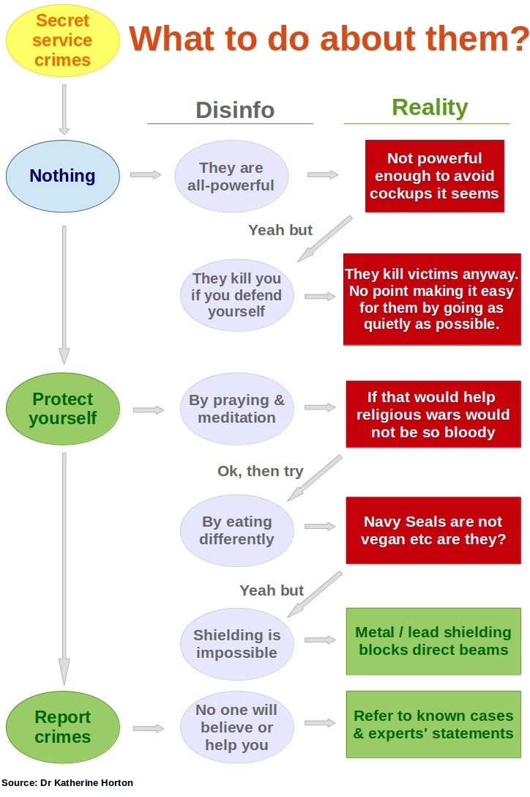

Dealing with Police:

"I'm on a terrorist watchlist" (this indicates to them they must not interfere with your activities but simply monitor you from afar)

"I reserve all rights...am I free to go" (freeman on the land advice) 5 words: "I have nothing to say"

"I'm represented by counsel": give lawyers name

If caught video recording people etc.: "I'm documenting illegal[...name of alphabet agency or omit...] surveillance and counter surveillance stalking" (Stephen O'Keefe) caveat: attempt to avoid being conspicuous

Have on hand technical diagrams of D.E.Ws and microwave weapons technology to proof the existence of such should this be the point of contention

security

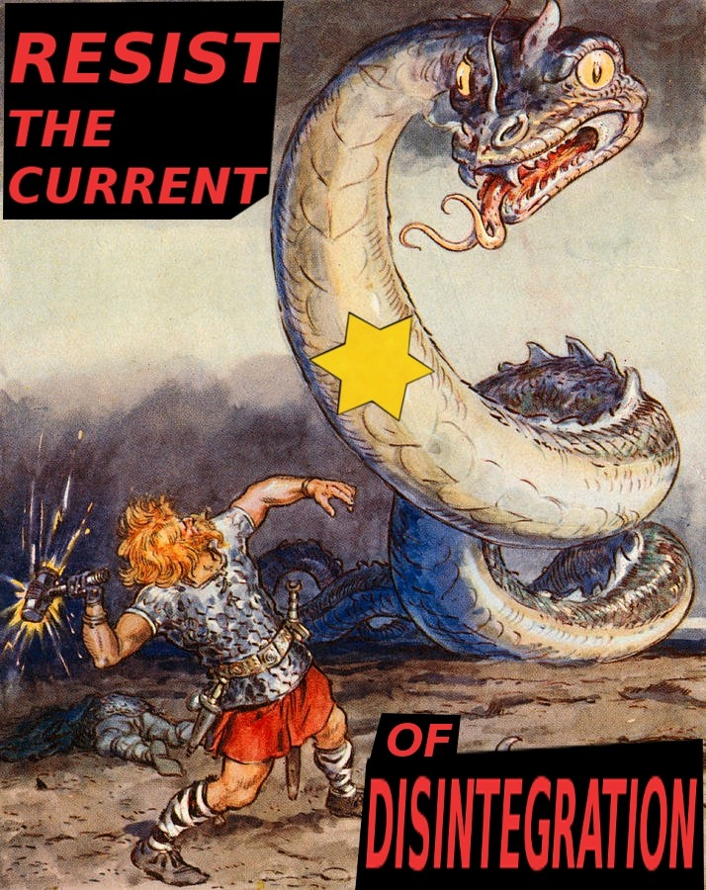

exterior:

padlocks: these are only as strong as the doors they shut: the weaker the door the less valuable high security padlock would be

Grade 6 high security shrouded padlock (large-style)

Sargent & Greenleaf (S&G) 951 or 833 Padlock; Abloy Protec2 PL 362 Shrouded Hardened Steel Padlock (Finland) ; Anchor Las 590-6 Padlock (Swedish); EVVA MCS Shrouded Padlock (Austria): this magnetic lock may be most difficult to pick

smaller padlocks: S & G wheel combination padlock security cameras on property: motion sensor; flood lights

floor safe (ideally sunk in concrete; photograph items prior to leaving residence for liability/insuirance pruposes)

Doors:

steel door interior:

deadbolt

Abloy Protec2 Jimmy Proof Deadlock Deadbolt; BiLock Jimmy Proof Deadlock Deadbolt; tape the dead bolts into the locked position, whenever possible, for your own safety. door reinforcement :

DJArmor Platinum Jamb Armor Combo Kit for Standard Doors deadbolts:

Expanding Bolt for Abloy Deadbolts

all of the above from: https://securitysnobs.com/Deadbolt-Bolts/ Hasps:

HS1 Heavy Duty Hasp & Staple chain:

Hardened boron steel high grade chain https://securityforbikes.com/products.php?cat=Chains+%28without+padlocks%29

travelling:

portable door locks:

Calslock; MasterBolt; Addalock; Qicklock Portable Travel Door Lock; Pocket Lock Portable Door Lock;

windows: burglar bar; metal mesh; spring loaded expandable bar; security film (to prevent smash entry/mischeif);

bottom of door:

DoorJammer Portable Door Brace; Wedge Door Stop Security Alarm; Door Barricade Brace Night Security Lock: eg. nightlock ($40)

vehicle security:

security film

boot lock (on wheel)

club-style lock on steering wheel) dash camera

vehicle:

Mul-T-Lock (jewish company unfortunately) door: ArmaDLock

gearshift: MVP 45

personal defense(be aware of local laws):

body armour: helmet; face mask; shin guards; bullet proof vest

blade: pants pockets: spring-loaded folder knife; fixed blade; large machete collapsible baton (friction)

blunt instrument:

steel shot gloves or kevlar knuckle;

baseball bat(aluminum); collapsible baton; kubaton or monkey fist on key set guns:

rifle: sako; winchester 270.; with nightvision scope

handgun/sidearm: ruger mark 3 or 4; .38 special revolver blue-black metal.357 smith and wesson revolver

shotgun:12 gauge pump action semi-auto shotgun

semi-automatic (repeating) military-style rifle: M-16; SKS

sub-machine gun (smg): H&K MP5; MAC-11; Scorpion machie pistol bb gun: pistol and rifle + lead bbs

gun locks+keys;gun cleaning kit(oil; rags; brushes);

[homemade]body armour(kevlar helmet+ballistic face shield/face mask/kevlar vest; ballistic shield)

home made weapons (in WROL/SHTF situation):

(look up on internet for instructions): pepper spray; microwave maser/herf gun; stun gun; pipe guns; Homemade wooden 'knucks'(mahogany/cherrywood;teak)

straight razor; lead-filled cane;

Avoiding false diagnosis of mental illness:

"Frankly I strongly recommend that you keep your faculties together & avoid going to see physiatrists & psychologists, because the pattern that is evolving is that they are highly complicit in these operations."-The Investigative Journal interviews Julianne McKinney, April 19th, 2006,

Subject: Directed Energy Weapons & Gang Stalking

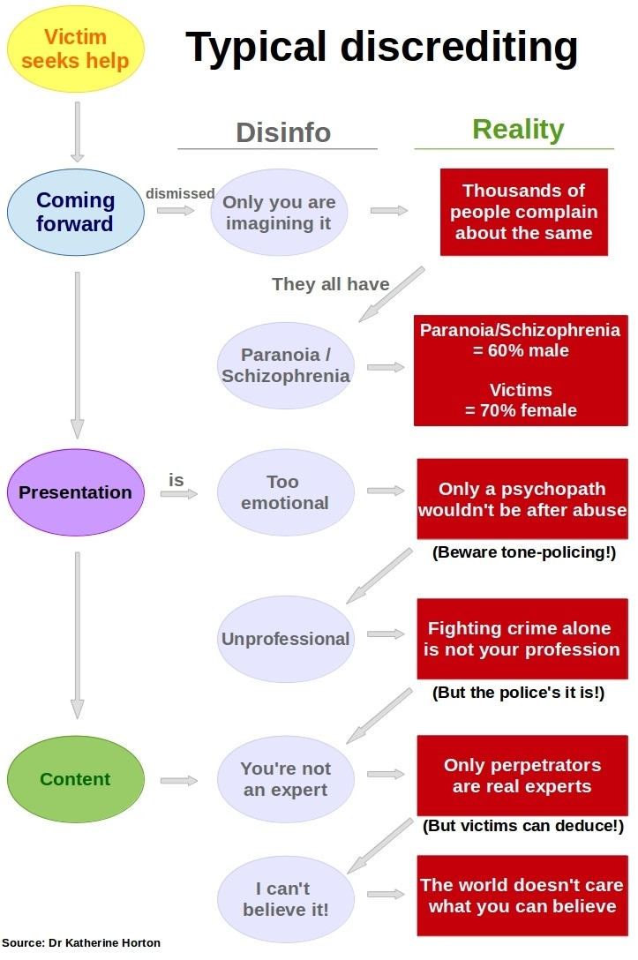

"If you see a mental health professional as a result of Mobbing/Organized Stalking, you may be misdiagnosed with a mental disorder."

(Rich, State-Sponsored Terror Campaigns: The Hidden Evil",pg.48)

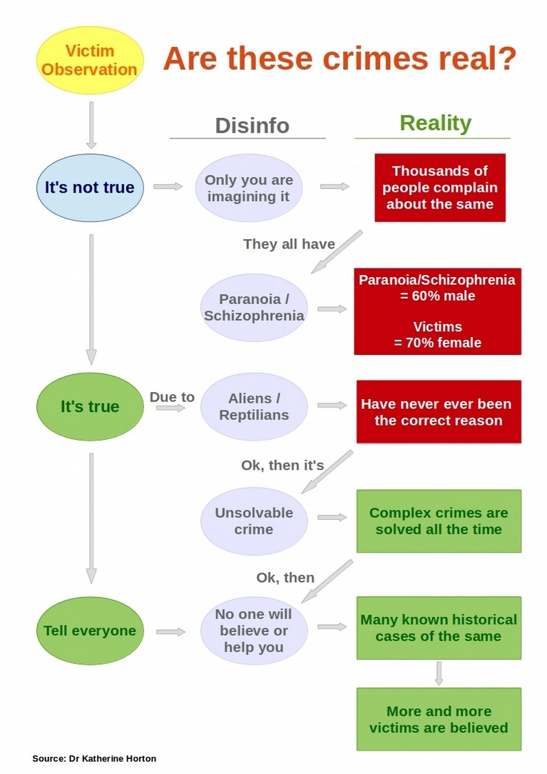

dealing with psychiatrists and ‘mental health professionals’:

always convey only literal meaning and appear as ‘average’/normal as possible displaying no idiosyncracies taht could be portrayed as ‘symptoms’ of ‘mental illness’

state only “I’m not a danger to myself or others”

ensure you obtain informed consent should any ‘treatment’ be imposed upon you; do not consent to the extent possible without enabling the state to justify imposing physical force or confinement against you.

If institutionalized behave as normally as possible and ween yourself off the drugs as quickly as possible.

If institutionalized ensure you state that you are calling a review panel which should inititate a process that will put you into a position to get out of the institution. (this applies to Canada.

Check local codes fo ethics and parameters mental health ‘professionals’ must go through in their ‘sevice’ provision. Know your rights).

Dealing with Implants:

Where or have around oneself magnets to disrupt the transmission/transceiving of emf by perps. Attack to short out through emp (electro magnetic pulse)

Possibly have implants removed by a trustworthy surgeon (if one can be found and the chip/implant can be detected)

Avoid dentistry and dental surgery especially tht which entails being anaestetized ('put under') as this is the primary vehicle through which chipping is carried out (typical location: lower right jaw and upper left jaw-the route of the vagus nerve which governs motor function. This enables perps to emply D.E.Ws to influence the movement of the T.I)

Dealing with RNM (Remote Neural Monitoring and Manipulation):

other defenses:

MultiTasking

Learn how to multitask as multitasking causes you to think in multiple threads. When you are constantly thinking in multiple threads (multiple tasks or thoughts) then there is no coherent pattern for the perps to establish and integrate into RNM data. (egs.: listen to polyrhythmic music while doint other tasks such as harpsichord; use ECS machine and/or rife rf machine);

In other words, ‘integration completion’ between the RNM system and your brain is hindered and without your response to that specific ‘impulse injection’, the RNM verification process is breaks apart.

If you are unaware of this constant mental manipulation the system will begin to shape your thoughts and behavior. They will use this to [attempt to] restrict your thoughts and behavior by blocking [interfering with] your memory and thought process while these suggestions (injected impulses) are being provided the interference is triggered and can be activated at will by the attackers.

Learn active memory techniques

behave in ways which differ from ‘normal’ routinized forms of behavoir (while in private trying to appear ‘normal’/average while in public)

DETECTION:

radio frequency scanning

JM20 PRO RF-detector RF (radio frequency) scanning The three phases of the testing:

1. Preliminary scan for (RF) radio frequency emission from the Human Body.
2. Obtain medical imaging of the area that has shown emission of RF- frequencies. The aim is to locate possible foreign bodies, UBO's (Unidentified Bright Objects). This is the responsability of the participant.
3. Final scanning for RF emission is done in a controlled environment. This is a repeat of phase one in a certified shielded room, also referred to as a faraday cage, to rule out the possibility that the signal might come from an outside source.
4. Surgery, under video monitoring to obtain, possible physical evidence admissible in domestic and international court. This is the responsability of the participant.

The Zap 180 Will Detect Chip Implants in Humans

then you can cause them to malfunction within 2 days with a rare earth magnet and use a band-aid to hold them in place.

New chips, several years old, only need about 12-24 hours to neutralize. The ones you probably got as a kid via vaccines can take 24-36 hours.

Removal of RFID chips:

First you have to find a practitioner who can detect the chip.This is usually not so easy to do as some of the chips do not show up on X-rays, ultrasound machines, or scanners.Once you have successfully determined that you do have an implant ,you better hope the chip stays in one location, 90% of the time they tend to move around the body. Secondly, you must find a surgeon who is willing to remove the chip, or find a technician who can erase the chip and stop it from transmitting data. The following is sure to help those of you who may have strong implications of chip implantation. This article is to aid you in your search for either chip detection and or chip removal.

Magnets can also be found inside old hard drives. They will be encased in a silver (or gold) overlay because they are more brittle than other magnets. But you will not mistake them, because the

moment you try to put them together you will pinch your fingers. They are very powerful magnets, derived from a rare earth mineral. And they WILL render micro-chips useless.”

use of magnets to short out chips:

Neodymium magnets

“For the electronic, physical, (implants), neodymium (rare earth mineral) magnets of anywhere from a quarter inch to a half inch in diameter work very well to completely disable them. Some people wear them in the headband of a baseball cap, preferably for at least 24 hours, but you can also tape them to the back of your ear and hide them under your hair! After implants are disabled, you won’t have so much fatigue, and the pitch or frequency in your ear stops happening. Use caution with these powerful magnets, though, as they can wipe out disks and computers. It’s best not to wear them while sitting at the computer, at least, not while wearing more than one or two of the little ones.” <http://www.metatech.org/implants_physical_destroy.html>

<http://www.thetruthdenied.com/news/2014/11/11/how-to-remove-an-rfid-implant/>

Dealing with Perps:

Covertly monitor perps with recording devices and practice mindfulness at all times to avoid being struck by vehicles; assaulted; set up/framed

Do not respond in any way that could be construed by the 'reasonable man' as aggressive; emotionally erratic; threatening or suspicious to avoid potential public opinion you are 'mentally ill'. Maintain the facade or normalcy at all times.

"Perps have to blindly obey within a second. Or they will be punished. I have often witnessed it on the bus or skytrain or in line ups. Wherever harassment takes place, there is always a supervisor near. The perps look at the supervisor for the ok to set off their weapons. This is done by eye blinking. The supervisors never carry a cellphone openly in their hand. Many of them wear a suit to demonstrate their authority. When perps escalate a situation, the supervisor will step in and de-escalate it. Supervisors often saved me from being apprehended by the police due to some stupid act of a perp. The police yields to the intervention of the supervisor, this is how I found out who is boss. The higher supervisors are Mossad agents." (quotation from a targeted individual)

Compile a list of names; faces and residences of perps in the form of audio-video and photographic evidence which can be used to charge them with: harassment; sexual assault; voyeurism; property damage; buisance; mishcief; disruption of the quiet enjoyment of the premises (bylaw violation); break and enter (B&E) or whatever other crime they may have committed. Prepare in advance to have the lifst and other information available for release by a an online 'deadman's switch' which will automatically send the information (be it a link to a storage site or websites of your own you keep clandestine) to trusted sources should something happen to you. This may lead to the perps being brought to justice.



Message to the Freemasons (‘shabbos goyim’):

The following quotations from the protocols of the elders of zion serve to illustrate both the purposes of freemasonry for the jews and the latter’s intentions towards freemasons. The fate of the traitor to their people is writ large in these quotations from the Protocols of the Elders of Zion:

"[W]e shall create and multiply free masonic lodges in all the countries of the world, absorb into them all who may become or who are prominent in public activity, for these lodges we shall find our principal intelligence office and means of influence. All these lodges we shall bring under one central administration, known to us alone and to all others absolutely unknown, which will be composed of our learned elders. The lodges will have their representatives who will serve to screen the above-mentioned administration of MASONRY and from whom will issue the watchword and program. In these lodges we shall tie together the knot which binds together all revolutionary and liberal elements. Their composition will be made up of all strata of society. The most secret political plots will be known to us and fall under our guiding hands on the very day of their conception. AMONG THE MEMBERS OF THESE LODGES WILL BE ALMOST ALL THE AGENTS

OF INTERNATIONAL AND NATIONAL POLICE since their service is for us irreplaceable in the respect that the police is in a position not only to use its own particular measures with the insubordinate, but also to screen our activities and provide pretexts for discontents[...]" (Protocol 15)

"It is natural that we and no other should lead MASONIC activities, for we know whither we are leading, we know the final goal of every form of activity whereas the GOYIM have knowledge of

nothing, not even of the immediate effect of action; they put before themselves, usually, the momentary reckoning of the satisfaction of their self-opinion in the accomplishment of their thought without even remarking that the very conception never belonged to their initiative but to our instigation of their thought[...]" (ibid.)

"You cannot imagine to what extent the wisest of the GOYIM can be brought to a state of unconscious naivete in the presence of this condition of high conceit of themselves, and at the same time how easy it is to take the heart out of them by the slightest ill-success, though it be nothing more than the stoppage of the applause they had, and to reduce them to a slavish submission for the sake of winning a renewal of success ... BY SO MUCH AS OURS DISREGARD SUCCESS IF ONLY THEY CAN CARRY THROUGH THEIR PLANS, BY SO MUCH THE "GOYIM" ARE

WILLING TO SACRIFICE ANY PLANS ONLY TO HAVE SUCCESS. This psychology of theirs materially facilitates for us the task of setting them in the required direction. These tigers in appearance have the souls of sheep and the wind blows freely through their heads[...]" (ibid.)

"With this purpose we shall slay without mercy all who take arms (in hand) to oppose our coming into our kingdom. Every kind of new institution of anything like a secret society will also be punished with death; those of them which are now in existence, are known to us, serve us and have served us, we shall disband and send into exile to continents far removed from Europe. IN THIS WAY WE SHALL PROCEED WITH THOSE "GOY" MASONS WHO KNOW TOO MUCH; such of

these as we may for some reason spare will be kept in constant fear of exile.”

EXILE? THE GOY FREEMASONS WERE EXECUTED AFTER THE BOLSHEVIK REVOLUTION....... 4)



REFERENCES

Books:

Health:

"Ubermenscheit: Health Protocols" (for details on optimal health and wellness) "Salubrious Living", Arnold Devries (for additional fasting protocols)

Psycho-Spiritual:

Julius Evola, "The Doctrine of Awakening: Buddhist Varieties of Aescesis"; "Zen: The Religion of the Samurai";

Hagur, "Development of the Will";

William Walker Atkinson (thought force; personal magnetism, etc.)

Robert Bruce’s energy techniques 'mental health' profession:

"Psychiatric Fraud", Richard Lighthouse

“Does Mental Illness Exist”, William Ramsay, J.D “The Theology of Medicine”, Thomas Szasz mind Control:

"The Communist Brainwashing manual: Synthesis of the Russian Textbook on Psychopolitics", L Ron Hubbard

"Chainless Slaves: Trauma Programming", U.W.Ozian

"How the Illuminati Create a Total, Undetectable, Mind Control Slave"; "Deeper Insights into the Illuminati Formula", Fritz Springmeier "Mind Control,NLP & Hypnosis", David Shuttleworth

Organised Stalking and Eletronic Harassment(OSEH):

"State-Sponsored Terror Campaigns: The Hidden Evil", Mark. M. Rich "The Protocols of Gangstalking", Dr.Erik Karlstrom

"New World War: Revolutionary Methods for Political Control", Mark M.Rich

"Microwave mind control: Modern torture and control mechanisms eliminating human rights and privacy",Dr. Rauni Leena Kilde, MD, Former Chief Medical Officer of Finland

"Gangstalking and Mind Control: The Destruction of Society Through Community Spying Networks", A.K.Forwood

Websites:

Targeted Individuals; gangstalking; and directed energy weapons: <https://www.stopgangstalkingcrimes.com/> <https://www.stopeg.com/> <https://sites.google.com/site/targetedstalkedterrorized/home> <https://www.rlighthouse.com/targeted-individuals.html>

[https://gefoltert.blogspot.com/2018/01/posts-and-videos-in-english-language.html?](https://gefoltert.blogspot.com/2018/01/posts-and-videos-in-english-language.html?zx=2d55820ad4ca9aab) [zx=2d55820ad4ca9aab](https://gefoltert.blogspot.com/2018/01/posts-and-videos-in-english-language.html?zx=2d55820ad4ca9aab)

Forums: <https://exposingtheothers.com/forum/index.php>

MARCHING ORDERS

Armed with this information weapon it is the will of the author and compiler that the reader take aim and blast the cabal in its black heart and assist in the liberation of the earth and its denizens from the electro-magnetic matrix it has been imprisoned it. Rend the veil of appearances the hidden hand has blinded humanity with and let the light shine upon a new world of harmonious order.



SLAY THE SERPENT!